Webservice concepts

**1.(a) Creating soap project with wsdl**

Initially, Download and install SOAP UI tool -> open it and click on SOAP which is on top (or) right click on the file and click on New SOAP project -> we can see a dialog box and in that enter Project Name and give URL (or) file name for Initial WSDL and click on OK.

-> Sometimes we can even add WSDL file at the middle of the project like ->right click on the project and click on Add WSDL- >enter url or file name and click on OK.

**Example:**

**Step-1**

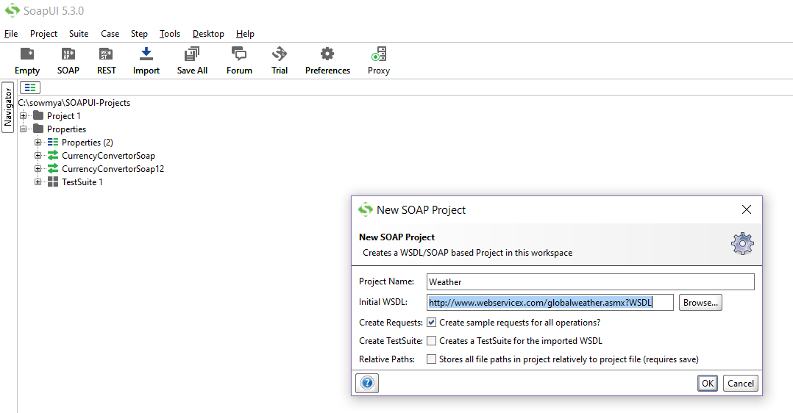

* We have given project name as Weather and imported WSDL file.

**WSDL** - Which describes all the information (requests and responses) about the webservice which is to be tested.

**Step-2**

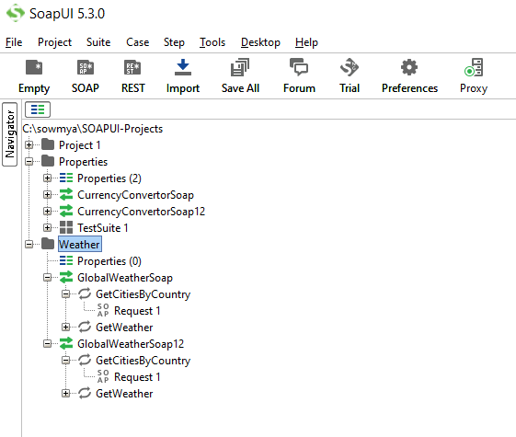

* Now, the url will be processed and respective services will be loaded into the project and requests will be generated.

**1.(b) How to send request xml?**

* At first double click on the Request1 (service name) and then u can see a box which is opened. In that click on XML u can see an input xml request of Weather webservice. “**?**” indicates the input parameters which has to be given to get a response based on that.

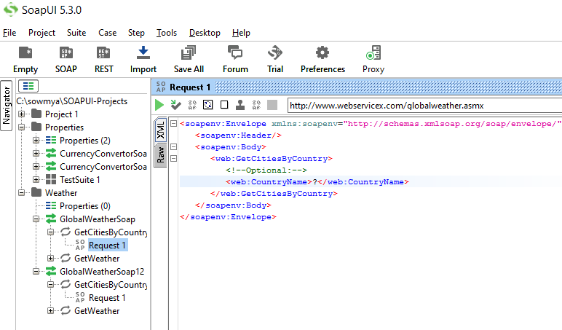

Now, Here we have two types of requests:

1. GetCitiesBy Country
2. GetWeather

* Let’s give input parameters for the first xml request (in the place of **“?”** enter India/INDIA and now click on green icon greenIcon.PNG then it will hit the Weather webservice and gives response based on our input value which is displayed towards the right side.

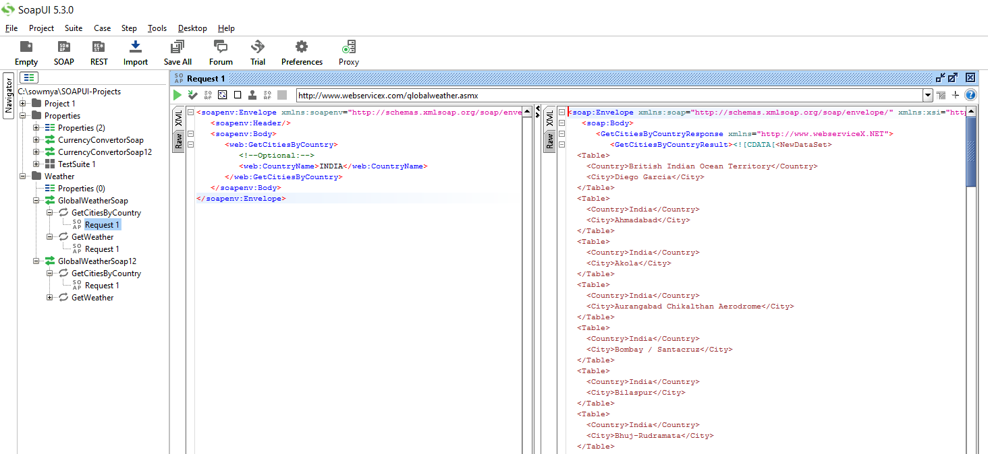

1. **Creating test suite, test case, test steps**

**Test suite:**

Right click on SOAP project -> click on new Test suite -> a small popup will open -> give the name in that and click on ok.

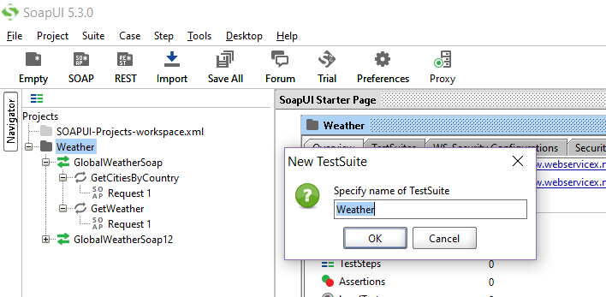

**Test Case:**

Right click on Weather Test suite -> click on new Test case -> a small popup will open -> give the name in that and click on ok.

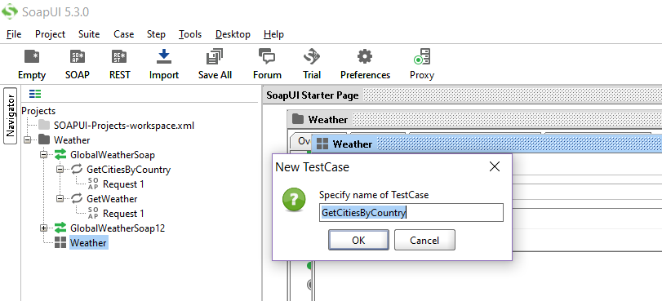

**Test step:**

Expand on Weather Test suite -> right click on GetCitiesByCountry test case -> go to add step and click on SOAP Request -> a popup will open -> give the name in that and click on ok -> another window will appear -> then click on ok ->

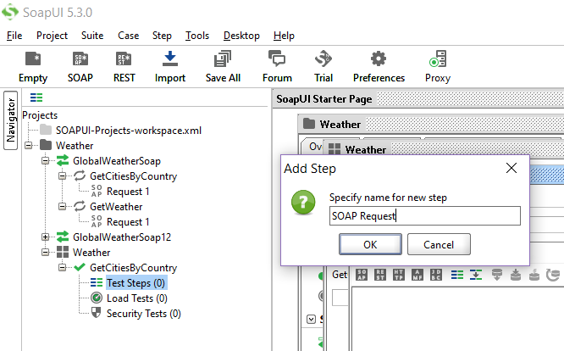

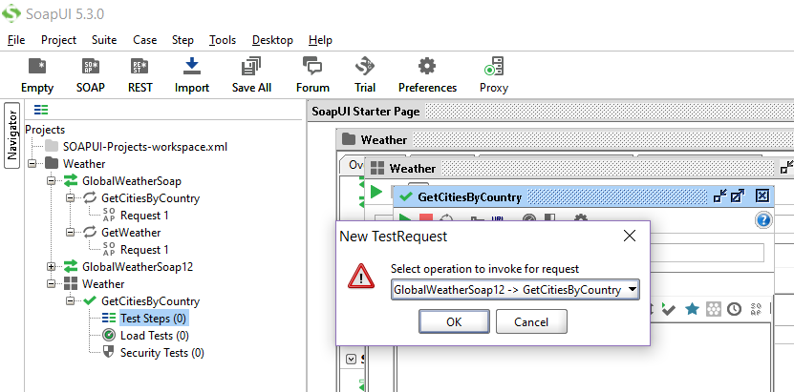

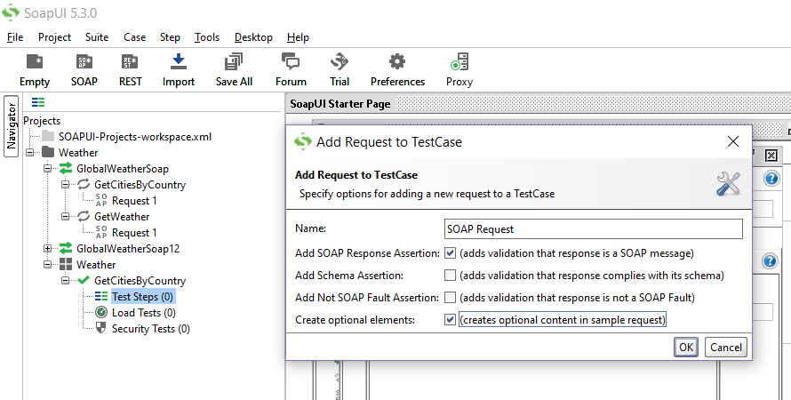

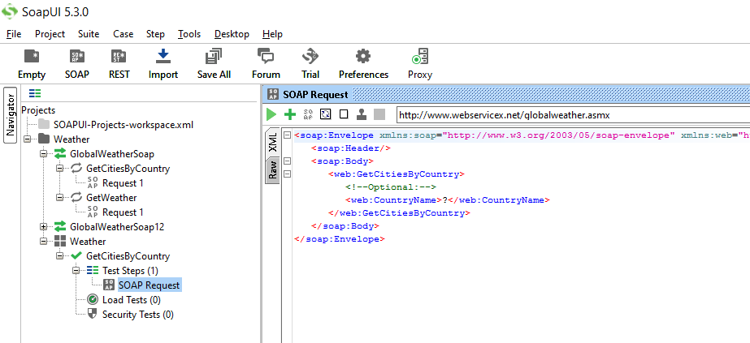

**3. Reading data from response xml using assertions**

**Assertion:**

* It is an act of stating something. It can also be interpreted as check point or a validation point.
* Once a request is sent to a web server a response is received. We need to validate if the response contains the data that we expect. In order to validate the response, we need to use assertions.

**Different types of Assertions:**

1. Property Content
2. Compliance Status Standard
3. Script
4. SLA
5. JMS
6. Security

**Property Content:** It contains the following types

1. Contains Assertion:
2. Not contains Assertion:
3. X Path Match Assertion:
4. X Query Match Assertion:
5. Scripting Assertion:

**Note:** Normally we cannot create assertions with the file which we got when imported. For this, we have to create test suite**.**

**3. Creating propety and use the property in test steps  
5. Validating reqest xml, response xml using xsd  
6. Security testing, passing token string to web service**