SQL Retail Analytics Project

1. Create Tables
CREATE TABLE customers (
customer_id NUMBER,
customer_name VARCHAR2(50)
);
CREATE TABLE stores (
store_id NUMBER,
store_name VARCHAR2(50)
);
CREATE TABLE products (
product_id NUMBER,
category VARCHAR2(50)
);
CREATE TABLE sales (
sale_id NUMBER,
customer_id NUMBER,
store_id NUMBER,
product_id NUMBER,
sale_date DATE,
amount NUMBER,
quantity NUMBER,
discount NUMBER
);

2. Insert Data (Auto Generate 1000 Rows)
-- Customers
INSERT INTO customers
SELECT LEVEL, 'Cust_'||LEVEL FROM dual CONNECT BY LEVEL<=50;
-- Stores
INSERT INTO stores VALUES (1,'CMR');
INSERT INTO stores VALUES (2,'SR');
INSERT INTO stores VALUES (3,'Lucky');
-- Products
INSERT INTO products VALUES (1,'Electronics');
INSERT INTO products VALUES (2,'Fashion');
INSERT INTO products VALUES (3,'Grocery');
INSERT INTO products VALUES (4,'Home');
-- Sales (1000 rows)
INSERT INTO sales
SELECT
LEVEL,
MOD(LEVEL,50)+1,
MOD(LEVEL,3)+1,
MOD(LEVEL,4)+1,
DATE '2025-01-01' + MOD(LEVEL,90),
ROUND(DBMS_RANDOM.VALUE(100,10000)),
MOD(LEVEL,5)+1,
CASE WHEN MOD(LEVEL,4)=0 THEN NULL ELSE ROUND(DBMS_RANDOM.VALUE(10,500)) END
FROM dual
CONNECT BY LEVEL <= 1000;

1. Data Understanding
--1. Find total number of transactions.
select count(*) as total_transactions from sales;
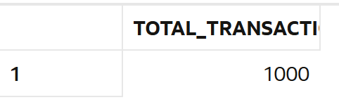
--2. Find total revenue generated.
select sum(amount) as total_revenue from sales;
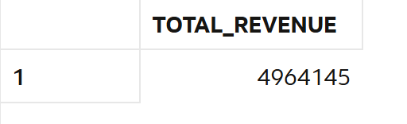
--3. Find total unique customers.
select count( distinct customer_id) as unique_customers from customers;--(registered customers)
select count(distinct customer_id) as unique_customers from sales;--(actively available for transactions)
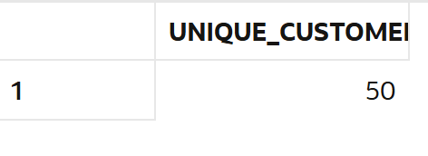
--4. Find average order value.
select round(avg(amount),0) as avg_order_value from sales;
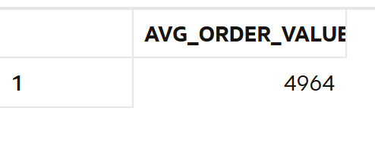
--5. Find total quantity sold.
select sum(quantity) as total_quantity from sales;
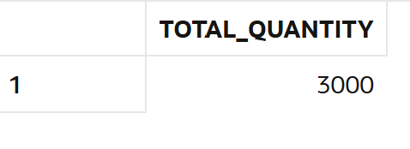
--6. Find minimum and maximum sale amount.
select
max(amount) as max_sale,
min(amount) as min_sale
from sales;
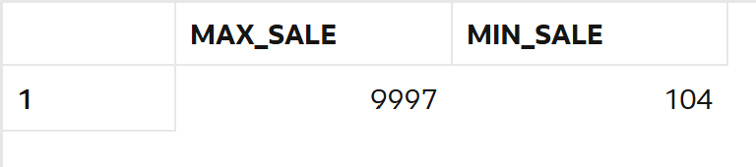
--7. Find average discount given.
select round(avg(discount),3) as avg_discount from sales;
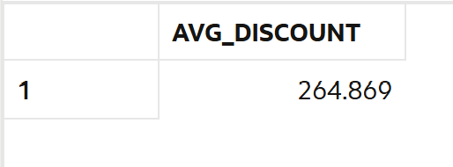
--8. Find total sales per store.
select store_id,sum(amount) as total_sales from sales
group by store_id order by store_id;
(or)
select so.store_name,sum(s.amount) as total_sales from sales s
left join stores so on so.store_id=s.store_id
group by so.store_name ;
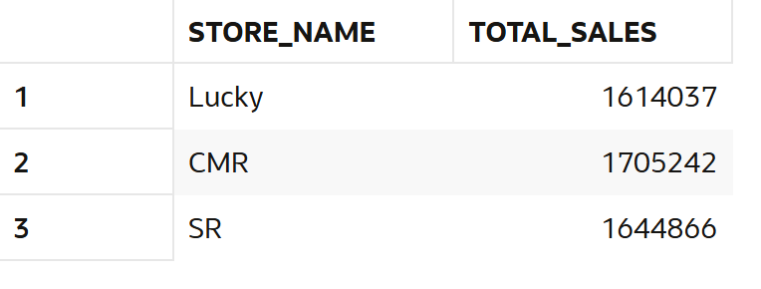
--9. Find total sales per category.
select product_id,sum(amount) as total_sales from sales
group by product_id order by product_id;
(or)
select p.category,sum(s.amount) as total_sales from products p
left join sales s on s.product_id=p.product_id
group by p.category;
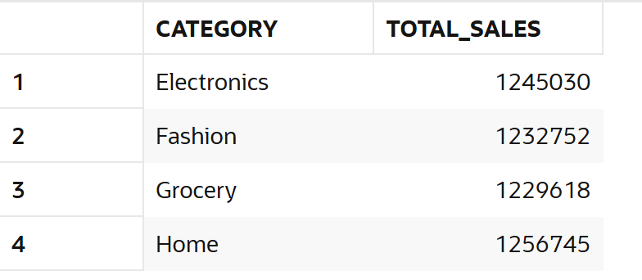

--10. Find number of transactions per day.
select sale_date,count(*) as total_transactions from SALES
group by sale_date
order by sale_date;
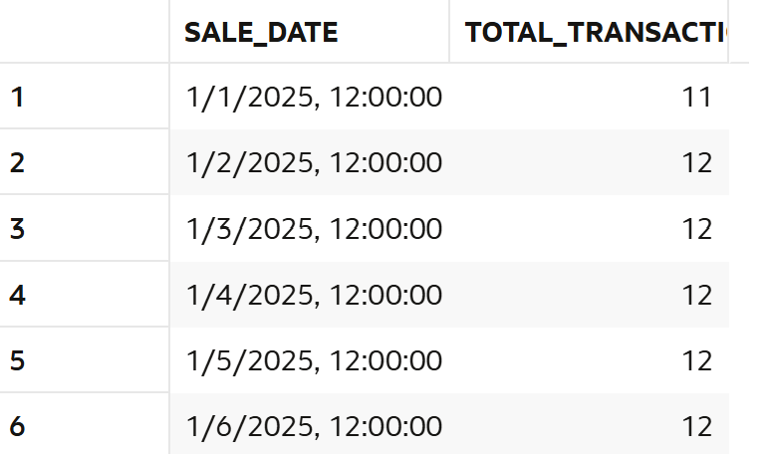

2. Data Cleaning
--11. Replace NULL discount with 0.
select nvl(discount,0) as discountnew from sales;
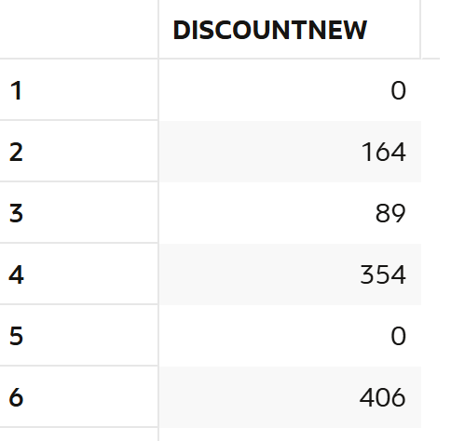

--12. Find number of NULL discounts.
select count(*) as no_of_nulls from sales
where discount is null;

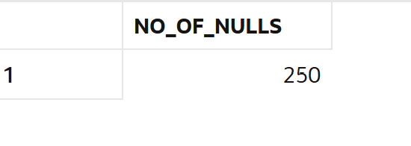
--13. Calculate net revenue (amount - discount).
select sum(amount-nvl(discount,0)) as net_revenue from sales;
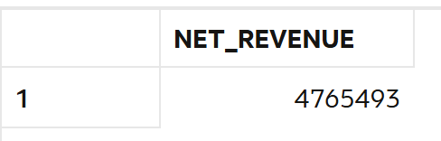
--14. Replace NULL quantity with 1.
select nvl(quantity,1) as quantity_replace from sales;
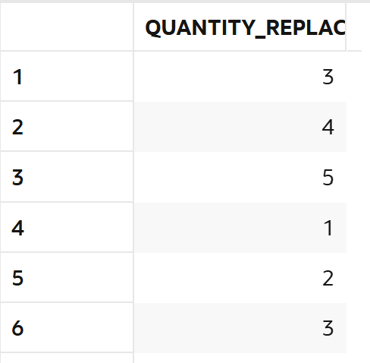
--15. Identify rows where amount is NULL.
select amount from sales
where amount is null;
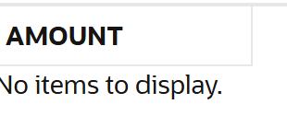
--16. Use COALESCE to handle multiple NULL columns.
select coalesce(discount,0,amount,quantity) as use_case_coalesce from sales;
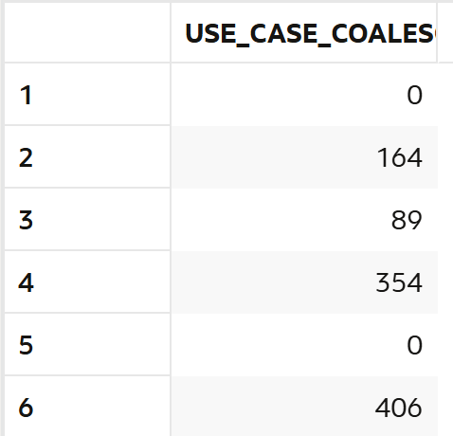
--17. Create a cleaned column for revenue.
select sale_id,amount,discount,(amount-nvl(discount,0)) as revenue
from sales;
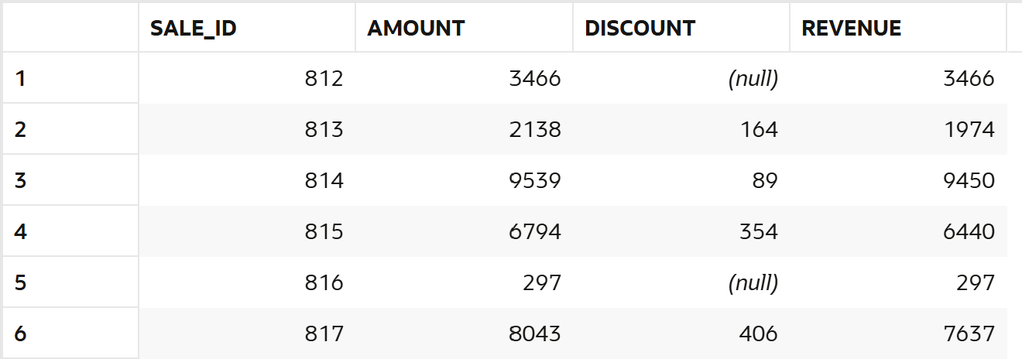
--18. Check percentage of missing data.
SELECT
SUM(CASE WHEN discount IS NULL THEN 1 ELSE 0 END) AS missing_data,
COUNT(*) AS total_rows,
ROUND(
(SUM(CASE WHEN discount IS NULL THEN 1 ELSE 0 END) / COUNT(*)) * 100,
2
) AS percentage
FROM sales;
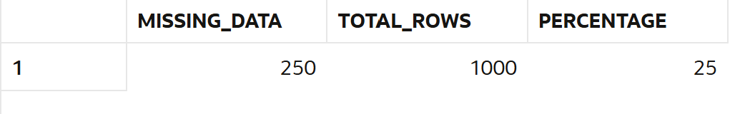
--19. Flag rows with missing values.
SELECT
sale_id,
amount,
discount,
CASE
WHEN discount IS NULL THEN 'Missing'
ELSE 'Not Missing'
END AS flag
FROM sales;
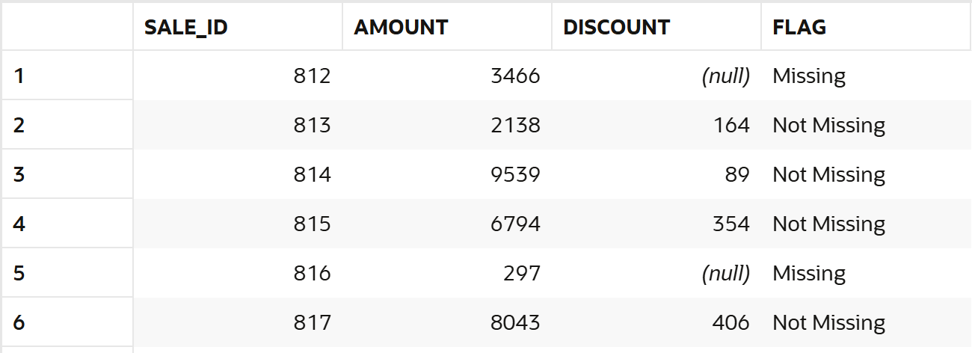
--20. Prepare dataset for analysis.
select c.customer_name,s.store_name,p.category,sa.amount,
nvl(sa.discount,0) as cleaned_discount,
amount-nvl(sa.discount,0) as net_revenue,
case
when sa.discount is null then 'No Discount'
else 'Discount given'
end as discount_status
from sales sa
left join customers c on c.customer_id=sa.customer_id
left join stores s on s.store_id=sa.store_id
left join product p on p.product_id=sa.product_id;
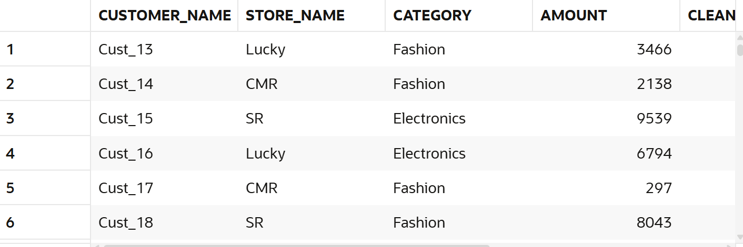

3. Filtering (WHERE)

--21. Find sales in last 30 days.
select *from sales
where sale_date>=(select max(sale_date) from sales)-30;
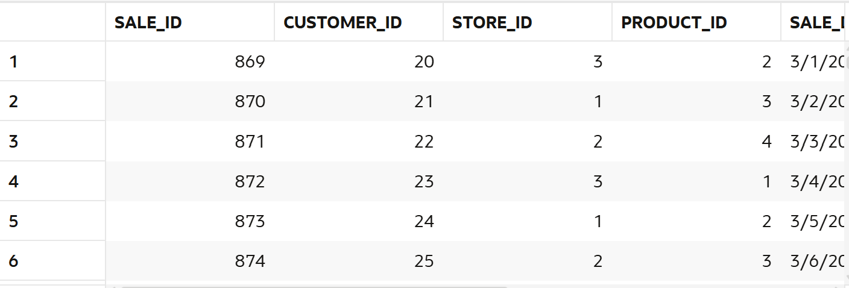
--22. Find sales above 5000.
select *from sales
where amount>5000;
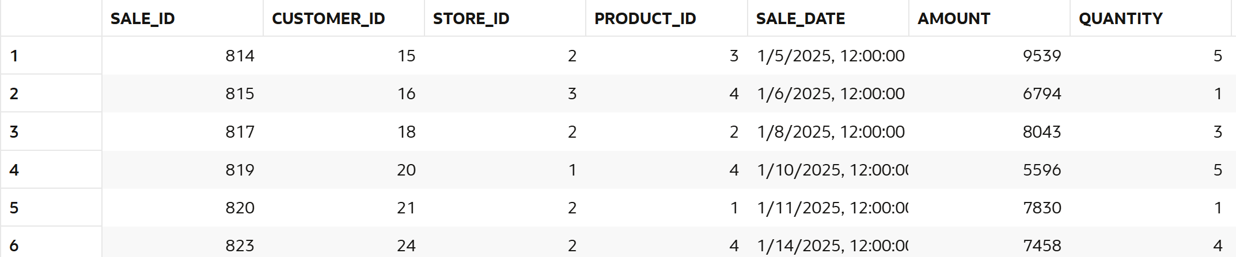
--23. Find sales between 1000 and 5000.
select *from SALES
where amount between 1000 and 5000;
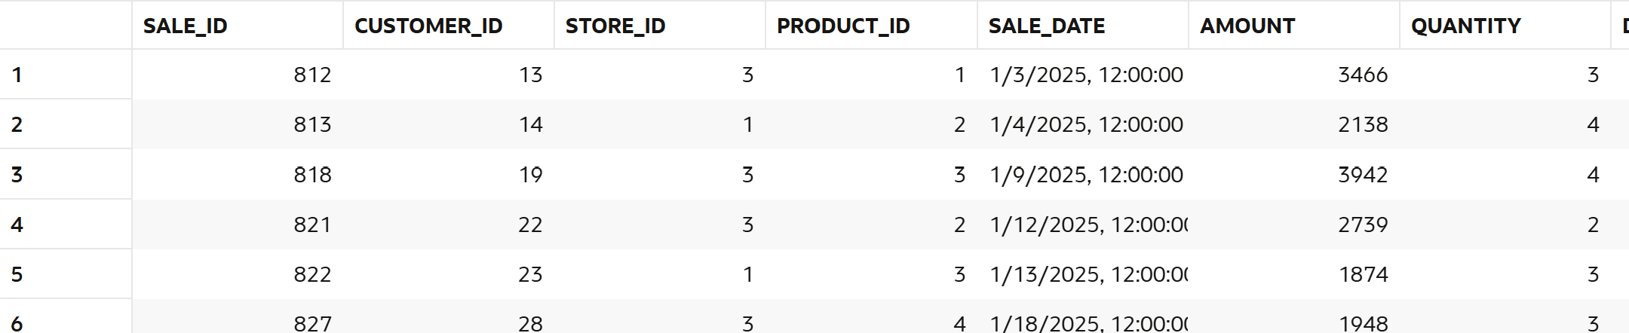
--24. Find sales from CMR store.
select s.store_name,sa.amount from sales sa
left join stores s on s.store_id=sa.store_id
where s.store_name='CMR';
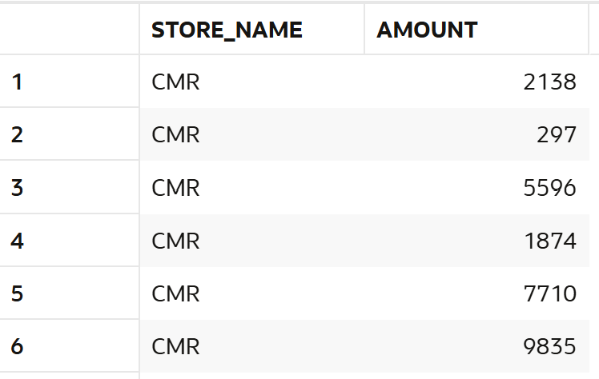
--25. Find Electronics category sales.
select p.category,sa.amount from sales sa
left join products p on p.product_id=sa.product_id
where p.category='Electronics';
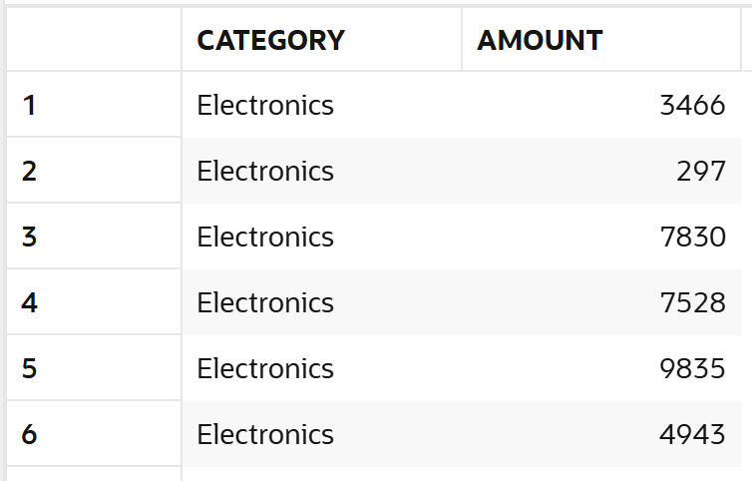
--26. Find sales excluding Grocery category.
select p.category,sa.amount from sales sa
left join products p on p.product_id=sa.PRODUCT_ID
where p.category not in('Grocery');
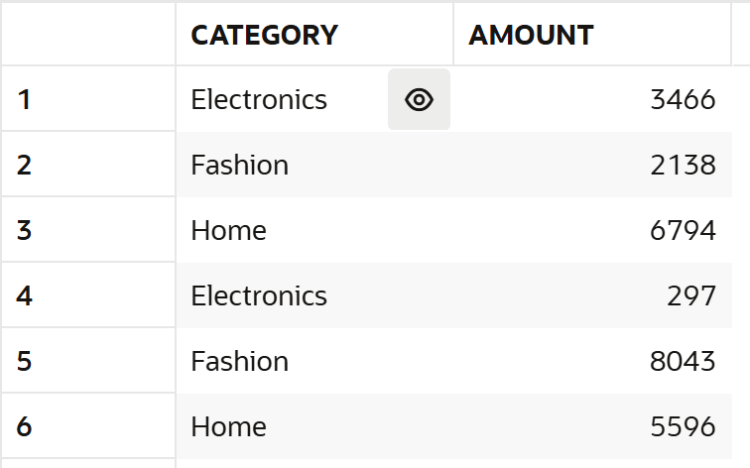
--27. Find customers from specific store.
select distinct c.customer_name,s.store_name
from sales sa
left join customers c on c.customer_id =sa.CUSTOMER_ID
left join stores s on s.store_id=sa.STORE_ID
where s.store_name='Lucky';
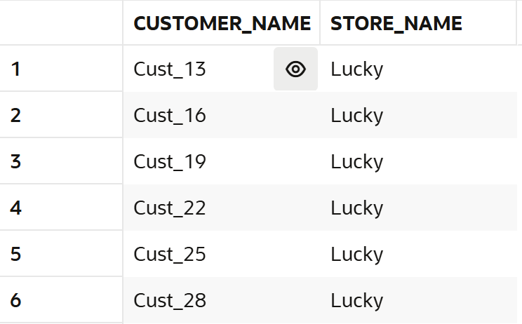
--28. Find high discount transactions.
select *from sales
where discount>(select round(avg(discount),0) from sales);
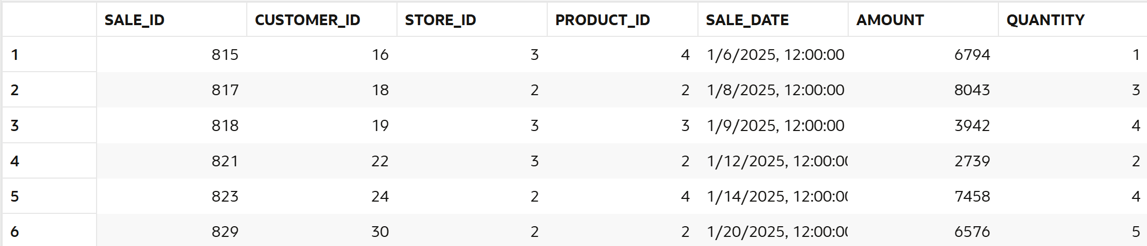
--29. Find low quantity sales.
select *from sales
where quantity < (select round(avg(quantity),0)from sales);
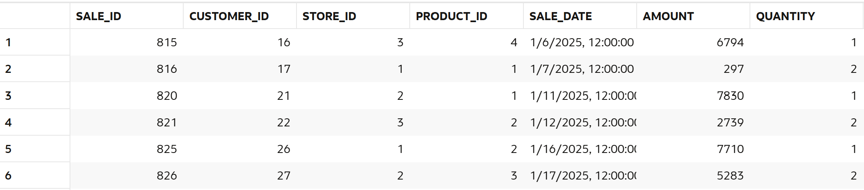
--30. Find recent transactions.
select *from sales
order by sale_date DESC
Fetch first 10 rows only;
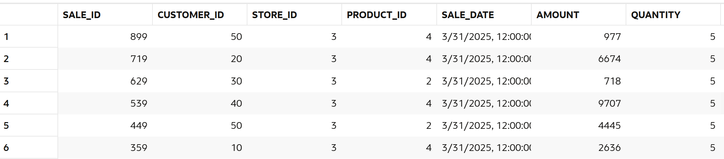

4.Aggregation (GROUP BY)
--31. Revenue per store.
select s.store_name,sum(sa.amount-nvl(sa.discount,0)) as revenue from sales sa
left join stores s on s.store_id=sa.store_id
group by s.store_name;
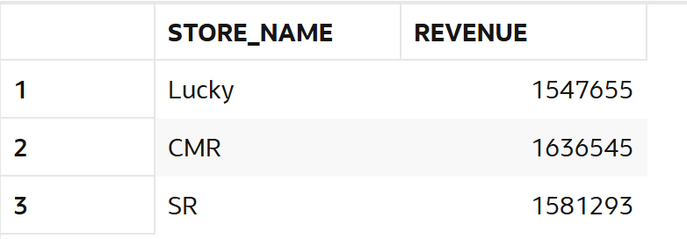
--32. Revenue per category.
select p.category,sum(sa.amount-nvl(sa.discount,0)) as revenue from sales sa
left join products p on p.product_id=sa.PRODUCT_ID
group by p.category;
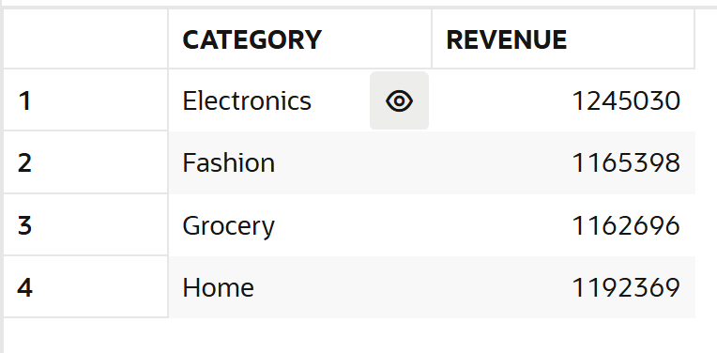
--33. Revenue per customer.
select c.customer_name,sum(sa.amount-nvl(sa.discount,0)) as revenue from sales sa
left join customers c on c.customer_id=sa.CUSTOMER_ID
group by c.customer_name;
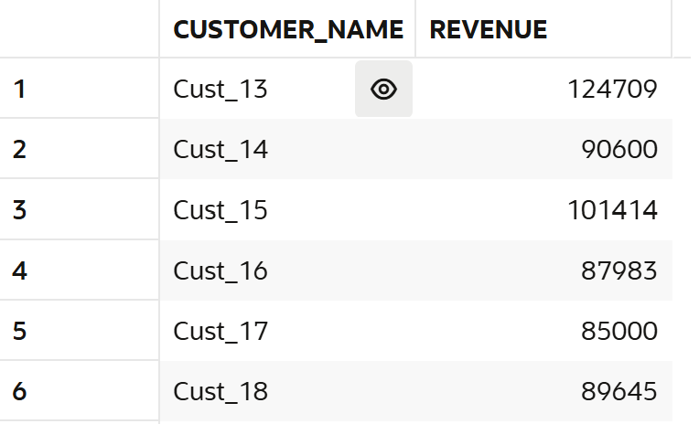
--34. Monthly revenue.
select to_char(sale_date,'yyyy-mm') as month,
sum(amount-nvl(discount,0))as Revenue from sales
group by to_char(sale_date,'yyyy-mm')
order by to_char(sale_date,'yyyy-mm');
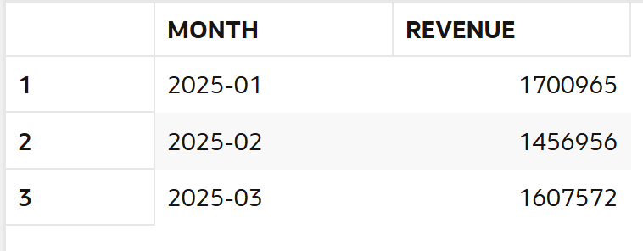
--35. Daily revenue.
select to_char(sale_date,'yyyy-dd') as daily,
sum(amount-nvl(discount,0)) as revenue from SALES
group by to_char(sale_date,'yyyy-dd')
order by to_char(sale_date,'yyyy-dd') ;
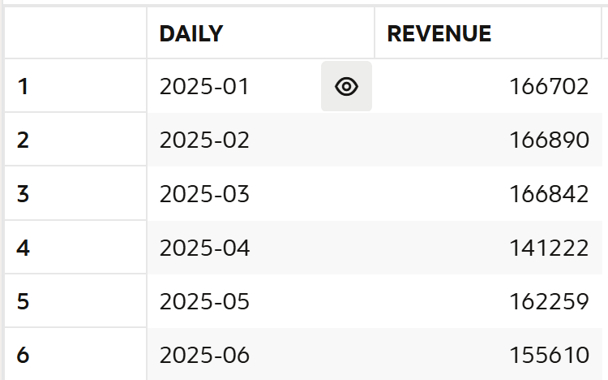
--36. Average sales per store.
select st.store_name,round(avg(sa.amount),0) as avg_sales from sales sa
left join stores st on st.store_id=sa.STORE_ID
group by st.store_name;
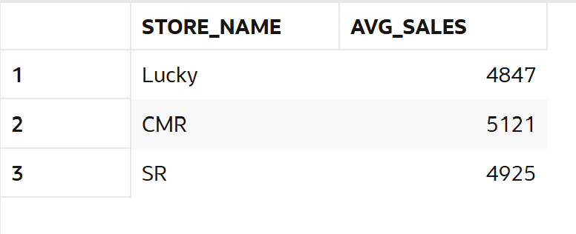
--37. Total quantity per category.
select p.category,sum(sa.quantity) as total_quantity from sales sa
left join products p on p.product_id=sa.PRODUCT_ID
group by p.category;
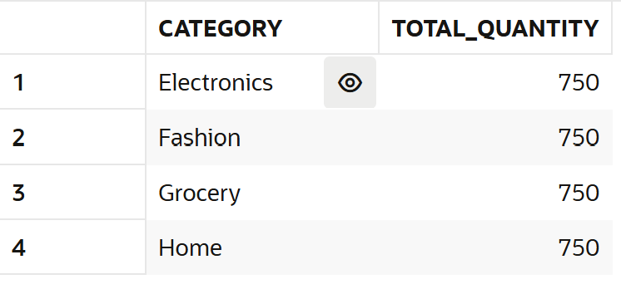
--38. Total discount per store.
select st.store_name,sum(nvl(sa.discount,0)) as total_discount from sales sa
left join stores st on st.store_id=sa.store_id
group by st.store_name;
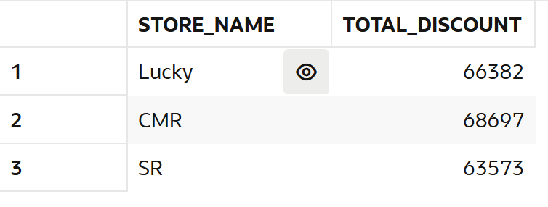
--39. Customer-wise total spending.
select c.customer_name,sum(sa.amount) as revenue from sales sa
left join customers c on c.customer_id=sa.CUSTOMER_ID
group by c.customer_name;
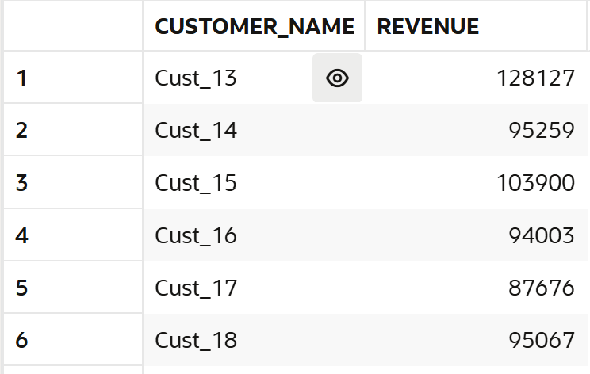
--40. Store-wise transaction count.
select st.store_name,count(*) as transaction_count from sales sa
left join stores st on st.store_id=sa.store_id
group by st.store_name;
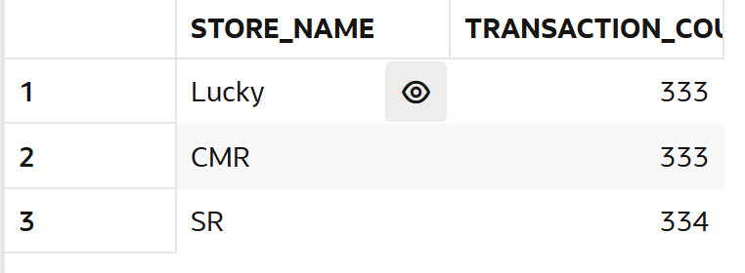

5. HAVING

--41. Customers with revenue > 20000.
select c.customer_name,sum(sa.amount-nvl(sa.discount,0)) as revenue from sales sa
left join customers c on c.customer_id=sa.customer_id
group by c.customer_name
having sum(sa.amount-nvl(sa.discount,0))>20000;
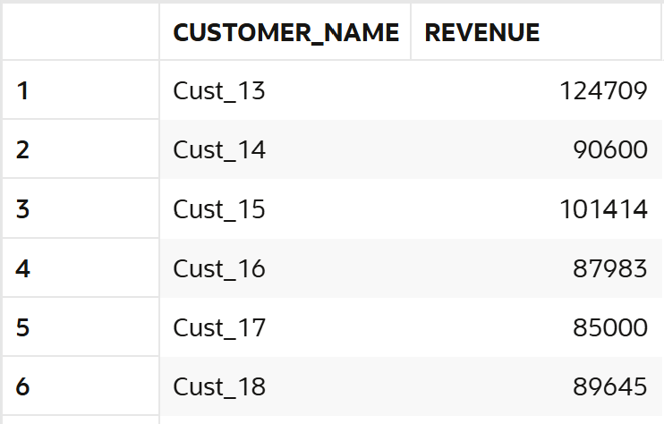
--42. Stores with revenue > 100000.
select st.store_name,sum(sa.amount-nvl(sa.discount,0)) as revenue from sales sa
left join stores st on st.store_id=sa.store_id
group by st.STORE_NAME
having sum(sa.amount-nvl(sa.discount,0))>100000;
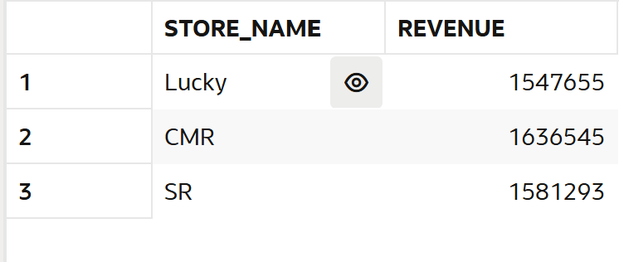
--43. Categories with avg sales > 3000.
select p.category,round(avg(amount),2) as avg_sales from sales sa
left join products p on p.product_id=sa.PRODUCT_ID
group by p.category
having round(avg(amount),2)>3000;
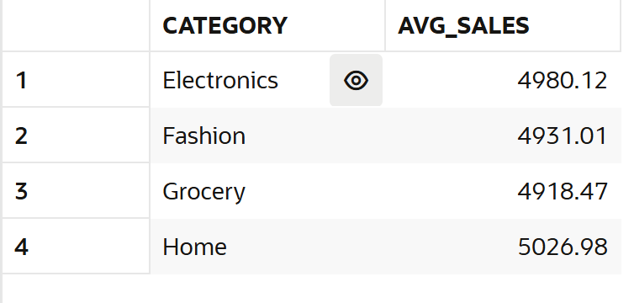
--44. Customers with more than 5 transactions.
select c.customer_name,count(*) as transactions from sales sa
left join customers c on c.customer_id=sa.customer_id
group by c.customer_name
having count(*) > 5;
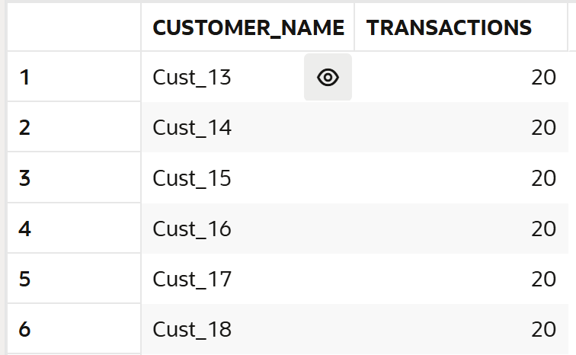
--45. Stores with high discount usage.
select st.store_name,round(avg(nvl(sa.discount,0)),2) as transaction from sales sa
left join stores st on st.store_id=sa.store_id
group by st.store_name
having avg(nvl(sa.discount,0))>(select avg(nvl(discount,0)) from sales);
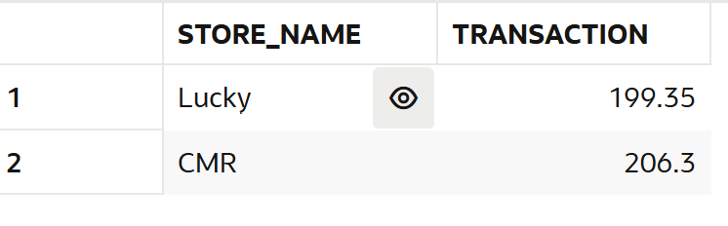
--46. Categories with low performance.
select p.category,round(avg(sa.amount),0) as performance from sales sa
left join products p on p.product_id=sa.PRODUCT_ID
group by p.CATEGORY
having avg(sa.amount)<(select avg(amount) from sales);
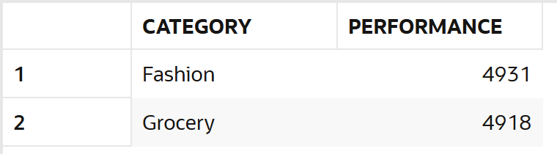
--47. Customers with high avg order value
select c.customer_name,round(avg(sa.amount),0) as avg_order_value from sales sa
left join customers c on c.customer_id=sa.customer_id
group by c.customer_name
having avg(sa.amount) > (select avg(amount) from sales);
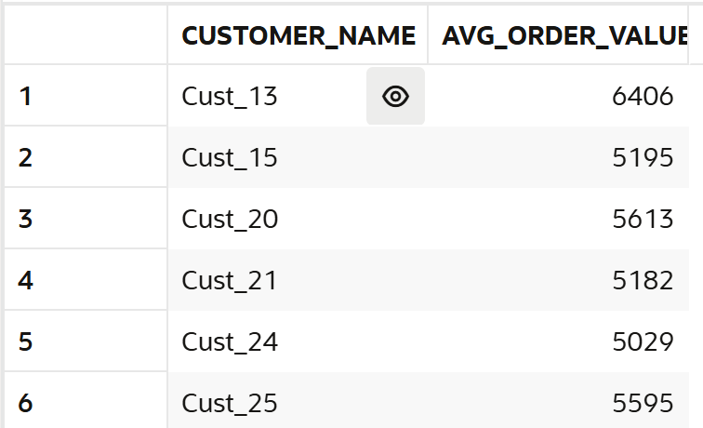
--48. Find top 5 customers using HAVING.
select c.customer_name,sum(sa.amount-nvl(sa.discount,0)) as revenue from sales sa
left join customers c on c.customer_id=sa.customer_id
group by c.CUSTOMER_NAME
fetch first 5 rows only;
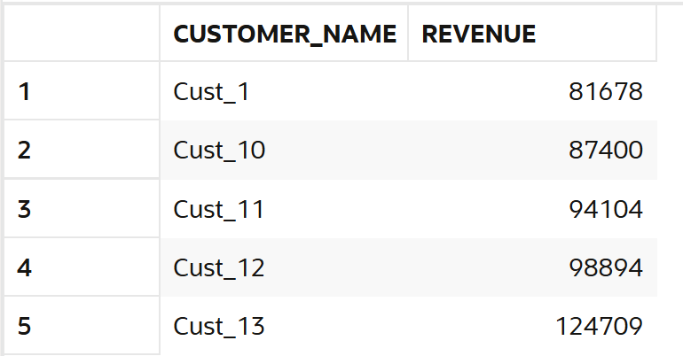
--49. Stores with max transactions.
select st.store_name, count(*) as revenue from sales sa
left join stores st on st.store_id = sa.STORE_ID
group by st.store_name
order by count(*) desc
fetch first 1 rows only;
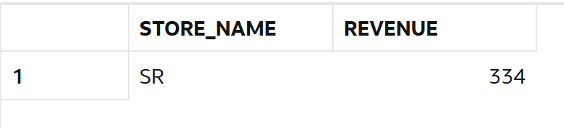
--50. Categories with high growth.
select p.category,avg(sa.amount-nvl(sa.discount,0)) as avg_sales from sales sa
left join products p on p.product_id=sa.product_id
group by p.category
having avg(sa.amount-nvl(sa.discount,0)) > (select avg(amount-nvl(discount,0)) from sales)
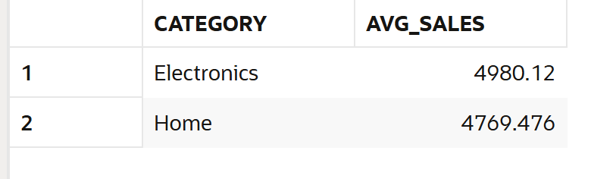

6. CASE WHEN

--51. Classify customers as High/Medium/Low spenders.
SELECT
c.customer_name,
SUM(sa.amount) AS revenue,
CASE
WHEN SUM(sa.amount) > 100000 THEN 'High'
WHEN SUM(sa.amount) BETWEEN 5000 AND 100000 THEN 'Medium'
ELSE 'Low'
END AS amount_tag
FROM sales sa
JOIN customers c ON c.customer_id = sa.customer_id
GROUP BY c.customer_name;
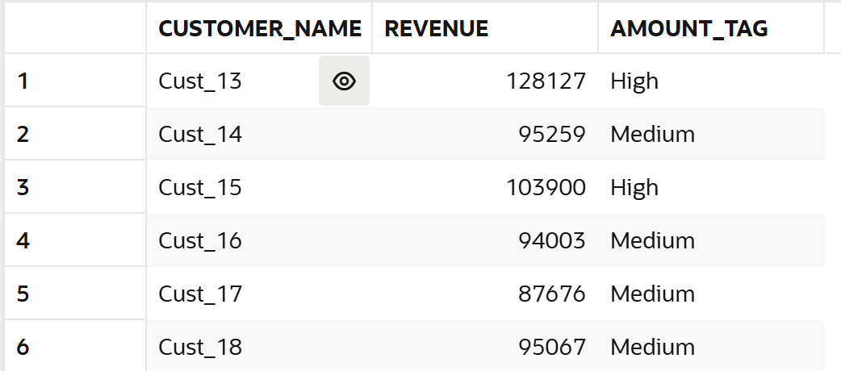
--52. Classify transactions as Big/Small.
SELECT
sale_id,
amount,
CASE
WHEN amount > 5000 THEN 'Big'
ELSE 'Small'
END AS transaction_type
FROM sales;
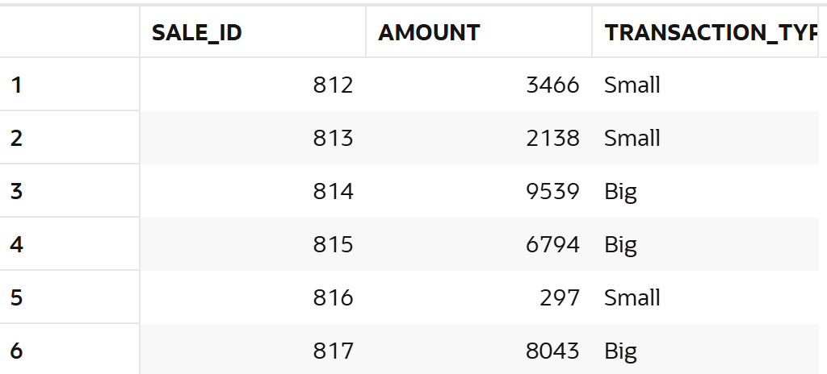
--53. Create discount flag.
select discount,
case when discount is null then 'No Discount' else 'Discount given'
end as discount_flag
from sales;
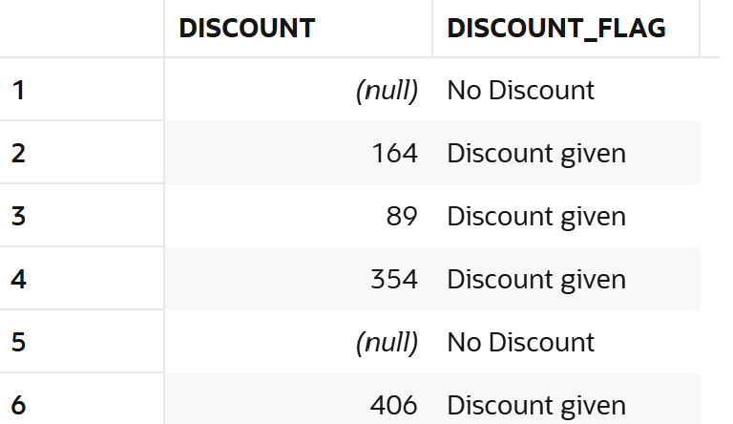
--54. Segment stores based on revenue.
SELECT
st.store_name,
SUM(sa.amount - NVL(sa.discount,0)) AS revenue,
CASE
WHEN SUM(sa.amount - NVL(sa.discount,0)) > 2000000 THEN 'High'
WHEN SUM(sa.amount - NVL(sa.discount,0)) BETWEEN 1500000 AND 2000000 THEN 'Medium'
ELSE 'Low'
END AS store_segment
FROM sales sa
JOIN stores st ON st.store_id = sa.store_id
GROUP BY st.store_name;
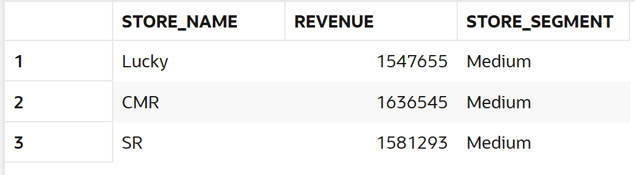
--55. Categorize customers based on frequency.
select c.customer_name,count(*) as transactions,
case
when count(*) >20 then 'High Frequency'
when count(*) between 10 and 20 then 'Medium Frequency'
else 'low'
end as frequency
from sales sa
left join customers c on c.customer_id=sa.customer_id
group by c.customer_name;
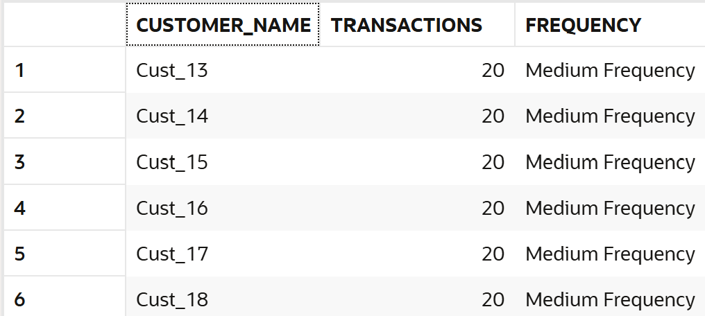
--56. Create sales buckets.
select amount,
case
when amount>5000 then 'Bucket 1'
when amount between 1000 and 5000 then 'Bucket 2'
else 'Bucket 3'
end as sales_bucket
from sales;
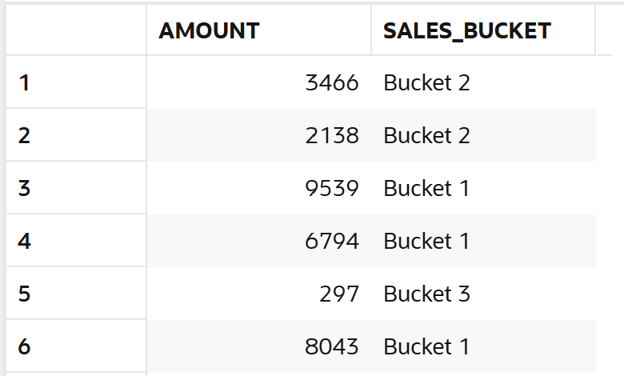
--57. Identify premium customers.
SELECT
c.customer_name,
SUM(sa.amount - NVL(sa.discount, 0)) AS revenue,
CASE
WHEN SUM(sa.amount - NVL(sa.discount, 0)) > 100000
THEN 'Premium Customer'
ELSE 'Regular Customer'
END AS customer_type
FROM sales sa
LEFT JOIN customers c
ON c.customer_id = sa.customer_id
GROUP BY c.customer_name
HAVING SUM(sa.amount - NVL(sa.discount, 0)) > 100000;
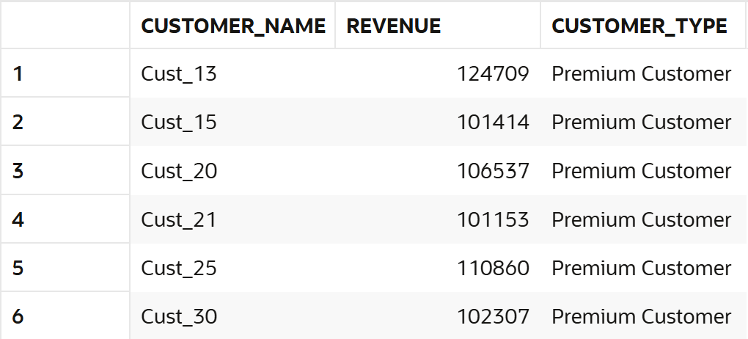
--58. Mark high-value transactions.
SELECT
sale_id,
customer_id,
amount,
CASE
WHEN amount > 5000 THEN 'High Value'
ELSE 'Normal'
END AS transaction_type
FROM sales;
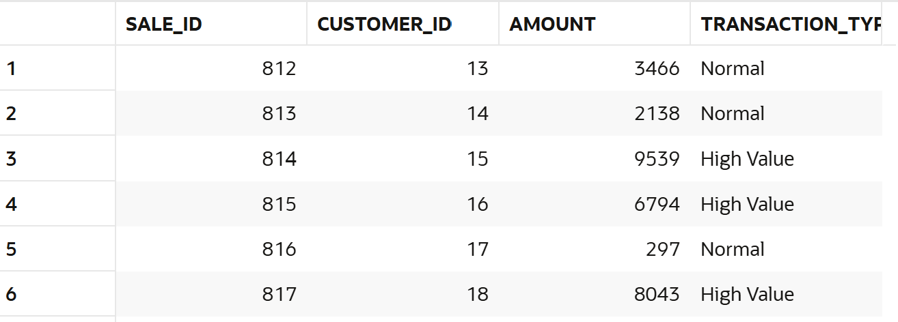
--59. Classify categories based on performance.
SELECT
p.category,
SUM(sa.amount - NVL(discount,0)) AS revenue,
CASE
WHEN SUM(sa.amount - NVL(discount,0)) > 1200000 THEN 'High'
WHEN SUM(sa.amount - NVL(discount,0)) BETWEEN 1150000 AND 1200000 THEN 'Medium'
ELSE 'Low'
END AS performance
FROM sales sa
JOIN products p ON p.product_id = sa.product_id
GROUP BY p.category;
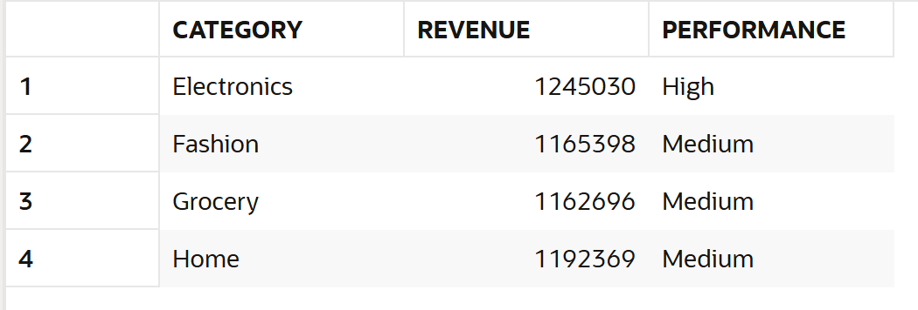
--60. Create custom labels for reporting.
--based on discount
select discount,
case when discount is null then 'No Discount' else 'Discount given'
end as discount_flag
from sales;
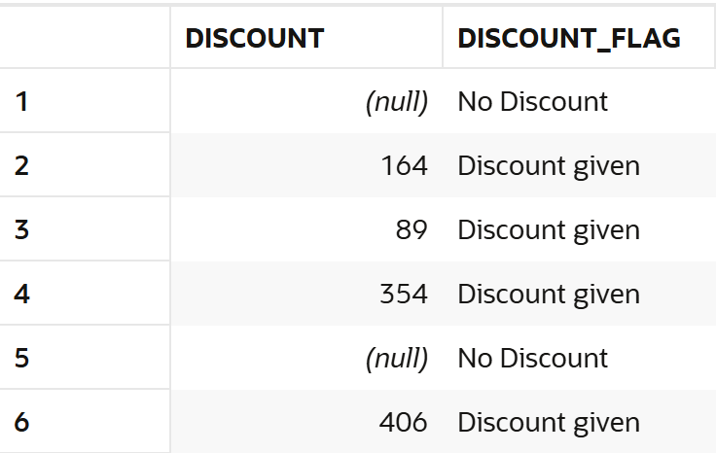
--based on customer
SELECT
c.customer_name,
SUM(sa.amount) AS total_spending,
CASE
WHEN SUM(sa.amount) > 100000 THEN 'Premium'
ELSE 'Regular'
END AS customer_label
FROM sales sa
JOIN customers c ON c.customer_id = sa.customer_id
GROUP BY c.customer_name;
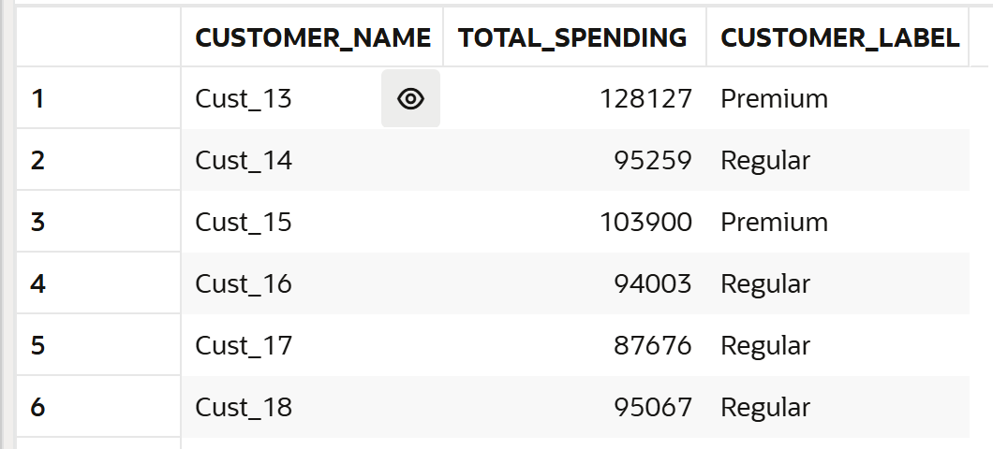

7. JOINS (Multiple Tables)

--61. Join sales with customers table.
select c.customer_id,c.customer_name,sa.amount from sales sa
left join customers c on c.customer_id=sa.customer_id;
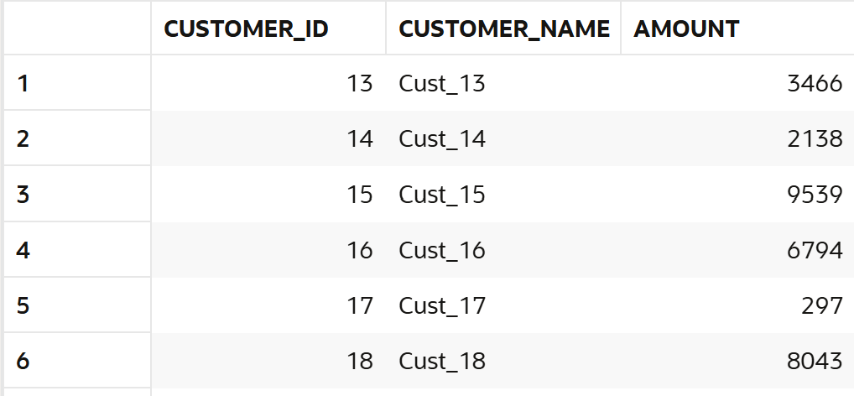
--62. Join sales with stores table.
select st.store_id,st.store_name,sa.amount from sales sa
left join stores st on st.store_id=sa.store_id;
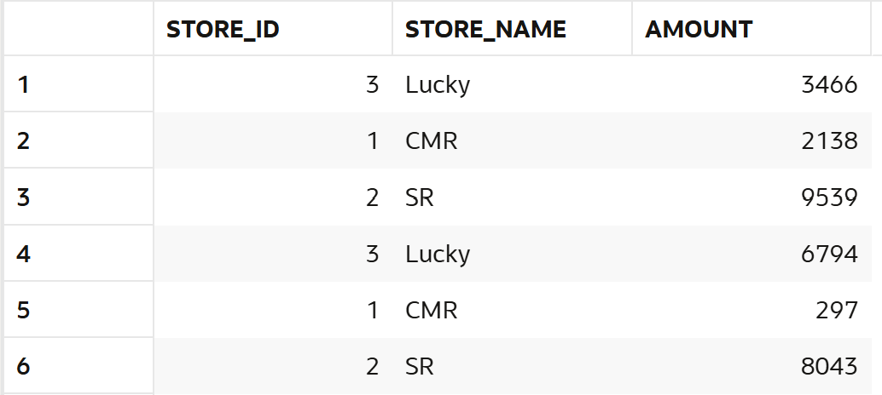
--63. Join sales with products table.
select p.product_id,p.category,sa.amount from sales sa
left join products p on p.product_id=sa.product_id;
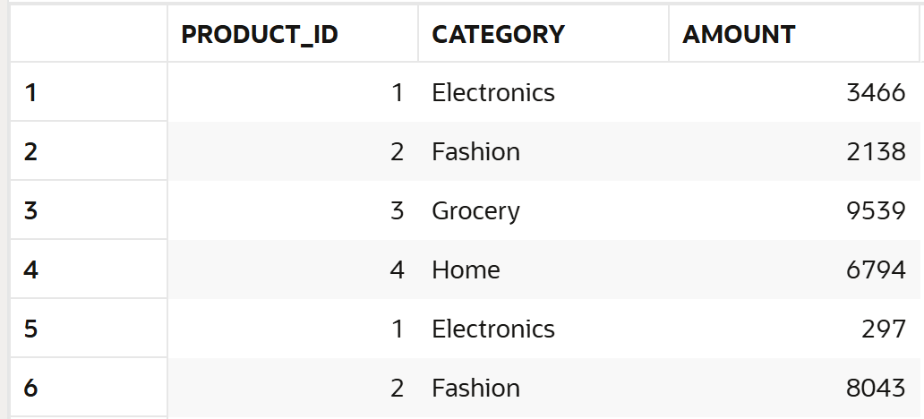
--64. Find customer name with store name and sales.
select c.customer_name,st.store_name,sa.amount from sales sa
left join customers c on c.customer_id=sa.customer_id
left join stores st on st.store_id -sa.store_id;
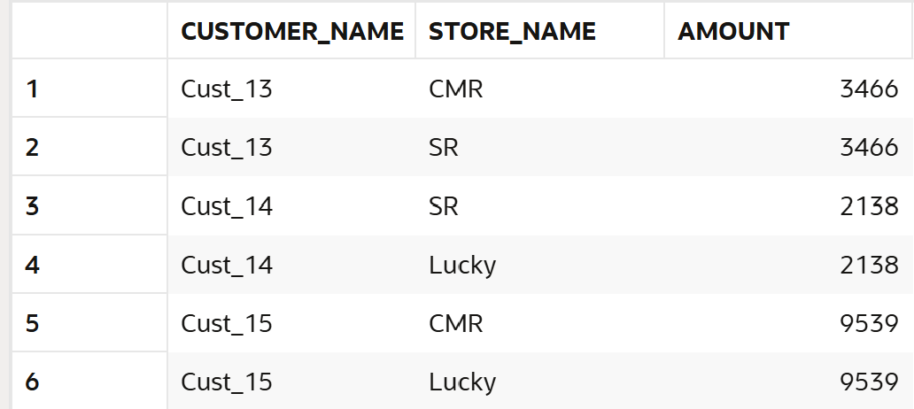
--65. Find category-wise revenue using joins.
select p.category,sum(sa.amount-nvl(sa.discount,0)) as revenue
from sales sa
left join products p on p.product_id=sa.product_id
group by p.category;
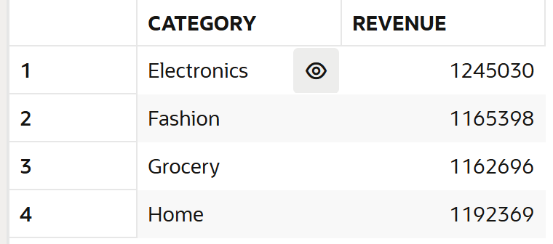
--66. Find store-wise customer count.
select st.store_name,count(distinct sa.customer_id) as customer_count from sales sa
left join customers c on c.customer_id=sa.customer_id
left join stores st on st.store_id=sa.store_id
group by st.store_name;
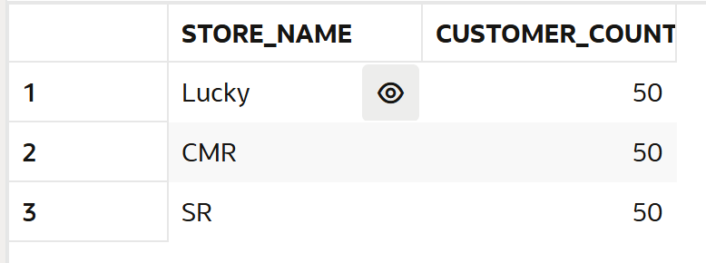
--67. Find top product per store.
select st.store_name,p.category,sum(sa.amount-nvl(sa.dsicount,0)) as revenue from sales sa
left join stores st on st.store_id=sa.store_id
left join products p on p.product_id=sa.product_id
group by st.store_name,p.category;
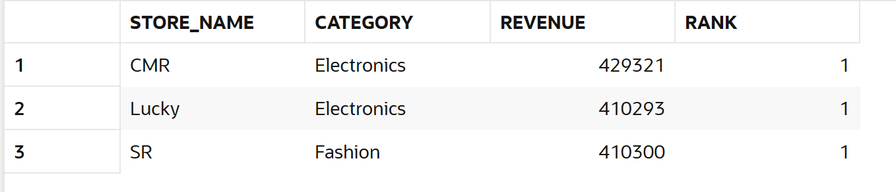
--68. Find customers who purchased from multiple stores.
select c.customer_name,count(distinct st.store_id) as customer_multi_visit from sales sa
left join customers c on c.customer_id=sa.customer_id
left join stores st on st.store_id=sa.store_id
group by c.customer_name
having count(distinct st.store_id) >1;
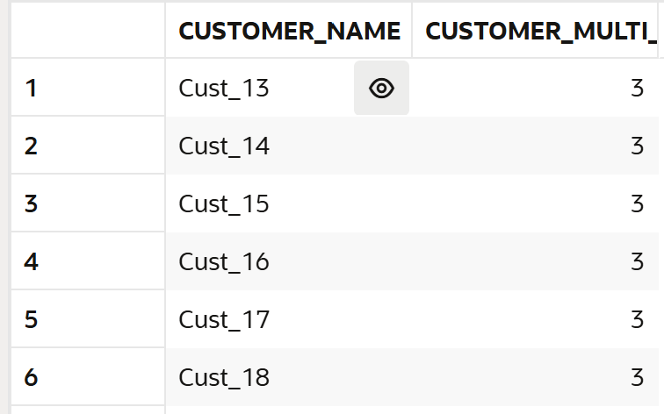
--69. Find sales with product category.
select p.category,sa.amount,nvl(discount,0) as newdiscount from sales sa
left join products p on p.product_id=sa.product_id
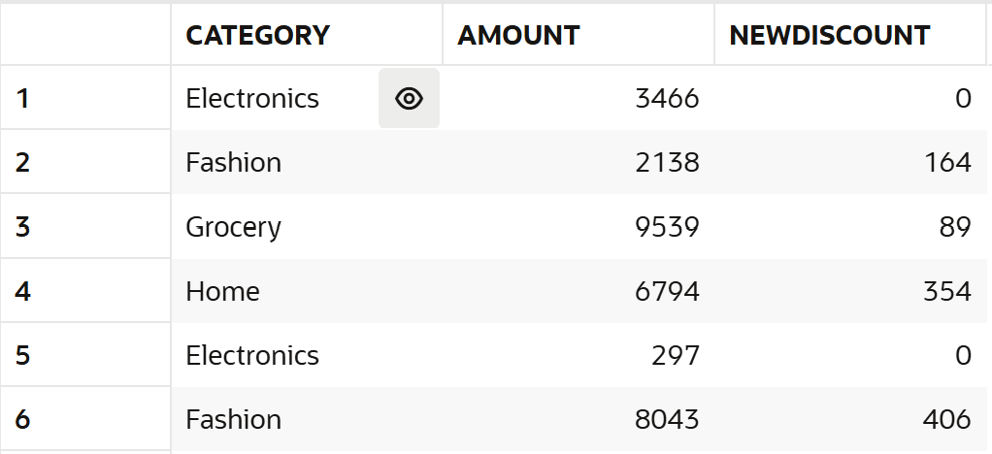
--70. Find revenue per customer per store.
select c.customer_name,st.store_name,sum(sa.amount-nvl(sa.discount,0)) as revenue from sales sa
left join customers c on c.customer_id=sa.customer_id
left join stores st on st.store_id=sa.store_id
group by c.customer_name,st.store_name;
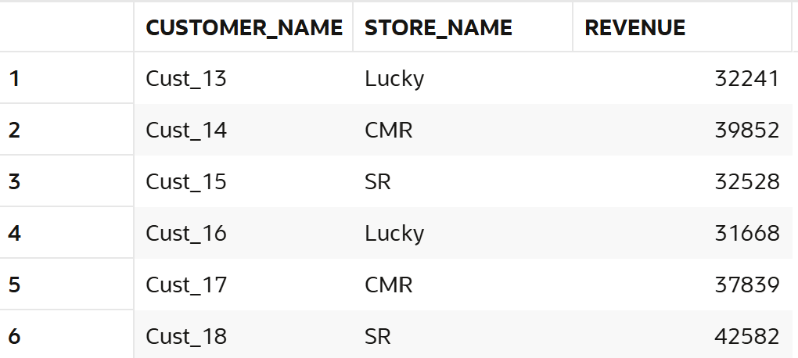
--71. Find customers with no transactions (LEFT JOIN).
select c.customer_id,c.customer_name from customers c
left join sales sa on c.customer_id=sa.CUSTOMER_ID
where sa.customer_id is null; --data has no such case every customer having atleast one transaction
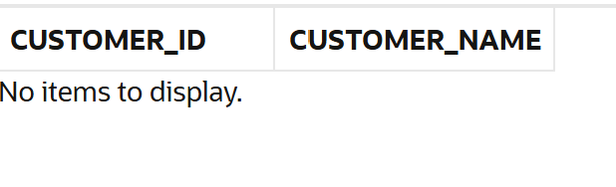
--72. Find missing product mappings.
select p.category from products p
left join sales sa on p.product_id=sa.product_id
where sa.product_id is null;-- data has no such case
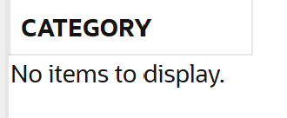
--73. Find store performance using joins.
select st.store_name,sum(sa.amount-nvl(sa.discount,0)) as store_performance from sales sa
left join stores st on st.store_id=sa.store_id
group by st.store_name;
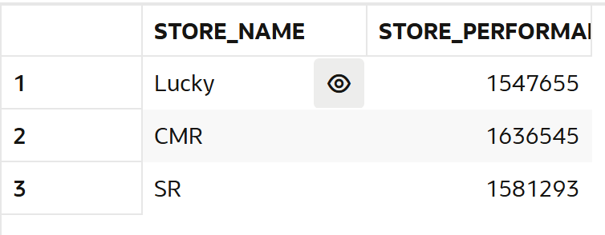
--74. Find cross-category purchases.
select c.customer_name,count(distinct p.category) as count from sales sa
left join customers c on c.customer_id=sa.customer_id
left join products p on p.product_id=sa.product_id
group by c.customer_name
having count(distinct p.category) >1;
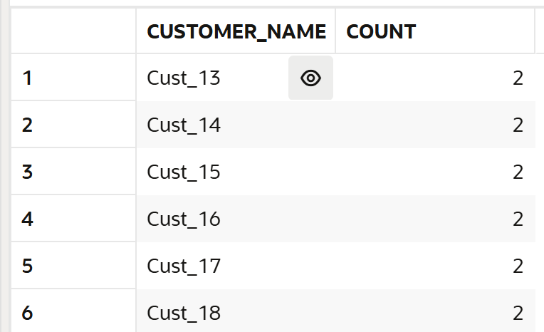
--75. Find total revenue using joins.
SELECT
SUM(sa.amount - NVL(sa.discount,0)) AS total_revenue
FROM sales sa
JOIN customers c ON c.customer_id = sa.customer_id;
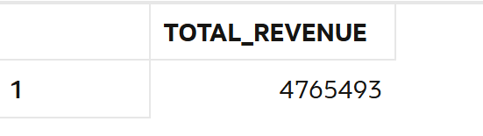

8. Window Functions

--76. Calculate total spend per customer using window function.
select c.customer_name,sa.sale_id,sa.amount,sum(sa.amount-nvl(discount,0))
over(partition by c.customer_name order by sa.amount desc) as total_spend
from sales sa
left join cUstomers c on c.customer_id=sa.customer_id;
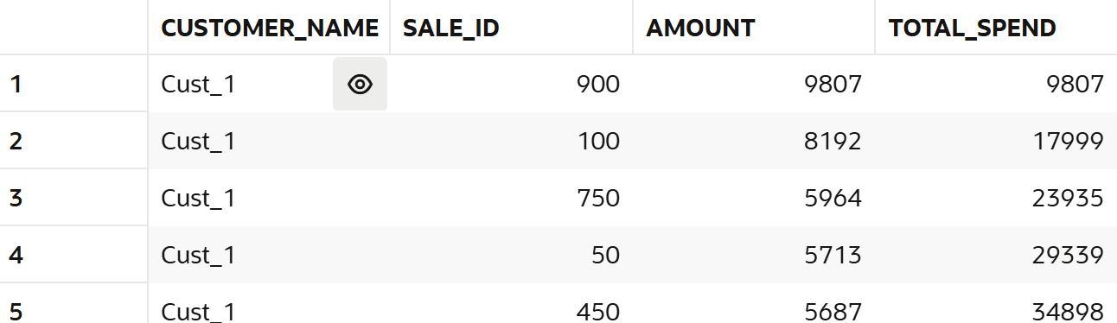
--77. Rank customers by revenue.
select c.customer_name,sum(sa.amount-nvl(sa.discount,0)) as revenue,
rank()
over( order by sum(sa.amount-nvl(sa.discount,0)) desc ) as rnk
from sales sa
left join customers c on c.customer_id=sa.customer_id
group by c.customer_name;
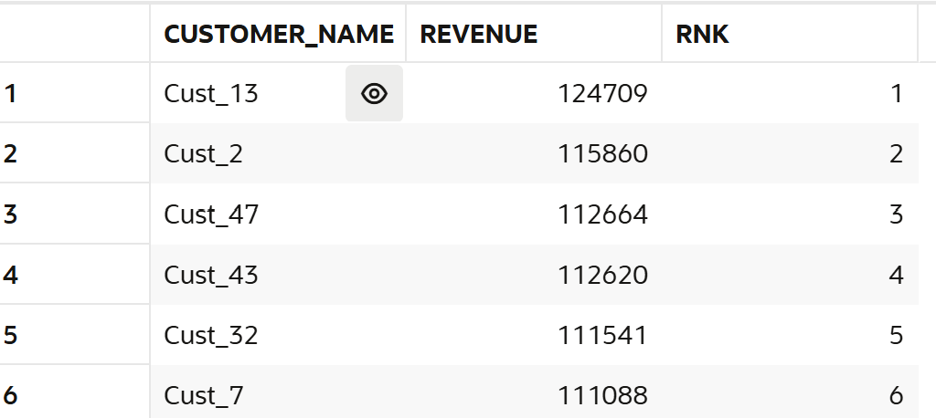
--78. Find top customer per store.
select * from(
select c.customer_name,st.store_name,sum(sa.amount-nvl(sa.discount,0)) as revenue,
rank() over(partition by st.store_name order by sum(sa.amount-nvl(sa.discount,0))desc) as rnk
from sales sa
left join customers c on c.customer_id=sa.customer_id
left join stores st on st.store_id=sa.store_id
group by
c.customer_name,st.store_name) where rnk=1;
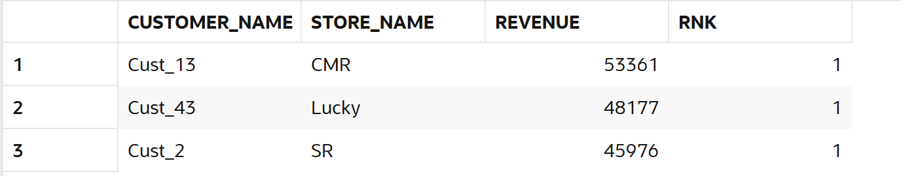
--79. Calculate running total of sales.
select sale_id,amount,sum(amount) over(order by sale_date desc rows between unbounded preceding and current row)
as running_total from sales;
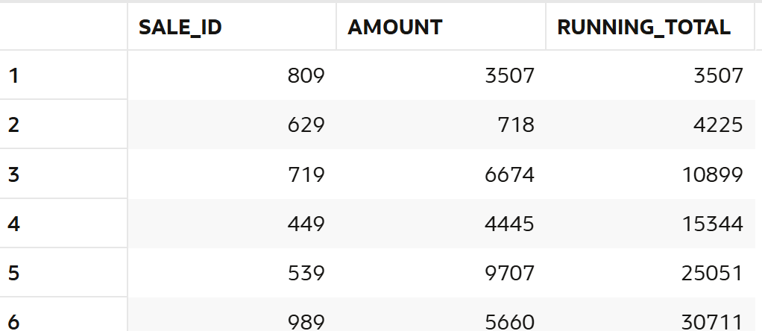
--80. Find previous sale using LAG.
select sale_id,amount,lag(amount,1,0) over(order by sale_date desc) as previous_sale
from sales;
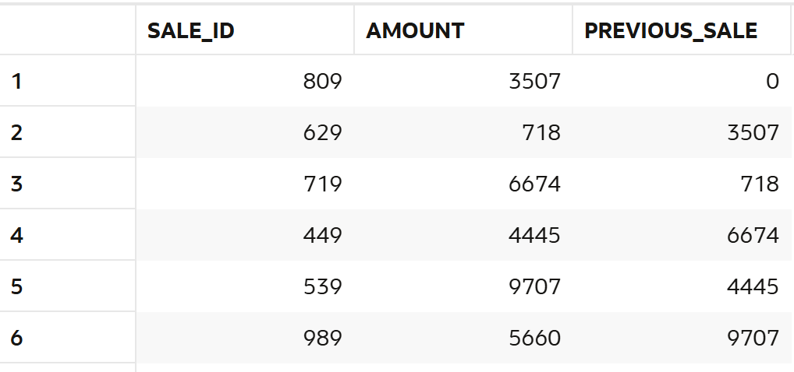
--81. Find next sale using LEAD.
select sale_id,amount,lead(amount,1,0) over(order by sale_date desc) as next_sale
from sales;
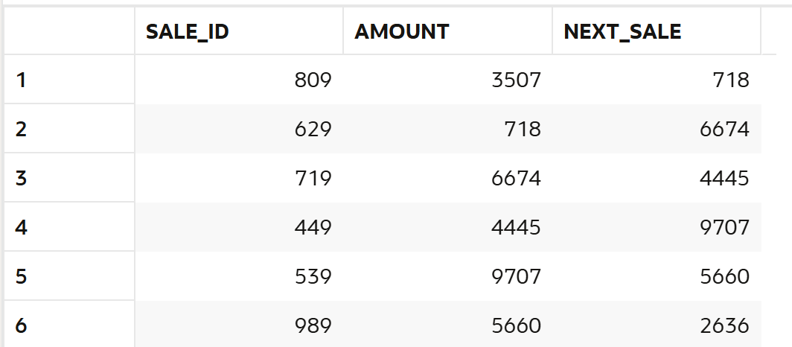
--82. Calculate sales growth.
select sale_id,amount,amount-lag(amount,1,0) over(order by sale_date desc) as sales,
case
when amount-lag(amount,1,0) over(order by sale_date desc) >0 then 'Increasing'
else 'Decreasing'
end as growith
from sales;
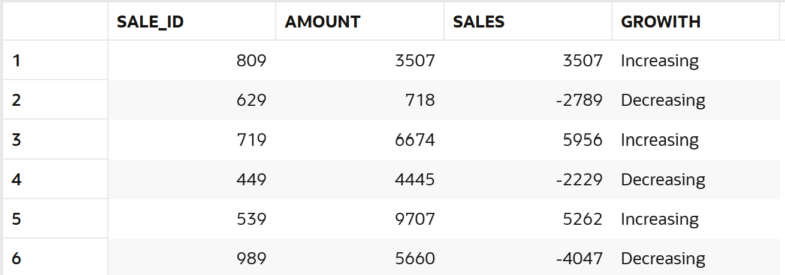

--83. Find difference between transactions.
select sale_id,amount,amount-lag(amount,1,0) over(order by sale_date desc) as difference from sales;
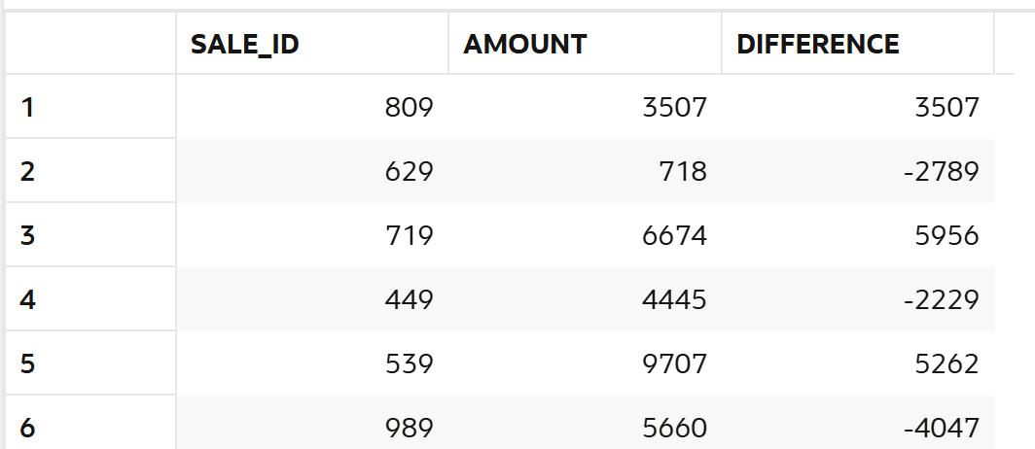
--84. Calculate cumulative revenue
select sale_id,amount,sum(amount) over(order by sale_date rows between unbounded preceding and current row) as cummulative_revenue
from sales;

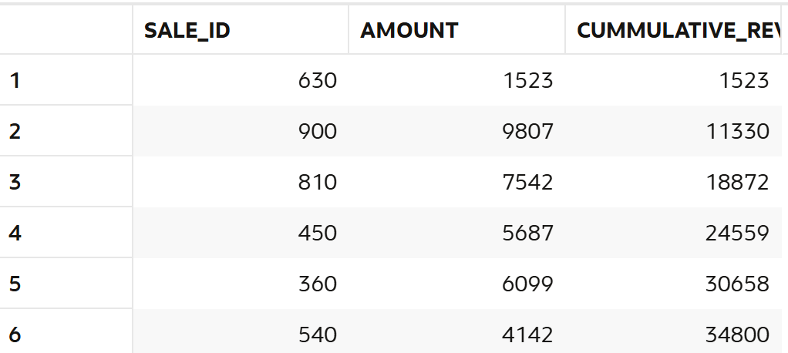
--85. Find moving average of sales.
select sale_id,amount,round(avg(amount) over(order by sale_date rows between 2 preceding and current row ),2) as moving_average
from sales;
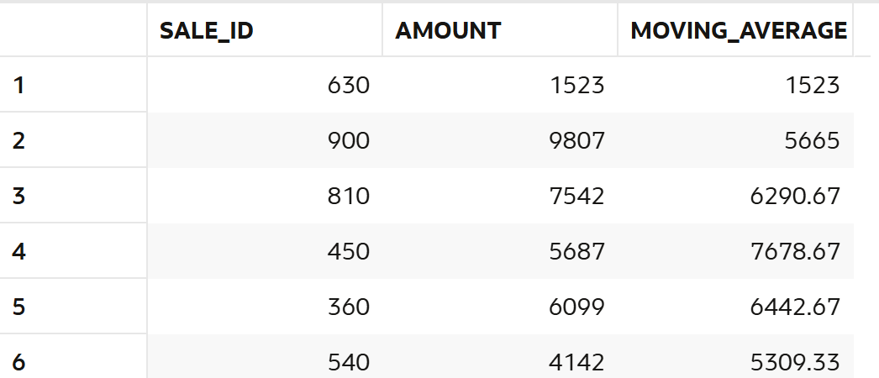
--86. Rank stores by revenue.
select st.store_name,sum(sa.amount-nvl(sa.discount,0)) as revenue,rank () over(order by sum(sa.amount-nvl(sa.discount,0))) as rnk
from sales sa
left join stores st on st.store_id=sa.store_id
group by st.store_name;
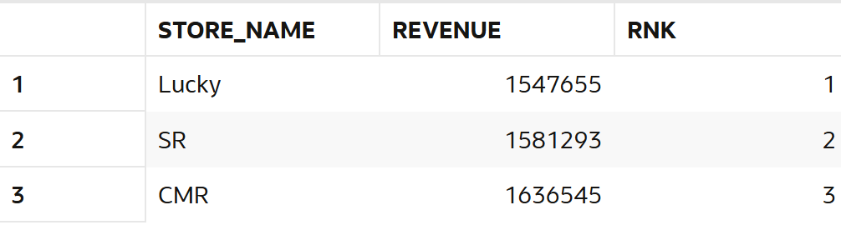
-87. Find second highest sale.
select amount from(select amount,dense_rank() over(order by amount desc) as rnk from sales) where rnk=2;
--(or)
select max(amount) as second_highest from sales
where amount<(select max(amount) from sales);

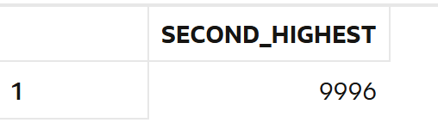
-- --88. Partition data by store and analyze.
--store revenue
select st.store_name,sa.sale_id,sa.amount,sum(sa.amount-nvl(sa.discount,0))
over (partition by st.store_name ) as total_revenue
from sales sa
left join stores st on st.store_id=sa.store_id;
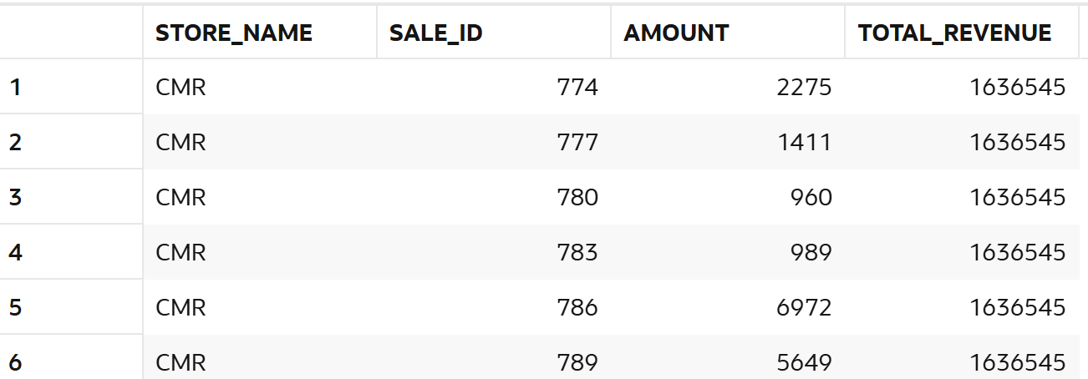

--89. Find customer ranking per store.
SELECT *
FROM (
SELECT
st.store_name,
c.customer_name,
SUM(sa.amount - NVL(sa.discount, 0)) AS revenue,
RANK() OVER (
PARTITION BY st.store_name
ORDER BY SUM(sa.amount - NVL(sa.discount, 0)) DESC
) AS rnk
FROM sales sa
JOIN customers c
ON c.customer_id = sa.customer_id
JOIN stores st
ON st.store_id = sa.store_id
GROUP BY
st.store_name,
c.customer_name

) ;
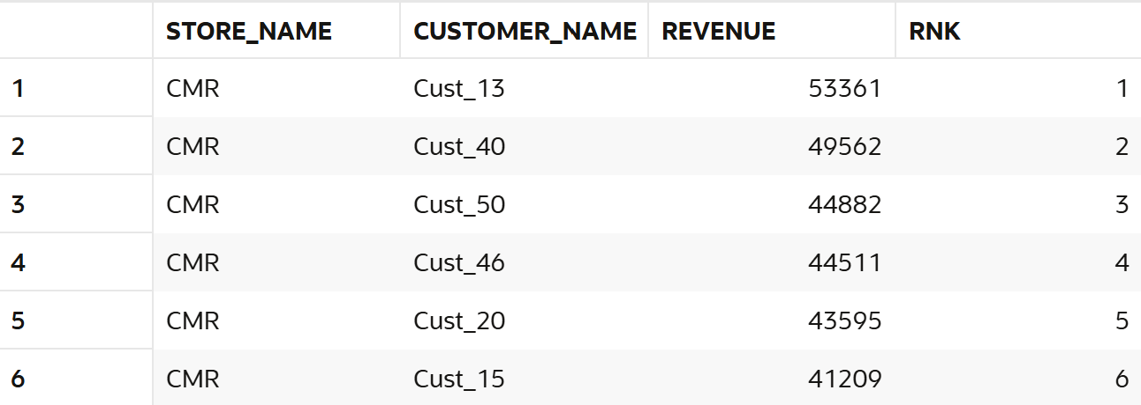

--90. Calculate frequency using window.
select customer_id, count(*) over(partition by customer_id) as frequency from sales;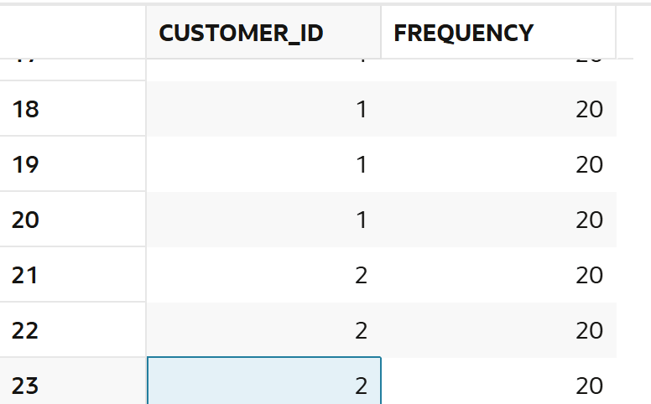

9. NTILE / Segmentation
--91. Divide customers into 4 segments.
select customer_id,ntile(4) over(order by amount desc) as segment from sales

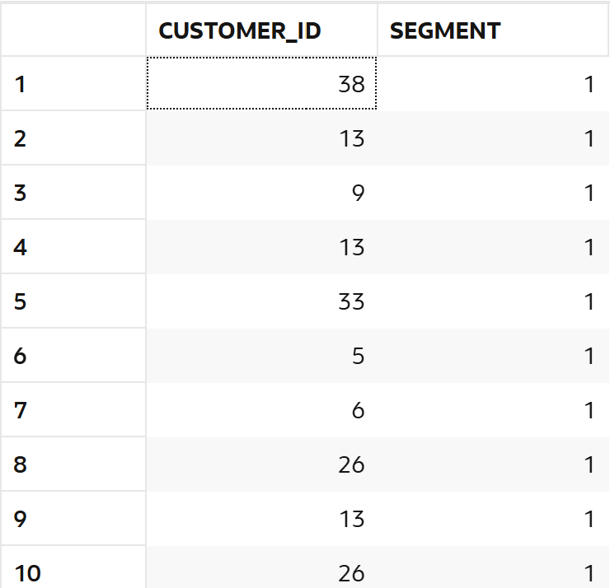

-- --92. Identify top 25% customers.
SELECT
customer_id,
CASE
WHEN grp = 1 THEN 'Top 25%'
ELSE 'Others'
END AS category
FROM (
SELECT
customer_id,
NTILE(4) OVER (
ORDER BY SUM(amount - NVL(discount,0)) DESC
) AS grp
FROM sales
GROUP BY customer_id
) ;
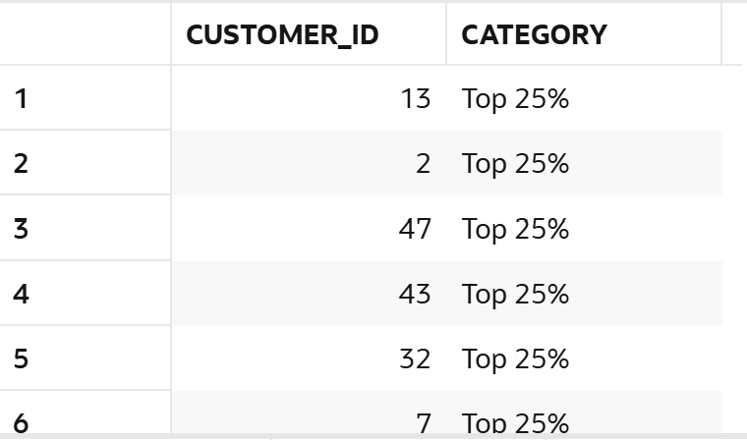
--93. Identify bottom 25% customers.
SELECT
customer_id,
CASE
WHEN grp = 4 THEN 'Bottom 25%'
ELSE 'Others'
END AS category
FROM (
SELECT
customer_id,
NTILE(4) OVER (
ORDER BY SUM(amount - NVL(discount,0)) DESC
) AS grp
FROM sales
GROUP BY customer_id
) ;
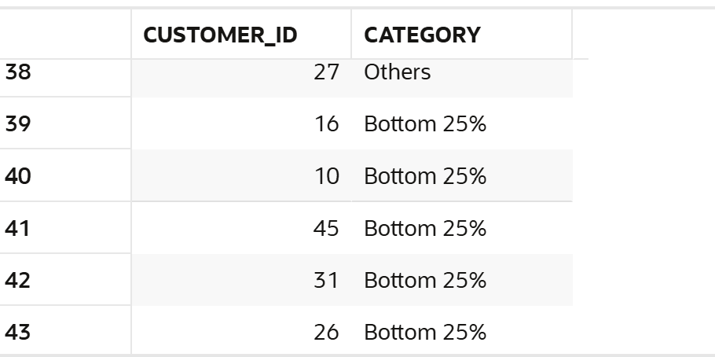
--94. Segment stores into 3 groups.
SELECT
store_name,
revenue,
NTILE(3) OVER (ORDER BY revenue DESC) AS segment
FROM (
SELECT
st.store_name,
SUM(sa.amount - NVL(sa.discount,0)) AS revenue
FROM sales sa
JOIN stores st
ON st.store_id = sa.store_id
GROUP BY st.store_name
) ;
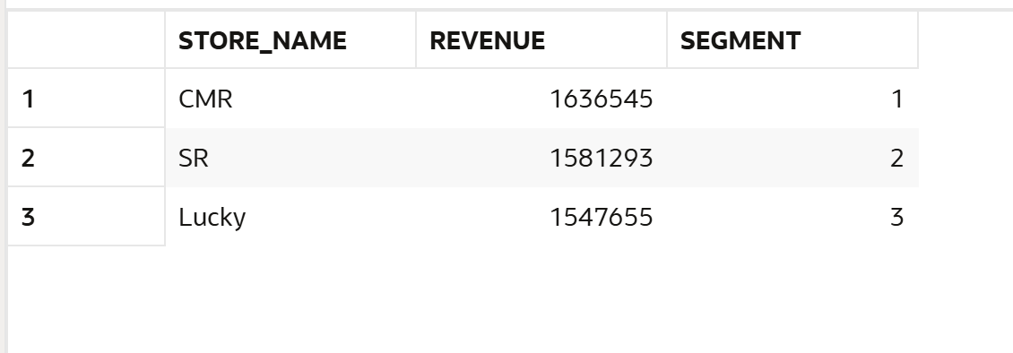
--95. Create quartiles based on revenue.
SELECT
customer_id,
revenue,
NTILE(4) OVER (ORDER BY revenue DESC) AS quartile
FROM (
SELECT
customer_id,
SUM(amount - NVL(discount,0)) AS revenue
FROM sales
GROUP BY customer_id
) ;
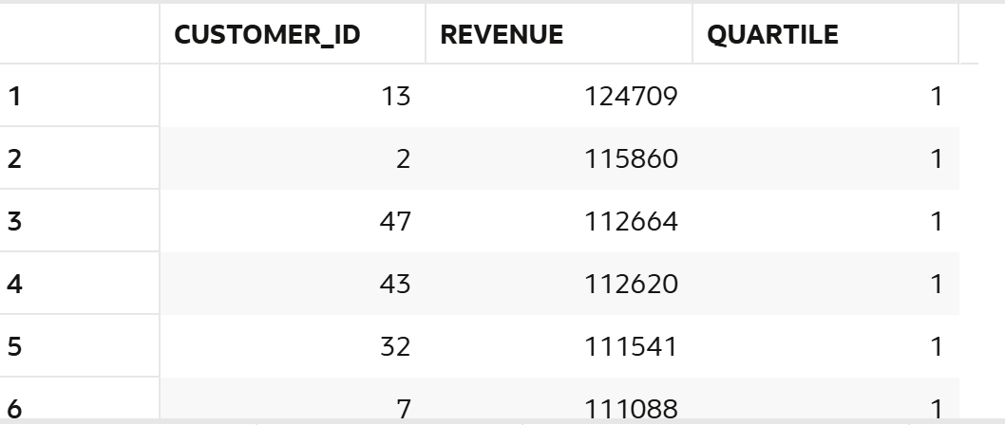
--97. Identify premium segment.
SELECT *
FROM (
SELECT
customer_id,
SUM(amount - NVL(discount,0)) AS revenue,
NTILE(3) OVER (ORDER BY SUM(amount - NVL(discount,0)) DESC) AS segment
FROM sales
GROUP BY customer_id
) t
WHERE segment = 1;

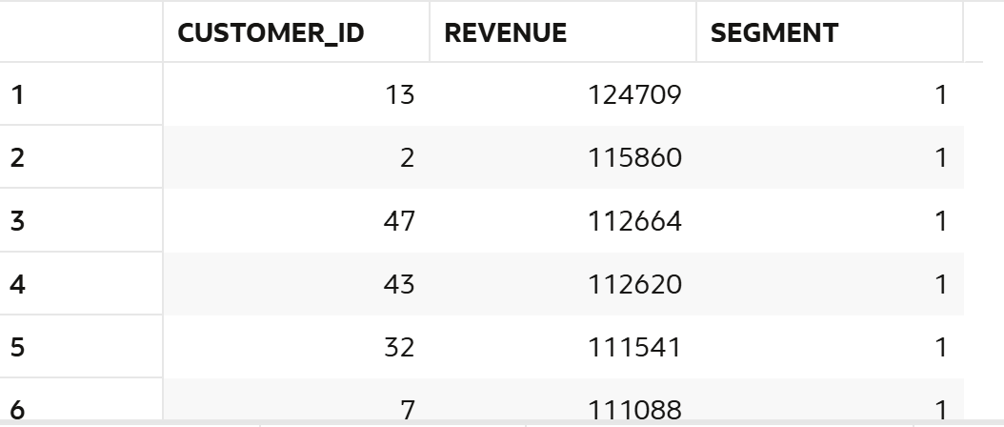
--98. Find mid-level customers.
SELECT *
FROM (
SELECT
customer_id,
SUM(amount - NVL(discount,0)) AS revenue,
NTILE(3) OVER (ORDER BY SUM(amount - NVL(discount,0)) DESC) AS segment
FROM sales
GROUP BY customer_id
) t
WHERE segment = 2;
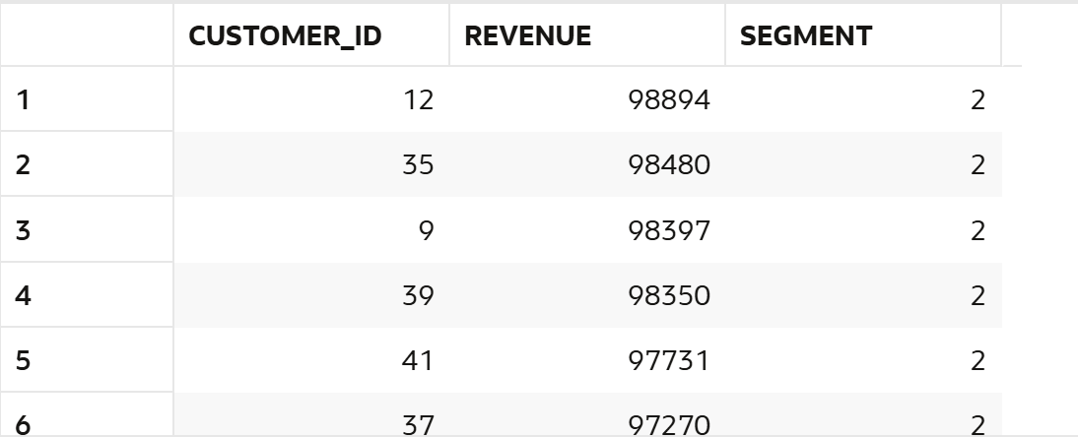
--99. Analyze bucket distribution.
SELECT
segment,
COUNT(*) AS customer_count
FROM (
SELECT
customer_id,
NTILE(3) OVER (ORDER BY SUM(amount - NVL(discount,0)) DESC) AS segment
FROM sales
GROUP BY customer_id
) t
GROUP BY segment;
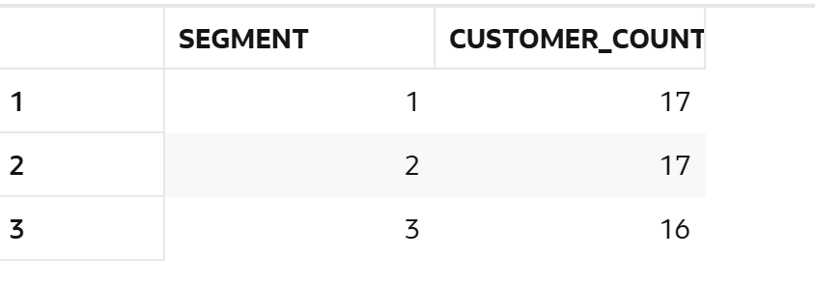
--100. Create marketing segments.
SELECT
customer_id,
revenue,
CASE
WHEN segment = 1 THEN 'Premium'
WHEN segment = 2 THEN 'Standard'
ELSE 'Basic'
END AS customer_type
FROM (
SELECT
customer_id,
SUM(amount - NVL(discount,0)) AS revenue,
NTILE(3) OVER (ORDER BY SUM(amount - NVL(discount,0)) DESC) AS segment
FROM sales
GROUP BY customer_id
) t;
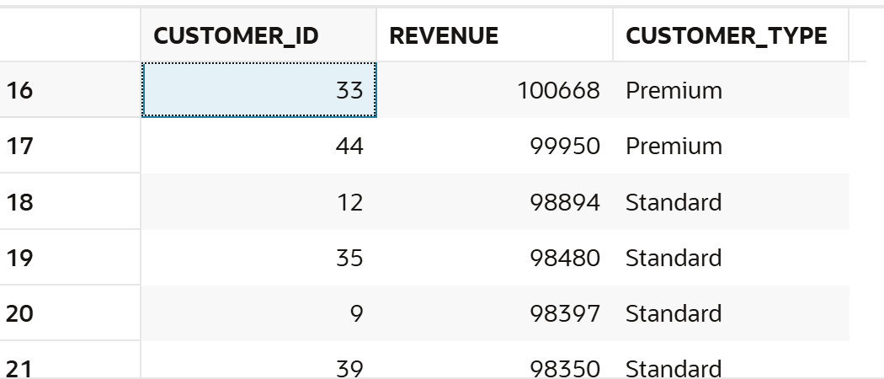

10. FIRST_VALUE / LAST_VALUE

--101. Find highest sale.
select customer_id,amount,
first_value(amount)
over(partition by customer_Id order by amount desc)
from sales
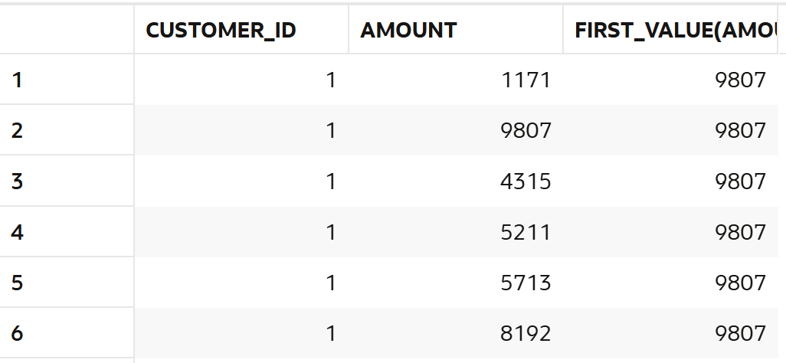
--102. Find lowest sale.
SELECT
customer_id,
amount,
LAST_VALUE(amount)
OVER (
PARTITION BY customer_id
ORDER BY amount desc
ROWS BETWEEN UNBOUNDED PRECEDING AND UNBOUNDED FOLLOWING
) AS lowest_amount
FROM sales;
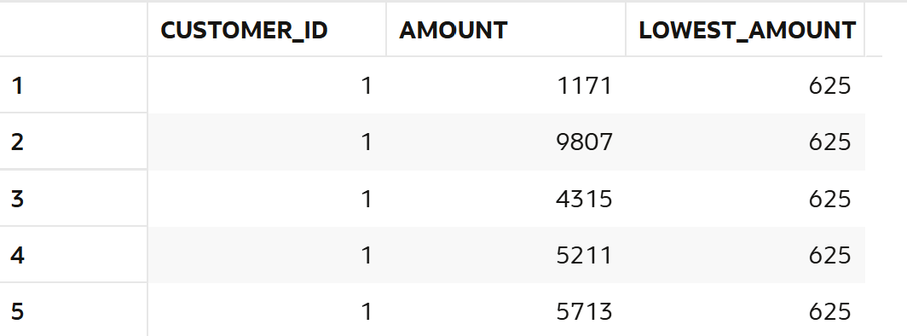
--103. Compare each sale with highest.
select customer_id,amount,
first_value(amount)
over(partition by customer_Id order by amount desc)
from sales
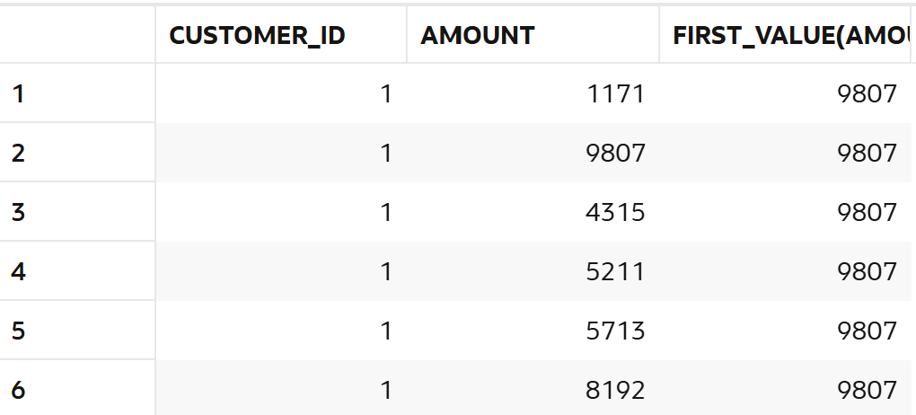
--104. Compare each sale with lowest.
SELECT sale_id,
sale_amount,
LAST_VALUE(sale_amount) OVER (
ORDER BY sale_amount DESC
ROWS BETWEEN UNBOUNDED PRECEDING AND UNBOUNDED FOLLOWING
) AS lowest_sale,
sale_amount - LAST_VALUE(sale_amount) OVER (
ORDER BY sale_amount DESC
ROWS BETWEEN UNBOUNDED PRECEDING AND UNBOUNDED FOLLOWING
) AS difference
FROM sales;
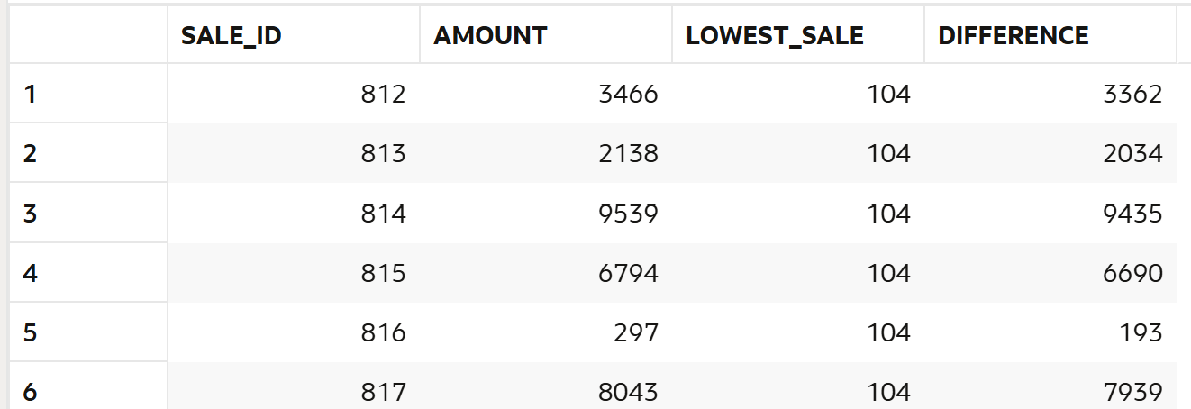
--105. Find highest sale per store.
select st.store_name,sa.amount,
first_value(sa.amount)
over(partition by st.store_name order by sa.amount desc)
from sales sa
left join stores st on st.store_id=sa.store_id;
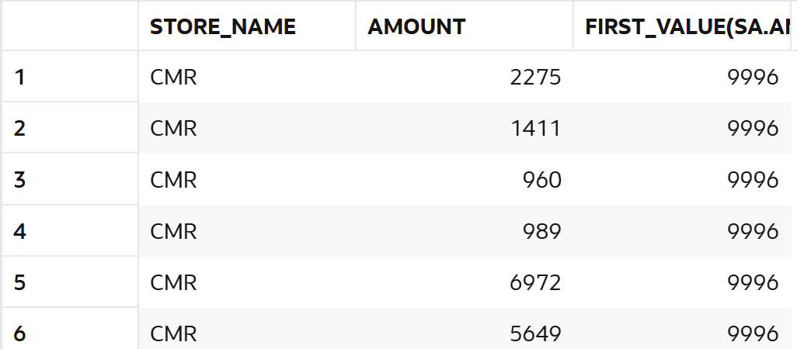
--106. Find lowest sale per store.
select st.store_name,sa.amount,
last_value(sa.amount)
over(partition by st.store_name order by sa.amount desc
rows between unbounded preceding and unbounded following)
as lowest_per_store
from sales sa
left join stores st on st.store_id=sa.store_id;
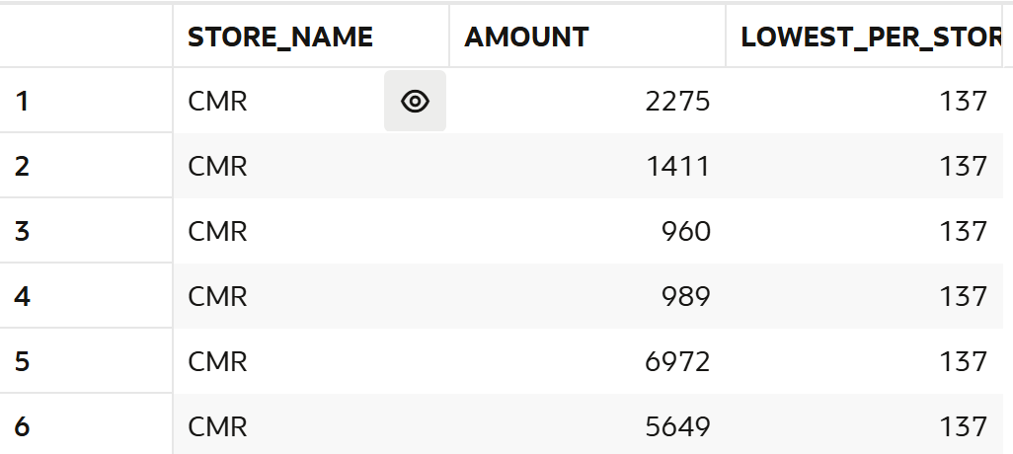
--107. Compare category performance.
SELECT
st.category,
SUM(s.amount) AS total_sales,
RANK() OVER (ORDER BY SUM(s.amount) DESC) AS category_rank
FROM sales s
JOIN stores st
ON s.store_id = st.store_id
GROUP BY st.category;
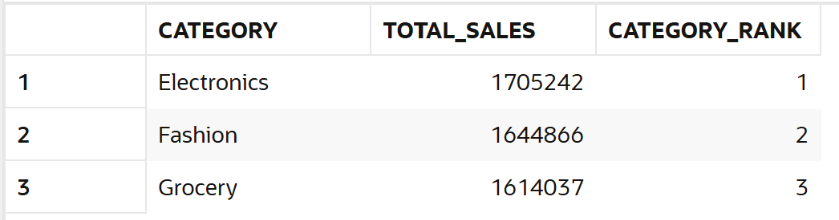
--108. Find best customer per store.
SELECT *
FROM (
SELECT
st.store_name,
c.customer_name,
SUM(sa.amount) AS total_spent,
RANK() OVER (
PARTITION BY st.store_name
ORDER BY SUM(sa.amount) DESC
) AS rnk
FROM sales sa
JOIN customers c ON c.customer_id = sa.customer_id
JOIN stores st ON st.store_id = sa.store_id
GROUP BY st.store_name, c.customer_name
)
WHERE rnk = 1;
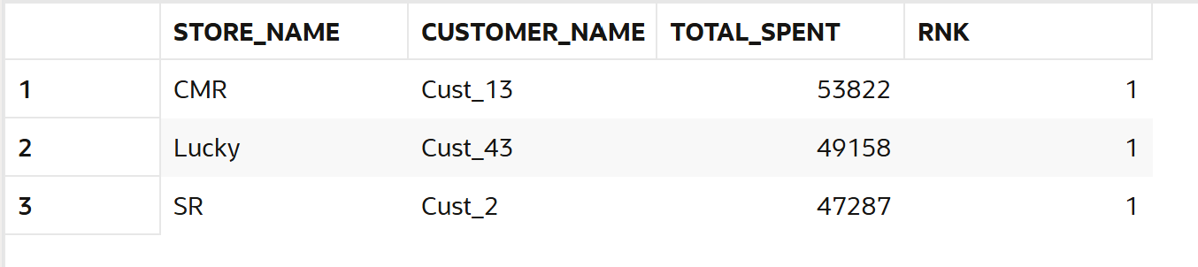
--109. Find worst performing category.
SELECT *
FROM (
SELECT
p.category,
SUM(s.amount) AS total_sales,
RANK() OVER (ORDER BY SUM(s.amount)) AS rnk
FROM sales s
JOIN products p
ON s.product_id = p.product_id
GROUP BY p.category
)
WHERE rnk = 1;
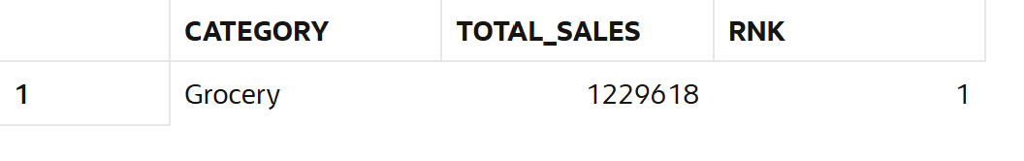
--110. Analyze gap between best and worst.
SELECT
MAX(total_sales) AS best_sales,
MIN(total_sales) AS worst_sales,
MAX(total_sales) - MIN(total_sales) AS gap
FROM (
SELECT
category,
SUM(amount) AS total_sales
FROM sales
GROUP BY category
);
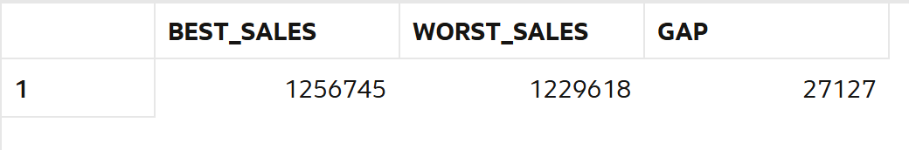
11.Date Analysis
--111. Find daily sales.
select sale_date,sum(amount) as daily_sales from sales
group by sale_date;
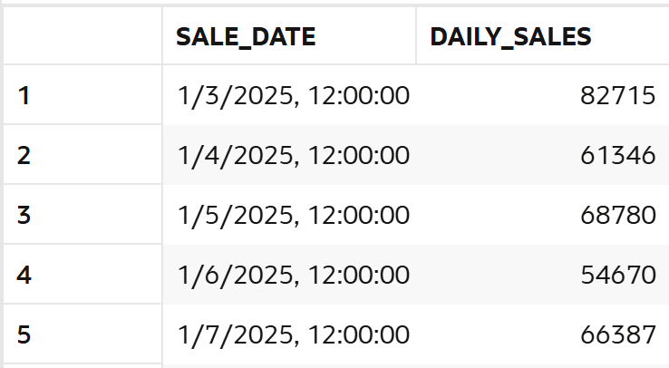
--112. Find monthly sales.
select to_char(sale_date,'yyyy-mm') ,sum(amount) as monthly_sales from sales
group by to_char(sale_date,'yyyy-mm') ;
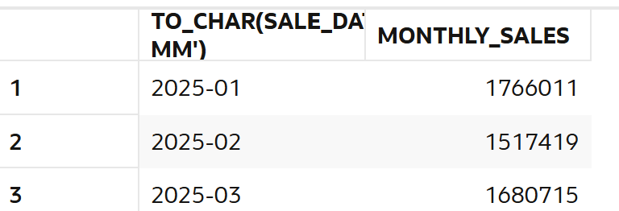
--113. Find weekend sales.
SELECT sale_date, SUM(amount)
FROM sales
WHERE TO_CHAR(sale_date,'Dy') IN ('Sat','Sun')
GROUP BY sale_date;
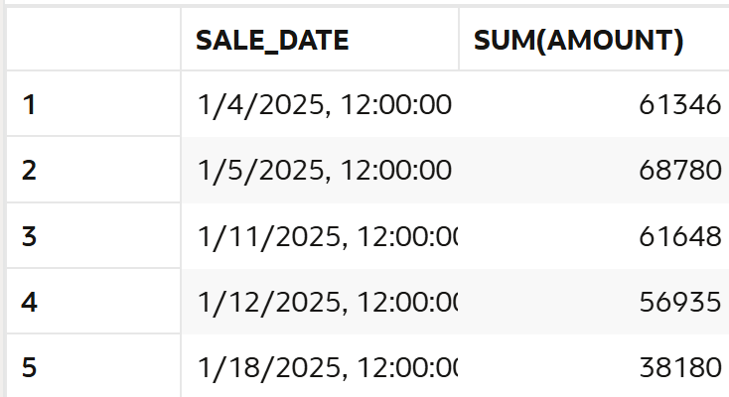
--114. Find first sale date.
select min(sale_date) as first_sale from sales;
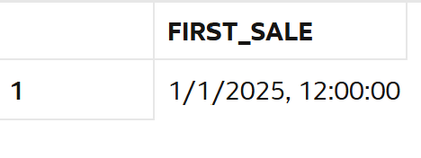
--115. Find last sale date.
select max(sale_date) as first_sale from sales;
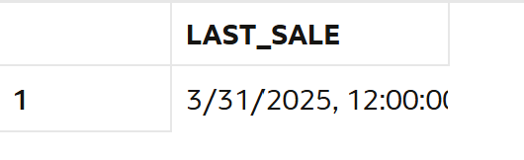
--116. Find sales in specific month.
select to_char(sale_date,'yyyy-mm'),sum(amount) as monthly_sales from sales
where to_char(sale_date,'yyyy-mm') = '2025-03'
group by to_char(sale_date,'yyyy-mm');
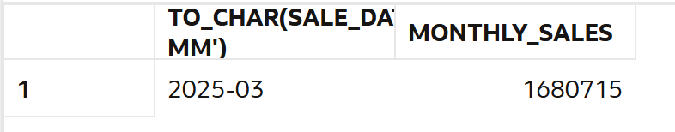
--117. Find sales growth month-wise.
SELECT
TO_CHAR(sale_date, 'YYYY-MM') AS month,
SUM(amount) AS total_sales,
LAG(SUM(amount)) OVER (ORDER BY TO_CHAR(sale_date, 'YYYY-MM')) AS prev_month_sales,

ROUND(
(SUM(amount) - LAG(SUM(amount)) OVER (ORDER BY TO_CHAR(sale_date, 'YYYY-MM')))
/ LAG(SUM(amount)) OVER (ORDER BY TO_CHAR(sale_date, 'YYYY-MM')) * 100,
2
) AS growth_percent

FROM sales
GROUP BY TO_CHAR(sale_date, 'YYYY-MM')
ORDER BY month;
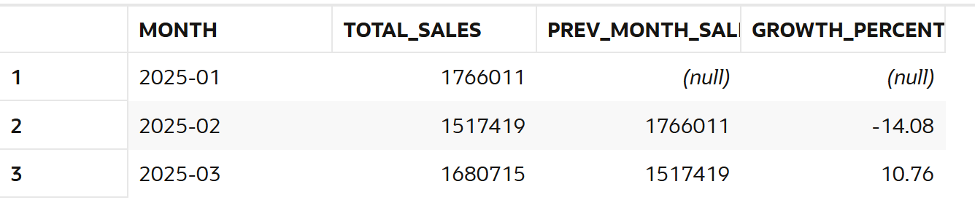
--118. Find inactive customers (30 days).
select c.customer_name
from customers c
left join sales s on c.customer_id= s.customer_id
group by c.customer_name
having max(sale_date) <sysdate -30;
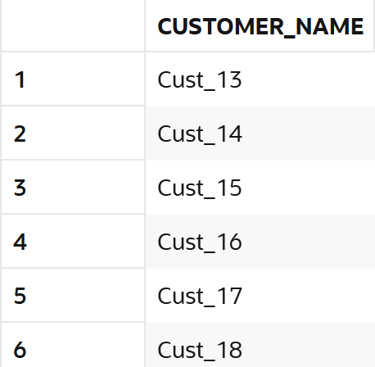
--119. Find repeat customers.
select c.customer_name,count(s.sale_id) as repeat_customer
from customers c
left join sales s on c.customer_id= s.customer_id
group by c.customer_name
having count(s.sale_id) >1;
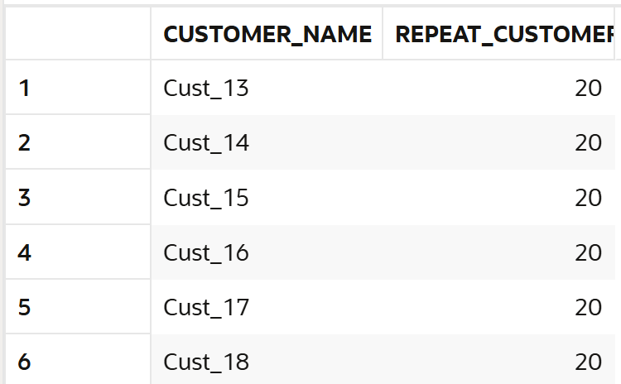
--120. Find sales trend.
select to_char(sale_date,'yyyy-mm') ,sum(amount) as monthly_sales from sales
group by to_char(sale_date,'yyyy-mm');
