MY SQL ASSIGNMENT-1

BY,SOWMYA

22H51A0588

1. displaying productcode

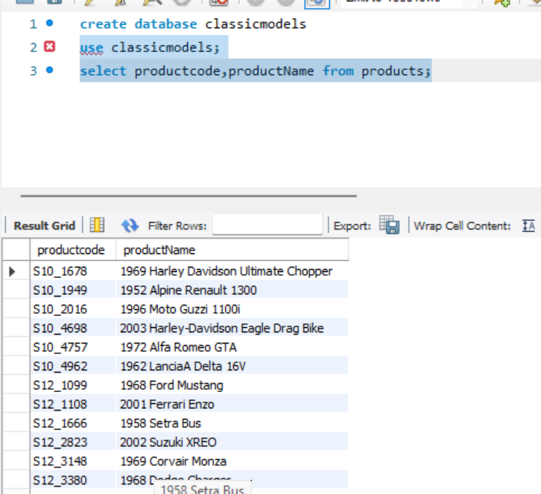

2.displaying customer details in descending order country

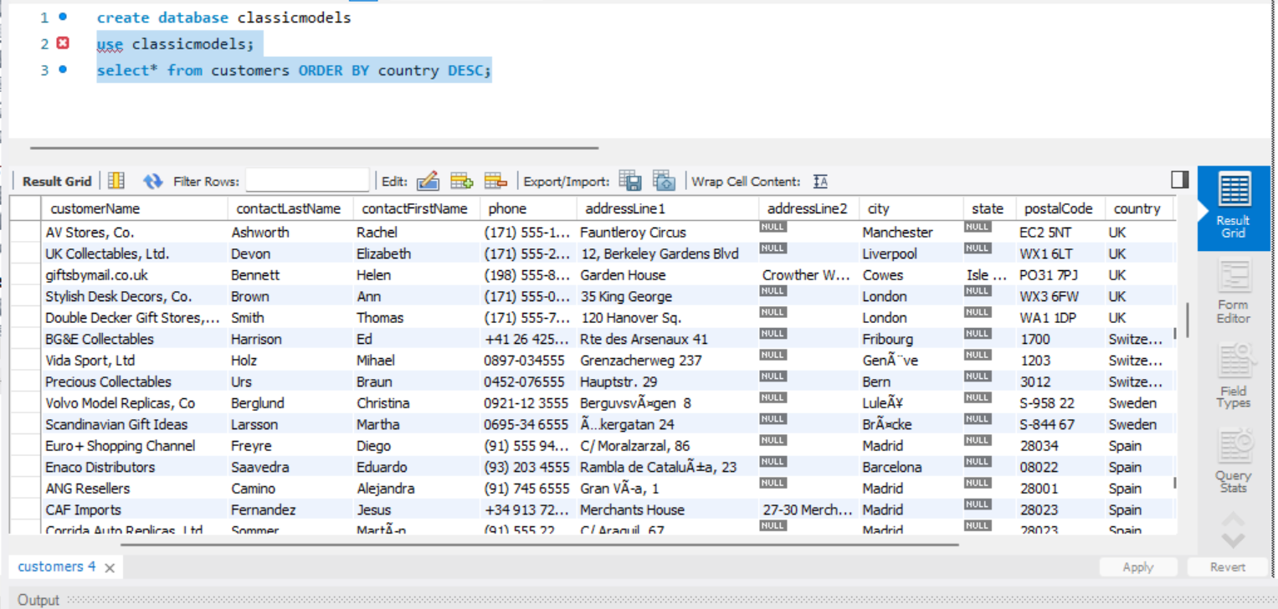

3. displaying customers who are having comments regarding shipping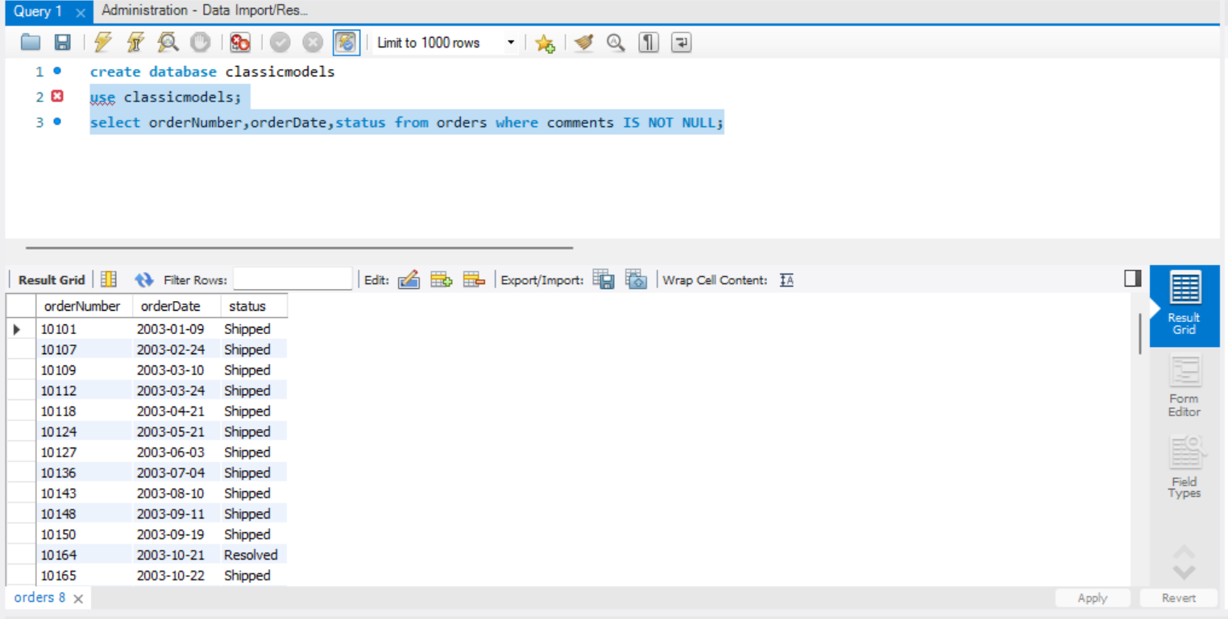

4. maxpayment 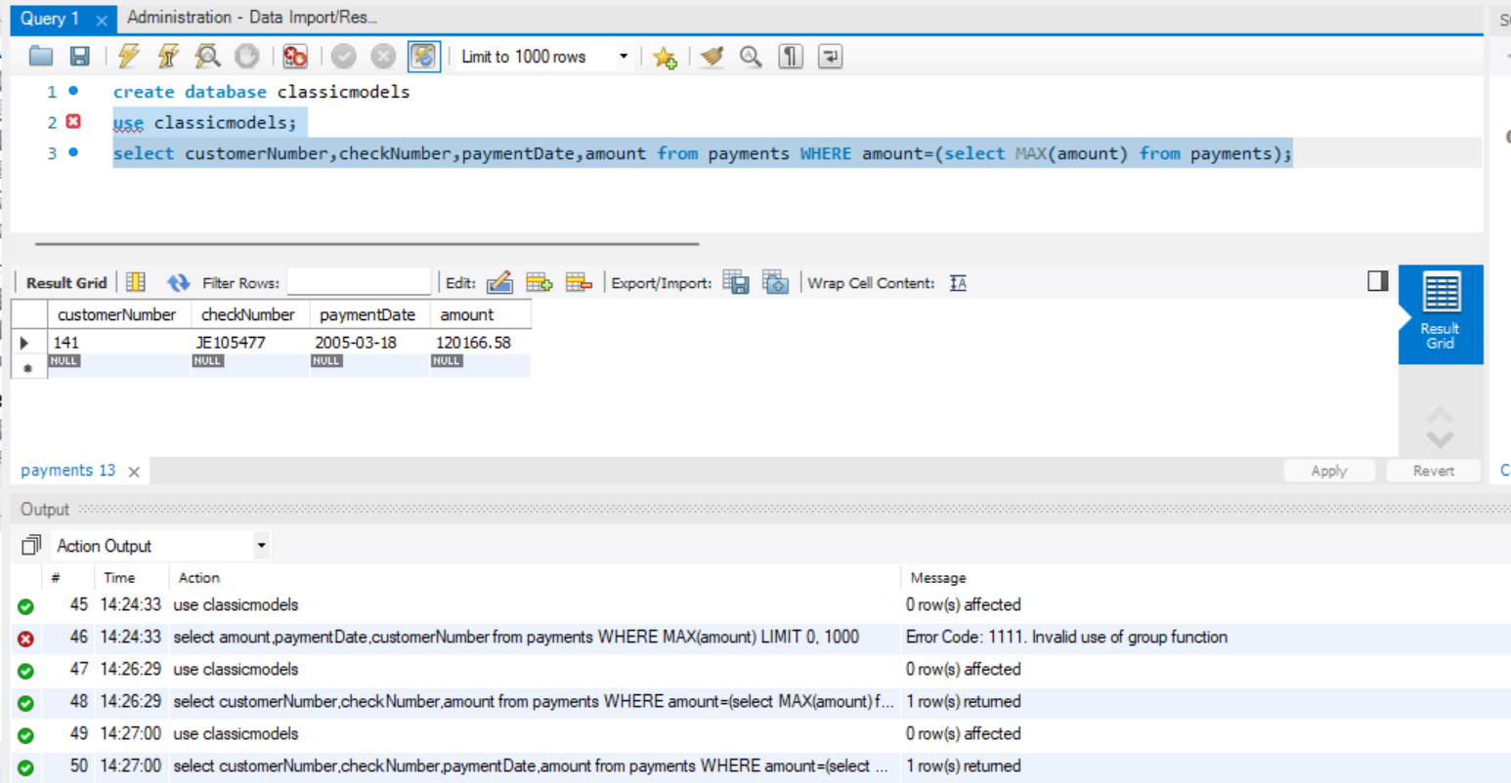

5.displaying second top 5 payments

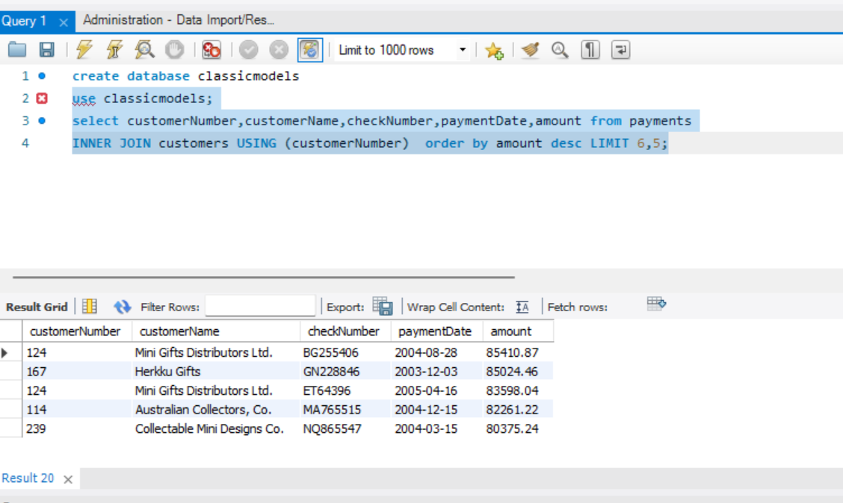6.credit limit between specified range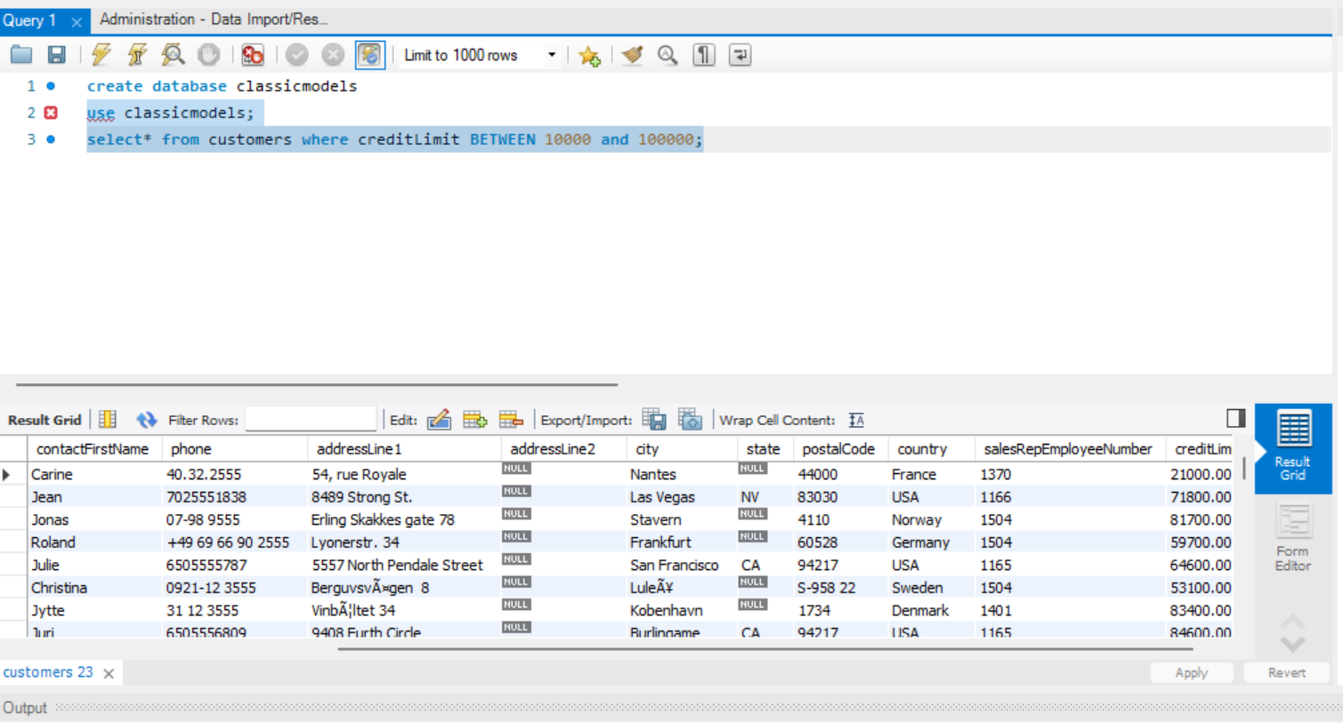

7.employees whose lastname starts with B

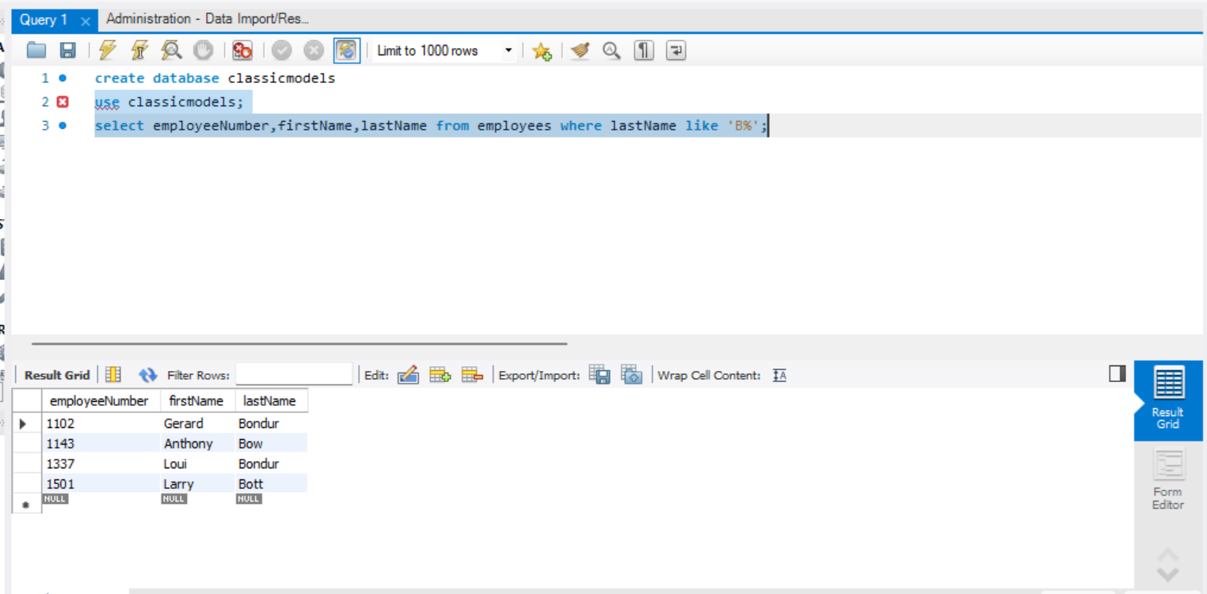

8.totalamount greater thank 50k

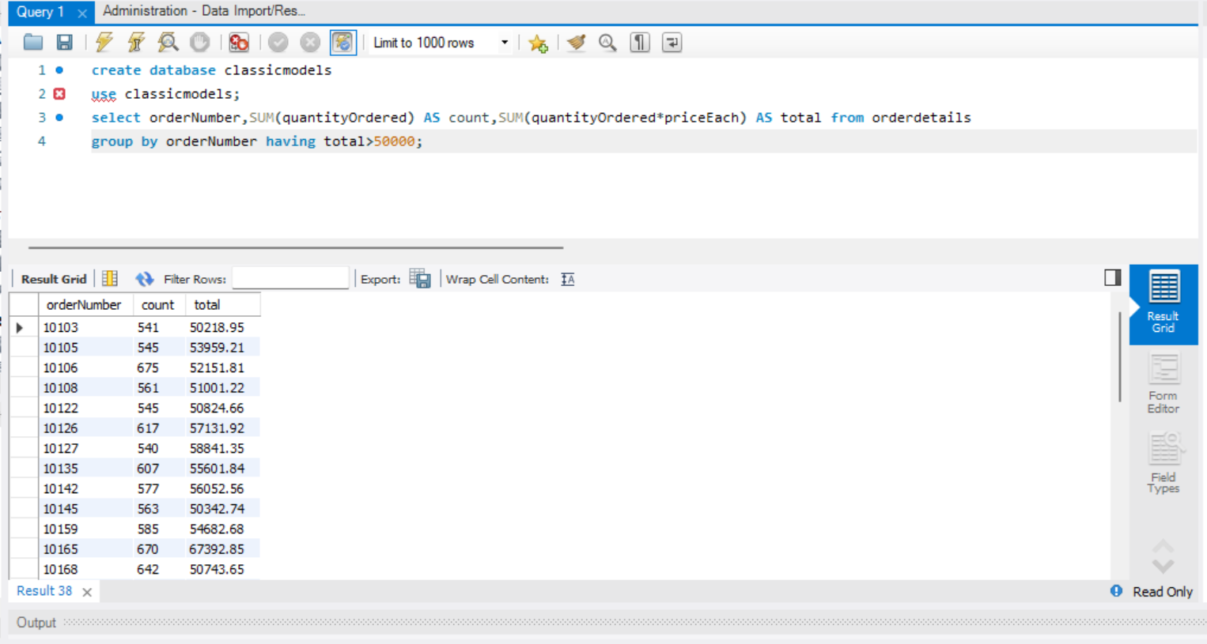

9.returning productcode,name,textdescription from product and productline tables

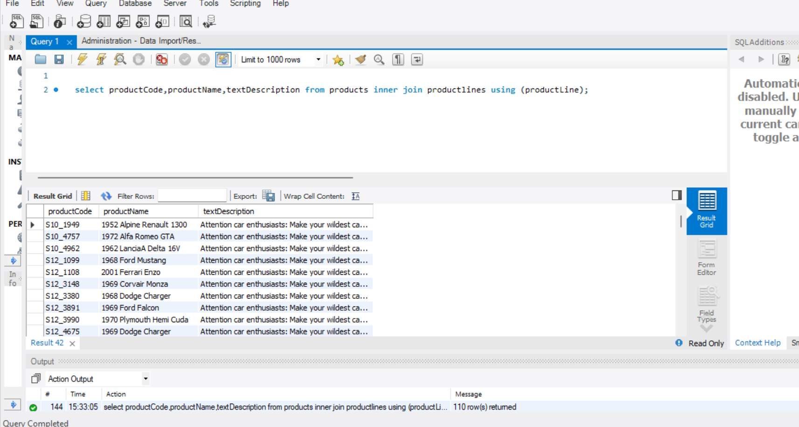

10.customers who are having no orders

