**A Real-time Research Project Report on**

**ONLINE LIBRARYMANAGEMENT SYSTEM(E-BOOKS)**

A Dissertation submitted to JNTU Hyderabad in partial fulfillment of the academic requirements for the award of the degree.

**Bachelor of Technology**

**In**

**COMPUTER SCIENCE AND ENGINEERING**

Submitted by

D.VINAY

(22H51A0578)

G.SRIKAR

(22H51A0582)

G.SOWMYA

(22H51A0588)

Under the esteemed guidance of

Dr.P.Senthil

(Asst.Professor)

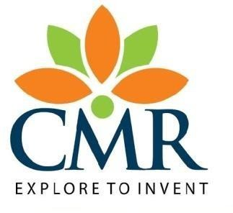

**Department of Computer Science and Engineering**

### CMR COLLEGE OF ENGINEERING & TECHNOLOGY

(UGC Autonomous)

*Approved by AICTE *Affiliated to JNTUH *NAAC Accredited with A+ Grade

KANDLAKOYA, MEDCHAL ROAD, HYDERABAD - 501401.

### 2023- 2024

**CMR COLLEGE OF ENGINEERING & TECHNOLOGY**

KANDLAKOYA, MEDCHAL ROAD, HYDERABAD – 501401

**DEPARTMENT OF COMPUTER SCIENCE AND ENGINEERING**

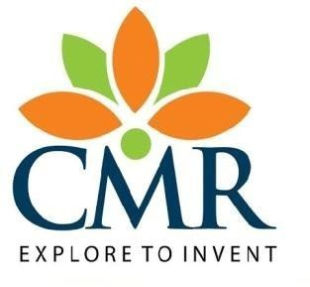

### CERTIFICATE

## This is to certify that the Real-time Research Project report entitled

## " ONLINE LIBRARY MANAGEMENT SYSTEM (E-BOOKS)" being submitted by D.VINAY (22H51A0578), G.SRIKAR (22H51A0582), G.SOWMYA (22H51A0588) in partial fulfillment for the award of Bachelor of Technology in COMPUTER SCIENCE AND ENGINEERING

## is a record of bonafide work carried out under my guidance and supervision.

## The results embodies in this project report have not been submitted to any other University or Institute for the award of any Degree.

**Dr.P.Senthil**

**Asst. Professor Dr. S. Siva Skandha**

**Dept. Of CSE**

HOD CSE

### ACKNOWLEDGEMENT

With great pleasure we want to take this opportunity to express our heartfelt gratitude to all the people who helped in making this project a grand success.

We are grateful to **Dr.P.Senthil**, Asst. Professor, Department of Computer Science and Engineering for his valuable technical suggestions and guidance during the execution of this project work.

We would like to thank, **Dr. S. Siva Skandha,** Head of the Department of Dept Computer Science and Engineering, CMR College of Engineering and Technology, who is the major driving forces to complete our project work successfully.

We are very grateful to **Dr. Ghanta Devadasu**, Dean-Academics, CMR College of Engineering and Technology, for his constant support and motivation in carrying out the project work successfully.

We are highly indebted to **Major Dr. V A Narayana**, Principal, CMR College of Engineering and Technology, for giving permission to carry out this project in a successful and fruitful way.

We would like to thank the **Teaching & Non- teaching staff** of Department of Dept Name for their co-operation

We express our sincere thanks to **Shri. Ch. Gopal Reddy**, Secretary& Correspondent, CMR Group of Institutions, and Shri Ch Abhinav Reddy, CEO, CMR Group of Institutions for their continuous care and support.

Finally, we extend thanks to our parents who stood behind us at different stages of this Project. We sincerely acknowledge and thank all those who gave support directly or indirectly in completion of this project work.

D.VINAY 22H51A0578

G.SRIKAR 22H51A0582

G.SOWMYA 22H51A0588

**TABLE OF CONTENTS**

|  |  |
| --- | --- |
| **CHAPTER NO. TITLE** | **PAGE NO.** |
| **LIST OF FIGURES** | ii |
| **LIST OF TABLES** | iii |
| **ABSTRACT** | iv |
| **1 INTRODUCTION** | 1 |
| 1.1 Problem Statement | 2 |
| 1.2 Research Objective | 2 |
| 1.3 Project Scope and Limitations | 3 |
| **2** **BACKGROUND WORK** | 4 |
| 2.1. Integrated Library System |  |
| 2.1.1.Introduction | 5 |
| 2.1.2.Merits,Demerits and Challenges | 5 |
| 2.1.3.Implementation | 5 |
| 2.2. Digital Rights Management |  |
| 2.2.1.Introduction | 6 |
| 2.2.2.Merits,Demerits and Challenges | 6 |
| 2.2.3.Implementation | 6 |
| **3 PROPOSED SYSTEM** | 7 |
| 3.1. Objective of Proposed Model | 8 |
| 3.2. Enhancing User Experience  3.3. Streamlining Inventory Management  3.4. Ensuring Data Accuracy and Security  3.5. Facilitating Efficient Communication  3.6. Algorithms/Flow charts used for proposed model | 8  8  8  9 |
| 3.7. Designing | 10 |
| 3.7.1.UML Diagram | 10 |
| 3.8. Stepwise Implementation and Code  3.9. Working | 12 |
| **4 RESULTS AND DISCUSSION** | 13 |
| 4.1. Performance metrics | 14 |
| **5 CONCLUSION** | 15 |
| 5.1 Conclusion and Future Enhancement | 16 |
| **REFERENCES** | **18** |

**List of Figures**

|  |  |  |
| --- | --- | --- |
| **FIGURE NO.** | **TITLE** | **PAGE NO.** |
| 3.2.1 | Flow chart | 9 |
| 3.3.1 | UML Diagram | 10 |
| 3.3.2.1 | Implementation | 11 |
| 3.3.2.2 | Registration Page | 11 |
|  |  |  |

**List of Tables**

**TABLE NO. TITLE PAGE NO.**

4.1 Performance Metrices . 14

# ABSTRACT

The "Online Library Management System (E-books)" project is designed to create a userfriendly and comprehensive platform for browsing, purchasing, and managing electronic books. Users can effortlessly register on the platform, allowing them to securely log in and access a vast catalog of e-books categorized by genre, author, and other criteria. The advanced search functionality enables users to find books quickly, check their availability in the store online, and each book's detailed page provides descriptions, author information, and user reviews. The system ensures a seamless purchasing experience with a secure shopping cart and reliable payment gateways that support various payment methods. Upon completing a purchase, users can instantly download their e-books in multiple formats compatible with different e-readers. The admin panel empowers administrators to efficiently manage library resources, user accounts, and transactions, ensuring the system runs smoothly. Designed for high performance, scalability, and robust security, the platform also includes future-ready features like personalized book recommendations and social interaction capabilities, providing a comprehensive solution for modern digital library needs.

# CHAPTER 1

## INTRODUCTION

**CHAPTER 1**

**INTRODUCTION**

**1.1.Problem Statement**

In today's digital age, traditional library systems face significant challenges in managing and distributing e-books efficiently. The current methods of cataloging, storing, and providing access to digital books are often fragmented, leading to difficulties in book retrieval, inconsistent user experiences, and inefficiencies in library operations. Users face obstacles in finding and borrowing e-books seamlessly, and libraries struggle to integrate digital rights management effectively. Additionally, the lack of a unified platform that supports multi-device access and personalized recommendations hinders user engagement and satisfaction. To address these issues, there is a pressing need for a robust Online Library Management System specifically tailored for e-books. This system should offer comprehensive features for streamlined book management, secure distribution, and enhanced user accessibility, ensuring an efficient, user-friendly, and technologically advanced solution for modern library needs.

**1.2.Research Objective**

This applied research aims to design, develop and implement online library management system. This web-based application provides:

* **Analyse Existing Systems**: Identify and address the limitations and inefficiencies of current library management systems in handling e-books.
* **Develop a Comprehensive Platform:** Design a user-friendly system with features for user registration, book borrowing, returning, and advanced search functionality.
* **Ensure Secure Access:** Integrate robust digital rights management (DRM) solutions to protect and securely distribute e-books.
* **Enhance User Experience:** Implement personalized recommendations and multi-device access for a consistent and engaging user experience.

#### Project Scope and Limitations

##### Scope:

* **User Management**: Implementing features for user registration, authentication, and profile management.
* **E-Book Cataloging**: Developing a comprehensive database for cataloging e-books with metadata like author, genre, publication date, and more.
* **Multi-Device Access**: Ensuring the platform is accessible across various devices such as smartphones, tablets, and computers.
* **User Interface Design**: Creating an intuitive and user-friendly interface for both users and library administrators.
* **Scalability and Integration**: Ensuring the system can scale to accommodate a growing number of e-books and users, and integrate with existing library systems.
* **Search and Retrieval**: Providing advanced search functionalities to allow users to easily find and access e-books.

##### Limitations:

* **Digital Rights Management (DRM) Constraints:** Implementing DRM may restrict certain functionalities, such as sharing, copying, or printing e-books, potentially affecting user experience.
* **Device Compatibility**: Ensuring compatibility across all devices and operating systems can be challenging, and some older devices may not fully support the platform.
* **User Adoption and Training**: The system’s success relies on user adoption, which may require comprehensive training and continuous support to ensure users are comfortable and proficient with the platform.
* **Network Dependency**: As an online platform, the system requires a stable internet connection, which may limit accessibility in areas with poor or unreliable internet service.
* **Initial Setup and Maintenance Costs**: Developing, deploying, and maintaining the system may involve significant initial costs and ongoing expenses for updates, support, and system enhancements.

# CHAPTER 2

## BACKGROUND WORK

1. **Existing Methods:**

### CHAPTER 2 BACKGROUND WORK

### 

##### Method 1: Integrated Library Systems

* + 1. **Introduction**
       - Integrated Library Systems (ILS) are comprehensive software solutions used by libraries to manage cataloging, circulation, acquisitions, and patron services, streamlining operations and improving access to library resources.

##### Merits, Demerits, and Challenges Merits:

* + - * **Streamlined Operations:** Integrates various library functions such as cataloging, circulation, and acquisitions into one system, improving efficiency.
      * **Improved User Access:** Provides easy access to library resources through user-friendly interfaces and online catalogs.

##### Demerits:

* + - * **High initial costs :** Can be expensive to implement due to software licensing, hardware requirements, and staff training.
      * **Complexity:** May be complex to set up and maintain, requiring specialized knowledge and technical support.

##### Challenges:

* + - * **High Implementation Costs:** Initial costs for purchasing software licenses, hardware, and training staff can be prohibitive, especially for

smaller libraries.

* + - * **Customization and Scalability:** Customizing the ILS to meet specific needs can be difficult, and some systems may not scale well with growing library collections or user bases.

##### Implementation

* + - * **Needs Assessment:** Determine the specific needs and goals of the library, including the types of materials, user demographics, and desired features.
      * **Selecting the ILS:** Develop standardized forms and procedures for data entry and record-keeping.
      * **Staff Training:** Provide comprehensive training for library staff on using the new ILS, focusing on key functions such as cataloging, circulation, and user management.
      * **Maintenance:** Ensure the ILS is kept up to date with regular software updates and patches.

##### Method 2: Digital Rights Management (DRM)

* + 1. **Introduction:**
       - Digital Rights Management (DRM) refers to technologies and strategies used to control and protect digital content, preventing unauthorized access, copying, and distribution of e-books, music, videos, and software.

##### Merits, Demerits, and Challenges Merits:

* + - * **Protection of Intellectual Property:** DRM helps protect creators' and publishers' rights by preventing unauthorized copying and distribution of digital content.
      * **Content Control:** Enables rights holders to manage how their content is used, including setting limits on sharing, copying, and printing..

##### Demerits:

* + - * **User Restrictions:** Can inconvenience legitimate users by restricting how they can use the purchased content, such as limiting device compatibility or the ability to share.
      * **Complexity and Costs:** Difficult to synchronize data across multiple locations or users.

##### Challenges:

* + - * **Balancing Protection and Usability:** Finding the right balance between protecting content and providing a seamless user experience is challenging.
      * **Market Fragmentation:** Different DRM systems used by various providers can lead to market fragmentation, complicating content access for users.

##### Implementation

* + - * **Assess Needs and Goals:** Determine what digital content needs protection (e.g., e-books, music, videos, software).
      * **Select a DRM Solution:** Investigate various DRM solutions available on the market, considering factors like security features, compatibility, and ease of use.
      * **Content Preparation:** Attach appropriate metadata and license information to each piece of content.
      * **System Setup:** Set up the necessary infrastructure, including servers and software, to support the DRM system.

# CHAPTER 3

## PROPOSED SYSTEM

### CHAPTER 3 PROPOSED SYSTEM

**3.1. Objective of Proposed Model**

An online library management system for e-books aims to efficiently catalog, manage, and provide access to digital resources. It prioritizes user accessibility through intuitive interfaces and supports various e-book formats, ensuring compatibility across devices. Security measures like Digital Rights Management (DRM) protect intellectual property, while automated processes streamline tasks such as cataloging and circulation. The system integrates data analytics to enhance decision-making and user experience, tracking usage patterns and popular titles.

**3.2. Enhancing User Experience**

Enhancing user experience in online library management for e-books involves intuitive interfaces, advanced search capabilities, personalized recommendations, and seamless access across devices. Features like user accounts for tracking reading history and preferences further optimize satisfaction and engagement. Users can easily check the availability of books in the store online, making the browsing and purchasing process more efficient and enjoyable.

**3.3. Streamlining Inventory Management**

Streamlining inventory management in online library management involves automated cataloging, real-time updates of available e-books, efficient circulation processes, and integration with digital repositories. This ensures accurate inventory tracking and enhances overall operational efficiency. Administrators can efficiently manage library resources and ensure that users have access to the most up-to-date content.

**3.4. Ensuring Data Accuracy and Security**

Ensuring data accuracy and security in online library management involves robust encryption for e-books and patron information, regular data audits, and compliance with privacy regulations. Access controls and secure authentication methods further protect sensitive data

from unauthorized access and breaches. The system also includes secure payment processing to protect users' financial information during transactions.

**3.5. Facilitating Efficient Communication**

Automated notifications and reminders via email, SMS, and in-app messaging enhance engagement and responsiveness, ensuring users are informed about new releases, special offers, and system updates. This feature helps maintain an active user base and encourages frequent interaction with the platform, fostering a vibrant online library community.

#### Algorithms/Flow chart Used for Proposed Model

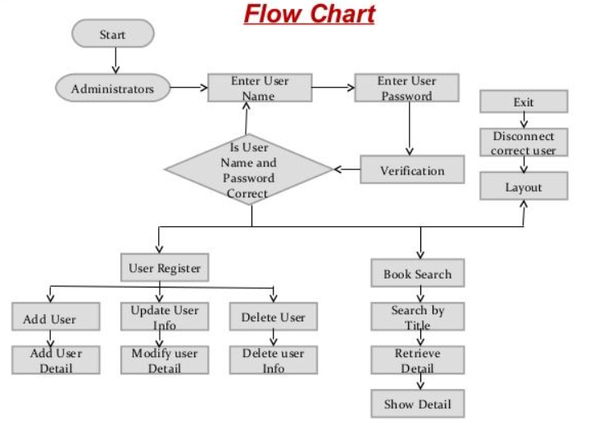

**Fig 3.6 Flow Chart**

#### 3.7.Designing

**3.8.1 UML Diagram**

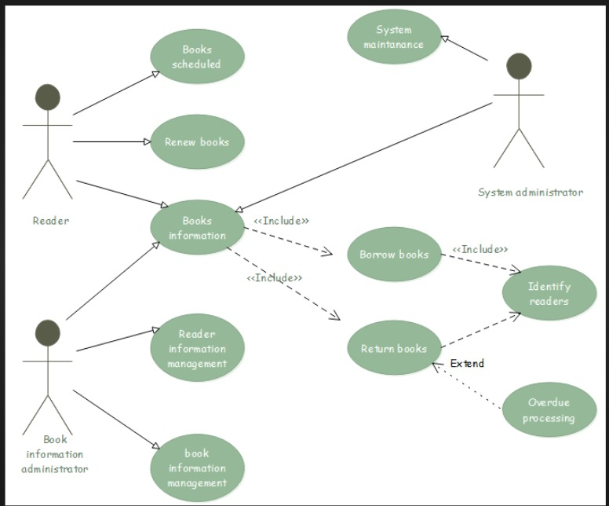

**Fig :3.8.1 UML Diagram**

#### 3.8.2 Stepwise Implementation and Code

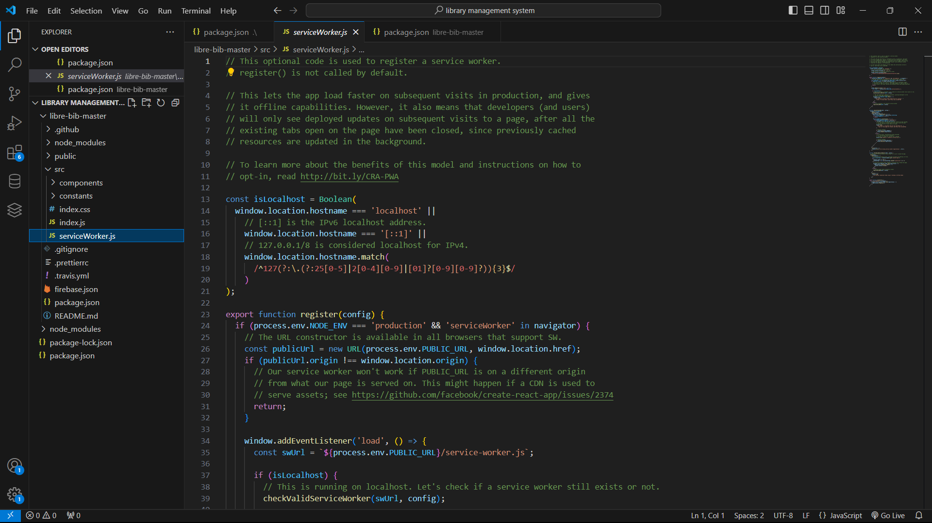

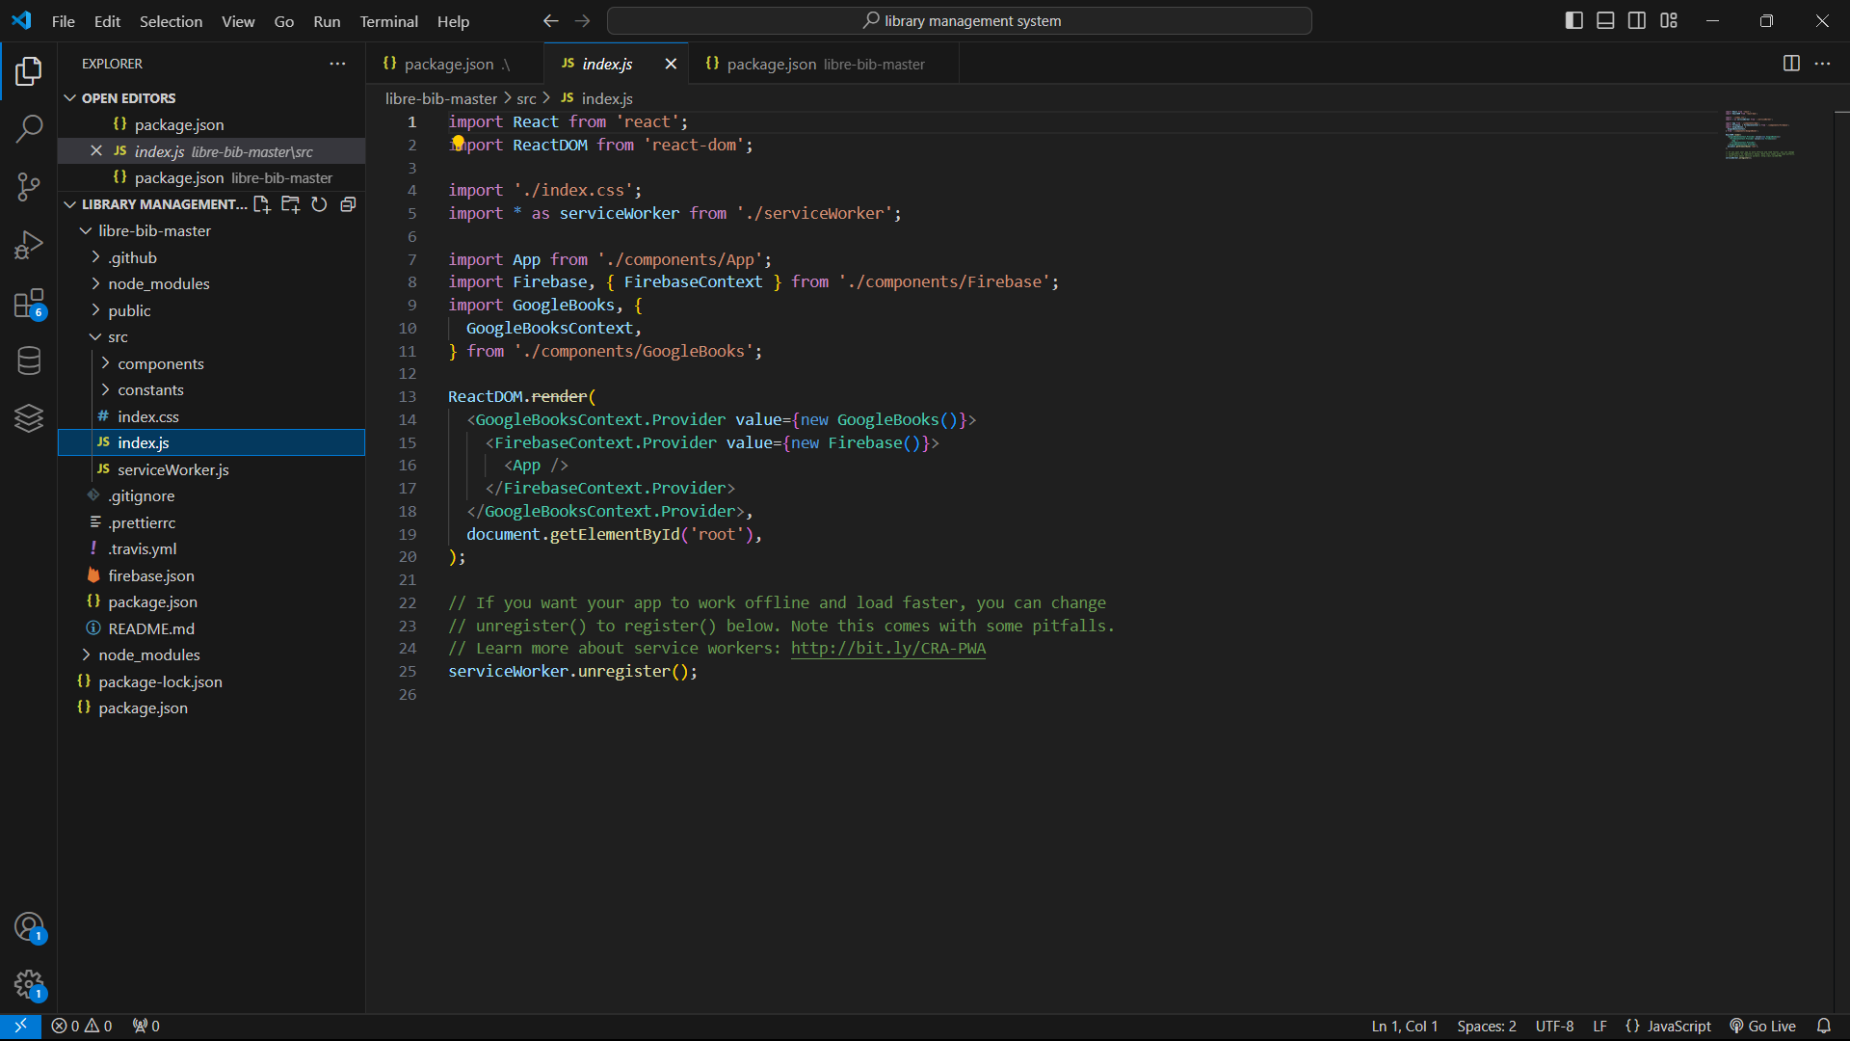

#### 3.9 Working

#### 

**Fig 3.9.1 Login page**

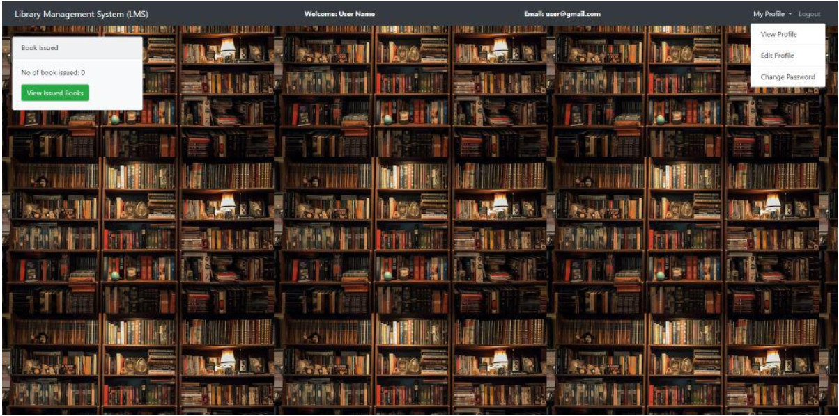

**Fig 3.9.2 dashboard**

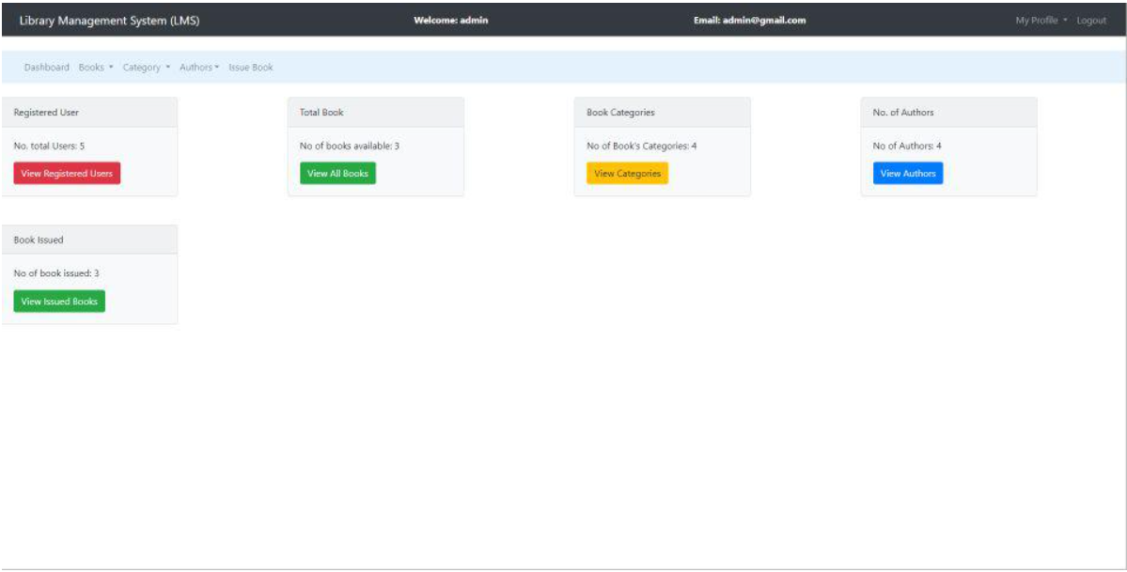

**Fig 3.9.3 Admin DashBoard**

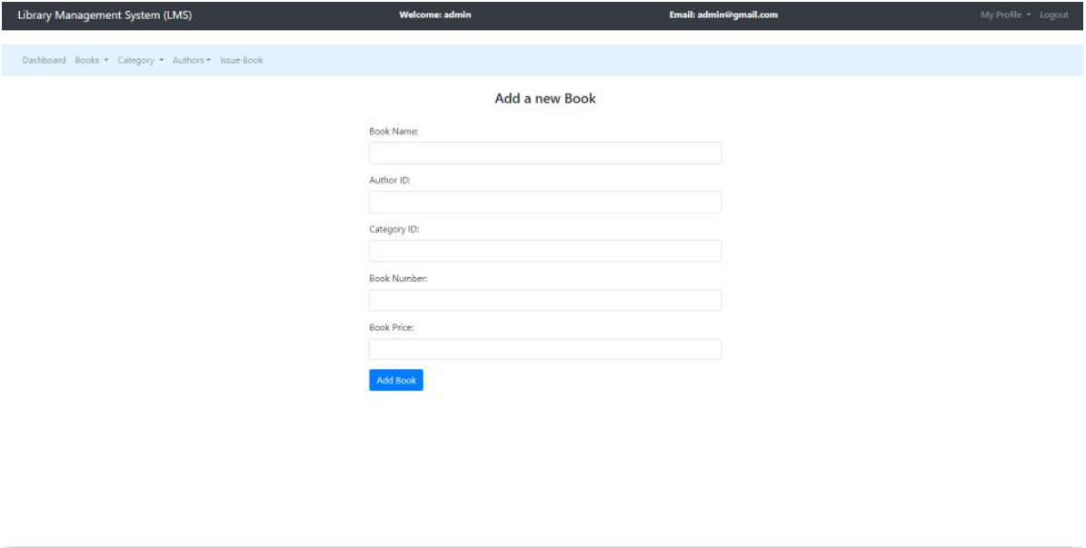

**Fig 3.9.4 Manage Book Page**

# CHAPTER 4

## RESULTS AND DISCUSSION

ONLINE LIBRARY MANAGEMENT SYSTEM(E-BOOKS)

### CHAPTER 4 RESULTS AND DISCUSSION

#### 4.1. Performance metrics

|  |  |
| --- | --- |
| **Performance Metric** | **Description** |
| Customer Satisfaction (CSAT) | User feedback collected through surveys regarding their satisfaction with the platform. |
| Daily Active Users (DAU) | Number of users who interact with the platform daily. |
| Monthly Active Users (MAU) | Number of users who interact with the platform monthly. |
| Session Duration | Average time users spend on the platform per session. |
| Pages Per Session | Average number of pages a user views during a single session. |
| Bounce Rate | Percentage of users who leave the platform after viewing only one page. |
| Circulation Efficiency | Time taken to make an e-book available after it has been added to the system. |
| Conversion Rate | Percentage of users who make a purchase out of the total number of visitors. |
| Average Order Value (AOV) | Average amount spent by users per transaction. |
| Cart Abandonment Rate | Percentage of users who add items to their cart but do not complete the purchase. |
| Payment Success Rate | Percentage of transactions that are successfully processed. |
| Response Time | Timeliness of addressing technical issues or system downtime. |
| Page Load Time | Average time it takes for a page to load completely. |
| Server Response Time | Time taken for the server to respond to user requests. |
| Uptime | Percentage of time the system is operational and available to users. |
| Error Rate | Frequency of errors occurring within the system. |
| |  | | --- | | Operational Costs |  |  | | --- | |  | | |  | | --- | | Cost-effectiveness of maintaining and operating the system. | |

**CHAPTER 5**

## CONCLUSION

### CHAPTER 5 CONCLUSION

#### 5.1 Conclusion and Future Enhancement

Implementing an online library management system for e-books enhances accessibility, security, and operational efficiency. By prioritizing user experience through intuitive interfaces and personalized features, and ensuring data accuracy and security with robust measures, libraries can create a seamless and trusted digital environment for patrons.

**Future Enhancements**

Future enhancements for online library management systems for e-books could include:

**Enhanced Personalization:** Implementing AI-driven recommendation engines to suggest e-books based on user preferences and reading history.

**Integration with Learning Management Systems:** Facilitating seamless access to e-books from educational platforms and course materials.

**Virtual Reality (VR) and Augmented Reality (AR) Integration:** Offering immersive reading experiences and virtual library tours.

**Blockchain Technology:** Utilizing blockchain for enhanced security and transparent management of digital rights and transactions.

**Expanded Accessibility Features:** Improving accessibility options such as text-to-speech capabilities and customizable reading interfaces for users with disabilities.

## REFERENCES

### REFERENCES

<https://www.slideshare.net/slideshow/online-library-management-system-including-uml-diagrams/33680362>

<https://www.scribd.com/document/406805940/Blood-Bank-Management-System-docx>

[https://www.geeksforgeeks.org/library-management-system/?ref=lbp#step-3-creation-of-admin-dashboard-module](https://www.geeksforgeeks.org/library-management-system/?ref=lbp%23step-3-creation-of-admin-dashboard-module)