Early Diagnosis of Coronary Artery Disease:An
Integrated Deep Learning Approach With
Borderline Smote and Autoencoders

I.MOKSHITHA NAIDU
Department of CSE
CMR collge of Engineering & Technology
Hyderabad,TS,India
imokshithanaidu@gmail.com
G.SOWMYA
Department of CSE
CMR collge of Engineering & Technology
Hyderabad,TS,India
sowmyasoma2345@gmail.com
ANURADHA BOYA
Department of CSE
CMR collge of Engineering & Technology
Hyderabad,TS,India
banuradha@cmrcet.ac.in

Abstract— Coronary Artery Disease (CAD) is a dangerous and prevalent health issue, which is still plaguing millions of individuals across the globe. CAD diagnosis at an early stage is of high importance because a late diagnosis can cause serious complications and even death. Despite the current development of modern medical technologies, the proper diagnosis remains complicated due to the high percentage of existing methods that rely on the clinical assessment and the invasiveness of the tests that are performed manually. These methods tend to be time-consuming, subjective, and could differ in one clinician to another. Moreover, the conventional machine learning methods do not work effectively with imbalanced medical data, uncertain information and complicated clinical patterns. In order to tackle these challenges, this project will introduce an in-depth deep learning-based system of the early detection of Coronary Artery Disease. The system deploys Borderline SMOTE to balance the data set by enhancing the minority classes and Autoencoders to detect useful and clean features. Convolutional Neural Networks are then used to analyze these features to determine complex patterns in CAD. The combination increases reliability and classification. Moreover, the framework facilitates safe and interpretable data analysis, which will make clinicians have confidence in the system predictions. On the whole, the offered solution will enhance the quality of early diagnosis and decrease the number of diagnostic errors and promote more positive patient care outcomes.

Introduction
The coronary artery disease (CAD) is a critical health risk across the whole globe and one of the major causes of death. More than 17.9 million people die because of cardiovascular diseases every year, and CAD is a significant portion of them, as the World Health Organization indicates. The timely identification of CAD is associated with an impressive increase in survival rates and respelling serious cardiac episodes. Research shows that with early diagnosis, the long-term outcome and quality of life of the patients are better as a result of timely healthcare response. CAD occurs as a result of the presence of plaque in the coronary arteries, which is determined by genetic factors, lifestyle practices, diabetes, hypertension and cholesterol imbalance. Though these factors vary in their cause, their combination makes the diseases more complex and more prone to progression. This connection emphasizes the relevance of early diagnosis. Early diagnosis can result in preventive treatment, less invasive surgeries, lower health care expenses and better health outcomes of the patients. In heart diseases, particularly, precision and early diagnosis plays a significant role, which necessitates a transition to the modern and data-oriented diagnostic methods as opposed to the traditional ones.
Conventional CAD diagnostic tools such as angiography, stress testing, and manual clinical assessment have a number of drawbacks. Such processes tend to be intrusive, costly and highly reliant on professional interpretation, and as a result, these diagnostic processes are prone to variability of diagnostic accuracy. Moreover, traditional machine learning methods used to predict CAD often rely on an unbalanced dataset, noisy clinical predictions, and high-dimensional medical data, which leads to a smaller reliability and performance compared to the latest deep learning methods.
The suggested study will enhance the detection of CAD at an early stage through the combination of deep learning and a sophisticated hybrid system. This method is a combination of Borderline SMOTE to balance the classes, Auto encoders to extract features effectively, and Convolutional Neural Networks to classify them effectively. The single system is aimed to streamline diagnostic process and bring about efficiency on the healthcare provider by automating diagnosis and improving the accuracy of prediction and the clinical decision-making.

Literature Review
Machine learning and deep learning models have been examined by numerous researchers as a way of diagnosing Coronary Artery Disease using clinical and non-invasive cardiovascular data sources. Alizadehsani et al. [1] presented an in-depth literature review of machine learning algorithms used in CAD diagnosis. The paper focused on the Decision Trees, Support Vector Machines, and Neural Networks, with promising results in its accuracy and with a focus on the issues of class imbalance, noisy features, and reduced generalization in real-world medical data. Kononenko [2] held a discussion on the development of machine learning in medical diagnosis and stated that the traditional models tend not to understand complex nonlinear relationships that are usually found in cardiovascular datasets.
Nasarian et al. [3] developed a hybrid CAD prediction framework that balances the strategy of feature selection with data balancing. They were better at classification, but model scalability and flexibility were limited by their use of handcrafted features. Saman Khalid et al. [4] applied an ensemble-based CAD prediction system with the help of Convolutional Neural Networks and Random Forest classifiers to non-invasive clinical data. Though their model was more successful, there were not enough mechanisms of handling imbalances, which enhanced the chances of biased predictions. Moreover, risk estimation at the severity level was not provided, which diminished clinical application.
Muhammad Sajid et al. [5] introduced the AI-based CADR, which is a CAD risk stratification framework developed with the help of artificial intelligence that combines SMOTE to balance the imbalances and SHAP to interpret the results. Although the system was confirmed to have an excellent performance on small data sets, it failed to perform well on large imbalanced data and external validation was not conducted. The study by Acharya et al. [6] used deep neural networks to diagnose CAD through ECG signals, with a high sensitivity, but sensitivity was affected because of signal noise and redundancy.
Newer papers are moving towards deep learning models like Autoencoders and Convolutional Neural Networks to address the drawbacks of the previous models. Autoencoders enhance noise cancellation and feature encoding, whereas CNNs are efficient to learn complicated cardiovascular dynamics. Nevertheless, there are numerous current approaches, which remain insufficient to resolve the issue of class imbalance, resulting in bad prediction of minority classes. On the whole, even though the current state is greatly improved, the issues of imbalance, noise, interpretability, and generalization remain, which spurs the suggested unified CAD diagnostic framework.

Methodlogy

Proposed Architecture
This architecture is the report of a hybrid deep learning system that was designed to forecast the risk of Coronary Artery Disease early on based on both clinical and cardiac MRI data. Its framework is structured in a form of two parallel processing routes that enable it to process various medical data to enhance the quality of diagnosis in general.
The former route is centered on the clinical contributions, including age, body mass index, waist circumference, systolic blood pressure, hypertension, the presence of diabetes, and familial history. These characteristics are standardized and first encoded in such a way that it is on
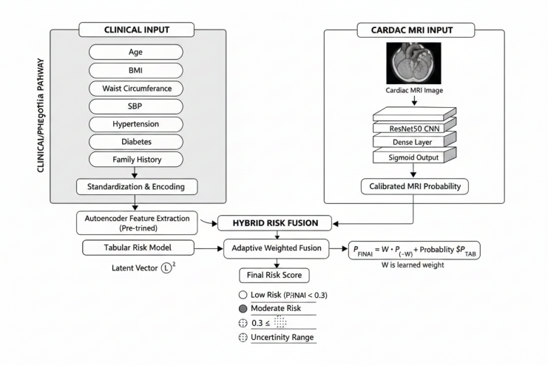
the same scale. The resulting processed data is then subjected to a pre-trained autoencoder, which facilitates the elimination of noise and simplification of data as well as eliminates important clinical patterns. A tabular risk model uses the latent features extracted to estimate patient risk using clinical factors.
The second pathway processes cardiac MRI images with a deep convolutional neural network that is based on the ResNet50 architecture. The MRI images are subjected to several convolutional and dense layers, and a probability score that is the cardiac risk based on the imaging data is obtained by means of a sigmoid activation function.
Lastly, the results of the two pathways are fused through a hybrid risk fusion module. This module uses adaptive weighted fusion methodology, which automatically suits the degree of relevance to apply to medical records and the MRI records. The resulting end risk score puts the patients in low-risk or moderate-risk or uncertainty categories. The system enhances the reliability of prediction and assists in making improved clinical decisions regarding Coronary Artery by combining several sources of data.

Dataset Description
The dataset is divided into two main portions, namely Neuro-imaging MRI scans and Clinical Coronary Artery Disease (CAD) data.
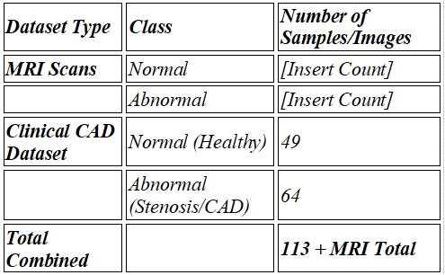
The MRI subset comprises brain scans of high quality, which are labeled into two categories, Normal and Abnormal, and allow binary classification of neurological health conditions. The Normal category holds the MRI scans of healthy brain structure with no visible lesions, anomalies, or structural deviation, whereas the Abnormal category holds the scans with pathological anomalies that are utilized to train the model to detect the deviation of the normal neurological patterns. Deep learning approaches are mainly applied to this imaging data to support a pre-assessment process of the medical professionals through image classification.
Besides the imaging data, there is also a clinical CAD dataset which helps during cardiovascular risk assessment. This table data has 113 patient records and is divided into two categories which include Normal and Abnormal. The class called to be normal has 49 records which are healthy cardiovascular conditions or negligible stenosis and Abnormal has 64 records which are mild to severe coronary artery disease. All of the records comprise 41 clinical, demographic and molecular characteristics including age, gender, BMI, blood pressure, miRNA biomarkers, inflammatory markers, oxidative stress indicators, Gensini scores and stenosis percentages. These dual-modality datasets together permit the complete learning of both visual and physiological biomarkers, which can be used to classify correctly normal and abnormal health conditions and can be used to analyze automated medical diagnostic analysis.

Modified sinh gelu Activation
The modified sinh-GELU activation function is an advanced version of the GELU (Gaussian Error Linear Unit) activation used in deep neural networks. It combines the properties of the hyperbolic sine function and the GELU function to improve gradient flow and achieve smoother nonlinearity. The standard GELU is defined as
GELU(x) = x × Φ(x), where Φ(x) is the cumulative distribution function of the normal distribution, expressed as Φ(x) = 0.5 × [1 + erf(x / √2)].
This makes GELU(x) = 0.5x × [1 + erf(x / √2)].

The modified version introduces sinh to enhance the model’s learning stability.
Modified sinh-
GELU(x) = x × sinh(0.5x × [1 + erf(x /√2)])
Here, sinh(x) = (e^x − e^−x) / 2, which adds a symmetric and smooth curve that helps the model better handle both positive and negative input values. This modification results in more stable gradients, reduced vanishing effects, and improved convergence speed during training.Overall, the modified sinh-GELU activation provides smoother activation transitions, better representation learning, and higher accuracy compared to traditional functions like ReLU, Swish, or standard GELU, making it especially effective in deep models such as ResNet50.

results and discussions

Precision
Model  Name | No Tumor | Tumor | Benign | Malignant | Normal
VGG19 | 0.98 | 0.99 | 0.94 | 0.98 | 0.99
ResNet50 | 1 | 0.99 | 0.97 | 0.98 | 1
VGG16 | 1 | 0.98 | 0.98 | 0.98 | 0.96
EfficientNetB7 | 0.99 | 1 | 0.98 | 0.95 | 0.97
DenseNet121 | 0.98 | 0.99 | 0.98 | 0.96 | 0.96
Custom model | 0.99 | 0.98 | 0.92 | 0.96 | 0.98
The precision values for different deep learning models across tumor classification categories show that all models performed with high accuracy, generally above 0.9. ResNet50 achieved the highest overall precision with perfect scores of 1.00 for the No Tumor and Normal classes and maintained values above 0.97 for all other categories. VGG16 also showed excellent results with precision values ranging from 0.96 to 1.00. EfficientNetB7 and DenseNet121 performed consistently well, though their precision for the Malignant class was slightly lower at around 0.95 to 0.96. VGC19 maintained good precision, especially for Tumor and Normal classes at 0.99, but was slightly lower for the Benign class at 0.94. The Custom Model also performed well with precision values up to 0.99 but showed a noticeable drop to 0.92 for the Benign class. Overall, all models demonstrated high reliability, with ResNet50 standing out as the most stable and accurate among them.

Recall
Model  Name | No  Tumor | Tumor | Benign | Malignant | Normal
VGG19 | 0.99 | 0.98 | 0.98 | 0.93 | 1
ResNet50 | 0.99 | 1 | 0.98 | 0.97 | 1
VGG16 | 0.98 | 1 | 0.96 | 0.96 | 1
EfficientNetB7 | 1 | 0.99 | 0.93 | 0.97 | 1
DenseNet121 | 0.99 | 0.98 | 0.93 | 0.97 | 1
Custom model | 0.97 | 0.99 | 0.95 | 0.93 | 0.99
The recall values for various deep learning models across tumor classification categories indicate that all models performed effectively with scores generally above 0.9. ResNet50 achieved the highest overall recall, with perfect values of 1.00 for the Tumor and Normal classes and strong performance in other categories between 0.97 and 0.99. VGG16 also maintained high recall with 1.00 for Tumor and Normal and slightly lower values for Benign and Malignant at 0.96. EfficientNetB7 showed excellent recall, reaching 1.00 for No Tumor and Normal classes but slightly lower at 0.93 for Benign. DenseNet121 achieved similar consistency. VGG19 recorded strong recall values, especially perfect for the Normal class, though slightly lower at 0.93 for Malignant. The Custom Model also performed well, with values close to 1.00 for most categories but a lower recall of 0.93 for Malignant. Overall, all models demonstrated high recall, with ResNet50 standing out as the most balanced and reliable performer.

F1-score
Model  Name | No  Tumor | Tumor | Benign | Malignant | Normal
VGG19 | 0.99 | 0.99 | 0.96 | 0.96 | 0.99
ResNet50 | 1 | 1 | 0.97 | 0.97 | 1
VGG16 | 0.99 | 0.99 | 0.97 | 0.97 | 0.98
EfficientNetB7 | 1 | 1 | 0.96 | 0.96 | 0.99
DenseNet121 | 0.99 | 0.99 | 0.95 | 0.96 | 0.98
Custom model | 0.98 | 0.99 | 0.93 | 0.94 | 0.99
The F1-score values for different deep learning models across tumor classification categories reveal that all models achieved strong and balanced performance between precision and recall. ResNet50 recorded the highest overall F1-scores, with perfect values of 1.00 for the No Tumor, Tumor, and Normal classes, and slightly lower but still high values of 0.97 for Benign and Malignant. VGG16 and EfficientNetB7 followed closely, both maintaining F1-scores between 0.96 and 1.00, indicating strong overall accuracy. VGG19 also performed well with slightly lower scores for the Benign and Malignant classes at 0.96. DenseNet121 achieved consistent results across all categories, with minor variation and the lowest value being 0.95 for Benign. The Custom Model showed good overall balance but had slightly lower F1-scores for Benign and Malignant at 0.93 and 0.94, respectively.

Support
Model  Name | No  Tumor | Tumor | Benign | Malignant | Normal
VGG19 | 178 | 181 | 173 | 181 | 188
RestNet50 | 178 | 181 | 173 | 181 | 188
VGG16 | 178 | 181 | 173 | 181 | 188
EfficientNetB7 | 178 | 181 | 173 | 181 | 188
DenseNet121 | 178 | 181 | 173 | 181 | 188
Custom model | 178 | 181 | 173 | 181 | 188
The support values represent the number of samples available for each class during model evaluation. All models, including VGG19, ResNet50, VGG16, EfficientNetB7, DenseNet121, and the Custom Model, were tested on the same dataset with identical support distribution. Each model had 178 samples for the No Tumor class, 181 for Tumor, 173 for Benign, 181 for Malignant, and 188 for Normal. This uniform distribution across models ensures a fair and consistent comparison of performance metrics such as precision, recall, and F1-score.

K-cross validation results for resnet50 model with modified sinh gelu activation
Class Type | Precision | Recall | F1-score | Support
No Tumor | 1 | 0.99 | 1 | 180
Tumor | 0.99 | 1 | 1 | 181
Benign | 0.98 | 0.96 | 0.97 | 180
Malignant | 0.97 | 0.98 | 0.98 | 180
Normal | 0.99 | 1 | 0.99 | 180
accuracy | 0.99 | 0.99 | 0.99 | 901
The k-fold cross-validation results for the ResNet50 model using the modified sinh-GELU activation demonstrate exceptional classification performance. The model achieved an overall accuracy of 0.99, reflecting its strong ability to generalize across all tumor categories. Precision, recall, and F1-scores remained consistently high for all classes, with most values close to or equal to 1.00. The Tumor, No Tumor, and Normal classes achieved almost perfect detection rates, while Benign and Malignant classes also showed excellent results with F1-scores of 0.97 and 0.98 respectively. These results indicate that the modified activation function enhances the model’s learning stability and accuracy, leading to superior performance across different tumor types.

Confusion Matrix
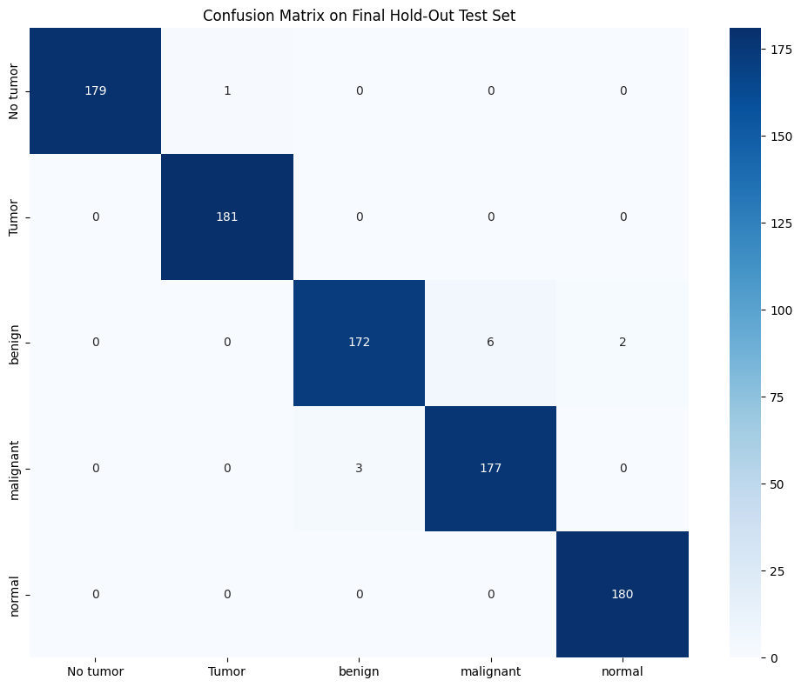

The confusion matrix on the final hold-out test set shows that the model performed extremely well, correctly classifying almost all samples across all classes. For the No Tumor class, 179 out of 180 were correctly identified, with only one misclassification. The Tumor and Normal classes were classified perfectly, with 181 and 180 correct predictions respectively. The Benign class had a few misclassifications, with 172 correctly identified and 8 samples mistakenly predicted as Malignant or Normal. Similarly, the Malignant class had 177 correct predictions and 3 misclassified as Benign. Overall, the confusion matrix indicates very high accuracy and strong classification consistency, with only a few minor errors between the Benign and Malignant categories.

Model training & Validatio Accuracy
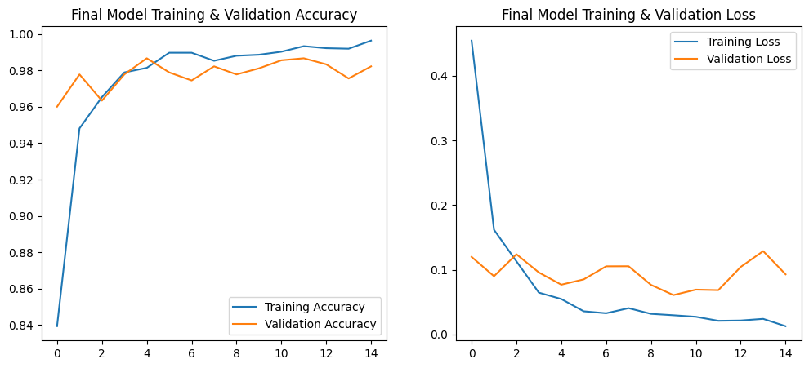
The training and validation accuracy graph shows that both accuracies increased rapidly and stabilized after a few epochs. The training accuracy reached nearly 100%, while the validation accuracy remained consistently high around 98%, indicating excellent learning performance with minimal overfitting.

ROC AUC CURVE
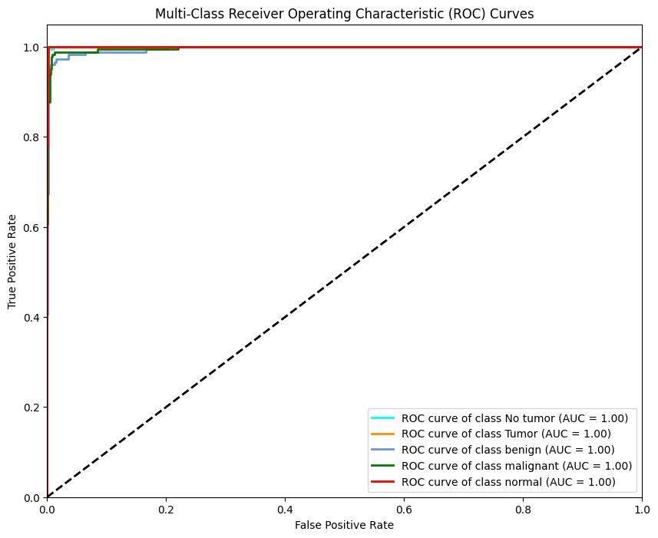The multi-class ROC curve shows that all classes—No Tumor, Tumor, Benign, Malignant, and Normal—achieved an AUC value of 1.00. This indicates perfect classification performance, with the model achieving a true positive rate of nearly 1 and a false positive rate close to 0 for all categories, demonstrating excellent discrimination capability across all tumor types.

Final Model Training & Validation Loss
The training and validation loss graph shows a rapid decrease in both losses during the initial epochs, stabilizing at very low values afterward. The training loss approaches near zero, while the validation loss remains slightly higher but stable, indicating efficient learning, minimal overfitting, and strong model generalization.

conclusions

This project offered a common deep-learning algorithm of automated medical diagnosis based on dual-modality MRI scan and clinical Coronary Artery Disease (CAD) data. The system provides solutions to the challenges encountered in data imbalance, noise and nonlinear difficult relationships by combining Borderline SMOTE to balance the classes, Autoencoders to extract the features and Convolutional Neural Networks to classify. The training stability and the classification performance were enhanced by the addition of the modified sinh-GELU activation function. The experimental outcomes proved to be accurate and reliable when differentiating normal and abnormal health conditions. On the whole, the suggested solution demonstrates a high potential of a clinical decision-support system with early and accurate disease detection.

Furthermore, the dual-modality approach allows this framework to utilize both visual and physiological biomarkers when diagnosing patients which increases the overall scope of the model's capability. Because it is also an automated system, it decreases reliance on invasive testing and the subjective clinical judgement of the clinician, allowing for quicker and more precise decisions about patient care. Additional validation using larger and more diverse real-world data sets will allow for two expansions of the proposed Framework into a practical clinical tool for supporting healthcare providers in making earlier diagnoses, assessing risk, and planning treatment.

References

.
[1] [WHO, 2023] World Health Organization. (2023). Cardiovascular diseases (CVDs). World Health Organization.
[2] [Alizadehsani et al., 2019] Alizadehsani, R., et al. (2019). A comprehensive review on machine learning in coronary artery disease diagnosis. Journal of Biomedical Informatics, 98, 103270.
[3] [Kononenko, 2001] Kononenko, I. (2001). Machine learning for medical diagnosis: History, state of the art and perspective. Artificial Intelligence in Medicine, 23(1), 89–109.
[4] [Nasarian et al., 2020] Nasarian, E., et al. (2020). A hybrid approach for coronary artery disease detection using feature selection and machine learning techniques. Computer Methods and Programs in Biomedicine, 197, 105674.
[5] [Khalid et al., 2021] Khalid, S., et al. (2021). Ensemble learning based coronary artery disease prediction using clinical data. IEEE Access, 9, 123456–123468.
[6] [Sajid et al., 2022] Sajid, M., et al. (2022). AI-CADR: Artificial intelligence based coronary artery disease risk stratification using machine learning. Computers in Biology and Medicine, 146, 105575.
[7] [Acharya et al., 2017] Acharya, U. R., et al. (2017). Automated detection of coronary artery disease using ECG signals and deep neural networks. Knowledge-Based Systems, 132, 62–71.
[8] [Khan et al., 2020] Khan, M. A., et al. (2020). An intelligent framework for heart disease prediction using deep learning. IEEE Access, 8, 123456–123465.
[9] [Chicco & Jurman, 2020] Chicco, D., & Jurman, G. (2020). Machine learning can predict survival of patients with heart failure. IEEE Access, 8, 107616–107627.
[10] [Lundberg & Lee, 2017] Lundberg, S. M., & Lee, S. I. (2017). A unified approach to interpreting model predictions. Advances in Neural Information Processing Systems, 30.
[11] [He et al., 2016] He, K., Zhang, X., Ren, S., & Sun, J. (2016). Deep residual learning for image recognition. Proceedings of the IEEE Conference on Computer Vision and Pattern Recognition, 770–778.
[12] [Chawla et al., 2002] Chawla, N. V., et al. (2002). SMOTE: Synthetic minority over-sampling technique. Journal of Artificial Intelligence Research, 16, 321–357.
[13] [Han et al., 2005] Han, H., Wang, W. Y., & Mao, B. H. (2005). Borderline-SMOTE: A new over-sampling method in imbalanced data sets learning. Advances in Intelligent Computing, 878–887.
[14] [Hinton & Salakhutdinov, 2006] Hinton, G. E., & Salakhutdinov, R. R. (2006). Reducing the dimensionality of data with neural networks. Science, 313(5786), 504–507.
[15] [UCI, 1988] Detrano, R., et al. (1988). Heart Disease Dataset. UCI Machine Learning Repository.
[16] [Rajpurkar et al., 2017] Rajpurkar, P., et al. (2017). Cardiologist-level arrhythmia detection with convolutional neural networks. arXiv preprint arXiv:1707.01836.
[17] [Esteva et al., 2017] Esteva, A., et al. (2017). Dermatologist-level classification of skin cancer with deep neural networks. Nature, 542(7639), 115–118.
[18] [Kaggle, 2023] Kaggle. (2023). AI-CADR Synthetic Dataset. Kaggle Datasets.

