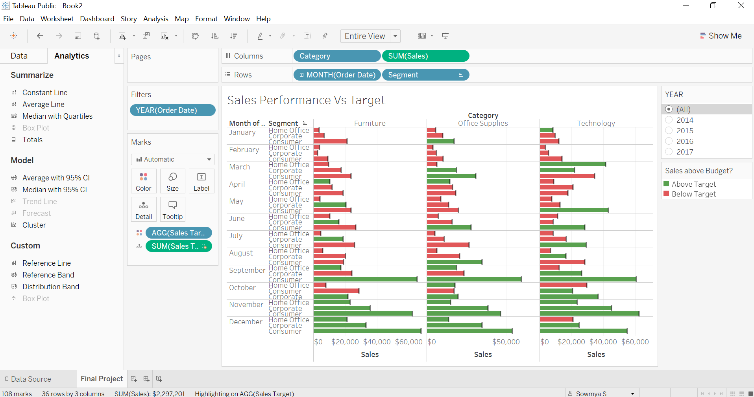

Calculated Field**: Sales Target**

Formula: IF SUM([Sales])> SUM([Sales Target (Sales_Target)].[Sales Target (Sales Target)])THEN 'Above Target'  
ELSE 'Below Target'  
END