Mongo db

Create a student collection with all student details.

Create a batch collection with multiple batches and its corresponding details.

Every batch will contain fields representing students attending the batch on a particular date.

A student will belong to only one batch.

inside the batch collection,Each batch will contain multiple students attending the respective batch.

Questions

Write a query to insert student details in student collection

Write a query to insert batch details in batch collection

Write a query to Mark attendance for the students at respective batch on Jan 23 2020.

Write a query to display the batch details and attendance history of student 1.

Write a query to display the students attending batch1 along with their attendance history

1 && 2

[

  {

    "name": "Saran",

    "batch": "A",

    "class": "10"

  },

  {

    "name": "Ramesh",

    "batch": "B",

    "class": "10"

  },

  {

    "name": "Suresh",

    "batch": "A",

    "class": "10"

  },

  {

    "name": "Sneha",

    "batch": "B",

    "class": "10"

  },

  {

    "name": "Baskar",

    "batch": "A",

    "class": "10"

  },

  {

    "name": "Eswar",

    "batch": "B",

    "class": "10"

  }

]

let b = [

  {

    "batchName": "A",

    "attendance": [

      {

        "date": "21/01/2020",

        "attendees": ["Saran", "Baskar"]

      },

      {

        "date": "28/01/2020",

        "attendees": ["Saran", "Suresh"]

      },

      {

        "date": "29/01/2020",

        "attendees": ["Saran", "Suresh", "Baskar"]

      },

    ]

  },

  {

    "batchName": "B",

    "attendance": [

      {

        "date": "21/01/2020",

        "attendees": ["Ramesh", "Eswar"]

      },

      {

        "date": "28/01/2020",

        "attendees": ["Sneha", "Eswar"]

      },

      {

        "date": "29/01/2020",

        "attendees": ["Ramesh", "Sneha", "Eswar"]

      },

    ]

  },

]

3.db.batch.update({batchName:"A"},{$push: {

"attendance": [

{

"date": "23/01/2020",

"attendees": ["Saran","Suresh","Baskar"]

}

]

}});

4.

[{

$match: {

$and: [{

"batchName": "A"

}, {

"attendance.attendees": {

$in: ["Saran"]

}

}]

}

}, {

$lookup: {

from: "students",

localField: 'string',

foreignField: 'string',

as: 'students'

}

}]

5.[{

$match: {

"batch": "A"

}

}, {

$lookup: {

from: 'batch',

localField: 'string',

foreignField: 'string',

as: 'batch'

}

}]

SQL

Create a schema to represent A Student with all the student details and a Batches with all the batch details with students attending the batches.

Execute the following queries in the schema.

Write a sql query to display a table containing students attending batch1 along with their attendance history

Write a sql query to display a table containing batch details and attendance history of student 1

create table students (id integer PRIMARY KEY, name varchar(100), batch varchar(100),class varchar(10) );

insert into students (id, name, batch,class) values (1, 'Saran', 'A',"10");

insert into students (id, name, batch,class) values (2, 'Ramesh','B',"10");

insert into students (id, name, batch,class) values (3, 'Suresh', 'A',"10");

insert into students (id, name, batch,class) values (4, 'Sneha', 'B',"10");

insert into students (id, name, batch,class) values (5, 'Baskar', 'A',"10");

insert into students (id, name, batch,class) values (6, 'Eswar', 'B',"10");

select \* from students;

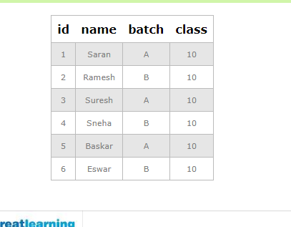

create table batch (id integer PRIMARY KEY,AttendeesId integer, batchName varchar(100), attendeddDate varchar(100) );

insert into batch (id,AttendeesId, batchName, attendeddDate) values (1,1, 'A',"21/01/2020");

insert into batch (id,AttendeesId, batchName, attendeddDate) values (2,5, 'A',"21/01/2020");

insert into batch (id,AttendeesId, batchName, attendeddDate) values (3,1, 'A',"28/01/2020");

insert into batch (id,AttendeesId, batchName, attendeddDate) values (4,3, 'A',"28/01/2020");

insert into batch (id,AttendeesId, batchName, attendeddDate) values (5,1, 'A',"29/01/2020");

insert into batch (id,AttendeesId, batchName, attendeddDate) values (6,3, 'A',"29/01/2020");

insert into batch (id,AttendeesId, batchName, attendeddDate) values (7,5, 'A',"29/01/2020");

insert into batch (id,AttendeesId, batchName, attendeddDate) values (8,2, 'B',"21/01/2020");

insert into batch (id,AttendeesId, batchName, attendeddDate) values (9,6, 'B',"21/01/2020");

insert into batch (id,AttendeesId, batchName, attendeddDate) values (10,4, 'B',"28/01/2020");

insert into batch (id,AttendeesId, batchName, attendeddDate) values (11,6, 'B',"28/01/2020");

insert into batch (id,AttendeesId, batchName, attendeddDate) values (12,2, 'B',"29/01/2020");

insert into batch (id,AttendeesId, batchName, attendeddDate) values (13,4, 'B',"29/01/2020");

insert into batch (id,AttendeesId, batchName, attendeddDate) values (14,6, 'B',"29/01/2020");

select \* from batch;

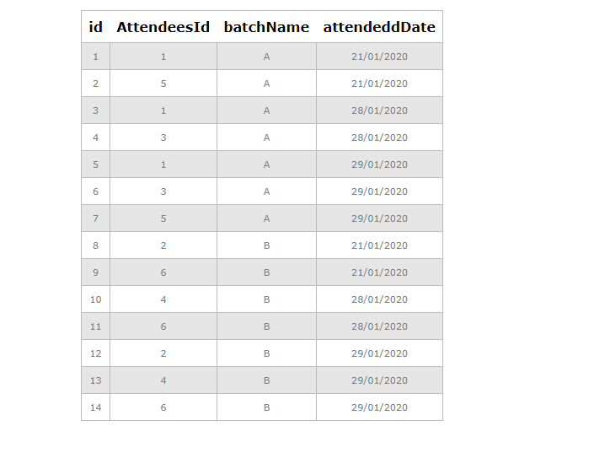

3.select \*,attendeddDate from students join batch on students.id=batch.AttendeesId where batch="A";

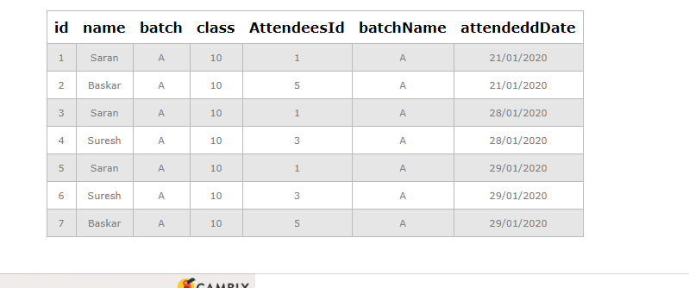

4.select \*,name from batch join students on batch.AttendeesId=students.id where AttendeesId=1;

