**DOCSPOT: Seamless Appointment Booking for Health**

**1. INTRODUCTION**

**1.1 Project Overview**

DocSpot is a full-stack web application that streamlines the process of scheduling appointments with doctors. It caters to both patients and doctors, offering functionalities such as registration, login, appointment booking, doctor availability viewing, and dashboards to manage appointments.

**1.2 Purpose**

The purpose of DocSpot is to digitize and simplify the healthcare appointment system. It reduces waiting times, prevents scheduling conflicts, and improves access to healthcare services for patients.

**2. IDEATION PHASE**

**2.1 Problem Statement**

Traditional healthcare appointment systems are often manual, resulting in long wait times, booking conflicts, and inefficiencies. There is a need for a digital platform to automate this process.

**2.2 Empathy Map Canvas**

* Users: Patients, Doctors
* Think & Feel: Need quick access to healthcare, want an easy system
* Hear: Complaints about delays, confusion in hospital queues
* See: Complex hospital forms, long queues
* Say & Do: Prefer digital interaction, desire flexible booking
* Pain: Wasted time, double booking, no real-time updates
* Gain: Easy scheduling, time-saving, real-time confirmation

**2.3 Brainstorming**

**Ideas considered:**

* Hospital queue system
* Appointment scheduling
* Doctor search by specialization/location
* File upload for patient reports

**3. REQUIREMENT ANALYSIS**

**3.1 Customer Journey Map**

User registers/login → Searches doctors → Views doctor availability → Books appointment → Uploads report → Views dashboard

**3.2 Solution Requirement**

* Functional: Registration, Login, Doctor listing, Booking, Upload, Dashboard
* Non-functional: Responsive UI, Secure login, Fast backend

**3.3 Data Flow Diagram**

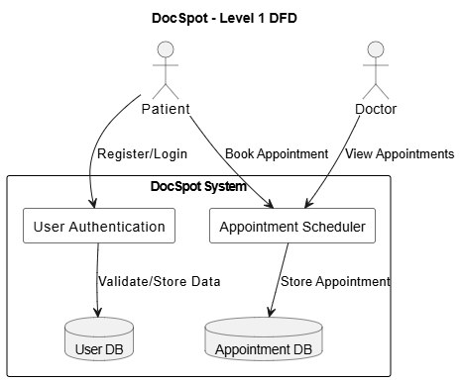

**3.4 Technology Stack**

* Frontend: React.js, Bootstrap
* Backend: Node.js, Express.js
* Database: MongoDB
* Tools: Visual Studio Code, MongoDB Atlas

**4. PROJECT DESIGN**

**4.1 Problem Solution Fit**

The solution directly addresses the appointment management issue through digitization.

**4.2 Proposed Solution**

A full-stack responsive web app that connects doctors and patients and allows easy scheduling.

**4.3 Solution Architecture**

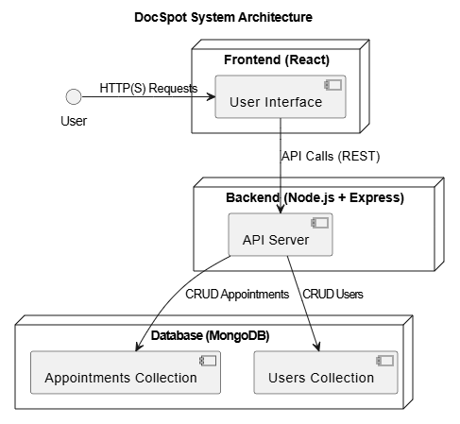

**5. PROJECT PLANNING & SCHEDULING**

**5.1 Project Planning**

| **Phase** | **Task** | **Timeline** |
| --- | --- | --- |
| Week 1 | Ideation & Requirements | 2 days |
| Week 1 | Frontend Development | 3 days |
| Week 2 | Backend Development | 3 days |
| Week 2 | Integration & Testing | 2 days |
| Week 2 | Finalization & Deployment | 2 days |

**6. FUNCTIONAL AND PERFORMANCE TESTING**

**6.1 Functional Testing**

* Registration: Pass
* Login: Pass
* Doctor Listing: Pass
* Appointment Booking: Pass
* Dashboard View: Pass

**6.2 Performance Testing**

* Backend API response time < 300ms
* MongoDB queries optimized

**7. RESULTS**

**7.1 Output Screenshots**

* **Landing Page**

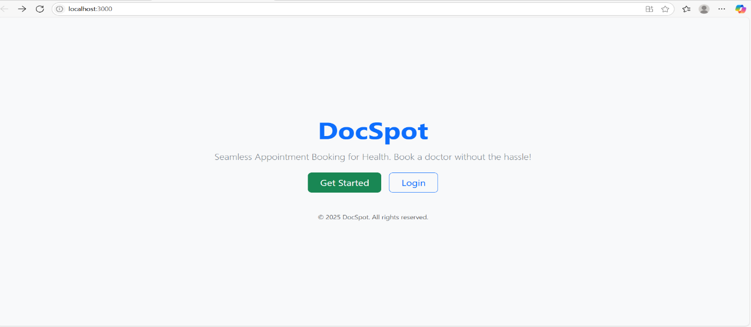

* **Registration page**

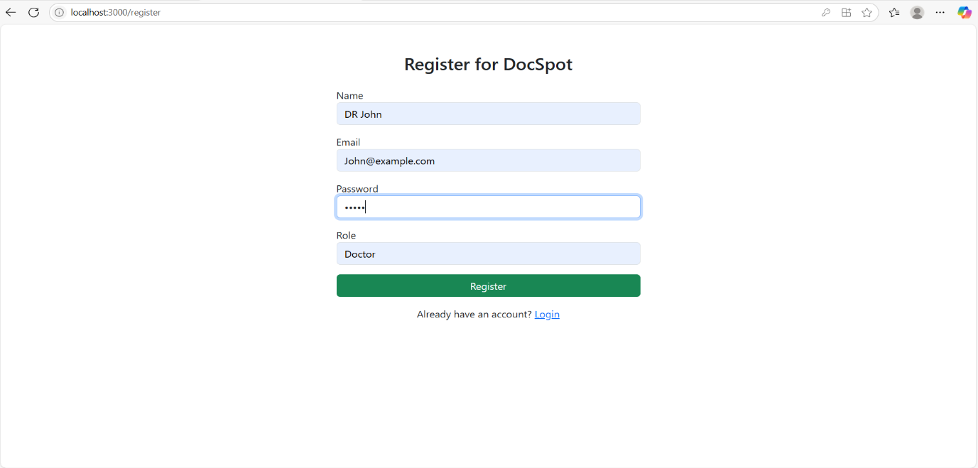

* **Login page**

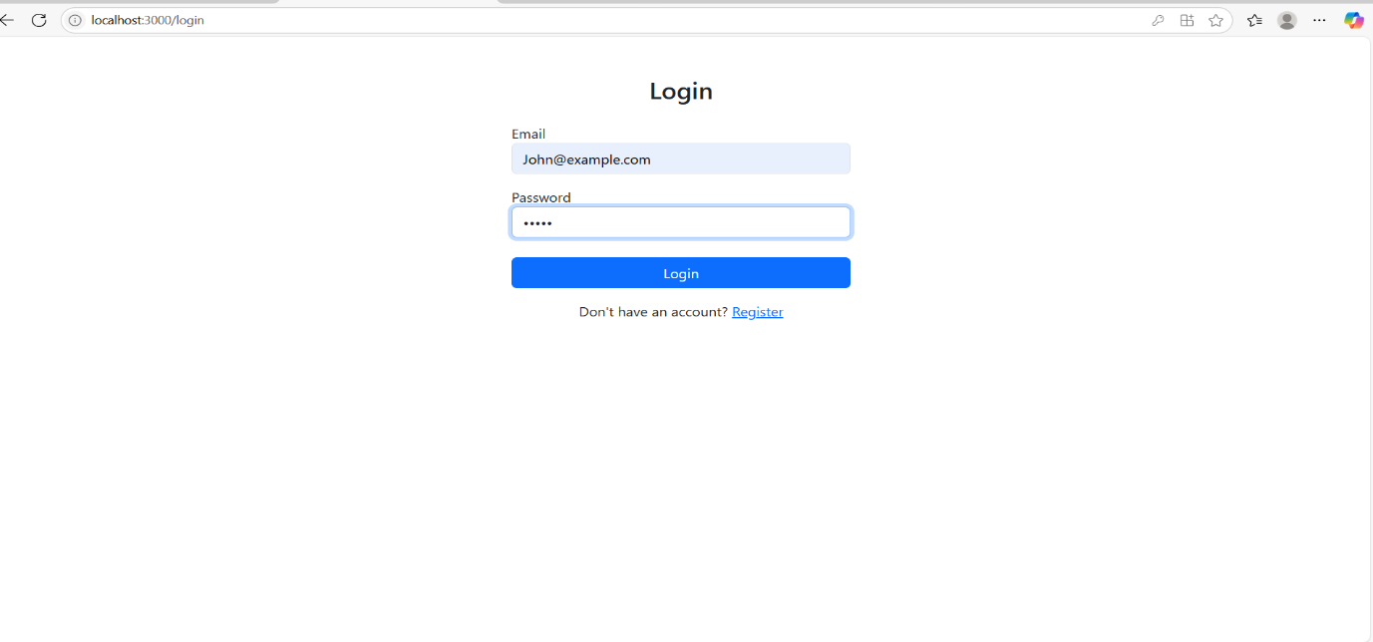

* **DoctorList**

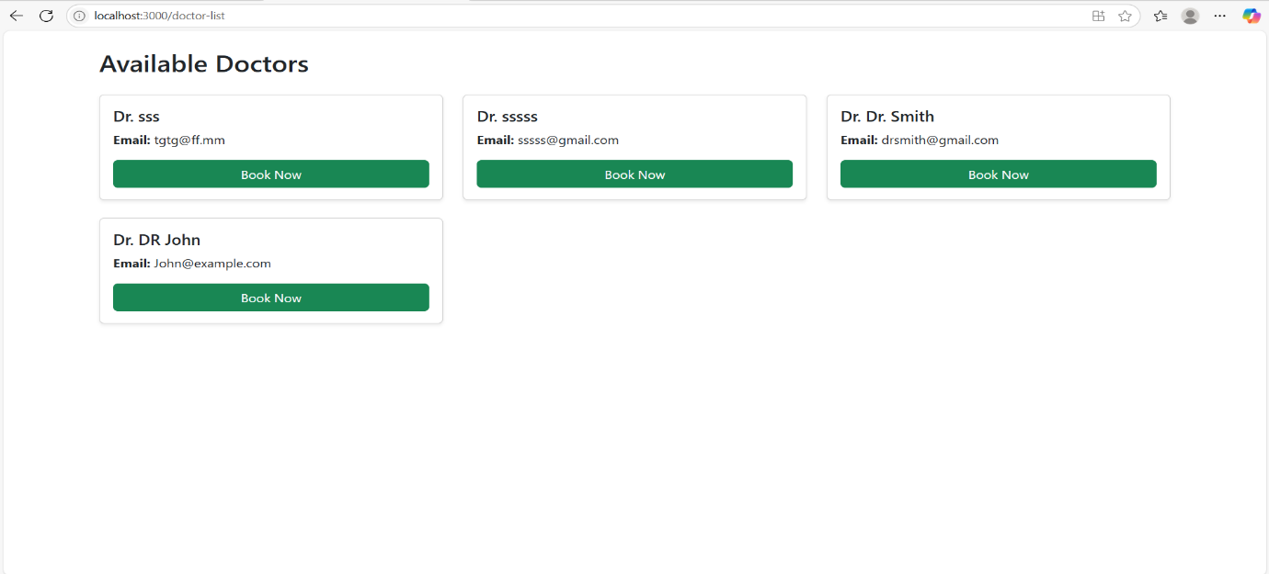

* **Booking Appointment**

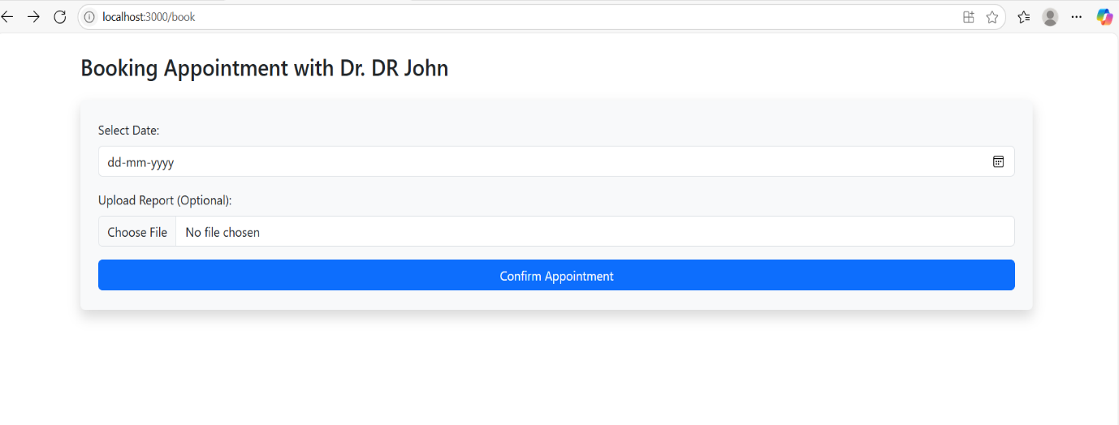

* **Patient dashboard**

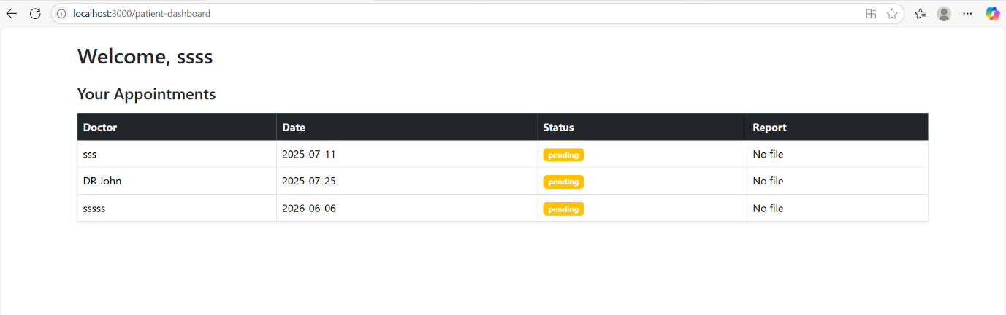

* **Doctor dashboard**

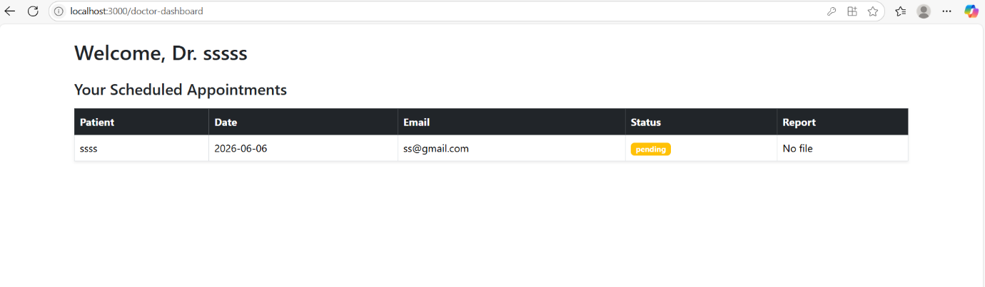

**8. ADVANTAGES & DISADVANTAGES**

**Advantages:**

* Easy to use
* Time-saving
* Accessible 24/7

**Disadvantages:**

* Requires internet access
* Limited to users with digital literacy

**9. CONCLUSION**

DocSpot successfully digitalizes the doctor-patient appointment system and enhances efficiency in the healthcare scheduling domain.

**10. FUTURE SCOPE**

* Add video consultation
* Online payment integration
* Notification system
* Admin panel for hospital staff

**11. APPENDIX**

* Source Code: https://github.com/sowmyabethina/DocSpot