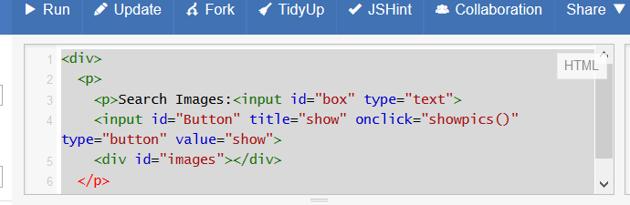

How it works: There is a text box and a button, when-ever we type the text and press the button it searches in Google search API retrieves the respective information from Google and displays the images below.

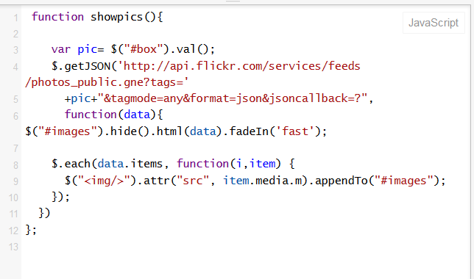

This is the code in JAVA SCRIPT.

Results: Screen Shot

