Question: 1

Created a mashup application using flickr API to search images, facebook API to like the image and twitter API to share the image on twitter.

<http://jsfiddle.net/EXJv2/4/>

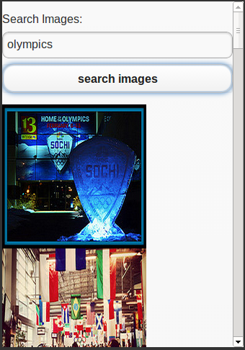

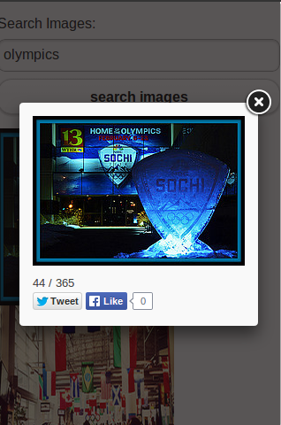

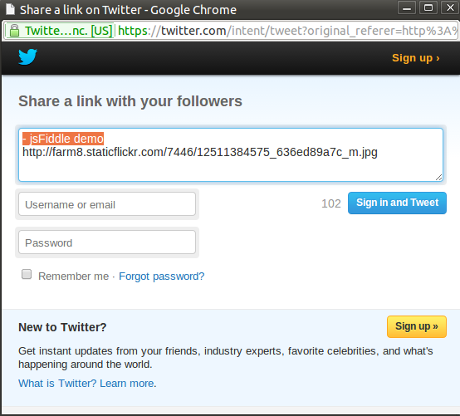

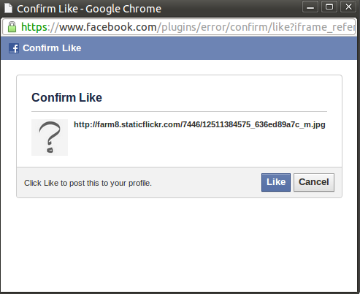

2.

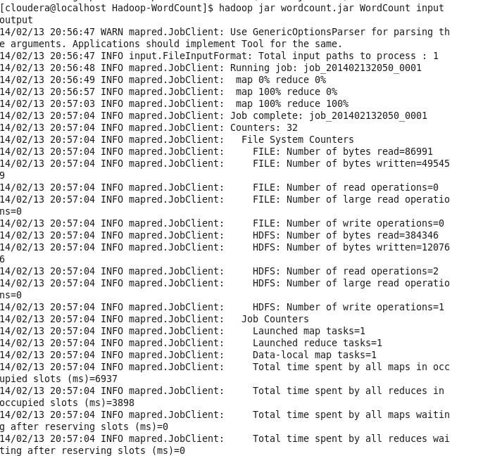

Question: 3