CS5560 Lab Assignment – 4

For Lab4 Assignment, I implemented mahout application for recommendation systems. Recommendation system is created for users who read certain books and they are suggested to read some books of their own interest.

**Screenshots from mahout and mobile application:**

Input data for the mahout project with book id and book name.

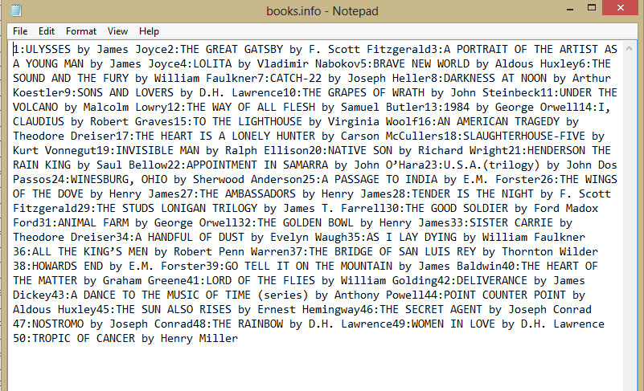

Recommended books id output from mahout project:

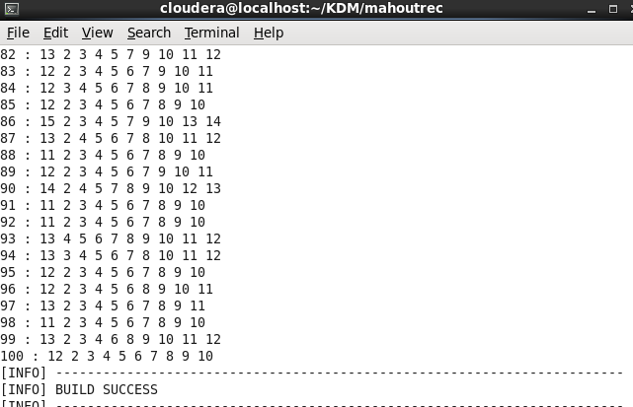

Full file:

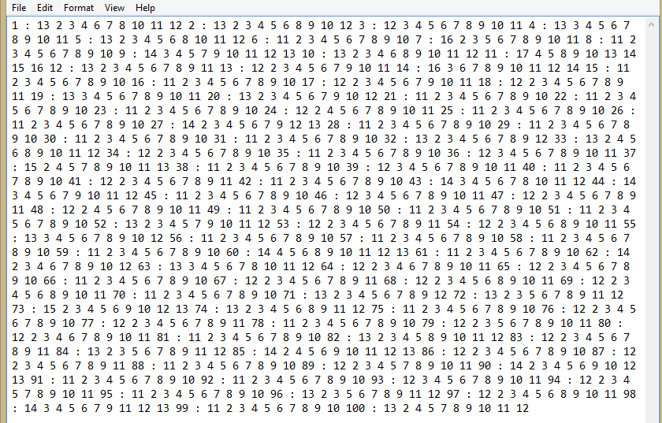

This is given as the input for the Android application:

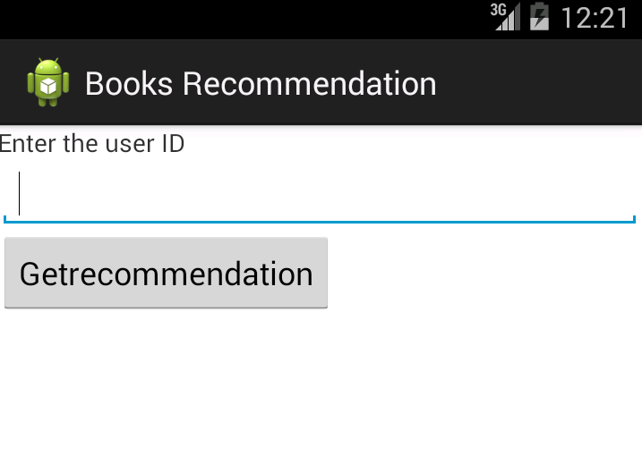

For example ID-6 was entered and its output:

