Lab-3

Task: 1

Made changes to the code HbaseClient.java and sample.java to run on android device. This generates a text file.

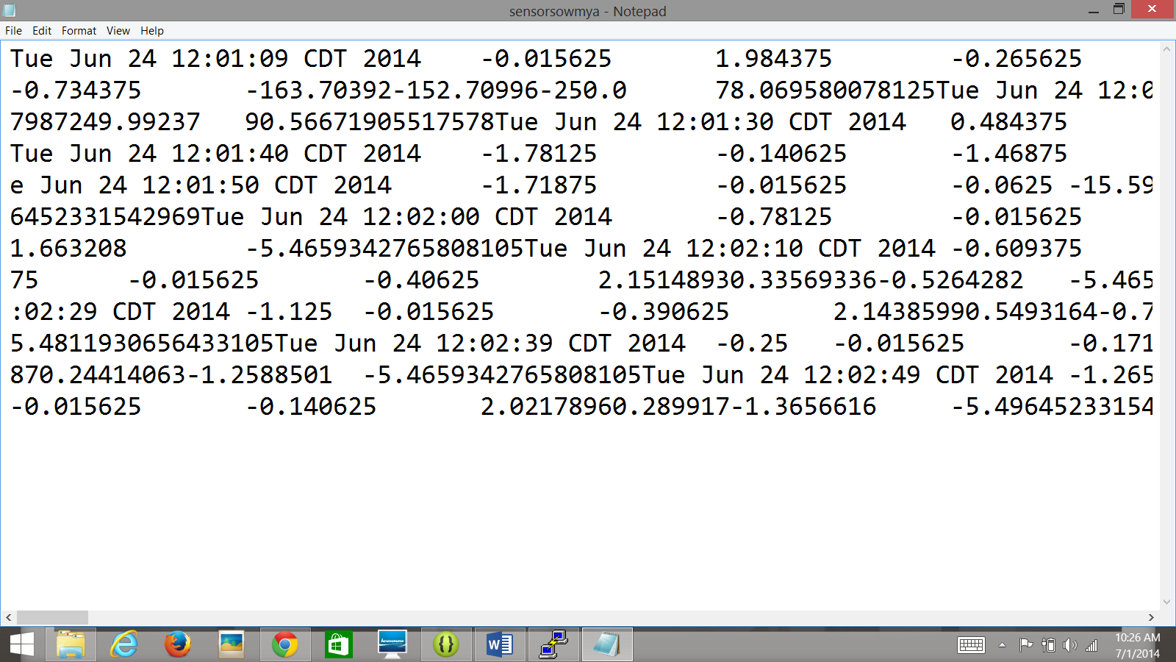

Task: 2

Imported Hbase FrontEnd code from blackboard. And made changes to the code to transfer files from local machine to cloudera. Connection is successfully established.

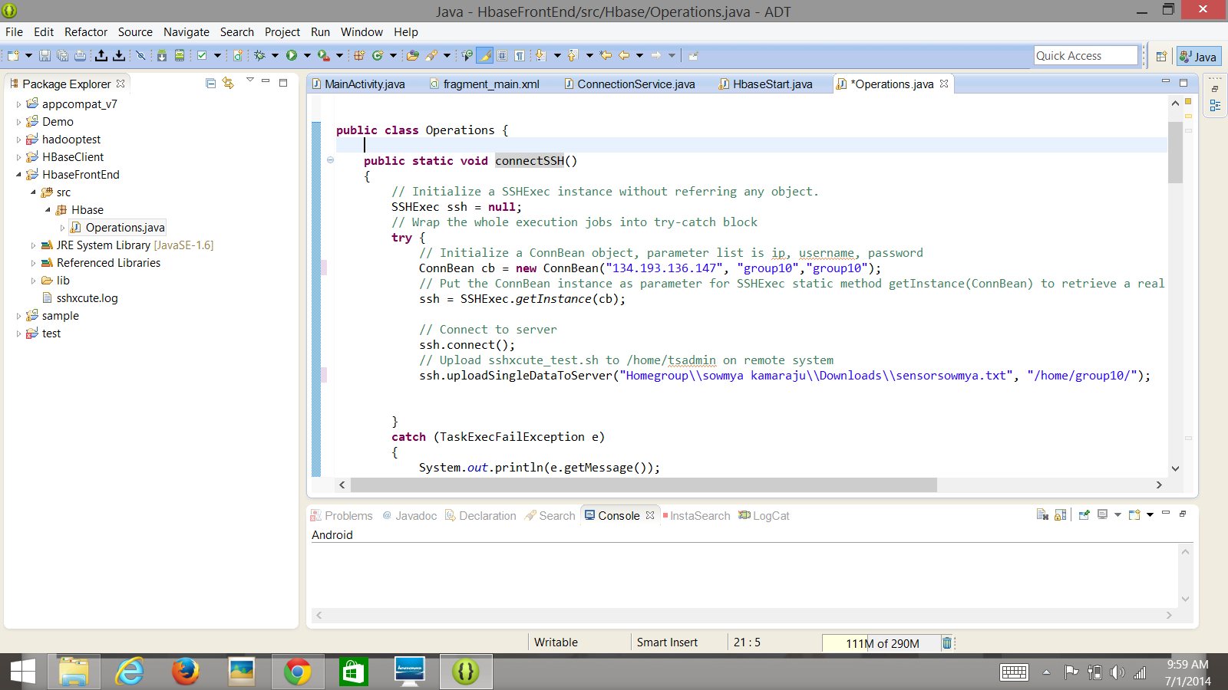

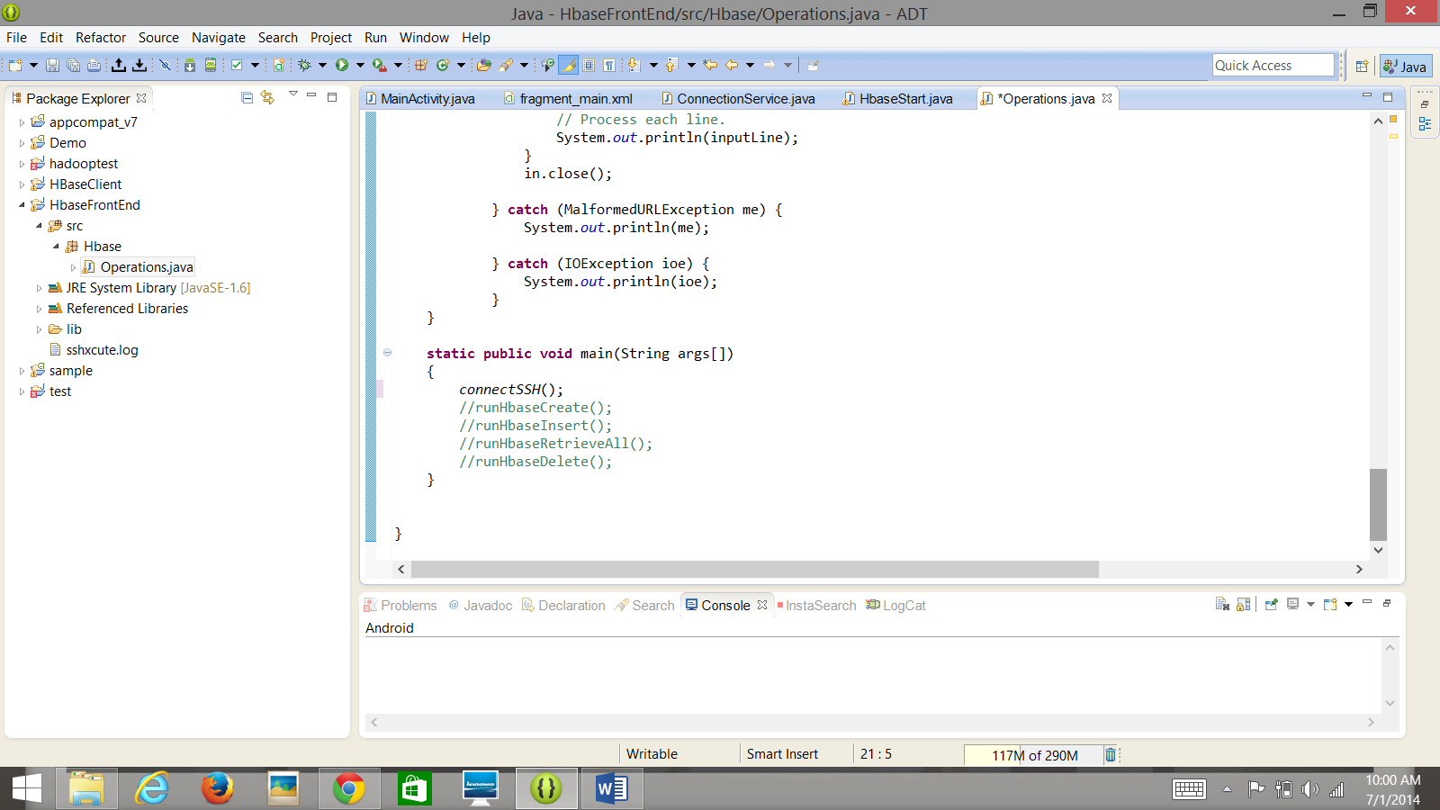

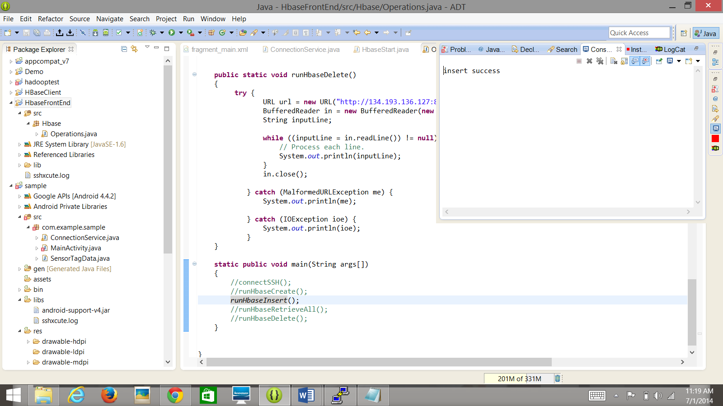

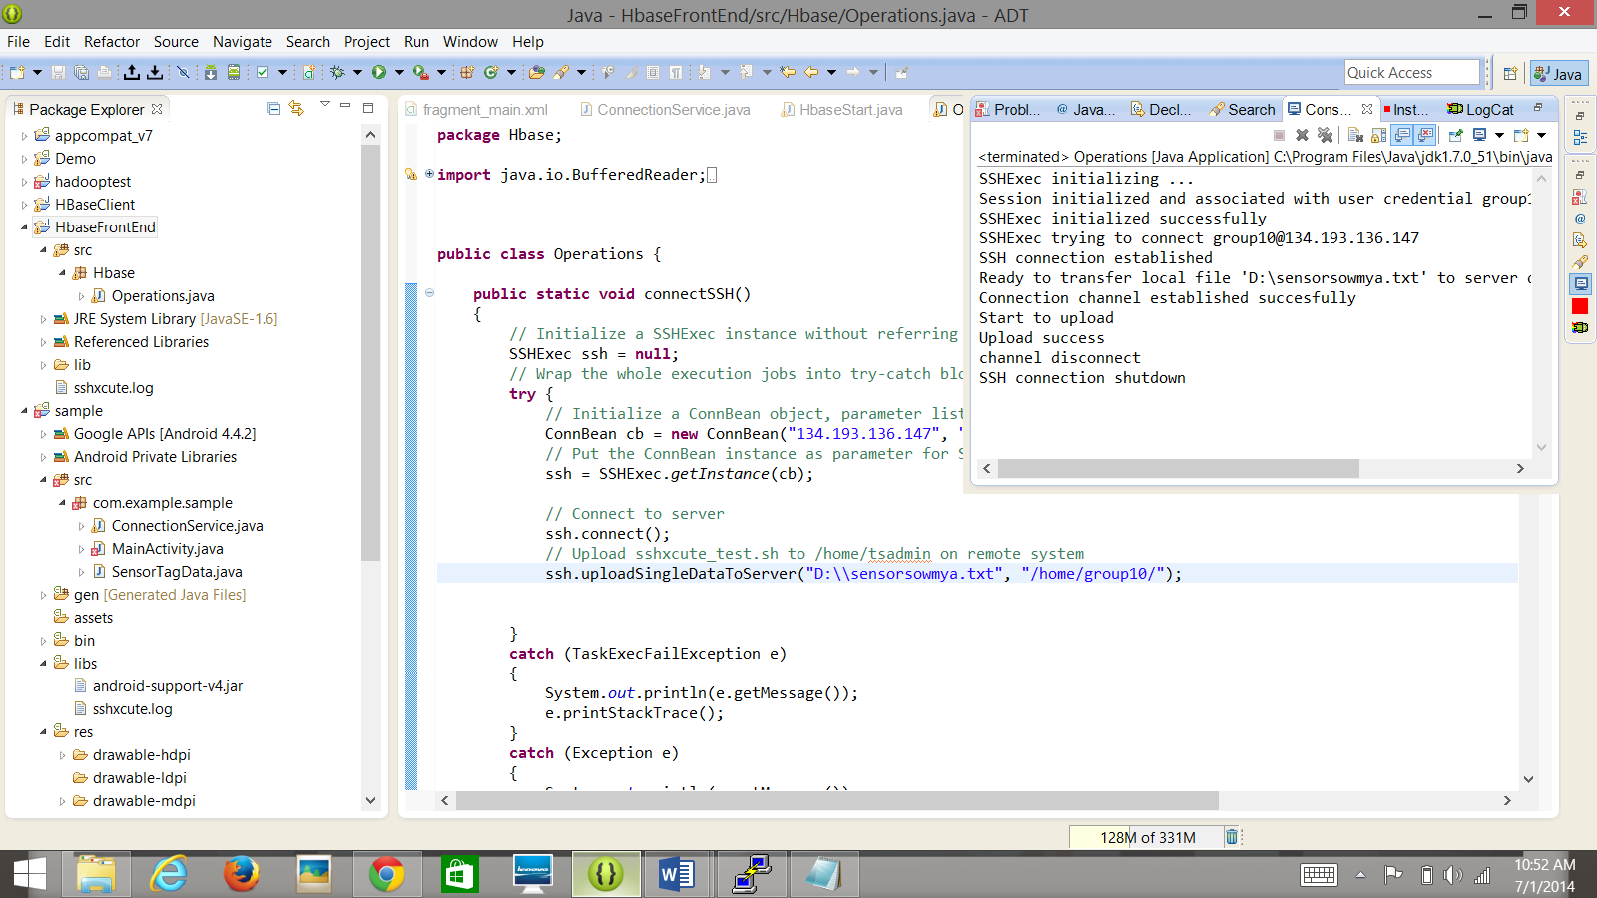

In the Fragment changes are made to the code adding the onClick button.

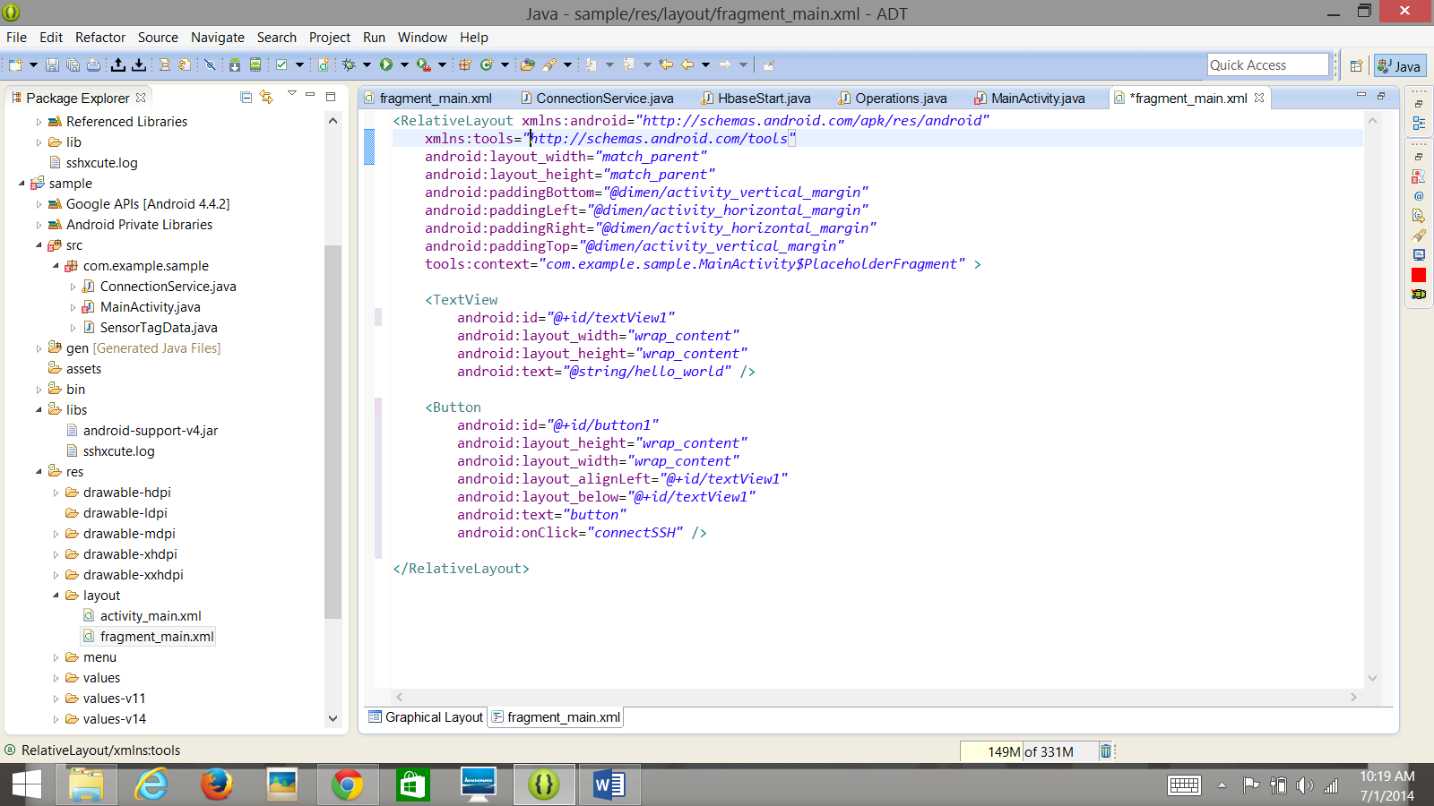

Here is the graphical representation of the button.

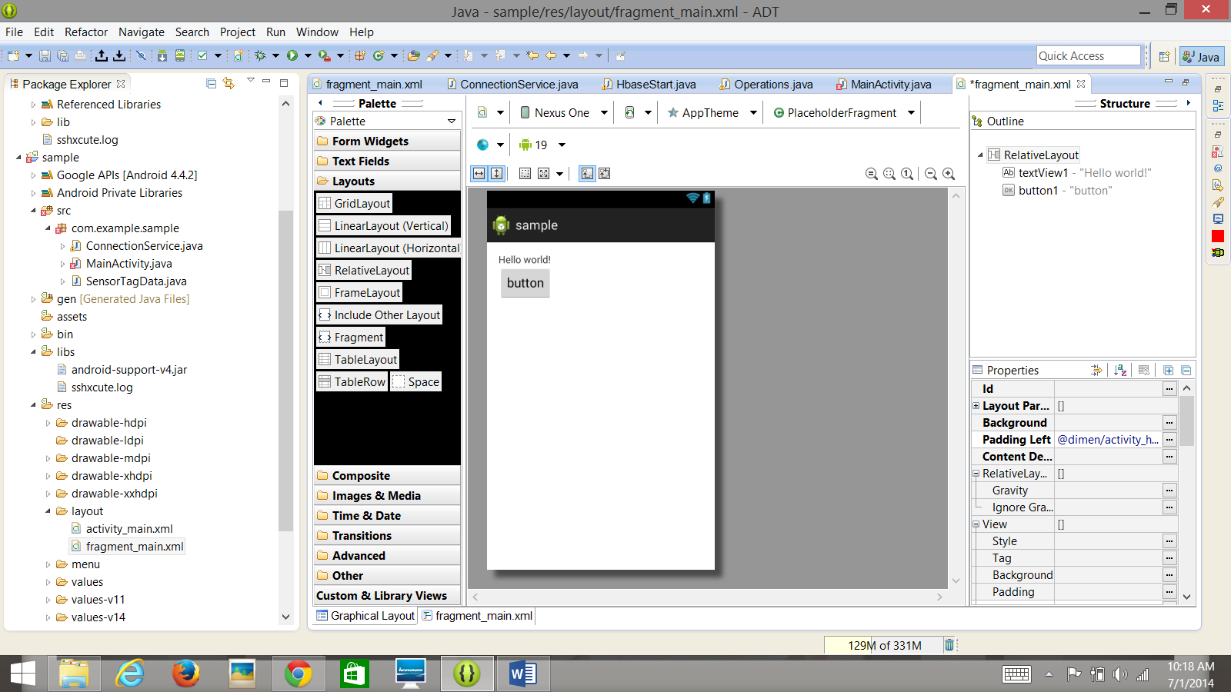

Logged into Putty and typed the command ls. It shows the sensor text file as sensorsowmya.

