Lab-4

Created save and retrieve options in the android app.

Code changes were made to push the created file to ssh and retrieve the file.

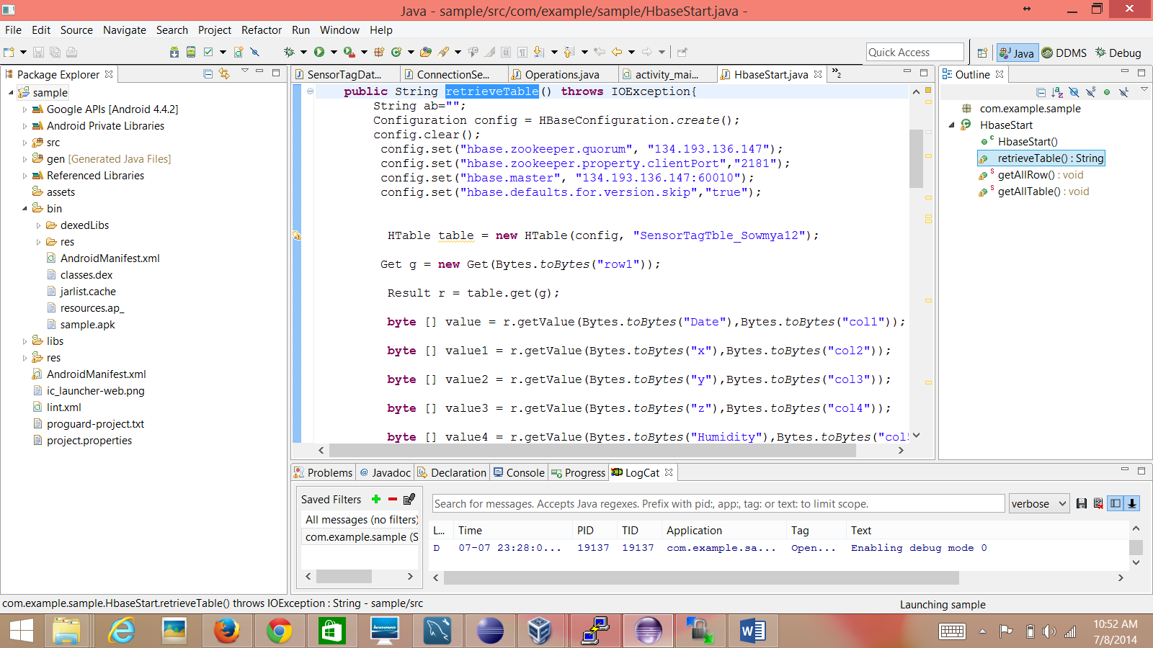

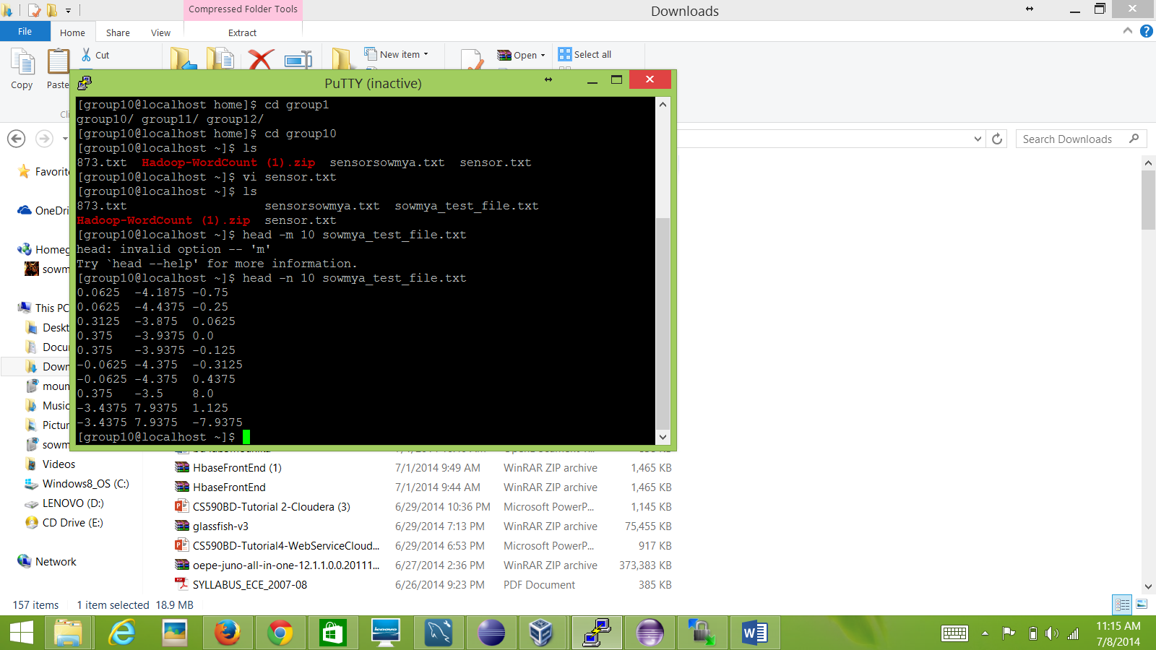

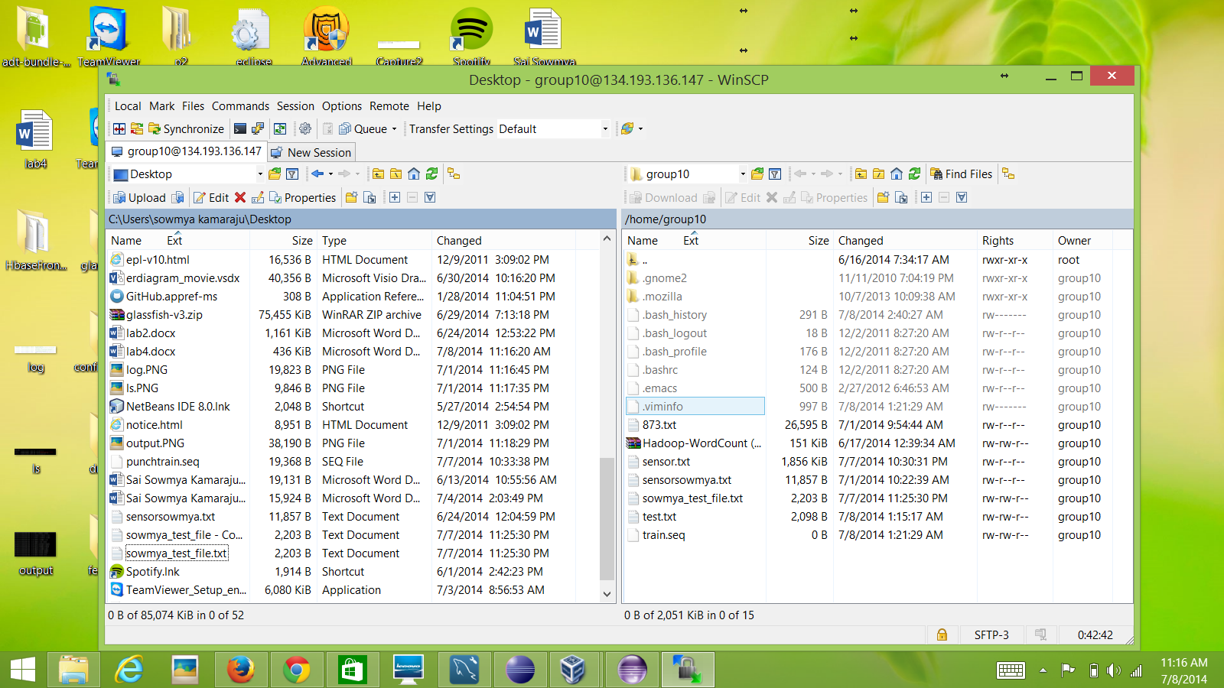

I’m done with all the code enhancements and procedures. But I don’t have the device to run. For now I will upload the code and further enhance my report with the screen shots once I get the device.