**1.The build should trigger as soon as anyone in the dev team checks in code to master branch.**

To achieve this requirement, We need to follow the below steps

At the pipeline level first we need to enable continuous integration option then in branch filters we need include master branch as shown in the below screenshot:

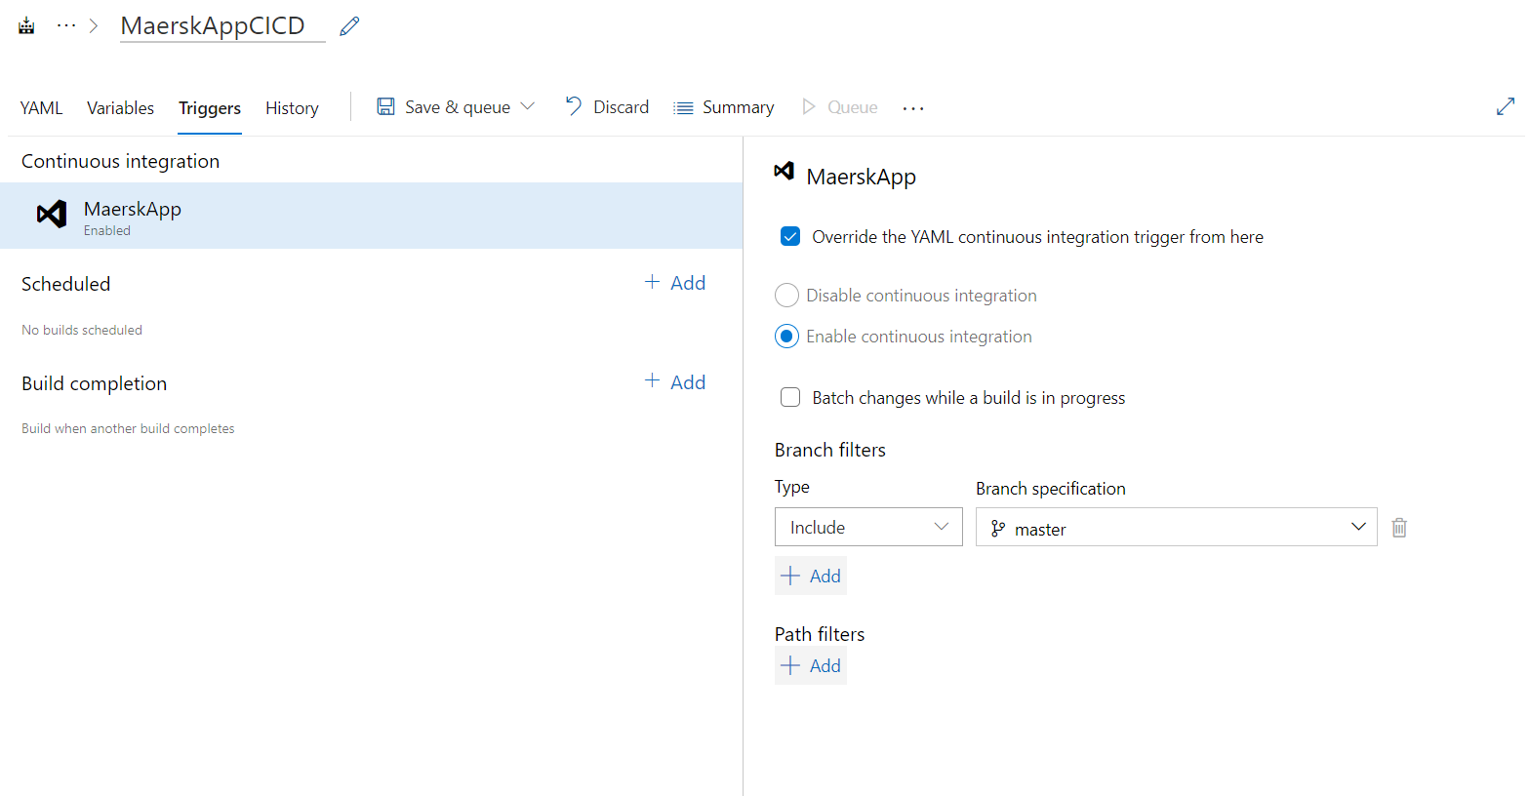

When dev team checks in the code through pull request from their feature branch to master branch

Build will be triggered.

trigger:

  branches:

   include:

   - master

   exclude:

   - feature/*

Upon Pull request from feature to Master,It triggers the master branch and builds starts.

**2) There will be test projects which will create and maintained in the solution along the Web and API.**

**The trigger should build all the 3 projects - Web, API and test. The build should not be successful if any test fails.**

During build process we need one more task for test which validates all the test cases and if it failed to pass the test cases then build will get failed.

**3) The deployment of code and artifacts should be automated to Dev environment.**

After successful build, Build artifacts generates and will publish that artifacts and we will use this artifacts to deploy to multiple stages like Dev,QA and Prod with approvals and checks.

**4) Upon successful deployment to the Dev environment, deployment should be easily promoted to QA and Prod through automated process.**

This can be achieved based on the single build and multi stage deployment where we can control deployment to higher environment with approvals and checks.Also dependson condition in yaml file will allows deployment to higher environment only when deployment is successful in the lower environment.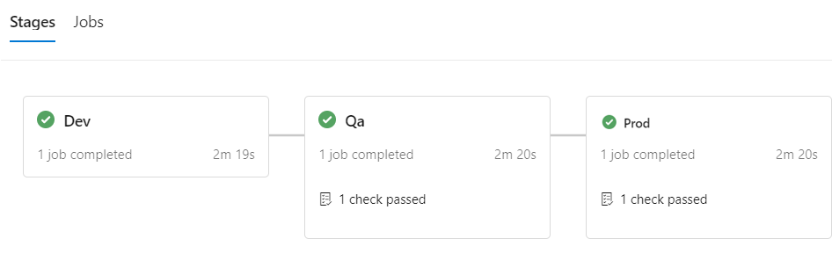

**5) The deployments to QA and Prod should be enabled with Approvals from approvers only.**

This can be achieved using Environments, where we have an option called approval and checks there we can specify approvers name for each stage deployment

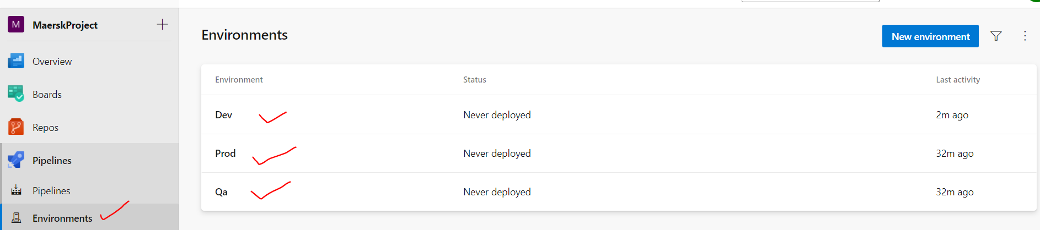

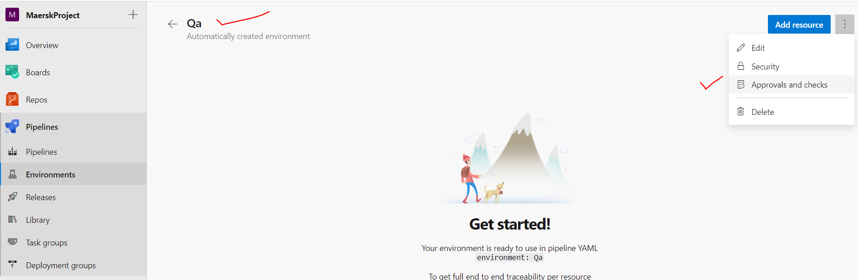

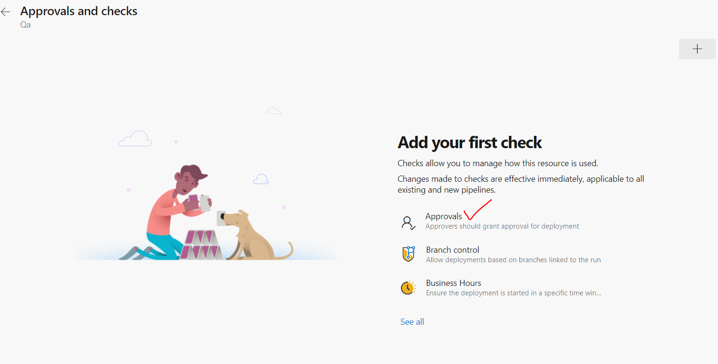

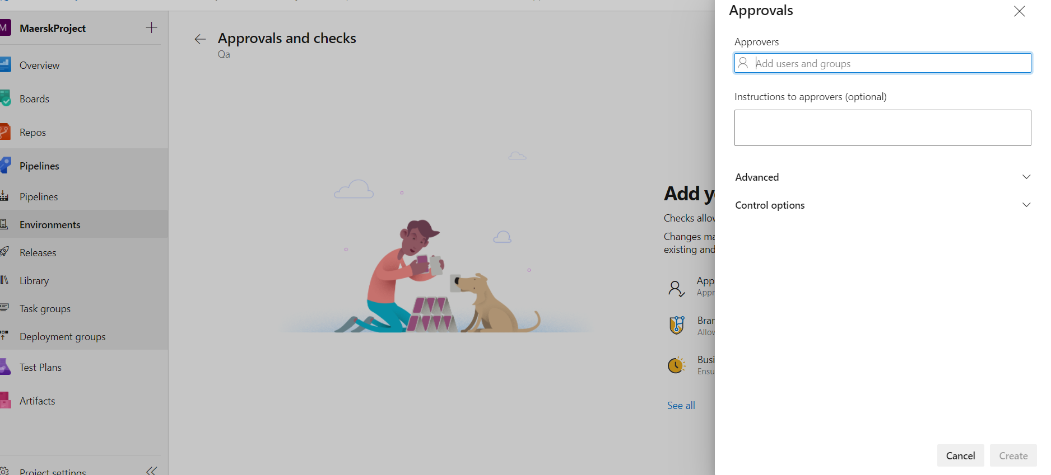

Please find the yaml cicd code mentioned for the above steps.

