DDSAnalytics Project – Case Study 02

#Introduction: This Case Study is about analyzing the workforce planning, employee training programs, identifying high-potential employees and reducing/preventing voluntary employee turnover (attrition) for FritoLAy.  
  
#Description: DDSAnalytics is an analytics company that specializes in talent management solutions for Fortune 100 companies. Talent management is defined as the iterative process of developing and retaining employees. It may include workforce planning, employee training programs, identifying high-potential employees and reducing/preventing voluntary employee turnover (attrition). To gain a competitive edge over its competition, DDSAnalytics is planning to leverage data science for talent management. The executive leadership has identified predicting employee turnover as its first application of data science for talent management. Before the business green lights the project, they have tasked your data science team to conduct an analysis of existing employee data.   
  
#The data set used for this case study analysis consists of 3 Datasets:  
  
#CaseStudy2-data : Dataset consists of the below details:  
#Age:Age of the Employee (numeric)  
#Attrition:Attrition Status of the Employee (Yes/No)  
#Business Travel:Travel required in the job (non numeric)  
#DailyRate:Daily Rate of the Employee (numeric)  
#Department:Department in the company where the Empoyee is working for (non numeric)  
#DistanceFromHome:Distance the employee travels from home to work (numeric)  
#Education:Education level of Employee (numeric)  
#EducationField:Employee Field of study (non numeric)  
#EmployeeCount:Count of Employee per observation (numeric)  
#EmployeeNumber:Employee ID a unique identifier of Employee (numeric)  
#EnvironmentSatisfaction:Employee Satisfaction number (numeric)  
#Gender:Gender of Employee (non numeric Male/Female)  
#HourlyRate:Hourly Rate of Employee (numeric)  
#JobInvolvement:Job involvement of Employee (numeric)  
#JobLevel:Job Level of Employee (numeric)  
#JobRole:Designation of the Employee (non numeric)  
#JobSatisfaction:Job satisfaction of Employee (numeric)  
#MaritalStatus:Marital status of Employee (non numeric)  
#MonthlyIncome:Monthly income of Employee (numeric)  
#MonthlyRate:Monthly rate of employee (numeric)  
#NumCompaniesWorked:Number of companies worked by employee (numeric)  
#Over18:Check if Employee > 18 (Y/N)  
#OverTime:Is the employee working overtime (Yes/No)  
#PercentSalaryHike:Percentage of Salary Hike (numeric)  
#PerformanceRating:Performance Rating (numeric)  
#RelationshipSatisfaction:Employee relationship satisfaction (numeric)  
#StandardHours:Standard work hours of employee (numeric)  
#StockOptionLevel:Stock option level (numeric)  
#TotalWorkingYears:Total work years of experience (numeric)  
#TrainingTimesLastYear:Hours of training last year (numeric)  
#WorkLifeBalance:Work life balance (numeric)  
#YearsAtCompany:Number of years worked in this company (numeric)  
#YearsInCurrentRole:Years of Employee in current role (numeric)  
#YearsSinceLastPromotion:Years of employee since last promotion (numeric)  
#YearsWithCurrManager:Years of employee with same manager (numeric)  
  
#CaseStudy2CompSet No Salary : This is a test dataset to predict the salary of an employee  
#CaseStudy2CompSet No Attrition: This is a test dataset to predict the attrition status of the employee  
  
#The goal of this case study is to analyze the employee dataset of Fritolay to   
#1.Predict Attrition  
#2.Predict the Employee Salary  
#3.Identify the top three factors that contribute to turnover  
#4.Identify any job role specific trends that may exist  
#5.Interesting trends and observations from your analysis  
   
#Libraries loaded for the ANalysis  
library(XML)

## Warning: package 'XML' was built under R version 4.0.3

library(dplyr)

## Warning: package 'dplyr' was built under R version 4.0.3

##   
## Attaching package: 'dplyr'

## The following objects are masked from 'package:stats':  
##   
## filter, lag

## The following objects are masked from 'package:base':  
##   
## intersect, setdiff, setequal, union

library(RCurl)

## Warning: package 'RCurl' was built under R version 4.0.3

library(httr)

## Warning: package 'httr' was built under R version 4.0.3

library(jsonlite)

## Warning: package 'jsonlite' was built under R version 4.0.3

library(tidyverse)

## Warning: package 'tidyverse' was built under R version 4.0.3

## -- Attaching packages --------------------------------------- tidyverse 1.3.0 --

## v ggplot2 3.3.3 v purrr 0.3.4  
## v tibble 3.0.4 v stringr 1.4.0  
## v tidyr 1.1.2 v forcats 0.5.0  
## v readr 1.4.0

## Warning: package 'ggplot2' was built under R version 4.0.4

## Warning: package 'tibble' was built under R version 4.0.3

## Warning: package 'tidyr' was built under R version 4.0.3

## Warning: package 'readr' was built under R version 4.0.3

## Warning: package 'purrr' was built under R version 4.0.3

## Warning: package 'stringr' was built under R version 4.0.3

## Warning: package 'forcats' was built under R version 4.0.3

## -- Conflicts ------------------------------------------ tidyverse_conflicts() --  
## x tidyr::complete() masks RCurl::complete()  
## x dplyr::filter() masks stats::filter()  
## x purrr::flatten() masks jsonlite::flatten()  
## x dplyr::lag() masks stats::lag()

library(naniar)

## Warning: package 'naniar' was built under R version 4.0.3

library(GGally)

## Warning: package 'GGally' was built under R version 4.0.3

## Registered S3 method overwritten by 'GGally':  
## method from   
## +.gg ggplot2

library(ggplot2)  
library(class)  
library(caret)

## Warning: package 'caret' was built under R version 4.0.3

## Loading required package: lattice

##   
## Attaching package: 'caret'

## The following object is masked from 'package:purrr':  
##   
## lift

## The following object is masked from 'package:httr':  
##   
## progress

library(knnp)

## Warning: package 'knnp' was built under R version 4.0.3

##   
## Attaching package: 'knnp'

## The following object is masked from 'package:class':  
##   
## knn

library(e1071)

## Warning: package 'e1071' was built under R version 4.0.3

library(maps)

## Warning: package 'maps' was built under R version 4.0.3

##   
## Attaching package: 'maps'

## The following object is masked from 'package:purrr':  
##   
## map

library(mapproj)

## Warning: package 'mapproj' was built under R version 4.0.3

library(ggcorrplot)

## Warning: package 'ggcorrplot' was built under R version 4.0.3

library(viridis)

## Warning: package 'viridis' was built under R version 4.0.3

## Loading required package: viridisLite

library(gplots)

## Warning: package 'gplots' was built under R version 4.0.4

##   
## Attaching package: 'gplots'

## The following object is masked from 'package:stats':  
##   
## lowess

library(leaps)

## Warning: package 'leaps' was built under R version 4.0.5

library(matrixStats)

##   
## Attaching package: 'matrixStats'

## The following object is masked from 'package:dplyr':  
##   
## count

library(ResourceSelection)

## Warning: package 'ResourceSelection' was built under R version 4.0.4

## ResourceSelection 0.3-5 2019-07-22

library(MASS)

## Warning: package 'MASS' was built under R version 4.0.3

##   
## Attaching package: 'MASS'

## The following object is masked from 'package:dplyr':  
##   
## select

library(glmnet)

## Warning: package 'glmnet' was built under R version 4.0.3

## Loading required package: Matrix

## Warning: package 'Matrix' was built under R version 4.0.3

##   
## Attaching package: 'Matrix'

## The following objects are masked from 'package:tidyr':  
##   
## expand, pack, unpack

## Loaded glmnet 4.1

library(ROCR)

## Warning: package 'ROCR' was built under R version 4.0.4

library(randomForest)

## Warning: package 'randomForest' was built under R version 4.0.4

## randomForest 4.6-14

## Type rfNews() to see new features/changes/bug fixes.

##   
## Attaching package: 'randomForest'

## The following object is masked from 'package:ggplot2':  
##   
## margin

## The following object is masked from 'package:dplyr':  
##   
## combine

library(magrittr)

## Warning: package 'magrittr' was built under R version 4.0.3

##   
## Attaching package: 'magrittr'

## The following object is masked from 'package:purrr':  
##   
## set_names

## The following object is masked from 'package:tidyr':  
##   
## extract

library(tidyr)  
library(plotly)

## Warning: package 'plotly' was built under R version 4.0.4

##   
## Attaching package: 'plotly'

## The following object is masked from 'package:MASS':  
##   
## select

## The following object is masked from 'package:ggplot2':  
##   
## last_plot

## The following object is masked from 'package:httr':  
##   
## config

## The following object is masked from 'package:stats':  
##   
## filter

## The following object is masked from 'package:graphics':  
##   
## layout

library(forcats)  
library(car)

## Warning: package 'car' was built under R version 4.0.3

## Loading required package: carData

## Warning: package 'carData' was built under R version 4.0.3

##   
## Attaching package: 'car'

## The following object is masked from 'package:purrr':  
##   
## some

## The following object is masked from 'package:dplyr':  
##   
## recode

library(ISLR)

## Warning: package 'ISLR' was built under R version 4.0.3

library(olsrr)

## Warning: package 'olsrr' was built under R version 4.0.3

##   
## Attaching package: 'olsrr'

## The following object is masked from 'package:MASS':  
##   
## cement

## The following object is masked from 'package:datasets':  
##   
## rivers

library(OLScurve)

## Warning: package 'OLScurve' was built under R version 4.0.3

library(shiny)

## Warning: package 'shiny' was built under R version 4.0.5

##   
## Attaching package: 'shiny'

## The following object is masked from 'package:jsonlite':  
##   
## validate

library(MASS)  
library(tidyverse)  
  
#Import the Employee Data  
Empl<-read.csv('C:/Sowmya/SMU/04_Doing Data Science/Unit-14 & Unit-15/CaseStudy2-data.csv',header = TRUE)  
Empl_nosal<-read.csv('C:/Sowmya/SMU/04_Doing Data Science/Unit-14 & Unit-15/CaseStudy2CompSet_No_Salary.csv',header = TRUE)  
Empl_No_Attrition<-read.csv('C:/Sowmya/SMU/04_Doing Data Science/Unit-14 & Unit-15/CaseStudy2CompSet_No_Attrition.csv',header = TRUE)  
  
#Quick Peek at the SUmmary of the available dataset  
summary(Empl)

## ID Age Attrition BusinessTravel   
## Min. : 1.0 Min. :18.00 Length:870 Length:870   
## 1st Qu.:218.2 1st Qu.:30.00 Class :character Class :character   
## Median :435.5 Median :35.00 Mode :character Mode :character   
## Mean :435.5 Mean :36.83   
## 3rd Qu.:652.8 3rd Qu.:43.00   
## Max. :870.0 Max. :60.00   
## Daily.Rate Department Distance.From.Home Education   
## Min. : 103.0 Length:870 Min. : 1.000 Min. :1.000   
## 1st Qu.: 472.5 Class :character 1st Qu.: 2.000 1st Qu.:2.000   
## Median : 817.5 Mode :character Median : 7.000 Median :3.000   
## Mean : 815.2 Mean : 9.339 Mean :2.901   
## 3rd Qu.:1165.8 3rd Qu.:14.000 3rd Qu.:4.000   
## Max. :1499.0 Max. :29.000 Max. :5.000   
## EducationField Employee.Count Employee.Number Environment.Satisfaction  
## Length:870 Min. :1 Min. : 1.0 Min. :1.000   
## Class :character 1st Qu.:1 1st Qu.: 477.2 1st Qu.:2.000   
## Mode :character Median :1 Median :1039.0 Median :3.000   
## Mean :1 Mean :1029.8 Mean :2.701   
## 3rd Qu.:1 3rd Qu.:1561.5 3rd Qu.:4.000   
## Max. :1 Max. :2064.0 Max. :4.000   
## Gender Hourly.Rate Job.Involvement Job.Level   
## Length:870 Min. : 30.00 Min. :1.000 Min. :1.000   
## Class :character 1st Qu.: 48.00 1st Qu.:2.000 1st Qu.:1.000   
## Mode :character Median : 66.00 Median :3.000 Median :2.000   
## Mean : 65.61 Mean :2.723 Mean :2.039   
## 3rd Qu.: 83.00 3rd Qu.:3.000 3rd Qu.:3.000   
## Max. :100.00 Max. :4.000 Max. :5.000   
## Job.Role Job.Satisfaction Marital.Status Monthly.Income   
## Length:870 Min. :1.000 Length:870 Min. : 1081   
## Class :character 1st Qu.:2.000 Class :character 1st Qu.: 2840   
## Mode :character Median :3.000 Mode :character Median : 4946   
## Mean :2.709 Mean : 6390   
## 3rd Qu.:4.000 3rd Qu.: 8182   
## Max. :4.000 Max. :19999   
## Monthly.Rate Num.Companies.Worked Over18 OverTime   
## Min. : 2094 Min. :0.000 Length:870 Length:870   
## 1st Qu.: 8092 1st Qu.:1.000 Class :character Class :character   
## Median :14074 Median :2.000 Mode :character Mode :character   
## Mean :14326 Mean :2.728   
## 3rd Qu.:20456 3rd Qu.:4.000   
## Max. :26997 Max. :9.000   
## Percent.Salary.Hike Performance.Rating Relationship.Satisfaction  
## Min. :11.0 Min. :3.000 Min. :1.000   
## 1st Qu.:12.0 1st Qu.:3.000 1st Qu.:2.000   
## Median :14.0 Median :3.000 Median :3.000   
## Mean :15.2 Mean :3.152 Mean :2.707   
## 3rd Qu.:18.0 3rd Qu.:3.000 3rd Qu.:4.000   
## Max. :25.0 Max. :4.000 Max. :4.000   
## Standard.Hours Stock.Option.Level Total.Working.Years Training.Times.Last.Year  
## Min. :80 Min. :0.0000 Min. : 0.00 Min. :0.000   
## 1st Qu.:80 1st Qu.:0.0000 1st Qu.: 6.00 1st Qu.:2.000   
## Median :80 Median :1.0000 Median :10.00 Median :3.000   
## Mean :80 Mean :0.7839 Mean :11.05 Mean :2.832   
## 3rd Qu.:80 3rd Qu.:1.0000 3rd Qu.:15.00 3rd Qu.:3.000   
## Max. :80 Max. :3.0000 Max. :40.00 Max. :6.000   
## Work.Life.Balance Years.At.Company Years.In.Current.Role  
## Min. :1.000 Min. : 0.000 Min. : 0.000   
## 1st Qu.:2.000 1st Qu.: 3.000 1st Qu.: 2.000   
## Median :3.000 Median : 5.000 Median : 3.000   
## Mean :2.782 Mean : 6.962 Mean : 4.205   
## 3rd Qu.:3.000 3rd Qu.:10.000 3rd Qu.: 7.000   
## Max. :4.000 Max. :40.000 Max. :18.000   
## Years.Since.Last.Promotion Years.With.Curr.Manager  
## Min. : 0.000 Min. : 0.00   
## 1st Qu.: 0.000 1st Qu.: 2.00   
## Median : 1.000 Median : 3.00   
## Mean : 2.169 Mean : 4.14   
## 3rd Qu.: 3.000 3rd Qu.: 7.00   
## Max. :15.000 Max. :17.00

str(Empl)

## 'data.frame': 870 obs. of 36 variables:  
## $ ID : int 1 2 3 4 5 6 7 8 9 10 ...  
## $ Age : int 32 40 35 32 24 27 41 37 34 34 ...  
## $ Attrition : chr "No" "No" "No" "No" ...  
## $ BusinessTravel : chr "Travel_Rarely" "Travel_Rarely" "Travel_Frequently" "Travel_Rarely" ...  
## $ Daily.Rate : int 117 1308 200 801 567 294 1283 309 1333 653 ...  
## $ Department : chr "Sales" "Research & Development" "Research & Development" "Sales" ...  
## $ Distance.From.Home : int 13 14 18 1 2 10 5 10 10 10 ...  
## $ Education : int 4 3 2 4 1 2 5 4 4 4 ...  
## $ EducationField : chr "Life Sciences" "Medical" "Life Sciences" "Marketing" ...  
## $ Employee.Count : int 1 1 1 1 1 1 1 1 1 1 ...  
## $ Employee.Number : int 859 1128 1412 2016 1646 733 1448 1105 1055 1597 ...  
## $ Environment.Satisfaction : int 2 3 3 3 1 4 2 4 3 4 ...  
## $ Gender : chr "Male" "Male" "Male" "Female" ...  
## $ Hourly.Rate : int 73 44 60 48 32 32 90 88 87 92 ...  
## $ Job.Involvement : int 3 2 3 3 3 3 4 2 3 2 ...  
## $ Job.Level : int 2 5 3 3 1 3 1 2 1 2 ...  
## $ Job.Role : chr "Sales Executive" "Research Director" "Manufacturing Director" "Sales Executive" ...  
## $ Job.Satisfaction : int 4 3 4 4 4 1 3 4 3 3 ...  
## $ Marital.Status : chr "Divorced" "Single" "Single" "Married" ...  
## $ Monthly.Income : int 4403 19626 9362 10422 3760 8793 2127 6694 2220 5063 ...  
## $ Monthly.Rate : int 9250 17544 19944 24032 17218 4809 5561 24223 18410 15332 ...  
## $ Num.Companies.Worked : int 2 1 2 1 1 1 2 2 1 1 ...  
## $ Over18 : chr "Y" "Y" "Y" "Y" ...  
## $ OverTime : chr "No" "No" "No" "No" ...  
## $ Percent.Salary.Hike : int 11 14 11 19 13 21 12 14 19 14 ...  
## $ Performance.Rating : int 3 3 3 3 3 4 3 3 3 3 ...  
## $ Relationship.Satisfaction : int 3 1 3 3 3 3 1 3 4 2 ...  
## $ Standard.Hours : int 80 80 80 80 80 80 80 80 80 80 ...  
## $ Stock.Option.Level : int 1 0 0 2 0 2 0 3 1 1 ...  
## $ Total.Working.Years : int 8 21 10 14 6 9 7 8 1 8 ...  
## $ Training.Times.Last.Year : int 3 2 2 3 2 4 5 5 2 3 ...  
## $ Work.Life.Balance : int 2 4 3 3 3 2 2 3 3 2 ...  
## $ Years.At.Company : int 5 20 2 14 6 9 4 1 1 8 ...  
## $ Years.In.Current.Role : int 2 7 2 10 3 7 2 0 1 2 ...  
## $ Years.Since.Last.Promotion: int 0 4 2 5 1 1 0 0 0 7 ...  
## $ Years.With.Curr.Manager : int 3 9 2 7 3 7 3 0 0 7 ...

#Checking for Missing Data  
sapply(Empl,function(x) sum(is.na(x)))

## ID Age   
## 0 0   
## Attrition BusinessTravel   
## 0 0   
## Daily.Rate Department   
## 0 0   
## Distance.From.Home Education   
## 0 0   
## EducationField Employee.Count   
## 0 0   
## Employee.Number Environment.Satisfaction   
## 0 0   
## Gender Hourly.Rate   
## 0 0   
## Job.Involvement Job.Level   
## 0 0   
## Job.Role Job.Satisfaction   
## 0 0   
## Marital.Status Monthly.Income   
## 0 0   
## Monthly.Rate Num.Companies.Worked   
## 0 0   
## Over18 OverTime   
## 0 0   
## Percent.Salary.Hike Performance.Rating   
## 0 0   
## Relationship.Satisfaction Standard.Hours   
## 0 0   
## Stock.Option.Level Total.Working.Years   
## 0 0   
## Training.Times.Last.Year Work.Life.Balance   
## 0 0   
## Years.At.Company Years.In.Current.Role   
## 0 0   
## Years.Since.Last.Promotion Years.With.Curr.Manager   
## 0 0

gg_miss_var(Empl)+xlab("Missing Variables")

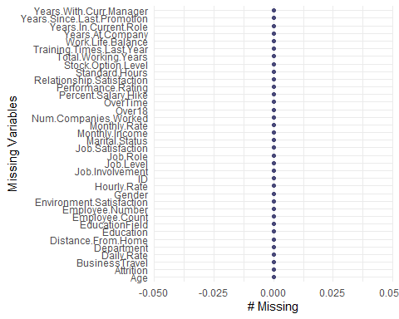

#No missing data found  
  
#Importing the Test Data set  
  
#Importing Test data set to predict Employee Salary  
Empl_Sal<-read.csv('C:/Sowmya/SMU/04_Doing Data Science/Unit-14 & Unit-15/CaseStudy2CompSet_No_Salary.csv',header = TRUE)  
summary(Empl_Sal)

## ID Age Attrition BusinessTravel   
## Min. : 871.0 Min. :18.00 Length:300 Length:300   
## 1st Qu.: 945.8 1st Qu.:29.00 Class :character Class :character   
## Median :1020.5 Median :36.00 Mode :character Mode :character   
## Mean :1020.5 Mean :36.27   
## 3rd Qu.:1095.2 3rd Qu.:42.00   
## Max. :1170.0 Max. :60.00   
## Daily.Rate Department Distance.From.Home Education   
## Min. : 105.0 Length:300 Min. : 1.00 Min. :1.000   
## 1st Qu.: 429.2 Class :character 1st Qu.: 2.00 1st Qu.:2.000   
## Median : 693.0 Mode :character Median : 7.00 Median :3.000   
## Mean : 783.2 Mean : 8.70 Mean :2.887   
## 3rd Qu.:1171.2 3rd Qu.:11.25 3rd Qu.:4.000   
## Max. :1492.0 Max. :29.00 Max. :5.000   
## EducationField Employee.Count Employee.Number Environment.Satisfaction  
## Length:300 Min. :1 Min. : 7 Min. :1.00   
## Class :character 1st Qu.:1 1st Qu.: 477 1st Qu.:2.00   
## Mode :character Median :1 Median :1008 Median :3.00   
## Mean :1 Mean :1014 Mean :2.77   
## 3rd Qu.:1 3rd Qu.:1569 3rd Qu.:4.00   
## Max. :1 Max. :2068 Max. :4.00   
## Gender Hourly.Rate Job.Involvement Job.Level  
## Length:300 Min. : 30.00 Min. :1.000 Min. :1   
## Class :character 1st Qu.: 48.00 1st Qu.:2.000 1st Qu.:1   
## Mode :character Median : 66.00 Median :3.000 Median :2   
## Mean : 66.52 Mean :2.737 Mean :2   
## 3rd Qu.: 85.25 3rd Qu.:3.000 3rd Qu.:2   
## Max. :100.00 Max. :4.000 Max. :5   
## Job.Role Job.Satisfaction Marital.Status Monthly.Rate   
## Length:300 Min. :1.000 Length:300 Min. : 2122   
## Class :character 1st Qu.:2.000 Class :character 1st Qu.: 7778   
## Mode :character Median :3.000 Mode :character Median :13508   
## Mean :2.747 Mean :14091   
## 3rd Qu.:4.000 3rd Qu.:20464   
## Max. :4.000 Max. :26999   
## Num.Companies.Worked Over18 OverTime Percent.Salary.Hike  
## Min. :0.00 Length:300 Length:300 Min. :11.00   
## 1st Qu.:1.00 Class :character Class :character 1st Qu.:12.75   
## Median :2.00 Mode :character Mode :character Median :14.00   
## Mean :2.74 Mean :15.28   
## 3rd Qu.:4.00 3rd Qu.:18.00   
## Max. :9.00 Max. :25.00   
## Performance.Rating Relationship.Satisfaction Standard.Hours Stock.Option.Level  
## Min. :3.00 Min. :1.000 Min. :80 Min. :0.0000   
## 1st Qu.:3.00 1st Qu.:2.000 1st Qu.:80 1st Qu.:0.0000   
## Median :3.00 Median :3.000 Median :80 Median :1.0000   
## Mean :3.16 Mean :2.637 Mean :80 Mean :0.8333   
## 3rd Qu.:3.00 3rd Qu.:4.000 3rd Qu.:80 3rd Qu.:1.0000   
## Max. :4.00 Max. :4.000 Max. :80 Max. :3.0000   
## Total.Working.Years Training.Times.Last.Year Work.Life.Balance  
## Min. : 0.00 Min. :0.00 Min. :1.000   
## 1st Qu.: 6.00 1st Qu.:2.00 1st Qu.:2.000   
## Median : 9.00 Median :3.00 Median :3.000   
## Mean :10.78 Mean :2.82 Mean :2.717   
## 3rd Qu.:14.00 3rd Qu.:3.00 3rd Qu.:3.000   
## Max. :40.00 Max. :6.00 Max. :4.000   
## Years.At.Company Years.In.Current.Role Years.Since.Last.Promotion  
## Min. : 0.000 Min. : 0.0 Min. : 0.00   
## 1st Qu.: 3.000 1st Qu.: 2.0 1st Qu.: 0.00   
## Median : 5.000 Median : 3.0 Median : 1.00   
## Mean : 6.623 Mean : 4.2 Mean : 2.14   
## 3rd Qu.: 9.000 3rd Qu.: 7.0 3rd Qu.: 3.00   
## Max. :33.000 Max. :16.0 Max. :15.00   
## Years.With.Curr.Manager  
## Min. : 0.000   
## 1st Qu.: 2.000   
## Median : 3.000   
## Mean : 3.817   
## 3rd Qu.: 7.000   
## Max. :15.000

str(Empl_Sal)

## 'data.frame': 300 obs. of 35 variables:  
## $ ID : int 871 872 873 874 875 876 877 878 879 880 ...  
## $ Age : int 43 33 55 36 27 39 33 21 30 51 ...  
## $ Attrition : chr "No" "No" "Yes" "No" ...  
## $ BusinessTravel : chr "Travel_Frequently" "Travel_Rarely" "Travel_Rarely" "Non-Travel" ...  
## $ Daily.Rate : int 1422 461 267 1351 1302 895 750 251 1312 1405 ...  
## $ Department : chr "Sales" "Research & Development" "Sales" "Research & Development" ...  
## $ Distance.From.Home : int 2 13 13 9 19 5 22 10 23 11 ...  
## $ Education : int 4 1 4 4 3 3 2 2 3 2 ...  
## $ EducationField : chr "Life Sciences" "Life Sciences" "Marketing" "Life Sciences" ...  
## $ Employee.Count : int 1 1 1 1 1 1 1 1 1 1 ...  
## $ Employee.Number : int 1849 995 1372 1949 1619 42 160 1279 159 1367 ...  
## $ Environment.Satisfaction : int 1 2 1 1 4 4 3 1 1 4 ...  
## $ Gender : chr "Male" "Female" "Male" "Male" ...  
## $ Hourly.Rate : int 92 53 85 66 67 56 95 45 96 82 ...  
## $ Job.Involvement : int 3 3 4 4 2 3 3 2 1 2 ...  
## $ Job.Level : int 2 1 4 1 1 2 2 1 1 4 ...  
## $ Job.Role : chr "Sales Executive" "Research Scientist" "Sales Executive" "Laboratory Technician" ...  
## $ Job.Satisfaction : int 4 4 3 2 1 4 2 3 3 2 ...  
## $ Marital.Status : chr "Married" "Single" "Single" "Married" ...  
## $ Monthly.Rate : int 19246 17241 9277 9238 16290 3335 15480 25308 22310 24439 ...  
## $ Num.Companies.Worked : int 1 3 6 1 1 3 0 1 1 3 ...  
## $ Over18 : chr "Y" "Y" "Y" "Y" ...  
## $ OverTime : chr "No" "No" "Yes" "No" ...  
## $ Percent.Salary.Hike : int 20 18 17 22 11 14 13 20 25 16 ...  
## $ Performance.Rating : int 4 3 3 4 3 3 3 4 4 3 ...  
## $ Relationship.Satisfaction : int 3 1 3 2 1 3 1 3 3 2 ...  
## $ Standard.Hours : int 80 80 80 80 80 80 80 80 80 80 ...  
## $ Stock.Option.Level : int 1 0 0 0 2 1 1 0 3 0 ...  
## $ Total.Working.Years : int 7 5 24 5 7 19 8 2 10 29 ...  
## $ Training.Times.Last.Year : int 5 4 2 3 3 6 2 2 2 1 ...  
## $ Work.Life.Balance : int 3 3 2 3 3 4 4 1 2 2 ...  
## $ Years.At.Company : int 7 3 19 5 7 1 7 2 10 5 ...  
## $ Years.In.Current.Role : int 7 2 7 4 7 0 7 2 7 2 ...  
## $ Years.Since.Last.Promotion: int 7 0 3 0 0 0 0 2 0 0 ...  
## $ Years.With.Curr.Manager : int 7 2 8 2 7 0 7 2 9 3 ...

#Rechecking if the data set has any missing data  
sapply(Empl_Sal,function(x) sum(is.na(x)))

## ID Age   
## 0 0   
## Attrition BusinessTravel   
## 0 0   
## Daily.Rate Department   
## 0 0   
## Distance.From.Home Education   
## 0 0   
## EducationField Employee.Count   
## 0 0   
## Employee.Number Environment.Satisfaction   
## 0 0   
## Gender Hourly.Rate   
## 0 0   
## Job.Involvement Job.Level   
## 0 0   
## Job.Role Job.Satisfaction   
## 0 0   
## Marital.Status Monthly.Rate   
## 0 0   
## Num.Companies.Worked Over18   
## 0 0   
## OverTime Percent.Salary.Hike   
## 0 0   
## Performance.Rating Relationship.Satisfaction   
## 0 0   
## Standard.Hours Stock.Option.Level   
## 0 0   
## Total.Working.Years Training.Times.Last.Year   
## 0 0   
## Work.Life.Balance Years.At.Company   
## 0 0   
## Years.In.Current.Role Years.Since.Last.Promotion   
## 0 0   
## Years.With.Curr.Manager   
## 0

gg_miss_var(Empl_Sal)+xlab("Missing Variables")

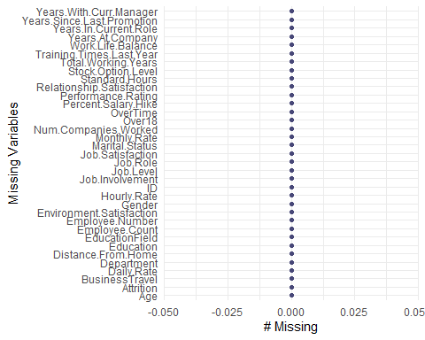

#No Missing data found  
  
#Importing Test data set to predict Employee Attrition  
Empl_Att<-read.csv('C:/Sowmya/SMU/04_Doing Data Science/Unit-14 & Unit-15/CaseStudy2CompSet_No_Attrition.csv',header = TRUE)  
summary(Empl_Att)

## ID Age BusinessTravel Daily.Rate   
## Min. :1171 Min. :19.00 Length:300 Min. : 102.0   
## 1st Qu.:1246 1st Qu.:31.00 Class :character 1st Qu.: 448.0   
## Median :1320 Median :36.00 Mode :character Median : 775.0   
## Mean :1320 Mean :37.86 Mean : 784.8   
## 3rd Qu.:1395 3rd Qu.:44.00 3rd Qu.:1117.0   
## Max. :1470 Max. :60.00 Max. :1490.0   
## Department Distance.From.Home Education EducationField   
## Length:300 Min. : 1.00 Min. :1.000 Length:300   
## Class :character 1st Qu.: 2.00 1st Qu.:2.000 Class :character   
## Mode :character Median : 7.00 Median :3.000 Mode :character   
## Mean : 9.26 Mean :2.973   
## 3rd Qu.:14.00 3rd Qu.:4.000   
## Max. :29.00 Max. :5.000   
## Employee.Count Employee.Number Environment.Satisfaction Gender   
## Min. :1 Min. : 2.0 Min. :1.000 Length:300   
## 1st Qu.:1 1st Qu.: 508.8 1st Qu.:2.000 Class :character   
## Median :1 Median : 994.5 Median :3.000 Mode :character   
## Mean :1 Mean :1020.9 Mean :2.733   
## 3rd Qu.:1 3rd Qu.:1542.5 3rd Qu.:4.000   
## Max. :1 Max. :2065.0 Max. :4.000   
## Hourly.Rate Job.Involvement Job.Level Job.Role   
## Min. : 30.00 Min. :1.000 Min. :1.0 Length:300   
## 1st Qu.: 50.00 1st Qu.:2.000 1st Qu.:1.0 Class :character   
## Median : 66.00 Median :3.000 Median :2.0 Mode :character   
## Mean : 66.07 Mean :2.743 Mean :2.2   
## 3rd Qu.: 83.00 3rd Qu.:3.000 3rd Qu.:3.0   
## Max. :100.00 Max. :4.000 Max. :5.0   
## Job.Satisfaction Marital.Status Monthly.Income Monthly.Rate   
## Min. :1.000 Length:300 Min. : 1232 Min. : 2097   
## 1st Qu.:2.000 Class :character 1st Qu.: 3034 1st Qu.: 8420   
## Median :3.000 Mode :character Median : 5208 Median :15091   
## Mean :2.767 Mean : 7103 Mean :14499   
## 3rd Qu.:4.000 3rd Qu.: 9750 3rd Qu.:20330   
## Max. :4.000 Max. :19973 Max. :26914   
## Num.Companies.Worked Over18 OverTime Percent.Salary.Hike  
## Min. :0.000 Length:300 Length:300 Min. :11.00   
## 1st Qu.:1.000 Class :character Class :character 1st Qu.:12.00   
## Median :2.000 Mode :character Mode :character Median :14.00   
## Mean :2.547 Mean :15.17   
## 3rd Qu.:4.000 3rd Qu.:18.00   
## Max. :9.000 Max. :25.00   
## Performance.Rating Relationship.Satisfaction Standard.Hours Stock.Option.Level  
## Min. :3.000 Min. :1.000 Min. :80 Min. :0.0000   
## 1st Qu.:3.000 1st Qu.:2.000 1st Qu.:80 1st Qu.:0.0000   
## Median :3.000 Median :3.000 Median :80 Median :1.0000   
## Mean :3.153 Mean :2.803 Mean :80 Mean :0.7833   
## 3rd Qu.:3.000 3rd Qu.:4.000 3rd Qu.:80 3rd Qu.:1.0000   
## Max. :4.000 Max. :4.000 Max. :80 Max. :3.0000   
## Total.Working.Years Training.Times.Last.Year Work.Life.Balance  
## Min. : 0.00 Min. :0.000 Min. :1.000   
## 1st Qu.: 6.00 1st Qu.:2.000 1st Qu.:2.000   
## Median :10.00 Median :2.000 Median :3.000   
## Mean :12.44 Mean :2.683 Mean :2.747   
## 3rd Qu.:18.00 3rd Qu.:3.000 3rd Qu.:3.000   
## Max. :38.00 Max. :6.000 Max. :4.000   
## Years.At.Company Years.In.Current.Role Years.Since.Last.Promotion  
## Min. : 0.000 Min. : 0.00 Min. : 0.00   
## 1st Qu.: 3.000 1st Qu.: 2.00 1st Qu.: 0.00   
## Median : 5.000 Median : 3.00 Median : 1.00   
## Mean : 7.527 Mean : 4.33 Mean : 2.29   
## 3rd Qu.:10.000 3rd Qu.: 7.00 3rd Qu.: 3.00   
## Max. :37.000 Max. :18.00 Max. :15.00   
## Years.With.Curr.Manager  
## Min. : 0.00   
## 1st Qu.: 2.00   
## Median : 3.00   
## Mean : 4.38   
## 3rd Qu.: 7.00   
## Max. :17.00

str(Empl_Att)

## 'data.frame': 300 obs. of 35 variables:  
## $ ID : int 1171 1172 1173 1174 1175 1176 1177 1178 1179 1180 ...  
## $ Age : int 35 33 26 55 29 51 52 39 31 31 ...  
## $ BusinessTravel : chr "Travel_Rarely" "Travel_Rarely" "Travel_Rarely" "Travel_Rarely" ...  
## $ Daily.Rate : int 750 147 1330 1311 1246 1456 585 1387 1062 534 ...  
## $ Department : chr "Research & Development" "Human Resources" "Research & Development" "Research & Development" ...  
## $ Distance.From.Home : int 28 2 21 2 19 1 29 10 24 20 ...  
## $ Education : int 3 3 3 3 3 4 4 5 3 3 ...  
## $ EducationField : chr "Life Sciences" "Human Resources" "Medical" "Life Sciences" ...  
## $ Employee.Count : int 1 1 1 1 1 1 1 1 1 1 ...  
## $ Employee.Number : int 1596 1207 1107 505 1497 145 2019 1618 1252 587 ...  
## $ Environment.Satisfaction : int 2 2 1 3 3 1 1 2 3 1 ...  
## $ Gender : chr "Male" "Male" "Male" "Female" ...  
## $ Hourly.Rate : int 46 99 37 97 77 30 40 76 96 66 ...  
## $ Job.Involvement : int 4 3 3 3 2 2 3 3 2 3 ...  
## $ Job.Level : int 2 1 1 4 2 3 1 2 2 3 ...  
## $ Job.Role : chr "Laboratory Technician" "Human Resources" "Laboratory Technician" "Manager" ...  
## $ Job.Satisfaction : int 3 3 3 4 3 1 4 1 1 3 ...  
## $ Marital.Status : chr "Married" "Married" "Divorced" "Single" ...  
## $ Monthly.Income : int 3407 3600 2377 16659 8620 7484 3482 5377 6812 9824 ...  
## $ Monthly.Rate : int 25348 8429 19373 23258 23757 25796 19788 3835 17198 22908 ...  
## $ Num.Companies.Worked : int 1 1 1 2 1 3 2 2 1 3 ...  
## $ Over18 : chr "Y" "Y" "Y" "Y" ...  
## $ OverTime : chr "No" "No" "No" "Yes" ...  
## $ Percent.Salary.Hike : int 17 13 20 13 14 20 15 13 19 12 ...  
## $ Performance.Rating : int 3 3 4 3 3 4 3 3 3 3 ...  
## $ Relationship.Satisfaction : int 4 4 3 3 3 3 2 4 2 1 ...  
## $ Standard.Hours : int 80 80 80 80 80 80 80 80 80 80 ...  
## $ Stock.Option.Level : int 2 1 1 0 2 0 2 3 0 0 ...  
## $ Total.Working.Years : int 10 5 1 30 10 23 16 10 10 12 ...  
## $ Training.Times.Last.Year : int 3 2 0 2 3 1 3 3 2 2 ...  
## $ Work.Life.Balance : int 2 3 2 3 3 2 2 3 3 3 ...  
## $ Years.At.Company : int 10 5 1 5 10 13 9 7 10 1 ...  
## $ Years.In.Current.Role : int 9 4 1 4 7 12 8 7 9 0 ...  
## $ Years.Since.Last.Promotion: int 6 1 0 1 0 12 0 7 1 0 ...  
## $ Years.With.Curr.Manager : int 8 4 0 2 4 8 0 7 8 0 ...

#Rechecking if the data set has any missing data  
sapply(Empl_Att,function(x) sum(is.na(x)))

## ID Age   
## 0 0   
## BusinessTravel Daily.Rate   
## 0 0   
## Department Distance.From.Home   
## 0 0   
## Education EducationField   
## 0 0   
## Employee.Count Employee.Number   
## 0 0   
## Environment.Satisfaction Gender   
## 0 0   
## Hourly.Rate Job.Involvement   
## 0 0   
## Job.Level Job.Role   
## 0 0   
## Job.Satisfaction Marital.Status   
## 0 0   
## Monthly.Income Monthly.Rate   
## 0 0   
## Num.Companies.Worked Over18   
## 0 0   
## OverTime Percent.Salary.Hike   
## 0 0   
## Performance.Rating Relationship.Satisfaction   
## 0 0   
## Standard.Hours Stock.Option.Level   
## 0 0   
## Total.Working.Years Training.Times.Last.Year   
## 0 0   
## Work.Life.Balance Years.At.Company   
## 0 0   
## Years.In.Current.Role Years.Since.Last.Promotion   
## 0 0   
## Years.With.Curr.Manager   
## 0

gg_miss_var(Empl_Att)+xlab("Missing Variables")

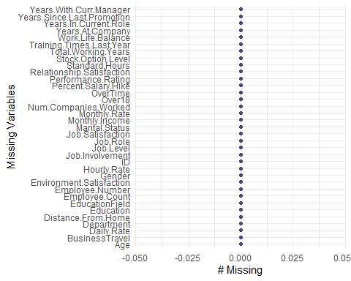

#No Missing data found

## R Markdown

This is an R Markdown document. Markdown is a simple formatting syntax for authoring HTML, PDF, and MS Word documents. For more details on using R Markdown see <http://rmarkdown.rstudio.com>.

When you click the **Knit** button a document will be generated that includes both content as well as the output of any embedded R code chunks within the document. You can embed an R code chunk like this:

#With Attrition as Response  
#Attrition  
Empl%>%  
 ggplot(aes(x=(as.factor(Employee.Count)), fill=Attrition)) +   
 geom_bar(position = "fill") +   
 scale_fill_viridis_d() +  
 ylab("Proposition") +xlab("Attrition")+  
 ggtitle("Proposition subscribed to Attrition")+ theme(axis.text.x = element_text(angle=90, hjust=1))

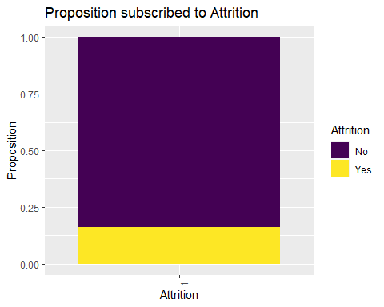

#The overall the attrition rate is 16% for Yes and 84% for No  
  
#Age Vs Attrition  
prop.table(table(Empl$Attrition,Empl$Age),2)

##   
## 18 19 20 21 22 23  
## No 0.33333333 0.42857143 0.25000000 0.66666667 0.62500000 1.00000000  
## Yes 0.66666667 0.57142857 0.75000000 0.33333333 0.37500000 0.00000000  
##   
## 24 25 26 27 28 29  
## No 0.76470588 0.76470588 0.80000000 0.90909091 0.66666667 0.70731707  
## Yes 0.23529412 0.23529412 0.20000000 0.09090909 0.33333333 0.29268293  
##   
## 30 31 32 33 34 35  
## No 0.86486486 0.74358974 0.81578947 0.80000000 0.89473684 0.85416667  
## Yes 0.13513514 0.25641026 0.18421053 0.20000000 0.10526316 0.14583333  
##   
## 36 37 38 39 40 41  
## No 0.88095238 0.90322581 0.97222222 0.83333333 0.89655172 0.84000000  
## Yes 0.11904762 0.09677419 0.02777778 0.16666667 0.10344828 0.16000000  
##   
## 42 43 44 45 46 47  
## No 0.96551724 0.90000000 0.88888889 0.92307692 0.90909091 0.89473684  
## Yes 0.03448276 0.10000000 0.11111111 0.07692308 0.09090909 0.10526316  
##   
## 48 49 50 51 52 53  
## No 0.84615385 0.92857143 0.85714286 0.90909091 0.70000000 0.85714286  
## Yes 0.15384615 0.07142857 0.14285714 0.09090909 0.30000000 0.14285714  
##   
## 54 55 56 57 58 59  
## No 1.00000000 0.91666667 0.80000000 1.00000000 0.57142857 1.00000000  
## Yes 0.00000000 0.08333333 0.20000000 0.00000000 0.42857143 0.00000000  
##   
## 60  
## No 1.00000000  
## Yes 0.00000000

Empl%>%  
 ggplot(aes(x=Age, fill=Attrition)) +   
 geom_bar(position = "fill") +   
 scale_fill_viridis_d() +  
 ylab("Proposition") +xlab("Attrition")+  
 ggtitle("Proposition subscribed to Attrition by Age")+ theme(axis.text.x = element_text(angle=90, hjust=1))

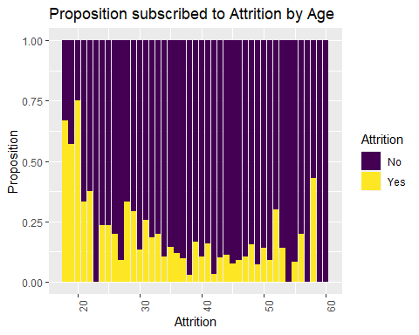

#Attrition Rate seems to be higher for Age < 35 and slowly increases after 50 which is not as much as for ages < 35.  
  
# BusinessTravel vs Attrition  
prop.table(table(Empl$Attrition,Empl$BusinessTravel),2)

##   
## Non-Travel Travel_Frequently Travel_Rarely  
## No 0.8829787 0.7784810 0.8478964  
## Yes 0.1170213 0.2215190 0.1521036

Empl %>%   
 ggplot(aes(x=BusinessTravel, fill=Attrition)) +   
 geom_bar(position="fill") +   
 scale_fill_viridis_d() +  
 ylab("Proportion") +xlab("BusinessTravel")+  
 ggtitle("Proposition subscribed to Attrition by BusinessTravel")+ theme(axis.text.x = element_text(angle=90, hjust=1))

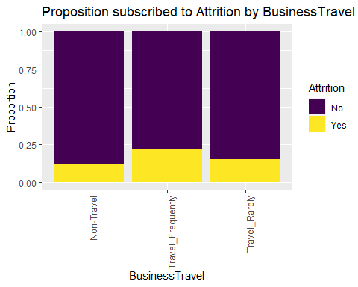

#Attrition Rate seems to be higher for frequent travel jobs preceding by Rarely travel jobs.  
  
# Daily Rate vs Attrition  
t(aggregate(Daily.Rate~Attrition,data=Empl,summary))

## [,1] [,2]   
## Attrition "No" "Yes"   
## Daily.Rate.Min. " 111.0000" " 103.0000"  
## Daily.Rate.1st Qu. " 483.7500" " 428.7500"  
## Daily.Rate.Median " 828.5000" " 751.0000"  
## Daily.Rate.Mean " 821.1603" " 784.2929"  
## Daily.Rate.3rd Qu. "1178.2500" "1110.7500"  
## Daily.Rate.Max. "1499.0000" "1496.0000"

Empl %>%  
 ggplot(aes(x=Attrition, y=log(Daily.Rate), color=Attrition)) +  
 geom_boxplot() +  
 scale_color_viridis_d() +  
 ggtitle("Daily Rate vs Attrition") +  
 xlab("Daily Rate")

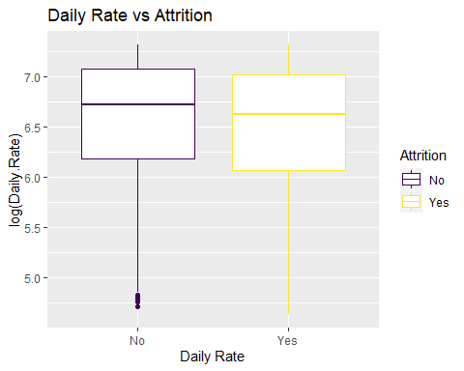

#The Attrition rate is higher for Employees with comparatively lower daily rates  
  
# Department vs Attrition  
prop.table(table(Empl$Attrition,Empl$Department),2)

##   
## Human Resources Research & Development Sales  
## No 0.8285714 0.8665480 0.7838828  
## Yes 0.1714286 0.1334520 0.2161172

Empl %>%   
 ggplot(aes(x=Department, fill=Attrition)) +   
 geom_bar(position="fill") +   
 scale_fill_viridis_d() +  
 ylab("Proportion") +xlab("Department")+  
 ggtitle("Proposition subscribed to Attrition by Department")+ theme(axis.text.x = element_text(angle=90, hjust=1))

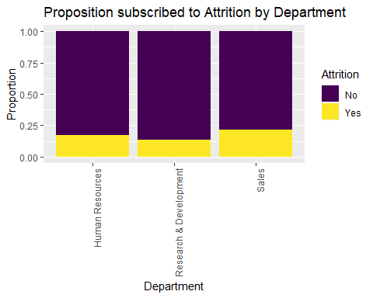

#Attrition Rate seems to be higher for Sales than Human Resources and Research&Development.  
#Research&Development has lower attrition rate.  
  
# Distance From Home vs Attrition  
t(aggregate(Distance.From.Home~Attrition,data=Empl,summary))

## [,1] [,2]   
## Attrition "No" "Yes"   
## Distance.From.Home.Min. " 1.000000" " 1.000000"  
## Distance.From.Home.1st Qu. " 2.000000" " 3.000000"  
## Distance.From.Home.Median " 7.000000" " 9.000000"  
## Distance.From.Home.Mean " 9.028767" "10.957143"  
## Distance.From.Home.3rd Qu. "13.000000" "19.000000"  
## Distance.From.Home.Max. "29.000000" "29.000000"

Empl %>%  
 ggplot(aes(x=Attrition, y=Distance.From.Home, color=Attrition)) +  
 geom_boxplot() +  
 scale_color_viridis_d() +  
 ggtitle("Distance From Home vs Attrition") +  
 xlab("Distance From Home")+  
 ggtitle("Proposition subscribed to Attrition by Distance From Home")+ theme(axis.text.x = element_text(angle=90, hjust=1))

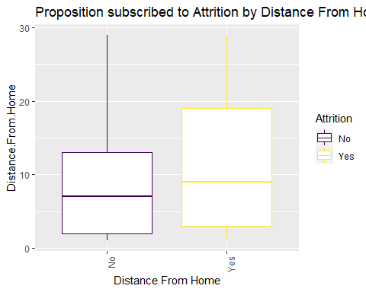

#The Attrition rate is high for Employees who traveled longer distance to work  
  
# Education vs Attrition  
prop.table(table(Empl$Attrition,Empl$Education),2)

##   
## 1 2 3 4 5  
## No 0.8163265 0.8241758 0.8302469 0.8666667 0.8846154  
## Yes 0.1836735 0.1758242 0.1697531 0.1333333 0.1153846

Empl %>%   
 ggplot(aes(x=Education, fill=Attrition)) +   
 geom_bar(position="fill") +   
 scale_fill_viridis_d() +  
 ylab("Proportion") +xlab("Education")+  
 ggtitle("Proposition subscribed to Attrition by Education")+ theme(axis.text.x = element_text(angle=90, hjust=1))

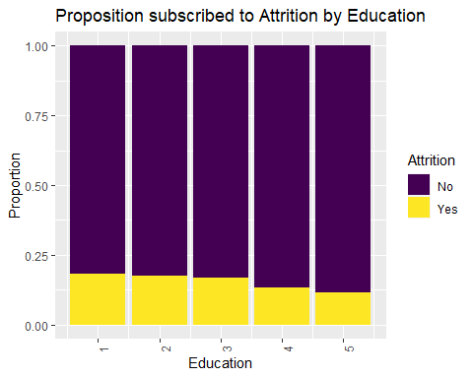

#Attrition Rate is high at Education level 1,2 and 3 than 4 and 5  
  
# Education Field vs Attrition  
prop.table(table(Empl$Attrition,Empl$EducationField),2)

##   
## Human Resources Life Sciences Marketing Medical Other  
## No 0.7333333 0.8519553 0.8000000 0.8629630 0.8269231  
## Yes 0.2666667 0.1480447 0.2000000 0.1370370 0.1730769  
##   
## Technical Degree  
## No 0.7733333  
## Yes 0.2266667

Empl %>%   
 ggplot(aes(x=EducationField, fill=Attrition)) +   
 geom_bar(position="fill") +   
 scale_fill_viridis_d() +  
 ylab("Proportion") +xlab("Education Field")+  
 ggtitle("Proposition subscribed to Attrition by Education Field")+ theme(axis.text.x = element_text(angle=90, hjust=1))

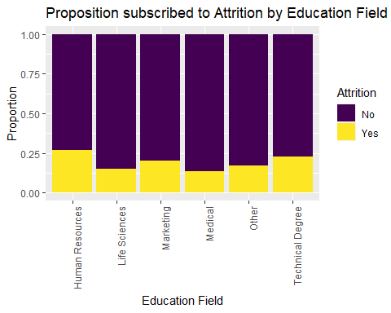

#Attrition Rate seems to be higher for Human Resource,Technical Degree and Marketing. The employees in Education Filed Life science, Medical and other are more content.  
  
#Environment Satisfaction Vs Attrition  
prop.table(table(Empl$Environment.Satisfaction,Empl$Attrition),2)

##   
## No Yes  
## 1 0.1780822 0.3000000  
## 2 0.2109589 0.1714286  
## 3 0.3054795 0.2500000  
## 4 0.3054795 0.2785714

Empl %>%   
 ggplot(aes(x=Environment.Satisfaction, fill=Attrition)) +   
 geom_bar(position="fill") +   
 scale_fill_viridis_d() +  
 ylab("Proportion") +xlab("Environment Satisfaction")+  
 ggtitle("Proposition subscribed to Attrition by Environment Satisfaction")+ theme(axis.text.x = element_text(angle=90, hjust=1))

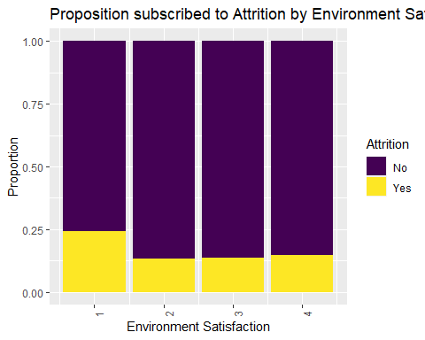

#Attrition Rate seems to be high for Environment Satisfaction level 1 than 2,3 and 4  
  
#Gender Vs Attrition  
prop.table(table(Empl$Gender,Empl$Attrition),2)

##   
## No Yes  
## Female 0.4123288 0.3785714  
## Male 0.5876712 0.6214286

Empl %>%   
 ggplot(aes(x=Gender, fill=Attrition)) +   
 geom_bar(position="fill") +   
 scale_fill_viridis_d() +  
 ylab("Proportion") +xlab("Gender")+  
 ggtitle("Proposition subscribed to Attrition by Gender")+ theme(axis.text.x = element_text(angle=90, hjust=1))

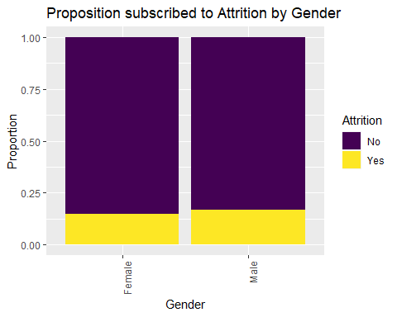

#Attrition Rate seems to be high for Male than Female  
  
# Hourly Rate vs Attrition  
t(aggregate(Hourly.Rate~Attrition,data=Empl,summary))

## [,1] [,2]   
## Attrition "No" "Yes"   
## Hourly.Rate.Min. " 30.00000" " 32.00000"  
## Hourly.Rate.1st Qu. " 48.00000" " 51.00000"  
## Hourly.Rate.Median " 64.50000" " 68.50000"  
## Hourly.Rate.Mean " 65.29178" " 67.29286"  
## Hourly.Rate.3rd Qu. " 82.75000" " 84.00000"  
## Hourly.Rate.Max. "100.00000" "100.00000"

Empl %>%  
 ggplot(aes(x=Attrition, y=log(Hourly.Rate), color=Attrition)) +  
 geom_boxplot() +  
 scale_color_viridis_d() +  
 ggtitle("Hourly.Rate vs Attrition") +  
 xlab("Hourly Rate")+  
 ggtitle("Proposition subscribed to Attrition by Hourly Rate")+ theme(axis.text.x = element_text(angle=90, hjust=1))

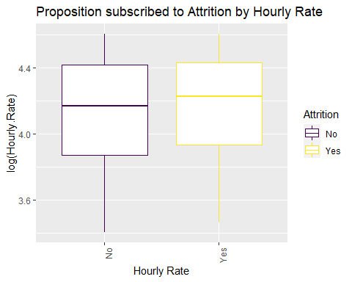

#The Attrition rate is high for Employees who had comparatively higher hourly rate  
  
#Job Involvement Vs Attrition  
prop.table(table(Empl$Job.Involvement,Empl$Attrition),2)

##   
## No Yes  
## 1 0.03424658 0.15714286  
## 2 0.25205479 0.31428571  
## 3 0.61232877 0.47857143  
## 4 0.10136986 0.05000000

Empl %>%   
 ggplot(aes(x=Job.Involvement, fill=Attrition)) +   
 geom_bar(position="fill") +   
 scale_fill_viridis_d() +  
 ylab("Proportion") +xlab("Job Involvement")+  
 ggtitle("Proposition subscribed to Attrition by Job Involvement")+ theme(axis.text.x = element_text(angle=90, hjust=1))

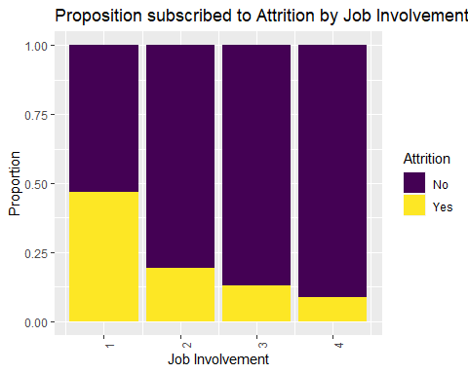

#Attrition Rate seems to be high for Job Involvement 1.Job Involvement level 4 has the least attrition rate.  
  
#Job Level Vs Attrition  
prop.table(table(Empl$Job.Level,Empl$Attrition),2)

##   
## No Yes  
## 1 0.33287671 0.61428571  
## 2 0.38630137 0.21428571  
## 3 0.15753425 0.12142857  
## 4 0.07808219 0.02142857  
## 5 0.04520548 0.02857143

Empl %>%   
 ggplot(aes(x=Job.Level, fill=Attrition)) +   
 geom_bar(position="fill") +   
 scale_fill_viridis_d() +  
 ylab("Proportion") +xlab("Job Level")+  
 ggtitle("Proposition subscribed to Attrition by Job Level")+ theme(axis.text.x = element_text(angle=90, hjust=1))

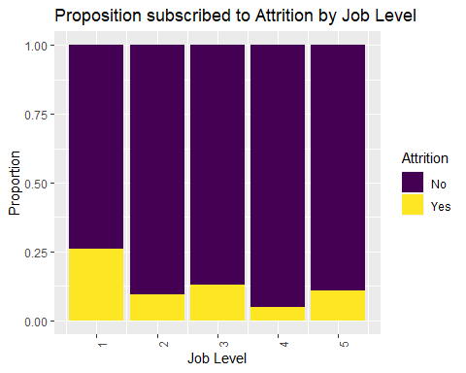

#Attrition Rate seems to be high for Job Level 1. Job level 4 has the lower attrition.  
  
#Job Role Vs Attrition  
prop.table(table(Empl$Job.Role,Empl$Attrition),2)

##   
## No Yes  
## Healthcare Representative 0.093150685 0.057142857  
## Human Resources 0.028767123 0.042857143  
## Laboratory Technician 0.168493151 0.214285714  
## Manager 0.064383562 0.028571429  
## Manufacturing Director 0.116438356 0.014285714  
## Research Director 0.068493151 0.007142857  
## Research Scientist 0.191780822 0.228571429  
## Sales Executive 0.228767123 0.235714286  
## Sales Representative 0.039726027 0.171428571

Empl %>%   
 ggplot(aes(x=Job.Role, fill=Attrition)) +   
 geom_bar(position="fill") +   
 scale_fill_viridis_d() +  
 ylab("Proportion") +xlab("Job Role")+  
 ggtitle("Proposition subscribed to Attrition by Job Role")+ theme(axis.text.x = element_text(angle=90, hjust=1))

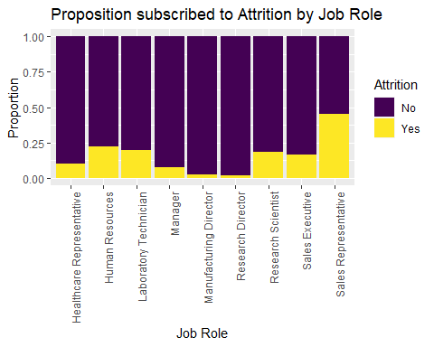

#Attrition Rate seems to be high for Sales Rep and Human Resource.Laboratory Technician,Research Scientist and sales executive are the next in row for attrition.Manufacturing Director & Research Director are more content with their job.  
  
#Job Satisfaction Vs Attrition  
prop.table(table(Empl$Job.Satisfaction,Empl$Attrition),2)

##   
## No Yes  
## 1 0.1931507 0.2714286  
## 2 0.1849315 0.2214286  
## 3 0.2890411 0.3071429  
## 4 0.3328767 0.2000000

Empl %>%   
 ggplot(aes(x=Job.Satisfaction, fill=Attrition)) +   
 geom_bar(position="fill") +   
 scale_fill_viridis_d() +  
 ylab("Proportion") +xlab("Job Satisfaction")+  
 ggtitle("Proposition subscribed to Attrition by Job Satisfaction")+ theme(axis.text.x = element_text(angle=90, hjust=1))

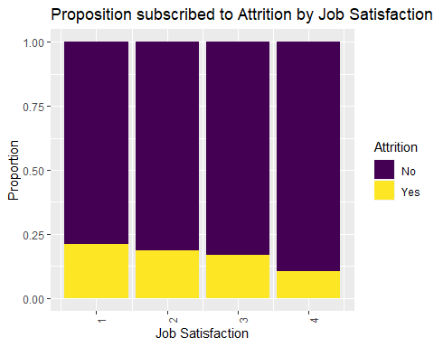

#Attrition Rate seems to be high for Job Satisfaction 1.Job Satisfaction 4 has lowest attrition.  
  
#Marital Status Vs Attrition  
prop.table(table(Empl$Marital.Status,Empl$Attrition),2)

##   
## No Yes  
## Divorced 0.24520548 0.08571429  
## Married 0.48219178 0.41428571  
## Single 0.27260274 0.50000000

Empl %>%   
 ggplot(aes(x=Marital.Status, fill=Attrition)) +   
 geom_bar(position="fill") +   
 scale_fill_viridis_d() +  
 ylab("Proportion") +xlab("Marital Status")+  
 ggtitle("Proposition subscribed to Attrition by Marital Status")+ theme(axis.text.x = element_text(angle=90, hjust=1))

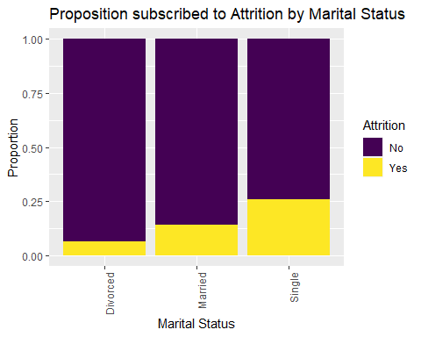

#Attrition Rate seems to be high with Singles  
  
# Monthly Income vs Attrition  
t(aggregate(Monthly.Income~Attrition,data=Empl,summary))

## [,1] [,2]   
## Attrition "No" "Yes"   
## Monthly.Income.Min. " 1129.000" " 1081.000"  
## Monthly.Income.1st Qu. " 3162.000" " 2341.500"  
## Monthly.Income.Median " 5208.500" " 3171.000"  
## Monthly.Income.Mean " 6702.000" " 4764.786"  
## Monthly.Income.3rd Qu. " 8736.500" " 5838.750"  
## Monthly.Income.Max. "19999.000" "19859.000"

Empl %>%  
 ggplot(aes(x=Attrition, y=Monthly.Income, color=Attrition)) +  
 geom_boxplot() +  
 scale_color_viridis_d() +  
 ggtitle("Monthly Income vs Attrition") +  
 xlab("Monthly Income")+  
 ggtitle("Proposition subscribed to Attrition by Monthly Income")+ theme(axis.text.x = element_text(angle=90, hjust=1))

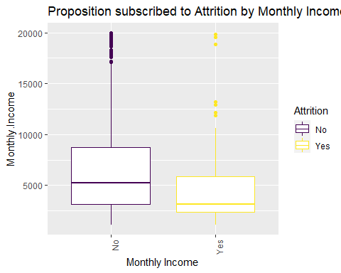

#The Attrition rate is high for Employees who have lower Monthly Income. Higher the monthly income the more content the employees are with their job.  
  
# Monthly Rate vs Attrition  
t(aggregate(Monthly.Rate~Attrition,data=Empl,summary))

## [,1] [,2]   
## Attrition "No" "Yes"   
## Monthly.Rate.Min. " 2094.00" " 2396.00"  
## Monthly.Rate.1st Qu. " 8191.25" " 8054.25"  
## Monthly.Rate.Median "14235.50" "12651.00"  
## Monthly.Rate.Mean "14460.12" "13624.29"  
## Monthly.Rate.3rd Qu. "20644.75" "19498.00"  
## Monthly.Rate.Max. "26997.00" "26959.00"

Empl %>%  
 ggplot(aes(x=Attrition, y=Monthly.Rate, color=Attrition)) +  
 geom_boxplot() +  
 scale_color_viridis_d() +  
 ggtitle("Monthly Rate vs Attrition") +  
 xlab("Monthly Rate")+  
 ggtitle("Proposition subscribed to Attrition by Monthly Rate")+ theme(axis.text.x = element_text(angle=90, hjust=1))

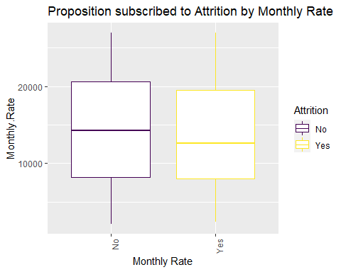

#The Attrition rate is higher for Employees who had comparatively lower monthly rates  
  
#Num Companies Worked Vs Attrition  
prop.table(table(Empl$Num.Companies.Worked,Empl$Attrition),2)

##   
## No Yes  
## 0 0.13698630 0.07857143  
## 1 0.35616438 0.42857143  
## 2 0.08904110 0.06428571  
## 3 0.11232877 0.06428571  
## 4 0.10684932 0.05000000  
## 5 0.04383562 0.07857143  
## 6 0.04109589 0.06428571  
## 7 0.04794521 0.07857143  
## 8 0.03150685 0.03571429  
## 9 0.03424658 0.05714286

Empl %>%   
 ggplot(aes(x=Num.Companies.Worked, fill=Attrition)) +   
 geom_bar(position="fill") +   
 scale_fill_viridis_d() +  
 ylab("Proportion") +xlab("Num Companies Worked")+  
 ggtitle("Proposition subscribed to Attrition by Num Companies Worked")+ theme(axis.text.x = element_text(angle=90, hjust=1))

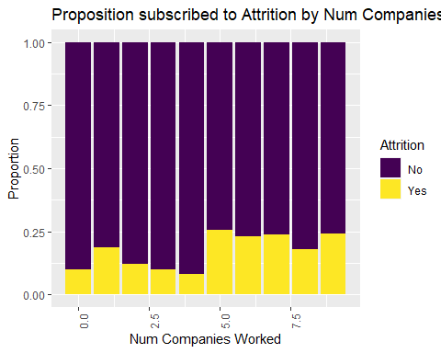

#Attrition Rate seems to be higher for Employees who had worked in 5 or more companies.  
  
#OverTime Worked Vs Attrition  
prop.table(table(Empl$OverTime,Empl$Attrition),2)

##   
## No Yes  
## No 0.7643836 0.4285714  
## Yes 0.2356164 0.5714286

Empl %>%   
 ggplot(aes(x=OverTime, fill=Attrition)) +   
 geom_bar(position="fill") +   
 scale_fill_viridis_d() +  
 ylab("Proportion") +xlab("OverTime")+  
 ggtitle("Proposition subscribed to Attrition by OverTime")+ theme(axis.text.x = element_text(angle=90, hjust=1))

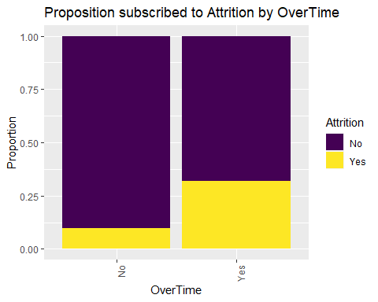

#Attrition Rate seems to be higher for Employees who worked overtime  
  
# Percent Salary vs Attrition  
t(aggregate(Percent.Salary.Hike~Attrition,data=Empl,summary))

## [,1] [,2]   
## Attrition "No" "Yes"   
## Percent.Salary.Hike.Min. "11.00000" "11.00000"  
## Percent.Salary.Hike.1st Qu. "12.00000" "12.00000"  
## Percent.Salary.Hike.Median "14.00000" "14.00000"  
## Percent.Salary.Hike.Mean "15.17534" "15.32857"  
## Percent.Salary.Hike.3rd Qu. "18.00000" "18.00000"  
## Percent.Salary.Hike.Max. "25.00000" "25.00000"

Empl %>%  
 ggplot(aes(x=Attrition, y=Percent.Salary.Hike, color=Attrition)) +  
 geom_boxplot() +  
 scale_color_viridis_d() +  
 ggtitle("Percent Salary Hike vs Attrition") +  
 xlab("Percent Salary Hike")+  
 ggtitle("Proposition subscribed to Attrition by Percent Salary Hike")+ theme(axis.text.x = element_text(angle=90, hjust=1))

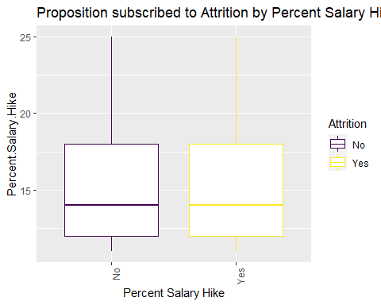

#Not much difference on the attrition rate  
  
# Performance Rating vs Attrition  
prop.table(table(Empl$Performance.Rating,Empl$Attrition),2)

##   
## No Yes  
## 3 0.8506849 0.8357143  
## 4 0.1493151 0.1642857

Empl %>%   
 ggplot(aes(x=as.factor(Performance.Rating), fill=Attrition)) +   
 geom_bar(position="fill") +   
 scale_fill_viridis_d() +  
 ylab("Proportion") +xlab("Performance Rating")+  
 ggtitle("Proposition subscribed to Attrition by Performance Rating")+ theme(axis.text.x = element_text(angle=90, hjust=1))

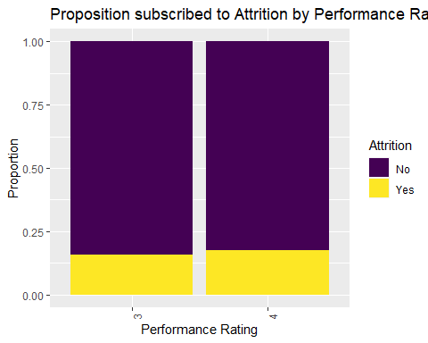

#The Attrition rate is high for Employees who have performance rating 4  
  
#Relationship Satisfaction Vs Attrition  
prop.table(table(Empl$Relationship.Satisfaction,Empl$Attrition),2)

##   
## No Yes  
## 1 0.1904110 0.2500000  
## 2 0.1972603 0.1928571  
## 3 0.3082192 0.2571429  
## 4 0.3041096 0.3000000

Empl %>%   
 ggplot(aes(x=Relationship.Satisfaction, fill=Attrition)) +   
 geom_bar(position="fill") +   
 scale_fill_viridis_d() +  
 ylab("Proportion") +xlab("Relationship Satisfaction")+  
 ggtitle("Proposition subscribed to Attrition by Relationship Satisfaction")+ theme(axis.text.x = element_text(angle=90, hjust=1))

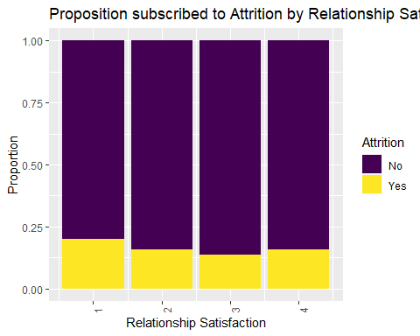

#Attrition Rate seems to be high for Employees who had relationship satisfaction 1  
  
#Stock Option Level Vs Attrition  
prop.table(table(Empl$Stock.Option.Level,Empl$Attrition),2)

##   
## No Yes  
## 0 0.38493151 0.70000000  
## 1 0.44931507 0.19285714  
## 2 0.10684932 0.02142857  
## 3 0.05890411 0.08571429

Empl %>%   
 ggplot(aes(x=Stock.Option.Level, fill=Attrition)) +   
 geom_bar(position="fill") +   
 scale_fill_viridis_d() +  
 ylab("Proportion") +xlab("Stock Option Level")+  
 ggtitle("Proposition subscribed to Attrition by Stock Option Level")+ theme(axis.text.x = element_text(angle=90, hjust=1))

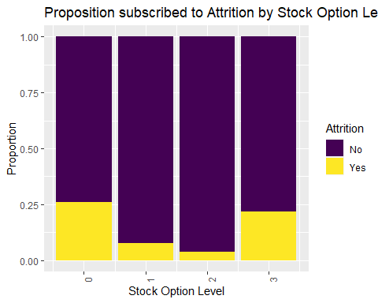

#Attrition Rate seems to be high for Employees who have stock option 0 and 3  
  
# Total Working Years vs Attrition  
t(aggregate(Total.Working.Years~Attrition,data=Empl,summary))

## [,1] [,2]   
## Attrition "No" "Yes"   
## Total.Working.Years.Min. " 0.000000" " 0.000000"  
## Total.Working.Years.1st Qu. " 6.000000" " 3.000000"  
## Total.Working.Years.Median "10.000000" " 6.500000"  
## Total.Working.Years.Mean "11.602740" " 8.185714"  
## Total.Working.Years.3rd Qu. "15.000000" "10.000000"  
## Total.Working.Years.Max. "37.000000" "40.000000"

Empl %>%  
 ggplot(aes(x=Attrition, y=Total.Working.Years, color=Attrition)) +  
 geom_boxplot() +  
 scale_color_viridis_d() +  
 ggtitle("Total Working Years vs Attrition") +  
 xlab("Total Working Years")+  
 ggtitle("Proposition subscribed to Attrition by Total Working Years")+ theme(axis.text.x = element_text(angle=90, hjust=1))

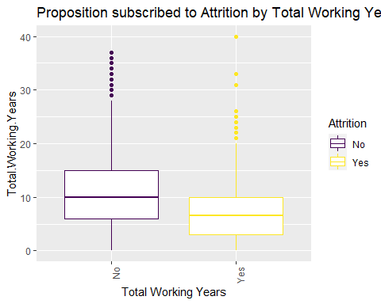

#The Attrition rate is higher for Employees who had less working years. There is an outlier at Total Working Years 40.  
   
# Training Times Last Year vs Attrition  
t(aggregate(Training.Times.Last.Year~Attrition,data=Empl,summary))

## [,1] [,2]   
## Attrition "No" "Yes"   
## Training.Times.Last.Year.Min. "0.000000" "0.000000"  
## Training.Times.Last.Year.1st Qu. "2.000000" "2.000000"  
## Training.Times.Last.Year.Median "3.000000" "2.500000"  
## Training.Times.Last.Year.Mean "2.867123" "2.650000"  
## Training.Times.Last.Year.3rd Qu. "3.000000" "3.000000"  
## Training.Times.Last.Year.Max. "6.000000" "6.000000"

Empl %>%  
 ggplot(aes(x=Attrition, y=Training.Times.Last.Year, color=Attrition)) +  
 geom_boxplot() +  
 scale_color_viridis_d() +  
 ggtitle("Training Times Last Year vs Attrition") +  
 xlab("Total Working Years")+  
 ggtitle("Proposition subscribed to Attrition by Training Times Last Year")+ theme(axis.text.x = element_text(angle=90, hjust=1))

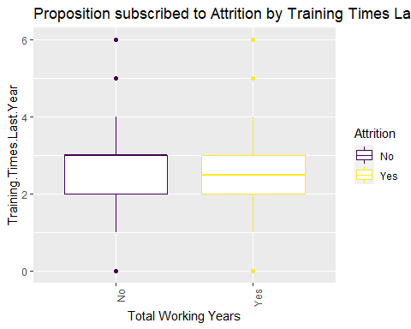

#Not much impact  
  
# Work Life Balance vs Attrition  
prop.table(table(Empl$Work.Life.Balance,Empl$Attrition),2)

##   
## No Yes  
## 1 0.04246575 0.12142857  
## 2 0.22191781 0.21428571  
## 3 0.61917808 0.57142857  
## 4 0.11643836 0.09285714

Empl %>%   
 ggplot(aes(x=Work.Life.Balance, fill=Attrition)) +   
 geom_bar(position="fill") +   
 scale_fill_viridis_d() +  
 ylab("Proportion") +xlab("Work Life Balance")+  
 ggtitle("Proposition subscribed to Attrition by Work Life Balance")+ theme(axis.text.x = element_text(angle=90, hjust=1))

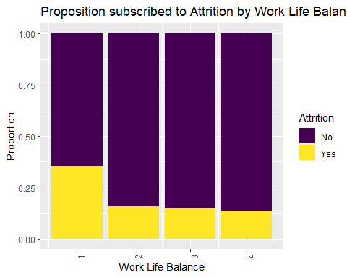

#Attrition Rate seems to be higher for Employees who have work life balance 1  
  
# Years At Company vs Attrition  
t(aggregate(Years.At.Company~Attrition,data=Empl,summary))

## [,1] [,2]   
## Attrition "No" "Yes"   
## Years.At.Company.Min. " 0.000000" " 0.000000"  
## Years.At.Company.1st Qu. " 3.000000" " 1.000000"  
## Years.At.Company.Median " 6.000000" " 3.000000"  
## Years.At.Company.Mean " 7.301370" " 5.192857"  
## Years.At.Company.3rd Qu. "10.000000" " 8.000000"  
## Years.At.Company.Max. "33.000000" "40.000000"

Empl %>%  
 ggplot(aes(x=Attrition, y=(Years.At.Company), color=Attrition)) +  
 geom_boxplot() +  
 scale_color_viridis_d() +  
 ggtitle("Years At Company vs Attrition") +  
 xlab("Total Working Years")+  
 ggtitle("Proposition subscribed to Attrition by Years At Company")+ theme(axis.text.x = element_text(angle=90, hjust=1))

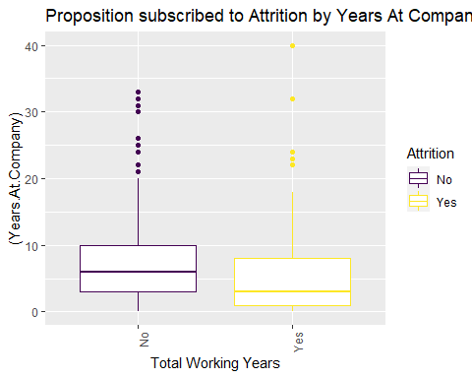

#Attrition Rate seems to be more for Employees who worked less years in the company.There is an outlier at Years At Company=40.  
#The employees who worked for longer years in a company are more content and satisfied.  
  
# Years In Current Role vs Attrition  
t(aggregate(Years.In.Current.Role~Attrition,data=Empl,summary))

## [,1] [,2]   
## Attrition "No" "Yes"   
## Years.In.Current.Role.Min. " 0.000000" " 0.000000"  
## Years.In.Current.Role.1st Qu. " 2.000000" " 0.000000"  
## Years.In.Current.Role.Median " 3.000000" " 2.000000"  
## Years.In.Current.Role.Mean " 4.453425" " 2.907143"  
## Years.In.Current.Role.3rd Qu. " 7.000000" " 4.000000"  
## Years.In.Current.Role.Max. "18.000000" "15.000000"

Empl %>%  
 ggplot(aes(x=Attrition, y=(Years.In.Current.Role), color=Attrition)) +  
 geom_boxplot() +  
 scale_color_viridis_d() +  
 ggtitle("Years In Current Role vs Attrition") +  
 xlab("Years In Current Role")+  
 ggtitle("Proposition subscribed to Attrition by Years In Current Role")+ theme(axis.text.x = element_text(angle=90, hjust=1))

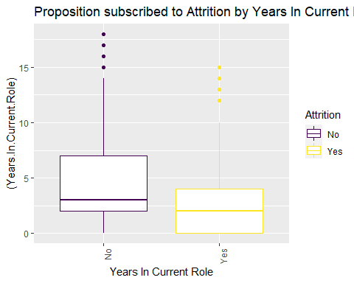

#Attrition Rate seems to be high for Employees who were in the current role for less years  
  
# Years Since Last Promotion vs Attrition  
t(aggregate(Years.Since.Last.Promotion~Attrition,data=Empl,summary))

## [,1] [,2]   
## Attrition "No" "Yes"   
## Years.Since.Last.Promotion.Min. " 0.000000" " 0.000000"  
## Years.Since.Last.Promotion.1st Qu. " 0.000000" " 0.000000"  
## Years.Since.Last.Promotion.Median " 1.000000" " 1.000000"  
## Years.Since.Last.Promotion.Mean " 2.175342" " 2.135714"  
## Years.Since.Last.Promotion.3rd Qu. " 3.000000" " 2.000000"  
## Years.Since.Last.Promotion.Max. "15.000000" "15.000000"

Empl %>%  
 ggplot(aes(x=Attrition,y=log(Years.Since.Last.Promotion),color=Attrition)) +  
 geom_boxplot() +  
 scale_color_viridis_d() +  
 ggtitle("Years Since Last Promotion vs Attrition") +  
 xlab("Years Since Last Promotion")+  
 ggtitle("Proposition subscribed to Attrition by Years Since Last Promotion")+ theme(axis.text.x = element_text(angle=90, hjust=1))

## Warning: Removed 342 rows containing non-finite values (stat_boxplot).

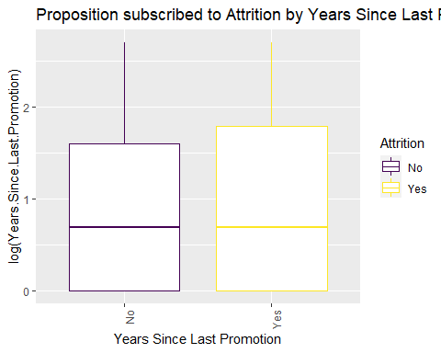

#Attrition Rate seems to be high for Employees who were in the company for less years after promotion  
  
# Years With Current Manager vs Attrition  
t(aggregate(Years.With.Curr.Manager~Attrition,data=Empl,summary))

## [,1] [,2]   
## Attrition "No" "Yes"   
## Years.With.Curr.Manager.Min. " 0.000000" " 0.000000"  
## Years.With.Curr.Manager.1st Qu. " 2.000000" " 0.000000"  
## Years.With.Curr.Manager.Median " 3.000000" " 2.000000"  
## Years.With.Curr.Manager.Mean " 4.369863" " 2.942857"  
## Years.With.Curr.Manager.3rd Qu. " 7.000000" " 6.000000"  
## Years.With.Curr.Manager.Max. "17.000000" "14.000000"

Empl %>%  
 ggplot(aes(x=Attrition,y=log(Years.With.Curr.Manager),color=Attrition)) +  
 geom_boxplot() +  
 scale_color_viridis_d()+  
 ggtitle("Years With Curr Manager vs Attrition") +  
 xlab("Years With Curr Manager")+  
 ggtitle("Proposition subscribed to Attrition by Years With Curr Manager")+ theme(axis.text.x = element_text(angle=90, hjust=1))

## Warning: Removed 166 rows containing non-finite values (stat_boxplot).

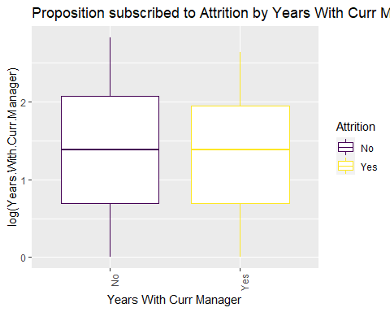

#Attrition Rate seems to be high for Employees who with their current manager for less years comparatively.There is an outlier at Attrition="No" and Years with current Manager > 15.

#With Monthly Income(Salary) as Response  
#Monthly Income as Response  
Empl%>%  
 ggplot(aes(x=log(Monthly.Income),fill=Attrition)) +   
 geom_histogram() +  
 ylab("Count") +xlab("Monthly Income")+scale_fill_viridis_d()+  
 ggtitle("Monthly Income Summary")+ theme(axis.text.x = element_text(angle=90, hjust=1))

## `stat_bin()` using `bins = 30`. Pick better value with `binwidth`.

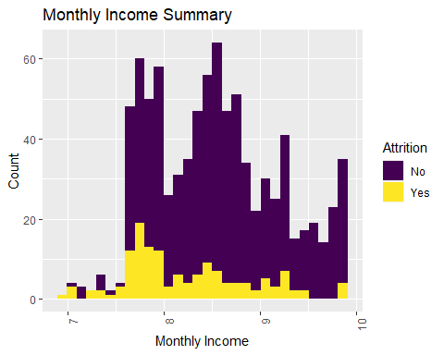

#The Monthly Income is skewed. With the number of observations in the dataset, this should not be a problem based on the central limit #theorem.Log transform looks better  
  
#Monthly Income Vs Age  
Empl %>%  
 ggplot(aes(x=(Age), y=(Monthly.Income), color=Attrition)) +  
 geom_point(position="jitter") +  
 scale_color_viridis_d() +geom_smooth(method = "lm")+ylab("Monthly Income") +xlab("Age")+  
 ggtitle("Monthly Income by Age")+ggtitle("Monthly Income By Age")+ theme(axis.text.x = element_text(angle=90, hjust=1))

## `geom_smooth()` using formula 'y ~ x'

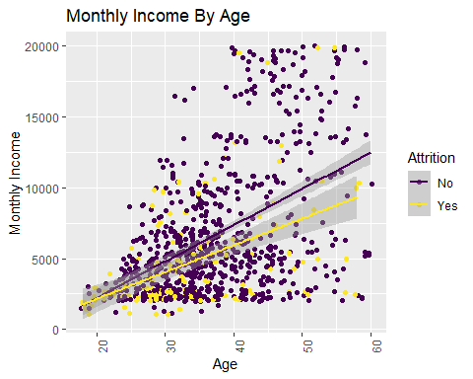

#Age and Monthly Income seems to be linearly correlated  
  
#Monthly Income Vs Attrition  
Empl %>%  
 ggplot(aes(x=Attrition,y=Monthly.Income,fill=Attrition )) +  
 geom_col() +  
 scale_fill_viridis_d()+ylab("Monthly Income") +xlab("Attrition")+  
 ggtitle("Monthly Income by Attrition")

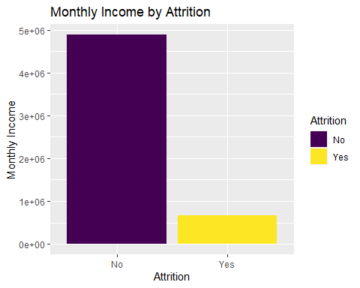

#Attrition is higher for employees with lower monthly income/Salary  
  
#Monthly Income Vs Business Travel  
Empl %>%  
 ggplot(aes(x=BusinessTravel,y=Monthly.Income,fill=Attrition )) +  
 geom_col() +  
 scale_fill_viridis_d()+ylab("Monthly Income") +xlab("BusinessTravel")+  
 ggtitle("Monthly Income by BusinessTravel")

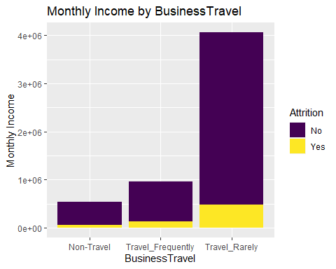

#Monthly Income is higher for Travel-Rarely job.But the attrition rate is more for frequently travel jobs.  
  
#Monthly Income Vs Daily Rate  
Empl %>%  
 ggplot(aes(x=log(Daily.Rate), y=log(Monthly.Income), color=Attrition)) +  
 geom_point(position="jitter") +  
 scale_color_viridis_d() +geom_smooth(method = "lm")+ylab("Monthly Income") +xlab("Daily Rate")+  
 ggtitle("Monthly Income by Daily Rate")+ggtitle("Monthly Income By Daily Rate")+ theme(axis.text.x = element_text(angle=90, hjust=1))

## `geom_smooth()` using formula 'y ~ x'

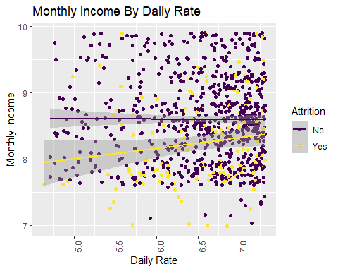

#Monthly Income and daily rate are not co-related to each other  
  
#Monthly Income Vs Department  
Empl %>%  
 ggplot(aes(x=Department,y=Monthly.Income,fill=Attrition )) +  
 geom_col() +  
 scale_fill_viridis_d()+ylab("Monthly Income") +xlab("Department")+  
 ggtitle("Monthly Income by Department")

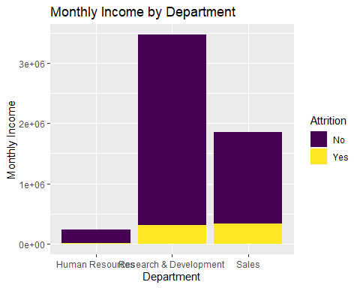

#Monthly Income is the highest for Research & Development and least for Human Resources.Attrition is highest for Human resources and Sales than Research & Development.  
  
##Monthly Income Vs Distance From Home  
Empl %>%  
 ggplot(aes(x=Distance.From.Home, y=log(Monthly.Income), color=Attrition)) +  
 geom_point(position="jitter") +  
 scale_color_viridis_d() +geom_smooth(method = "lm")+ylab("Monthly Income") +xlab("Distance From Home")+  
 ggtitle("Monthly Income by Distance From Home")+ theme(axis.text.x = element_text(angle=90, hjust=1))

## `geom_smooth()` using formula 'y ~ x'

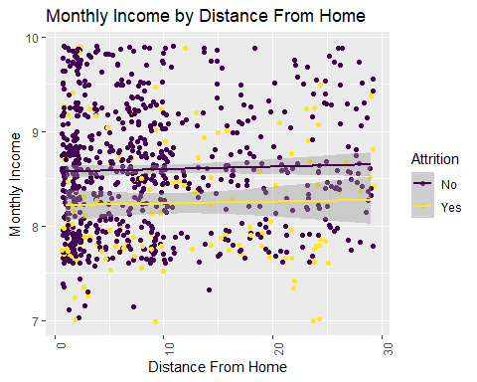

#Nothing interesting seen here  
  
#Monthly Income Vs Education  
Empl %>%  
 ggplot(aes(x=Education,y=Monthly.Income,fill=Attrition )) +  
 geom_col() +  
 scale_fill_viridis_d()+ylab("Monthly Income") +xlab("Education")+  
 ggtitle("Monthly Income by Education")

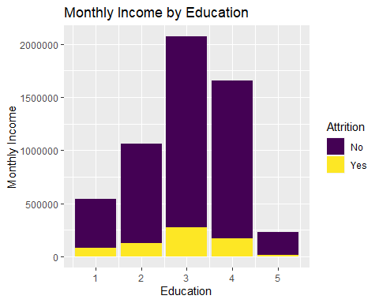

#Monthly Income is the highest for Education level 3&4 and least for 5.  
  
#Monthly Income Vs Education Field  
Empl %>%  
 ggplot(aes(x=EducationField,y=Monthly.Income,fill=Attrition )) +  
 geom_col() +  
 scale_fill_viridis_d()+ylab("Monthly Income") +xlab("Education Field")+  
 ggtitle("Monthly Income by Education Field")

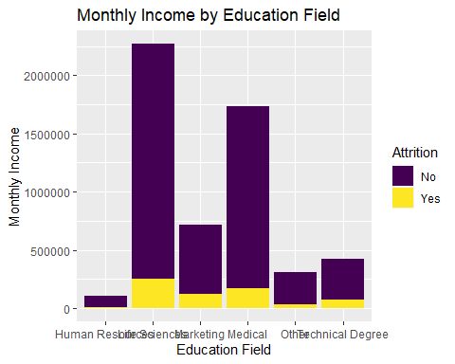

#Monthly Income is the highest for Life sciences & Medical and Human resources is the least.  
  
#Monthly Income Vs Environment Satisfaction  
Empl %>%  
 ggplot(aes(x=Environment.Satisfaction,y=Monthly.Income,fill=Attrition )) +  
 geom_col() +  
 scale_fill_viridis_d()+ylab("Monthly Income") +xlab("Environment Satisfaction")+  
 ggtitle("Monthly Income by Environment Satisfaction")

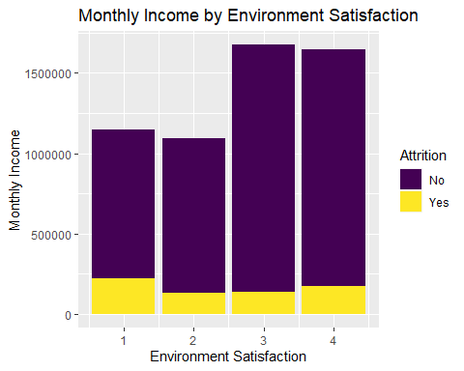

#Monthly Income is the highest for Environment Satisfaction is 3 & 4  
  
#Monthly Income Vs Gender  
Empl %>%  
 ggplot(aes(x=Gender,y=Monthly.Income,fill=Attrition )) +  
 geom_col() +  
 scale_fill_viridis_d()+ylab("Monthly Income") +xlab("Gender")+  
 ggtitle("Monthly Income by Gender")

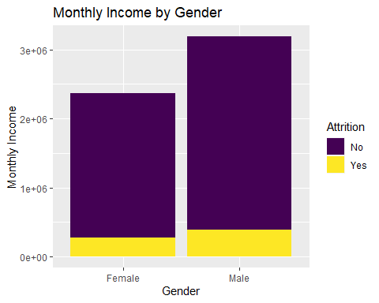

#Monthly Income is the higher for Male than Female  
  
#Monthly Income Vs Hourly Rate  
Empl %>%  
 ggplot(aes(x=log(Hourly.Rate), y=log(Monthly.Income), color=Attrition)) +  
 geom_point(position="jitter") +  
 scale_color_viridis_d() +geom_smooth(method = 'lm')+ylab("Monthly Income") +xlab("Hourly Rate")+  
 ggtitle("Monthly Income by Hourly Rate")+ theme(axis.text.x = element_text(angle=90, hjust=1))

## `geom_smooth()` using formula 'y ~ x'

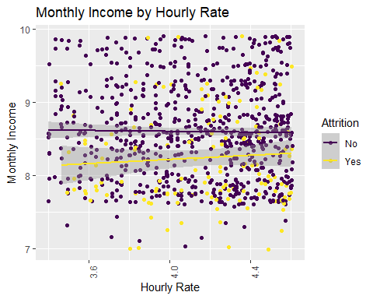

#Monthly Income and Hourly rate are not co-related to each other  
  
#Monthly Income Vs Job Involvement  
Empl %>%  
 ggplot(aes(x=Job.Involvement,y=Monthly.Income,fill=Attrition )) +  
 geom_col() +  
 scale_fill_viridis_d()+ylab("Monthly Income") +xlab("Job Involvement")+  
 ggtitle("Monthly Income by Job Involvement")

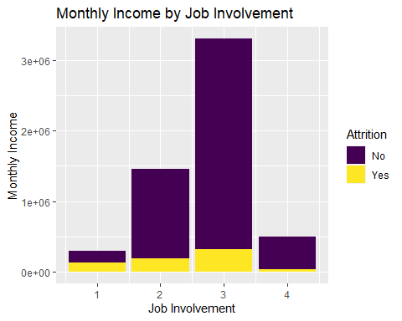

#Monthly Income is the highest for Job involvement 3 and least for job involvement 1.Job attrition rate is highest for Job involvement for 1.  
  
#Monthly Income Vs Job Level  
Empl %>%  
 ggplot(aes(x=Job.Level,y=Monthly.Income,fill=Attrition )) +  
 geom_col() +  
 scale_fill_viridis_d()+ylab("Monthly Income") +xlab("Job Level")+  
 ggtitle("Monthly Income by Job Level")

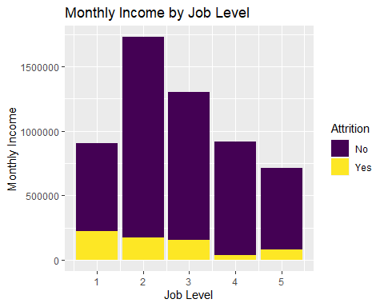

#Monthly Income is the highest for Job Level 2&3 and least for job Level 5.Job level attrition rate is highest for Job Level 1.  
  
#Monthly Income Vs Job Role  
Empl %>%  
 ggplot(aes(x=Job.Role,y=Monthly.Income,fill=Attrition )) +  
 geom_col() +  
 scale_fill_viridis_d()+ylab("Monthly Income") +xlab("Job Role")+  
 ggtitle("Monthly Income by Job Role")

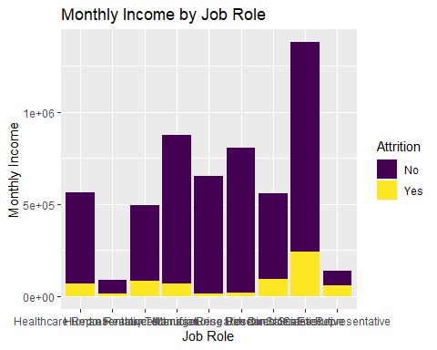

#Monthly Income is the highest for Sales Executive,Manager and Research Director and least for Human resource and Sales Rep.We understand that the attrition rate is highest for Human resources and Sales Rep.  
  
#Monthly Income Vs Job Satisfaction  
Empl %>%  
 ggplot(aes(x=Job.Satisfaction,y=Monthly.Income,fill=Attrition )) +  
 geom_col() +  
 scale_fill_viridis_d()+ylab("Monthly Income") +xlab("Job Satisfaction")+  
 ggtitle("Monthly Income by Job Satisfaction")

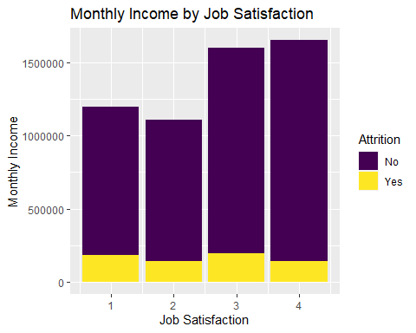

#Monthly Income is the highest for Job Satisfaction 3 & 4  
  
#Monthly Income Vs Marital Status  
Empl %>%  
 ggplot(aes(x=Marital.Status,y=Monthly.Income,fill=Attrition )) +  
 geom_col() +  
 scale_fill_viridis_d()+ylab("Monthly Income") +xlab("Marital Status")+  
 ggtitle("Monthly Income by Marital Status")

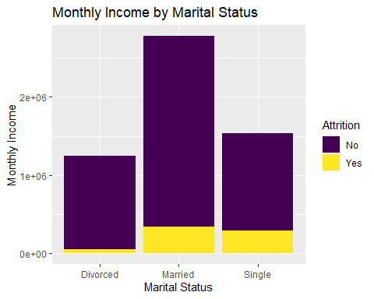

#Monthly Income is the higher for Married and least for divorced.  
  
#Monthly Income Vs Monthly Rate  
Empl %>%  
 ggplot(aes(x=log(Monthly.Rate), y=log(Monthly.Income), color=Attrition)) +  
 geom_point(position="jitter") +  
 scale_color_viridis_d() +geom_smooth(method = 'lm')+ylab("Monthly Income") +xlab("Monthly Rate")+  
 ggtitle("Monthly Income by Monthly Rate")+ theme(axis.text.x = element_text(angle=90, hjust=1))

## `geom_smooth()` using formula 'y ~ x'

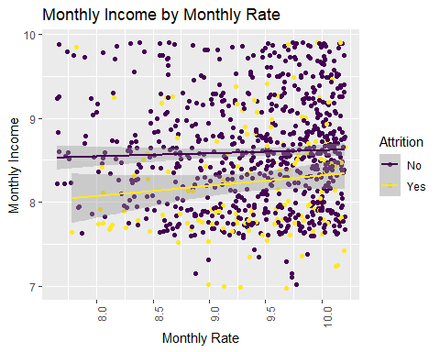

#Monthly Income and Hourly rate are not co-related to each other  
  
#Monthly Income Vs Num Companies Worked  
Empl %>%  
 ggplot(aes(x=as.factor(Num.Companies.Worked),y=Monthly.Income,fill=Attrition )) +  
 geom_col() +  
 scale_fill_viridis_d()+ylab("Monthly Income") +xlab("Num Companies Worked")+  
 ggtitle("Monthly Income by Num Companies Worked")

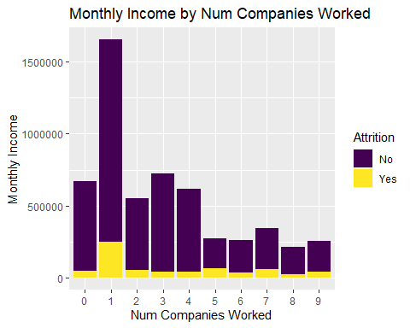

#Monthly Income is the highest for those who worked in 1 company  
  
#Monthly Income Vs OverTime  
Empl %>%  
 ggplot(aes(x=OverTime,y=Monthly.Income,fill=Attrition )) +  
 geom_col() +  
 scale_fill_viridis_d()+ylab("Monthly Income") +xlab("OverTime")+  
 ggtitle("Monthly Income by OverTime")

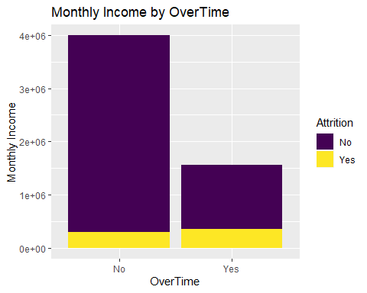

#Monthly Income is the higher for those who worked overtime.  
  
#Monthly Income Vs Percent Salary Hike  
Empl %>%  
 ggplot(aes(x=log(Percent.Salary.Hike), y=log(Monthly.Income), color=Attrition)) +  
 geom_point() +  
 scale_color_viridis_d() +geom_smooth(method = "lm")+ylab("Monthly Income") +xlab("Percent Salary Hike")+  
 ggtitle("Monthly Income by Percent Salary Hike")+ theme(axis.text.x = element_text(angle=90, hjust=1))

## `geom_smooth()` using formula 'y ~ x'

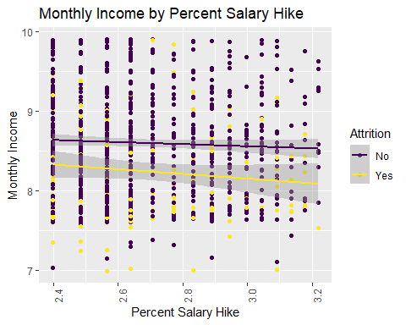

#Monthly Income and Percent Salary Hike are not co-related to each other  
  
#Monthly Income Vs Performance Rating  
Empl %>%  
 ggplot(aes(x=as.factor(Performance.Rating),y=Monthly.Income,fill=Attrition )) +  
 geom_col() +  
 scale_fill_viridis_d()+ylab("Monthly Income") +xlab("Performance Rating")+  
 ggtitle("Monthly Income by Performance Rating")

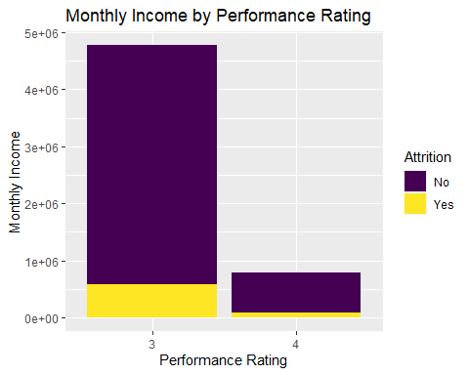

#Monthly Income is the highest for those who have a performance rating 3.  
  
#Monthly Income Vs Relationship Satisfaction  
Empl %>%  
 ggplot(aes(x=as.factor(Relationship.Satisfaction),y=Monthly.Income,fill=Attrition )) +  
 geom_col() +  
 scale_fill_viridis_d()+ylab("Monthly Income") +xlab("Relationship Satisfaction")+  
 ggtitle("Monthly Income by Relationship Satisfaction")

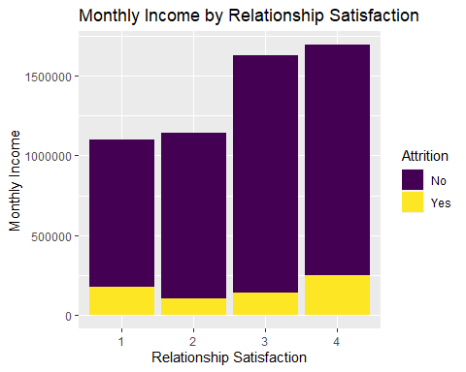

#Monthly Income is the highest for those who have a Relationship Satisfaction 3&4.  
  
#Monthly Income Vs Stock Option Level  
Empl %>%  
 ggplot(aes(x=as.factor(Stock.Option.Level),y=Monthly.Income,fill=Attrition )) +  
 geom_col() +  
 scale_fill_viridis_d()+ylab("Monthly Income") +xlab("Stock Option Level")+  
 ggtitle("Monthly Income by Stock Option Level")

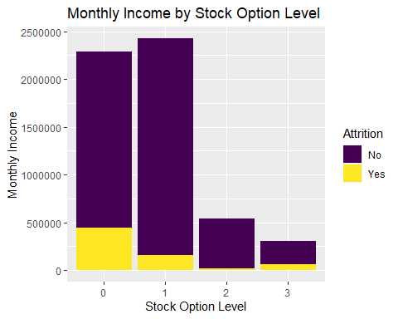

#Monthly Income is the highest for those who have a Stock Option Level 0 & 1.  
  
#Monthly Income Vs Total Working Years  
Empl %>%  
 ggplot(aes(x=log(Total.Working.Years), y=log(Monthly.Income), color=Attrition)) +  
 geom_point(position="jitter") +  
 scale_color_viridis_d() +geom_smooth(method = "lm")+ylab("Monthly Income") +xlab("Total Working Years")+  
 ggtitle("Monthly Income by Total Working Years")+ theme(axis.text.x = element_text(angle=90, hjust=1))

## `geom_smooth()` using formula 'y ~ x'

## Warning: Removed 7 rows containing non-finite values (stat_smooth).

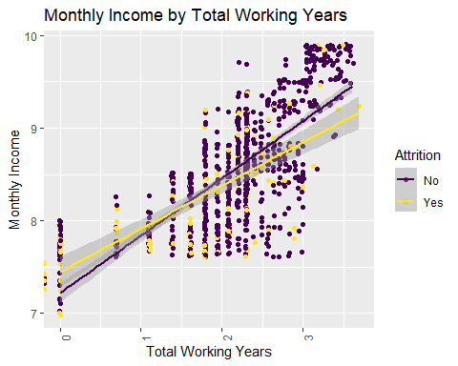

#Monthly Income and Total Working Years are linearly co-related to each other  
  
#Monthly Income Vs Training Times Last Year  
Empl %>%  
 ggplot(aes(x=as.factor(Training.Times.Last.Year),y=Monthly.Income,fill=Attrition )) +  
 geom_col() +  
 scale_fill_viridis_d()+ylab("Monthly Income") +xlab("Training Times Last Year")+  
 ggtitle("Monthly Income by Training Times Last Year")

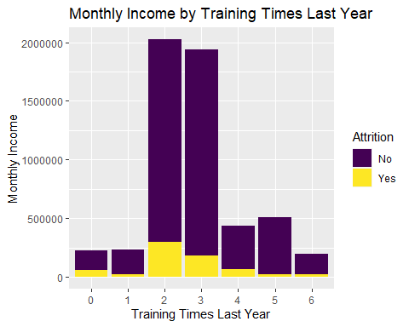

#Monthly Income is the highest for those who have a Training Times Last Year 2&3.  
  
#Monthly Income Vs Work Life Balance  
Empl %>%  
 ggplot(aes(x=as.factor(Work.Life.Balance),y=Monthly.Income,fill=Attrition )) +  
 geom_col() +  
 scale_fill_viridis_d()+ylab("Monthly Income") +xlab("Work Life Balance")+  
 ggtitle("Monthly Income by Work Life Balance")

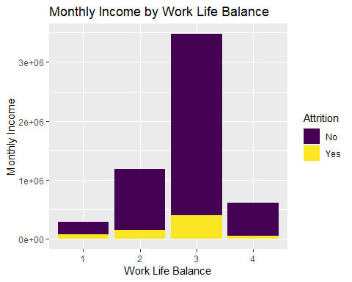

#Monthly Income is the higher for those who have a Work Life Balance 3.  
  
#Monthly Income Vs Years At Company  
Empl %>%  
 ggplot(aes(x=log(Years.At.Company), y=log(Monthly.Income), color=Attrition)) +  
 geom_point(position="jitter") +  
 scale_color_viridis_d() +geom_smooth(method = "lm")+ylab("Monthly Income") +xlab("Years At Company")+  
 ggtitle("Monthly Income by Years At Company")+ theme(axis.text.x = element_text(angle=90, hjust=1))

## `geom_smooth()` using formula 'y ~ x'

## Warning: Removed 28 rows containing non-finite values (stat_smooth).

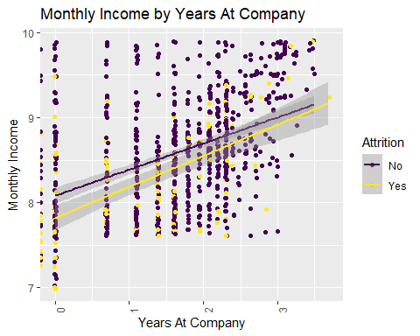

#Monthly Income and Total Working Years are linearly co-related to each other  
  
#Monthly Income Vs Years In Current Role  
Empl %>%  
 ggplot(aes(x=Years.In.Current.Role, y=log(Monthly.Income), color=Attrition)) +  
 geom_point(position="jitter") +  
 scale_color_viridis_d() +geom_smooth(method = "lm")+ylab("Monthly Income") +xlab("Total Working Years")+  
 ggtitle("Monthly Income by Years In Current Role")+ theme(axis.text.x = element_text(angle=90, hjust=1))

## `geom_smooth()` using formula 'y ~ x'

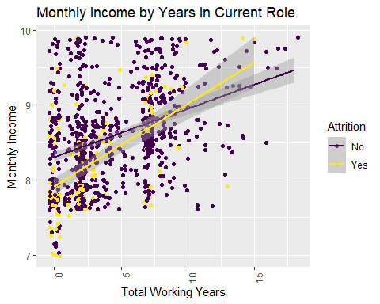

#Monthly Income and Years In Current Role are linearly co-related to each other  
  
#Monthly Income Vs Years Since Last Promotion  
Empl %>%  
 ggplot(aes(x=Years.Since.Last.Promotion, y=log(Monthly.Income), color=Attrition)) +  
 geom_point(position="jitter") +  
 scale_color_viridis_d() +geom_smooth(method = "lm")+ylab("Monthly Income") +xlab("Years Since Last Promotion")+  
 ggtitle("Monthly Income by Years Since Last Promotion")+ theme(axis.text.x = element_text(angle=90, hjust=1))

## `geom_smooth()` using formula 'y ~ x'

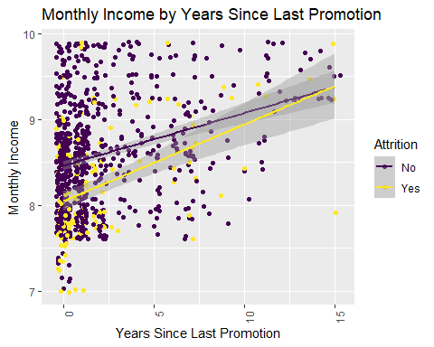

#Monthly Income and Years Since Last Promotion are linearly co-related to each other  
  
#Monthly Income Vs Years With Curr Manager  
Empl %>%  
 ggplot(aes(x=Years.With.Curr.Manager, y=log(Monthly.Income), color=Attrition)) +  
 geom_point(position="jitter") +  
 scale_color_viridis_d() +geom_smooth(method = "lm")+ylab("Monthly Income") +xlab("Years With Curr Manager")+  
 ggtitle("Monthly Income by Years With Curr Manager")+ theme(axis.text.x = element_text(angle=90, hjust=1))

## `geom_smooth()` using formula 'y ~ x'

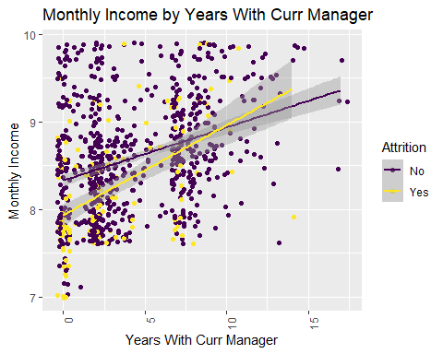

#Monthly Income and Years With Current Manager are linearly co-related to each other

Note that the echo = FALSE parameter was added to the code chunk to prevent printing of the R code that generated the plot.

#The outlier seen is at working years = 40.Removing the outlier.  
Empl = subset(Empl, Total.Working.Years != 40)  
str(Empl)

## 'data.frame': 869 obs. of 36 variables:  
## $ ID : int 1 2 3 4 5 6 7 8 9 10 ...  
## $ Age : int 32 40 35 32 24 27 41 37 34 34 ...  
## $ Attrition : chr "No" "No" "No" "No" ...  
## $ BusinessTravel : chr "Travel_Rarely" "Travel_Rarely" "Travel_Frequently" "Travel_Rarely" ...  
## $ Daily.Rate : int 117 1308 200 801 567 294 1283 309 1333 653 ...  
## $ Department : chr "Sales" "Research & Development" "Research & Development" "Sales" ...  
## $ Distance.From.Home : int 13 14 18 1 2 10 5 10 10 10 ...  
## $ Education : int 4 3 2 4 1 2 5 4 4 4 ...  
## $ EducationField : chr "Life Sciences" "Medical" "Life Sciences" "Marketing" ...  
## $ Employee.Count : int 1 1 1 1 1 1 1 1 1 1 ...  
## $ Employee.Number : int 859 1128 1412 2016 1646 733 1448 1105 1055 1597 ...  
## $ Environment.Satisfaction : int 2 3 3 3 1 4 2 4 3 4 ...  
## $ Gender : chr "Male" "Male" "Male" "Female" ...  
## $ Hourly.Rate : int 73 44 60 48 32 32 90 88 87 92 ...  
## $ Job.Involvement : int 3 2 3 3 3 3 4 2 3 2 ...  
## $ Job.Level : int 2 5 3 3 1 3 1 2 1 2 ...  
## $ Job.Role : chr "Sales Executive" "Research Director" "Manufacturing Director" "Sales Executive" ...  
## $ Job.Satisfaction : int 4 3 4 4 4 1 3 4 3 3 ...  
## $ Marital.Status : chr "Divorced" "Single" "Single" "Married" ...  
## $ Monthly.Income : int 4403 19626 9362 10422 3760 8793 2127 6694 2220 5063 ...  
## $ Monthly.Rate : int 9250 17544 19944 24032 17218 4809 5561 24223 18410 15332 ...  
## $ Num.Companies.Worked : int 2 1 2 1 1 1 2 2 1 1 ...  
## $ Over18 : chr "Y" "Y" "Y" "Y" ...  
## $ OverTime : chr "No" "No" "No" "No" ...  
## $ Percent.Salary.Hike : int 11 14 11 19 13 21 12 14 19 14 ...  
## $ Performance.Rating : int 3 3 3 3 3 4 3 3 3 3 ...  
## $ Relationship.Satisfaction : int 3 1 3 3 3 3 1 3 4 2 ...  
## $ Standard.Hours : int 80 80 80 80 80 80 80 80 80 80 ...  
## $ Stock.Option.Level : int 1 0 0 2 0 2 0 3 1 1 ...  
## $ Total.Working.Years : int 8 21 10 14 6 9 7 8 1 8 ...  
## $ Training.Times.Last.Year : int 3 2 2 3 2 4 5 5 2 3 ...  
## $ Work.Life.Balance : int 2 4 3 3 3 2 2 3 3 2 ...  
## $ Years.At.Company : int 5 20 2 14 6 9 4 1 1 8 ...  
## $ Years.In.Current.Role : int 2 7 2 10 3 7 2 0 1 2 ...  
## $ Years.Since.Last.Promotion: int 0 4 2 5 1 1 0 0 0 7 ...  
## $ Years.With.Curr.Manager : int 3 9 2 7 3 7 3 0 0 7 ...

# Correlations between continuous variable  
# Exploring multicollinearity  
#str(Empl)  
#pairs(Empl[,c(2,5,7,8,10,11,12,14,15,16,18,20,21,22,25,26,27,28,29,30,31,32,33,34,35)])  
#my.cor<-cor(Empl[,c(2,5,7,8,10,11,12,14,15,16,18,20,21,22,25,26,27,28,29,30,31,32,33,34,35)])  
#my.cor  
#ggcorrplot(my.cor, type = "lower",  
 # lab = TRUE, lab_size = 3, method = "circle",  
# colors = c("tomato2", "white", "springgreen3"),  
# title = "Correlations of all relevant variables",  
# ggtheme = theme_bw())  
  
#Selecting certain predictors to look at it more closely  
pairs(Empl[,c(2,7,8,12,15,16,18,20,21,22,25,26,27,30,32,33,34,35)])

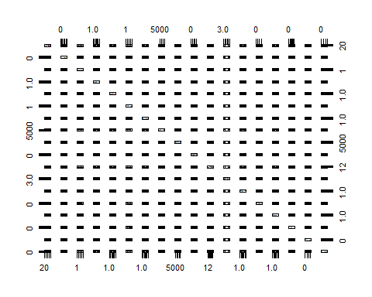

my.cor<-cor(Empl[,c(2,7,8,12,15,16,18,20,21,22,25,26,27,30,32,33,34,35)])  
my.cor

## Age Distance.From.Home Education  
## Age 1.000000000 0.002069392 0.215196241  
## Distance.From.Home 0.002069392 1.000000000 0.047544174  
## Education 0.215196241 0.047544174 1.000000000  
## Environment.Satisfaction -0.010721660 -0.041085710 -0.038045747  
## Job.Involvement 0.015047697 -0.005047646 0.031792042  
## Job.Level 0.478782583 0.020063616 0.129439074  
## Job.Satisfaction -0.025631156 -0.023515027 0.011694707  
## Monthly.Income 0.483729748 -0.008334054 0.126212656  
## Monthly.Rate 0.076265691 -0.004898324 -0.018330046  
## Num.Companies.Worked 0.296437055 -0.047673812 0.161917633  
## Percent.Salary.Hike -0.028530119 0.056093340 -0.001311187  
## Performance.Rating -0.040063842 0.034066750 -0.027549219  
## Relationship.Satisfaction -0.008580424 0.034048088 -0.027208799  
## Total.Working.Years 0.649755831 -0.003299314 0.142595553  
## Work.Life.Balance -0.009266554 -0.011724058 0.011197978  
## Years.At.Company 0.280343918 -0.032055486 0.056204592  
## Years.In.Current.Role 0.204962168 -0.011523497 0.059537610  
## Years.Since.Last.Promotion 0.208818063 -0.024656956 0.063989027  
## Environment.Satisfaction Job.Involvement  
## Age -0.0107216602 1.504770e-02  
## Distance.From.Home -0.0410857098 -5.047646e-03  
## Education -0.0380457468 3.179204e-02  
## Environment.Satisfaction 1.0000000000 -5.705592e-04  
## Job.Involvement -0.0005705592 1.000000e+00  
## Job.Level -0.0010465930 -1.628360e-02  
## Job.Satisfaction -0.0200244595 -5.352090e-02  
## Monthly.Income -0.0180605258 6.053562e-05  
## Monthly.Rate 0.0614903603 -1.760747e-02  
## Num.Companies.Worked 0.0138936263 -5.304873e-03  
## Percent.Salary.Hike 0.0023270860 1.473049e-02  
## Performance.Rating -0.0039531099 1.188263e-02  
## Relationship.Satisfaction 0.0029589609 1.633697e-02  
## Total.Working.Years -0.0254390502 -1.587147e-02  
## Work.Life.Balance 0.0857434936 8.240384e-03  
## Years.At.Company -0.0229894555 -4.487420e-02  
## Years.In.Current.Role 0.0203689384 1.246755e-02  
## Years.Since.Last.Promotion 0.0037330100 -3.256581e-02  
## Job.Level Job.Satisfaction Monthly.Income  
## Age 0.478782583 -0.025631156 4.837297e-01  
## Distance.From.Home 0.020063616 -0.023515027 -8.334054e-03  
## Education 0.129439074 0.011694707 1.262127e-01  
## Environment.Satisfaction -0.001046593 -0.020024460 -1.806053e-02  
## Job.Involvement -0.016283600 -0.053520903 6.053562e-05  
## Job.Level 1.000000000 -0.051545135 9.515986e-01  
## Job.Satisfaction -0.051545135 1.000000000 -5.435144e-02  
## Monthly.Income 0.951598568 -0.054351437 1.000000e+00  
## Monthly.Rate 0.076141925 0.027235397 6.621230e-02  
## Num.Companies.Worked 0.141632633 -0.074917017 1.566760e-01  
## Percent.Salary.Hike -0.061437303 0.013144833 -5.305577e-02  
## Performance.Rating -0.038288524 -0.004081496 -4.273795e-02  
## Relationship.Satisfaction -0.006019041 -0.035480664 -5.043381e-03  
## Total.Working.Years 0.783919103 -0.054935357 7.817629e-01  
## Work.Life.Balance 0.031434618 -0.025042242 2.190808e-02  
## Years.At.Company 0.524417261 0.021433839 4.948487e-01  
## Years.In.Current.Role 0.390432917 -0.005609015 3.609544e-01  
## Years.Since.Last.Promotion 0.329585877 -0.027448148 3.150421e-01  
## Monthly.Rate Num.Companies.Worked  
## Age 0.0762656905 0.296437055  
## Distance.From.Home -0.0048983236 -0.047673812  
## Education -0.0183300460 0.161917633  
## Environment.Satisfaction 0.0614903603 0.013893626  
## Job.Involvement -0.0176074678 -0.005304873  
## Job.Level 0.0761419252 0.141632633  
## Job.Satisfaction 0.0272353972 -0.074917017  
## Monthly.Income 0.0662122975 0.156675952  
## Monthly.Rate 1.0000000000 0.015572413  
## Num.Companies.Worked 0.0155724126 1.000000000  
## Percent.Salary.Hike 0.0001104432 -0.023138141  
## Performance.Rating -0.0040384133 -0.029651500  
## Relationship.Satisfaction -0.0219871151 0.043019573  
## Total.Working.Years 0.0653192521 0.263475297  
## Work.Life.Balance 0.0045871950 0.020469386  
## Years.At.Company -0.0085418040 -0.140182905  
## Years.In.Current.Role 0.0281004602 -0.102734684  
## Years.Since.Last.Promotion 0.0147383500 -0.068701405  
## Percent.Salary.Hike Performance.Rating  
## Age -0.0285301192 -0.040063842  
## Distance.From.Home 0.0560933405 0.034066750  
## Education -0.0013111869 -0.027549219  
## Environment.Satisfaction 0.0023270860 -0.003953110  
## Job.Involvement 0.0147304876 0.011882630  
## Job.Level -0.0614373033 -0.038288524  
## Job.Satisfaction 0.0131448327 -0.004081496  
## Monthly.Income -0.0530557658 -0.042737946  
## Monthly.Rate 0.0001104432 -0.004038413  
## Num.Companies.Worked -0.0231381410 -0.029651500  
## Percent.Salary.Hike 1.0000000000 0.775047506  
## Performance.Rating 0.7750475064 1.000000000  
## Relationship.Satisfaction -0.0445999644 -0.029435279  
## Total.Working.Years -0.0609902470 -0.039847441  
## Work.Life.Balance 0.0063818080 0.016713047  
## Years.At.Company -0.0529252300 -0.024374855  
## Years.In.Current.Role -0.0213789386 0.009593141  
## Years.Since.Last.Promotion -0.0706947911 -0.034900362  
## Relationship.Satisfaction Total.Working.Years  
## Age -0.008580424 0.649755831  
## Distance.From.Home 0.034048088 -0.003299314  
## Education -0.027208799 0.142595553  
## Environment.Satisfaction 0.002958961 -0.025439050  
## Job.Involvement 0.016336970 -0.015871470  
## Job.Level -0.006019041 0.783919103  
## Job.Satisfaction -0.035480664 -0.054935357  
## Monthly.Income -0.005043381 0.781762933  
## Monthly.Rate -0.021987115 0.065319252  
## Num.Companies.Worked 0.043019573 0.263475297  
## Percent.Salary.Hike -0.044599964 -0.060990247  
## Performance.Rating -0.029435279 -0.039847441  
## Relationship.Satisfaction 1.000000000 -0.022996683  
## Total.Working.Years -0.022996683 1.000000000  
## Work.Life.Balance 0.038646267 0.023818009  
## Years.At.Company 0.000981254 0.628015570  
## Years.In.Current.Role -0.003256904 0.484383538  
## Years.Since.Last.Promotion 0.026967646 0.435760094  
## Work.Life.Balance Years.At.Company  
## Age -0.009266554 0.280343918  
## Distance.From.Home -0.011724058 -0.032055486  
## Education 0.011197978 0.056204592  
## Environment.Satisfaction 0.085743494 -0.022989455  
## Job.Involvement 0.008240384 -0.044874197  
## Job.Level 0.031434618 0.524417261  
## Job.Satisfaction -0.025042242 0.021433839  
## Monthly.Income 0.021908082 0.494848734  
## Monthly.Rate 0.004587195 -0.008541804  
## Num.Companies.Worked 0.020469386 -0.140182905  
## Percent.Salary.Hike 0.006381808 -0.052925230  
## Performance.Rating 0.016713047 -0.024374855  
## Relationship.Satisfaction 0.038646267 0.000981254  
## Total.Working.Years 0.023818009 0.628015570  
## Work.Life.Balance 1.000000000 0.037086536  
## Years.At.Company 0.037086536 1.000000000  
## Years.In.Current.Role 0.084300660 0.780833009  
## Years.Since.Last.Promotion 0.047222638 0.635551862  
## Years.In.Current.Role Years.Since.Last.Promotion  
## Age 0.204962168 0.20881806  
## Distance.From.Home -0.011523497 -0.02465696  
## Education 0.059537610 0.06398903  
## Environment.Satisfaction 0.020368938 0.00373301  
## Job.Involvement 0.012467553 -0.03256581  
## Job.Level 0.390432917 0.32958588  
## Job.Satisfaction -0.005609015 -0.02744815  
## Monthly.Income 0.360954380 0.31504215  
## Monthly.Rate 0.028100460 0.01473835  
## Num.Companies.Worked -0.102734684 -0.06870141  
## Percent.Salary.Hike -0.021378939 -0.07069479  
## Performance.Rating 0.009593141 -0.03490036  
## Relationship.Satisfaction -0.003256904 0.02696765  
## Total.Working.Years 0.484383538 0.43576009  
## Work.Life.Balance 0.084300660 0.04722264  
## Years.At.Company 0.780833009 0.63555186  
## Years.In.Current.Role 1.000000000 0.55230588  
## Years.Since.Last.Promotion 0.552305881 1.00000000

ggcorrplot(my.cor, type = "lower",  
 lab = TRUE, lab_size = 3, method = "circle",  
 colors = c("tomato2", "white", "springgreen3"),  
 title = "Correlations of all relevant variables",  
 ggtheme = theme_bw())

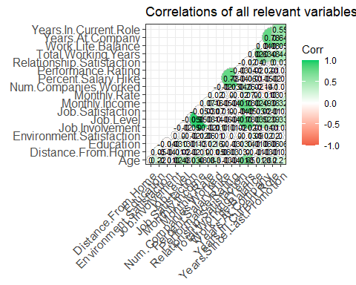

#1.Job Level and Monthly Income are highly positively correlated (0.95)  
#2.Percent Salary Hike and Performance Rating are highly positively correlated (0.78)  
#3.Monthly Income and Total Years of working is highly positively correlated (0.78)  
#4.Job Level and Total Years of Working is highly positively correlated (0.78)  
#5.Years at company and Years in current role is highly positively correlated (0.78)  
#6.Age and TOtal Working Years is positively correlated (0.65)  
#7.Years at company and Years since last promotion is positively correlated (0.64)  
#8.Total working years and years at company is positively correlated (0.63)  
#9.Years in current role and Years since last promotion is positively correlated (0.55)  
#10.Job Level and years at company is positively correlated (0.52)

# Heatmap  
my.cor<-cor(Empl[,c(2,7,8,12,15,16,18,20,21,22,25,26,27,30,32,33,34,35)])  
heatmap.2(my.cor,col=redgreen(75),   
 density.info="none", trace="none", dendrogram=c("row"),   
 symm=F,symkey=T,symbreaks=T, scale="none")

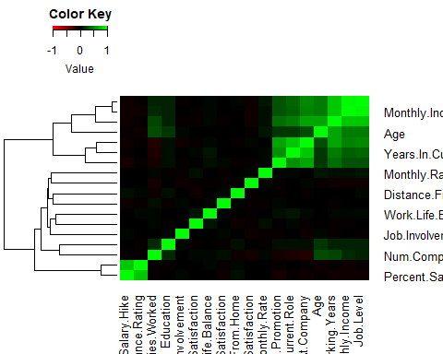

# Normality will be a concern for LDA/QDA:  
hist(Empl$Age) #Looks Normal

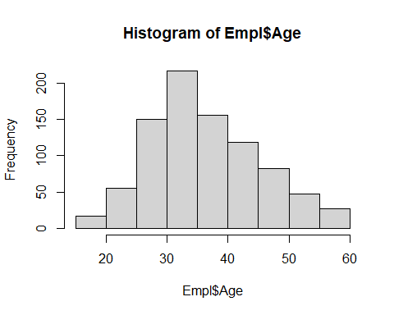

hist(log(Empl$Daily.Rate)) #Looks good after log transform

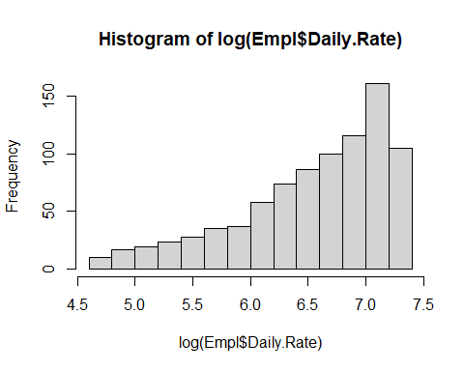

hist((Empl$Distance.From.Home)) #skewed

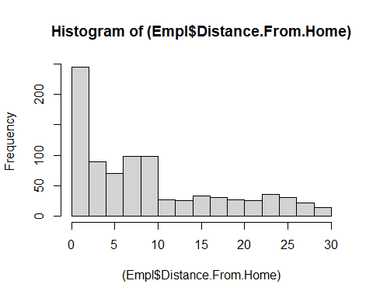

hist((Empl$Education)) #Doesnt look great

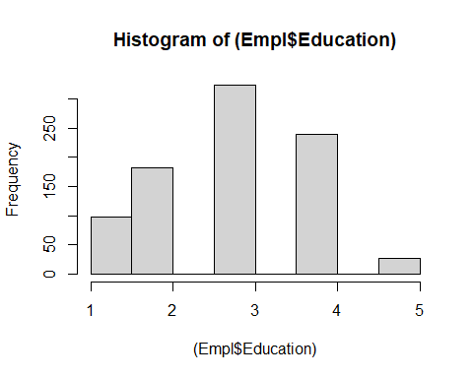

hist(log(Empl$Hourly.Rate)) #skewed after log transform

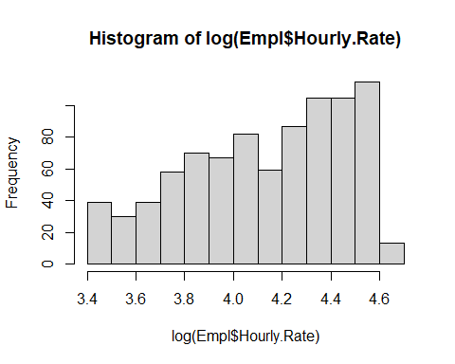

hist((Empl$Environment.Satisfaction))#Not good

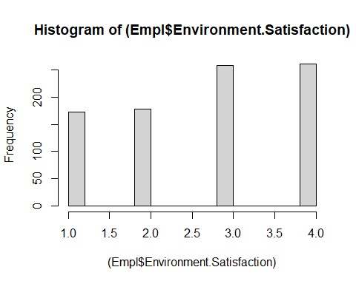

hist(Empl$Job.Involvement) #Not good

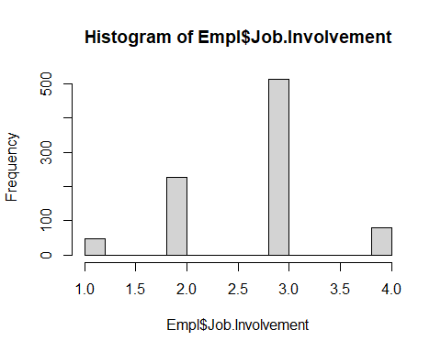

hist((Empl$Job.Level)) #Doesnt look great

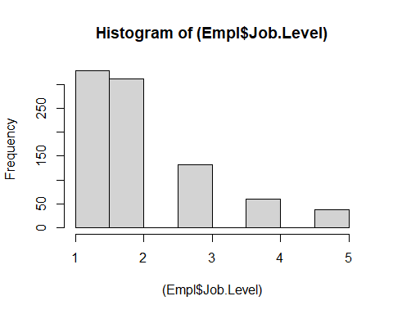

hist(Empl$Job.Satisfaction) #Doesnt look great

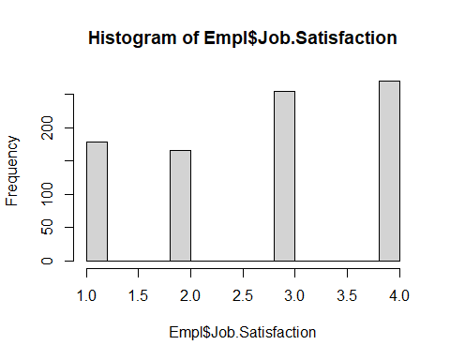

hist((Empl$Monthly.Income))#Normal

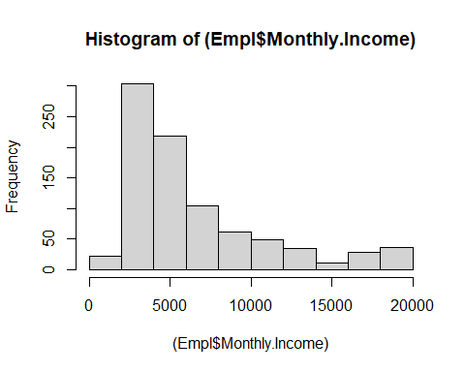

hist(log(Empl$Monthly.Rate))#Not Bad

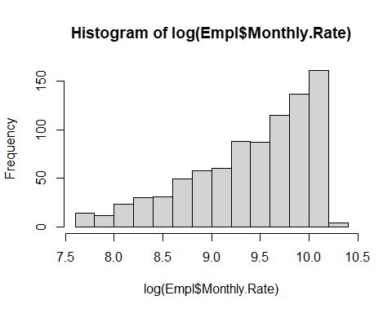

hist((Empl$Num.Companies.Worked))#Not Bad

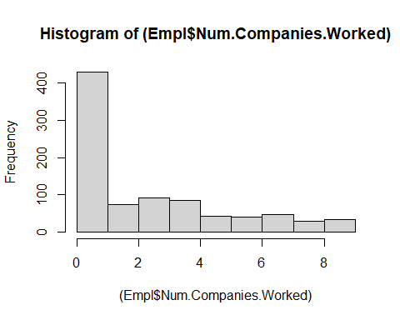

hist((Empl$Percent.Salary.Hike))#Not Bad

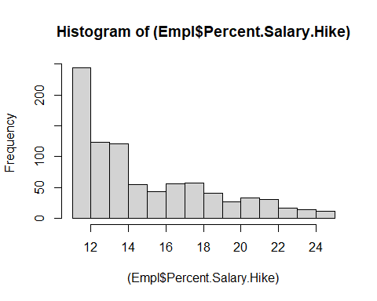

hist((Empl$Performance.Rating))#Doesnt look great

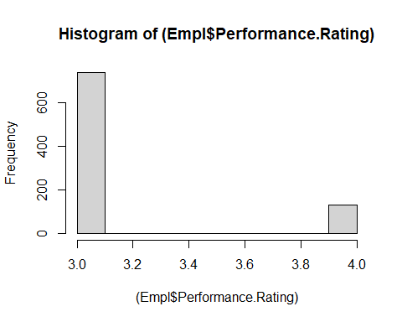

hist((Empl$Relationship.Satisfaction))#Doesnt look great

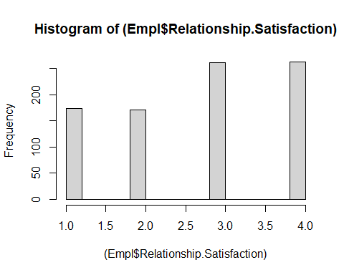

hist((Empl$Stock.Option.Level))#Doesnt look great

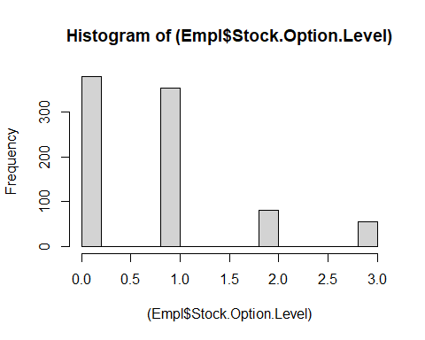

hist(log(Empl$Total.Working.Years)) #Normal after taking a log

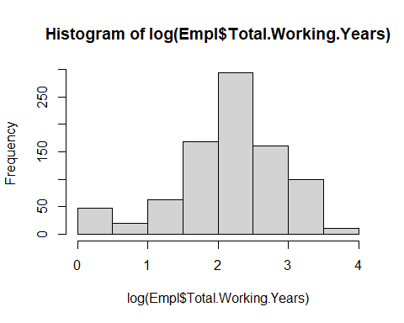

hist(log(Empl$Training.Times.Last.Year))#Doesnt look great

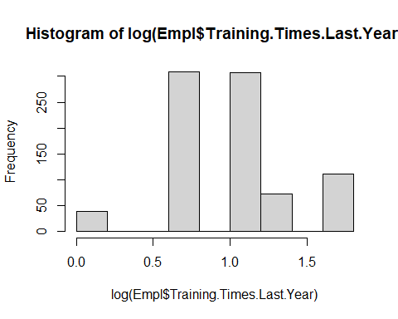

hist((Empl$Work.Life.Balance))#Doesnt look great

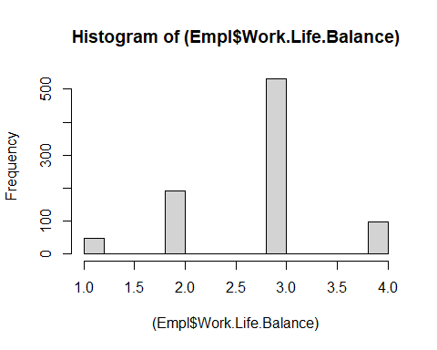

hist((Empl$Years.At.Company)) #Skwewd after taking a log

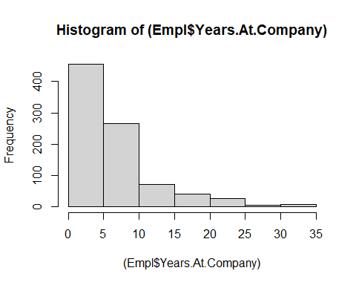

hist((Empl$Years.In.Current.Role)) #slightly skewed

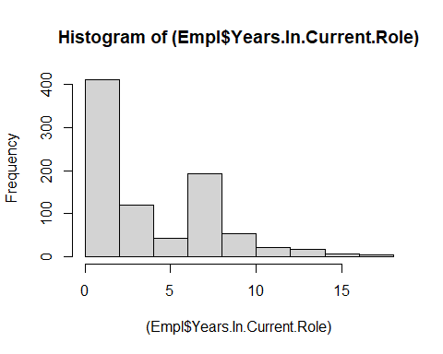

hist((Empl$Years.Since.Last.Promotion))#skewed

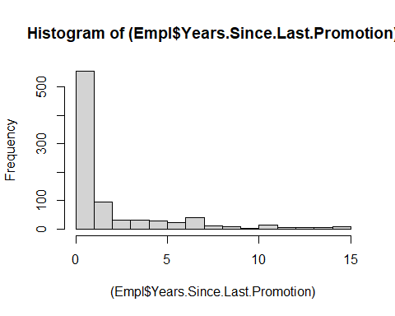

hist((Empl$Years.With.Curr.Manager))#skewed

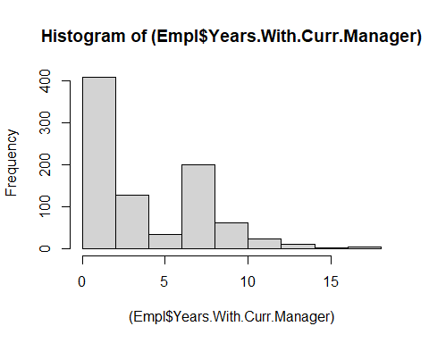

#Normality looks good for the below:  
#Age  
#log(Daily.Rate)  
#Hourly Rate  
#log(Monthly.Income)  
#log(Total.Working.Years)  
#log(Years.At.Company)  
#Years.In.Current.Role  
#Years.Since.Last.Promotion  
#Years.With.Curr.Manager

# train test split  
# 80/20 would be: 695:174  
set.seed(1234)  
  
sampleSizeTrain <- floor(.80 * nrow(Empl))  
sampleSizeTest <- floor(.20 * nrow(Empl))  
  
indicesTrain <- sort(sample(seq_len(nrow(Empl)), size=sampleSizeTrain))  
indicesNotTest<- setdiff(seq_len(nrow(Empl)), sampleSizeTrain)  
indicesTest<- sort(sample(seq_len(nrow(Empl)), size=sampleSizeTest))  
  
Train <- Empl[indicesTrain, ]  
Test <- Empl[indicesTest, ]  
  
dim(Train)

## [1] 695 36

dim(Test)

## [1] 173 36

testASEfwd<-c()  
testASEbwd<-c()  
testASEstp<-c()  
testASEsimp1<-c()  
testASEsimp2<-c()

set.seed(1234)  
##### Null Model #######  
EmplTrain<-Train%>%select(Age,Attrition,BusinessTravel,Department,Daily.Rate,Distance.From.Home,Education,EducationField,Environment.Satisfaction,Gender,(Hourly.Rate),(Monthly.Income),Job.Involvement,Job.Level,Job.Role,Job.Satisfaction,Marital.Status,(Monthly.Rate),Num.Companies.Worked,OverTime,Percent.Salary.Hike,Performance.Rating,Relationship.Satisfaction,Stock.Option.Level,(Total.Working.Years),Training.Times.Last.Year,Work.Life.Balance,(Years.At.Company),Years.In.Current.Role,Years.Since.Last.Promotion,Years.With.Curr.Manager)  
  
EmplTest<-Test%>%select(Age,Attrition,BusinessTravel,Department,Daily.Rate,Distance.From.Home,Education,EducationField,Environment.Satisfaction,Gender,(Hourly.Rate),Monthly.Income,Job.Involvement,Job.Level,Job.Role,Job.Satisfaction,Marital.Status,Monthly.Rate,Num.Companies.Worked,OverTime,Percent.Salary.Hike,Performance.Rating,Relationship.Satisfaction,Stock.Option.Level,(Total.Working.Years),Training.Times.Last.Year,Work.Life.Balance,(Years.At.Company),Years.In.Current.Role,Years.Since.Last.Promotion,Years.With.Curr.Manager)  
  
dim(EmplTrain)

## [1] 695 31

dim(EmplTest)

## [1] 173 31

Model_Null<-lm(log(Monthly.Income)~.,data=EmplTrain) # . means all variable not mpg  
summary(Model_Null)

##   
## Call:  
## lm(formula = log(Monthly.Income) ~ ., data = EmplTrain)  
##   
## Residuals:  
## Min 1Q Median 3Q Max   
## -0.78497 -0.13365 -0.00122 0.13938 0.61954   
##   
## Coefficients:  
## Estimate Std. Error t value Pr(>|t|)   
## (Intercept) 7.727e+00 1.824e-01 42.370 < 2e-16 ***  
## Age 8.366e-04 1.323e-03 0.632 0.52730   
## AttritionYes -7.454e-02 2.849e-02 -2.617 0.00908 **   
## BusinessTravelTravel_Frequently 5.906e-02 3.341e-02 1.767 0.07762 .   
## BusinessTravelTravel_Rarely 7.993e-02 2.763e-02 2.893 0.00394 **   
## DepartmentResearch & Development 9.363e-02 1.120e-01 0.836 0.40338   
## DepartmentSales 8.109e-02 1.170e-01 0.693 0.48836   
## Daily.Rate 5.585e-05 2.170e-05 2.574 0.01028 *   
## Distance.From.Home 5.649e-04 1.070e-03 0.528 0.59769   
## Education -2.473e-03 8.711e-03 -0.284 0.77657   
## EducationFieldLife Sciences -8.975e-03 8.768e-02 -0.102 0.91850   
## EducationFieldMarketing -1.925e-03 9.291e-02 -0.021 0.98348   
## EducationFieldMedical -2.113e-02 8.833e-02 -0.239 0.81099   
## EducationFieldOther 3.874e-02 9.366e-02 0.414 0.67924   
## EducationFieldTechnical Degree -4.399e-02 9.113e-02 -0.483 0.62945   
## Environment.Satisfaction -1.502e-02 8.061e-03 -1.863 0.06290 .   
## GenderMale 3.603e-03 1.772e-02 0.203 0.83892   
## Hourly.Rate 3.207e-05 4.392e-04 0.073 0.94182   
## Job.Involvement 4.726e-03 1.267e-02 0.373 0.70921   
## Job.Level 3.732e-01 2.010e-02 18.571 < 2e-16 ***  
## Job.RoleHuman Resources -1.725e-01 1.195e-01 -1.443 0.14945   
## Job.RoleLaboratory Technician -3.499e-01 4.089e-02 -8.559 < 2e-16 ***  
## Job.RoleManager 1.287e-01 6.796e-02 1.894 0.05872 .   
## Job.RoleManufacturing Director -4.889e-05 4.073e-02 -0.001 0.99904   
## Job.RoleResearch Director 1.700e-01 5.208e-02 3.264 0.00115 **   
## Job.RoleResearch Scientist -3.233e-01 4.067e-02 -7.949 8.34e-15 ***  
## Job.RoleSales Executive -1.649e-02 8.714e-02 -0.189 0.84998   
## Job.RoleSales Representative -3.825e-01 9.458e-02 -4.045 5.87e-05 ***  
## Job.Satisfaction 1.536e-03 7.917e-03 0.194 0.84622   
## Marital.StatusMarried 1.039e-02 2.379e-02 0.437 0.66249   
## Marital.StatusSingle 1.315e-02 3.238e-02 0.406 0.68487   
## Monthly.Rate 2.124e-06 1.227e-06 1.731 0.08390 .   
## Num.Companies.Worked 9.393e-03 4.018e-03 2.338 0.01970 *   
## OverTimeYes 4.811e-02 2.001e-02 2.404 0.01651 *   
## Percent.Salary.Hike 4.631e-03 3.736e-03 1.240 0.21559   
## Performance.Rating -6.309e-02 3.849e-02 -1.639 0.10165   
## Relationship.Satisfaction -1.336e-02 7.897e-03 -1.692 0.09110 .   
## Stock.Option.Level 8.154e-03 1.369e-02 0.596 0.55169   
## Total.Working.Years 5.480e-03 2.607e-03 2.102 0.03595 *   
## Training.Times.Last.Year 1.164e-03 6.965e-03 0.167 0.86732   
## Work.Life.Balance -7.488e-03 1.234e-02 -0.607 0.54404   
## Years.At.Company -2.902e-03 3.409e-03 -0.851 0.39490   
## Years.In.Current.Role 9.278e-03 4.183e-03 2.218 0.02690 *   
## Years.Since.Last.Promotion 2.961e-03 3.716e-03 0.797 0.42583   
## Years.With.Curr.Manager 3.363e-03 4.043e-03 0.832 0.40584   
## ---  
## Signif. codes: 0 '***' 0.001 '**' 0.01 '*' 0.05 '.' 0.1 ' ' 1  
##   
## Residual standard error: 0.2225 on 650 degrees of freedom  
## Multiple R-squared: 0.8954, Adjusted R-squared: 0.8884   
## F-statistic: 126.5 on 44 and 650 DF, p-value: < 2.2e-16

vif(Model_Null)

## GVIF Df GVIF^(1/(2*Df))  
## Age 1.976077 1 1.405730  
## Attrition 1.425854 1 1.194091  
## BusinessTravel 1.152761 2 1.036179  
## Department 121.929719 2 3.322977  
## Daily.Rate 1.069148 1 1.033996  
## Distance.From.Home 1.086419 1 1.042314  
## Education 1.129670 1 1.062859  
## EducationField 3.303965 5 1.126947  
## Environment.Satisfaction 1.095402 1 1.046615  
## Gender 1.054963 1 1.027114  
## Hourly.Rate 1.071097 1 1.034938  
## Job.Involvement 1.094423 1 1.046147  
## Job.Level 6.747920 1 2.597676  
## Job.Role 641.056708 8 1.497721  
## Job.Satisfaction 1.089498 1 1.043790  
## Marital.Status 2.137359 2 1.209120  
## Monthly.Rate 1.044819 1 1.022164  
## Num.Companies.Worked 1.409970 1 1.187422  
## OverTime 1.162226 1 1.078066  
## Percent.Salary.Hike 2.632904 1 1.622622  
## Performance.Rating 2.644845 1 1.626298  
## Relationship.Satisfaction 1.067791 1 1.033340  
## Stock.Option.Level 1.896768 1 1.377232  
## Total.Working.Years 5.325026 1 2.307602  
## Training.Times.Last.Year 1.081166 1 1.039791  
## Work.Life.Balance 1.050614 1 1.024995  
## Years.At.Company 5.456434 1 2.335901  
## Years.In.Current.Role 3.196533 1 1.787885  
## Years.Since.Last.Promotion 1.895031 1 1.376601  
## Years.With.Curr.Manager 2.915403 1 1.707455

#Department and Job.Role have a greater vif > 10 so we can try rerunning without these 2 predictors. Also taking a log on Monthly Income makes the residual charts look better especially the qq plot, histogram and the cooks D.All the observations are below 0.02 so we are good.The QQ plot is a straigh line and the histogram is a nice bell shaped curve displaying normality.  
  
#Outlier:  
#Outliers seen are the below observations:  
Train = subset(Train, ID != 365)   
Train = subset(Train, ID != 458)  
Train = subset(Train, ID != 364)  
Train = subset(Train, ID != 266)  
Train = subset(Train, ID != 265)  
Train = subset(Train, ID != 254)  
Train = subset(Train, ID != 253)  
  
par(mfrow=c(1,5))  
ols_plot_resid_fit(Model_Null)

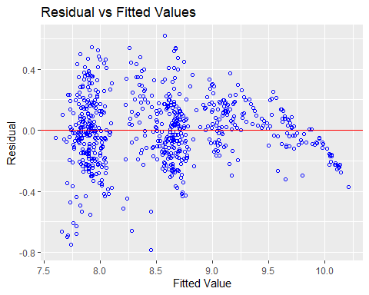

ols_plot_resid_lev(Model_Null)

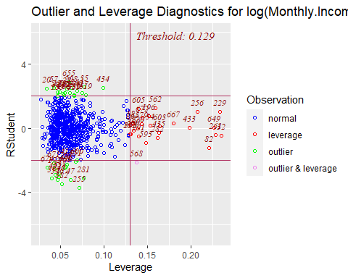

ols_plot_resid_qq(Model_Null)

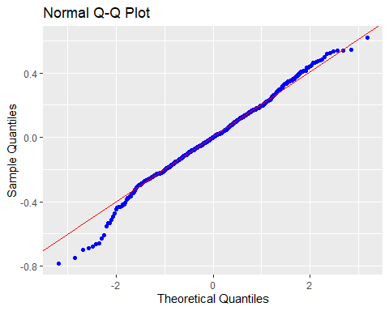

ols_plot_resid_hist(Model_Null)

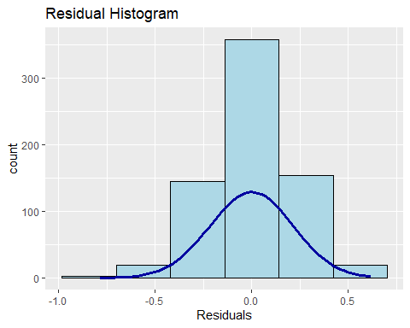

ols_plot_cooksd_bar(Model_Null)

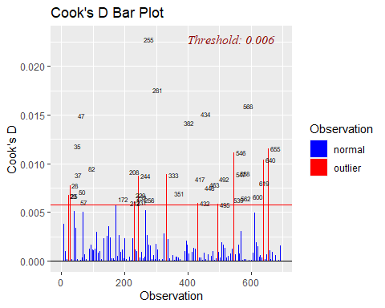

#Business Travel Rarely, Daily Rates,Job Level,Laboratory Technician,Research #Director, Research Scientist,Sales #Representative,Number of companies #worked,overtime,Total.Working.Years,Years.In.Current.Role are statistically #significant.  
  
#Prediction  
Pred_Full=predict(Model_Null , newdata = EmplTest, interval = "confidence")  
  
as.data.frame(Pred_Full)

## fit lwr upr  
## 6 8.935808 8.825122 9.046495  
## 27 8.670848 8.590364 8.751333  
## 32 8.034357 7.916504 8.152210  
## 35 8.657264 8.553041 8.761486  
## 40 7.851354 7.746477 7.956231  
## 45 7.787182 7.700121 7.874242  
## 48 9.060691 8.973492 9.147891  
## 49 7.749149 7.641731 7.856567  
## 53 8.039803 7.938009 8.141596  
## 55 8.648090 8.555760 8.740420  
## 57 7.913026 7.803566 8.022486  
## 58 8.051037 7.948522 8.153551  
## 65 7.772001 7.669161 7.874841  
## 82 8.762209 8.660295 8.864124  
## 83 8.634445 8.532113 8.736777  
## 86 9.615853 9.497501 9.734206  
## 94 8.691813 8.596707 8.786918  
## 95 10.059810 9.927598 10.192021  
## 97 9.641311 9.491737 9.790885  
## 103 8.640974 8.539798 8.742151  
## 107 8.634047 8.510607 8.757487  
## 109 8.561137 8.437907 8.684368  
## 114 8.547596 8.426459 8.668732  
## 118 8.470475 8.366817 8.574133  
## 124 8.554675 8.455117 8.654233  
## 125 8.684821 8.586091 8.783550  
## 127 7.893628 7.775049 8.012207  
## 137 7.767464 7.665330 7.869598  
## 160 9.291042 9.161454 9.420631  
## 162 8.930429 8.801569 9.059289  
## 166 7.698237 7.595340 7.801134  
## 176 7.891663 7.779473 8.003854  
## 181 9.119207 9.026117 9.212297  
## 182 8.697316 8.607081 8.787551  
## 187 8.626440 8.516364 8.736515  
## 191 8.369995 8.271321 8.468669  
## 192 8.992583 8.891391 9.093776  
## 202 8.347240 8.258938 8.435543  
## 204 7.984664 7.877250 8.092078  
## 216 7.893670 7.819139 7.968202  
## 217 8.746397 8.644778 8.848016  
## 224 7.906647 7.816024 7.997269  
## 225 7.987110 7.890613 8.083608  
## 228 7.978948 7.892233 8.065664  
## 245 8.725866 8.631287 8.820446  
## 253 7.815777 7.724504 7.907050  
## 254 7.839820 7.669643 8.009997  
## 261 7.733779 7.625803 7.841756  
## 272 8.378565 8.293007 8.464123  
## 273 8.246965 8.119177 8.374753  
## 278 7.934910 7.830724 8.039095  
## 279 8.523271 8.425164 8.621378  
## 280 8.680986 8.570290 8.791682  
## 283 8.679888 8.588573 8.771204  
## 284 8.657224 8.565023 8.749425  
## 289 9.047089 8.937356 9.156822  
## 295 9.512214 9.301152 9.723277  
## 297 8.692302 8.590280 8.794323  
## 308 7.856147 7.747380 7.964913  
## 311 8.458391 8.366236 8.550547  
## 312 9.542327 9.426305 9.658349  
## 318 8.613599 8.523163 8.704035  
## 324 8.575434 8.451801 8.699068  
## 328 8.391564 8.299181 8.483946  
## 333 7.851042 7.742742 7.959343  
## 338 8.639090 8.532997 8.745184  
## 340 7.819098 7.718135 7.920061  
## 368 8.639170 8.531127 8.747213  
## 369 7.870590 7.777959 7.963221  
## 377 8.021192 7.888104 8.154281  
## 379 8.068341 7.968266 8.168416  
## 387 9.015914 8.914243 9.117585  
## 388 8.586196 8.476026 8.696367  
## 389 8.317530 8.212771 8.422290  
## 400 9.193728 9.083739 9.303718  
## 406 9.702232 9.579169 9.825295  
## 407 8.710870 8.611948 8.809792  
## 417 7.872522 7.775149 7.969895  
## 424 7.749240 7.641172 7.857307  
## 425 8.585035 8.485368 8.684701  
## 436 8.691898 8.603970 8.779827  
## 438 7.898641 7.799766 7.997516  
## 448 8.703351 8.602472 8.804231  
## 451 8.754185 8.632053 8.876316  
## 452 7.963746 7.875334 8.052159  
## 453 8.625318 8.520227 8.730409  
## 454 8.619723 8.534115 8.705332  
## 456 9.977372 9.819441 10.135303  
## 459 7.927541 7.815688 8.039393  
## 461 8.009459 7.898381 8.120537  
## 465 7.896411 7.783488 8.009334  
## 466 7.925857 7.844806 8.006908  
## 467 7.900670 7.788090 8.013250  
## 473 9.275864 9.154153 9.397575  
## 474 8.032209 7.937729 8.126689  
## 479 8.047267 7.927508 8.167026  
## 480 9.328019 9.210629 9.445408  
## 482 8.046390 7.965580 8.127201  
## 488 7.951231 7.851362 8.051100  
## 492 9.751050 9.637461 9.864640  
## 494 9.085828 8.974016 9.197640  
## 496 9.732702 9.572639 9.892766  
## 511 8.634608 8.542508 8.726707  
## 516 8.679442 8.575998 8.782886  
## 521 7.877544 7.791474 7.963614  
## 527 8.697972 8.596737 8.799208  
## 530 8.046984 7.927273 8.166695  
## 532 8.705996 8.615588 8.796404  
## 540 8.634369 8.540609 8.728129  
## 547 8.890774 8.744472 9.037075  
## 550 8.013700 7.875389 8.152011  
## 565 7.888240 7.789742 7.986737  
## 566 8.023894 7.940641 8.107148  
## 567 8.200699 8.096755 8.304642  
## 573 8.656401 8.562272 8.750529  
## 584 8.669050 8.560164 8.777936  
## 596 8.669085 8.564393 8.773776  
## 601 7.675062 7.572837 7.777287  
## 603 9.261877 9.137595 9.386160  
## 604 8.050325 7.956802 8.143848  
## 608 8.623958 8.504290 8.743626  
## 618 8.695206 8.589054 8.801357  
## 626 7.943131 7.855456 8.030807  
## 627 8.643503 8.549160 8.737845  
## 628 9.295515 9.181108 9.409922  
## 636 7.897206 7.788652 8.005759  
## 639 8.019895 7.929804 8.109986  
## 653 9.338808 9.213739 9.463876  
## 654 9.200091 9.044370 9.355812  
## 665 8.559067 8.454543 8.663592  
## 667 9.026317 8.907379 9.145255  
## 674 7.914342 7.789566 8.039118  
## 680 7.914462 7.800727 8.028196  
## 681 8.566124 8.461578 8.670670  
## 688 7.848846 7.754119 7.943573  
## 695 8.561031 8.449991 8.672070  
## 696 7.943319 7.826909 8.059730  
## 697 9.526412 9.382247 9.670577  
## 698 8.456033 8.357691 8.554374  
## 700 10.084350 9.976740 10.191960  
## 703 9.060490 8.933842 9.187137  
## 712 9.652964 9.496298 9.809630  
## 719 8.695565 8.570498 8.820633  
## 727 7.943253 7.837465 8.049041  
## 731 8.577893 8.470751 8.685035  
## 732 8.642993 8.534047 8.751939  
## 738 8.634308 8.531498 8.737119  
## 740 8.360172 8.255130 8.465214  
## 752 7.759887 7.653272 7.866501  
## 755 9.376088 9.243728 9.508447  
## 756 7.811952 7.704949 7.918956  
## 768 9.010626 8.884053 9.137198  
## 769 8.573951 8.468935 8.678966  
## 772 9.133874 8.995538 9.272209  
## 774 7.843001 7.744010 7.941992  
## 776 7.900494 7.812085 7.988904  
## 778 7.712335 7.598975 7.825695  
## 788 8.302892 8.192990 8.412794  
## 799 7.722806 7.608245 7.837367  
## 803 9.607483 9.473745 9.741220  
## 804 8.952154 8.836883 9.067425  
## 809 7.928495 7.827517 8.029474  
## 814 9.879090 9.670943 10.087238  
## 816 8.011770 7.919173 8.104368  
## 818 9.186773 9.081701 9.291844  
## 821 8.002181 7.892368 8.111994  
## 825 8.732519 8.633142 8.831895  
## 831 8.278899 8.168372 8.389427  
## 834 7.825153 7.737407 7.912899  
## 845 8.621222 8.521778 8.720667  
## 852 7.848969 7.750422 7.947516  
## 854 8.671832 8.564195 8.779469  
## 864 9.484186 9.336369 9.632003

MSPE = data.frame(Observed = log(EmplTest$Monthly.Income), Predicted = Pred_Full)  
MSPE$Resisdual = MSPE$Observed - MSPE$Predicted.fit  
MSPE$SquaredResidual = MSPE$Resisdual^2  
MSPE

## Observed Predicted.fit Predicted.lwr Predicted.upr Resisdual  
## 6 9.081711 8.935808 8.825122 9.046495 0.145903178  
## 27 9.202711 8.670848 8.590364 8.751333 0.531863109  
## 32 7.614805 8.034357 7.916504 8.152210 -0.419551542  
## 35 9.177714 8.657264 8.553041 8.761486 0.520450255  
## 40 7.934155 7.851354 7.746477 7.956231 0.082801485  
## 45 7.109062 7.787182 7.700121 7.874242 -0.678119382  
## 48 9.075665 9.060691 8.973492 9.147891 0.014974097  
## 49 7.537963 7.749149 7.641731 7.856567 -0.211186460  
## 53 7.606387 8.039803 7.938009 8.141596 -0.433415289  
## 55 8.394800 8.648090 8.555760 8.740420 -0.253290685  
## 57 7.922624 7.913026 7.803566 8.022486 0.009598023  
## 58 8.460199 8.051037 7.948522 8.153551 0.409162605  
## 65 7.700748 7.772001 7.669161 7.874841 -0.071253319  
## 82 8.836810 8.762209 8.660295 8.864124 0.074600490  
## 83 8.579417 8.634445 8.532113 8.736777 -0.055028303  
## 86 9.527047 9.615853 9.497501 9.734206 -0.088806244  
## 94 8.722906 8.691813 8.596707 8.786918 0.031093196  
## 95 9.899781 10.059810 9.927598 10.192021 -0.160028849  
## 97 9.717519 9.641311 9.491737 9.790885 0.076208399  
## 103 8.785387 8.640974 8.539798 8.742151 0.144412556  
## 107 8.370779 8.634047 8.510607 8.757487 -0.263267585  
## 109 9.096724 8.561137 8.437907 8.684368 0.535586167  
## 114 8.535622 8.547596 8.426459 8.668732 -0.011973457  
## 118 8.300280 8.470475 8.366817 8.574133 -0.170194863  
## 124 8.301025 8.554675 8.455117 8.654233 -0.253649820  
## 125 8.423761 8.684821 8.586091 8.783550 -0.261059576  
## 127 8.273592 7.893628 7.775049 8.012207 0.379963827  
## 137 7.748891 7.767464 7.665330 7.869598 -0.018572817  
## 160 9.487290 9.291042 9.161454 9.420631 0.196247664  
## 162 9.073604 8.930429 8.801569 9.059289 0.143174671  
## 166 7.622664 7.698237 7.595340 7.801134 -0.075573125  
## 176 7.635304 7.891663 7.779473 8.003854 -0.256359410  
## 181 9.237372 9.119207 9.026117 9.212297 0.118164801  
## 182 8.838262 8.697316 8.607081 8.787551 0.140945668  
## 187 8.557567 8.626440 8.516364 8.736515 -0.068872538  
## 191 8.661294 8.369995 8.271321 8.468669 0.291298259  
## 192 9.173365 8.992583 8.891391 9.093776 0.180782121  
## 202 8.735525 8.347240 8.258938 8.435543 0.388284845  
## 204 7.703459 7.984664 7.877250 8.092078 -0.281205118  
## 216 7.760041 7.893670 7.819139 7.968202 -0.133629611  
## 217 9.192584 8.746397 8.644778 8.848016 0.446186509  
## 224 7.354362 7.906647 7.816024 7.997269 -0.552284593  
## 225 8.470311 7.987110 7.890613 8.083608 0.483200937  
## 228 7.752765 7.978948 7.892233 8.065664 -0.226183385  
## 245 8.528331 8.725866 8.631287 8.820446 -0.197535542  
## 253 7.729296 7.815777 7.724504 7.907050 -0.086481140  
## 254 7.991592 7.839820 7.669643 8.009997 0.151772180  
## 261 7.932003 7.733779 7.625803 7.841756 0.198223663  
## 272 8.600247 8.378565 8.293007 8.464123 0.221681767  
## 273 8.171882 8.246965 8.119177 8.374753 -0.075083378  
## 278 7.805882 7.934910 7.830724 8.039095 -0.129027576  
## 279 8.655911 8.523271 8.425164 8.621378 0.132639779  
## 280 8.302762 8.680986 8.570290 8.791682 -0.378224368  
## 283 8.781555 8.679888 8.588573 8.771204 0.101667040  
## 284 8.928905 8.657224 8.565023 8.749425 0.271681407  
## 289 9.183791 9.047089 8.937356 9.156822 0.136702343  
## 295 9.707290 9.512214 9.301152 9.723277 0.195076050  
## 297 9.163982 8.692302 8.590280 8.794323 0.471680746  
## 308 7.999343 7.856147 7.747380 7.964913 0.143196114  
## 311 8.609590 8.458391 8.366236 8.550547 0.151198555  
## 312 9.490771 9.542327 9.426305 9.658349 -0.051556245  
## 318 8.437500 8.613599 8.523163 8.704035 -0.176098341  
## 324 8.437067 8.575434 8.451801 8.699068 -0.138367099  
## 328 8.596004 8.391564 8.299181 8.483946 0.204440393  
## 333 7.758761 7.851042 7.742742 7.959343 -0.092281803  
## 338 8.956222 8.639090 8.532997 8.745184 0.317131735  
## 340 7.758333 7.819098 7.718135 7.920061 -0.060764601  
## 368 8.607582 8.639170 8.531127 8.747213 -0.031587553  
## 369 7.636752 7.870590 7.777959 7.963221 -0.233837817  
## 377 7.916807 8.021192 7.888104 8.154281 -0.104384718  
## 379 7.681560 8.068341 7.968266 8.168416 -0.386780902  
## 387 9.081256 9.015914 8.914243 9.117585 0.065341958  
## 388 8.357494 8.586196 8.476026 8.696367 -0.228702640  
## 389 8.412277 8.317530 8.212771 8.422290 0.094746897  
## 400 9.231025 9.193728 9.083739 9.303718 0.037296474  
## 406 9.718783 9.702232 9.579169 9.825295 0.016551261  
## 407 8.606668 8.710870 8.611948 8.809792 -0.104202009  
## 417 7.849324 7.872522 7.775149 7.969895 -0.023198189  
## 424 7.384610 7.749240 7.641172 7.857307 -0.364629507  
## 425 8.460411 8.585035 8.485368 8.684701 -0.124623561  
## 436 8.734560 8.691898 8.603970 8.779827 0.042661936  
## 438 7.961021 7.898641 7.799766 7.997516 0.062380568  
## 448 8.619389 8.703351 8.602472 8.804231 -0.083962757  
## 451 8.492491 8.754185 8.632053 8.876316 -0.261694225  
## 452 8.137396 7.963746 7.875334 8.052159 0.173649551  
## 453 8.667852 8.625318 8.520227 8.730409 0.042533878  
## 454 8.610137 8.619723 8.534115 8.705332 -0.009586370  
## 456 9.895102 9.977372 9.819441 10.135303 -0.082269149  
## 459 7.633370 7.927541 7.815688 8.039393 -0.294170871  
## 461 7.646354 8.009459 7.898381 8.120537 -0.363105172  
## 465 7.798523 7.896411 7.783488 8.009334 -0.097888015  
## 466 8.279951 7.925857 7.844806 8.006908 0.354093692  
## 467 7.880048 7.900670 7.788090 8.013250 -0.020622026  
## 473 9.491375 9.275864 9.154153 9.397575 0.215511209  
## 474 8.146709 8.032209 7.937729 8.126689 0.114499925  
## 479 7.989560 8.047267 7.927508 8.167026 -0.057706541  
## 480 9.528358 9.328019 9.210629 9.445408 0.200339083  
## 482 7.764721 8.046390 7.965580 8.127201 -0.281669795  
## 488 7.976252 7.951231 7.851362 8.051100 0.025020830  
## 492 9.733885 9.751050 9.637461 9.864640 -0.017165721  
## 494 9.060215 9.085828 8.974016 9.197640 -0.025613239  
## 496 9.699350 9.732702 9.572639 9.892766 -0.033352370  
## 511 8.583543 8.634608 8.542508 8.726707 -0.051065146  
## 516 8.609225 8.679442 8.575998 8.782886 -0.070216503  
## 521 7.845024 7.877544 7.791474 7.963614 -0.032519561  
## 527 8.518392 8.697972 8.596737 8.799208 -0.179579887  
## 530 8.509766 8.046984 7.927273 8.166695 0.462781558  
## 532 8.826881 8.705996 8.615588 8.796404 0.120885365  
## 540 8.547722 8.634369 8.540609 8.728129 -0.086646957  
## 547 8.909641 8.890774 8.744472 9.037075 0.018867100  
## 550 7.685703 8.013700 7.875389 8.152011 -0.327996955  
## 565 8.251403 7.888240 7.789742 7.986737 0.363163368  
## 566 7.798113 8.023894 7.940641 8.107148 -0.225781725  
## 567 7.685244 8.200699 8.096755 8.304642 -0.515455096  
## 573 8.829665 8.656401 8.562272 8.750529 0.173264619  
## 584 8.471987 8.669050 8.560164 8.777936 -0.197063249  
## 596 8.303257 8.669085 8.564393 8.773776 -0.365827508  
## 601 7.617268 7.675062 7.572837 7.777287 -0.057794399  
## 603 9.342771 9.261877 9.137595 9.386160 0.080893909  
## 604 8.049108 8.050325 7.956802 8.143848 -0.001217363  
## 608 8.631414 8.623958 8.504290 8.743626 0.007456340  
## 618 8.604105 8.695206 8.589054 8.801357 -0.091100999  
## 626 7.830823 7.943131 7.855456 8.030807 -0.112308317  
## 627 8.333751 8.643503 8.549160 8.737845 -0.309751527  
## 628 9.350972 9.295515 9.181108 9.409922 0.055456920  
## 636 7.773174 7.897206 7.788652 8.005759 -0.124032134  
## 639 7.910224 8.019895 7.929804 8.109986 -0.109671322  
## 653 9.510371 9.338808 9.213739 9.463876 0.171563356  
## 654 9.433804 9.200091 9.044370 9.355812 0.233712796  
## 665 8.426831 8.559067 8.454543 8.663592 -0.132236646  
## 667 8.976894 9.026317 8.907379 9.145255 -0.049423232  
## 674 7.611842 7.914342 7.789566 8.039118 -0.302499685  
## 680 7.753194 7.914462 7.800727 8.028196 -0.161267578  
## 681 8.356085 8.566124 8.461578 8.670670 -0.210038806  
## 688 7.871693 7.848846 7.754119 7.943573 0.022846742  
## 695 9.161675 8.561031 8.449991 8.672070 0.600644495  
## 696 8.099858 7.943319 7.826909 8.059730 0.156538582  
## 697 9.629182 9.526412 9.382247 9.670577 0.102770387  
## 698 8.685078 8.456033 8.357691 8.554374 0.229044737  
## 700 9.856448 10.084350 9.976740 10.191960 -0.227901474  
## 703 9.247347 9.060490 8.933842 9.187137 0.186857571  
## 712 9.555206 9.652964 9.496298 9.809630 -0.097758109  
## 719 8.429673 8.695565 8.570498 8.820633 -0.265892583  
## 727 7.997327 7.943253 7.837465 8.049041 0.054074009  
## 731 8.469053 8.577893 8.470751 8.685035 -0.108840241  
## 732 8.563695 8.642993 8.534047 8.751939 -0.079298427  
## 738 8.550821 8.634308 8.531498 8.737119 -0.083486828  
## 740 8.210940 8.360172 8.255130 8.465214 -0.149232626  
## 752 7.741534 7.759887 7.653272 7.866501 -0.018353120  
## 755 9.514068 9.376088 9.243728 9.508447 0.137980318  
## 756 8.218248 7.811952 7.704949 7.918956 0.406295617  
## 768 9.299450 9.010626 8.884053 9.137198 0.288823984  
## 769 8.906393 8.573951 8.468935 8.678966 0.332442884  
## 772 9.254644 9.133874 8.995538 9.272209 0.120770410  
## 774 8.127995 7.843001 7.744010 7.941992 0.284994044  
## 776 8.161946 7.900494 7.812085 7.988904 0.261451648  
## 778 7.946971 7.712335 7.598975 7.825695 0.234636511  
## 788 8.505323 8.302892 8.192990 8.412794 0.202430792  
## 799 7.527794 7.722806 7.608245 7.837367 -0.195012091  
## 803 9.744961 9.607483 9.473745 9.741220 0.137477896  
## 804 9.167642 8.952154 8.836883 9.067425 0.215487972  
## 809 7.959276 7.928495 7.827517 8.029474 0.030780730  
## 814 9.886240 9.879090 9.670943 10.087238 0.007149265  
## 816 7.930566 8.011770 7.919173 8.104368 -0.081204613  
## 818 9.366575 9.186773 9.081701 9.291844 0.179801773  
## 821 8.105308 8.002181 7.892368 8.111994 0.103126490  
## 825 8.447414 8.732519 8.633142 8.831895 -0.285104320  
## 831 8.197814 8.278899 8.168372 8.389427 -0.081085445  
## 834 7.844633 7.825153 7.737407 7.912899 0.019479257  
## 845 8.704336 8.621222 8.521778 8.720667 0.083114111  
## 852 7.698936 7.848969 7.750422 7.947516 -0.150032848  
## 854 8.641356 8.671832 8.564195 8.779469 -0.030476560  
## 864 9.530248 9.484186 9.336369 9.632003 0.046061442  
## SquaredResidual  
## 6 2.128774e-02  
## 27 2.828784e-01  
## 32 1.760235e-01  
## 35 2.708685e-01  
## 40 6.856086e-03  
## 45 4.598459e-01  
## 48 2.242236e-04  
## 49 4.459972e-02  
## 53 1.878488e-01  
## 55 6.415617e-02  
## 57 9.212204e-05  
## 58 1.674140e-01  
## 65 5.077035e-03  
## 82 5.565233e-03  
## 83 3.028114e-03  
## 86 7.886549e-03  
## 94 9.667868e-04  
## 95 2.560923e-02  
## 97 5.807720e-03  
## 103 2.085499e-02  
## 107 6.930982e-02  
## 109 2.868525e-01  
## 114 1.433637e-04  
## 118 2.896629e-02  
## 124 6.433823e-02  
## 125 6.815210e-02  
## 127 1.443725e-01  
## 137 3.449495e-04  
## 160 3.851315e-02  
## 162 2.049899e-02  
## 166 5.711297e-03  
## 176 6.572015e-02  
## 181 1.396292e-02  
## 182 1.986568e-02  
## 187 4.743427e-03  
## 191 8.485468e-02  
## 192 3.268218e-02  
## 202 1.507651e-01  
## 204 7.907632e-02  
## 216 1.785687e-02  
## 217 1.990824e-01  
## 224 3.050183e-01  
## 225 2.334831e-01  
## 228 5.115892e-02  
## 245 3.902029e-02  
## 253 7.478988e-03  
## 254 2.303479e-02  
## 261 3.929262e-02  
## 272 4.914281e-02  
## 273 5.637514e-03  
## 278 1.664812e-02  
## 279 1.759331e-02  
## 280 1.430537e-01  
## 283 1.033619e-02  
## 284 7.381079e-02  
## 289 1.868753e-02  
## 295 3.805467e-02  
## 297 2.224827e-01  
## 308 2.050513e-02  
## 311 2.286100e-02  
## 312 2.658046e-03  
## 318 3.101063e-02  
## 324 1.914545e-02  
## 328 4.179587e-02  
## 333 8.515931e-03  
## 338 1.005725e-01  
## 340 3.692337e-03  
## 368 9.977735e-04  
## 369 5.468012e-02  
## 377 1.089617e-02  
## 379 1.495995e-01  
## 387 4.269572e-03  
## 388 5.230490e-02  
## 389 8.976975e-03  
## 400 1.391027e-03  
## 406 2.739442e-04  
## 407 1.085806e-02  
## 417 5.381560e-04  
## 424 1.329547e-01  
## 425 1.553103e-02  
## 436 1.820041e-03  
## 438 3.891335e-03  
## 448 7.049745e-03  
## 451 6.848387e-02  
## 452 3.015417e-02  
## 453 1.809131e-03  
## 454 9.189850e-05  
## 456 6.768213e-03  
## 459 8.653650e-02  
## 461 1.318454e-01  
## 465 9.582064e-03  
## 466 1.253823e-01  
## 467 4.252680e-04  
## 473 4.644508e-02  
## 474 1.311023e-02  
## 479 3.330045e-03  
## 480 4.013575e-02  
## 482 7.933787e-02  
## 488 6.260419e-04  
## 492 2.946620e-04  
## 494 6.560380e-04  
## 496 1.112381e-03  
## 511 2.607649e-03  
## 516 4.930357e-03  
## 521 1.057522e-03  
## 527 3.224894e-02  
## 530 2.141668e-01  
## 532 1.461327e-02  
## 540 7.507695e-03  
## 547 3.559674e-04  
## 550 1.075820e-01  
## 565 1.318876e-01  
## 566 5.097739e-02  
## 567 2.656940e-01  
## 573 3.002063e-02  
## 584 3.883392e-02  
## 596 1.338298e-01  
## 601 3.340193e-03  
## 603 6.543825e-03  
## 604 1.481972e-06  
## 608 5.559701e-05  
## 618 8.299392e-03  
## 626 1.261316e-02  
## 627 9.594601e-02  
## 628 3.075470e-03  
## 636 1.538397e-02  
## 639 1.202780e-02  
## 653 2.943399e-02  
## 654 5.462167e-02  
## 665 1.748653e-02  
## 667 2.442656e-03  
## 674 9.150606e-02  
## 680 2.600723e-02  
## 681 4.411630e-02  
## 688 5.219736e-04  
## 695 3.607738e-01  
## 696 2.450433e-02  
## 697 1.056175e-02  
## 698 5.246149e-02  
## 700 5.193908e-02  
## 703 3.491575e-02  
## 712 9.556648e-03  
## 719 7.069887e-02  
## 727 2.923998e-03  
## 731 1.184620e-02  
## 732 6.288241e-03  
## 738 6.970050e-03  
## 740 2.227038e-02  
## 752 3.368370e-04  
## 755 1.903857e-02  
## 756 1.650761e-01  
## 768 8.341929e-02  
## 769 1.105183e-01  
## 772 1.458549e-02  
## 774 8.122161e-02  
## 776 6.835696e-02  
## 778 5.505429e-02  
## 788 4.097823e-02  
## 799 3.802972e-02  
## 803 1.890017e-02  
## 804 4.643507e-02  
## 809 9.474533e-04  
## 814 5.111200e-05  
## 816 6.594189e-03  
## 818 3.232868e-02  
## 821 1.063507e-02  
## 825 8.128447e-02  
## 831 6.574849e-03  
## 834 3.794414e-04  
## 845 6.907955e-03  
## 852 2.250986e-02  
## 854 9.288207e-04  
## 864 2.121656e-03

mean(MSPE$SquaredResidual)

## [1] 0.05108796

##Removing Job ROle and Department and removing outliers  
EmplTrain<-Train%>%select(Age,Attrition,BusinessTravel,Daily.Rate,Distance.From.Home,Education,EducationField,Environment.Satisfaction,Gender,(Hourly.Rate),(Monthly.Income),Job.Involvement,Job.Level,Job.Satisfaction,Marital.Status,(Monthly.Rate),Num.Companies.Worked,OverTime,Percent.Salary.Hike,Performance.Rating,Relationship.Satisfaction,Stock.Option.Level,(Total.Working.Years),Training.Times.Last.Year,Work.Life.Balance,(Years.At.Company),Years.In.Current.Role,Years.Since.Last.Promotion,Years.With.Curr.Manager)  
  
EmplTest<-Test%>%select(Age,Attrition,BusinessTravel,Daily.Rate,Distance.From.Home,Education,EducationField,Environment.Satisfaction,Gender,(Hourly.Rate),(Monthly.Income),Job.Involvement,Job.Level,Job.Satisfaction,Marital.Status,(Monthly.Rate),Num.Companies.Worked,OverTime,Percent.Salary.Hike,Performance.Rating,Relationship.Satisfaction,Stock.Option.Level,(Total.Working.Years),Training.Times.Last.Year,Work.Life.Balance,(Years.At.Company),Years.In.Current.Role,Years.Since.Last.Promotion,Years.With.Curr.Manager)  
  
dim(EmplTest)

## [1] 173 29

dim(EmplTrain)

## [1] 689 29

Model_Null<-lm(log(Monthly.Income)~.,data=EmplTrain) # . means all variable not mpg  
summary(Model_Null)

##   
## Call:  
## lm(formula = log(Monthly.Income) ~ ., data = EmplTrain)  
##   
## Residuals:  
## Min 1Q Median 3Q Max   
## -0.89888 -0.14967 -0.00222 0.15484 0.73458   
##   
## Coefficients:  
## Estimate Std. Error t value Pr(>|t|)   
## (Intercept) 7.214e+00 1.625e-01 44.400 < 2e-16 ***  
## Age 1.259e-03 1.461e-03 0.862 0.389245   
## AttritionYes -1.147e-01 3.102e-02 -3.698 0.000236 ***  
## BusinessTravelTravel_Frequently 4.507e-02 3.631e-02 1.241 0.215017   
## BusinessTravelTravel_Rarely 6.992e-02 3.017e-02 2.318 0.020776 *   
## Daily.Rate 6.136e-05 2.371e-05 2.588 0.009858 **   
## Distance.From.Home -1.205e-04 1.172e-03 -0.103 0.918097   
## Education -1.276e-03 9.573e-03 -0.133 0.894015   
## EducationFieldLife Sciences 6.635e-02 7.707e-02 0.861 0.389569   
## EducationFieldMarketing 1.130e-01 8.047e-02 1.404 0.160736   
## EducationFieldMedical 5.298e-02 7.771e-02 0.682 0.495676   
## EducationFieldOther 1.119e-01 8.469e-02 1.321 0.187075   
## EducationFieldTechnical Degree 2.203e-02 8.196e-02 0.269 0.788144   
## Environment.Satisfaction -2.028e-02 8.803e-03 -2.303 0.021566 *   
## GenderMale 5.995e-04 1.951e-02 0.031 0.975494   
## Hourly.Rate 3.513e-04 4.834e-04 0.727 0.467642   
## Job.Involvement 9.814e-03 1.396e-02 0.703 0.482199   
## Job.Level 5.371e-01 1.448e-02 37.095 < 2e-16 ***  
## Job.Satisfaction 3.570e-03 8.721e-03 0.409 0.682427   
## Marital.StatusMarried -3.489e-03 2.614e-02 -0.133 0.893890   
## Marital.StatusSingle -1.479e-02 3.555e-02 -0.416 0.677483   
## Monthly.Rate 2.090e-06 1.357e-06 1.540 0.123940   
## Num.Companies.Worked 1.154e-02 4.386e-03 2.632 0.008693 **   
## OverTimeYes 5.120e-02 2.190e-02 2.338 0.019687 *   
## Percent.Salary.Hike 4.900e-03 4.110e-03 1.192 0.233620   
## Performance.Rating -3.933e-02 4.213e-02 -0.934 0.350894   
## Relationship.Satisfaction -1.230e-02 8.697e-03 -1.414 0.157872   
## Stock.Option.Level 3.752e-03 1.506e-02 0.249 0.803334   
## Total.Working.Years 3.810e-04 2.791e-03 0.136 0.891479   
## Training.Times.Last.Year 1.397e-03 7.617e-03 0.183 0.854497   
## Work.Life.Balance -7.019e-03 1.362e-02 -0.516 0.606375   
## Years.At.Company -6.035e-03 3.735e-03 -1.616 0.106596   
## Years.In.Current.Role 1.188e-02 4.582e-03 2.593 0.009718 **   
## Years.Since.Last.Promotion 1.574e-03 4.083e-03 0.386 0.699984   
## Years.With.Curr.Manager 7.822e-03 4.425e-03 1.767 0.077611 .   
## ---  
## Signif. codes: 0 '***' 0.001 '**' 0.01 '*' 0.05 '.' 0.1 ' ' 1  
##   
## Residual standard error: 0.2454 on 654 degrees of freedom  
## Multiple R-squared: 0.87, Adjusted R-squared: 0.8632   
## F-statistic: 128.7 on 34 and 654 DF, p-value: < 2.2e-16

vif(Model_Null)

## GVIF Df GVIF^(1/(2*Df))  
## Age 1.953799 1 1.397784  
## Attrition 1.376464 1 1.173228  
## BusinessTravel 1.096878 2 1.023386  
## Daily.Rate 1.036521 1 1.018097  
## Distance.From.Home 1.060868 1 1.029984  
## Education 1.105174 1 1.051272  
## EducationField 1.275694 5 1.024648  
## Environment.Satisfaction 1.064364 1 1.031680  
## Gender 1.042569 1 1.021063  
## Hourly.Rate 1.058995 1 1.029075  
## Job.Involvement 1.074719 1 1.036686  
## Job.Level 2.807214 1 1.675474  
## Job.Satisfaction 1.080699 1 1.039567  
## Marital.Status 2.079730 2 1.200886  
## Monthly.Rate 1.041107 1 1.020347  
## Num.Companies.Worked 1.370725 1 1.170780  
## OverTime 1.136492 1 1.066064  
## Percent.Salary.Hike 2.598258 1 1.611911  
## Performance.Rating 2.580588 1 1.606421  
## Relationship.Satisfaction 1.055597 1 1.027422  
## Stock.Option.Level 1.879109 1 1.370806  
## Total.Working.Years 4.955875 1 2.226179  
## Training.Times.Last.Year 1.051358 1 1.025358  
## Work.Life.Balance 1.041605 1 1.020591  
## Years.At.Company 5.284511 1 2.298806  
## Years.In.Current.Role 3.126788 1 1.768273  
## Years.Since.Last.Promotion 1.864074 1 1.365311  
## Years.With.Curr.Manager 2.829962 1 1.682249

par(mfrow=c(1,5))  
ols_plot_resid_fit(Model_Null)

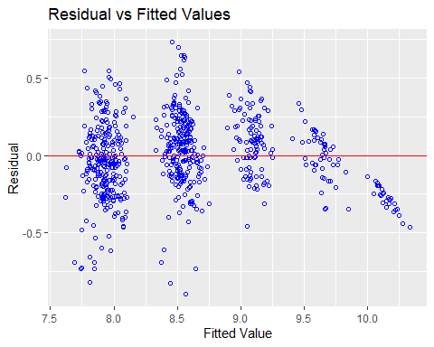

ols_plot_resid_lev(Model_Null)

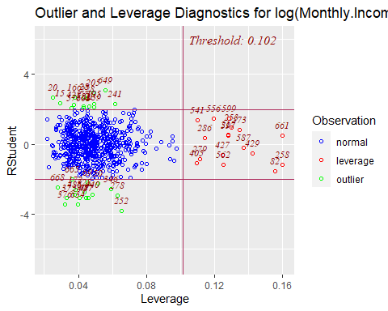

ols_plot_resid_qq(Model_Null)

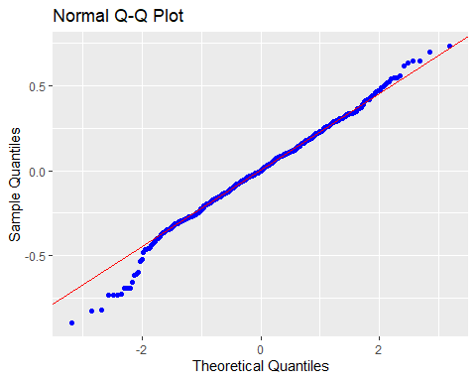

ols_plot_resid_hist(Model_Null)

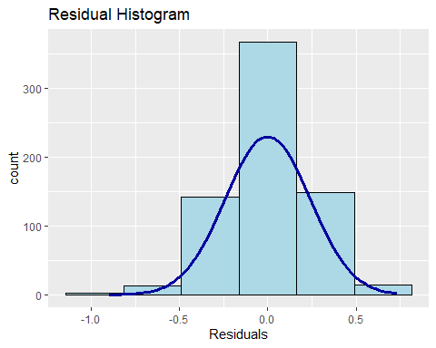

ols_plot_cooksd_bar(Model_Null)

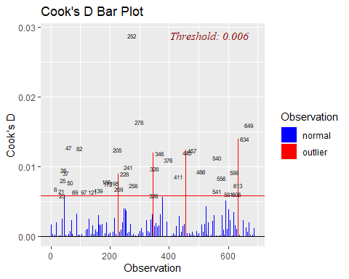

#Assumptions are met:  
#The histogram shows a bell shape curve which suggests that there is enough evidence for normality.  
#The QQ Plot shows a straight line which suggests that there is enough evidence for constant variance.  
#The ouliers are all below 0.2 which suggests there is not major high leverage points.  
#The observations are considered to be independent as they are randomly assigned.  
#Business Travel Rarely, Daily Rates,Job Level,Laboratory Technician,Research #Director, Research Scientist,Sales #Representative,Number of companies #worked,overtime,Total.Working.Years,Years.In.Current.Role are statistically #significant.  
  
#Prediction  
Pred_Null=predict(Model_Null , newdata = EmplTest, interval = "confidence")  
  
as.data.frame(Pred_Null)

## fit lwr upr  
## 6 8.966675 8.853946 9.079404  
## 27 8.553834 8.477738 8.629931  
## 32 8.072180 7.944277 8.200083  
## 35 8.528084 8.427371 8.628797  
## 40 7.951552 7.859629 8.043475  
## 45 7.844903 7.757056 7.932750  
## 48 9.167045 9.073327 9.260764  
## 49 7.862934 7.759261 7.966608  
## 53 8.072873 7.967125 8.178621  
## 55 8.520492 8.433540 8.607444  
## 57 7.917627 7.800776 8.034478  
## 58 8.093502 7.988611 8.198393  
## 65 7.791887 7.684906 7.898867  
## 82 8.576249 8.480853 8.671646  
## 83 8.485891 8.387836 8.583946  
## 86 9.691359 9.582896 9.799821  
## 94 8.544279 8.461301 8.627257  
## 95 10.212364 10.110621 10.314107  
## 97 9.631403 9.519873 9.742934  
## 103 8.609982 8.499430 8.720535  
## 107 8.488624 8.365828 8.611421  
## 109 8.382242 8.264626 8.499858  
## 114 8.376871 8.257697 8.496044  
## 118 8.650310 8.543061 8.757559  
## 124 8.491513 8.382315 8.600711  
## 125 8.563795 8.465429 8.662162  
## 127 7.852915 7.728962 7.976867  
## 137 7.789474 7.685867 7.893082  
## 160 9.076918 8.949588 9.204247  
## 162 8.893225 8.764878 9.021571  
## 166 7.755306 7.662484 7.848128  
## 176 7.910050 7.793780 8.026319  
## 181 9.109276 9.020064 9.198489  
## 182 8.604664 8.516819 8.692508  
## 187 8.516917 8.406306 8.627528  
## 191 8.535820 8.439179 8.632462  
## 192 9.078909 8.972246 9.185571  
## 202 8.530321 8.446275 8.614368  
## 204 7.976061 7.863280 8.088841  
## 216 7.926476 7.850502 8.002449  
## 217 8.556385 8.462707 8.650063  
## 224 7.974841 7.880431 8.069250  
## 225 8.013332 7.910772 8.115893  
## 228 8.016383 7.923647 8.109119  
## 245 8.562254 8.475071 8.649436  
## 253 7.866969 7.770714 7.963225  
## 254 7.701408 7.515337 7.887479  
## 261 7.806283 7.702448 7.910117  
## 272 8.566638 8.485701 8.647575  
## 273 8.511483 8.403233 8.619734  
## 278 7.966969 7.858665 8.075274  
## 279 8.392815 8.288285 8.497345  
## 280 8.557047 8.450623 8.663470  
## 283 8.546856 8.466103 8.627609  
## 284 8.585986 8.486275 8.685697  
## 289 9.106986 8.993741 9.220232  
## 295 9.576961 9.468145 9.685778  
## 297 8.549076 8.446200 8.651952  
## 308 7.874680 7.760094 7.989267  
## 311 8.652752 8.563845 8.741659  
## 312 9.667832 9.562518 9.773147  
## 318 8.466919 8.391006 8.542831  
## 324 8.750926 8.620746 8.881106  
## 328 8.567301 8.474366 8.660236  
## 333 7.848730 7.734030 7.963430  
## 338 8.487508 8.388509 8.586506  
## 340 7.890165 7.784127 7.996204  
## 368 8.498917 8.390491 8.607343  
## 369 7.887190 7.790213 7.984168  
## 377 7.971999 7.830883 8.113114  
## 379 8.085348 7.979097 8.191599  
## 387 9.112418 9.004743 9.220093  
## 388 8.417723 8.312115 8.523332  
## 389 8.515860 8.438775 8.592944  
## 400 9.187092 9.079846 9.294339  
## 406 9.664552 9.543163 9.785941  
## 407 8.602444 8.495712 8.709177  
## 417 7.894481 7.794192 7.994769  
## 424 7.836322 7.724323 7.948320  
## 425 8.456746 8.358084 8.555408  
## 436 8.636693 8.541329 8.732057  
## 438 7.938260 7.832473 8.044047  
## 448 8.563485 8.470617 8.656352  
## 451 8.586025 8.468515 8.703536  
## 452 7.960558 7.870779 8.050336  
## 453 8.449602 8.344226 8.554977  
## 454 8.529563 8.436529 8.622596  
## 456 10.111709 9.995821 10.227597  
## 459 8.008270 7.890077 8.126463  
## 461 8.066668 7.948370 8.184966  
## 465 7.864553 7.745993 7.983112  
## 466 7.943248 7.859510 8.026986  
## 467 8.024963 7.933743 8.116183  
## 473 9.074468 8.960706 9.188230  
## 474 8.039872 7.940179 8.139564  
## 479 8.093627 7.964849 8.222404  
## 480 9.162659 9.060071 9.265247  
## 482 8.054337 7.968896 8.139778  
## 488 7.970076 7.865095 8.075057  
## 492 9.668762 9.561160 9.776365  
## 494 9.065817 8.957388 9.174246  
## 496 9.763666 9.636974 9.890359  
## 511 8.550500 8.459404 8.641595  
## 516 8.526651 8.425395 8.627907  
## 521 7.891127 7.802295 7.979959  
## 527 8.596846 8.494203 8.699488  
## 530 8.046374 7.916339 8.176410  
## 532 8.562289 8.474763 8.649816  
## 540 8.565693 8.463186 8.668201  
## 547 9.131761 8.982208 9.281313  
## 550 7.958544 7.860267 8.056822  
## 565 7.940966 7.836798 8.045134  
## 566 8.057852 7.970271 8.145433  
## 567 8.376255 8.270498 8.482012  
## 573 8.555848 8.462588 8.649107  
## 584 8.637247 8.517776 8.756717  
## 596 8.616336 8.507378 8.725294  
## 601 7.788779 7.700855 7.876703  
## 603 9.119398 9.004679 9.234118  
## 604 8.103770 8.005182 8.202359  
## 608 8.546896 8.423499 8.670292  
## 618 8.688520 8.571601 8.805440  
## 626 7.990382 7.899664 8.081100  
## 627 8.532163 8.438930 8.625396  
## 628 9.159502 9.062100 9.256903  
## 636 7.949650 7.834216 8.065085  
## 639 8.049490 7.954596 8.144384  
## 653 9.157857 9.042831 9.272883  
## 654 9.097074 8.977531 9.216617  
## 665 8.494850 8.380022 8.609679  
## 667 9.046747 8.925160 9.168335  
## 674 7.875823 7.739543 8.012103  
## 680 7.965268 7.865944 8.064593  
## 681 8.496846 8.384305 8.609388  
## 688 7.892014 7.792808 7.991220  
## 695 8.445019 8.334482 8.555556  
## 696 8.053416 7.949680 8.157152  
## 697 9.539408 9.415941 9.662876  
## 698 8.633580 8.533247 8.733913  
## 700 10.171325 10.071683 10.270967  
## 703 9.137267 8.999481 9.275053  
## 712 9.641369 9.506661 9.776077  
## 719 8.522941 8.392305 8.653576  
## 727 8.005452 7.913515 8.097389  
## 731 8.498823 8.393123 8.604523  
## 732 8.464904 8.360206 8.569602  
## 738 8.499412 8.399751 8.599074  
## 740 8.544546 8.435275 8.653817  
## 752 7.811529 7.708158 7.914901  
## 755 9.219353 9.095886 9.342819  
## 756 7.836283 7.721892 7.950674  
## 768 8.992849 8.862328 9.123369  
## 769 8.415455 8.315495 8.515415  
## 772 9.154925 9.006240 9.303610  
## 774 7.827361 7.721181 7.933541  
## 776 7.947442 7.855841 8.039043  
## 778 7.843303 7.739100 7.947505  
## 788 8.431988 8.318275 8.545701  
## 799 7.761630 7.639331 7.883930  
## 803 9.585419 9.473111 9.697727  
## 804 8.976190 8.857032 9.095347  
## 809 7.916602 7.810594 8.022610  
## 814 10.084418 9.973347 10.195490  
## 816 8.007866 7.912266 8.103465  
## 818 9.002215 8.912521 9.091908  
## 821 8.032253 7.917417 8.147089  
## 825 8.604230 8.511919 8.696541  
## 831 8.487732 8.376182 8.599283  
## 834 7.869657 7.780415 7.958898  
## 845 8.490197 8.389901 8.590494  
## 852 7.852041 7.747050 7.957031  
## 854 8.519911 8.416502 8.623320  
## 864 9.590017 9.439599 9.740435

MSPE = data.frame(Observed = log(EmplTest$Monthly.Income), Predicted = Pred_Null)  
MSPE$Resisdual = MSPE$Observed - MSPE$Predicted.fit  
MSPE$SquaredResidual = MSPE$Resisdual^2  
MSPE

## Observed Predicted.fit Predicted.lwr Predicted.upr Resisdual  
## 6 9.081711 8.966675 8.853946 9.079404 0.115036597  
## 27 9.202711 8.553834 8.477738 8.629931 0.648877183  
## 32 7.614805 8.072180 7.944277 8.200083 -0.457374279  
## 35 9.177714 8.528084 8.427371 8.628797 0.649629980  
## 40 7.934155 7.951552 7.859629 8.043475 -0.017396722  
## 45 7.109062 7.844903 7.757056 7.932750 -0.735841163  
## 48 9.075665 9.167045 9.073327 9.260764 -0.091379993  
## 49 7.537963 7.862934 7.759261 7.966608 -0.324971564  
## 53 7.606387 8.072873 7.967125 8.178621 -0.466485865  
## 55 8.394800 8.520492 8.433540 8.607444 -0.125692148  
## 57 7.922624 7.917627 7.800776 8.034478 0.004996754  
## 58 8.460199 8.093502 7.988611 8.198393 0.366697464  
## 65 7.700748 7.791887 7.684906 7.898867 -0.091138804  
## 82 8.836810 8.576249 8.480853 8.671646 0.260560581  
## 83 8.579417 8.485891 8.387836 8.583946 0.093525753  
## 86 9.527047 9.691359 9.582896 9.799821 -0.164311464  
## 94 8.722906 8.544279 8.461301 8.627257 0.178626938  
## 95 9.899781 10.212364 10.110621 10.314107 -0.312583059  
## 97 9.717519 9.631403 9.519873 9.742934 0.086115910  
## 103 8.785387 8.609982 8.499430 8.720535 0.175404542  
## 107 8.370779 8.488624 8.365828 8.611421 -0.117845016  
## 109 9.096724 8.382242 8.264626 8.499858 0.714481751  
## 114 8.535622 8.376871 8.257697 8.496044 0.158751642  
## 118 8.300280 8.650310 8.543061 8.757559 -0.350030051  
## 124 8.301025 8.491513 8.382315 8.600711 -0.190487996  
## 125 8.423761 8.563795 8.465429 8.662162 -0.140034124  
## 127 8.273592 7.852915 7.728962 7.976867 0.420676886  
## 137 7.748891 7.789474 7.685867 7.893082 -0.040583037  
## 160 9.487290 9.076918 8.949588 9.204247 0.410372519  
## 162 9.073604 8.893225 8.764878 9.021571 0.180379299  
## 166 7.622664 7.755306 7.662484 7.848128 -0.132641988  
## 176 7.635304 7.910050 7.793780 8.026319 -0.274745883  
## 181 9.237372 9.109276 9.020064 9.198489 0.128095549  
## 182 8.838262 8.604664 8.516819 8.692508 0.233598050  
## 187 8.557567 8.516917 8.406306 8.627528 0.040649707  
## 191 8.661294 8.535820 8.439179 8.632462 0.125473277  
## 192 9.173365 9.078909 8.972246 9.185571 0.094456574  
## 202 8.735525 8.530321 8.446275 8.614368 0.205203928  
## 204 7.703459 7.976061 7.863280 8.088841 -0.272601490  
## 216 7.760041 7.926476 7.850502 8.002449 -0.166434836  
## 217 9.192584 8.556385 8.462707 8.650063 0.636198530  
## 224 7.354362 7.974841 7.880431 8.069250 -0.620478228  
## 225 8.470311 8.013332 7.910772 8.115893 0.456978763  
## 228 7.752765 8.016383 7.923647 8.109119 -0.263618033  
## 245 8.528331 8.562254 8.475071 8.649436 -0.033922608  
## 253 7.729296 7.866969 7.770714 7.963225 -0.137673646  
## 254 7.991592 7.701408 7.515337 7.887479 0.290184207  
## 261 7.932003 7.806283 7.702448 7.910117 0.125720632  
## 272 8.600247 8.566638 8.485701 8.647575 0.033608289  
## 273 8.171882 8.511483 8.403233 8.619734 -0.339601491  
## 278 7.805882 7.966969 7.858665 8.075274 -0.161087006  
## 279 8.655911 8.392815 8.288285 8.497345 0.263096427  
## 280 8.302762 8.557047 8.450623 8.663470 -0.254284932  
## 283 8.781555 8.546856 8.466103 8.627609 0.234699715  
## 284 8.928905 8.585986 8.486275 8.685697 0.342919025  
## 289 9.183791 9.106986 8.993741 9.220232 0.076804748  
## 295 9.707290 9.576961 9.468145 9.685778 0.130328774  
## 297 9.163982 8.549076 8.446200 8.651952 0.614906307  
## 308 7.999343 7.874680 7.760094 7.989267 0.124662487  
## 311 8.609590 8.652752 8.563845 8.741659 -0.043161953  
## 312 9.490771 9.667832 9.562518 9.773147 -0.177060957  
## 318 8.437500 8.466919 8.391006 8.542831 -0.029418274  
## 324 8.437067 8.750926 8.620746 8.881106 -0.313858681  
## 328 8.596004 8.567301 8.474366 8.660236 0.028703368  
## 333 7.758761 7.848730 7.734030 7.963430 -0.089969742  
## 338 8.956222 8.487508 8.388509 8.586506 0.468714231  
## 340 7.758333 7.890165 7.784127 7.996204 -0.131831855  
## 368 8.607582 8.498917 8.390491 8.607343 0.108665208  
## 369 7.636752 7.887190 7.790213 7.984168 -0.250438297  
## 377 7.916807 7.971999 7.830883 8.113114 -0.055191066  
## 379 7.681560 8.085348 7.979097 8.191599 -0.403787640  
## 387 9.081256 9.112418 9.004743 9.220093 -0.031161744  
## 388 8.357494 8.417723 8.312115 8.523332 -0.060229486  
## 389 8.412277 8.515860 8.438775 8.592944 -0.103582553  
## 400 9.231025 9.187092 9.079846 9.294339 0.043932607  
## 406 9.718783 9.664552 9.543163 9.785941 0.054230851  
## 407 8.606668 8.602444 8.495712 8.709177 0.004223855  
## 417 7.849324 7.894481 7.794192 7.994769 -0.045156734  
## 424 7.384610 7.836322 7.724323 7.948320 -0.451711415  
## 425 8.460411 8.456746 8.358084 8.555408 0.003665267  
## 436 8.734560 8.636693 8.541329 8.732057 0.097866736  
## 438 7.961021 7.938260 7.832473 8.044047 0.022761556  
## 448 8.619389 8.563485 8.470617 8.656352 0.055904007  
## 451 8.492491 8.586025 8.468515 8.703536 -0.093534921  
## 452 8.137396 7.960558 7.870779 8.050336 0.176838304  
## 453 8.667852 8.449602 8.344226 8.554977 0.218250430  
## 454 8.610137 8.529563 8.436529 8.622596 0.080574256  
## 456 9.895102 10.111709 9.995821 10.227597 -0.216606471  
## 459 7.633370 8.008270 7.890077 8.126463 -0.374900143  
## 461 7.646354 8.066668 7.948370 8.184966 -0.420314001  
## 465 7.798523 7.864553 7.745993 7.983112 -0.066029693  
## 466 8.279951 7.943248 7.859510 8.026986 0.336702619  
## 467 7.880048 8.024963 7.933743 8.116183 -0.144914369  
## 473 9.491375 9.074468 8.960706 9.188230 0.416907229  
## 474 8.146709 8.039872 7.940179 8.139564 0.106837407  
## 479 7.989560 8.093627 7.964849 8.222404 -0.104066189  
## 480 9.528358 9.162659 9.060071 9.265247 0.365698322  
## 482 7.764721 8.054337 7.968896 8.139778 -0.289616537  
## 488 7.976252 7.970076 7.865095 8.075057 0.006176189  
## 492 9.733885 9.668762 9.561160 9.776365 0.065122354  
## 494 9.060215 9.065817 8.957388 9.174246 -0.005602186  
## 496 9.699350 9.763666 9.636974 9.890359 -0.064316667  
## 511 8.583543 8.550500 8.459404 8.641595 0.033042648  
## 516 8.609225 8.526651 8.425395 8.627907 0.082574141  
## 521 7.845024 7.891127 7.802295 7.979959 -0.046102572  
## 527 8.518392 8.596846 8.494203 8.699488 -0.078453078  
## 530 8.509766 8.046374 7.916339 8.176410 0.463391450  
## 532 8.826881 8.562289 8.474763 8.649816 0.264591866  
## 540 8.547722 8.565693 8.463186 8.668201 -0.017971066  
## 547 8.909641 9.131761 8.982208 9.281313 -0.222120286  
## 550 7.685703 7.958544 7.860267 8.056822 -0.272841234  
## 565 8.251403 7.940966 7.836798 8.045134 0.310437053  
## 566 7.798113 8.057852 7.970271 8.145433 -0.259739407  
## 567 7.685244 8.376255 8.270498 8.482012 -0.691011035  
## 573 8.829665 8.555848 8.462588 8.649107 0.273817521  
## 584 8.471987 8.637247 8.517776 8.756717 -0.165259987  
## 596 8.303257 8.616336 8.507378 8.725294 -0.313078906  
## 601 7.617268 7.788779 7.700855 7.876703 -0.171511422  
## 603 9.342771 9.119398 9.004679 9.234118 0.223372953  
## 604 8.049108 8.103770 8.005182 8.202359 -0.054662735  
## 608 8.631414 8.546896 8.423499 8.670292 0.084518673  
## 618 8.604105 8.688520 8.571601 8.805440 -0.084415521  
## 626 7.830823 7.990382 7.899664 8.081100 -0.159559244  
## 627 8.333751 8.532163 8.438930 8.625396 -0.198412103  
## 628 9.350972 9.159502 9.062100 9.256903 0.191469914  
## 636 7.773174 7.949650 7.834216 8.065085 -0.176476595  
## 639 7.910224 8.049490 7.954596 8.144384 -0.139266137  
## 653 9.510371 9.157857 9.042831 9.272883 0.352514066  
## 654 9.433804 9.097074 8.977531 9.216617 0.336729702  
## 665 8.426831 8.494850 8.380022 8.609679 -0.068019711  
## 667 8.976894 9.046747 8.925160 9.168335 -0.069853481  
## 674 7.611842 7.875823 7.739543 8.012103 -0.263980765  
## 680 7.753194 7.965268 7.865944 8.064593 -0.212073991  
## 681 8.356085 8.496846 8.384305 8.609388 -0.140761106  
## 688 7.871693 7.892014 7.792808 7.991220 -0.020321117  
## 695 9.161675 8.445019 8.334482 8.555556 0.716656477  
## 696 8.099858 8.053416 7.949680 8.157152 0.046441636  
## 697 9.629182 9.539408 9.415941 9.662876 0.089774122  
## 698 8.685078 8.633580 8.533247 8.733913 0.051498018  
## 700 9.856448 10.171325 10.071683 10.270967 -0.314876816  
## 703 9.247347 9.137267 8.999481 9.275053 0.110080300  
## 712 9.555206 9.641369 9.506661 9.776077 -0.086163120  
## 719 8.429673 8.522941 8.392305 8.653576 -0.093268279  
## 727 7.997327 8.005452 7.913515 8.097389 -0.008124995  
## 731 8.469053 8.498823 8.393123 8.604523 -0.029769969  
## 732 8.563695 8.464904 8.360206 8.569602 0.098791084  
## 738 8.550821 8.499412 8.399751 8.599074 0.051409117  
## 740 8.210940 8.544546 8.435275 8.653817 -0.333606258  
## 752 7.741534 7.811529 7.708158 7.914901 -0.069995807  
## 755 9.514068 9.219353 9.095886 9.342819 0.294715266  
## 756 8.218248 7.836283 7.721892 7.950674 0.381964944  
## 768 9.299450 8.992849 8.862328 9.123369 0.306600741  
## 769 8.906393 8.415455 8.315495 8.515415 0.490938525  
## 772 9.254644 9.154925 9.006240 9.303610 0.099719021  
## 774 8.127995 7.827361 7.721181 7.933541 0.300633734  
## 776 8.161946 7.947442 7.855841 8.039043 0.214503415  
## 778 7.946971 7.843303 7.739100 7.947505 0.103668774  
## 788 8.505323 8.431988 8.318275 8.545701 0.073334754  
## 799 7.527794 7.761630 7.639331 7.883930 -0.233836314  
## 803 9.744961 9.585419 9.473111 9.697727 0.159541567  
## 804 9.167642 8.976190 8.857032 9.095347 0.191452090  
## 809 7.959276 7.916602 7.810594 8.022610 0.042673928  
## 814 9.886240 10.084418 9.973347 10.195490 -0.198178809  
## 816 7.930566 8.007866 7.912266 8.103465 -0.077300097  
## 818 9.366575 9.002215 8.912521 9.091908 0.364359712  
## 821 8.105308 8.032253 7.917417 8.147089 0.073054661  
## 825 8.447414 8.604230 8.511919 8.696541 -0.156815739  
## 831 8.197814 8.487732 8.376182 8.599283 -0.289918352  
## 834 7.844633 7.869657 7.780415 7.958898 -0.025023865  
## 845 8.704336 8.490197 8.389901 8.590494 0.214138968  
## 852 7.698936 7.852041 7.747050 7.957031 -0.153104498  
## 854 8.641356 8.519911 8.416502 8.623320 0.121445036  
## 864 9.530248 9.590017 9.439599 9.740435 -0.059769782  
## SquaredResidual  
## 6 1.323342e-02  
## 27 4.210416e-01  
## 32 2.091912e-01  
## 35 4.220191e-01  
## 40 3.026459e-04  
## 45 5.414622e-01  
## 48 8.350303e-03  
## 49 1.056065e-01  
## 53 2.176091e-01  
## 55 1.579852e-02  
## 57 2.496755e-05  
## 58 1.344670e-01  
## 65 8.306282e-03  
## 82 6.789182e-02  
## 83 8.747066e-03  
## 86 2.699826e-02  
## 94 3.190758e-02  
## 95 9.770817e-02  
## 97 7.415950e-03  
## 103 3.076675e-02  
## 107 1.388745e-02  
## 109 5.104842e-01  
## 114 2.520208e-02  
## 118 1.225210e-01  
## 124 3.628568e-02  
## 125 1.960956e-02  
## 127 1.769690e-01  
## 137 1.646983e-03  
## 160 1.684056e-01  
## 162 3.253669e-02  
## 166 1.759390e-02  
## 176 7.548530e-02  
## 181 1.640847e-02  
## 182 5.456805e-02  
## 187 1.652399e-03  
## 191 1.574354e-02  
## 192 8.922044e-03  
## 202 4.210865e-02  
## 204 7.431157e-02  
## 216 2.770055e-02  
## 217 4.047486e-01  
## 224 3.849932e-01  
## 225 2.088296e-01  
## 228 6.949447e-02  
## 245 1.150743e-03  
## 253 1.895403e-02  
## 254 8.420687e-02  
## 261 1.580568e-02  
## 272 1.129517e-03  
## 273 1.153292e-01  
## 278 2.594902e-02  
## 279 6.921973e-02  
## 280 6.466083e-02  
## 283 5.508396e-02  
## 284 1.175935e-01  
## 289 5.898969e-03  
## 295 1.698559e-02  
## 297 3.781098e-01  
## 308 1.554074e-02  
## 311 1.862954e-03  
## 312 3.135058e-02  
## 318 8.654348e-04  
## 324 9.850727e-02  
## 328 8.238833e-04  
## 333 8.094554e-03  
## 338 2.196930e-01  
## 340 1.737964e-02  
## 368 1.180813e-02  
## 369 6.271934e-02  
## 377 3.046054e-03  
## 379 1.630445e-01  
## 387 9.710543e-04  
## 388 3.627591e-03  
## 389 1.072935e-02  
## 400 1.930074e-03  
## 406 2.940985e-03  
## 407 1.784095e-05  
## 417 2.039131e-03  
## 424 2.040432e-01  
## 425 1.343418e-05  
## 436 9.577898e-03  
## 438 5.180885e-04  
## 448 3.125258e-03  
## 451 8.748781e-03  
## 452 3.127179e-02  
## 453 4.763325e-02  
## 454 6.492211e-03  
## 456 4.691836e-02  
## 459 1.405501e-01  
## 461 1.766639e-01  
## 465 4.359920e-03  
## 466 1.133687e-01  
## 467 2.100017e-02  
## 473 1.738116e-01  
## 474 1.141423e-02  
## 479 1.082977e-02  
## 480 1.337353e-01  
## 482 8.387774e-02  
## 488 3.814531e-05  
## 492 4.240921e-03  
## 494 3.138448e-05  
## 496 4.136634e-03  
## 511 1.091817e-03  
## 516 6.818489e-03  
## 521 2.125447e-03  
## 527 6.154885e-03  
## 530 2.147316e-01  
## 532 7.000886e-02  
## 540 3.229592e-04  
## 547 4.933742e-02  
## 550 7.444234e-02  
## 565 9.637116e-02  
## 566 6.746456e-02  
## 567 4.774963e-01  
## 573 7.497603e-02  
## 584 2.731086e-02  
## 596 9.801840e-02  
## 601 2.941617e-02  
## 603 4.989548e-02  
## 604 2.988015e-03  
## 608 7.143406e-03  
## 618 7.125980e-03  
## 626 2.545915e-02  
## 627 3.936736e-02  
## 628 3.666073e-02  
## 636 3.114399e-02  
## 639 1.939506e-02  
## 653 1.242662e-01  
## 654 1.133869e-01  
## 665 4.626681e-03  
## 667 4.879509e-03  
## 674 6.968584e-02  
## 680 4.497538e-02  
## 681 1.981369e-02  
## 688 4.129478e-04  
## 695 5.135965e-01  
## 696 2.156826e-03  
## 697 8.059393e-03  
## 698 2.652046e-03  
## 700 9.914741e-02  
## 703 1.211767e-02  
## 712 7.424083e-03  
## 719 8.698972e-03  
## 727 6.601555e-05  
## 731 8.862510e-04  
## 732 9.759678e-03  
## 738 2.642897e-03  
## 740 1.112931e-01  
## 752 4.899413e-03  
## 755 8.685709e-02  
## 756 1.458972e-01  
## 768 9.400401e-02  
## 769 2.410206e-01  
## 772 9.943883e-03  
## 774 9.038064e-02  
## 776 4.601172e-02  
## 778 1.074721e-02  
## 788 5.377986e-03  
## 799 5.467942e-02  
## 803 2.545351e-02  
## 804 3.665390e-02  
## 809 1.821064e-03  
## 814 3.927484e-02  
## 816 5.975305e-03  
## 818 1.327580e-01  
## 821 5.336983e-03  
## 825 2.459118e-02  
## 831 8.405265e-02  
## 834 6.261938e-04  
## 845 4.585550e-02  
## 852 2.344099e-02  
## 854 1.474890e-02  
## 864 3.572427e-03

mean(MSPE$SquaredResidual)

## [1] 0.06735389

##### Forward Model #####  
#Forward:  
Model_FWD<-stepAIC(Model_Null,direction="forward",trace=FALSE)  
summary(Model_FWD)

##   
## Call:  
## lm(formula = log(Monthly.Income) ~ Age + Attrition + BusinessTravel +   
## Daily.Rate + Distance.From.Home + Education + EducationField +   
## Environment.Satisfaction + Gender + Hourly.Rate + Job.Involvement +   
## Job.Level + Job.Satisfaction + Marital.Status + Monthly.Rate +   
## Num.Companies.Worked + OverTime + Percent.Salary.Hike + Performance.Rating +   
## Relationship.Satisfaction + Stock.Option.Level + Total.Working.Years +   
## Training.Times.Last.Year + Work.Life.Balance + Years.At.Company +   
## Years.In.Current.Role + Years.Since.Last.Promotion + Years.With.Curr.Manager,   
## data = EmplTrain)  
##   
## Residuals:  
## Min 1Q Median 3Q Max   
## -0.89888 -0.14967 -0.00222 0.15484 0.73458   
##   
## Coefficients:  
## Estimate Std. Error t value Pr(>|t|)   
## (Intercept) 7.214e+00 1.625e-01 44.400 < 2e-16 ***  
## Age 1.259e-03 1.461e-03 0.862 0.389245   
## AttritionYes -1.147e-01 3.102e-02 -3.698 0.000236 ***  
## BusinessTravelTravel_Frequently 4.507e-02 3.631e-02 1.241 0.215017   
## BusinessTravelTravel_Rarely 6.992e-02 3.017e-02 2.318 0.020776 *   
## Daily.Rate 6.136e-05 2.371e-05 2.588 0.009858 **   
## Distance.From.Home -1.205e-04 1.172e-03 -0.103 0.918097   
## Education -1.276e-03 9.573e-03 -0.133 0.894015   
## EducationFieldLife Sciences 6.635e-02 7.707e-02 0.861 0.389569   
## EducationFieldMarketing 1.130e-01 8.047e-02 1.404 0.160736   
## EducationFieldMedical 5.298e-02 7.771e-02 0.682 0.495676   
## EducationFieldOther 1.119e-01 8.469e-02 1.321 0.187075   
## EducationFieldTechnical Degree 2.203e-02 8.196e-02 0.269 0.788144   
## Environment.Satisfaction -2.028e-02 8.803e-03 -2.303 0.021566 *   
## GenderMale 5.995e-04 1.951e-02 0.031 0.975494   
## Hourly.Rate 3.513e-04 4.834e-04 0.727 0.467642   
## Job.Involvement 9.814e-03 1.396e-02 0.703 0.482199   
## Job.Level 5.371e-01 1.448e-02 37.095 < 2e-16 ***  
## Job.Satisfaction 3.570e-03 8.721e-03 0.409 0.682427   
## Marital.StatusMarried -3.489e-03 2.614e-02 -0.133 0.893890   
## Marital.StatusSingle -1.479e-02 3.555e-02 -0.416 0.677483   
## Monthly.Rate 2.090e-06 1.357e-06 1.540 0.123940   
## Num.Companies.Worked 1.154e-02 4.386e-03 2.632 0.008693 **   
## OverTimeYes 5.120e-02 2.190e-02 2.338 0.019687 *   
## Percent.Salary.Hike 4.900e-03 4.110e-03 1.192 0.233620   
## Performance.Rating -3.933e-02 4.213e-02 -0.934 0.350894   
## Relationship.Satisfaction -1.230e-02 8.697e-03 -1.414 0.157872   
## Stock.Option.Level 3.752e-03 1.506e-02 0.249 0.803334   
## Total.Working.Years 3.810e-04 2.791e-03 0.136 0.891479   
## Training.Times.Last.Year 1.397e-03 7.617e-03 0.183 0.854497   
## Work.Life.Balance -7.019e-03 1.362e-02 -0.516 0.606375   
## Years.At.Company -6.035e-03 3.735e-03 -1.616 0.106596   
## Years.In.Current.Role 1.188e-02 4.582e-03 2.593 0.009718 **   
## Years.Since.Last.Promotion 1.574e-03 4.083e-03 0.386 0.699984   
## Years.With.Curr.Manager 7.822e-03 4.425e-03 1.767 0.077611 .   
## ---  
## Signif. codes: 0 '***' 0.001 '**' 0.01 '*' 0.05 '.' 0.1 ' ' 1  
##   
## Residual standard error: 0.2454 on 654 degrees of freedom  
## Multiple R-squared: 0.87, Adjusted R-squared: 0.8632   
## F-statistic: 128.7 on 34 and 654 DF, p-value: < 2.2e-16

vif(Model_FWD)

## GVIF Df GVIF^(1/(2*Df))  
## Age 1.953799 1 1.397784  
## Attrition 1.376464 1 1.173228  
## BusinessTravel 1.096878 2 1.023386  
## Daily.Rate 1.036521 1 1.018097  
## Distance.From.Home 1.060868 1 1.029984  
## Education 1.105174 1 1.051272  
## EducationField 1.275694 5 1.024648  
## Environment.Satisfaction 1.064364 1 1.031680  
## Gender 1.042569 1 1.021063  
## Hourly.Rate 1.058995 1 1.029075  
## Job.Involvement 1.074719 1 1.036686  
## Job.Level 2.807214 1 1.675474  
## Job.Satisfaction 1.080699 1 1.039567  
## Marital.Status 2.079730 2 1.200886  
## Monthly.Rate 1.041107 1 1.020347  
## Num.Companies.Worked 1.370725 1 1.170780  
## OverTime 1.136492 1 1.066064  
## Percent.Salary.Hike 2.598258 1 1.611911  
## Performance.Rating 2.580588 1 1.606421  
## Relationship.Satisfaction 1.055597 1 1.027422  
## Stock.Option.Level 1.879109 1 1.370806  
## Total.Working.Years 4.955875 1 2.226179  
## Training.Times.Last.Year 1.051358 1 1.025358  
## Work.Life.Balance 1.041605 1 1.020591  
## Years.At.Company 5.284511 1 2.298806  
## Years.In.Current.Role 3.126788 1 1.768273  
## Years.Since.Last.Promotion 1.864074 1 1.365311  
## Years.With.Curr.Manager 2.829962 1 1.682249

#Residual Plots  
par(mfrow=c(1,5))  
ols_plot_resid_fit(Model_FWD)



ols_plot_resid_lev(Model_FWD)



ols_plot_resid_qq(Model_FWD)



ols_plot_resid_hist(Model_FWD)



ols_plot_cooksd_bar(Model_FWD)



#Assumptions are met:  
#The histogram shows a bell shape curve which suggests that there is enough evidence for normality.  
#The QQ Plot shows a straight line which suggests that there is enough evidence for constant variance.  
#The ouliers are all below 0.2 which suggests there is not major high leverage points.  
#The observations are considered to be independent as they are randomly assigned.  
#Business Travel Rarely, Daily Rates,Job Level,Laboratory Technician,Research #Director, Research Scientist,Sales #Representative,Number of companies #worked,overtime,Total.Working.Years,Years.In.Current.Role are statistically #significant.  
  
#Prediction  
Pred_FWD=predict(Model_FWD, newdata = EmplTest, interval = "confidence")  
as.data.frame(Pred_FWD)

## fit lwr upr  
## 6 8.966675 8.853946 9.079404  
## 27 8.553834 8.477738 8.629931  
## 32 8.072180 7.944277 8.200083  
## 35 8.528084 8.427371 8.628797  
## 40 7.951552 7.859629 8.043475  
## 45 7.844903 7.757056 7.932750  
## 48 9.167045 9.073327 9.260764  
## 49 7.862934 7.759261 7.966608  
## 53 8.072873 7.967125 8.178621  
## 55 8.520492 8.433540 8.607444  
## 57 7.917627 7.800776 8.034478  
## 58 8.093502 7.988611 8.198393  
## 65 7.791887 7.684906 7.898867  
## 82 8.576249 8.480853 8.671646  
## 83 8.485891 8.387836 8.583946  
## 86 9.691359 9.582896 9.799821  
## 94 8.544279 8.461301 8.627257  
## 95 10.212364 10.110621 10.314107  
## 97 9.631403 9.519873 9.742934  
## 103 8.609982 8.499430 8.720535  
## 107 8.488624 8.365828 8.611421  
## 109 8.382242 8.264626 8.499858  
## 114 8.376871 8.257697 8.496044  
## 118 8.650310 8.543061 8.757559  
## 124 8.491513 8.382315 8.600711  
## 125 8.563795 8.465429 8.662162  
## 127 7.852915 7.728962 7.976867  
## 137 7.789474 7.685867 7.893082  
## 160 9.076918 8.949588 9.204247  
## 162 8.893225 8.764878 9.021571  
## 166 7.755306 7.662484 7.848128  
## 176 7.910050 7.793780 8.026319  
## 181 9.109276 9.020064 9.198489  
## 182 8.604664 8.516819 8.692508  
## 187 8.516917 8.406306 8.627528  
## 191 8.535820 8.439179 8.632462  
## 192 9.078909 8.972246 9.185571  
## 202 8.530321 8.446275 8.614368  
## 204 7.976061 7.863280 8.088841  
## 216 7.926476 7.850502 8.002449  
## 217 8.556385 8.462707 8.650063  
## 224 7.974841 7.880431 8.069250  
## 225 8.013332 7.910772 8.115893  
## 228 8.016383 7.923647 8.109119  
## 245 8.562254 8.475071 8.649436  
## 253 7.866969 7.770714 7.963225  
## 254 7.701408 7.515337 7.887479  
## 261 7.806283 7.702448 7.910117  
## 272 8.566638 8.485701 8.647575  
## 273 8.511483 8.403233 8.619734  
## 278 7.966969 7.858665 8.075274  
## 279 8.392815 8.288285 8.497345  
## 280 8.557047 8.450623 8.663470  
## 283 8.546856 8.466103 8.627609  
## 284 8.585986 8.486275 8.685697  
## 289 9.106986 8.993741 9.220232  
## 295 9.576961 9.468145 9.685778  
## 297 8.549076 8.446200 8.651952  
## 308 7.874680 7.760094 7.989267  
## 311 8.652752 8.563845 8.741659  
## 312 9.667832 9.562518 9.773147  
## 318 8.466919 8.391006 8.542831  
## 324 8.750926 8.620746 8.881106  
## 328 8.567301 8.474366 8.660236  
## 333 7.848730 7.734030 7.963430  
## 338 8.487508 8.388509 8.586506  
## 340 7.890165 7.784127 7.996204  
## 368 8.498917 8.390491 8.607343  
## 369 7.887190 7.790213 7.984168  
## 377 7.971999 7.830883 8.113114  
## 379 8.085348 7.979097 8.191599  
## 387 9.112418 9.004743 9.220093  
## 388 8.417723 8.312115 8.523332  
## 389 8.515860 8.438775 8.592944  
## 400 9.187092 9.079846 9.294339  
## 406 9.664552 9.543163 9.785941  
## 407 8.602444 8.495712 8.709177  
## 417 7.894481 7.794192 7.994769  
## 424 7.836322 7.724323 7.948320  
## 425 8.456746 8.358084 8.555408  
## 436 8.636693 8.541329 8.732057  
## 438 7.938260 7.832473 8.044047  
## 448 8.563485 8.470617 8.656352  
## 451 8.586025 8.468515 8.703536  
## 452 7.960558 7.870779 8.050336  
## 453 8.449602 8.344226 8.554977  
## 454 8.529563 8.436529 8.622596  
## 456 10.111709 9.995821 10.227597  
## 459 8.008270 7.890077 8.126463  
## 461 8.066668 7.948370 8.184966  
## 465 7.864553 7.745993 7.983112  
## 466 7.943248 7.859510 8.026986  
## 467 8.024963 7.933743 8.116183  
## 473 9.074468 8.960706 9.188230  
## 474 8.039872 7.940179 8.139564  
## 479 8.093627 7.964849 8.222404  
## 480 9.162659 9.060071 9.265247  
## 482 8.054337 7.968896 8.139778  
## 488 7.970076 7.865095 8.075057  
## 492 9.668762 9.561160 9.776365  
## 494 9.065817 8.957388 9.174246  
## 496 9.763666 9.636974 9.890359  
## 511 8.550500 8.459404 8.641595  
## 516 8.526651 8.425395 8.627907  
## 521 7.891127 7.802295 7.979959  
## 527 8.596846 8.494203 8.699488  
## 530 8.046374 7.916339 8.176410  
## 532 8.562289 8.474763 8.649816  
## 540 8.565693 8.463186 8.668201  
## 547 9.131761 8.982208 9.281313  
## 550 7.958544 7.860267 8.056822  
## 565 7.940966 7.836798 8.045134  
## 566 8.057852 7.970271 8.145433  
## 567 8.376255 8.270498 8.482012  
## 573 8.555848 8.462588 8.649107  
## 584 8.637247 8.517776 8.756717  
## 596 8.616336 8.507378 8.725294  
## 601 7.788779 7.700855 7.876703  
## 603 9.119398 9.004679 9.234118  
## 604 8.103770 8.005182 8.202359  
## 608 8.546896 8.423499 8.670292  
## 618 8.688520 8.571601 8.805440  
## 626 7.990382 7.899664 8.081100  
## 627 8.532163 8.438930 8.625396  
## 628 9.159502 9.062100 9.256903  
## 636 7.949650 7.834216 8.065085  
## 639 8.049490 7.954596 8.144384  
## 653 9.157857 9.042831 9.272883  
## 654 9.097074 8.977531 9.216617  
## 665 8.494850 8.380022 8.609679  
## 667 9.046747 8.925160 9.168335  
## 674 7.875823 7.739543 8.012103  
## 680 7.965268 7.865944 8.064593  
## 681 8.496846 8.384305 8.609388  
## 688 7.892014 7.792808 7.991220  
## 695 8.445019 8.334482 8.555556  
## 696 8.053416 7.949680 8.157152  
## 697 9.539408 9.415941 9.662876  
## 698 8.633580 8.533247 8.733913  
## 700 10.171325 10.071683 10.270967  
## 703 9.137267 8.999481 9.275053  
## 712 9.641369 9.506661 9.776077  
## 719 8.522941 8.392305 8.653576  
## 727 8.005452 7.913515 8.097389  
## 731 8.498823 8.393123 8.604523  
## 732 8.464904 8.360206 8.569602  
## 738 8.499412 8.399751 8.599074  
## 740 8.544546 8.435275 8.653817  
## 752 7.811529 7.708158 7.914901  
## 755 9.219353 9.095886 9.342819  
## 756 7.836283 7.721892 7.950674  
## 768 8.992849 8.862328 9.123369  
## 769 8.415455 8.315495 8.515415  
## 772 9.154925 9.006240 9.303610  
## 774 7.827361 7.721181 7.933541  
## 776 7.947442 7.855841 8.039043  
## 778 7.843303 7.739100 7.947505  
## 788 8.431988 8.318275 8.545701  
## 799 7.761630 7.639331 7.883930  
## 803 9.585419 9.473111 9.697727  
## 804 8.976190 8.857032 9.095347  
## 809 7.916602 7.810594 8.022610  
## 814 10.084418 9.973347 10.195490  
## 816 8.007866 7.912266 8.103465  
## 818 9.002215 8.912521 9.091908  
## 821 8.032253 7.917417 8.147089  
## 825 8.604230 8.511919 8.696541  
## 831 8.487732 8.376182 8.599283  
## 834 7.869657 7.780415 7.958898  
## 845 8.490197 8.389901 8.590494  
## 852 7.852041 7.747050 7.957031  
## 854 8.519911 8.416502 8.623320  
## 864 9.590017 9.439599 9.740435

MSPE = data.frame(Observed = log(EmplTest$Monthly.Income), Predicted = Pred_FWD)  
MSPE$Resisdual = MSPE$Observed - MSPE$Predicted.fit  
MSPE$SquaredResidual = MSPE$Resisdual^2  
MSPE

## Observed Predicted.fit Predicted.lwr Predicted.upr Resisdual  
## 6 9.081711 8.966675 8.853946 9.079404 0.115036597  
## 27 9.202711 8.553834 8.477738 8.629931 0.648877183  
## 32 7.614805 8.072180 7.944277 8.200083 -0.457374279  
## 35 9.177714 8.528084 8.427371 8.628797 0.649629980  
## 40 7.934155 7.951552 7.859629 8.043475 -0.017396722  
## 45 7.109062 7.844903 7.757056 7.932750 -0.735841163  
## 48 9.075665 9.167045 9.073327 9.260764 -0.091379993  
## 49 7.537963 7.862934 7.759261 7.966608 -0.324971564  
## 53 7.606387 8.072873 7.967125 8.178621 -0.466485865  
## 55 8.394800 8.520492 8.433540 8.607444 -0.125692148  
## 57 7.922624 7.917627 7.800776 8.034478 0.004996754  
## 58 8.460199 8.093502 7.988611 8.198393 0.366697464  
## 65 7.700748 7.791887 7.684906 7.898867 -0.091138804  
## 82 8.836810 8.576249 8.480853 8.671646 0.260560581  
## 83 8.579417 8.485891 8.387836 8.583946 0.093525753  
## 86 9.527047 9.691359 9.582896 9.799821 -0.164311464  
## 94 8.722906 8.544279 8.461301 8.627257 0.178626938  
## 95 9.899781 10.212364 10.110621 10.314107 -0.312583059  
## 97 9.717519 9.631403 9.519873 9.742934 0.086115910  
## 103 8.785387 8.609982 8.499430 8.720535 0.175404542  
## 107 8.370779 8.488624 8.365828 8.611421 -0.117845016  
## 109 9.096724 8.382242 8.264626 8.499858 0.714481751  
## 114 8.535622 8.376871 8.257697 8.496044 0.158751642  
## 118 8.300280 8.650310 8.543061 8.757559 -0.350030051  
## 124 8.301025 8.491513 8.382315 8.600711 -0.190487996  
## 125 8.423761 8.563795 8.465429 8.662162 -0.140034124  
## 127 8.273592 7.852915 7.728962 7.976867 0.420676886  
## 137 7.748891 7.789474 7.685867 7.893082 -0.040583037  
## 160 9.487290 9.076918 8.949588 9.204247 0.410372519  
## 162 9.073604 8.893225 8.764878 9.021571 0.180379299  
## 166 7.622664 7.755306 7.662484 7.848128 -0.132641988  
## 176 7.635304 7.910050 7.793780 8.026319 -0.274745883  
## 181 9.237372 9.109276 9.020064 9.198489 0.128095549  
## 182 8.838262 8.604664 8.516819 8.692508 0.233598050  
## 187 8.557567 8.516917 8.406306 8.627528 0.040649707  
## 191 8.661294 8.535820 8.439179 8.632462 0.125473277  
## 192 9.173365 9.078909 8.972246 9.185571 0.094456574  
## 202 8.735525 8.530321 8.446275 8.614368 0.205203928  
## 204 7.703459 7.976061 7.863280 8.088841 -0.272601490  
## 216 7.760041 7.926476 7.850502 8.002449 -0.166434836  
## 217 9.192584 8.556385 8.462707 8.650063 0.636198530  
## 224 7.354362 7.974841 7.880431 8.069250 -0.620478228  
## 225 8.470311 8.013332 7.910772 8.115893 0.456978763  
## 228 7.752765 8.016383 7.923647 8.109119 -0.263618033  
## 245 8.528331 8.562254 8.475071 8.649436 -0.033922608  
## 253 7.729296 7.866969 7.770714 7.963225 -0.137673646  
## 254 7.991592 7.701408 7.515337 7.887479 0.290184207  
## 261 7.932003 7.806283 7.702448 7.910117 0.125720632  
## 272 8.600247 8.566638 8.485701 8.647575 0.033608289  
## 273 8.171882 8.511483 8.403233 8.619734 -0.339601491  
## 278 7.805882 7.966969 7.858665 8.075274 -0.161087006  
## 279 8.655911 8.392815 8.288285 8.497345 0.263096427  
## 280 8.302762 8.557047 8.450623 8.663470 -0.254284932  
## 283 8.781555 8.546856 8.466103 8.627609 0.234699715  
## 284 8.928905 8.585986 8.486275 8.685697 0.342919025  
## 289 9.183791 9.106986 8.993741 9.220232 0.076804748  
## 295 9.707290 9.576961 9.468145 9.685778 0.130328774  
## 297 9.163982 8.549076 8.446200 8.651952 0.614906307  
## 308 7.999343 7.874680 7.760094 7.989267 0.124662487  
## 311 8.609590 8.652752 8.563845 8.741659 -0.043161953  
## 312 9.490771 9.667832 9.562518 9.773147 -0.177060957  
## 318 8.437500 8.466919 8.391006 8.542831 -0.029418274  
## 324 8.437067 8.750926 8.620746 8.881106 -0.313858681  
## 328 8.596004 8.567301 8.474366 8.660236 0.028703368  
## 333 7.758761 7.848730 7.734030 7.963430 -0.089969742  
## 338 8.956222 8.487508 8.388509 8.586506 0.468714231  
## 340 7.758333 7.890165 7.784127 7.996204 -0.131831855  
## 368 8.607582 8.498917 8.390491 8.607343 0.108665208  
## 369 7.636752 7.887190 7.790213 7.984168 -0.250438297  
## 377 7.916807 7.971999 7.830883 8.113114 -0.055191066  
## 379 7.681560 8.085348 7.979097 8.191599 -0.403787640  
## 387 9.081256 9.112418 9.004743 9.220093 -0.031161744  
## 388 8.357494 8.417723 8.312115 8.523332 -0.060229486  
## 389 8.412277 8.515860 8.438775 8.592944 -0.103582553  
## 400 9.231025 9.187092 9.079846 9.294339 0.043932607  
## 406 9.718783 9.664552 9.543163 9.785941 0.054230851  
## 407 8.606668 8.602444 8.495712 8.709177 0.004223855  
## 417 7.849324 7.894481 7.794192 7.994769 -0.045156734  
## 424 7.384610 7.836322 7.724323 7.948320 -0.451711415  
## 425 8.460411 8.456746 8.358084 8.555408 0.003665267  
## 436 8.734560 8.636693 8.541329 8.732057 0.097866736  
## 438 7.961021 7.938260 7.832473 8.044047 0.022761556  
## 448 8.619389 8.563485 8.470617 8.656352 0.055904007  
## 451 8.492491 8.586025 8.468515 8.703536 -0.093534921  
## 452 8.137396 7.960558 7.870779 8.050336 0.176838304  
## 453 8.667852 8.449602 8.344226 8.554977 0.218250430  
## 454 8.610137 8.529563 8.436529 8.622596 0.080574256  
## 456 9.895102 10.111709 9.995821 10.227597 -0.216606471  
## 459 7.633370 8.008270 7.890077 8.126463 -0.374900143  
## 461 7.646354 8.066668 7.948370 8.184966 -0.420314001  
## 465 7.798523 7.864553 7.745993 7.983112 -0.066029693  
## 466 8.279951 7.943248 7.859510 8.026986 0.336702619  
## 467 7.880048 8.024963 7.933743 8.116183 -0.144914369  
## 473 9.491375 9.074468 8.960706 9.188230 0.416907229  
## 474 8.146709 8.039872 7.940179 8.139564 0.106837407  
## 479 7.989560 8.093627 7.964849 8.222404 -0.104066189  
## 480 9.528358 9.162659 9.060071 9.265247 0.365698322  
## 482 7.764721 8.054337 7.968896 8.139778 -0.289616537  
## 488 7.976252 7.970076 7.865095 8.075057 0.006176189  
## 492 9.733885 9.668762 9.561160 9.776365 0.065122354  
## 494 9.060215 9.065817 8.957388 9.174246 -0.005602186  
## 496 9.699350 9.763666 9.636974 9.890359 -0.064316667  
## 511 8.583543 8.550500 8.459404 8.641595 0.033042648  
## 516 8.609225 8.526651 8.425395 8.627907 0.082574141  
## 521 7.845024 7.891127 7.802295 7.979959 -0.046102572  
## 527 8.518392 8.596846 8.494203 8.699488 -0.078453078  
## 530 8.509766 8.046374 7.916339 8.176410 0.463391450  
## 532 8.826881 8.562289 8.474763 8.649816 0.264591866  
## 540 8.547722 8.565693 8.463186 8.668201 -0.017971066  
## 547 8.909641 9.131761 8.982208 9.281313 -0.222120286  
## 550 7.685703 7.958544 7.860267 8.056822 -0.272841234  
## 565 8.251403 7.940966 7.836798 8.045134 0.310437053  
## 566 7.798113 8.057852 7.970271 8.145433 -0.259739407  
## 567 7.685244 8.376255 8.270498 8.482012 -0.691011035  
## 573 8.829665 8.555848 8.462588 8.649107 0.273817521  
## 584 8.471987 8.637247 8.517776 8.756717 -0.165259987  
## 596 8.303257 8.616336 8.507378 8.725294 -0.313078906  
## 601 7.617268 7.788779 7.700855 7.876703 -0.171511422  
## 603 9.342771 9.119398 9.004679 9.234118 0.223372953  
## 604 8.049108 8.103770 8.005182 8.202359 -0.054662735  
## 608 8.631414 8.546896 8.423499 8.670292 0.084518673  
## 618 8.604105 8.688520 8.571601 8.805440 -0.084415521  
## 626 7.830823 7.990382 7.899664 8.081100 -0.159559244  
## 627 8.333751 8.532163 8.438930 8.625396 -0.198412103  
## 628 9.350972 9.159502 9.062100 9.256903 0.191469914  
## 636 7.773174 7.949650 7.834216 8.065085 -0.176476595  
## 639 7.910224 8.049490 7.954596 8.144384 -0.139266137  
## 653 9.510371 9.157857 9.042831 9.272883 0.352514066  
## 654 9.433804 9.097074 8.977531 9.216617 0.336729702  
## 665 8.426831 8.494850 8.380022 8.609679 -0.068019711  
## 667 8.976894 9.046747 8.925160 9.168335 -0.069853481  
## 674 7.611842 7.875823 7.739543 8.012103 -0.263980765  
## 680 7.753194 7.965268 7.865944 8.064593 -0.212073991  
## 681 8.356085 8.496846 8.384305 8.609388 -0.140761106  
## 688 7.871693 7.892014 7.792808 7.991220 -0.020321117  
## 695 9.161675 8.445019 8.334482 8.555556 0.716656477  
## 696 8.099858 8.053416 7.949680 8.157152 0.046441636  
## 697 9.629182 9.539408 9.415941 9.662876 0.089774122  
## 698 8.685078 8.633580 8.533247 8.733913 0.051498018  
## 700 9.856448 10.171325 10.071683 10.270967 -0.314876816  
## 703 9.247347 9.137267 8.999481 9.275053 0.110080300  
## 712 9.555206 9.641369 9.506661 9.776077 -0.086163120  
## 719 8.429673 8.522941 8.392305 8.653576 -0.093268279  
## 727 7.997327 8.005452 7.913515 8.097389 -0.008124995  
## 731 8.469053 8.498823 8.393123 8.604523 -0.029769969  
## 732 8.563695 8.464904 8.360206 8.569602 0.098791084  
## 738 8.550821 8.499412 8.399751 8.599074 0.051409117  
## 740 8.210940 8.544546 8.435275 8.653817 -0.333606258  
## 752 7.741534 7.811529 7.708158 7.914901 -0.069995807  
## 755 9.514068 9.219353 9.095886 9.342819 0.294715266  
## 756 8.218248 7.836283 7.721892 7.950674 0.381964944  
## 768 9.299450 8.992849 8.862328 9.123369 0.306600741  
## 769 8.906393 8.415455 8.315495 8.515415 0.490938525  
## 772 9.254644 9.154925 9.006240 9.303610 0.099719021  
## 774 8.127995 7.827361 7.721181 7.933541 0.300633734  
## 776 8.161946 7.947442 7.855841 8.039043 0.214503415  
## 778 7.946971 7.843303 7.739100 7.947505 0.103668774  
## 788 8.505323 8.431988 8.318275 8.545701 0.073334754  
## 799 7.527794 7.761630 7.639331 7.883930 -0.233836314  
## 803 9.744961 9.585419 9.473111 9.697727 0.159541567  
## 804 9.167642 8.976190 8.857032 9.095347 0.191452090  
## 809 7.959276 7.916602 7.810594 8.022610 0.042673928  
## 814 9.886240 10.084418 9.973347 10.195490 -0.198178809  
## 816 7.930566 8.007866 7.912266 8.103465 -0.077300097  
## 818 9.366575 9.002215 8.912521 9.091908 0.364359712  
## 821 8.105308 8.032253 7.917417 8.147089 0.073054661  
## 825 8.447414 8.604230 8.511919 8.696541 -0.156815739  
## 831 8.197814 8.487732 8.376182 8.599283 -0.289918352  
## 834 7.844633 7.869657 7.780415 7.958898 -0.025023865  
## 845 8.704336 8.490197 8.389901 8.590494 0.214138968  
## 852 7.698936 7.852041 7.747050 7.957031 -0.153104498  
## 854 8.641356 8.519911 8.416502 8.623320 0.121445036  
## 864 9.530248 9.590017 9.439599 9.740435 -0.059769782  
## SquaredResidual  
## 6 1.323342e-02  
## 27 4.210416e-01  
## 32 2.091912e-01  
## 35 4.220191e-01  
## 40 3.026459e-04  
## 45 5.414622e-01  
## 48 8.350303e-03  
## 49 1.056065e-01  
## 53 2.176091e-01  
## 55 1.579852e-02  
## 57 2.496755e-05  
## 58 1.344670e-01  
## 65 8.306282e-03  
## 82 6.789182e-02  
## 83 8.747066e-03  
## 86 2.699826e-02  
## 94 3.190758e-02  
## 95 9.770817e-02  
## 97 7.415950e-03  
## 103 3.076675e-02  
## 107 1.388745e-02  
## 109 5.104842e-01  
## 114 2.520208e-02  
## 118 1.225210e-01  
## 124 3.628568e-02  
## 125 1.960956e-02  
## 127 1.769690e-01  
## 137 1.646983e-03  
## 160 1.684056e-01  
## 162 3.253669e-02  
## 166 1.759390e-02  
## 176 7.548530e-02  
## 181 1.640847e-02  
## 182 5.456805e-02  
## 187 1.652399e-03  
## 191 1.574354e-02  
## 192 8.922044e-03  
## 202 4.210865e-02  
## 204 7.431157e-02  
## 216 2.770055e-02  
## 217 4.047486e-01  
## 224 3.849932e-01  
## 225 2.088296e-01  
## 228 6.949447e-02  
## 245 1.150743e-03  
## 253 1.895403e-02  
## 254 8.420687e-02  
## 261 1.580568e-02  
## 272 1.129517e-03  
## 273 1.153292e-01  
## 278 2.594902e-02  
## 279 6.921973e-02  
## 280 6.466083e-02  
## 283 5.508396e-02  
## 284 1.175935e-01  
## 289 5.898969e-03  
## 295 1.698559e-02  
## 297 3.781098e-01  
## 308 1.554074e-02  
## 311 1.862954e-03  
## 312 3.135058e-02  
## 318 8.654348e-04  
## 324 9.850727e-02  
## 328 8.238833e-04  
## 333 8.094554e-03  
## 338 2.196930e-01  
## 340 1.737964e-02  
## 368 1.180813e-02  
## 369 6.271934e-02  
## 377 3.046054e-03  
## 379 1.630445e-01  
## 387 9.710543e-04  
## 388 3.627591e-03  
## 389 1.072935e-02  
## 400 1.930074e-03  
## 406 2.940985e-03  
## 407 1.784095e-05  
## 417 2.039131e-03  
## 424 2.040432e-01  
## 425 1.343418e-05  
## 436 9.577898e-03  
## 438 5.180885e-04  
## 448 3.125258e-03  
## 451 8.748781e-03  
## 452 3.127179e-02  
## 453 4.763325e-02  
## 454 6.492211e-03  
## 456 4.691836e-02  
## 459 1.405501e-01  
## 461 1.766639e-01  
## 465 4.359920e-03  
## 466 1.133687e-01  
## 467 2.100017e-02  
## 473 1.738116e-01  
## 474 1.141423e-02  
## 479 1.082977e-02  
## 480 1.337353e-01  
## 482 8.387774e-02  
## 488 3.814531e-05  
## 492 4.240921e-03  
## 494 3.138448e-05  
## 496 4.136634e-03  
## 511 1.091817e-03  
## 516 6.818489e-03  
## 521 2.125447e-03  
## 527 6.154885e-03  
## 530 2.147316e-01  
## 532 7.000886e-02  
## 540 3.229592e-04  
## 547 4.933742e-02  
## 550 7.444234e-02  
## 565 9.637116e-02  
## 566 6.746456e-02  
## 567 4.774963e-01  
## 573 7.497603e-02  
## 584 2.731086e-02  
## 596 9.801840e-02  
## 601 2.941617e-02  
## 603 4.989548e-02  
## 604 2.988015e-03  
## 608 7.143406e-03  
## 618 7.125980e-03  
## 626 2.545915e-02  
## 627 3.936736e-02  
## 628 3.666073e-02  
## 636 3.114399e-02  
## 639 1.939506e-02  
## 653 1.242662e-01  
## 654 1.133869e-01  
## 665 4.626681e-03  
## 667 4.879509e-03  
## 674 6.968584e-02  
## 680 4.497538e-02  
## 681 1.981369e-02  
## 688 4.129478e-04  
## 695 5.135965e-01  
## 696 2.156826e-03  
## 697 8.059393e-03  
## 698 2.652046e-03  
## 700 9.914741e-02  
## 703 1.211767e-02  
## 712 7.424083e-03  
## 719 8.698972e-03  
## 727 6.601555e-05  
## 731 8.862510e-04  
## 732 9.759678e-03  
## 738 2.642897e-03  
## 740 1.112931e-01  
## 752 4.899413e-03  
## 755 8.685709e-02  
## 756 1.458972e-01  
## 768 9.400401e-02  
## 769 2.410206e-01  
## 772 9.943883e-03  
## 774 9.038064e-02  
## 776 4.601172e-02  
## 778 1.074721e-02  
## 788 5.377986e-03  
## 799 5.467942e-02  
## 803 2.545351e-02  
## 804 3.665390e-02  
## 809 1.821064e-03  
## 814 3.927484e-02  
## 816 5.975305e-03  
## 818 1.327580e-01  
## 821 5.336983e-03  
## 825 2.459118e-02  
## 831 8.405265e-02  
## 834 6.261938e-04  
## 845 4.585550e-02  
## 852 2.344099e-02  
## 854 1.474890e-02  
## 864 3.572427e-03

mean(MSPE$SquaredResidual)

## [1] 0.06735389

reg.fwd=regsubsets(log(Monthly.Income)~.,data=EmplTrain,method="forward",nvmax=29)  
k<-ols_step_forward_aic(Model_Null, details = TRUE)

## Forward Selection Method   
## ------------------------  
##   
## Candidate Terms:   
##   
## 1 . Age   
## 2 . Attrition   
## 3 . BusinessTravel   
## 4 . Daily.Rate   
## 5 . Distance.From.Home   
## 6 . Education   
## 7 . EducationField   
## 8 . Environment.Satisfaction   
## 9 . Gender   
## 10 . Hourly.Rate   
## 11 . Job.Involvement   
## 12 . Job.Level   
## 13 . Job.Satisfaction   
## 14 . Marital.Status   
## 15 . Monthly.Rate   
## 16 . Num.Companies.Worked   
## 17 . OverTime   
## 18 . Percent.Salary.Hike   
## 19 . Performance.Rating   
## 20 . Relationship.Satisfaction   
## 21 . Stock.Option.Level   
## 22 . Total.Working.Years   
## 23 . Training.Times.Last.Year   
## 24 . Work.Life.Balance   
## 25 . Years.At.Company   
## 26 . Years.In.Current.Role   
## 27 . Years.Since.Last.Promotion   
## 28 . Years.With.Curr.Manager   
##   
## Step 0: AIC = 1393.29   
## log(Monthly.Income) ~ 1   
##   
## ----------------------------------------------------------------------------------------  
## Variable DF AIC Sum Sq RSS R-Sq Adj. R-Sq   
## ----------------------------------------------------------------------------------------  
## Job.Level 1 75.972 258.352 44.653 0.853 0.852   
## Total.Working.Years 1 822.312 171.092 131.913 0.565 0.564   
## Years.At.Company 1 1209.933 71.471 231.534 0.236 0.235   
## Age 1 1214.403 69.964 233.041 0.231 0.230   
## Years.In.Current.Role 1 1271.951 49.664 253.342 0.164 0.163   
## Years.With.Curr.Manager 1 1297.264 40.183 262.822 0.133 0.131   
## Years.Since.Last.Promotion 1 1323.485 29.988 273.017 0.099 0.098   
## Attrition 1 1357.267 16.268 286.737 0.054 0.052   
## Num.Companies.Worked 1 1371.338 10.353 292.653 0.034 0.033   
## Education 1 1380.446 6.458 296.547 0.021 0.020   
## Marital.Status 1 1385.871 4.980 298.025 0.016 0.014   
## EducationField 1 1392.075 4.892 298.113 0.016 0.009   
## Monthly.Rate 1 1389.858 2.379 300.626 0.008 0.006   
## Training.Times.Last.Year 1 1392.177 1.366 301.639 0.005 0.003   
## BusinessTravel 1 1394.576 1.191 301.814 0.004 0.001   
## Stock.Option.Level 1 1393.377 0.840 302.165 0.003 0.001   
## Performance.Rating 1 1393.953 0.587 302.418 0.002 0.000   
## Percent.Salary.Hike 1 1394.202 0.478 302.527 0.002 0.000   
## Distance.From.Home 1 1394.448 0.370 302.635 0.001 0.000   
## Gender 1 1394.496 0.349 302.656 0.001 0.000   
## Relationship.Satisfaction 1 1394.523 0.337 302.668 0.001 0.000   
## Daily.Rate 1 1394.597 0.304 302.701 0.001 0.000   
## Work.Life.Balance 1 1394.647 0.283 302.723 0.001 -0.001   
## Job.Satisfaction 1 1394.809 0.211 302.794 0.001 -0.001   
## Environment.Satisfaction 1 1395.099 0.084 302.921 0.000 -0.001   
## Job.Involvement 1 1395.264 0.011 302.994 0.000 -0.001   
## OverTime 1 1395.271 0.008 302.997 0.000 -0.001   
## Hourly.Rate 1 1395.280 0.004 303.001 0.000 -0.001   
## ----------------------------------------------------------------------------------------  
##   
##   
## - Job.Level   
##   
##   
## Step 1 : AIC = 75.97176   
## log(Monthly.Income) ~ Job.Level   
##   
## ------------------------------------------------------------------------------------  
## Variable DF AIC Sum Sq RSS R-Sq Adj. R-Sq   
## ------------------------------------------------------------------------------------  
## Attrition 1 63.193 0.948 43.705 0.856 0.855   
## Years.In.Current.Role 1 65.003 0.833 43.820 0.855 0.855   
## Years.With.Curr.Manager 1 68.934 0.582 44.071 0.855 0.854   
## EducationField 1 76.977 0.579 44.074 0.855 0.853   
## Daily.Rate 1 69.246 0.562 44.091 0.854 0.854   
## Total.Working.Years 1 71.568 0.413 44.240 0.854 0.854   
## BusinessTravel 1 73.586 0.412 44.241 0.854 0.853   
## Age 1 71.740 0.402 44.251 0.854 0.854   
## Num.Companies.Worked 1 72.437 0.357 44.296 0.854 0.853   
## Marital.Status 1 76.001 0.257 44.396 0.853 0.853   
## Job.Involvement 1 74.203 0.244 44.409 0.853 0.853   
## Environment.Satisfaction 1 75.281 0.174 44.479 0.853 0.853   
## Relationship.Satisfaction 1 75.559 0.156 44.497 0.853 0.853   
## Stock.Option.Level 1 75.563 0.156 44.497 0.853 0.853   
## Monthly.Rate 1 75.878 0.135 44.517 0.853 0.853   
## Years.At.Company 1 75.893 0.135 44.518 0.853 0.853   
## Education 1 76.562 0.091 44.562 0.853 0.853   
## OverTime 1 76.759 0.079 44.574 0.853 0.852   
## Years.Since.Last.Promotion 1 77.138 0.054 44.599 0.853 0.852   
## Job.Satisfaction 1 77.331 0.042 44.611 0.853 0.852   
## Hourly.Rate 1 77.457 0.033 44.620 0.853 0.852   
## Percent.Salary.Hike 1 77.524 0.029 44.624 0.853 0.852   
## Gender 1 77.671 0.020 44.633 0.853 0.852   
## Work.Life.Balance 1 77.813 0.010 44.643 0.853 0.852   
## Distance.From.Home 1 77.831 0.009 44.644 0.853 0.852   
## Performance.Rating 1 77.899 0.005 44.648 0.853 0.852   
## Training.Times.Last.Year 1 77.888 0.005 44.648 0.853 0.852   
## ------------------------------------------------------------------------------------  
##   
## - Attrition   
##   
##   
## Step 2 : AIC = 63.19317   
## log(Monthly.Income) ~ Job.Level + Attrition   
##   
## ------------------------------------------------------------------------------------  
## Variable DF AIC Sum Sq RSS R-Sq Adj. R-Sq   
## ------------------------------------------------------------------------------------  
## Years.In.Current.Role 1 54.224 0.690 43.015 0.858 0.857   
## EducationField 1 64.934 0.521 43.185 0.857 0.856   
## Daily.Rate 1 57.053 0.513 43.192 0.857 0.857   
## Num.Companies.Worked 1 57.956 0.457 43.249 0.857 0.857   
## Years.With.Curr.Manager 1 58.267 0.437 43.268 0.857 0.857   
## BusinessTravel 1 60.717 0.409 43.296 0.857 0.856   
## OverTime 1 59.814 0.340 43.365 0.857 0.856   
## Total.Working.Years 1 60.340 0.307 43.399 0.857 0.856   
## Age 1 60.372 0.305 43.401 0.857 0.856   
## Environment.Satisfaction 1 61.068 0.261 43.444 0.857 0.856   
## Relationship.Satisfaction 1 62.195 0.190 43.516 0.856 0.856   
## Marital.Status 1 65.341 0.117 43.588 0.856 0.855   
## Monthly.Rate 1 63.420 0.112 43.593 0.856 0.856   
## Job.Involvement 1 63.544 0.105 43.601 0.856 0.855   
## Years.At.Company 1 63.816 0.087 43.618 0.856 0.855   
## Education 1 63.928 0.080 43.625 0.856 0.855   
## Stock.Option.Level 1 63.952 0.079 43.627 0.856 0.855   
## Years.Since.Last.Promotion 1 64.198 0.063 43.642 0.856 0.855   
## Hourly.Rate 1 64.365 0.053 43.653 0.856 0.855   
## Percent.Salary.Hike 1 64.674 0.033 43.672 0.856 0.855   
## Work.Life.Balance 1 64.714 0.030 43.675 0.856 0.855   
## Gender 1 64.939 0.016 43.689 0.856 0.855   
## Training.Times.Last.Year 1 64.959 0.015 43.691 0.856 0.855   
## Job.Satisfaction 1 65.074 0.008 43.698 0.856 0.855   
## Performance.Rating 1 65.146 0.003 43.702 0.856 0.855   
## Distance.From.Home 1 65.179 0.001 43.704 0.856 0.855   
## ------------------------------------------------------------------------------------  
##   
## - Years.In.Current.Role   
##   
##   
## Step 3 : AIC = 54.22357   
## log(Monthly.Income) ~ Job.Level + Attrition + Years.In.Current.Role   
##   
## ------------------------------------------------------------------------------------  
## Variable DF AIC Sum Sq RSS R-Sq Adj. R-Sq   
## ------------------------------------------------------------------------------------  
## Num.Companies.Worked 1 45.248 0.680 42.335 0.860 0.859   
## Daily.Rate 1 47.549 0.538 42.477 0.860 0.859   
## EducationField 1 55.669 0.531 42.484 0.860 0.858   
## BusinessTravel 1 52.030 0.385 42.630 0.859 0.858   
## OverTime 1 50.733 0.341 42.674 0.859 0.858   
## Environment.Satisfaction 1 51.338 0.304 42.711 0.859 0.858   
## Age 1 51.705 0.281 42.734 0.859 0.858   
## Years.At.Company 1 52.161 0.253 42.762 0.859 0.858   
## Relationship.Satisfaction 1 53.425 0.174 42.841 0.859 0.858   
## Total.Working.Years 1 54.519 0.106 42.909 0.858 0.858   
## Monthly.Rate 1 54.536 0.105 42.910 0.858 0.858   
## Job.Involvement 1 54.576 0.103 42.912 0.858 0.858   
## Marital.Status 1 56.767 0.091 42.924 0.858 0.857   
## Education 1 55.036 0.074 42.941 0.858 0.857   
## Stock.Option.Level 1 55.384 0.052 42.963 0.858 0.857   
## Hourly.Rate 1 55.479 0.046 42.969 0.858 0.857   
## Work.Life.Balance 1 55.556 0.042 42.973 0.858 0.857   
## Percent.Salary.Hike 1 55.599 0.039 42.976 0.858 0.857   
## Years.Since.Last.Promotion 1 55.600 0.039 42.976 0.858 0.857   
## Years.With.Curr.Manager 1 55.920 0.019 42.996 0.858 0.857   
## Training.Times.Last.Year 1 56.030 0.012 43.003 0.858 0.857   
## Job.Satisfaction 1 56.124 0.006 43.009 0.858 0.857   
## Gender 1 56.143 0.005 43.010 0.858 0.857   
## Performance.Rating 1 56.169 0.003 43.012 0.858 0.857   
## Distance.From.Home 1 56.222 0.000 43.015 0.858 0.857   
## ------------------------------------------------------------------------------------  
##   
## - Num.Companies.Worked   
##   
##   
## Step 4 : AIC = 45.24834   
## log(Monthly.Income) ~ Job.Level + Attrition + Years.In.Current.Role + Num.Companies.Worked   
##   
## ------------------------------------------------------------------------------------  
## Variable DF AIC Sum Sq RSS R-Sq Adj. R-Sq   
## ------------------------------------------------------------------------------------  
## EducationField 1 46.626 0.526 41.809 0.862 0.860   
## Daily.Rate 1 39.237 0.489 41.846 0.862 0.861   
## BusinessTravel 1 42.733 0.398 41.937 0.862 0.860   
## OverTime 1 41.492 0.352 41.983 0.861 0.860   
## Environment.Satisfaction 1 41.633 0.344 41.992 0.861 0.860   
## Relationship.Satisfaction 1 44.296 0.181 42.154 0.861 0.860   
## Years.At.Company 1 45.331 0.118 42.218 0.861 0.860   
## Age 1 45.532 0.105 42.230 0.861 0.860   
## Monthly.Rate 1 45.654 0.098 42.237 0.861 0.860   
## Job.Involvement 1 45.840 0.086 42.249 0.861 0.860   
## Marital.Status 1 47.847 0.086 42.249 0.861 0.859   
## Work.Life.Balance 1 46.298 0.058 42.277 0.860 0.859   
## Years.With.Curr.Manager 1 46.339 0.056 42.279 0.860 0.859   
## Hourly.Rate 1 46.498 0.046 42.289 0.860 0.859   
## Stock.Option.Level 1 46.505 0.046 42.290 0.860 0.859   
## Percent.Salary.Hike 1 46.592 0.040 42.295 0.860 0.859   
## Education 1 46.941 0.019 42.316 0.860 0.859   
## Years.Since.Last.Promotion 1 46.949 0.018 42.317 0.860 0.859   
## Job.Satisfaction 1 46.996 0.016 42.320 0.860 0.859   
## Total.Working.Years 1 47.140 0.007 42.329 0.860 0.859   
## Gender 1 47.202 0.003 42.332 0.860 0.859   
## Performance.Rating 1 47.219 0.002 42.333 0.860 0.859   
## Distance.From.Home 1 47.237 0.001 42.335 0.860 0.859   
## Training.Times.Last.Year 1 47.225 0.001 42.334 0.860 0.859   
## ------------------------------------------------------------------------------------  
##   
## - Daily.Rate   
##   
##   
## Step 5 : AIC = 39.23693   
## log(Monthly.Income) ~ Job.Level + Attrition + Years.In.Current.Role + Num.Companies.Worked + Daily.Rate   
##   
## ------------------------------------------------------------------------------------  
## Variable DF AIC Sum Sq RSS R-Sq Adj. R-Sq   
## ------------------------------------------------------------------------------------  
## EducationField 1 40.326 0.538 41.308 0.864 0.862   
## BusinessTravel 1 36.260 0.422 41.424 0.863 0.862   
## Environment.Satisfaction 1 35.811 0.328 41.518 0.863 0.862   
## OverTime 1 35.938 0.321 41.525 0.863 0.862   
## Relationship.Satisfaction 1 38.385 0.173 41.673 0.862 0.861   
## Monthly.Rate 1 39.301 0.117 41.728 0.862 0.861   
## Age 1 39.440 0.109 41.737 0.862 0.861   
## Years.At.Company 1 39.868 0.083 41.763 0.862 0.861   
## Job.Involvement 1 40.012 0.074 41.772 0.862 0.861   
## Years.With.Curr.Manager 1 40.081 0.070 41.776 0.862 0.861   
## Marital.Status 1 42.152 0.066 41.780 0.862 0.861   
## Work.Life.Balance 1 40.475 0.046 41.800 0.862 0.861   
## Stock.Option.Level 1 40.552 0.042 41.804 0.862 0.861   
## Percent.Salary.Hike 1 40.713 0.032 41.814 0.862 0.861   
## Hourly.Rate 1 40.771 0.028 41.818 0.862 0.861   
## Education 1 40.904 0.020 41.826 0.862 0.861   
## Job.Satisfaction 1 40.971 0.016 41.830 0.862 0.861   
## Total.Working.Years 1 41.000 0.014 41.831 0.862 0.861   
## Years.Since.Last.Promotion 1 41.052 0.011 41.835 0.862 0.861   
## Gender 1 41.218 0.001 41.845 0.862 0.861   
## Performance.Rating 1 41.213 0.001 41.844 0.862 0.861   
## Training.Times.Last.Year 1 41.227 0.001 41.845 0.862 0.861   
## Distance.From.Home 1 41.237 0.000 41.846 0.862 0.861   
## ------------------------------------------------------------------------------------  
##   
## - Environment.Satisfaction   
##   
##   
## Step 6 : AIC = 35.81099   
## log(Monthly.Income) ~ Job.Level + Attrition + Years.In.Current.Role + Num.Companies.Worked + Daily.Rate + Environment.Satisfaction   
##   
## ------------------------------------------------------------------------------------  
## Variable DF AIC Sum Sq RSS R-Sq Adj. R-Sq   
## ------------------------------------------------------------------------------------  
## EducationField 1 36.833 0.537 40.980 0.865 0.863   
## BusinessTravel 1 32.989 0.409 41.109 0.864 0.863   
## OverTime 1 31.524 0.377 41.140 0.864 0.863   
## Relationship.Satisfaction 1 34.850 0.178 41.340 0.864 0.862   
## Monthly.Rate 1 35.745 0.124 41.393 0.863 0.862   
## Age 1 36.082 0.104 41.414 0.863 0.862   
## Years.At.Company 1 36.202 0.097 41.421 0.863 0.862   
## Marital.Status 1 38.661 0.069 41.448 0.863 0.862   
## Job.Involvement 1 36.776 0.062 41.455 0.863 0.862   
## Years.With.Curr.Manager 1 36.932 0.053 41.465 0.863 0.862   
## Stock.Option.Level 1 37.022 0.048 41.470 0.863 0.862   
## Percent.Salary.Hike 1 37.343 0.028 41.489 0.863 0.862   
## Work.Life.Balance 1 37.388 0.025 41.492 0.863 0.862   
## Hourly.Rate 1 37.480 0.020 41.498 0.863 0.862   
## Education 1 37.565 0.015 41.503 0.863 0.862   
## Job.Satisfaction 1 37.639 0.010 41.507 0.863 0.862   
## Total.Working.Years 1 37.656 0.009 41.508 0.863 0.862   
## Years.Since.Last.Promotion 1 37.687 0.007 41.510 0.863 0.862   
## Performance.Rating 1 37.789 0.001 41.516 0.863 0.862   
## Distance.From.Home 1 37.803 0.000 41.517 0.863 0.862   
## Gender 1 37.807 0.000 41.517 0.863 0.862   
## Training.Times.Last.Year 1 37.808 0.000 41.517 0.863 0.862   
## ------------------------------------------------------------------------------------  
##   
## - OverTime   
##   
##   
## Step 7 : AIC = 31.52424   
## log(Monthly.Income) ~ Job.Level + Attrition + Years.In.Current.Role + Num.Companies.Worked + Daily.Rate + Environment.Satisfaction + OverTime   
##   
## ------------------------------------------------------------------------------------  
## Variable DF AIC Sum Sq RSS R-Sq Adj. R-Sq   
## ------------------------------------------------------------------------------------  
## EducationField 1 32.746 0.521 40.620 0.866 0.864   
## BusinessTravel 1 29.193 0.376 40.764 0.865 0.864   
## Relationship.Satisfaction 1 30.265 0.194 40.946 0.865 0.863   
## Monthly.Rate 1 31.421 0.125 41.015 0.865 0.863   
## Years.At.Company 1 31.637 0.113 41.028 0.865 0.863   
## Age 1 32.107 0.085 41.056 0.865 0.863   
## Job.Involvement 1 32.561 0.057 41.083 0.864 0.863   
## Marital.Status 1 34.561 0.057 41.083 0.864 0.863   
## Years.With.Curr.Manager 1 32.564 0.057 41.083 0.864 0.863   
## Stock.Option.Level 1 32.854 0.040 41.101 0.864 0.863   
## Percent.Salary.Hike 1 33.003 0.031 41.109 0.864 0.863   
## Work.Life.Balance 1 33.064 0.027 41.113 0.864 0.863   
## Hourly.Rate 1 33.165 0.021 41.119 0.864 0.863   
## Education 1 33.275 0.015 41.126 0.864 0.863   
## Total.Working.Years 1 33.411 0.007 41.134 0.864 0.863   
## Job.Satisfaction 1 33.428 0.006 41.135 0.864 0.863   
## Years.Since.Last.Promotion 1 33.442 0.005 41.136 0.864 0.863   
## Distance.From.Home 1 33.478 0.003 41.138 0.864 0.863   
## Gender 1 33.512 0.001 41.140 0.864 0.863   
## Performance.Rating 1 33.523 0.000 41.140 0.864 0.863   
## Training.Times.Last.Year 1 33.524 0.000 41.140 0.864 0.863   
## ------------------------------------------------------------------------------------  
##   
## - BusinessTravel   
##   
##   
## Step 8 : AIC = 29.19285   
## log(Monthly.Income) ~ Job.Level + Attrition + Years.In.Current.Role + Num.Companies.Worked + Daily.Rate + Environment.Satisfaction + OverTime + BusinessTravel   
##   
## ------------------------------------------------------------------------------------  
## Variable DF AIC Sum Sq RSS R-Sq Adj. R-Sq   
## ------------------------------------------------------------------------------------  
## EducationField 1 30.905 0.487 40.277 0.867 0.864   
## Relationship.Satisfaction 1 28.180 0.178 40.586 0.866 0.864   
## Monthly.Rate 1 29.006 0.129 40.635 0.866 0.864   
## Years.At.Company 1 29.602 0.094 40.670 0.866 0.864   
## Age 1 29.773 0.084 40.680 0.866 0.864   
## Years.With.Curr.Manager 1 29.875 0.078 40.686 0.866 0.864   
## Marital.Status 1 32.159 0.061 40.703 0.866 0.863   
## Job.Involvement 1 30.391 0.047 40.717 0.866 0.864   
## Percent.Salary.Hike 1 30.503 0.041 40.723 0.866 0.864   
## Stock.Option.Level 1 30.506 0.041 40.724 0.866 0.864   
## Work.Life.Balance 1 30.746 0.026 40.738 0.866 0.864   
## Hourly.Rate 1 30.782 0.024 40.740 0.866 0.864   
## Education 1 30.967 0.013 40.751 0.866 0.864   
## Job.Satisfaction 1 31.049 0.008 40.756 0.865 0.864   
## Total.Working.Years 1 31.128 0.004 40.760 0.865 0.863   
## Years.Since.Last.Promotion 1 31.181 0.001 40.764 0.865 0.863   
## Distance.From.Home 1 31.189 0.000 40.764 0.865 0.863   
## Gender 1 31.188 0.000 40.764 0.865 0.863   
## Performance.Rating 1 31.190 0.000 40.764 0.865 0.863   
## Training.Times.Last.Year 1 31.192 0.000 40.764 0.865 0.863   
## ------------------------------------------------------------------------------------  
##   
## - Relationship.Satisfaction   
##   
##   
## Step 9 : AIC = 28.18003   
## log(Monthly.Income) ~ Job.Level + Attrition + Years.In.Current.Role + Num.Companies.Worked + Daily.Rate + Environment.Satisfaction + OverTime + BusinessTravel + Relationship.Satisfaction   
##   
## ------------------------------------------------------------------------------------  
## Variable DF AIC Sum Sq RSS R-Sq Adj. R-Sq   
## ------------------------------------------------------------------------------------  
## EducationField 1 29.941 0.482 40.104 0.868 0.865   
## Monthly.Rate 1 27.963 0.130 40.456 0.866 0.864   
## Years.At.Company 1 28.736 0.085 40.501 0.866 0.864   
## Age 1 28.853 0.078 40.508 0.866 0.864   
## Years.With.Curr.Manager 1 28.915 0.074 40.512 0.866 0.864   
## Marital.Status 1 31.432 0.044 40.542 0.866 0.864   
## Job.Involvement 1 29.465 0.042 40.544 0.866 0.864   
## Percent.Salary.Hike 1 29.604 0.034 40.552 0.866 0.864   
## Stock.Option.Level 1 29.678 0.030 40.557 0.866 0.864   
## Hourly.Rate 1 29.695 0.029 40.558 0.866 0.864   
## Work.Life.Balance 1 29.782 0.023 40.563 0.866 0.864   
## Education 1 30.008 0.010 40.576 0.866 0.864   
## Job.Satisfaction 1 30.075 0.006 40.580 0.866 0.864   
## Total.Working.Years 1 30.153 0.002 40.585 0.866 0.864   
## Distance.From.Home 1 30.179 0.000 40.586 0.866 0.864   
## Gender 1 30.178 0.000 40.586 0.866 0.864   
## Performance.Rating 1 30.180 0.000 40.586 0.866 0.864   
## Training.Times.Last.Year 1 30.179 0.000 40.586 0.866 0.864   
## Years.Since.Last.Promotion 1 30.179 0.000 40.586 0.866 0.864   
## ------------------------------------------------------------------------------------  
##   
## - Monthly.Rate   
##   
##   
## Step 10 : AIC = 27.96347   
## log(Monthly.Income) ~ Job.Level + Attrition + Years.In.Current.Role + Num.Companies.Worked + Daily.Rate + Environment.Satisfaction + OverTime + BusinessTravel + Relationship.Satisfaction + Monthly.Rate   
##   
## ------------------------------------------------------------------------------------  
## Variable DF AIC Sum Sq RSS R-Sq Adj. R-Sq   
## ------------------------------------------------------------------------------------  
## EducationField 1 29.278 0.507 39.949 0.868 0.865   
## Years.With.Curr.Manager 1 28.502 0.086 40.370 0.867 0.864   
## Years.At.Company 1 28.761 0.071 40.385 0.867 0.864   
## Age 1 28.802 0.068 40.388 0.867 0.864   
## Marital.Status 1 31.168 0.047 40.409 0.867 0.864   
## Job.Involvement 1 29.194 0.045 40.411 0.867 0.864   
## Percent.Salary.Hike 1 29.354 0.036 40.420 0.867 0.864   
## Stock.Option.Level 1 29.343 0.036 40.420 0.867 0.864   
## Hourly.Rate 1 29.376 0.034 40.421 0.867 0.864   
## Work.Life.Balance 1 29.598 0.021 40.434 0.867 0.864   
## Education 1 29.778 0.011 40.445 0.867 0.864   
## Job.Satisfaction 1 29.877 0.005 40.451 0.867 0.864   
## Total.Working.Years 1 29.942 0.001 40.455 0.866 0.864   
## Distance.From.Home 1 29.956 0.000 40.456 0.866 0.864   
## Gender 1 29.963 0.000 40.456 0.866 0.864   
## Performance.Rating 1 29.963 0.000 40.456 0.866 0.864   
## Training.Times.Last.Year 1 29.963 0.000 40.456 0.866 0.864   
## Years.Since.Last.Promotion 1 29.963 0.000 40.456 0.866 0.864   
## ------------------------------------------------------------------------------------  
##   
##   
## No more variables to be added.  
##   
## Variables Entered:   
##   
## - Job.Level   
## - Attrition   
## - Years.In.Current.Role   
## - Num.Companies.Worked   
## - Daily.Rate   
## - Environment.Satisfaction   
## - OverTime   
## - BusinessTravel   
## - Relationship.Satisfaction   
## - Monthly.Rate   
##   
##   
## Final Model Output   
## ------------------  
##   
## Model Summary   
## -------------------------------------------------------------  
## R 0.931 RMSE 0.244   
## R-Squared 0.866 Coef. Var 2.867   
## Adj. R-Squared 0.864 MSE 0.060   
## Pred R-Squared 0.862 MAE 0.188   
## -------------------------------------------------------------  
## RMSE: Root Mean Square Error   
## MSE: Mean Square Error   
## MAE: Mean Absolute Error   
##   
## ANOVA   
## ---------------------------------------------------------------------  
## Sum of   
## Squares DF Mean Square F Sig.   
## ---------------------------------------------------------------------  
## Regression 262.549 11 23.868 399.415 0.0000   
## Residual 40.456 677 0.060   
## Total 303.005 688   
## ---------------------------------------------------------------------  
##   
## Parameter Estimates   
## -------------------------------------------------------------------------------------------------------------  
## model Beta Std. Error Std. Beta t Sig lower upper   
## -------------------------------------------------------------------------------------------------------------  
## (Intercept) 7.316 0.055 133.445 0.000 7.209 7.424   
## Job.Level 0.538 0.010 0.878 55.463 0.000 0.519 0.557   
## AttritionYes -0.129 0.028 -0.069 -4.535 0.000 -0.185 -0.073   
## Years.In.Current.Role 0.011 0.003 0.062 3.955 0.000 0.006 0.017   
## Num.Companies.Worked 0.013 0.004 0.050 3.415 0.001 0.006 0.021   
## Daily.Rate 0.000 0.000 0.040 2.817 0.005 0.000 0.000   
## Environment.Satisfaction -0.022 0.009 -0.036 -2.537 0.011 -0.039 -0.005   
## OverTimeYes 0.053 0.021 0.036 2.452 0.014 0.010 0.095   
## BusinessTravelTravel_Frequently 0.047 0.036 0.027 1.314 0.189 -0.023 0.116   
## BusinessTravelTravel_Rarely 0.071 0.030 0.049 2.398 0.017 0.013 0.129   
## Relationship.Satisfaction -0.015 0.008 -0.024 -1.731 0.084 -0.031 0.002   
## Monthly.Rate 0.000 0.000 0.021 1.477 0.140 0.000 0.000   
## -------------------------------------------------------------------------------------------------------------

par(mfrow=c(1,3))  
plot(k$aics,xlab="No of Predictors",ylab="AICS", col = "red")  
plot(k$arsq,xlab="No of Predictors",ylab="AdjR2", col = "red")  
plot(k$rsq,xlab="No of Predictors",ylab="RMSE", col = "red")

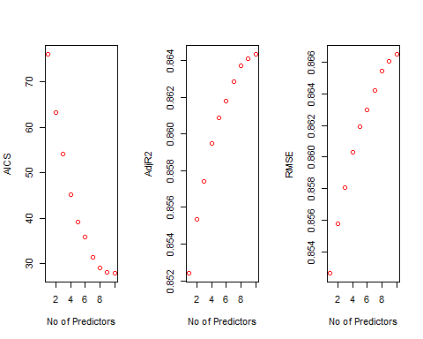

k$predictors

## [1] "Job.Level" "Attrition"   
## [3] "Years.In.Current.Role" "Num.Companies.Worked"   
## [5] "Daily.Rate" "Environment.Satisfaction"   
## [7] "OverTime" "BusinessTravel"   
## [9] "Relationship.Satisfaction" "Monthly.Rate"

#Plot for AISC  
for (i in 1:29){  
 predictions<-predict(object=Model_FWD,newdata=EmplTest,id=i)   
 testASEfwd[i]<-mean((log(EmplTest$Monthly.Income)-predictions)^2)  
}  
dim(EmplTest)

## [1] 173 29

par(mfrow=c(1,1))  
plot(1:29,testASEfwd,type="l",xlab="# of predictors",ylab="test vs train ASE",ylim=c(0,0.5))  
index<-which(testASEfwd==min(testASEfwd))  
points(index,testASEfwd[index],col="red",pch=10)  
rss<-summary(reg.fwd)$rss  
lines(index,rss/869,col="blue") #Dividing by 869 since ASE=RSS/sample size

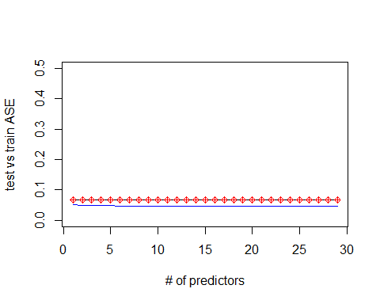

##### Backward Model #####  
  
Model_BCK<-stepAIC(Model_Null,direction="backward",trace=FALSE)  
summary(Model_BCK)

##   
## Call:  
## lm(formula = log(Monthly.Income) ~ Attrition + BusinessTravel +   
## Daily.Rate + Environment.Satisfaction + Job.Level + Monthly.Rate +   
## Num.Companies.Worked + OverTime + Relationship.Satisfaction +   
## Years.At.Company + Years.In.Current.Role + Years.With.Curr.Manager,   
## data = EmplTrain)  
##   
## Residuals:  
## Min 1Q Median 3Q Max   
## -0.9123 -0.1503 0.0086 0.1490 0.7614   
##   
## Coefficients:  
## Estimate Std. Error t value Pr(>|t|)   
## (Intercept) 7.306e+00 5.543e-02 131.814 < 2e-16 ***  
## AttritionYes -1.263e-01 2.847e-02 -4.435 1.07e-05 ***  
## BusinessTravelTravel_Frequently 4.593e-02 3.545e-02 1.296 0.19546   
## BusinessTravelTravel_Rarely 7.170e-02 2.957e-02 2.425 0.01558 *   
## Daily.Rate 6.372e-05 2.334e-05 2.730 0.00650 **   
## Environment.Satisfaction -2.143e-02 8.598e-03 -2.492 0.01294 *   
## Job.Level 5.440e-01 1.054e-02 51.596 < 2e-16 ***  
## Monthly.Rate 1.916e-06 1.332e-06 1.439 0.15071   
## Num.Companies.Worked 1.250e-02 3.927e-03 3.183 0.00152 **   
## OverTimeYes 5.503e-02 2.146e-02 2.564 0.01056 *   
## Relationship.Satisfaction -1.377e-02 8.474e-03 -1.625 0.10470   
## Years.At.Company -6.108e-03 3.313e-03 -1.844 0.06565 .   
## Years.In.Current.Role 1.253e-02 4.466e-03 2.804 0.00518 **   
## Years.With.Curr.Manager 8.286e-03 4.334e-03 1.912 0.05632 .   
## ---  
## Signif. codes: 0 '***' 0.001 '**' 0.01 '*' 0.05 '.' 0.1 ' ' 1  
##   
## Residual standard error: 0.2439 on 675 degrees of freedom  
## Multiple R-squared: 0.8674, Adjusted R-squared: 0.8649   
## F-statistic: 339.8 on 13 and 675 DF, p-value: < 2.2e-16

vif(Model_BCK)

## GVIF Df GVIF^(1/(2*Df))  
## Attrition 1.173884 1 1.083459  
## BusinessTravel 1.031317 2 1.007739  
## Daily.Rate 1.017393 1 1.008659  
## Environment.Satisfaction 1.028015 1 1.013911  
## Job.Level 1.506902 1 1.227559  
## Monthly.Rate 1.015982 1 1.007959  
## Num.Companies.Worked 1.112172 1 1.054596  
## OverTime 1.105066 1 1.051221  
## Relationship.Satisfaction 1.014559 1 1.007253  
## Years.At.Company 4.208867 1 2.051552  
## Years.In.Current.Role 3.007399 1 1.734185  
## Years.With.Curr.Manager 2.747785 1 1.657644

#Residual Plots  
par(mfrow=c(1,5))  
ols_plot_resid_fit(Model_BCK)

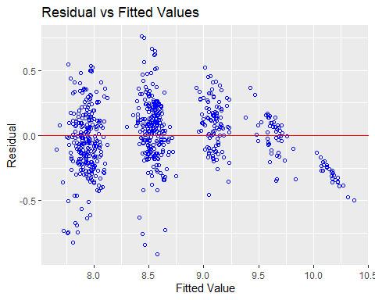

ols_plot_resid_lev(Model_BCK)

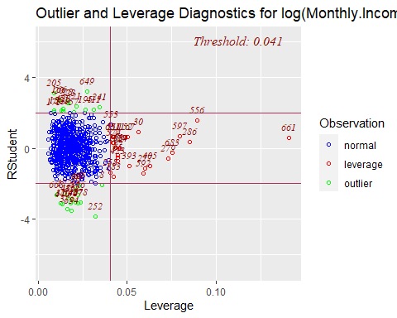

ols_plot_resid_qq(Model_BCK)

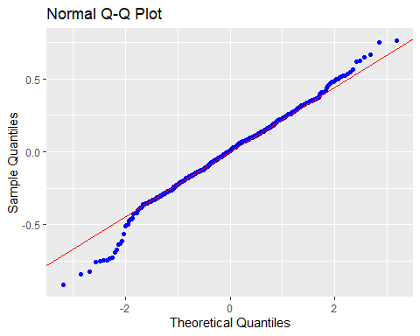

ols_plot_resid_hist(Model_BCK)

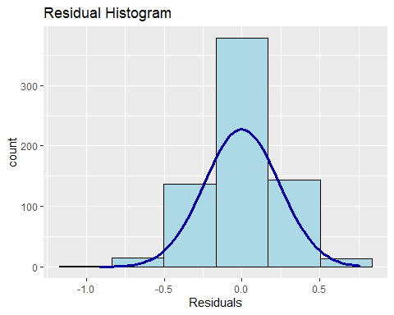

ols_plot_cooksd_bar(Model_BCK)

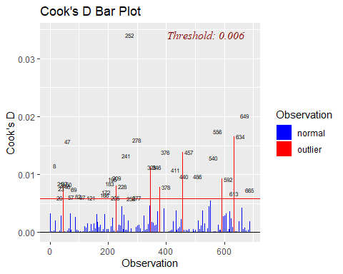

#Assumptions are met:  
#The histogram shows a bell shape curve which suggests that there is enough evidence for normality.  
#The QQ Plot shows a straight line which suggests that there is enough evidence for constant variance.  
#The ouliers are all below 0.2 which suggests there is not major high leverage points.  
#The observations are considered to be independent as they are randomly assigned.  
#Business Travel Rarely, Daily Rates,Job Level,Laboratory Technician,Research #Director, Research Scientist,Sales #Representative,Number of companies #worked,overtime,Total.Working.Years,Years.In.Current.Role are statistically #significant.  
  
#Prediction  
Pred_BCK=predict(Model_BCK, newdata = EmplTest, interval = "confidence")  
as.data.frame(Pred_BCK)

## fit lwr upr  
## 6 8.988037 8.919905 9.056169  
## 27 8.552513 8.500865 8.604161  
## 32 8.039287 7.964812 8.113763  
## 35 8.553180 8.490666 8.615694  
## 40 7.939835 7.873789 8.005881  
## 45 7.851645 7.798060 7.905231  
## 48 9.129421 9.067715 9.191127  
## 49 7.837830 7.762353 7.913307  
## 53 8.026602 7.968008 8.085196  
## 55 8.532713 8.487919 8.577507  
## 57 7.908115 7.834244 7.981985  
## 58 8.102636 8.034502 8.170770  
## 65 7.771408 7.694686 7.848129  
## 82 8.577471 8.520739 8.634202  
## 83 8.494810 8.431211 8.558408  
## 86 9.687449 9.621792 9.753105  
## 94 8.573856 8.514424 8.633288  
## 95 10.221309 10.146156 10.296463  
## 97 9.649847 9.551718 9.747975  
## 103 8.564073 8.484016 8.644130  
## 107 8.553808 8.470394 8.637222  
## 109 8.376688 8.299596 8.453780  
## 114 8.400524 8.323661 8.477387  
## 118 8.642356 8.579083 8.705629  
## 124 8.482912 8.421636 8.544189  
## 125 8.563888 8.497321 8.630456  
## 127 7.869327 7.787131 7.951522  
## 137 7.822936 7.758623 7.887249  
## 160 9.081372 9.000796 9.161949  
## 162 8.979456 8.885426 9.073487  
## 166 7.791997 7.722677 7.861316  
## 176 8.002748 7.944223 8.061272  
## 181 9.110624 9.067932 9.153316  
## 182 8.609701 8.561259 8.658144  
## 187 8.486994 8.423389 8.550598  
## 191 8.555154 8.497281 8.613027  
## 192 9.043237 8.972586 9.113889  
## 202 8.520320 8.468572 8.572068  
## 204 8.013359 7.927260 8.099458  
## 216 7.924289 7.885741 7.962836  
## 217 8.529183 8.476867 8.581499  
## 224 7.966170 7.907285 8.025054  
## 225 7.972268 7.926539 8.017996  
## 228 8.002968 7.943675 8.062262  
## 245 8.571810 8.514008 8.629611  
## 253 7.857905 7.801166 7.914645  
## 254 7.726274 7.651843 7.800705  
## 261 7.812925 7.737238 7.888611  
## 272 8.567748 8.517683 8.617813  
## 273 8.551551 8.499023 8.604079  
## 278 7.946833 7.876524 8.017143  
## 279 8.392798 8.319306 8.466289  
## 280 8.539958 8.483983 8.595934  
## 283 8.521606 8.479116 8.564097  
## 284 8.535482 8.480401 8.590564  
## 289 9.136186 9.064453 9.207919  
## 295 9.609803 9.533756 9.685850  
## 297 8.546655 8.484463 8.608848  
## 308 7.855523 7.788204 7.922843  
## 311 8.639855 8.578378 8.701331  
## 312 9.675990 9.589232 9.762747  
## 318 8.513634 8.478010 8.549258  
## 324 8.748473 8.658760 8.838187  
## 328 8.555284 8.501692 8.608876  
## 333 7.811990 7.745173 7.878807  
## 338 8.480718 8.416545 8.544892  
## 340 7.903999 7.847562 7.960437  
## 368 8.521231 8.457242 8.585221  
## 369 7.922052 7.875469 7.968636  
## 377 7.949472 7.857190 8.041753  
## 379 8.076049 8.009477 8.142621  
## 387 9.088808 9.024795 9.152822  
## 388 8.483849 8.433263 8.534435  
## 389 8.511835 8.469519 8.554152  
## 400 9.174236 9.102509 9.245963  
## 406 9.623399 9.547570 9.699227  
## 407 8.553474 8.495313 8.611635  
## 417 7.907672 7.838770 7.976573  
## 424 7.843998 7.775967 7.912030  
## 425 8.506050 8.465697 8.546402  
## 436 8.596862 8.540880 8.652844  
## 438 7.945214 7.886451 8.003977  
## 448 8.526753 8.478492 8.575014  
## 451 8.578435 8.505485 8.651386  
## 452 7.960472 7.903705 8.017238  
## 453 8.417294 8.348875 8.485712  
## 454 8.505098 8.450183 8.560014  
## 456 10.125318 10.048523 10.202114  
## 459 7.976896 7.920548 8.033244  
## 461 7.972401 7.904551 8.040252  
## 465 7.892910 7.810297 7.975523  
## 466 7.967294 7.903981 8.030607  
## 467 8.024367 7.972265 8.076469  
## 473 9.042609 8.975988 9.109230  
## 474 8.045648 7.995456 8.095839  
## 479 8.030907 7.962738 8.099076  
## 480 9.145374 9.078506 9.212243  
## 482 8.037263 7.981745 8.092780  
## 488 7.948720 7.899200 7.998239  
## 492 9.695976 9.626450 9.765502  
## 494 9.045435 8.986158 9.104711  
## 496 9.704508 9.601831 9.807185  
## 511 8.550005 8.492233 8.607776  
## 516 8.506246 8.453051 8.559441  
## 521 7.882758 7.829086 7.936431  
## 527 8.629925 8.572620 8.687231  
## 530 7.987379 7.902914 8.071844  
## 532 8.575310 8.520658 8.629961  
## 540 8.555616 8.495391 8.615840  
## 547 9.085486 8.983980 9.186993  
## 550 7.977688 7.930324 8.025052  
## 565 7.966878 7.918791 8.014966  
## 566 8.088967 8.032644 8.145290  
## 567 8.442362 8.386457 8.498268  
## 573 8.591515 8.527515 8.655515  
## 584 8.612285 8.549463 8.675107  
## 596 8.633584 8.574078 8.693089  
## 601 7.795775 7.727016 7.864535  
## 603 9.121202 9.055102 9.187302  
## 604 8.122623 8.054660 8.190586  
## 608 8.536846 8.461652 8.612041  
## 618 8.639491 8.579060 8.699921  
## 626 7.997529 7.942884 8.052174  
## 627 8.573763 8.518480 8.629047  
## 628 9.157412 9.092470 9.222354  
## 636 7.915866 7.849353 7.982378  
## 639 8.063327 8.009233 8.117422  
## 653 9.161862 9.070704 9.253020  
## 654 9.077906 9.016152 9.139661  
## 665 8.462513 8.399283 8.525743  
## 667 9.067502 8.975468 9.159536  
## 674 7.807985 7.714909 7.901061  
## 680 7.982490 7.921412 8.043569  
## 681 8.491377 8.447125 8.535630  
## 688 7.926996 7.868668 7.985323  
## 695 8.468708 8.411985 8.525432  
## 696 8.030768 7.967130 8.094406  
## 697 9.524507 9.443085 9.605930  
## 698 8.649222 8.571560 8.726884  
## 700 10.199405 10.116694 10.282115  
## 703 9.099828 9.001157 9.198498  
## 712 9.578079 9.503491 9.652666  
## 719 8.486215 8.406981 8.565448  
## 727 8.005171 7.933966 8.076375  
## 731 8.503688 8.444014 8.563361  
## 732 8.446912 8.377362 8.516462  
## 738 8.478442 8.424813 8.532071  
## 740 8.523533 8.474837 8.572230  
## 752 7.844400 7.767128 7.921673  
## 755 9.248486 9.174739 9.322233  
## 756 7.868120 7.792447 7.943793  
## 768 8.963555 8.895998 9.031111  
## 769 8.440645 8.393979 8.487311  
## 772 9.049846 8.963681 9.136011  
## 774 7.806765 7.731078 7.882452  
## 776 7.944364 7.888101 8.000626  
## 778 7.834270 7.772207 7.896333  
## 788 8.400571 8.326119 8.475023  
## 799 7.792505 7.707240 7.877769  
## 803 9.586900 9.510106 9.663693  
## 804 9.032283 8.950960 9.113605  
## 809 7.926738 7.851627 8.001850  
## 814 10.087663 10.005624 10.169702  
## 816 8.014770 7.943098 8.086443  
## 818 9.045013 8.984624 9.105402  
## 821 7.960850 7.917636 8.004064  
## 825 8.615757 8.549850 8.681663  
## 831 8.488664 8.407863 8.569465  
## 834 7.889768 7.845892 7.933644  
## 845 8.539190 8.482226 8.596154  
## 852 7.878667 7.793303 7.964031  
## 854 8.531477 8.473134 8.589820  
## 864 9.586472 9.454749 9.718195

MSPE = data.frame(Observed = log(EmplTest$Monthly.Income), Predicted = Pred_BCK)  
MSPE$Resisdual = MSPE$Observed - MSPE$Predicted.fit  
MSPE$SquaredResidual = MSPE$Resisdual^2  
MSPE

## Observed Predicted.fit Predicted.lwr Predicted.upr Resisdual  
## 6 9.081711 8.988037 8.919905 9.056169 0.093674392  
## 27 9.202711 8.552513 8.500865 8.604161 0.650198529  
## 32 7.614805 8.039287 7.964812 8.113763 -0.424482004  
## 35 9.177714 8.553180 8.490666 8.615694 0.624533880  
## 40 7.934155 7.939835 7.873789 8.005881 -0.005679346  
## 45 7.109062 7.851645 7.798060 7.905231 -0.742583014  
## 48 9.075665 9.129421 9.067715 9.191127 -0.053755769  
## 49 7.537963 7.837830 7.762353 7.913307 -0.299867363  
## 53 7.606387 8.026602 7.968008 8.085196 -0.420214729  
## 55 8.394800 8.532713 8.487919 8.577507 -0.137913347  
## 57 7.922624 7.908115 7.834244 7.981985 0.014508783  
## 58 8.460199 8.102636 8.034502 8.170770 0.357563580  
## 65 7.700748 7.771408 7.694686 7.848129 -0.070660044  
## 82 8.836810 8.577471 8.520739 8.634202 0.259338983  
## 83 8.579417 8.494810 8.431211 8.558408 0.084606786  
## 86 9.527047 9.687449 9.621792 9.753105 -0.160401552  
## 94 8.722906 8.573856 8.514424 8.633288 0.149049592  
## 95 9.899781 10.221309 10.146156 10.296463 -0.321528759  
## 97 9.717519 9.649847 9.551718 9.747975 0.067672813  
## 103 8.785387 8.564073 8.484016 8.644130 0.221313538  
## 107 8.370779 8.553808 8.470394 8.637222 -0.183028948  
## 109 9.096724 8.376688 8.299596 8.453780 0.720035435  
## 114 8.535622 8.400524 8.323661 8.477387 0.135098137  
## 118 8.300280 8.642356 8.579083 8.705629 -0.342075843  
## 124 8.301025 8.482912 8.421636 8.544189 -0.181887232  
## 125 8.423761 8.563888 8.497321 8.630456 -0.140127065  
## 127 8.273592 7.869327 7.787131 7.951522 0.404265289  
## 137 7.748891 7.822936 7.758623 7.887249 -0.074044639  
## 160 9.487290 9.081372 9.000796 9.161949 0.405917629  
## 162 9.073604 8.979456 8.885426 9.073487 0.094147682  
## 166 7.622664 7.791997 7.722677 7.861316 -0.169332814  
## 176 7.635304 8.002748 7.944223 8.061272 -0.367443742  
## 181 9.237372 9.110624 9.067932 9.153316 0.126747431  
## 182 8.838262 8.609701 8.561259 8.658144 0.228560265  
## 187 8.557567 8.486994 8.423389 8.550598 0.070573576  
## 191 8.661294 8.555154 8.497281 8.613027 0.106139580  
## 192 9.173365 9.043237 8.972586 9.113889 0.130127705  
## 202 8.735525 8.520320 8.468572 8.572068 0.215205320  
## 204 7.703459 8.013359 7.927260 8.099458 -0.309900233  
## 216 7.760041 7.924289 7.885741 7.962836 -0.164248071  
## 217 9.192584 8.529183 8.476867 8.581499 0.663400457  
## 224 7.354362 7.966170 7.907285 8.025054 -0.611807358  
## 225 8.470311 7.972268 7.926539 8.017996 0.498043372  
## 228 7.752765 8.002968 7.943675 8.062262 -0.250203608  
## 245 8.528331 8.571810 8.514008 8.629611 -0.043478664  
## 253 7.729296 7.857905 7.801166 7.914645 -0.128609724  
## 254 7.991592 7.726274 7.651843 7.800705 0.265318171  
## 261 7.932003 7.812925 7.737238 7.888611 0.119078558  
## 272 8.600247 8.567748 8.517683 8.617813 0.032498315  
## 273 8.171882 8.551551 8.499023 8.604079 -0.379669013  
## 278 7.805882 7.946833 7.876524 8.017143 -0.140951185  
## 279 8.655911 8.392798 8.319306 8.466289 0.263113569  
## 280 8.302762 8.539958 8.483983 8.595934 -0.237196653  
## 283 8.781555 8.521606 8.479116 8.564097 0.259949265  
## 284 8.928905 8.535482 8.480401 8.590564 0.393423090  
## 289 9.183791 9.136186 9.064453 9.207919 0.047604773  
## 295 9.707290 9.609803 9.533756 9.685850 0.097487097  
## 297 9.163982 8.546655 8.484463 8.608848 0.617326918  
## 308 7.999343 7.855523 7.788204 7.922843 0.143819641  
## 311 8.609590 8.639855 8.578378 8.701331 -0.030264489  
## 312 9.490771 9.675990 9.589232 9.762747 -0.185218615  
## 318 8.437500 8.513634 8.478010 8.549258 -0.076133353  
## 324 8.437067 8.748473 8.658760 8.838187 -0.311406264  
## 328 8.596004 8.555284 8.501692 8.608876 0.040720407  
## 333 7.758761 7.811990 7.745173 7.878807 -0.053229658  
## 338 8.956222 8.480718 8.416545 8.544892 0.475503916  
## 340 7.758333 7.903999 7.847562 7.960437 -0.145665972  
## 368 8.607582 8.521231 8.457242 8.585221 0.086350707  
## 369 7.636752 7.922052 7.875469 7.968636 -0.285300102  
## 377 7.916807 7.949472 7.857190 8.041753 -0.032664013  
## 379 7.681560 8.076049 8.009477 8.142621 -0.394488483  
## 387 9.081256 9.088808 9.024795 9.152822 -0.007552098  
## 388 8.357494 8.483849 8.433263 8.534435 -0.126355105  
## 389 8.412277 8.511835 8.469519 8.554152 -0.099558418  
## 400 9.231025 9.174236 9.102509 9.245963 0.056789113  
## 406 9.718783 9.623399 9.547570 9.699227 0.095384598  
## 407 8.606668 8.553474 8.495313 8.611635 0.053194180  
## 417 7.849324 7.907672 7.838770 7.976573 -0.058347930  
## 424 7.384610 7.843998 7.775967 7.912030 -0.459387886  
## 425 8.460411 8.506050 8.465697 8.546402 -0.045638753  
## 436 8.734560 8.596862 8.540880 8.652844 0.137697745  
## 438 7.961021 7.945214 7.886451 8.003977 0.015807474  
## 448 8.619389 8.526753 8.478492 8.575014 0.092635434  
## 451 8.492491 8.578435 8.505485 8.651386 -0.085944804  
## 452 8.137396 7.960472 7.903705 8.017238 0.176924200  
## 453 8.667852 8.417294 8.348875 8.485712 0.250558307  
## 454 8.610137 8.505098 8.450183 8.560014 0.105038475  
## 456 9.895102 10.125318 10.048523 10.202114 -0.230215945  
## 459 7.633370 7.976896 7.920548 8.033244 -0.343525988  
## 461 7.646354 7.972401 7.904551 8.040252 -0.326047752  
## 465 7.798523 7.892910 7.810297 7.975523 -0.094386796  
## 466 8.279951 7.967294 7.903981 8.030607 0.312656856  
## 467 7.880048 8.024367 7.972265 8.076469 -0.144318792  
## 473 9.491375 9.042609 8.975988 9.109230 0.448766764  
## 474 8.146709 8.045648 7.995456 8.095839 0.101061293  
## 479 7.989560 8.030907 7.962738 8.099076 -0.041346514  
## 480 9.528358 9.145374 9.078506 9.212243 0.382983295  
## 482 7.764721 8.037263 7.981745 8.092780 -0.272542042  
## 488 7.976252 7.948720 7.899200 7.998239 0.027532251  
## 492 9.733885 9.695976 9.626450 9.765502 0.037908661  
## 494 9.060215 9.045435 8.986158 9.104711 0.014780275  
## 496 9.699350 9.704508 9.601831 9.807185 -0.005158161  
## 511 8.583543 8.550005 8.492233 8.607776 0.033537923  
## 516 8.609225 8.506246 8.453051 8.559441 0.102979221  
## 521 7.845024 7.882758 7.829086 7.936431 -0.037734025  
## 527 8.518392 8.629925 8.572620 8.687231 -0.111532840  
## 530 8.509766 7.987379 7.902914 8.071844 0.522386693  
## 532 8.826881 8.575310 8.520658 8.629961 0.251571509  
## 540 8.547722 8.555616 8.495391 8.615840 -0.007893104  
## 547 8.909641 9.085486 8.983980 9.186993 -0.175845766  
## 550 7.685703 7.977688 7.930324 8.025052 -0.291985343  
## 565 8.251403 7.966878 7.918791 8.014966 0.284524767  
## 566 7.798113 8.088967 8.032644 8.145290 -0.290854434  
## 567 7.685244 8.442362 8.386457 8.498268 -0.757118870  
## 573 8.829665 8.591515 8.527515 8.655515 0.238150428  
## 584 8.471987 8.612285 8.549463 8.675107 -0.140298349  
## 596 8.303257 8.633584 8.574078 8.693089 -0.330326404  
## 601 7.617268 7.795775 7.727016 7.864535 -0.178507310  
## 603 9.342771 9.121202 9.055102 9.187302 0.221568981  
## 604 8.049108 8.122623 8.054660 8.190586 -0.073515515  
## 608 8.631414 8.536846 8.461652 8.612041 0.094568159  
## 618 8.604105 8.639491 8.579060 8.699921 -0.035386093  
## 626 7.830823 7.997529 7.942884 8.052174 -0.166705966  
## 627 8.333751 8.573763 8.518480 8.629047 -0.240012281  
## 628 9.350972 9.157412 9.092470 9.222354 0.193559646  
## 636 7.773174 7.915866 7.849353 7.982378 -0.142692060  
## 639 7.910224 8.063327 8.009233 8.117422 -0.153103564  
## 653 9.510371 9.161862 9.070704 9.253020 0.348509225  
## 654 9.433804 9.077906 9.016152 9.139661 0.355897426  
## 665 8.426831 8.462513 8.399283 8.525743 -0.035682361  
## 667 8.976894 9.067502 8.975468 9.159536 -0.090608401  
## 674 7.611842 7.807985 7.714909 7.901061 -0.196142606  
## 680 7.753194 7.982490 7.921412 8.043569 -0.229296131  
## 681 8.356085 8.491377 8.447125 8.535630 -0.135292302  
## 688 7.871693 7.926996 7.868668 7.985323 -0.055302884  
## 695 9.161675 8.468708 8.411985 8.525432 0.692966789  
## 696 8.099858 8.030768 7.967130 8.094406 0.069089896  
## 697 9.629182 9.524507 9.443085 9.605930 0.104675125  
## 698 8.685078 8.649222 8.571560 8.726884 0.035855853  
## 700 9.856448 10.199405 10.116694 10.282115 -0.342956343  
## 703 9.247347 9.099828 9.001157 9.198498 0.147519143  
## 712 9.555206 9.578079 9.503491 9.652666 -0.022872860  
## 719 8.429673 8.486215 8.406981 8.565448 -0.056542068  
## 727 7.997327 8.005171 7.933966 8.076375 -0.007843706  
## 731 8.469053 8.503688 8.444014 8.563361 -0.034634771  
## 732 8.563695 8.446912 8.377362 8.516462 0.116783204  
## 738 8.550821 8.478442 8.424813 8.532071 0.072379216  
## 740 8.210940 8.523533 8.474837 8.572230 -0.312593414  
## 752 7.741534 7.844400 7.767128 7.921673 -0.102866594  
## 755 9.514068 9.248486 9.174739 9.322233 0.265582291  
## 756 8.218248 7.868120 7.792447 7.943793 0.350127969  
## 768 9.299450 8.963555 8.895998 9.031111 0.335894990  
## 769 8.906393 8.440645 8.393979 8.487311 0.465748088  
## 772 9.254644 9.049846 8.963681 9.136011 0.204798446  
## 774 8.127995 7.806765 7.731078 7.882452 0.321229916  
## 776 8.161946 7.944364 7.888101 8.000626 0.217581877  
## 778 7.946971 7.834270 7.772207 7.896333 0.112701710  
## 788 8.505323 8.400571 8.326119 8.475023 0.104752319  
## 799 7.527794 7.792505 7.707240 7.877769 -0.264710623  
## 803 9.744961 9.586900 9.510106 9.663693 0.158061042  
## 804 9.167642 9.032283 8.950960 9.113605 0.135359096  
## 809 7.959276 7.926738 7.851627 8.001850 0.032537626  
## 814 9.886240 10.087663 10.005624 10.169702 -0.201423222  
## 816 7.930566 8.014770 7.943098 8.086443 -0.084204528  
## 818 9.366575 9.045013 8.984624 9.105402 0.321562038  
## 821 8.105308 7.960850 7.917636 8.004064 0.144457066  
## 825 8.447414 8.615757 8.549850 8.681663 -0.168342424  
## 831 8.197814 8.488664 8.407863 8.569465 -0.290849530  
## 834 7.844633 7.889768 7.845892 7.933644 -0.045135423  
## 845 8.704336 8.539190 8.482226 8.596154 0.165146403  
## 852 7.698936 7.878667 7.793303 7.964031 -0.179731003  
## 854 8.641356 8.531477 8.473134 8.589820 0.109879022  
## 864 9.530248 9.586472 9.454749 9.718195 -0.056224549  
## SquaredResidual  
## 6 8.774892e-03  
## 27 4.227581e-01  
## 32 1.801850e-01  
## 35 3.900426e-01  
## 40 3.225497e-05  
## 45 5.514295e-01  
## 48 2.889683e-03  
## 49 8.992044e-02  
## 53 1.765804e-01  
## 55 1.902009e-02  
## 57 2.105048e-04  
## 58 1.278517e-01  
## 65 4.992842e-03  
## 82 6.725671e-02  
## 83 7.158308e-03  
## 86 2.572866e-02  
## 94 2.221578e-02  
## 95 1.033807e-01  
## 97 4.579610e-03  
## 103 4.897968e-02  
## 107 3.349960e-02  
## 109 5.184510e-01  
## 114 1.825151e-02  
## 118 1.170159e-01  
## 124 3.308297e-02  
## 125 1.963559e-02  
## 127 1.634304e-01  
## 137 5.482609e-03  
## 160 1.647691e-01  
## 162 8.863786e-03  
## 166 2.867360e-02  
## 176 1.350149e-01  
## 181 1.606491e-02  
## 182 5.223979e-02  
## 187 4.980630e-03  
## 191 1.126561e-02  
## 192 1.693322e-02  
## 202 4.631333e-02  
## 204 9.603815e-02  
## 216 2.697743e-02  
## 217 4.401002e-01  
## 224 3.743082e-01  
## 225 2.480472e-01  
## 228 6.260185e-02  
## 245 1.890394e-03  
## 253 1.654046e-02  
## 254 7.039373e-02  
## 261 1.417970e-02  
## 272 1.056141e-03  
## 273 1.441486e-01  
## 278 1.986724e-02  
## 279 6.922875e-02  
## 280 5.626225e-02  
## 283 6.757362e-02  
## 284 1.547817e-01  
## 289 2.266214e-03  
## 295 9.503734e-03  
## 297 3.810925e-01  
## 308 2.068409e-02  
## 311 9.159393e-04  
## 312 3.430594e-02  
## 318 5.796287e-03  
## 324 9.697386e-02  
## 328 1.658152e-03  
## 333 2.833397e-03  
## 338 2.261040e-01  
## 340 2.121858e-02  
## 368 7.456445e-03  
## 369 8.139615e-02  
## 377 1.066938e-03  
## 379 1.556212e-01  
## 387 5.703418e-05  
## 388 1.596561e-02  
## 389 9.911879e-03  
## 400 3.225003e-03  
## 406 9.098222e-03  
## 407 2.829621e-03  
## 417 3.404481e-03  
## 424 2.110372e-01  
## 425 2.082896e-03  
## 436 1.896067e-02  
## 438 2.498762e-04  
## 448 8.581324e-03  
## 451 7.386509e-03  
## 452 3.130217e-02  
## 453 6.277947e-02  
## 454 1.103308e-02  
## 456 5.299938e-02  
## 459 1.180101e-01  
## 461 1.063071e-01  
## 465 8.908867e-03  
## 466 9.775431e-02  
## 467 2.082791e-02  
## 473 2.013916e-01  
## 474 1.021338e-02  
## 479 1.709534e-03  
## 480 1.466762e-01  
## 482 7.427916e-02  
## 488 7.580249e-04  
## 492 1.437067e-03  
## 494 2.184565e-04  
## 496 2.660663e-05  
## 511 1.124792e-03  
## 516 1.060472e-02  
## 521 1.423857e-03  
## 527 1.243957e-02  
## 530 2.728879e-01  
## 532 6.328822e-02  
## 540 6.230109e-05  
## 547 3.092173e-02  
## 550 8.525544e-02  
## 565 8.095434e-02  
## 566 8.459630e-02  
## 567 5.732290e-01  
## 573 5.671563e-02  
## 584 1.968363e-02  
## 596 1.091155e-01  
## 601 3.186486e-02  
## 603 4.909281e-02  
## 604 5.404531e-03  
## 608 8.943137e-03  
## 618 1.252176e-03  
## 626 2.779088e-02  
## 627 5.760590e-02  
## 628 3.746534e-02  
## 636 2.036102e-02  
## 639 2.344070e-02  
## 653 1.214587e-01  
## 654 1.266630e-01  
## 665 1.273231e-03  
## 667 8.209882e-03  
## 674 3.847192e-02  
## 680 5.257672e-02  
## 681 1.830401e-02  
## 688 3.058409e-03  
## 695 4.802030e-01  
## 696 4.773414e-03  
## 697 1.095688e-02  
## 698 1.285642e-03  
## 700 1.176191e-01  
## 703 2.176190e-02  
## 712 5.231677e-04  
## 719 3.197006e-03  
## 727 6.152373e-05  
## 731 1.199567e-03  
## 732 1.363832e-02  
## 738 5.238751e-03  
## 740 9.771464e-02  
## 752 1.058154e-02  
## 755 7.053395e-02  
## 756 1.225896e-01  
## 768 1.128254e-01  
## 769 2.169213e-01  
## 772 4.194240e-02  
## 774 1.031887e-01  
## 776 4.734187e-02  
## 778 1.270168e-02  
## 788 1.097305e-02  
## 799 7.007171e-02  
## 803 2.498329e-02  
## 804 1.832208e-02  
## 809 1.058697e-03  
## 814 4.057131e-02  
## 816 7.090403e-03  
## 818 1.034021e-01  
## 821 2.086784e-02  
## 825 2.833917e-02  
## 831 8.459345e-02  
## 834 2.037206e-03  
## 845 2.727333e-02  
## 852 3.230323e-02  
## 854 1.207340e-02  
## 864 3.161200e-03

mean(MSPE$SquaredResidual)

## [1] 0.06832213

reg.bck=regsubsets(log(Monthly.Income)~.,data=EmplTrain,method="backward",nvmax=29)  
k<-ols_step_backward_aic(Model_Null, details = TRUE)

## Backward Elimination Method   
## ---------------------------  
##   
## Candidate Terms:   
##   
## 1 . Age   
## 2 . Attrition   
## 3 . BusinessTravel   
## 4 . Daily.Rate   
## 5 . Distance.From.Home   
## 6 . Education   
## 7 . EducationField   
## 8 . Environment.Satisfaction   
## 9 . Gender   
## 10 . Hourly.Rate   
## 11 . Job.Involvement   
## 12 . Job.Level   
## 13 . Job.Satisfaction   
## 14 . Marital.Status   
## 15 . Monthly.Rate   
## 16 . Num.Companies.Worked   
## 17 . OverTime   
## 18 . Percent.Salary.Hike   
## 19 . Performance.Rating   
## 20 . Relationship.Satisfaction   
## 21 . Stock.Option.Level   
## 22 . Total.Working.Years   
## 23 . Training.Times.Last.Year   
## 24 . Work.Life.Balance   
## 25 . Years.At.Company   
## 26 . Years.In.Current.Role   
## 27 . Years.Since.Last.Promotion   
## 28 . Years.With.Curr.Manager   
##   
## Step 0: AIC = 55.75066   
## log(Monthly.Income) ~ Age + Attrition + BusinessTravel + Daily.Rate + Distance.From.Home + Education + EducationField + Environment.Satisfaction + Gender + Hourly.Rate + Job.Involvement + Job.Level + Job.Satisfaction + Marital.Status + Monthly.Rate + Num.Companies.Worked + OverTime + Percent.Salary.Hike + Performance.Rating + Relationship.Satisfaction + Stock.Option.Level + Total.Working.Years + Training.Times.Last.Year + Work.Life.Balance + Years.At.Company + Years.In.Current.Role + Years.Since.Last.Promotion + Years.With.Curr.Manager   
##   
## --------------------------------------------------------------------------------------  
## Variable DF AIC Sum Sq RSS R-Sq Adj. R-Sq   
## --------------------------------------------------------------------------------------  
## Gender 1 53.752 0.000 39.401 0.870 0.863   
## Distance.From.Home 1 53.762 0.001 39.401 0.870 0.863   
## Education 1 53.769 0.001 39.402 0.870 0.863   
## Total.Working.Years 1 53.770 0.001 39.402 0.870 0.863   
## Training.Times.Last.Year 1 53.786 0.002 39.403 0.870 0.863   
## Stock.Option.Level 1 53.816 0.004 39.404 0.870 0.863   
## Years.Since.Last.Promotion 1 53.907 0.009 39.410 0.870 0.863   
## Job.Satisfaction 1 53.927 0.010 39.411 0.870 0.863   
## Marital.Status 1 51.968 0.012 39.413 0.870 0.864   
## Work.Life.Balance 1 54.031 0.016 39.417 0.870 0.863   
## Job.Involvement 1 54.271 0.030 39.430 0.870 0.863   
## Hourly.Rate 1 54.307 0.032 39.432 0.870 0.863   
## Age 1 54.532 0.045 39.445 0.870 0.863   
## Performance.Rating 1 54.668 0.053 39.453 0.870 0.863   
## Percent.Salary.Hike 1 55.246 0.086 39.486 0.870 0.863   
## Relationship.Satisfaction 1 55.853 0.120 39.521 0.870 0.863   
## Monthly.Rate 1 56.246 0.143 39.544 0.869 0.863   
## Years.At.Company 1 56.496 0.157 39.558 0.869 0.863   
## Years.With.Curr.Manager 1 57.034 0.188 39.589 0.869 0.863   
## Environment.Satisfaction 1 59.318 0.320 39.720 0.869 0.862   
## OverTime 1 59.486 0.329 39.730 0.869 0.862   
## BusinessTravel 1 57.775 0.346 39.747 0.869 0.862   
## Daily.Rate 1 60.773 0.404 39.804 0.869 0.862   
## Years.In.Current.Role 1 60.800 0.405 39.806 0.869 0.862   
## Num.Companies.Worked 1 61.009 0.417 39.818 0.869 0.862   
## EducationField 1 53.667 0.455 39.856 0.868 0.863   
## Attrition 1 68.005 0.824 40.224 0.867 0.861   
## Job.Level 1 834.191 82.902 122.302 0.596 0.576   
## --------------------------------------------------------------------------------------  
##   
##   
## Variables Removed:   
##   
## - Marital.Status   
##   
##   
## Step 1 : AIC = 51.96847   
## log(Monthly.Income) ~ Age + Attrition + BusinessTravel + Daily.Rate + Distance.From.Home + Education + EducationField + Environment.Satisfaction + Gender + Hourly.Rate + Job.Involvement + Job.Level + Job.Satisfaction + Monthly.Rate + Num.Companies.Worked + OverTime + Percent.Salary.Hike + Performance.Rating + Relationship.Satisfaction + Stock.Option.Level + Total.Working.Years + Training.Times.Last.Year + Work.Life.Balance + Years.At.Company + Years.In.Current.Role + Years.Since.Last.Promotion + Years.With.Curr.Manager   
##   
## --------------------------------------------------------------------------------------  
## Variable DF AIC Sum Sq RSS R-Sq Adj. R-Sq   
## --------------------------------------------------------------------------------------  
## Gender 1 49.972 0.000 39.413 0.870 0.864   
## Distance.From.Home 1 49.977 0.000 39.414 0.870 0.864   
## Total.Working.Years 1 49.984 0.001 39.414 0.870 0.864   
## Education 1 49.989 0.001 39.414 0.870 0.864   
## Training.Times.Last.Year 1 49.996 0.002 39.415 0.870 0.864   
## Job.Satisfaction 1 50.120 0.009 39.422 0.870 0.864   
## Years.Since.Last.Promotion 1 50.132 0.009 39.422 0.870 0.864   
## Work.Life.Balance 1 50.250 0.016 39.429 0.870 0.864   
## Job.Involvement 1 50.476 0.029 39.442 0.870 0.864   
## Stock.Option.Level 1 50.518 0.031 39.444 0.870 0.864   
## Hourly.Rate 1 50.529 0.032 39.445 0.870 0.864   
## Age 1 50.839 0.050 39.463 0.870 0.864   
## Performance.Rating 1 50.891 0.053 39.466 0.870 0.864   
## Percent.Salary.Hike 1 51.482 0.087 39.500 0.870 0.863   
## Relationship.Satisfaction 1 52.183 0.127 39.540 0.870 0.863   
## Monthly.Rate 1 52.502 0.145 39.558 0.869 0.863   
## Years.At.Company 1 52.675 0.155 39.568 0.869 0.863   
## Years.With.Curr.Manager 1 53.189 0.185 39.598 0.869 0.863   
## Environment.Satisfaction 1 55.586 0.323 39.736 0.869 0.863   
## OverTime 1 55.778 0.334 39.747 0.869 0.863   
## BusinessTravel 1 53.989 0.346 39.759 0.869 0.863   
## Years.In.Current.Role 1 57.037 0.406 39.819 0.869 0.862   
## Daily.Rate 1 57.130 0.412 39.825 0.869 0.862   
## Num.Companies.Worked 1 57.189 0.415 39.828 0.869 0.862   
## EducationField 1 49.962 0.460 39.873 0.868 0.863   
## Attrition 1 65.127 0.877 40.290 0.867 0.861   
## Job.Level 1 831.188 83.066 122.479 0.596 0.577   
## --------------------------------------------------------------------------------------  
##   
## - EducationField   
##   
##   
## Step 2 : AIC = 49.96191   
## log(Monthly.Income) ~ Age + Attrition + BusinessTravel + Daily.Rate + Distance.From.Home + Education + Environment.Satisfaction + Gender + Hourly.Rate + Job.Involvement + Job.Level + Job.Satisfaction + Monthly.Rate + Num.Companies.Worked + OverTime + Percent.Salary.Hike + Performance.Rating + Relationship.Satisfaction + Stock.Option.Level + Total.Working.Years + Training.Times.Last.Year + Work.Life.Balance + Years.At.Company + Years.In.Current.Role + Years.Since.Last.Promotion + Years.With.Curr.Manager   
##   
## --------------------------------------------------------------------------------------  
## Variable DF AIC Sum Sq RSS R-Sq Adj. R-Sq   
## --------------------------------------------------------------------------------------  
## Distance.From.Home 1 47.962 0.000 39.873 0.868 0.863   
## Total.Working.Years 1 47.963 0.000 39.873 0.868 0.863   
## Gender 1 47.963 0.000 39.873 0.868 0.863   
## Education 1 47.967 0.000 39.873 0.868 0.863   
## Training.Times.Last.Year 1 47.977 0.001 39.874 0.868 0.863   
## Years.Since.Last.Promotion 1 48.063 0.006 39.879 0.868 0.863   
## Job.Satisfaction 1 48.127 0.010 39.883 0.868 0.863   
## Work.Life.Balance 1 48.256 0.017 39.890 0.868 0.863   
## Job.Involvement 1 48.390 0.025 39.898 0.868 0.863   
## Hourly.Rate 1 48.390 0.025 39.898 0.868 0.863   
## Stock.Option.Level 1 48.433 0.027 39.900 0.868 0.863   
## Performance.Rating 1 48.854 0.052 39.925 0.868 0.863   
## Age 1 48.951 0.057 39.930 0.868 0.863   
## Percent.Salary.Hike 1 49.495 0.089 39.962 0.868 0.863   
## Monthly.Rate 1 50.072 0.122 39.995 0.868 0.863   
## Relationship.Satisfaction 1 50.195 0.129 40.002 0.868 0.863   
## Years.At.Company 1 51.153 0.185 40.058 0.868 0.863   
## Years.With.Curr.Manager 1 51.733 0.219 40.092 0.868 0.862   
## Environment.Satisfaction 1 53.367 0.314 40.187 0.867 0.862   
## OverTime 1 53.992 0.350 40.223 0.867 0.862   
## BusinessTravel 1 52.479 0.379 40.252 0.867 0.862   
## Daily.Rate 1 54.761 0.395 40.268 0.867 0.862   
## Num.Companies.Worked 1 54.783 0.397 40.270 0.867 0.862   
## Years.In.Current.Role 1 55.211 0.422 40.295 0.867 0.862   
## Attrition 1 63.356 0.901 40.774 0.865 0.860   
## Job.Level 1 837.800 85.595 125.468 0.586 0.570   
## --------------------------------------------------------------------------------------  
##   
## - Distance.From.Home   
##   
##   
## Step 3 : AIC = 47.96249   
## log(Monthly.Income) ~ Age + Attrition + BusinessTravel + Daily.Rate + Education + Environment.Satisfaction + Gender + Hourly.Rate + Job.Involvement + Job.Level + Job.Satisfaction + Monthly.Rate + Num.Companies.Worked + OverTime + Percent.Salary.Hike + Performance.Rating + Relationship.Satisfaction + Stock.Option.Level + Total.Working.Years + Training.Times.Last.Year + Work.Life.Balance + Years.At.Company + Years.In.Current.Role + Years.Since.Last.Promotion + Years.With.Curr.Manager   
##   
## --------------------------------------------------------------------------------------  
## Variable DF AIC Sum Sq RSS R-Sq Adj. R-Sq   
## --------------------------------------------------------------------------------------  
## Total.Working.Years 1 45.963 0.000 39.873 0.868 0.863   
## Gender 1 45.963 0.000 39.873 0.868 0.863   
## Education 1 45.967 0.000 39.873 0.868 0.863   
## Training.Times.Last.Year 1 45.977 0.001 39.874 0.868 0.863   
## Years.Since.Last.Promotion 1 46.064 0.006 39.879 0.868 0.863   
## Job.Satisfaction 1 46.128 0.010 39.883 0.868 0.863   
## Work.Life.Balance 1 46.257 0.017 39.890 0.868 0.863   
## Hourly.Rate 1 46.390 0.025 39.898 0.868 0.863   
## Job.Involvement 1 46.391 0.025 39.898 0.868 0.863   
## Stock.Option.Level 1 46.434 0.027 39.900 0.868 0.863   
## Performance.Rating 1 46.854 0.052 39.925 0.868 0.863   
## Age 1 46.952 0.057 39.930 0.868 0.863   
## Percent.Salary.Hike 1 47.495 0.089 39.962 0.868 0.863   
## Monthly.Rate 1 48.077 0.123 39.996 0.868 0.863   
## Relationship.Satisfaction 1 48.210 0.130 40.003 0.868 0.863   
## Years.At.Company 1 49.153 0.185 40.058 0.868 0.863   
## Years.With.Curr.Manager 1 49.740 0.219 40.092 0.868 0.863   
## Environment.Satisfaction 1 51.373 0.314 40.187 0.867 0.862   
## OverTime 1 52.001 0.351 40.224 0.867 0.862   
## BusinessTravel 1 50.512 0.381 40.254 0.867 0.862   
## Daily.Rate 1 52.762 0.395 40.268 0.867 0.862   
## Num.Companies.Worked 1 52.821 0.399 40.272 0.867 0.862   
## Years.In.Current.Role 1 53.212 0.422 40.295 0.867 0.862   
## Attrition 1 61.404 0.904 40.777 0.865 0.860   
## Job.Level 1 837.085 85.829 125.702 0.585 0.570   
## --------------------------------------------------------------------------------------  
##   
## - Total.Working.Years   
##   
##   
## Step 4 : AIC = 45.9631   
## log(Monthly.Income) ~ Age + Attrition + BusinessTravel + Daily.Rate + Education + Environment.Satisfaction + Gender + Hourly.Rate + Job.Involvement + Job.Level + Job.Satisfaction + Monthly.Rate + Num.Companies.Worked + OverTime + Percent.Salary.Hike + Performance.Rating + Relationship.Satisfaction + Stock.Option.Level + Training.Times.Last.Year + Work.Life.Balance + Years.At.Company + Years.In.Current.Role + Years.Since.Last.Promotion + Years.With.Curr.Manager   
##   
## ----------------------------------------------------------------------------------------  
## Variable DF AIC Sum Sq RSS R-Sq Adj. R-Sq   
## ----------------------------------------------------------------------------------------  
## Gender 1 43.964 0.000 39.873 0.868 0.864   
## Education 1 43.968 0.000 39.873 0.868 0.864   
## Training.Times.Last.Year 1 43.978 0.001 39.874 0.868 0.864   
## Years.Since.Last.Promotion 1 44.067 0.006 39.879 0.868 0.864   
## Job.Satisfaction 1 44.129 0.010 39.883 0.868 0.864   
## Work.Life.Balance 1 44.257 0.017 39.890 0.868 0.864   
## Job.Involvement 1 44.391 0.025 39.898 0.868 0.864   
## Hourly.Rate 1 44.392 0.025 39.898 0.868 0.864   
## Stock.Option.Level 1 44.434 0.027 39.900 0.868 0.864   
## Performance.Rating 1 44.855 0.052 39.925 0.868 0.863   
## Age 1 45.269 0.076 39.949 0.868 0.863   
## Percent.Salary.Hike 1 45.495 0.089 39.962 0.868 0.863   
## Monthly.Rate 1 46.079 0.123 39.996 0.868 0.863   
## Relationship.Satisfaction 1 46.229 0.131 40.004 0.868 0.863   
## Years.At.Company 1 47.391 0.199 40.072 0.868 0.863   
## Years.With.Curr.Manager 1 47.741 0.219 40.092 0.868 0.863   
## Environment.Satisfaction 1 49.385 0.315 40.188 0.867 0.863   
## OverTime 1 50.001 0.351 40.224 0.867 0.862   
## BusinessTravel 1 48.547 0.383 40.256 0.867 0.863   
## Daily.Rate 1 50.764 0.396 40.269 0.867 0.862   
## Years.In.Current.Role 1 51.215 0.422 40.295 0.867 0.862   
## Num.Companies.Worked 1 51.521 0.440 40.313 0.867 0.862   
## Attrition 1 59.512 0.910 40.783 0.865 0.861   
## Job.Level 1 1071.657 137.326 177.199 0.415 0.394   
## ----------------------------------------------------------------------------------------  
##   
## - Gender   
##   
##   
## Step 5 : AIC = 43.96385   
## log(Monthly.Income) ~ Age + Attrition + BusinessTravel + Daily.Rate + Education + Environment.Satisfaction + Hourly.Rate + Job.Involvement + Job.Level + Job.Satisfaction + Monthly.Rate + Num.Companies.Worked + OverTime + Percent.Salary.Hike + Performance.Rating + Relationship.Satisfaction + Stock.Option.Level + Training.Times.Last.Year + Work.Life.Balance + Years.At.Company + Years.In.Current.Role + Years.Since.Last.Promotion + Years.With.Curr.Manager   
##   
## ----------------------------------------------------------------------------------------  
## Variable DF AIC Sum Sq RSS R-Sq Adj. R-Sq   
## ----------------------------------------------------------------------------------------  
## Education 1 41.968 0.000 39.873 0.868 0.864   
## Training.Times.Last.Year 1 41.979 0.001 39.874 0.868 0.864   
## Years.Since.Last.Promotion 1 42.068 0.006 39.879 0.868 0.864   
## Job.Satisfaction 1 42.129 0.010 39.883 0.868 0.864   
## Work.Life.Balance 1 42.258 0.017 39.890 0.868 0.864   
## Hourly.Rate 1 42.392 0.025 39.898 0.868 0.864   
## Job.Involvement 1 42.393 0.025 39.898 0.868 0.864   
## Stock.Option.Level 1 42.434 0.027 39.900 0.868 0.864   
## Performance.Rating 1 42.855 0.052 39.925 0.868 0.864   
## Age 1 43.270 0.076 39.949 0.868 0.864   
## Percent.Salary.Hike 1 43.497 0.089 39.962 0.868 0.864   
## Monthly.Rate 1 44.083 0.123 39.996 0.868 0.863   
## Relationship.Satisfaction 1 44.232 0.131 40.005 0.868 0.863   
## Years.At.Company 1 45.392 0.199 40.072 0.868 0.863   
## Years.With.Curr.Manager 1 45.747 0.220 40.093 0.868 0.863   
## Environment.Satisfaction 1 47.394 0.315 40.189 0.867 0.863   
## OverTime 1 48.001 0.351 40.224 0.867 0.863   
## BusinessTravel 1 46.553 0.383 40.256 0.867 0.863   
## Daily.Rate 1 48.778 0.396 40.269 0.867 0.863   
## Years.In.Current.Role 1 49.218 0.422 40.295 0.867 0.862   
## Num.Companies.Worked 1 49.528 0.440 40.313 0.867 0.862   
## Attrition 1 57.518 0.910 40.783 0.865 0.861   
## Job.Level 1 1069.965 137.405 177.278 0.415 0.395   
## ----------------------------------------------------------------------------------------  
##   
## - Education   
##   
##   
## Step 6 : AIC = 41.96847   
## log(Monthly.Income) ~ Age + Attrition + BusinessTravel + Daily.Rate + Environment.Satisfaction + Hourly.Rate + Job.Involvement + Job.Level + Job.Satisfaction + Monthly.Rate + Num.Companies.Worked + OverTime + Percent.Salary.Hike + Performance.Rating + Relationship.Satisfaction + Stock.Option.Level + Training.Times.Last.Year + Work.Life.Balance + Years.At.Company + Years.In.Current.Role + Years.Since.Last.Promotion + Years.With.Curr.Manager   
##   
## ----------------------------------------------------------------------------------------  
## Variable DF AIC Sum Sq RSS R-Sq Adj. R-Sq   
## ----------------------------------------------------------------------------------------  
## Training.Times.Last.Year 1 39.983 0.001 39.874 0.868 0.864   
## Years.Since.Last.Promotion 1 40.075 0.006 39.879 0.868 0.864   
## Job.Satisfaction 1 40.137 0.010 39.883 0.868 0.864   
## Work.Life.Balance 1 40.262 0.017 39.890 0.868 0.864   
## Hourly.Rate 1 40.397 0.025 39.898 0.868 0.864   
## Job.Involvement 1 40.398 0.025 39.898 0.868 0.864   
## Stock.Option.Level 1 40.442 0.027 39.901 0.868 0.864   
## Performance.Rating 1 40.867 0.052 39.925 0.868 0.864   
## Age 1 41.312 0.078 39.951 0.868 0.864   
## Percent.Salary.Hike 1 41.513 0.089 39.963 0.868 0.864   
## Monthly.Rate 1 42.085 0.123 39.996 0.868 0.864   
## Relationship.Satisfaction 1 42.243 0.132 40.005 0.868 0.864   
## Years.At.Company 1 43.417 0.200 40.073 0.868 0.863   
## Years.With.Curr.Manager 1 43.781 0.221 40.095 0.868 0.863   
## Environment.Satisfaction 1 45.413 0.316 40.190 0.867 0.863   
## OverTime 1 46.003 0.351 40.224 0.867 0.863   
## BusinessTravel 1 44.566 0.384 40.257 0.867 0.863   
## Daily.Rate 1 46.780 0.396 40.269 0.867 0.863   
## Years.In.Current.Role 1 47.223 0.422 40.295 0.867 0.863   
## Num.Companies.Worked 1 47.707 0.450 40.324 0.867 0.863   
## Attrition 1 55.527 0.911 40.784 0.865 0.861   
## Job.Level 1 1068.682 137.590 177.463 0.414 0.395   
## ----------------------------------------------------------------------------------------  
##   
## - Training.Times.Last.Year   
##   
##   
## Step 7 : AIC = 39.9828   
## log(Monthly.Income) ~ Age + Attrition + BusinessTravel + Daily.Rate + Environment.Satisfaction + Hourly.Rate + Job.Involvement + Job.Level + Job.Satisfaction + Monthly.Rate + Num.Companies.Worked + OverTime + Percent.Salary.Hike + Performance.Rating + Relationship.Satisfaction + Stock.Option.Level + Work.Life.Balance + Years.At.Company + Years.In.Current.Role + Years.Since.Last.Promotion + Years.With.Curr.Manager   
##   
## ----------------------------------------------------------------------------------------  
## Variable DF AIC Sum Sq RSS R-Sq Adj. R-Sq   
## ----------------------------------------------------------------------------------------  
## Years.Since.Last.Promotion 1 38.085 0.006 39.880 0.868 0.864   
## Job.Satisfaction 1 38.145 0.009 39.884 0.868 0.864   
## Work.Life.Balance 1 38.274 0.017 39.891 0.868 0.864   
## Job.Involvement 1 38.406 0.024 39.899 0.868 0.864   
## Hourly.Rate 1 38.414 0.025 39.899 0.868 0.864   
## Stock.Option.Level 1 38.455 0.027 39.901 0.868 0.864   
## Performance.Rating 1 38.884 0.052 39.926 0.868 0.864   
## Age 1 39.321 0.078 39.952 0.868 0.864   
## Percent.Salary.Hike 1 39.527 0.089 39.964 0.868 0.864   
## Monthly.Rate 1 40.100 0.123 39.997 0.868 0.864   
## Relationship.Satisfaction 1 40.258 0.132 40.006 0.868 0.864   
## Years.At.Company 1 41.418 0.199 40.073 0.868 0.864   
## Years.With.Curr.Manager 1 41.801 0.222 40.096 0.868 0.864   
## Environment.Satisfaction 1 43.419 0.316 40.190 0.867 0.863   
## OverTime 1 44.006 0.350 40.224 0.867 0.863   
## BusinessTravel 1 42.592 0.384 40.258 0.867 0.863   
## Daily.Rate 1 44.789 0.396 40.270 0.867 0.863   
## Years.In.Current.Role 1 45.223 0.421 40.295 0.867 0.863   
## Num.Companies.Worked 1 45.713 0.450 40.324 0.867 0.863   
## Attrition 1 53.623 0.915 40.790 0.865 0.861   
## Job.Level 1 1067.762 137.867 177.741 0.413 0.395   
## ----------------------------------------------------------------------------------------  
##   
## - Years.Since.Last.Promotion   
##   
##   
## Step 8 : AIC = 38.08461   
## log(Monthly.Income) ~ Age + Attrition + BusinessTravel + Daily.Rate + Environment.Satisfaction + Hourly.Rate + Job.Involvement + Job.Level + Job.Satisfaction + Monthly.Rate + Num.Companies.Worked + OverTime + Percent.Salary.Hike + Performance.Rating + Relationship.Satisfaction + Stock.Option.Level + Work.Life.Balance + Years.At.Company + Years.In.Current.Role + Years.With.Curr.Manager   
##   
## ---------------------------------------------------------------------------------------  
## Variable DF AIC Sum Sq RSS R-Sq Adj. R-Sq   
## ---------------------------------------------------------------------------------------  
## Job.Satisfaction 1 36.234 0.009 39.889 0.868 0.864   
## Work.Life.Balance 1 36.357 0.016 39.896 0.868 0.864   
## Hourly.Rate 1 36.514 0.025 39.905 0.868 0.864   
## Job.Involvement 1 36.515 0.025 39.905 0.868 0.864   
## Stock.Option.Level 1 36.553 0.027 39.907 0.868 0.864   
## Performance.Rating 1 37.007 0.053 39.933 0.868 0.864   
## Age 1 37.482 0.081 39.961 0.868 0.864   
## Percent.Salary.Hike 1 37.644 0.090 39.970 0.868 0.864   
## Monthly.Rate 1 38.202 0.123 40.003 0.868 0.864   
## Relationship.Satisfaction 1 38.330 0.130 40.010 0.868 0.864   
## Years.At.Company 1 39.500 0.198 40.078 0.868 0.864   
## Years.With.Curr.Manager 1 39.957 0.225 40.105 0.868 0.864   
## Environment.Satisfaction 1 41.458 0.312 40.192 0.867 0.863   
## OverTime 1 42.048 0.347 40.227 0.867 0.863   
## BusinessTravel 1 40.621 0.380 40.260 0.867 0.863   
## Daily.Rate 1 42.874 0.395 40.275 0.867 0.863   
## Years.In.Current.Role 1 43.531 0.433 40.313 0.867 0.863   
## Num.Companies.Worked 1 43.775 0.448 40.328 0.867 0.863   
## Attrition 1 51.632 0.910 40.790 0.865 0.861   
## Job.Level 1 1065.779 137.865 177.745 0.413 0.396   
## ---------------------------------------------------------------------------------------  
##   
## - Job.Satisfaction   
##   
##   
## Step 9 : AIC = 36.23422   
## log(Monthly.Income) ~ Age + Attrition + BusinessTravel + Daily.Rate + Environment.Satisfaction + Hourly.Rate + Job.Involvement + Job.Level + Monthly.Rate + Num.Companies.Worked + OverTime + Percent.Salary.Hike + Performance.Rating + Relationship.Satisfaction + Stock.Option.Level + Work.Life.Balance + Years.At.Company + Years.In.Current.Role + Years.With.Curr.Manager   
##   
## ---------------------------------------------------------------------------------------  
## Variable DF AIC Sum Sq RSS R-Sq Adj. R-Sq   
## ---------------------------------------------------------------------------------------  
## Work.Life.Balance 1 34.525 0.017 39.906 0.868 0.865   
## Hourly.Rate 1 34.622 0.022 39.911 0.868 0.865   
## Job.Involvement 1 34.635 0.023 39.912 0.868 0.865   
## Stock.Option.Level 1 34.693 0.027 39.915 0.868 0.865   
## Performance.Rating 1 35.183 0.055 39.944 0.868 0.864   
## Age 1 35.630 0.081 39.970 0.868 0.864   
## Percent.Salary.Hike 1 35.817 0.092 39.980 0.868 0.864   
## Monthly.Rate 1 36.372 0.124 40.013 0.868 0.864   
## Relationship.Satisfaction 1 36.520 0.133 40.021 0.868 0.864   
## Years.At.Company 1 37.604 0.196 40.084 0.868 0.864   
## Years.With.Curr.Manager 1 38.160 0.228 40.117 0.868 0.864   
## Environment.Satisfaction 1 39.708 0.318 40.207 0.867 0.864   
## OverTime 1 40.282 0.352 40.240 0.867 0.863   
## BusinessTravel 1 38.735 0.378 40.267 0.867 0.864   
## Daily.Rate 1 41.037 0.396 40.284 0.867 0.863   
## Years.In.Current.Role 1 41.597 0.429 40.317 0.867 0.863   
## Num.Companies.Worked 1 41.860 0.444 40.333 0.867 0.863   
## Attrition 1 50.498 0.953 40.841 0.865 0.861   
## Job.Level 1 1065.642 138.338 178.227 0.412 0.395   
## ---------------------------------------------------------------------------------------  
##   
## - Work.Life.Balance   
##   
##   
## Step 10 : AIC = 34.52468   
## log(Monthly.Income) ~ Age + Attrition + BusinessTravel + Daily.Rate + Environment.Satisfaction + Hourly.Rate + Job.Involvement + Job.Level + Monthly.Rate + Num.Companies.Worked + OverTime + Percent.Salary.Hike + Performance.Rating + Relationship.Satisfaction + Stock.Option.Level + Years.At.Company + Years.In.Current.Role + Years.With.Curr.Manager   
##   
## ---------------------------------------------------------------------------------------  
## Variable DF AIC Sum Sq RSS R-Sq Adj. R-Sq   
## ---------------------------------------------------------------------------------------  
## Job.Involvement 1 32.923 0.023 39.929 0.868 0.865   
## Hourly.Rate 1 32.933 0.024 39.929 0.868 0.865   
## Stock.Option.Level 1 32.952 0.025 39.930 0.868 0.865   
## Performance.Rating 1 33.494 0.056 39.962 0.868 0.865   
## Age 1 33.958 0.083 39.989 0.868 0.864   
## Percent.Salary.Hike 1 34.130 0.093 39.999 0.868 0.864   
## Monthly.Rate 1 34.693 0.126 40.031 0.868 0.864   
## Relationship.Satisfaction 1 34.854 0.135 40.041 0.868 0.864   
## Years.At.Company 1 35.864 0.194 40.099 0.868 0.864   
## Years.With.Curr.Manager 1 36.540 0.233 40.139 0.868 0.864   
## Environment.Satisfaction 1 38.270 0.334 40.240 0.867 0.864   
## OverTime 1 38.545 0.350 40.256 0.867 0.864   
## BusinessTravel 1 37.044 0.379 40.285 0.867 0.864   
## Daily.Rate 1 39.440 0.403 40.308 0.867 0.863   
## Years.In.Current.Role 1 39.736 0.420 40.325 0.867 0.863   
## Num.Companies.Worked 1 40.042 0.438 40.343 0.867 0.863   
## Attrition 1 48.574 0.940 40.846 0.865 0.862   
## Job.Level 1 1063.721 138.342 178.247 0.412 0.396   
## ---------------------------------------------------------------------------------------  
##   
## - Job.Involvement   
##   
##   
## Step 11 : AIC = 32.92323   
## log(Monthly.Income) ~ Age + Attrition + BusinessTravel + Daily.Rate + Environment.Satisfaction + Hourly.Rate + Job.Level + Monthly.Rate + Num.Companies.Worked + OverTime + Percent.Salary.Hike + Performance.Rating + Relationship.Satisfaction + Stock.Option.Level + Years.At.Company + Years.In.Current.Role + Years.With.Curr.Manager   
##   
## ---------------------------------------------------------------------------------------  
## Variable DF AIC Sum Sq RSS R-Sq Adj. R-Sq   
## ---------------------------------------------------------------------------------------  
## Hourly.Rate 1 31.373 0.026 39.955 0.868 0.865   
## Stock.Option.Level 1 31.380 0.026 39.955 0.868 0.865   
## Performance.Rating 1 31.856 0.054 39.983 0.868 0.865   
## Age 1 32.352 0.083 40.011 0.868 0.865   
## Percent.Salary.Hike 1 32.489 0.091 40.019 0.868 0.865   
## Monthly.Rate 1 33.055 0.124 40.052 0.868 0.864   
## Relationship.Satisfaction 1 33.299 0.138 40.067 0.868 0.864   
## Years.At.Company 1 34.525 0.209 40.138 0.868 0.864   
## Years.With.Curr.Manager 1 35.150 0.246 40.174 0.867 0.864   
## Environment.Satisfaction 1 36.802 0.342 40.271 0.867 0.864   
## OverTime 1 37.006 0.354 40.283 0.867 0.864   
## BusinessTravel 1 35.576 0.387 40.316 0.867 0.864   
## Daily.Rate 1 37.915 0.407 40.336 0.867 0.864   
## Years.In.Current.Role 1 38.257 0.427 40.356 0.867 0.863   
## Num.Companies.Worked 1 38.516 0.442 40.371 0.867 0.863   
## Attrition 1 48.410 1.026 40.955 0.865 0.861   
## Job.Level 1 1061.747 138.325 178.254 0.412 0.397   
## ---------------------------------------------------------------------------------------  
##   
## - Hourly.Rate   
##   
##   
## Step 12 : AIC = 31.37264   
## log(Monthly.Income) ~ Age + Attrition + BusinessTravel + Daily.Rate + Environment.Satisfaction + Job.Level + Monthly.Rate + Num.Companies.Worked + OverTime + Percent.Salary.Hike + Performance.Rating + Relationship.Satisfaction + Stock.Option.Level + Years.At.Company + Years.In.Current.Role + Years.With.Curr.Manager   
##   
## ---------------------------------------------------------------------------------------  
## Variable DF AIC Sum Sq RSS R-Sq Adj. R-Sq   
## ---------------------------------------------------------------------------------------  
## Stock.Option.Level 1 29.894 0.030 39.985 0.868 0.865   
## Performance.Rating 1 30.246 0.051 40.005 0.868 0.865   
## Percent.Salary.Hike 1 30.851 0.086 40.041 0.868 0.865   
## Age 1 30.886 0.088 40.043 0.868 0.865   
## Monthly.Rate 1 31.418 0.119 40.073 0.868 0.865   
## Relationship.Satisfaction 1 31.673 0.134 40.088 0.868 0.865   
## Years.At.Company 1 33.064 0.215 40.169 0.867 0.864   
## Years.With.Curr.Manager 1 33.639 0.248 40.203 0.867 0.864   
## OverTime 1 35.419 0.352 40.307 0.867 0.864   
## Environment.Satisfaction 1 35.422 0.352 40.307 0.867 0.864   
## BusinessTravel 1 33.970 0.384 40.339 0.867 0.864   
## Daily.Rate 1 36.622 0.423 40.377 0.867 0.864   
## Years.In.Current.Role 1 36.796 0.433 40.387 0.867 0.864   
## Num.Companies.Worked 1 36.896 0.439 40.393 0.867 0.864   
## Attrition 1 46.585 1.011 40.965 0.865 0.862   
## Job.Level 1 1059.748 138.300 178.254 0.412 0.398   
## ---------------------------------------------------------------------------------------  
##   
## - Stock.Option.Level   
##   
##   
## Step 13 : AIC = 29.8942   
## log(Monthly.Income) ~ Age + Attrition + BusinessTravel + Daily.Rate + Environment.Satisfaction + Job.Level + Monthly.Rate + Num.Companies.Worked + OverTime + Percent.Salary.Hike + Performance.Rating + Relationship.Satisfaction + Years.At.Company + Years.In.Current.Role + Years.With.Curr.Manager   
##   
## ---------------------------------------------------------------------------------------  
## Variable DF AIC Sum Sq RSS R-Sq Adj. R-Sq   
## ---------------------------------------------------------------------------------------  
## Performance.Rating 1 28.807 0.053 40.038 0.868 0.865   
## Age 1 29.423 0.089 40.074 0.868 0.865   
## Percent.Salary.Hike 1 29.432 0.089 40.074 0.868 0.865   
## Monthly.Rate 1 29.829 0.112 40.097 0.868 0.865   
## Relationship.Satisfaction 1 30.357 0.143 40.128 0.868 0.865   
## Years.At.Company 1 31.697 0.221 40.206 0.867 0.864   
## Years.With.Curr.Manager 1 32.102 0.245 40.230 0.867 0.864   
## Environment.Satisfaction 1 33.871 0.348 40.333 0.867 0.864   
## OverTime 1 34.054 0.359 40.344 0.867 0.864   
## BusinessTravel 1 32.456 0.383 40.368 0.867 0.864   
## Daily.Rate 1 35.151 0.423 40.408 0.867 0.864   
## Num.Companies.Worked 1 35.427 0.440 40.424 0.867 0.864   
## Years.In.Current.Role 1 35.703 0.456 40.441 0.867 0.864   
## Attrition 1 46.066 1.069 41.054 0.865 0.861   
## Job.Level 1 1057.871 138.301 178.286 0.412 0.398   
## ---------------------------------------------------------------------------------------  
##   
## - Performance.Rating   
##   
##   
## Step 14 : AIC = 28.80719   
## log(Monthly.Income) ~ Age + Attrition + BusinessTravel + Daily.Rate + Environment.Satisfaction + Job.Level + Monthly.Rate + Num.Companies.Worked + OverTime + Percent.Salary.Hike + Relationship.Satisfaction + Years.At.Company + Years.In.Current.Role + Years.With.Curr.Manager   
##   
## ---------------------------------------------------------------------------------------  
## Variable DF AIC Sum Sq RSS R-Sq Adj. R-Sq   
## ---------------------------------------------------------------------------------------  
## Percent.Salary.Hike 1 27.432 0.036 40.074 0.868 0.865   
## Age 1 28.445 0.095 40.133 0.868 0.865   
## Monthly.Rate 1 28.750 0.113 40.151 0.867 0.865   
## Relationship.Satisfaction 1 29.273 0.144 40.181 0.867 0.865   
## Years.At.Company 1 30.594 0.221 40.259 0.867 0.864   
## Years.With.Curr.Manager 1 30.837 0.235 40.273 0.867 0.864   
## Environment.Satisfaction 1 32.930 0.357 40.395 0.867 0.864   
## OverTime 1 33.219 0.374 40.412 0.867 0.864   
## BusinessTravel 1 31.355 0.382 40.420 0.867 0.864   
## Daily.Rate 1 34.288 0.437 40.475 0.866 0.864   
## Num.Companies.Worked 1 34.362 0.441 40.479 0.866 0.864   
## Years.In.Current.Role 1 34.675 0.460 40.498 0.866 0.864   
## Attrition 1 45.145 1.080 41.118 0.864 0.861   
## Job.Level 1 1055.930 138.263 178.301 0.412 0.399   
## ---------------------------------------------------------------------------------------  
##   
## - Percent.Salary.Hike   
##   
##   
## Step 15 : AIC = 27.43173   
## log(Monthly.Income) ~ Age + Attrition + BusinessTravel + Daily.Rate + Environment.Satisfaction + Job.Level + Monthly.Rate + Num.Companies.Worked + OverTime + Relationship.Satisfaction + Years.At.Company + Years.In.Current.Role + Years.With.Curr.Manager   
##   
## ---------------------------------------------------------------------------------------  
## Variable DF AIC Sum Sq RSS R-Sq Adj. R-Sq   
## ---------------------------------------------------------------------------------------  
## Age 1 27.040 0.094 40.168 0.867 0.865   
## Monthly.Rate 1 27.335 0.111 40.185 0.867 0.865   
## Relationship.Satisfaction 1 28.004 0.150 40.224 0.867 0.865   
## Years.At.Company 1 29.327 0.227 40.301 0.867 0.864   
## Years.With.Curr.Manager 1 29.386 0.231 40.305 0.867 0.864   
## Environment.Satisfaction 1 31.639 0.363 40.437 0.867 0.864   
## OverTime 1 31.802 0.372 40.447 0.867 0.864   
## BusinessTravel 1 29.805 0.372 40.447 0.867 0.864   
## Num.Companies.Worked 1 32.935 0.439 40.513 0.866 0.864   
## Daily.Rate 1 33.021 0.444 40.518 0.866 0.864   
## Years.In.Current.Role 1 33.443 0.469 40.543 0.866 0.864   
## Attrition 1 43.722 1.078 41.152 0.864 0.862   
## Job.Level 1 1053.963 138.235 178.310 0.412 0.400   
## ---------------------------------------------------------------------------------------  
##   
## - Age   
##   
##   
## Step 16 : AIC = 27.04041   
## log(Monthly.Income) ~ Attrition + BusinessTravel + Daily.Rate + Environment.Satisfaction + Job.Level + Monthly.Rate + Num.Companies.Worked + OverTime + Relationship.Satisfaction + Years.At.Company + Years.In.Current.Role + Years.With.Curr.Manager   
##   
## ---------------------------------------------------------------------------------------  
## Variable DF AIC Sum Sq RSS R-Sq Adj. R-Sq   
## ---------------------------------------------------------------------------------------  
## Monthly.Rate 1 27.150 0.123 40.291 0.867 0.865   
## Relationship.Satisfaction 1 27.729 0.157 40.325 0.867 0.865   
## Years.At.Company 1 28.502 0.202 40.370 0.867 0.864   
## Years.With.Curr.Manager 1 28.761 0.218 40.385 0.867 0.864   
## Environment.Satisfaction 1 31.350 0.370 40.537 0.866 0.864   
## BusinessTravel 1 29.427 0.374 40.542 0.866 0.864   
## OverTime 1 31.719 0.391 40.559 0.866 0.864   
## Daily.Rate 1 32.607 0.444 40.611 0.866 0.864   
## Years.In.Current.Role 1 33.022 0.468 40.636 0.866 0.864   
## Num.Companies.Worked 1 35.305 0.603 40.771 0.865 0.863   
## Attrition 1 44.833 1.171 41.339 0.864 0.861   
## Job.Level 1 1126.180 158.421 198.589 0.345 0.333   
## ---------------------------------------------------------------------------------------  
##   
##   
## No more variables to be removed.  
##   
## Variables Removed:   
##   
## - Marital.Status   
## - EducationField   
## - Distance.From.Home   
## - Total.Working.Years   
## - Gender   
## - Education   
## - Training.Times.Last.Year   
## - Years.Since.Last.Promotion   
## - Job.Satisfaction   
## - Work.Life.Balance   
## - Job.Involvement   
## - Hourly.Rate   
## - Stock.Option.Level   
## - Performance.Rating   
## - Percent.Salary.Hike   
## - Age   
##   
##   
## Final Model Output   
## ------------------  
##   
## Model Summary   
## -------------------------------------------------------------  
## R 0.931 RMSE 0.244   
## R-Squared 0.867 Coef. Var 2.861   
## Adj. R-Squared 0.865 MSE 0.060   
## Pred R-Squared 0.862 MAE 0.187   
## -------------------------------------------------------------  
## RMSE: Root Mean Square Error   
## MSE: Mean Square Error   
## MAE: Mean Absolute Error   
##   
## ANOVA   
## ---------------------------------------------------------------------  
## Sum of   
## Squares DF Mean Square F Sig.   
## ---------------------------------------------------------------------  
## Regression 262.837 13 20.218 339.757 0.0000   
## Residual 40.168 675 0.060   
## Total 303.005 688   
## ---------------------------------------------------------------------  
##   
## Parameter Estimates   
## -------------------------------------------------------------------------------------------------------------  
## model Beta Std. Error Std. Beta t Sig lower upper   
## -------------------------------------------------------------------------------------------------------------  
## (Intercept) 7.306 0.055 131.814 0.000 7.197 7.415   
## AttritionYes -0.126 0.028 -0.067 -4.435 0.000 -0.182 -0.070   
## BusinessTravelTravel_Frequently 0.046 0.035 0.026 1.296 0.195 -0.024 0.116   
## BusinessTravelTravel_Rarely 0.072 0.030 0.049 2.425 0.016 0.014 0.130   
## Daily.Rate 0.000 0.000 0.039 2.730 0.006 0.000 0.000   
## Environment.Satisfaction -0.021 0.009 -0.035 -2.492 0.013 -0.038 -0.005   
## Job.Level 0.544 0.011 0.888 51.596 0.000 0.523 0.565   
## Monthly.Rate 0.000 0.000 0.020 1.439 0.151 0.000 0.000   
## Num.Companies.Worked 0.012 0.004 0.047 3.183 0.002 0.005 0.020   
## OverTimeYes 0.055 0.021 0.038 2.564 0.011 0.013 0.097   
## Relationship.Satisfaction -0.014 0.008 -0.023 -1.625 0.105 -0.030 0.003   
## Years.At.Company -0.006 0.003 -0.053 -1.844 0.066 -0.013 0.000   
## Years.In.Current.Role 0.013 0.004 0.068 2.804 0.005 0.004 0.021   
## Years.With.Curr.Manager 0.008 0.004 0.044 1.912 0.056 0.000 0.017   
## -------------------------------------------------------------------------------------------------------------

par(mfrow=c(1,3))  
plot(k$aics,xlab="No of Predictors",ylab="AICS", col = "red")  
plot(k$arsq,xlab="No of Predictors",ylab="AdjR2", col = "red")  
plot(k$rsq,xlab="No of Predictors",ylab="RMSE", col = "red")

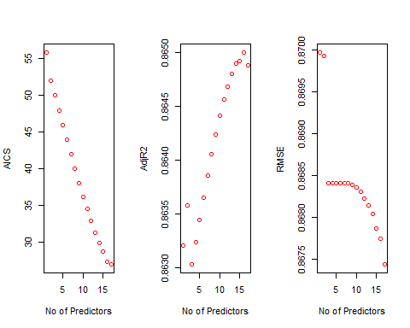

k$predictors

## [1] "Marital.Status" "EducationField"   
## [3] "Distance.From.Home" "Total.Working.Years"   
## [5] "Gender" "Education"   
## [7] "Training.Times.Last.Year" "Years.Since.Last.Promotion"  
## [9] "Job.Satisfaction" "Work.Life.Balance"   
## [11] "Job.Involvement" "Hourly.Rate"   
## [13] "Stock.Option.Level" "Performance.Rating"   
## [15] "Percent.Salary.Hike" "Age"

for (i in 1:29){  
 predictions<-predict(object=Model_BCK,newdata=EmplTest,id=i)   
 testASEbwd[i]<-mean((log(EmplTest$Monthly.Income)-predictions)^2)  
}  
  
dim(EmplTest)

## [1] 173 29

par(mfrow=c(1,1))  
plot(1:29,testASEbwd,type="l",xlab="# of predictors",ylab="test vs train ASE",ylim=c(0,0.8))  
index<-which(testASEbwd==min(testASEbwd))  
points(index,testASEbwd[index],col="red",pch=10)  
rss<-summary(reg.fwd)$rss  
lines(index,rss/869,col="blue") #Dividing by 869 since ASE=RSS/sample size

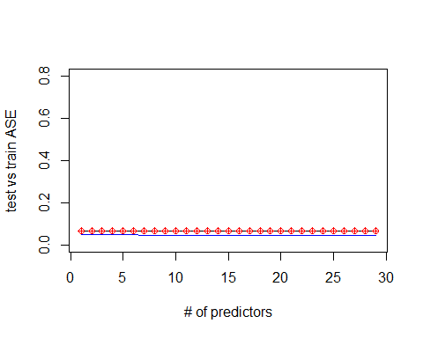

##### Stepwise Model #####  
Model_Step<-stepAIC(Model_Null,trace=FALSE)  
summary(Model_Step)

##   
## Call:  
## lm(formula = log(Monthly.Income) ~ Attrition + BusinessTravel +   
## Daily.Rate + Environment.Satisfaction + Job.Level + Monthly.Rate +   
## Num.Companies.Worked + OverTime + Relationship.Satisfaction +   
## Years.At.Company + Years.In.Current.Role + Years.With.Curr.Manager,   
## data = EmplTrain)  
##   
## Residuals:  
## Min 1Q Median 3Q Max   
## -0.9123 -0.1503 0.0086 0.1490 0.7614   
##   
## Coefficients:  
## Estimate Std. Error t value Pr(>|t|)   
## (Intercept) 7.306e+00 5.543e-02 131.814 < 2e-16 ***  
## AttritionYes -1.263e-01 2.847e-02 -4.435 1.07e-05 ***  
## BusinessTravelTravel_Frequently 4.593e-02 3.545e-02 1.296 0.19546   
## BusinessTravelTravel_Rarely 7.170e-02 2.957e-02 2.425 0.01558 *   
## Daily.Rate 6.372e-05 2.334e-05 2.730 0.00650 **   
## Environment.Satisfaction -2.143e-02 8.598e-03 -2.492 0.01294 *   
## Job.Level 5.440e-01 1.054e-02 51.596 < 2e-16 ***  
## Monthly.Rate 1.916e-06 1.332e-06 1.439 0.15071   
## Num.Companies.Worked 1.250e-02 3.927e-03 3.183 0.00152 **   
## OverTimeYes 5.503e-02 2.146e-02 2.564 0.01056 *   
## Relationship.Satisfaction -1.377e-02 8.474e-03 -1.625 0.10470   
## Years.At.Company -6.108e-03 3.313e-03 -1.844 0.06565 .   
## Years.In.Current.Role 1.253e-02 4.466e-03 2.804 0.00518 **   
## Years.With.Curr.Manager 8.286e-03 4.334e-03 1.912 0.05632 .   
## ---  
## Signif. codes: 0 '***' 0.001 '**' 0.01 '*' 0.05 '.' 0.1 ' ' 1  
##   
## Residual standard error: 0.2439 on 675 degrees of freedom  
## Multiple R-squared: 0.8674, Adjusted R-squared: 0.8649   
## F-statistic: 339.8 on 13 and 675 DF, p-value: < 2.2e-16

vif(Model_Step)

## GVIF Df GVIF^(1/(2*Df))  
## Attrition 1.173884 1 1.083459  
## BusinessTravel 1.031317 2 1.007739  
## Daily.Rate 1.017393 1 1.008659  
## Environment.Satisfaction 1.028015 1 1.013911  
## Job.Level 1.506902 1 1.227559  
## Monthly.Rate 1.015982 1 1.007959  
## Num.Companies.Worked 1.112172 1 1.054596  
## OverTime 1.105066 1 1.051221  
## Relationship.Satisfaction 1.014559 1 1.007253  
## Years.At.Company 4.208867 1 2.051552  
## Years.In.Current.Role 3.007399 1 1.734185  
## Years.With.Curr.Manager 2.747785 1 1.657644

#Residual Plots  
par(mfrow=c(1,5))  
ols_plot_resid_fit(Model_Step)



ols_plot_resid_lev(Model_Step)



ols_plot_resid_qq(Model_Step)



ols_plot_resid_hist(Model_Step)



ols_plot_cooksd_bar(Model_Step)



#Assumptions are met:  
#The histogram shows a bell shape curve which suggests that there is enough evidence for normality.  
#The QQ Plot shows a straight line which suggests that there is enough evidence for constant variance.  
#The observations are considered to be independent as they are randomly assigned.  
#The outlier at 255 seems to be seen only in this model. Leaving it in the dataset for now.  
#Business Travel Rarely, Daily Rates,Job Level,Laboratory Technician,Research #Director, Research Scientist,Sales #Representative,Number of companies #worked,overtime,Total.Working.Years,Years.In.Current.Role are statistically #significant.  
  
#Prediction  
Pred_STP=predict(Model_Step, newdata = EmplTest, interval = "confidence")  
as.data.frame(Pred_STP)

## fit lwr upr  
## 6 8.988037 8.919905 9.056169  
## 27 8.552513 8.500865 8.604161  
## 32 8.039287 7.964812 8.113763  
## 35 8.553180 8.490666 8.615694  
## 40 7.939835 7.873789 8.005881  
## 45 7.851645 7.798060 7.905231  
## 48 9.129421 9.067715 9.191127  
## 49 7.837830 7.762353 7.913307  
## 53 8.026602 7.968008 8.085196  
## 55 8.532713 8.487919 8.577507  
## 57 7.908115 7.834244 7.981985  
## 58 8.102636 8.034502 8.170770  
## 65 7.771408 7.694686 7.848129  
## 82 8.577471 8.520739 8.634202  
## 83 8.494810 8.431211 8.558408  
## 86 9.687449 9.621792 9.753105  
## 94 8.573856 8.514424 8.633288  
## 95 10.221309 10.146156 10.296463  
## 97 9.649847 9.551718 9.747975  
## 103 8.564073 8.484016 8.644130  
## 107 8.553808 8.470394 8.637222  
## 109 8.376688 8.299596 8.453780  
## 114 8.400524 8.323661 8.477387  
## 118 8.642356 8.579083 8.705629  
## 124 8.482912 8.421636 8.544189  
## 125 8.563888 8.497321 8.630456  
## 127 7.869327 7.787131 7.951522  
## 137 7.822936 7.758623 7.887249  
## 160 9.081372 9.000796 9.161949  
## 162 8.979456 8.885426 9.073487  
## 166 7.791997 7.722677 7.861316  
## 176 8.002748 7.944223 8.061272  
## 181 9.110624 9.067932 9.153316  
## 182 8.609701 8.561259 8.658144  
## 187 8.486994 8.423389 8.550598  
## 191 8.555154 8.497281 8.613027  
## 192 9.043237 8.972586 9.113889  
## 202 8.520320 8.468572 8.572068  
## 204 8.013359 7.927260 8.099458  
## 216 7.924289 7.885741 7.962836  
## 217 8.529183 8.476867 8.581499  
## 224 7.966170 7.907285 8.025054  
## 225 7.972268 7.926539 8.017996  
## 228 8.002968 7.943675 8.062262  
## 245 8.571810 8.514008 8.629611  
## 253 7.857905 7.801166 7.914645  
## 254 7.726274 7.651843 7.800705  
## 261 7.812925 7.737238 7.888611  
## 272 8.567748 8.517683 8.617813  
## 273 8.551551 8.499023 8.604079  
## 278 7.946833 7.876524 8.017143  
## 279 8.392798 8.319306 8.466289  
## 280 8.539958 8.483983 8.595934  
## 283 8.521606 8.479116 8.564097  
## 284 8.535482 8.480401 8.590564  
## 289 9.136186 9.064453 9.207919  
## 295 9.609803 9.533756 9.685850  
## 297 8.546655 8.484463 8.608848  
## 308 7.855523 7.788204 7.922843  
## 311 8.639855 8.578378 8.701331  
## 312 9.675990 9.589232 9.762747  
## 318 8.513634 8.478010 8.549258  
## 324 8.748473 8.658760 8.838187  
## 328 8.555284 8.501692 8.608876  
## 333 7.811990 7.745173 7.878807  
## 338 8.480718 8.416545 8.544892  
## 340 7.903999 7.847562 7.960437  
## 368 8.521231 8.457242 8.585221  
## 369 7.922052 7.875469 7.968636  
## 377 7.949472 7.857190 8.041753  
## 379 8.076049 8.009477 8.142621  
## 387 9.088808 9.024795 9.152822  
## 388 8.483849 8.433263 8.534435  
## 389 8.511835 8.469519 8.554152  
## 400 9.174236 9.102509 9.245963  
## 406 9.623399 9.547570 9.699227  
## 407 8.553474 8.495313 8.611635  
## 417 7.907672 7.838770 7.976573  
## 424 7.843998 7.775967 7.912030  
## 425 8.506050 8.465697 8.546402  
## 436 8.596862 8.540880 8.652844  
## 438 7.945214 7.886451 8.003977  
## 448 8.526753 8.478492 8.575014  
## 451 8.578435 8.505485 8.651386  
## 452 7.960472 7.903705 8.017238  
## 453 8.417294 8.348875 8.485712  
## 454 8.505098 8.450183 8.560014  
## 456 10.125318 10.048523 10.202114  
## 459 7.976896 7.920548 8.033244  
## 461 7.972401 7.904551 8.040252  
## 465 7.892910 7.810297 7.975523  
## 466 7.967294 7.903981 8.030607  
## 467 8.024367 7.972265 8.076469  
## 473 9.042609 8.975988 9.109230  
## 474 8.045648 7.995456 8.095839  
## 479 8.030907 7.962738 8.099076  
## 480 9.145374 9.078506 9.212243  
## 482 8.037263 7.981745 8.092780  
## 488 7.948720 7.899200 7.998239  
## 492 9.695976 9.626450 9.765502  
## 494 9.045435 8.986158 9.104711  
## 496 9.704508 9.601831 9.807185  
## 511 8.550005 8.492233 8.607776  
## 516 8.506246 8.453051 8.559441  
## 521 7.882758 7.829086 7.936431  
## 527 8.629925 8.572620 8.687231  
## 530 7.987379 7.902914 8.071844  
## 532 8.575310 8.520658 8.629961  
## 540 8.555616 8.495391 8.615840  
## 547 9.085486 8.983980 9.186993  
## 550 7.977688 7.930324 8.025052  
## 565 7.966878 7.918791 8.014966  
## 566 8.088967 8.032644 8.145290  
## 567 8.442362 8.386457 8.498268  
## 573 8.591515 8.527515 8.655515  
## 584 8.612285 8.549463 8.675107  
## 596 8.633584 8.574078 8.693089  
## 601 7.795775 7.727016 7.864535  
## 603 9.121202 9.055102 9.187302  
## 604 8.122623 8.054660 8.190586  
## 608 8.536846 8.461652 8.612041  
## 618 8.639491 8.579060 8.699921  
## 626 7.997529 7.942884 8.052174  
## 627 8.573763 8.518480 8.629047  
## 628 9.157412 9.092470 9.222354  
## 636 7.915866 7.849353 7.982378  
## 639 8.063327 8.009233 8.117422  
## 653 9.161862 9.070704 9.253020  
## 654 9.077906 9.016152 9.139661  
## 665 8.462513 8.399283 8.525743  
## 667 9.067502 8.975468 9.159536  
## 674 7.807985 7.714909 7.901061  
## 680 7.982490 7.921412 8.043569  
## 681 8.491377 8.447125 8.535630  
## 688 7.926996 7.868668 7.985323  
## 695 8.468708 8.411985 8.525432  
## 696 8.030768 7.967130 8.094406  
## 697 9.524507 9.443085 9.605930  
## 698 8.649222 8.571560 8.726884  
## 700 10.199405 10.116694 10.282115  
## 703 9.099828 9.001157 9.198498  
## 712 9.578079 9.503491 9.652666  
## 719 8.486215 8.406981 8.565448  
## 727 8.005171 7.933966 8.076375  
## 731 8.503688 8.444014 8.563361  
## 732 8.446912 8.377362 8.516462  
## 738 8.478442 8.424813 8.532071  
## 740 8.523533 8.474837 8.572230  
## 752 7.844400 7.767128 7.921673  
## 755 9.248486 9.174739 9.322233  
## 756 7.868120 7.792447 7.943793  
## 768 8.963555 8.895998 9.031111  
## 769 8.440645 8.393979 8.487311  
## 772 9.049846 8.963681 9.136011  
## 774 7.806765 7.731078 7.882452  
## 776 7.944364 7.888101 8.000626  
## 778 7.834270 7.772207 7.896333  
## 788 8.400571 8.326119 8.475023  
## 799 7.792505 7.707240 7.877769  
## 803 9.586900 9.510106 9.663693  
## 804 9.032283 8.950960 9.113605  
## 809 7.926738 7.851627 8.001850  
## 814 10.087663 10.005624 10.169702  
## 816 8.014770 7.943098 8.086443  
## 818 9.045013 8.984624 9.105402  
## 821 7.960850 7.917636 8.004064  
## 825 8.615757 8.549850 8.681663  
## 831 8.488664 8.407863 8.569465  
## 834 7.889768 7.845892 7.933644  
## 845 8.539190 8.482226 8.596154  
## 852 7.878667 7.793303 7.964031  
## 854 8.531477 8.473134 8.589820  
## 864 9.586472 9.454749 9.718195

MSPE = data.frame(Observed = log(EmplTest$Monthly.Income), Predicted = Pred_STP)  
MSPE$Resisdual = MSPE$Observed - MSPE$Predicted.fit  
MSPE$SquaredResidual = MSPE$Resisdual^2  
MSPE

## Observed Predicted.fit Predicted.lwr Predicted.upr Resisdual  
## 6 9.081711 8.988037 8.919905 9.056169 0.093674392  
## 27 9.202711 8.552513 8.500865 8.604161 0.650198529  
## 32 7.614805 8.039287 7.964812 8.113763 -0.424482004  
## 35 9.177714 8.553180 8.490666 8.615694 0.624533880  
## 40 7.934155 7.939835 7.873789 8.005881 -0.005679346  
## 45 7.109062 7.851645 7.798060 7.905231 -0.742583014  
## 48 9.075665 9.129421 9.067715 9.191127 -0.053755769  
## 49 7.537963 7.837830 7.762353 7.913307 -0.299867363  
## 53 7.606387 8.026602 7.968008 8.085196 -0.420214729  
## 55 8.394800 8.532713 8.487919 8.577507 -0.137913347  
## 57 7.922624 7.908115 7.834244 7.981985 0.014508783  
## 58 8.460199 8.102636 8.034502 8.170770 0.357563580  
## 65 7.700748 7.771408 7.694686 7.848129 -0.070660044  
## 82 8.836810 8.577471 8.520739 8.634202 0.259338983  
## 83 8.579417 8.494810 8.431211 8.558408 0.084606786  
## 86 9.527047 9.687449 9.621792 9.753105 -0.160401552  
## 94 8.722906 8.573856 8.514424 8.633288 0.149049592  
## 95 9.899781 10.221309 10.146156 10.296463 -0.321528759  
## 97 9.717519 9.649847 9.551718 9.747975 0.067672813  
## 103 8.785387 8.564073 8.484016 8.644130 0.221313538  
## 107 8.370779 8.553808 8.470394 8.637222 -0.183028948  
## 109 9.096724 8.376688 8.299596 8.453780 0.720035435  
## 114 8.535622 8.400524 8.323661 8.477387 0.135098137  
## 118 8.300280 8.642356 8.579083 8.705629 -0.342075843  
## 124 8.301025 8.482912 8.421636 8.544189 -0.181887232  
## 125 8.423761 8.563888 8.497321 8.630456 -0.140127065  
## 127 8.273592 7.869327 7.787131 7.951522 0.404265289  
## 137 7.748891 7.822936 7.758623 7.887249 -0.074044639  
## 160 9.487290 9.081372 9.000796 9.161949 0.405917629  
## 162 9.073604 8.979456 8.885426 9.073487 0.094147682  
## 166 7.622664 7.791997 7.722677 7.861316 -0.169332814  
## 176 7.635304 8.002748 7.944223 8.061272 -0.367443742  
## 181 9.237372 9.110624 9.067932 9.153316 0.126747431  
## 182 8.838262 8.609701 8.561259 8.658144 0.228560265  
## 187 8.557567 8.486994 8.423389 8.550598 0.070573576  
## 191 8.661294 8.555154 8.497281 8.613027 0.106139580  
## 192 9.173365 9.043237 8.972586 9.113889 0.130127705  
## 202 8.735525 8.520320 8.468572 8.572068 0.215205320  
## 204 7.703459 8.013359 7.927260 8.099458 -0.309900233  
## 216 7.760041 7.924289 7.885741 7.962836 -0.164248071  
## 217 9.192584 8.529183 8.476867 8.581499 0.663400457  
## 224 7.354362 7.966170 7.907285 8.025054 -0.611807358  
## 225 8.470311 7.972268 7.926539 8.017996 0.498043372  
## 228 7.752765 8.002968 7.943675 8.062262 -0.250203608  
## 245 8.528331 8.571810 8.514008 8.629611 -0.043478664  
## 253 7.729296 7.857905 7.801166 7.914645 -0.128609724  
## 254 7.991592 7.726274 7.651843 7.800705 0.265318171  
## 261 7.932003 7.812925 7.737238 7.888611 0.119078558  
## 272 8.600247 8.567748 8.517683 8.617813 0.032498315  
## 273 8.171882 8.551551 8.499023 8.604079 -0.379669013  
## 278 7.805882 7.946833 7.876524 8.017143 -0.140951185  
## 279 8.655911 8.392798 8.319306 8.466289 0.263113569  
## 280 8.302762 8.539958 8.483983 8.595934 -0.237196653  
## 283 8.781555 8.521606 8.479116 8.564097 0.259949265  
## 284 8.928905 8.535482 8.480401 8.590564 0.393423090  
## 289 9.183791 9.136186 9.064453 9.207919 0.047604773  
## 295 9.707290 9.609803 9.533756 9.685850 0.097487097  
## 297 9.163982 8.546655 8.484463 8.608848 0.617326918  
## 308 7.999343 7.855523 7.788204 7.922843 0.143819641  
## 311 8.609590 8.639855 8.578378 8.701331 -0.030264489  
## 312 9.490771 9.675990 9.589232 9.762747 -0.185218615  
## 318 8.437500 8.513634 8.478010 8.549258 -0.076133353  
## 324 8.437067 8.748473 8.658760 8.838187 -0.311406264  
## 328 8.596004 8.555284 8.501692 8.608876 0.040720407  
## 333 7.758761 7.811990 7.745173 7.878807 -0.053229658  
## 338 8.956222 8.480718 8.416545 8.544892 0.475503916  
## 340 7.758333 7.903999 7.847562 7.960437 -0.145665972  
## 368 8.607582 8.521231 8.457242 8.585221 0.086350707  
## 369 7.636752 7.922052 7.875469 7.968636 -0.285300102  
## 377 7.916807 7.949472 7.857190 8.041753 -0.032664013  
## 379 7.681560 8.076049 8.009477 8.142621 -0.394488483  
## 387 9.081256 9.088808 9.024795 9.152822 -0.007552098  
## 388 8.357494 8.483849 8.433263 8.534435 -0.126355105  
## 389 8.412277 8.511835 8.469519 8.554152 -0.099558418  
## 400 9.231025 9.174236 9.102509 9.245963 0.056789113  
## 406 9.718783 9.623399 9.547570 9.699227 0.095384598  
## 407 8.606668 8.553474 8.495313 8.611635 0.053194180  
## 417 7.849324 7.907672 7.838770 7.976573 -0.058347930  
## 424 7.384610 7.843998 7.775967 7.912030 -0.459387886  
## 425 8.460411 8.506050 8.465697 8.546402 -0.045638753  
## 436 8.734560 8.596862 8.540880 8.652844 0.137697745  
## 438 7.961021 7.945214 7.886451 8.003977 0.015807474  
## 448 8.619389 8.526753 8.478492 8.575014 0.092635434  
## 451 8.492491 8.578435 8.505485 8.651386 -0.085944804  
## 452 8.137396 7.960472 7.903705 8.017238 0.176924200  
## 453 8.667852 8.417294 8.348875 8.485712 0.250558307  
## 454 8.610137 8.505098 8.450183 8.560014 0.105038475  
## 456 9.895102 10.125318 10.048523 10.202114 -0.230215945  
## 459 7.633370 7.976896 7.920548 8.033244 -0.343525988  
## 461 7.646354 7.972401 7.904551 8.040252 -0.326047752  
## 465 7.798523 7.892910 7.810297 7.975523 -0.094386796  
## 466 8.279951 7.967294 7.903981 8.030607 0.312656856  
## 467 7.880048 8.024367 7.972265 8.076469 -0.144318792  
## 473 9.491375 9.042609 8.975988 9.109230 0.448766764  
## 474 8.146709 8.045648 7.995456 8.095839 0.101061293  
## 479 7.989560 8.030907 7.962738 8.099076 -0.041346514  
## 480 9.528358 9.145374 9.078506 9.212243 0.382983295  
## 482 7.764721 8.037263 7.981745 8.092780 -0.272542042  
## 488 7.976252 7.948720 7.899200 7.998239 0.027532251  
## 492 9.733885 9.695976 9.626450 9.765502 0.037908661  
## 494 9.060215 9.045435 8.986158 9.104711 0.014780275  
## 496 9.699350 9.704508 9.601831 9.807185 -0.005158161  
## 511 8.583543 8.550005 8.492233 8.607776 0.033537923  
## 516 8.609225 8.506246 8.453051 8.559441 0.102979221  
## 521 7.845024 7.882758 7.829086 7.936431 -0.037734025  
## 527 8.518392 8.629925 8.572620 8.687231 -0.111532840  
## 530 8.509766 7.987379 7.902914 8.071844 0.522386693  
## 532 8.826881 8.575310 8.520658 8.629961 0.251571509  
## 540 8.547722 8.555616 8.495391 8.615840 -0.007893104  
## 547 8.909641 9.085486 8.983980 9.186993 -0.175845766  
## 550 7.685703 7.977688 7.930324 8.025052 -0.291985343  
## 565 8.251403 7.966878 7.918791 8.014966 0.284524767  
## 566 7.798113 8.088967 8.032644 8.145290 -0.290854434  
## 567 7.685244 8.442362 8.386457 8.498268 -0.757118870  
## 573 8.829665 8.591515 8.527515 8.655515 0.238150428  
## 584 8.471987 8.612285 8.549463 8.675107 -0.140298349  
## 596 8.303257 8.633584 8.574078 8.693089 -0.330326404  
## 601 7.617268 7.795775 7.727016 7.864535 -0.178507310  
## 603 9.342771 9.121202 9.055102 9.187302 0.221568981  
## 604 8.049108 8.122623 8.054660 8.190586 -0.073515515  
## 608 8.631414 8.536846 8.461652 8.612041 0.094568159  
## 618 8.604105 8.639491 8.579060 8.699921 -0.035386093  
## 626 7.830823 7.997529 7.942884 8.052174 -0.166705966  
## 627 8.333751 8.573763 8.518480 8.629047 -0.240012281  
## 628 9.350972 9.157412 9.092470 9.222354 0.193559646  
## 636 7.773174 7.915866 7.849353 7.982378 -0.142692060  
## 639 7.910224 8.063327 8.009233 8.117422 -0.153103564  
## 653 9.510371 9.161862 9.070704 9.253020 0.348509225  
## 654 9.433804 9.077906 9.016152 9.139661 0.355897426  
## 665 8.426831 8.462513 8.399283 8.525743 -0.035682361  
## 667 8.976894 9.067502 8.975468 9.159536 -0.090608401  
## 674 7.611842 7.807985 7.714909 7.901061 -0.196142606  
## 680 7.753194 7.982490 7.921412 8.043569 -0.229296131  
## 681 8.356085 8.491377 8.447125 8.535630 -0.135292302  
## 688 7.871693 7.926996 7.868668 7.985323 -0.055302884  
## 695 9.161675 8.468708 8.411985 8.525432 0.692966789  
## 696 8.099858 8.030768 7.967130 8.094406 0.069089896  
## 697 9.629182 9.524507 9.443085 9.605930 0.104675125  
## 698 8.685078 8.649222 8.571560 8.726884 0.035855853  
## 700 9.856448 10.199405 10.116694 10.282115 -0.342956343  
## 703 9.247347 9.099828 9.001157 9.198498 0.147519143  
## 712 9.555206 9.578079 9.503491 9.652666 -0.022872860  
## 719 8.429673 8.486215 8.406981 8.565448 -0.056542068  
## 727 7.997327 8.005171 7.933966 8.076375 -0.007843706  
## 731 8.469053 8.503688 8.444014 8.563361 -0.034634771  
## 732 8.563695 8.446912 8.377362 8.516462 0.116783204  
## 738 8.550821 8.478442 8.424813 8.532071 0.072379216  
## 740 8.210940 8.523533 8.474837 8.572230 -0.312593414  
## 752 7.741534 7.844400 7.767128 7.921673 -0.102866594  
## 755 9.514068 9.248486 9.174739 9.322233 0.265582291  
## 756 8.218248 7.868120 7.792447 7.943793 0.350127969  
## 768 9.299450 8.963555 8.895998 9.031111 0.335894990  
## 769 8.906393 8.440645 8.393979 8.487311 0.465748088  
## 772 9.254644 9.049846 8.963681 9.136011 0.204798446  
## 774 8.127995 7.806765 7.731078 7.882452 0.321229916  
## 776 8.161946 7.944364 7.888101 8.000626 0.217581877  
## 778 7.946971 7.834270 7.772207 7.896333 0.112701710  
## 788 8.505323 8.400571 8.326119 8.475023 0.104752319  
## 799 7.527794 7.792505 7.707240 7.877769 -0.264710623  
## 803 9.744961 9.586900 9.510106 9.663693 0.158061042  
## 804 9.167642 9.032283 8.950960 9.113605 0.135359096  
## 809 7.959276 7.926738 7.851627 8.001850 0.032537626  
## 814 9.886240 10.087663 10.005624 10.169702 -0.201423222  
## 816 7.930566 8.014770 7.943098 8.086443 -0.084204528  
## 818 9.366575 9.045013 8.984624 9.105402 0.321562038  
## 821 8.105308 7.960850 7.917636 8.004064 0.144457066  
## 825 8.447414 8.615757 8.549850 8.681663 -0.168342424  
## 831 8.197814 8.488664 8.407863 8.569465 -0.290849530  
## 834 7.844633 7.889768 7.845892 7.933644 -0.045135423  
## 845 8.704336 8.539190 8.482226 8.596154 0.165146403  
## 852 7.698936 7.878667 7.793303 7.964031 -0.179731003  
## 854 8.641356 8.531477 8.473134 8.589820 0.109879022  
## 864 9.530248 9.586472 9.454749 9.718195 -0.056224549  
## SquaredResidual  
## 6 8.774892e-03  
## 27 4.227581e-01  
## 32 1.801850e-01  
## 35 3.900426e-01  
## 40 3.225497e-05  
## 45 5.514295e-01  
## 48 2.889683e-03  
## 49 8.992044e-02  
## 53 1.765804e-01  
## 55 1.902009e-02  
## 57 2.105048e-04  
## 58 1.278517e-01  
## 65 4.992842e-03  
## 82 6.725671e-02  
## 83 7.158308e-03  
## 86 2.572866e-02  
## 94 2.221578e-02  
## 95 1.033807e-01  
## 97 4.579610e-03  
## 103 4.897968e-02  
## 107 3.349960e-02  
## 109 5.184510e-01  
## 114 1.825151e-02  
## 118 1.170159e-01  
## 124 3.308297e-02  
## 125 1.963559e-02  
## 127 1.634304e-01  
## 137 5.482609e-03  
## 160 1.647691e-01  
## 162 8.863786e-03  
## 166 2.867360e-02  
## 176 1.350149e-01  
## 181 1.606491e-02  
## 182 5.223979e-02  
## 187 4.980630e-03  
## 191 1.126561e-02  
## 192 1.693322e-02  
## 202 4.631333e-02  
## 204 9.603815e-02  
## 216 2.697743e-02  
## 217 4.401002e-01  
## 224 3.743082e-01  
## 225 2.480472e-01  
## 228 6.260185e-02  
## 245 1.890394e-03  
## 253 1.654046e-02  
## 254 7.039373e-02  
## 261 1.417970e-02  
## 272 1.056141e-03  
## 273 1.441486e-01  
## 278 1.986724e-02  
## 279 6.922875e-02  
## 280 5.626225e-02  
## 283 6.757362e-02  
## 284 1.547817e-01  
## 289 2.266214e-03  
## 295 9.503734e-03  
## 297 3.810925e-01  
## 308 2.068409e-02  
## 311 9.159393e-04  
## 312 3.430594e-02  
## 318 5.796287e-03  
## 324 9.697386e-02  
## 328 1.658152e-03  
## 333 2.833397e-03  
## 338 2.261040e-01  
## 340 2.121858e-02  
## 368 7.456445e-03  
## 369 8.139615e-02  
## 377 1.066938e-03  
## 379 1.556212e-01  
## 387 5.703418e-05  
## 388 1.596561e-02  
## 389 9.911879e-03  
## 400 3.225003e-03  
## 406 9.098222e-03  
## 407 2.829621e-03  
## 417 3.404481e-03  
## 424 2.110372e-01  
## 425 2.082896e-03  
## 436 1.896067e-02  
## 438 2.498762e-04  
## 448 8.581324e-03  
## 451 7.386509e-03  
## 452 3.130217e-02  
## 453 6.277947e-02  
## 454 1.103308e-02  
## 456 5.299938e-02  
## 459 1.180101e-01  
## 461 1.063071e-01  
## 465 8.908867e-03  
## 466 9.775431e-02  
## 467 2.082791e-02  
## 473 2.013916e-01  
## 474 1.021338e-02  
## 479 1.709534e-03  
## 480 1.466762e-01  
## 482 7.427916e-02  
## 488 7.580249e-04  
## 492 1.437067e-03  
## 494 2.184565e-04  
## 496 2.660663e-05  
## 511 1.124792e-03  
## 516 1.060472e-02  
## 521 1.423857e-03  
## 527 1.243957e-02  
## 530 2.728879e-01  
## 532 6.328822e-02  
## 540 6.230109e-05  
## 547 3.092173e-02  
## 550 8.525544e-02  
## 565 8.095434e-02  
## 566 8.459630e-02  
## 567 5.732290e-01  
## 573 5.671563e-02  
## 584 1.968363e-02  
## 596 1.091155e-01  
## 601 3.186486e-02  
## 603 4.909281e-02  
## 604 5.404531e-03  
## 608 8.943137e-03  
## 618 1.252176e-03  
## 626 2.779088e-02  
## 627 5.760590e-02  
## 628 3.746534e-02  
## 636 2.036102e-02  
## 639 2.344070e-02  
## 653 1.214587e-01  
## 654 1.266630e-01  
## 665 1.273231e-03  
## 667 8.209882e-03  
## 674 3.847192e-02  
## 680 5.257672e-02  
## 681 1.830401e-02  
## 688 3.058409e-03  
## 695 4.802030e-01  
## 696 4.773414e-03  
## 697 1.095688e-02  
## 698 1.285642e-03  
## 700 1.176191e-01  
## 703 2.176190e-02  
## 712 5.231677e-04  
## 719 3.197006e-03  
## 727 6.152373e-05  
## 731 1.199567e-03  
## 732 1.363832e-02  
## 738 5.238751e-03  
## 740 9.771464e-02  
## 752 1.058154e-02  
## 755 7.053395e-02  
## 756 1.225896e-01  
## 768 1.128254e-01  
## 769 2.169213e-01  
## 772 4.194240e-02  
## 774 1.031887e-01  
## 776 4.734187e-02  
## 778 1.270168e-02  
## 788 1.097305e-02  
## 799 7.007171e-02  
## 803 2.498329e-02  
## 804 1.832208e-02  
## 809 1.058697e-03  
## 814 4.057131e-02  
## 816 7.090403e-03  
## 818 1.034021e-01  
## 821 2.086784e-02  
## 825 2.833917e-02  
## 831 8.459345e-02  
## 834 2.037206e-03  
## 845 2.727333e-02  
## 852 3.230323e-02  
## 854 1.207340e-02  
## 864 3.161200e-03

mean(MSPE$SquaredResidual)

## [1] 0.06832213

reg.stp=regsubsets(log(Monthly.Income)~.,data=EmplTrain,method="seqrep",nvmax=29)  
k<-ols_step_both_aic(Model_Null, details = TRUE)

## Stepwise Selection Method   
## -------------------------  
##   
## Candidate Terms:   
##   
## 1 . Age   
## 2 . Attrition   
## 3 . BusinessTravel   
## 4 . Daily.Rate   
## 5 . Distance.From.Home   
## 6 . Education   
## 7 . EducationField   
## 8 . Environment.Satisfaction   
## 9 . Gender   
## 10 . Hourly.Rate   
## 11 . Job.Involvement   
## 12 . Job.Level   
## 13 . Job.Satisfaction   
## 14 . Marital.Status   
## 15 . Monthly.Rate   
## 16 . Num.Companies.Worked   
## 17 . OverTime   
## 18 . Percent.Salary.Hike   
## 19 . Performance.Rating   
## 20 . Relationship.Satisfaction   
## 21 . Stock.Option.Level   
## 22 . Total.Working.Years   
## 23 . Training.Times.Last.Year   
## 24 . Work.Life.Balance   
## 25 . Years.At.Company   
## 26 . Years.In.Current.Role   
## 27 . Years.Since.Last.Promotion   
## 28 . Years.With.Curr.Manager   
##   
## Step 0: AIC = 1393.29   
## log(Monthly.Income) ~ 1   
##   
##   
## Variables Entered/Removed:   
##   
## Enter New Variables   
## ----------------------------------------------------------------------------------------  
## Variable DF AIC Sum Sq RSS R-Sq Adj. R-Sq   
## ----------------------------------------------------------------------------------------  
## Job.Level 1 75.972 258.352 44.653 0.853 0.852   
## Total.Working.Years 1 822.312 171.092 131.913 0.565 0.564   
## Years.At.Company 1 1209.933 71.471 231.534 0.236 0.235   
## Age 1 1214.403 69.964 233.041 0.231 0.230   
## Years.In.Current.Role 1 1271.951 49.664 253.342 0.164 0.163   
## Years.With.Curr.Manager 1 1297.264 40.183 262.822 0.133 0.131   
## Years.Since.Last.Promotion 1 1323.485 29.988 273.017 0.099 0.098   
## Attrition 1 1357.267 16.268 286.737 0.054 0.052   
## Num.Companies.Worked 1 1371.338 10.353 292.653 0.034 0.033   
## Education 1 1380.446 6.458 296.547 0.021 0.020   
## Marital.Status 1 1385.871 4.980 298.025 0.016 0.014   
## EducationField 1 1392.075 4.892 298.113 0.016 0.009   
## Monthly.Rate 1 1389.858 2.379 300.626 0.008 0.006   
## Training.Times.Last.Year 1 1392.177 1.366 301.639 0.005 0.003   
## BusinessTravel 1 1394.576 1.191 301.814 0.004 0.001   
## Stock.Option.Level 1 1393.377 0.840 302.165 0.003 0.001   
## Performance.Rating 1 1393.953 0.587 302.418 0.002 0.000   
## Percent.Salary.Hike 1 1394.202 0.478 302.527 0.002 0.000   
## Distance.From.Home 1 1394.448 0.370 302.635 0.001 0.000   
## Gender 1 1394.496 0.349 302.656 0.001 0.000   
## Relationship.Satisfaction 1 1394.523 0.337 302.668 0.001 0.000   
## Daily.Rate 1 1394.597 0.304 302.701 0.001 0.000   
## Work.Life.Balance 1 1394.647 0.283 302.723 0.001 -0.001   
## Job.Satisfaction 1 1394.809 0.211 302.794 0.001 -0.001   
## Environment.Satisfaction 1 1395.099 0.084 302.921 0.000 -0.001   
## Job.Involvement 1 1395.264 0.011 302.994 0.000 -0.001   
## OverTime 1 1395.271 0.008 302.997 0.000 -0.001   
## Hourly.Rate 1 1395.280 0.004 303.001 0.000 -0.001   
## ----------------------------------------------------------------------------------------  
##   
## - Job.Level added   
##   
##   
## Step 1 : AIC = 75.97176   
## log(Monthly.Income) ~ Job.Level   
##   
## Enter New Variables   
## -------------------------------------------------------------------------------------  
## Variable DF AIC Sum Sq RSS R-Sq Adj. R-Sq   
## -------------------------------------------------------------------------------------  
## Attrition 1 63.193 259.300 43.705 0.856 0.855   
## Years.In.Current.Role 1 65.003 259.185 43.820 0.855 0.855   
## Years.With.Curr.Manager 1 68.934 258.934 44.071 0.855 0.854   
## EducationField 1 76.977 258.931 44.074 0.855 0.853   
## Daily.Rate 1 69.246 258.914 44.091 0.854 0.854   
## Total.Working.Years 1 71.568 258.765 44.240 0.854 0.854   
## BusinessTravel 1 73.586 258.764 44.241 0.854 0.853   
## Age 1 71.740 258.754 44.251 0.854 0.854   
## Num.Companies.Worked 1 72.437 258.710 44.296 0.854 0.853   
## Marital.Status 1 76.001 258.609 44.396 0.853 0.853   
## Job.Involvement 1 74.203 258.596 44.409 0.853 0.853   
## Environment.Satisfaction 1 75.281 258.526 44.479 0.853 0.853   
## Relationship.Satisfaction 1 75.559 258.508 44.497 0.853 0.853   
## Stock.Option.Level 1 75.563 258.508 44.497 0.853 0.853   
## Monthly.Rate 1 75.878 258.488 44.517 0.853 0.853   
## Years.At.Company 1 75.893 258.487 44.518 0.853 0.853   
## Education 1 76.562 258.444 44.562 0.853 0.853   
## OverTime 1 76.759 258.431 44.574 0.853 0.852   
## Years.Since.Last.Promotion 1 77.138 258.406 44.599 0.853 0.852   
## Job.Satisfaction 1 77.331 258.394 44.611 0.853 0.852   
## Hourly.Rate 1 77.457 258.386 44.620 0.853 0.852   
## Percent.Salary.Hike 1 77.524 258.381 44.624 0.853 0.852   
## Gender 1 77.671 258.372 44.633 0.853 0.852   
## Work.Life.Balance 1 77.813 258.363 44.643 0.853 0.852   
## Distance.From.Home 1 77.831 258.361 44.644 0.853 0.852   
## Training.Times.Last.Year 1 77.888 258.358 44.648 0.853 0.852   
## Performance.Rating 1 77.899 258.357 44.648 0.853 0.852   
## -------------------------------------------------------------------------------------  
##   
## - Attrition added   
##   
##   
## Step 2 : AIC = 63.19317   
## log(Monthly.Income) ~ Job.Level + Attrition   
##   
## Remove Existing Variables   
## -----------------------------------------------------------------------  
## Variable DF AIC Sum Sq RSS R-Sq Adj. R-Sq   
## -----------------------------------------------------------------------  
## Attrition 1 75.972 258.352 44.653 0.853 0.852   
## Job.Level 1 1357.267 16.268 286.737 0.054 0.052   
## -----------------------------------------------------------------------  
##   
## Enter New Variables   
## -------------------------------------------------------------------------------------  
## Variable DF AIC Sum Sq RSS R-Sq Adj. R-Sq   
## -------------------------------------------------------------------------------------  
## Years.In.Current.Role 1 54.224 259.990 43.015 0.858 0.857   
## EducationField 1 64.934 259.821 43.185 0.857 0.856   
## Daily.Rate 1 57.053 259.813 43.192 0.857 0.857   
## Num.Companies.Worked 1 57.956 259.756 43.249 0.857 0.857   
## Years.With.Curr.Manager 1 58.267 259.737 43.268 0.857 0.857   
## BusinessTravel 1 60.717 259.709 43.296 0.857 0.856   
## OverTime 1 59.814 259.640 43.365 0.857 0.856   
## Total.Working.Years 1 60.340 259.607 43.399 0.857 0.856   
## Age 1 60.372 259.605 43.401 0.857 0.856   
## Environment.Satisfaction 1 61.068 259.561 43.444 0.857 0.856   
## Relationship.Satisfaction 1 62.195 259.490 43.516 0.856 0.856   
## Marital.Status 1 65.341 259.417 43.588 0.856 0.855   
## Monthly.Rate 1 63.420 259.412 43.593 0.856 0.856   
## Job.Involvement 1 63.544 259.404 43.601 0.856 0.855   
## Years.At.Company 1 63.816 259.387 43.618 0.856 0.855   
## Education 1 63.928 259.380 43.625 0.856 0.855   
## Stock.Option.Level 1 63.952 259.378 43.627 0.856 0.855   
## Years.Since.Last.Promotion 1 64.198 259.363 43.642 0.856 0.855   
## Hourly.Rate 1 64.365 259.352 43.653 0.856 0.855   
## Percent.Salary.Hike 1 64.674 259.333 43.672 0.856 0.855   
## Work.Life.Balance 1 64.714 259.330 43.675 0.856 0.855   
## Gender 1 64.939 259.316 43.689 0.856 0.855   
## Training.Times.Last.Year 1 64.959 259.315 43.691 0.856 0.855   
## Job.Satisfaction 1 65.074 259.307 43.698 0.856 0.855   
## Performance.Rating 1 65.146 259.303 43.702 0.856 0.855   
## Distance.From.Home 1 65.179 259.301 43.704 0.856 0.855   
## -------------------------------------------------------------------------------------  
##   
## - Years.In.Current.Role added   
##   
##   
## Step 3 : AIC = 54.22357   
## log(Monthly.Income) ~ Job.Level + Attrition + Years.In.Current.Role   
##   
## Remove Existing Variables   
## -----------------------------------------------------------------------------------  
## Variable DF AIC Sum Sq RSS R-Sq Adj. R-Sq   
## -----------------------------------------------------------------------------------  
## Years.In.Current.Role 1 63.193 259.300 43.705 0.856 0.855   
## Attrition 1 65.003 259.185 43.820 0.855 0.855   
## Job.Level 1 1249.168 58.614 244.391 0.193 0.191   
## -----------------------------------------------------------------------------------  
##   
## Enter New Variables   
## -------------------------------------------------------------------------------------  
## Variable DF AIC Sum Sq RSS R-Sq Adj. R-Sq   
## -------------------------------------------------------------------------------------  
## Num.Companies.Worked 1 45.248 260.670 42.335 0.860 0.859   
## Daily.Rate 1 47.549 260.528 42.477 0.860 0.859   
## EducationField 1 55.669 260.521 42.484 0.860 0.858   
## BusinessTravel 1 52.030 260.375 42.630 0.859 0.858   
## OverTime 1 50.733 260.332 42.674 0.859 0.858   
## Environment.Satisfaction 1 51.338 260.294 42.711 0.859 0.858   
## Age 1 51.705 260.271 42.734 0.859 0.858   
## Years.At.Company 1 52.161 260.243 42.762 0.859 0.858   
## Relationship.Satisfaction 1 53.425 260.164 42.841 0.859 0.858   
## Total.Working.Years 1 54.519 260.096 42.909 0.858 0.858   
## Monthly.Rate 1 54.536 260.095 42.910 0.858 0.858   
## Job.Involvement 1 54.576 260.093 42.912 0.858 0.858   
## Marital.Status 1 56.767 260.081 42.924 0.858 0.857   
## Education 1 55.036 260.064 42.941 0.858 0.857   
## Stock.Option.Level 1 55.384 260.043 42.963 0.858 0.857   
## Hourly.Rate 1 55.479 260.037 42.969 0.858 0.857   
## Work.Life.Balance 1 55.556 260.032 42.973 0.858 0.857   
## Percent.Salary.Hike 1 55.599 260.029 42.976 0.858 0.857   
## Years.Since.Last.Promotion 1 55.600 260.029 42.976 0.858 0.857   
## Years.With.Curr.Manager 1 55.920 260.009 42.996 0.858 0.857   
## Training.Times.Last.Year 1 56.030 260.002 43.003 0.858 0.857   
## Job.Satisfaction 1 56.124 259.996 43.009 0.858 0.857   
## Gender 1 56.143 259.995 43.010 0.858 0.857   
## Performance.Rating 1 56.169 259.994 43.012 0.858 0.857   
## Distance.From.Home 1 56.222 259.990 43.015 0.858 0.857   
## -------------------------------------------------------------------------------------  
##   
## - Num.Companies.Worked added   
##   
##   
## Step 4 : AIC = 45.24834   
## log(Monthly.Income) ~ Job.Level + Attrition + Years.In.Current.Role + Num.Companies.Worked   
##   
## Remove Existing Variables   
## -----------------------------------------------------------------------------------  
## Variable DF AIC Sum Sq RSS R-Sq Adj. R-Sq   
## -----------------------------------------------------------------------------------  
## Num.Companies.Worked 1 54.224 259.990 43.015 0.858 0.857   
## Attrition 1 57.739 259.770 43.235 0.857 0.857   
## Years.In.Current.Role 1 57.956 259.756 43.249 0.857 0.857   
## Job.Level 1 1205.008 74.451 228.554 0.246 0.242   
## -----------------------------------------------------------------------------------  
##   
## Enter New Variables   
## -------------------------------------------------------------------------------------  
## Variable DF AIC Sum Sq RSS R-Sq Adj. R-Sq   
## -------------------------------------------------------------------------------------  
## EducationField 1 46.626 261.196 41.809 0.862 0.860   
## Daily.Rate 1 39.237 261.159 41.846 0.862 0.861   
## BusinessTravel 1 42.733 261.068 41.937 0.862 0.860   
## OverTime 1 41.492 261.022 41.983 0.861 0.860   
## Environment.Satisfaction 1 41.633 261.014 41.992 0.861 0.860   
## Relationship.Satisfaction 1 44.296 260.851 42.154 0.861 0.860   
## Years.At.Company 1 45.331 260.788 42.218 0.861 0.860   
## Age 1 45.532 260.775 42.230 0.861 0.860   
## Monthly.Rate 1 45.654 260.768 42.237 0.861 0.860   
## Job.Involvement 1 45.840 260.756 42.249 0.861 0.860   
## Marital.Status 1 47.847 260.756 42.249 0.861 0.859   
## Work.Life.Balance 1 46.298 260.728 42.277 0.860 0.859   
## Years.With.Curr.Manager 1 46.339 260.726 42.279 0.860 0.859   
## Hourly.Rate 1 46.498 260.716 42.289 0.860 0.859   
## Stock.Option.Level 1 46.505 260.716 42.290 0.860 0.859   
## Percent.Salary.Hike 1 46.592 260.710 42.295 0.860 0.859   
## Education 1 46.941 260.689 42.316 0.860 0.859   
## Years.Since.Last.Promotion 1 46.949 260.688 42.317 0.860 0.859   
## Job.Satisfaction 1 46.996 260.685 42.320 0.860 0.859   
## Total.Working.Years 1 47.140 260.677 42.329 0.860 0.859   
## Gender 1 47.202 260.673 42.332 0.860 0.859   
## Performance.Rating 1 47.219 260.672 42.333 0.860 0.859   
## Training.Times.Last.Year 1 47.225 260.671 42.334 0.860 0.859   
## Distance.From.Home 1 47.237 260.671 42.335 0.860 0.859   
## -------------------------------------------------------------------------------------  
##   
## - Daily.Rate added   
##   
##   
## Step 5 : AIC = 39.23693   
## log(Monthly.Income) ~ Job.Level + Attrition + Years.In.Current.Role + Num.Companies.Worked + Daily.Rate   
##   
## Remove Existing Variables   
## -----------------------------------------------------------------------------------  
## Variable DF AIC Sum Sq RSS R-Sq Adj. R-Sq   
## -----------------------------------------------------------------------------------  
## Daily.Rate 1 45.248 260.670 42.335 0.860 0.859   
## Num.Companies.Worked 1 47.549 260.528 42.477 0.860 0.859   
## Attrition 1 51.055 260.312 42.694 0.859 0.858   
## Years.In.Current.Role 1 52.399 260.228 42.777 0.859 0.858   
## Job.Level 1 1206.426 74.644 228.361 0.246 0.242   
## -----------------------------------------------------------------------------------  
##   
## Enter New Variables   
## -------------------------------------------------------------------------------------  
## Variable DF AIC Sum Sq RSS R-Sq Adj. R-Sq   
## -------------------------------------------------------------------------------------  
## EducationField 1 40.326 261.697 41.308 0.864 0.862   
## BusinessTravel 1 36.260 261.581 41.424 0.863 0.862   
## Environment.Satisfaction 1 35.811 261.488 41.518 0.863 0.862   
## OverTime 1 35.938 261.480 41.525 0.863 0.862   
## Relationship.Satisfaction 1 38.385 261.332 41.673 0.862 0.861   
## Monthly.Rate 1 39.301 261.277 41.728 0.862 0.861   
## Age 1 39.440 261.268 41.737 0.862 0.861   
## Years.At.Company 1 39.868 261.242 41.763 0.862 0.861   
## Job.Involvement 1 40.012 261.234 41.772 0.862 0.861   
## Years.With.Curr.Manager 1 40.081 261.229 41.776 0.862 0.861   
## Marital.Status 1 42.152 261.225 41.780 0.862 0.861   
## Work.Life.Balance 1 40.475 261.206 41.800 0.862 0.861   
## Stock.Option.Level 1 40.552 261.201 41.804 0.862 0.861   
## Percent.Salary.Hike 1 40.713 261.191 41.814 0.862 0.861   
## Hourly.Rate 1 40.771 261.188 41.818 0.862 0.861   
## Education 1 40.904 261.180 41.826 0.862 0.861   
## Job.Satisfaction 1 40.971 261.175 41.830 0.862 0.861   
## Total.Working.Years 1 41.000 261.174 41.831 0.862 0.861   
## Years.Since.Last.Promotion 1 41.052 261.171 41.835 0.862 0.861   
## Performance.Rating 1 41.213 261.161 41.844 0.862 0.861   
## Gender 1 41.218 261.160 41.845 0.862 0.861   
## Training.Times.Last.Year 1 41.227 261.160 41.845 0.862 0.861   
## Distance.From.Home 1 41.237 261.159 41.846 0.862 0.861   
## -------------------------------------------------------------------------------------  
##   
## - Environment.Satisfaction added   
##   
##   
## Step 6 : AIC = 35.81099   
## log(Monthly.Income) ~ Job.Level + Attrition + Years.In.Current.Role + Num.Companies.Worked + Daily.Rate + Environment.Satisfaction   
##   
## Remove Existing Variables   
## --------------------------------------------------------------------------------------  
## Variable DF AIC Sum Sq RSS R-Sq Adj. R-Sq   
## --------------------------------------------------------------------------------------  
## Environment.Satisfaction 1 39.237 261.159 41.846 0.862 0.861   
## Daily.Rate 1 41.633 261.014 41.992 0.861 0.860   
## Num.Companies.Worked 1 44.826 260.819 42.187 0.861 0.860   
## Attrition 1 49.247 260.547 42.458 0.860 0.859   
## Years.In.Current.Role 1 50.030 260.499 42.507 0.860 0.859   
## Job.Level 1 1207.239 75.037 227.968 0.248 0.242   
## --------------------------------------------------------------------------------------  
##   
## Enter New Variables   
## -------------------------------------------------------------------------------------  
## Variable DF AIC Sum Sq RSS R-Sq Adj. R-Sq   
## -------------------------------------------------------------------------------------  
## EducationField 1 36.833 262.025 40.980 0.865 0.863   
## BusinessTravel 1 32.989 261.897 41.109 0.864 0.863   
## OverTime 1 31.524 261.865 41.140 0.864 0.863   
## Relationship.Satisfaction 1 34.850 261.666 41.340 0.864 0.862   
## Monthly.Rate 1 35.745 261.612 41.393 0.863 0.862   
## Age 1 36.082 261.592 41.414 0.863 0.862   
## Years.At.Company 1 36.202 261.584 41.421 0.863 0.862   
## Marital.Status 1 38.661 261.557 41.448 0.863 0.862   
## Job.Involvement 1 36.776 261.550 41.455 0.863 0.862   
## Years.With.Curr.Manager 1 36.932 261.540 41.465 0.863 0.862   
## Stock.Option.Level 1 37.022 261.535 41.470 0.863 0.862   
## Percent.Salary.Hike 1 37.343 261.516 41.489 0.863 0.862   
## Work.Life.Balance 1 37.388 261.513 41.492 0.863 0.862   
## Hourly.Rate 1 37.480 261.508 41.498 0.863 0.862   
## Education 1 37.565 261.502 41.503 0.863 0.862   
## Job.Satisfaction 1 37.639 261.498 41.507 0.863 0.862   
## Total.Working.Years 1 37.656 261.497 41.508 0.863 0.862   
## Years.Since.Last.Promotion 1 37.687 261.495 41.510 0.863 0.862   
## Performance.Rating 1 37.789 261.489 41.516 0.863 0.862   
## Distance.From.Home 1 37.803 261.488 41.517 0.863 0.862   
## Gender 1 37.807 261.488 41.517 0.863 0.862   
## Training.Times.Last.Year 1 37.808 261.488 41.517 0.863 0.862   
## -------------------------------------------------------------------------------------  
##   
## - OverTime added   
##   
##   
## Step 7 : AIC = 31.52424   
## log(Monthly.Income) ~ Job.Level + Attrition + Years.In.Current.Role + Num.Companies.Worked + Daily.Rate + Environment.Satisfaction + OverTime   
##   
## Remove Existing Variables   
## --------------------------------------------------------------------------------------  
## Variable DF AIC Sum Sq RSS R-Sq Adj. R-Sq   
## --------------------------------------------------------------------------------------  
## OverTime 1 35.811 261.488 41.518 0.863 0.862   
## Environment.Satisfaction 1 35.938 261.480 41.525 0.863 0.862   
## Daily.Rate 1 36.837 261.426 41.579 0.863 0.862   
## Num.Companies.Worked 1 40.906 261.179 41.826 0.862 0.861   
## Years.In.Current.Role 1 46.034 260.867 42.138 0.861 0.860   
## Attrition 1 49.751 260.639 42.366 0.860 0.859   
## Job.Level 1 1204.650 76.550 226.455 0.253 0.246   
## --------------------------------------------------------------------------------------  
##   
## Enter New Variables   
## -------------------------------------------------------------------------------------  
## Variable DF AIC Sum Sq RSS R-Sq Adj. R-Sq   
## -------------------------------------------------------------------------------------  
## EducationField 1 32.746 262.385 40.620 0.866 0.864   
## BusinessTravel 1 29.193 262.241 40.764 0.865 0.864   
## Relationship.Satisfaction 1 30.265 262.059 40.946 0.865 0.863   
## Monthly.Rate 1 31.421 261.990 41.015 0.865 0.863   
## Years.At.Company 1 31.637 261.977 41.028 0.865 0.863   
## Age 1 32.107 261.949 41.056 0.865 0.863   
## Marital.Status 1 34.561 261.922 41.083 0.864 0.863   
## Job.Involvement 1 32.561 261.922 41.083 0.864 0.863   
## Years.With.Curr.Manager 1 32.564 261.922 41.083 0.864 0.863   
## Stock.Option.Level 1 32.854 261.905 41.101 0.864 0.863   
## Percent.Salary.Hike 1 33.003 261.896 41.109 0.864 0.863   
## Work.Life.Balance 1 33.064 261.892 41.113 0.864 0.863   
## Hourly.Rate 1 33.165 261.886 41.119 0.864 0.863   
## Education 1 33.275 261.880 41.126 0.864 0.863   
## Total.Working.Years 1 33.411 261.871 41.134 0.864 0.863   
## Job.Satisfaction 1 33.428 261.870 41.135 0.864 0.863   
## Years.Since.Last.Promotion 1 33.442 261.870 41.136 0.864 0.863   
## Distance.From.Home 1 33.478 261.867 41.138 0.864 0.863   
## Gender 1 33.512 261.865 41.140 0.864 0.863   
## Performance.Rating 1 33.523 261.865 41.140 0.864 0.863   
## Training.Times.Last.Year 1 33.524 261.865 41.140 0.864 0.863   
## -------------------------------------------------------------------------------------  
##   
## - BusinessTravel added   
##   
##   
## Step 8 : AIC = 29.19285   
## log(Monthly.Income) ~ Job.Level + Attrition + Years.In.Current.Role + Num.Companies.Worked + Daily.Rate + Environment.Satisfaction + OverTime + BusinessTravel   
##   
## Remove Existing Variables   
## --------------------------------------------------------------------------------------  
## Variable DF AIC Sum Sq RSS R-Sq Adj. R-Sq   
## --------------------------------------------------------------------------------------  
## OverTime 1 32.989 261.897 41.109 0.864 0.863   
## Environment.Satisfaction 1 33.393 261.872 41.133 0.864 0.863   
## BusinessTravel 1 31.524 261.865 41.140 0.864 0.863   
## Daily.Rate 1 34.948 261.780 41.226 0.864 0.862   
## Num.Companies.Worked 1 38.873 261.544 41.461 0.863 0.862   
## Years.In.Current.Role 1 43.321 261.276 41.730 0.862 0.861   
## Attrition 1 47.264 261.036 41.969 0.861 0.860   
## Job.Level 1 1206.360 77.302 225.704 0.255 0.246   
## --------------------------------------------------------------------------------------  
##   
## Enter New Variables   
## -------------------------------------------------------------------------------------  
## Variable DF AIC Sum Sq RSS R-Sq Adj. R-Sq   
## -------------------------------------------------------------------------------------  
## EducationField 1 30.905 262.728 40.277 0.867 0.864   
## Relationship.Satisfaction 1 28.180 262.419 40.586 0.866 0.864   
## Monthly.Rate 1 29.006 262.370 40.635 0.866 0.864   
## Years.At.Company 1 29.602 262.335 40.670 0.866 0.864   
## Age 1 29.773 262.325 40.680 0.866 0.864   
## Years.With.Curr.Manager 1 29.875 262.319 40.686 0.866 0.864   
## Marital.Status 1 32.159 262.302 40.703 0.866 0.863   
## Job.Involvement 1 30.391 262.288 40.717 0.866 0.864   
## Percent.Salary.Hike 1 30.503 262.282 40.723 0.866 0.864   
## Stock.Option.Level 1 30.506 262.282 40.724 0.866 0.864   
## Work.Life.Balance 1 30.746 262.267 40.738 0.866 0.864   
## Hourly.Rate 1 30.782 262.265 40.740 0.866 0.864   
## Education 1 30.967 262.254 40.751 0.866 0.864   
## Job.Satisfaction 1 31.049 262.249 40.756 0.865 0.864   
## Total.Working.Years 1 31.128 262.245 40.760 0.865 0.863   
## Years.Since.Last.Promotion 1 31.181 262.242 40.764 0.865 0.863   
## Gender 1 31.188 262.241 40.764 0.865 0.863   
## Distance.From.Home 1 31.189 262.241 40.764 0.865 0.863   
## Performance.Rating 1 31.190 262.241 40.764 0.865 0.863   
## Training.Times.Last.Year 1 31.192 262.241 40.764 0.865 0.863   
## -------------------------------------------------------------------------------------  
##   
## - Relationship.Satisfaction added   
##   
##   
## Step 9 : AIC = 28.18003   
## log(Monthly.Income) ~ Job.Level + Attrition + Years.In.Current.Role + Num.Companies.Worked + Daily.Rate + Environment.Satisfaction + OverTime + BusinessTravel + Relationship.Satisfaction   
##   
## Remove Existing Variables   
## ---------------------------------------------------------------------------------------  
## Variable DF AIC Sum Sq RSS R-Sq Adj. R-Sq   
## ---------------------------------------------------------------------------------------  
## Relationship.Satisfaction 1 29.193 262.241 40.764 0.865 0.864   
## OverTime 1 32.242 262.060 40.945 0.865 0.863   
## BusinessTravel 1 30.265 262.059 40.946 0.865 0.863   
## Environment.Satisfaction 1 32.547 262.042 40.963 0.865 0.863   
## Daily.Rate 1 33.842 261.965 41.040 0.865 0.863   
## Num.Companies.Worked 1 38.058 261.713 41.292 0.864 0.862   
## Years.In.Current.Role 1 42.049 261.473 41.532 0.863 0.861   
## Attrition 1 47.148 261.165 41.840 0.862 0.860   
## Job.Level 1 1207.359 77.629 225.376 0.256 0.246   
## ---------------------------------------------------------------------------------------  
##   
## Enter New Variables   
## -------------------------------------------------------------------------------------  
## Variable DF AIC Sum Sq RSS R-Sq Adj. R-Sq   
## -------------------------------------------------------------------------------------  
## EducationField 1 29.941 262.901 40.104 0.868 0.865   
## Monthly.Rate 1 27.963 262.549 40.456 0.866 0.864   
## Years.At.Company 1 28.736 262.504 40.501 0.866 0.864   
## Age 1 28.853 262.497 40.508 0.866 0.864   
## Years.With.Curr.Manager 1 28.915 262.493 40.512 0.866 0.864   
## Marital.Status 1 31.432 262.463 40.542 0.866 0.864   
## Job.Involvement 1 29.465 262.461 40.544 0.866 0.864   
## Percent.Salary.Hike 1 29.604 262.453 40.552 0.866 0.864   
## Stock.Option.Level 1 29.678 262.448 40.557 0.866 0.864   
## Hourly.Rate 1 29.695 262.447 40.558 0.866 0.864   
## Work.Life.Balance 1 29.782 262.442 40.563 0.866 0.864   
## Education 1 30.008 262.429 40.576 0.866 0.864   
## Job.Satisfaction 1 30.075 262.425 40.580 0.866 0.864   
## Total.Working.Years 1 30.153 262.420 40.585 0.866 0.864   
## Gender 1 30.178 262.419 40.586 0.866 0.864   
## Distance.From.Home 1 30.179 262.419 40.586 0.866 0.864   
## Years.Since.Last.Promotion 1 30.179 262.419 40.586 0.866 0.864   
## Training.Times.Last.Year 1 30.179 262.419 40.586 0.866 0.864   
## Performance.Rating 1 30.180 262.419 40.586 0.866 0.864   
## -------------------------------------------------------------------------------------  
##   
## - Monthly.Rate added   
##   
##   
## Step 10 : AIC = 27.96347   
## log(Monthly.Income) ~ Job.Level + Attrition + Years.In.Current.Role + Num.Companies.Worked + Daily.Rate + Environment.Satisfaction + OverTime + BusinessTravel + Relationship.Satisfaction + Monthly.Rate   
##   
## Remove Existing Variables   
## ---------------------------------------------------------------------------------------  
## Variable DF AIC Sum Sq RSS R-Sq Adj. R-Sq   
## ---------------------------------------------------------------------------------------  
## Monthly.Rate 1 28.180 262.419 40.586 0.866 0.864   
## Relationship.Satisfaction 1 29.006 262.370 40.635 0.866 0.864   
## OverTime 1 32.056 262.190 40.815 0.865 0.863   
## BusinessTravel 1 30.144 262.185 40.820 0.865 0.863   
## Environment.Satisfaction 1 32.484 262.165 40.841 0.865 0.863   
## Daily.Rate 1 33.993 262.075 40.930 0.865 0.863   
## Num.Companies.Worked 1 37.731 261.852 41.153 0.864 0.862   
## Years.In.Current.Role 1 41.699 261.615 41.391 0.863 0.861   
## Attrition 1 46.585 261.320 41.685 0.862 0.860   
## Job.Level 1 1206.008 78.723 224.282 0.260 0.249   
## ---------------------------------------------------------------------------------------  
##   
## Enter New Variables   
## -------------------------------------------------------------------------------------  
## Variable DF AIC Sum Sq RSS R-Sq Adj. R-Sq   
## -------------------------------------------------------------------------------------  
## EducationField 1 29.278 263.056 39.949 0.868 0.865   
## Years.With.Curr.Manager 1 28.502 262.635 40.370 0.867 0.864   
## Years.At.Company 1 28.761 262.620 40.385 0.867 0.864   
## Age 1 28.802 262.617 40.388 0.867 0.864   
## Marital.Status 1 31.168 262.596 40.409 0.867 0.864   
## Job.Involvement 1 29.194 262.594 40.411 0.867 0.864   
## Stock.Option.Level 1 29.343 262.586 40.420 0.867 0.864   
## Percent.Salary.Hike 1 29.354 262.585 40.420 0.867 0.864   
## Hourly.Rate 1 29.376 262.584 40.421 0.867 0.864   
## Work.Life.Balance 1 29.598 262.571 40.434 0.867 0.864   
## Education 1 29.778 262.560 40.445 0.867 0.864   
## Job.Satisfaction 1 29.877 262.554 40.451 0.867 0.864   
## Total.Working.Years 1 29.942 262.550 40.455 0.866 0.864   
## Distance.From.Home 1 29.956 262.550 40.456 0.866 0.864   
## Training.Times.Last.Year 1 29.963 262.549 40.456 0.866 0.864   
## Performance.Rating 1 29.963 262.549 40.456 0.866 0.864   
## Gender 1 29.963 262.549 40.456 0.866 0.864   
## Years.Since.Last.Promotion 1 29.963 262.549 40.456 0.866 0.864   
## -------------------------------------------------------------------------------------  
##   
##   
## No more variables to be added or removed.  
##   
## Final Model Output   
## ------------------  
##   
## Model Summary   
## -------------------------------------------------------------  
## R 0.931 RMSE 0.244   
## R-Squared 0.866 Coef. Var 2.867   
## Adj. R-Squared 0.864 MSE 0.060   
## Pred R-Squared 0.862 MAE 0.188   
## -------------------------------------------------------------  
## RMSE: Root Mean Square Error   
## MSE: Mean Square Error   
## MAE: Mean Absolute Error   
##   
## ANOVA   
## ---------------------------------------------------------------------  
## Sum of   
## Squares DF Mean Square F Sig.   
## ---------------------------------------------------------------------  
## Regression 262.549 11 23.868 399.415 0.0000   
## Residual 40.456 677 0.060   
## Total 303.005 688   
## ---------------------------------------------------------------------  
##   
## Parameter Estimates   
## -------------------------------------------------------------------------------------------------------------  
## model Beta Std. Error Std. Beta t Sig lower upper   
## -------------------------------------------------------------------------------------------------------------  
## (Intercept) 7.316 0.055 133.445 0.000 7.209 7.424   
## Job.Level 0.538 0.010 0.878 55.463 0.000 0.519 0.557   
## AttritionYes -0.129 0.028 -0.069 -4.535 0.000 -0.185 -0.073   
## Years.In.Current.Role 0.011 0.003 0.062 3.955 0.000 0.006 0.017   
## Num.Companies.Worked 0.013 0.004 0.050 3.415 0.001 0.006 0.021   
## Daily.Rate 0.000 0.000 0.040 2.817 0.005 0.000 0.000   
## Environment.Satisfaction -0.022 0.009 -0.036 -2.537 0.011 -0.039 -0.005   
## OverTimeYes 0.053 0.021 0.036 2.452 0.014 0.010 0.095   
## BusinessTravelTravel_Frequently 0.047 0.036 0.027 1.314 0.189 -0.023 0.116   
## BusinessTravelTravel_Rarely 0.071 0.030 0.049 2.398 0.017 0.013 0.129   
## Relationship.Satisfaction -0.015 0.008 -0.024 -1.731 0.084 -0.031 0.002   
## Monthly.Rate 0.000 0.000 0.021 1.477 0.140 0.000 0.000   
## -------------------------------------------------------------------------------------------------------------

par(mfrow=c(1,3))  
#plot(k$aics,xlab="No of Predictors",ylab="AICS", col = "red")  
plot(k$arsq,xlab="No of Predictors",ylab="AdjR2", col = "red")  
plot(k$rsq,xlab="No of Predictors",ylab="RMSE", col = "red")  
k$predictors

## [1] "Job.Level" "Attrition"   
## [3] "Years.In.Current.Role" "Num.Companies.Worked"   
## [5] "Daily.Rate" "Environment.Satisfaction"   
## [7] "OverTime" "BusinessTravel"   
## [9] "Relationship.Satisfaction" "Monthly.Rate"

#Plot for AISC  
for (i in 1:29){  
 predictions<-predict(object=Model_Step,newdata=EmplTest,id=i)   
 testASEstp[i]<-mean((log(EmplTest$Monthly.Income)-predictions)^2)  
}  
  
dim(EmplTest)

## [1] 173 29

par(mfrow=c(1,1))

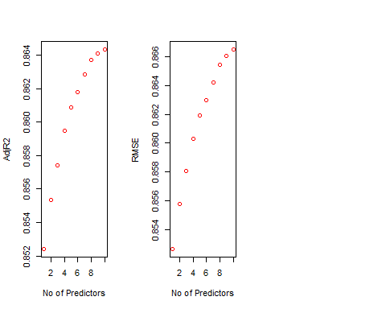

plot(1:29,testASEstp,type="l",xlab="# of predictors",ylab="test vs train ASE",ylim=c(0,0.8))  
index<-which(testASEstp==min(testASEstp))  
points(index,testASEstp[index],col="red",pch=10)  
rss<-summary(reg.fwd)$rss  
lines(index,rss/869,col="blue") #Dividing by 869 since ASE=RSS/sample size



##### Simple Model1 ##### Using Squared variable  
  
EmplTrainSimp1<-Train%>%select(Age,Attrition,BusinessTravel,Distance.From.Home,Education,EducationField,Environment.Satisfaction,Gender,(Monthly.Income),Job.Involvement,Job.Level,Job.Satisfaction,Marital.Status,Num.Companies.Worked,OverTime,Performance.Rating,Relationship.Satisfaction,(Total.Working.Years),Work.Life.Balance,Years.In.Current.Role,Years.Since.Last.Promotion,Years.With.Curr.Manager)  
  
EmplTestSimp1<-Test%>%select(Age,Attrition,BusinessTravel,Distance.From.Home,Education,EducationField,Environment.Satisfaction,Gender,(Monthly.Income),Job.Involvement,Job.Level,Job.Satisfaction,Marital.Status,Num.Companies.Worked,OverTime,Performance.Rating,Relationship.Satisfaction,(Total.Working.Years),Work.Life.Balance,Years.In.Current.Role,Years.Since.Last.Promotion,Years.With.Curr.Manager)  
  
dim(EmplTrainSimp1)

## [1] 689 22

dim(EmplTestSimp1)

## [1] 173 22

Model_Simp1<-lm(log(Monthly.Income)~Age+Attrition+BusinessTravel+Distance.From.Home+Education+EducationField+Environment.Satisfaction+Gender+Job.Involvement+Job.Level+Job.Satisfaction+Marital.Status+Num.Companies.Worked+OverTime+Performance.Rating+Relationship.Satisfaction+(Total.Working.Years)+Work.Life.Balance+Years.In.Current.Role+(Years.In.Current.Role)^2+Years.Since.Last.Promotion+Years.With.Curr.Manager,data=EmplTrainSimp1)  
   
summary(Model_Simp1)

##   
## Call:  
## lm(formula = log(Monthly.Income) ~ Age + Attrition + BusinessTravel +   
## Distance.From.Home + Education + EducationField + Environment.Satisfaction +   
## Gender + Job.Involvement + Job.Level + Job.Satisfaction +   
## Marital.Status + Num.Companies.Worked + OverTime + Performance.Rating +   
## Relationship.Satisfaction + (Total.Working.Years) + Work.Life.Balance +   
## Years.In.Current.Role + (Years.In.Current.Role)^2 + Years.Since.Last.Promotion +   
## Years.With.Curr.Manager, data = EmplTrainSimp1)  
##   
## Residuals:  
## Min 1Q Median 3Q Max   
## -0.88626 -0.15290 0.00928 0.15780 0.79523   
##   
## Coefficients:  
## Estimate Std. Error t value Pr(>|t|)   
## (Intercept) 7.253e+00 1.499e-01 48.392 < 2e-16 ***  
## Age 1.629e-03 1.461e-03 1.115 0.265276   
## AttritionYes -1.183e-01 3.111e-02 -3.802 0.000157 ***  
## BusinessTravelTravel_Frequently 4.014e-02 3.630e-02 1.106 0.269146   
## BusinessTravelTravel_Rarely 6.552e-02 3.026e-02 2.165 0.030725 *   
## Distance.From.Home 3.406e-06 1.174e-03 0.003 0.997686   
## Education -5.722e-04 9.605e-03 -0.060 0.952510   
## EducationFieldLife Sciences 8.540e-02 7.715e-02 1.107 0.268739   
## EducationFieldMarketing 1.291e-01 8.050e-02 1.604 0.109283   
## EducationFieldMedical 7.150e-02 7.769e-02 0.920 0.357753   
## EducationFieldOther 1.279e-01 8.473e-02 1.509 0.131715   
## EducationFieldTechnical Degree 4.399e-02 8.182e-02 0.538 0.590995   
## Environment.Satisfaction -2.068e-02 8.834e-03 -2.341 0.019512 *   
## GenderMale -6.612e-04 1.957e-02 -0.034 0.973052   
## Job.Involvement 1.276e-02 1.392e-02 0.917 0.359464   
## Job.Level 5.369e-01 1.449e-02 37.046 < 2e-16 ***  
## Job.Satisfaction 2.687e-03 8.690e-03 0.309 0.757256   
## Marital.StatusMarried -2.212e-03 2.486e-02 -0.089 0.929113   
## Marital.StatusSingle -2.214e-02 2.724e-02 -0.813 0.416720   
## Num.Companies.Worked 1.350e-02 4.283e-03 3.152 0.001692 **   
## OverTimeYes 5.176e-02 2.195e-02 2.358 0.018655 *   
## Performance.Rating -7.403e-04 2.662e-02 -0.028 0.977823   
## Relationship.Satisfaction -1.315e-02 8.724e-03 -1.507 0.132271   
## Total.Working.Years -1.195e-03 2.699e-03 -0.443 0.658198   
## Work.Life.Balance -8.438e-03 1.366e-02 -0.618 0.536886   
## Years.In.Current.Role 9.332e-03 4.092e-03 2.281 0.022885 *   
## Years.Since.Last.Promotion -7.058e-04 3.930e-03 -0.180 0.857516   
## Years.With.Curr.Manager 3.997e-03 4.049e-03 0.987 0.323924   
## ---  
## Signif. codes: 0 '***' 0.001 '**' 0.01 '*' 0.05 '.' 0.1 ' ' 1  
##   
## Residual standard error: 0.2469 on 661 degrees of freedom  
## Multiple R-squared: 0.867, Adjusted R-squared: 0.8616   
## F-statistic: 159.6 on 27 and 661 DF, p-value: < 2.2e-16

vif(Model_Simp1)

## GVIF Df GVIF^(1/(2*Df))  
## Age 1.930471 1 1.389414  
## Attrition 1.368305 1 1.169746  
## BusinessTravel 1.081383 2 1.019753  
## Distance.From.Home 1.052780 1 1.026051  
## Education 1.099600 1 1.048618  
## EducationField 1.179348 5 1.016633  
## Environment.Satisfaction 1.059429 1 1.029286  
## Gender 1.036601 1 1.018136  
## Job.Involvement 1.056592 1 1.027906  
## Job.Level 2.779449 1 1.667168  
## Job.Satisfaction 1.060734 1 1.029919  
## Marital.Status 1.158564 2 1.037481  
## Num.Companies.Worked 1.291672 1 1.136517  
## OverTime 1.128762 1 1.062432  
## Performance.Rating 1.018445 1 1.009181  
## Relationship.Satisfaction 1.050021 1 1.024705  
## Total.Working.Years 4.580563 1 2.140225  
## Work.Life.Balance 1.035847 1 1.017766  
## Years.In.Current.Role 2.464362 1 1.569829  
## Years.Since.Last.Promotion 1.706672 1 1.306397  
## Years.With.Curr.Manager 2.341068 1 1.530055

par(mfrow=c(1,5))  
ols_plot_resid_fit(Model_Simp1)

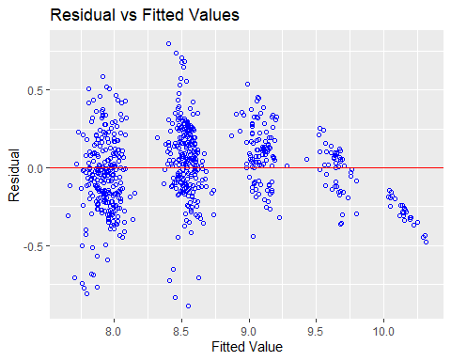

ols_plot_resid_lev(Model_Simp1)

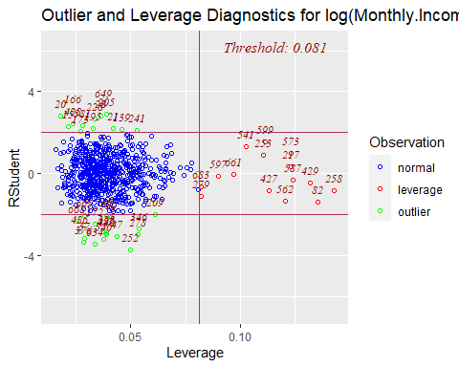

ols_plot_resid_qq(Model_Simp1)

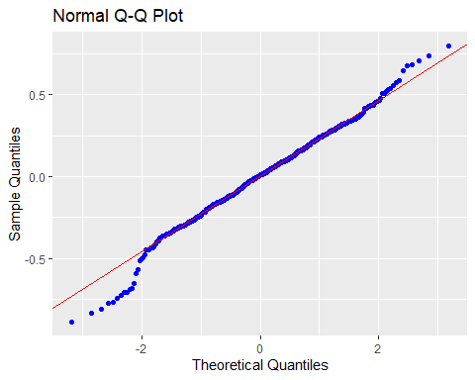

ols_plot_resid_hist(Model_Simp1)

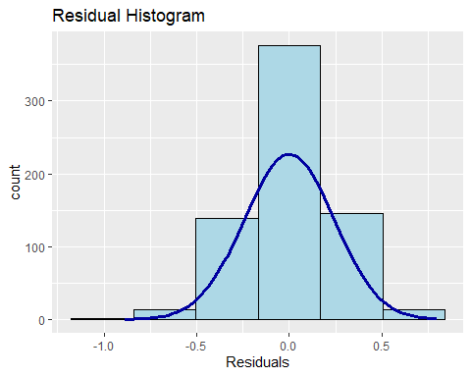

ols_plot_cooksd_bar(Model_Simp1)

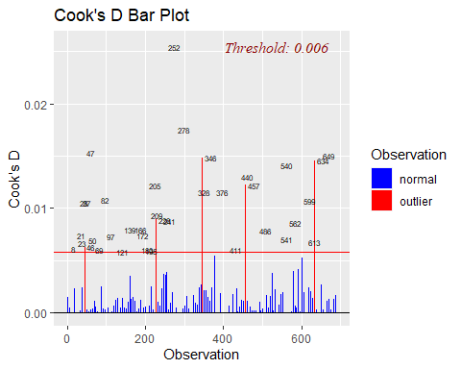

#Assumptions are met:  
#The histogram shows a bell shape curve which suggests that there is enough evidence for normality.  
#The QQ Plot shows a straight line which suggests that there is enough evidence for constant variance.  
#The observations are considered to be independent as they are randomly assigned.  
#Business Travel Rarely, Daily Rates,Job Level,Laboratory Technician,Research #Director, Research Scientist,Sales #Representative,Number of companies #worked,overtime,Total.Working.Years,Years.In.Current.Role are statistically #significant.  
#The outlier at 255 seems to be seen only in this model. Leaving it in the dataset for now.  
  
#Prediction  
Pred_Simp1=predict(Model_Simp1, newdata = EmplTestSimp1, interval = "confidence")  
as.data.frame(Pred_Simp1)

## fit lwr upr  
## 6 9.025450 8.924517 9.126383  
## 27 8.522011 8.456510 8.587512  
## 32 8.060779 7.961150 8.160407  
## 35 8.501898 8.409211 8.594585  
## 40 7.941871 7.856504 8.027238  
## 45 7.873044 7.790253 7.955835  
## 48 9.167598 9.079307 9.255890  
## 49 7.832858 7.732652 7.933063  
## 53 8.041673 7.944575 8.138770  
## 55 8.506589 8.422669 8.590508  
## 57 7.915701 7.813367 8.018034  
## 58 8.026580 7.932427 8.120733  
## 65 7.807507 7.707040 7.907973  
## 82 8.539146 8.455867 8.622425  
## 83 8.507668 8.417622 8.597714  
## 86 9.650587 9.553005 9.748168  
## 94 8.569802 8.495668 8.643937  
## 95 10.139399 10.054397 10.224400  
## 97 9.708235 9.603900 9.812571  
## 103 8.590412 8.483023 8.697801  
## 107 8.440080 8.331371 8.548790  
## 109 8.418193 8.303627 8.532759  
## 114 8.383650 8.273599 8.493702  
## 118 8.604469 8.505382 8.703556  
## 124 8.546485 8.444191 8.648779  
## 125 8.553622 8.466603 8.640641  
## 127 7.841606 7.723311 7.959901  
## 137 7.836953 7.748025 7.925881  
## 160 9.060157 8.952264 9.168051  
## 162 8.867613 8.742491 8.992736  
## 166 7.754726 7.665663 7.843789  
## 176 7.871503 7.768497 7.974509  
## 181 9.061688 8.986005 9.137372  
## 182 8.577622 8.500953 8.654290  
## 187 8.499387 8.405710 8.593065  
## 191 8.505589 8.417018 8.594161  
## 192 9.060314 8.959050 9.161577  
## 202 8.548279 8.478125 8.618433  
## 204 7.987434 7.881469 8.093400  
## 216 7.932376 7.860616 8.004137  
## 217 8.457854 8.382959 8.532749  
## 224 7.945731 7.856468 8.034993  
## 225 7.965477 7.885747 8.045207  
## 228 8.001198 7.912698 8.089698  
## 245 8.569642 8.485777 8.653507  
## 253 7.914390 7.831092 7.997688  
## 254 7.683347 7.507656 7.859038  
## 261 7.813281 7.714131 7.912430  
## 272 8.531096 8.457949 8.604244  
## 273 8.522000 8.429477 8.614522  
## 278 7.988960 7.901256 8.076665  
## 279 8.417910 8.329147 8.506673  
## 280 8.544594 8.447767 8.641421  
## 283 8.527383 8.455161 8.599605  
## 284 8.586510 8.497533 8.675488  
## 289 9.027481 8.931668 9.123294  
## 295 9.613188 9.518160 9.708216  
## 297 8.517112 8.427815 8.606409  
## 308 7.852685 7.765704 7.939667  
## 311 8.621932 8.539725 8.704138  
## 312 9.703162 9.612548 9.793776  
## 318 8.483408 8.412065 8.554750  
## 324 8.739807 8.620805 8.858809  
## 328 8.599956 8.517767 8.682145  
## 333 7.872623 7.773743 7.971504  
## 338 8.480170 8.395784 8.564556  
## 340 7.872662 7.787154 7.958169  
## 368 8.482055 8.389638 8.574471  
## 369 7.875766 7.785404 7.966129  
## 377 7.939932 7.807924 8.071940  
## 379 8.028150 7.932718 8.123582  
## 387 9.099824 8.997105 9.202543  
## 388 8.455379 8.360942 8.549816  
## 389 8.549348 8.477070 8.621627  
## 400 9.108337 9.013542 9.203131  
## 406 9.677845 9.565249 9.790441  
## 407 8.629863 8.532013 8.727713  
## 417 7.889318 7.794958 7.983677  
## 424 7.784879 7.686340 7.883418  
## 425 8.469226 8.392504 8.545947  
## 436 8.619486 8.535491 8.703481  
## 438 7.926520 7.842620 8.010420  
## 448 8.536788 8.461937 8.611638  
## 451 8.584455 8.486535 8.682375  
## 452 7.926434 7.848384 8.004484  
## 453 8.440289 8.345379 8.535199  
## 454 8.584263 8.499031 8.669496  
## 456 10.157750 10.052121 10.263378  
## 459 7.998378 7.883813 8.112944  
## 461 8.008621 7.902173 8.115069  
## 465 7.878526 7.768784 7.988267  
## 466 8.015307 7.944127 8.086486  
## 467 7.998512 7.909408 8.087616  
## 473 9.106394 8.999313 9.213475  
## 474 8.032521 7.939996 8.125046  
## 479 8.152567 8.029410 8.275723  
## 480 9.205554 9.113334 9.297774  
## 482 8.026417 7.953914 8.098919  
## 488 7.979225 7.887188 8.071261  
## 492 9.635078 9.544651 9.725505  
## 494 9.017323 8.922107 9.112539  
## 496 9.754149 9.632199 9.876100  
## 511 8.599515 8.529373 8.669657  
## 516 8.468102 8.377338 8.558867  
## 521 7.889700 7.811781 7.967618  
## 527 8.623735 8.535815 8.711656  
## 530 8.082063 7.973255 8.190871  
## 532 8.539027 8.462058 8.615997  
## 540 8.615864 8.520607 8.711121  
## 547 9.228338 9.112624 9.344052  
## 550 7.986864 7.895982 8.077745  
## 565 7.913988 7.824385 8.003591  
## 566 8.075377 7.994139 8.156614  
## 567 8.408033 8.312108 8.503957  
## 573 8.551092 8.465058 8.637126  
## 584 8.659185 8.550206 8.768164  
## 596 8.615915 8.515371 8.716459  
## 601 7.817063 7.732955 7.901171  
## 603 9.147286 9.060086 9.234486  
## 604 8.046285 7.962030 8.130540  
## 608 8.568387 8.450506 8.686267  
## 618 8.678064 8.568744 8.787383  
## 626 8.002075 7.934498 8.069652  
## 627 8.505100 8.426290 8.583909  
## 628 9.160152 9.075174 9.245131  
## 636 7.937146 7.827805 8.046486  
## 639 8.047865 7.965156 8.130573  
## 653 9.175721 9.072678 9.278763  
## 654 9.086471 8.973651 9.199292  
## 665 8.480284 8.367659 8.592910  
## 667 9.041890 8.932377 9.151404  
## 674 7.879416 7.758938 7.999894  
## 680 8.010605 7.924555 8.096656  
## 681 8.513637 8.414499 8.612775  
## 688 7.958488 7.870534 8.046442  
## 695 8.444008 8.345690 8.542327  
## 696 8.001608 7.904893 8.098322  
## 697 9.528817 9.421995 9.635639  
## 698 8.601903 8.508951 8.694855  
## 700 10.147588 10.059067 10.236109  
## 703 9.125460 9.000977 9.249944  
## 712 9.644789 9.520602 9.768976  
## 719 8.509150 8.381638 8.636661  
## 727 7.984295 7.897238 8.071353  
## 731 8.541826 8.445857 8.637794  
## 732 8.428258 8.334980 8.521535  
## 738 8.525072 8.432560 8.617583  
## 740 8.558433 8.449795 8.667072  
## 752 7.822286 7.725085 7.919487  
## 755 9.200611 9.086622 9.314600  
## 756 7.891714 7.789191 7.994237  
## 768 8.961182 8.834388 9.087976  
## 769 8.471715 8.379107 8.564322  
## 772 9.187220 9.056566 9.317873  
## 774 7.830451 7.740741 7.920160  
## 776 7.936838 7.857246 8.016429  
## 778 7.850837 7.760245 7.941429  
## 788 8.417003 8.307055 8.526950  
## 799 7.770599 7.656813 7.884385  
## 803 9.652581 9.557414 9.747748  
## 804 8.935463 8.820556 9.050370  
## 809 7.981821 7.889743 8.073899  
## 814 10.083076 9.984338 10.181814  
## 816 8.062898 7.980901 8.144896  
## 818 9.038456 8.965658 9.111254  
## 821 8.030967 7.927840 8.134093  
## 825 8.648941 8.567030 8.730851  
## 831 8.533676 8.431036 8.636317  
## 834 7.880418 7.798182 7.962655  
## 845 8.495211 8.402834 8.587588  
## 852 7.894588 7.800367 7.988809  
## 854 8.475860 8.393428 8.558291  
## 864 9.681386 9.542520 9.820253

MSPE = data.frame(Observed = log(EmplTestSimp1$Monthly.Income), Predicted = Pred_Simp1)  
MSPE$Resisdual = MSPE$Observed - MSPE$Predicted.fit  
MSPE$SquaredResidual = MSPE$Resisdual^2  
MSPE

## Observed Predicted.fit Predicted.lwr Predicted.upr Resisdual  
## 6 9.081711 9.025450 8.924517 9.126383 0.056261025  
## 27 9.202711 8.522011 8.456510 8.587512 0.680700351  
## 32 7.614805 8.060779 7.961150 8.160407 -0.445973336  
## 35 9.177714 8.501898 8.409211 8.594585 0.675815812  
## 40 7.934155 7.941871 7.856504 8.027238 -0.007715711  
## 45 7.109062 7.873044 7.790253 7.955835 -0.763981840  
## 48 9.075665 9.167598 9.079307 9.255890 -0.091932943  
## 49 7.537963 7.832858 7.732652 7.933063 -0.294894982  
## 53 7.606387 8.041673 7.944575 8.138770 -0.435285242  
## 55 8.394800 8.506589 8.422669 8.590508 -0.111789297  
## 57 7.922624 7.915701 7.813367 8.018034 0.006922958  
## 58 8.460199 8.026580 7.932427 8.120733 0.433619287  
## 65 7.700748 7.807507 7.707040 7.907973 -0.106758706  
## 82 8.836810 8.539146 8.455867 8.622425 0.297663858  
## 83 8.579417 8.507668 8.417622 8.597714 0.071748710  
## 86 9.527047 9.650587 9.553005 9.748168 -0.123539570  
## 94 8.722906 8.569802 8.495668 8.643937 0.153103338  
## 95 9.899781 10.139399 10.054397 10.224400 -0.239618052  
## 97 9.717519 9.708235 9.603900 9.812571 0.009284085  
## 103 8.785387 8.590412 8.483023 8.697801 0.194974651  
## 107 8.370779 8.440080 8.331371 8.548790 -0.069301269  
## 109 9.096724 8.418193 8.303627 8.532759 0.678530264  
## 114 8.535622 8.383650 8.273599 8.493702 0.151971844  
## 118 8.300280 8.604469 8.505382 8.703556 -0.304188657  
## 124 8.301025 8.546485 8.444191 8.648779 -0.245459739  
## 125 8.423761 8.553622 8.466603 8.640641 -0.129860584  
## 127 8.273592 7.841606 7.723311 7.959901 0.431985741  
## 137 7.748891 7.836953 7.748025 7.925881 -0.088061834  
## 160 9.487290 9.060157 8.952264 9.168051 0.427132973  
## 162 9.073604 8.867613 8.742491 8.992736 0.205990383  
## 166 7.622664 7.754726 7.665663 7.843789 -0.132061936  
## 176 7.635304 7.871503 7.768497 7.974509 -0.236199182  
## 181 9.237372 9.061688 8.986005 9.137372 0.175683419  
## 182 8.838262 8.577622 8.500953 8.654290 0.260640090  
## 187 8.557567 8.499387 8.405710 8.593065 0.058179887  
## 191 8.661294 8.505589 8.417018 8.594161 0.155704085  
## 192 9.173365 9.060314 8.959050 9.161577 0.113051581  
## 202 8.735525 8.548279 8.478125 8.618433 0.187245860  
## 204 7.703459 7.987434 7.881469 8.093400 -0.283975219  
## 216 7.760041 7.932376 7.860616 8.004137 -0.172335426  
## 217 9.192584 8.457854 8.382959 8.532749 0.734729497  
## 224 7.354362 7.945731 7.856468 8.034993 -0.591368663  
## 225 8.470311 7.965477 7.885747 8.045207 0.504834010  
## 228 7.752765 8.001198 7.912698 8.089698 -0.248433312  
## 245 8.528331 8.569642 8.485777 8.653507 -0.041310890  
## 253 7.729296 7.914390 7.831092 7.997688 -0.185094049  
## 254 7.991592 7.683347 7.507656 7.859038 0.308244983  
## 261 7.932003 7.813281 7.714131 7.912430 0.118722578  
## 272 8.600247 8.531096 8.457949 8.604244 0.069150305  
## 273 8.171882 8.522000 8.429477 8.614522 -0.350117562  
## 278 7.805882 7.988960 7.901256 8.076665 -0.183078415  
## 279 8.655911 8.417910 8.329147 8.506673 0.238001345  
## 280 8.302762 8.544594 8.447767 8.641421 -0.241832376  
## 283 8.781555 8.527383 8.455161 8.599605 0.254172651  
## 284 8.928905 8.586510 8.497533 8.675488 0.342395069  
## 289 9.183791 9.027481 8.931668 9.123294 0.156310218  
## 295 9.707290 9.613188 9.518160 9.708216 0.094102284  
## 297 9.163982 8.517112 8.427815 8.606409 0.646870093  
## 308 7.999343 7.852685 7.765704 7.939667 0.146657492  
## 311 8.609590 8.621932 8.539725 8.704138 -0.012341473  
## 312 9.490771 9.703162 9.612548 9.793776 -0.212390637  
## 318 8.437500 8.483408 8.412065 8.554750 -0.045907118  
## 324 8.437067 8.739807 8.620805 8.858809 -0.302740037  
## 328 8.596004 8.599956 8.517767 8.682145 -0.003951571  
## 333 7.758761 7.872623 7.773743 7.971504 -0.113862786  
## 338 8.956222 8.480170 8.395784 8.564556 0.476051823  
## 340 7.758333 7.872662 7.787154 7.958169 -0.114328119  
## 368 8.607582 8.482055 8.389638 8.574471 0.125527621  
## 369 7.636752 7.875766 7.785404 7.966129 -0.239014231  
## 377 7.916807 7.939932 7.807924 8.071940 -0.023124419  
## 379 7.681560 8.028150 7.932718 8.123582 -0.346589438  
## 387 9.081256 9.099824 8.997105 9.202543 -0.018567593  
## 388 8.357494 8.455379 8.360942 8.549816 -0.097885256  
## 389 8.412277 8.549348 8.477070 8.621627 -0.137071391  
## 400 9.231025 9.108337 9.013542 9.203131 0.122688184  
## 406 9.718783 9.677845 9.565249 9.790441 0.040937994  
## 407 8.606668 8.629863 8.532013 8.727713 -0.023194917  
## 417 7.849324 7.889318 7.794958 7.983677 -0.039993720  
## 424 7.384610 7.784879 7.686340 7.883418 -0.400268463  
## 425 8.460411 8.469226 8.392504 8.545947 -0.008814344  
## 436 8.734560 8.619486 8.535491 8.703481 0.115074561  
## 438 7.961021 7.926520 7.842620 8.010420 0.034501327  
## 448 8.619389 8.536788 8.461937 8.611638 0.082600960  
## 451 8.492491 8.584455 8.486535 8.682375 -0.091964611  
## 452 8.137396 7.926434 7.848384 8.004484 0.210961570  
## 453 8.667852 8.440289 8.345379 8.535199 0.227563087  
## 454 8.610137 8.584263 8.499031 8.669496 0.025873629  
## 456 9.895102 10.157750 10.052121 10.263378 -0.262647065  
## 459 7.633370 7.998378 7.883813 8.112944 -0.365008825  
## 461 7.646354 8.008621 7.902173 8.115069 -0.362267157  
## 465 7.798523 7.878526 7.768784 7.988267 -0.080002666  
## 466 8.279951 8.015307 7.944127 8.086486 0.264644027  
## 467 7.880048 7.998512 7.909408 8.087616 -0.118463874  
## 473 9.491375 9.106394 8.999313 9.213475 0.384981522  
## 474 8.146709 8.032521 7.939996 8.125046 0.114187598  
## 479 7.989560 8.152567 8.029410 8.275723 -0.163006054  
## 480 9.528358 9.205554 9.113334 9.297774 0.322803878  
## 482 7.764721 8.026417 7.953914 8.098919 -0.261696049  
## 488 7.976252 7.979225 7.887188 8.071261 -0.002972881  
## 492 9.733885 9.635078 9.544651 9.725505 0.098807081  
## 494 9.060215 9.017323 8.922107 9.112539 0.042891530  
## 496 9.699350 9.754149 9.632199 9.876100 -0.054799643  
## 511 8.583543 8.599515 8.529373 8.669657 -0.015972081  
## 516 8.609225 8.468102 8.377338 8.558867 0.141123132  
## 521 7.845024 7.889700 7.811781 7.967618 -0.044675170  
## 527 8.518392 8.623735 8.535815 8.711656 -0.105342927  
## 530 8.509766 8.082063 7.973255 8.190871 0.427702347  
## 532 8.826881 8.539027 8.462058 8.615997 0.287853912  
## 540 8.547722 8.615864 8.520607 8.711121 -0.068141368  
## 547 8.909641 9.228338 9.112624 9.344052 -0.318697730  
## 550 7.685703 7.986864 7.895982 8.077745 -0.301160747  
## 565 8.251403 7.913988 7.824385 8.003591 0.337415061  
## 566 7.798113 8.075377 7.994139 8.156614 -0.277263905  
## 567 7.685244 8.408033 8.312108 8.503957 -0.722788951  
## 573 8.829665 8.551092 8.465058 8.637126 0.278573625  
## 584 8.471987 8.659185 8.550206 8.768164 -0.187198361  
## 596 8.303257 8.615915 8.515371 8.716459 -0.312657975  
## 601 7.617268 7.817063 7.732955 7.901171 -0.199795092  
## 603 9.342771 9.147286 9.060086 9.234486 0.195484981  
## 604 8.049108 8.046285 7.962030 8.130540 0.002822957  
## 608 8.631414 8.568387 8.450506 8.686267 0.063027740  
## 618 8.604105 8.678064 8.568744 8.787383 -0.073959007  
## 626 7.830823 8.002075 7.934498 8.069652 -0.171251851  
## 627 8.333751 8.505100 8.426290 8.583909 -0.171348680  
## 628 9.350972 9.160152 9.075174 9.245131 0.190819241  
## 636 7.773174 7.937146 7.827805 8.046486 -0.163971867  
## 639 7.910224 8.047865 7.965156 8.130573 -0.137640863  
## 653 9.510371 9.175721 9.072678 9.278763 0.334650126  
## 654 9.433804 9.086471 8.973651 9.199292 0.347332467  
## 665 8.426831 8.480284 8.367659 8.592910 -0.053453530  
## 667 8.976894 9.041890 8.932377 9.151404 -0.064996220  
## 674 7.611842 7.879416 7.758938 7.999894 -0.267573738  
## 680 7.753194 8.010605 7.924555 8.096656 -0.257411100  
## 681 8.356085 8.513637 8.414499 8.612775 -0.157552188  
## 688 7.871693 7.958488 7.870534 8.046442 -0.086795183  
## 695 9.161675 8.444008 8.345690 8.542327 0.717666719  
## 696 8.099858 8.001608 7.904893 8.098322 0.098250268  
## 697 9.629182 9.528817 9.421995 9.635639 0.100365178  
## 698 8.685078 8.601903 8.508951 8.694855 0.083174487  
## 700 9.856448 10.147588 10.059067 10.236109 -0.291139698  
## 703 9.247347 9.125460 9.000977 9.249944 0.121886754  
## 712 9.555206 9.644789 9.520602 9.768976 -0.089583239  
## 719 8.429673 8.509150 8.381638 8.636661 -0.079477060  
## 727 7.997327 7.984295 7.897238 8.071353 0.013031407  
## 731 8.469053 8.541826 8.445857 8.637794 -0.072772690  
## 732 8.563695 8.428258 8.334980 8.521535 0.135437433  
## 738 8.550821 8.525072 8.432560 8.617583 0.025749462  
## 740 8.210940 8.558433 8.449795 8.667072 -0.347493523  
## 752 7.741534 7.822286 7.725085 7.919487 -0.080752708  
## 755 9.514068 9.200611 9.086622 9.314600 0.313456814  
## 756 8.218248 7.891714 7.789191 7.994237 0.326534063  
## 768 9.299450 8.961182 8.834388 9.087976 0.338267540  
## 769 8.906393 8.471715 8.379107 8.564322 0.434678899  
## 772 9.254644 9.187220 9.056566 9.317873 0.067424458  
## 774 8.127995 7.830451 7.740741 7.920160 0.297544520  
## 776 8.161946 7.936838 7.857246 8.016429 0.225108051  
## 778 7.946971 7.850837 7.760245 7.941429 0.096134720  
## 788 8.505323 8.417003 8.307055 8.526950 0.088320173  
## 799 7.527794 7.770599 7.656813 7.884385 -0.242804739  
## 803 9.744961 9.652581 9.557414 9.747748 0.092379767  
## 804 9.167642 8.935463 8.820556 9.050370 0.232178873  
## 809 7.959276 7.981821 7.889743 8.073899 -0.022544761  
## 814 9.886240 10.083076 9.984338 10.181814 -0.196836081  
## 816 7.930566 8.062898 7.980901 8.144896 -0.132332455  
## 818 9.366575 9.038456 8.965658 9.111254 0.328118396  
## 821 8.105308 8.030967 7.927840 8.134093 0.074341010  
## 825 8.447414 8.648941 8.567030 8.730851 -0.201526212  
## 831 8.197814 8.533676 8.431036 8.636317 -0.335862204  
## 834 7.844633 7.880418 7.798182 7.962655 -0.035785813  
## 845 8.704336 8.495211 8.402834 8.587588 0.209125743  
## 852 7.698936 7.894588 7.800367 7.988809 -0.195651977  
## 854 8.641356 8.475860 8.393428 8.558291 0.165496207  
## 864 9.530248 9.681386 9.542520 9.820253 -0.151138860  
## SquaredResidual  
## 6 3.165303e-03  
## 27 4.633530e-01  
## 32 1.988922e-01  
## 35 4.567270e-01  
## 40 5.953220e-05  
## 45 5.836683e-01  
## 48 8.451666e-03  
## 49 8.696305e-02  
## 53 1.894732e-01  
## 55 1.249685e-02  
## 57 4.792735e-05  
## 58 1.880257e-01  
## 65 1.139742e-02  
## 82 8.860377e-02  
## 83 5.147877e-03  
## 86 1.526203e-02  
## 94 2.344063e-02  
## 95 5.741681e-02  
## 97 8.619424e-05  
## 103 3.801511e-02  
## 107 4.802666e-03  
## 109 4.604033e-01  
## 114 2.309544e-02  
## 118 9.253074e-02  
## 124 6.025048e-02  
## 125 1.686377e-02  
## 127 1.866117e-01  
## 137 7.754887e-03  
## 160 1.824426e-01  
## 162 4.243204e-02  
## 166 1.744035e-02  
## 176 5.579005e-02  
## 181 3.086466e-02  
## 182 6.793326e-02  
## 187 3.384899e-03  
## 191 2.424376e-02  
## 192 1.278066e-02  
## 202 3.506101e-02  
## 204 8.064193e-02  
## 216 2.969950e-02  
## 217 5.398274e-01  
## 224 3.497169e-01  
## 225 2.548574e-01  
## 228 6.171911e-02  
## 245 1.706590e-03  
## 253 3.425981e-02  
## 254 9.501497e-02  
## 261 1.409505e-02  
## 272 4.781765e-03  
## 273 1.225823e-01  
## 278 3.351771e-02  
## 279 5.664464e-02  
## 280 5.848290e-02  
## 283 6.460374e-02  
## 284 1.172344e-01  
## 289 2.443288e-02  
## 295 8.855240e-03  
## 297 4.184409e-01  
## 308 2.150842e-02  
## 311 1.523120e-04  
## 312 4.510978e-02  
## 318 2.107463e-03  
## 324 9.165153e-02  
## 328 1.561491e-05  
## 333 1.296473e-02  
## 338 2.266253e-01  
## 340 1.307092e-02  
## 368 1.575718e-02  
## 369 5.712780e-02  
## 377 5.347387e-04  
## 379 1.201242e-01  
## 387 3.447555e-04  
## 388 9.581523e-03  
## 389 1.878857e-02  
## 400 1.505239e-02  
## 406 1.675919e-03  
## 407 5.380042e-04  
## 417 1.599498e-03  
## 424 1.602148e-01  
## 425 7.769266e-05  
## 436 1.324215e-02  
## 438 1.190342e-03  
## 448 6.822919e-03  
## 451 8.457490e-03  
## 452 4.450478e-02  
## 453 5.178496e-02  
## 454 6.694447e-04  
## 456 6.898348e-02  
## 459 1.332314e-01  
## 461 1.312375e-01  
## 465 6.400427e-03  
## 466 7.003646e-02  
## 467 1.403369e-02  
## 473 1.482108e-01  
## 474 1.303881e-02  
## 479 2.657097e-02  
## 480 1.042023e-01  
## 482 6.848482e-02  
## 488 8.838020e-06  
## 492 9.762839e-03  
## 494 1.839683e-03  
## 496 3.003001e-03  
## 511 2.551074e-04  
## 516 1.991574e-02  
## 521 1.995871e-03  
## 527 1.109713e-02  
## 530 1.829293e-01  
## 532 8.285987e-02  
## 540 4.643246e-03  
## 547 1.015682e-01  
## 550 9.069780e-02  
## 565 1.138489e-01  
## 566 7.687527e-02  
## 567 5.224239e-01  
## 573 7.760326e-02  
## 584 3.504323e-02  
## 596 9.775501e-02  
## 601 3.991808e-02  
## 603 3.821438e-02  
## 604 7.969085e-06  
## 608 3.972496e-03  
## 618 5.469935e-03  
## 626 2.932720e-02  
## 627 2.936037e-02  
## 628 3.641198e-02  
## 636 2.688677e-02  
## 639 1.894501e-02  
## 653 1.119907e-01  
## 654 1.206398e-01  
## 665 2.857280e-03  
## 667 4.224509e-03  
## 674 7.159571e-02  
## 680 6.626047e-02  
## 681 2.482269e-02  
## 688 7.533404e-03  
## 695 5.150455e-01  
## 696 9.653115e-03  
## 697 1.007317e-02  
## 698 6.917995e-03  
## 700 8.476232e-02  
## 703 1.485638e-02  
## 712 8.025157e-03  
## 719 6.316603e-03  
## 727 1.698176e-04  
## 731 5.295864e-03  
## 732 1.834330e-02  
## 738 6.630348e-04  
## 740 1.207517e-01  
## 752 6.521000e-03  
## 755 9.825517e-02  
## 756 1.066245e-01  
## 768 1.144249e-01  
## 769 1.889457e-01  
## 772 4.546057e-03  
## 774 8.853274e-02  
## 776 5.067363e-02  
## 778 9.241884e-03  
## 788 7.800453e-03  
## 799 5.895414e-02  
## 803 8.534021e-03  
## 804 5.390703e-02  
## 809 5.082662e-04  
## 814 3.874444e-02  
## 816 1.751188e-02  
## 818 1.076617e-01  
## 821 5.526586e-03  
## 825 4.061281e-02  
## 831 1.128034e-01  
## 834 1.280624e-03  
## 845 4.373358e-02  
## 852 3.827970e-02  
## 854 2.738899e-02  
## 864 2.284296e-02

mean(MSPE$SquaredResidual)

## [1] 0.06924576

reg.smp1=regsubsets(log(Monthly.Income)~Age+Attrition+BusinessTravel+Distance.From.Home+Education+EducationField+Environment.Satisfaction+Gender+Job.Involvement+Job.Level+Job.Satisfaction+Marital.Status+Num.Companies.Worked+OverTime+Performance.Rating+Relationship.Satisfaction+(Total.Working.Years)+Work.Life.Balance+Years.In.Current.Role+(Years.In.Current.Role)^2+Years.Since.Last.Promotion+Years.With.Curr.Manager,data=EmplTrainSimp1,method="forward",nvmax=29)  
  
k<-ols_step_forward_aic(Model_Simp1, details = TRUE)

## Forward Selection Method   
## ------------------------  
##   
## Candidate Terms:   
##   
## 1 . Age   
## 2 . Attrition   
## 3 . BusinessTravel   
## 4 . Distance.From.Home   
## 5 . Education   
## 6 . EducationField   
## 7 . Environment.Satisfaction   
## 8 . Gender   
## 9 . Job.Involvement   
## 10 . Job.Level   
## 11 . Job.Satisfaction   
## 12 . Marital.Status   
## 13 . Num.Companies.Worked   
## 14 . OverTime   
## 15 . Performance.Rating   
## 16 . Relationship.Satisfaction   
## 17 . Total.Working.Years   
## 18 . Work.Life.Balance   
## 19 . Years.In.Current.Role   
## 20 . Years.Since.Last.Promotion   
## 21 . Years.With.Curr.Manager   
##   
## Step 0: AIC = 1393.29   
## log(Monthly.Income) ~ 1   
##   
## ----------------------------------------------------------------------------------------  
## Variable DF AIC Sum Sq RSS R-Sq Adj. R-Sq   
## ----------------------------------------------------------------------------------------  
## Job.Level 1 75.972 258.352 44.653 0.853 0.852   
## Total.Working.Years 1 822.312 171.092 131.913 0.565 0.564   
## Age 1 1214.403 69.964 233.041 0.231 0.230   
## Years.In.Current.Role 1 1271.951 49.664 253.342 0.164 0.163   
## Years.With.Curr.Manager 1 1297.264 40.183 262.822 0.133 0.131   
## Years.Since.Last.Promotion 1 1323.485 29.988 273.017 0.099 0.098   
## Attrition 1 1357.267 16.268 286.737 0.054 0.052   
## Num.Companies.Worked 1 1371.338 10.353 292.653 0.034 0.033   
## Education 1 1380.446 6.458 296.547 0.021 0.020   
## Marital.Status 1 1385.871 4.980 298.025 0.016 0.014   
## EducationField 1 1392.075 4.892 298.113 0.016 0.009   
## BusinessTravel 1 1394.576 1.191 301.814 0.004 0.001   
## Performance.Rating 1 1393.953 0.587 302.418 0.002 0.000   
## Distance.From.Home 1 1394.448 0.370 302.635 0.001 0.000   
## Gender 1 1394.496 0.349 302.656 0.001 0.000   
## Relationship.Satisfaction 1 1394.523 0.337 302.668 0.001 0.000   
## Work.Life.Balance 1 1394.647 0.283 302.723 0.001 -0.001   
## Job.Satisfaction 1 1394.809 0.211 302.794 0.001 -0.001   
## Environment.Satisfaction 1 1395.099 0.084 302.921 0.000 -0.001   
## Job.Involvement 1 1395.264 0.011 302.994 0.000 -0.001   
## OverTime 1 1395.271 0.008 302.997 0.000 -0.001   
## ----------------------------------------------------------------------------------------  
##   
##   
## - Job.Level   
##   
##   
## Step 1 : AIC = 75.97176   
## log(Monthly.Income) ~ Job.Level   
##   
## ------------------------------------------------------------------------------------  
## Variable DF AIC Sum Sq RSS R-Sq Adj. R-Sq   
## ------------------------------------------------------------------------------------  
## Attrition 1 63.193 0.948 43.705 0.856 0.855   
## Years.In.Current.Role 1 65.003 0.833 43.820 0.855 0.855   
## Years.With.Curr.Manager 1 68.934 0.582 44.071 0.855 0.854   
## EducationField 1 76.977 0.579 44.074 0.855 0.853   
## Total.Working.Years 1 71.568 0.413 44.240 0.854 0.854   
## BusinessTravel 1 73.586 0.412 44.241 0.854 0.853   
## Age 1 71.740 0.402 44.251 0.854 0.854   
## Num.Companies.Worked 1 72.437 0.357 44.296 0.854 0.853   
## Marital.Status 1 76.001 0.257 44.396 0.853 0.853   
## Job.Involvement 1 74.203 0.244 44.409 0.853 0.853   
## Environment.Satisfaction 1 75.281 0.174 44.479 0.853 0.853   
## Relationship.Satisfaction 1 75.559 0.156 44.497 0.853 0.853   
## Education 1 76.562 0.091 44.562 0.853 0.853   
## OverTime 1 76.759 0.079 44.574 0.853 0.852   
## Years.Since.Last.Promotion 1 77.138 0.054 44.599 0.853 0.852   
## Job.Satisfaction 1 77.331 0.042 44.611 0.853 0.852   
## Gender 1 77.671 0.020 44.633 0.853 0.852   
## Work.Life.Balance 1 77.813 0.010 44.643 0.853 0.852   
## Distance.From.Home 1 77.831 0.009 44.644 0.853 0.852   
## Performance.Rating 1 77.899 0.005 44.648 0.853 0.852   
## ------------------------------------------------------------------------------------  
##   
## - Attrition   
##   
##   
## Step 2 : AIC = 63.19317   
## log(Monthly.Income) ~ Job.Level + Attrition   
##   
## ------------------------------------------------------------------------------------  
## Variable DF AIC Sum Sq RSS R-Sq Adj. R-Sq   
## ------------------------------------------------------------------------------------  
## Years.In.Current.Role 1 54.224 0.690 43.015 0.858 0.857   
## EducationField 1 64.934 0.521 43.185 0.857 0.856   
## Num.Companies.Worked 1 57.956 0.457 43.249 0.857 0.857   
## Years.With.Curr.Manager 1 58.267 0.437 43.268 0.857 0.857   
## BusinessTravel 1 60.717 0.409 43.296 0.857 0.856   
## OverTime 1 59.814 0.340 43.365 0.857 0.856   
## Total.Working.Years 1 60.340 0.307 43.399 0.857 0.856   
## Age 1 60.372 0.305 43.401 0.857 0.856   
## Environment.Satisfaction 1 61.068 0.261 43.444 0.857 0.856   
## Relationship.Satisfaction 1 62.195 0.190 43.516 0.856 0.856   
## Marital.Status 1 65.341 0.117 43.588 0.856 0.855   
## Job.Involvement 1 63.544 0.105 43.601 0.856 0.855   
## Education 1 63.928 0.080 43.625 0.856 0.855   
## Years.Since.Last.Promotion 1 64.198 0.063 43.642 0.856 0.855   
## Work.Life.Balance 1 64.714 0.030 43.675 0.856 0.855   
## Gender 1 64.939 0.016 43.689 0.856 0.855   
## Job.Satisfaction 1 65.074 0.008 43.698 0.856 0.855   
## Performance.Rating 1 65.146 0.003 43.702 0.856 0.855   
## Distance.From.Home 1 65.179 0.001 43.704 0.856 0.855   
## ------------------------------------------------------------------------------------  
##   
## - Years.In.Current.Role   
##   
##   
## Step 3 : AIC = 54.22357   
## log(Monthly.Income) ~ Job.Level + Attrition + Years.In.Current.Role   
##   
## ------------------------------------------------------------------------------------  
## Variable DF AIC Sum Sq RSS R-Sq Adj. R-Sq   
## ------------------------------------------------------------------------------------  
## Num.Companies.Worked 1 45.248 0.680 42.335 0.860 0.859   
## EducationField 1 55.669 0.531 42.484 0.860 0.858   
## BusinessTravel 1 52.030 0.385 42.630 0.859 0.858   
## OverTime 1 50.733 0.341 42.674 0.859 0.858   
## Environment.Satisfaction 1 51.338 0.304 42.711 0.859 0.858   
## Age 1 51.705 0.281 42.734 0.859 0.858   
## Relationship.Satisfaction 1 53.425 0.174 42.841 0.859 0.858   
## Total.Working.Years 1 54.519 0.106 42.909 0.858 0.858   
## Job.Involvement 1 54.576 0.103 42.912 0.858 0.858   
## Marital.Status 1 56.767 0.091 42.924 0.858 0.857   
## Education 1 55.036 0.074 42.941 0.858 0.857   
## Work.Life.Balance 1 55.556 0.042 42.973 0.858 0.857   
## Years.Since.Last.Promotion 1 55.600 0.039 42.976 0.858 0.857   
## Years.With.Curr.Manager 1 55.920 0.019 42.996 0.858 0.857   
## Job.Satisfaction 1 56.124 0.006 43.009 0.858 0.857   
## Gender 1 56.143 0.005 43.010 0.858 0.857   
## Performance.Rating 1 56.169 0.003 43.012 0.858 0.857   
## Distance.From.Home 1 56.222 0.000 43.015 0.858 0.857   
## ------------------------------------------------------------------------------------  
##   
## - Num.Companies.Worked   
##   
##   
## Step 4 : AIC = 45.24834   
## log(Monthly.Income) ~ Job.Level + Attrition + Years.In.Current.Role + Num.Companies.Worked   
##   
## ------------------------------------------------------------------------------------  
## Variable DF AIC Sum Sq RSS R-Sq Adj. R-Sq   
## ------------------------------------------------------------------------------------  
## EducationField 1 46.626 0.526 41.809 0.862 0.860   
## BusinessTravel 1 42.733 0.398 41.937 0.862 0.860   
## OverTime 1 41.492 0.352 41.983 0.861 0.860   
## Environment.Satisfaction 1 41.633 0.344 41.992 0.861 0.860   
## Relationship.Satisfaction 1 44.296 0.181 42.154 0.861 0.860   
## Age 1 45.532 0.105 42.230 0.861 0.860   
## Job.Involvement 1 45.840 0.086 42.249 0.861 0.860   
## Marital.Status 1 47.847 0.086 42.249 0.861 0.859   
## Work.Life.Balance 1 46.298 0.058 42.277 0.860 0.859   
## Years.With.Curr.Manager 1 46.339 0.056 42.279 0.860 0.859   
## Education 1 46.941 0.019 42.316 0.860 0.859   
## Years.Since.Last.Promotion 1 46.949 0.018 42.317 0.860 0.859   
## Job.Satisfaction 1 46.996 0.016 42.320 0.860 0.859   
## Total.Working.Years 1 47.140 0.007 42.329 0.860 0.859   
## Gender 1 47.202 0.003 42.332 0.860 0.859   
## Performance.Rating 1 47.219 0.002 42.333 0.860 0.859   
## Distance.From.Home 1 47.237 0.001 42.335 0.860 0.859   
## ------------------------------------------------------------------------------------  
##   
## - OverTime   
##   
##   
## Step 5 : AIC = 41.49172   
## log(Monthly.Income) ~ Job.Level + Attrition + Years.In.Current.Role + Num.Companies.Worked + OverTime   
##   
## ------------------------------------------------------------------------------------  
## Variable DF AIC Sum Sq RSS R-Sq Adj. R-Sq   
## ------------------------------------------------------------------------------------  
## EducationField 1 43.092 0.509 41.474 0.863 0.861   
## Environment.Satisfaction 1 36.837 0.404 41.579 0.863 0.862   
## BusinessTravel 1 39.384 0.371 41.612 0.863 0.861   
## Relationship.Satisfaction 1 40.270 0.196 41.787 0.862 0.861   
## Age 1 42.064 0.087 41.896 0.862 0.861   
## Job.Involvement 1 42.151 0.082 41.901 0.862 0.860   
## Marital.Status 1 44.250 0.076 41.907 0.862 0.860   
## Work.Life.Balance 1 42.455 0.063 41.920 0.862 0.860   
## Years.With.Curr.Manager 1 42.472 0.062 41.921 0.862 0.860   
## Education 1 43.173 0.019 41.964 0.862 0.860   
## Years.Since.Last.Promotion 1 43.254 0.015 41.969 0.861 0.860   
## Job.Satisfaction 1 43.321 0.010 41.973 0.861 0.860   
## Total.Working.Years 1 43.409 0.005 41.978 0.861 0.860   
## Gender 1 43.424 0.004 41.979 0.861 0.860   
## Distance.From.Home 1 43.492 0.000 41.983 0.861 0.860   
## Performance.Rating 1 43.487 0.000 41.983 0.861 0.860   
## ------------------------------------------------------------------------------------  
##   
## - Environment.Satisfaction   
##   
##   
## Step 6 : AIC = 36.83674   
## log(Monthly.Income) ~ Job.Level + Attrition + Years.In.Current.Role + Num.Companies.Worked + OverTime + Environment.Satisfaction   
##   
## ------------------------------------------------------------------------------------  
## Variable DF AIC Sum Sq RSS R-Sq Adj. R-Sq   
## ------------------------------------------------------------------------------------  
## EducationField 1 38.282 0.513 41.066 0.864 0.862   
## BusinessTravel 1 34.948 0.354 41.226 0.864 0.862   
## Relationship.Satisfaction 1 35.463 0.203 41.376 0.863 0.862   
## Age 1 37.500 0.081 41.499 0.863 0.862   
## Marital.Status 1 39.589 0.075 41.504 0.863 0.861   
## Job.Involvement 1 37.723 0.067 41.512 0.863 0.862   
## Years.With.Curr.Manager 1 38.092 0.045 41.535 0.863 0.862   
## Work.Life.Balance 1 38.238 0.036 41.543 0.863 0.861   
## Education 1 38.610 0.014 41.566 0.863 0.861   
## Years.Since.Last.Promotion 1 38.682 0.009 41.570 0.863 0.861   
## Job.Satisfaction 1 38.751 0.005 41.574 0.863 0.861   
## Gender 1 38.802 0.002 41.577 0.863 0.861   
## Total.Working.Years 1 38.804 0.002 41.577 0.863 0.861   
## Distance.From.Home 1 38.821 0.001 41.579 0.863 0.861   
## Performance.Rating 1 38.834 0.000 41.579 0.863 0.861   
## ------------------------------------------------------------------------------------  
##   
## - BusinessTravel   
##   
##   
## Step 7 : AIC = 34.94774   
## log(Monthly.Income) ~ Job.Level + Attrition + Years.In.Current.Role + Num.Companies.Worked + OverTime + Environment.Satisfaction + BusinessTravel   
##   
## ------------------------------------------------------------------------------------  
## Variable DF AIC Sum Sq RSS R-Sq Adj. R-Sq   
## ------------------------------------------------------------------------------------  
## EducationField 1 36.895 0.479 40.747 0.866 0.863   
## Relationship.Satisfaction 1 33.842 0.185 41.040 0.865 0.863   
## Age 1 35.606 0.080 41.145 0.864 0.862   
## Marital.Status 1 37.669 0.076 41.149 0.864 0.862   
## Years.With.Curr.Manager 1 35.897 0.063 41.163 0.864 0.862   
## Job.Involvement 1 35.986 0.057 41.168 0.864 0.862   
## Work.Life.Balance 1 36.364 0.035 41.191 0.864 0.862   
## Education 1 36.741 0.012 41.213 0.864 0.862   
## Job.Satisfaction 1 36.813 0.008 41.218 0.864 0.862   
## Years.Since.Last.Promotion 1 36.899 0.003 41.223 0.864 0.862   
## Gender 1 36.924 0.001 41.224 0.864 0.862   
## Total.Working.Years 1 36.937 0.001 41.225 0.864 0.862   
## Distance.From.Home 1 36.947 0.000 41.226 0.864 0.862   
## Performance.Rating 1 36.946 0.000 41.225 0.864 0.862   
## ------------------------------------------------------------------------------------  
##   
## - Relationship.Satisfaction   
##   
##   
## Step 8 : AIC = 33.84238   
## log(Monthly.Income) ~ Job.Level + Attrition + Years.In.Current.Role + Num.Companies.Worked + OverTime + Environment.Satisfaction + BusinessTravel + Relationship.Satisfaction   
##   
## ------------------------------------------------------------------------------------  
## Variable DF AIC Sum Sq RSS R-Sq Adj. R-Sq   
## ------------------------------------------------------------------------------------  
## EducationField 1 35.894 0.471 40.569 0.866 0.863   
## Age 1 34.592 0.074 40.966 0.865 0.863   
## Years.With.Curr.Manager 1 34.837 0.060 40.980 0.865 0.863   
## Marital.Status 1 36.909 0.056 40.985 0.865 0.863   
## Job.Involvement 1 34.978 0.051 40.989 0.865 0.863   
## Work.Life.Balance 1 35.316 0.031 41.009 0.865 0.863   
## Education 1 35.688 0.009 41.031 0.865 0.863   
## Job.Satisfaction 1 35.746 0.006 41.034 0.865 0.863   
## Distance.From.Home 1 35.827 0.001 41.039 0.865 0.863   
## Gender 1 35.826 0.001 41.039 0.865 0.863   
## Years.Since.Last.Promotion 1 35.822 0.001 41.039 0.865 0.863   
## Performance.Rating 1 35.842 0.000 41.040 0.865 0.863   
## Total.Working.Years 1 35.842 0.000 41.040 0.865 0.863   
## ------------------------------------------------------------------------------------  
##   
##   
## No more variables to be added.  
##   
## Variables Entered:   
##   
## - Job.Level   
## - Attrition   
## - Years.In.Current.Role   
## - Num.Companies.Worked   
## - OverTime   
## - Environment.Satisfaction   
## - BusinessTravel   
## - Relationship.Satisfaction   
##   
##   
## Final Model Output   
## ------------------  
##   
## Model Summary   
## -------------------------------------------------------------  
## R 0.930 RMSE 0.246   
## R-Squared 0.865 Coef. Var 2.883   
## Adj. R-Squared 0.863 MSE 0.060   
## Pred R-Squared 0.860 MAE 0.190   
## -------------------------------------------------------------  
## RMSE: Root Mean Square Error   
## MSE: Mean Square Error   
## MAE: Mean Absolute Error   
##   
## ANOVA   
## ---------------------------------------------------------------------  
## Sum of   
## Squares DF Mean Square F Sig.   
## ---------------------------------------------------------------------  
## Regression 261.965 9 29.107 481.572 0.0000   
## Residual 41.040 679 0.060   
## Total 303.005 688   
## ---------------------------------------------------------------------  
##   
## Parameter Estimates   
## -------------------------------------------------------------------------------------------------------------  
## model Beta Std. Error Std. Beta t Sig lower upper   
## -------------------------------------------------------------------------------------------------------------  
## (Intercept) 7.402 0.047 156.420 0.000 7.309 7.495   
## Job.Level 0.538 0.010 0.878 55.247 0.000 0.519 0.558   
## AttritionYes -0.134 0.029 -0.072 -4.697 0.000 -0.190 -0.078   
## Years.In.Current.Role 0.011 0.003 0.061 3.930 0.000 0.006 0.017   
## Num.Companies.Worked 0.014 0.004 0.052 3.536 0.000 0.006 0.021   
## OverTimeYes 0.055 0.022 0.038 2.559 0.011 0.013 0.098   
## Environment.Satisfaction -0.022 0.009 -0.037 -2.558 0.011 -0.039 -0.005   
## BusinessTravelTravel_Frequently 0.041 0.036 0.023 1.138 0.256 -0.029 0.111   
## BusinessTravelTravel_Rarely 0.067 0.030 0.046 2.254 0.024 0.009 0.125   
## Relationship.Satisfaction -0.015 0.009 -0.025 -1.751 0.080 -0.032 0.002   
## -------------------------------------------------------------------------------------------------------------

par(mfrow=c(1,3))  
plot(k$aics,xlab="No of Predictors",ylab="AICS", col = "red")  
plot(k$arsq,xlab="No of Predictors",ylab="AdjR2", col = "red")  
plot(k$rsq,xlab="No of Predictors",ylab="RMSE", col = "red")

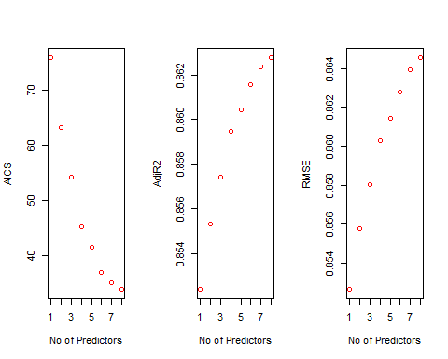

k$predictors

## [1] "Job.Level" "Attrition"   
## [3] "Years.In.Current.Role" "Num.Companies.Worked"   
## [5] "OverTime" "Environment.Satisfaction"   
## [7] "BusinessTravel" "Relationship.Satisfaction"

#Plot for AISC  
for (i in 1:27){  
 predictions<-predict(object=Model_Simp1,newdata=EmplTestSimp1,id=i)   
 testASEsimp1[i]<-mean((log(EmplTestSimp1$Monthly.Income)-predictions)^2)  
}  
  
par(mfrow=c(1,1))  
plot(1:27,testASEsimp1,type="l",xlab="# of predictors",ylab="test vs train ASE",ylim=c(0,0.8))  
index<-which(testASEsimp1==min(testASEsimp1))  
points(index,testASEsimp1[index],col="red",pch=10)  
rss<-summary(reg.smp1)$rss  
lines(index,rss/869,col="blue") #Dividing by 869 since ASE=RSS/sample size

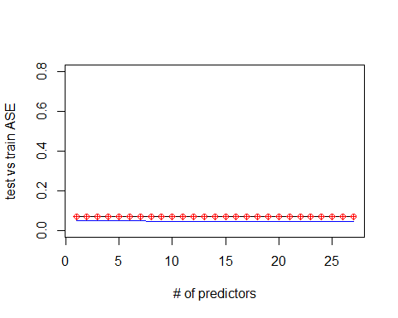

##### Simple Model2 ##### Using Interaction and Squared variable  
  
EmplTrainSimp2<-Train%>%select(Age,Attrition,BusinessTravel,Distance.From.Home,Education,EducationField,Environment.Satisfaction,Gender,(Monthly.Income),Job.Involvement,Job.Level,Job.Satisfaction,Marital.Status,Num.Companies.Worked,OverTime,Performance.Rating,Relationship.Satisfaction,(Total.Working.Years),Work.Life.Balance,Years.In.Current.Role,Years.Since.Last.Promotion,Years.With.Curr.Manager)  
  
EmplTestSimp2<-Test%>%select(Age,Attrition,BusinessTravel,Distance.From.Home,Education,EducationField,Environment.Satisfaction,Gender,(Monthly.Income),Job.Involvement,Job.Level,Job.Satisfaction,Marital.Status,Num.Companies.Worked,OverTime,Performance.Rating,Relationship.Satisfaction,(Total.Working.Years),Work.Life.Balance,Years.In.Current.Role,Years.Since.Last.Promotion,Years.With.Curr.Manager)  
  
dim(EmplTrainSimp2)

## [1] 689 22

dim(EmplTestSimp2)

## [1] 173 22

Model_Simp2<-lm(log(Monthly.Income)~Age+Attrition+BusinessTravel+Distance.From.Home+Education+EducationField+Environment.Satisfaction+Gender+Job.Involvement+Job.Level+Job.Satisfaction+Marital.Status+Num.Companies.Worked+OverTime+Performance.Rating+Relationship.Satisfaction+(Total.Working.Years)+Work.Life.Balance+Years.In.Current.Role+(Years.In.Current.Role)^2+Years.Since.Last.Promotion+Years.With.Curr.Manager,Age*Total.Working.Years,data=EmplTrainSimp2)  
   
summary(Model_Simp2)

##   
## Call:  
## lm(formula = log(Monthly.Income) ~ Age + Attrition + BusinessTravel +   
## Distance.From.Home + Education + EducationField + Environment.Satisfaction +   
## Gender + Job.Involvement + Job.Level + Job.Satisfaction +   
## Marital.Status + Num.Companies.Worked + OverTime + Performance.Rating +   
## Relationship.Satisfaction + (Total.Working.Years) + Work.Life.Balance +   
## Years.In.Current.Role + (Years.In.Current.Role)^2 + Years.Since.Last.Promotion +   
## Years.With.Curr.Manager, data = EmplTrainSimp2, subset = Age *   
## Total.Working.Years)  
##   
## Residuals:  
## Min 1Q Median 3Q Max   
## -0.80927 -0.11300 0.00921 0.15244 0.73471   
##   
## Coefficients:  
## Estimate Std. Error t value Pr(>|t|)   
## (Intercept) 6.725e+00 2.601e-01 25.860 < 2e-16 ***  
## Age 7.341e-03 1.898e-03 3.867 0.000124 ***  
## AttritionYes -1.441e-01 3.590e-02 -4.015 6.81e-05 ***  
## BusinessTravelTravel_Frequently 2.959e-02 4.178e-02 0.708 0.479087   
## BusinessTravelTravel_Rarely 5.430e-02 3.980e-02 1.364 0.173092   
## Distance.From.Home -2.969e-03 1.388e-03 -2.139 0.032926 *   
## Education 1.644e-02 1.176e-02 1.398 0.162719   
## EducationFieldLife Sciences 2.273e-01 1.699e-01 1.338 0.181385   
## EducationFieldMarketing 2.467e-01 1.728e-01 1.428 0.153936   
## EducationFieldMedical 2.237e-01 1.708e-01 1.310 0.190841   
## EducationFieldOther 1.811e-01 1.762e-01 1.028 0.304557   
## EducationFieldTechnical Degree 1.009e-01 1.735e-01 0.582 0.560848   
## Environment.Satisfaction -1.480e-02 1.047e-02 -1.414 0.157884   
## GenderMale 5.368e-02 2.287e-02 2.347 0.019285 *   
## Job.Involvement 4.594e-02 1.580e-02 2.907 0.003800 **   
## Job.Level 5.466e-01 1.672e-02 32.693 < 2e-16 ***  
## Job.Satisfaction 6.572e-03 1.009e-02 0.652 0.514909   
## Marital.StatusMarried 8.141e-02 2.818e-02 2.889 0.004020 **   
## Marital.StatusSingle 1.013e-01 3.220e-02 3.146 0.001749 **   
## Num.Companies.Worked -9.871e-05 4.951e-03 -0.020 0.984102   
## OverTimeYes 3.359e-03 2.471e-02 0.136 0.891921   
## Performance.Rating 6.934e-03 3.887e-02 0.178 0.858473   
## Relationship.Satisfaction -1.430e-02 1.035e-02 -1.382 0.167482   
## Total.Working.Years -3.998e-03 3.202e-03 -1.248 0.212405   
## Work.Life.Balance 1.810e-03 1.552e-02 0.117 0.907210   
## Years.In.Current.Role 1.772e-02 4.997e-03 3.547 0.000425 ***  
## Years.Since.Last.Promotion -5.641e-03 5.420e-03 -1.041 0.298424   
## Years.With.Curr.Manager -8.241e-03 5.183e-03 -1.590 0.112444   
## ---  
## Signif. codes: 0 '***' 0.001 '**' 0.01 '*' 0.05 '.' 0.1 ' ' 1  
##   
## Residual standard error: 0.2358 on 525 degrees of freedom  
## (130 observations deleted due to missingness)  
## Multiple R-squared: 0.8887, Adjusted R-squared: 0.883   
## F-statistic: 155.3 on 27 and 525 DF, p-value: < 2.2e-16

vif(Model_Simp2)

## GVIF Df GVIF^(1/(2*Df))  
## Age 2.489974 1 1.577965  
## Attrition 1.602016 1 1.265708  
## BusinessTravel 1.609693 2 1.126382  
## Distance.From.Home 1.266748 1 1.125499  
## Education 1.358421 1 1.165513  
## EducationField 1.932110 5 1.068079  
## Environment.Satisfaction 1.269431 1 1.126691  
## Gender 1.260084 1 1.122535  
## Job.Involvement 1.269655 1 1.126790  
## Job.Level 3.560963 1 1.887051  
## Job.Satisfaction 1.245031 1 1.115809  
## Marital.Status 1.784034 2 1.155715  
## Num.Companies.Worked 1.533035 1 1.238158  
## OverTime 1.351601 1 1.162584  
## Performance.Rating 1.190700 1 1.091192  
## Relationship.Satisfaction 1.248752 1 1.117476  
## Total.Working.Years 5.938813 1 2.436968  
## Work.Life.Balance 1.219439 1 1.104282  
## Years.In.Current.Role 2.982461 1 1.726980  
## Years.Since.Last.Promotion 1.866197 1 1.366088  
## Years.With.Curr.Manager 3.093828 1 1.758928

par(mfrow=c(1,5))  
ols_plot_resid_fit(Model_Simp2)

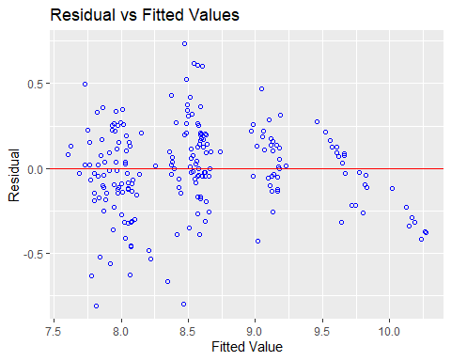

ols_plot_resid_lev(Model_Simp2)

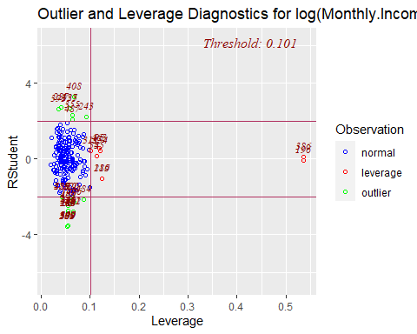

ols_plot_resid_qq(Model_Simp2)

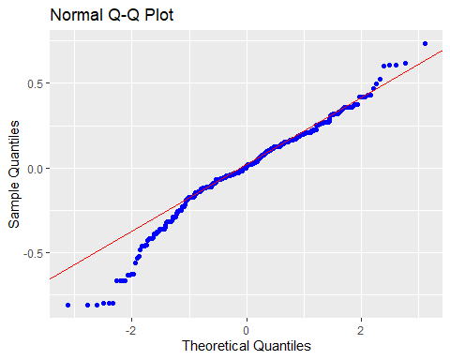

ols_plot_resid_hist(Model_Simp2)

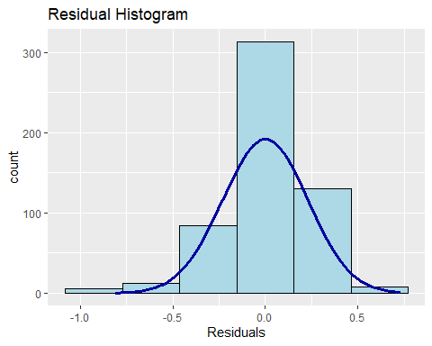

ols_plot_cooksd_bar(Model_Simp2)

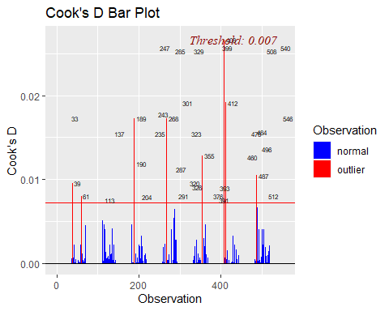

#Assumptions are met:  
#The histogram shows a bell shape curve which suggests that there is enough evidence for normality.  
#The QQ Plot shows a straight line which suggests that there is enough evidence for constant variance.  
#The observations are considered to be independent as they are randomly assigned.  
#Business Travel Rarely, Daily Rates,Job Level,Laboratory Technician,Research #Director, Research Scientist,Sales #Representative,Number of companies #worked,overtime,Total.Working.Years,Years.In.Current.Role are statistically #significant.  
#The outlier at below 0.02 so we are good.  
  
#Prediction  
Pred_Simp2=predict(Model_Simp2, newdata = EmplTestSimp2, interval = "confidence")  
as.data.frame(Pred_Simp2)

## fit lwr upr  
## 6 8.975101 8.865210 9.084992  
## 27 8.601808 8.513702 8.689914  
## 32 8.070600 7.954410 8.186790  
## 35 8.571372 8.459548 8.683196  
## 40 8.054322 7.959088 8.149557  
## 45 7.948960 7.846100 8.051821  
## 48 9.121792 9.023053 9.220532  
## 49 7.818928 7.702686 7.935169  
## 53 8.083709 7.961527 8.205892  
## 55 8.574763 8.469163 8.680364  
## 57 7.846122 7.731958 7.960287  
## 58 8.084668 7.976183 8.193154  
## 65 7.745009 7.623783 7.866235  
## 82 8.571588 8.484028 8.659148  
## 83 8.518708 8.413561 8.623856  
## 86 9.745596 9.643952 9.847240  
## 94 8.582088 8.501761 8.662414  
## 95 10.260054 10.172375 10.347732  
## 97 9.813464 9.696218 9.930711  
## 103 8.563265 8.433628 8.692902  
## 107 8.400626 8.262775 8.538478  
## 109 8.408238 8.254957 8.561519  
## 114 8.397024 8.255952 8.538097  
## 118 8.445018 8.327875 8.562162  
## 124 8.673104 8.539661 8.806547  
## 125 8.624358 8.527548 8.721168  
## 127 7.624136 7.476987 7.771285  
## 137 7.770368 7.666538 7.874199  
## 160 9.048834 8.929030 9.168637  
## 162 8.726910 8.563091 8.890728  
## 166 7.742152 7.638739 7.845566  
## 176 7.729604 7.606092 7.853115  
## 181 9.057574 8.960247 9.154901  
## 182 8.505969 8.413289 8.598649  
## 187 8.488691 8.387315 8.590067  
## 191 8.439355 8.327011 8.551700  
## 192 9.065170 8.956748 9.173592  
## 202 8.591789 8.505709 8.677869  
## 204 7.771226 7.649026 7.893426  
## 216 8.001888 7.914831 8.088945  
## 217 8.500344 8.409420 8.591268  
## 224 7.916836 7.807589 8.026083  
## 225 7.967839 7.880437 8.055241  
## 228 7.945595 7.831728 8.059461  
## 245 8.572111 8.467043 8.677179  
## 253 8.075115 7.982462 8.167768  
## 254 7.679550 7.325074 8.034025  
## 261 7.802792 7.680173 7.925411  
## 272 8.448936 8.351607 8.546265  
## 273 8.393434 8.252649 8.534219  
## 278 8.137875 8.034268 8.241481  
## 279 8.409670 8.310275 8.509065  
## 280 8.789176 8.671516 8.906836  
## 283 8.508592 8.430949 8.586235  
## 284 8.511234 8.418847 8.603621  
## 289 8.965937 8.854328 9.077547  
## 295 9.694976 9.572906 9.817045  
## 297 8.543797 8.449275 8.638319  
## 308 7.958894 7.855272 8.062515  
## 311 8.656653 8.574666 8.738639  
## 312 9.613154 9.502851 9.723458  
## 318 8.553660 8.473444 8.633876  
## 324 8.631268 8.491162 8.771373  
## 328 8.538650 8.448343 8.628957  
## 333 7.871758 7.758552 7.984964  
## 338 8.592538 8.508499 8.676577  
## 340 7.861301 7.760070 7.962531  
## 368 8.618637 8.503723 8.733552  
## 369 7.855107 7.741983 7.968230  
## 377 7.880451 7.724429 8.036472  
## 379 7.892011 7.768016 8.016006  
## 387 9.190623 9.068315 9.312931  
## 388 8.318161 8.203660 8.432663  
## 389 8.590689 8.508021 8.673357  
## 400 9.176915 9.081383 9.272446  
## 406 9.553229 9.442131 9.664327  
## 407 8.509191 8.395741 8.622640  
## 417 7.945894 7.837693 8.054094  
## 424 7.868610 7.742337 7.994883  
## 425 8.450055 8.357003 8.543108  
## 436 8.608371 8.520373 8.696369  
## 438 8.012049 7.911177 8.112921  
## 448 8.652058 8.561025 8.743092  
## 451 8.588663 8.460388 8.716938  
## 452 8.075365 7.985181 8.165549  
## 453 8.415636 8.305804 8.525469  
## 454 8.632873 8.531819 8.733926  
## 456 10.270962 10.146829 10.395094  
## 459 8.192550 8.035564 8.349536  
## 461 8.032407 7.914433 8.150382  
## 465 7.722197 7.598565 7.845829  
## 466 8.110920 8.025677 8.196163  
## 467 8.114496 8.004067 8.224925  
## 473 9.133220 9.003943 9.262496  
## 474 8.140996 8.019488 8.262504  
## 479 8.080829 7.942599 8.219059  
## 480 9.238082 9.112735 9.363428  
## 482 8.076939 7.998075 8.155802  
## 488 7.851679 7.721085 7.982272  
## 492 9.606891 9.522593 9.691190  
## 494 9.073784 8.963780 9.183788  
## 496 9.608595 9.461064 9.756126  
## 511 8.600164 8.510935 8.689393  
## 516 8.479618 8.371032 8.588204  
## 521 7.935691 7.843414 8.027969  
## 527 8.578034 8.475907 8.680161  
## 530 8.057097 7.926765 8.187429  
## 532 8.607488 8.523756 8.691219  
## 540 8.709350 8.585100 8.833599  
## 547 9.147977 9.006359 9.289595  
## 550 8.158753 8.042201 8.275305  
## 565 7.942215 7.833676 8.050754  
## 566 8.201502 8.098204 8.304801  
## 567 8.348178 8.239756 8.456601  
## 573 8.544375 8.452576 8.636174  
## 584 8.620812 8.480008 8.761616  
## 596 8.672601 8.544535 8.800666  
## 601 7.821735 7.712671 7.930800  
## 603 9.127575 9.016110 9.239040  
## 604 8.024646 7.928281 8.121010  
## 608 8.427100 8.271335 8.582865  
## 618 8.614317 8.472927 8.755708  
## 626 7.974774 7.891516 8.058033  
## 627 8.469408 8.367723 8.571093  
## 628 9.085974 8.980174 9.191774  
## 636 7.986110 7.855006 8.117214  
## 639 8.049171 7.952925 8.145417  
## 653 9.086308 8.966540 9.206075  
## 654 9.090329 8.931511 9.249147  
## 665 8.530931 8.381731 8.680131  
## 667 9.131725 9.001604 9.261845  
## 674 7.627969 7.476224 7.779715  
## 680 8.069320 7.962269 8.176372  
## 681 8.500774 8.391350 8.610198  
## 688 7.956605 7.834773 8.078436  
## 695 8.467567 8.359968 8.575166  
## 696 8.132989 8.026417 8.239561  
## 697 9.716350 9.579551 9.853148  
## 698 8.655274 8.547961 8.762587  
## 700 10.214829 10.119880 10.309779  
## 703 8.881550 8.715103 9.047997  
## 712 9.604430 9.456321 9.752540  
## 719 8.471416 8.289881 8.652951  
## 727 7.996106 7.894170 8.098041  
## 731 8.552881 8.431301 8.674462  
## 732 8.407139 8.292417 8.521860  
## 738 8.641476 8.526892 8.756060  
## 740 8.479132 8.346192 8.612073  
## 752 7.863998 7.737421 7.990575  
## 755 9.172317 9.040219 9.304416  
## 756 7.946096 7.822421 8.069771  
## 768 8.762355 8.600339 8.924370  
## 769 8.477384 8.367818 8.586949  
## 772 9.130483 8.956063 9.304904  
## 774 7.885206 7.777640 7.992772  
## 776 8.028668 7.934791 8.122545  
## 778 7.823501 7.711750 7.935251  
## 788 8.475665 8.338375 8.612955  
## 799 7.725072 7.572862 7.877282  
## 803 9.600924 9.467474 9.734375  
## 804 8.940509 8.786118 9.094900  
## 809 7.901743 7.789068 8.014417  
## 814 10.157954 10.051768 10.264139  
## 816 8.108656 8.015460 8.201852  
## 818 9.161550 9.074395 9.248705  
## 821 8.018316 7.900687 8.135946  
## 825 8.582431 8.494573 8.670289  
## 831 8.587175 8.473401 8.700949  
## 834 7.957673 7.856213 8.059133  
## 845 8.482837 8.375693 8.589981  
## 852 7.883562 7.775994 7.991130  
## 854 8.545626 8.444226 8.647026  
## 864 9.372485 9.189850 9.555119

MSPE = data.frame(Observed = log(EmplTestSimp1$Monthly.Income), Predicted = Pred_Simp1)  
MSPE$Resisdual = MSPE$Observed - MSPE$Predicted.fit  
MSPE$SquaredResidual = MSPE$Resisdual^2  
MSPE

## Observed Predicted.fit Predicted.lwr Predicted.upr Resisdual  
## 6 9.081711 9.025450 8.924517 9.126383 0.056261025  
## 27 9.202711 8.522011 8.456510 8.587512 0.680700351  
## 32 7.614805 8.060779 7.961150 8.160407 -0.445973336  
## 35 9.177714 8.501898 8.409211 8.594585 0.675815812  
## 40 7.934155 7.941871 7.856504 8.027238 -0.007715711  
## 45 7.109062 7.873044 7.790253 7.955835 -0.763981840  
## 48 9.075665 9.167598 9.079307 9.255890 -0.091932943  
## 49 7.537963 7.832858 7.732652 7.933063 -0.294894982  
## 53 7.606387 8.041673 7.944575 8.138770 -0.435285242  
## 55 8.394800 8.506589 8.422669 8.590508 -0.111789297  
## 57 7.922624 7.915701 7.813367 8.018034 0.006922958  
## 58 8.460199 8.026580 7.932427 8.120733 0.433619287  
## 65 7.700748 7.807507 7.707040 7.907973 -0.106758706  
## 82 8.836810 8.539146 8.455867 8.622425 0.297663858  
## 83 8.579417 8.507668 8.417622 8.597714 0.071748710  
## 86 9.527047 9.650587 9.553005 9.748168 -0.123539570  
## 94 8.722906 8.569802 8.495668 8.643937 0.153103338  
## 95 9.899781 10.139399 10.054397 10.224400 -0.239618052  
## 97 9.717519 9.708235 9.603900 9.812571 0.009284085  
## 103 8.785387 8.590412 8.483023 8.697801 0.194974651  
## 107 8.370779 8.440080 8.331371 8.548790 -0.069301269  
## 109 9.096724 8.418193 8.303627 8.532759 0.678530264  
## 114 8.535622 8.383650 8.273599 8.493702 0.151971844  
## 118 8.300280 8.604469 8.505382 8.703556 -0.304188657  
## 124 8.301025 8.546485 8.444191 8.648779 -0.245459739  
## 125 8.423761 8.553622 8.466603 8.640641 -0.129860584  
## 127 8.273592 7.841606 7.723311 7.959901 0.431985741  
## 137 7.748891 7.836953 7.748025 7.925881 -0.088061834  
## 160 9.487290 9.060157 8.952264 9.168051 0.427132973  
## 162 9.073604 8.867613 8.742491 8.992736 0.205990383  
## 166 7.622664 7.754726 7.665663 7.843789 -0.132061936  
## 176 7.635304 7.871503 7.768497 7.974509 -0.236199182  
## 181 9.237372 9.061688 8.986005 9.137372 0.175683419  
## 182 8.838262 8.577622 8.500953 8.654290 0.260640090  
## 187 8.557567 8.499387 8.405710 8.593065 0.058179887  
## 191 8.661294 8.505589 8.417018 8.594161 0.155704085  
## 192 9.173365 9.060314 8.959050 9.161577 0.113051581  
## 202 8.735525 8.548279 8.478125 8.618433 0.187245860  
## 204 7.703459 7.987434 7.881469 8.093400 -0.283975219  
## 216 7.760041 7.932376 7.860616 8.004137 -0.172335426  
## 217 9.192584 8.457854 8.382959 8.532749 0.734729497  
## 224 7.354362 7.945731 7.856468 8.034993 -0.591368663  
## 225 8.470311 7.965477 7.885747 8.045207 0.504834010  
## 228 7.752765 8.001198 7.912698 8.089698 -0.248433312  
## 245 8.528331 8.569642 8.485777 8.653507 -0.041310890  
## 253 7.729296 7.914390 7.831092 7.997688 -0.185094049  
## 254 7.991592 7.683347 7.507656 7.859038 0.308244983  
## 261 7.932003 7.813281 7.714131 7.912430 0.118722578  
## 272 8.600247 8.531096 8.457949 8.604244 0.069150305  
## 273 8.171882 8.522000 8.429477 8.614522 -0.350117562  
## 278 7.805882 7.988960 7.901256 8.076665 -0.183078415  
## 279 8.655911 8.417910 8.329147 8.506673 0.238001345  
## 280 8.302762 8.544594 8.447767 8.641421 -0.241832376  
## 283 8.781555 8.527383 8.455161 8.599605 0.254172651  
## 284 8.928905 8.586510 8.497533 8.675488 0.342395069  
## 289 9.183791 9.027481 8.931668 9.123294 0.156310218  
## 295 9.707290 9.613188 9.518160 9.708216 0.094102284  
## 297 9.163982 8.517112 8.427815 8.606409 0.646870093  
## 308 7.999343 7.852685 7.765704 7.939667 0.146657492  
## 311 8.609590 8.621932 8.539725 8.704138 -0.012341473  
## 312 9.490771 9.703162 9.612548 9.793776 -0.212390637  
## 318 8.437500 8.483408 8.412065 8.554750 -0.045907118  
## 324 8.437067 8.739807 8.620805 8.858809 -0.302740037  
## 328 8.596004 8.599956 8.517767 8.682145 -0.003951571  
## 333 7.758761 7.872623 7.773743 7.971504 -0.113862786  
## 338 8.956222 8.480170 8.395784 8.564556 0.476051823  
## 340 7.758333 7.872662 7.787154 7.958169 -0.114328119  
## 368 8.607582 8.482055 8.389638 8.574471 0.125527621  
## 369 7.636752 7.875766 7.785404 7.966129 -0.239014231  
## 377 7.916807 7.939932 7.807924 8.071940 -0.023124419  
## 379 7.681560 8.028150 7.932718 8.123582 -0.346589438  
## 387 9.081256 9.099824 8.997105 9.202543 -0.018567593  
## 388 8.357494 8.455379 8.360942 8.549816 -0.097885256  
## 389 8.412277 8.549348 8.477070 8.621627 -0.137071391  
## 400 9.231025 9.108337 9.013542 9.203131 0.122688184  
## 406 9.718783 9.677845 9.565249 9.790441 0.040937994  
## 407 8.606668 8.629863 8.532013 8.727713 -0.023194917  
## 417 7.849324 7.889318 7.794958 7.983677 -0.039993720  
## 424 7.384610 7.784879 7.686340 7.883418 -0.400268463  
## 425 8.460411 8.469226 8.392504 8.545947 -0.008814344  
## 436 8.734560 8.619486 8.535491 8.703481 0.115074561  
## 438 7.961021 7.926520 7.842620 8.010420 0.034501327  
## 448 8.619389 8.536788 8.461937 8.611638 0.082600960  
## 451 8.492491 8.584455 8.486535 8.682375 -0.091964611  
## 452 8.137396 7.926434 7.848384 8.004484 0.210961570  
## 453 8.667852 8.440289 8.345379 8.535199 0.227563087  
## 454 8.610137 8.584263 8.499031 8.669496 0.025873629  
## 456 9.895102 10.157750 10.052121 10.263378 -0.262647065  
## 459 7.633370 7.998378 7.883813 8.112944 -0.365008825  
## 461 7.646354 8.008621 7.902173 8.115069 -0.362267157  
## 465 7.798523 7.878526 7.768784 7.988267 -0.080002666  
## 466 8.279951 8.015307 7.944127 8.086486 0.264644027  
## 467 7.880048 7.998512 7.909408 8.087616 -0.118463874  
## 473 9.491375 9.106394 8.999313 9.213475 0.384981522  
## 474 8.146709 8.032521 7.939996 8.125046 0.114187598  
## 479 7.989560 8.152567 8.029410 8.275723 -0.163006054  
## 480 9.528358 9.205554 9.113334 9.297774 0.322803878  
## 482 7.764721 8.026417 7.953914 8.098919 -0.261696049  
## 488 7.976252 7.979225 7.887188 8.071261 -0.002972881  
## 492 9.733885 9.635078 9.544651 9.725505 0.098807081  
## 494 9.060215 9.017323 8.922107 9.112539 0.042891530  
## 496 9.699350 9.754149 9.632199 9.876100 -0.054799643  
## 511 8.583543 8.599515 8.529373 8.669657 -0.015972081  
## 516 8.609225 8.468102 8.377338 8.558867 0.141123132  
## 521 7.845024 7.889700 7.811781 7.967618 -0.044675170  
## 527 8.518392 8.623735 8.535815 8.711656 -0.105342927  
## 530 8.509766 8.082063 7.973255 8.190871 0.427702347  
## 532 8.826881 8.539027 8.462058 8.615997 0.287853912  
## 540 8.547722 8.615864 8.520607 8.711121 -0.068141368  
## 547 8.909641 9.228338 9.112624 9.344052 -0.318697730  
## 550 7.685703 7.986864 7.895982 8.077745 -0.301160747  
## 565 8.251403 7.913988 7.824385 8.003591 0.337415061  
## 566 7.798113 8.075377 7.994139 8.156614 -0.277263905  
## 567 7.685244 8.408033 8.312108 8.503957 -0.722788951  
## 573 8.829665 8.551092 8.465058 8.637126 0.278573625  
## 584 8.471987 8.659185 8.550206 8.768164 -0.187198361  
## 596 8.303257 8.615915 8.515371 8.716459 -0.312657975  
## 601 7.617268 7.817063 7.732955 7.901171 -0.199795092  
## 603 9.342771 9.147286 9.060086 9.234486 0.195484981  
## 604 8.049108 8.046285 7.962030 8.130540 0.002822957  
## 608 8.631414 8.568387 8.450506 8.686267 0.063027740  
## 618 8.604105 8.678064 8.568744 8.787383 -0.073959007  
## 626 7.830823 8.002075 7.934498 8.069652 -0.171251851  
## 627 8.333751 8.505100 8.426290 8.583909 -0.171348680  
## 628 9.350972 9.160152 9.075174 9.245131 0.190819241  
## 636 7.773174 7.937146 7.827805 8.046486 -0.163971867  
## 639 7.910224 8.047865 7.965156 8.130573 -0.137640863  
## 653 9.510371 9.175721 9.072678 9.278763 0.334650126  
## 654 9.433804 9.086471 8.973651 9.199292 0.347332467  
## 665 8.426831 8.480284 8.367659 8.592910 -0.053453530  
## 667 8.976894 9.041890 8.932377 9.151404 -0.064996220  
## 674 7.611842 7.879416 7.758938 7.999894 -0.267573738  
## 680 7.753194 8.010605 7.924555 8.096656 -0.257411100  
## 681 8.356085 8.513637 8.414499 8.612775 -0.157552188  
## 688 7.871693 7.958488 7.870534 8.046442 -0.086795183  
## 695 9.161675 8.444008 8.345690 8.542327 0.717666719  
## 696 8.099858 8.001608 7.904893 8.098322 0.098250268  
## 697 9.629182 9.528817 9.421995 9.635639 0.100365178  
## 698 8.685078 8.601903 8.508951 8.694855 0.083174487  
## 700 9.856448 10.147588 10.059067 10.236109 -0.291139698  
## 703 9.247347 9.125460 9.000977 9.249944 0.121886754  
## 712 9.555206 9.644789 9.520602 9.768976 -0.089583239  
## 719 8.429673 8.509150 8.381638 8.636661 -0.079477060  
## 727 7.997327 7.984295 7.897238 8.071353 0.013031407  
## 731 8.469053 8.541826 8.445857 8.637794 -0.072772690  
## 732 8.563695 8.428258 8.334980 8.521535 0.135437433  
## 738 8.550821 8.525072 8.432560 8.617583 0.025749462  
## 740 8.210940 8.558433 8.449795 8.667072 -0.347493523  
## 752 7.741534 7.822286 7.725085 7.919487 -0.080752708  
## 755 9.514068 9.200611 9.086622 9.314600 0.313456814  
## 756 8.218248 7.891714 7.789191 7.994237 0.326534063  
## 768 9.299450 8.961182 8.834388 9.087976 0.338267540  
## 769 8.906393 8.471715 8.379107 8.564322 0.434678899  
## 772 9.254644 9.187220 9.056566 9.317873 0.067424458  
## 774 8.127995 7.830451 7.740741 7.920160 0.297544520  
## 776 8.161946 7.936838 7.857246 8.016429 0.225108051  
## 778 7.946971 7.850837 7.760245 7.941429 0.096134720  
## 788 8.505323 8.417003 8.307055 8.526950 0.088320173  
## 799 7.527794 7.770599 7.656813 7.884385 -0.242804739  
## 803 9.744961 9.652581 9.557414 9.747748 0.092379767  
## 804 9.167642 8.935463 8.820556 9.050370 0.232178873  
## 809 7.959276 7.981821 7.889743 8.073899 -0.022544761  
## 814 9.886240 10.083076 9.984338 10.181814 -0.196836081  
## 816 7.930566 8.062898 7.980901 8.144896 -0.132332455  
## 818 9.366575 9.038456 8.965658 9.111254 0.328118396  
## 821 8.105308 8.030967 7.927840 8.134093 0.074341010  
## 825 8.447414 8.648941 8.567030 8.730851 -0.201526212  
## 831 8.197814 8.533676 8.431036 8.636317 -0.335862204  
## 834 7.844633 7.880418 7.798182 7.962655 -0.035785813  
## 845 8.704336 8.495211 8.402834 8.587588 0.209125743  
## 852 7.698936 7.894588 7.800367 7.988809 -0.195651977  
## 854 8.641356 8.475860 8.393428 8.558291 0.165496207  
## 864 9.530248 9.681386 9.542520 9.820253 -0.151138860  
## SquaredResidual  
## 6 3.165303e-03  
## 27 4.633530e-01  
## 32 1.988922e-01  
## 35 4.567270e-01  
## 40 5.953220e-05  
## 45 5.836683e-01  
## 48 8.451666e-03  
## 49 8.696305e-02  
## 53 1.894732e-01  
## 55 1.249685e-02  
## 57 4.792735e-05  
## 58 1.880257e-01  
## 65 1.139742e-02  
## 82 8.860377e-02  
## 83 5.147877e-03  
## 86 1.526203e-02  
## 94 2.344063e-02  
## 95 5.741681e-02  
## 97 8.619424e-05  
## 103 3.801511e-02  
## 107 4.802666e-03  
## 109 4.604033e-01  
## 114 2.309544e-02  
## 118 9.253074e-02  
## 124 6.025048e-02  
## 125 1.686377e-02  
## 127 1.866117e-01  
## 137 7.754887e-03  
## 160 1.824426e-01  
## 162 4.243204e-02  
## 166 1.744035e-02  
## 176 5.579005e-02  
## 181 3.086466e-02  
## 182 6.793326e-02  
## 187 3.384899e-03  
## 191 2.424376e-02  
## 192 1.278066e-02  
## 202 3.506101e-02  
## 204 8.064193e-02  
## 216 2.969950e-02  
## 217 5.398274e-01  
## 224 3.497169e-01  
## 225 2.548574e-01  
## 228 6.171911e-02  
## 245 1.706590e-03  
## 253 3.425981e-02  
## 254 9.501497e-02  
## 261 1.409505e-02  
## 272 4.781765e-03  
## 273 1.225823e-01  
## 278 3.351771e-02  
## 279 5.664464e-02  
## 280 5.848290e-02  
## 283 6.460374e-02  
## 284 1.172344e-01  
## 289 2.443288e-02  
## 295 8.855240e-03  
## 297 4.184409e-01  
## 308 2.150842e-02  
## 311 1.523120e-04  
## 312 4.510978e-02  
## 318 2.107463e-03  
## 324 9.165153e-02  
## 328 1.561491e-05  
## 333 1.296473e-02  
## 338 2.266253e-01  
## 340 1.307092e-02  
## 368 1.575718e-02  
## 369 5.712780e-02  
## 377 5.347387e-04  
## 379 1.201242e-01  
## 387 3.447555e-04  
## 388 9.581523e-03  
## 389 1.878857e-02  
## 400 1.505239e-02  
## 406 1.675919e-03  
## 407 5.380042e-04  
## 417 1.599498e-03  
## 424 1.602148e-01  
## 425 7.769266e-05  
## 436 1.324215e-02  
## 438 1.190342e-03  
## 448 6.822919e-03  
## 451 8.457490e-03  
## 452 4.450478e-02  
## 453 5.178496e-02  
## 454 6.694447e-04  
## 456 6.898348e-02  
## 459 1.332314e-01  
## 461 1.312375e-01  
## 465 6.400427e-03  
## 466 7.003646e-02  
## 467 1.403369e-02  
## 473 1.482108e-01  
## 474 1.303881e-02  
## 479 2.657097e-02  
## 480 1.042023e-01  
## 482 6.848482e-02  
## 488 8.838020e-06  
## 492 9.762839e-03  
## 494 1.839683e-03  
## 496 3.003001e-03  
## 511 2.551074e-04  
## 516 1.991574e-02  
## 521 1.995871e-03  
## 527 1.109713e-02  
## 530 1.829293e-01  
## 532 8.285987e-02  
## 540 4.643246e-03  
## 547 1.015682e-01  
## 550 9.069780e-02  
## 565 1.138489e-01  
## 566 7.687527e-02  
## 567 5.224239e-01  
## 573 7.760326e-02  
## 584 3.504323e-02  
## 596 9.775501e-02  
## 601 3.991808e-02  
## 603 3.821438e-02  
## 604 7.969085e-06  
## 608 3.972496e-03  
## 618 5.469935e-03  
## 626 2.932720e-02  
## 627 2.936037e-02  
## 628 3.641198e-02  
## 636 2.688677e-02  
## 639 1.894501e-02  
## 653 1.119907e-01  
## 654 1.206398e-01  
## 665 2.857280e-03  
## 667 4.224509e-03  
## 674 7.159571e-02  
## 680 6.626047e-02  
## 681 2.482269e-02  
## 688 7.533404e-03  
## 695 5.150455e-01  
## 696 9.653115e-03  
## 697 1.007317e-02  
## 698 6.917995e-03  
## 700 8.476232e-02  
## 703 1.485638e-02  
## 712 8.025157e-03  
## 719 6.316603e-03  
## 727 1.698176e-04  
## 731 5.295864e-03  
## 732 1.834330e-02  
## 738 6.630348e-04  
## 740 1.207517e-01  
## 752 6.521000e-03  
## 755 9.825517e-02  
## 756 1.066245e-01  
## 768 1.144249e-01  
## 769 1.889457e-01  
## 772 4.546057e-03  
## 774 8.853274e-02  
## 776 5.067363e-02  
## 778 9.241884e-03  
## 788 7.800453e-03  
## 799 5.895414e-02  
## 803 8.534021e-03  
## 804 5.390703e-02  
## 809 5.082662e-04  
## 814 3.874444e-02  
## 816 1.751188e-02  
## 818 1.076617e-01  
## 821 5.526586e-03  
## 825 4.061281e-02  
## 831 1.128034e-01  
## 834 1.280624e-03  
## 845 4.373358e-02  
## 852 3.827970e-02  
## 854 2.738899e-02  
## 864 2.284296e-02

mean(MSPE$SquaredResidual)

## [1] 0.06924576

reg.smp2=regsubsets(log(Monthly.Income)~Age+Attrition+BusinessTravel+Distance.From.Home+Education+EducationField+Environment.Satisfaction+Gender+Job.Involvement+Job.Level+Job.Satisfaction+Marital.Status+Num.Companies.Worked+OverTime+Performance.Rating+Relationship.Satisfaction+(Total.Working.Years)+Work.Life.Balance+Years.In.Current.Role+(Years.In.Current.Role)^2+Years.Since.Last.Promotion+Years.With.Curr.Manager+Age*Total.Working.Years,data=EmplTrainSimp2,method="forward",nvmax=27)  
  
k<-ols_step_forward_aic(Model_Simp2, details = TRUE)

## Forward Selection Method   
## ------------------------  
##   
## Candidate Terms:   
##   
## 1 . Age   
## 2 . Attrition   
## 3 . BusinessTravel   
## 4 . Distance.From.Home   
## 5 . Education   
## 6 . EducationField   
## 7 . Environment.Satisfaction   
## 8 . Gender   
## 9 . Job.Involvement   
## 10 . Job.Level   
## 11 . Job.Satisfaction   
## 12 . Marital.Status   
## 13 . Num.Companies.Worked   
## 14 . OverTime   
## 15 . Performance.Rating   
## 16 . Relationship.Satisfaction   
## 17 . Total.Working.Years   
## 18 . Work.Life.Balance   
## 19 . Years.In.Current.Role   
## 20 . Years.Since.Last.Promotion   
## 21 . Years.With.Curr.Manager   
##   
## Step 0: AIC = 1393.29   
## log(Monthly.Income) ~ 1   
##   
## ----------------------------------------------------------------------------------------  
## Variable DF AIC Sum Sq RSS R-Sq Adj. R-Sq   
## ----------------------------------------------------------------------------------------  
## Job.Level 1 75.972 258.352 44.653 0.853 0.852   
## Total.Working.Years 1 822.312 171.092 131.913 0.565 0.564   
## Age 1 1214.403 69.964 233.041 0.231 0.230   
## Years.In.Current.Role 1 1271.951 49.664 253.342 0.164 0.163   
## Years.With.Curr.Manager 1 1297.264 40.183 262.822 0.133 0.131   
## Years.Since.Last.Promotion 1 1323.485 29.988 273.017 0.099 0.098   
## Attrition 1 1357.267 16.268 286.737 0.054 0.052   
## Num.Companies.Worked 1 1371.338 10.353 292.653 0.034 0.033   
## Education 1 1380.446 6.458 296.547 0.021 0.020   
## Marital.Status 1 1385.871 4.980 298.025 0.016 0.014   
## EducationField 1 1392.075 4.892 298.113 0.016 0.009   
## BusinessTravel 1 1394.576 1.191 301.814 0.004 0.001   
## Performance.Rating 1 1393.953 0.587 302.418 0.002 0.000   
## Distance.From.Home 1 1394.448 0.370 302.635 0.001 0.000   
## Gender 1 1394.496 0.349 302.656 0.001 0.000   
## Relationship.Satisfaction 1 1394.523 0.337 302.668 0.001 0.000   
## Work.Life.Balance 1 1394.647 0.283 302.723 0.001 -0.001   
## Job.Satisfaction 1 1394.809 0.211 302.794 0.001 -0.001   
## Environment.Satisfaction 1 1395.099 0.084 302.921 0.000 -0.001   
## Job.Involvement 1 1395.264 0.011 302.994 0.000 -0.001   
## OverTime 1 1395.271 0.008 302.997 0.000 -0.001   
## ----------------------------------------------------------------------------------------  
##   
##   
## - Job.Level   
##   
##   
## Step 1 : AIC = 75.97176   
## log(Monthly.Income) ~ Job.Level   
##   
## ------------------------------------------------------------------------------------  
## Variable DF AIC Sum Sq RSS R-Sq Adj. R-Sq   
## ------------------------------------------------------------------------------------  
## Attrition 1 63.193 0.948 43.705 0.856 0.855   
## Years.In.Current.Role 1 65.003 0.833 43.820 0.855 0.855   
## Years.With.Curr.Manager 1 68.934 0.582 44.071 0.855 0.854   
## EducationField 1 76.977 0.579 44.074 0.855 0.853   
## Total.Working.Years 1 71.568 0.413 44.240 0.854 0.854   
## BusinessTravel 1 73.586 0.412 44.241 0.854 0.853   
## Age 1 71.740 0.402 44.251 0.854 0.854   
## Num.Companies.Worked 1 72.437 0.357 44.296 0.854 0.853   
## Marital.Status 1 76.001 0.257 44.396 0.853 0.853   
## Job.Involvement 1 74.203 0.244 44.409 0.853 0.853   
## Environment.Satisfaction 1 75.281 0.174 44.479 0.853 0.853   
## Relationship.Satisfaction 1 75.559 0.156 44.497 0.853 0.853   
## Education 1 76.562 0.091 44.562 0.853 0.853   
## OverTime 1 76.759 0.079 44.574 0.853 0.852   
## Years.Since.Last.Promotion 1 77.138 0.054 44.599 0.853 0.852   
## Job.Satisfaction 1 77.331 0.042 44.611 0.853 0.852   
## Gender 1 77.671 0.020 44.633 0.853 0.852   
## Work.Life.Balance 1 77.813 0.010 44.643 0.853 0.852   
## Distance.From.Home 1 77.831 0.009 44.644 0.853 0.852   
## Performance.Rating 1 77.899 0.005 44.648 0.853 0.852   
## ------------------------------------------------------------------------------------  
##   
## - Attrition   
##   
##   
## Step 2 : AIC = 63.19317   
## log(Monthly.Income) ~ Job.Level + Attrition   
##   
## ------------------------------------------------------------------------------------  
## Variable DF AIC Sum Sq RSS R-Sq Adj. R-Sq   
## ------------------------------------------------------------------------------------  
## Years.In.Current.Role 1 54.224 0.690 43.015 0.858 0.857   
## EducationField 1 64.934 0.521 43.185 0.857 0.856   
## Num.Companies.Worked 1 57.956 0.457 43.249 0.857 0.857   
## Years.With.Curr.Manager 1 58.267 0.437 43.268 0.857 0.857   
## BusinessTravel 1 60.717 0.409 43.296 0.857 0.856   
## OverTime 1 59.814 0.340 43.365 0.857 0.856   
## Total.Working.Years 1 60.340 0.307 43.399 0.857 0.856   
## Age 1 60.372 0.305 43.401 0.857 0.856   
## Environment.Satisfaction 1 61.068 0.261 43.444 0.857 0.856   
## Relationship.Satisfaction 1 62.195 0.190 43.516 0.856 0.856   
## Marital.Status 1 65.341 0.117 43.588 0.856 0.855   
## Job.Involvement 1 63.544 0.105 43.601 0.856 0.855   
## Education 1 63.928 0.080 43.625 0.856 0.855   
## Years.Since.Last.Promotion 1 64.198 0.063 43.642 0.856 0.855   
## Work.Life.Balance 1 64.714 0.030 43.675 0.856 0.855   
## Gender 1 64.939 0.016 43.689 0.856 0.855   
## Job.Satisfaction 1 65.074 0.008 43.698 0.856 0.855   
## Performance.Rating 1 65.146 0.003 43.702 0.856 0.855   
## Distance.From.Home 1 65.179 0.001 43.704 0.856 0.855   
## ------------------------------------------------------------------------------------  
##   
## - Years.In.Current.Role   
##   
##   
## Step 3 : AIC = 54.22357   
## log(Monthly.Income) ~ Job.Level + Attrition + Years.In.Current.Role   
##   
## ------------------------------------------------------------------------------------  
## Variable DF AIC Sum Sq RSS R-Sq Adj. R-Sq   
## ------------------------------------------------------------------------------------  
## Num.Companies.Worked 1 45.248 0.680 42.335 0.860 0.859   
## EducationField 1 55.669 0.531 42.484 0.860 0.858   
## BusinessTravel 1 52.030 0.385 42.630 0.859 0.858   
## OverTime 1 50.733 0.341 42.674 0.859 0.858   
## Environment.Satisfaction 1 51.338 0.304 42.711 0.859 0.858   
## Age 1 51.705 0.281 42.734 0.859 0.858   
## Relationship.Satisfaction 1 53.425 0.174 42.841 0.859 0.858   
## Total.Working.Years 1 54.519 0.106 42.909 0.858 0.858   
## Job.Involvement 1 54.576 0.103 42.912 0.858 0.858   
## Marital.Status 1 56.767 0.091 42.924 0.858 0.857   
## Education 1 55.036 0.074 42.941 0.858 0.857   
## Work.Life.Balance 1 55.556 0.042 42.973 0.858 0.857   
## Years.Since.Last.Promotion 1 55.600 0.039 42.976 0.858 0.857   
## Years.With.Curr.Manager 1 55.920 0.019 42.996 0.858 0.857   
## Job.Satisfaction 1 56.124 0.006 43.009 0.858 0.857   
## Gender 1 56.143 0.005 43.010 0.858 0.857   
## Performance.Rating 1 56.169 0.003 43.012 0.858 0.857   
## Distance.From.Home 1 56.222 0.000 43.015 0.858 0.857   
## ------------------------------------------------------------------------------------  
##   
## - Num.Companies.Worked   
##   
##   
## Step 4 : AIC = 45.24834   
## log(Monthly.Income) ~ Job.Level + Attrition + Years.In.Current.Role + Num.Companies.Worked   
##   
## ------------------------------------------------------------------------------------  
## Variable DF AIC Sum Sq RSS R-Sq Adj. R-Sq   
## ------------------------------------------------------------------------------------  
## EducationField 1 46.626 0.526 41.809 0.862 0.860   
## BusinessTravel 1 42.733 0.398 41.937 0.862 0.860   
## OverTime 1 41.492 0.352 41.983 0.861 0.860   
## Environment.Satisfaction 1 41.633 0.344 41.992 0.861 0.860   
## Relationship.Satisfaction 1 44.296 0.181 42.154 0.861 0.860   
## Age 1 45.532 0.105 42.230 0.861 0.860   
## Job.Involvement 1 45.840 0.086 42.249 0.861 0.860   
## Marital.Status 1 47.847 0.086 42.249 0.861 0.859   
## Work.Life.Balance 1 46.298 0.058 42.277 0.860 0.859   
## Years.With.Curr.Manager 1 46.339 0.056 42.279 0.860 0.859   
## Education 1 46.941 0.019 42.316 0.860 0.859   
## Years.Since.Last.Promotion 1 46.949 0.018 42.317 0.860 0.859   
## Job.Satisfaction 1 46.996 0.016 42.320 0.860 0.859   
## Total.Working.Years 1 47.140 0.007 42.329 0.860 0.859   
## Gender 1 47.202 0.003 42.332 0.860 0.859   
## Performance.Rating 1 47.219 0.002 42.333 0.860 0.859   
## Distance.From.Home 1 47.237 0.001 42.335 0.860 0.859   
## ------------------------------------------------------------------------------------  
##   
## - OverTime   
##   
##   
## Step 5 : AIC = 41.49172   
## log(Monthly.Income) ~ Job.Level + Attrition + Years.In.Current.Role + Num.Companies.Worked + OverTime   
##   
## ------------------------------------------------------------------------------------  
## Variable DF AIC Sum Sq RSS R-Sq Adj. R-Sq   
## ------------------------------------------------------------------------------------  
## EducationField 1 43.092 0.509 41.474 0.863 0.861   
## Environment.Satisfaction 1 36.837 0.404 41.579 0.863 0.862   
## BusinessTravel 1 39.384 0.371 41.612 0.863 0.861   
## Relationship.Satisfaction 1 40.270 0.196 41.787 0.862 0.861   
## Age 1 42.064 0.087 41.896 0.862 0.861   
## Job.Involvement 1 42.151 0.082 41.901 0.862 0.860   
## Marital.Status 1 44.250 0.076 41.907 0.862 0.860   
## Work.Life.Balance 1 42.455 0.063 41.920 0.862 0.860   
## Years.With.Curr.Manager 1 42.472 0.062 41.921 0.862 0.860   
## Education 1 43.173 0.019 41.964 0.862 0.860   
## Years.Since.Last.Promotion 1 43.254 0.015 41.969 0.861 0.860   
## Job.Satisfaction 1 43.321 0.010 41.973 0.861 0.860   
## Total.Working.Years 1 43.409 0.005 41.978 0.861 0.860   
## Gender 1 43.424 0.004 41.979 0.861 0.860   
## Distance.From.Home 1 43.492 0.000 41.983 0.861 0.860   
## Performance.Rating 1 43.487 0.000 41.983 0.861 0.860   
## ------------------------------------------------------------------------------------  
##   
## - Environment.Satisfaction   
##   
##   
## Step 6 : AIC = 36.83674   
## log(Monthly.Income) ~ Job.Level + Attrition + Years.In.Current.Role + Num.Companies.Worked + OverTime + Environment.Satisfaction   
##   
## ------------------------------------------------------------------------------------  
## Variable DF AIC Sum Sq RSS R-Sq Adj. R-Sq   
## ------------------------------------------------------------------------------------  
## EducationField 1 38.282 0.513 41.066 0.864 0.862   
## BusinessTravel 1 34.948 0.354 41.226 0.864 0.862   
## Relationship.Satisfaction 1 35.463 0.203 41.376 0.863 0.862   
## Age 1 37.500 0.081 41.499 0.863 0.862   
## Marital.Status 1 39.589 0.075 41.504 0.863 0.861   
## Job.Involvement 1 37.723 0.067 41.512 0.863 0.862   
## Years.With.Curr.Manager 1 38.092 0.045 41.535 0.863 0.862   
## Work.Life.Balance 1 38.238 0.036 41.543 0.863 0.861   
## Education 1 38.610 0.014 41.566 0.863 0.861   
## Years.Since.Last.Promotion 1 38.682 0.009 41.570 0.863 0.861   
## Job.Satisfaction 1 38.751 0.005 41.574 0.863 0.861   
## Gender 1 38.802 0.002 41.577 0.863 0.861   
## Total.Working.Years 1 38.804 0.002 41.577 0.863 0.861   
## Distance.From.Home 1 38.821 0.001 41.579 0.863 0.861   
## Performance.Rating 1 38.834 0.000 41.579 0.863 0.861   
## ------------------------------------------------------------------------------------  
##   
## - BusinessTravel   
##   
##   
## Step 7 : AIC = 34.94774   
## log(Monthly.Income) ~ Job.Level + Attrition + Years.In.Current.Role + Num.Companies.Worked + OverTime + Environment.Satisfaction + BusinessTravel   
##   
## ------------------------------------------------------------------------------------  
## Variable DF AIC Sum Sq RSS R-Sq Adj. R-Sq   
## ------------------------------------------------------------------------------------  
## EducationField 1 36.895 0.479 40.747 0.866 0.863   
## Relationship.Satisfaction 1 33.842 0.185 41.040 0.865 0.863   
## Age 1 35.606 0.080 41.145 0.864 0.862   
## Marital.Status 1 37.669 0.076 41.149 0.864 0.862   
## Years.With.Curr.Manager 1 35.897 0.063 41.163 0.864 0.862   
## Job.Involvement 1 35.986 0.057 41.168 0.864 0.862   
## Work.Life.Balance 1 36.364 0.035 41.191 0.864 0.862   
## Education 1 36.741 0.012 41.213 0.864 0.862   
## Job.Satisfaction 1 36.813 0.008 41.218 0.864 0.862   
## Years.Since.Last.Promotion 1 36.899 0.003 41.223 0.864 0.862   
## Gender 1 36.924 0.001 41.224 0.864 0.862   
## Total.Working.Years 1 36.937 0.001 41.225 0.864 0.862   
## Distance.From.Home 1 36.947 0.000 41.226 0.864 0.862   
## Performance.Rating 1 36.946 0.000 41.225 0.864 0.862   
## ------------------------------------------------------------------------------------  
##   
## - Relationship.Satisfaction   
##   
##   
## Step 8 : AIC = 33.84238   
## log(Monthly.Income) ~ Job.Level + Attrition + Years.In.Current.Role + Num.Companies.Worked + OverTime + Environment.Satisfaction + BusinessTravel + Relationship.Satisfaction   
##   
## ------------------------------------------------------------------------------------  
## Variable DF AIC Sum Sq RSS R-Sq Adj. R-Sq   
## ------------------------------------------------------------------------------------  
## EducationField 1 35.894 0.471 40.569 0.866 0.863   
## Age 1 34.592 0.074 40.966 0.865 0.863   
## Years.With.Curr.Manager 1 34.837 0.060 40.980 0.865 0.863   
## Marital.Status 1 36.909 0.056 40.985 0.865 0.863   
## Job.Involvement 1 34.978 0.051 40.989 0.865 0.863   
## Work.Life.Balance 1 35.316 0.031 41.009 0.865 0.863   
## Education 1 35.688 0.009 41.031 0.865 0.863   
## Job.Satisfaction 1 35.746 0.006 41.034 0.865 0.863   
## Distance.From.Home 1 35.827 0.001 41.039 0.865 0.863   
## Gender 1 35.826 0.001 41.039 0.865 0.863   
## Years.Since.Last.Promotion 1 35.822 0.001 41.039 0.865 0.863   
## Performance.Rating 1 35.842 0.000 41.040 0.865 0.863   
## Total.Working.Years 1 35.842 0.000 41.040 0.865 0.863   
## ------------------------------------------------------------------------------------  
##   
##   
## No more variables to be added.  
##   
## Variables Entered:   
##   
## - Job.Level   
## - Attrition   
## - Years.In.Current.Role   
## - Num.Companies.Worked   
## - OverTime   
## - Environment.Satisfaction   
## - BusinessTravel   
## - Relationship.Satisfaction   
##   
##   
## Final Model Output   
## ------------------  
##   
## Model Summary   
## -------------------------------------------------------------  
## R 0.930 RMSE 0.246   
## R-Squared 0.865 Coef. Var 2.883   
## Adj. R-Squared 0.863 MSE 0.060   
## Pred R-Squared 0.860 MAE 0.190   
## -------------------------------------------------------------  
## RMSE: Root Mean Square Error   
## MSE: Mean Square Error   
## MAE: Mean Absolute Error   
##   
## ANOVA   
## ---------------------------------------------------------------------  
## Sum of   
## Squares DF Mean Square F Sig.   
## ---------------------------------------------------------------------  
## Regression 261.965 9 29.107 481.572 0.0000   
## Residual 41.040 679 0.060   
## Total 303.005 688   
## ---------------------------------------------------------------------  
##   
## Parameter Estimates   
## -------------------------------------------------------------------------------------------------------------  
## model Beta Std. Error Std. Beta t Sig lower upper   
## -------------------------------------------------------------------------------------------------------------  
## (Intercept) 7.402 0.047 156.420 0.000 7.309 7.495   
## Job.Level 0.538 0.010 0.878 55.247 0.000 0.519 0.558   
## AttritionYes -0.134 0.029 -0.072 -4.697 0.000 -0.190 -0.078   
## Years.In.Current.Role 0.011 0.003 0.061 3.930 0.000 0.006 0.017   
## Num.Companies.Worked 0.014 0.004 0.052 3.536 0.000 0.006 0.021   
## OverTimeYes 0.055 0.022 0.038 2.559 0.011 0.013 0.098   
## Environment.Satisfaction -0.022 0.009 -0.037 -2.558 0.011 -0.039 -0.005   
## BusinessTravelTravel_Frequently 0.041 0.036 0.023 1.138 0.256 -0.029 0.111   
## BusinessTravelTravel_Rarely 0.067 0.030 0.046 2.254 0.024 0.009 0.125   
## Relationship.Satisfaction -0.015 0.009 -0.025 -1.751 0.080 -0.032 0.002   
## -------------------------------------------------------------------------------------------------------------

par(mfrow=c(1,3))  
plot(k$aics,xlab="No of Predictors",ylab="AICS", col = "red")  
plot(k$arsq,xlab="No of Predictors",ylab="AdjR2", col = "red")  
plot(k$rsq,xlab="No of Predictors",ylab="RMSE", col = "red")



k$predictors

## [1] "Job.Level" "Attrition"   
## [3] "Years.In.Current.Role" "Num.Companies.Worked"   
## [5] "OverTime" "Environment.Satisfaction"   
## [7] "BusinessTravel" "Relationship.Satisfaction"

#Plot for AISC  
for (i in 1:27){  
 predictions<-predict(object=Model_Simp2,newdata=EmplTestSimp2,id=i)   
 testASEsimp2[i]<-mean((log(EmplTestSimp2$Monthly.Income)-predictions)^2)  
}  
par(mfrow=c(1,1))  
plot(1:27,testASEsimp2,type="l",xlab="# of predictors",ylab="test vs train ASE",ylim=c(0,0.8))  
index<-which(testASEsimp2==min(testASEsimp2))  
points(index,testASEsimp2[index],col="red",pch=10)  
rss<-summary(reg.smp2)$rss  
lines(index,rss/869,col="blue") #Dividing by 869 since ASE=RSS/sample size

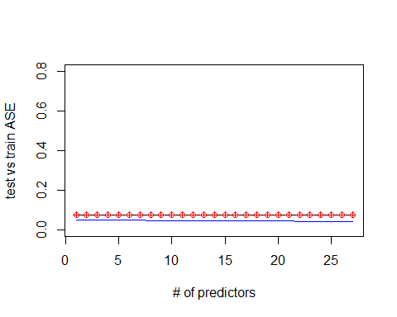

#Forward  
Empl_Nosal_Pred<-Empl_nosal%>%select(Age,Attrition,BusinessTravel,Daily.Rate,Distance.From.Home,Education,EducationField,Environment.Satisfaction,Gender,(Hourly.Rate),Job.Involvement,Job.Level,Job.Satisfaction,Marital.Status,(Monthly.Rate),Num.Companies.Worked,OverTime,Percent.Salary.Hike,Performance.Rating,Relationship.Satisfaction,Stock.Option.Level,(Total.Working.Years),Training.Times.Last.Year,Work.Life.Balance,(Years.At.Company),Years.In.Current.Role,Years.Since.Last.Promotion,Years.With.Curr.Manager)  
Pred_Nosal_FWD=predict(Model_FWD, newdata = Empl_Nosal_Pred, interval = "confidence")  
data.frame(Pred_Nosal_FWD)

## fit lwr upr  
## 1 8.643070 8.527044 8.759097  
## 2 7.997547 7.909613 8.085481  
## 3 9.656945 9.529002 9.784888  
## 4 7.960549 7.853987 8.067112  
## 5 8.064925 7.947940 8.181910  
## 6 8.284957 8.148523 8.421392  
## 7 8.532685 8.422547 8.642824  
## 8 7.792116 7.677969 7.906262  
## 9 8.092143 7.956373 8.227914  
## 10 9.597572 9.472827 9.722317  
## 11 9.073578 8.937584 9.209571  
## 12 7.951626 7.867258 8.035994  
## 13 8.471798 8.383344 8.560251  
## 14 8.536818 8.425255 8.648381  
## 15 8.523069 8.424864 8.621274  
## 16 8.419332 8.308053 8.530612  
## 17 8.527114 8.391742 8.662486  
## 18 8.420460 8.322861 8.518058  
## 19 8.528561 8.432282 8.624840  
## 20 7.928976 7.821100 8.036851  
## 21 8.577067 8.486176 8.667959  
## 22 9.012902 8.908623 9.117180  
## 23 8.949714 8.839635 9.059793  
## 24 8.563495 8.451314 8.675676  
## 25 9.193118 9.085046 9.301189  
## 26 9.143799 9.053317 9.234281  
## 27 8.911656 8.804975 9.018337  
## 28 9.557085 9.436383 9.677788  
## 29 8.493461 8.390168 8.596755  
## 30 7.949722 7.875332 8.024112  
## 31 8.020007 7.918105 8.121909  
## 32 8.560304 8.450256 8.670353  
## 33 8.648732 8.553141 8.744322  
## 34 8.049141 7.948583 8.149698  
## 35 9.566868 9.463991 9.669745  
## 36 8.424598 8.337032 8.512163  
## 37 9.084198 8.964347 9.204049  
## 38 8.583138 8.489714 8.676562  
## 39 7.844793 7.745534 7.944053  
## 40 7.855405 7.774048 7.936762  
## 41 10.220574 10.115231 10.325918  
## 42 7.988969 7.865374 8.112564  
## 43 8.018409 7.924442 8.112375  
## 44 9.074997 8.971401 9.178592  
## 45 8.509093 8.415642 8.602543  
## 46 8.510769 8.415608 8.605931  
## 47 7.949403 7.863706 8.035100  
## 48 8.431827 8.354509 8.509144  
## 49 7.921992 7.825361 8.018623  
## 50 8.078692 7.941494 8.215889  
## 51 7.940487 7.845928 8.035046  
## 52 7.918262 7.812787 8.023737  
## 53 8.498866 8.379681 8.618052  
## 54 8.459361 8.344516 8.574206  
## 55 9.710712 9.578367 9.843058  
## 56 8.114291 8.026970 8.201612  
## 57 8.521892 8.435513 8.608270  
## 58 9.148381 9.024663 9.272100  
## 59 7.892594 7.783305 8.001883  
## 60 7.955730 7.871433 8.040027  
## 61 8.592201 8.471938 8.712463  
## 62 9.122463 9.017650 9.227277  
## 63 9.154867 9.054679 9.255054  
## 64 7.914053 7.775745 8.052360  
## 65 7.750408 7.635977 7.864839  
## 66 7.791648 7.694804 7.888492  
## 67 9.073580 8.985747 9.161413  
## 68 8.952602 8.832710 9.072495  
## 69 8.615199 8.501491 8.728907  
## 70 7.923201 7.837395 8.009008  
## 71 7.854219 7.740829 7.967609  
## 72 9.096251 8.992569 9.199933  
## 73 9.267826 9.136347 9.399304  
## 74 8.521060 8.433650 8.608470  
## 75 7.842113 7.750933 7.933293  
## 76 8.553146 8.430453 8.675839  
## 77 7.778187 7.674973 7.881402  
## 78 8.022110 7.914146 8.130074  
## 79 7.867638 7.742487 7.992788  
## 80 8.441791 8.333617 8.549965  
## 81 7.830835 7.705714 7.955956  
## 82 8.600140 8.497580 8.702699  
## 83 8.492191 8.384121 8.600261  
## 84 7.971041 7.879971 8.062110  
## 85 8.485597 8.389514 8.581681  
## 86 8.948161 8.830949 9.065373  
## 87 9.105628 8.963929 9.247327  
## 88 8.001769 7.879844 8.123695  
## 89 9.069383 8.971858 9.166908  
## 90 10.107180 9.959045 10.255314  
## 91 8.016952 7.928365 8.105539  
## 92 8.662089 8.546669 8.777509  
## 93 8.468582 8.369626 8.567537  
## 94 8.515387 8.333488 8.697286  
## 95 7.933595 7.837980 8.029209  
## 96 10.142323 9.991333 10.293314  
## 97 7.886582 7.777595 7.995570  
## 98 9.003518 8.883827 9.123208  
## 99 9.551567 9.409833 9.693302  
## 100 7.915643 7.812979 8.018306  
## 101 8.567332 8.467801 8.666862  
## 102 8.530267 8.420566 8.639967  
## 103 7.858331 7.758208 7.958454  
## 104 7.826254 7.725175 7.927332  
## 105 8.485124 8.379521 8.590727  
## 106 7.850156 7.762833 7.937478  
## 107 8.490914 8.387863 8.593965  
## 108 7.795220 7.687792 7.902647  
## 109 9.215648 9.110037 9.321258  
## 110 10.123968 10.010107 10.237830  
## 111 8.050559 7.932896 8.168223  
## 112 9.184863 9.086543 9.283183  
## 113 8.060920 7.957732 8.164107  
## 114 7.926598 7.813947 8.039249  
## 115 8.608261 8.509545 8.706976  
## 116 7.882995 7.779404 7.986587  
## 117 7.795454 7.682290 7.908618  
## 118 8.565206 8.467832 8.662579  
## 119 8.972039 8.853010 9.091069  
## 120 7.907384 7.815048 7.999721  
## 121 8.568835 8.475775 8.661896  
## 122 7.925185 7.844650 8.005720  
## 123 8.572144 8.392719 8.751569  
## 124 8.516149 8.401423 8.630874  
## 125 8.398833 8.282415 8.515252  
## 126 8.647022 8.532355 8.761688  
## 127 7.951713 7.847671 8.055754  
## 128 9.620043 9.500867 9.739220  
## 129 9.153639 9.056493 9.250786  
## 130 7.889227 7.778307 8.000147  
## 131 8.621981 8.524160 8.719801  
## 132 8.580379 8.459372 8.701386  
## 133 8.497678 8.414311 8.581046  
## 134 8.557695 8.450829 8.664562  
## 135 8.095442 7.965507 8.225377  
## 136 8.498193 8.407037 8.589348  
## 137 7.956841 7.866970 8.046713  
## 138 8.586213 8.490880 8.681546  
## 139 10.259616 10.138846 10.380386  
## 140 8.722792 8.593206 8.852377  
## 141 8.944628 8.828006 9.061250  
## 142 8.511032 8.431564 8.590500  
## 143 8.577671 8.459786 8.695556  
## 144 8.327572 8.208816 8.446327  
## 145 8.375340 8.255348 8.495332  
## 146 7.933757 7.814923 8.052592  
## 147 7.950565 7.843762 8.057367  
## 148 9.137212 9.036733 9.237690  
## 149 9.113920 9.024982 9.202857  
## 150 7.796866 7.703574 7.890159  
## 151 8.592913 8.480953 8.704872  
## 152 8.388372 8.278347 8.498398  
## 153 8.595711 8.471466 8.719955  
## 154 9.059570 8.907839 9.211301  
## 155 9.637223 9.530663 9.743783  
## 156 9.946408 9.829313 10.063503  
## 157 8.381855 8.213299 8.550411  
## 158 8.547606 8.455998 8.639215  
## 159 8.500952 8.388705 8.613200  
## 160 8.988014 8.851414 9.124614  
## 161 8.579196 8.456660 8.701732  
## 162 7.989724 7.896424 8.083025  
## 163 9.064951 8.945406 9.184496  
## 164 7.957338 7.870327 8.044349  
## 165 8.551188 8.430218 8.672158  
## 166 7.817100 7.707319 7.926880  
## 167 8.512899 8.404381 8.621416  
## 168 9.023539 8.921678 9.125399  
## 169 9.082536 8.979583 9.185488  
## 170 8.570522 8.474191 8.666852  
## 171 7.725720 7.614283 7.837156  
## 172 8.033935 7.909181 8.158690  
## 173 9.089319 8.989447 9.189192  
## 174 8.662035 8.559364 8.764706  
## 175 7.843554 7.754792 7.932316  
## 176 7.803745 7.692203 7.915287  
## 177 8.400967 8.300589 8.501345  
## 178 9.093772 8.990582 9.196961  
## 179 7.808825 7.695503 7.922147  
## 180 8.505474 8.396462 8.614486  
## 181 8.820467 8.620532 9.020401  
## 182 7.909642 7.806227 8.013057  
## 183 8.612529 8.493495 8.731563  
## 184 8.013780 7.930239 8.097321  
## 185 7.844343 7.745203 7.943483  
## 186 7.875976 7.779731 7.972222  
## 187 8.414725 8.290721 8.538729  
## 188 9.802209 9.687832 9.916587  
## 189 8.554810 8.430812 8.678807  
## 190 8.066592 7.964679 8.168506  
## 191 8.608914 8.493052 8.724777  
## 192 8.496557 8.391326 8.601788  
## 193 8.592905 8.475024 8.710787  
## 194 7.885444 7.775027 7.995862  
## 195 8.416663 8.298649 8.534677  
## 196 7.872486 7.779312 7.965661  
## 197 7.999463 7.880862 8.118063  
## 198 10.136862 9.990349 10.283375  
## 199 8.418320 8.319642 8.516997  
## 200 8.007213 7.905021 8.109404  
## 201 8.021725 7.922493 8.120956  
## 202 8.560034 8.449517 8.670551  
## 203 7.925786 7.821707 8.029865  
## 204 8.463749 8.375729 8.551769  
## 205 8.593597 8.482331 8.704863  
## 206 9.871674 9.723819 10.019530  
## 207 10.319994 10.189806 10.450182  
## 208 8.521460 8.422220 8.620701  
## 209 8.420119 8.306119 8.534119  
## 210 8.519760 8.409184 8.630337  
## 211 7.932437 7.849005 8.015870  
## 212 7.859236 7.760427 7.958044  
## 213 7.838664 7.707697 7.969630  
## 214 8.725464 8.616900 8.834029  
## 215 8.959596 8.851915 9.067276  
## 216 9.174673 9.052845 9.296502  
## 217 8.503055 8.406470 8.599640  
## 218 8.005172 7.890920 8.119423  
## 219 7.912665 7.817945 8.007384  
## 220 8.471182 8.359852 8.582513  
## 221 8.588290 8.477240 8.699340  
## 222 8.570284 8.426841 8.713726  
## 223 9.166925 9.039369 9.294481  
## 224 8.456821 8.342555 8.571087  
## 225 8.430177 8.331681 8.528673  
## 226 8.575304 8.497687 8.652921  
## 227 7.977095 7.874947 8.079242  
## 228 7.744867 7.564276 7.925457  
## 229 7.900293 7.810868 7.989718  
## 230 8.310539 8.193889 8.427190  
## 231 10.107018 10.001204 10.212832  
## 232 8.607545 8.505341 8.709750  
## 233 8.514015 8.406811 8.621220  
## 234 9.271041 9.127617 9.414465  
## 235 7.986305 7.868016 8.104594  
## 236 7.865624 7.766951 7.964297  
## 237 8.104181 8.000131 8.208230  
## 238 8.573792 8.476157 8.671427  
## 239 8.499421 8.408007 8.590836  
## 240 8.487349 8.396293 8.578405  
## 241 8.443259 8.335352 8.551166  
## 242 9.147806 9.027057 9.268555  
## 243 9.117008 8.995137 9.238879  
## 244 8.453566 8.336414 8.570718  
## 245 9.250666 9.130944 9.370387  
## 246 7.960640 7.847839 8.073442  
## 247 8.530966 8.430001 8.631931  
## 248 8.506570 8.368675 8.644465  
## 249 9.024056 8.900126 9.147986  
## 250 7.888902 7.768241 8.009563  
## 251 8.987264 8.873968 9.100561  
## 252 9.578605 9.443139 9.714072  
## 253 8.487687 8.361963 8.613410  
## 254 9.675730 9.539441 9.812018  
## 255 7.926428 7.813493 8.039362  
## 256 7.692183 7.558233 7.826132  
## 257 7.898722 7.796377 8.001068  
## 258 8.619903 8.517645 8.722162  
## 259 9.540400 9.406750 9.674050  
## 260 7.914453 7.809293 8.019614  
## 261 9.145608 9.032612 9.258603  
## 262 9.636763 9.495361 9.778165  
## 263 8.440612 8.350483 8.530740  
## 264 7.859072 7.757353 7.960792  
## 265 7.937817 7.823935 8.051699  
## 266 7.941449 7.845129 8.037768  
## 267 8.031499 7.932882 8.130117  
## 268 8.503749 8.393274 8.614225  
## 269 9.123898 9.020931 9.226865  
## 270 9.706077 9.599422 9.812733  
## 271 8.505836 8.391234 8.620438  
## 272 8.521045 8.427597 8.614493  
## 273 9.238030 9.147966 9.328095  
## 274 8.522787 8.435162 8.610412  
## 275 8.497854 8.316882 8.678826  
## 276 8.518785 8.425717 8.611853  
## 277 8.502995 8.414380 8.591610  
## 278 8.052747 7.945161 8.160333  
## 279 8.026964 7.924758 8.129170  
## 280 8.617513 8.497699 8.737328  
## 281 7.886348 7.787277 7.985419  
## 282 8.391647 8.280921 8.502372  
## 283 8.467778 8.361496 8.574060  
## 284 7.898575 7.789198 8.007951  
## 285 8.562257 8.460810 8.663704  
## 286 9.560472 9.441130 9.679814  
## 287 7.944752 7.832965 8.056538  
## 288 8.538636 8.417997 8.659275  
## 289 7.834174 7.750186 7.918162  
## 290 8.461707 8.353455 8.569959  
## 291 7.885977 7.788912 7.983043  
## 292 9.014995 8.920404 9.109587  
## 293 7.930050 7.819582 8.040518  
## 294 9.051233 8.947536 9.154930  
## 295 7.939753 7.836040 8.043465  
## 296 7.886800 7.769165 8.004436  
## 297 9.160731 9.007625 9.313838  
## 298 8.489665 8.389008 8.590321  
## 299 7.930317 7.834606 8.026028  
## 300 8.094931 7.995573 8.194289

write.csv(data.frame(Pred_Nosal_FWD),'C:/Sowmya/SMU/04_Doing Data Science/Unit-14 & Unit-15/CaseStudy2Predict_Salary_FWD.csv')  
Pred_Nosal_BCK=predict(Model_BCK, newdata = Empl_Nosal_Pred, interval = "confidence")  
data.frame(Pred_Nosal_BCK)

## fit lwr upr  
## 1 8.620038 8.550292 8.689784  
## 2 7.988173 7.940094 8.036252  
## 3 9.567412 9.479027 9.655798  
## 4 7.953349 7.880150 8.026548  
## 5 8.051717 7.992403 8.111030  
## 6 8.307162 8.233933 8.380391  
## 7 8.496251 8.425605 8.566897  
## 8 7.813222 7.731721 7.894722  
## 9 8.073113 7.999855 8.146372  
## 10 9.633672 9.566477 9.700867  
## 11 9.022621 8.944358 9.100884  
## 12 7.934326 7.888267 7.980384  
## 13 8.483043 8.421324 8.544761  
## 14 8.455777 8.392720 8.518835  
## 15 8.525827 8.467588 8.584065  
## 16 8.419584 8.352793 8.486376  
## 17 8.518569 8.441190 8.595948  
## 18 8.437627 8.380313 8.494941  
## 19 8.525260 8.472868 8.577652  
## 20 7.942243 7.900145 7.984341  
## 21 8.560408 8.513497 8.607320  
## 22 9.096993 9.052128 9.141858  
## 23 8.948453 8.871604 9.025303  
## 24 8.575064 8.507473 8.642656  
## 25 9.187236 9.134825 9.239647  
## 26 9.106664 9.060592 9.152735  
## 27 8.933471 8.853954 9.012988  
## 28 9.561046 9.470034 9.652058  
## 29 8.525046 8.475853 8.574239  
## 30 7.931455 7.882904 7.980006  
## 31 8.056512 7.985121 8.127903  
## 32 8.500700 8.427679 8.573721  
## 33 8.614430 8.557226 8.671633  
## 34 7.995119 7.925213 8.065026  
## 35 9.557823 9.489605 9.626041  
## 36 8.423639 8.364476 8.482802  
## 37 9.098088 9.024738 9.171437  
## 38 8.568017 8.508646 8.627388  
## 39 7.899477 7.835389 7.963565  
## 40 7.868988 7.818550 7.919427  
## 41 10.234529 10.165695 10.303364  
## 42 7.944614 7.867660 8.021568  
## 43 7.970265 7.918537 8.021993  
## 44 9.136694 9.074604 9.198784  
## 45 8.528259 8.477075 8.579444  
## 46 8.526225 8.470588 8.581862  
## 47 7.953727 7.914108 7.993345  
## 48 8.477615 8.431716 8.523515  
## 49 7.932446 7.877425 7.987468  
## 50 8.045919 7.984126 8.107712  
## 51 7.906985 7.851914 7.962056  
## 52 7.883182 7.824676 7.941687  
## 53 8.428890 8.357588 8.500192  
## 54 8.455985 8.377100 8.534869  
## 55 9.677167 9.626018 9.728316  
## 56 8.107750 8.044806 8.170694  
## 57 8.526315 8.488420 8.564211  
## 58 9.191408 9.105194 9.277622  
## 59 7.883666 7.806711 7.960620  
## 60 7.950227 7.889097 8.011358  
## 61 8.587390 8.492319 8.682460  
## 62 9.132714 9.081567 9.183862  
## 63 9.101187 9.060490 9.141884  
## 64 7.865606 7.780339 7.950874  
## 65 7.785897 7.715506 7.856289  
## 66 7.822280 7.752669 7.891891  
## 67 9.060350 9.009081 9.111619  
## 68 8.953074 8.864100 9.042048  
## 69 8.638459 8.560827 8.716091  
## 70 7.911815 7.856584 7.967046  
## 71 7.824049 7.751374 7.896724  
## 72 9.119378 9.055275 9.183482  
## 73 9.263306 9.162613 9.363999  
## 74 8.516111 8.461204 8.571018  
## 75 7.904991 7.850880 7.959103  
## 76 8.524486 8.457735 8.591237  
## 77 7.761552 7.693539 7.829565  
## 78 8.000195 7.942288 8.058101  
## 79 7.869970 7.780640 7.959300  
## 80 8.430739 8.361855 8.499624  
## 81 7.855783 7.787465 7.924101  
## 82 8.534343 8.486850 8.581836  
## 83 8.459511 8.402883 8.516139  
## 84 7.980618 7.910560 8.050675  
## 85 8.490025 8.412722 8.567328  
## 86 8.972237 8.914740 9.029735  
## 87 9.120990 9.062477 9.179503  
## 88 8.037953 7.950576 8.125330  
## 89 9.064822 9.001360 9.128285  
## 90 10.105602 9.975916 10.235288  
## 91 8.009267 7.959572 8.058962  
## 92 8.675838 8.612078 8.739597  
## 93 8.470062 8.404098 8.536026  
## 94 8.555897 8.486132 8.625661  
## 95 7.961305 7.903109 8.019501  
## 96 10.151287 10.023860 10.278714  
## 97 7.919640 7.872771 7.966510  
## 98 9.021162 8.935655 9.106668  
## 99 9.564056 9.482286 9.645826  
## 100 7.941657 7.871555 8.011759  
## 101 8.552131 8.494122 8.610140  
## 102 8.540313 8.488769 8.591857  
## 103 7.904553 7.838047 7.971058  
## 104 7.870845 7.819514 7.922175  
## 105 8.505133 8.453491 8.556775  
## 106 7.864464 7.806797 7.922130  
## 107 8.486317 8.431430 8.541204  
## 108 7.802035 7.729492 7.874578  
## 109 9.243372 9.160869 9.325874  
## 110 10.147081 10.060267 10.233895  
## 111 8.028125 7.963617 8.092632  
## 112 9.101244 9.048858 9.153629  
## 113 8.037299 7.976772 8.097825  
## 114 7.896762 7.837006 7.956518  
## 115 8.558825 8.505050 8.612600  
## 116 7.884356 7.803746 7.964966  
## 117 7.820904 7.743220 7.898588  
## 118 8.509636 8.466293 8.552979  
## 119 9.007538 8.919560 9.095516  
## 120 7.927144 7.866968 7.987320  
## 121 8.594362 8.533456 8.655269  
## 122 7.925695 7.882945 7.968446  
## 123 8.610650 8.551979 8.669321  
## 124 8.528622 8.459625 8.597619  
## 125 8.449345 8.373153 8.525537  
## 126 8.629639 8.565792 8.693487  
## 127 7.932767 7.869680 7.995854  
## 128 9.584126 9.504372 9.663880  
## 129 9.158595 9.101321 9.215870  
## 130 7.860653 7.794910 7.926396  
## 131 8.620100 8.556708 8.683491  
## 132 8.553488 8.478430 8.628546  
## 133 8.507137 8.456011 8.558263  
## 134 8.544785 8.489581 8.599989  
## 135 8.030407 7.957129 8.103684  
## 136 8.518488 8.471232 8.565743  
## 137 7.983545 7.937022 8.030069  
## 138 8.574329 8.514112 8.634545  
## 139 10.238549 10.161216 10.315881  
## 140 8.656329 8.596833 8.715826  
## 141 8.952915 8.866173 9.039657  
## 142 8.523364 8.480434 8.566295  
## 143 8.643923 8.573443 8.714403  
## 144 8.291156 8.202633 8.379678  
## 145 8.345009 8.267336 8.422681  
## 146 7.961404 7.907764 8.015043  
## 147 7.968560 7.903446 8.033674  
## 148 9.097046 9.049055 9.145038  
## 149 9.136042 9.078936 9.193149  
## 150 7.808609 7.736986 7.880232  
## 151 8.515941 8.468812 8.563070  
## 152 8.407687 8.343168 8.472206  
## 153 8.544836 8.485586 8.604085  
## 154 9.022034 8.903008 9.141061  
## 155 9.634380 9.564396 9.704364  
## 156 9.948235 9.850773 10.045696  
## 157 8.480359 8.419571 8.541147  
## 158 8.587123 8.539892 8.634354  
## 159 8.521133 8.436114 8.606151  
## 160 8.992798 8.878666 9.106930  
## 161 8.536976 8.477405 8.596546  
## 162 7.975383 7.916919 8.033846  
## 163 9.130969 9.066890 9.195047  
## 164 7.958134 7.904109 8.012158  
## 165 8.509159 8.444978 8.573339  
## 166 7.862781 7.781726 7.943836  
## 167 8.545396 8.507006 8.583786  
## 168 9.008254 8.947766 9.068741  
## 169 9.116288 9.064495 9.168081  
## 170 8.596914 8.531760 8.662068  
## 171 7.772339 7.698469 7.846210  
## 172 8.028336 7.972103 8.084568  
## 173 9.072592 9.018116 9.127068  
## 174 8.656322 8.577088 8.735556  
## 175 7.871339 7.803446 7.939231  
## 176 7.818771 7.737321 7.900220  
## 177 8.411164 8.344102 8.478225  
## 178 9.106006 9.039183 9.172828  
## 179 7.814075 7.726308 7.901842  
## 180 8.513249 8.442204 8.584294  
## 181 8.818948 8.671947 8.965948  
## 182 7.928586 7.853874 8.003298  
## 183 8.560510 8.496974 8.624047  
## 184 8.003921 7.961997 8.045844  
## 185 7.860731 7.801515 7.919947  
## 186 7.886338 7.821877 7.950798  
## 187 8.458227 8.399062 8.517392  
## 188 9.758494 9.688241 9.828747  
## 189 8.485498 8.418407 8.552589  
## 190 8.057186 7.994447 8.119924  
## 191 8.545739 8.484287 8.607190  
## 192 8.483305 8.413072 8.553539  
## 193 8.580953 8.511949 8.649956  
## 194 7.869646 7.804059 7.935233  
## 195 8.414317 8.339374 8.489259  
## 196 7.915624 7.865456 7.965791  
## 197 7.978510 7.937941 8.019078  
## 198 10.123917 10.011314 10.236521  
## 199 8.439235 8.372269 8.506202  
## 200 7.936975 7.874320 7.999630  
## 201 8.018428 7.954538 8.082317  
## 202 8.591559 8.528041 8.655076  
## 203 7.882972 7.833896 7.932047  
## 204 8.449706 8.388002 8.511410  
## 205 8.519514 8.465521 8.573506  
## 206 9.814781 9.712061 9.917501  
## 207 10.274232 10.193728 10.354735  
## 208 8.532696 8.468273 8.597119  
## 209 8.488012 8.415619 8.560405  
## 210 8.510704 8.448266 8.573142  
## 211 7.946107 7.891316 8.000899  
## 212 7.871611 7.819763 7.923459  
## 213 7.768785 7.680618 7.856952  
## 214 8.689259 8.619348 8.759170  
## 215 9.000243 8.929282 9.071204  
## 216 9.209226 9.129918 9.288535  
## 217 8.530516 8.483245 8.577787  
## 218 7.996850 7.930178 8.063521  
## 219 7.953746 7.903861 8.003631  
## 220 8.440589 8.377067 8.504112  
## 221 8.568511 8.499542 8.637480  
## 222 8.495951 8.411656 8.580246  
## 223 9.125902 9.059567 9.192236  
## 224 8.518593 8.458883 8.578302  
## 225 8.429094 8.365350 8.492839  
## 226 8.579565 8.534120 8.625010  
## 227 7.979944 7.932577 8.027311  
## 228 7.813041 7.739923 7.886159  
## 229 7.912896 7.844880 7.980912  
## 230 8.314540 8.233108 8.395973  
## 231 10.125068 10.050404 10.199733  
## 232 8.562103 8.511288 8.612917  
## 233 8.493160 8.422504 8.563815  
## 234 9.185143 9.116276 9.254010  
## 235 7.915730 7.859163 7.972298  
## 236 7.848806 7.779743 7.917870  
## 237 8.109444 8.042762 8.176126  
## 238 8.618451 8.562727 8.674175  
## 239 8.518396 8.453346 8.583446  
## 240 8.481948 8.438783 8.525112  
## 241 8.450637 8.372373 8.528900  
## 242 9.155165 9.106380 9.203950  
## 243 9.146929 9.064135 9.229722  
## 244 8.468246 8.391918 8.544575  
## 245 9.248612 9.180857 9.316367  
## 246 7.930062 7.860172 7.999952  
## 247 8.552111 8.493621 8.610602  
## 248 8.527999 8.452502 8.603496  
## 249 9.065618 9.001016 9.130220  
## 250 7.914248 7.843498 7.984998  
## 251 8.939809 8.870124 9.009493  
## 252 9.583476 9.500531 9.666420  
## 253 8.518985 8.456259 8.581710  
## 254 9.677661 9.577266 9.778055  
## 255 7.921719 7.864547 7.978891  
## 256 7.770092 7.688985 7.851200  
## 257 7.887249 7.809764 7.964733  
## 258 8.606268 8.542065 8.670471  
## 259 9.528708 9.441709 9.615707  
## 260 7.925908 7.866763 7.985053  
## 261 9.179634 9.098898 9.260370  
## 262 9.637074 9.545729 9.728419  
## 263 8.417440 8.361253 8.473628  
## 264 7.888169 7.820184 7.956154  
## 265 7.985737 7.909359 8.062115  
## 266 7.964366 7.904799 8.023934  
## 267 8.041717 7.994938 8.088495  
## 268 8.434217 8.369193 8.499240  
## 269 9.108231 9.037592 9.178869  
## 270 9.708044 9.636383 9.779704  
## 271 8.527381 8.452893 8.601870  
## 272 8.480153 8.425078 8.535228  
## 273 9.246741 9.182142 9.311341  
## 274 8.545134 8.494381 8.595887  
## 275 8.583804 8.505371 8.662238  
## 276 8.522466 8.460101 8.584830  
## 277 8.523329 8.479014 8.567644  
## 278 8.062750 7.997755 8.127744  
## 279 7.997276 7.940618 8.053935  
## 280 8.573108 8.516860 8.629355  
## 281 7.867360 7.808915 7.925805  
## 282 8.442122 8.377102 8.507143  
## 283 8.466069 8.410211 8.521928  
## 284 7.888535 7.814401 7.962669  
## 285 8.550421 8.493476 8.607366  
## 286 9.542825 9.466193 9.619457  
## 287 7.931287 7.862800 7.999774  
## 288 8.488669 8.429492 8.547846  
## 289 7.852185 7.799512 7.904858  
## 290 8.476868 8.414092 8.539644  
## 291 7.877944 7.817938 7.937949  
## 292 9.029431 8.963844 9.095018  
## 293 7.960949 7.892317 8.029582  
## 294 9.100887 9.050272 9.151501  
## 295 7.952418 7.873513 8.031323  
## 296 7.853587 7.790018 7.917156  
## 297 9.195434 9.106678 9.284191  
## 298 8.554362 8.512711 8.596013  
## 299 7.951208 7.900161 8.002256  
## 300 8.091814 8.022270 8.161357

write.csv(data.frame(Pred_Nosal_BCK),'C:/Sowmya/SMU/04_Doing Data Science/Unit-14 & Unit-15/CaseStudy2Predict_Salary_BCK.csv')  
Pred_Nosal_Step=predict(Model_Step, newdata = Empl_Nosal_Pred, interval = "confidence")  
data.frame(Pred_Nosal_Step)

## fit lwr upr  
## 1 8.620038 8.550292 8.689784  
## 2 7.988173 7.940094 8.036252  
## 3 9.567412 9.479027 9.655798  
## 4 7.953349 7.880150 8.026548  
## 5 8.051717 7.992403 8.111030  
## 6 8.307162 8.233933 8.380391  
## 7 8.496251 8.425605 8.566897  
## 8 7.813222 7.731721 7.894722  
## 9 8.073113 7.999855 8.146372  
## 10 9.633672 9.566477 9.700867  
## 11 9.022621 8.944358 9.100884  
## 12 7.934326 7.888267 7.980384  
## 13 8.483043 8.421324 8.544761  
## 14 8.455777 8.392720 8.518835  
## 15 8.525827 8.467588 8.584065  
## 16 8.419584 8.352793 8.486376  
## 17 8.518569 8.441190 8.595948  
## 18 8.437627 8.380313 8.494941  
## 19 8.525260 8.472868 8.577652  
## 20 7.942243 7.900145 7.984341  
## 21 8.560408 8.513497 8.607320  
## 22 9.096993 9.052128 9.141858  
## 23 8.948453 8.871604 9.025303  
## 24 8.575064 8.507473 8.642656  
## 25 9.187236 9.134825 9.239647  
## 26 9.106664 9.060592 9.152735  
## 27 8.933471 8.853954 9.012988  
## 28 9.561046 9.470034 9.652058  
## 29 8.525046 8.475853 8.574239  
## 30 7.931455 7.882904 7.980006  
## 31 8.056512 7.985121 8.127903  
## 32 8.500700 8.427679 8.573721  
## 33 8.614430 8.557226 8.671633  
## 34 7.995119 7.925213 8.065026  
## 35 9.557823 9.489605 9.626041  
## 36 8.423639 8.364476 8.482802  
## 37 9.098088 9.024738 9.171437  
## 38 8.568017 8.508646 8.627388  
## 39 7.899477 7.835389 7.963565  
## 40 7.868988 7.818550 7.919427  
## 41 10.234529 10.165695 10.303364  
## 42 7.944614 7.867660 8.021568  
## 43 7.970265 7.918537 8.021993  
## 44 9.136694 9.074604 9.198784  
## 45 8.528259 8.477075 8.579444  
## 46 8.526225 8.470588 8.581862  
## 47 7.953727 7.914108 7.993345  
## 48 8.477615 8.431716 8.523515  
## 49 7.932446 7.877425 7.987468  
## 50 8.045919 7.984126 8.107712  
## 51 7.906985 7.851914 7.962056  
## 52 7.883182 7.824676 7.941687  
## 53 8.428890 8.357588 8.500192  
## 54 8.455985 8.377100 8.534869  
## 55 9.677167 9.626018 9.728316  
## 56 8.107750 8.044806 8.170694  
## 57 8.526315 8.488420 8.564211  
## 58 9.191408 9.105194 9.277622  
## 59 7.883666 7.806711 7.960620  
## 60 7.950227 7.889097 8.011358  
## 61 8.587390 8.492319 8.682460  
## 62 9.132714 9.081567 9.183862  
## 63 9.101187 9.060490 9.141884  
## 64 7.865606 7.780339 7.950874  
## 65 7.785897 7.715506 7.856289  
## 66 7.822280 7.752669 7.891891  
## 67 9.060350 9.009081 9.111619  
## 68 8.953074 8.864100 9.042048  
## 69 8.638459 8.560827 8.716091  
## 70 7.911815 7.856584 7.967046  
## 71 7.824049 7.751374 7.896724  
## 72 9.119378 9.055275 9.183482  
## 73 9.263306 9.162613 9.363999  
## 74 8.516111 8.461204 8.571018  
## 75 7.904991 7.850880 7.959103  
## 76 8.524486 8.457735 8.591237  
## 77 7.761552 7.693539 7.829565  
## 78 8.000195 7.942288 8.058101  
## 79 7.869970 7.780640 7.959300  
## 80 8.430739 8.361855 8.499624  
## 81 7.855783 7.787465 7.924101  
## 82 8.534343 8.486850 8.581836  
## 83 8.459511 8.402883 8.516139  
## 84 7.980618 7.910560 8.050675  
## 85 8.490025 8.412722 8.567328  
## 86 8.972237 8.914740 9.029735  
## 87 9.120990 9.062477 9.179503  
## 88 8.037953 7.950576 8.125330  
## 89 9.064822 9.001360 9.128285  
## 90 10.105602 9.975916 10.235288  
## 91 8.009267 7.959572 8.058962  
## 92 8.675838 8.612078 8.739597  
## 93 8.470062 8.404098 8.536026  
## 94 8.555897 8.486132 8.625661  
## 95 7.961305 7.903109 8.019501  
## 96 10.151287 10.023860 10.278714  
## 97 7.919640 7.872771 7.966510  
## 98 9.021162 8.935655 9.106668  
## 99 9.564056 9.482286 9.645826  
## 100 7.941657 7.871555 8.011759  
## 101 8.552131 8.494122 8.610140  
## 102 8.540313 8.488769 8.591857  
## 103 7.904553 7.838047 7.971058  
## 104 7.870845 7.819514 7.922175  
## 105 8.505133 8.453491 8.556775  
## 106 7.864464 7.806797 7.922130  
## 107 8.486317 8.431430 8.541204  
## 108 7.802035 7.729492 7.874578  
## 109 9.243372 9.160869 9.325874  
## 110 10.147081 10.060267 10.233895  
## 111 8.028125 7.963617 8.092632  
## 112 9.101244 9.048858 9.153629  
## 113 8.037299 7.976772 8.097825  
## 114 7.896762 7.837006 7.956518  
## 115 8.558825 8.505050 8.612600  
## 116 7.884356 7.803746 7.964966  
## 117 7.820904 7.743220 7.898588  
## 118 8.509636 8.466293 8.552979  
## 119 9.007538 8.919560 9.095516  
## 120 7.927144 7.866968 7.987320  
## 121 8.594362 8.533456 8.655269  
## 122 7.925695 7.882945 7.968446  
## 123 8.610650 8.551979 8.669321  
## 124 8.528622 8.459625 8.597619  
## 125 8.449345 8.373153 8.525537  
## 126 8.629639 8.565792 8.693487  
## 127 7.932767 7.869680 7.995854  
## 128 9.584126 9.504372 9.663880  
## 129 9.158595 9.101321 9.215870  
## 130 7.860653 7.794910 7.926396  
## 131 8.620100 8.556708 8.683491  
## 132 8.553488 8.478430 8.628546  
## 133 8.507137 8.456011 8.558263  
## 134 8.544785 8.489581 8.599989  
## 135 8.030407 7.957129 8.103684  
## 136 8.518488 8.471232 8.565743  
## 137 7.983545 7.937022 8.030069  
## 138 8.574329 8.514112 8.634545  
## 139 10.238549 10.161216 10.315881  
## 140 8.656329 8.596833 8.715826  
## 141 8.952915 8.866173 9.039657  
## 142 8.523364 8.480434 8.566295  
## 143 8.643923 8.573443 8.714403  
## 144 8.291156 8.202633 8.379678  
## 145 8.345009 8.267336 8.422681  
## 146 7.961404 7.907764 8.015043  
## 147 7.968560 7.903446 8.033674  
## 148 9.097046 9.049055 9.145038  
## 149 9.136042 9.078936 9.193149  
## 150 7.808609 7.736986 7.880232  
## 151 8.515941 8.468812 8.563070  
## 152 8.407687 8.343168 8.472206  
## 153 8.544836 8.485586 8.604085  
## 154 9.022034 8.903008 9.141061  
## 155 9.634380 9.564396 9.704364  
## 156 9.948235 9.850773 10.045696  
## 157 8.480359 8.419571 8.541147  
## 158 8.587123 8.539892 8.634354  
## 159 8.521133 8.436114 8.606151  
## 160 8.992798 8.878666 9.106930  
## 161 8.536976 8.477405 8.596546  
## 162 7.975383 7.916919 8.033846  
## 163 9.130969 9.066890 9.195047  
## 164 7.958134 7.904109 8.012158  
## 165 8.509159 8.444978 8.573339  
## 166 7.862781 7.781726 7.943836  
## 167 8.545396 8.507006 8.583786  
## 168 9.008254 8.947766 9.068741  
## 169 9.116288 9.064495 9.168081  
## 170 8.596914 8.531760 8.662068  
## 171 7.772339 7.698469 7.846210  
## 172 8.028336 7.972103 8.084568  
## 173 9.072592 9.018116 9.127068  
## 174 8.656322 8.577088 8.735556  
## 175 7.871339 7.803446 7.939231  
## 176 7.818771 7.737321 7.900220  
## 177 8.411164 8.344102 8.478225  
## 178 9.106006 9.039183 9.172828  
## 179 7.814075 7.726308 7.901842  
## 180 8.513249 8.442204 8.584294  
## 181 8.818948 8.671947 8.965948  
## 182 7.928586 7.853874 8.003298  
## 183 8.560510 8.496974 8.624047  
## 184 8.003921 7.961997 8.045844  
## 185 7.860731 7.801515 7.919947  
## 186 7.886338 7.821877 7.950798  
## 187 8.458227 8.399062 8.517392  
## 188 9.758494 9.688241 9.828747  
## 189 8.485498 8.418407 8.552589  
## 190 8.057186 7.994447 8.119924  
## 191 8.545739 8.484287 8.607190  
## 192 8.483305 8.413072 8.553539  
## 193 8.580953 8.511949 8.649956  
## 194 7.869646 7.804059 7.935233  
## 195 8.414317 8.339374 8.489259  
## 196 7.915624 7.865456 7.965791  
## 197 7.978510 7.937941 8.019078  
## 198 10.123917 10.011314 10.236521  
## 199 8.439235 8.372269 8.506202  
## 200 7.936975 7.874320 7.999630  
## 201 8.018428 7.954538 8.082317  
## 202 8.591559 8.528041 8.655076  
## 203 7.882972 7.833896 7.932047  
## 204 8.449706 8.388002 8.511410  
## 205 8.519514 8.465521 8.573506  
## 206 9.814781 9.712061 9.917501  
## 207 10.274232 10.193728 10.354735  
## 208 8.532696 8.468273 8.597119  
## 209 8.488012 8.415619 8.560405  
## 210 8.510704 8.448266 8.573142  
## 211 7.946107 7.891316 8.000899  
## 212 7.871611 7.819763 7.923459  
## 213 7.768785 7.680618 7.856952  
## 214 8.689259 8.619348 8.759170  
## 215 9.000243 8.929282 9.071204  
## 216 9.209226 9.129918 9.288535  
## 217 8.530516 8.483245 8.577787  
## 218 7.996850 7.930178 8.063521  
## 219 7.953746 7.903861 8.003631  
## 220 8.440589 8.377067 8.504112  
## 221 8.568511 8.499542 8.637480  
## 222 8.495951 8.411656 8.580246  
## 223 9.125902 9.059567 9.192236  
## 224 8.518593 8.458883 8.578302  
## 225 8.429094 8.365350 8.492839  
## 226 8.579565 8.534120 8.625010  
## 227 7.979944 7.932577 8.027311  
## 228 7.813041 7.739923 7.886159  
## 229 7.912896 7.844880 7.980912  
## 230 8.314540 8.233108 8.395973  
## 231 10.125068 10.050404 10.199733  
## 232 8.562103 8.511288 8.612917  
## 233 8.493160 8.422504 8.563815  
## 234 9.185143 9.116276 9.254010  
## 235 7.915730 7.859163 7.972298  
## 236 7.848806 7.779743 7.917870  
## 237 8.109444 8.042762 8.176126  
## 238 8.618451 8.562727 8.674175  
## 239 8.518396 8.453346 8.583446  
## 240 8.481948 8.438783 8.525112  
## 241 8.450637 8.372373 8.528900  
## 242 9.155165 9.106380 9.203950  
## 243 9.146929 9.064135 9.229722  
## 244 8.468246 8.391918 8.544575  
## 245 9.248612 9.180857 9.316367  
## 246 7.930062 7.860172 7.999952  
## 247 8.552111 8.493621 8.610602  
## 248 8.527999 8.452502 8.603496  
## 249 9.065618 9.001016 9.130220  
## 250 7.914248 7.843498 7.984998  
## 251 8.939809 8.870124 9.009493  
## 252 9.583476 9.500531 9.666420  
## 253 8.518985 8.456259 8.581710  
## 254 9.677661 9.577266 9.778055  
## 255 7.921719 7.864547 7.978891  
## 256 7.770092 7.688985 7.851200  
## 257 7.887249 7.809764 7.964733  
## 258 8.606268 8.542065 8.670471  
## 259 9.528708 9.441709 9.615707  
## 260 7.925908 7.866763 7.985053  
## 261 9.179634 9.098898 9.260370  
## 262 9.637074 9.545729 9.728419  
## 263 8.417440 8.361253 8.473628  
## 264 7.888169 7.820184 7.956154  
## 265 7.985737 7.909359 8.062115  
## 266 7.964366 7.904799 8.023934  
## 267 8.041717 7.994938 8.088495  
## 268 8.434217 8.369193 8.499240  
## 269 9.108231 9.037592 9.178869  
## 270 9.708044 9.636383 9.779704  
## 271 8.527381 8.452893 8.601870  
## 272 8.480153 8.425078 8.535228  
## 273 9.246741 9.182142 9.311341  
## 274 8.545134 8.494381 8.595887  
## 275 8.583804 8.505371 8.662238  
## 276 8.522466 8.460101 8.584830  
## 277 8.523329 8.479014 8.567644  
## 278 8.062750 7.997755 8.127744  
## 279 7.997276 7.940618 8.053935  
## 280 8.573108 8.516860 8.629355  
## 281 7.867360 7.808915 7.925805  
## 282 8.442122 8.377102 8.507143  
## 283 8.466069 8.410211 8.521928  
## 284 7.888535 7.814401 7.962669  
## 285 8.550421 8.493476 8.607366  
## 286 9.542825 9.466193 9.619457  
## 287 7.931287 7.862800 7.999774  
## 288 8.488669 8.429492 8.547846  
## 289 7.852185 7.799512 7.904858  
## 290 8.476868 8.414092 8.539644  
## 291 7.877944 7.817938 7.937949  
## 292 9.029431 8.963844 9.095018  
## 293 7.960949 7.892317 8.029582  
## 294 9.100887 9.050272 9.151501  
## 295 7.952418 7.873513 8.031323  
## 296 7.853587 7.790018 7.917156  
## 297 9.195434 9.106678 9.284191  
## 298 8.554362 8.512711 8.596013  
## 299 7.951208 7.900161 8.002256  
## 300 8.091814 8.022270 8.161357

write.csv(data.frame(Pred_Nosal_Step),'C:/Sowmya/SMU/04_Doing Data Science/Unit-14 & Unit-15/CaseStudy2Predict_Salary_Step.csv')

#Classification  
##Train - 695 : Test - 174  
##### knn - K-Nearest Neighbors #####   
  
set.seed(32)   
iterations = 100  
accs = data.frame(accuracy = numeric(30), k = numeric(30))  
  
splitPerc = .80  
TrainIndicesKnn = sample(seq(1:length(Empl$Attrition)),round(splitPerc * length(Empl$Attrition)))  
TrainKnn = Empl[TrainIndicesKnn,]  
TestKnn = Empl[-TrainIndicesKnn,]  
  
  
TrainKnn<-na.omit(TrainKnn)  
TestKnn<-na.omit(TestKnn)  
  
dim(TrainKnn)

## [1] 695 36

dim(TestKnn)

## [1] 174 36

for(i in 1:30)  
{  
modelKNN = class::knn(TrainKnn[,c(2,5,7,8,12,14,15,16,18,20,21,22,25,26,27,29,30,31,32,33,34,35,36)],TestKnn[,c(2,5,7,8,12,14,15,16,18,20,21,22,25,26,27,29,30,31,32,33,34,35,36)],(TrainKnn$Attrition),k=i,prob=TRUE)  
table(modelKNN,TestKnn$Attrition)  
CM = confusionMatrix(table(modelKNN,TestKnn$Attrition))  
 accs$accuracy[i] = CM$overall[1]  
 accs$k[i] = i  
}  
plot(accs$k,accs$accuracy, type = "l", xlab = "k")

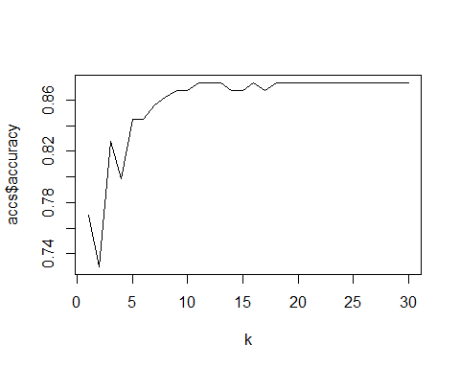

#Best value of k=7  
MeanAcc = colMeans(accs)  
MeanAcc

## accuracy k   
## 0.8574713 15.5000000

#  
modelKNN = class::knn(TrainKnn[,c(2,5,7,8,12,14,15,16,18,20,21,22,25,26,27,29,30,31,32,33,34,35,36)],TestKnn[,c(2,5,7,8,12,14,15,16,18,20,21,22,25,26,27,29,30,31,32,33,34,35,36)],(TrainKnn$Attrition),k=9,prob=TRUE)  
table(modelKNN,TestKnn$Attrition)

##   
## modelKNN No Yes  
## No 150 21  
## Yes 2 1

CM = confusionMatrix(table(modelKNN,TestKnn$Attrition))  
  
##### confusionMatrix KNN #####  
CM

## Confusion Matrix and Statistics  
##   
##   
## modelKNN No Yes  
## No 150 21  
## Yes 2 1  
##   
## Accuracy : 0.8678   
## 95% CI : (0.8083, 0.9143)  
## No Information Rate : 0.8736   
## P-Value [Acc > NIR] : 0.6432147   
##   
## Kappa : 0.0512   
##   
## Mcnemar's Test P-Value : 0.0001746   
##   
## Sensitivity : 0.98684   
## Specificity : 0.04545   
## Pos Pred Value : 0.87719   
## Neg Pred Value : 0.33333   
## Prevalence : 0.87356   
## Detection Rate : 0.86207   
## Detection Prevalence : 0.98276   
## Balanced Accuracy : 0.51615   
##   
## 'Positive' Class : No   
##

######NB-Naive Base #####  
  
iterations = 100  
accsNB = data.frame(accuracy = numeric(30), k = numeric(30))  
splitPerc = .80  
  
TrainIndicesNB = sample(seq(1:length(Empl$Attrition)),round(splitPerc * length(Empl$Attrition)))  
TrainNB = Empl[TrainIndicesNB,]  
TestNB = Empl[-TrainIndicesNB,]  
  
for(i in 1:30)  
{  
modelNB = naiveBayes(TrainNB[,c(2,5,7,8,12,14,15,16,18,20,21,22,25,26,27,29,30,31,32,33,34,35,36)],as.factor(TrainNB$Attrition))  
table(predict(modelNB,TestNB[,c(2,5,7,8,12,14,15,16,18,20,21,22,25,26,27,29,30,31,32,33,34,35,36)]),as.factor(TestNB$Attrition))  
CM = confusionMatrix(table(predict(modelNB,TestNB[,c(2,11)]),as.factor(TestNB$Attrition)))  
 accsNB$accuracy[i] = CM$overall[1]  
 accsNB$k[i] = i  
}

plot(accsNB$k,accsNB$accuracy, type = "l", xlab = "k")

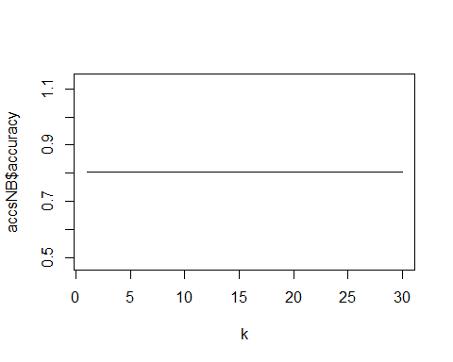

#Best value of k=7  
MeanAccNB = colMeans(accsNB)  
MeanAccNB

## accuracy k   
## 0.8045977 15.5000000

modelNB = naiveBayes(TrainNB[,c(2,5,7,8,12,14,15,16,18,20,21,22,25,26,27,29,30,31,32,33,34,35,36)],as.factor(TrainNB$Attrition))  
table(predict(modelNB,TestNB[,c(2,5,7,8,12,14,15,16,18,20,21,22,25,26,27,29,30,31,32,33,34,35,36)]),as.factor(TestNB$Attrition))

##   
## No Yes  
## No 116 19  
## Yes 24 15

CM = confusionMatrix(table(predict(modelNB,TestNB[,c(2,5,7,8,12,14,15,16,18,20,21,22,25,26,27,29,30,31,32,33,34,35,36)]),as.factor(TestNB$Attrition)))  
  
##### confusionMatrix NB #####  
CM

## Confusion Matrix and Statistics  
##   
##   
## No Yes  
## No 116 19  
## Yes 24 15  
##   
## Accuracy : 0.7529   
## 95% CI : (0.6819, 0.815)  
## No Information Rate : 0.8046   
## P-Value [Acc > NIR] : 0.9623   
##   
## Kappa : 0.2555   
##   
## Mcnemar's Test P-Value : 0.5419   
##   
## Sensitivity : 0.8286   
## Specificity : 0.4412   
## Pos Pred Value : 0.8593   
## Neg Pred Value : 0.3846   
## Prevalence : 0.8046   
## Detection Rate : 0.6667   
## Detection Prevalence : 0.7759   
## Balanced Accuracy : 0.6349   
##   
## 'Positive' Class : No   
##

##### Random Forest #####  
Test<-na.omit(Test)  
Train<-na.omit(Train)  
# Random Forest (training data)  
# Remove id variable as it's just for reference  
dat.train.rf <- Train  
train.rf<-randomForest(as.factor(Attrition)~.,data=dat.train.rf,mtry=4,ntree=500,importance=T)  
fit.pred<-predict(train.rf,newdata=dat.train.rf,type="prob")  
pred <- prediction(fit.pred[,2], dat.train.rf$Attrition)  
roc.perf = performance(pred, measure = "tpr", x.measure = "fpr")  
auc.train <- performance(pred, measure = "auc")  
auc.train <- auc.train@y.values  
plot(roc.perf)  
abline(a=0, b= 1)  
text(x = .40, y = .6,paste("AUC = ", round(auc.train[[1]],3), sep = ""))

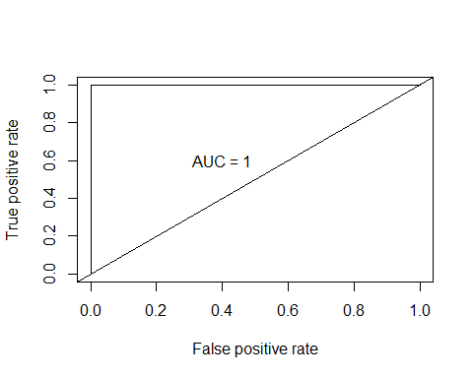

#AUC=1  
  
# Random Forest (test data)  
#Predict test set  
dat.val1.rf <- Test  
pred.val1<-predict(train.rf,newdata=dat.val1.rf,type="prob")  
pred <- prediction(pred.val1[,2], dat.val1.rf$Attrition)  
roc.perf = performance(pred, measure = "tpr", x.measure = "fpr")  
auc.train <- performance(pred, measure = "auc")  
auc.train <- auc.train@y.values  
plot(roc.perf, colorize=TRUE)  
abline(a=0, b= 1)  
text(x = .40, y = .6,paste("AUC = ", round(auc.train[[1]],3), sep = ""))

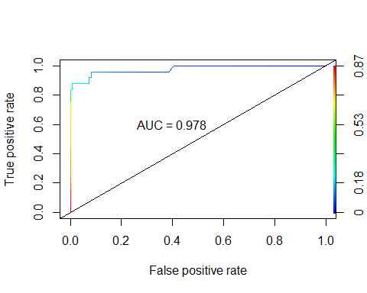

# AUC = 0.974

Empl_NoAttrition_Pred<-Empl_No_Attrition%>%select(Age,Monthly.Income,BusinessTravel,Daily.Rate,Distance.From.Home,Education,EducationField,Environment.Satisfaction,Gender,(Hourly.Rate),Job.Involvement,Job.Level,Job.Satisfaction,Marital.Status,(Monthly.Rate),Num.Companies.Worked,OverTime,Percent.Salary.Hike,Performance.Rating,Relationship.Satisfaction,Stock.Option.Level,(Total.Working.Years),Training.Times.Last.Year,Work.Life.Balance,(Years.At.Company),Years.In.Current.Role,Years.Since.Last.Promotion,Years.With.Curr.Manager)  
dim(TrainKnn)

## [1] 695 36

dim(Empl_No_Attrition)

## [1] 300 35

TrainKnn<-na.omit(TrainKnn)  
Empl_No_Attrition<-na.omit(Empl_No_Attrition)  
  
modelKNN=class::knn(TrainKnn[,c(2,5,7,8,12,14,15,16,18,20,21,22,25,26,27,29,30,31,32,33,34,35,36)],Empl_No_Attrition[,c(2,4,6,7,11,13,14,15,17,19,20,21,24,25,26,28,29,30,31,32,33,34,35)],TrainKnn$Attrition, prob = TRUE, k = 7)  
modelKNN

## [1] No No No No No No No No No No No No No No No No No No   
## [19] No No No No No No No No No No No No No No No No No No   
## [37] No No No No No No No No No No No No No No No No No No   
## [55] No No No No No No No No No No No No No No No No No No   
## [73] No No No No No No No No No No No No No No No No No No   
## [91] No No No No No No No No No No No No No No Yes No No No   
## [109] No No No No No No No No No No No No No No No No No No   
## [127] Yes No No No Yes No No No No No No No No No No No No No   
## [145] No No No No No No No No No No No No No No No No No No   
## [163] No No No No No No No No No No No No No No No No No No   
## [181] No No No No No No No No No No No No No Yes No No No No   
## [199] No No No No No No No No No No No No No No No No No No   
## [217] No No No No No No No No No No No No No No No No No No   
## [235] No No No No No No No No No No No No No No No No Yes No   
## [253] No No No No No No No No No No No No No No No No No No   
## [271] No Yes No No No No No No No No No Yes No No No No No No   
## [289] No No No No No No No No No No No No   
## attr(,"prob")  
## [1] 1.0000000 1.0000000 0.5714286 1.0000000 0.8571429 1.0000000 0.8571429  
## [8] 0.8571429 1.0000000 0.7142857 1.0000000 0.5714286 0.7142857 1.0000000  
## [15] 0.8571429 0.5714286 1.0000000 1.0000000 0.8571429 1.0000000 0.8571429  
## [22] 1.0000000 1.0000000 0.5714286 1.0000000 1.0000000 0.8571429 1.0000000  
## [29] 1.0000000 0.7142857 0.7142857 0.8571429 1.0000000 0.7142857 0.8571429  
## [36] 0.8571429 1.0000000 0.8571429 0.8571429 1.0000000 0.8571429 0.7142857  
## [43] 1.0000000 1.0000000 0.7142857 0.8571429 1.0000000 1.0000000 1.0000000  
## [50] 0.8571429 1.0000000 0.8571429 0.5714286 0.8571429 0.7142857 1.0000000  
## [57] 0.8571429 0.7142857 1.0000000 1.0000000 1.0000000 0.8571429 0.7142857  
## [64] 1.0000000 0.8571429 0.8571429 1.0000000 1.0000000 0.8571429 0.8571429  
## [71] 1.0000000 0.8571429 0.8571429 1.0000000 0.8571429 0.7142857 1.0000000  
## [78] 0.8571429 0.7142857 0.8571429 0.8571429 0.8571429 0.5714286 0.8571429  
## [85] 0.8571429 0.8571429 0.8571429 0.8571429 0.7142857 0.8571429 0.7142857  
## [92] 0.8571429 0.5714286 1.0000000 1.0000000 1.0000000 0.8571429 1.0000000  
## [99] 0.8571429 0.5714286 1.0000000 1.0000000 0.7142857 1.0000000 0.5714286  
## [106] 1.0000000 0.8571429 1.0000000 0.8571429 1.0000000 0.8571429 0.7142857  
## [113] 0.8571429 1.0000000 1.0000000 1.0000000 0.7142857 1.0000000 1.0000000  
## [120] 0.8571429 0.8571429 0.7142857 0.8571429 0.7142857 0.8571429 0.7142857  
## [127] 0.5714286 1.0000000 1.0000000 0.8571429 0.7142857 1.0000000 0.8571429  
## [134] 0.8571429 1.0000000 1.0000000 1.0000000 0.8571429 1.0000000 1.0000000  
## [141] 0.8571429 0.8571429 0.8571429 0.7142857 0.8571429 0.7142857 0.8571429  
## [148] 0.8571429 0.8571429 0.8571429 0.5714286 0.8571429 1.0000000 0.8571429  
## [155] 0.7142857 0.8571429 0.8571429 0.8571429 0.5714286 1.0000000 0.8571429  
## [162] 1.0000000 0.8571429 0.8571429 0.8571429 0.5714286 0.8571429 0.8571429  
## [169] 0.5714286 1.0000000 0.7142857 0.5714286 0.8571429 0.5714286 1.0000000  
## [176] 1.0000000 0.7142857 1.0000000 1.0000000 0.8571429 0.5714286 0.5714286  
## [183] 0.7142857 0.8571429 1.0000000 1.0000000 1.0000000 1.0000000 0.8571429  
## [190] 1.0000000 0.8571429 1.0000000 0.8571429 0.5714286 0.7142857 0.8571429  
## [197] 0.7142857 0.7142857 0.8571429 1.0000000 0.8571429 1.0000000 0.7142857  
## [204] 0.7142857 0.8571429 0.8571429 0.8571429 0.8571429 0.8571429 0.8571429  
## [211] 0.8571429 0.7142857 1.0000000 0.8571429 0.7142857 1.0000000 0.7142857  
## [218] 0.8571429 0.5714286 1.0000000 0.8571429 0.5714286 1.0000000 1.0000000  
## [225] 0.8571429 0.7142857 0.8571429 1.0000000 0.7142857 1.0000000 0.7142857  
## [232] 0.5714286 0.8571429 1.0000000 0.8571429 1.0000000 0.5714286 1.0000000  
## [239] 1.0000000 1.0000000 0.8571429 0.7142857 1.0000000 0.8571429 0.5714286  
## [246] 1.0000000 0.8571429 0.7142857 0.8571429 0.5714286 0.5714286 0.8571429  
## [253] 1.0000000 0.8571429 1.0000000 0.8571429 1.0000000 1.0000000 0.7142857  
## [260] 1.0000000 1.0000000 1.0000000 1.0000000 0.8571429 0.8571429 0.7142857  
## [267] 1.0000000 1.0000000 0.8571429 0.7142857 0.7142857 0.7142857 0.7142857  
## [274] 0.7142857 0.7142857 0.8571429 0.7142857 1.0000000 0.7142857 0.8571429  
## [281] 0.7142857 0.5714286 1.0000000 0.7142857 0.8571429 1.0000000 0.7142857  
## [288] 0.7142857 0.5714286 0.7142857 0.8571429 0.7142857 0.7142857 0.8571429  
## [295] 0.7142857 0.7142857 0.8571429 0.7142857 0.8571429 0.8571429  
## Levels: No Yes

write.csv(data.frame(modelKNN),'C:/Sowmya/SMU/04_Doing Data Science/Unit-14 & Unit-15/CaseStudy2Predict_Attrition_KNN.csv')  
modelNB = naiveBayes(TrainNB[,c(2,5,7,8,12,14,15,16,18,20,21,22,25,26,27,29,30,31,32,33,34,35,36)],as.factor(TrainNB$Attrition))  
PredNB=predict(modelNB,Empl_No_Attrition[,c(2,4,6,7,11,13,14,15,17,19,20,21,24,25,26,28,29,30,31,32,33,34,35)])  
PredNB

## [1] No No Yes No No No No No No No No No No No No No No No   
## [19] No No Yes No No No No No Yes Yes Yes Yes No No No Yes Yes Yes  
## [37] No No No No No No No No Yes No No No Yes No No No No No   
## [55] No No No No No No No No Yes No No No No No No No Yes No   
## [73] No No No Yes No No No No No No No No No No No No No Yes  
## [91] No No No No No No No No No Yes No No No No Yes No No No   
## [109] No No No No No No No No No No No No No No No No No No   
## [127] No No No No No No No No No No No No Yes Yes No No No No   
## [145] No No Yes Yes No No No No No No Yes No Yes No Yes No No Yes  
## [163] No No No Yes No No No No Yes No Yes No No No No Yes No No   
## [181] Yes No No No No No No Yes No No No No No No No No No Yes  
## [199] No No No No No No No Yes No No No No Yes No No No No No   
## [217] Yes No Yes No No No No No Yes No No No Yes No No No No Yes  
## [235] No No No No No No Yes No No No No No Yes No No No Yes No   
## [253] No No No No No No No No No No No No No No No No Yes No   
## [271] Yes Yes No Yes Yes No No No Yes Yes Yes No No No Yes Yes Yes Yes  
## [289] Yes Yes No No Yes No Yes No No Yes No No   
## Levels: No Yes

write.csv(data.frame(PredNB),'C:/Sowmya/SMU/04_Doing Data Science/Unit-14 & Unit-15/CaseStudy2Predict_Attrition_NB.csv')

R SHINY App

The Landing Page for the RShiny App:

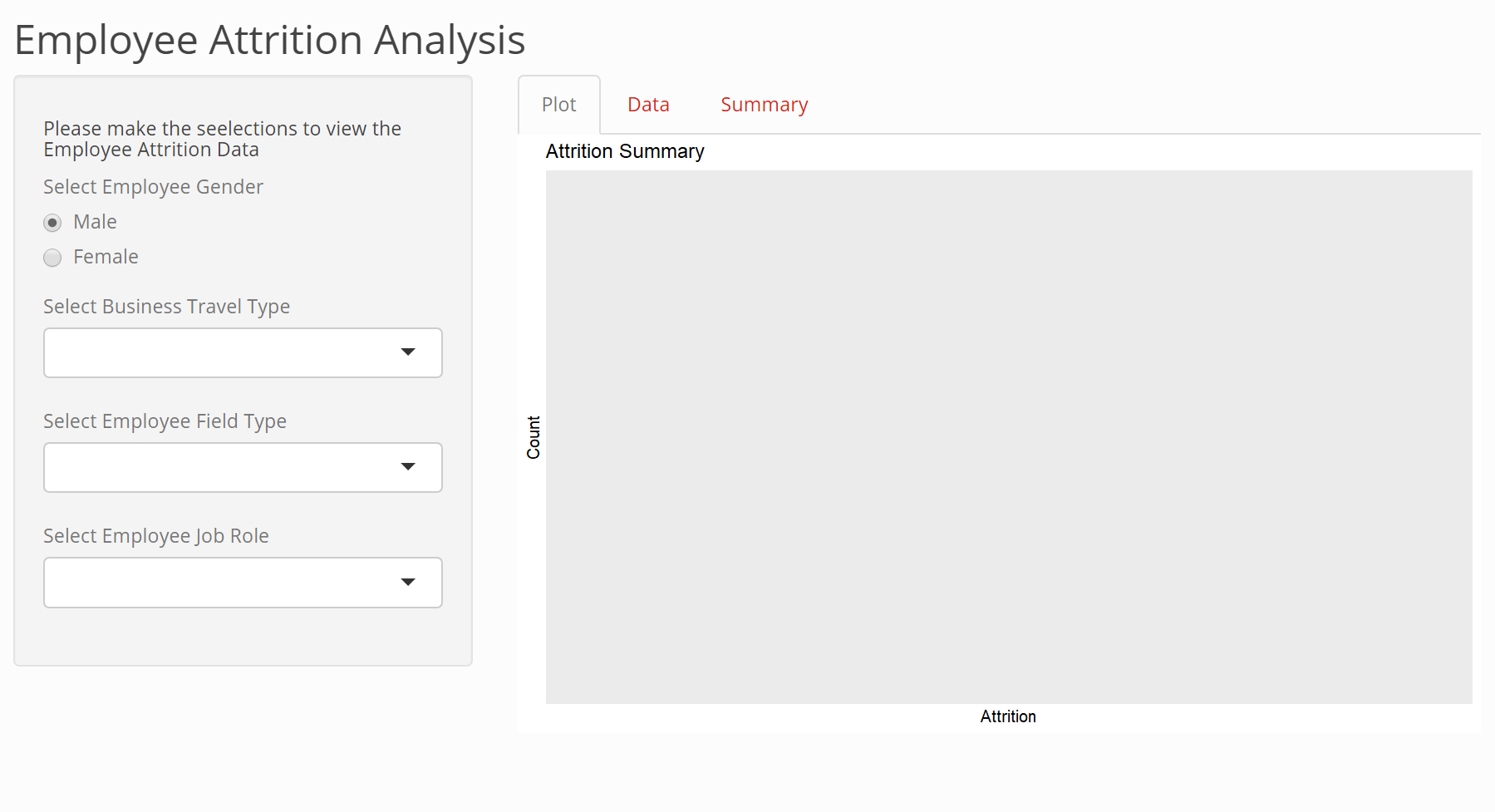

On Selecting the text Drop downs for Business Travel, Employee Field Type and Employee Job Role:

Gender: Male; Business Travel Type: Travel Frequently; Filed Type: Life Science , Job Role : Research Scientist

Selection 1: Displays the Attrition summary for the selected values in Tab Plot

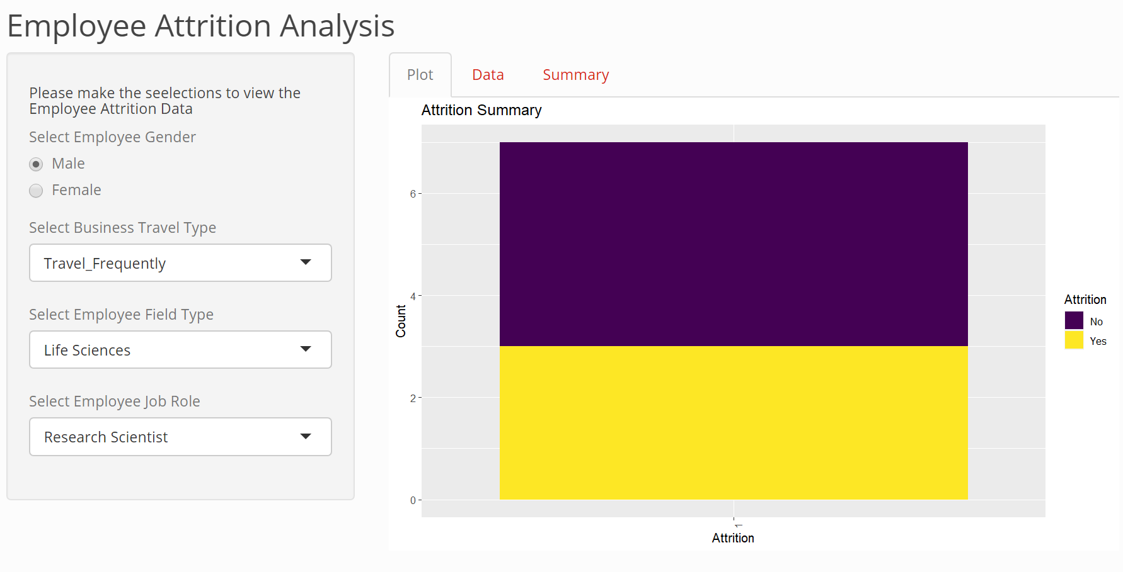

Tab Data displays the raw data for this selection:

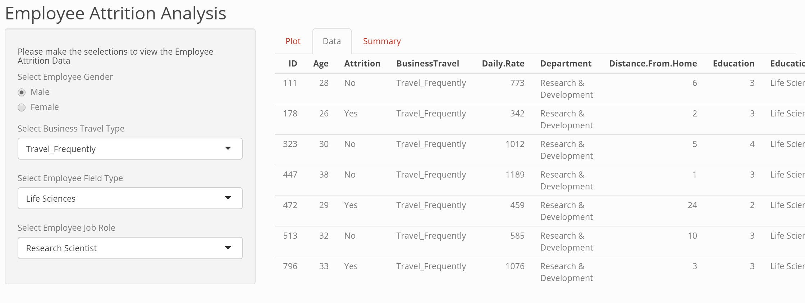

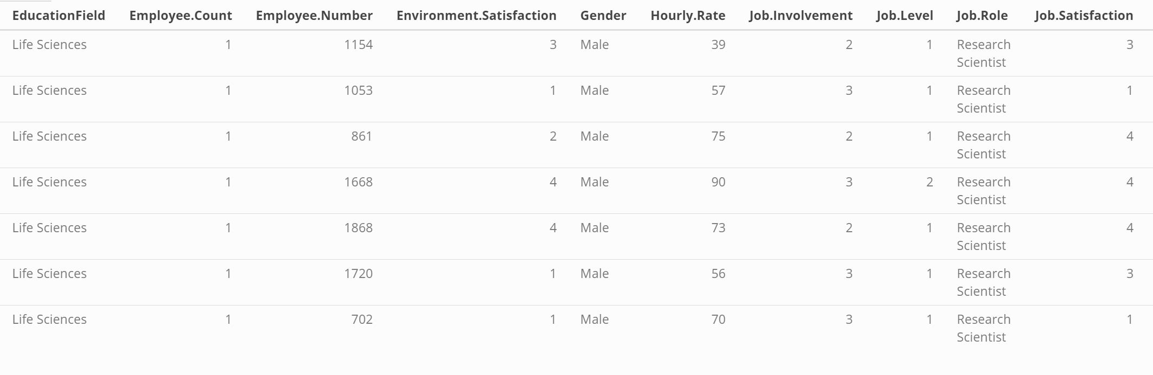

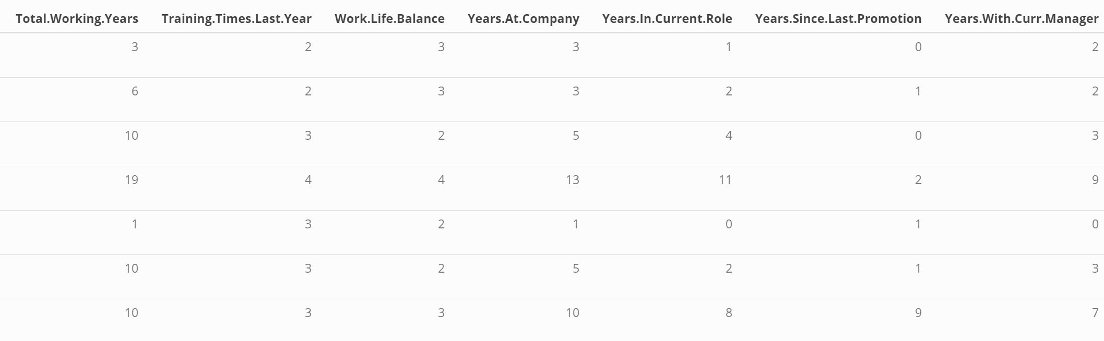

The Summary Tab displays the summary of the dataset

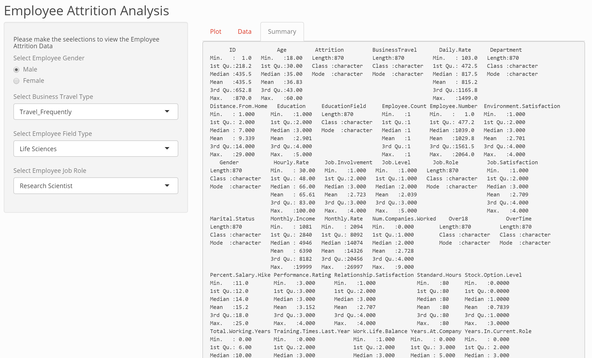

Running the application for another selection:

Gender: Male; Business Travel Type: Non-Travel; Filed Type: Medical , Job Role : Sales Executive

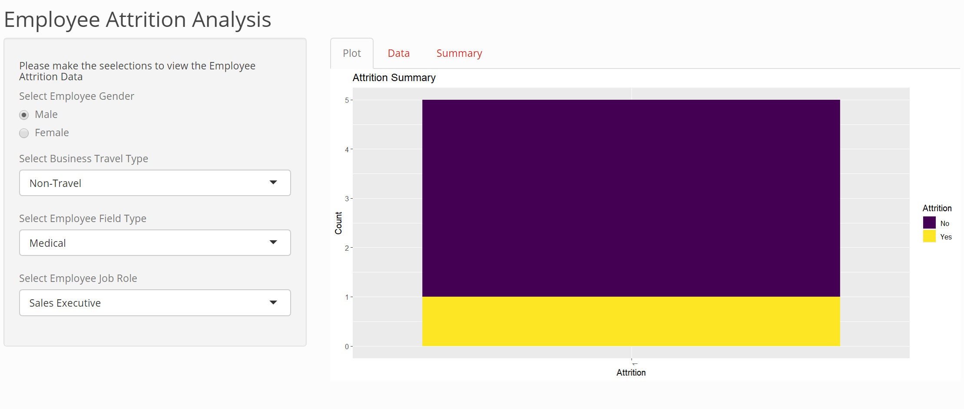





Link to the youtube video:

<https://youtu.be/cT7-F18Ar7k>