Task 2 – Exploratory Data Analysis & Business Intelligence
ApexPlanet Software Pvt. Ltd. – Data Analytics Internship
Sales Transaction Dataset Analysis

1. Introduction
The objective of this task is to perform Exploratory Data Analysis (EDA) on a sales transaction dataset and extract meaningful business insights using Python, Pandas, SQL and data visualization.

2. Dataset Overview
The dataset contains 1,000 sales transaction records and 12 variables. The variables include transaction details, customer information, product information, quantity, unit price and total sales.
Dataset dimensions: 1,000 rows × 12 columns.
Main variables include Order_ID, Order_Date, Customer_ID, Customer_Name, Age, Gender, City, Product, Category, Quantity, Unit_Price and Total_Sales.

3. Data Preparation
The cleaned dataset produced during Task 1 was used for this analysis.
The Order_Date column was converted into datetime format. Missing Age values were handled using the median, while missing City values were handled using the most frequent city.
Duplicate records and Total_Sales consistency were also validated during the data-cleaning stage.

4. Descriptive Statistics
The main numerical variables were summarized using descriptive statistics.
Variable | Mean | Minimum | Maximum
Age | 41.35 | 18 | 65
Quantity | 5.44 | 1 | 10
Unit Price | 25,486.78 | 145.78 | 49,997.53
Total Sales | 139,399.44 | 437.34 | 493,677.50

5. Key Performance Metrics
Total Sales: ₹139,399,439.65
Total Transactions: 1,000
Average Order Value: ₹139,399.44
Average Quantity per Transaction: 5.43

6. Univariate Analysis

6.1 Product Sales
Laptop generated the highest total sales at ₹25,443,008.51, followed closely by Mobile at ₹25,335,573.19 and Book at ₹25,031,689.40. Shoes recorded the lowest total sales at ₹19,835,895.79.

6.2 Category Sales
Electronics generated the highest total sales at ₹50,778,581.70. Education generated ₹25,031,689.40, while Fashion recorded ₹19,835,895.79.

6.3 City Sales
Patna recorded the highest total sales among the analyzed cities at ₹20,826,584.43. Gaya recorded ₹14,380,859.39.

6.4 Gender Sales
Total sales associated with Male customers were ₹72,463,550.63, while Female customers accounted for ₹66,935,889.02.

7. Business Questions & SQL Analysis
- Q1. Which products generate the highest total sales?
- Q2. Which categories generate the highest total sales?
- Q3. Which cities generate the highest total sales?
- Q4. What is the average order value by category?
- Q5. Which products have the highest average quantity sold?
- Q6. What are the total sales by gender?
- Q7. How do sales change month by month?
The seven business questions were answered using SQL queries executed against a SQLite sales database. The query outputs are available in SQL_Results.xlsx, while the SQL statements are stored in SQL_Queries.sql.

8. Multivariate & Correlation Analysis
Correlation analysis was performed on Age, Quantity, Unit_Price and Total_Sales.
- Age and Total Sales: 0.001
- Quantity and Total Sales: 0.647
- Unit Price and Total Sales: 0.686
- Age and Quantity: -0.028
- Age and Unit Price: -0.012
- Quantity and Unit Price: 0.022
Quantity and Unit Price show the strongest relationships with Total Sales in this dataset. Age has almost no linear relationship with Total Sales.
Note: Total_Sales is calculated from Quantity × Unit_Price, so the positive relationships between these variables and Total_Sales are partly expected from the structure of the dataset. Correlation should therefore not be interpreted as proof of causation.

9. Business Intelligence Dashboard
A static sales dashboard was created using Python and Matplotlib. The dashboard contains key performance indicators, sales by product, sales by category, sales by city and the monthly sales trend.
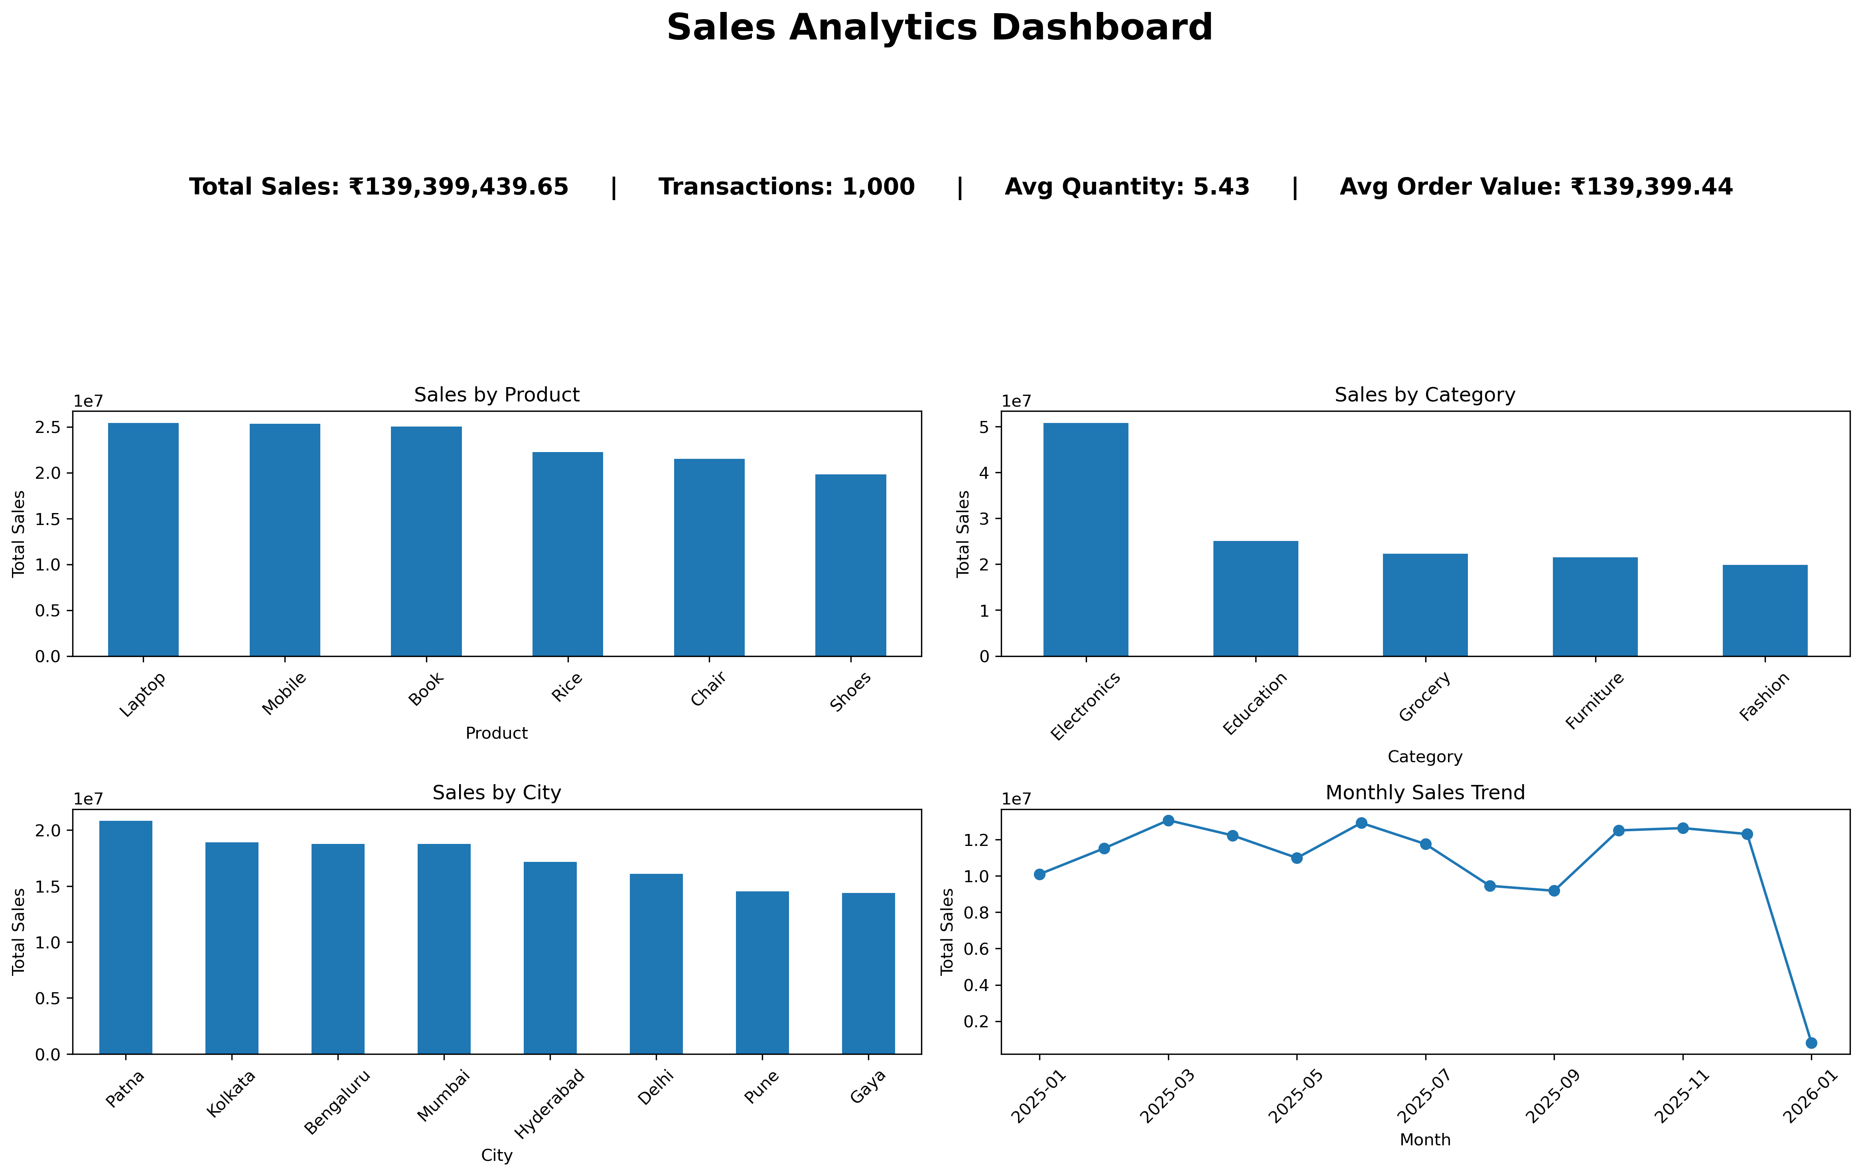

10. Key Findings
- The dataset contains 1,000 sales transactions across 12 variables.
- Total sales across all transactions were ₹139.40 million.
- Laptop recorded the highest total sales among individual products.
- Electronics was the highest-sales product category.
- Patna recorded the highest total sales among the analyzed cities.
- Male customers accounted for ₹72.46 million in total sales.
- Quantity and Unit Price showed the strongest relationships with Total Sales.
- Age showed almost no linear relationship with Total Sales.

11. Conclusion
The EDA provided an overview of sales performance across products, categories, cities and customer gender. SQL analysis was used to answer business-oriented questions, while correlation analysis was used to examine relationships between numerical variables.
The analysis and dashboard provide a foundation for deeper business analysis and interactive dashboard development in the subsequent stages of the internship.

12. Tools & Technologies
- Python
- Pandas
- SQLite
- SQL
- Matplotlib
- Jupyter Notebook
- Microsoft Excel

