**Written Report – 6.419x Module 5**

**Name:** 4sowmya

**Problem 2: Long-range Correlations**

Steps to get the samples with long-range correlation:

* Picked random 10000 pairs of points from the horizontal and vertical flow vectors.
* Get the correlation between the point pairs in both horizontal and vertical matrix and get the minimum correlation for that point pair.
* A threshold of +0.90, -0.90 is set for correlation and the 125 for distance between the points.
* Filtered only the points above the thresholds. Sorted the correlation in descending order. Pict the top 5 to visualize.

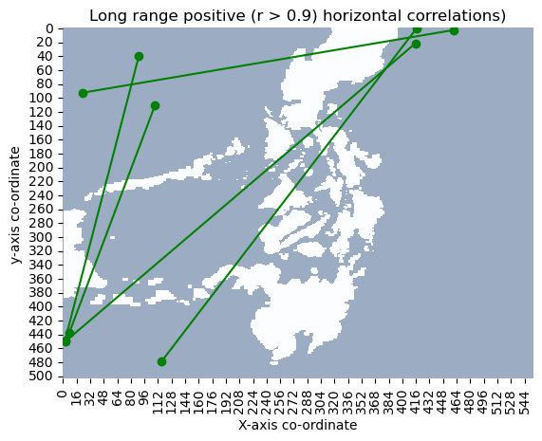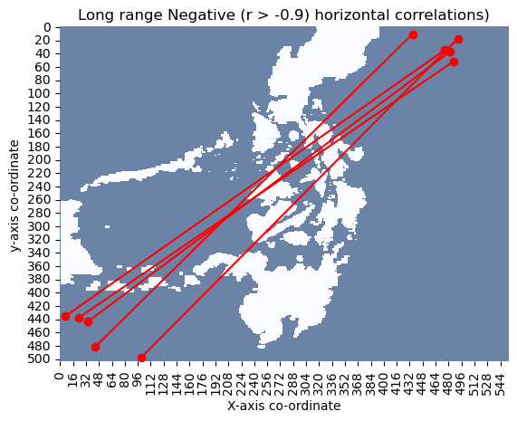

They are highly correlated because when we look at the flow over the 100 times at the same point follows similar pattern. The U and V flows of the two points have similar trend. Here is a sample time series pattern for the highly correlation points in positive and negative side.

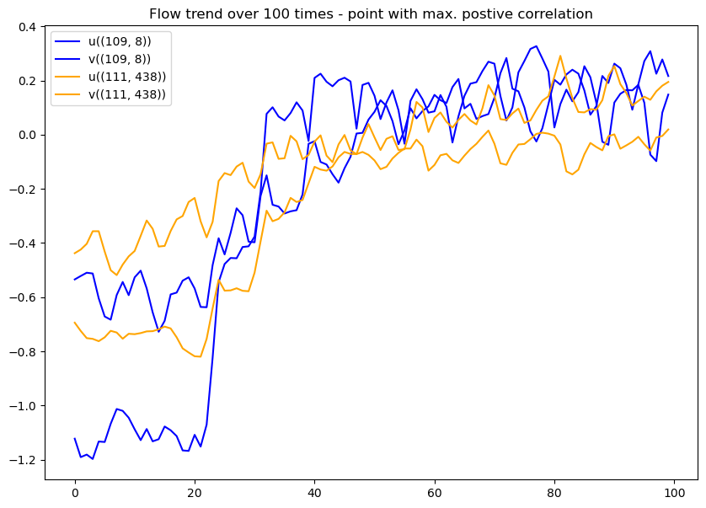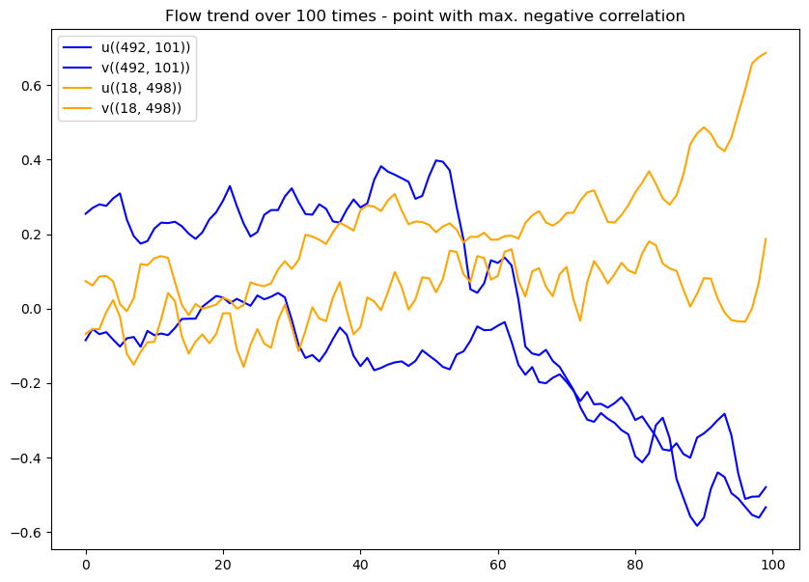

**Problem 3: Simulating particle movement in the flow**