**BDP-ICP-1**

**Creating a directory in hadoop file system :**

**hdfs dfs -mkdir /hadoop-path**

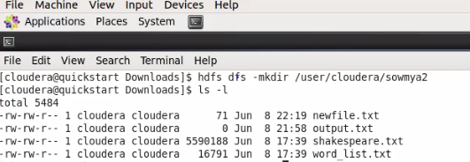

**Loading files into hadoop hdfs from local file system :**

**hdfs dfs -copyFromLocal localfile /hadoop-path**

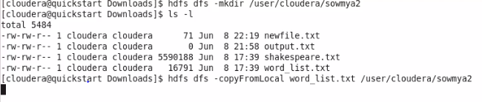

**Visualization of files in hadoop using Hue :**

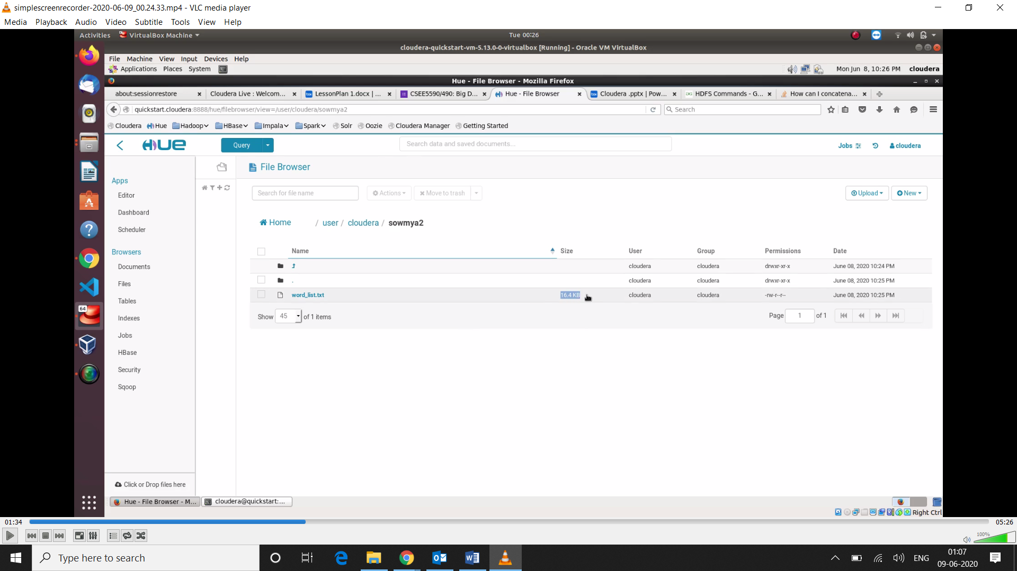

**File Content :**

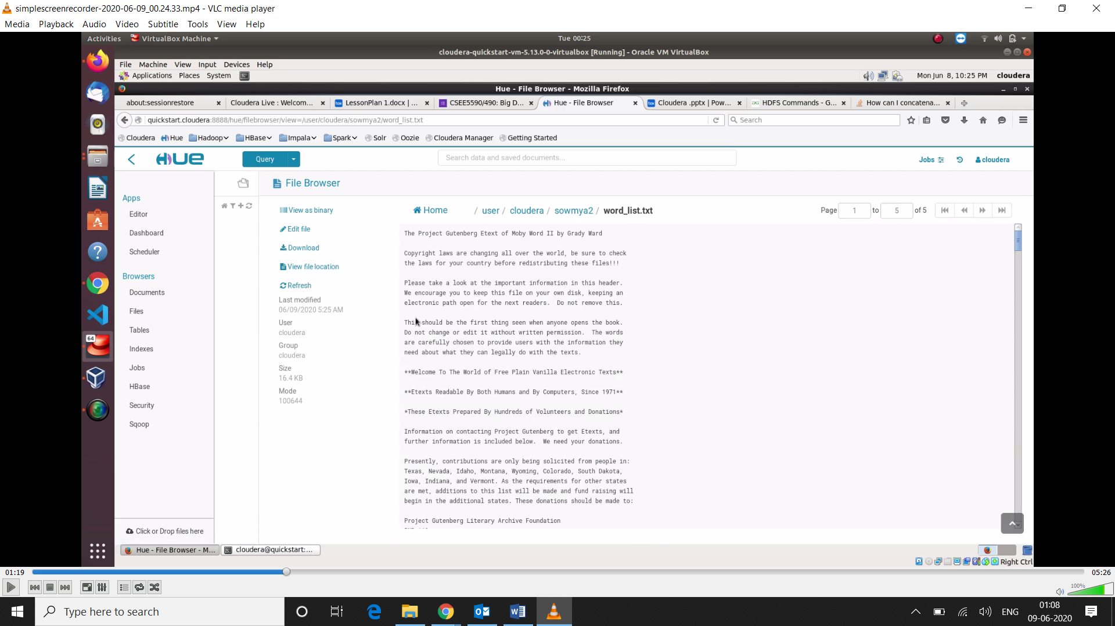

**Appending file to the first file :**

**hdfs dfs -appendToFile localfile /user/hadoop/hadoopfile**

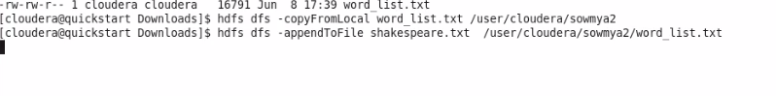

**visualization of appended file in hadoop with larger memory size as new file has been appended :**

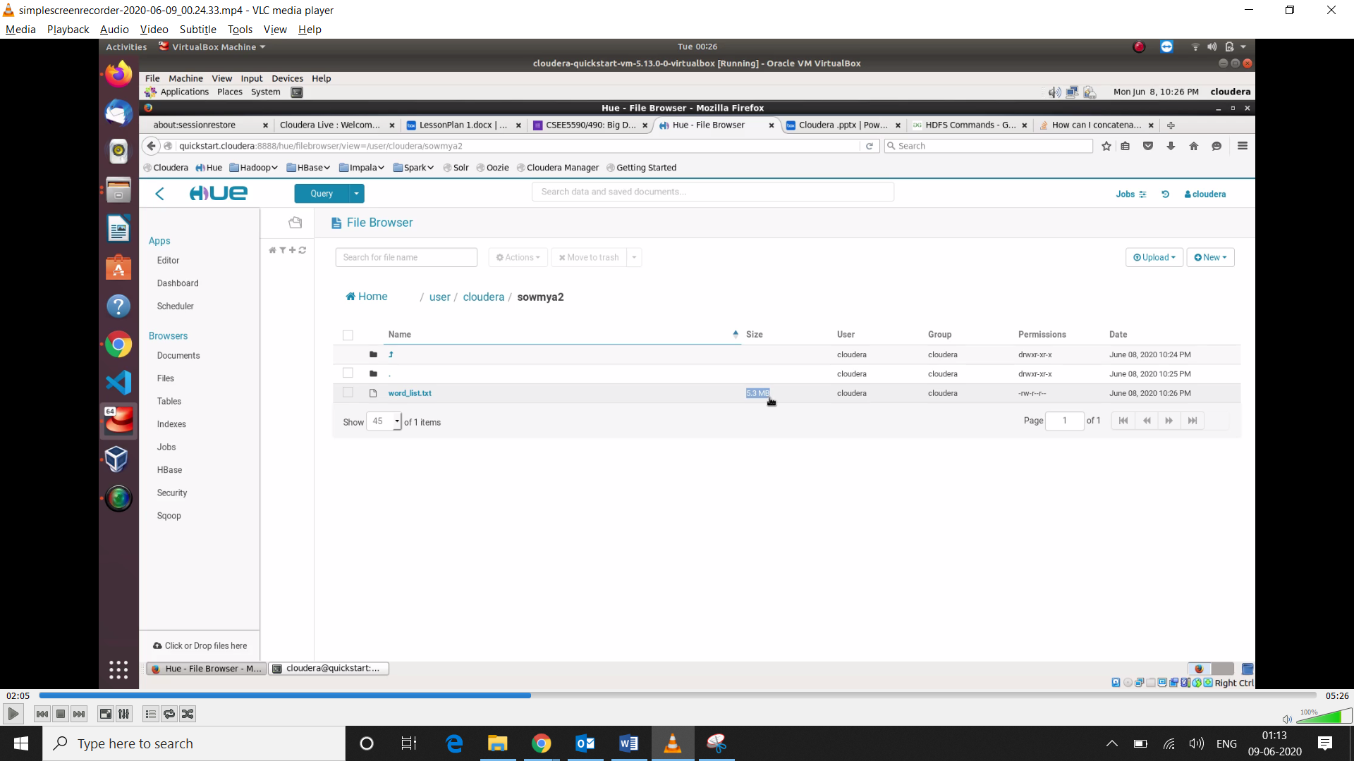

**Appended File :**

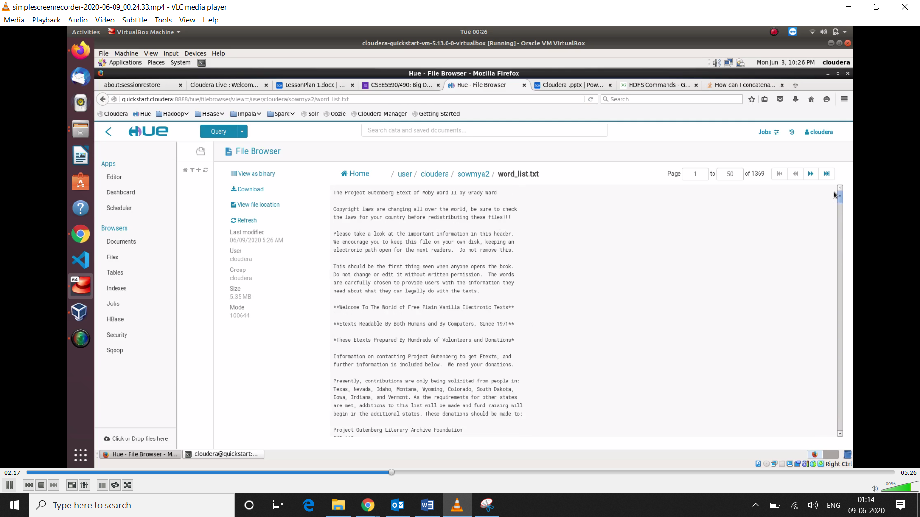

**View the first lines in the merged file :**

**hdfs dfs -cat /hadoopfile | head -5**

**View the last lines in the merged file :**

**hdfs dfs -cat /hadoopfile | tail -5**

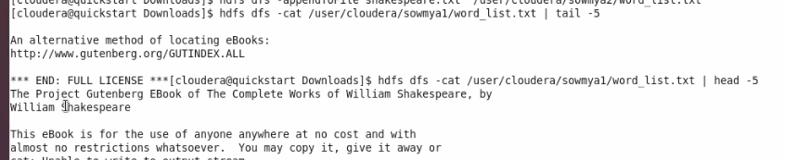

**Create a new text file and loading into hdfs and appending all three datasets :**

**hdfs dfs -cat /hadoopfiles | hdfs dfs -put /outputfile**

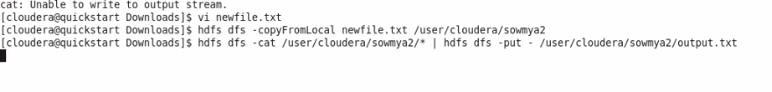

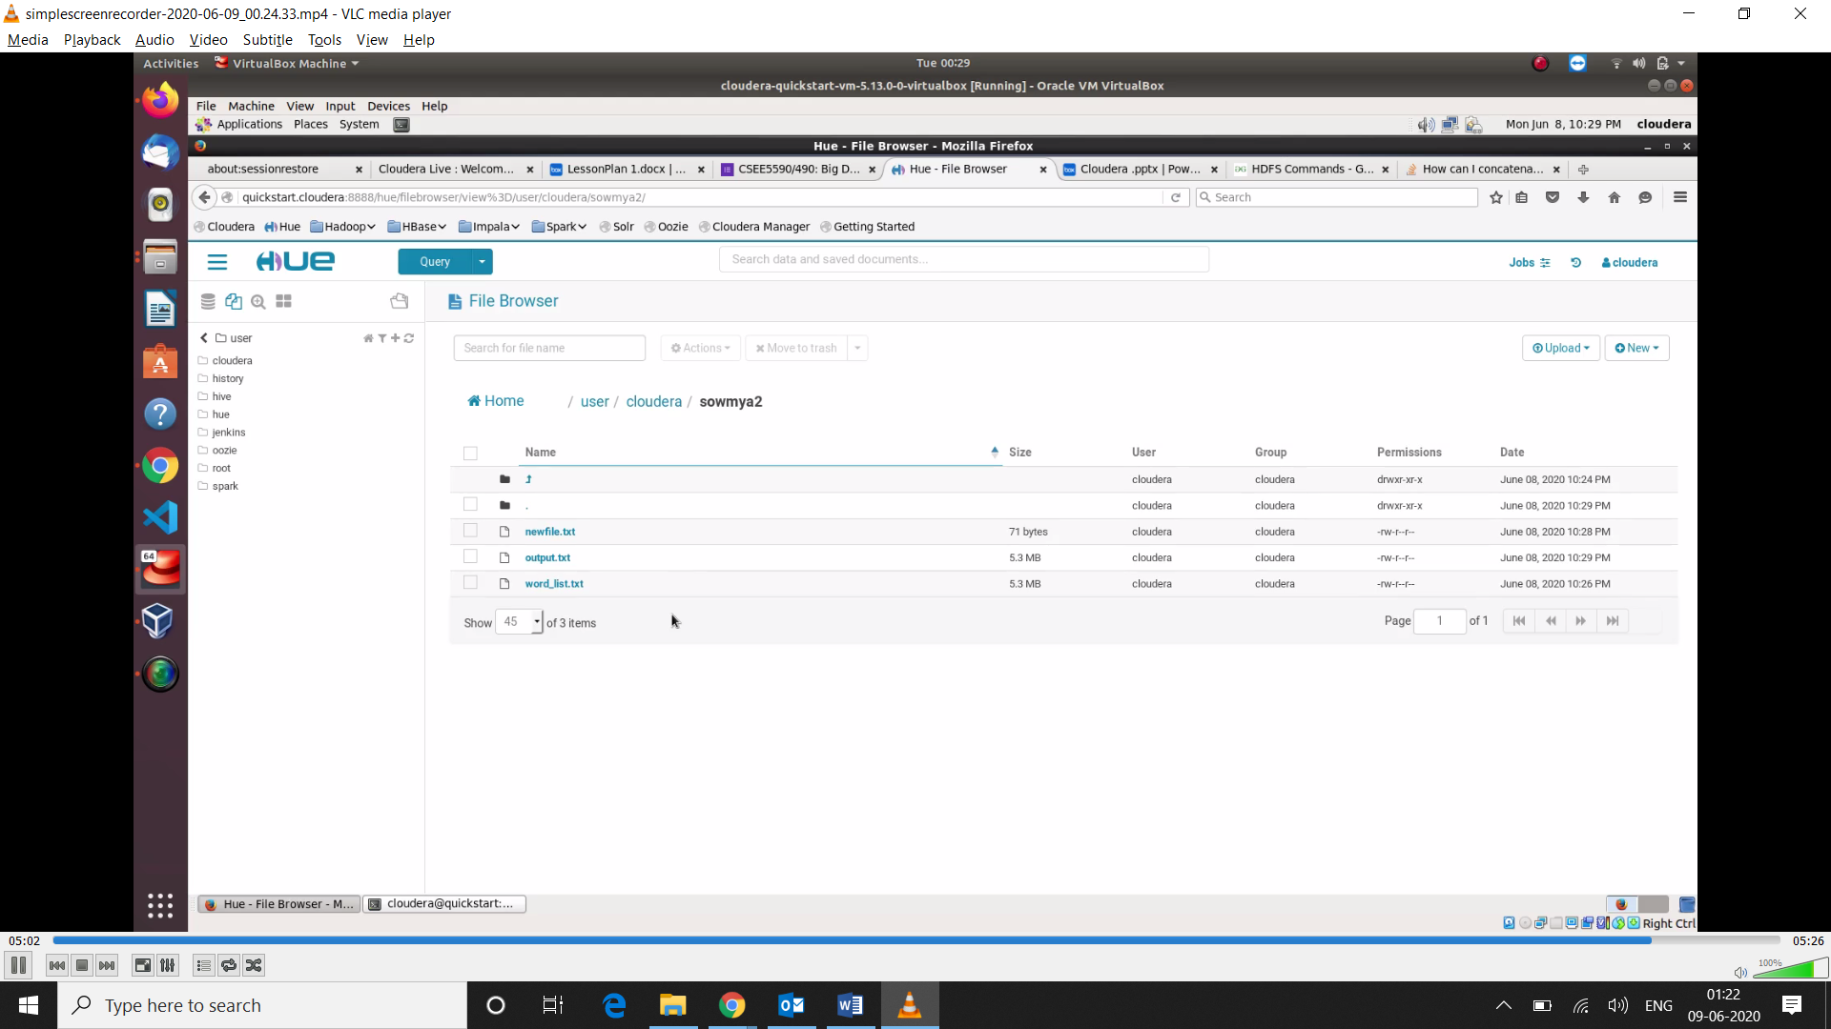

**Appended Content of three files :**

