2000030359

HARI VENKATA SYAMA SOWMYASRI

ID,TAGNAME:  
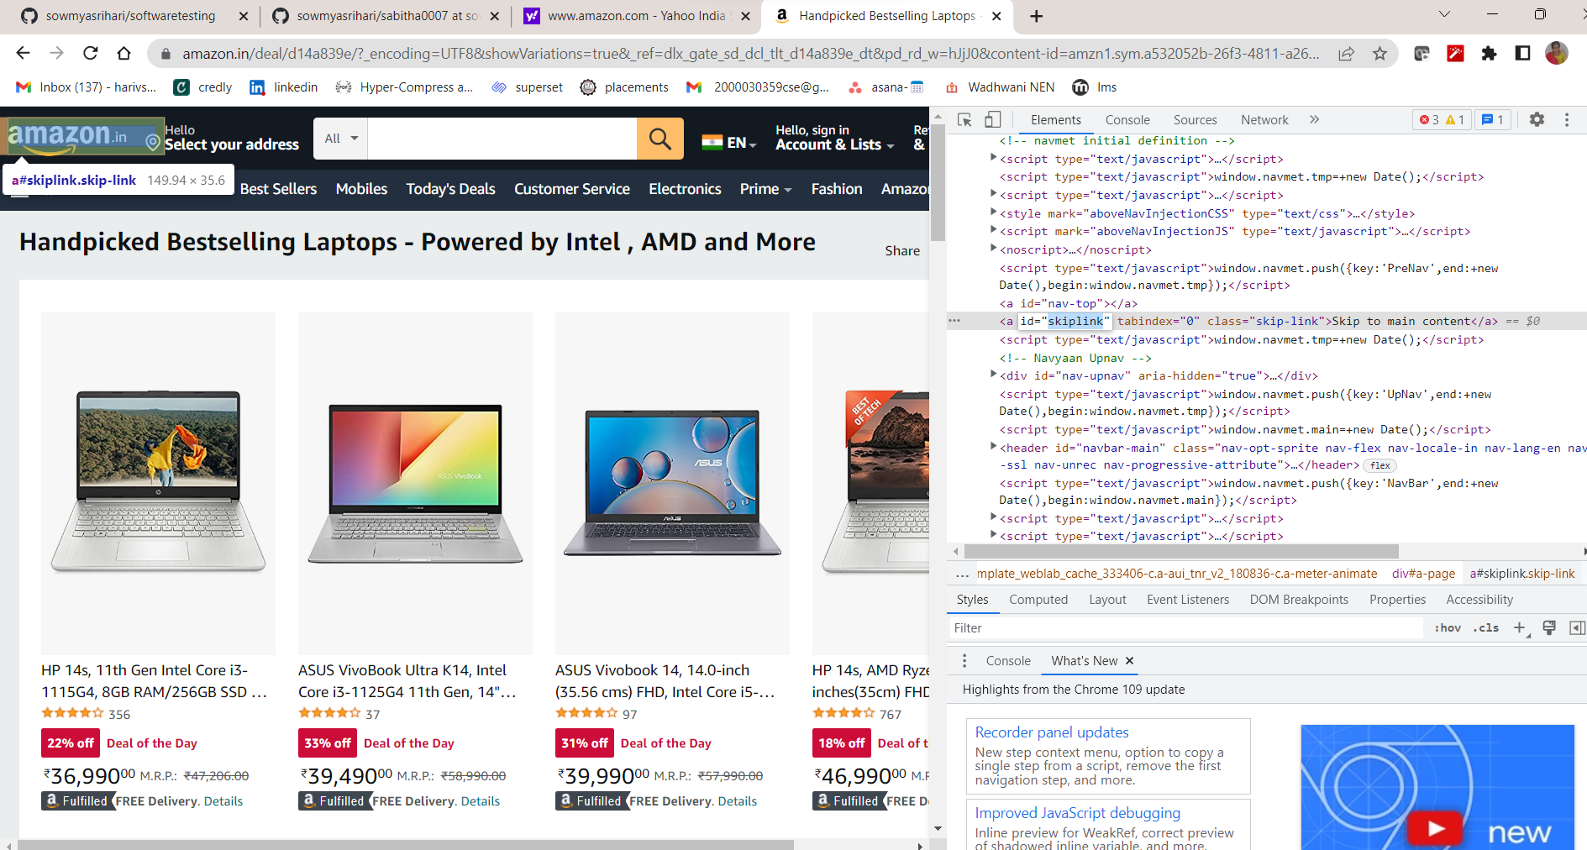

LINK:

CLASSNAME: 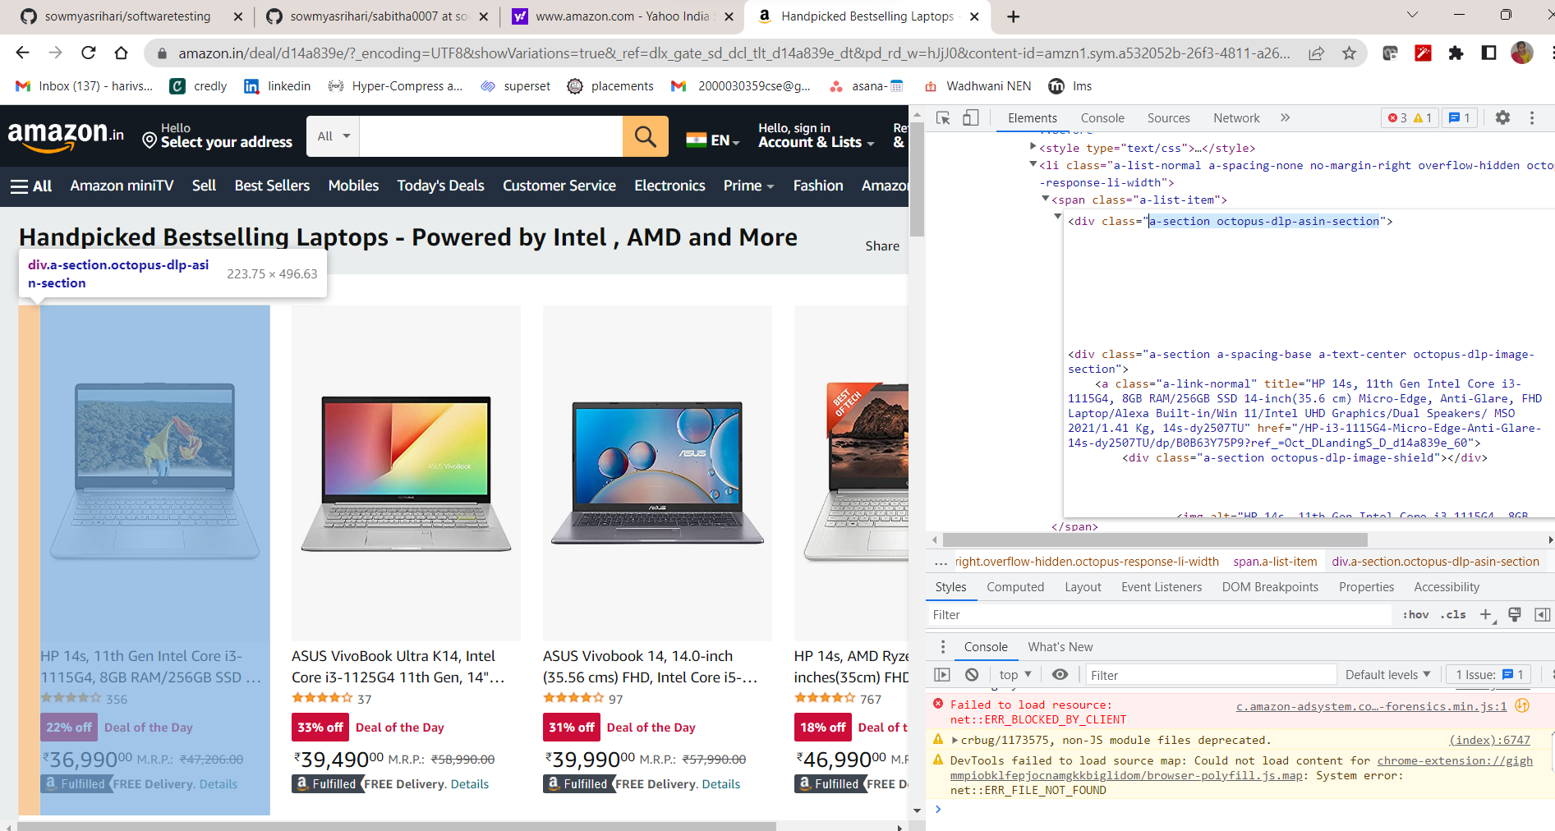CSS SELECTOR:

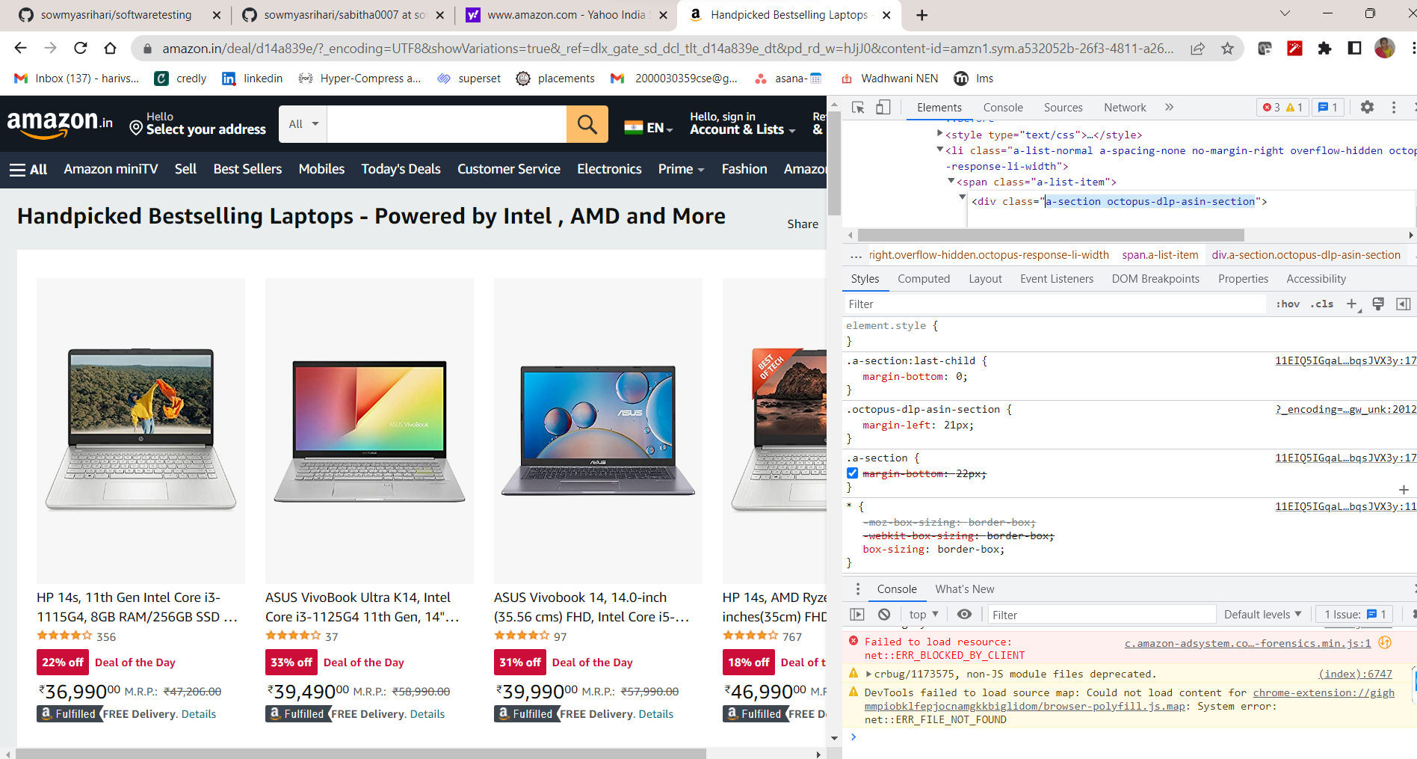

NAME:

