Report

Date | 18 -09-2026
Team ID | MCA
Project Name | Smartphone Usage, Digital Addiction & Well-Being Analytics
Maximum Marks | 5 Marks

A report is a comprehensive document that provides a detailed and structured account of data analysis, findings, and insights. It is typically used for in-depth analysis, documentation, and communication of results. Reports are suitable for a diverse audience, including decision-makers, analysts, and stakeholders who need a comprehensive understanding of the data.
Designing a report in Power BI involves connecting to data sources, creating visualizations like charts and graphs, customizing their appearance and interactivity, organizing them logically on the canvas, formatting elements for consistency and clarity, and optionally creating dashboards for a summarized view. Throughout the process, it's essential to consider the audience's needs and ensure the report effectively communicates insights from the data. Finally, iterate based on feedback to continually improve the report's design and usefulness.
Observations drawn from reports in Power BI can provide valuable insights into business performance and trends.
Report-1
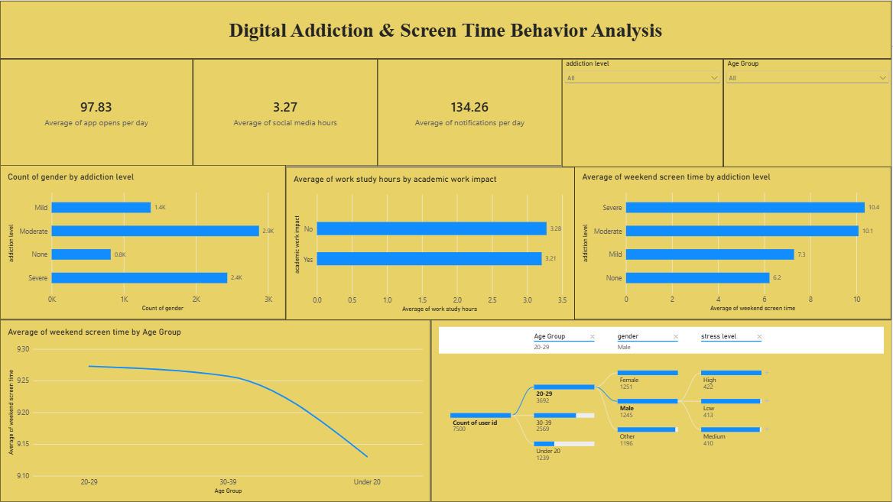
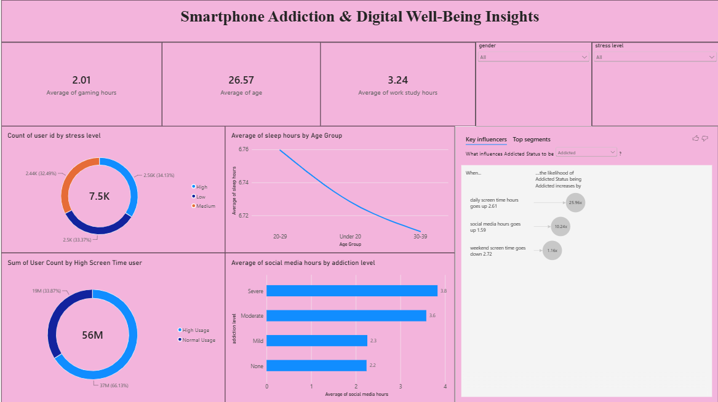
Report-2
1. Trends Over Time:
- Analyze how key metrics (e.g., sales, revenue, or customer counts) change over different time periods (monthly, quarterly, annually) to identify growth patterns or seasonality.
2. Performance Comparisons:
- Compare performance across different categories, such as regions, products, or departments, to determine which areas are excelling or underperforming.
3. Customer Segmentation:
- Assess demographic data (age, gender, location) to understand customer segments and tailor marketing strategies accordingly.
4. Goal Achievement:
- Measure progress against established KPIs (Key Performance Indicators) to assess whether business goals are being met.

Example:
- Daily Engagement Metrics: Monitored individuals show an average of 97.83 app opens per day and face an intensive average of 134.26 notifications per day, highlighting high ambient digital distraction.
- Social Media Consumption: Users spend an average of 3.27 hours on social media daily, with severe addiction segments peaking at an average of 3.8 hours, demonstrating a direct link between platform usage and perceived addiction severity.
- Academic and Work Habits: The sample reflects an average of 3.24 work-study hours, which remains mostly steady regardless of perceived academic impact levels (3.28 hours for "No" versus 3.21 hours for "Yes").
- Weekend Screentime Escalation: Weekend device usage jumps heavily among highly dependent users, with severe addiction cases reaching a high average weekend screen time of 10.4 hours, compared to just 5.2 hours for non-addicted users.
- Age-Based Screentime Trends: A clear demographic drop is present in weekend consumption; younger cohorts aged 20–29 log the highest weekend screen time (nearly 9.27 hours), which steadily slopes down to its lowest point among users under 20 (9.12 hours).
- Stress Level Segmentation: The cohort splits relatively evenly across psychological markers, tracking 2.56K users under high stress (34.13%), followed closely by 2.5K medium stress users (33.37%) and 2.44K low stress users (32.49%).
- Sleep Deprivation Patterns: Rest habits show a sharp negative trajectory as age demographics shift, showing that the 20–29 age bracket enjoys the highest rest at 6.76 average sleep hours while the 30–39 demographic drops down to 6.71 sleep hours.
- Key Addiction Influencers: Statistical metrics reveal that the likelihood of an individual's status being flagged as "Addicted" increases by 25.96 times when daily screen time rises by 2.61 hours, establishing it as the most critical behavioral driver.

