**Docker Commands**

Pull SpringBoot Code From Git Repo

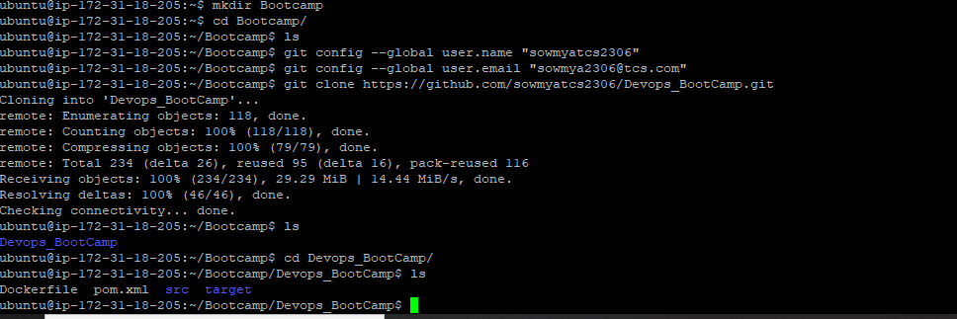

Building Image from Docker File

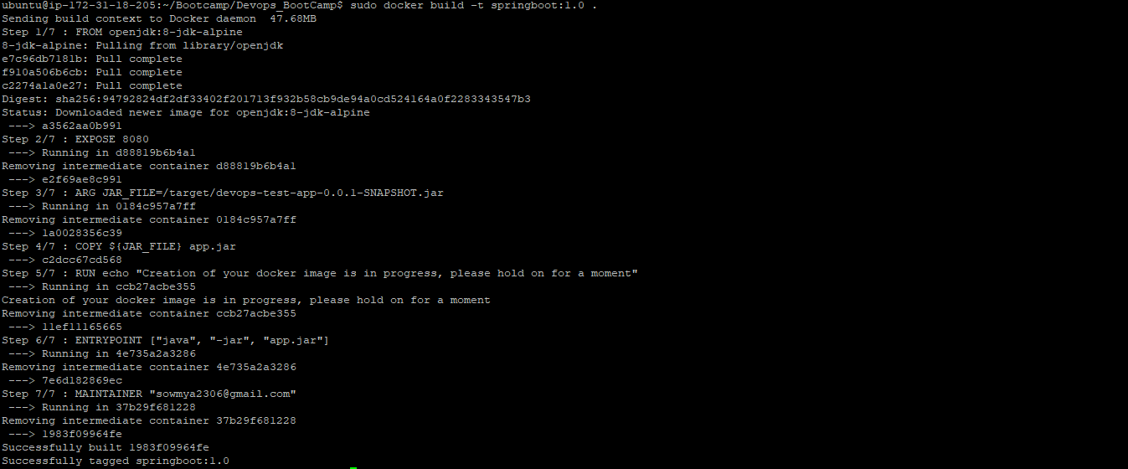

**ubuntu@ip-172-31-18-205:~/Bootcamp/Devops_BootCamp$ sudo docker image build -t springboot:1.0 .**

**Sending build context to Docker daemon 47.68MB**

**Step 1/7 : FROM openjdk:8-jdk-alpine**

**---> a3562aa0b991**

**Step 2/7 : EXPOSE 8080**

**---> Using cache**

**---> e2f69ae8c991**

**Step 3/7 : ARG JAR_FILE=/target/devops-test-app-0.0.1-SNAPSHOT.jar**

**---> Using cache**

**---> 1a0028356c39**

**Step 4/7 : COPY ${JAR_FILE} app.jar**

**---> Using cache**

**---> c2dcc67cd568**

**Step 5/7 : RUN echo "Creation of your docker image is in progress, please hold on for a moment"**

**---> Using cache**

**---> 11ef11165665**

**Step 6/7 : ENTRYPOINT ["java", "-jar", "app.jar"]**

**---> Using cache**

**---> 7e6d182869ec**

**Step 7/7 : MAINTAINER "sowmya2306@gmail.com"**

**---> Using cache**

**---> 1983f09964fe**

**Successfully built 1983f09964fe**

**Successfully tagged springboot:1.0**

**ubuntu@ip-172-31-18-205:~/Bootcamp/Devops_BootCamp$ sudo docker image ls**

**REPOSITORY TAG IMAGE ID CREATED SIZE**

**springboot 1.0 1983f09964fe 10 minutes ago 122MB**

**openjdk 8-jdk-alpine a3562aa0b991 14 months ago 105MB**

**ubuntu@ip-172-31-18-205:~/Bootcamp/Devops_BootCamp$**

**DockerFile**

FROM openjdk:8-jdk-alpine

EXPOSE 8080

ARG JAR_FILE=/target/devops-test-app-0.0.1-SNAPSHOT.jar

COPY ${JAR_FILE} app.jar

RUN echo "Creation of your docker image is in progress, please hold on for a moment"

ENTRYPOINT ["java", "-jar", "app.jar"]

MAINTAINER [sowmya2306@gmail.com](mailto:sowmya2306@gmail.com)

**Docker Login And Image pushed to Docker Hub**

root@ip-172-31-18-205:~/Bootcamp/Devops_BootCamp# docker push sowmyatcs2306/springboot:1.0

The push refers to repository [docker.io/sowmyatcs2306/springboot]

20ab5d043683: Pushed

ceaf9e1ebef5: Pushed

9b9b7f3d56a0: Pushed

f1b5933fe4b5: Pushed

1.0: digest: sha256:ccc016bd68db4e68e7548e5f58a85fae5a2a1092e77760498f7d97607d1f649e size: 1159

**Docker Run and ps Commands**

root@ip-172-31-18-205:~/Bootcamp/Devops_BootCamp# docker run -p 9090:9090 -d sowmyatcs2306/springboot:1.0

e5f7a3acb57c8cf125b1c0831127a022bd11aa997525657fee536a2309c5cae5

root@ip-172-31-18-205:~/Bootcamp/Devops_BootCamp# docker ps

CONTAINER ID IMAGE COMMAND CREATED STATUS PORTS NAMES

e5f7a3acb57c sowmyatcs2306/springboot:1.0 "java -jar app.jar" 10 seconds ago Up 8 seconds 8080/tcp, 0.0.0.0:9090->9090/tcp eloquent_nobel

**Test-Curl**

**root@ip-172-31-18-205:~/Bootcamp/Devops_BootCamp# curl http://localhost:9090/getParam?num=90**

**90**

**root@ip-172-31-18-205:~/Bootcamp/Devops_BootCamp# curl http://localhost:9090/random**

**380**

**Output :**

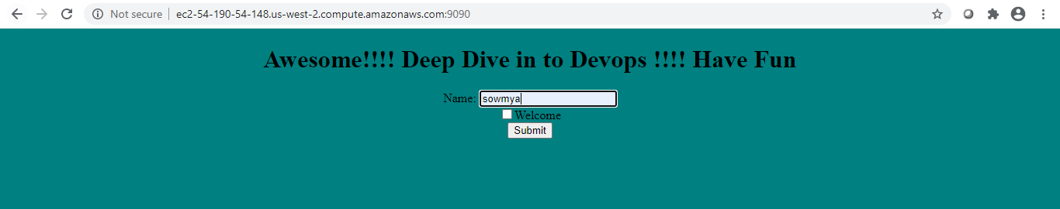

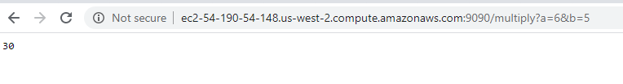

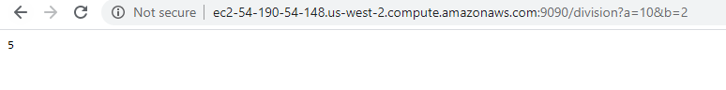

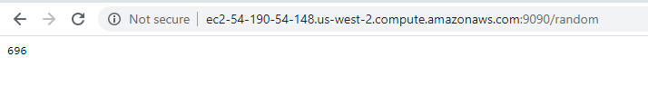

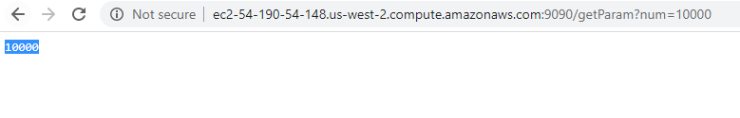

Docker HUB-Image pushed

