Checkout code from GIT ,build the package via mvn ,deploy it in tomcat local

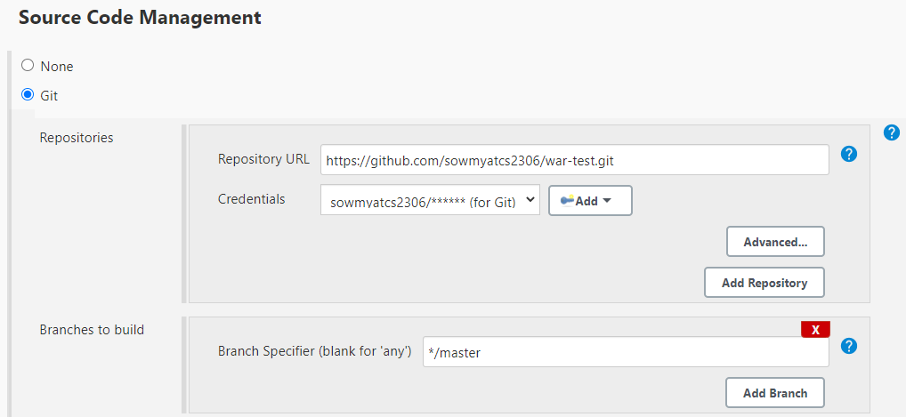

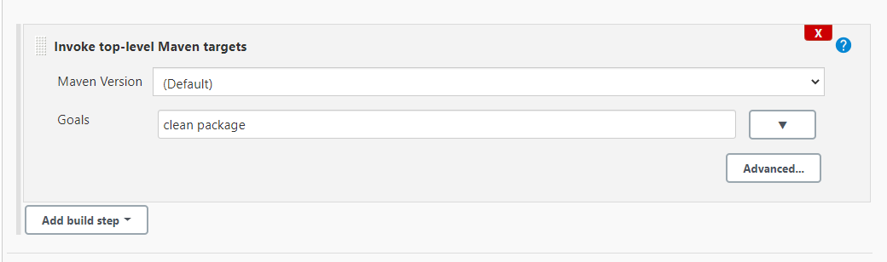

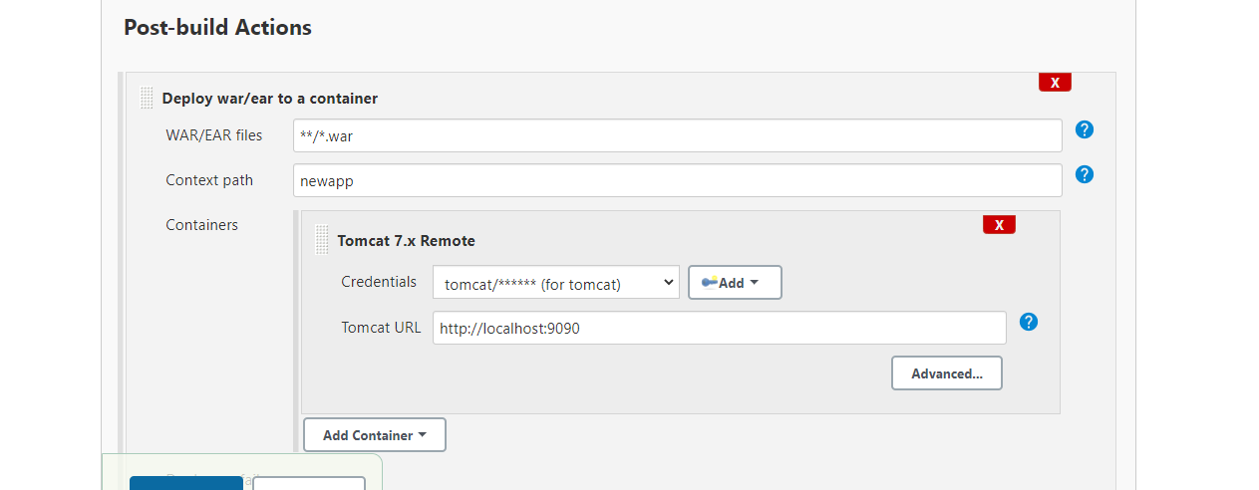

Output

