**Project Name:** PicStudio Lab

**Team Members:** Sowmya Thogiti

Vigneshwar Reddy Lenkala

Bharath Kumar Gandhasiri

**Project Logo:** 

**Project problem/issues cover:** Many stores have different kinds of shopping areas including groceries, cosmetics, clothing, Photographic studios, Floristry, etc. Nowadays people are being so busy, as they don’t have time to step into a photographic studio and grab the frames by selecting them in-person providing the photographs of their loved ones. But our application PicStudio Lab is going to make it easy for people in making their memories with a wide variety of frames available to rest on their home walls by just ordering online.

**Activities and its purposes:** Below are the activities used to develop the application and sketches are shown as per the descriptions.

**Login activity**: The purpose of the login activity is to help users to log in to the application which redirects work with selecting frames and explore a new world of frames available in it. This activity consists of 2 text edits (email/phone) and a password which allows alphanumeric values, 2 buttons for Sign Up and log in, 1 clickable link for forgot password, and accepts login through Gmail, Facebook.

**Create profile Activity**: The purpose of create profile activity is to help users to first signup and set up all basic details provided in the text views such as first name, middle name, last name, gender details, age, email, password updates. By clicking on the button named signup, it allows users to create a profile and continue shopping the frames of selected pictures.

**Navigation bar:** We have a navigation bar to navigate through the app when clicked on the icons of Profile, Home, and services.

**ForgotPassword Activity:** The purpose of forgot password activity is to help the user to login even if they forgot password by just providing an email ID and click a button for requesting a link for resetting the password. Once the password has been reset, the user can click on the clickable text “Back to login” page.

**MailConfirmation Activity:** The purpose of MailConfirmation Activity is to help the user to confirm that the mail with reset link has been sent to the inbox of registered email. If the user is not able to receive any reset link to the registered mail, then we have the feasibility to re-send the link by just clicking the resend button.

**Facebook Activity:**  This activity helps user if they don’t have an account in PicStudio Lab by just logging in to Facebook account with their credentials.

**Google Activity:** This activity helps users if they don’t have an account in PicStudio Lab by just logging into the Gmail account with their credentials.

**Frame Setup Activity**: The purpose of the frame setup activity in the home navigation bar is to help users to select a wide variety of frames available on the PicStudio lab application. We have frame 1 for solo pictures, frame 2 for a couple pictures, frame 3 for family pictures, and so on to add to the cart for purchase.

**Services Activity:** When the service's icon in the navigation bar is clicked, the options to select the frames for a wide variety of uploads of pictures are shown here. Once any variety is selected by a toggle button, then it redirects to respective activities designed for individual frame selection based on the occasion by selecting the icon of the camera to select a pic there itself or by clicking the image icon to upload any pictures from the file manager.

**Wedding Activity:**  Here this activity lets the user select different types of frames available in the wedding category and select the number of items by clicking the add button and finally add them to the cart by just clicking another button “add to cart” which navigates to uploading pictures screen.

**Invitation Activity:** Here this activity lets the user select different types of frames available in the Invitation category and select type of frames and the number of items by clicking the add button and finally add them to the cart by just clicking another button “add to cart” which navigates to uploading pictures screen.

**Confirmation Page Activity:** Here this activity lets the user to confirm the page. At the point when the user taps on the Save button Marriage.pdf is sent to the users given email address and the connection Marriage.pdf shows the review variant and the user can see the content like "Please check your email for the attachments of your beloved pictures of marriage".

**Zoom Invitation Activity:** Here this activity lets the user to join the Zoom meeting as the users can’t go to the wedding genuinely because of the pandemic over the world. The link is loacted underneath the content “Here is the link to join”.

**Browse pics Activity**: The purpose of the browse pics activity is to help users to upload pictures of the pictures of their loved ones or self-pictures on selected frames. Based on the selection done in the frame setup activity items to cart which is a button, this activity screen allows you to upload pictures based on the number of frames selected. If it is a multiple frame layout, we have a clickable link to add more for asking browse options.

**Payment Activity**: The purpose of payment activity is to help users to select the “Take Away” option or “Cash on delivery” based on the situation user needs to be done for the delivery. If the user selects a take away option, it allows users to give the customer details by providing the name of the customer, order number, pickup date, and time of the product. Once the user agree to terms and conditions, it is ready for placing an order by just clicking the button name “ Place order”. As it is not feasible to order it by providing bank details, we used only take away here.

**Map Activity**: The purpose of map activity is to help users identify the locations of the PicStudio Lab where one can walk in directly to collect their orders. This also has a map view shown and has navigation options to check whether it is on your way to work where people can grab their orders easily.

**GitHub Link:** [**https://github.com/sowmyathogiti/PicStudioLab**](https://github.com/sowmyathogiti/PicStudioLab)

**Roughsketches:**

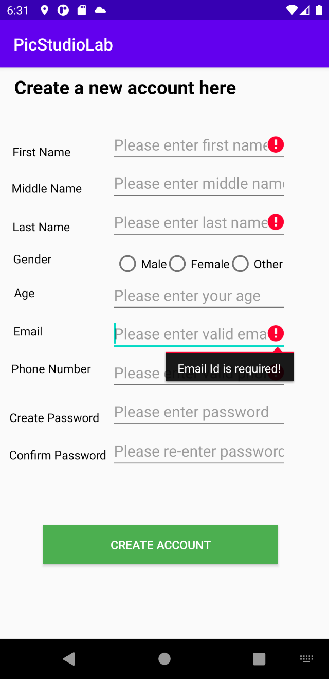 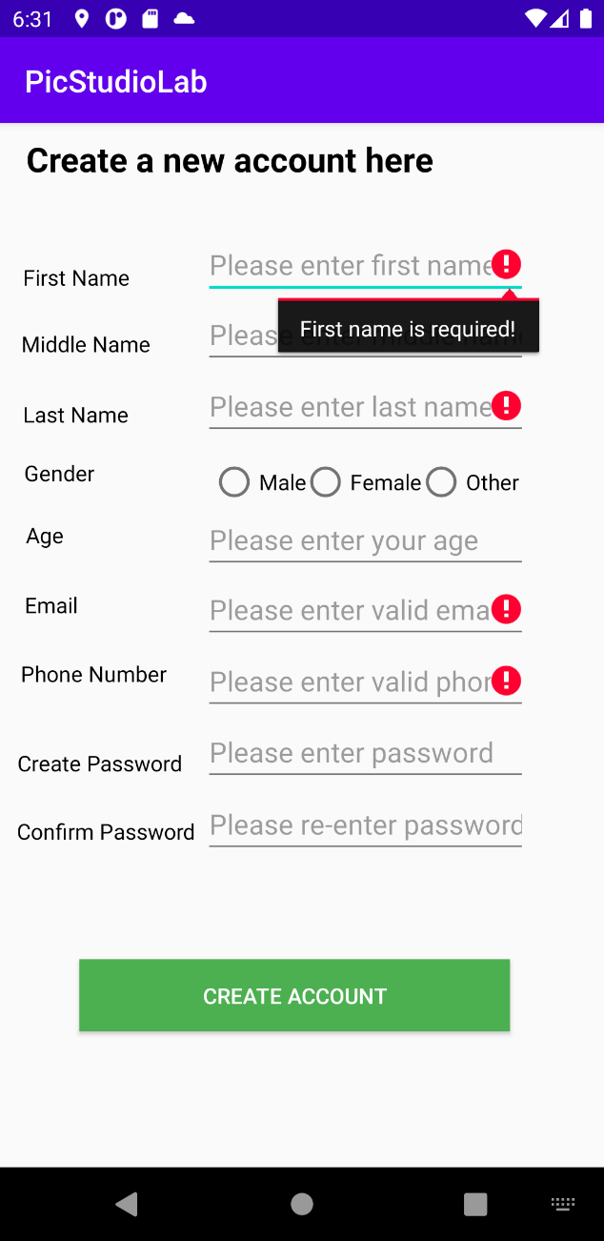

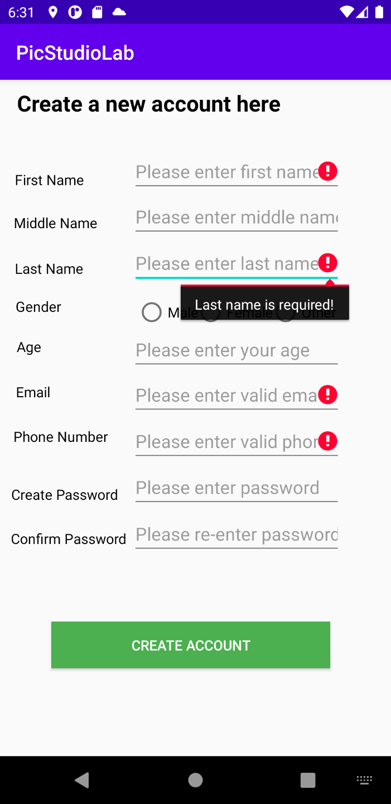 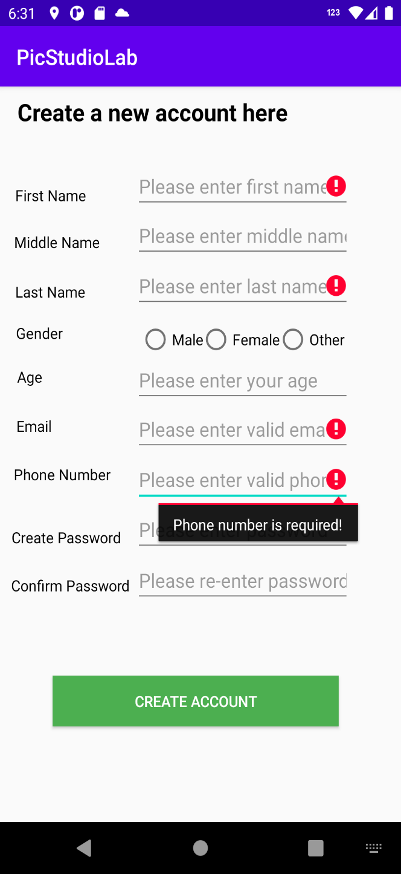

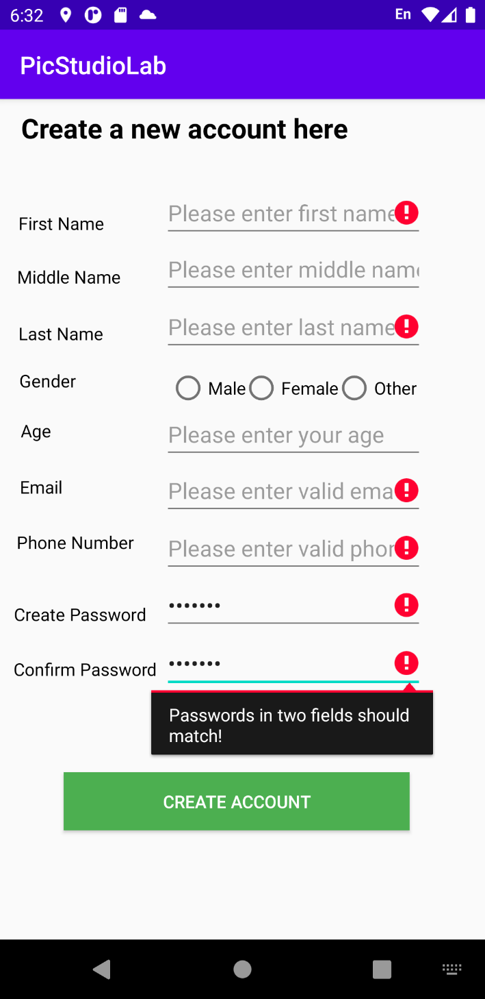 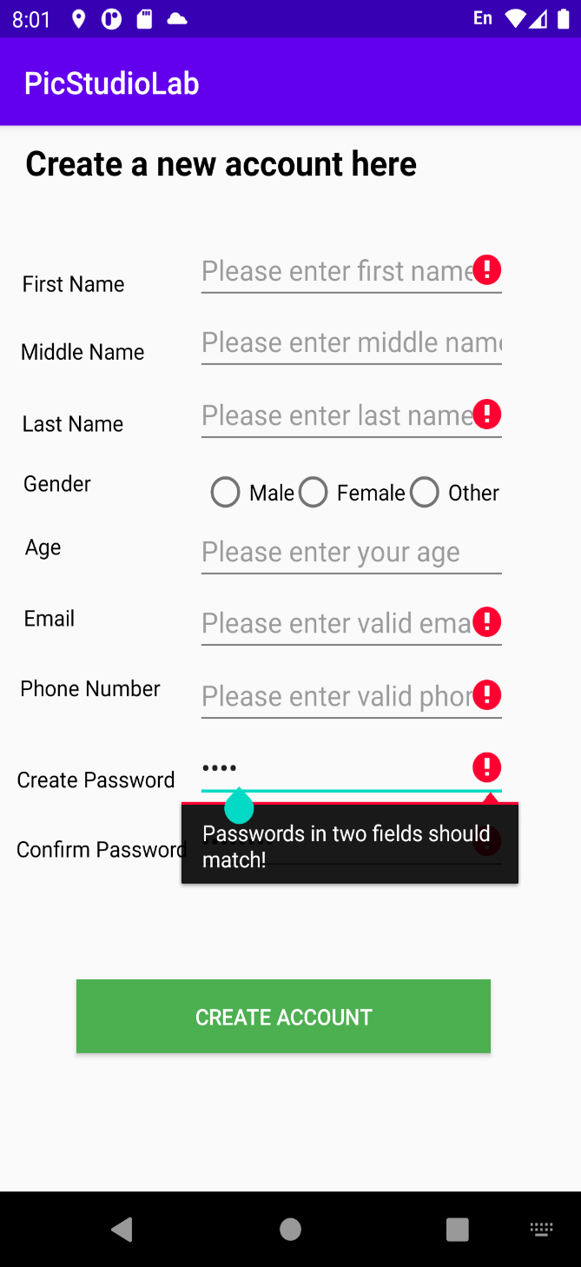

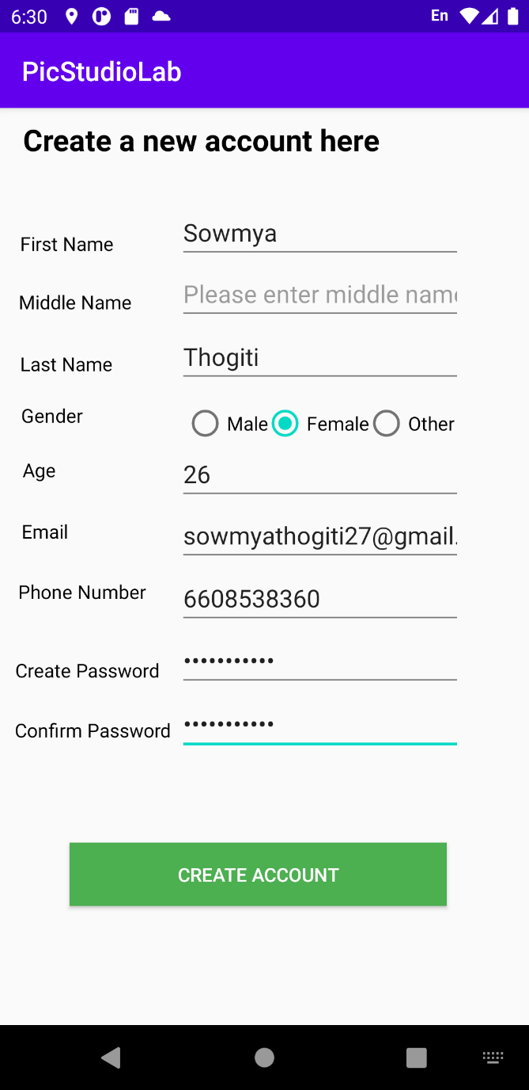 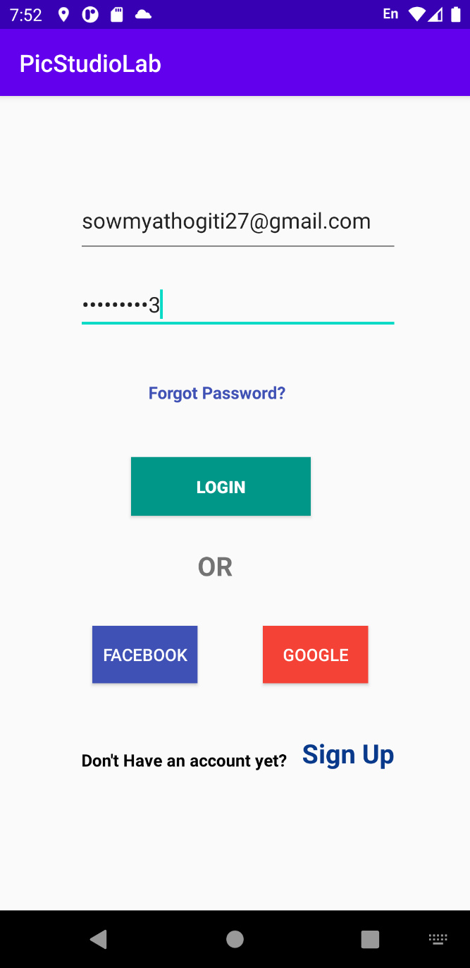

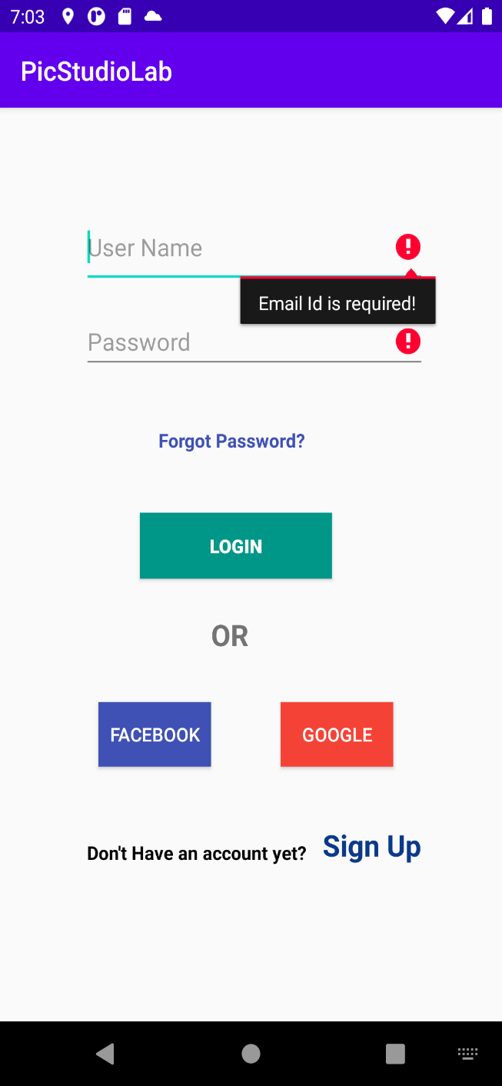 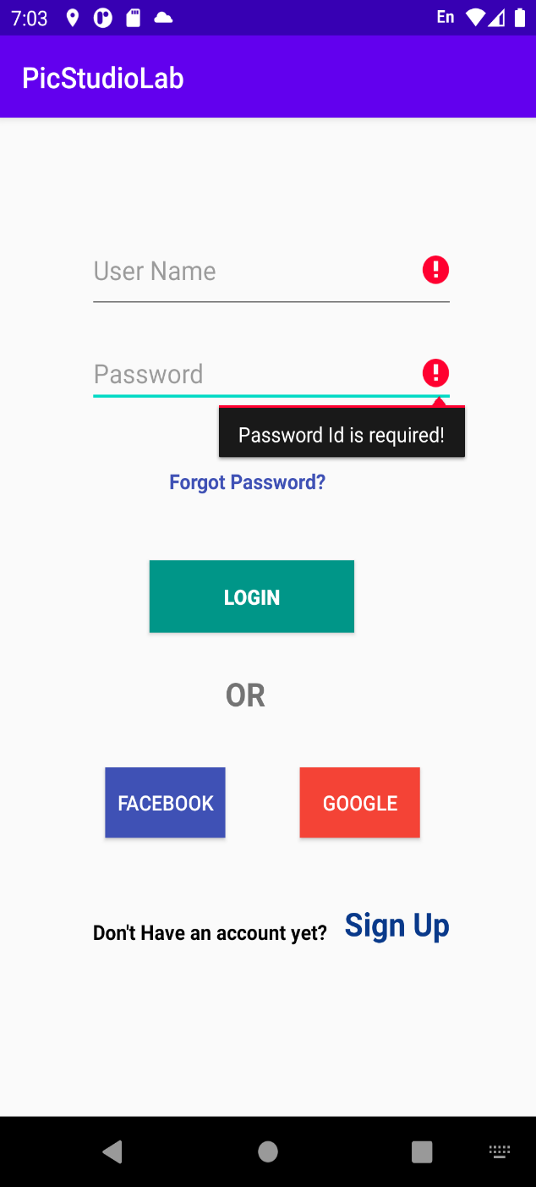

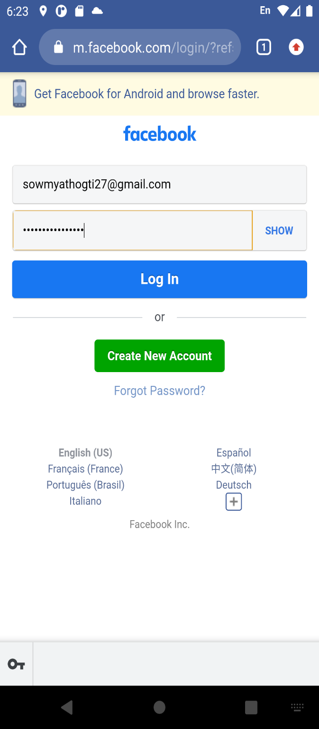 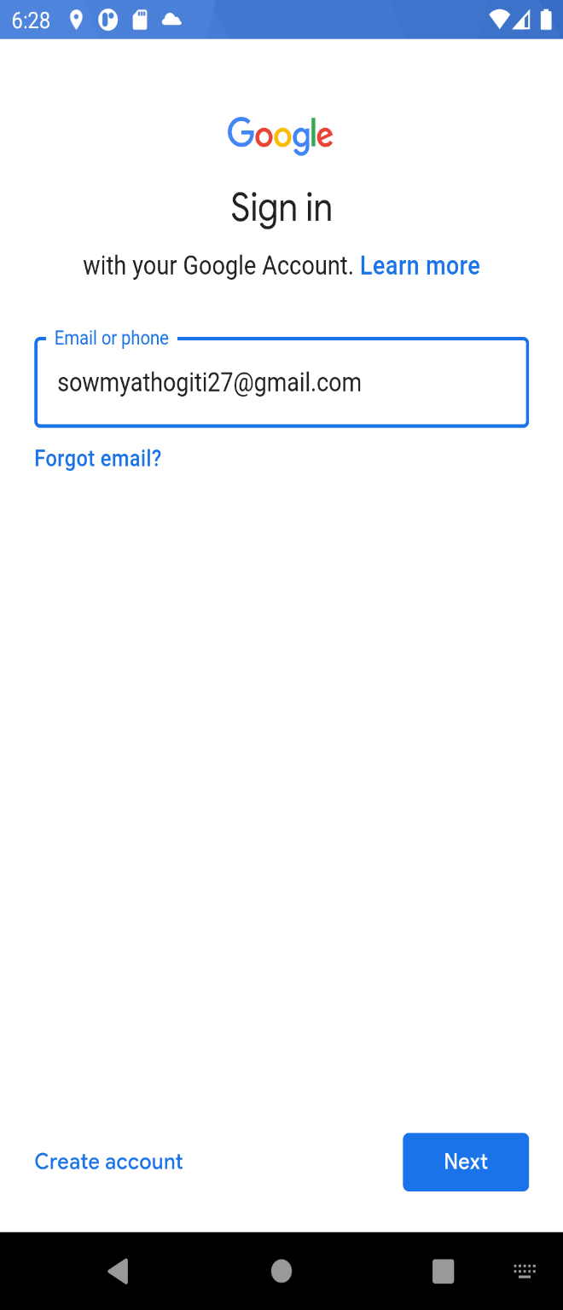

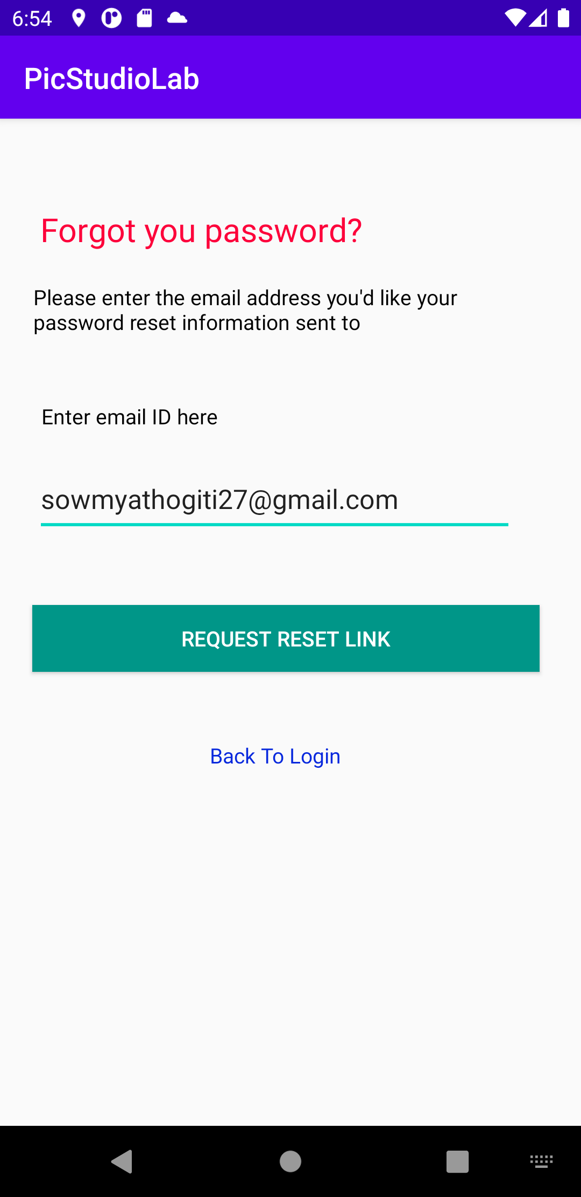 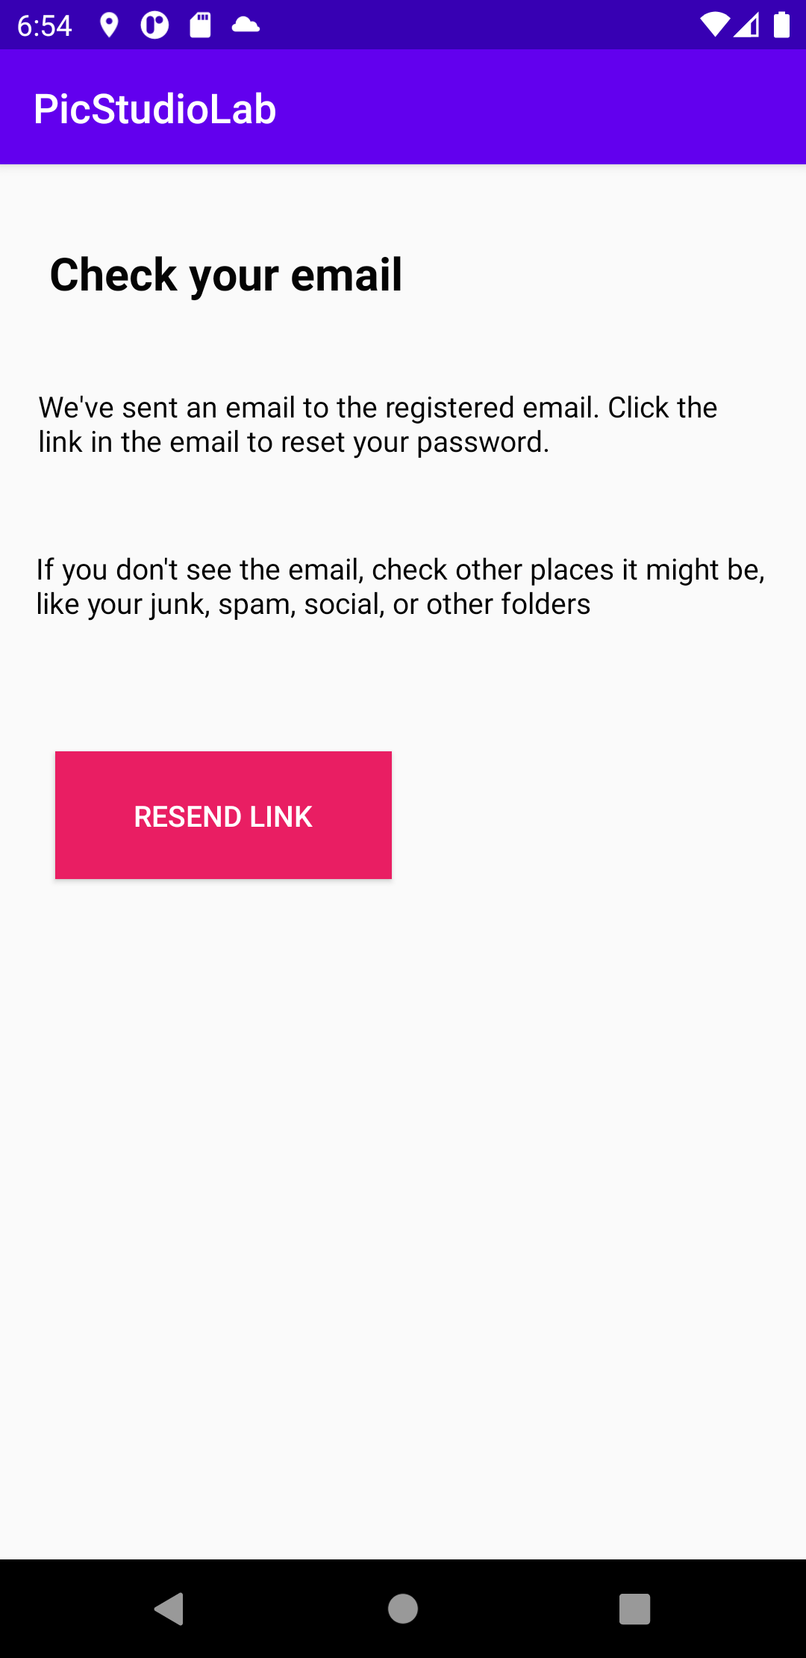

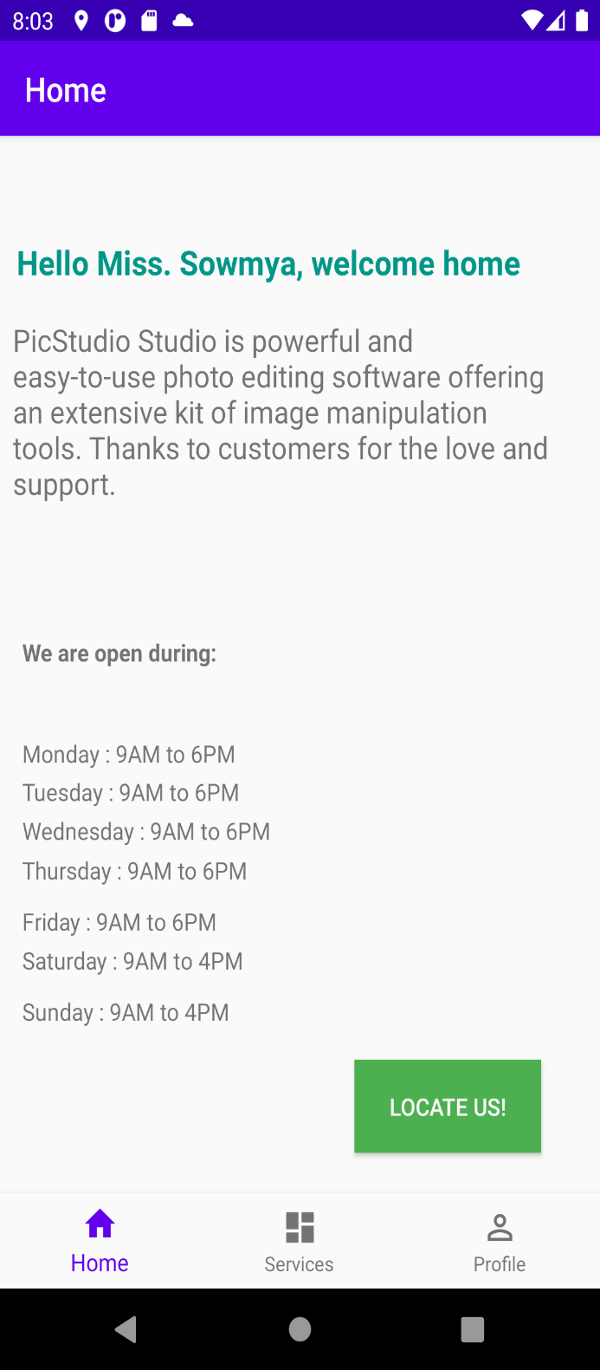

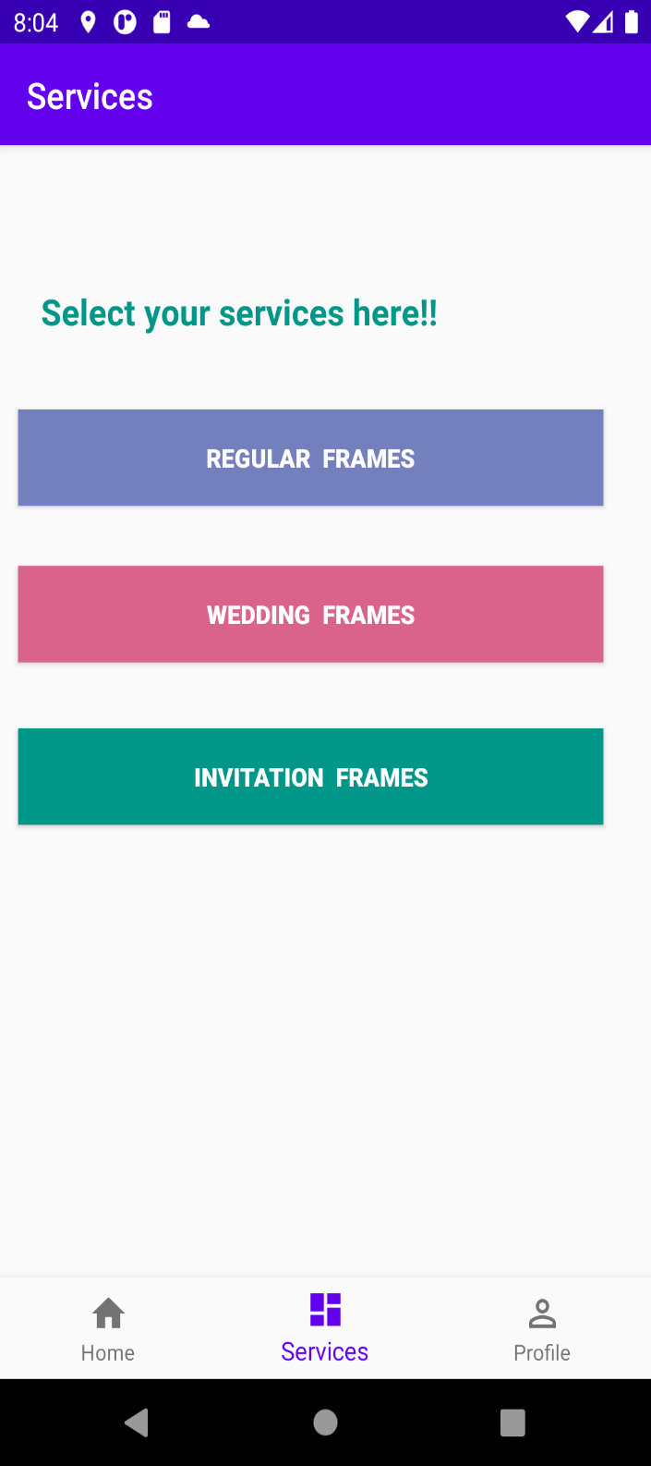 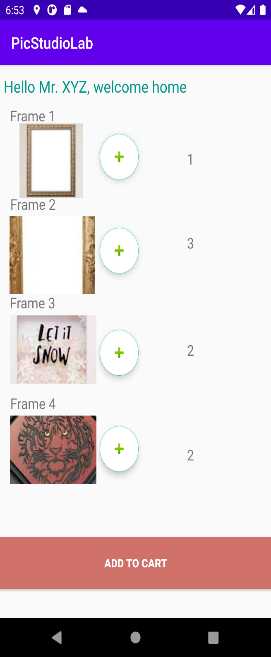

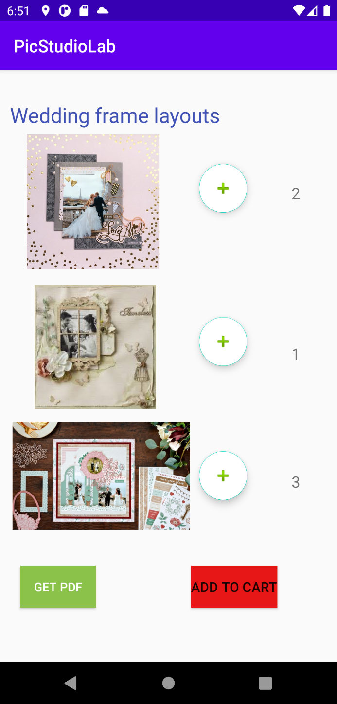 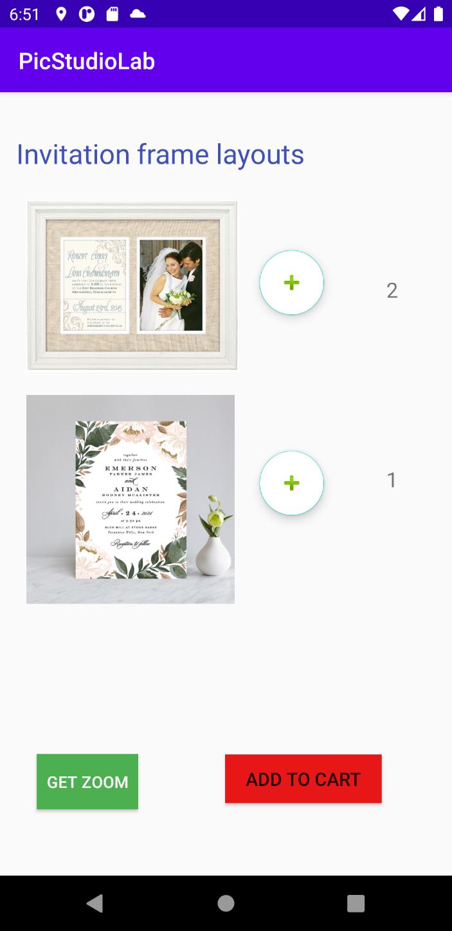

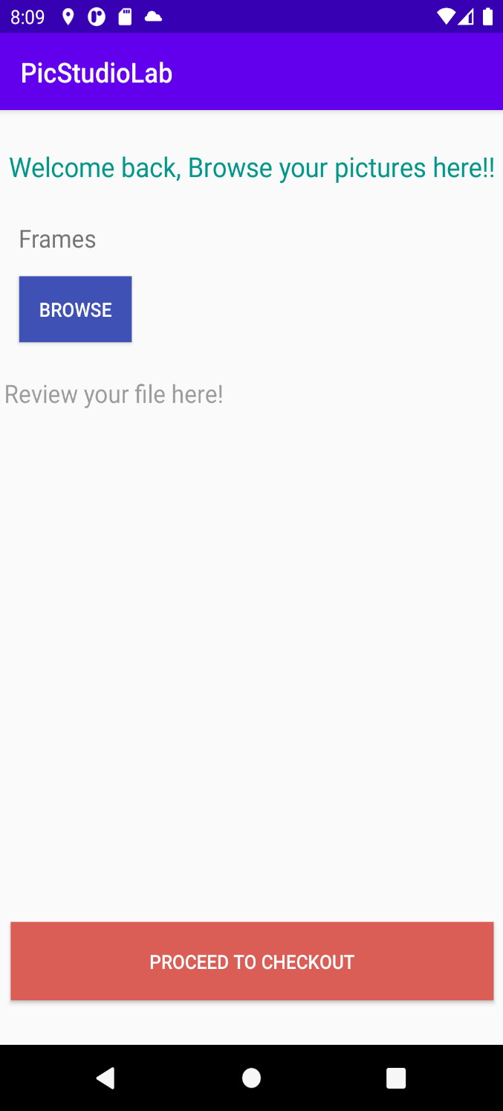 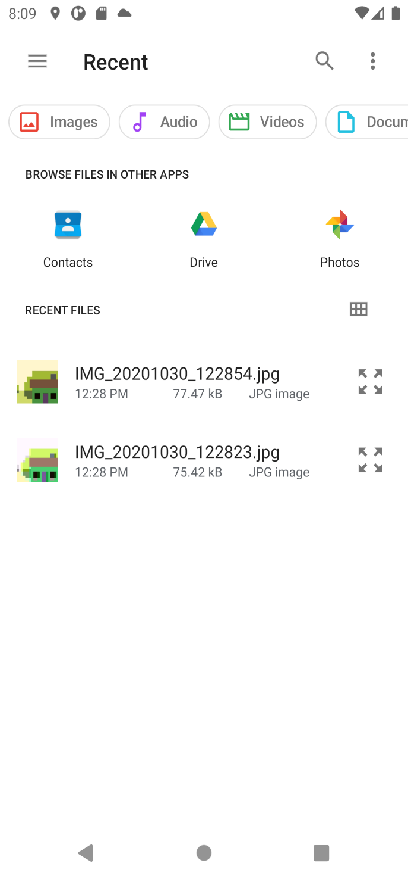

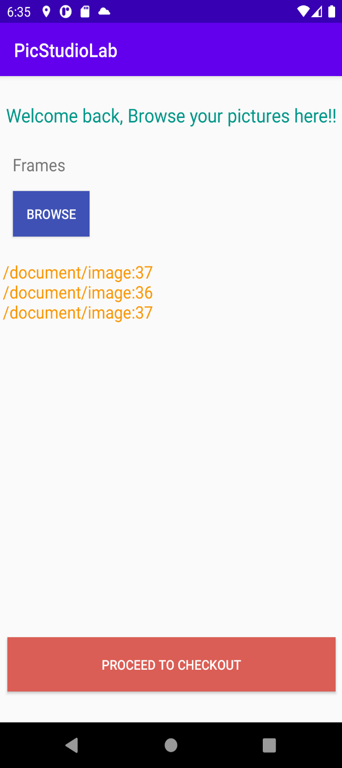 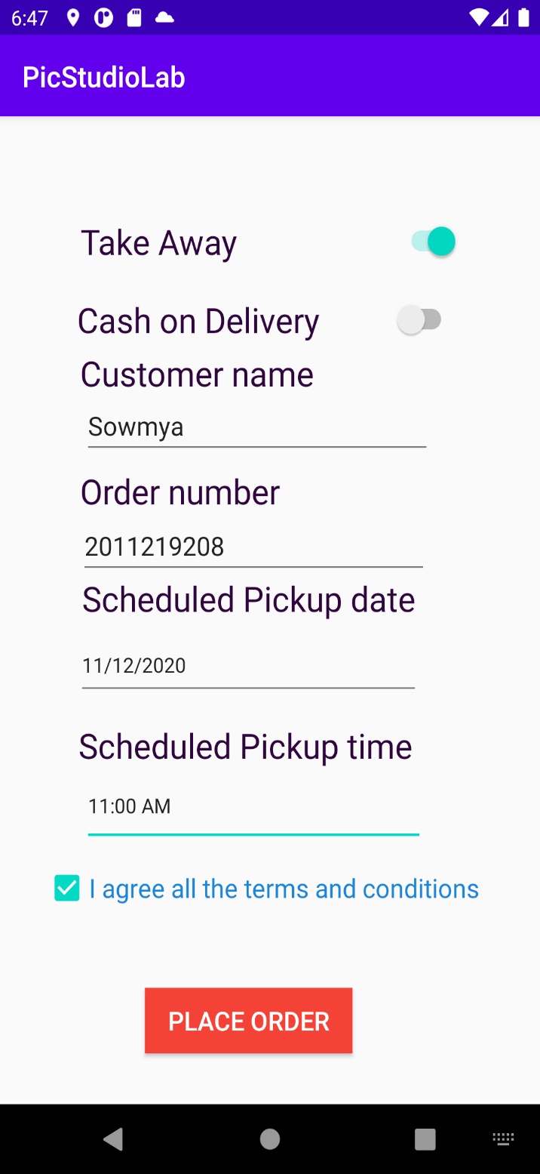

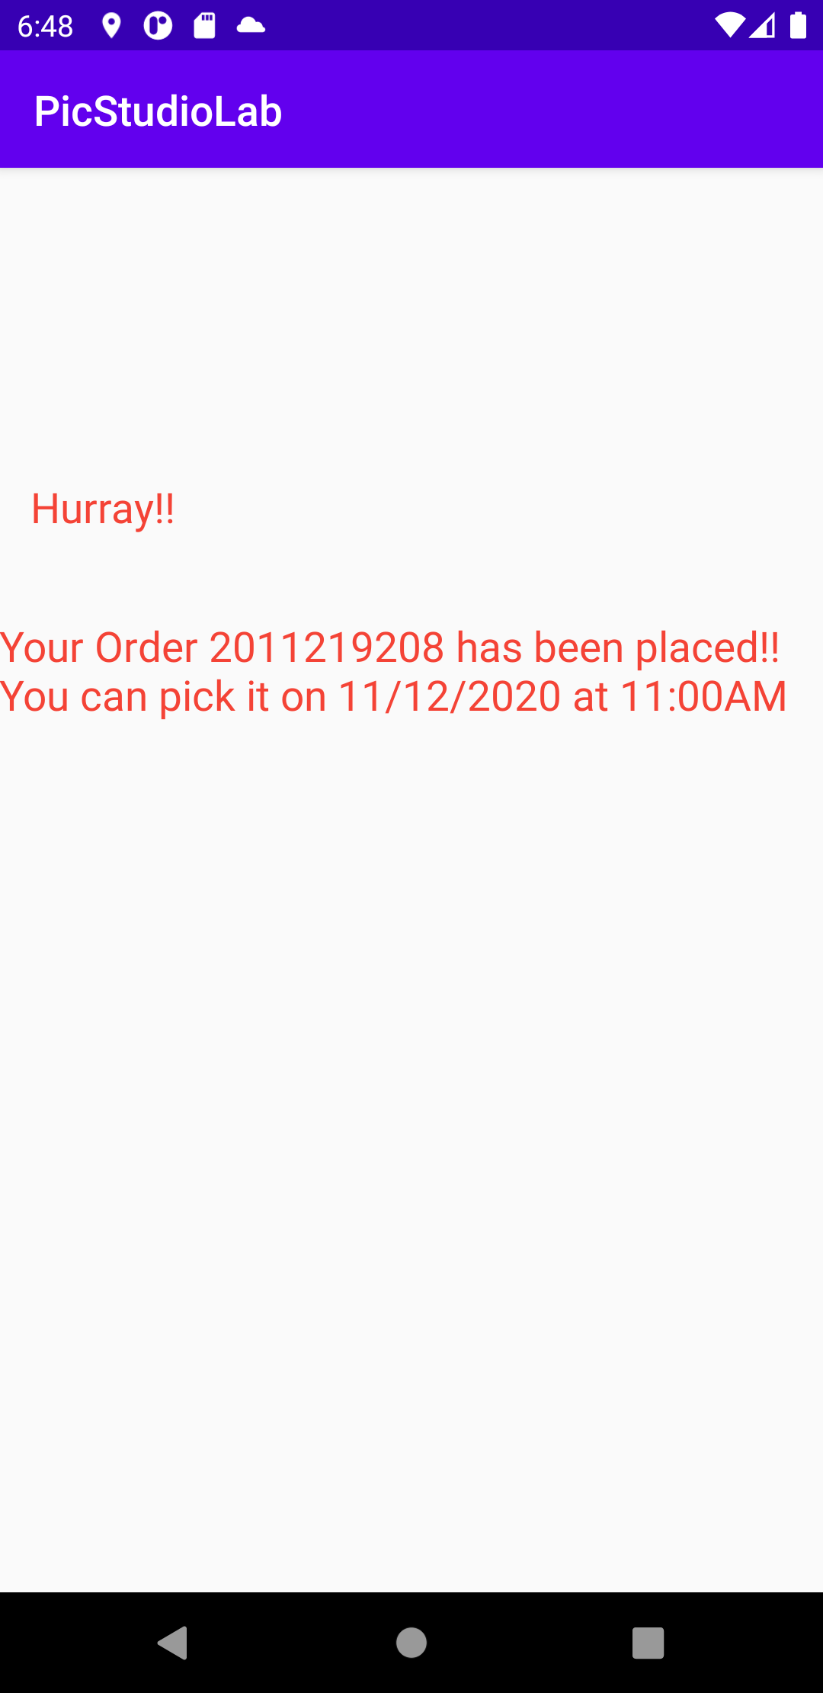 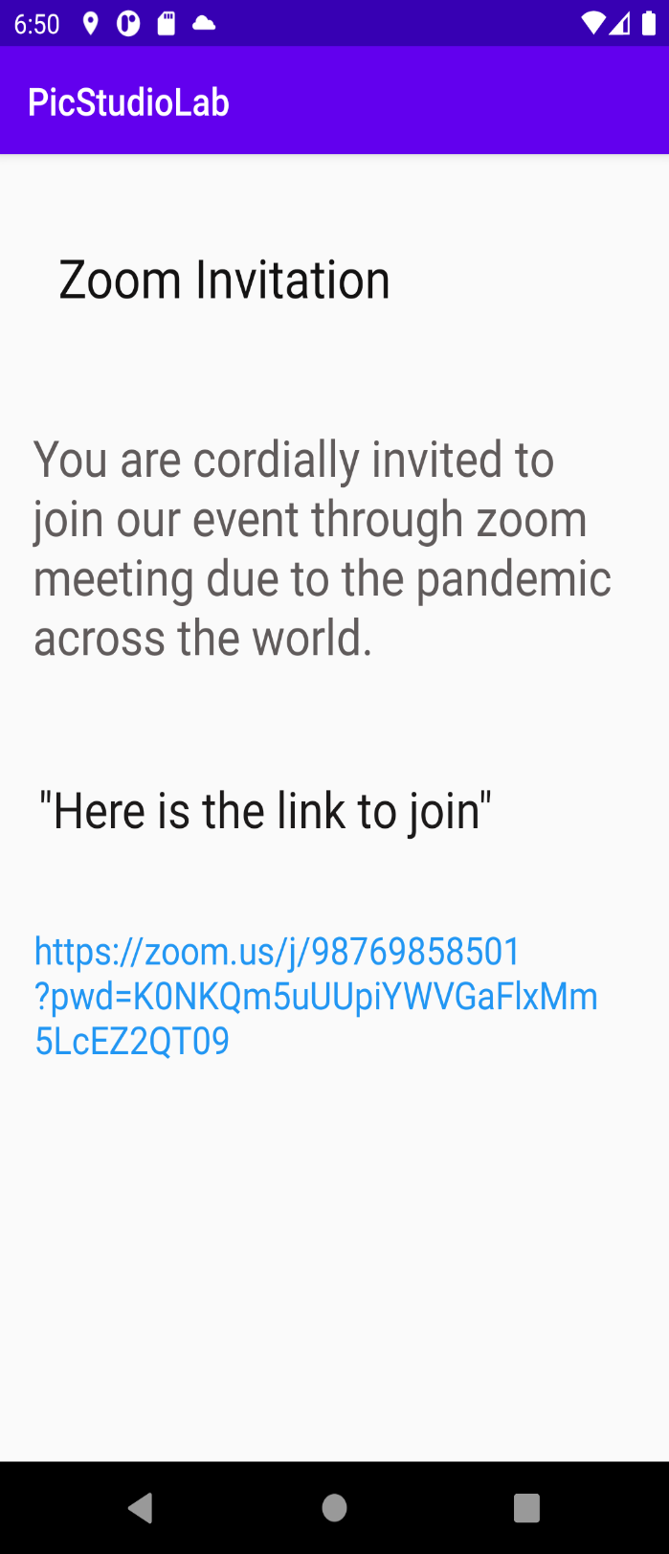

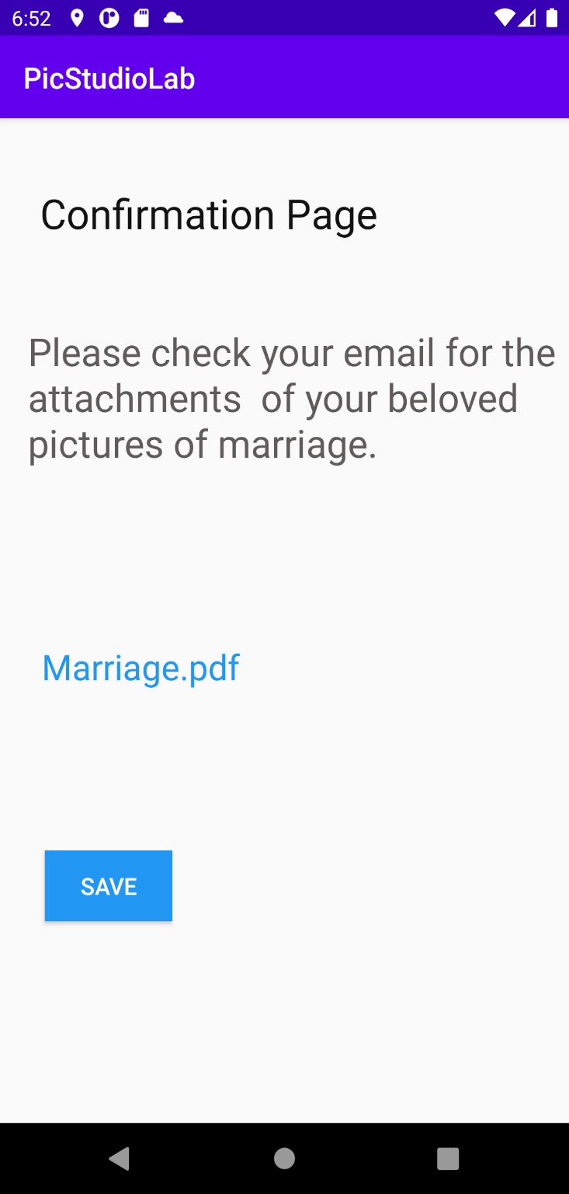 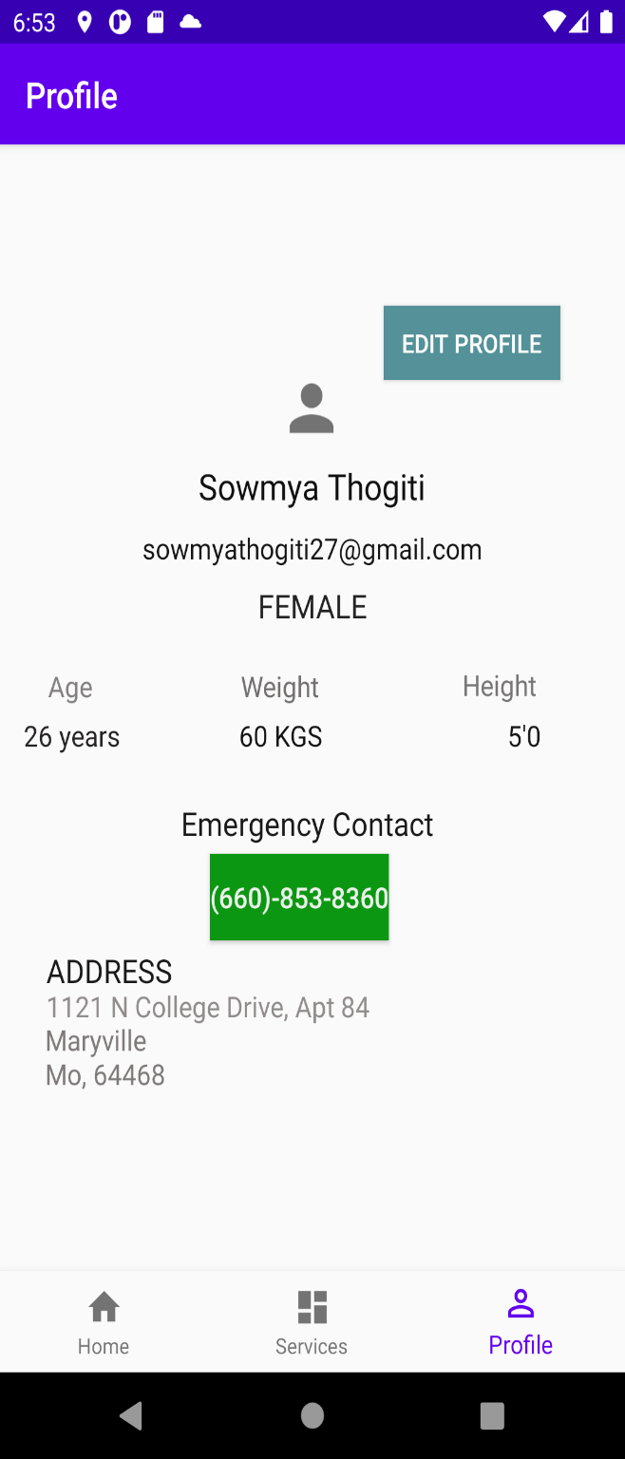

**Flow Chart:**

