Handwritten Digit Recognition on MNIST
Project report: SVM baseline vs. Convolutional Neural Network
Name: ____________ Roll No / ID: ____________ Date: ____________

1. Objective
Machines struggle with handwritten digits because every person writes differently. This project trains models that classify 28x28 grayscale images into the digits 0-9, and compares a classical machine-learning baseline (SVM) with a small deep-learning model (CNN).

2. Dataset
MNIST: 60,000 training images and 10,000 test images, 28x28 pixels, grayscale (0-255). The ten classes are roughly balanced. Pixel values were normalised to the range 0-1. For the CNN, 10 percent of the training images were held out as a validation set.
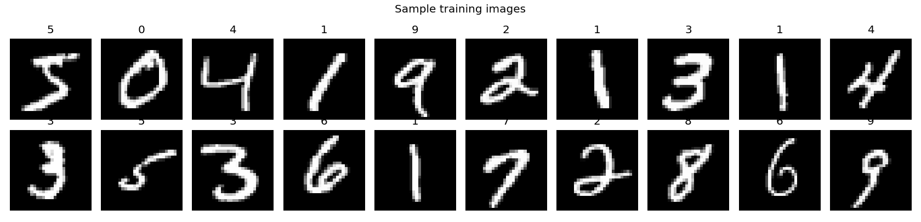
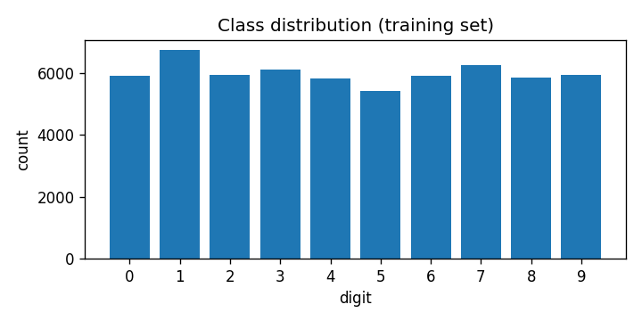

3. Models
- Baseline: SVM with RBF kernel (C=5, gamma='scale') on the 784 flattened pixels. To keep training time reasonable, it was trained on the first 10,000 training images.
- CNN: Conv2D(32) - MaxPool - Conv2D(64) - MaxPool - Flatten - Dropout(0.4) - Dense(10, softmax). Adam optimiser, sparse categorical cross-entropy, 5 epochs, batch size 128, trained on all 60,000 images (10 percent used for validation).
- Evaluation: accuracy and macro F1-score on the 10,000 unseen test images, plus confusion matrices.

4. Results
Model | Test accuracy | Macro F1 | Training time
SVM (10k train images) | 96.79% | 0.9677 | 46 s
CNN (60k train images) | 98.83% | 0.9883 | 125 s

The CNN is better by 2.0 percentage points. Note that the models were trained on different amounts of data (10k vs 60k), so the comparison reflects both the model type and the training-set size.
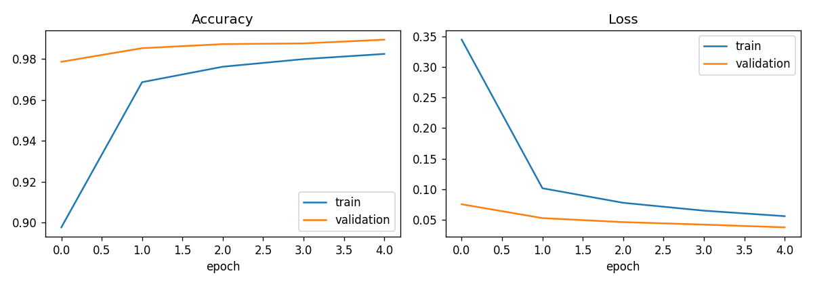
Figure: CNN accuracy and loss per epoch. Training and validation curves stay close together, so there is no strong over-fitting.
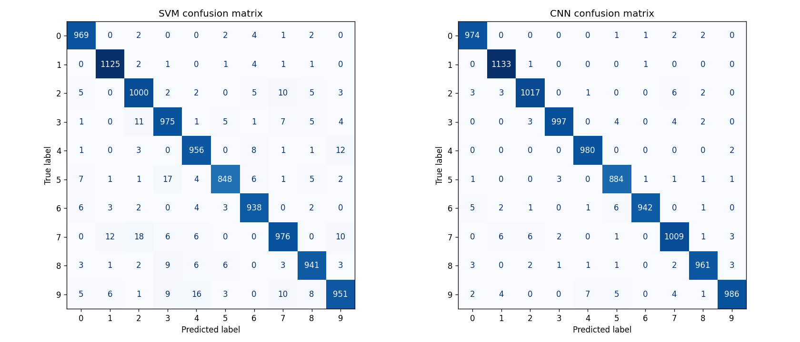
Figure: confusion matrices (left SVM, right CNN). Most mass is on the diagonal (correct predictions).

5. Sample predictions
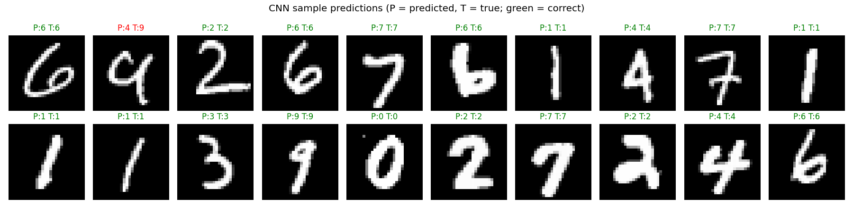
Green titles are correct predictions, red are errors (P = predicted, T = true).
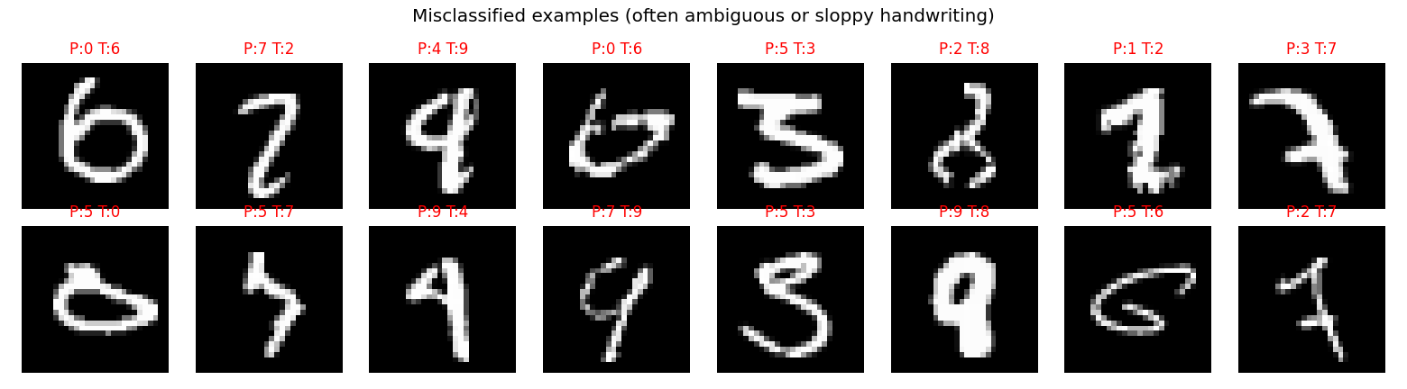
Examples of CNN mistakes. Many are genuinely ambiguous or sloppily written digits.

6. Conclusion and future work
A small CNN reaches about 98.8 percent test accuracy in a couple of minutes on a CPU, outperforming the SVM baseline (96.8 percent). CNNs work better because they learn spatial features such as strokes and loops, while the SVM treats each pixel independently. Future work: data augmentation (shifts and rotations), a deeper network, training the SVM on all data, and testing on photographs of real handwriting.

