# Forecasting

**Business Objective:** Forecast the CocaCola prices

**Step 1:** Install the library and read the file.

**Step 2:**Use the TimePlot to show the Salesdata distribution.

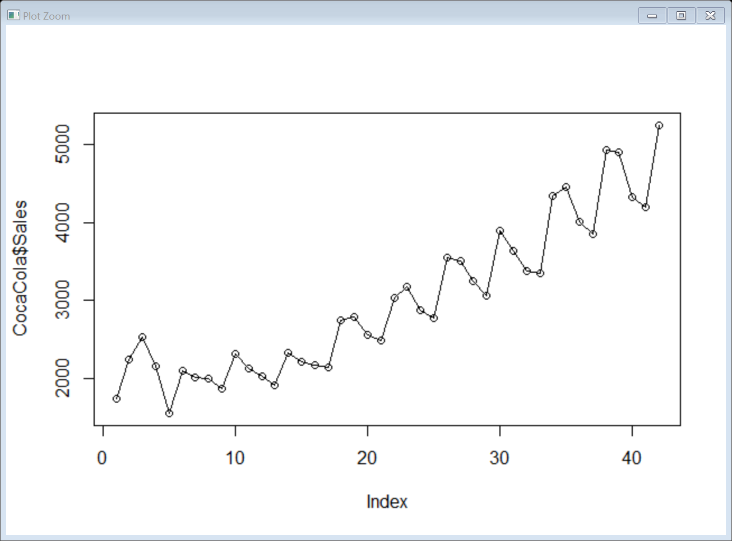

Step 3: Creating 12 dummy variables

Step 4: Column bind the Q1 Q2 Q3 Q4

Step 5: Calculate the t , log t , Squared t values

Step 6: Create the train and test data

Step 7: Linear Model RMSE = 644.0188

Step 8: Exponential model RMSE = 524.73

Step 9: Quadratic model RMSE = 434.71

Step10: Additive Seasonality RMSE = 1785.135

Step 11: Additive Linear Seasonality model RMSE = 534.6979

Step 12: Additive Seasonality with Quadratic RMSE = 236.7075

Step 13: Multiplicative Seasonality RMSE = 1871.203

Step 14: Multiplicative Seasonality Linear trend RMSE = 335.102

Conclusion: Additive Seasonality with Quadratic trend has least RMSE value

**Business Objective:** Forecast Airlines Passengers data set.

Step 1: Install the packages and read the Airlines dataset

Step2: Use the TimePlot to show the Airlines Seasonality

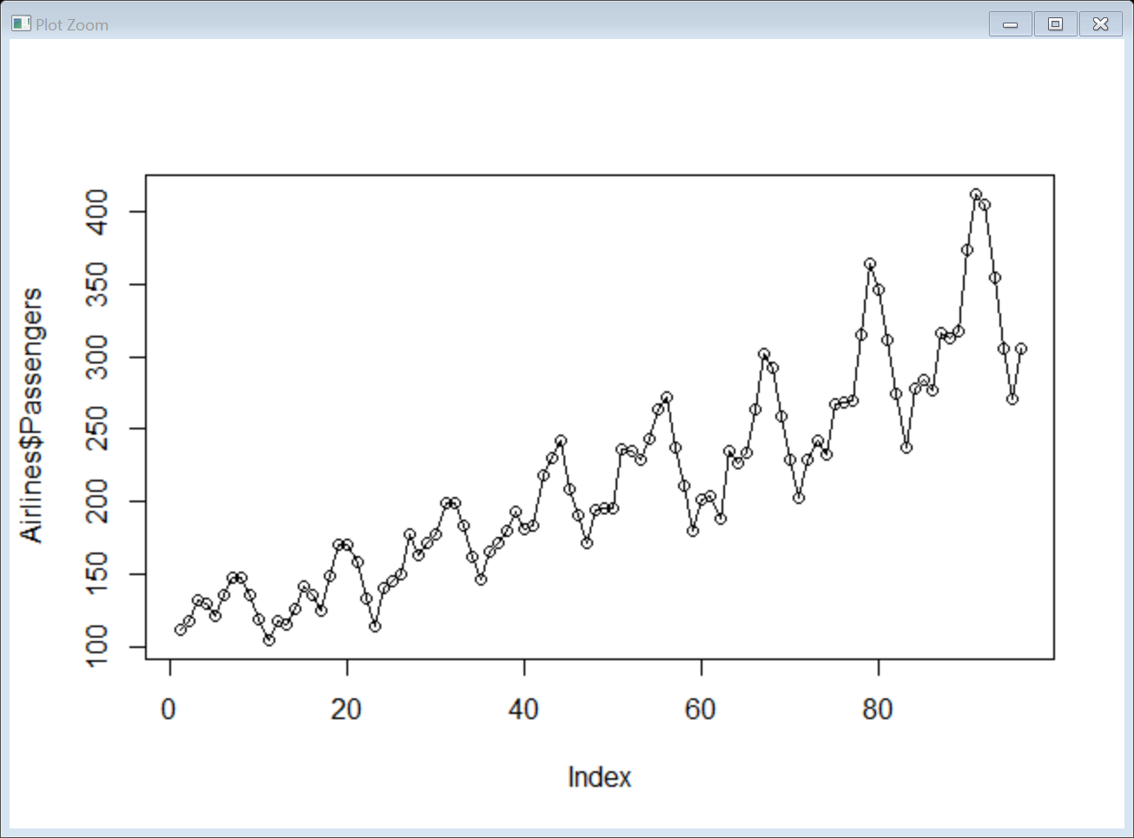

Step 3: Creating 12 dummy variables, Calculate the t , log t , Squared t values, Create the train and test data.

Step 4: Linear Model RMSE = 53.19924

Step 5: Exponential model RMSE = 46.05736 and Adjusted R2 - 82.18 %

Step 6: Quadratic model RMSE = 48.05189

Step 7: Additive Seasonality RMSE = 132.8198

Step 8: Additive Seasonality with Linear RMSE = 35.34896 and Adjusted R2 - 94.75%

Step 9: Additive Seasonality with Quadratic RMSE = 26.36082 and Adjusted R2 - 95.24%

Step 10 : Multiplicative Seasonality RMSE = 140.0632

Step 11 : Multiplicative Seasonality Linear trend RMSE = 10.51917 and Adjusted R2 - 97.23%

Step 12 : Preparing table on model and it's RMSE values

Conclusion: Multiplicative Seasonality Linear trend has least RMSE value

**Business Objective:** Plastic Sales Time Series Forecast

Step1: Install the packages and read the Airlines dataset

Step2: Use the TimePlot to show the Plastic Sales Seasonalityfrom the plot below it looks multiplicative linear trend.

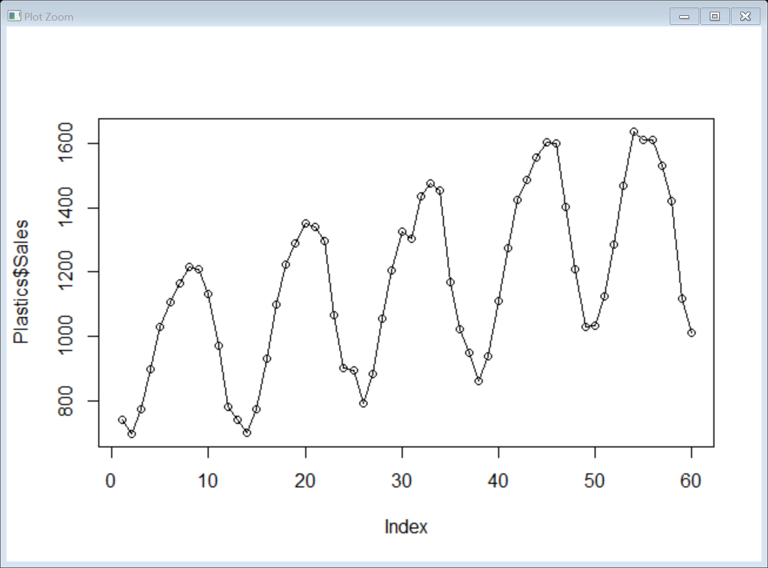

Step 3: Creating 12 dummy variables, Calculate the t , log t , Squared t values, Create the train and test data.

Step 4: Linear Model RMSE = 260.9378 and Adjusted R2 Value = 31.50

Step 5: Exponential RMSE = 268.6938 and Adjusted R2 - 30.25 %

Step 6: Quadratic RMSE=297.4067 and Adjusted R2 - 30.48%

Step 7: Additive Seasonality RMSE = 235.6027 and Adjusted R2 Value = 69.85

Step 8 : Additive Seasonality with Linear RMSE = 135.5536 and Adjusted R2 - 96.45%

Step 9: Additive Seasonality with Quadratic RMSE = 218.1939 and Adjusted R2 - 97.68 %

Step 10 : Multiplicative Seasonality RMSE = 239.6543

Step 11: Multiplicative Seasonality Linear trend RMSE = 160.6833 and Adjusted R2 - 97.51%

Conclusion : Multiplicative Seasonality Linear trend has least RMSE value

