# KNN

# Business Objective: Prepare a model for glass classification using KNN

**Step 1:** Installand setup all required library

Step 2: Its ideal to standardize featues in the data, especially with KNN algorithm. Lets go ahead and standardize. Here we are using scale() to standardize the feature columns of glassand assign it to a new variable. Exclude the target column Type while scaling.

Step 3: Below plot explains the relation between different features in glass dataset.

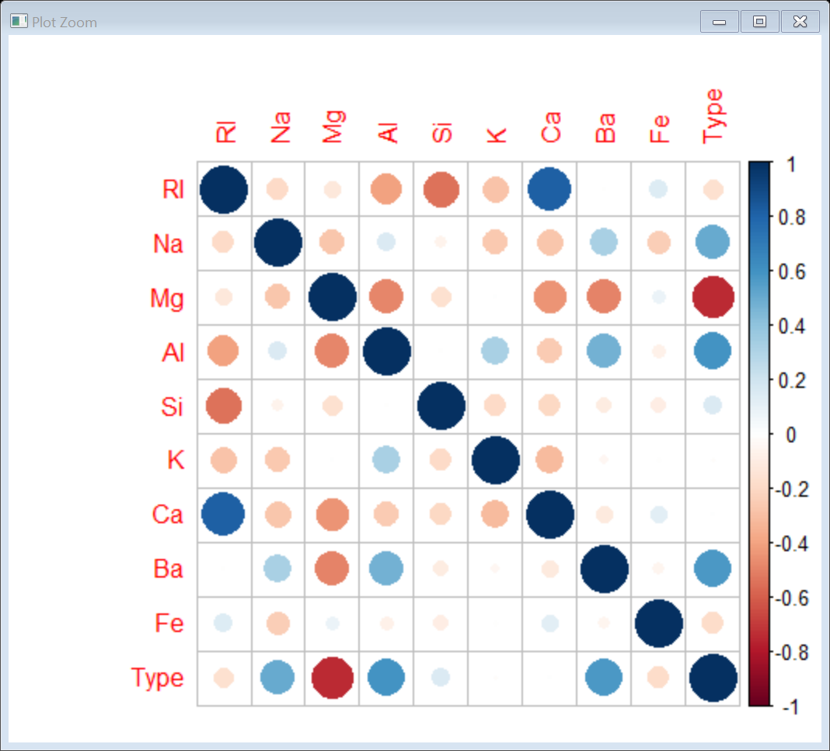

Step 4: We use caTools() to split the datainto train and test datasets with a SplitRatio = 0.70.

Step 5: We use knn() to predict our target variable Type of the test dataset with k=1.

Step 6: The above results reveal that our model achieved an accuracy of **72.3076923 %**. Lets try different values of k and assess our model.

Step 7: Lets plot error.type vs k using ggplot.

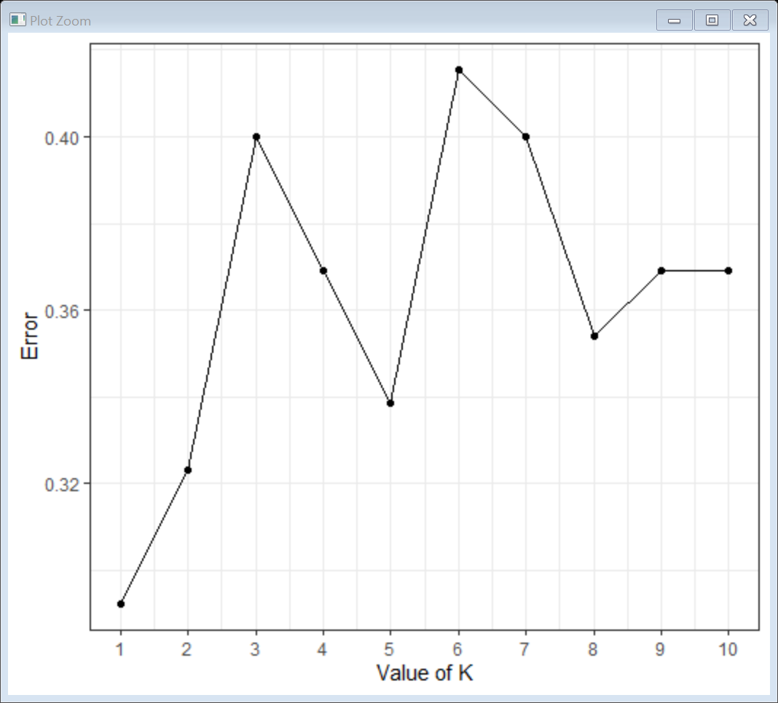

Step 8: The above plot reveals that error is lowest when k=3 and then jumps back high revealing that k=3 is the optimum value. Now lets build our model using k=3 and assess it.

Conclusion: The Above Model gave us an accuracy of **78.4615385 %.**

# Business Objective: Implement a KNN model to classify the animals in to categorie

Step 1: **:** Installand setup all required library

Step 2: convert all the variables to as.factor and exclude the 1st column .

Step 3: Data Partitioin using the set.seed() function.

Step 4: KNN model using Method repeatedcvfor train function.

Step 5: set.seed() for train and test partition.Fit the data with output variable type with all the variavles and method = knn, tunelenth = 20.

Step 6: Plot the fit as shown below with neighbors on the y axis and accuracy on x axis.

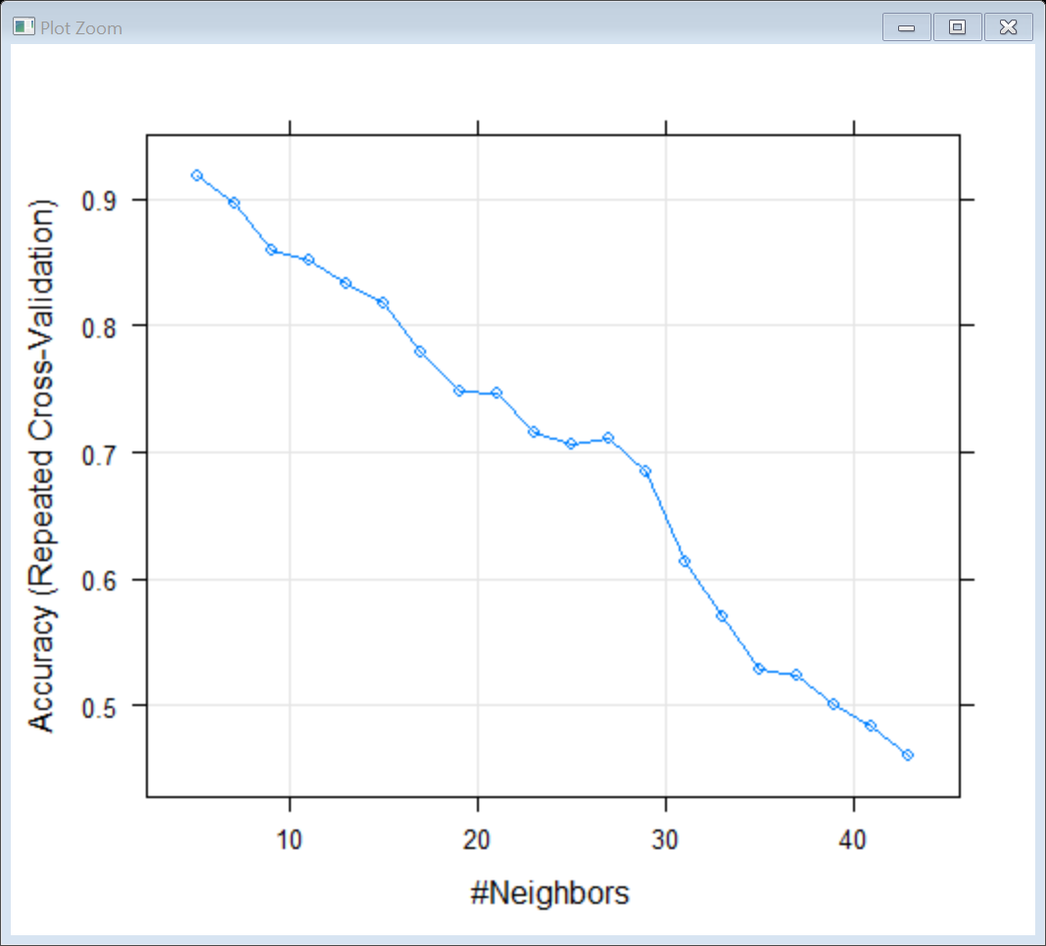

Step 7 : Confusion Matrix is used to calculate the accuracy

Conclusion: Accuracy of 89.66 %