Table of Contents

1.Introduction 1

1.1 Description 1

1.2 Features 1

1.3 5W and 1H 2

1.4 SWOT analysis 2

2. Requirements 2

2.1 High level requirements 2

2.2 Low level requirements 3

Low level requirements for HLR 1 3

3. Block diagram and components 4

3.1 Block diagram 4

3.2 Components 4

3.2.1 Sensors 4

3.2.2 Accuators 4

3.3.3 Other components 4

4. Architetcure 5

4.1 Behavioral diagram 5

4.1.1 High level flow chart 5

4.1.1 Low level flow chart 5

4.2 Structural diagram 5

4.1.1 Using case diagram 5

5 Applications 6

# 1.Introduction

## 1.1 Description

This is a password based door lock system. This a microcontroller based project which created a secure access for a door which needs a password to open the door. The system will be used in places where we need more security. It can be used in door, lockers, main gates of house and ATM etc. The system uses a seven segment display array to show the password, a matrix keypad to enter the numbers/password and operates a relay (to activate the solenoid valve) for locking and unlocking purpose. The system alarms through a buzzer if a wrong password is entered for 3 times continuously and the system resumes for 1 hour.

## 1.2 Features

The user must enter a correct password to gain access.

The system uses a seven segment display array to show the password, a matrix keypad to enter the numbers/password and operates a relay for locking and unlocking purpose.

The system alarms through a buzzer.

If a wrong password is entered for 3 times continuously and the system resumes for 1 hour.

## 1.3 5W and 1H

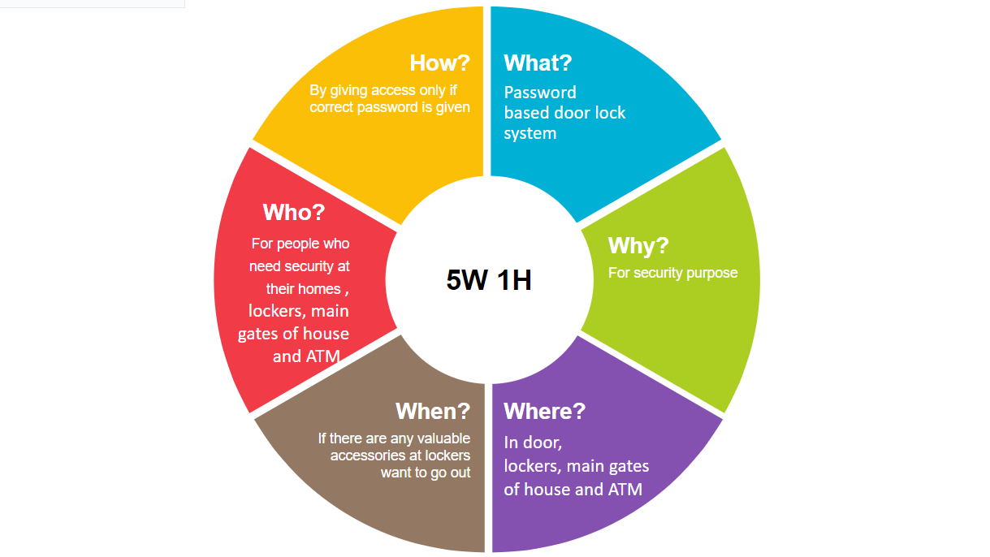

## 1.4 SWOT analysis

# 2. Requirements

## 2.1 High level requirements

HLR 1. It shall take the input through 4*4 keypad matrix.

HLR 2. It shall display the password on 7 segment led.

HLR 3. Password shall me verified

HLR 4. It shall turn the buzzer on if wrong password is entered.

HLR 5. It shall turn on the led if correct password is given.

## 2.2 Low level requirements

### Low level requirements for HLR 1

|  |  |  |  |
| --- | --- | --- | --- |
| ID | Low level requirements for HLR 1 | ID | Low level requirements for HLR 2 |
| LLR 1.1 | It shall give a 4 digit password | LLR 2.1 | It shall have a option to either display the password or not |
| LLR 1.2 | It shall press open key to open | LLR 2.2 | It shall display a g segment |

|  |  |  |  |
| --- | --- | --- | --- |
| ID | Low level requirements for HLR 3 | ID | Low level requirements for HLR 4 |
| LLR 3.1 | The entered password shall be stored in the form of array | LLR 4.1 | If the password is incorrect a buzzer is turned on |
| LLR 3.2 | Then continue whether the password is valid or invalid | LLR 4.2 | It shall have a potentiometer to vary the sound of buzzer |

|  |  |
| --- | --- |
| ID | Low level requirements for HLR 5 |
| LLR 5.1 | It shall on the relay |
| LLR 5.2 | It shall open the door |

# 3. Block diagram and components

## 3.1 Block diagram

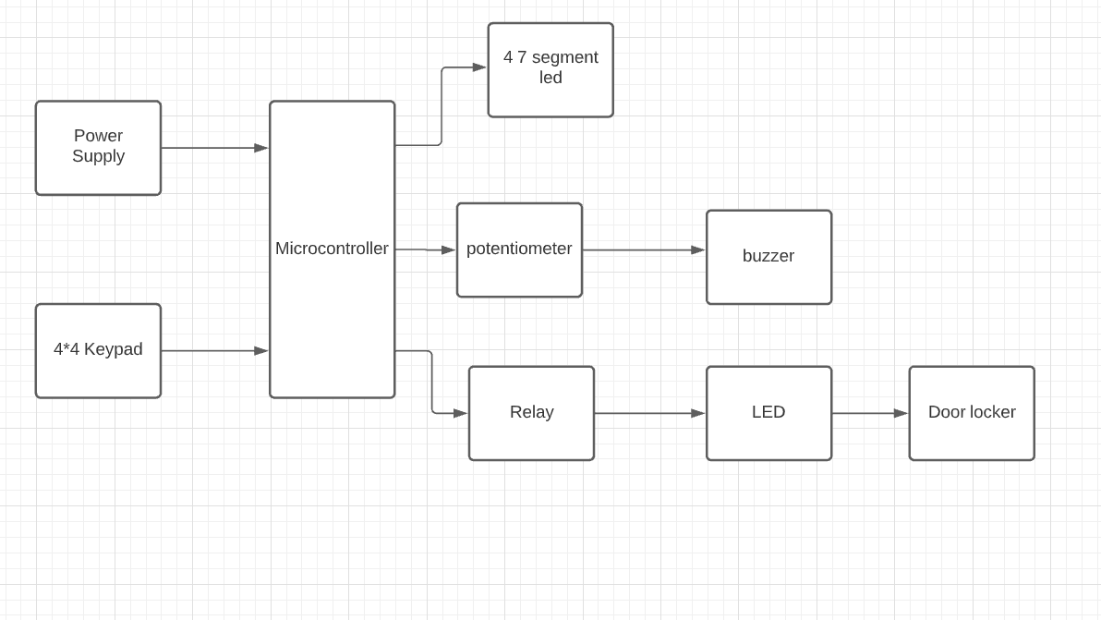

## 3.2 Components

### 3.2.1 Sensors

4*4 Keypad: To give user input i.e, a four digit password

Potentiometer: Here it can be used to vary the sound of the buzzer.

Push buttons: Acts as a door locker for opening and closing of door.

Led sensor: To indicate the correct password. If a correct assword is given the led is turned on by a relay placed nearby.

## 3.2.2 Accuators

Relay: As soon as correct password is entered the relay is activated. This is indicated by a LED which is placed near the relay. Also used for locking and unlocking purpose.

Buzzer: It is used to notify if a wrong password is applied.

### 3.3.3 Other components

Microcontroller: Here Atmega16 is used. It controls al the operations

7 segment Led: To display the four digit password entered.

# 4. Architetcure

## 4.1 Behavioral diagram

### 4.1.1 High level flow chart

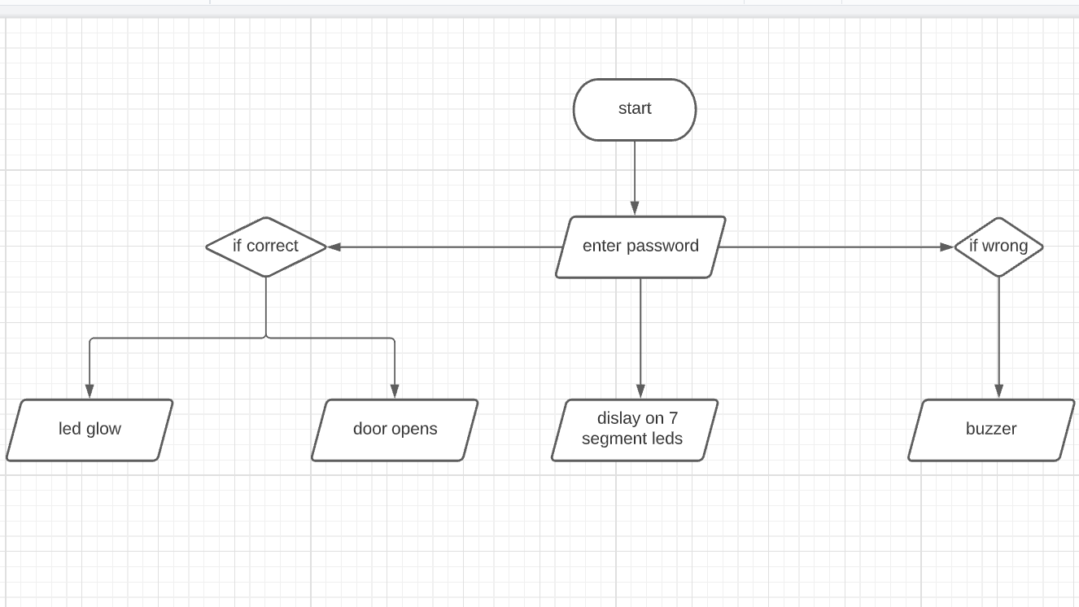

### 4.1.1 Low level flow chart

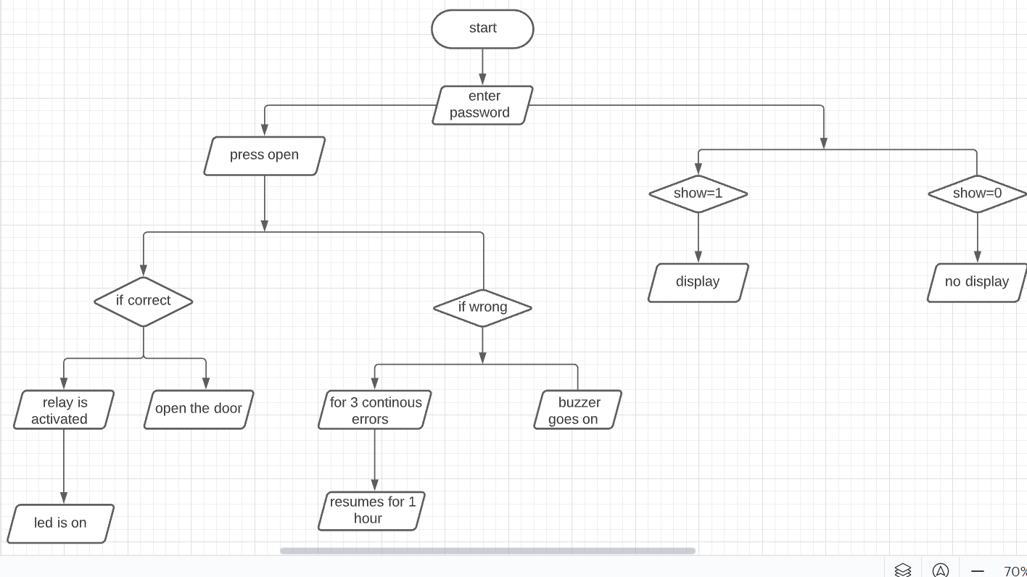

## 

## 4.2 Structural diagram

### 4.2.1 Using case diagram

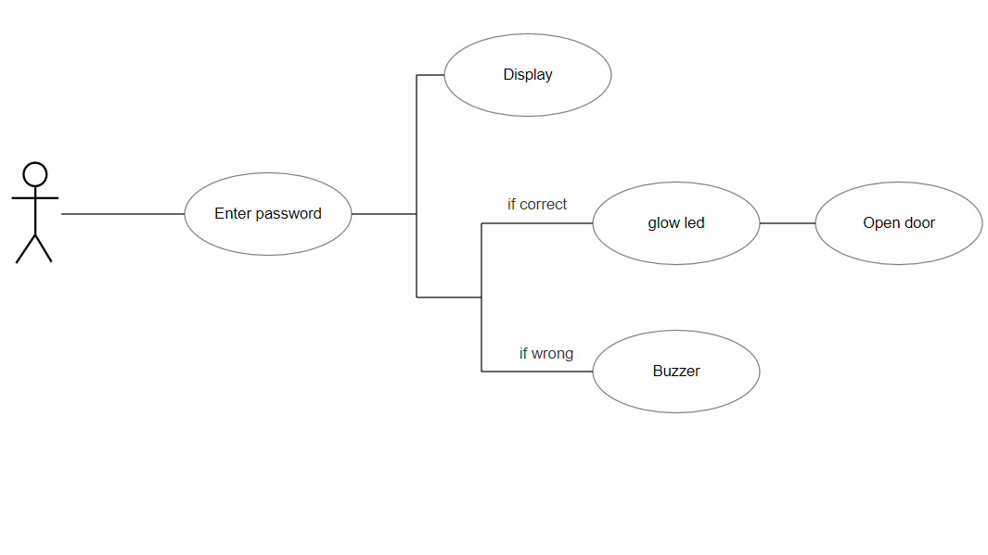

# 5 Applications

1. This simple circuit can be used at residential places to ensure better safety.

2. It can be used at organizations to ensure authorized access to highly secured places.

3. With a slight modification this Project can be used to control the switching of loads through password.