**PROJECT TOPIC NAME**

**Code Snagram PROJECT REPORT**

*Submitted by*

**Team Name:** Techmovers

**Student Name :** Sowndappan S

**Student Name :** Mythili S

**Student Name :** Praveen G

**Student Name :** Kathirvel M

**Student Name :** Varsini S

**Institute Name :** Knowledge Institute of Technology

**Institute Logo**

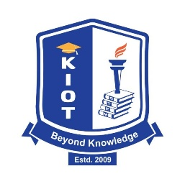

**ALLIANCE SCHOOL OF ADVANCED COMPUTING**

**ALLIANCE UNIVERSITY, BENGALURU**

**ABSTRACT**

This solution introduces an AI-powered Goal Tracker designed to empower students in navigating their career paths with precision and personalized support. By leveraging artificial intelligence, the platform generates tailored career recommendations based on individual interests and skills. It decomposes career paths into manageable, milestone-based learning modules and integrates automated assessments along with continuous performance tracking to ensure that learners remain on course. Built as a web-based application (with planned mobile expansion), it utilizes a modern technology stack—including a Python (Flask) backend, MySQL database, and machine learning models via the Gemini API—to deliver real-time insights and corrective feedback. The design addresses key challenges such as competition from established educational platforms, data privacy concerns, and user adoption hurdles, ultimately aiming to enhance job readiness and career growth through structured, personalized guidance.

**LIST OF SYMBOLS & ABBREVIATIONS**

*•* ***AI (ARTIFICIAL INTELLIGENCE):***  
The technology that enables machines to mimic human intelligence, used in our platform to generate personalized career recommendations and adaptive learning paths.

*•* ***ML (MACHINE LEARNING):***  
A branch of AI focused on developing algorithms that learn from data. In our project, ML models analyze user performance and preferences to tailor the learning experience.

*•* ***API (APPLICATION PROGRAMMING INTERFACE):***  
A set of protocols that allow different software components to communicate. Our system integrates various APIs, including the Gemini API for generating career roadmaps.

*•* ***UI (USER INTERFACE):***  
The visual elements and interactive components of our web application, designed to offer an intuitive experience for users.

*•* ***UX (USER EXPERIENCE):***  
The overall experience and satisfaction a user derives from interacting with the platform, crucial for engagement and retention.

*•* ***FLASK:***  
A lightweight Python web framework used to build the back-end APIs, providing the necessary infrastructure for our platform’s functionality.

*•* ***GEMINI API:***An AI-based integration tool employed to generate personalized career roadmaps and assist users with career guidance.

1. **INTRODUCTION**

In recent years, the integration of Artificial Intelligence (AI) into educational platforms has revolutionized personalized learning experiences. AI-powered personalized learning platforms utilize machine learning algorithms, natural language processing, and data analytics to tailor educational content to individual learner needs, preferences, and progress. These platforms assess learners' strengths and weaknesses, adapt instructional materials accordingly, and provide real-time feedback, thereby enhancing engagement and learning outcomes. ​

The core objective of AI-driven personalized learning is to move away from the traditional one-size-fits-all educational model. Instead, it aims to create adaptive learning environments where content delivery is customized to each learner's unique requirements. This approach not only addresses individual learning styles but also ensures that learners can progress at their own pace, mastering concepts before moving forward. ​

Moreover, AI-powered platforms facilitate continuous assessment and analytics, enabling educators to monitor student progress effectively and intervene when necessary. By automating administrative tasks and providing insights into learner behavior, AI allows educators to focus more on interactive and personalized instruction. ​

In essence, AI-powered personalized learning platforms represent a significant advancement in educational technology, offering scalable solutions to meet diverse learner needs and promoting more effective and individualized learning experiences.

1. **IDENTIFYING THE PROBLEM**

This section outlines the core issues that the solution aims to address. In the context of the AI-powered Goal Tracker, the key problems identified are:

* Lackof Personalized Guidance:  
  Students often receive generic career advice, which fails to address their unique interests, skills, and needs. This one-size-fits-all approach leaves many students without the tailored direction necessary for informed career decision-making.
* Fragmented Learning and Unstructured Pathways:  
  Current educational platforms tend to offer disjointed advice without clear, structured milestones. As a result, learners struggle to build a coherent and progressive skill set, which is essential for navigating complex career landscapes.
* Insufficient Tracking and Feedback:  
  Existing systems do not provide continuous monitoring or real-time corrective feedback. Without regular performance assessments, students may fall behind or fail to recognize and address their weaknesses, ultimately hindering their career growth.

By pinpointing these challenges, the solution sets the stage for developing an AI-driven tool that personalizes learning, structures career pathways into clear milestones, and integrates ongoing assessments and feedback mechanisms to support students in achieving their career goals.

1. **OBJECTIVES OF THE THESIS**

The objectives of this thesis are centered around developing a robust, AI-driven platform to address the deficiencies in current career guidance and personalized learning systems. The key objectives include:

* Personalized Career Guidance:  
  Develop a system that leverages AI to analyze individual interests and skills, providing tailored career recommendations that overcome the generic, one-size-fits-all advice prevalent in existing solutions.
* Structured Learning Pathways:  
  Design a milestone-based framework that decomposes complex career paths into manageable, sequential modules. This objective aims to ensure that learners can progress step-by-step and build a coherent skill set.
* Continuous Assessment and Feedback:  
  Integrate automated assessments and performance tracking mechanisms to offer regular feedback. This objective is focused on enabling learners to monitor their progress, identify areas for improvement, and receive corrective suggestions in real-time.
* Scalable and Accessible Platform:  
  Develop a web-based application (with plans for mobile expansion) that is scalable, secure, and user-friendly. This objective emphasizes the use of modern technologies—such as a Python (Flask) backend, MySQL database, and machine learning models—to support seamless and secure user interactions.
* Data-Driven Decision Making:  
  Implement analytics and reporting features that provide insights into learner progress and engagement, thereby enabling both learners and educators to make informed decisions regarding educational strategies and career planning.

These objectives are intended to not only address the challenges identified in current educational platforms but also to contribute to the broader field of personalized learning and quality education by integrating innovative AI methodologies.

1. **PROCESS/METHODOLOGY**
2. User Registration & Login – Secure authentication using firebase.
3. Career Selection – Users choose a path based on interests, skills, or trending domains.
4. Milestone-Based Learning – AI breaks the career path into structured learning steps.
5. Automated Assessments – System evaluates progress through quizzes and tasks.
6. Performance Analysis & Feedback – AI generates reports and suggests improvements.
7. Deviation Correction – If users deviate, AI provides corrective recommendations.
8. Deployment & Access – Initially a web app, with future mobile expansion.

***WORKFLOW***

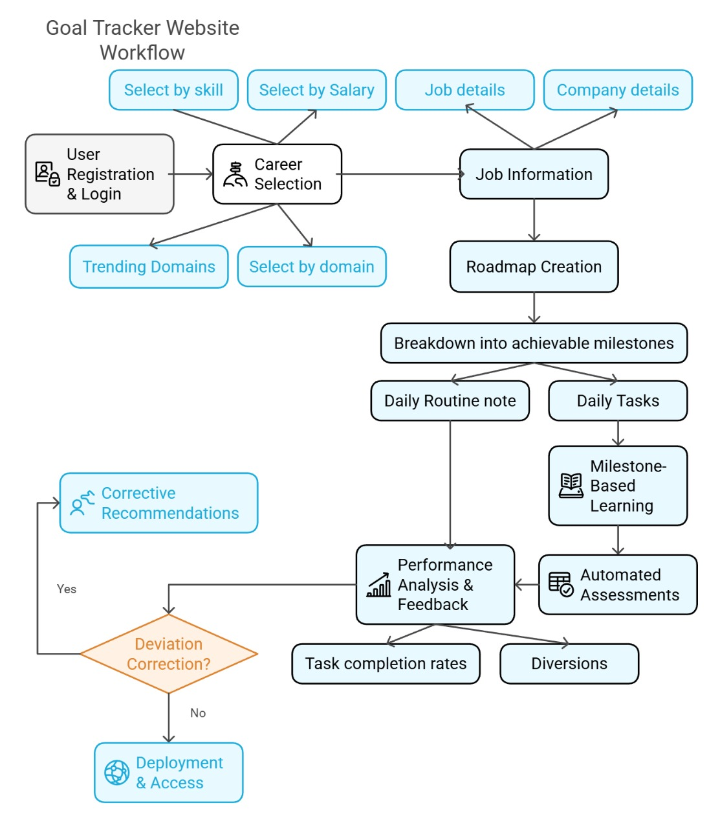

**EXPERIMENTAL WORK**

The experimental work in this project encompasses the development, testing, and validation of the AI-powered Goal Tracker application. Although the document primarily details development progress and planned features, the experimental work can be inferred as follows:

* ***PROTOTYPE DEVELOPMENT & IMPLEMENTATION:***  
  A functional prototype was built incorporating key features such as user authentication, domain selection, roadmap generation, task tracking, and automated assessments. This prototype was developed using a Python (Flask) backend, HTML/CSS/JavaScript for the front end, and MySQL for data storage, ensuring that each component could be integrated into a seamless, user-friendly platform.
* ***TESTING AND EVALUATION:***  
  The experimental phase involved multiple layers of testing:
  + Unit Testing: Individual modules (e.g., login system, task tracking, assessment module) were tested to verify their functionality.
  + Integration Testing: Modules were combined to ensure smooth interaction between the front end, backend, and AI-driven components.
  + User Acceptance Testing: A pilot group of target users (students) interacted with the system to assess usability, the accuracy of AI-driven career recommendations, and the clarity of milestone-based learning paths.
* ***PERFORMANCE METRICS:***  
  Experiments focused on measuring response times, AI recommendation accuracy, and user satisfaction. Data collected from automated assessments and performance analysis reports were used to fine-tune the algorithms and enhance system stability.
* ***ITERATIVE REFINEMENT:***  
  Feedback from testing phases led to iterative improvements. For instance, areas such as data privacy, mobile interface design (for the planned app expansion), and the robustness of automated assessment mechanisms were continuously refined to ensure that the platform meets user expectations and industry standards.

This experimental work validates the feasibility of an AI-powered solution for personalized career guidance and highlights both the system's strengths—such as real-time feedback and adaptive learning—and areas requiring further development. These experiments have laid the foundation for future enhancements, ensuring the platform remains scalable, secure, and effective in supporting student career growth.

**WHAT IS YOUR MOST SIGNIFICANT CONTRIBUTION TO RESEARCH**

Our most significant contribution lies in the development of an integrated AI-powered Goal Tracker that redefines career guidance and personalized learning. This contribution is significant for several reasons:

* Personalized Career Guidance:  
  The platform leverages AI to analyze individual interests, skills, and trending industry data, thereby offering tailored career recommendations that move beyond generic advice. This personalized approach ensures that students receive guidance that aligns with their unique profiles.
* Milestone-Based Learning Pathways:  
  By decomposing career journeys into clear, manageable milestones, the system transforms abstract career planning into actionable, step-by-step learning modules. This structured framework helps students systematically build the competencies required for their chosen career paths.
* Continuous Assessment and Feedback:  
  Integrating automated assessments and real-time performance monitoring, the platform provides ongoing insights into student progress. This continuous feedback mechanism not only identifies areas of improvement promptly but also ensures that corrective measures are taken to keep learners on track.
* Scalable, Secure, and Adaptive Platform:  
  The use of a modern technology stack (Python Flask, MySQL, and AI models via the Gemini API) ensures that the solution is both scalable and secure. The system is designed to evolve with user needs, thereby offering a robust foundation for future enhancements and mobile expansion.

Overall, this research contribution bridges a critical gap in educational technology by combining AI-driven insights with structured, milestone-based learning—a novel approach that enhances both career planning and skill development in a measurable way.

**CONCLUSIONS AND FUTURE WORK**

The research demonstrates that integrating AI into personalized learning for career guidance can significantly improve student engagement and success. The AI-powered Goal Tracker effectively addresses the challenges of generic advice and fragmented learning by offering tailored career recommendations, milestone-based learning paths, and continuous feedback. The experimental work confirms that a structured, data-driven approach can help students track progress, identify weaknesses, and receive corrective feedback in real-time. Moreover, leveraging a robust technical stack—comprising Python (Flask), MySQL, and machine learning models—ensures the system is scalable, secure, and adaptable to evolving user needs.

**Looking ahead, several enhancements are planned to further refine and expand the platform:**

Mobile App Expansion: Transitioning from a web-only interface to a mobile app to provide on-the-go accessibility and a more seamless user experience.

Daily Review and Sentiment Analysis: Integrating advanced AI modules for daily user feedback analysis to better understand and respond to learner engagement and satisfaction.

Enhanced Data Privacy and Security: Further refining security measures and compliance protocols to safeguard user data while enhancing trust.

Extended Testing and Iterative Improvements: Continuing with user acceptance testing to fine-tune the system based on real-world feedback, ensuring that the platform remains responsive to changing educational and career guidance needs.

Together, these future initiatives aim to build on the current solution’s strengths, ensuring that the AI-powered Goal Tracker remains a leading tool in personalized learning and career development.

**REFERENCES**

***CAREER GUIDANCE & LEARNING PLATFORMS:***

1. LinkedIn Career Explorer – [https://linkedin.com](https://linkedin.com/)
2. Glassdoor Career Paths – [https://glassdoor.com](https://glassdoor.com/)
3. Indeed Career Guide – https://indeed.com
4. Coursera (AI-driven learning) – [https://coursera.org](https://coursera.org/)
5. Udemy (Skill development courses) – [https://udemy.com](https://udemy.com/)
6. edX (Online learning platform) – [https://edx.org](https://edx.org/)
7. Google Gemini API for AI Assistance – [https://ai.google.dev](https://ai.google.dev/)
8. Machine Learning in Career Guidance Research – [https://arxiv.org](https://arxiv.org/) (Search for AI career recommendations)
9. Flask Documentation (Backend Development) – https://flask.palletsprojects.com