Explain for Mysql  
  
Query_1

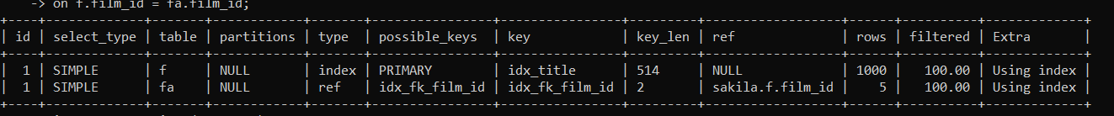

Based on the primary key in film table and foreign key in film_actor, the table got joined using index.

Query_2

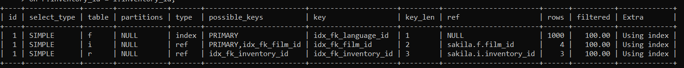

Based on the primary key in film table and foreign key in inventory, the table got joined using index and the resultant table is joined with rental table based on the primary key inventory_id.

Query_3



Based on the primary key in film table and foreign key in film_actor, the table got joined using index and the resultant table is joined with actor table based on the primary key actor_id.

Query_4

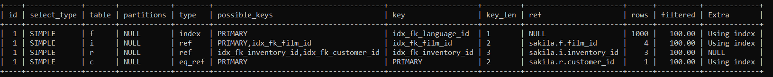

Based on the primary key in film table and foreign key in inventory, the table got joined using index and the resultant table is joined with rental table and the resultant of all the above table is joined with customer table based on the primary key field customer_id.

Query_5

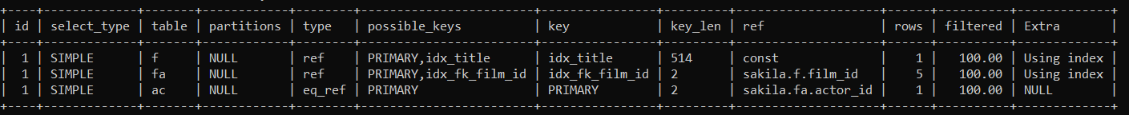

Records are selected on the condition where film title = Chicago north which is joined based on the primary key in film table and foreign key in film_actor, the table got joined using index and the resultant table is joined with actor table based on the primary key actor_id.

Query_6



Records are selected on the condition where film title = Chicago north which is joined based on the primary key in film table and foreign key in inventory, the table got joined using index and the resultant table is joined with rental table and the resultant of all the above table is joined with customer table based on the primary key field customer_id.

Explain for Postgre SQL

Query_1

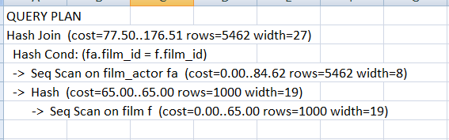

Based on the primary key in film table and foreign key in film_actor, the table got joined using index.

**Query_2**

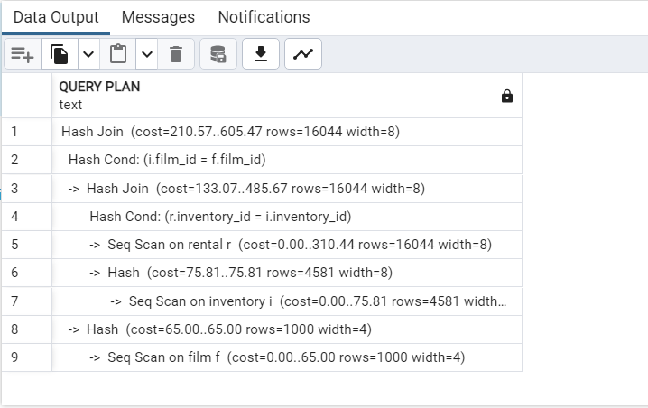

Based on the primary key in film table and foreign key in inventory, the table got joined using index and the resultant table is joined with rental table based on the primary key inventory_id.

**Query_3**

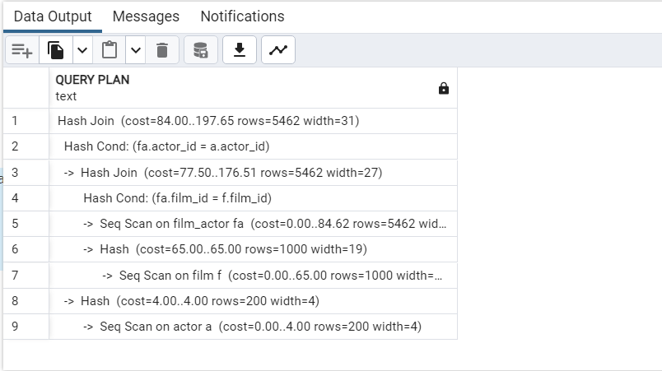

Based on the primary key in film table and foreign key in film_actor, the table got joined using index and the resultant table is joined with actor table based on the primary key actor_id.

**Query_4**

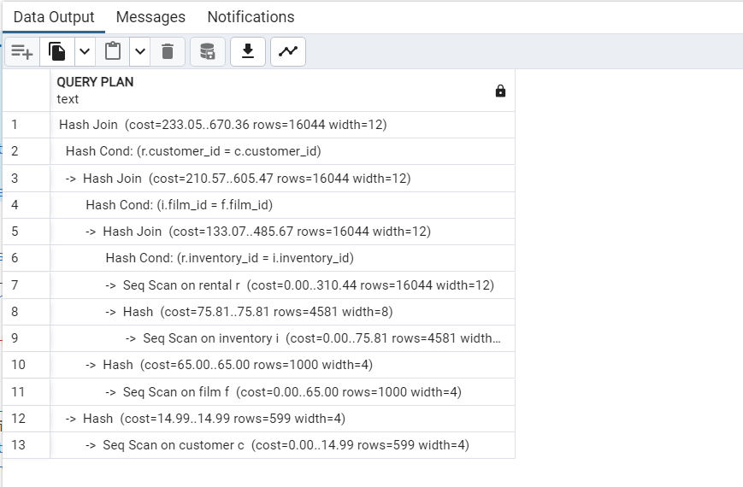

Based on the primary key in film table and foreign key in inventory, the table got joined using index and the resultant table is joined with rental table and the resultant of all the above table is joined with customer table based on the primary key field customer_id.

**Query_5**

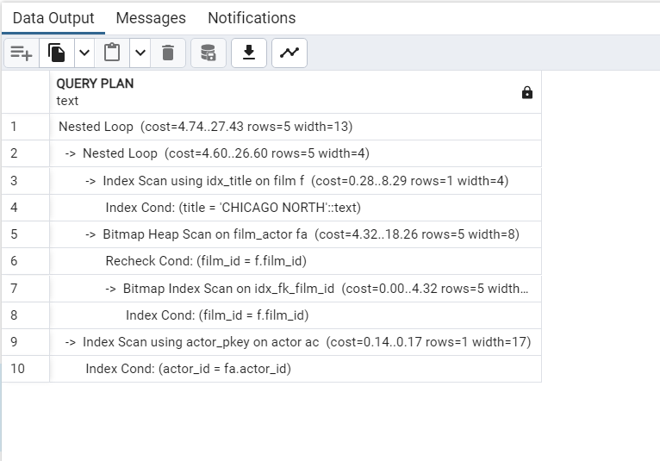

Records are selected on the condition where film title = Chicago north which is joined based on the primary key in film table and foreign key in film_actor, the table got joined using index and the resultant table is joined with actor table based on the primary key actor_id.

**Query_6**

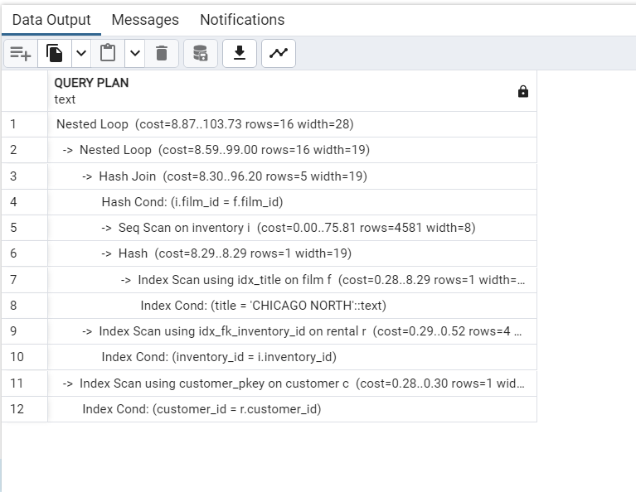

Records are selected on the condition where film title = Chicago north which is joined based on the primary key in film table and foreign key in inventory, the table got joined using index and the resultant table is joined with rental table and the resultant of all the above table is joined with customer table based on the primary key field customer_id.