1. Download vechile sales data -> https://github.com/shashank-mishra219/Hive-Class/blob/main/sales_order_data.csv

2. Store raw data into hdfs location

3. Create a internal hive table "sales_order_csv" which will store csv data sales_order_csv .. make sure to skip header row while creating table

4. Load data from hdfs path into "sales_order_csv"

create table sales_order_csv

(

ORDERNUMBER INT,

QUANTITYORDERED INT,

PRICEEACH INT,

ORDERLINENUMBER INT,

SALES FLOAT,

STATUS STRING,

QTR_ID INT,

MONTH_ID INT,

YEAR_ID INT,

PRODUCTLINE STRING,

MSRP INT,

PRODUCTCODE STRING,

PHONE STRING,

CITY STRING,

STATE STRING,

POSTALCODE STRING,

COUNTRY STRING,

TERRITORY STRING,

CONTACTLASTNAME STRING,

DEALSIZE STRING

)

row format delimited

fields terminated by ','

location '/assignment1/sales'

tblproperties("skip.header.line.count"="1");

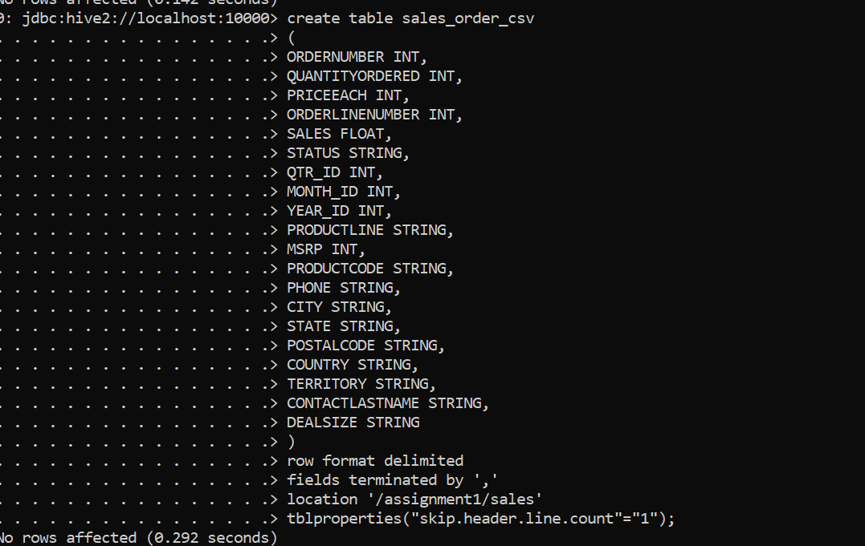

5. Create an internal hive table which will store data in ORC format "sales_order_orc"

create table sales_order_orc

(

ORDERNUMBER INT,

QUANTITYORDERED INT,

PRICEEACH INT,

ORDERLINENUMBER INT,

SALES FLOAT,

STATUS STRING,

QTR_ID INT,

MONTH_ID INT,

YEAR_ID INT,

PRODUCTLINE STRING,

MSRP INT,

PRODUCTCODE STRING,

PHONE STRING,

CITY STRING,

STATE STRING,

POSTALCODE STRING,

COUNTRY STRING,

TERRITORY STRING,

CONTACTLASTNAME STRING,

DEALSIZE STRING

)

stored as orc;

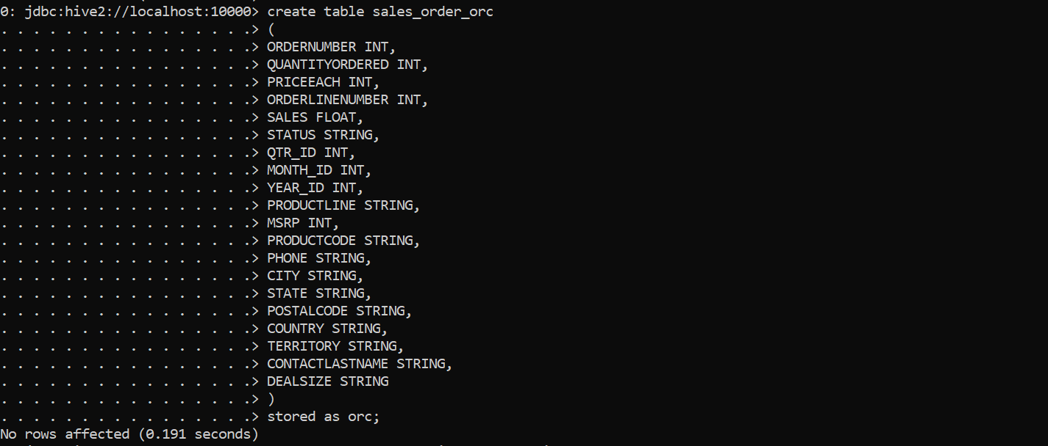

6. Load data from "sales_order_csv" into "sales_order_orc"

from sales_order_csv insert overwrite table sales_order_orc select *;



a. Calculate total sales per year

SELECT year_id AS year, SUM(quantityordered * priceeach) AS total_sales

from sales_order_orc

GROUP BY year_id

limit 5;

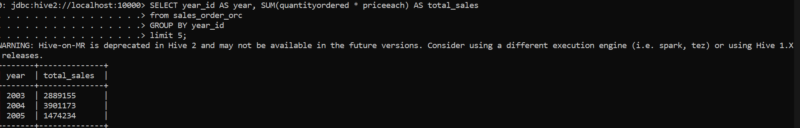

b. Find a product for which maximum orders were placed

select productline,sum(quantityordered) as total

from sales_order_orc

group by productline

order by total desc

limit 1;

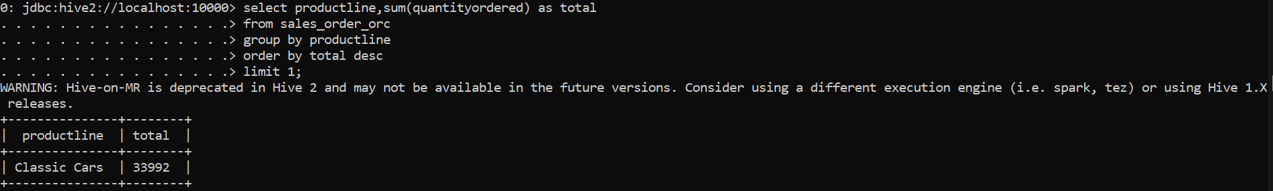

c. Calculate the total sales for each quarter

select qtr_id, sum(sales) as total_sales

from sales_order_orc

group by qtr_id;

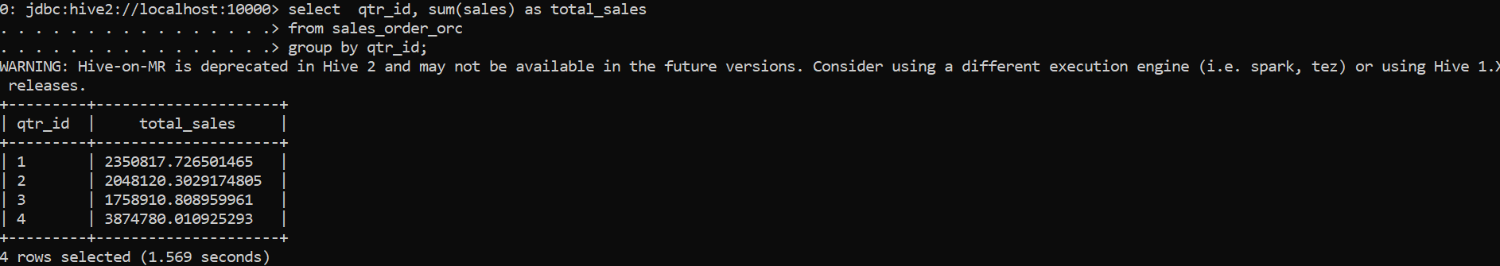

d. In which quarter sales was minimum

select qtr_id, sum(sales) as total_sales

from sales_order_orc

group by qtr_id

order by total_sales

limit 1;

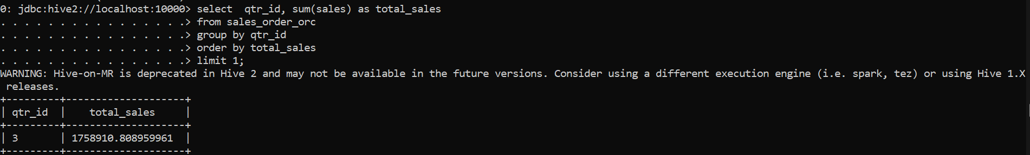

e. In which country sales was maximum and in which country sales was minimum

SELECT

country,

total_sales

FROM (

SELECT

country,

SUM(sales) as total_sales,

RANK() OVER (ORDER BY SUM(sales) DESC) as sales_rank_desc,

RANK() OVER (ORDER BY SUM(sales) ASC) as sales_rank_asc

FROM sales_order_orc

GROUP BY country

) as temp

WHERE sales_rank_desc = 1 OR sales_rank_asc = 1;

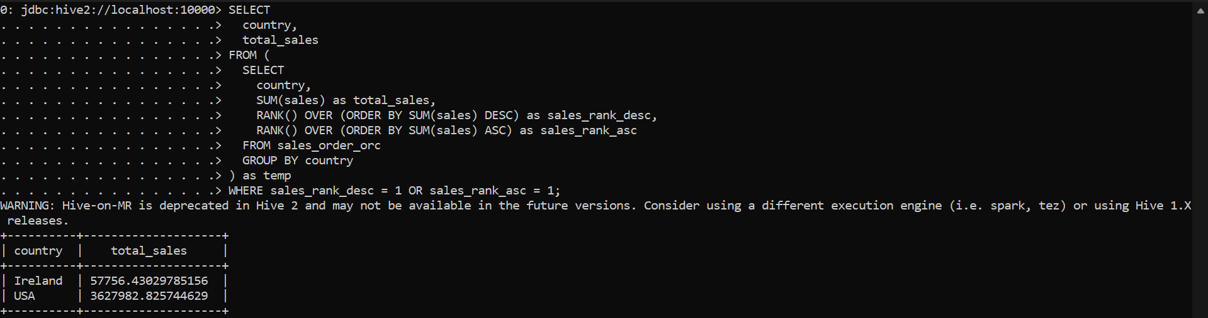

f. Calculate quartelry sales for each city

select qtr_id,city,sum(sales) as total_sales

from sales_order_orc

group by city,qtr_id;

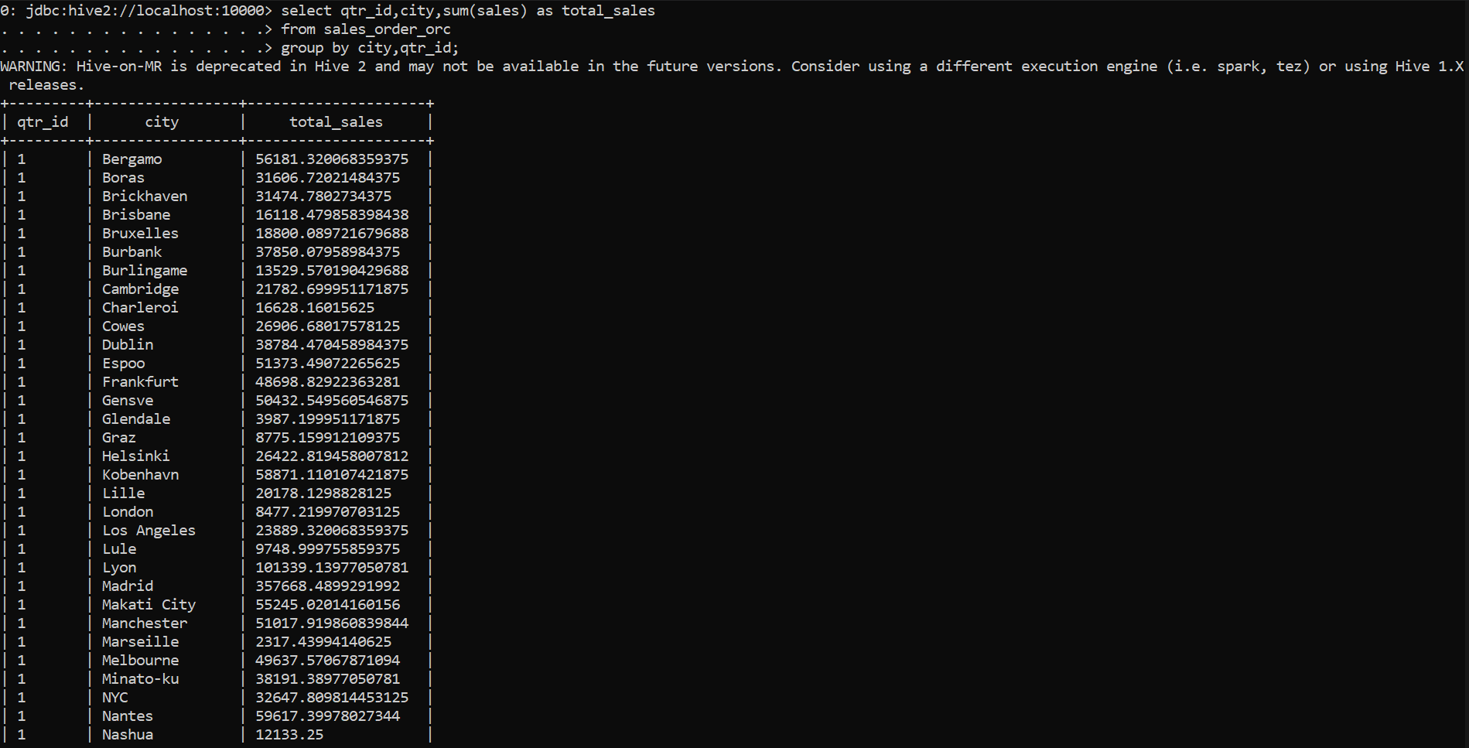

h. Find a month for each year in which maximum number of quantities were sold

SELECT month_id, year_id, QUANTITYORDERED, rnk

FROM (

SELECT month_id, year_id, QUANTITYORDERED, RANK() OVER (PARTITION BY year_id ORDER BY QUANTITYORDERED DESC) AS rnk

FROM sales_order_csv

) a

WHERE a.rnk = 1;

