MOVIE ANALYTICS WIREFRAME:

platform architecture :

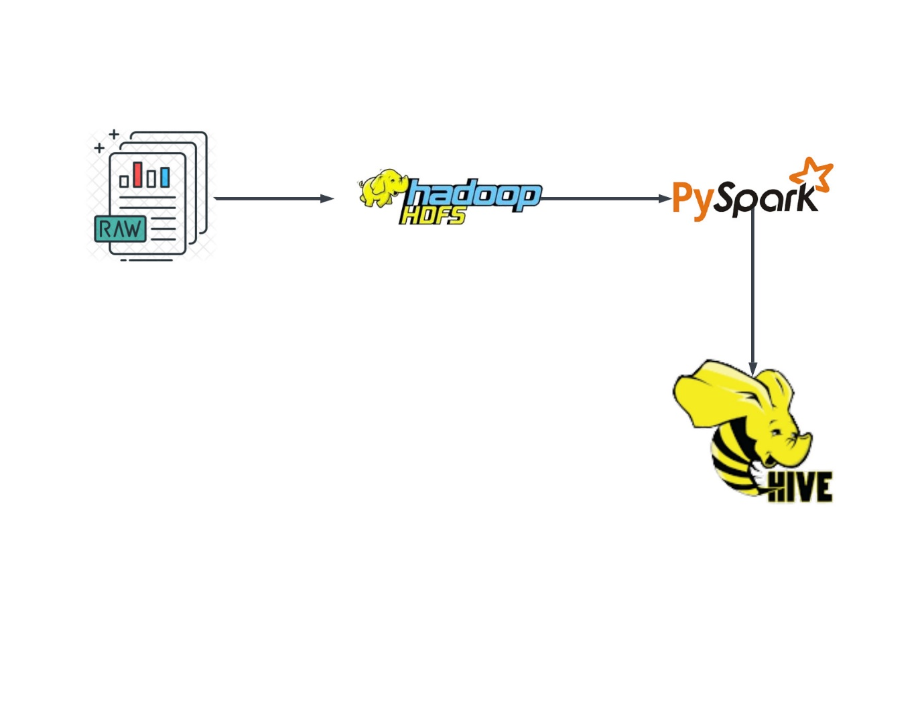conceptual architecture :

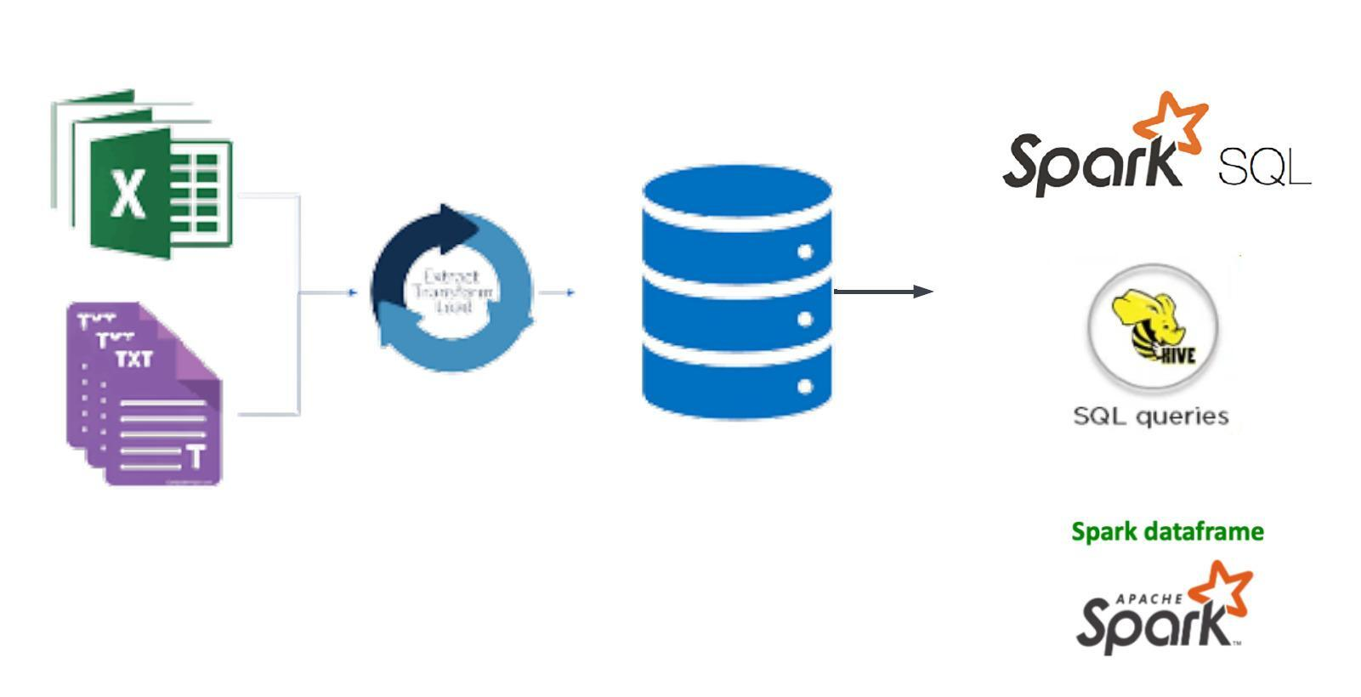

We have three data source files

* users.dat

|  |  |
| --- | --- |
| UserID | Int |
| Gender | char |
| Age | integer |
| Occupation | integer |
| Zip-code | string |

- Gender is denoted by a "M" for male and "F" for female

- Age is chosen from the following ranges:

* 1: "Under 18"

* 18: "18-24"

* 25: "25-34"

* 35: "35-44"

* 45: "45-49"

* 50: "50-55"

* 56: "56+"

- Occupation is chosen from the following choices:

* 0: "other" or not specified

* 1: "academic/educator"

* 2: "artist"

* 3: "clerical/admin"

* 4: "college/grad student"

* 5: "customer service"

* 6: "doctor/health care"

* 7: "executive/managerial"

* 8: "farmer"

* 9: "homemaker"

* 10: "K-12 student"

* 11: "lawyer"

* 12: "programmer"

* 13: "retired"

* 14: "sales/marketing"

* 15: "scientist"

* 16: "self-employed"

* 17: "technician/engineer"

* 18: "tradesman/craftsman"

* 19: "unemployed"

* 20: "writer"

* ratings.dat

|  |  |
| --- | --- |
| UserID | integer |
| MovieID | integer |
| Rating | integer |
| Timestamp | timestamp |

- UserIDs range between 1 and 6040

- MovieIDs range between 1 and 3952

- Ratings are made on a 5-star scale (whole-star ratings only)

- Timestamp is represented in seconds since the epoch as returned by time(2)

- Each user has at least 20 ratings

* movies.dat

|  |  |
| --- | --- |
| MovieID | int |
| Title | strings |
| Genres | string |

- Titles are identical to titles provided by the IMDB (including

year of release)

- Genres are pipe-separated and are selected from the following genres:

* Action

* Adventure

* Animation

* Children's

* Comedy

* Crime

* Documentary

* Drama

* Fantasy

* Film-Noir

* Horror

* Musical

* Mystery

* Romance

* Sci-Fi

* Thriller

* War

* Western

- Some MovieIDs do not correspond to a movie due to accidental duplicate

entries and/or test entries

- Movies are mostly entered by hand, so errors and inconsistencies may exist