**Project-Earthquake Prediction Model using Python**

**Understanding the Problem Statement:**

* The problem is to develop a machine learning model for the earthquake prediction using a dataset from Kaggle’s repository.
* The primary objective is to explore and understand the key features in earthquake data, create visualizations for global earthquake distribution, split the data into training and testing, and build a neural network model to predict the earthquake magnitudes based on given features.

**Goal:**

The goal of earthquake prediction models is to contribute to the development of early warning systems that can provide real-time alerts to potentially affected areas. Such systems have the potential to save lives and reduce property damage.

**Understanding the Design Thinking:**

**Data Source Selection:**

* The first step is to import the earthquake dataset downloaded from Kaggle.
* The dataset contains features such as date, time, latitude, longitude, depth, and magnitude.

**Data Preprocessing:**

* Handle Missing Data: If missing data values are present in the dataset, then try to remove or amputate it.
* Data Formatting: Convert data types as needed, especially date and time features, which should be converted into datetime objects for analysis.
* Outlier Handling: Identify outliers in the dataset, which could adversely affect model performance.

**Feature Exploration:**

* Exploratory Data Analysis (EDA) should be conducted to understand the distribution, central tendencies, and variability of each feature.
* Identification of target variable in our dataset. The target variable in this earthquake prediction model is the earthquake magnitude.
* Calculate and visualize correlations between features and the target variable (earthquake magnitude) to identify relationships.

**Visualization:**

* Data visualization libraries such as matplotlib and seaborn is used to build histograms, scatter plots and correlation matrices to provide clearer understanding of the features in the dataset.
* A world map visualization depicting the frequency distribution of earthquakes globally is useful for identifying earthquake prone regions visually.

**Data Splitting:**

* The dataset is split into training and testing sets.
* A common practice is to allocate 80% of the data for training and 20% for testing.

**Model Development:**

* Neural Networks machine learning model is used to predict the earthquake magnitudes,
* The neural network architecture should be designed by specifying the number of hidden layers, units, activation functions, and any regularization techniques (e.g., dropout) to be used.

**Training and Evaluation:**

* Train the neural network model using the training data and set suitable hyperparameters.
* Monitor the training process, track metrics (e.g., mean squared error, accuracy, precision, correlation matrix), and visualize training/validation loss to check for overfitting.
* Evaluate the performance of the model using appropriate evaluation metrics such as Mean Squared Error and R-squared.

**Flow-Chart for Desing Thinking:**

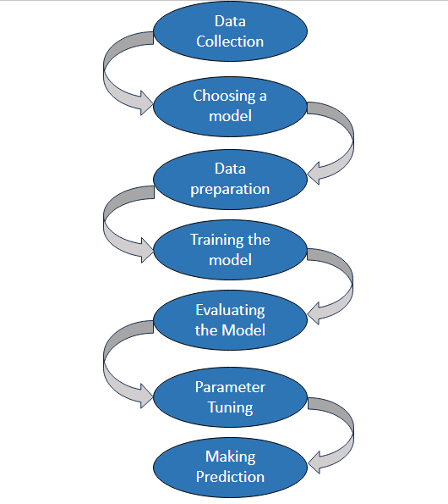

**Conclusion:**

1. **Data Quality and Quantity:** The success of any machine learning model depends heavily on the availability of high-quality data. Earthquake prediction models require vast and diverse datasets, which can be challenging to obtain due to the rarity of large seismic events.

2. **Feature Engineering:** Identifying the most relevant features or indicators for earthquake prediction is an ongoing research challenge. Incorporating geological, geophysical, and environmental factors into the model is crucial for accurate predictions.

3. **Model Complexity:** The development of effective earthquake prediction models often involves complex algorithms, deep learning architectures, or ensemble methods. Balancing model complexity with interpretability is essential for practical implementation.

4. **Interpretability:** Ensuring that the predictions generated by machine learning models are interpretable is vital for gaining trust among stakeholders and decision-makers. Understanding why a model makes a particular prediction can be just as important as the prediction itself.

5. **Evaluation and Validation:** Rigorous evaluation and validation of earthquake prediction models are critical. Models should be tested on independent datasets and subjected to various performance metrics to assess their accuracy and reliability.

6. **Ethical Considerations:** The deployment of earthquake prediction models also raises ethical considerations, such as data privacy, fairness, and the potential for false alarms. Ensuring that these models are developed and used responsibly is essential.