

**STUDENT PROJECT MANAGEMENT**

**Requirement & Design Specification**

– Hanoi, September 2023 –

# Record of Changes

|  |  |  |  |  |
| --- | --- | --- | --- | --- |
| **Version** | **Date** | **A* M, D** | **In charge** | **Change Description** |
|  |  |  |  |  |
|  |  |  |  |  |
|  |  |  |  |  |
|  |  |  |  |  |

*A - Added M - Modified D - Deleted

Contents

Record of Changes 2

I. Overview 9

1. User Requirements 9

1.1 Actors 9

1.2 Use Cases 9

2. Overall Functionalities 16

2.1 Screens Flow 16

2.2 Screen Descriptions 16

2.3 Screen Authorization 19

2.4 Non-UI Functions 21

3. System High Level Design 22

3.1 Database Design 22

3.2 Code Packages 24

II. Requirement Specifications 26

1. Common Feature 26

1.1 UC-1_View Landing Page 26

1.2 UC-2_Register an account 26

1.3 UC-3_Login to the system 28

1.4 UC-4_Reset password 29

1.5 UC-5_Change password 30

1.6 UC-6_Logout 31

1.7 UC-7_View/Edit profile 32

2. Admin Feature 32

2.1 UC-8_View user list 32

2.2 UC-9_Add new user 33

2.3 UC-10_Update user details 34

2.4 UC-11_Activate/Deactivate user 35

2.5 UC-12_View subject list 36

2.6 UC-13_Add new subject 36

2.7 UC-14_Update subject details 37

2.8 UC-15_Activate/Deactivate subject 38

2.9 UC-16_View setting list 38

2.10 UC-17_Add new setting 39

2.11 UC-18_Update setting details 40

2.12 UC-19_Activate/Deactivate setting 41

3. Subject Manager Feature 41

3.1 UC-20_View subject setting list 41

3.2 UC-21_Activate/Deactivate subject settings 42

3.3 UC-22_Add new subject setting 42

3.4 UC-23_Update subject setting details 43

3.5 UC-24_View subject assignment list 44

3.6 UC-25_ Add new subject assignment 45

3.7 UC-26_ Update subject assignment details 46

3.8 UC-27_ Delete subject assignments 46

3.9 UC-28_View class list 47

3.10 UC-29_ Add new class 48

3.11 UC-30_ Update class details 49

3.12 UC-31_ Cancel started class 49

3.13 UC-32_ Delete pending class 50

3.14 UC-33_View class assignment list 51

3.15 UC-34_ Add new class assignment 52

3.16 UC-35_ Update class assignment details 53

4. Class Manager Feature 53

4.1 UC-36_View assigned class list 53

4.2 UC-37_ Update assigned class details 54

4.3 UC-38_ Synchronize class information with Gitlab 55

4.4 UC-39_ List class assignments 56

4.5 UC-40_ Update class assignment details 56

4.6 UC-41_ Synchronize class assignments with Gitlab 57

4.7 UC-42_ View class student list 58

4.8 UC-43_ View class student details 59

4.9 UC-44_ Add student 59

4.10 UC-45_ Remove student 60

4.11 UC-46_ Update student status with note 61

4.12 UC-47_ Import/export class students with excel 61

4.13 UC-48_ View class issue setting list 62

4.14 UC-49_ Add new class issue setting 63

4.15 UC-50_ Update class issue setting details 64

4.16 UC-51_ Activate/Deactivate class issue setting 65

4.17 UC-52_ Synchronize class issue settings with Gitlab 65

4.18 UC-53_ View project list 66

4.19 UC-54_ Add new project 67

4.20 UC-55_ Update project details 68

4.21 UC-56_ Delete inactive project 68

4.22 UC-57_ View project member list 69

4.23 UC-58_ Assign team leader 70

4.24 UC-59_ Freeze project 70

4.25 UC-60_ Update member status with note 71

4.26 UC-61_ Import/Export/Move member 72

4.27 UC-62_ View assigned project list 72

UC-62_View assigned project list 72

4.28 UC-63_ Update assigned project details 73

UC-63_Update assigned project details 73

4.29 UC-64_ View project submission list 74

UC-64_View project submission list 74

4.30 UC-65_ Download project submission 75

UC-65 Download project submission 75

4.31 UC-66_ View project submit details 75

UC-66_View project submission details 75

66.0 View project submission details 76

4.32 UC-67_ Reject project assignments 76

UC-67_Reject project submission 76

4.33 UC-68_ Give detailed evaluation for submit 77

4.34 UC-69_ View project milestone list 78

4.35 UC-70_ Add new project milestones 78

4.36 UC-71_ Update project milestones details 79

4.37 UC-72_ Delete pending project milestones 80

4.38 UC-73_ Synchronize project milestones with Gitlab 81

4.39 UC-74_View class issue setting list 82

4.40 UC-75_ View class issue setting details 82

4.41 UC-76_ View project issue setting list 83

4.42 UC-77_ Update project issue setting details 84

4.43 UC-78_ Add new project issue setting details 86

4.44 UC-79_Activate/Deactivate project issue setting 86

4.45 UC-80_ Synchronize project issue setting with Gitlab 87

4.46 UC-81_ Submit assignment result 88

4.47 UC-82_ Update submission details 89

4.48 UC-83_ View project issue list 89

4.49 UC-84_ Add new project issue 90

4.50 UC-85_ Update project issue details 91

4.51 UC-86_ Batch update project issues 91

4.52 UC-87_ Export class students with Excel 92

4.53 UC-88_ Synchronize project issue with Gitlab 93

4.54 UC-89_ View work list 94

4.55 UC-90_ Add new work 94

4.56 UC-91_ Update work details 95

4.57 UC-92_ Delete work 96

4.58 UC-93_View assignment list 97

4.59 UC-94_ View submit details 97

4.60 UC-95-LOC Evaluation 98

4.61 UC-96-Reject issue submit 99

III. Design Specifications 101

1. Common Feature 101

1.1 Public 101

1.2 Authentication 101

1.3 Profile Management 107

2. Admin Feature 108

2.1 Dashboard 108

2.2 User Management 109

2.3 Subject Management 113

2.4 Setting Management 118

3. Subject Manager Feature 121

3.1 Subject Assignment Details 121

3.2 Class Management 121

3.3 Criteria Management 129

3.4 Subject Setting Management 132

4. Class Manager Feature 135

4.1 Milestone Details 135

4.2 Class Student Management 136

4.3 Issue Setting Details 138

4.4 Project Management 139

5. Project Mentor Feature 145

5.1 Assignment List 145

5.2 Project Submission Details 146

5.3 LOC EVALUATION 147

5.4 Project List 147

5.5 Assignment Evaluation 148

6. Team leader Feature 149

6.1 Submission Details 149

6.2 Issue List 150

7. Student Feature 152

7.1 Work List 152

7.2 Add new Work 153

7.3 Edit Work 153

IV. Appendix 154

1. Assumptions & Dependencies 154

2. Limitations & Exclusions 155

3. Business Rules 155

# I. Overview

## 1. User Requirements

### 1.1 Actors

|  |  |  |
| --- | --- | --- |
| **#** | **Actor** | **Description** |
| 1 | Guest | Non-registered visitor. |
| 2 | Student | Enrolled learner in an educational program. |
| 3 | Team Leader | Student leading a project team. |
| 4 | Project Mentor | A person responsible for managing assigned projects. |
| 5 | Class Manager | A person responsible for managing assigned classes. |
| 6 | Subject Manager | A person who manages the curriculum and resources related to a specific academic subject. |
| 7 | Admin | A person who manages and oversees administrative tasks to keep things running smoothly in an organization or system. |

### 1.2 Use Cases

#### a. Diagram(s)

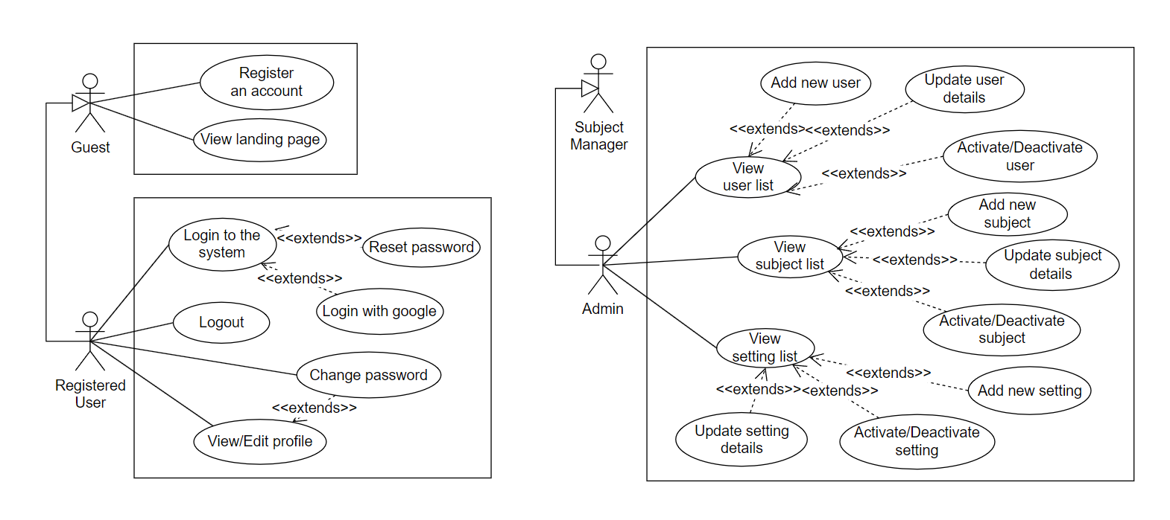

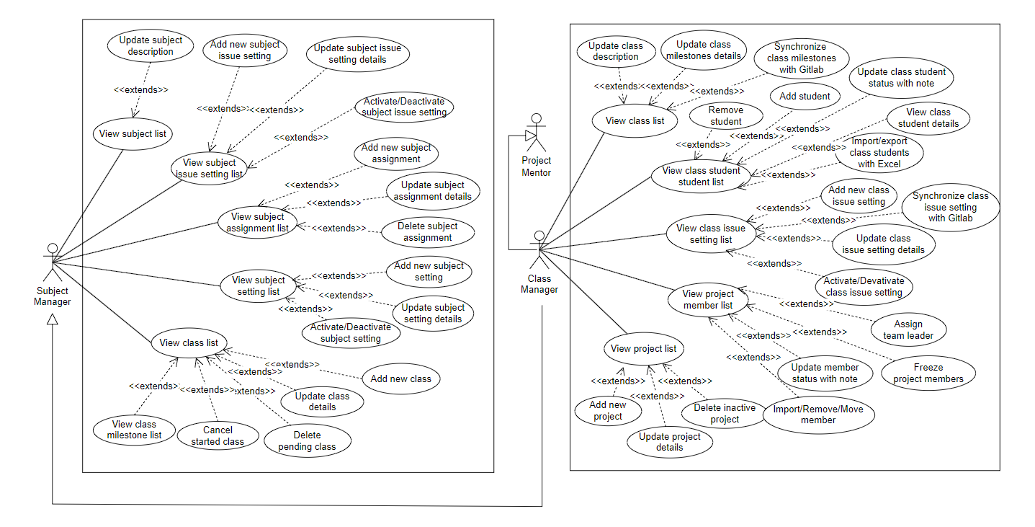

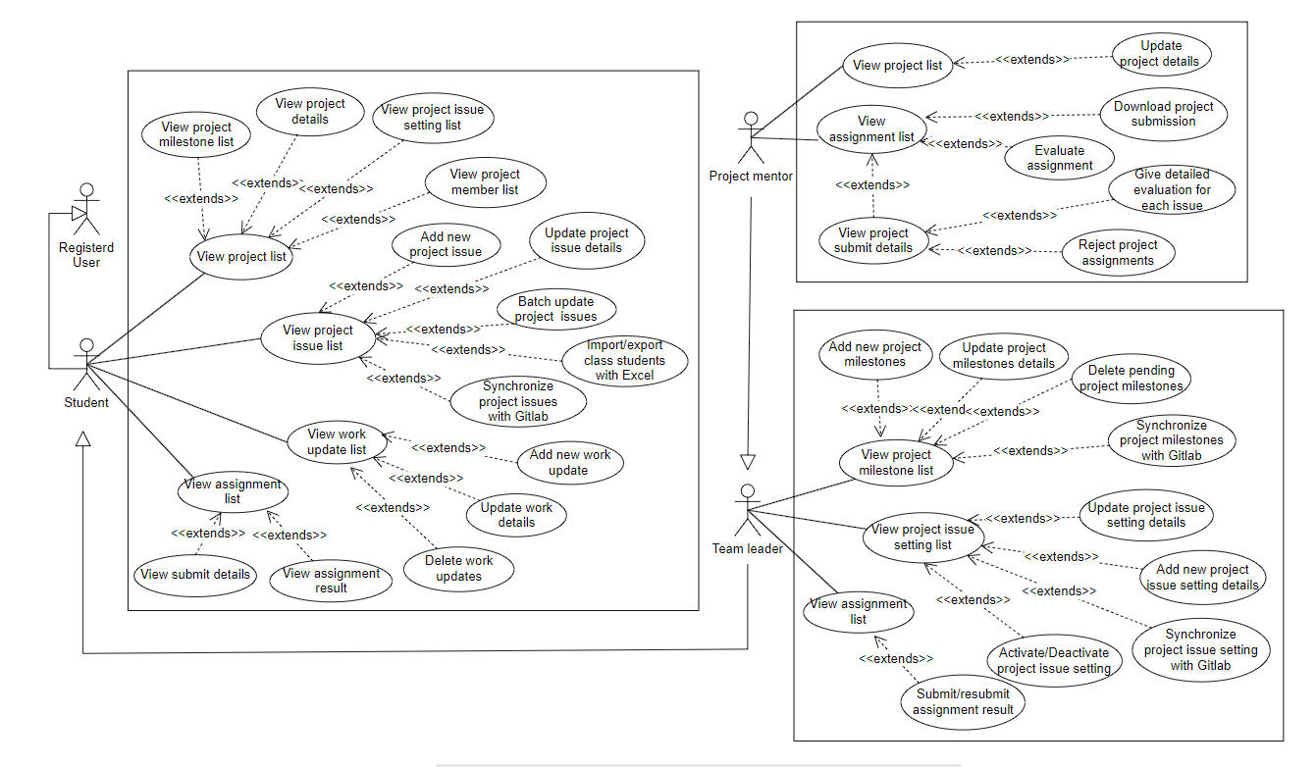

#### b. Descriptions

|  |  |  |  |
| --- | --- | --- | --- |
| **#** | **Feature** | **Use case** | **Use case description** |
| 1 | Common | View page landing | Users can access the landing page of the application, providing an initial view and introduction to the system. |
| 2 | Common | Register an account | New users can register for an account by providing required information, such as username, password, email, and personal details. Verify mail/phone |
| 3 | Common | Login to the system | Users can log in to the system by providing their username and password or via Google login page, as long as the input email's domain is listed in the predefined domain list |
| 4 | Common | Reset password | Users can reset their password in case they forget their password |
| 5 | Common | Change password | Users have the option to change their account passwords for security reasons. |
| 6 | Common | Logout | User can logs out of the system |
| 7 | Common | View/Edit profile | Users can view their own user profile within the system, allowing them to see and edit their personal information and settings. |
| 8 | Admin | View user list | Displays a list of all users |
| 9 | Admin | Add new user | Add an user with username and password |
| 10 | Admin | Update user details | Update information of an user (display name, username, ...) |
| 11 | Admin | Activate/Deactivate user | Activate or deactivate for an user to prevent or allow users to use the system |
| 12 | Admin | View subject list | Displays a list of all subjects |
| 13 | Admin | Add new subject | Add a new subject to system |
| 14 | Admin | Update subject details | Activate or deactivate for a subject |
| 15 | Admin | Activate/Deactivate subject | Update details, documents,... of a subject |
| 16 | Admin | View setting list | Displays a list of all settings |
| 17 | Admin | Add new setting | Add a new setting to system |
| 18 | Admin | Update setting details | Update details of a setting |
| 19 | Admin | Activate/deactivate setting | Activate or deactivate a setting |
| 20 | Subject Manager | View subject setting list | Displays a list of all subject setting |
| 21 | Subject Manager | Activate/Deactivate subject setting | Activate or deactivate a subject setting |
| 22 | Subject Manager | Update subject setting details | Update details of a subject setting |
| 23 | Subject Manager | Add new subject setting | Add a new subject setting to system |
| 24 | Subject Manager | View subject assignment list | Displays a list of all subject assignments |
| 25 | Subject Manager | Add new subject assignment | Add a new subject assignment to system |
| 26 | Subject Manager | Update subject assignment details | Update details of a subject assignment |
| 27 | Subject Manager | Delete subject assignment | Delete a subject assignment |
| 28 | Subject Manager | View class list | Displays a list of all classes that learn this subject |
| 29 | Subject Manager | Add new class | Add a new class that learn this subject |
| 30 | Subject Manager | Update class details | Update details of a class |
| 31 | Subject Manager | Cancel started class | Cancel a class that has started |
| 32 | Subject Manager | Delete pending class | delete a class that is pending |
| 33 | Subject Manager | View class  assignment list | Displays a list of all assignments of a class that learn this subject |
| 34 | Subject Manager | Add new class  assignment | Setup assignments for a class that learn this subject |
| 35 | Subject Manager | Update class  assignment details | Update assignments of subject for all class learn this subject |
| 36 | Class Manager | View assigned  class list | Displays a list of all classes that the class manager manages |
| 37 | Class Manager | Update class details | Update information of a class |
| 38 | Class Manager | Synchronize class information  with Gitlab | Synchronize information of a class from teacher Gitlab's group |
| 39 | Class Manager | View class assignment list | Displays a list of all assignments of a class |
| 40 | Class Manager | Update class assignment details | Update assignments for a class that learn this subject |
| 41 | Class Manager | Synchronize class assignments  with Gitlab | Synchronize assignments of a class from Gitlab |
| 42 | Class Manager | View class student list | Displays a list of all student of class |
| 43 | Class Manager | View class student details | View details of a student of the class |
| 44 | Class Manager | Add student | Add to a project |
| 45 | Class Manager | Remove student | Remove student from a project |
| 46 | Class Manager | Update class student status with note | Update status, note of a student in class |
| 47 | Class Manager | Import/export class students  with Excel | Import or export student list with Excel |
| 48 | Class Manager | View class issue setting list | Displays a list of all issues of class |
| 49 | Class Manager | Add new class issue setting | Add a new issue setting of a class |
| 50 | Class Manager | Update class  issue setting details | Update issue setting of a class |
| 51 | Class Manager | Activate/Deactivate class issue setting | Update status of issue setting in a class |
| 52 | Class Manager | Synchronize class issue settings  with Gitlab | Synchronize class issue setting with Gitlab |
| 53 | Class Manager | View project list | Display all project in class |
| 54 | Class Manager | Add new project | Create a new project for class |
| 55 | Class Manager | Update project details | Update details of a project |
| 56 | Class Manager | Delete inactive project | Delete project that is inactive |
| 57 | Class Manager | View project member list | Display all member in project |
| 58 | Class Manager | Assign  team leader | Select a leader for project |
| 59 | Class Manager | Freeze  project members | Freeze a member in a project group |
| 60 | Class Manager | Update member  status with note | Update status, note of a student in class |
| 61 | Class Manager | Import/Remove/Move member | Change member in project or import list member of project |
| 61 | Project Mentor | View assigned project list | View list assigned project |
| 62 | Project Mentor | Update assigned project details | Update assigned project details |
| 63 | Project Mentor | View project submission list | View list project submission |
| 64 | Project Mentor | Download project submission | Download project submission |
| 65 | Project Mentor | View project submit details | View project submission details |
| 66 | Project Mentor | Reject project assignments | Reject a project assignment |
| 67 | Project Mentor | Give detailed evaluation for submit | Comment and evaluate submission |
| 68 | Team Leader | View project milestone list | View list project milestones |
| 69 | Team Leader | Add new project milestones | Add new project milestones |
| 70 | Team Leader | Update project milestones details | Update project milestones details |
| 71 | Team Leader | Delete pending project milestones | Pending delete request for project milestone |
| 72 | Team Leader | Synchronize project milestones with Gitlab | Synchronize project milestones with the Gitlab project milestones |
| 73 | Team Leader | View class issue setting list | View list class issue settings |
| 74 | Team Leader | View class issue setting details | View and Update class issue setting details |
| 75 | Team Leader | View project issue setting list | View list project issue settings |
| 76 | Team Leader | Update project issue setting details | Update current project issue setting details |
| 77 | Team Leader | Add new project issue setting details | Add new project issue setting details |
| 78 | Team Leader | Activate/Deactivate project issue setting | Activate/Deactivate project issue setting |
| 79 | Team Leader | Synchronize project issue setting with Gitlab | Synchronize project setting in gitlab |
| 80 | Team Leader | Submit assignment result | View subject assignment result |
| 81 | Team Leader | Update submission details | Update submission details |
| 82 | Student | View project issue list | View list project issues |
| 83 | Student | Add new  project issue | Add new project issue |
| 84 | Student | Update project issue details | Update project issue details |
| 85 | Student | Batch update  project issues | Update batch project issues |
| 86 | Student | Import/export class students with Excel | Import / Export list student or class in excel |
| 87 | Student | Synchronize project issue with Gitlab | Synchronize project issue with the Gitlab project issues |
| 88 | Student | View work list | View list to do work |
| 89 | Student | Add new work | Add new work in the to do list |
| 90 | Student | Update work details | Update work details in the to do list |
| 91 | Student | Delete works | Delete work in to do list |
| 92 | Student | View assignment list | View student's assignment |
| 93 | Student | View assignment details | View student's assignment details |

## 2. Overall Functionalities

### 2.1 Screens Flow

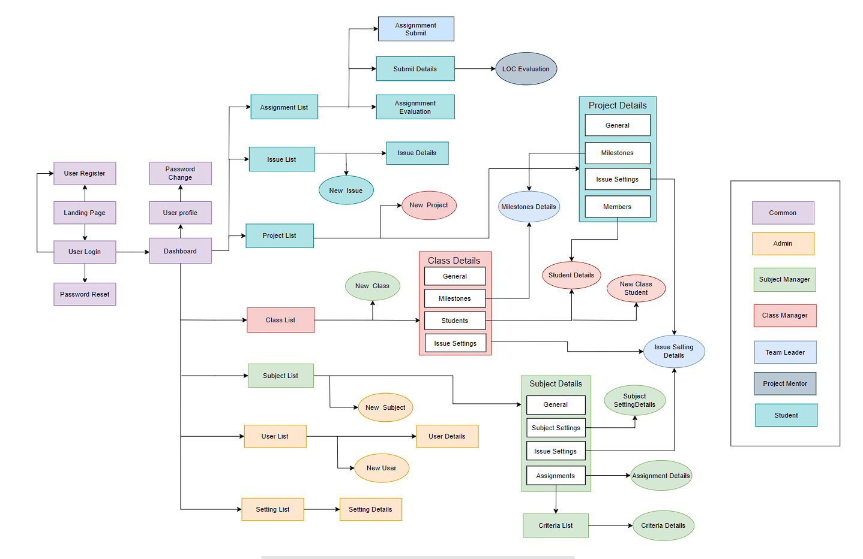

### 2.2 Screen Descriptions

|  |  |  |  |
| --- | --- | --- | --- |
| # | **Feature** | **Screen/Function** | **Screen/Function Details** |
| 1 | Common | Landing Page | View Landing Page |
| 2 | Common | User Register | Register a new account |
| 3 | Common | User Login | Login by email/phone number & password  Login with google |
| 4 | Common | Password Reset | Reset password via Email or Phone Number |
| 5 | Common | Password Change | Allows the user to change password |
| 6 | Common | User Profile | View user profile information and update profile |
| 7 | Admin | Admin Dashboard | Allows admin go to screen user list, subject list, setting list |
| 8 | Admin | User List | View all users |
| 9 | Admin | New User | Add new user into the system |
| 10 | Admin | User Details | Admin can view and change user detail |
| 11 | Admin | Subject List | View all subjects |
| 12 | Admin | New Subject | Add new subject to the system |
| 13 | Admin | Subject Details | This screen allows to view and update subject details |
| 14 | Admin | Setting List | Add a new setting to system |
| 15 | Admin | Setting Details | Update setting details to the system |
| 16 | Common | Home Page | The home page acts as the central hub, offering users a concise overview and easy access to the key features. |
| 17 | Common | Issue Setting List | Displays a list of all issue settings of class |
| 18 | Common | Issue Setting Details | Update details of issue setting in a class |
| 19 | Common | Milestone List | Displays a list of all assignments of a class that learn this subject |
| 20 | Common | Milestone Details | Update class assignment details of a class |
| 21 | Subject Manager | Subject Setting List | Displays a list of all settings of subject |
| 22 | Subject Manager | Subject Setting Details | Update details of subject setting of subject |
| 23 | Subject Manager | Subject Assignment List | Displays a list of all subject assignments |
| 24 | Subject Manager | Subject Assignment Details | Update assignments of subject for all classes learn this subject |
| 25 | Subject Manager | New Class | Add a new class that learn this subject |
| 26 | Class Manager | Class List | Displays a list of all classes that learn this subject |
| 27 | Class Manager | Class Details | View or update details of a class |
| 28 | Class Manager | Class Students List | Displays a list of all student of class |
| 29 | Class Manager | Class Student Details | View details of a student of a class |
| 30 | Class Manager | New Class Student | Add student of class |
| 31 | Class Manager | Project List | Display all project in class |
| 32 | Class Manager | New Project | Add a new project |
| 33 | Class Manager | Project Details | Update details of a project |
| 34 | Class Manager | Project Allocation | Display all member of project group in class |
| 35 | Class Manager | Group Label Sync | Synchronize class issue settings with group labels in Gitlab |
| 36 | Class Manager | Group Milestone Sync | Synchronize class milestones with group milestones in Gitlab |
| 37 | Subject Manager | Criteria List | Displays a list of all criteria of a subject |
| 38 | Subject Manager | Criteria details | Update details of a criteria of a subject |
| 39 | Project Mentor | LOC Evaluation | Give the loc evaluation for a issue |
| 40 | Project Mentor | Assignment Evaluation | Give the detailed evaluation for project team's assignment  submission |
| 41 | Project Mentor | Project Label Sync | Synchronize project issue settings with project labels in Gitlab |
| 42 | Project Mentor | Project Milestone Sync | Synchronize project milestones with project milestones in Gitlab |
| 43 | Team Leader | Assignment Submit | Choose file, issue list that have done in this assignment |
| 44 | Student | Project List | Displays a list of projects that the student join or project mentor manage |
| 45 | Student | Issue List | Displays a list of all issues |
| 46 | Student | Issue Details | Update details of a issue |
| 47 | Student | New Issue | Add new a issue |
| 48 | Student | Work List | Displays a list of all works |
| 49 | Student | Work Details | Update details of a work |
| 50 | Student | Assignment List | Displays a list of all assignment that the student need to submit |
| 51 | Student | Submit Details | View details of a project submission |
| 52 | Admin | Admin Dashboard | Central control for system administrators. |
| 53 | Subject Manager | Subject Manager Dashboard | Tool to manage educational subjects. |
| 54 | Project Mentor | Teacher Dashboard | Digital interface for educators. |
| 55 | Student | Student Dashboard | Hub for student academic information. |

### 2.3 Screen Authorization

|  |  |  |  |  |  |  |  |
| --- | --- | --- | --- | --- | --- | --- | --- |
| **Screen** | **Guest** | **Student** | **Leader** | **Project Mentor** | **Class Manager** | **Subject Manager** | **Admin** |
| Landing Page | X | X | X | X | X | X | X |
| User Register | X | X | X | X | X | X | X |
| User Login |  | X | X | X | X | X | X |
| Password Reset |  | X | X | X | X | X | X |
| Password Change |  | X | X | X | X | X | X |
| User Profile |  | X | X | X | X | X | X |
| User List |  |  |  |  |  |  | X |
| New User |  |  |  |  |  |  | X |
| User Details |  |  |  |  |  |  | X |
| Subject List |  |  |  |  |  |  | X |
| New Subject |  |  |  |  |  |  | X |
| Subject Details |  |  |  |  |  |  | X |
| Setting List |  |  |  |  |  |  | X |
| Setting Details |  |  |  |  |  |  | X |
| Home Page |  |  | X | X | X | X | X |
| Issue Setting List |  |  | X | X | X | X | X |
| Issue Setting Details |  |  | X | X | X | X | X |
| Milestone List |  |  | X | X | X | X | X |
| Milestone Details |  |  | X | X | X | X | X |
| Subject Setting List |  |  |  |  |  | X | X |
| Subject Setting Details |  |  |  |  |  | X | X |
| Subject Assignment List |  |  |  |  |  | X | X |
| Subject Assignment Details |  |  |  |  |  | X | X |
| New Class |  |  |  |  | X | X | X |
| Class List |  |  |  |  | X | X | X |
| Class Details |  |  |  |  | X | X | X |
| Class Students List |  |  |  |  | X | X | X |
| Class Student Details |  |  |  |  | X | X | X |
| New Class Student |  |  |  |  | X | X | X |
| Project List |  |  |  |  | X | X | X |
| New Project |  |  |  |  | X | X | X |
| Project Details |  | X | X | X | X | X | X |
| Project Allocation |  |  |  |  | X | X | X |
| Group Label Sync |  |  |  |  | X | X | X |
| Group Milestone Sync |  |  |  |  | X | X | X |
| Criteria List |  |  |  | X | X | X | X |
| Criteria Details |  |  |  |  | X | X | X |
| LOC Evaluation |  |  |  | X | X | X | X |
| Assignment Evaluation |  | X | X | X | X | X | X |
| Project Label Sync |  |  | X | X | X | X | X |
| Project Milestone Sync |  |  | X | X | X | X | X |
| Assignment Submit |  |  | X |  |  |  |  |
| Project List |  | X | X | X | X | X | X |
| Issue List |  | X | X | X | X | X | X |
| Issue Details |  | X | X | X | X | X | X |
| New Issue |  | X | X | X | X | X | X |
| Work List |  | X | X |  |  |  |  |
| Work Details |  | X | X |  |  |  |  |
| Assignment List |  | X | X | X | X | X | X |
| Submit Details |  | X | X | X | X | X | X |
| Admin Dashboard |  |  |  |  |  |  | X |
| Subject Manager Dashboard |  |  |  |  |  | X |  |
| Teacher Dashboard |  |  |  | X | X |  |  |
| Student Dashboard |  | X | X |  |  |  |  |
| Chat |  | X | X | X |  |  |  |

### 2.4 Non-UI Functions

|  |  |  |  |
| --- | --- | --- | --- |
| **#** | **Feature** | **System Function** | **Description** |
| 1 | Common | Authorization | System check permission of user when they use an authorized function. |
| 2 | Common | Hash password | Passwords must be md5 encrypted before adding to database to secure user information |
| 3 | Class Manager | Synchronize class milestones with Gitlab | Synchronize class assignments with the Gitlab group milestones |
| 4 | Class Manager | Synchronize class issue settings with Gitlab | Synchronize class issue settings with the Gitlab group issue settings |

## 3. System High Level Design

### 3.1 Database Design

#### a. Database Schema

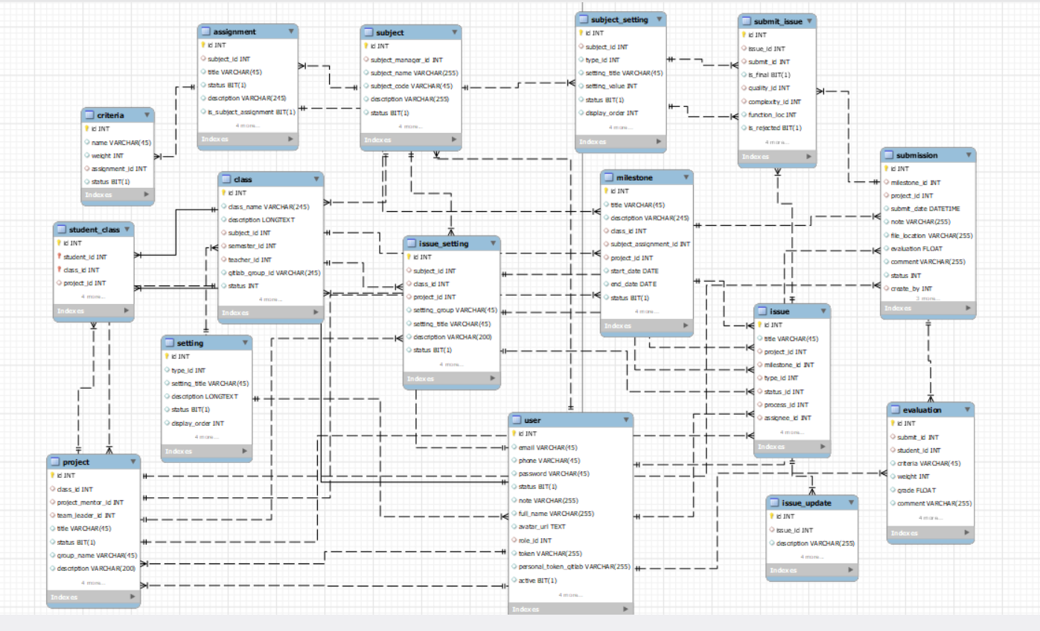

#### b. Table Descriptions

|  |  |  |
| --- | --- | --- |
| **No** | **Table** | **Description** |
| 01 | user | To store user's account information.  - Primary keys: id  - Foreign keys: role_id |
| 02 | setting | To store settings or configurations of the system.  - Primary keys: id  - Foreign keys: # |
| 03 | subject | To store basic information about the subject.  - Primary keys: id  - Foreign keys: subject_manager_id |
| 04 | assignment | To store information about the assignment of a subject.  - Primary keys: id  - Foreign keys:  subject_id |
| 05 | subject_setting | To store settings of the subject .  - Primary keys: id  - Foreign keys: subject_id, class_id, project_id |
| 06 | issue_setting | To store issue settings of the subject .  - Primary keys: id  - Foreign keys: subject_id, class_id, project_id |
| 07 | class | To store basic information about the class.  - Primary keys: id  - Foreign keys: teacher_id , sememter_id |
| 08 | milestone | To store information about the assignment of a class.  - Primary keys: id  - Foreign keys:  class_id, project_id |
| 09 | class_student | To store information about the assignment of members of a project.  - Primary keys: class_id, project_id, member_id  - Foreign keys: class_idproject_id, member_id |
| 10 | project | To store information about the project.  - Primary keys: id  - Foreign keys: class_id, project_mentor_id, team_leader_id |
| 11 | criteria | To store basic information about the mark evaluation for assignment.  - Primary keys: id  - Foreign keys: assignment_id |
| 12 | submission | To store basic information about the submission list for assignment.  - Primary keys: id  - Foreign keys: milestone_id, project_id |
| 13 | member_eval | To store individual mark of each assignment  - Primary keys: id  - Foreign keys: submit_id, student_id |
| 14 | issue | To store list of issue for a project  - Primary keys: id  - Foreign keys: project_id, milestone_id, type_id, status_id, process_id, assignee_id |
| 15 | submit_issue | To store list of issue for a submission  - Primary keys: id  - Foreign keys: issue_id, submit_id, quality_id, complexity_id |
| 16 | issue_update | To store list of work update for an issue  - Primary keys: id  - Foreign keys: issue_id |

### 3.2 Code Packages

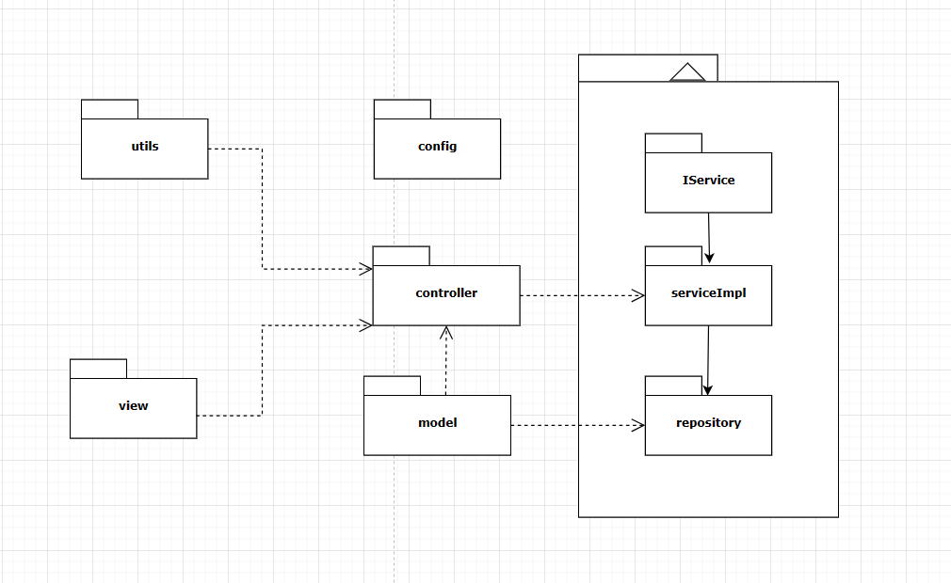

***Package descriptions***

|  |  |  |
| --- | --- | --- |
| **No** | **Package** | **Description** |
| 1 | templates | Contains web pages |
| 2 | controller | Contains classes that handle User’s requests  **Classes’ name: ClassNameController** |
| 3 | services | Contains interfaces that are used to perform business logic and communicate with database and user  **Interfaces’ name: IInterfaceNameService** |
| 4 | serviceimpl | Contains classes that implement service interface  **Classes’ name: ClassNameService** |
| 5 | model | Contains classes that represent real entities in database  **Classes’ name: ClassName, User, …** |
| 6 | repository | Contains interfaces that communicate with the database and return data to service  **Interfaces’ name: INameRepository** |
| 7 | config | Components define system configurations.  **Classes’ name: configConfigName** |

# II. Requirement Specifications

## Common Feature

### 1.1 UC-1_View Landing Page

#### a. Functionalities

|  |  |  |  |
| --- | --- | --- | --- |
| UC ID and Name: | **UC-1_View landing page** | | |
| Created By: | SonDV | Date Created: | 2024/03/15 |
| Primary Actor: | Amin, Subject manager, Class Manager, Team Leader, Student, Guest | Secondary Actors: | None |
| Trigger: | This screen triggers when a user enters the website | | |
| Description: | When the user opens the first link or after login as user, shows the homepage. | | |
| Preconditions: | PRE-1. Users enter the website | | |
| Postconditions: | POST-1. The website display sliders, hot posts, the latest posts, feedback | | |
| Normal Flow: | **1.0 View landing page**  1. Displaying the company logo and/or name  2. Providing a navigation menu to help users explore different sections of the site  3. Highlighting featured content or promotions  4. Providing access to user account information, if applicable . | | |
| Alternative Flows: | 1. If the user is not logged in, the home page might provide a call-to-action button to encourage them to create an account. | | |
| Exceptions: | N/A | | |
| Priority: | Medium | | |
| Frequency of Use: | High | | |
| Business Rules: | None | | |
| Other Information: | N/A | | |
| Assumptions: | N/A | | |

#### b. Business Rules

None

### 1.2 UC-2_Register an account

#### a. Functionalities

|  |  |  |  |
| --- | --- | --- | --- |
| UC ID and Name: | **UC-2_Register an account** | | |
| Created By: | SonDV | Date Created: | 2024/03/15 |
| Primary Actor: | Amin, Subject manager, Class Manager, Team Leader, Student, Guest | Secondary Actors: | None |
| Trigger: | Click a button Register | | |
| Description: | Signup for a new account | | |
| Preconditions: | PRE-1. The user email/phone does not register | | |
| Postconditions: | POST-1. The user has an account to login into system | | |
| Normal Flow: | **2.0 Register an account**  1. User selects the account registration function on the main screen.  2. The system displays a text box allowing the user to create an  fullname, username, password.  3. User fills in the account name and password he wants to create.  **4. The system checks the characters entered in the username and**  **password fields.**  5. User selects “Register”.  **6. The system checks the account name and password with the**  **data on the system. If it exists, go to the registration page..**  7. The system checks the email domain with the data on the system. If it does not exist, add the account and password to the system.  8.1 The user receives the OTP from the inputted phone.  8.2 The user receives a link to verify from inputted email.  9.1 The web moves to enter the OTP screen.  9.2 User clicks the links then redirects to his/her dashboard.  10. The user enters the OTP.  11. The user clicks the “Confirm” button.  12 The system moves to the his/her dashboard. | | |
| Alternative Flows: | **2.1 Register an account**  **4. Username containing special characters**  1. The system displays the message "Invalid username or password"  below the text box of the registered name.  2. User re-enters the username.  3. Go back to step 4.  **2.2 Register an account**  **6. The registered name matches the data on the system**  1. The system displays the message "Registered name is already in  use".  2. User re-enters the registered name and password.  3. Go back to step 6.  7. The system checks the email domain with the data on the system. If it does not exist, add the account and password to the system.  1. The system displays the message "Email domain is not allowed".  2. User re-enters the registered name and password.  3. Go back to step 6. | | |
| Exceptions: | N/A | | |
| Priority: | High, Must Have | | |
| Frequency of Use: | N/A | | |
| Business Rules: | FR1, FR2 | | |
| Other Information: | N/A | | |
| Assumptions: | N/A | | |

#### b. Business Rules

|  |  |  |
| --- | --- | --- |
| **ID** | **Business Rule** | **Business Rule Description** |
| FR1 | Password Encoding | User’s password must be encoded |
| FR2 | Authenticate email or phone number | User account will not active if   * ·    His/her already not authenticate |

### 1.3 UC-3_Login to the system

#### a. Functionalities

|  |  |  |  |
| --- | --- | --- | --- |
| UC ID and Name: | **UC-3_Login to the system** | | |
| Created By: | SonDV | Date Created: | 2024/03/15 |
| Primary Actor: | Amin, Subject manager, Class Manager, Team Leader, Student | Secondary Actors: | None |
| Trigger: | User clicks Login button | | |
| Description: | As a user, I want to be able to log into the system so that I can use the system’s authenticated features and access my personalized account. | | |
| Preconditions: | PRE-1. User account has been created & authorized | | |
| Postconditions: | POST-1. User logs in the system successfully | | |
| Normal Flow | **3.0 Login to the system**  1. User accesses the User Login screen  2. User types in the login details or choose other login options (see 3.1)  3. User clicks the Login button  4. System validates the login details (see 3.0.E1)  5. System allows user to access  6. System tracks user’s success login to the Activity Log  7. System accesses the Dash Board | | |
| Alternative Flows: | ***3.1 Google Login***  1. User chooses to login system using Google account  2. System redirects the user to the Google’s Login screen  3. User types in the Google account details and chooses to login  4. Google validates user’s login information successfully and redirect him/her back to the system  5. Return to step 5 of normal flow. | | |
| Exceptions: | ***3.0.E1 System can’t authenticate the user***  1. The Error Message screen is shown to the user  2. User cancels the logging in *=> UC stops, change to UC-1_View Landing Page*  3. User clicks “Forgot Password?” link *=> change to UC-4_Reset Password*  4. User clicks “Register” link *=> change to UC-2_Register*  ***3.0.E2 User has been blocked***  1. The system show show the message “ Your account has been blocked” | | |
| Priority: | Must Have | | |
| Frequency of Use: | High | | |
| Business Rules: | FR1, FR2 | | |
| Other Information: | N/A | | |
| Assumptions: | N/A | | |

#### b. Business Rules

|  |  |  |
| --- | --- | --- |
| **ID** | **Business Rule** | **Business Rule Description** |
| FR1 | Password Encoding | User’s password must be encoded |
| FR2 | Invalid Logging In | User can’t be authenticated to login the system if below cases   * His/her logging-in details are incorrect * His/her account has not been verified * His/her account has been locked or blocked |

### 1.4 UC-4_Reset password

#### a. Functionalities

|  |  |  |  |
| --- | --- | --- | --- |
| UC ID and Name: | **UC-4_Reset password** | | |
| Created By: | SonDV | Date Created: | 2024/03/15 |
| Primary Actor: | Amin, Subject manager, Class Manager, Team Leader, Student | Secondary Actors: | None |
| Trigger: | When users click on the “Forgot Password” button in the Login screen | | |
| Description: | The user input his/her email to receive OTP code. This code is sent to the user's email for his/her password resetting. | | |
| Preconditions: | PRE-1. The user account is active | | |
| Postconditions: | POST-1. The user can log in with the new password | | |
| Normal Flow: | **4.0** **Reset password**  1. The user clicks “Forgot password?”  2. The user enters an email/phone.  3. The user clicks the “Continue” button.  4. The system checks the email that the user entered.  **5. The user receives the OTP from inputted email/phone.**  6. The web moves to enter the OTP screen.  **7. The user enters the OTP.**  8. The user clicks the “Confirm” button.  9. The system checks the input OTP that the user entered.  10. The web moves to reset the password screen.  11. The user enters the new password and confirms the new password, then clicks the “Save” button.  12. The system checks the valid password that the user entered.  15. When the user clicks OK, the dialog is closed and the web returns to the home page | | |
| Alternative Flows: | **4.1** **User did not receive the confirmation code**  1. The system displays the message “Confirmation code sent”.  2. User re-enters the confirmation code.  3. Go back to step 6.  **4.2**  **User entered wrong confirmation code**  1. The system displays the message "Invalid confirmation code".  2. User re-enters the confirmation code.  3. Go back to step 8. | | |
| Exceptions: | N/A | | |
| Priority: | High, Must Have | | |
| Frequency of Use: | Low | | |
| Business Rules: | FR1 | | |
| Other Information: | N/A | | |
| Assumptions: | N/A | | |

#### b. Business Rules

|  |  |  |
| --- | --- | --- |
| **ID** | **Business Rule** | **Business Rule Description** |
| FR1 | Password Encoding | User’s password must be encoded |

### 1.5 UC-5_Change password

#### a. Functionalities

|  |  |  |  |
| --- | --- | --- | --- |
| UC ID and Name: | **UC-5_Change password** | | |
| Created By: | SonDV | Date Created: | 2024/03/15 |
| Primary Actor: | Amin, Subject manager, Class Manager, Team Leader, Student | Primary Actor: | None |
| Trigger: | When users click on the button “Change Password” | | |
| Description: | This is a function which allows the user to change his/her password by inputting his current password as well as new password (twice). | | |
| Preconditions: | PRE-1. Users login successfully | | |
| Postconditions: | POST-1. Users can change passwords. | | |
| Normal Flow: | **5.0 Change password**  1. User selects "Change Password”  **2. The system displays a text box allowing the user to enter the old password (1 time) and enter the old password (2 times).**  4. Click “Save Changes” and the user has changed the new password for the system. | | |
| Alternative Flows: | **5.1 User entered wrong old password**  1. The system displays the message “Need to enter the correct old password”.  2. After entering, continue the sequence.  **5.2 User entered wrong new password**  1. The system displays the message “New password does not match”.  2. The user must enter the new password twice, making sure that the two passwords match.  3. After entering, continue the sequence. | | |
| Exceptions: | N/A | | |
| Priority: | High, Must Have | | |
| Frequency of Use: | Medium | | |
| Business Rules: | FR1 | | |
| Other Information: | N/A | | |
| Assumptions: | N/A | | |

#### b. Business Rules

|  |  |  |
| --- | --- | --- |
| **ID** | **Business Rule** | **Business Rule Description** |
| FR1 | Password Encoding | User’s password must be encoded |

### 1.6 UC-6_Logout

#### a. Functionalities

|  |  |  |  |
| --- | --- | --- | --- |
| UC ID and Name: | **UC-6_Logout** | | |
| Created By: | SonDV | Date Created: | 2024/03/15 |
| Primary Actor: | Amin, Subject manager, Class Manager, Team Leader, Student | Secondary Actors: | None |
| Trigger: | When users click on the button “Logout” | | |
| Description: | This is a function which allows the user to sign out the system | | |
| Preconditions: | PRE-1. Users login successfully | | |
| Postconditions: | POST-1. Users logout of the system. | | |
| Normal Flow: | **6.0 Logout**  1. User selects "Logout”  2. User logout of the system successfully | | |
| Alternative Flows: | N/A | | |
| Exceptions: | N/A | | |
| Priority: | Medium | | |
| Frequency of Use: | Medium | | |
| Business Rules: | None | | |
| Other Information: | N/A | | |
| Assumptions: | N/A | | |

#### b. Business Rules

None

### 1.7 UC-7_View/Edit profile

#### a. Functionalities

|  |  |  |  |
| --- | --- | --- | --- |
| UC ID and Name: | **UC-7_View/Edit profile** | | |
| Created By: | SonDV | Date Created: | 2024/03/15 |
| Primary Actor: | Amin, Subject manager, Class Manager, Team Leader, Studen | Secondary Actors: | None |
| Trigger: | User clicks “My profile” button | | |
| Description: | As a user, I want to view my profile so that i can confirm and update information | | |
| Preconditions: | PRE-1. User has logged the system | | |
| Postconditions: | POST-1. User see profile successfully | | |
| Normal Flow: | **7.0 View/Edit profile**  1. User selects "My profile”  2. The system displays the profile of the user.  3. User edits his/her own profile.  4. Click “Save Changes” and the user has updated his/her profile for the system. | | |
| Alternative Flows: | **7.1 Full name contains special characters**  1. The system displays the message "Invalid fullname"  2. User re-enters the full name.  3. Go back to step 4 of normal flow | | |
| Exceptions: | N/A | | |
| Priority: | High | | |
| Frequency of Use: | Medium | | |
| Business Rules: | None | | |
| Other Information: | N/A | | |
| Assumptions: | N/A | | |

#### b. Business Rules

None

## 2. Admin Feature

### 2.1 UC-8_View user list

#### a. Functional Description

|  |  |  |  |
| --- | --- | --- | --- |
| UC ID and Name: | **UC-8_View user list** | | |
| Created By: | SonDV | Date Created: | 2024/03/15 |
| Primary Actor: | Admin | Secondary Actors: | None |
| Trigger: | Clicks “User” button from the sidebar | | |
| Description: | *As an admin, I want to be able to view all users of the system so that I can manage all users.* | | |
| Preconditions: | PRE-1. User account have admin role | | |
| Postconditions: | POST-1. Show a list of all users in the system and their information. | | |
| Normal Flow | **8.0 List users**  1. User clicks the “User” in the sidebar  2. System show a list of all users | | |
| Alternative Flows: | None | | |
| Exceptions: |  | | |
| Priority: | Must Have | | |
| Frequency of Use: | Medium | | |
| Business Rules: | None | | |
| Other Information: | N/A | | |
| Assumptions: | N/A | | |

#### b. Business Rules

None

### 2.2 UC-9_Add new user

#### a. Functional Description

|  |  |  |  |
| --- | --- | --- | --- |
| UC ID and Name: | **UC-9_Add new user** | | |
| Created By: | SonDV | Date Created: | 2024/03/15 |
| Primary Actor: | Admin | Secondary Actors: | None |
| Trigger: | Clicks *Add new user* button in User list screen | | |
| Description: | *As an admin, I want to be able to add new users so that I can add new users like a new admin account, quickly create users without registering.* | | |
| Preconditions: | PRE-1. User account have admin role | | |
| Postconditions: | POST-1. Add a new user to the system successfully | | |
| Normal Flow | **9.0 Add new user**  1. User clicks the “Add new user” button.  2. The web displays a form for the admin to fill out the user's details.  3. User fills out the form and clicks the “Add” button.  4. A new user has been added to the system. | | |
| Alternative Flows: | **9.1. Email of a new user existing in the system or email domain isn’t appropriate.**  1. Fill other email that isn’t existed in system  2. Return to step 4 of normal flow.  **9.2. Phone number of new user existed in system**  1. Fill other phone that isn’t existed in system  2. Return to step 4 of normal flow. | | |
| Exceptions: | None | | |
| Priority: | Medium | | |
| Frequency of Use: | Medium | | |
| Business Rules: | FR1 | | |
| Other Information: | N/A | | |
| Assumptions: | N/A | | |

#### b. Business Rules

|  |  |  |
| --- | --- | --- |
| **ID** | **Business Rule** | **Business Rule Description** |
| FR1 | Password Encoding | User’s password must be encoded |

### 2.3 UC-10_Update user details

#### a. Functional Description

|  |  |  |  |
| --- | --- | --- | --- |
| UC ID and Name: | **UC-10_Update user details** | | |
| Created By: | SonDV | Date Created: | 2024/03/15 |
| Primary Actor: | Admin | Secondary Actors: | None |
| Trigger: | Clicks View details button from User list screen | | |
| Description: | *As an admin, I want to be able to update users so that I can change user information.* | | |
| Preconditions: | PRE-1. User account have admin role | | |
| Postconditions: | POST-1. User details has been updated successfully | | |
| Normal Flow | **10.0 Update user details**  1. User clicks “View Details” of the user list screen.  2. The system displays the user's details.  3. User edits the user's details .  4. Click “Update” and the user has updated the user's details for the system. | | |
| Alternative Flows: | **10.1. Update mail that existed in the system or email domain isn’t appropriate.**  1. Fill other email that isn’t existed in system  2. Return to step 4 of normal flow.  **10.2. Update phone number existed in system**  1. Fill other phone that isn’t existed in system  2. Return to step 4 of normal flow. | | |
| Exceptions: | None | | |
| Priority: | Medium | | |
| Frequency of Use: | Medium | | |
| Business Rules: | None | | |
| Other Information: | N/A | | |
| Assumptions: | N/A | | |

#### b. Business Rules

None

### 2.4 UC-11_Activate/Deactivate user

#### a. Functional Description

|  |  |  |  |
| --- | --- | --- | --- |
| UC ID and Name: | **UC-11_Activate/Deactivate user** | | |
| Created By: | SonDV | Date Created: | 2024/03/15 |
| Primary Actor: | Admin | Secondary Actors: | None |
| Trigger: | Clicks Status toggle in User List screen | | |
| Description: | *As an admin, I want to be able to deactivate/activate users so that I can block or allow any user to use the system.* | | |
| Preconditions: | PRE-1. User account have admin role | | |
| Postconditions: | POST-1. Activate/deactivate a user successfully | | |
| Normal Flow | **11.0 Activate/Deactivate user**  1. User clicks status toggle to activate/deactivate a user.  2. The system displays a confirmation form.  3. Click “Confirm” to activate/deactivate a user.  4. A user has been activated/deactivated successfully | | |
| Alternative Flows: | **11.0 Activate/Deactivate user in user detail screen**  1. Choose “edit” icon  2. The system move to User Details  3. User clicks status toggle to activate/deactivate a user.  4. Click “Update” and the user has updated status for a user. | | |
| Exceptions: | None | | |
| Priority: | Must Have | | |
| Frequency of Use: | Medium | | |
| Business Rules: | None | | |
| Other Information: | N/A | | |
| Assumptions: | N/A | | |

#### b. Business Rules

None

### 2.5 UC-12_View subject list

#### a. Functional Description

|  |  |  |  |
| --- | --- | --- | --- |
| UC ID and Name: | **UC-12_View subject list** | | |
| Created By: | SonDV | Date Created: | 2024/03/15 |
| Primary Actor: | Admin | Secondary Actors: | None |
| Trigger: | Clicks “Subject” button from the sidebar | | |
| Description: | *As an admin, I want to be able to view all subjects of the system so that I can manage all subjects.* | | |
| Preconditions: | PRE-1. User account have admin role | | |
| Postconditions: | POST-1. Show a list of all subjects in the system and their information. | | |
| Normal Flow | **12.0 View subject list**  1. User clicks the “Subject” in the sidebar  2. System show a list of all subjects | | |
| Alternative Flows: | None | | |
| Exceptions: | N/A | | |
| Priority: | Must Have | | |
| Frequency of Use: | Medium | | |
| Business Rules: | None | | |
| Other Information: | N/A | | |
| Assumptions: | N/A | | |

#### b. Business Rules

None

### 2.6 UC-13_Add new subject

#### a. Functional Description

|  |  |  |  |
| --- | --- | --- | --- |
| UC ID and Name: | **UC-13_Add new subject** | | |
| Created By: | SonDV | Date Created: | 2024/03/15 |
| Primary Actor: | Admin | Secondary Actors: | None |
| Trigger: | Clicks *Add new subject* button in Subject list screen | | |
| Description: | The admin add new subject to the system | | |
| Preconditions: | PRE-1. User account have admin role | | |
| Postconditions: | POST-1. Add a new subject to the system successfully | | |
| Normal Flow | **13.0 Add new subject**  1. User clicks the “Add new subject” button.  2. The system displays a form for the admin to fill out the subject's details.  3. User fills out the form and clicks the “Add” button.  4. A new subject has been added to the system. | | |
| Alternative Flows: | **13.1 Update subject name has special characters**  1. The system displays the message "Subject name has special characters"  2. User re-enters the subject name.  3. Go back to step 4 of normal flow | | |
| Exceptions: | None | | |
| Priority: | Medium | | |
| Frequency of Use: | Medium | | |
| Business Rules: | None | | |
| Other Information: | N/A | | |
| Assumptions: | N/A | | |

#### b. Business Rules

None

### 2.7 UC-14_Update subject details

#### a. Functional Description

|  |  |  |  |
| --- | --- | --- | --- |
| UC ID and Name: | **UC-14_Update subject details** | | |
| Created By: | SonDV | Date Created: | 2024/03/15 |
| Primary Actor: | Admin | Secondary Actors: | None |
| Trigger: | Clicks View details button from Subject list screen | | |
| Description: | *As an admin, I want to be able to update subjects so that I can change subject information.* | | |
| Preconditions: | PRE-1. User account have admin role | | |
| Postconditions: | POST-1. Subject details has been updated successfully | | |
| Normal Flow | **14.0 Update subject details**  1. User clicks “View Details” of a user.  2. The system displays the subject's details.  3. User edits the subject's details.  4. Click “Update” and the user has updated the subject's details for the system. | | |
| Alternative Flows: | **14.1 Subject has been existed**  1. The system displays the message "This subject has been existed"  2. User re-enters the subject name.  3. Go back to step 4 of normal flow | | |
| Exceptions: | None | | |
| Priority: | Medium | | |
| Frequency of Use: | Medium | | |
| Business Rules: | None | | |
| Other Information: | N/A | | |
| Assumptions: | N/A | | |

#### b. Business Rules

None

### 2.8 UC-15_Activate/Deactivate subject

#### a. Functional Description

|  |  |  |  |
| --- | --- | --- | --- |
| UC ID and Name: | **UC-15_Activate/Deactivate subject** | | |
| Created By: | SonDV | Date Created: | 2024/03/15 |
| Primary Actor: | Admin | Secondary Actors: | None |
| Trigger: | Clicks Status toggle in Subject List screen | | |
| Description: | The admin deactivate/activate subjects | | |
| Preconditions: | PRE-1. User account have admin role | | |
| Postconditions: | POST-1. Activate/deactivate a subject successfully | | |
| Normal Flow | **15.0 Activate/Deactivate subject**  1. User clicks status toggle to activate/deactivate a subject.  2. The system displays a confirmation form.  3. Click “Confirm” to activate/deactivate a subject.  4. A subject has been activated/deactivated successfully. | | |
| Alternative Flows: | **15.0 Activate/Deactivate user in subject detail screen**  1. Choose “edit” icon  2. The system move to Subject Details  3. User clicks status toggle to activate/deactivate a subject.  4. Click “Update” and the user has updated status for a subject. | | |
| Exceptions: | N/A | | |
| Priority: | Must Have | | |
| Frequency of Use: | Low | | |
| Business Rules: | None | | |
| Other Information: | N/A | | |
| Assumptions: | N/A | | |

#### b. Business Rules

None

### 2.9 UC-16_View setting list

#### a. Functional Description

|  |  |  |  |
| --- | --- | --- | --- |
| UC ID and Name: | **UC-16_View setting list** | | |
| Created By: | SonDV | Date Created: | 2024/03/15 |
| Primary Actor: | Admin | Secondary Actors: | None |
| Trigger: | Clicks “Setting” button from the sidebar | | |
| Description: | *As an admin, I want to be able to view all settings of system so that i can manage the system more effectively.* | | |
| Preconditions: | PRE-1. User account have admin role | | |
| Postconditions: | POST-1. Show a list of all settings in the system and their information. | | |
| Normal Flow | **16.0 View setting list**  1. User clicks the “Setting” in the sidebar  2. System show a list of all settings | | |
| Alternative Flows: | None | | |
| Exceptions: | N/A | | |
| Priority: | Must Have | | |
| Frequency of Use: | Medium | | |
| Business Rules: | None | | |
| Other Information: | N/A | | |
| Assumptions: | N/A | | |

#### b. Business Rules

None

### 2.10 UC-17_Add new setting

#### a. Functional Description

|  |  |  |  |
| --- | --- | --- | --- |
| UC ID and Name: | **UC-17_Add new setting** | | |
| Created By: | SonDV | Date Created: | 2024/03/15 |
| Primary Actor: | Admin | Secondary Actors: | None |
| Trigger: | Clicks *Add new* button in Setting list screen | | |
| Description: | *As an admin, I want to be able to add new settings so that I can manage the system more effectively.* | | |
| Preconditions: | PRE-1. User account have admin role | | |
| Postconditions: | POST-1. Add a new setting to the system successfully | | |
| Normal Flow | **17.0 Add new setting**  1. User clicks the “Add new” button.  2. The system displays a form for the admin to fill out setting's details.  3. User fills out the form and clicks the “Add” button.  4. A new setting has been added to the system. | | |
| Alternative Flows: | **17.1 Setting has been existed**  1. The system displays the message "This setting has been existed"  2. User re-enters the setting title.  3. Go back to step 4 of normal flow | | |
| Exceptions: | None | | |
| Priority: | Medium | | |
| Frequency of Use: | Medium | | |
| Business Rules: | None | | |
| Other Information: | N/A | | |
| Assumptions: | N/A | | |

#### b. Business Rules

None

### 2.11 UC-18_Update setting details

#### a. Functional Description

|  |  |  |  |
| --- | --- | --- | --- |
| UC ID and Name: | **UC-18_Update setting details** | | |
| Created By: | SonDV | Date Created: | 2024/03/15 |
| Primary Actor: | Admin | Secondary Actors: | None |
| Trigger: | Clicks “Edit icon” from Setting list screen | | |
| Description: | *As an admin, I want to be able to update settings so that I can manage the system more effectively.* | | |
| Preconditions: | PRE-1. User account have admin role | | |
| Postconditions: | POST-1.Subject details has been updated successfully | | |
| Normal Flow | **18.0 Update setting details**  1. User clicks the “Edit” Icon of a setting.  2. The system displays setting's details.  3. User edits the setting's details.  4. Click “Update” and the user has updated setting's details for the system. | | |
| Alternative Flows: | **18.1 Setting has been duplicated**  1. The system displays the message "Duplicated setting title"  2. User re-enters the setting title.  3. Go back to step 4 of normal flow | | |
| Exceptions: | None | | |
| Priority: | Medium | | |
| Frequency of Use: | Low | | |
| Business Rules: | None | | |
| Other Information: | N/A | | |
| Assumptions: | N/A | | |

#### b. Business Rules

None

### 2.12 UC-19_Activate/Deactivate setting

#### a. Functional Description

|  |  |  |  |
| --- | --- | --- | --- |
| UC ID and Name: | **UC-20_ Activate/Deactivate setting** | | |
| Created By: | SonDV | Date Created: | 2024/03/15 |
| Primary Actor: | Admin | Secondary Actors: | None |
| Trigger: | Clicks Status toggle in Setting List screen | | |
| Description: | *As an admin, I want to be able to deactivate/activate settings so that i can manage the system more effectively.* | | |
| Preconditions: | PRE-1. User account have admin role | | |
| Postconditions: | POST-1. Activate/deactivate a setting successfully | | |
| Normal Flow | **20.0 Activate/Deactivate setting in Setting List**  1. User clicks status toggle to activate/deactivate a setting or choose “edit” icon to update status in setting details (see 20.1)  2. The system displays a confirmation form.  3. Click “Confirm” to activate/deactivate a setting.  4. A setting has been activated/deactivated successfully. | | |
| Alternative Flows: | **20.1 Activate/Deactivate setting in Setting Details**  1. Choose “edit” icon  2. The system move to Setting Details  3. User clicks status toggle to activate/deactivate a setting.  4. Click “Update” and the user has updated status for a setting . | | |
| Exceptions: | None | | |
| Priority: | Must Have | | |
| Frequency of Use: | Low | | |
| Business Rules: | None | | |
| Other Information: | N/A | | |
| Assumptions: | N/A | | |

#### b. Business Rules

None

## 3. Subject Manager Feature

### 3.1 UC-20_View subject setting list

#### a. Functional Description

|  |  |  |  |
| --- | --- | --- | --- |
| UC ID and Name: | **UC-20_View subject setting list** | | |
| Created By: | SonDV | Date Created: | 2024/03/15 |
| Primary Actor: | Admin | Secondary Actors: | None |
| Trigger: | Clicks “Subject Setting” button from the sidebar | | |
| Description: | *As a subject manager, I want to be able to view all subject settings of a subject so that I can manage subjects more effectively.* | | |
| Preconditions: | PRE-1. User account have subject manager role | | |
| Postconditions: | POST-1. Show a list of all subject settings in the system and their information. | | |
| Normal Flow | **20.0 View subject setting list**  1. Subject manager clicks the “Subject Setting” tab in the subject details  2. System show a list of all subject settings | | |
| Alternative Flows: | None | | |
| Exceptions: | N/A | | |
| Priority: | Must Have | | |
| Frequency of Use: | Medium | | |
| Business Rules: | None | | |
| Other Information: | N/A | | |
| Assumptions: | N/A | | |

#### b. Business Rules

None

### 3.2 UC-21_Activate/Deactivate subject settings

#### a. Functional Description

|  |  |  |  |
| --- | --- | --- | --- |
| UC ID and Name: | **UC-22_ Activate/Deactivate subject setting** | | |
| Created By: | SonDV | Date Created: | 2024/03/15 |
| Primary Actor: | Admin | Secondary Actors: | None |
| Trigger: | Clicks Status toggle in Subject Setting List screen | | |
| Description: | *As a subject manager, I want to be able to deactivate/activate subject settings so that I can manage subjects more effectively.* | | |
| Preconditions: | PRE-1. User account have subject manager role | | |
| Postconditions: | POST-1. Activate/deactivate a subject setting successfully | | |
| Normal Flow | **21.0 Activate/Deactivate subject setting in List Screen**  1.User clicks status toggle to activate/deactivate a subject setting or choose “edit” icon to update status in subject setting details (see 22.1)  2. The system displays a confirmation form.  3. Click “Confirm” to activate/deactivate a subject setting. | | |
| Alternative Flows: | **21.1 Activate/Deactivate Subject Setting in Details Screen**  1. Choose “edit” icon  2. The system move to Subject Setting Details  3. User clicks status toggle to activate/deactivate a subject setting.  4. Click “Update” and the user has updated status for a subject setting. | | |
| Exceptions: | None | | |
| Priority: | Must Have | | |
| Frequency of Use: | Low | | |
| Business Rules: | None | | |
| Other Information: | N/A | | |
| Assumptions: | N/A | | |

#### b. Business Rules

None

### 3.3 UC-22_Add new subject setting

#### a. Functional Description

|  |  |  |  |
| --- | --- | --- | --- |
| UC ID and Name: | **UC-22_Add new subject setting** | | |
| Created By: | SonDV | Date Created: | 2024/03/15 |
| Primary Actor: | Subject Manager | Secondary Actors: | None |
| Trigger: | Clicks *Add new* button in Subject Setting List Screen | | |
| Description: | *As a subject manager, I want to be able to add new subject settings so that I can manage the subject more effectively.* | | |
| Preconditions: | PRE-1. User account have subject manager role | | |
| Postconditions: | POST-1. Add a new subject setting to the system successfully | | |
| Normal Flow | **22.0 Add new subject setting**  1. User clicks the “Add new” button.  2. The system displays a form for the admin to fill out the subject setting's details.  3. User fills out the form and clicks the “Add” button.  4. A new subject setting has been added to the system. | | |
| Alternative Flows: | **22.1 Subject setting has been existed**  1. The system displays the message "This subject setting has been existed"  2. User re-enters the setting title.  3. Go back to step 4 of normal flow | | |
| Exceptions: | None | | |
| Priority: | Medium | | |
| Frequency of Use: | Low | | |
| Business Rules: | None | | |
| Other Information: | N/A | | |
| Assumptions: | N/A | | |

#### b. Business Rules

None

### 3.4 UC-23_Update subject setting details

#### a. Functional Description

|  |  |  |  |
| --- | --- | --- | --- |
| UC ID and Name: | **UC-23_Update subject setting details** | | |
| Created By: | SonDV | Date Created: | 2024/03/15 |
| Primary Actor: | Subject Manager | Secondary Actors: | None |
| Trigger: | Clicks “Edit icon” from Subject Setting list screen | | |
| Description: | *As a subject manager, I want to be able to update subject settings so that I can manage the subject more effectively.* | | |
| Preconditions: | PRE-1. User account have subject manager role | | |
| Postconditions: | POST-1. Subject setting details has been updated successfully | | |
| Normal Flow | **23.0 Update subject setting details**  1. User clicks the “Edit” Icon of a subject setting.  2. The system displays the subject setting's details.  3. User edits the subject setting's details.  4. Click “Update” and the user has updated the subject setting's details for the system. | | |
| Alternative Flows: | **23.1 Subject setting has been duplicated**  1. The system displays the message "Duplicated subject setting name"  2. User re-enters the subject setting name.  3. Go back to step 4 of normal flow | | |
| Exceptions: | None | | |
| Priority: | Medium | | |
| Frequency of Use: | Low | | |
| Business Rules: | None | | |
| Other Information: | N/A | | |
| Assumptions: | N/A | | |

#### b. Business Rules

None

### 3.5 UC-24_View subject assignment list

#### a. Functional Description

|  |  |  |  |  |
| --- | --- | --- | --- | --- |
| UC ID and Name: | **UC-24_View subject assignment list** | | | |
| Created By: | SonDV |  | Date Created: | 2024/03/15 |
| Primary Actor: | Subject Manager |  | Secondary Actors: | None |
| Trigger: | Clicks “Subject Assignment” button from the sidebar | | | |
| Description: | *As a subject manager, I want to be able to view all subject assignments so that I can manage my subjects assignment more effectively.* | | | |
| Preconditions: | PRE-1. User account have subject manager role | | | |
| Postconditions: | POST-1. Show a list of all subject assignments and their information. | | | |
| Normal Flow | **25.0 List subject assignments**  1. User clicks the “Subject Assignment” in the sidebar  2. System show a list of all Subject Assignment | | | |
| Alternative Flows: | None | | | |
| Exceptions: | None | | | |
| Priority: | Must have | | | |
| Frequency of Use: | High | | | |
| Business Rules: | None | | | |
| Other Information: | N/A | | | |
| Assumptions: | N/A | | | |

#### b. Business Rules

None

### 3.6 UC-25_ Add new subject assignment

#### a. Functional Description

|  |  |  |  |
| --- | --- | --- | --- |
| UC ID and Name: | **UC-25_Add new subject assignment** | | |
| Created By: | SonDV | Date Created: | 2024/03/15 |
| Primary Actor: | Subject Manager | Secondary Actors: | None |
| Trigger: | Clicks *Add new subject assignment* button in *subject assignment* list screen | | |
| Description: | *As a subject manager, I want to be able to add new*  subject assignments so *that I can add more classes to the system.* | | |
| Preconditions: | PRE-1. User account have subject manager role | | |
| Postconditions: | POST-1. Add a subject assignmentof this subject to the system successfully | | |
| Normal Flow | **25.0 Add new subject assignment**  1. Users click the “Add new subject assignment” button.  2. The system displays a form for users to fill out class's details.  3. User fills out the form and clicks the “Add” button.  4. A new subject assignment has been added to the system. | | |
| Alternative Flows: | **25.1 Subject assignment** **has been existed**  1. The system displays the message "This assignment has been existed"  2. User re-enters the assignment title  3. Go back to step 4 of normal flow | | |
| Exceptions: | None | | |
| Priority: | Must Have | | |
| Frequency of Use: | Medium | | |
| Business Rules: | None | | |
| Other Information: | N/A | | |
| Assumptions: | N/A | | |

#### b. Business Rules

None

### 3.7 UC-26_ Update subject assignment details

#### a. Functional Description

|  |  |  |  |
| --- | --- | --- | --- |
| UC ID and Name: | **UC-26_Update subject assignment details** | | |
| Created By: | SonDV | Date Created: | 2024/03/15 |
| Primary Actor: | Subject Manager | Secondary Actors: | None |
| Trigger: | Clicks “Edit” icon from Subject Assignment list screen | | |
| Description: | *As a subject manager, I want to be able to update class details so that I can update up-to-now information for Subject Assignments* | | |
| Preconditions: | PRE-1. User account have subject managerrole | | |
| Postconditions: | POST-1. Subject Assignment details has been updated successfully | | |
| Normal Flow | **26.0 Update subject assignment details**  1. Userclicks the “Edit” icon of the subject assignment list screen.  2. The system displays subject assignment’s details.  3. User edits subject assignment’s details.  4. Click “Update” and the user has updated the subject assignment’s details for the system. | | |
| Alternative Flows: | **26.1 Subject assignment has been duplicated**  1. The system displays the message "Duplicate subject assignment "  2. User re-enters the subject assignment .  3. Go back to step 4 of normal flow | | |
| Exceptions: | None | | |
| Priority: | Medium | | |
| Frequency of Use: | Medium | | |
| Business Rules: | None | | |
| Other Information: | N/A | | |
| Assumptions: | N/A | | |

#### b. Business Rules

None

### 3.8 UC-27_ Delete subject assignments

#### a. Functional Description

|  |  |  |  |
| --- | --- | --- | --- |
| UC ID and Name: | **UC-27_Delete subject assignment** | | |
| Created By: | SonDV | Date Created: | 2024/03/15 |
| Primary Actor: | Subject Manager | Secondary Actors: | None |
| Trigger: | Clicks “Delete” button from the sidebar | | |
| Description: | *As a subject manager, I want to be able to delete subject assignments so that I can manage my subject assignment more effectively.* | | |
| Preconditions: | PRE-1. User account have subject manager role | | |
| Postconditions: | POST-1. Delete subject assignment with its id. | | |
| Normal Flow | **27.0 Delete subject assignment**  1. User clicks the “Delete” in the list subject assignment  2. System will delete subject assignment | | |
| Alternative Flows: | None | | |
| Exceptions: | None | | |
| Priority: | Must Have | | |
| Frequency of Use: | Low | | |
| Business Rules: | None | | |
| Other Information: | N/A | | |
| Assumptions: | N/A | | |

#### b. Business Rules

None

### 3.9 UC-28_View class list

#### a. Functional Description

|  |  |  |  |
| --- | --- | --- | --- |
| UC ID and Name: | **UC-28_View class list** | | |
| Created By: | SonDV | Date Created: | 2024/03/15 |
| Primary Actor: | Subject Manager | Secondary Actors: | None |
| Trigger: | Clicks “Class” button from the sidebar | | |
| Description: | *As a subject manager, I want to be able to view all classes so that I can manage my subjects more effectively.* | | |
| Preconditions: | PRE-1. User account have subject manager role | | |
| Postconditions: | POST-1. Show a list of all classes and their information. | | |
| Normal Flow | **28.0 View class list**  1. User clicks the “Class” in the sidebar  2. System show a list of all classes | | |
| Alternative Flows: | None | | |
| Exceptions: | None | | |
| Priority: | Must Have | | |
| Frequency of Use: | High | | |
| Business Rules: | None | | |
| Other Information: | N/A | | |
| Assumptions: | N/A | | |

#### b. Business Rules

None

### 3.10 UC-29_ Add new class

#### a. Functional Description

|  |  |  |  |
| --- | --- | --- | --- |
| UC ID and Name: | **UC-29_Add new class** | | |
| Created By: | SonDV | Date Created: | 2024/03/15 |
| Primary Actor: | Subject Manager | Secondary Actors: | None |
| Trigger: | Clicks *Add new class* button in Class list screen | | |
| Description: | *As a subject manager, I want to be able to add new classes so that I can add more classes to the system.* | | |
| Preconditions: | PRE-1. User account have subject manager role | | |
| Postconditions: | POST-1. Add a class that learn this subject to the system successfully | | |
| Normal Flow | **29.0 Add new class**  1. User clicks the “Add new class” button.  2. The system displays a form for users to fill out class's details.  3. User fills out the form and clicks the “Add” button.  4. A new class has been added to the system. | | |
| Alternative Flows: | **29.1 Class has been existed**  1. The system displays the message "This class has been existed"  2. User re-enters the class name.  3. Go back to step 4 of normal flow | | |
| Exceptions: | None | | |
| Priority: | Medium | | |
| Frequency of Use: | High | | |
| Business Rules: | None | | |
| Other Information: | N/A | | |
| Assumptions: | N/A | | |

#### b. Business Rules

None

### 3.11 UC-30_ Update class details

#### a. Functional Description

|  |  |  |  |
| --- | --- | --- | --- |
| UC ID and Name: | **UC-30_Update class details** | | |
| Created By: | SonDV | Date Created: | 2024/03/15 |
| Primary Actor: | Subject Manager | Secondary Actors: | None |
| Trigger: | Clicks “Edit” icon from Class list screen | | |
| Description: | *As a subject manager, I want to be able to update class details so that I can update up-to-now information for classes* | | |
| Preconditions: | PRE-1. User account have subject managerrole | | |
| Postconditions: | POST-1. Class details has been updated successfully | | |
| Normal Flow | **30.0 Update class details**  1. Userclicks the “Edit” icon of the class list screen.  2. The system displays class's details.  3. User edits the class's details.  4. Click “Update” and the user has updated the class's details for the system. | | |
| Alternative Flows: | **30.1 Class name has been duplicated**  1. The system displays the message "Duplicate class name"  2. User re-enters the class name.  3. Go back to step 4 of normal flow | | |
| Exceptions: | None | | |
| Priority: | Medium | | |
| Frequency of Use: | Medium | | |
| Business Rules: | None | | |
| Other Information: | N/A | | |
| Assumptions: | N/A | | |

#### b. Business Rules

None

### 3.12 UC-31_ Cancel started class

#### a. Functional Description

|  |  |  |  |
| --- | --- | --- | --- |
| UC ID and Name: | **UC-31_Cancel started class** | | |
| Created By: | SonDV | Date Created: | 2024/03/15 |
| Primary Actor: | Subject Manager | Secondary Actors: | None |
| Trigger: | Clicks Status toggle in Class List screen | | |
| Description: | *As a subject manager, I want to be able to cancel classes so that I can prevent that class from learning my subject.* | | |
| Preconditions: | PRE-1. User account have subject managerrole | | |
| Postconditions: | POST-1. Cancel started class successfully | | |
| Normal Flow | **31.0 Cancel started class**  1. User clicks status toggle to cancel started class pending class.  2. The system displays a confirmation form.  3. Click “Confirm” to cancel the started class.  4. A class has been canceled/deleted successfully | | |
| Alternative Flows: | **31.1 Cancel class in Details Screen**  1. Choose “edit” icon  2. The system move to Class Details  3. User choose “cancel” status.  4. Click “Update” and the user has cancel a class. | | |
| Exceptions: | None | | |
| Priority: | Must Have | | |
| Frequency of Use: | Medium | | |
| Business Rules: | None | | |
| Other Information: | N/A | | |
| Assumptions: | N/A | | |

#### b. Business Rules

None

### 3.13 UC-32_ Delete pending class

#### a. Functional Description

|  |  |  |  |
| --- | --- | --- | --- |
| UC ID and Name: | **UC-32_Delete pending class** | | |
| Created By: | SonDV | Date Created: | 2024/03/15 |
| Primary Actor: | Subject Manager | Secondary Actors: | None |
| Trigger: | Clicks Status toggle in Class List screen | | |
| Description: | *As a subject manager, I want to be able to delete pending classes so that I can prevent that class from learning my subject.* | | |
| Preconditions: | PRE-1. User account have subject managerrole | | |
| Postconditions: | POST-1. Cancel started class/ Delete pending class successfully | | |
| Normal Flow | **32.0 Delete pending class**  1. User clicks status toggle to delete pending class.  2. The system displays a confirmation form.  3. Click “Confirm” to delete pending class.  4. A class has been deleted successfully | | |
| Alternative Flows: | None | | |
| Exceptions: | None | | |
| Priority: | Must Have | | |
| Frequency of Use: | Medium | | |
| Business Rules: | None | | |
| Other Information: | N/A | | |
| Assumptions: | N/A | | |

#### b. Business Rules

None

### 3.14 UC-33_View class assignment list

#### a. Functional Description

|  |  |  |  |
| --- | --- | --- | --- |
| UC ID and Name: | **UC-33_View class assignment list** | | |
| Created By: | SonDV | Date Created: | 2024/03/15 |
| Primary Actor: | Subject Manager | Secondary Actors: | None |
| Trigger: | Clicks “Class” button from the sidebar, choose assignment button | | |
| Description: | *As a subject manager, I want to be able to view all classes assignment in the subject so that I can manage them effectively* | | |
| Preconditions: | PRE-1. User account have subject managerrole | | |
| Postconditions: | POST-1. Show a list of all class in subject and their information  POST-2. View detail of a class | | |
| Normal Flow | **33.0 View class assignment list**  1. Subject manager clicks the “Milestone” tab in the class details screen  2. System show a list of all class milestones in subject | | |
| Alternative Flows: | None | | |
| Exceptions: | None | | |
| Priority: | Must Have | | |
| Frequency of Use: | High | | |
| Business Rules: | None | | |
| Other Information: | N/A | | |
| Assumptions: | N/A | | |

#### b. Business Rules

None

### 3.15 UC-34_ Add new class assignment

#### a. Functional Description

|  |  |  |  |
| --- | --- | --- | --- |
| UC ID and Name: | **UC-34_Add new class assignment** | | |
| Created By: | SonDV | Date Created: | 2024/03/15 |
| Primary Actor: | Subject Manager | Secondary Actors: | None |
| Trigger: | Clicks “Add class” button from the page Class list | | |
| Description: | *As a subject manager, I want to be able to add a class assignment* | | |
| Preconditions: | PRE-1. User account have subject managerrole | | |
| Postconditions: | POST-1. The website display the class added | | |
| Normal Flow | **34.0 Add new class assignment**  1. User clicks the “Add new” button in the class milestones list.  2. The system displays a form for admin to fill out Class milestones details.  3. User fills out the form and clicks the “Add” button.  4. Return to class milestones list | | |
| Alternative Flows: | **34.1 Class assignment has been existed**  1. The system displays the message "This class assignment has been existed"  2. User re-enters the class assignment title.  3. Go back to step 4 of normal flow | | |
| Exceptions: | None | | |
| Priority: | Must Have | | |
| Frequency of Use: | High | | |
| Business Rules: | None | | |
| Other Information: | N/A | | |
| Assumptions: | N/A | | |

#### b. Business Rules

None

### 3.16 UC-35_ Update class assignment details

#### a. Functional Description

|  |  |  |  |
| --- | --- | --- | --- |
| UC ID and Name: | **UC-35_Update class assignment details** | | |
| Created By: | SonDV | Date Created: | 2024/03/15 |
| Primary Actor: | Subject Manager | Secondary Actors: | None |
| Trigger: | Clicks “Details” button from the Class Assignment list | | |
| Description: | *As a subject manager, I want to be able to update class assignment details so that I can change class information.* | | |
| Preconditions: | PRE-1. User account have subject managerrole | | |
| Postconditions: | POST-1. The website display the updated class *assignment* list | | |
| Normal Flow | **35.0 Update class assignment details**  1. User clicks “View Details” of a user.  2. The system displays class *assignment* details.  3.User edits class *assignment* details .  4. Click “Update” and the user has updated class *assignment* details for the system.  5. The system displays the user list | | |
| Alternative Flows: | **35.1 Class assignment title has been duplicated**  1. The system displays the message "Duplicate class assignment title"  2. User re-enters the class assignment title.  3. Go back to step 4 of normal flow | | |
| Exceptions: | None | | |
| Priority: | Must Have | | |
| Frequency of Use: | Medium | | |
| Business Rules: | None | | |
| Other Information: | N/A | | |

#### b. Business Rules

None

## 4. Class Manager Feature

### 4.1 UC-36_View assigned class list

#### a. Functional Description

|  |  |  |  |
| --- | --- | --- | --- |
| UC ID and Name: | **UC-36_View assigned class list** | | |
| Created By: | SonDV | Date Created: | 2024/03/15 |
| Primary Actor: | Class Manager | Secondary Actors: | None |
| Trigger: | Clicks “Assigned Class” button from the sidebar | | |
| Description: | *As a class manager, I want to be able to view all assigned classes so that I can manage all classes more effectively.* | | |
| Preconditions: | PRE-1. User account have class managerrole | | |
| Postconditions: | POST-1. Show a list of all assigned classes and their information. | | |
| Normal Flow | **36.0 View assigned class list**  1. User clicks the “Assigned Class” in the sidebar  2. System shows a list of all assigned classes. | | |
| Alternative Flows: | None | | |
| Exceptions: | None | | |
| Priority: | Must Have | | |
| Frequency of Use: | High | | |
| Business Rules: | None | | |
| Other Information: | N/A | | |
| Assumptions: | N/A | | |

#### b. Business Rules

None

### 4.2 UC-37_ Update assigned class details

#### a. Functional Description

|  |  |  |  |
| --- | --- | --- | --- |
| UC ID and Name: | **UC-37_Update assigned class details** | | |
| Created By: | SonDV | Date Created: | 2024/03/15 |
| Primary Actor: | Class Manager | Secondary Actors: | None |
| Trigger: | Clicks “Edit” icon from Assigned class list screen | | |
| Description: | *As a class manager, I want to be able to update class details so that I can update up-to-now information for classes.* | | |
| Preconditions: | PRE-1. User account have class manager role | | |
| Postconditions: | POST-1. Assigned class details has been updated successfully | | |
| Normal Flow | **37.0 Update assigned class details**  1. User clicks the “Edit” icon from the Class list screen.  2. The system displays the assigned class's details.  3. User edits assigned class’s details.  4. Click “Update” and the user has updated the assigned class’s details for the system. | | |
| Alternative Flows: | **37.1 Class name has been duplicated**  1. The system displays the message "Duplicate class name"  2. User re-enters the class name.  3. Go back to step 4 of normal flow | | |
| Exceptions: | None | | |
| Priority: | Medium | | |
| Frequency of Use: | Medium | | |
| Business Rules: | None | | |
| Other Information: | N/A | | |
| Assumptions: | N/A | | |

#### b. Business Rules

None

### 4.3 UC-38_ Synchronize class information with Gitlab

#### a. Functional Description

|  |  |  |  |
| --- | --- | --- | --- |
| UC ID and Name: | **UC-38_Synchronize class information with Gitlab** | | |
| Created By: | SonDV | Date Created: | 2024/03/15 |
| Primary Actor: | Class Manager | Secondary Actors: | None |
| Trigger: | Clicks “Synchronize” button from Class list screen | | |
| Description: | *As a subject manager, I want to be able to synchronize class information with Gitlab so that I can update up-to-now information for classes.* | | |
| Preconditions: | PRE-1. User account have class manager role | | |
| Postconditions: | POST-1. Synchronize class information with Gitlab successfully | | |
| Normal Flow | **38.0 Synchronize class information with Gitlab**  1. User clicks the “Synchronize” button icon from the Class list screen.  2. Class information has been synchronized with Gitlab | | |
| Alternative Flows: | None | | |
| Exceptions: | None | | |
| Priority: | Medium | | |
| Frequency of Use: | Medium | | |
| Business Rules: | None | | |
| Other Information: | N/A | | |
| Assumptions: | N/A | | |

#### b. Business Rules

None

### 4.4 UC-39_ List class assignments

#### a. Functional Description

|  |  |  |  |
| --- | --- | --- | --- |
| UC ID and Name: | **UC-39_List class assignments** | | |
| Created By: | SonDV | Date Created: | 2024/03/15 |
| Primary Actor: | Class manager | Secondary Actors: | None |
| Trigger: | Clicks “Class” button from the sidebar, choose assignment button | | |
| Description: | *As a subject manager, I want to be able to view class assignment details so that I can update up-to-now information for classes.* | | |
| Preconditions: | PRE-1. User account have class manager role | | |
| Postconditions: | POST-1.The website display the class *assignment* list | | |
| Normal Flow | **39.0 List class assignments**  1. User clicks the “Class” in the sidebar  2. System show a list of all class in subject  3. Click view detail  4. Choose Assignment button | | |
| Alternative Flows: | None | | |
| Exceptions: | None | | |
| Priority: | Medium | | |
| Frequency of Use: | High | | |
| Business Rules: | None | | |
| Other Information: | N/A | | |
| Assumptions: | N/A | | |

#### b. Business Rules

None

### 4.5 UC-40_ Update class assignment details

#### a. Functional Description

|  |  |  |  |
| --- | --- | --- | --- |
| UC ID and Name: | **UC-40_Update class assignment details** | | |
| Created By: | SonDV | Date Created: | 2024/03/15 |
| Primary Actor: | Class manager | Secondary Actors: | None |
| Trigger: | Clicks “Edit” icon from Class Assignment list screen | | |
| Description: | *As a subject manager, I want to be able to update class assignment details so that I can change class information.* | | |
| Preconditions: | PRE-1. User account have class manager role | | |
| Postconditions: | POST-1. The website display the updated class *assignment* list | | |
| Normal Flow | **40.0 Update class assignment details**  1. User clicks “View Details” of a user.  2. The web displays class *assignment* details.  3.User edits class *assignment* details .  4. Click “Update” and the user has updated class *assignment* details for the system.  5. The system displays the user list | | |
| Alternative Flows: | **40.1 Class assignment title has been duplicated**  1. The system displays the message "Duplicate class assignment title"  2. User re-enters the class assignment title.  3. Go back to step 4 of normal flow | | |
| Exceptions: | None | | |
| Priority: | Medium | | |
| Frequency of Use: | N/A | | |
| Business Rules: | None | | |
| Other Information: | N/A | | |
| Assumptions: | N/A | | |

#### b. Business Rules

None

### 4.6 UC-41_ Synchronize class assignments with Gitlab

#### a. Functional Description

|  |  |  |  |
| --- | --- | --- | --- |
| UC ID and Name: | **UC-41_Synchronize class assignment with Gitlab** | | |
| Created By: | SonDV | Date Created: | 2024/03/15 |
| Primary Actor: | Class manager | Secondary Actors: | None |
| Trigger: | Clicks “Synchronize” button from Class assignment list screen | | |
| Description: | *As a subject manager, I want to be able to view class assignment progress through Gitlab.* | | |
| Preconditions: | PRE-1. User account have class manager role | | |
| Postconditions: | POST-1. All milestone and progress stored and linked to gitlab | | |
| Normal Flow | **41.0 Synchronize class assignment with Gitlab**  1. View subject assignment details  2. Click on view gitlab | | |
| Alternative Flows: | None | | |
| Exceptions: | None | | |
| Priority: | Medium | | |
| Frequency of Use: | N/A | | |
| Business Rules: | None | | |
| Other Information: | N/A | | |
| Assumptions: | N/A | | |

#### b. Business Rules

None

### 4.7 UC-42_ View class student list

#### a. Functional Description

|  |  |  |  |
| --- | --- | --- | --- |
| UC ID and Name: | **UC-42_View class student list** | | |
| Created By: | SonDV | Date Created: | 2024/03/15 |
| Primary Actor: | Class Manager | Secondary Actors: | None |
| Trigger: | Clicks “Class Student” button from the sidebar | | |
| Description: | *As a class manager, I want to be able to view all students of classes so that I can manage my classes more effectively.* | | |
| Preconditions: | PRE-1. User account have class manager role | | |
| Postconditions: | POST-1. Show a list of all students grouped by class and their information. | | |
| Normal Flow | **42.0 View class student list**  1. User clicks the “Class student” button in the sidebar  2. System shows a list of all students grouped by class. | | |
| Alternative Flows: | None | | |
| Exceptions: | None | | |
| Priority: | Must Have | | |
| Frequency of Use: | Medium | | |
| Business Rules: | None | | |
| Other Information: | N/A | | |
| Assumptions: | N/A | | |

#### b. Business Rules

None

### 4.8 UC-43_ View class student details

#### a. Functional Description

|  |  |  |  |
| --- | --- | --- | --- |
| UC ID and Name: | **UC-43_View class student details** | | |
| Created By: | SonDV | Date Created: | 2024/03/15 |
| Primary Actor: | Class Manager | Secondary Actors: | None |
| Trigger: | Clicks “View details” from Class student list screen | | |
| Description: | *As a class manager, I want to be able to view student details so that I can know more clearly about my students* | | |
| Preconditions: | PRE-1. User account have class managerrole | | |
| Postconditions: | POST-1. View details of student in classes | | |
| Normal Flow | **43.0 View class student details**  1. User“View details” from Class student list screen  2. The system displays student's details. | | |
| Alternative Flows: | None | | |
| Exceptions: | None | | |
| Priority: | Medium | | |
| Frequency of Use: | Medium | | |
| Business Rules: | None | | |
| Other Information: | N/A | | |
| Assumptions: | N/A | | |

#### b. Business Rules

None

### 4.9 UC-44_ Add student

#### a. Functional Description

|  |  |  |  |
| --- | --- | --- | --- |
| UC ID and Name: | **UC-44_Add student** | | |
| Created By: | SonDV | Date Created: | 2024/03/15 |
| Primary Actor: | Class Manager | Secondary Actors: | None |
| Trigger: | Clicks “Add new” button in Student Class List screen | | |
| Description: | *As a subject manager, I want to be able to add a student so that I can manage students that learn in my classes .* | | |
| Preconditions: | PRE-1. User account have class managerrole | | |
| Postconditions: | POST-1.Add student to the class successfully | | |
| Normal Flow | **44.0 Add student** 1 User clicks “Add new” button  2 The system displays a text box to fill the email of the student that wants to add.  3. Clicks “Add” button  4. A class has added a student successfully | | |
| ` | None | | |
| Exceptions: | None | | |
| Priority: | Must Have | | |
| Frequency of Use: | Medium | | |
| Business Rules: | None | | |
| Other Information: | N/A | | |
| Assumptions: | N/A | | |

#### b. Business Rules

None

### 4.10 UC-45_ Remove student

#### a. Functional Description

|  |  |  |  |
| --- | --- | --- | --- |
| UC ID and Name: | **UC-45_Remove student** | | |
| Created By: | SonDV | Date Created: | 2024/03/15 |
| Primary Actor: | Class Manager | Secondary Actors: | None |
| Trigger: | Clicks “X” button in Student Class List screen | | |
| Description: | *As a subject manager, I want to be able to add/remove a student so that I can manage students that learn in my classes .* | | |
| Preconditions: | PRE-1. User account have class managerrole | | |
| Postconditions: | POST-1. Remove a student from the class successfully | | |
| Normal Flow | **45.0 Remove student**  1 User clicks “X” button  2 The web displays a confirmation form.  3 Click “Confirm” to remove the student.  4. A class has removed a student successfully | | |
| ` | None | | |
| Exceptions: | None | | |
| Priority: | Must Have | | |
| Frequency of Use: | N/A | | |
| Business Rules: | None | | |
| Other Information: | N/A | | |
| Assumptions: | N/A | | |

#### b. Business Rules

None

### 4.11 UC-46_ Update student status with note

#### a. Functional Description

|  |  |  |  |
| --- | --- | --- | --- |
| UC ID and Name: | **UC-46_Update student status with note** | | |
| Created By: | SonDV | Date Created: | 2024/03/15 |
| Primary Actor: | Class Manager | Secondary Actors: | None |
| Trigger: | Clicks Status toggle in Class Student List screen | | |
| Description: | *As a class manager, I want to be able to update student status so that I can manage students in my classes.* | | |
| Preconditions: | PRE-1. User account have class manager role | | |
| Postconditions: | POST-1. Student status has been updated successfully | | |
| Normal Flow | **46.0 Update student status with note**  1. User clicks Status toggle in the Class Student List screen.  2. The system displays a confirmation form.  3. Click “Confirm” to update status for a student.  4. The system displays a note to fill if you want.  5. Clicks “Ok” and a student status has been updated successfully. | | |
| Alternative Flows: | None | | |
| Exceptions: | None | | |
| Priority: | Medium | | |
| Frequency of Use: | Low | | |
| Business Rules: | None | | |
| Other Information: | N/A | | |
| Assumptions: | N/A | | |

#### b. Business Rules

None

### 4.12 UC-47_ Import/export class students with excel

#### a. Functional Description

|  |  |  |  |
| --- | --- | --- | --- |
| UC ID and Name: | **UC-47_** **Import/export class student with excel** | | |
| Created By: | SonDV | Date Created: | 2024/03/15 |
| Primary Actor: | Class Manager | Secondary Actors: | None |
| Trigger: | Clicks “Import” button from the list student screen | | |
| Description: | *As a class manager, I want to be able to Import/export class students with excel files so that I can manage classes effectively.* | | |
| Preconditions: | PRE-1. User account have class manager role | | |
| Postconditions: | POST-1. *Import/export class students by file excel* | | |
| Normal Flow | **47.0** **Import/export class student with excel**  1.User clicks the “*Import/export*” in the screen  2. Choose file excel and import it to list student, and download file excel list student if user export. | | |
| Alternative Flows: | None | | |
| Exceptions: | None | | |
| Priority: | Medium | | |
| Frequency of Use: | Medium | | |
| Business Rules: | None | | |
| Other Information: | N/A | | |
| Assumptions: | N/A | | |

#### b. Business Rules

None

### 4.13 UC-48_ View class issue setting list

#### a. Functional Description

|  |  |  |  |
| --- | --- | --- | --- |
| UC ID and Name: | **UC-48_View class issue setting list** | | |
| Created By: | SonDV | Date Created: | 2024/03/15 |
| Primary Actor: | Class Manager | Secondary Actors: | None |
| Trigger: | Clicks “Class Issue Setting” button from the sidebar | | |
| Description: | *As a class manager, I want to be able to view all class issue settings of a class so that I can manage classes effectively.* | | |
| Preconditions: | PRE-1. User account have class manager role | | |
| Postconditions: | POST-1. Show a list of all class issue settings in the system and their information. | | |
| Normal Flow | **48.0 View class issue setting list**  1.User clicks the “Class Issue Setting” in the sidebar  2. System show a list of all class issue settings | | |
| Alternative Flows: | None | | |
| Exceptions: | None | | |
| Priority: | Medium | | |
| Frequency of Use: | Medium | | |
| Business Rules: | None | | |
| Other Information: | N/A | | |
| Assumptions: | N/A | | |

#### b. Business Rules

None

### 4.14 UC-49_ Add new class issue setting

#### a. Functional Description

|  |  |  |  |
| --- | --- | --- | --- |
| UC ID and Name: | **UC-49 Add new class issue setting** | | |
| Created By: | SonDV | Date Created: | 2024/03/15 |
| Primary Actor: | Class Manager | Secondary Actors: | None |
| Trigger: | Clicks “Add new” button above the list class issue setting and have clicks “Class Issue Setting” button | | |
| Description: | *As a class manager, I want to be able to add class issue setting details in the class so that I can manage classes effectively.* | | |
| Preconditions: | PRE-1. User account have class manager role and | | |
| Postconditions: | POST-1. Show detail of class issue setting (type,title,displayorder) | | |
| Normal Flow | **49.0 Add new class issue setting**  1. User clicks the “Add new” button.  2. The system displays a form for users to fill out issue details.  3. User fills out the form and clicks the “Add” button.  4. A new class issue setting has been added to the system. | | |
| Alternative Flows: | **34.1 Class issue setting has been existed**  1. The system displays the message "This class issue settingthas been existed"  2. User re-enters the class issue setting title.  3. Go back to step 4 of normal flow | | |
| Exceptions: | None | | |
| Priority: | Medium | | |
| Frequency of Use: | Medium | | |
| Business Rules: | None | | |
| Other Information: | N/A | | |
| Assumptions: | N/A | | |

#### b. Business Rules

None

### 4.15 UC-50_ Update class issue setting details

#### a. Functional Description

|  |  |  |  |
| --- | --- | --- | --- |
| UC ID and Name: | **UC-50_Update class issue setting details** | | |
| Created By: | SonDV | Date Created: | 2024/03/15 |
| Primary Actor: | Class manager | Secondary Actors: | None |
| Trigger: | Clicks “Edit” button from the specific class issue setting | | |
| Description: | *As a class manager, I want to be able to view, update class issue setting details in the class so that I can manage classes effectively.* | | |
| Preconditions: | PRE-1. User account have class manager role | | |
| Postconditions: | POST-1. Show detail of class issue setting (type, title, displayorder) | | |
| Normal Flow | **50.0 Update class issue setting details**  1. User clicks the “Edit” icon from the class issues setting list screen.  2. The system displays class issues setting 's details.  3. User update detail  4. User click the “Update”  5. System show detail of class issue setting after update | | |
| Alternative Flows: | **35.1 Class issue setting name has been duplicated**  1. The system displays the message "Duplicate issue setting name"  2. User re-enters the class issue setting name.  3. Go back to step 4 of normal flow | | |
| Exceptions: | None | | |
| Priority: | Medium | | |
| Frequency of Use: | Medium | | |
| Business Rules: | None | | |
| Other Information: | N/A | | |
| Assumptions: | N/A | | |

#### b. Business Rules

None

### 4.16 UC-51_ Activate/Deactivate class issue setting

#### a. Functional Description

|  |  |  |  |
| --- | --- | --- | --- |
| UC ID and Name: | **UC-51_Activate/Deactivate class issue settings** | | |
| Created By: | SonDV | Date Created: | 2024/03/15 |
| Primary Actor: | Class manager | Secondary Actors: | None |
| Trigger: | Clicks Status toggle in Class Issue Setting List screen | | |
| Description: | *As a class manager, I want to be able to deactivate/activate class issue settings so that I can manage classes effectively.* | | |
| Preconditions: | PRE-1. User account have class manager role | | |
| Postconditions: | POST-1. Activate/deactivate a class issue setting successfully | | |
| Normal Flow | **51.0 Activate/Deactivate class issue settings**  1. User clicks status toggle to activate/deactivate a class issue setting or choose “edit” icon to update status in class issue setting details  2. The system displays a confirmation form.  3. Click “Confirm” to activate/deactivate a class issue setting. | | |
| Alternative Flows: | **51.1 Activate/Deactivate class issue settings**  1. Choose “edit” icon  2. The system move to Class Issue Setting Details  3. User clicks status toggle to activate/deactivate a class issue setting.  4. Click “Update” and user has updated status for a class issue setting. | | |
| Exceptions: | None | | |
| Priority: | Medium | | |
| Frequency of Use: | Medium | | |
| Business Rules: | None | | |
| Other Information: | N/A | | |
| Assumptions: | N/A | | |

#### b. Business Rules

None

### 4.17 UC-52_ Synchronize class issue settings with Gitlab

#### a. Functional Description

|  |  |  |  |
| --- | --- | --- | --- |
| UC ID and Name: | **UC-52_Synchronize class issue settings with Gitlab** | | |
| Created By: | SonDV | Date Created: | 2024/03/15 |
| Primary Actor: | Class manager | Secondary Actors: | None |
| Trigger: | Clicks “Edit” icon from Class Issue Setting list screen | | |
| Description: | *As a class manager, I want to be able to view class issue progress through Gitlab.* | | |
| Preconditions: | PRE-1. User account have class manager role | | |
| Postconditions: | POST-1. Assigned class issue details are view in gitlab | | |
| Normal Flow | **52.0 Synchronize class issue settings with Gitlab**  1. View class issue setting details  2. Click on view gitlab | | |
| Alternative Flows: | None | | |
| Exceptions: | None | | |
| Priority: | Medium | | |
| Frequency of Use: | Medium | | |
| Business Rules: | None | | |
| Other Information: | N/A | | |
| Assumptions: | N/A | | |

#### b. Business Rules

None

### 4.18 UC-53_ View project list

#### a. Functional Description

|  |  |  |  |
| --- | --- | --- | --- |
| UC ID and Name: | **UC-53_View project list** | | |
| Created By: | SonDV | Date Created: | 2024/03/15 |
| Primary Actor: | Class manager | Secondary Actors: | None |
| Trigger: | Clicks “Projects list” button from the sidebar | | |
| Description: | *As a class manager, I want to view all projects in my class so that I can manage all of my students ' projects.* | | |
| Preconditions: | PRE-1. User account have class manager role | | |
| Postconditions: | POST-1. Show a list of all projects in all assigned classes. | | |
| Normal Flow | **52.0 View project list**  1. User clicks the “Projects list” in the sidebar  2. System show a list of all projects | | |
| Alternative Flows: | **52.1 View project list**  1. User clicks the “Projects list” in assigned class details  2. System show a list of all projects in that class | | |
| Exceptions: | None | | |
| Priority: | Must Have | | |
| Frequency of Use: | High | | |
| Business Rules: | None | | |
| Other Information: | N/A | | |
| Assumptions: | N/A | | |

#### b. Business Rules

None

### 4.19 UC-54_ Add new project

#### a. Functional Description

|  |  |  |  |
| --- | --- | --- | --- |
| UC ID and Name: | **UC-54_Add new project** | | |
| Created By: | SonDV | Date Created: | 2024/03/15 |
| Primary Actor: | Class manager | Secondary Actors: | None |
| Trigger: | Clicks “Add Projects” button from the “Projects list” screen | | |
| Description: | *As a class manager, I want to add new projects so that my students can join and work on that project.* | | |
| Preconditions: | PRE-1. User account have class manager role | | |
| Postconditions: | POST-1. Add a new project to selected classes. | | |
| Normal Flow | **54.0 Add new project**  1. User clicks the “Add Projects” in the “Projects list” screen  2. System add a new project to selected class | | |
| Alternative Flows: | **54.1 Project name has been existed**  1. The system displays the message "This project name has been existed"  2. User re-enters the project name.  3. Go back to step 4 of normal flow | | |
| Exceptions: | None | | |
| Priority: | Must Have | | |
| Frequency of Use: | Medium | | |
| Business Rules: | None | | |
| Other Information: | N/A | | |
| Assumptions: | N/A | | |

#### b. Business Rules

None

### 4.20 UC-55_ Update project details

#### a. Functional Description

|  |  |  |  |
| --- | --- | --- | --- |
| UC ID and Name: | **UC-55_Update project details** | | |
| Created By: | SonDV | Date Created: | 2024/03/15 |
| Primary Actor: | Class manager | Secondary Actors: | None |
| Trigger: | Clicks “View details” button from the “Projects list” screen | | |
| Description: | *As a class manager, I want to view and update project details so that my students can understand the project.* | | |
| Preconditions: | PRE-1. User account have class manager role | | |
| Postconditions: | POST-1. View and update project details. | | |
| Normal Flow | **55.0 Update project details**  1. User clicks the “View details” in the “Projects list” screen  2. Input change details  3. Click “Update” button | | |
| Alternative Flows: | **55.1 Project name has been duplicated**  1. The system displays the message "Duplicate project name"  2. User re-enters the project name.  3. Go back to step 4 of normal flow | | |
| Exceptions: | None | | |
| Priority: | Must Have | | |
| Frequency of Use: | Medium | | |
| Business Rules: | None | | |
| Other Information: | N/A | | |
| Assumptions: | N/A | | |

#### b. Business Rules

None

### 4.21 UC-56_ Delete inactive project

#### a. Functional Description

|  |  |  |  |
| --- | --- | --- | --- |
| UC ID and Name: | **UC-56_Delete inactive project** | | |
| Created By: | SonDV | Date Created: | 2024/03/15 |
| Primary Actor: | Class manager | Secondary Actors: | None |
| Trigger: | Clicks “Delete project” button from the “Projects list” screen | | |
| Description: | *As a class manager, I want to delete inactive project details so that I can clean my projects list.* | | |
| Preconditions: | PRE-1. User account have class manager role | | |
| Postconditions: | POST-1. Remove inactive projects from the system. | | |
| Normal Flow | **56.0 Delete inactive project**  1. User clicks the “Delete” in the “Projects list” screen  2. Click “Ok” button on pop-up dialog | | |
| Alternative Flows: | None | | |
| Exceptions: | None | | |
| Priority: | Must Have | | |
| Frequency of Use: | Low | | |
| Business Rules: | None | | |
| Other Information: | N/A | | |
| Assumptions: | N/A | | |

#### b. Business Rules

None

### 4.22 UC-57_ View project member list

#### a. Functional Description

|  |  |  |  |
| --- | --- | --- | --- |
| UC ID and Name: | **UC-57_View project member list** | | |
| Created By: | SonDV | Date Created: | 2024/03/15 |
| Primary Actor: | Class manager | Secondary Actors: | None |
| Trigger: | Clicks any project title in “Projects list” screen | | |
| Description: | *As a class manager, I want to view all members in projects so that I can manage all members in those projects.* | | |
| Preconditions: | PRE-1. User account have class manager role | | |
| Postconditions: | POST-1. Show a list of all members in all projects. | | |
| Normal Flow | **57.0 View project member list**  1. User clicks the any project title in “Projects list” screen  2. System show a list of all projects | | |
| Alternative Flows: | None | | |
| Exceptions: | None | | |
| Priority: | Must Have | | |
| Frequency of Use: | Medium | | |
| Business Rules: | None | | |
| Other Information: | N/A | | |
| Assumptions: | N/A | | |

#### b. Business Rules

None

### 4.23 UC-58_ Assign team leader

#### a. Functional Description

|  |  |  |  |
| --- | --- | --- | --- |
| UC ID and Name: | **UC-58_Assign team leader** | | |
| Created By: | SonDV | Date Created: | 2024/03/15 |
| Primary Actor: | Class manager | Secondary Actors: | None |
| Trigger: | Clicks “Select team leader” button on ”List project” screen | | |
| Description: | *As a class manager, I want to select team leaders in projects so that I can grant permission for the leader of that project.* | | |
| Preconditions: | PRE-1. User account have class manager role | | |
| Postconditions: | POST-1. Grant permission for the leader of the project. | | |
| Normal Flow | **58.0 Assign team leader**  1. User clicks the “Select team leader” button on ”List project” screen | | |
| Alternative Flows: | None | | |
| Exceptions: | None | | |
| Priority: | Must Have | | |
| Frequency of Use: | Medium | | |
| Business Rules: | None | | |
| Other Information: | N/A | | |
| Assumptions: | N/A | | |

#### b. Business Rules

None

### 4.24 UC-59_ Freeze project

#### a. Functional Description

|  |  |  |  |
| --- | --- | --- | --- |
| UC ID and Name: | **UC-59_Freeze project** | | |
| Created By: | SonDV | Date Created: | 2024/03/15 |
| Primary Actor: | Class manager | Secondary Actors: | None |
| Trigger: | Clicks “Freeze project” button on ”List project” screen | | |
| Description: | *As a class manager, I want to freeze all projects in class so that I complete editing all project details.* | | |
| Preconditions: | PRE-1. User account have class manager role | | |
| Postconditions: | POST-1. *Restrict change details of all projects.* | | |
| Normal Flow | **59.0 Freeze project members**  1. User clicks the “Freeze project” button on ”List project” screen | | |
| Alternative Flows: | None | | |
| Exceptions: | None | | |
| Priority: | Must Have | | |
| Frequency of Use: | Medium | | |
| Business Rules: | None | | |
| Other Information: | N/A | | |
| Assumptions: | N/A | | |

#### b. Business Rules

None

### 4.25 UC-60_ Update member status with note

#### a. Functional Description

|  |  |  |  |
| --- | --- | --- | --- |
| UC ID and Name: | **UC-60_Update members status with note** | | |
| Created By: | SonDV | Date Created: | 2024/03/15 |
| Primary Actor: | Class manager | Secondary Actors: | None |
| Trigger: | Clicks “Note” button on ”List project member” screen | | |
| Description: | *As a class manager, I want to note a member in projects so that I can take note of something about a member.* | | |
| Preconditions: | PRE-1. User account have class manager role | | |
| Postconditions: | POST-1. *Give notes to a member in projects.* | | |
| Normal Flow | **60.0 Update members status with note**  1. Input note description  2. User clicks the “Note” button on ”List project” screen to update | | |
| Alternative Flows: | None | | |
| Exceptions: | None | | |
| Priority: | Must Have | | |
| Frequency of Use: | Low | | |
| Business Rules: | None | | |
| Other Information: | N/A | | |
| Assumptions: | N/A | | |

#### b. Business Rules

None

### 4.26 UC-61_ Import/Export/Move member

#### a. Functional Description

|  |  |  |  |
| --- | --- | --- | --- |
| UC ID and Name: | **UC-61_Import/Export/Move member** | | |
| Created By: | SonDV | Date Created: | 2024/03/15 |
| Primary Actor: | Class manager | Secondary Actors: | None |
| Trigger: | Clicks “Arrange member” button on ”List project member” screen | | |
| Description: | *As a class manager, I want to move members between projects so that I can arrange members in those projects.* | | |
| Preconditions: | PRE-1. User account have class manager role | | |
| Postconditions: | POST-1. *Move members between projects* | | |
| Normal Flow | **61.0 Import/Export/Move member**  1. User clicks the “Arrange member” button on ”List project” screen  2. Drag and drop member name between project groups | | |
| Alternative Flows: | None | | |
| Exceptions: | None | | |
| Priority: | Must Have | | |
| Frequency of Use: | Medium | | |
| Business Rules: | None | | |
| Other Information: | N/A | | |
| Assumptions: | N/A | | |

#### b. Business Rules

None

### 4.27 UC-62_ View assigned project list

#### a. Functional Description

#### 

|  |  |  |  |
| --- | --- | --- | --- |
| UC ID and Name: | **UC-62_View assigned project list** | | |
| Created By: | SonDV | Date Created: | 2024/03/15 |
| Primary Actor: | Project Mentor | Secondary Actors: | None |
| Trigger: | Clicks “Assigned Projects” button from the sidebar | | |
| Description: | *As a project mentor, I want to be able to view all assigned projects so that I can manage all projects more effectively.* | | |
| Preconditions: | PRE-1. User account have project mentorrole | | |
| Postconditions: | POST-1. Show a list of all assigned projects and their information. | | |
| Normal Flow | **62.0 View assigned project list**  1. User clicks the “Assigned Projects” in the sidebar  2. System shows a list of all assigned projects. | | |
| Alternative Flows: | None | | |
| Exceptions: | None | | |
| Priority: | Must Have | | |
| Frequency of Use: | High | | |
| Business Rules: | None | | |
| Other Information: | N/A | | |
| Assumptions: | N/A | | |

#### b. Business Rules

None

### 4.28 UC-63_ Update assigned project details

#### a. Functional Description

#### 

|  |  |  |  |
| --- | --- | --- | --- |
| UC ID and Name: | **UC-63_Update assigned project details** | | |
| Created By: | SonDVH | Date Created: | 2024/03/15 |
| Primary Actor: | Project Mentor | Secondary Actors: | None |
| Trigger: | Clicks “Edit details” button from the list | | |
| Description: | *As a class manager, I want to be able to view all assigned classes so that I can manage all classes more effectively.* | | |
| Preconditions: | PRE-1. User account have class managerrole | | |
| Postconditions: | POST-1. Show a list of all assigned classes and their information. | | |
| Normal Flow | **63.0 Update assigned project**  1. Clicks “Edit details” button on ”Project Submission list” screen  2. Input update details  3. Click Update | | |
| Alternative Flows: | **63.1 Project name has been duplicated**  1. The system displays the message "Duplicate project name"  2. User re-enters the project name.  3. Go back to step 4 of normal flow | | |
| Exceptions: | None | | |
| Priority: | Must Have | | |
| Frequency of Use: | High | | |
| Business Rules: | None | | |
| Other Information: | N/A | | |
| Assumptions: | N/A | | |

#### b. Business Rules

None

### 4.29 UC-64_ View project submission list

#### a. Functional Description

#### 

|  |  |  |  |
| --- | --- | --- | --- |
| UC ID and Name: | **UC-64_View project submission list** | | |
| Created By: | SonDV | Date Created: | 2024/03/15 |
| Primary Actor: | Project Mentor | Secondary Actors: | None |
| Trigger: | Clicks “Submission List” button from the assigned project list | | |
| Description: | *As a class manager, I want to be able to view all assigned classes so that I can manage all classes more effectively.* | | |
| Preconditions: | PRE-1. User account have class managerrole | | |
| Postconditions: | POST-1. Show a list of all project submissions and their information. | | |
| Normal Flow | **64.0 View project submission list**  1. User clicks the “Assigned Class” in the sidebar  2. System shows a list of all assigned classes. | | |
| Alternative Flows: | None | | |
| Exceptions: | None | | |
| Priority: | Must Have | | |
| Frequency of Use: | High | | |
| Business Rules: | None | | |
| Other Information: | N/A | | |
| Assumptions: | N/A | | |

#### b. Business Rules

None

### 4.30 UC-65_ Download project submission

#### a. Functional Description

#### 

|  |  |  |  |
| --- | --- | --- | --- |
| UC ID and Name: | **UC-65 Download project submission** | | |
| Created By: | SonDV | Date Created: | 2024/03/15 |
| Primary Actor: | Class Manager | Secondary Actors: | None |
| Trigger: | Clicks “Download Submission” button from the submission details screen | | |
| Description: | *As a class manager, I want to be able to download submissions into my computer.* | | |
| Preconditions: | PRE-1. User account have class managerrole | | |
| Postconditions: | POST-1. Download submission into the user's computer. | | |
| Normal Flow | **65.0 Download project submission**  1. User clicks the “Download Submission” in the submission details screen  2. System will automatically download student’s submissions into their computer | | |
| Alternative Flows: | None | | |
| Exceptions: | None | | |
| Priority: | Must Have | | |
| Frequency of Use: | High | | |
| Business Rules: | None | | |
| Other Information: | N/A | | |
| Assumptions: | N/A | | |

#### b. Business Rules

None

### 4.31 UC-66_ View project submit details

#### a. Functional Description

#### 

|  |  |  |  |
| --- | --- | --- | --- |
| UC ID and Name: | **UC-66_View project submission details** | | |
| Created By: | SonDV | Date Created: | 2024/03/15 |
| Primary Actor: | Project Mentor | Secondary Actors: | None |
| Trigger: | Clicks “View details” button from the submission list | | |
| Description: | *As a class manager, I want to be able to view information about a submission.* | | |
| Preconditions: | PRE-1. User account have class managerrole | | |
| Postconditions: | POST-1. Show information of submission. | | |
| Normal Flow | **66.0 View project submission details** 1. User clicks the “View details” in the submission list  2. System shows information about a submission. | | |
| Alternative Flows: | None | | |
| Exceptions: | None | | |
| Priority: | Must Have | | |
| Frequency of Use: | High | | |
| Business Rules: | None | | |
| Other Information: | N/A | | |
| Assumptions: | N/A | | |

#### b. Business Rules

None

### 4.32 UC-67_ Reject project assignments

#### a. Functional Description

#### 

|  |  |  |  |
| --- | --- | --- | --- |
| UC ID and Name: | **UC-67_Reject project submission** | | |
| Created By: | SonDV | Date Created: | 2024/03/15 |
| Primary Actor: | Project Mentor | Secondary Actors: | None |
| Trigger: | Clicks “Reject this assignment” button from the in the submission details screen | | |
| Description: | *As a class manager, I want to be able to reject under qualified submission.* | | |
| Preconditions: | PRE-1. User account have class managerrole | | |
| Postconditions: | POST-1. Submission will be rejected | | |
| Normal Flow | **67.0 Reject project submission**  1. User clicks the “Reject this assignment” in the submission details screen  2. Modal popup to confirm your action  3. System shows a notification rejecting the submission | | |
| Alternative Flows: | None | | |
| Exceptions: | None | | |
| Priority: | Must Have | | |
| Frequency of Use: | High | | |
| Business Rules: | None | | |
| Other Information: | N/A | | |
| Assumptions: | N/A | | |

#### b. Business Rules

None

### 4.33 UC-68_ Give detailed evaluation for submit

#### a. Functional Description

#### 

|  |  |  |  |
| --- | --- | --- | --- |
| UC ID and Name: | **UC-36_Give detailed evaluation for submit** | | |
| Created By: | SonDV | Date Created: | 2024/03/15 |
| Primary Actor: | Project Mentor | Secondary Actors: | None |
| Trigger: | Clicks “Evaluate” button from the in the submission details screen | | |
| Description: | *As a project mentor, I want to be able to evaluate submitted assignments so that I can manage grade assignments more effectively.* | | |
| Preconditions: | PRE-1. User accounts have a project managerrole and assignment was submitted. | | |
| Postconditions: | POST-1. Show the assignment details. | | |
| Normal Flow | **36.0 View assignment details**  1. User clicks the “assignment details” in the assignment list.  2. System shows a text box to evaluate grade.  3. User fill and click button evaluate. | | |
| Alternative Flows: | None | | |
| Exceptions: | None | | |
| Priority: | Must Have | | |
| Frequency of Use: | High | | |
| Business Rules: | None | | |
| Other Information: | N/A | | |
| Assumptions: | N/A | | |

#### b. Business Rules

None

### 4.34 UC-69_ View project milestone list

#### a. Functional Description

#### 

#### 

|  |  |  |  |
| --- | --- | --- | --- |
| UC ID and Name: | **UC-69_View project milestone list** | | |
| Created By: | SonDV | Date Created: | 2024/03/15 |
| Primary Actor: | Team Leader | Secondary Actors: | None |
| Trigger: | Clicks “milestone” tab from the project details screen | | |
| Description: | *As a team leader, I want to be able to view all milestones of a group so that I can manage my projects effectively.* | | |
| Preconditions: | PRE-1. User account have team leader role and the user is on the project details screen | | |
| Postconditions: | POST-1. Show a list of all milestones’s project in the system and their information. | | |
| Normal Flow | **69.0 View project milestone list**  1.User clicks the “Milestone” tab from the project details screen  2. System show a list of all milestone in a group | | |
| Alternative Flows: | None | | |
| Exceptions: | None | | |
| Priority: | Medium | | |
| Frequency of Use: | Medium | | |
| Business Rules: | None | | |
| Other Information: | N/A | | |
| Assumptions: | N/A | | |

#### 

#### b. Business Rules

None

### 4.35 UC-70_ Add new project milestones

#### a. Functional Description

#### 

|  |  |  |  |
| --- | --- | --- | --- |
| UC ID and Name: | **UC-70 Add new project milestones** | | |
| Created By: | SonDV | Date Created: | 2024/03/15 |
| Primary Actor: | Team Leader | Secondary Actors: | None |
| Trigger: | Clicks “Add new” button above the list project milestones | | |
| Description: | *As a team leader, I want to be able to add project milestones details in the project so that I can manage projects effectively.* | | |
| Preconditions: | PRE-1. User account have team leader role | | |
| Postconditions: | POST-1. Show detail of project milestones(title,description, start date, end date) | | |
| Normal Flow | **70.0 Add new project milestones**  1. User clicks the “Add new” button.  2. The system displays a form for users to fill out milestone details.  3. User fills out the form and clicks the “Add” button.  4. A new milestone has been added to the system.  5. The system return project issue setting list and show toast “Add new project milestone successfully” | | |
| Alternative Flows: | **70.1 Project milestones** **has been existed**  1. The system displays the message "This project milestone title has been existed"  2. User re-enters the project milestone title.  3. Go back to step 3 of normal flow | | |
| Exceptions: | None | | |
| Priority: | Medium | | |
| Frequency of Use: | Medium | | |
| Business Rules: | None | | |
| Other Information: | N/A | | |
| Assumptions: | N/A | | |

#### 

#### b. Business Rules

None

### 4.36 UC-71_ Update project milestones details

#### a. Functional Description

|  |  |  |  |
| --- | --- | --- | --- |
| UC ID and Name: | **UC-71_Update project milestones details** | | |
| Created By: | SonDV | Date Created: | 2024/03/15 |
| Primary Actor: | Team Leader | Secondary Actors: | None |
| Trigger: | Clicks “Edit” button from the specific project milestone | | |
| Description: | *As a team leader, I want to be able to view, update project* milestone *details in the project so that I can manage projects effectively.* | | |
| Preconditions: | PRE-1. User account have team leader role | | |
| Postconditions: | POST-1. Show detail of project milestone (title, description, start date, end date) | | |
| Normal Flow | **71.0 Update project issue setting details**  1. User clicks the “Edit” icon from the project milestone list screen.  2. The system displays project milestone 's details.  3. User update detail  4. User click the “Update”  5. System return list of project milestone and show toast “Update project milestone successfully” | | |
| Alternative Flows: | **71.1 Project issue setting title has been duplicated**  1. The system displays the message "Duplicate project issue setting title"  2. User re-enters the project issue setting title.  3. Go back to step 4 of normal flow | | |
| Exceptions: | None | | |
| Priority: | Medium | | |
| Frequency of Use: | Medium | | |
| Business Rules: | None | | |
| Other Information: | N/A | | |
| Assumptions: | N/A | | |

#### b. Business Rules

None

### 4.37 UC-72_ Delete pending project milestones

#### a. Functional Description

|  |  |  |  |
| --- | --- | --- | --- |
| UC ID and Name: | **UC-72_Delete pending project milestones** | | |
| Created By: | SonDV | Date Created: | 2024/03/15 |
| Primary Actor: | Team Leader | Secondary Actors: | None |
| Trigger: | Clicks “Delete” button from the list project milestone | | |
| Description: | *As a team leader, I want to be able to delete project* milestone *in the project so that I can manage projects effectively.* | | |
| Preconditions: | PRE-1. User account have team leader role and project milestone are in the pending status | | |
| Postconditions: | POST-1. Show detail of project milestone (title, description, start date, end date) | | |
| Normal Flow | **72.0 Delete pending project milestones**  1. User clicks the “Delete” icon from the project milestone list screen.  2. The system display confirm modal.  3. User click “OK”  5. System return list of project milestone and show toast “Delete project milestone successfully” | | |
| Alternative Flows: | None | | |
| Exceptions: | None | | |
| Priority: | Medium | | |
| Frequency of Use: | Medium | | |
| Business Rules: | None | | |
| Other Information: | N/A | | |
| Assumptions: | N/A | | |

#### b. Business Rules

None

### 4.38 UC-73_ Synchronize project milestones with Gitlab

#### a. Functional Description

#### 

|  |  |  |  |
| --- | --- | --- | --- |
| UC ID and Name: | **UC-73_Synchronize project milestones with Gitlab** | | |
| Created By: | SonDV | Date Created: | 2024/03/15 |
| Primary Actor: | Team Leader | Secondary Actors: | None |
| Trigger: | Clicks “Synchronize ” button from the list project milestone | | |
| Description: | *As a team leader, I want to be able to Synchronize project* milestone *in the project with gitlab so that I can manage projects effectively.* | | |
| Preconditions: | PRE-1. User account have team leader role and project milestone gitlab was config token and repository gitlab. | | |
| Postconditions: | POST-1. Show list of project milestone (title, description, start date, end date) | | |
| Normal Flow | **73.0 Synchronize project milestones with Gitlab**  1. User clicks the “Synchronize ” button from the project milestone list screen.  2. The system get milestone from gitlab and Synchronize.  5. System return list of project milestone and show toast “Synchronize project milestone successfully” | | |
| Alternative Flows: | None | | |
| Exceptions: | None | | |
| Priority: | Medium | | |
| Frequency of Use: | Medium | | |
| Business Rules: | None | | |
| Other Information: | N/A | | |
| Assumptions: | N/A | | |

#### b. Business Rules

None

### 4.39 UC-74_View class issue setting list

#### a. Functional Description

#### 

|  |  |  |  |
| --- | --- | --- | --- |
| UC ID and Name: | **UC-74_View class issue setting list** | | |
| Created By: | SonDV | Date Created: | 2024/03/15 |
| Primary Actor: | Team Leader | Secondary Actors: | None |
| Trigger: | Clicks “Settings” tab from the class details screen | | |
| Description: | *As a team leader, I want to be able to view all class issue settings of a class so that I can manage my projects effectively.* | | |
| Preconditions: | PRE-1. User account have team leader role | | |
| Postconditions: | POST-1. Show a list of all class issue settings in the system and their information. | | |
| Normal Flow | **74.0 View class issue setting list**  1.User clicks the “Settings” tab from the class details screen  2. System show a list of all class issue settings | | |
| Alternative Flows: | None | | |
| Exceptions: | None | | |
| Priority: | Medium | | |
| Frequency of Use: | Medium | | |
| Business Rules: | None | | |
| Other Information: | N/A | | |
| Assumptions: | N/A | | |

#### 

#### b. Business Rules

None

### 4.40 UC-75_ View class issue setting details

#### a. Functional Description

|  |  |  |  |
| --- | --- | --- | --- |
| UC ID and Name: | **UC-75_View class issue setting details** | | |
| Created By: | SonDV | Date Created: | 2024/03/15 |
| Primary Actor: | Team Leader | Secondary Actors: | None |
| Trigger: | Clicks “Edit” button from the specific class issue setting list | | |
| Description: | *As a team leader, I want to be able to view class issue setting details in the class so that I can manage classes effectively.* | | |
| Preconditions: | PRE-1. User account have team leader role | | |
| Postconditions: | POST-1. Show detail of class issue setting (type, title, displayorder) | | |
| Normal Flow | **75.0 View class issue setting details**  1. User clicks the “Edit” icon from the class issues setting list screen.  2. The system displays class issues setting 's details. | | |
| Alternative Flows: | None | | |
| Exceptions: | None | | |
| Priority: | Medium | | |
| Frequency of Use: | Medium | | |
| Business Rules: | None | | |
| Other Information: | N/A | | |
| Assumptions: | N/A | | |

#### b. Business Rules

None

### 4.41 UC-76_ View project issue setting list

#### a. Functional Description

#### 

|  |  |  |  |
| --- | --- | --- | --- |
| UC ID and Name: | **UC-76_View project issue setting list** | | |
| Created By: | SonDV | Date Created: | 2024/03/15 |
| Primary Actor: | Team Leader | Secondary Actors: | None |
| Trigger: | Clicks “Settings” tab from the project details screen | | |
| Description: | *As a team leader, I want to be able to view all project issue settings of a class so that I can manage my projects effectively.* | | |
| Preconditions: | PRE-1. User account have team leader role | | |
| Postconditions: | POST-1. Show a list of all project issue settings in the system and their information. | | |
| Normal Flow | **76.0 View project issue setting list**  1.User clicks the “Settings” tab from the project details screen  2. System show a list of all project issue settings | | |
| Alternative Flows: | None | | |
| Exceptions: | None | | |
| Priority: | Medium | | |
| Frequency of Use: | Medium | | |
| Business Rules: | None | | |
| Other Information: | N/A | | |
| Assumptions: | N/A | | |

#### 

#### b. Business Rules

None

### 4.42 UC-77_ Update project issue setting details

#### a. Functional Description

|  |  |  |  |
| --- | --- | --- | --- |
| UC ID and Name: | **UC-77_Update project issue setting details** | | |
| Created By: | SonDV | Date Created: | 2024/03/15 |
| Primary Actor: | Team Leader | Secondary Actors: | None |
| Trigger: | Clicks “Edit” button from the specific project issue setting | | |
| Description: | *As a team leader, I want to be able to view, update project issue setting details in the project so that I can manage projects effectively.* | | |
| Preconditions: | PRE-1. User account have team leader role | | |
| Postconditions: | POST-1. Show detail of project issue setting (type, title,descriptiom) | | |
| Normal Flow | **77.0 Update project issue setting details**  1. User clicks the “Edit” icon from the project issues setting list screen.  2. The system displays project issues setting 's details.  3. User update detail  4. User click the “Update”  5. System return list of project issue setting and show toast “Update project issue setting successfully” | | |
| Alternative Flows: | None | | |
| Exceptions: | None | | |
| Priority: | Medium | | |
| Frequency of Use: | Medium | | |
| Business Rules: | None | | |
| Other Information: | N/A | | |
| Assumptions: | N/A | | |

#### b. Business Rules

None

### 4.43 UC-78_ Add new project issue setting details

#### a. Functional Description

#### 

|  |  |  |  |
| --- | --- | --- | --- |
| UC ID and Name: | **UC-78 Add new project issue setting** | | |
| Created By: | SonDV | Date Created: | 2024/03/15 |
| Primary Actor: | Team Leader | Secondary Actors: | None |
| Trigger: | Clicks “Add new” button above the list project issue setting | | |
| Description: | *As a team leader, I want to be able to add project issue setting details in the project so that I can manage projects effectively.* | | |
| Preconditions: | PRE-1. User account have team leader role and | | |
| Postconditions: | POST-1. Show detail of project issue setting (type,title,description) | | |
| Normal Flow | **78.0 Add new project issue setting**  1. User clicks the “Add new” button.  2. The system displays a form for users to fill out issue setting details.  3. User fills out the form and clicks the “Add” button.  4. A new class has been added to the system.  5. The system return project issue setting list and show toast “Add new project issue setting successfully” | | |
| Alternative Flows: | None | | |
| Exceptions: | None | | |
| Priority: | Medium | | |
| Frequency of Use: | Medium | | |
| Business Rules: | None | | |
| Other Information: | N/A | | |
| Assumptions: | N/A | | |

#### 

#### b. Business Rules

None

### 4.44 UC-79_Activate/Deactivate project issue setting

#### a. Functional Description

|  |  |  |  |
| --- | --- | --- | --- |
| UC ID and Name: | **UC-79_Activate/Deactivate project issue settings** | | |
| Created By: | SonDV | Date Created: | 2024/03/15 |
| Primary Actor: | Team Leader | Secondary Actors: | None |
| Trigger: | Clicks Status toggle in Project Issue Setting List screen | | |
| Description: | *As a team leader, I want to be able to deactivate/activate project issue settings so that I can manage projects effectively.* | | |
| Preconditions: | PRE-1. User account have team leader role | | |
| Postconditions: | POST-1. Activate/deactivate a project issue setting successfully | | |
| Normal Flow | **51.0 Activate/Deactivate project issue settings**  1. User clicks status toggle to activate/deactivate a class issue setting or choose “edit” icon to update status in project issue setting details  2. The system displays a confirmation form.  3. Click “Confirm” to activate/deactivate a project issue setting. | | |
| Alternative Flows: | **51.1 Activate/Deactivate project issue settings**  1. Choose “edit” icon  2. The system move to Project Issue Setting Details  3. User clicks status toggle to activate/deactivate a project issue setting.  4. Click “Update” and user has updated status for a project issue setting. | | |
| Exceptions: | None | | |
| Priority: | Medium | | |
| Frequency of Use: | Medium | | |
| Business Rules: | None | | |
| Other Information: | N/A | | |
| Assumptions: | N/A | | |

#### b. Business Rules

None

### 4.45 UC-80_ Synchronize project issue setting with Gitlab

#### a. Functional Description

|  |  |  |  |
| --- | --- | --- | --- |
| UC ID and Name: | **UC-80_Synchronize project issue setting with Gitlab** | | |
| Created By: | SonDV | Date Created: | 2024/03/15 |
| Primary Actor: | Team leader | Secondary Actors: | None |
| Trigger: | Clicks “Sync project issue” button on ”Project details” screen | | |
| Description: | *As a team leader, I want to sync project issues settings of projects with Gitlab so that I can view project issue settings from the system and Gitlab.* | | |
| Preconditions: | PRE-1. User account have Team leader role | | |
| Postconditions: | POST-1. *Gitlab and project have same project issue settings* | | |
| Normal Flow | **80.0 Synchronize project issue setting with Gitlab**  1. Clicks “Sync project issue” button on ”Project details” screen  2. System merge project issue setting from Gitlab and system | | |
| Alternative Flows: | None | | |
| Exceptions: | None | | |
| Priority: | Medium | | |
| Frequency of Use: | Low | | |
| Business Rules: | None | | |
| Other Information: | N/A | | |
| Assumptions: | N/A | | |

#### b. Business Rules

None

### 4.46 UC-81_ Submit assignment result

#### a. Functional Description

#### 

|  |  |  |  |
| --- | --- | --- | --- |
| UC ID and Name: | **UC-81_Submit assignment result** | | |
| Created By: | SonDV | Date Created: | 2024/03/15 |
| Primary Actor: | Team leader | Secondary Actors: | None |
| Trigger: | Clicks “Submit assignment” button on ”Assignment list” screen | | |
| Description: | *As a team leader, I want to submit assignment to project mentor so that project mentor can view and evaluate.* | | |
| Preconditions: | PRE-1. User account have Team leader role | | |
| Postconditions: | POST-1. *Upload assignment result to system* | | |
| Normal Flow | **81.0 Submit assignment result**  1. Clicks “Submit assignment” button on ”Assignment list” screen  2. Choose file to upload  3. Click Submit | | |
| Alternative Flows: | None | | |
| Exceptions: | None | | |
| Priority: | Must have | | |
| Frequency of Use: | Low | | |
| Business Rules: | None | | |
| Other Information: | N/A | | |
| Assumptions: | N/A | | |

#### b. Business Rules

None

### 4.47 UC-82_ Update submission details

#### a. Functional Description

#### 

|  |  |  |  |
| --- | --- | --- | --- |
| UC ID and Name: | **UC-82_ Update submission details** | | |
| Created By: | SonDV | Date Created: | 2024/03/15 |
| Primary Actor: | Team leader | Secondary Actors: | None |
| Trigger: | Clicks “Edit submission” button on ”Submission list” screen | | |
| Description: | *As a team leader, I want to edit assignments so that I can update details of submission for a better result.* | | |
| Preconditions: | PRE-1. User account have Team leader role | | |
| Postconditions: | POST-1. *Change details of submission* | | |
| Normal Flow | **82.0 Update submission details**  1. Clicks “Edit submission” button on ”Submission list” screen  2. Input update details  3. Click Update | | |
| Alternative Flows: | None | | |
| Exceptions: | None | | |
| Priority: | Medium | | |
| Frequency of Use: | Low | | |
| Business Rules: | None | | |
| Other Information: | N/A | | |
| Assumptions: | N/A | | |

#### b. Business Rules

None

### 4.48 UC-83_ View project issue list

#### a. Functional Description

#### 

|  |  |  |  |
| --- | --- | --- | --- |
| UC ID and Name: | **UC-83_ View project issue list** | | |
| Created By: | SonDV | Date Created: | 2024/03/15 |
| Primary Actor: | Team leader | Secondary Actors: | None |
| Trigger: | Clicks “Show project issue list” button on ”Project details” screen | | |
| Description: | *As a team leader, I want to view project issue list* | | |
| Preconditions: | PRE-1. User account have Team leader role | | |
| Postconditions: | POST-1. *System show project issue list* | | |
| Normal Flow | **83.0 View project issue list**  1. Clicks “Show project issue list” button on ”Project details” screen  2. System show project issue list | | |
| Alternative Flows: | None | | |
| Exceptions: | None | | |
| Priority: | Must have | | |
| Frequency of Use: | Low | | |
| Business Rules: | None | | |
| Other Information: | N/A | | |
| Assumptions: | N/A | | |

#### b. Business Rules

None

### 4.49 UC-84_ Add new project issue

#### a. Functional Description

|  |  |  |  |
| --- | --- | --- | --- |
| UC ID and Name: | **UC-84_ Add new project issue** | | |
| Created By: | SonDV | Date Created: | 2024/03/15 |
| Primary Actor: | Team leader | Secondary Actors: | None |
| Trigger: | Clicks “Add new project issue” button on ”Project details” screen | | |
| Description: | *As a team leader, I want to add new project issue* | | |
| Preconditions: | PRE-1. User account have Team leader role | | |
| Postconditions: | POST-1. *Add new project issue to system* | | |
| Normal Flow | **84.0 Add new project issue**  1. Clicks “Add new project issue” button on ”Project details” screen  2. Input details of project issue  3. Click Add | | |
| Alternative Flows: | None | | |
| Exceptions: | None | | |
| Priority: | Must have | | |
| Frequency of Use: | Low | | |
| Business Rules: | None | | |
| Other Information: | N/A | | |
| Assumptions: | N/A | | |

#### b. Business Rules

None

### 4.50 UC-85_ Update project issue details

#### a. Functional Description

#### 

|  |  |  |  |
| --- | --- | --- | --- |
| UC ID and Name: | **UC-85_ Update project issue details** | | |
| Created By: | SonDV | Date Created: | 2024/03/15 |
| Primary Actor: | Team leader | Secondary Actors: | None |
| Trigger: | Clicks “Update project issue” button on ”Project details” screen | | |
| Description: | *As a team leader, I want to update project issue details* | | |
| Preconditions: | PRE-1. User account have Team leader role | | |
| Postconditions: | POST-1. *Update project issue details* | | |
| Normal Flow | **85.0 Update project issue details**  1. Clicks “Update project issue” button on ”Project issue list” screen  2. Input details of project issue  3. Click Update | | |
| Alternative Flows: | None | | |
| Exceptions: | None | | |
| Priority: | Must have | | |
| Frequency of Use: | Low | | |
| Business Rules: | None | | |
| Other Information: | N/A | | |
| Assumptions: | N/A | | |

#### b. Business Rules

None

### 4.51 UC-86_ Batch update project issues

#### a. Functional Description

#### 

|  |  |  |  |
| --- | --- | --- | --- |
| UC ID and Name: | **UC-86_ Bath update project issue** | | |
| Created By: | SonDV | Date Created: | 2024/03/15 |
| Primary Actor: | Student | Secondary Actors: | None |
| Trigger: | Clicks “Update bath project issue” button on ”Project issue list” screen | | |
| Description: | *As a student, I want to update bath project issue to save time* | | |
| Preconditions: | PRE-1. User account have Student role | | |
| Postconditions: | POST-1. *Update project issue details* | | |
| Normal Flow | **86.0 Bath update project issue**  1. Edit some information of project issue on ”Project issue list” screen  2. Clicks “Update bath project issue” button on ”Project issue list” screen  3. Project issue update successfully | | |
| Alternative Flows: | None | | |
| Exceptions: | None | | |
| Priority: | Must have | | |
| Frequency of Use: | Low | | |
| Business Rules: | None | | |
| Other Information: | N/A | | |
| Assumptions: | N/A | | |

#### b. Business Rules

None

### 4.52 UC-87_ Export class students with Excel

#### a. Functional Description

#### 

|  |  |  |  |
| --- | --- | --- | --- |
| UC ID and Name: | **UC-87_Export class students with Excel** | | |
| Created By: | SonDV | Date Created: | 2024/03/15 |
| Primary Actor: | Student | Secondary Actors: | None |
| Trigger: | Clicks “Import” button from Class list screen | | |
| Description: | *As a student, I want to be able to import/export class students so that I can get more information about classes.* | | |
| Preconditions: | PRE-1. User account have class manager role | | |
| Postconditions: | POST-1. Synchronize class information with Gitlab successfully | | |
| Normal Flow | **87.0 Update assigned class details**  1.User clicks the “*Export*” in the screen  2. Download file excel list student if user export. | | |
| Alternative Flows: | None | | |
| Exceptions: | None | | |
| Priority: | Medium | | |
| Frequency of Use: | Medium | | |
| Business Rules: | None | | |
| Other Information: | N/A | | |
| Assumptions: | N/A | | |

#### b. Business Rules

None

### 4.53 UC-88_ Synchronize project issue with Gitlab

#### a. Functional Description

#### 

|  |  |  |  |
| --- | --- | --- | --- |
| UC ID and Name: | **UC-88_Synchronize project issue with Gitlab** | | |
| Created By: | SonDV | Date Created: | 2024/03/15 |
| Primary Actor: | Student | Secondary Actors: | None |
| Trigger: | Clicks “Synchronize” button from Project issue list screen | | |
| Description: | *As a student, I want to be able to synchronize project issues with Gitlab so that I can update up-to-now issues of the project.* | | |
| Preconditions: | PRE-1. User account have student role | | |
| Postconditions: | POST-1. Synchronize project issue with Gitlab successfully | | |
| Normal Flow | **88.0 Update assigned class details**  1. User clicks the “Synchronize” button icon from the Project issue list screen.  2. Project issue has been synchronized with Gitlab | | |
| Alternative Flows: | None | | |
| Exceptions: | None | | |
| Priority: | Medium | | |
| Frequency of Use: | Medium | | |
| Business Rules: | None | | |
| Other Information: | N/A | | |
| Assumptions: | N/A | | |

#### b. Business Rules

None

### 4.54 UC-89_ View work list

#### a. Functional Description

#### 

|  |  |  |  |
| --- | --- | --- | --- |
| UC ID and Name: | **UC-89_View work list** | | |
| Created By: | SonDV | Date Created: | 2024/03/15 |
| Primary Actor: | Student | Secondary Actors: | None |
| Trigger: | Clicks “Work List” from Dashboard of Student | | |
| Description: | *As a student, I want to be able to see my work list so that I can manage my work.* | | |
| Preconditions: | PRE-1. User account have student role | | |
| Postconditions: | POST-1. View work list successfully | | |
| Normal Flow | **89.0 View work list**  1. User clicks the “Work list” from the dashboard.  2. View work list of the student | | |
| Alternative Flows: | None | | |
| Exceptions: | None | | |
| Priority: | Medium | | |
| Frequency of Use: | Medium | | |
| Business Rules: | None | | |
| Other Information: | N/A | | |
| Assumptions: | N/A | | |

#### b. Business Rules

None

### 4.55 UC-90_ Add new work

#### a. Functional Description

#### 

|  |  |  |  |
| --- | --- | --- | --- |
| UC ID and Name: | **UC-90_View work list** | | |
| Created By: | SonDV | Date Created: | 2024/03/15 |
| Primary Actor: | Student | Secondary Actors: | None |
| Trigger: | Clicks “Add new” from above Work List | | |
| Description: | *As a student, I want to be able to see my work list so that I can manage my work.* | | |
| Preconditions: | PRE-1. User account have student role and | | |
| Postconditions: | POST-1. Add new work successfully | | |
| Normal Flow | **90.0 View work list**  1. User clicks the ”Add new ” from the above work list.  2. Fill necessary information of work  3. Click “Add” button  4. New work create successfully | | |
| Alternative Flows: | None | | |
| Exceptions: | None | | |
| Priority: | Medium | | |
| Frequency of Use: | Medium | | |
| Business Rules: | None | | |
| Other Information: | N/A | | |
| Assumptions: | N/A | | |

#### b. Business Rules

None

### 4.56 UC-91_ Update work details

#### a. Functional Description

#### 

|  |  |  |  |
| --- | --- | --- | --- |
| UC ID and Name: | **UC-91_Update work details** | | |
| Created By: | SonDV | Date Created: | 2024/03/15 |
| Primary Actor: | Student | Secondary Actors: | None |
| Trigger: | Clicks “Edit” button from specific work | | |
| Description: | *As a student, I want to be able to update my work details so that I can manage my work.* | | |
| Preconditions: | PRE-1. User account have student role and | | |
| Postconditions: | POST-1. Update work detail successfully | | |
| Normal Flow | **91.0 Update work details**  1. Clicks “Edit” button from specific work  2. Fill necessary information of work  3. Click “Update” button  4. Work detail update successfully | | |
| Alternative Flows: | None | | |
| Exceptions: | None | | |
| Priority: | Medium | | |
| Frequency of Use: | Medium | | |
| Business Rules: | None | | |
| Other Information: | N/A | | |
| Assumptions: | N/A | | |

#### b. Business Rules

None

### 4.57 UC-92_ Delete work

#### a. Functional Description

|  |  |  |  |
| --- | --- | --- | --- |
| UC ID and Name: | **UC-92_Delete work** | | |
| Created By: | SonDV | Date Created: | 2024/03/15 |
| Primary Actor: | Student | Secondary Actors: | None |
| Trigger: | Clicks “Delete” button in work list screen | | |
| Description: | *As a student, I want to be able to delete work so that I can manage my work effectively.* | | |
| Preconditions: | PRE-1. User account have student role | | |
| Postconditions: | POST-1. Delete a work successfully | | |
| Normal Flow | **92.0 Delete work**  1. User clicks “Delete” button to delete a work  2. The system displays a confirmation form.  3. Click “Confirm” to delete a work. | | |
| Alternative Flows: | None | | |
| Exceptions: | None | | |
| Priority: | Medium | | |
| Frequency of Use: | Medium | | |
| Business Rules: | None | | |
| Other Information: | N/A | | |
| Assumptions: | N/A | | |

#### b. Business Rules

None

### 4.58 UC-93_View assignment list

#### a. Functional Description

#### 

|  |  |  |  |
| --- | --- | --- | --- |
| UC ID and Name: | **UC-93_View assignment list** | | |
| Created By: | SonDV | Date Created: | 2024/03/15 |
| Primary Actor: | Student | Secondary Actors: | None |
| Trigger: | Clicks “Assignment” tab in class details screen | | |
| Description: | *As a student, I want to be able to view all assignment in the subject so that I can know the assignments I need to do* | | |
| Preconditions: | PRE-1. User account have student role | | |
| Postconditions: | POST-1. Show a list of all assignments | | |
| Normal Flow | **93.0 View assignment list**  1. User clicks the “Assignment” tab in class details screen  2. System show a list of all assignment | | |
| Alternative Flows: | None | | |
| Exceptions: | None | | |
| Priority: | Must Have | | |
| Frequency of Use: | High | | |
| Business Rules: | None | | |
| Other Information: | N/A | | |
| Assumptions: | N/A | | |

#### b. Business Rules

None

### 4.59 UC-94_ View submit details

#### a. Functional Description

#### 

|  |  |  |  |
| --- | --- | --- | --- |
| UC ID and Name: | **UC-94_View submit details** | | |
| Created By: | SonDV | Date Created: | 2024/03/15 |
| Primary Actor: | Student | Secondary Actors: | None |
| Trigger: | Clicks “Edit” button in the Assignment list screen | | |
| Description: | *As a student, I want to be able to view assignment details so that I can understand the assignment clearly and accurately .* | | |
| Preconditions: | PRE-1. User account have studentrole | | |
| Postconditions: | POST-1. The website display the details *assignment* list | | |
| Normal Flow | **94.0 View submit details**  1. User clicks the “Edit” button in the Assignment list screen.  2. The system displays *assignment* details. | | |
| Alternative Flows: | None | | |
| Exceptions: | None | | |
| Priority: | Must Have | | |
| Frequency of Use: | Medium | | |
| Business Rules: | None | | |
| Other Information: | N/A | | |

#### b. Business Rules

None

### 4.60 UC-95-LOC Evaluation

#### a. Functional Description

#### 

|  |  |  |  |
| --- | --- | --- | --- |
| UC ID and Name: | **UC-95_LOC EVALUATION** | | |
| Created By: | SonDV | Date Created: | 2024/03/15 |
| Primary Actor: | Project Mentor | Secondary Actors: | None |
| Trigger: | Clicks “Evaluate” button in the Submit Issue list screen | | |
| Description: | *As a project mentor , I want to be able to evaluate submit issues so that I can grade milestones and assignments.* | | |
| Preconditions: | PRE-1. User account have project mentor role | | |
| Postconditions: | POST-1. The website display the details *submit issue* list | | |
| Normal Flow | **94.0 LOC EVALUATION**  1. User clicks the “Evaluate” button in the SubmitIssuelist screen.  2. The system displays *pop-up Evaluate* details.  3. Fill necessary information  4. Click ‘Evaluate’ button to evaluate  5. The system display success message | | |
| Alternative Flows: | 1. User clicks the “Evaluate” button in the SubmitIssuelist screen.  2. The system displays *pop-up Evaluate* details.  3. Fill necessary information  4. Click the ‘Evaluate’ button to evaluate but have invalid field (null, not integer,..)  5. The system display fail message | | |
| Exceptions: | None | | |
| Priority: | Must Have | | |
| Frequency of Use: | Medium | | |
| Business Rules: | None | | |
| Other Information: | N/A | | |

#### b. Business Rules

None

### 4.61 UC-96-Reject issue submit

#### a. Functional Description

#### 

|  |  |  |  |
| --- | --- | --- | --- |
| UC ID and Name: | **UC-96_Reject Issue Submit** | | |
| Created By: | SonDV | Date Created: | 2024/03/15 |
| Primary Actor: | Project Mentor | Secondary Actors: | None |
| Trigger: | Clicks “Reject” button in the Submit Issue list screen | | |
| Description: | *As a project mentor , I want to be able to reject submit issues so that I can grade milestones and assignments.* | | |
| Preconditions: | PRE-1. User account have project mentor role | | |
| Postconditions: | POST-1. The website display the details *submit issue* list | | |
| Normal Flow | **94.0 LOC EVALUATION**  1. User clicks the “Reject” button in the SubmitIssuelist screen.  2. The system displays *pop-up Confirm*.  3. Click ‘Yes’ button  4. Submit Issue rejected, Back submit issue list  5. The system display message | | |
| Alternative Flows: | 1. User clicks the “Reject” button in the SubmitIssuelist screen.  2. The system displays *pop-up Confirm*.  3. Click ‘No’ button  4. Back submit issue list | | |
| Exceptions: | None | | |
| Priority: | Must Have | | |
| Frequency of Use: | Medium | | |
| Business Rules: | None | | |
| Other Information: | N/A | | |

#### b. Business Rules

None

# 

# III. Design Specifications

## 1. Common Feature

### 1.1 Public

#### Landing Page

This screen allows user to know introduction of the website.

Related use cases:

* [UC-1_View landing page](https://docs.google.com/document/d/12WUVF9drpY1HSYgpNq1JY2UvNiHSz3SUNO5U4dRYRJM/edit#heading=h.3abhhcj)

**UI Design** 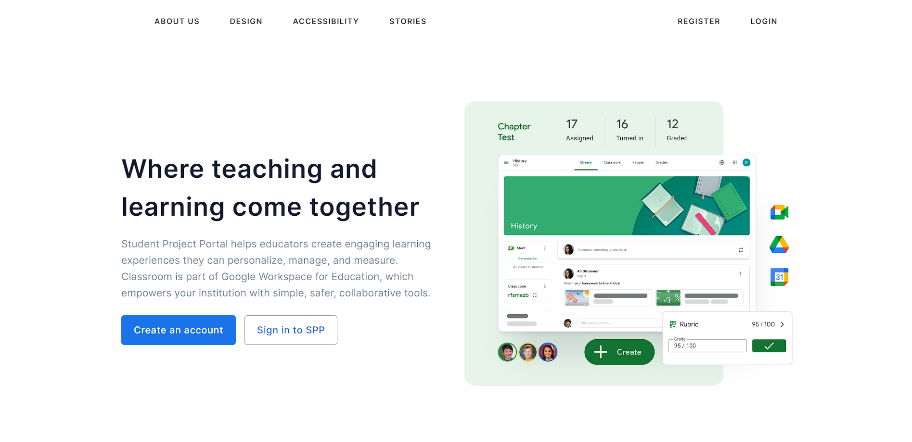

|  |  |  |
| --- | --- | --- |
| **Field Name** | **Field Type** | **Description** |
| Register | Hyperlink | Click to register a new account |
| Login | Hyperlink | Click to login into the system |

**Database Access**

none

### 1.2 Authentication

#### a. User Register

This screen allows user to be authenticated to the system screens/functionalities.

Related use cases:

* [UC-2_Register](https://docs.google.com/document/d/12WUVF9drpY1HSYgpNq1JY2UvNiHSz3SUNO5U4dRYRJM/edit#heading=h.1pgrrkc)

##### UI Design

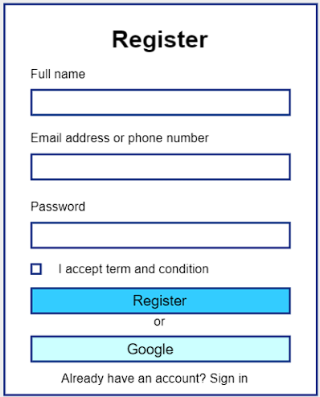

|  |  |  |
| --- | --- | --- |
| **Field Name** | **Field Type** | **Description** |
| Fullname* | Text Box | Enter full name |
| Username* | Text Box | Enter Email or Phone number |
| Password* | Password Box | Enter password |
| Register | Button | Click to Register account |
| Google | Button | Click to sign in or sign up with google |
| Sign in | Hyperlink | Click to go Login Page |

##### Database Access

|  |  |  |
| --- | --- | --- |
| **Table** | **CRUD** | **Description** |
| User | C | Insert new user into database |

#### b. User Login

This screen allows users change their password.

Related use cases:

* [UC-3_Login](https://docs.google.com/document/d/12WUVF9drpY1HSYgpNq1JY2UvNiHSz3SUNO5U4dRYRJM/edit#heading=h.49gfa85)

##### UI Design

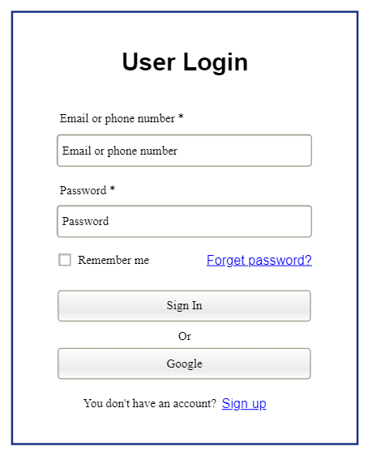

|  |  |  |
| --- | --- | --- |
| **Field Name** | **Field Type** | **Description** |
| Email or phone number* | Text Box | This is for user to input valid email address/ valid phone number for logging in |
| Password* | Password Box | This is for user to input password for logging in |
| Login | Button | User clicks to authenticate him/herself into the system with provided email/phone & password |
| Remember me | Check Box | User ticks to remember login information |
| Forgot Password? | Hyperlink | User clicks to redirect to the Password Reset page for resetting his/her forgot password |
| Login with Google | Hyperlink | Allow user to login with his/her Google account |
| Sign up | Hyperlink | User clicks to redirect to the User Register page for registering new user account to access the system |

##### Database Access

|  |  |  |
| --- | --- | --- |
| **Table** | **CRUD** | **Description** |
| User | CR | Find User By Email & Password information  Find User By Phone & Password information  Check Existed Email (login with google)  Create new user (login with google) |
| Setting | R | Check Email Domain |

#### c. Password Reset

This screen allows users reset their password if forgot

Related use cases:

* [UC-4_Reset password](https://docs.google.com/document/d/12WUVF9drpY1HSYgpNq1JY2UvNiHSz3SUNO5U4dRYRJM/edit#heading=h.2olpkfy)

##### UI Design

This screen allows user to verify username and then accept user enter new password.

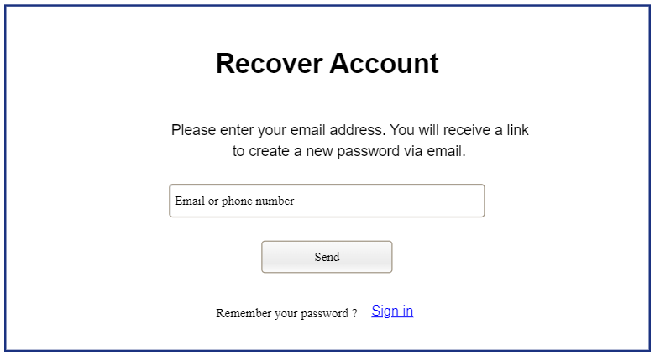

|  |  |  |
| --- | --- | --- |
| **Field Name** | **Field Type** | **Description** |
| Email/Phone | Password Box | This is for user to input email or password to verify |
| Reset Password | Button | Click to send link/otp to email/phone |
| Sign in | Hyperlink | Click to go Login Page |

This screen allow user to resend to verify email address

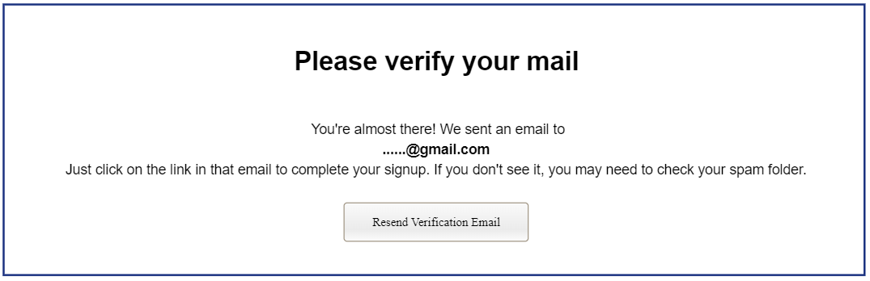

|  |  |  |
| --- | --- | --- |
| **Field Name** | **Field Type** | **Description** |
| Resend Verification Email | Button | Click to resend email |

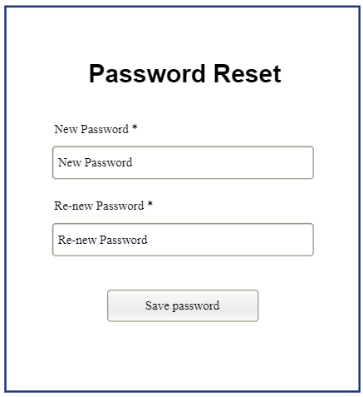

|  |  |  |
| --- | --- | --- |
| **Table** | **CRUD** | **Description** |
| New password | Password Box | Enter new password |
| Re-New password | Password Box | Enter re-new password |
| Save password | Button | Save new password to account |

##### Database Access

|  |  |  |
| --- | --- | --- |
| **Table** | **CRUD** | **Description** |
| User | U | Update Password |

#### d. Password Change

This screen allows users change their password

Related use cases:

* [UC-5_Change password](https://docs.google.com/document/d/12WUVF9drpY1HSYgpNq1JY2UvNiHSz3SUNO5U4dRYRJM/edit#heading=h.13qzunr)

##### UI Design

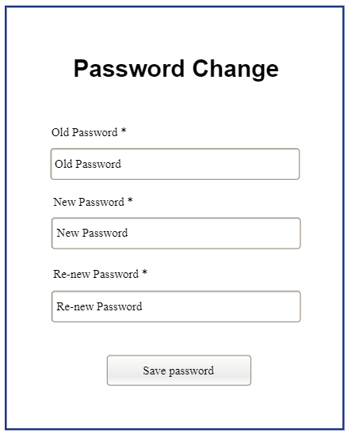

|  |  |  |
| --- | --- | --- |
| **Field Name** | **Field Type** | **Description** |
| Old password * | Password Box | This is for user to input old password |
| New Password* | Password Box | This is for user to input new password |
| ReNew Password* | Password Box | This is for user to input confirm new password |
| Save password | Button | User clicks to update new password |

##### Database Access

|  |  |  |
| --- | --- | --- |
| **Table** | **CRUD** | **Description** |
| User | U | Update new password |

### 1.3 Profile Management

#### User Profile

This screen allows user to see details of the profile.

Related use cases:

* [UC-7_View/Edit profile](https://docs.google.com/document/d/12WUVF9drpY1HSYgpNq1JY2UvNiHSz3SUNO5U4dRYRJM/edit#heading=h.3nqndbk) ss

##### UI Design

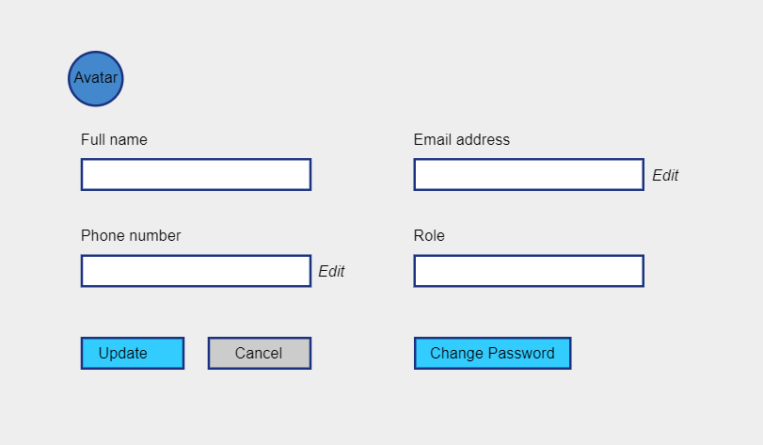

|  |  |  |
| --- | --- | --- |
| **Field Name** | **Field Type** | **Description** |
| Email* | Text Box | Show email |
| Phone | Text Box | This show phone number |
| Role | Text Box | Show role |
| FullName | Text Box | Show fullname and can edit |
| Edit | Hyperlink | Click to open email verify page  or phone verify page |
| Update | Button | Click to update information and refresh page |
| Cancel | Button | Click to cancel change |
| Change Password | Button | Click to open change password page |

##### Database Access

|  |  |  |
| --- | --- | --- |
| **Table** | **CRUD** | **Description** |
| User,Setting | RU | show information(full name,email,phone.role) of user and update profile |

## 2. Admin Feature

### 2.1 Dashboard

#### Admin Dashboard

This screen allows admins to navigate to manage user list, subject list, and setting list.

Related use cases:

* UC-8_View user list
* Uc-12 View subject list
* [UC-16 View setting list](https://docs.google.com/document/d/12WUVF9drpY1HSYgpNq1JY2UvNiHSz3SUNO5U4dRYRJM/edit#heading=h.1h65qms)

##### UI Design

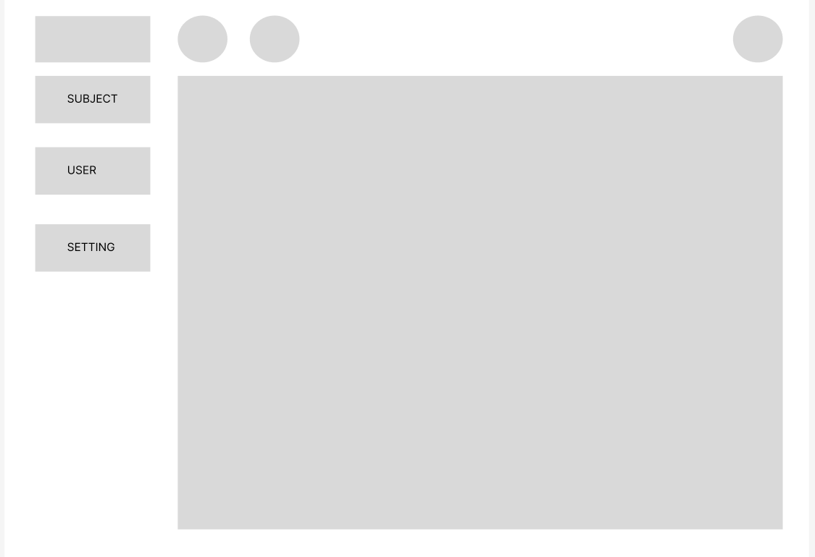

|  |  |  |
| --- | --- | --- |
| **Field Name** | **Field Type** | **Description** |
| Subject | Hyperlink | Click to show subject list and edit |
| User | Hyperlink | Click to show userlist and edit |
| Setting | Hyperlink | Click to show settinglist and edit |

##### Database Access

None

### 2.2 User Management

#### a. User List

This screen allows admins to see the list of users

Related use cases:

* UC-8_View user list
* UC-11_Activate/Deactivate user

##### UI Design

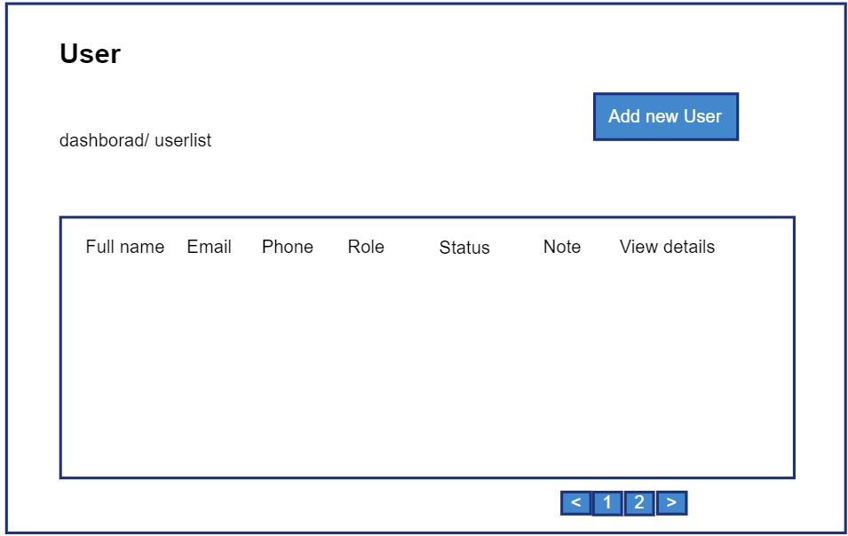

|  |  |  |
| --- | --- | --- |
| **Field Name** | **Field Type** | **Description** |
| Add New | Hyperlink | Click to open New User page for adding new user(master data) |
| ***Data Table*** | | |
| Fullname | Text | Show full name of user |
| Email | Text | Show email of user |
| Phone | Text | Show phone of user |
| ***Data Status*** | | |
| Activate/ Deactivate | On/Off toggle | Shown when the data status is inactive. This is to activate/deactivate the relevant user (master data) |
| ***Data Actions*** |  |  |
| Edit | icon | Click to open the User Details page for updating the relevant user (master data) |

##### Database Access

|  |  |  |
| --- | --- | --- |
| **Table** | **CRUD** | **Description** |
| User | RU | Query the list of current users from the database  Update status of a specific user |

#### b. New User

This screen allows admins to add a new user.

Related use cases:

* UC-9_Add new user

##### UI Design

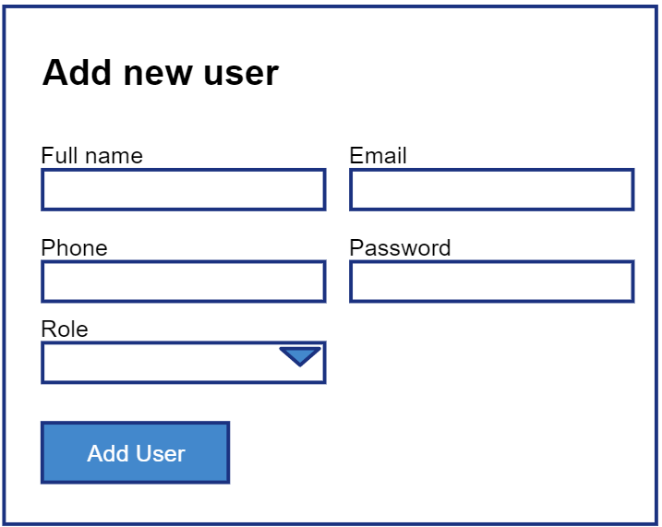

|  |  |  |
| --- | --- | --- |
| **Field Name** | **Field Type** | **Description** |
| Fullname | Text Box | Input full name of new user |
| Email | Text Box | Input email of new user |
| Phone | Text Box | Input phone of new user |
| Role | Select box | Select role of new user |
| Add user | Button | Click to add new user |

##### Database Access

|  |  |  |
| --- | --- | --- |
| **Table** | **CRUD** | **Description** |
| User | C | Insert new user into database |

#### c. User Details

This screen allows admins to show user details and update details if wanted

Related use cases:

* UC-10_Update user details

##### UI Design

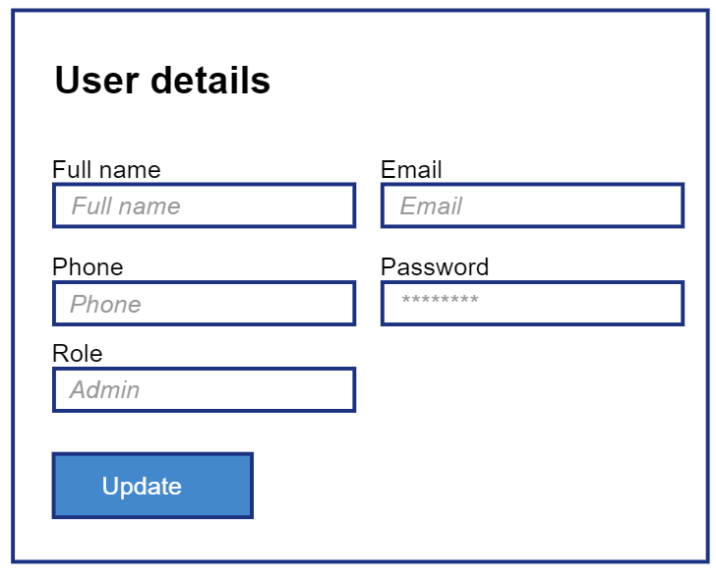

|  |  |  |
| --- | --- | --- |
| **Field Name** | **Field Type** | **Description** |
| Fullname | Text Box | Input field to update full name |
| Email | Text Box | Input field to update email |
| Phone | Text Box | Input field to update phone |
| Role | Select box | Select box to update role |
| Status | Select box | Select box to update status (true, false) |
| Note | Text Box | Input field to update note |
| Update user | Button | Click to add update user |

##### Database Access

|  |  |  |
| --- | --- | --- |
| User | RU | Query specific user details from the database  Update specific user details |

### 2.3 Subject Management

#### a. Subject List

This screen allows admins to see a list of subjects

Related use cases:

* UC-12_View subject list
* UC-15_Activate/Deactivate subject

##### UI Design

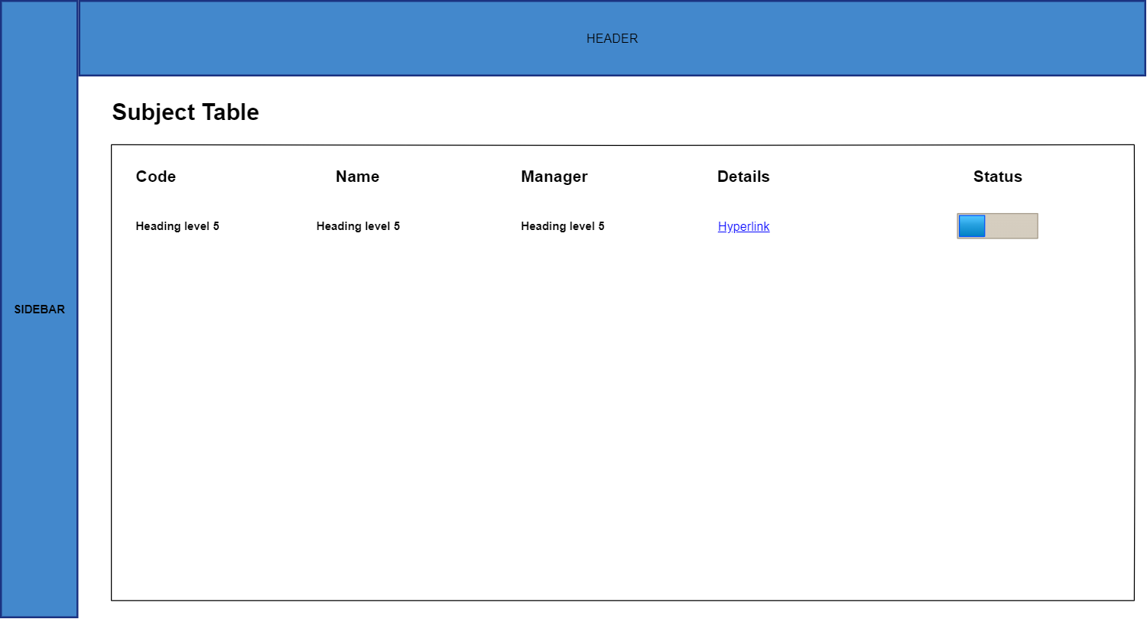

|  |  |  |
| --- | --- | --- |
| **Field Name** | **Field Type** | **Description** |
| Add New Subject | Hyperlink | Click to open the Subject Details page for adding new subject (master data) |
| ***Data Table*** | | |
| Subject Code | Text | Code of the subject |
| Subject Name | Text | Name of the subject |
| Subject Manager | Text | Manager of the subject |
| ***Data Status*** | | |
| Activate/ Deactivate | On/Off toggle | Shown when the data status is inactive. This is to activate/deactivate the relevant subject (master data) |
| ***Data Actions*** |  |  |
| View details | Hyperlink | Click to open the Subject Details page for updating the relevant subject (master data) |

##### Database Access

|  |  |  |
| --- | --- | --- |
| **Table** | **CRUD** | **Description** |
| Subject | RU | Query the list of current subjects from the database  Update status of a specific subject |

#### b. New Subject

This screen allows admins to add a new subject to the system

Related use cases:

* UC-13_Add new subject

##### UI Design

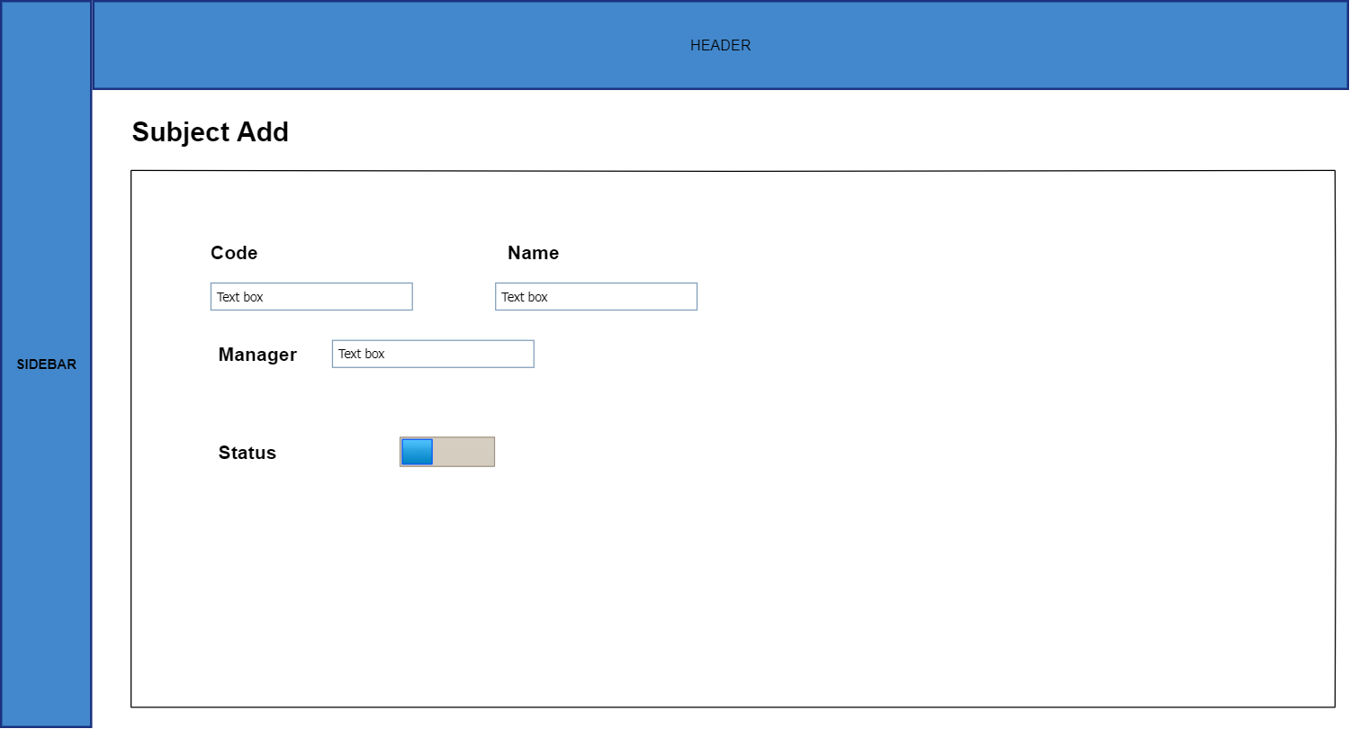

|  |  |  |
| --- | --- | --- |
| **Field Name** | **Field Type** | **Description** |
| Subject Code | String | Code of the subject |
| Subject Name | String | Name of the subject |
| Subject Manager | Select box | Manager of the subject |
| Add Subject | Button | Click to add a new subject to the system |

##### 

##### Database Access

|  |  |  |
| --- | --- | --- |
| **Table** | **CRUD** | **Description** |
| Subject | C | Insert subject into database |

#### c. Subject Details

This screen allows admins to show subject details and update details if wanted

Related use cases:

* UC-14_Update subject details
* UC-24_View subject assignment list
* UC-27_Activate/Deactivate subject assignment
* UC-20_View subject setting list
* UC-21_Activate/Deactivate subject setting

##### UI Design

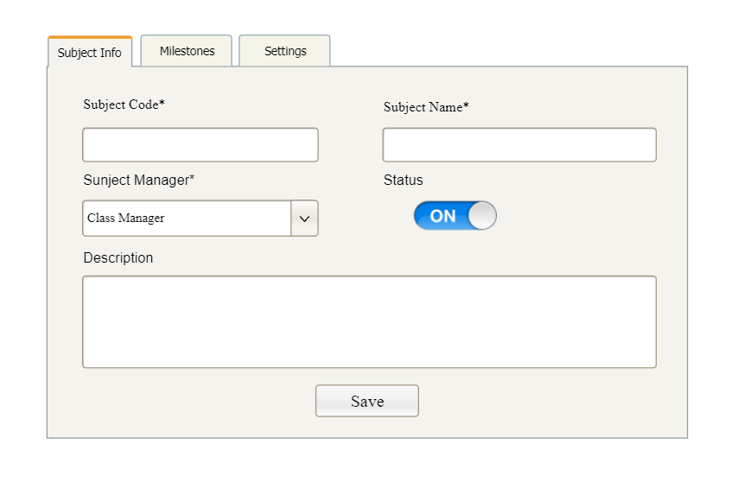

|  |  |  |
| --- | --- | --- |
| **Field Name** | **Field Type** | **Description** |
| Subject Code | String | Code of the subject |
| Subject Name | String | Name of the subject |
| Subject Manager | String | Manager of the subject |
| Status | Select box | Status of the subject |
| Update Subject | Button | Click to update subject details |

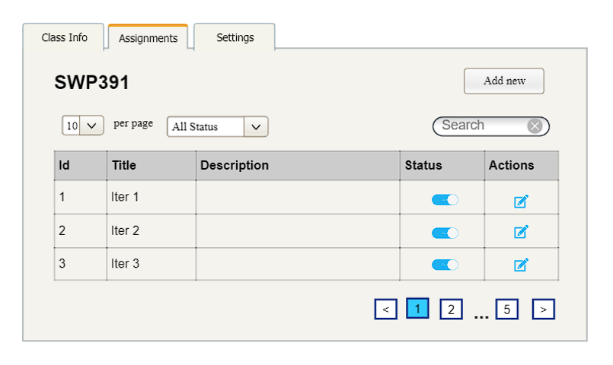

|  |  |  |
| --- | --- | --- |
| **Field Name** | **Field Type** | **Description** |
| Add New Subject Assignment | Hyperlink | Click to open the Subject Details page for adding new subject assignment (master data) |
| ***Data Table*** | | |
| Subject Code | Text | Code of the subject |
| Subject Name | Text | Name of the subject |
| Assignment Title | Text | Title of the assignment |
| Subject Description | Text | Description of the assignment |
| ***Data Actions*** |  |  |
| View details | Hyperlink | Click to open the Subject Details page for updating the relevant Subject Assignment (master data) |

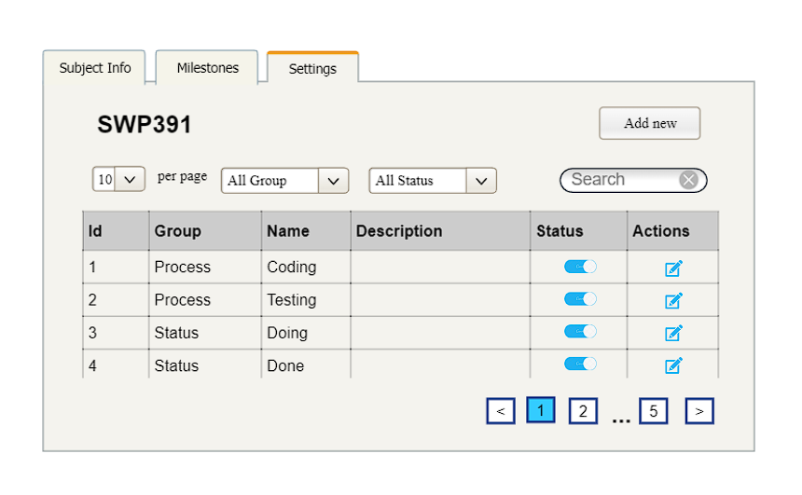

|  |  |  |
| --- | --- | --- |
| **Field Name** | **Field Type** | **Description** |
| Add New | Hyperlink | Click to open the Subject Setting Details page for adding new subject setting (master data) |
| ***Data Table*** | | |
| Subject | Text | Name of subject that subject manager manages |
| Type | Text | Type of the subject setting |
| Tittle | Text | Name of subject setting |
| Display Order | Integer | Display order of the setting: the order of the subject setting type, displayed among the list of subject settings with the same type |
| ***Data Status*** | | |
| Activate/ Deactivate | On/Off toggle | Shown when the data status is inactive. This is to activate/deactivate the relevant subject setting (master data) |
| ***Data Actions*** |  |  |
| Edit | icon | Click to open the Subject Setting Details page for updating the relevant setting (master data) |

##### Database Access*SQL Commands:*

|  |  |  |
| --- | --- | --- |
| **Table** | **CRUD** | **Description** |
| Subject | RU | Query specific subject details from the database  Update specific subject details |
| Assignment | RU | Query the list of current Subject Assignment from the database  Update status of a specific SubjectAssignment |
| Subject, User | R | Query the manager of the Subject Assignment |
| Subject_setting | RU | Query the list of current subject settings of the subject that subject manager manages from the database  Update status of a specific setting setting |

### 2.4 Setting Management

#### a. Setting List

This screen allows admins to see a list of settings

Related use cases:

* UC-16_View setting list
* UC-19_Activate/Deactivate setting

##### UI Design

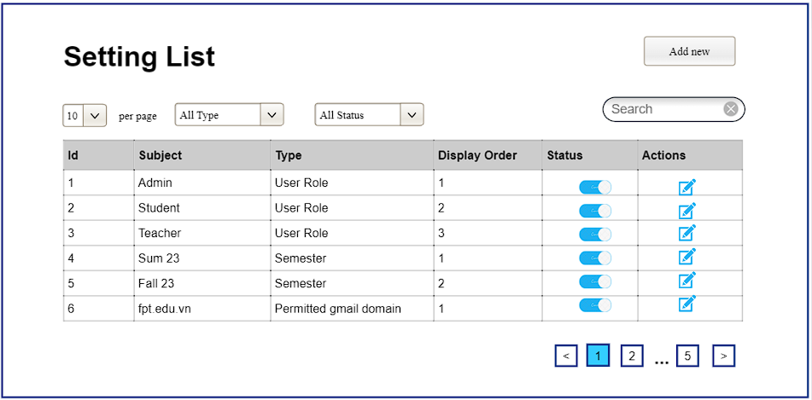

|  |  |  |
| --- | --- | --- |
| **Field Name** | **Field Type** | **Description** |
| Add New | Hyperlink | Click to open the Setting Details page for adding new setting (master data) |
| ***Data Table*** | | |
| Role/semester/permitted email domain | Text | Name of the setting |
| Display Order | Integer | Display order of the setting: the order of the setting type, displayed among the list of settings with the same type |
| ***Data Status*** | | |
| Activate/ Deactivate | On/Off toggle | Shown when the data status is inactive. This is to activate/deactivate the relevant setting (master data) |
| ***Data Actions*** |  |  |
| Edit | icon | Click to open the Setting Details page for updating the relevant setting (master data) |

##### Database Access

|  |  |  |
| --- | --- | --- |
| **Table** | **CRUD** | **Description** |
| Setting | RU | Query the list of current settings by each type_id from the database  Update status of a specific setting |

#### b. Setting Details

This screen allows admins see setting details, update setting details and add new setting

Related use cases:

* UC-17_Add new setting
* UC-18_Update setting details

##### UI Design

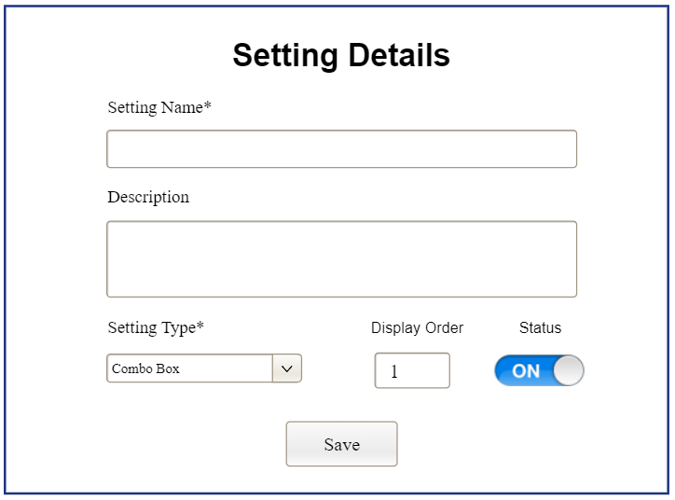

|  |  |  |
| --- | --- | --- |
| **Field Name** | **Field Type** | **Description** |
| Role/semester/ permitted email domain | Text Box  String (30) | Name of the setting |
| Display Order | Number Box | Display order of the setting: the order of the setting type, displayed among the list of settings with the same type |
| Status | On/Off toggle | Status of the setting: Active or Inactive  Default value: Active |
| Save/Add | Button | Click to store new or updated setting details |

##### Database Access

|  |  |  |
| --- | --- | --- |
| **Table** | **CRUD** | **Description** |
| Setting | CRU | Query specific setting details from the database  Update specific setting details  Add new setting |

## 3. Subject Manager Feature

### 3.1 Subject Assignment Details

This screen allows user to show class assignment details and update details if wanted

Related use cases:

* UC-26_Update subject assignment details
* UC-25_Add new subject assignment

##### UI Design

|  |  |  |
| --- | --- | --- |
| **Field Name** | **Field Type** | **Description** |
| Subject Code | Text Box | Code of the subject |
| Assignment Title | Text Box | Title of the assignment |
| Assignment Description | Text Box | Description of the assignment |
| Status | Select box | Status of the subject |

##### 

##### Database Access

|  |  |  |
| --- | --- | --- |
| Subject Assignment | RU | Query specific assignment details from the database  Update specific subject details |

### 3.2 Class Management

#### a. Class List

This screen allows subject manager to see the list of classes

Related use cases:

* UC-28_View class list
* UC-31_Cancel started class
* UC-32_Delete pending class

##### UI Design

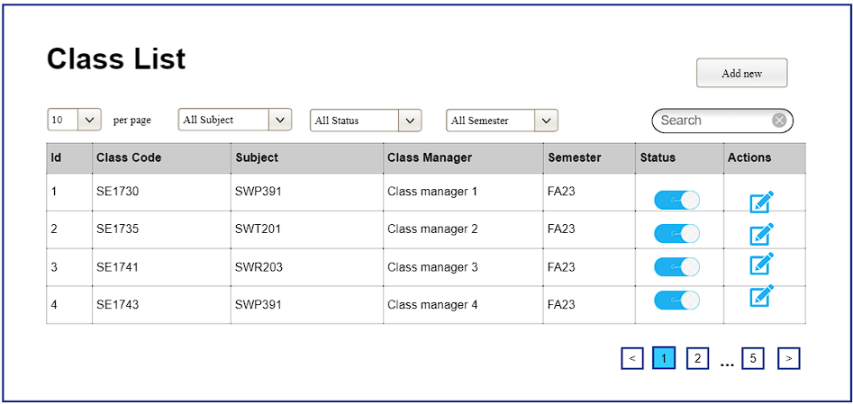

|  |  |  |
| --- | --- | --- |
| **Field Name** | **Field Type** | **Description** |
| Add New Class | Hyperlink | Click to open New Class page for adding new class(master data) |
| ***Data Table*** | | |
| Class Code | Text | Show name of a class |
| Subject | Text | Show email of subject |
| Class Manager | Text | Show name of class manager |
| Semester | Text | Show the semester of this class |
| Status | Text | Show the status of class (Started/Pending) |
| ***Data Actions*** |  |  |
| Edit | icon | Click to open the Class Details page for updating the class (master data) |
| Delete | Icon | Cancel started class/ Delete pending class |

##### Database Access

|  |  |  |
| --- | --- | --- |
| **Table** | **CRUD** | **Description** |
| class | RU | Query the list of current classes that is learning the subjects which is managed by this subject manager from the database |

#### b. New Class

This screen allows subject managers to add a new user.

Related use cases:

* UC-29_Add new class

##### UI Design

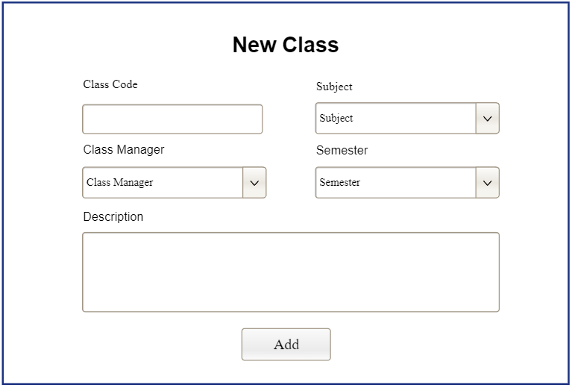

|  |  |  |
| --- | --- | --- |
| **Field Name** | **Field Type** | **Description** |
| Class Code | Text Box | Input name code of new class |
| Subject | Select Box | Select subject of new class |
| Class Manager | Select Box | Select class manager of new class |
| Semester | Select box | Select semester of new class |
| Add class | Button | Click to add new class |

##### Database Access

|  |  |  |
| --- | --- | --- |
| **Table** | **CRUD** | **Description** |
| Class | C | Insert new class into database |

#### c. Class Details

This screen allows subject managers to show class details and update details if wanted

Related use cases:

* UC-30_Update class details
* UC-39 List class assignments
* UC-48_View class issue setting list
* UC-51_Activate/Deactivate class assignment
* UC-39 List class assignments
* UC-42_ View class student list
* UC-45_ Remove student from class
* UC-46_ Update student with note
* UC-61_ Import/Export/Move member

##### UI Design

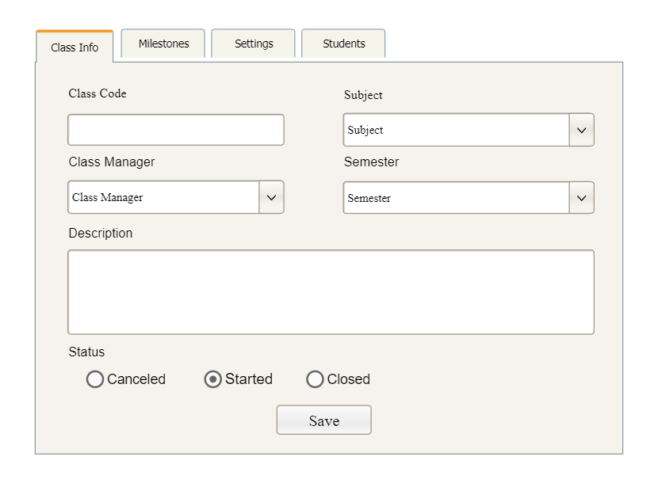

|  |  |  |
| --- | --- | --- |
| **Field Name** | **Field Type** | **Description** |
| Class Code | Text Box | Input name code of class |
| Subject | Select Box | Select subject of class |
| Class Manager | Select Box | Select class manager of class |
| Semester | Select box | Select semester of class |
| Description | Text Box | Input description for a class |
| Update | Button | Click to update class details |

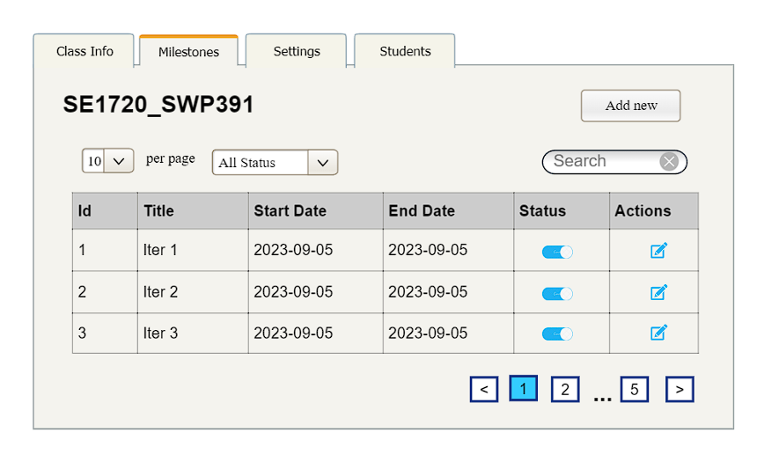

|  |  |  |
| --- | --- | --- |
| **Field Name** | **Field Type** | **Description** |
| ***Search Field*** | | |
| Entries per page | Combo Box  Single-Choice | Value: 5, 10, 15, 20, 25  Allow user to choose number of entries in a page  Default value: 10 |
| Milestone status | Combo Box  Single-Choice | Value: All status, Active, Inactive  Allow to filter the list by status  Default value: “All Statuses” |
| Search input | Text Box | Allow user to search by title or start date or end date  Default value: blank |
| Add New | Hyperlink | Click to open New Milestones page for adding new user(master data) |
| ***Data Table*** | | |
| id | Text | Show id of milestone |
| title | Text | Show title of milestone |
| start date | Text | Show start date of milestone |
| end date | Text | Show end date of milestone |
| ***Data Status*** | | |
| Activate/ Deactivate | On/Off toggle | Shown when the data status is inactive. This is to activate/deactivate the relevant milestone (master data) |
| ***Data Actions*** |  |  |
| Edit | icon | Click to open the Milestone Details page for updating the relevant milestone(master data) |

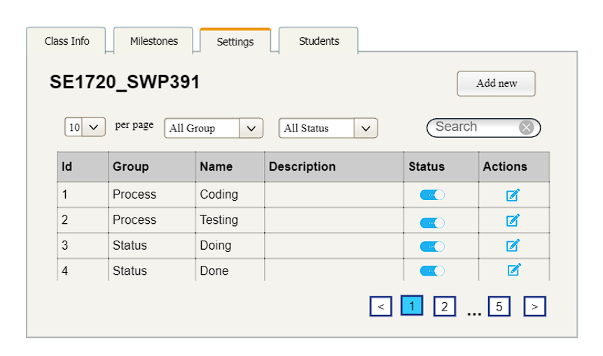

|  |  |  |
| --- | --- | --- |
| **Field Name** | **Field Type** | **Description** |
| ***Search Field*** | | |
| Entries per page | Combo Box  Single-Choice | Value: 5, 10, 15, 20, 25  Allow user to choose number of entries in a page  Default value: 10 |
| Setting group | Combo Box  Single-Choice | Value: groups of setting in database  Allow user to filter the setting group  Default value: All |
| Status | Combo Box  Single-Choice | Value: All status, Active, Inactive  Allow to filter the list by status  Default value: “All Statuses” |
| Search input | Text Box | Allow user to search by group or name  Default value: blank |
| Add New | Hyperlink | Click to open the Issue Setting Details page for adding new subject setting (master data) |
| ***Data Table*** | | |
| Id | Text | Id of issue setting |
| Group | Text | Group of the issue setting |
| Name | Text | Name of issue setting |
| Description | Text | Description of issue setting |
| ***Data Status*** | | |
| Activate/ Deactivate | On/Off toggle | Shown when the data status is inactive. This is to activate/deactivate the relevant issue setting (master data) |
| ***Data Actions*** |  |  |
| Edit | icon | Click to open the Subject Setting Details page for updating the relevant issue setting (master data) |

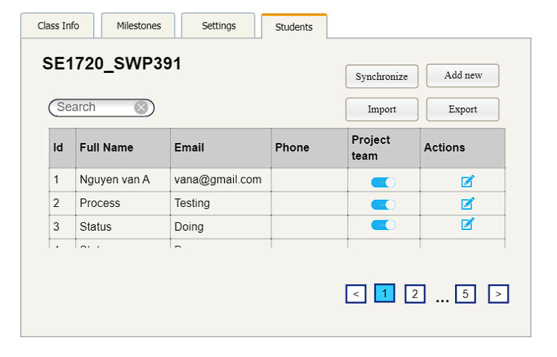

|  |  |  |
| --- | --- | --- |
| **Field Name** | **Field Type** | **Description** |
| ***Search Field*** | | |
| Search input | Text Box | Allow user to search by title or start date or end date  Default value: blank |
| Add New | Hyperlink | Click to open New Student page for adding new user(master data) |
| Synchronize | Hyperlink | Click to synchronize student with FAP |
| Import | Hyperlink | Import student list from Excel file |
| Export | Hyperlink | Export student list to Excel file |
| ***Data Table*** | | |
| Fullname | Text | Show full name of student |
| Email | Text | Show email of student |
| Phone | Text | Show phone of student |
| Project name | Text | Show name project’ student |
| ***Data Status*** | | |
| Activate/ Deactivate | On/Off toggle | Shown when the data status is inactive. This is to activate/deactivate the relevant student(master data) |
| ***Data Actions*** |  |  |
| Edit | icon | Click to open the Student Details page for updating the relevant student(master data) |
| Remove to class | button | Click to remove the student from the class |

##### Database Access

##### 

|  |  |  |
| --- | --- | --- |
| **Table** | **CRUD** | **Description** |
| Class | RU | Query specific class details from the database  Update specific class details |
| Milestone | RU | Query the list of current milestone of a class from the database  Update status of a specific milestone |
| Issue Setting | RU | Query the list of current issue setting of a class from the database  Update status of a specific issue setting |
| User | RU | Query the list of current students from the database  Update status of a specific student |

### 3.3 Criteria Management

#### a. Criteria List

This screen allows admins to see a list of criteria

##### UI Design

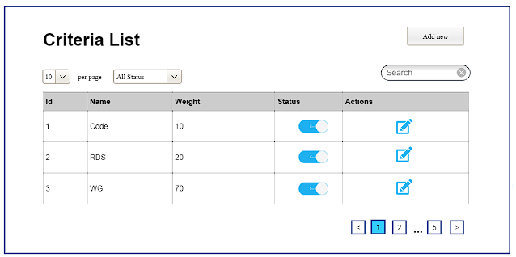

|  |  |  |
| --- | --- | --- |
| **Field Name** | **Field Type** | **Description** |
| Add New | Hyperlink | Click to open the Setting Details page for adding new setting (master data) |
| ***Data Table*** | | |
| Name | Text | Name of the criteria |
| Weight | Integer | Display the percentage of a criteria |
| ***Data Status*** | | |
| Activate/ Deactivate | On/Off toggle | Shown when the data status is inactive. This is to activate/deactivate the relevant criteria (master data) |
| ***Data Actions*** |  |  |
| Edit | icon | Click to open the Criteria Details page for updating the relevant criteria(master data) |

##### Database Access

|  |  |  |
| --- | --- | --- |
| **Table** | **CRUD** | **Description** |
| Criteria | RU | Query the list of current criteria of each assignment  Update status of a specific criteria |

#### b. Criteria Details

This screen allows admins see setting details, update setting details and add new setting

Related use cases:

##### UI Design

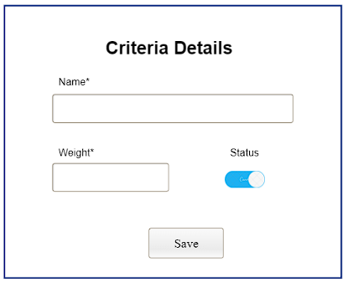

|  |  |  |
| --- | --- | --- |
| **Field Name** | **Field Type** | **Description** |
| Name | Text Box  String (30) | Name of the setting |
| Weight | Number Box | Display order of the setting: the order of the setting type, displayed among the list of settings with the same type |
| Status | On/Off toggle | Status of the setting: Active or Inactive  Default value: Active |
| Save/Add | Button | Click to store new or updated setting details |

##### Database Access

|  |  |  |
| --- | --- | --- |
| **Table** | **CRUD** | **Description** |
| Criteria | CRU | Query specific setting details from the database  Update specific setting details  Add new setting |

### 3.4 Subject Setting Management

#### a. Subject Setting List

This screen allows subject managers to see a list of subject settings

Related use cases:

* UC-20_View subject setting list
* UC-21_Activate/Deactivate subject setting

##### UI Design

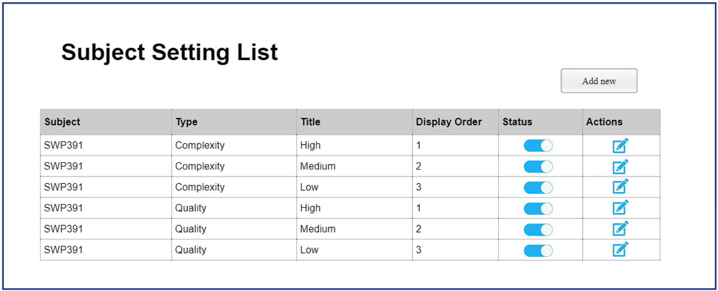

|  |  |  |
| --- | --- | --- |
| **Field Name** | **Field Type** | **Description** |
| Add New | Hyperlink | Click to open the Subject Setting Details page for adding new subject setting (master data) |
| ***Data Table*** | | |
| Subject | Text | Name of subject that subject manager manages |
| Type | Text | Type of the subject setting |
| Tittle | Text | Name of subject setting |
| Display Order | Integer | Display order of the setting: the order of the subject setting type, displayed among the list of subject settings with the same type |
| ***Data Status*** | | |
| Activate/ Deactivate | On/Off toggle | Shown when the data status is inactive. This is to activate/deactivate the relevant subject setting (master data) |
| ***Data Actions*** |  |  |
| Edit | icon | Click to open the Subject Setting Details page for updating the relevant setting (master data) |

##### Database Access

|  |  |  |
| --- | --- | --- |
| **Table** | **CRUD** | **Description** |
| subject_setting | RU | Query the list of current subject settings of the subject that subject manager manages from the database  Update status of a specific setting setting |

#### b. Subject Setting Details

This screen allows subject managers to see a list of subject settings

Related use cases:

* UC-22_Add new subject setting
* UC-23_Update subject setting details

##### UI Design

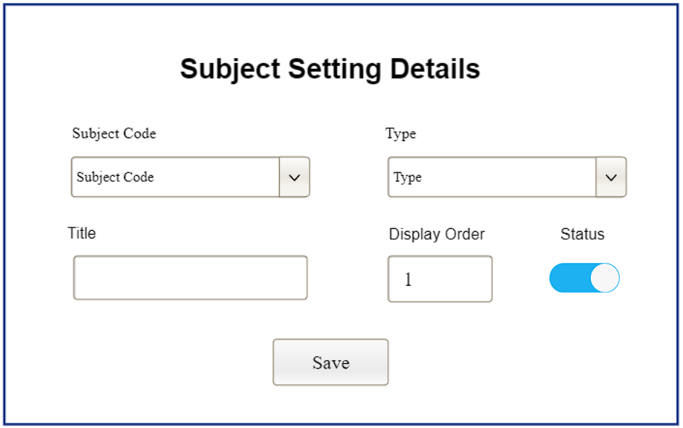

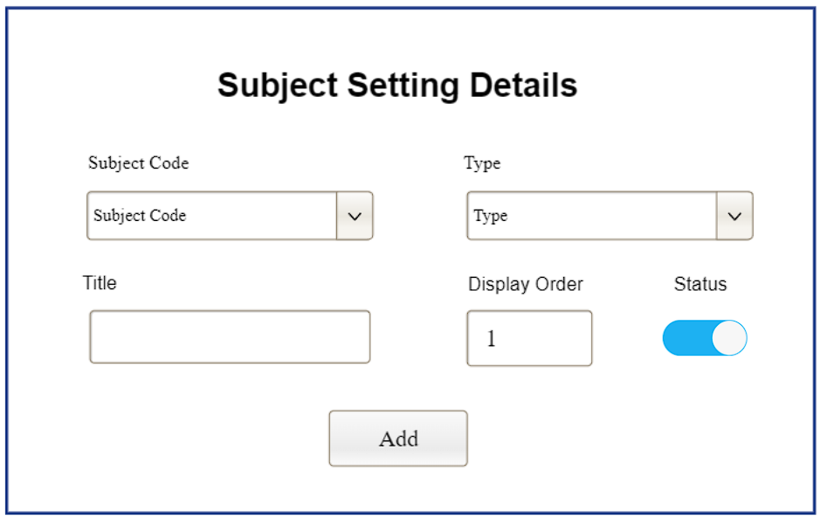

|  |  |  |
| --- | --- | --- |
| **Field Name** | **Field Type** | **Description** |
| Subject Code | Select Box | Subject code of the setting |
| Type | Select Box | Type of the setting |
| Title | Text Box  String (30) | Name of the setting |
| Display Order | Number Box | Display order of the setting: the order of the setting type, displayed among the list of settings with the same type |
| Status | On/Off toggle | Status of the setting: Active or Inactive  Default value: Active |
| Save/Add | Button | Click to store new or updated setting details |

##### Database Access

|  |  |  |
| --- | --- | --- |
| **Table** | **CRUD** | **Description** |
| subject_setting | CRU | Query specific subject setting details from the database  Update specific subject setting details  Add new subject setting |

## 4. Class Manager Feature

### 4.1 Milestone Details

This screen allows user to show class assignment details and update details if wanted

Related use cases:

* UC-35_Update class assignment details
* UC-25_Add new class assignment

##### UI Design

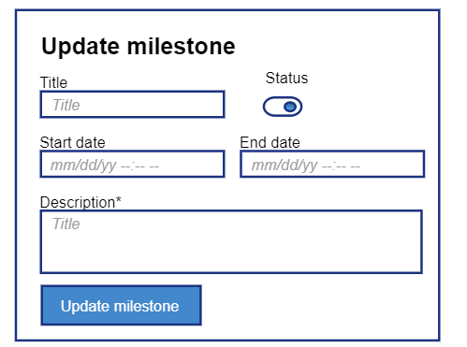

|  |  |  |
| --- | --- | --- |
| **Field Name** | **Field Type** | **Description** |
| Title | Text Box | Title of milestone |
| Start date | Date time | Start date of the milestone |
| End date | Date time | End date of the milestone |
| Status | Toggle | Status of the subject |

##### 

##### Database Access

|  |  |  |
| --- | --- | --- |
| milestone | RU | Query specific assignment details from the database  Update specific subject details |

### 4.2 Class Student Management

#### a. New Student

This screen allows admins to add a new student to class.

Related use cases:

* UC_

##### UI Design

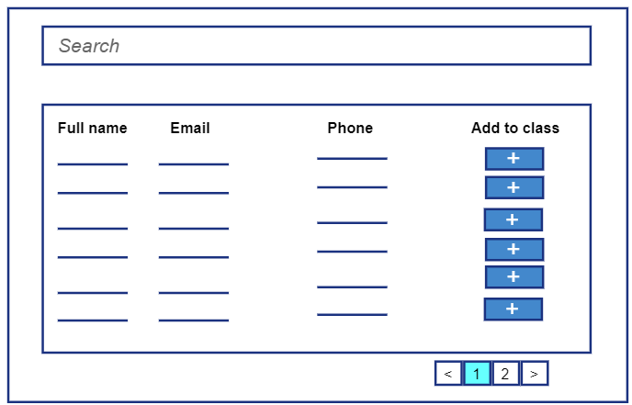

|  |  |  |
| --- | --- | --- |
| **Field Name** | **Field Type** | **Description** |
| Fullname | Label | Full name of new user |
| Email | Label | Email of new user |
| Phone | Label | Phone of new user |
| Add user | Button | Click to add new student to class |

##### Database Access

|  |  |  |
| --- | --- | --- |
| **Table** | **CRUD** | **Description** |
| User | C | Insert new student to class into database |

#### b. Student Details

This screen allows admins to show user details and update details if wanted

Related use cases:

* UC-10_Update user details

##### UI Design

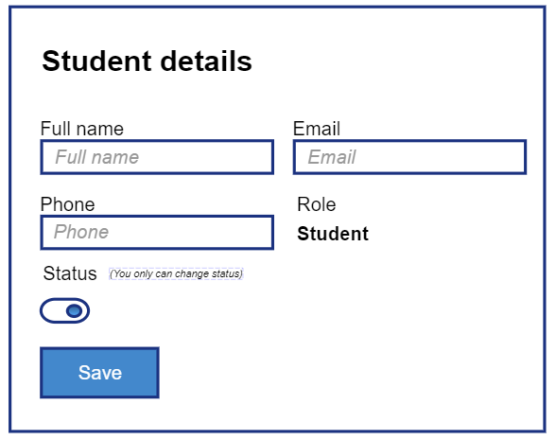

|  |  |  |
| --- | --- | --- |
| **Field Name** | **Field Type** | **Description** |
| Fullname | Text Box | Input field to update full name |
| Email | Text Box | Input field to update email |
| Phone | Text Box | Input field to update phone |
| Role | Select box | Select box to update role |
| Status | Toggle | Select box to update status (true, false) |
| Update user | Button | Click to add update user |

##### Database Access

|  |  |  |
| --- | --- | --- |
| User | RU | Query specific student details from the database  Update specific user details |

### 4.3 Issue Setting Details

This screen allows subject managers to see a list of subject settings

Related use cases:

* UC-22_Add new subject setting
* UC-23_Update subject setting details

##### UI Design

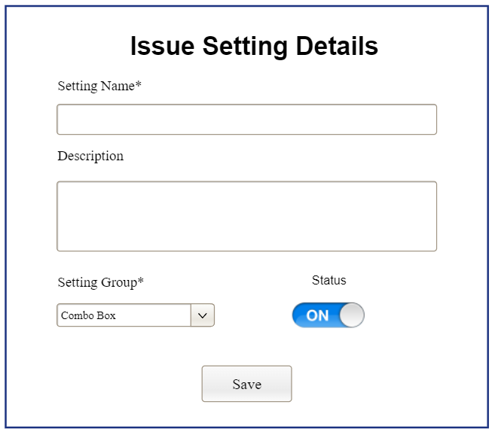

|  |  |  |
| --- | --- | --- |
| **Field Name** | **Field Type** | **Description** |
| Subject Code | Select Box | Subject code of the setting |
| Type | Select Box | Type of the setting |
| Title | Text Box  String (30) | Name of the setting |
| Display Order | Number Box | Display order of the setting: the order of the setting type, displayed among the list of settings with the same type |
| Status | On/Off toggle | Status of the setting: Active or Inactive  Default value: Active |
| Save/Add | Button | Click to store new or updated setting details |

##### Database Access

|  |  |  |
| --- | --- | --- |
| **Table** | **CRUD** | **Description** |
| subject_setting | CRU | Query specific subject setting details from the database  Update specific subject setting details  Add new subject setting |

### 4.4 Project Management

#### a. Project List

This screen allows admins to see the list of projects

Related use cases:

* UC-53_View project list
* UC-57_View project member list
* UC-58_Assign team leader
* UC-59_Freeze project
* UC-60_Update project member with note

##### UI Design

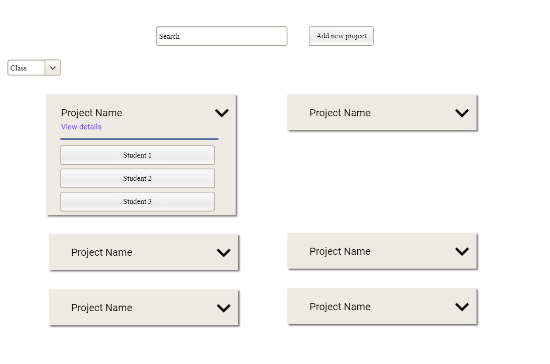

|  |  |  |
| --- | --- | --- |
| **Field Name** | **Field Type** | **Description** |
| Add New | Hyperlink | Click to open New User page for adding new project |
| ***Data Table*** | | |
| Project name | Text | Show name of project |
| Class | Text | Show class of project |
| Project mentor | Text | Show mentor of project |
| Team leader | Text | Show leader of project |
| Title | Text | Show title of project |
| ***Data Actions*** |  |  |
| Edit | icon | Click to open the Project Details page for updating the relevant project |
| Note | icon | Click to update note a student |
| Freeze | icon | Click to open freeze a student |

##### Database Access

|  |  |  |
| --- | --- | --- |
| **Table** | **CRUD** | **Description** |
| Project | R | Query the list of projects from the database |

#### b. New Project

This screen allows admins to add a new project.

Related use cases:

* UC-54_Add new project

##### UI Design

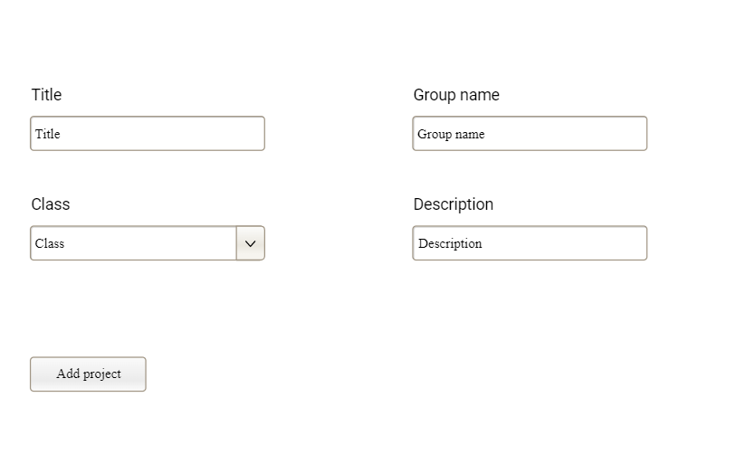

|  |  |  |
| --- | --- | --- |
| **Field Name** | **Field Type** | **Description** |
| Title | Text Box | Input title of new project |
| Class | Drop Box | Input class of new project |
| Project mentor | Drop Box | Input project mentor of new project |
| Add | Button | Click to add new project |

##### Database Access

|  |  |  |
| --- | --- | --- |
| **Table** | **CRUD** | **Description** |
| Project | C | Insert new project into database |

#### c. Project Details

This screen allows admins to show project details and update details if wanted

Related use cases:

* UC-55_Update project details

##### UI Design

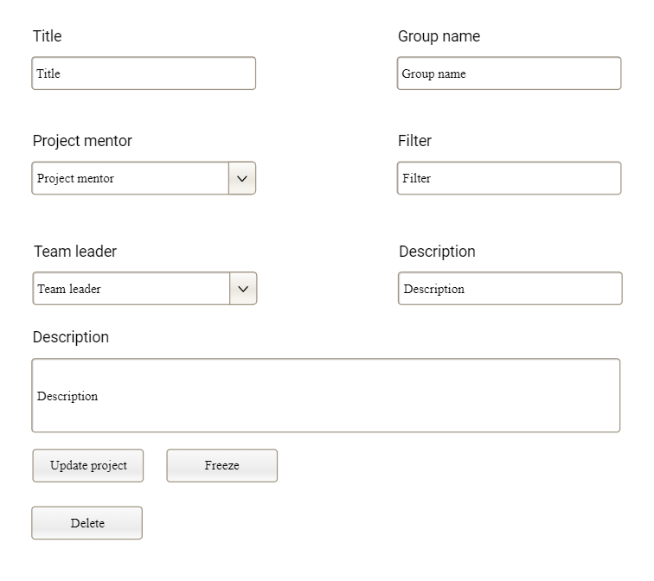

|  |  |  |
| --- | --- | --- |
| **Field Name** | **Field Type** | **Description** |
| Title | Text Box | Input field to update title |
| Class | Drop Box | Input field to update class |
| Project mentor | Drop Box | Input field to update mentor |
| Team leader | Drop Box | Input field to update leader |
| Update | Button | Click to update project |

##### Database Access

|  |  |  |
| --- | --- | --- |
| User | U | Update specific project details |

#### d. Project Member Arrange

This screen allows admins to see the project member list

Related use cases:

* UC-61_Import/Export/Move project members

##### UI Design

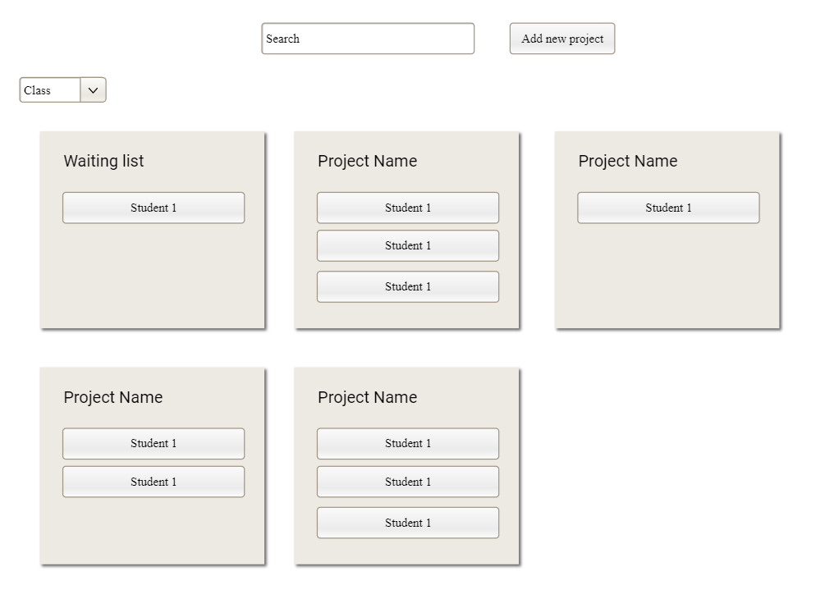

|  |  |  |
| --- | --- | --- |
| ***Data Table*** | | |
| Project title | Text | Show full title of project |
| List of student | Text | Show list of user in a project |
| No group | Text | Show list student not belong to any project |
| ***Data Actions*** |  |  |
| Move member | Drag and drop | Drag and drop student between projects |

##### Database Access

|  |  |  |
| --- | --- | --- |
| **Table** | **CRUD** | **Description** |
| student_class | RU | Query the list of project member from the database |

## 

## 5. Project Mentor Feature

### 5.1 Assignment List

This screen allows admins to see the project submission list

Related use cases:

* UC-64 View project submission list

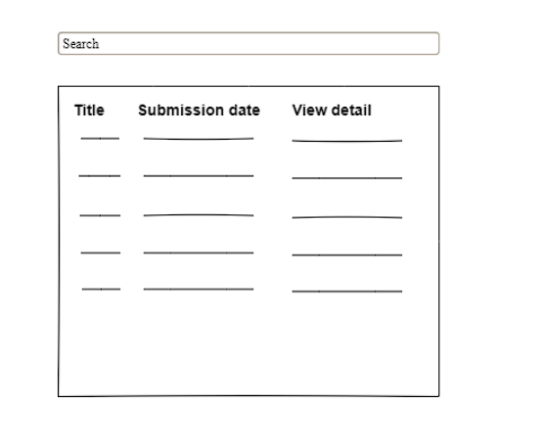

##### UI Design

|  |  |  |
| --- | --- | --- |
| ***Data Table*** | | |
| Project title | Text | Show full title of project |
| List of student | Text | Show list of user in a project |
| No group | Text | Show list student not belong to any project |
| ***Data Actions*** |  |  |
| Move member | Drag and drop | Drag and drop student between projects |

##### Database Access

|  |  |  |
| --- | --- | --- |
| **Table** | **CRUD** | **Description** |
| student_class | RU | Query the list of project member from the database |

### 5.2 Submit Details

This screen allows project mentor to see student’s project submission details

Related use cases:

* UC-66 View project submission details

##### UI Design

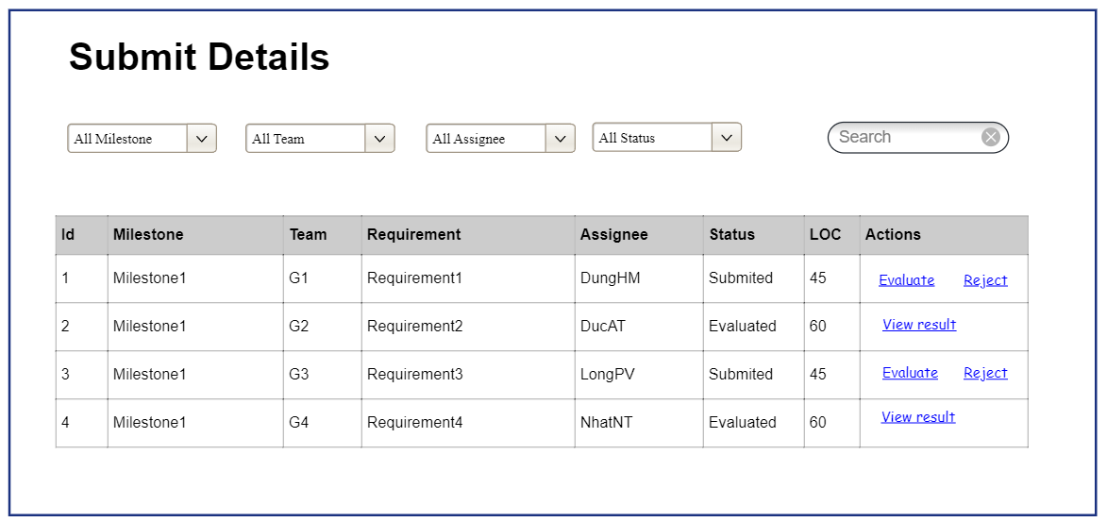

|  |  |  |
| --- | --- | --- |
| ***Data Table*** | | |
| Project title | Text | Show full title of project |
| List of student | Text | Show list of user in a project |
| No group | Text | Show list student not belong to any project |
| ***Data Actions*** |  |  |
| Move member | Drag and drop | Drag and drop student between projects |

##### Database Access

|  |  |  |
| --- | --- | --- |
| **Table** | **CRUD** | **Description** |
| student_class | RU | Query the list of project member from the database |

### 5.3 LOC EVALUATION

This screen allows admins to see the project submission list

Related use cases:

UC-96- LOC EVALUATION

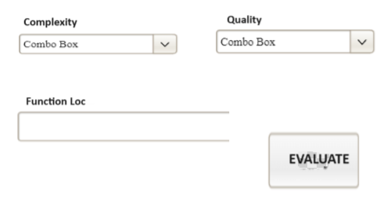

##### UI Design

|  |  |  |
| --- | --- | --- |
| ***Data Table*** | | |
| Complexity | Select Box | complexity of issue submit |
| Quality | Select Box | quality of issue submit |
| FunctionLoc | Text | function loc of issue submit |
| Evaluate | Button | Click to evaluate issue submit |

##### Database Access

|  |  |  |
| --- | --- | --- |
| **Table** | **CRUD** | **Description** |
| student_class | RU | Query the list of project member from the database |

### 5.4 Project List

This screen allows admins to show user details and update details if wanted

Related use cases:

##### UI Design

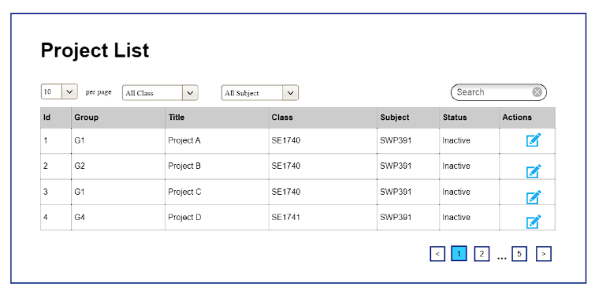

|  |  |  |
| --- | --- | --- |
| **Field Name** | **Field Type** | **Description** |
| Add New | Hyperlink | Click to open the project Details page for adding new subject (master data) |
| ***Data Table*** | | |
| Group | Text | Group of the project |
| Title | Text | Title of the project |
| Class | Text | Class of the project |
| Subject |  | Subject of the project |
| ***Data Status*** | | |
| Activate/ Deactivate | On/Off toggle | Shown when the data status is inactive. |
| ***Data Actions*** |  |  |
| View details | Hyperlink | Click to open the of the project Details page for updating the relevant subject (master data) |

##### Database Access

|  |  |  |
| --- | --- | --- |
| Project | RU | Query specific student details from the database  Update specific user details |

### 5.5 Assignment Evaluation

This screen allows admins to show user details and update details if wanted

Related use cases:

##### UI Design

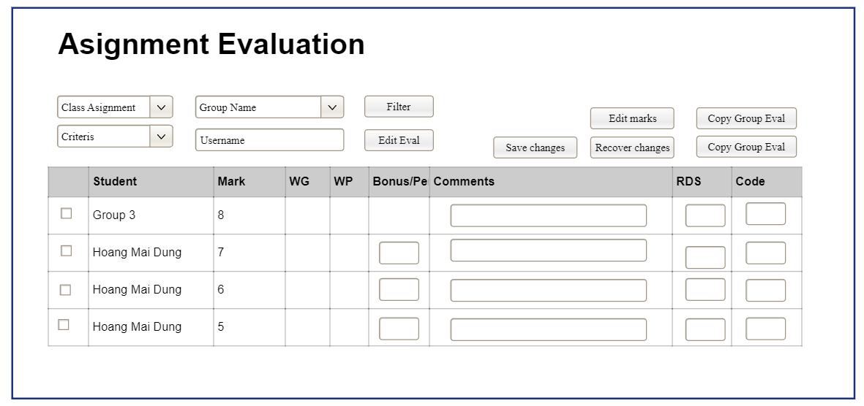

|  |  |  |
| --- | --- | --- |
| **Field Name** | **Field Type** | **Description** |
| ***Data Table*** | | |
| Student | Text | Student of the assignment |
| Mark | Text | Mark of the assignment |
| WG | Text | WG of the assignment |
| WP | Text | WP of the assignment |
| Bonus | Text | Bonus of the assignment |
| Comments | Text | Comments of the assignment |
| RDS | Text | RDS of the assignment |

##### Database Access

|  |  |  |
| --- | --- | --- |
| Evaluation | RU | Query specific student details from the database  Update specific user details |

## 6. Team leader Feature

### 6.1 Assignment Submit

This function allows team leader to update project submission

##### UI Design

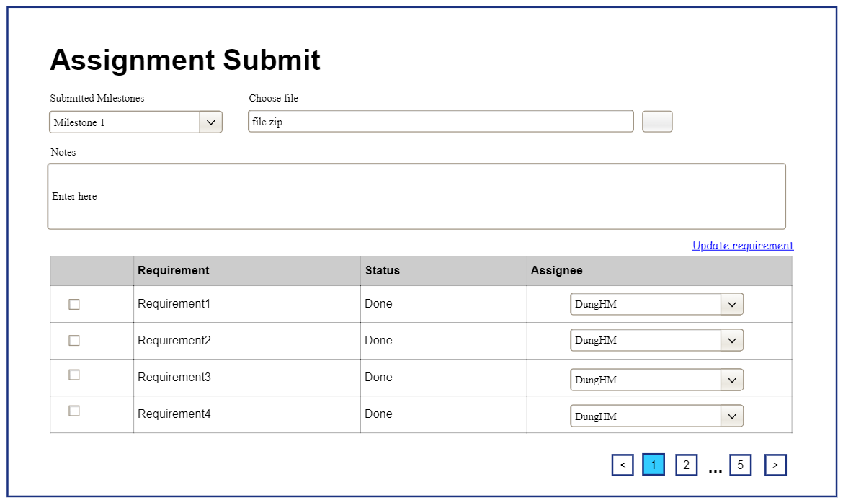

|  |  |  |
| --- | --- | --- |
| ***Data Table*** | | |
| Project title | Text | Show full title of project |
| List of student | Text | Show list of user in a project |
| No group | Text | Show list student not belong to any project |

##### Database Access

|  |  |  |
| --- | --- | --- |
| **Table** | **CRUD** | **Description** |
| student_class | U | Query the list of project member from the database |

### 6.2 Issue List

This screen allows admins to show user details and update details if wanted

Related use cases:

##### UI Design

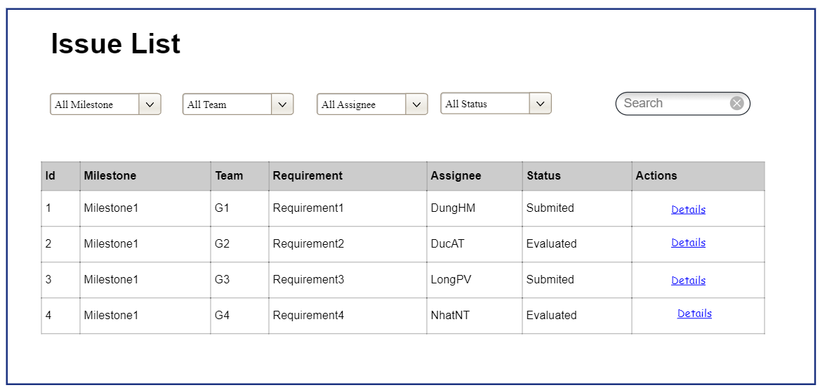

|  |  |  |
| --- | --- | --- |
| **Field Name** | **Field Type** | **Description** |
| Add New | Hyperlink | Click to open the issue Details page for adding new subject (master data) |
| ***Data Table*** | | |
| Milestone | Text | Milestone of the issue |
| Team | Text | Team of the issue |
| Requirement | Text | Requirement of the issue |
| Assignee | Text | Assignee of the issue |
| ***Data Status*** | | |
| Activate/ Deactivate | On/Off toggle | Shown when the data status is inactive. |
| ***Data Actions*** |  |  |
| View details | Hyperlink | Click to open the of the issue Details page for updating the relevant subject (master data) |

##### Database Access

|  |  |  |
| --- | --- | --- |
| Issue | RU | Query specific student details from the database |

## 7. Student Feature

### 7.1 Work List

UC-89 View Work List

* UC-89 View Work List

##### UI Design

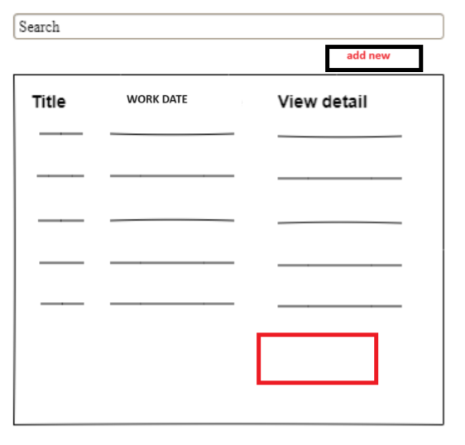

|  |  |  |
| --- | --- | --- |
| ***Data Table*** | | |
| Work title | Text | Show full title of work |
| Work Description | Text | Show description of work |
| Work date | Text | Show update date of work |

##### Database Access

|  |  |  |
| --- | --- | --- |
| **Table** | **CRUD** | **Description** |
| work | R | Query the list of work from the database |

### 7.2 Add new Work

UC-90 Add New Work

##### UI Design

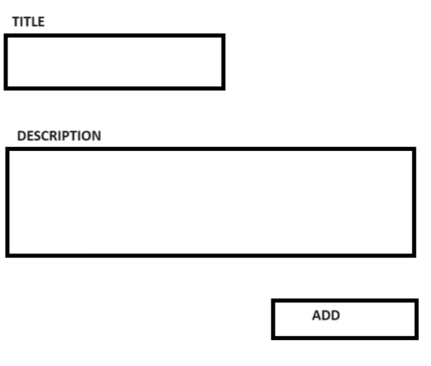

|  |  |  |
| --- | --- | --- |
| ***Data Table*** | | |
| Work title | Text | Input title of work |
| Add | Button | Click to add new work |
| Work description | Text | Input description of work |

##### Database Access

|  |  |  |
| --- | --- | --- |
| **Table** | **CRUD** | **Description** |
| work | U | Update work from the database |

Insert into *work* (title,description)

value(title,description)

### 7.3 Edit Work

UC-91 Update Work

##### UI Design

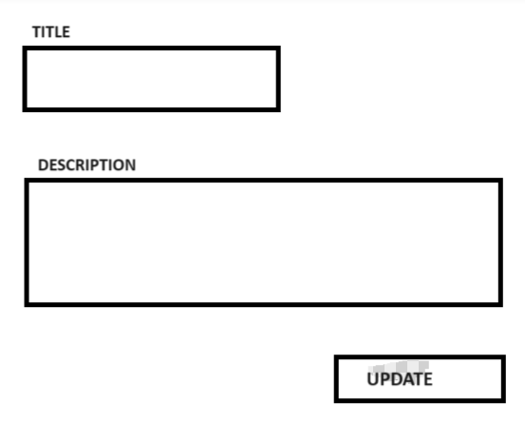

|  |  |  |
| --- | --- | --- |
| ***Data Table*** | | |
| Work title | Text | Input title of work |
| Update | Button | Click to update work |
| Work description | Text | Input description of work |

##### Database Access

|  |  |  |
| --- | --- | --- |
| **Table** | **CRUD** | **Description** |
| work | U | Update work from the database |

Insert into *work* (title,description)

value(title,description)

# IV. Appendix

## 1. Assumptions & Dependencies

AS-1: There will be full support and guidance from lecturers or project mentors to provide valuable feedback and assist in resolving any issues or challenges related to the project.

AS-2: The Internet at school has high speed and stability.

AS-3: Students and lecturers have complete equipment to easily use the platform.

DE-1: The system will ask the school to provide a database for subjects, teachers,...

DE-2: System deployment depends on other cloud services

## 2. Limitations & Exclusions

LI-1: Student submissions may be limited to file uploads due to limited server storage capacity

## 3. Business Rules

|  |  |
| --- | --- |
| **ID** | **Rule Definition** |
| BR-01 | User Registration and Authentication Users must provide a valid email address or mobile number for registration. |
| BR-02 | Email addresses must be verified by sending a verification code. |
| BR-03 | Only users with verified email addresses or mobile numbers can log in. |
| BR-04 | Users can log in using email, mobile, or Google login (for specific domains) |
| BR-05 | User Profile Users can view and edit their profiles, including full name, email, mobile, and avatar image. |
| BR-06 | Changing email or mobile requires verification. |
| BR-07 | Users can view their assigned user roles. |
| BR-08 | Users can reset their passwords if they have forgotten. |
| BR-09 | Password Management: Users can change their passwords. |
| BR-10 | Dashboard After logging in, users are directed to a dashboard. |
| BR-11 | The dashboard displays statistics and information related to their assigned projects |
| BR-12 | Student Students can manage project issues (list, add, update, batch update, import/export). |
| BR-13 | Customised issue statuses are supported, including a closing status. |
| BR-14 | Requirement issues can only be closed when linked to at least one non-requirement issue, and all linked issues are closed. |
| BR-15 | Project issues can be synchronised with GitLab. |
| BR-16 | Students can manage work updates (list, details, add, update). |
| BR-17 | BR-17 Students can view details of their team assignments, including submission information. |
| BR-18 | If eligible, students can submit or resubmit assignments. |
| BR-19 | Team Leader Team leaders can manage project milestones (list, add, update, delete pending). |
| BR-20 | Team leaders can manage project issue settings (types, statuses, work processes). |
| BR-21 | Team leaders can submit or resubmit project assignment results, including attachments and package descriptions. |
| BR-22 | Project Mentor Project mentors can manage assigned projects, including team leader changes (for both active and inactive projects). |
| BR-23 | Project mentors can evaluate project team assignments, providing grades and comments. |
| BR-24 | They can also evaluate the complexity and quality of work results. |
| BR-25 | In the case of the final assignment, they must re-evaluate submitted updated work. |
| BR-26 | Class Manager Class managers can manage assigned classes, including synchronisation settings. |
| BR-27 | They can update class assignments and synchronise them with GitLab milestones. |
| BR-28 | Class managers can manage class issue settings (types, statuses, work processes) |
| BR-29 | Class managers can manage class students, including import and export. |
| BR-30 | Class managers can manage projects within their classes. |
| BR-31 | Class managers can adjust project members, create new projects, and designate team leaders. |
| BR-32 | Subject Manager Subject managers can manage subject assignments. |
| BR-33 | Subject managers can set up subject-specific settings (work complexity levels, workloads, and quality levels). |
| BR-34 | Subject managers can manage classes, including adding new classes and defining assignments. |
| BR-35 | Administrator - Manage Subjects: Administrators can manage subjects, including activation/deactivation. |
| BR-36 | Administrators can manage users, including blocking/unblocking verified users. |
| BR-37 | Administrators can configure system settings (semesters, user roles, permitted email domains). |
| BR-38 | Use Google Firebase for mobile number verification via SMS. |

## 