

**GAS STORE**

**PROJECT**

**Software Design Specification**

– SUMMER 2023 –

Revision History

|  |  |  |  |
| --- | --- | --- | --- |
| **Version** | **Name** | **Reason For Changes** | **Date** |
| *1.0* | *Đào Văn Sơn*  *Nguyễn Tuấn Cường*  *Trịnh Hoàng Dũng*  *Hoàng Minh Tuấn*  *Nguyễn Xuân Hậu* | *Initial Revision* | *06/21/2* |
|  |  |  |  |

Approved By

|  |  |  |  |
| --- | --- | --- | --- |
| **Name** | **Signature** | **Department** | **Date** |
| Nguyễn Thành Ý |  | Instructor |  |
|  |  |  |  |

**Table of Contents**

I. Introduction 4

1. Purpose 4

2. System Overview 4

3. Definitions and Acronyms 4

II. Overview 4

1. Code Packages 5

2. Database Design 6

a. Database Schema 6

b. Table Description 6

III. Code Designs 11

1. Public Account 11

a. Class Diagram 11

b. Class Specifications 12

c. Sequence Diagram(s) 14

2. Public Order 22

a. Class Diagram 22

b. Class Specifications 23

c. Sequence Diagram(s) 23

3. Public Product 25

a. Class Diagram 25

b. Class Specifications 27

c. Sequence Diagram(s) 28

4. Public News 31

a. Class Diagram 31

b. Class Specifications 32

c. Sequence Diagram(s) 33

5. Public Category 36

a. Class Diagram 36

b. Class Specifications 38

c. Sequence Diagram(s) 38

6.Public Insurance 39

a. Class Diagram 39

b. Class Specifications 39

c. Sequence Diagram(s) 40

# I. Introduction

## 1. Purpose

The purpose of this document is to provide details for the structure, specifications, and the architecture of the Gas Store Management System (GSMS). This’s aim to make maintanance and upgrading easier

## 2. System Overview

The Gas Store Management System (GSMS) project provide an interface for customers and admins to interact with the system. The system features VNPay method, logging in by Google and many other features such as products, order, warranty, FAQ, accounts, shipping and suppliers management.

**Teamplate** – 3rd party workflow management software used by Clark Consulting

**Process** – One instance of a workflow - GI Request, for example

**Task** – One step or piece of a workflow

**Metrics** **Reporting** – Displays process breakdown by task and the amount of time it takes, on average, to complete a task in a process.

**Task** **Views** **Reporting** – Displays a single process type (Binder Request, Core, etc) tasks

**Process Specific Reporting –** Process specific reports where the filters are defined on a per process basis

# II. Overview

## 1. Code Packages

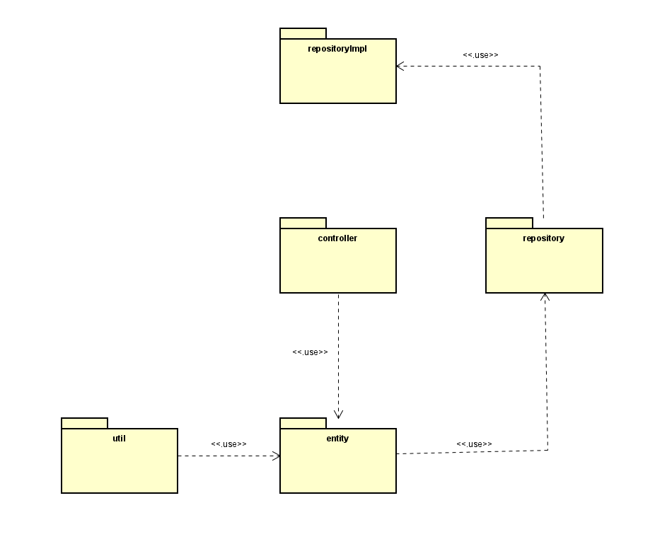

***Package descriptions***

|  |  |  |
| --- | --- | --- |
| **No** | **Package** | **Description** |
| 1 | Util | Util package helps connect to database to get, process and save data. |
| 2 | Entity | Entity package is package return to API of objects, contains all objects in the project. |
| 3 | Controller | Controller package contains APIs, servlet files to process data and show in the website. |

## 2. Database Design

### a. Database Schema

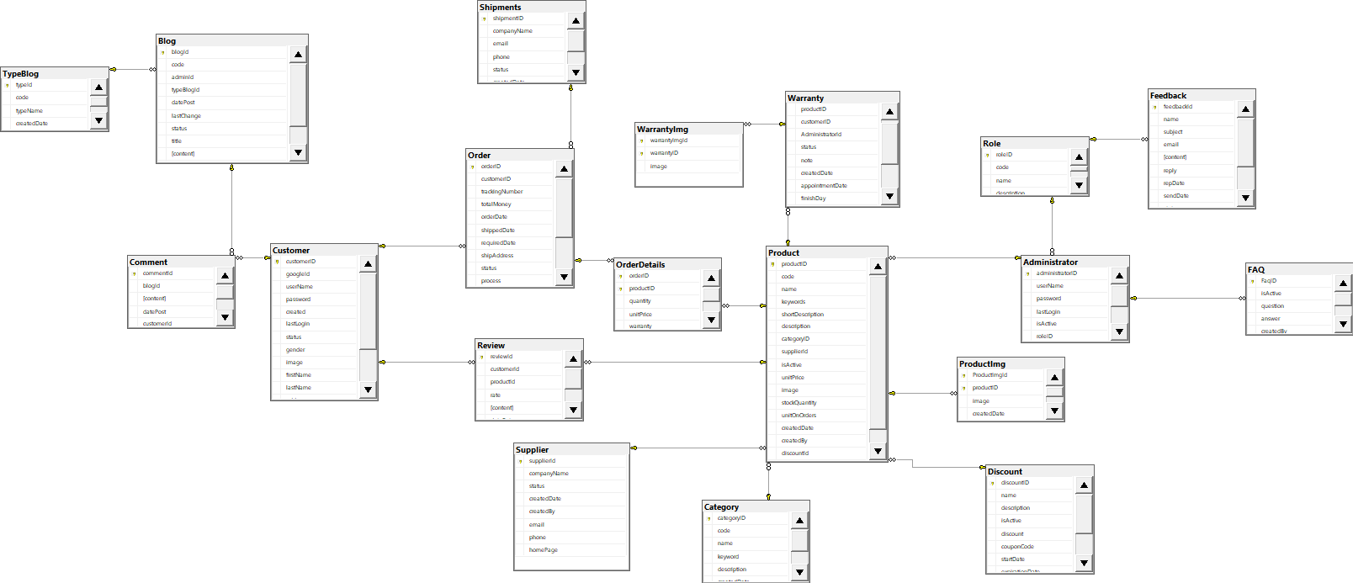

### b. Table Description

Category:

|  |  |  |  |  |  |  |  |
| --- | --- | --- | --- | --- | --- | --- | --- |
| **No** | **Field name** | **Type** | **Size** | **Unique** | **Not null** | **PK/ FK** | **Notes** |
| 1 | CategoryId | int |  | x |  | x | PK |
| 2 | code | varchar | 200 |  |  |  |  |
| 3 | Name | nvarchar | 100 |  |  |  |  |
| 4 | keyword | int |  |  |  |  |  |
| 5 | description | int |  |  |  |  |  |
| 6 | createdBy | int |  |  | x |  |  |
| 7 | createdDate | datetime |  |  | x |  |  |

Customer:

|  |  |  |  |  |  |  |  |
| --- | --- | --- | --- | --- | --- | --- | --- |
| **No** | **Field name** | **Type** | **Size** | **Unique** | **Not null** | **PK/ FK** | **Notes** |
| 1 | CustomerId | int |  | x |  | x | PK |
| 2 | GoogleId | nvarchar | 255 |  |  |  |  |
| 3 | firstName | nvarchar | 100 |  |  |  |  |
| 4 | lastName | Nvarchar | 100 |  |  |  |  |
| 5 | Password | nvarchar | 70 |  |  |  |  |
| 6 | Username | nvarchar | 50 |  |  |  |  |
| 7 | Email | nvarchar | 100 |  |  |  |  |
| 8 | Phone | varchar | 20 |  |  |  |  |
| 9 | Address | nvarchar | 50 |  |  |  |  |
| 10 | Status | bit |  |  | x |  | 0:true;  1:fasle; |
| 11 | Gender | bit |  |  |  |  | 0: female, 1: male |
| 12 | createdDate | datetime |  |  | X |  |  |
| 13 | Image | Blob |  |  |  |  |  |
| 14 | lastLogin | datetime |  |  |  |  |  |

Administrator:

|  |  |  |  |  |  |  |  |
| --- | --- | --- | --- | --- | --- | --- | --- |
| **No** | **Field name** | **Type** | **Size** | **Unique** | **Not null** | **PK/ FK** | **Notes** |
| 1 | administratorId | int |  | x |  | x | PK |
| 2 | userName | nvarchar | 50 |  | x |  |  |
| 3 | Password | nvarchar | 70 |  | x |  |  |
| 4 | RoleId | int |  |  | x | x | FK |
| 5 | Email | nvarchar | 100 |  | x |  |  |
| 6 | img | Blob |  |  |  |  |  |
| 7 | lastLogin | Datetime |  |  |  |  |  |
| 8 | isActive | bit |  |  | x |  | 0:true;  1:fasle; |

Order:

|  |  |  |  |  |  |  |  |
| --- | --- | --- | --- | --- | --- | --- | --- |
| **No** | **Field name** | **Type** | **Size** | **Unique** | **Not null** | **PK/ FK** | **Notes** |
| 1 | OrderId | Int |  | x |  | x | PK |
| 2 | CustomerId | Int |  |  |  | x | FK |
| 3 | OrderDate | Datetime |  |  | x |  |  |
| 4 | TotalMoney | Float |  |  | x |  |  |
| 5 | Address | Nvarchar | 100 |  | x |  |  |
| 6 | shippedDate | Datetime |  |  |  |  |  |
| 7 | requiredDate | Datetime |  |  | x |  |  |
| 8 | shipVia | Datetime |  |  | x |  | FK |
| 9 | Notes | Nvarchar | 4000 |  | x |  |  |
| 10 | Status | Int |  |  | x |  | 0:fail;  1:success; 2:process; 3:shipping; |
| 11 | payment | Bit |  |  | x |  | 0:fail;  1:success; |

OrderDetail:

|  |  |  |  |  |  |  |  |
| --- | --- | --- | --- | --- | --- | --- | --- |
| **No** | **Field name** | **Type** | **Size** | **Unique** | **Not null** | **PK/ FK** | **Notes** |
| 1 | OrderId | int |  |  |  | x | PK (FK from table Order) |
| 2 | ProductId | int |  |  |  | x | PK (FK from table Product) |
| 3 | Quantity | int |  |  |  |  |  |
| 4 | Warranty | int |  |  |  |  |  |
| 5 | UnitPrice | float |  |  |  |  |  |
| 6 | discount | int |  |  | x |  |  |

Product:

|  |  |  |  |  |  |  |  |
| --- | --- | --- | --- | --- | --- | --- | --- |
| **No** | **Field name** | **Type** | **Size** | **Unique** | **Not null** | **PK/ FK** | **Notes** |
| 1 | ProductId | int |  | x |  | x | PK |
| 2 | Code | Varchar | 200 |  |  |  |  |
| 3 | CategotyId | int |  |  |  | x | FK |
| 4 | Name | nvarchar | 100 |  |  |  |  |
| 5 | Description | nvarchar | 4000 |  |  |  |  |
| 6 | stockQuantity | Int |  |  |  |  |  |
| 7 | Price | Double |  |  |  |  |  |
| 8 | keyword | nvarchar | 200 |  |  |  |  |
| 9 | SupplierId | int |  |  | x | x | FK |
| 10 | unitOnOrders | Int |  |  | x |  |  |
| 11 | createdDate | datetime |  |  | x |  |  |
| 12 | isActive | bit |  |  | x |  | 0:true;  1:fasle; |
| 13 | createdBy | Int |  |  |  | x | FK |
| 14 | warranty | int |  |  |  |  |  |
| 15 | discountId | int |  |  |  | x | FK |
| 16 | Image | Nvarchar | 200 |  | x |  |  |

ProductImage:

|  |  |  |  |  |  |  |  |
| --- | --- | --- | --- | --- | --- | --- | --- |
| **No** | **Field name** | **Type** | **Size** | **Unique** | **Not null** | **PK/ FK** | **Notes** |
| 1 | ProductImgId | int |  | x |  | x | PK |
| 2 | ProductId | int |  |  |  | x | PK (FK from table product) |
| 3 | image | varchar | 200 |  |  |  |  |
| 4 | createdDate | datetime | 10 |  |  |  |  |
| 8 | CreatedBy | int |  |  | x |  |  |

Supplier:

|  |  |  |  |  |  |  |  |
| --- | --- | --- | --- | --- | --- | --- | --- |
| **No** | **Field name** | **Type** | **Size** | **Unique** | **Not null** | **PK/ FK** | **Notes** |
| 1 | SupplierId | int |  | x |  | x | PK |
| 2 | companyName | varchar | 4000 |  |  |  |  |
| 3 | status | Bit |  |  | x |  | 0:true;  1:fasle; |
| 4 | email | int |  |  | x |  |  |
| 5 | createdDate | datetime |  |  | x |  |  |
| 6 | createdBy | datetime |  |  | x |  |  |
| 7 | Phone | Varchar | 20 |  | x |  |  |

Shipments:

|  |  |  |  |  |  |  |  |
| --- | --- | --- | --- | --- | --- | --- | --- |
| **No** | **Field name** | **Type** | **Size** | **Unique** | **Not null** | **PK/ FK** | **Notes** |
| 1 | shipmentId | int |  | x |  | x | PK |
| 2 | companyName | Varchar | 4000 | x | X |  |  |
| 3 | email | Varchar | 200 | x | X |  |  |
| 4 | phone | varchar | 20 | x | x |  |  |
| 5 | status | bit |  |  | x |  | 0: true  1: fasle |
| 6 | createdDate | datetime |  |  |  |  |  |
| 7 | createdBy | Datetime |  |  |  |  |  |

Blog:

|  |  |  |  |  |  |  |  |
| --- | --- | --- | --- | --- | --- | --- | --- |
| **No** | **Field name** | **Type** | **Size** | **Unique** | **Not null** | **PK/ FK** | **Notes** |
| 1 | blogId | int |  | x |  | x | PK |
| 2 | code | nvarchar | max |  |  |  |  |
| 3 | typeBlogId | int |  |  |  | x | FK |
| 4 | Description | nvarchar | Max |  |  |  |  |
| 5 | createdBy | Int |  |  | x |  |  |
| 6 | datePost | Datetime |  |  | x |  |  |
| 7 | lastChange | datetime |  |  | x |  |  |
| 8 | status | Bit |  |  | x |  |  |
| 9 | content | Nvarchar | Max |  |  |  |  |
| 10 | img | Nvarchar | 200 |  |  |  |  |
| 11 | title | Nvarchar | 200 |  |  |  |  |

TypeBlog:

|  |  |  |  |  |  |  |  |
| --- | --- | --- | --- | --- | --- | --- | --- |
| **No** | **Field name** | **Type** | **Size** | **Unique** | **Not null** | **PK/ FK** | **Notes** |
| 1 | typeId | int |  | x |  | x | PK |
| 2 | code | varchar | 200 |  |  |  |  |
| 3 | typeName | nvarchar | 200 |  | x |  |  |
| 4 | createdDate | datetime |  |  | x |  |  |
| 5 | createdBy | int |  |  | x |  |  |

Comment:

|  |  |  |  |  |  |  |  |
| --- | --- | --- | --- | --- | --- | --- | --- |
| **No** | **Field name** | **Type** | **Size** | **Unique** | **Not null** | **PK/ FK** | **Notes** |
| 1 | commentId | int |  | x |  | x | PK |
| 2 | blogId | int |  |  |  |  |  |
| 3 | content | nvarchar | max |  | x |  |  |
| 4 | datePost | Datetime |  |  | x |  |  |
| 5 | customerId | int | Int |  | x | x | FK |
| 6 | status | Bit |  |  | x |  | 0: hidden,  1: display |

Review:

|  |  |  |  |  |  |  |  |
| --- | --- | --- | --- | --- | --- | --- | --- |
| **No** | **Field name** | **Type** | **Size** | **Unique** | **Not null** | **PK/ FK** | **Notes** |
| 1 | reviewId | int |  | x |  | x | PK |
| 2 | productId | int |  |  |  | x | FK |
| 3 | content | nvarchar | max |  | x |  |  |
| 4 | datePost | Datetime |  |  | x |  |  |
| 5 | customerId | int |  |  | x | x | FK |
| 6 | status | Bit |  |  | x |  | 0: hidden,  1: display |
| 7 | rate | int |  |  | x |  |  |

WarrantyImg:

|  |  |  |  |  |  |  |  |
| --- | --- | --- | --- | --- | --- | --- | --- |
| **No** | **Field name** | **Type** | **Size** | **Unique** | **Not null** | **PK/ FK** | **Notes** |
| 1 | warrantyImgId | int |  | x |  | x | PK |
| 2 | warrantyID | int |  |  |  | x | PK (FK from table warranty) |
| 3 | image | nvarchar | max |  |  |  |  |

Warranty:

|  |  |  |  |  |  |  |  |
| --- | --- | --- | --- | --- | --- | --- | --- |
| **No** | **Field name** | **Type** | **Size** | **Unique** | **Not null** | **PK/ FK** | **Notes** |
| 1 | warrantyID | int |  | x |  | x | PK |
| 2 | productId | int |  |  |  | x | FK |
| 3 | AdministratorId | nvarchar | max |  |  | x |  |
| 4 | createdDate | Datetime |  |  | x |  |  |
| 5 | customerId | int |  |  | x | x | FK |
| 6 | status | Bit |  |  |  |  | 0: success,  1: fail |
| 7 | orderId | int |  |  | x | x |  |
| 8 | note | Nvarchar | Max |  |  |  |  |
| 9 | appointmentDate | Datetime |  |  |  |  |  |
| 10 | finishDay | Datetime |  |  |  |  |  |
| 11 | description | nvarchar | Max |  |  |  |  |
| 12 | method | int |  |  |  |  | 1: change new  2: not change  0: other |

Discount:

|  |  |  |  |  |  |  |  |
| --- | --- | --- | --- | --- | --- | --- | --- |
| **No** | **Field name** | **Type** | **Size** | **Unique** | **Not null** | **PK/ FK** | **Notes** |
| 1 | discountID | int |  | x |  | x | PK |
| 2 | name | Nvarchar | 200 |  | x |  |  |
| 3 | description | nvarchar | max |  |  |  |  |
| 4 | isActive | Bit |  |  | x |  | 0: false,  1: true |
| 5 | discount | Real |  |  | x |  |  |
| 6 | couponCode | Nvarchar | 200 |  |  |  |  |
| 7 | startDate | Datetime |  |  | x |  |  |
| 8 | expirationDate | Datetime |  |  | x |  |  |
| 9 | createdDate | Datetime |  |  | x |  |  |
| 10 | createdBy | Int |  |  | x |  |  |

Feedback:

|  |  |  |  |  |  |  |  |
| --- | --- | --- | --- | --- | --- | --- | --- |
| **No** | **Field name** | **Type** | **Size** | **Unique** | **Not null** | **PK/ FK** | **Notes** |
| 1 | feedbackId | int |  | x |  | x | PK |
| 2 | name | Nvarchar | 200 |  |  |  |  |
| 3 | subject | nvarchar | max |  |  |  |  |
| 4 | email | Bit |  |  | X |  |  |
| 5 | content | Nvarchar | max |  | X |  |  |
| 6 | reply | Nvarchar | max |  |  |  |  |
| 7 | repDate | Datetime |  |  |  |  |  |
| 8 | sendDate | Datetime |  |  | X |  |  |
| 9 | status | Bit |  |  | x |  | 0: false,  1: true |
| 10 | repBy | Int |  |  |  |  |  |
| 11 | roleId | int |  |  |  | x | FK |

Faq:

|  |  |  |  |  |  |  |  |
| --- | --- | --- | --- | --- | --- | --- | --- |
| **No** | **Field name** | **Type** | **Size** | **Unique** | **Not null** | **PK/ FK** | **Notes** |
| 1 | FaqID | int |  | x |  | x | PK |
| 2 | question | Nvarchar | 200 |  | x |  |  |
| 3 | answer | nvarchar | max |  |  |  |  |
| 4 | isActive | Bit |  |  | x |  | 0: false,  1: true |
| 5 | createdDate | Datetime |  |  | x |  |  |
| 6 | createdBy | Int |  |  | x |  |  |

Role:

|  |  |  |  |  |  |  |  |
| --- | --- | --- | --- | --- | --- | --- | --- |
| **No** | **Field name** | **Type** | **Size** | **Unique** | **Not null** | **PK/ FK** | **Notes** |
| 1 | roleID | int |  | x |  | x | PK |
| 2 | code | Nvarchar | 200 |  | x |  |  |
| 3 | name | nvarchar | max |  | x |  |  |
| 4 | description | Nvarchar | max |  |  |  |  |

# III. Code Designs

## 1. Public Customer

### a. Class Diagram

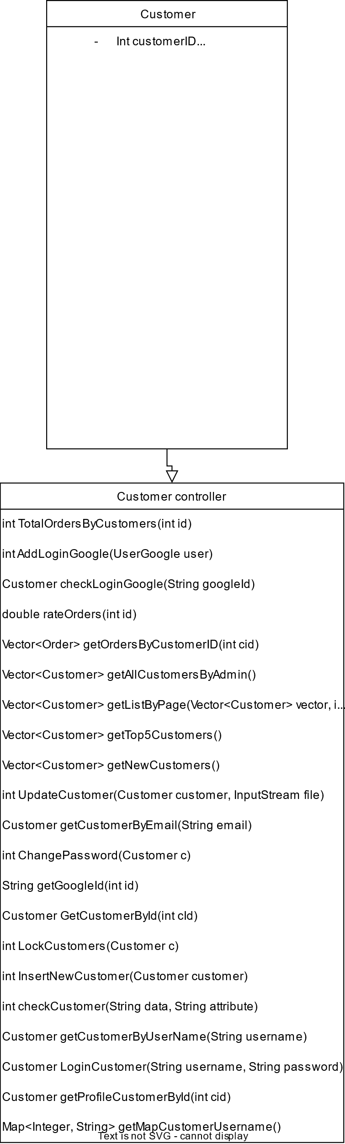

### b. Class Specifications

#### DAOCustomer.java

|  |  |  |
| --- | --- | --- |
| **No** | **Method** | **Description** |
| 01 | public int TotalOrdersByCustomers(int id) | Handle request get Amount of Order by Customer ID |
| 02 | public double rateOrders(int id) | Handle request get the rate of cancel Order by Customer ID |
| f03 | public Vector<Order> getOrdersByCustomerID(int cid) | Handle request get list of Order by Customer ID |
| 04 | public Vector<Customer> getAllCustomersByAdmin() | Handle request get list of all Customer |
| 05 | public Vector<Customer> getListByPage(Vector<Customer> vector, int start, int end) | Handle request get list of Customer by page |
| 06 | public Vector<Customer> getTop5Customers() | Handle request get list of top 5 Customer order by total money spent |
| 07 | public Vector<Customer> getNewCustomers() | Handle request get list of top 5 newest Customer |
| 08 | public int UpdateCustomer(Customer customer, InputStream file) | Handle request update Customer |
| 09 | public Customer getCustomerByEmail(String email) | Handle request get Customer by email |
| 10 | public int ChangePassword(Customer c) | Handle request change Customer’s password |
| 11 | public Customer GetCustomerById(int cId) | Handle request get Customer by ID |
| 12 | public int LockCustomers(Customer c) | Handle request lock Customer account |
| 13 | public int InsertNewCustomer(Customer customer) | Handle request add Customer |
| 14 | public int checkCustomer(String data, String attribute) | Handle request get number of Customer by custom attribute |
| 15 | public Customer getCustomerByUserName(String username) | Handle request get Customer by name |
| 16 | public Customer LoginCustomer(String username, String password) | Handle request login for Customer |
| 17 | public Map<Integer, String> getMapCustomerUsername() | Handle request get map of Customer’s name |

### c. Sequence Diagram(s)

#### Login

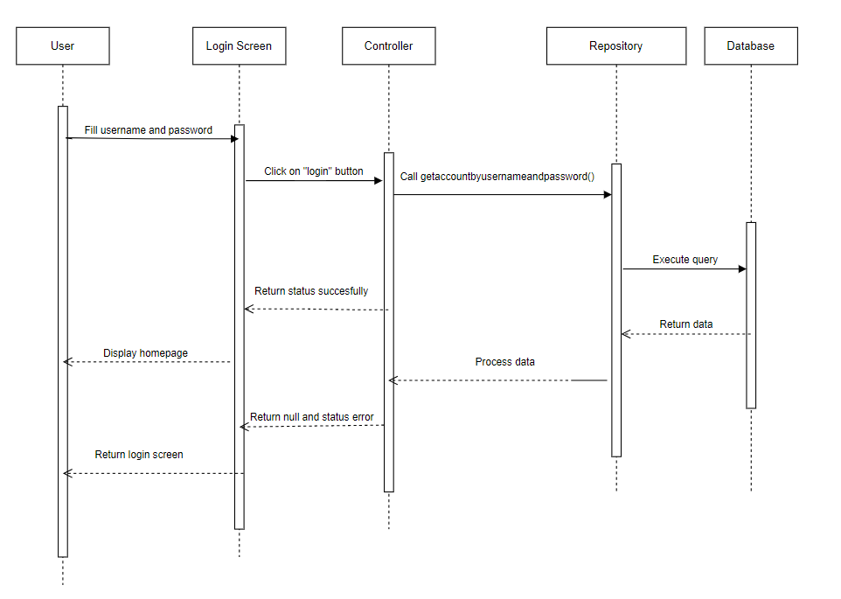

#### Logout

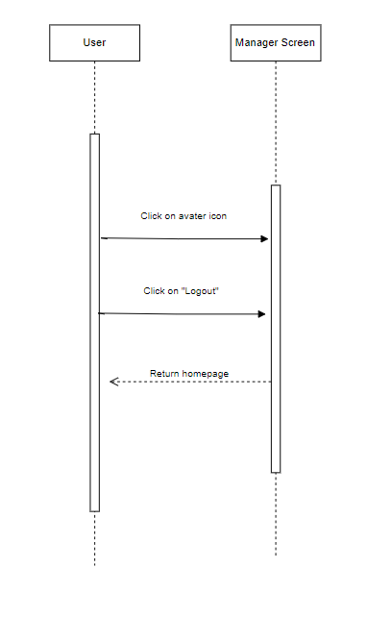

#### Signup

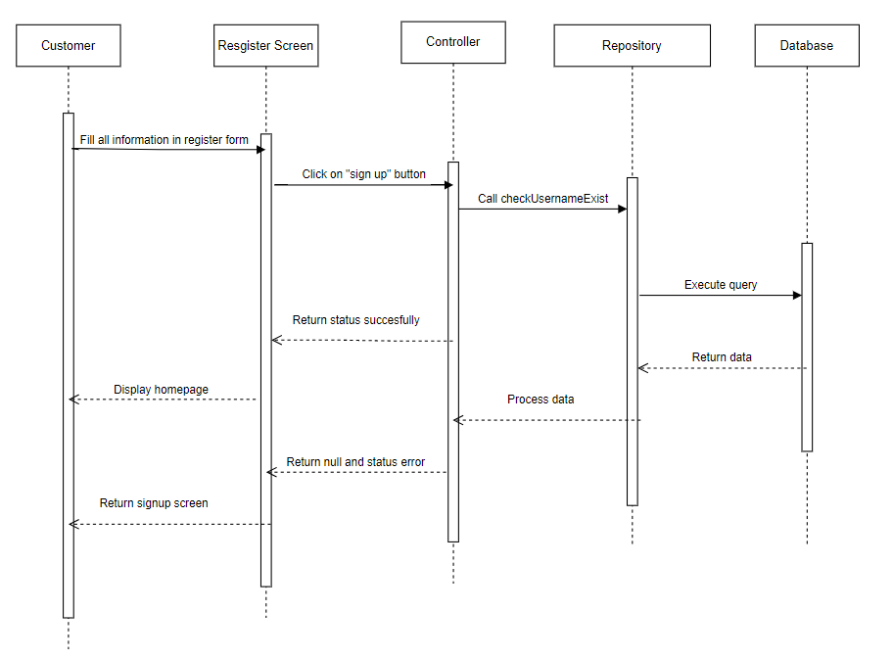

#### Forgot Password

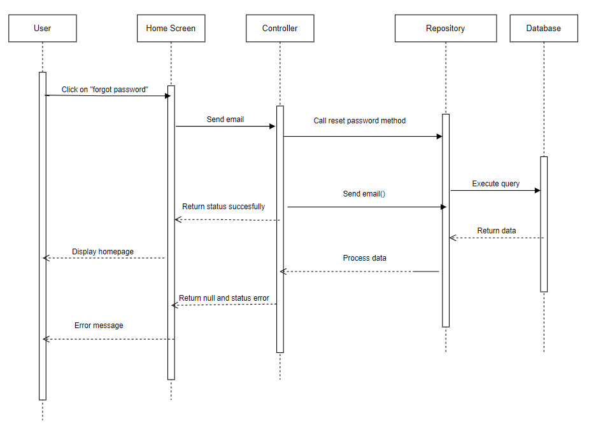

#### Reset Password

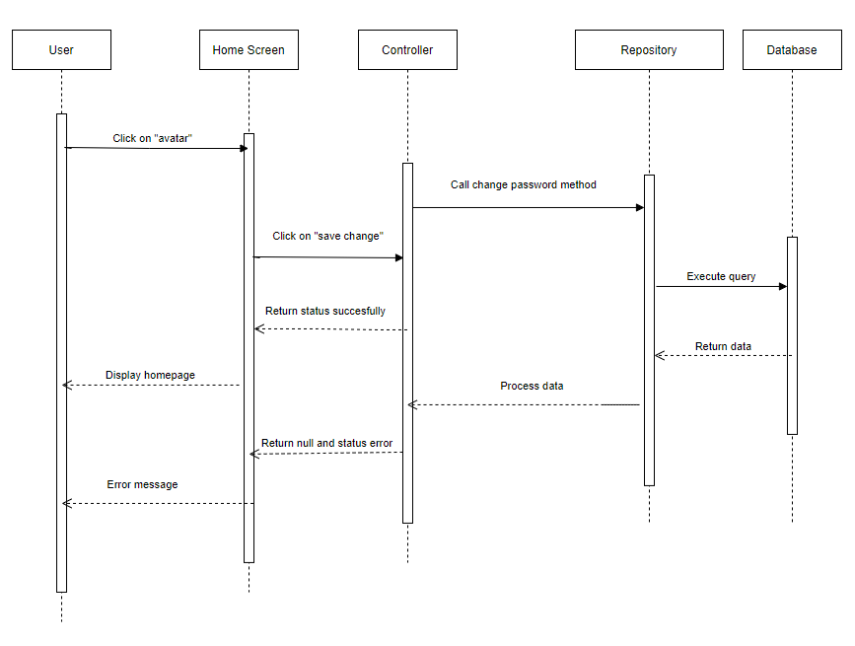

#### Update Profile

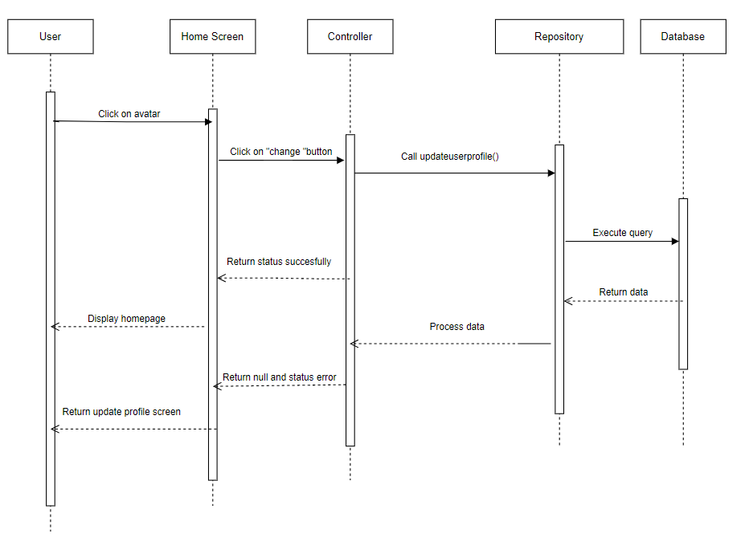

#### Click to call

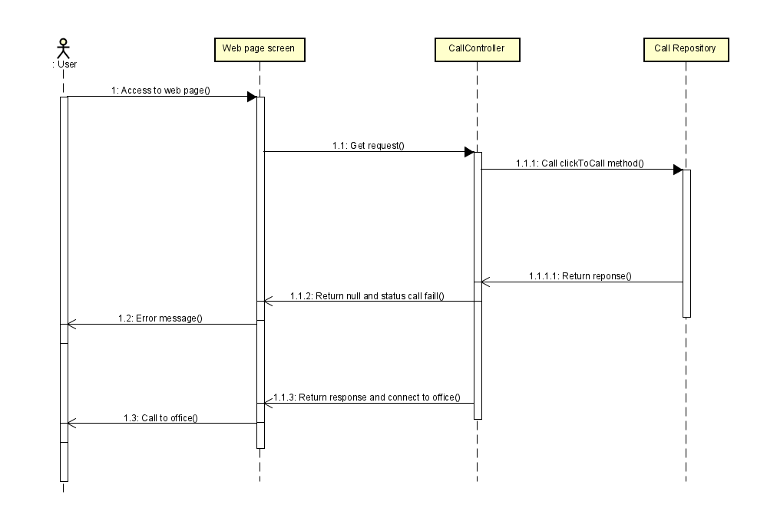

#### View customer account

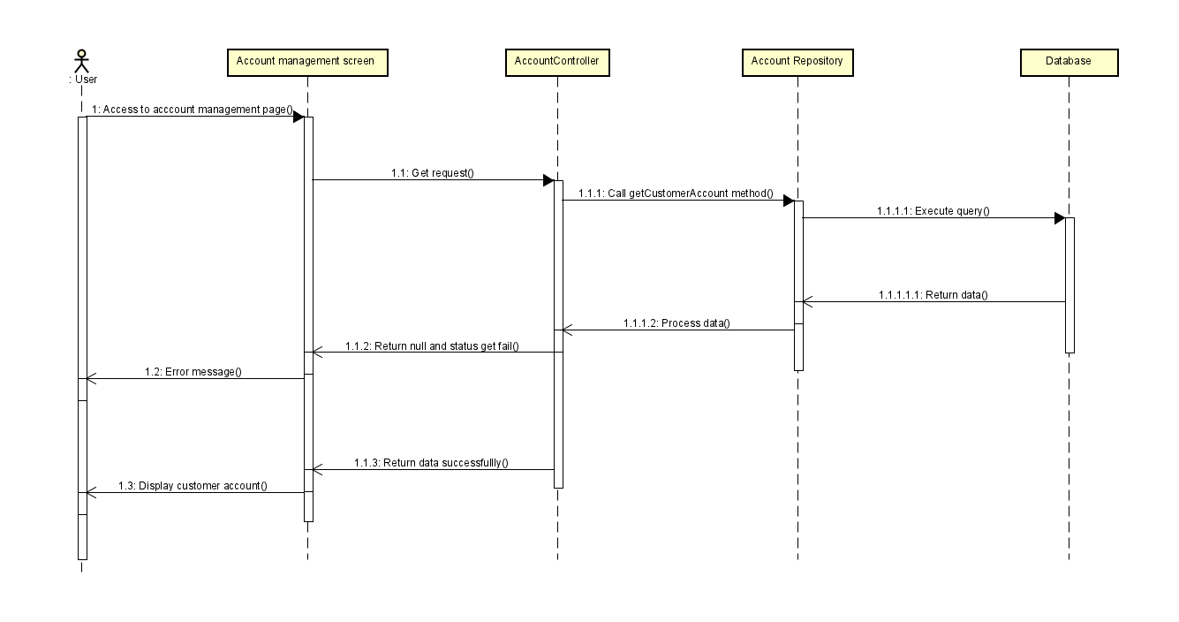

#### Update account status

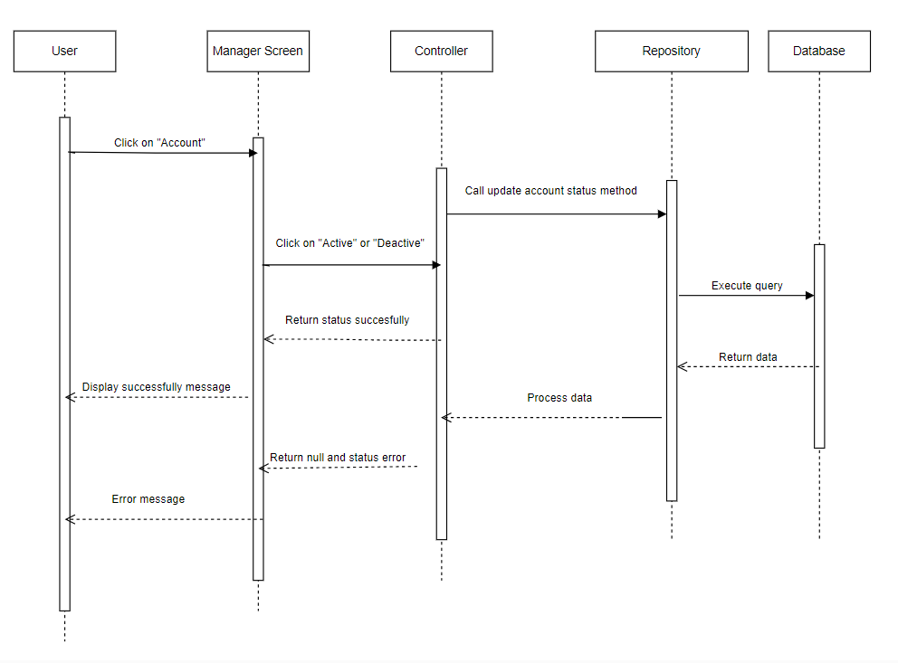

#### View all customer

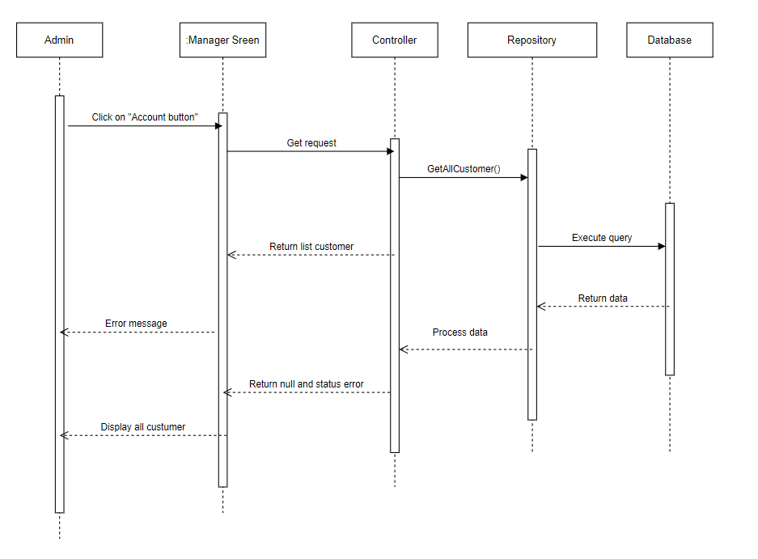

#### Search customer

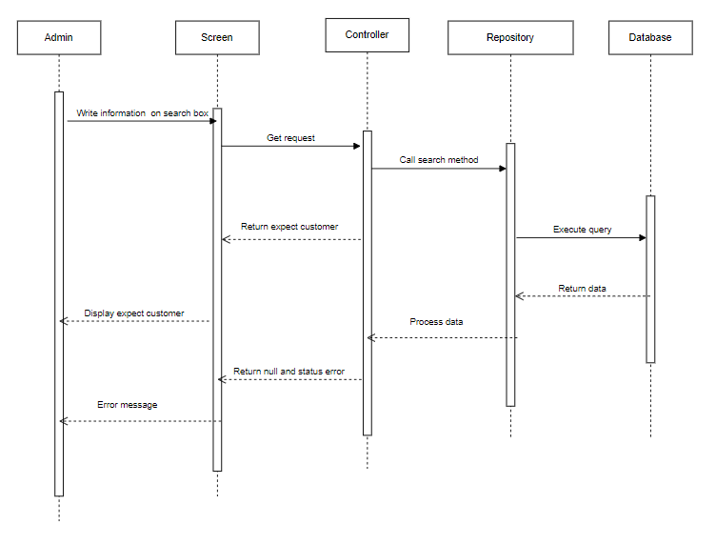

## 2. Public Order

### a. Class Diagram

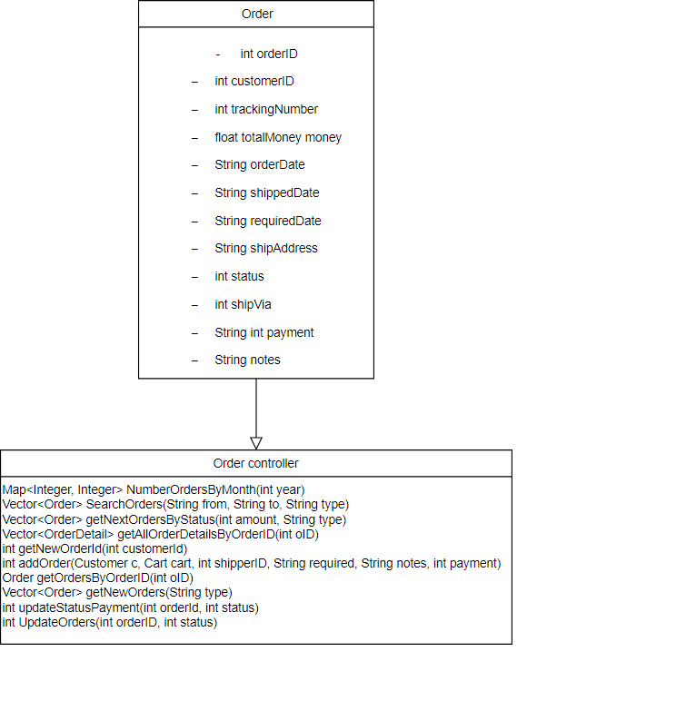

### b. Class Specifications

#### DAOOrder.java

|  |  |  |
| --- | --- | --- |
| **No** | **Method** | **Description** |
| 01 | public Map<Integer, Integer> NumberOrdersByMonth(int year) | Handle request get Map for number of Order in a month by year |
| 02 | public Vector<Order> SearchOrders(String from, String to, String type) | Handle request get List of specified number of Order by status |
| 03 | public Vector<Order> getNextOrdersByStatus(int amount, String type) | Handle request get List of specified number of Order by status after a specified number of Order |
| 04 | ublic Vector<OrderDetail> getAllOrderDetailsByOrderID(int oID, String date) | Handle request get list of Order detail |
| 05 | public int getNewOrderId(int customerId) | Handle request get newest Order |
| 06 | public int addOrder(Customer c, Cart cart, int shipperID, String required, String notes, int payment) | Handle request add Order |
| 07 | public Order getOrdersByOrderID(int oID) | Handle request get list of Order by Order ID |
| 08 | public Vector<Order> getOrdersByCustomerID(int oID) | Handle request get list of Order by Customer ID |
| 09 | public Vector<Order> getNewOrders(String type) | Handle request get list of top 5 newest Order by status |
| 10 | public int updateStatusPayment(int orderId, int status) | Handle request set payment status for Order |
| 11 | public int UpdateOrders(int orderID, int status) | Handle request set status for Order |
| 12 | public List<Supplier> filterSuppliers(Vector<OrderDetail> orderDetailsList) | Handle request get list of Supplier from a list of OrderDetail |
| 13 | public int TotalProductsSaleBySupplier(int supplierID) | Handle request get number of sale attribute to a Supplier |

### c. Sequence Diagram(s)

#### Add to cart

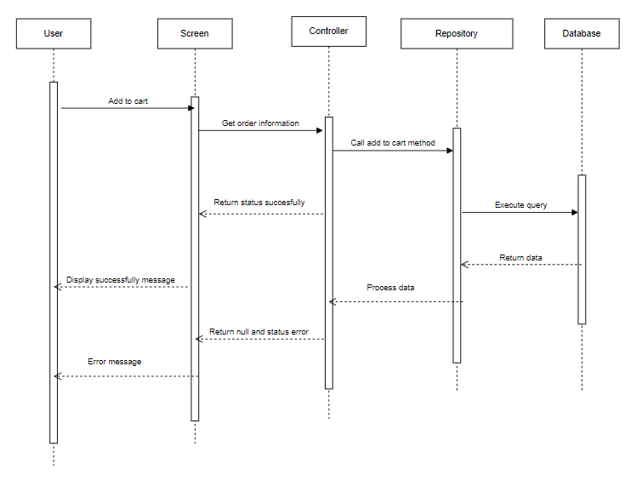

#### View order detail

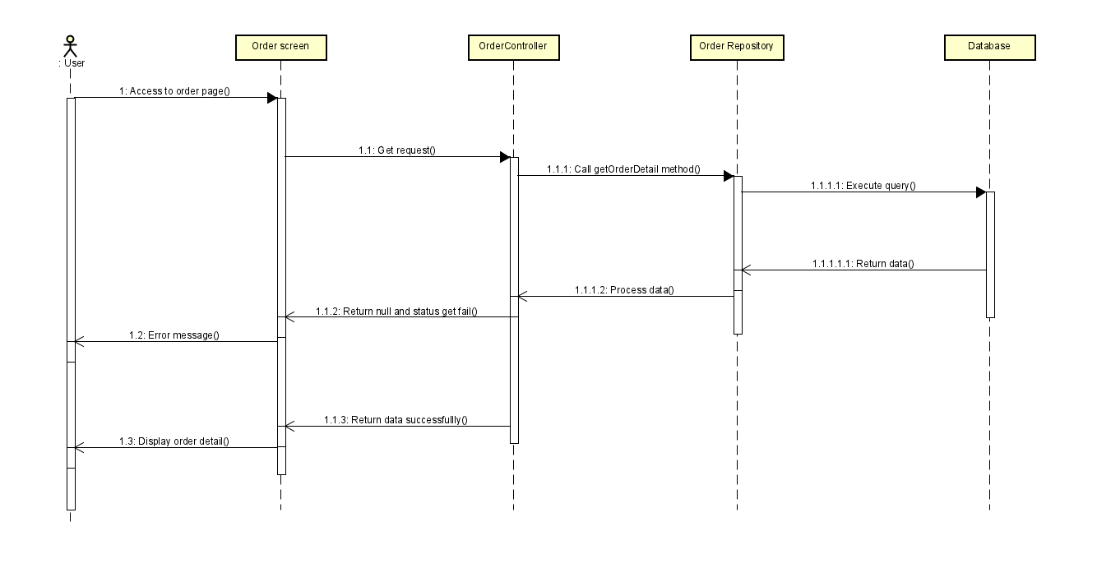

#### Search Order

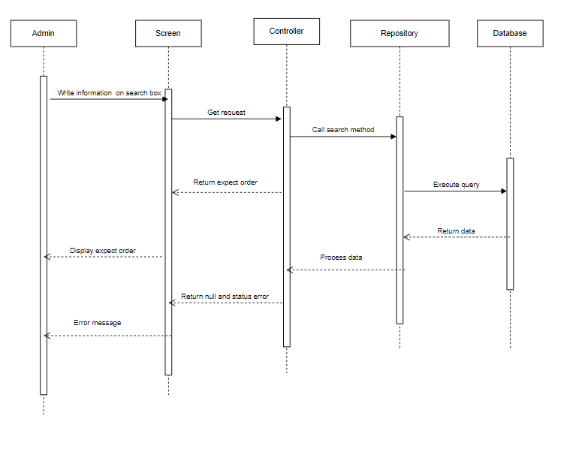

#### View all order

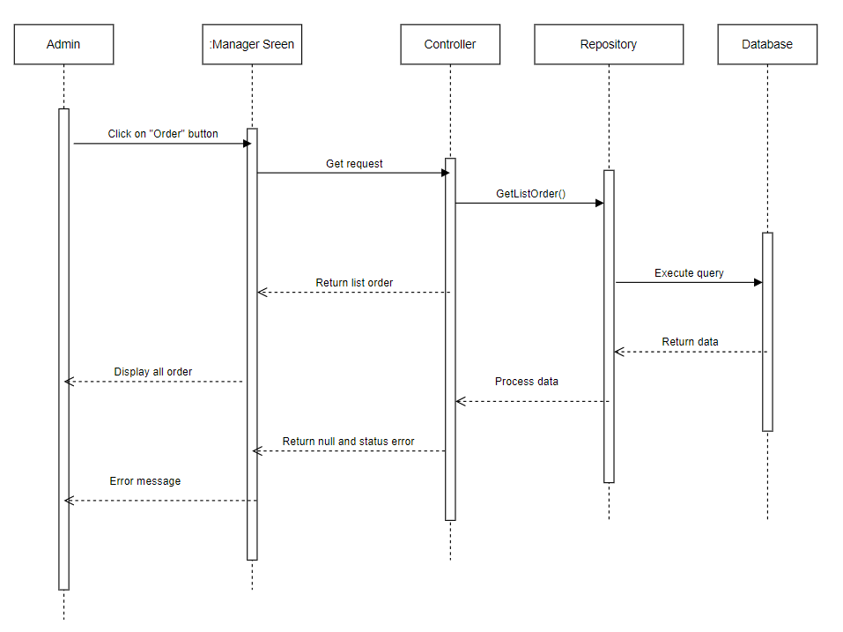

## 3. Public Product

### a. Class Diagram

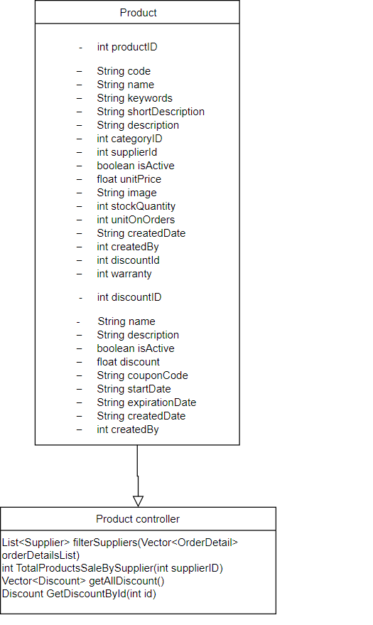

### b. Class Specifications

#### DAOProduct.java

|  |  |  |
| --- | --- | --- |
| **No** | **Method** | **Description** |
| 01 | public Vector<Product> SearchProduct(String key) | Handle request get list of Product by name or code |
| 02 | public Product getInformationProduct(int id) | Handle request get all information of a Product by ID |
| 03 | public int getProductIdByCode(String code) | Handle request get Product ID by code |
| 04 | public Vector<Product> getProductsBySuppliers(int[] id, int cId, String idorder, double from, double to) | Handle request get Product by Suppliers |
| 05 | public double getTopPrice(String type) | Handle request get the highest price of Product |
| 06 | public Vector<Product> getListByPage(Vector<Product> vector, | Handle request get list of Product by page |
| 07 | public Vector<Product> getProductByCategory(int cateId, String status) | Handle request get list of Product by Category |
| 08 | public Product getProductById(int id) | Handle request get Product by ID |
| 09 | public Vector<Product> getAllProducts() | Handle request get list of all Product |
| 10 | public int AddNewProduct(Product product, Administrator admin) | Handle request add Product |
| 11 | public int InsertImgProduct(String img, int pid) | Handle request set image of a Product |
| 12 | public int updateCode(Product p) | Handle request set code of a Product |
| 13 | public Product getProductNew(Administrator admin) | Handle request get newest Product added of an Admin |

### c. Sequence Diagram(s)

#### View product detail

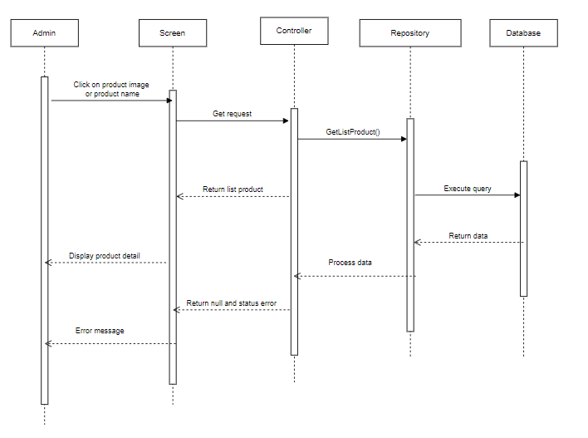

#### Search product

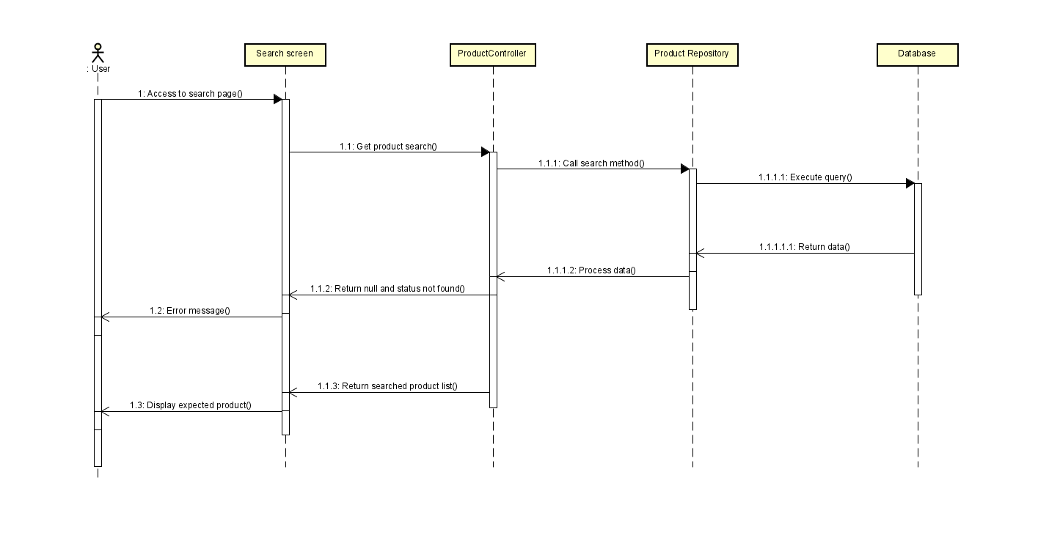

#### View all product

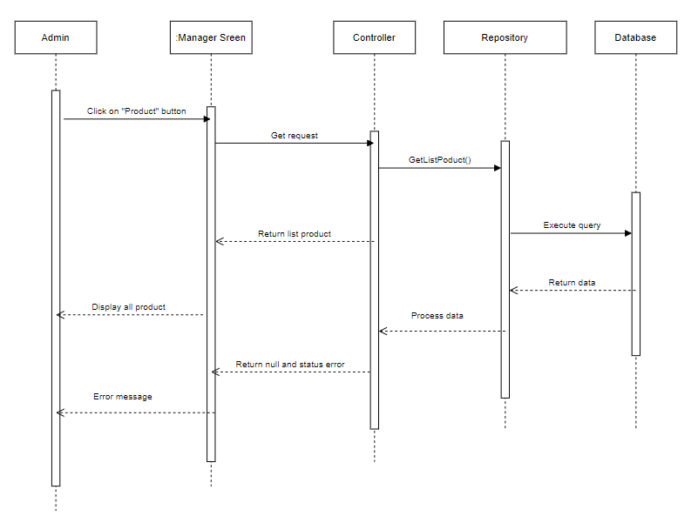

#### Add Product

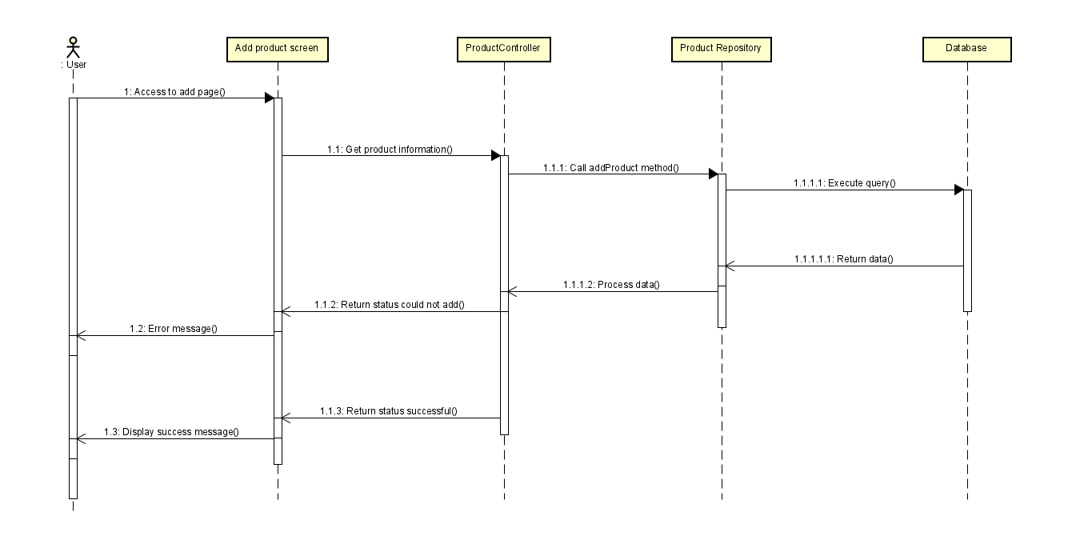

#### Edit product

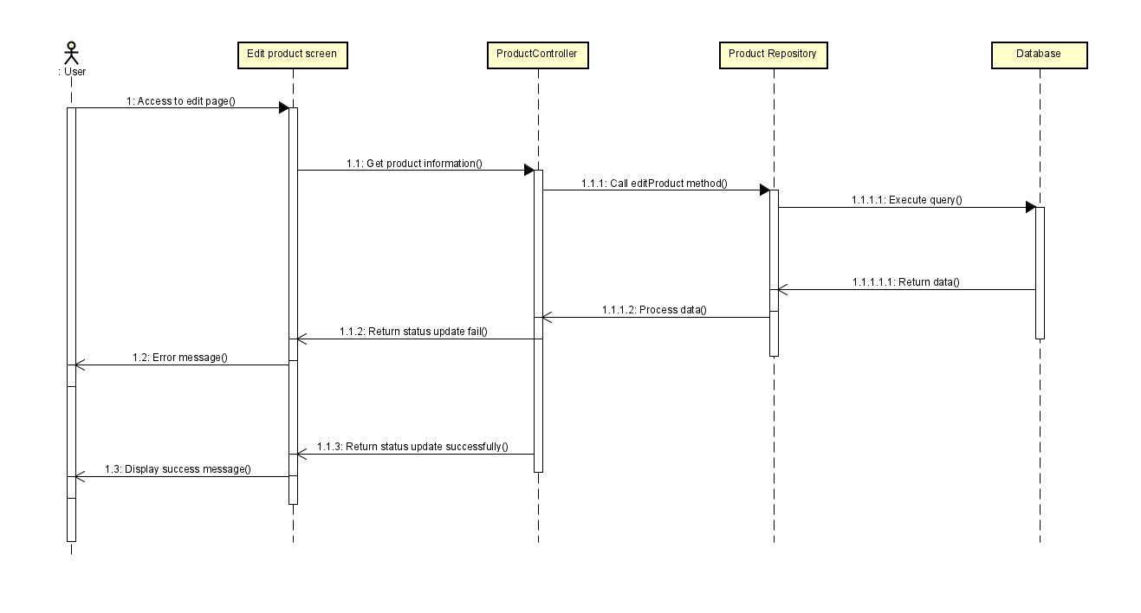

## 4. Public Blog

### a. Class Diagram

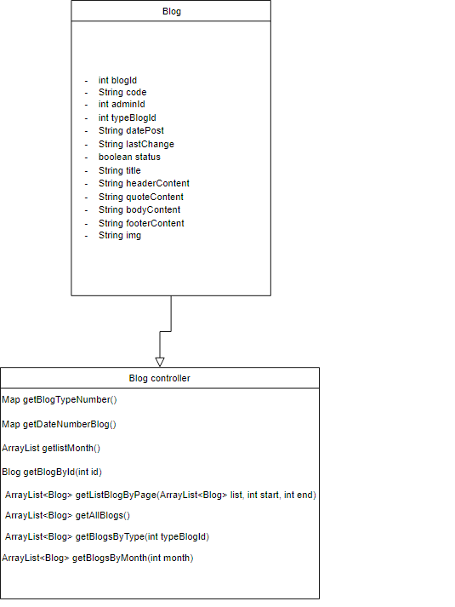

### b. Class Specifications

#### DAOBlog.java

|  |  |  |
| --- | --- | --- |
| **No** | **Method** | **Description** |
| 01 | public ArrayList<Blog> getListBlogByPage(ArrayList<Blog> list, int start, int end) | Handle request get list of Blog by page |
| 02 | public ArrayList<Blog> getAllBlogs() | Handle request get list of all Blog |
| 03 | public ArrayList<Blog> getBlogsByType(int typeBlogId) | Handle request get list of Blog by typeBlogId |
| 04 | public ArrayList<Blog> getBlogsByMonth(int month) | Handle request get list of Blog by month |
| 05 | public Map<Integer, Integer> getBlogTypeNumber() | Handle request get map for number of Blog in TypeBlog |
| 06 | public Map<Integer, Integer> getDateNumberBlog() | Handle request get map for number of Blog in a month |
| 07 | public ArrayList<Integer> getlistMonth() | Handle request get list of month |
| 08 | public Blog getBlogById(int id) | Handle request get Blog by ID |
| 09 | public int getCurrentBlogID() | Handle request get ID of Blog |
| 10 | public int InsertImg(String path, int id) | Handle request set image for Blog |
| 11 | public int insertBlog(Blog blog) | Handle request add Blog |
| 12 | public boolean deleteBlog(int id) | Handle request delete Blog |
| 13 | public void updateBlog(Blog blog) | Handle request update Blog |

#### DAOTypeBlog.java

|  |  |  |
| --- | --- | --- |
| **No** | **Method** | **Description** |
| 01 | public ArrayList<TypeBlog> getAllTypeBlogs() | Handle request get list of all TypeBlog |
| 02 | public Map<Integer, TypeBlog> getMapTypeBlog() | Handle request get map of TypeBlog |
| 03 | public void updateTypeBlog(int id, String typeName) | Handle request update TypeBlog |
| 04 | public int getCurrentTypeBlogID() | Handle request get TypeBlog ID |
| 05 | public boolean deleteTypeBlog(int id) | Handle request delete TypeBlog |
| 06 | public int insertTypeBlog(TypeBlog typeBlog) | Handle request add TypeBlog |

### c. Sequence Diagram(s)

#### View list blog

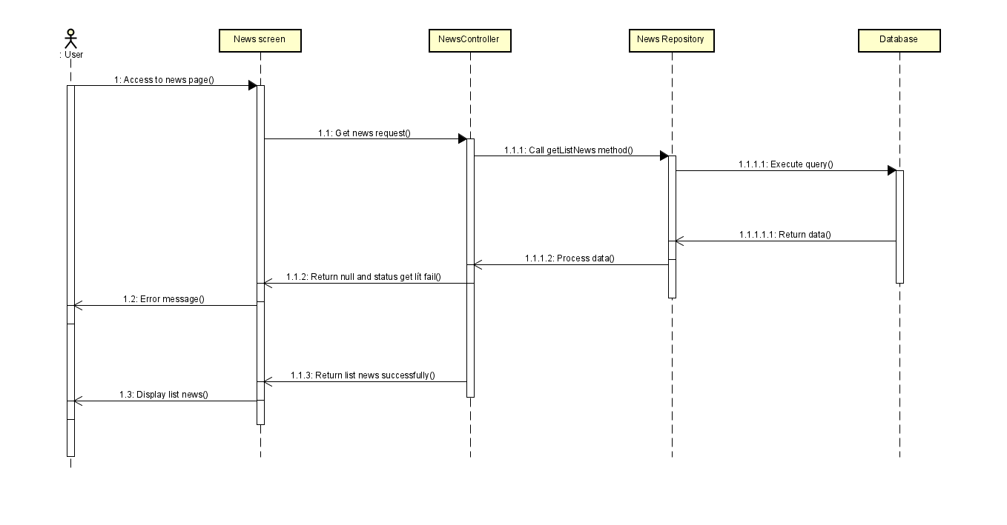

#### Add blog

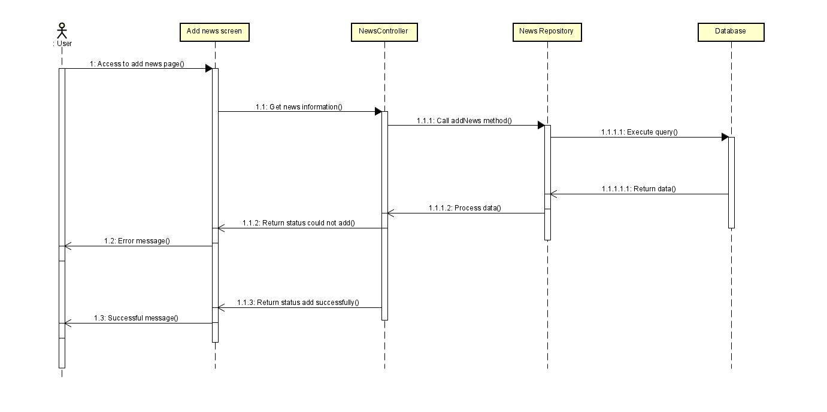

#### Edit blog

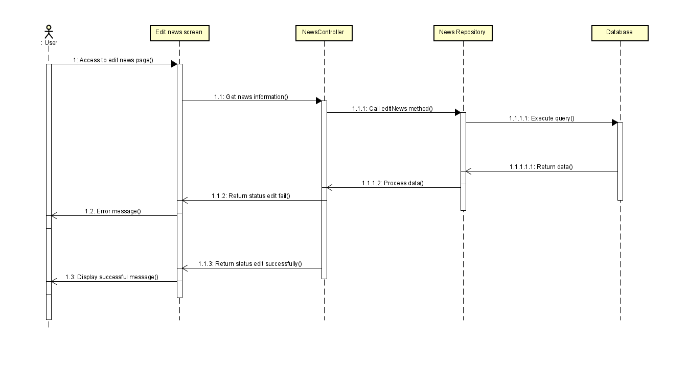

#### Update blog status

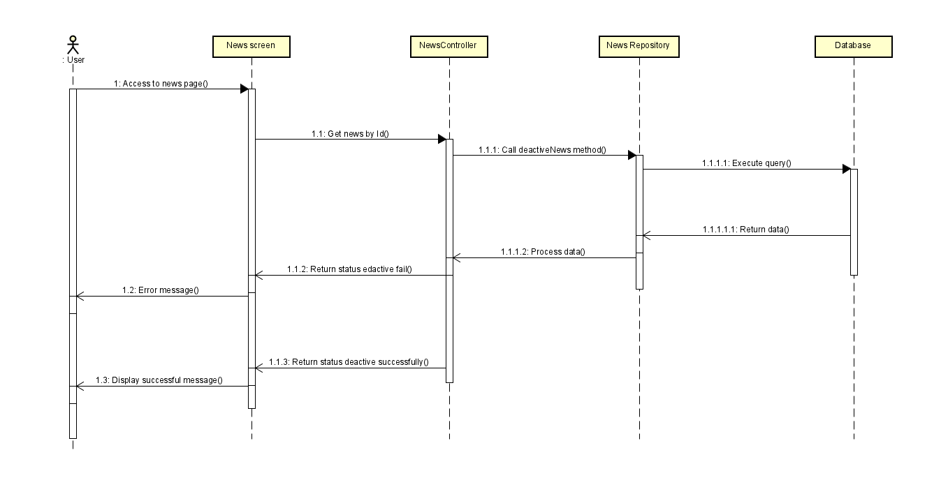

## 5. Public Category

### a. Class Diagram

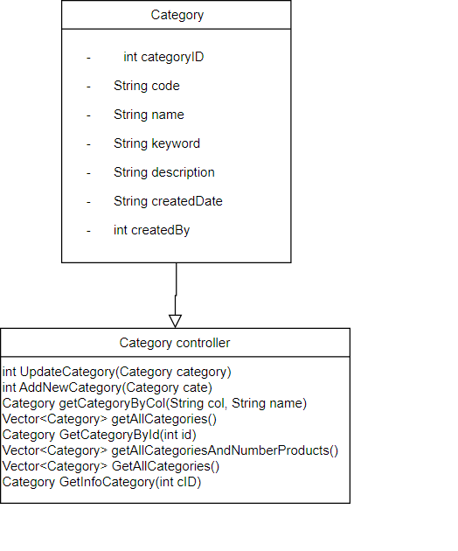

### b. Class Specifications

|  |  |  |
| --- | --- | --- |
| **No** | **Method** | **Description** |
| 01 | public int UpdateCategory(Category category) | Handle request update category by categoryId |
| 02 | public int AddNewCategory(Category cate) | Handle request add new category |
| 03 | public Vector<Category> GetAllCategories() | Handle request get all categories |
| 04 | public Category GetCategoryById(int id) | Handle request get category by ID |

### c. Sequence Diagram(s)

#### View list category

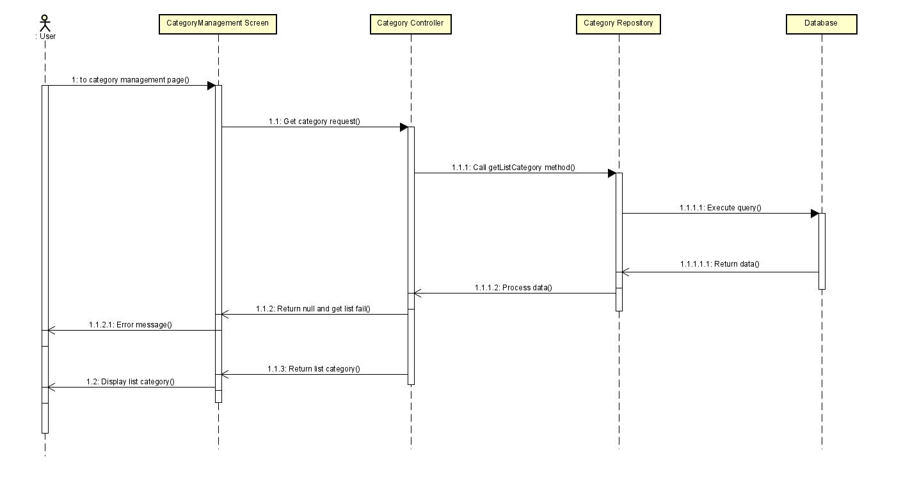

#### Add category

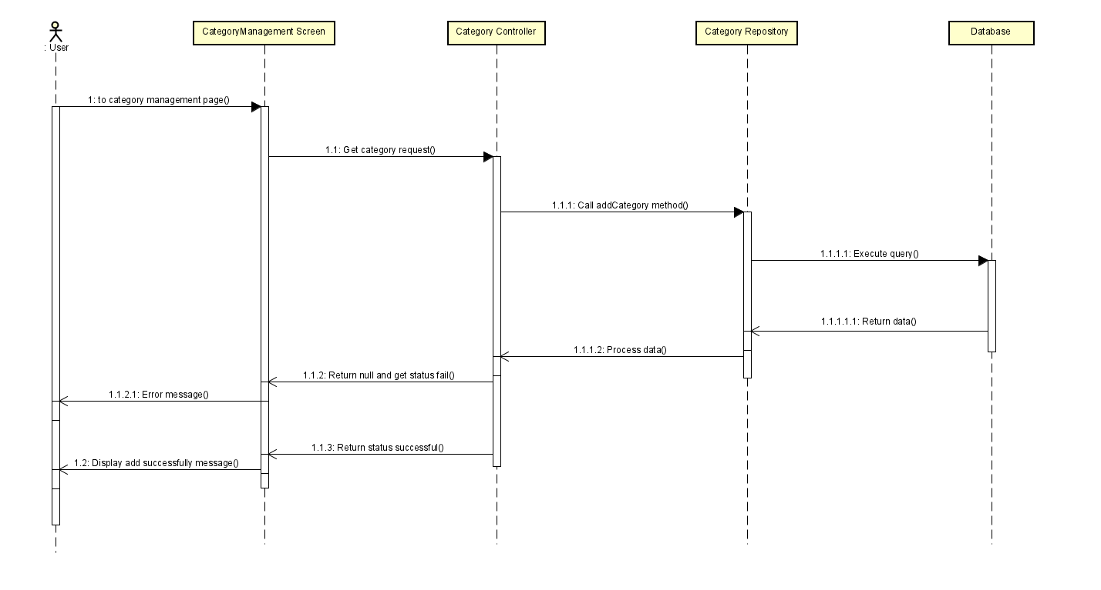

#### Edit category

