

Requirement & Design Specification

**Student Project Portal System (SPPS)**

**Version: 3.0**

– Hanoi, September 2023 –

**Contents**

[Record of Changes 8](https://docs.google.com/document/d/1Q2VJPatnRJE1MoHUW3OpFVFgN5gc4dmi/edit#heading=h.gjdgxs)

[I. Overview 9](https://docs.google.com/document/d/1Q2VJPatnRJE1MoHUW3OpFVFgN5gc4dmi/edit#heading=h.30j0zll)

[1. Overall Description 9](https://docs.google.com/document/d/1Q2VJPatnRJE1MoHUW3OpFVFgN5gc4dmi/edit#heading=h.n3h0385ira2f)

[1.1 Product Overview 9](https://docs.google.com/document/d/1Q2VJPatnRJE1MoHUW3OpFVFgN5gc4dmi/edit#heading=h.1bvqogwpgwb5)

[1.2 Business Rules 9](https://docs.google.com/document/d/1Q2VJPatnRJE1MoHUW3OpFVFgN5gc4dmi/edit#heading=h.iqkoopqgkva4)

[2. User Requirements 10](https://docs.google.com/document/d/1Q2VJPatnRJE1MoHUW3OpFVFgN5gc4dmi/edit#heading=h.1fob9te)

[2.1 Actors 10](https://docs.google.com/document/d/1Q2VJPatnRJE1MoHUW3OpFVFgN5gc4dmi/edit#heading=h.3znysh7)

[2.2 Use Cases 11](https://docs.google.com/document/d/1Q2VJPatnRJE1MoHUW3OpFVFgN5gc4dmi/edit#heading=h.2et92p0)

[a. Use Case Diagram(s) 11](https://docs.google.com/document/d/1Q2VJPatnRJE1MoHUW3OpFVFgN5gc4dmi/edit#heading=h.vbnkzytfpl0l)

[b. Descriptions 16](https://docs.google.com/document/d/1Q2VJPatnRJE1MoHUW3OpFVFgN5gc4dmi/edit#heading=)

[3. Overall Functionalities 25](https://docs.google.com/document/d/1Q2VJPatnRJE1MoHUW3OpFVFgN5gc4dmi/edit#heading=h.tyjcwt)

[3.1 Screens Flow 25](https://docs.google.com/document/d/1Q2VJPatnRJE1MoHUW3OpFVFgN5gc4dmi/edit#heading=h.3dy6vkm)

[3.2 Screen Descriptions 26](https://docs.google.com/document/d/1Q2VJPatnRJE1MoHUW3OpFVFgN5gc4dmi/edit#heading=h.1t3h5sf)

[3.3  Screen Authorization 30](https://docs.google.com/document/d/1Q2VJPatnRJE1MoHUW3OpFVFgN5gc4dmi/edit#heading=h.4d34og8)

[3.4 Non-UI Functions 31](https://docs.google.com/document/d/1Q2VJPatnRJE1MoHUW3OpFVFgN5gc4dmi/edit#heading=h.dqslajsekjip)

[4. System High Level Design 32](https://docs.google.com/document/d/1Q2VJPatnRJE1MoHUW3OpFVFgN5gc4dmi/edit#heading=h.17dp8vu)

[4.1 Database Design 32](https://docs.google.com/document/d/1Q2VJPatnRJE1MoHUW3OpFVFgN5gc4dmi/edit#heading=h.3rdcrjn)

[4.1.1. Database Schema 32](https://docs.google.com/document/d/1Q2VJPatnRJE1MoHUW3OpFVFgN5gc4dmi/edit#heading=)

[4.1.1. Table Descriptions 32](https://docs.google.com/document/d/1Q2VJPatnRJE1MoHUW3OpFVFgN5gc4dmi/edit#heading=h.lnxbz9)

[4.2 Code Packages 34](https://docs.google.com/document/d/1Q2VJPatnRJE1MoHUW3OpFVFgN5gc4dmi/edit#heading=h.35nkun2)

[4.2.1. Package Diagram 34](https://docs.google.com/document/d/1Q2VJPatnRJE1MoHUW3OpFVFgN5gc4dmi/edit#heading=h.lwcho3mxhmaq)

[4.2.1. Package descriptions 34](https://docs.google.com/document/d/1Q2VJPatnRJE1MoHUW3OpFVFgN5gc4dmi/edit#heading=h.d4x5ovi7j71d)

[II. Requirement Specifications 36](https://docs.google.com/document/d/1Q2VJPatnRJE1MoHUW3OpFVFgN5gc4dmi/edit#heading=h.1ksv4uv)

[1. Common Feature 36](https://docs.google.com/document/d/1Q2VJPatnRJE1MoHUW3OpFVFgN5gc4dmi/edit#heading=h.rxf5zl2urey2)

[1.1 UC-1_View Landing Page 36](https://docs.google.com/document/d/1Q2VJPatnRJE1MoHUW3OpFVFgN5gc4dmi/edit#heading=h.q25jhjepaobm)

[a. Functionalities 36](https://docs.google.com/document/d/1Q2VJPatnRJE1MoHUW3OpFVFgN5gc4dmi/edit#heading=)

[b. Business Rules 36](https://docs.google.com/document/d/1Q2VJPatnRJE1MoHUW3OpFVFgN5gc4dmi/edit#heading=)

[1.2 UC-2_Register an account 36](https://docs.google.com/document/d/1Q2VJPatnRJE1MoHUW3OpFVFgN5gc4dmi/edit#heading=h.1fw1ts43aned)

[a. Functionalities 36](https://docs.google.com/document/d/1Q2VJPatnRJE1MoHUW3OpFVFgN5gc4dmi/edit#heading=)

[b. Business Rules 37](https://docs.google.com/document/d/1Q2VJPatnRJE1MoHUW3OpFVFgN5gc4dmi/edit#heading=)

[1.3 UC-3_Login to the system 37](https://docs.google.com/document/d/1Q2VJPatnRJE1MoHUW3OpFVFgN5gc4dmi/edit#heading=h.gwuz1yj9u5qk)

[a. Functionalities 37](https://docs.google.com/document/d/1Q2VJPatnRJE1MoHUW3OpFVFgN5gc4dmi/edit#heading=)

[b. Business Rules 39](https://docs.google.com/document/d/1Q2VJPatnRJE1MoHUW3OpFVFgN5gc4dmi/edit#heading=)

[1.4 UC-4_Reset password 39](https://docs.google.com/document/d/1Q2VJPatnRJE1MoHUW3OpFVFgN5gc4dmi/edit#heading=h.m3w64qq9ldar)

[a. Functionalities 39](https://docs.google.com/document/d/1Q2VJPatnRJE1MoHUW3OpFVFgN5gc4dmi/edit#heading=)

[b. Business Rules 40](https://docs.google.com/document/d/1Q2VJPatnRJE1MoHUW3OpFVFgN5gc4dmi/edit#heading=)

[1.5 UC-8_Change password 40](https://docs.google.com/document/d/1Q2VJPatnRJE1MoHUW3OpFVFgN5gc4dmi/edit#heading=h.u1l9zohm7ftd)

[a. Functionalities 40](https://docs.google.com/document/d/1Q2VJPatnRJE1MoHUW3OpFVFgN5gc4dmi/edit#heading=)

[b. Business Rules 41](https://docs.google.com/document/d/1Q2VJPatnRJE1MoHUW3OpFVFgN5gc4dmi/edit#heading=)

[1.6 UC-6_Logout 41](https://docs.google.com/document/d/1Q2VJPatnRJE1MoHUW3OpFVFgN5gc4dmi/edit#heading=h.nzkub5w6835m)

[a. Functionalities 41](https://docs.google.com/document/d/1Q2VJPatnRJE1MoHUW3OpFVFgN5gc4dmi/edit#heading=)

[b. Business Rules 41](https://docs.google.com/document/d/1Q2VJPatnRJE1MoHUW3OpFVFgN5gc4dmi/edit#heading=)

[1.7 UC-7_View/Edit profile 41](https://docs.google.com/document/d/1Q2VJPatnRJE1MoHUW3OpFVFgN5gc4dmi/edit#heading=h.ckqmwy6js46l)

[a. Functionalities 41](https://docs.google.com/document/d/1Q2VJPatnRJE1MoHUW3OpFVFgN5gc4dmi/edit#heading=)

[b. Business Rules 42](https://docs.google.com/document/d/1Q2VJPatnRJE1MoHUW3OpFVFgN5gc4dmi/edit#heading=)

[2. Admin Feature 42](https://docs.google.com/document/d/1Q2VJPatnRJE1MoHUW3OpFVFgN5gc4dmi/edit#heading=h.3oozxq8tttv3)

[2.1 UC-9_View user list 42](https://docs.google.com/document/d/1Q2VJPatnRJE1MoHUW3OpFVFgN5gc4dmi/edit#heading=h.2ofiswimc50o)

[a. Functional Description 42](https://docs.google.com/document/d/1Q2VJPatnRJE1MoHUW3OpFVFgN5gc4dmi/edit#heading=)

[b. Business Rules 43](https://docs.google.com/document/d/1Q2VJPatnRJE1MoHUW3OpFVFgN5gc4dmi/edit#heading=)

[2.2 UC-10_Add new user 43](https://docs.google.com/document/d/1Q2VJPatnRJE1MoHUW3OpFVFgN5gc4dmi/edit#heading=h.8nkm1mw13lhg)

[a. Functional Description 43](https://docs.google.com/document/d/1Q2VJPatnRJE1MoHUW3OpFVFgN5gc4dmi/edit#heading=)

[b. Business Rules 43](https://docs.google.com/document/d/1Q2VJPatnRJE1MoHUW3OpFVFgN5gc4dmi/edit#heading=)

[2.3 UC-12_Update user details 43](https://docs.google.com/document/d/1Q2VJPatnRJE1MoHUW3OpFVFgN5gc4dmi/edit#heading=h.g34xwb40wh8i)

[a. Functional Description 43](https://docs.google.com/document/d/1Q2VJPatnRJE1MoHUW3OpFVFgN5gc4dmi/edit#heading=)

[b. Business Rules 44](https://docs.google.com/document/d/1Q2VJPatnRJE1MoHUW3OpFVFgN5gc4dmi/edit#heading=)

[2.4 UC-11_Activate/Deactivate user 44](https://docs.google.com/document/d/1Q2VJPatnRJE1MoHUW3OpFVFgN5gc4dmi/edit#heading=h.e0mkcq8yx2l9)

[a. Functional Description 44](https://docs.google.com/document/d/1Q2VJPatnRJE1MoHUW3OpFVFgN5gc4dmi/edit#heading=)

[b. Business Rules 45](https://docs.google.com/document/d/1Q2VJPatnRJE1MoHUW3OpFVFgN5gc4dmi/edit#heading=)

[2.5 UC-13_View subject list 45](https://docs.google.com/document/d/1Q2VJPatnRJE1MoHUW3OpFVFgN5gc4dmi/edit#heading=h.6cqtl31jo1x0)

[a. Functional Description 45](https://docs.google.com/document/d/1Q2VJPatnRJE1MoHUW3OpFVFgN5gc4dmi/edit#heading=)

[b. Business Rules 45](https://docs.google.com/document/d/1Q2VJPatnRJE1MoHUW3OpFVFgN5gc4dmi/edit#heading=)

[2.6 UC-15_Add new subject 46](https://docs.google.com/document/d/1Q2VJPatnRJE1MoHUW3OpFVFgN5gc4dmi/edit#heading=h.vtdr6sgjrdfk)

[a. Functional Description 46](https://docs.google.com/document/d/1Q2VJPatnRJE1MoHUW3OpFVFgN5gc4dmi/edit#heading=)

[b. Business Rules 46](https://docs.google.com/document/d/1Q2VJPatnRJE1MoHUW3OpFVFgN5gc4dmi/edit#heading=)

[2.7 UC-14_Update subject details 46](https://docs.google.com/document/d/1Q2VJPatnRJE1MoHUW3OpFVFgN5gc4dmi/edit#heading=h.tgef036mtehh)

[a. Functional Description 46](https://docs.google.com/document/d/1Q2VJPatnRJE1MoHUW3OpFVFgN5gc4dmi/edit#heading=)

[b. Business Rules 47](https://docs.google.com/document/d/1Q2VJPatnRJE1MoHUW3OpFVFgN5gc4dmi/edit#heading=)

[2.8 UC-16_Activate/Deactivate subject 47](https://docs.google.com/document/d/1Q2VJPatnRJE1MoHUW3OpFVFgN5gc4dmi/edit#heading=h.z247ixwh7p85)

[a. Functional Description 47](https://docs.google.com/document/d/1Q2VJPatnRJE1MoHUW3OpFVFgN5gc4dmi/edit#heading=)

[b. Business Rules 48](https://docs.google.com/document/d/1Q2VJPatnRJE1MoHUW3OpFVFgN5gc4dmi/edit#heading=)

[2.9 UC-19_View setting list 48](https://docs.google.com/document/d/1Q2VJPatnRJE1MoHUW3OpFVFgN5gc4dmi/edit#heading=h.jin82sh8om9i)

[a. Functional Description 48](https://docs.google.com/document/d/1Q2VJPatnRJE1MoHUW3OpFVFgN5gc4dmi/edit#heading=)

[b. Business Rules 48](https://docs.google.com/document/d/1Q2VJPatnRJE1MoHUW3OpFVFgN5gc4dmi/edit#heading=)

[2.10 UC-19_Add new setting 48](https://docs.google.com/document/d/1Q2VJPatnRJE1MoHUW3OpFVFgN5gc4dmi/edit#heading=h.1yfubsu4dsai)

[a. Functional Description 48](https://docs.google.com/document/d/1Q2VJPatnRJE1MoHUW3OpFVFgN5gc4dmi/edit#heading=)

[b. Business Rules 49](https://docs.google.com/document/d/1Q2VJPatnRJE1MoHUW3OpFVFgN5gc4dmi/edit#heading=)

[2.11 UC-20_Update setting details 49](https://docs.google.com/document/d/1Q2VJPatnRJE1MoHUW3OpFVFgN5gc4dmi/edit#heading=h.6c51jij03mfp)

[a. Functional Description 49](https://docs.google.com/document/d/1Q2VJPatnRJE1MoHUW3OpFVFgN5gc4dmi/edit#heading=)

[b. Business Rules 50](https://docs.google.com/document/d/1Q2VJPatnRJE1MoHUW3OpFVFgN5gc4dmi/edit#heading=)

[2.12 UC-21_Activate/Deactivate setting 50](https://docs.google.com/document/d/1Q2VJPatnRJE1MoHUW3OpFVFgN5gc4dmi/edit#heading=h.bqvapauoyuwy)

[a. Functional Description 50](https://docs.google.com/document/d/1Q2VJPatnRJE1MoHUW3OpFVFgN5gc4dmi/edit#heading=)

[b. Business Rules 51](https://docs.google.com/document/d/1Q2VJPatnRJE1MoHUW3OpFVFgN5gc4dmi/edit#heading=)

[3. Subject Manager Feature 51](https://docs.google.com/document/d/1Q2VJPatnRJE1MoHUW3OpFVFgN5gc4dmi/edit#heading=h.qraqy9doc61p)

[3.1 UC-22_View subject assignment list 51](https://docs.google.com/document/d/1Q2VJPatnRJE1MoHUW3OpFVFgN5gc4dmi/edit#heading=h.evmkycjhu1qi)

[a. Functional Description 51](https://docs.google.com/document/d/1Q2VJPatnRJE1MoHUW3OpFVFgN5gc4dmi/edit#heading=)

[b. Business Rules 51](https://docs.google.com/document/d/1Q2VJPatnRJE1MoHUW3OpFVFgN5gc4dmi/edit#heading=h.wq3xly1zgtc7)

[3.2 UC-23_ Add new subject assignment 51](https://docs.google.com/document/d/1Q2VJPatnRJE1MoHUW3OpFVFgN5gc4dmi/edit#heading=h.8rng4baum6my)

[a. Functional Description 51](https://docs.google.com/document/d/1Q2VJPatnRJE1MoHUW3OpFVFgN5gc4dmi/edit#heading=)

[b. Business Rules 52](https://docs.google.com/document/d/1Q2VJPatnRJE1MoHUW3OpFVFgN5gc4dmi/edit#heading=h.iih41wr2fdet)

[3.3 UC-24_ Update subject assignment details 52](https://docs.google.com/document/d/1Q2VJPatnRJE1MoHUW3OpFVFgN5gc4dmi/edit#heading=h.r22jgkz3xnz0)

[a. Functional Description 52](https://docs.google.com/document/d/1Q2VJPatnRJE1MoHUW3OpFVFgN5gc4dmi/edit#heading=)

[b. Business Rules 53](https://docs.google.com/document/d/1Q2VJPatnRJE1MoHUW3OpFVFgN5gc4dmi/edit#heading=h.30qtelfzu24d)

[3.4 UC-25_ Delete subject assignments 53](https://docs.google.com/document/d/1Q2VJPatnRJE1MoHUW3OpFVFgN5gc4dmi/edit#heading=h.emfnnyseso8h)

[a. Functional Description 53](https://docs.google.com/document/d/1Q2VJPatnRJE1MoHUW3OpFVFgN5gc4dmi/edit#heading=)

[b. Business Rules 53](https://docs.google.com/document/d/1Q2VJPatnRJE1MoHUW3OpFVFgN5gc4dmi/edit#heading=h.bd7ylj34qywp)

[3.5 UC-31_View class list 54](https://docs.google.com/document/d/1Q2VJPatnRJE1MoHUW3OpFVFgN5gc4dmi/edit#heading=h.bl1uvp6o7j10)

[a. Functional Description 54](https://docs.google.com/document/d/1Q2VJPatnRJE1MoHUW3OpFVFgN5gc4dmi/edit#heading=)

[b. Business Rules 54](https://docs.google.com/document/d/1Q2VJPatnRJE1MoHUW3OpFVFgN5gc4dmi/edit#heading=)

[3.6 UC-32_ Add new class 54](https://docs.google.com/document/d/1Q2VJPatnRJE1MoHUW3OpFVFgN5gc4dmi/edit#heading=h.eakda9g0dmny)

[a. Functional Description 54](https://docs.google.com/document/d/1Q2VJPatnRJE1MoHUW3OpFVFgN5gc4dmi/edit#heading=)

[b. Business Rules 55](https://docs.google.com/document/d/1Q2VJPatnRJE1MoHUW3OpFVFgN5gc4dmi/edit#heading=)

[3.7 UC-33_ Update class details 55](https://docs.google.com/document/d/1Q2VJPatnRJE1MoHUW3OpFVFgN5gc4dmi/edit#heading=h.b4cv4eqc4hnu)

[a. Functional Description 55](https://docs.google.com/document/d/1Q2VJPatnRJE1MoHUW3OpFVFgN5gc4dmi/edit#heading=)

[b. Business Rules 56](https://docs.google.com/document/d/1Q2VJPatnRJE1MoHUW3OpFVFgN5gc4dmi/edit#heading=)

[3.8 UC-34_ Update class assignment details 56](https://docs.google.com/document/d/1Q2VJPatnRJE1MoHUW3OpFVFgN5gc4dmi/edit#heading=h.ey8c9omk9r3e)

[a. Functional Description 56](https://docs.google.com/document/d/1Q2VJPatnRJE1MoHUW3OpFVFgN5gc4dmi/edit#heading=)

[b. Business Rules 56](https://docs.google.com/document/d/1Q2VJPatnRJE1MoHUW3OpFVFgN5gc4dmi/edit#heading=h.n77eg4ds4amf)

[4. Class Manager Feature 56](https://docs.google.com/document/d/1Q2VJPatnRJE1MoHUW3OpFVFgN5gc4dmi/edit#heading=h.dbr7z99lmjhd)

[4.1 UC-36_View assigned class list 57](https://docs.google.com/document/d/1Q2VJPatnRJE1MoHUW3OpFVFgN5gc4dmi/edit#heading=h.ch6br1ifos8v)

[a. Functional Description 57](https://docs.google.com/document/d/1Q2VJPatnRJE1MoHUW3OpFVFgN5gc4dmi/edit#heading=)

[b. Business Rules 57](https://docs.google.com/document/d/1Q2VJPatnRJE1MoHUW3OpFVFgN5gc4dmi/edit#heading=)

[4.2 UC-37_ Update assigned class details 57](https://docs.google.com/document/d/1Q2VJPatnRJE1MoHUW3OpFVFgN5gc4dmi/edit#heading=h.f7iv2yvvr9eg)

[a. Functional Description 57](https://docs.google.com/document/d/1Q2VJPatnRJE1MoHUW3OpFVFgN5gc4dmi/edit#heading=)

[b. Business Rules 58](https://docs.google.com/document/d/1Q2VJPatnRJE1MoHUW3OpFVFgN5gc4dmi/edit#heading=)

[4.3 UC-38_ List class assignments 58](https://docs.google.com/document/d/1Q2VJPatnRJE1MoHUW3OpFVFgN5gc4dmi/edit#heading=h.fiyvxkx68gc4)

[a. Functional Description 58](https://docs.google.com/document/d/1Q2VJPatnRJE1MoHUW3OpFVFgN5gc4dmi/edit#heading=)

[b. Business Rules 59](https://docs.google.com/document/d/1Q2VJPatnRJE1MoHUW3OpFVFgN5gc4dmi/edit#heading=h.r775h0uvt9h8)

[4.4 UC-56_ View class student list 59](https://docs.google.com/document/d/1Q2VJPatnRJE1MoHUW3OpFVFgN5gc4dmi/edit#heading=h.5t5or5esgqq7)

[a. Functional Description 59](https://docs.google.com/document/d/1Q2VJPatnRJE1MoHUW3OpFVFgN5gc4dmi/edit#heading=)

[b. Business Rules 59](https://docs.google.com/document/d/1Q2VJPatnRJE1MoHUW3OpFVFgN5gc4dmi/edit#heading=h.9ks6l42qob73)

[4.5 UC-60_ Add student 59](https://docs.google.com/document/d/1Q2VJPatnRJE1MoHUW3OpFVFgN5gc4dmi/edit#heading=h.w4bbga3i1axi)

[a. Functional Description 59](https://docs.google.com/document/d/1Q2VJPatnRJE1MoHUW3OpFVFgN5gc4dmi/edit#heading=)

[b. Business Rules 60](https://docs.google.com/document/d/1Q2VJPatnRJE1MoHUW3OpFVFgN5gc4dmi/edit#heading=h.fn178kbc9dla)

[4.6 UC-40_ Remove student 60](https://docs.google.com/document/d/1Q2VJPatnRJE1MoHUW3OpFVFgN5gc4dmi/edit#heading=h.44q0u56uwpp8)

[a. Functional Description 60](https://docs.google.com/document/d/1Q2VJPatnRJE1MoHUW3OpFVFgN5gc4dmi/edit#heading=h.1xsnfkoh63fv)

[b. Business Rules 61](https://docs.google.com/document/d/1Q2VJPatnRJE1MoHUW3OpFVFgN5gc4dmi/edit#heading=h.71bk0ea8rxke)

[4.7 UC-50_ View project list 61](https://docs.google.com/document/d/1Q2VJPatnRJE1MoHUW3OpFVFgN5gc4dmi/edit#heading=h.bmay7r2zjs2u)

[a. Functional Description 61](https://docs.google.com/document/d/1Q2VJPatnRJE1MoHUW3OpFVFgN5gc4dmi/edit#heading=h.4u6s8ragupd8)

[b. Business Rules 61](https://docs.google.com/document/d/1Q2VJPatnRJE1MoHUW3OpFVFgN5gc4dmi/edit#heading=h.a7n89aqbc32d)

[4.8 UC-51_ Add new project 61](https://docs.google.com/document/d/1Q2VJPatnRJE1MoHUW3OpFVFgN5gc4dmi/edit#heading=h.5n2xjxrewqie)

[a. Functional Description 61](https://docs.google.com/document/d/1Q2VJPatnRJE1MoHUW3OpFVFgN5gc4dmi/edit#heading=h.mecwr1v15t5r)

[b. Business Rules 62](https://docs.google.com/document/d/1Q2VJPatnRJE1MoHUW3OpFVFgN5gc4dmi/edit#heading=h.qnlqgv3e7mub)

[4.9 UC-55_ Update project details 62](https://docs.google.com/document/d/1Q2VJPatnRJE1MoHUW3OpFVFgN5gc4dmi/edit#heading=h.yg6uu9ulk78)

[a. Functional Description 62](https://docs.google.com/document/d/1Q2VJPatnRJE1MoHUW3OpFVFgN5gc4dmi/edit#heading=h.5aodaxv68pt2)

[b. Business Rules 63](https://docs.google.com/document/d/1Q2VJPatnRJE1MoHUW3OpFVFgN5gc4dmi/edit#heading=h.lqvfff1v8cgl)

[4.10 UC-54_ Delete inactive project 63](https://docs.google.com/document/d/1Q2VJPatnRJE1MoHUW3OpFVFgN5gc4dmi/edit#heading=h.3mliq2uachpl)

[a. Functional Description 63](https://docs.google.com/document/d/1Q2VJPatnRJE1MoHUW3OpFVFgN5gc4dmi/edit#heading=h.wlica3vi0qlz)

[b. Business Rules 63](https://docs.google.com/document/d/1Q2VJPatnRJE1MoHUW3OpFVFgN5gc4dmi/edit#heading=h.8u9kmvpzrsw3)

[4.11 UC-39_ View project member list 63](https://docs.google.com/document/d/1Q2VJPatnRJE1MoHUW3OpFVFgN5gc4dmi/edit#heading=h.rbk4oxj2g7tg)

[a. Functional Description 63](https://docs.google.com/document/d/1Q2VJPatnRJE1MoHUW3OpFVFgN5gc4dmi/edit#heading=h.8leq5trourkn)

[b. Business Rules 64](https://docs.google.com/document/d/1Q2VJPatnRJE1MoHUW3OpFVFgN5gc4dmi/edit#heading=h.mr2k7srl345)

[4.12 UC-42_ Assign team leader 64](https://docs.google.com/document/d/1Q2VJPatnRJE1MoHUW3OpFVFgN5gc4dmi/edit#heading=h.9hwig32nez3s)

[a. Functional Description 64](https://docs.google.com/document/d/1Q2VJPatnRJE1MoHUW3OpFVFgN5gc4dmi/edit#heading=h.1aqw9r91mgqn)

[b. Business Rules 65](https://docs.google.com/document/d/1Q2VJPatnRJE1MoHUW3OpFVFgN5gc4dmi/edit#heading=h.xb3dixk96wjr)

[4.13 UC-44_ Update member status with note 65](https://docs.google.com/document/d/1Q2VJPatnRJE1MoHUW3OpFVFgN5gc4dmi/edit#heading=h.a3q9ncm5bz9n)

[a. Functional Description 65](https://docs.google.com/document/d/1Q2VJPatnRJE1MoHUW3OpFVFgN5gc4dmi/edit#heading=h.rwnd7j4i0tn8)

[b. Business Rules 65](https://docs.google.com/document/d/1Q2VJPatnRJE1MoHUW3OpFVFgN5gc4dmi/edit#heading=h.565zd9ovb1ec)

[4.14 UC-41_ Import/Export/Move member 65](https://docs.google.com/document/d/1Q2VJPatnRJE1MoHUW3OpFVFgN5gc4dmi/edit#heading=h.ahuw643o9mrs)

[a. Functional Description 65](https://docs.google.com/document/d/1Q2VJPatnRJE1MoHUW3OpFVFgN5gc4dmi/edit#heading=h.rz4z6hdgh4uw)

[b. Business Rules 66](https://docs.google.com/document/d/1Q2VJPatnRJE1MoHUW3OpFVFgN5gc4dmi/edit#heading=h.rs10pt32lo7v)

[4.15 UC-62_ View assigned project list 66](https://docs.google.com/document/d/1Q2VJPatnRJE1MoHUW3OpFVFgN5gc4dmi/edit#heading=h.l2zikoy58u8j)

[a. Functional Description 66](https://docs.google.com/document/d/1Q2VJPatnRJE1MoHUW3OpFVFgN5gc4dmi/edit#heading=h.jyyg3bx7s92)

[UC-62_View assigned project list 66](https://docs.google.com/document/d/1Q2VJPatnRJE1MoHUW3OpFVFgN5gc4dmi/edit#heading=h.338q0dadthdv)

[b. Business Rules 67](https://docs.google.com/document/d/1Q2VJPatnRJE1MoHUW3OpFVFgN5gc4dmi/edit#heading=h.3r0m5h10d3q)

[4.16 UC-63_ Update assigned project details 67](https://docs.google.com/document/d/1Q2VJPatnRJE1MoHUW3OpFVFgN5gc4dmi/edit#heading=h.e91hulhf9b0l)

[a. Functional Description 67](https://docs.google.com/document/d/1Q2VJPatnRJE1MoHUW3OpFVFgN5gc4dmi/edit#heading=h.qd2n8kmd0x6w)

[UC-63_Update assigned project details 67](https://docs.google.com/document/d/1Q2VJPatnRJE1MoHUW3OpFVFgN5gc4dmi/edit#heading=h.u9iyxbm2rh9u)

[b. Business Rules 67](https://docs.google.com/document/d/1Q2VJPatnRJE1MoHUW3OpFVFgN5gc4dmi/edit#heading=h.udcavyrijom)

[4.17 UC-61_ Export class students with Excel 68](https://docs.google.com/document/d/1Q2VJPatnRJE1MoHUW3OpFVFgN5gc4dmi/edit#heading=h.9csjik2tcwmc)

[a. Functional Description 68](https://docs.google.com/document/d/1Q2VJPatnRJE1MoHUW3OpFVFgN5gc4dmi/edit#heading=h.y9zeapv5ugkn)

[b. Business Rules 68](https://docs.google.com/document/d/1Q2VJPatnRJE1MoHUW3OpFVFgN5gc4dmi/edit#heading=h.q7liz5jhmcn9)

[III. Design Specifications 68](https://docs.google.com/document/d/1Q2VJPatnRJE1MoHUW3OpFVFgN5gc4dmi/edit#heading=h.1ci93xb)

[1. Common Feature 68](https://docs.google.com/document/d/1Q2VJPatnRJE1MoHUW3OpFVFgN5gc4dmi/edit#heading=h.3h4r7td2payg)

[1.1 Authentication 68](https://docs.google.com/document/d/1Q2VJPatnRJE1MoHUW3OpFVFgN5gc4dmi/edit#heading=h.wnyagw)

[a. User Register 68](https://docs.google.com/document/d/1Q2VJPatnRJE1MoHUW3OpFVFgN5gc4dmi/edit#heading=h.h08in776bsve)

[b. User Login 69](https://docs.google.com/document/d/1Q2VJPatnRJE1MoHUW3OpFVFgN5gc4dmi/edit#heading=)

[UI Design 70](https://docs.google.com/document/d/1Q2VJPatnRJE1MoHUW3OpFVFgN5gc4dmi/edit#heading=h.hynairetx423)

[c. Password Reset 70](https://docs.google.com/document/d/1Q2VJPatnRJE1MoHUW3OpFVFgN5gc4dmi/edit#heading=h.384lhidemboy)

[UI Design 70](https://docs.google.com/document/d/1Q2VJPatnRJE1MoHUW3OpFVFgN5gc4dmi/edit#heading=h.3gnlt4p)

[d. Password Change 71](https://docs.google.com/document/d/1Q2VJPatnRJE1MoHUW3OpFVFgN5gc4dmi/edit#heading=)

[UI Design 71](https://docs.google.com/document/d/1Q2VJPatnRJE1MoHUW3OpFVFgN5gc4dmi/edit#heading=h.zhpqb7top1bj)

[d. User Profile 72](https://docs.google.com/document/d/1Q2VJPatnRJE1MoHUW3OpFVFgN5gc4dmi/edit#heading=h.u2fs7hj9nmdk)

[UI Design 72](https://docs.google.com/document/d/1Q2VJPatnRJE1MoHUW3OpFVFgN5gc4dmi/edit#heading=h.upzp4owo8zif)

[2. Admin Feature 73](https://docs.google.com/document/d/1Q2VJPatnRJE1MoHUW3OpFVFgN5gc4dmi/edit#heading=h.4fsjm0b)

[2.1 Dashboard 73](https://docs.google.com/document/d/1Q2VJPatnRJE1MoHUW3OpFVFgN5gc4dmi/edit#heading=h.2uxtw84)

[Admin Dashboard 73](https://docs.google.com/document/d/1Q2VJPatnRJE1MoHUW3OpFVFgN5gc4dmi/edit#heading=)

[UI Design 74](https://docs.google.com/document/d/1Q2VJPatnRJE1MoHUW3OpFVFgN5gc4dmi/edit#heading=h.9jevcg6mrpzu)

[2.2 User Manager 74](https://docs.google.com/document/d/1Q2VJPatnRJE1MoHUW3OpFVFgN5gc4dmi/edit#heading=h.hjt3k98qc3nx)

[User List 74](https://docs.google.com/document/d/1Q2VJPatnRJE1MoHUW3OpFVFgN5gc4dmi/edit#heading=h.emgp563ib9wm)

[UI Design 74](https://docs.google.com/document/d/1Q2VJPatnRJE1MoHUW3OpFVFgN5gc4dmi/edit#heading=h.n045h2qms7u1)

[New User 75](https://docs.google.com/document/d/1Q2VJPatnRJE1MoHUW3OpFVFgN5gc4dmi/edit#heading=h.v0wysc7bo2ai)

[UI Design 75](https://docs.google.com/document/d/1Q2VJPatnRJE1MoHUW3OpFVFgN5gc4dmi/edit#heading=h.irtg5re1s51p)

[Update User 75](https://docs.google.com/document/d/1Q2VJPatnRJE1MoHUW3OpFVFgN5gc4dmi/edit#heading=h.jha9oqatkge1)

[UI Design 76](https://docs.google.com/document/d/1Q2VJPatnRJE1MoHUW3OpFVFgN5gc4dmi/edit#heading=h.r322m2n4gc2u)

[2.3 Subject Manager 76](https://docs.google.com/document/d/1Q2VJPatnRJE1MoHUW3OpFVFgN5gc4dmi/edit#heading=h.j624cikj5jwr)

[Subject List 76](https://docs.google.com/document/d/1Q2VJPatnRJE1MoHUW3OpFVFgN5gc4dmi/edit#heading=h.wrmaaeyd59n)

[UI Design 77](https://docs.google.com/document/d/1Q2VJPatnRJE1MoHUW3OpFVFgN5gc4dmi/edit#heading=h.tp9e1rfu1jqq)

[New Subject/ Subject Details/ Update Subject 77](https://docs.google.com/document/d/1Q2VJPatnRJE1MoHUW3OpFVFgN5gc4dmi/edit#heading=h.d5fn8q67zcpz)

[UI Design 78](https://docs.google.com/document/d/1Q2VJPatnRJE1MoHUW3OpFVFgN5gc4dmi/edit#heading=h.xe9fc15w9yee)

[2.4 Class Manager 78](https://docs.google.com/document/d/1Q2VJPatnRJE1MoHUW3OpFVFgN5gc4dmi/edit#heading=h.fh8mnjmlqe2c)

[Class List 78](https://docs.google.com/document/d/1Q2VJPatnRJE1MoHUW3OpFVFgN5gc4dmi/edit#heading=h.q2zpjm33dixo)

[UI Design 79](https://docs.google.com/document/d/1Q2VJPatnRJE1MoHUW3OpFVFgN5gc4dmi/edit#heading=h.stwttyn1henh)

[New Class 79](https://docs.google.com/document/d/1Q2VJPatnRJE1MoHUW3OpFVFgN5gc4dmi/edit#heading=h.641cux1qajd6)

[UI Design 80](https://docs.google.com/document/d/1Q2VJPatnRJE1MoHUW3OpFVFgN5gc4dmi/edit#heading=h.ke8fyodolfqn)

[Update Class 80](https://docs.google.com/document/d/1Q2VJPatnRJE1MoHUW3OpFVFgN5gc4dmi/edit#heading=h.9bhprnmhsvxw)

[Subject Assignment List 81](https://docs.google.com/document/d/1Q2VJPatnRJE1MoHUW3OpFVFgN5gc4dmi/edit#heading=h.ctdfvvtzi9a)

[New Subject Assignment 82](https://docs.google.com/document/d/1Q2VJPatnRJE1MoHUW3OpFVFgN5gc4dmi/edit#heading=h.chh08v7nj1cm)

[Subject Assignment Details/ Update Subject Assignment 83](https://docs.google.com/document/d/1Q2VJPatnRJE1MoHUW3OpFVFgN5gc4dmi/edit#heading=h.25x4r6cdoyjm)

[2.6 Setting Manager 84](https://docs.google.com/document/d/1Q2VJPatnRJE1MoHUW3OpFVFgN5gc4dmi/edit#heading=h.rwk2yoaw574u)

[System Setting List 84](https://docs.google.com/document/d/1Q2VJPatnRJE1MoHUW3OpFVFgN5gc4dmi/edit#heading=h.409vc61g2blg)

[New System Setting 85](https://docs.google.com/document/d/1Q2VJPatnRJE1MoHUW3OpFVFgN5gc4dmi/edit#heading=h.udha59gx3atu)

[IV. Appendix 87](https://docs.google.com/document/d/1Q2VJPatnRJE1MoHUW3OpFVFgN5gc4dmi/edit#heading=h.3as4poj)

[1. Assumptions & Dependencies 87](https://docs.google.com/document/d/1Q2VJPatnRJE1MoHUW3OpFVFgN5gc4dmi/edit#heading=h.1pxezwc)

[2. Limitations & Exclusions 87](https://docs.google.com/document/d/1Q2VJPatnRJE1MoHUW3OpFVFgN5gc4dmi/edit#heading=h.49x2ik5)

[3. Messages List 88](https://docs.google.com/document/d/1Q2VJPatnRJE1MoHUW3OpFVFgN5gc4dmi/edit#heading=h.147n2zr)

# Record of Changes

|  |  |  |  |  |
| --- | --- | --- | --- | --- |
| **Version** | **Date** | **A* M, D** | **In charge** | **Change Description** |
| V1.0 | 16/09 | A | HungLQHE161677 | Actors, UC Diagram - Description for admin role. |
| V1.0 | 18/09 | A | HungLQHE161677 | Database V1 |
| V1.0 | 23/09 | A | HungLQHE161677 | UC Diagram for Subject Manager role. |
| V1.0 | 24/09 | A | NgocPTBHE176778 | UC Description for Student role. |
| V1.0 | 24/09 | A | MinhLVHHE163657 | UC Description for Team Leader role. |
| V1.0 | 24/09 | A | HungLQHE161677 | UC Diagram for Student role (include Team Leader). |
| v1.0 | 25/09 | A | DatNVHE176009 | Code Package Diagram |
| v2.0 | 22/10 | M | DatNVHE176009 | Database Design |
| v2.0 | 22/10 | A | NgocPTBHE176778 | Product Overview, Screenflow |
| v3.0 | 25/10 | A | NgocPTBHE176778 | Entity Relationship |
| v3.0 | 25/10 | A | MinhLVHHE163657 | Business Rules |
| v3.0 | 25/10 | M | DatNVHE176009 | Actors, Use Case Diagram, Non-UI Functions |
| v3.0 | 26/10 | M | DatNVHE176009 | UC Diagram - Description,  Screen Description - Authorization |
| v3.0 | 26/10 | A | DatNVHE176009 | Requirement Specifications - Class |
| v3.0 | 26/10 | A | NgocPTBHE176778 | Requirement Specifications - Subject |
| v3.0 | 26/10 | A | MinhLVHHE163657 | Requirement Specifications - System Setting |
| v3.0 | 27/10 | M | DatNVHE176009 | Package Diagram |
| v3.0 | 10/11 | M | DatNVHE176009 | Screen Description |
| v3.0 | 13/11 | A | DatNVHE176009 | Requirement Specifications |
| v3.0 | 14/11 | A | DatNVHE176009 | Design Specifications |
| v3.0 | 15/11 | M | DatNVHE176009 | Design Specifications |

*A - Added M - Modified D - Deleted

# Overview

## Overall Description

### 1.1 Product Overview

The context diagram of our SPP project management software illustrates its external interactions with administrators, management instructors, and students. This diagram visually represents the data flows, demonstrating the intricate workings of the SPP system as teachers and students engage with the program. Through this diagram, we can observe how teachers and students utilize the system to manage projects efficiently. The user-friendly SPP Project Management System plays a crucial role in enhancing student project management, offering robust features and intuitive tools for optimal project supervision and coordination.

### 1.2 Business Rules

| **ID** | **Rule Definition** |
| --- | --- |
| BR-01 | Students must submit their project and assignments before the assigned deadlines. Late submissions will result in a deduction of marks. |
| BR-02 | Assignments must be delivered through the online system; physical submissions are not accepted. |
| BR-03 | Students are allowed to request late submission with a valid reason. However, there are specific time frames. |
| BR-04 | Students may submit assignments late, but points will be deducted at a flat rate for each day late. |
| BR-05 | Students will be graded based on the quality of their assignments and adherence to deadlines. |
| BR-06 | Each member of the group is expected to contribute equally. Assessments should include an evaluation of individual contributions. |
| BR-07 | Project and assignment must have a size less than 50MB. |
| BR-08 | Students will receive feedback within two weeks of assignment submission. |
| BR-09 | Students can request re-submission within assigned deadlines of receiving feedback, and the highest possible grade for re-submissions is capped at a certain percentage. |
| BR-10 | Assignment scores must not be publicly disclosed but should be accessible only to the individual student. |
| BR-11 | Ensure that student personal data is secure and complies with data protection regulations. |

## User Requirements

### 2.1 Actors

|  |  |  |
| --- | --- | --- |
| **#** | **Actor** | **Description** |
| 1 | Guest | Users who have not logged in the system. |
| 2 | Registered User | Users who can login and access the system's features. |
| 3 | Administrator | Users who can manage users, subjects and system settings. |
| 4 | Subject Manager | Users who can manage classes, subject settings, subject assignments. |
| 5 | Class Manager | Users who can manage assigned classes,class issue settings, class students, projects, project members. |
| 6 | Project Mentor | Users who can manage assigned projects, evaluate project submisions. |
| 7 | Team Leader | Users who can manage project milestones, project issue settings, and submit assignment results. |
| 8 | Student | Users who can manage project issues, manage work updates, view assignment details. |

### 2.2 Use Cases

#### a. Use Case Diagram(s)

|  |
| --- |
|  |
|  |
|  |
|  |
|  |
|  |
|  |
|  |

#### b. Descriptions

|  |  |  |  |
| --- | --- | --- | --- |
| **ID** | **Feature** | **Use Case** | **Use Case Description** |
| UC-1 | Common | View Landing Page | Users first see this page. |
| UC-2 | Common | Register User | Register new user to access feature of system |
| UC-3 | Common | Login System | Users can log in to the system by providing their username and password or via Google login page |
| UC-4 | Common | Reset Password | Reset and create new password in case of forgetting the old one |
| UC-5 | Common | View Dashboard | Users can see the information and statistics. |
| UC-6 | Common | Logout | Users who logged in can logout the system. |
| UC-7 | Common | View/Edit Profile | Users who logged in can view/edit his/her profile. |
| UC-8 | Common | Change Password | Users can change their password. |
| UC-9 | Admin | View User List | Admin can see a list of all users. |
| UC-10 | Admin | Add new User | Admin can be a new user to this system. |
| UC-11 | Admin | Activate/Deactivate user | Admin can change the status of the user's account. |
| UC-12 | Admin | Update User Details | Admin can update user information. |
| UC-13 | Admin | View Subject List | Admin can see a list of all subjects. |
| UC-14 | Admin | View/Update Subject Detail | Admin and subject manager clicks on each subject in the list to see detail. |
| UC-15 | Admin | Add Subjects | Admin and subject manager can add new subjects. |
| UC-16 | Admin | Activate/Deactivate subject | Admin and subject manager can activate or deactivate the subject. |
| UC-17 | Admin | View Setting List | Admin can see a list of all system settings. |
| UC-18 | Admin | View Setting Detail | Admin clicks on each setting in the list to see detail. |
| UC-19 | Admin | Add System Settings | Admin can add new settings. |
| UC-20 | Admin | Update System Settings | Admin can update settings. |
| UC-21 | Admin | Activate/deactivate setting | Admin can activate or deactivate. |
| UC-22 | Subject Manager | View Subject Assignment List | The Subject Manager can see a list of subject assignments. |
| UC-23 | Subject Manager | Add Subject Assignment | The Subject Manager can add new subject assignments. |
| UC-24 | Subject Manager | View/Update Subject Assignment | The Subject Manager can update subject assignments. |
| UC-25 | Subject Manager | Delete Subject Assignment | The Subject Manager can delete subject assignments. |
| UC-26 | Subject Manager | View List Subject Settings | The Subject Manager can see a list of subject settings. |
| UC-27 | Subject Manager | View Subject Setting Details | The Subject Manager can see subject settings details. |
| UC-28 | Subject Manager | Add Subject Setting | The Subject Manager can add a new subject setting. |
| UC-29 | Subject Manager | Update Subject Setting | The Subject Manager can update subject settings. |
| UC-30 | Subject Manager | Activate/Deactivate subject setting | The Subject Manager can active/deactive subject settings. |
| UC-31 | Subject Manager | View List Classes | The Subject Manager can see a list of classes. |
| UC-32 | Subject Manager | Add New Class | The Subject Manager can add a new class. |
| UC-33 | Subject Manager | Update Class Details | The Subject Manager can update classes. |
| UC-34 | Subject Manager | Add Class Assignment | The Subject Manager can update class assignments. |
| UC-35 | Subject Manager | Change Status Class | The Subject Manager can start or cancel class. |
| UC-36 | Class Manager | View List Assigned Classes | Class Manager can see assigned classes |
| UC-37 | Class Manager | Update Class Description | Class Manager can update class description. |
| UC-38 | Class Manager | Update Class Assignments | Class Manager can change information of class assignments |
| UC-39 | Class Manager | View List Project Member | Class Managers can view the list of members assigned to a specific project. |
| UC-40 | Class Manager | Remove Student | Class Managers can remove students from a class. |
| UC-41 | Class Manager | Import Member From Excel | Class Managers can import member information from an Excel file. |
| UC-42 | Class Manager | Assign Member As Leader | Class Managers can assign a member as the leader of a project or class. |
| UC-43 | Class Manager | Move Member To Other Project | Class Managers can transfer a member from one project or class to another. |
| UC-44 | Class Manager | Update Project's Member With Note | Class Managers can update a project's member records with relevant notes. |
| UC-45 | Class Manager | View List Issue Settings | Class Managers, and Team Leaders can view a list of issue settings. |
| UC-46 | Class Manager | Add Issue Setting | Class Managers, and Team Leaders can add new issue settings. |
| UC-47 | Class Manager | Update Issue Settings | Class Managers, and Team Leaders are authorized to modify and update existing issue settings as needed. |
| UC-48 | Class Manager | Change Status Issue Settings | Class Managers, and Team Leaders can modify the status of issue settings. |
| UC-49 | Class Manager | View Issue Setting Details | Class Managers, and Team Leaders can access specific details of issue settings. |
| UC-50 | Class Manager | View List Project | Class Managers can view a list of projects. |
| UC-51 | Class Manager | Add Project | Class Managers can add new projects. |
| UC-52 | Class Manager | View Project Details | Class Managers can access and review project details. |
| UC-53 | Class Manager | Change Status Project | Class Managers can change the status of a project. |
| UC-54 | Class Manager | Delete Inactive Project | Class Managers can delete inactive projects. |
| UC-55 | Class Manager | Update Project Details | Class Managers can update project details. |
| UC-56 | Class Manager | View List Class Student | Class Manager can see list of student that has signed up to the class |
| UC-57 | Class Manager | Add Student To Class | Subject Manager can add student to the specific class he/shemanage |
| UC-58 | Class Manager | View Student Details | Class Managers can access detailed information about students. |
| UC-59 | Class Manager | Update Class Student Status With Note | Class Managers can update the status of class students, including adding notes as needed. |
| UC-60 | Class Manager | Import List Class Student | Class Managers can import a list of class students from excel. |
| UC-61 | Class Manager | Export List Class Student | Subject Manager can export list class student to excel file |
| UC-62 | Project Mentor | View List Assigned Projects | Project Mentor can access a list of projects assigned to students. |
| UC-63 | Project Mentor | View/Update Project Details | Project Mentor can access details of specific projects. |
| UC-64 | Project Mentor | Change Team Leader | Project Mentors can change the team leader for a project. |
| UC-65 | Project Mentor | View Submission | Project Mentors can view student submissions. |
| UC-66 | Project Mentor | Evaluate Submission | Project Mentors can evaluate student submissions. |
| UC-67 | Project Mentor | Download Submission | Project Mentors can download student submissions. |
| UC-68 | Project Mentor | Reject Submission | Project Mentors can reject student submissions. |
| UC-69 | Project Mentor | Submit Assignment Result | Team Leader can submit assignment results. |
| UC-70 | Team Leader | View List Milestones | Team Leader can view a list of project milestones. |
| UC-71 | Team Leader | Add Milestone | Team Leader can add project milestones. |
| UC-72 | Team Leader | Update Milestone | Team Leader can update project milestones. |
| UC-73 | Team Leader | Delete Pending Milestone | Team Leader can delete pending project milestones. |
| UC-74 | Students | View List Issues | Students can view a list of project issues. |
| UC-75 | Students | Add Issue | Students can add project issues. |
| UC-76 | Students | Import Issue From Excel | Students import project issues from an Excel file. |
| UC-77 | Students | Export Issue To Excel | Students can export project issues to an Excel file. |
| UC-78 | Students | Batch Update Issue | Students can perform batch updates on project issues. |
| UC-79 | Students | Update Issue | Students can update project issues. |
| UC-80 | Student | View List Work Updates | Students view a list of work updates. |
| UC-81 | Student | Delete Work | Students can delete work records. |
| UC-82 | Student | Update Work | Students can update work records. |
| UC-83 | Student | Add Work Update | Students can add work updates. |
| UC-84 | Student | View Work Update Details | Students access detailed information on work updates. |
| UC-85 | Student | View List Assignment Milestones | Students can view a list of assignment milestones. |
| UC-86 | Student | View Evaluation | Students can access and view their and other evaluations. |
| UC-87 | Student | View Team Submission | Students can view team submissions. |
| UC-88 | Student | Gitlab Synchronization | Users synchronize data with Gitlab for project management purposes. |
| UC-89 |  |  |  |
| UC-90 |  |  |  |

## 3. Overall Functionalities

### 3.1 Screens Flow

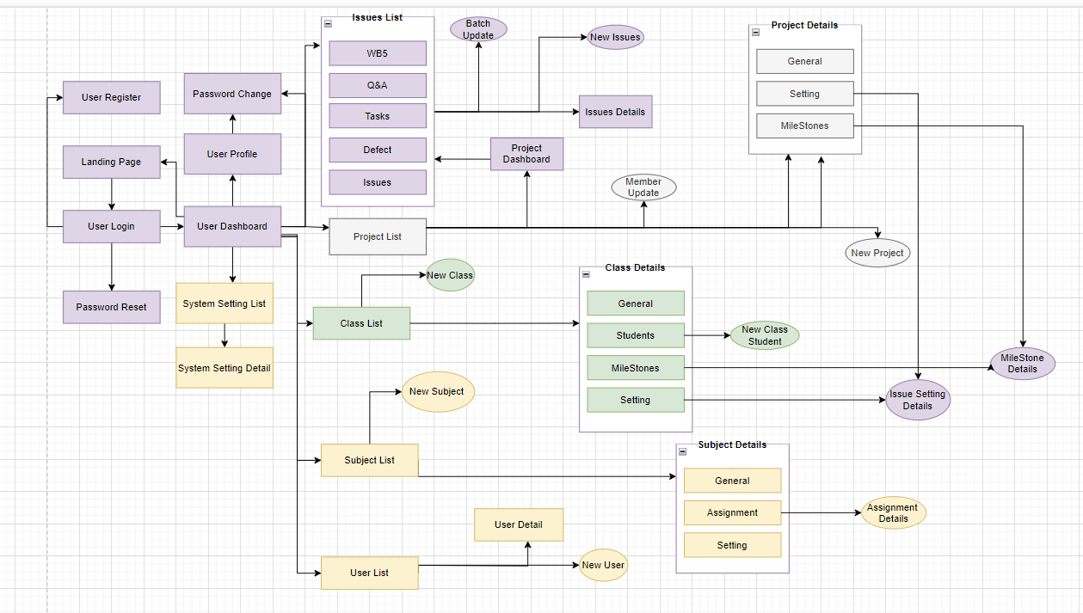

### 3.2 Screen Descriptions

|  |  |  |  |
| --- | --- | --- | --- |
| # | **Feature** | **Screen/Function** | **Screen/Function Details** |
| 1 | Common | Landing Page | * View Landing Page |
| 2 | Common | User Register | * Register a new account |
| 3 | Common | User Login | * Login by email/phone number & password * Login with google |
| 4 | Common | Password Reset | * Reset password via Email |
| 5 | Common | Password Change | * Allows the user to change password |
| 6 | Common | User Profile | * View user profile information and update profile |
| 7 | Admin | Admin Dashboard | * Allows admin go to screen user list, subject list, setting list |
| 8 | Admin | User List | * View all users |
| 9 | Admin | New User | * Add new user into the system |
| 10 | Admin | User Details | * Admin can view and change user detail |
| 11 | Admin | Subject List | * View all subjects |
| 12 | Admin | New Subject | * Add new subject to the system |
| 13 | Admin | Subject Details | * This screen allows to view and update subject details |
| 14 | Admin | Setting List | * Add a new setting to system |
| 15 | Admin | Setting Details | * Update setting details to the system |
| 16 | Common | Home Page | * The home page acts as the central hub, offering users a concise overview and easy access to the key features. |
| 17 | Common | Issue Setting List | * Displays a list of all issue settings of class |
| 18 | Common | Issue Setting Details | * Update details of issue setting in a class |
| 19 | Common | Milestone List | * Displays a list of all assignments of a class that learn this subject |
| 20 | Common | Milestone Details | * Update class assignment details of a class |
| 21 | Subject Manager | Subject Setting List | * Displays a list of all settings of subject |
| 22 | Subject Manager | Subject Setting Details | * Update details of subject setting of subject |
| 23 | Subject Manager | Subject Assignment List | * Displays a list of all subject assignments |
| 24 | Subject Manager | Subject Assignment Details | * Update assignments of subject for all classes learn this subject |
| 25 | Subject Manager | New Class | * Add a new class that learn this subject |
| 26 | Class Manager | Class List | * Displays a list of all classes that learn this subject |
| 27 | Class Manager | Class Details | * View or update details of a class |
| 28 | Class Manager | Class Students List | * Displays a list of all student of class |
| 29 | Class Manager | Class Student Details | * View details of a student of a class |
| 30 | Class Manager | New Class Student | * Add student of class |
| 31 | Class Manager | Project List | * Display all project in class |
| 32 | Class Manager | New Project | * Add a new project |
| 33 | Class Manager | Project Details | * Update details of a project |
| 34 | Class Manager | Project Allocation | * Display all member of project group in class |
| 35 | Class Manager | Group Label Sync | Synchronize class issue settings with group labels in Gitlab |
| 36 | Class Manager | Group Milestone Sync | Synchronize class milestones with group milestones in Gitlab |
| 40 | Project Mentor | Assignment Evaluation | Give the detailed evaluation for project team's assignment  submission |
| 41 | Project Mentor | Project Label Sync | Synchronize project issue settings with project labels in Gitlab |
| 42 | Project Mentor | Project Milestone Sync | Synchronize project milestones with project milestones in Gitlab |
| 43 | Team Leader | Assignment Submit | Choose file, issue list that have done in this assignment |
| 44 | Student | Project List | Displays a list of projects that the student join or project mentor manage |
| 45 | Student | Issue List | Displays a list of all issues |
| 46 | Student | Issue Details | Update details of a issue |
| 47 | Student | New Issue | Add new a issue |
| 48 | Student | Work List | Displays a list of all works |
| 49 | Student | Work Details | Update details of a work |
| 50 | Student | Assignment List | Displays a list of all assignment that the student need to submit |
| 51 | Student | Submit Details | View details of a project submission |

### 3.3  [Screen Authorization](https://docs.google.com/document/d/1Q2VJPatnRJE1MoHUW3OpFVFgN5gc4dmi/edit#heading=h.4d34og8)

|  |  |  |  |  |  |  |  |
| --- | --- | --- | --- | --- | --- | --- | --- |
| **Screen** | **Guest** | **Student** | **Leader** | **Project Mentor** | **Class Manager** | **Subject Manager** | **Admin** |
| Landing Page | X | X | X | X | X | X | X |
| User Register | X | X | X | X | X | X | X |
| User Login |  | X | X | X | X | X | X |
| Password Reset |  | X | X | X | X | X | X |
| Password Change |  | X | X | X | X | X | X |
| User Profile |  | X | X | X | X | X | X |
| User List |  |  |  |  |  |  | X |
| New User |  |  |  |  |  |  | X |
| User Details |  |  |  |  |  |  | X |
| Subject List |  |  |  |  |  |  | X |
| New Subject |  |  |  |  |  |  | X |
| Subject Details |  |  |  |  |  |  | X |
| Setting List |  |  |  |  |  |  | X |
| Setting Details |  |  |  |  |  |  | X |
| Home Page |  |  | X | X | X | X | X |
| Issue Setting List |  |  | X | X | X | X | X |
| Issue Setting Details |  |  | X | X | X | X | X |
| Milestone List |  |  | X | X | X | X | X |
| Milestone Details |  |  | X | X | X | X | X |
| Subject Setting List |  |  |  |  |  | X | X |
| Subject Setting Details |  |  |  |  |  | X | X |
| Subject Assignment List |  |  |  |  |  | X | X |
| Subject Assignment Details |  |  |  |  |  | X | X |
| New Class |  |  |  |  | X | X | X |
| Class List |  |  |  |  | X | X | X |
| Class Details |  |  |  |  | X | X | X |
| Class Students List |  |  |  |  | X | X | X |
| Class Student Details |  |  |  |  | X | X | X |
| New Class Student |  |  |  |  | X | X | X |
| Project List |  |  |  |  | X | X | X |
| New Project |  |  |  |  | X | X | X |
| Project Details |  | X | X | X | X | X | X |
| Project Allocation |  |  |  |  | X | X | X |
| Group Label Sync |  |  |  |  | X | X | X |
| Group Milestone Sync |  |  |  |  | X | X | X |
| Criteria List |  |  |  | X | X | X | X |
| Criteria Details |  |  |  |  | X | X | X |
| LOC Evaluation |  |  |  | X | X | X | X |
| Assignment Evaluation |  | X | X | X | X | X | X |
| Project Label Sync |  |  | X | X | X | X | X |
| Project Milestone Sync |  |  | X | X | X | X | X |
| Assignment Submit |  |  | X |  |  |  |  |
| Project List |  | X | X | X | X | X | X |
| Issue List |  | X | X | X | X | X | X |
| Issue Details |  | X | X | X | X | X | X |
| New Issue |  | X | X | X | X | X | X |
| Work List |  | X | X |  |  |  |  |
| Work Details |  | X | X |  |  |  |  |
| Assignment List |  | X | X | X | X | X | X |
| Submit Details |  | X | X | X | X | X | X |
| Admin Dashboard |  |  |  |  |  |  | X |
| Subject Manager Dashboard |  |  |  |  |  | X |  |
| Teacher Dashboard |  |  |  | X | X |  |  |
| Student Dashboard |  | X | X |  |  |  |  |

### 3.4 Non-UI Functions

|  |  |  |  |
| --- | --- | --- | --- |
| **No** | **Feature** | **System Function** | **Description** |
| 1 | Verification | Send Email Verification | After registering, send an email which contains a link to verify for the user. Without verification, users can not use any feature of this system. |
| 2 | Authentication | Token-based Authentication | After signing in, users will access this system with better security by JWT security. |

## 4. System High Level Design

### 4.1 Database Design

#### 4.1.1. Database Schema

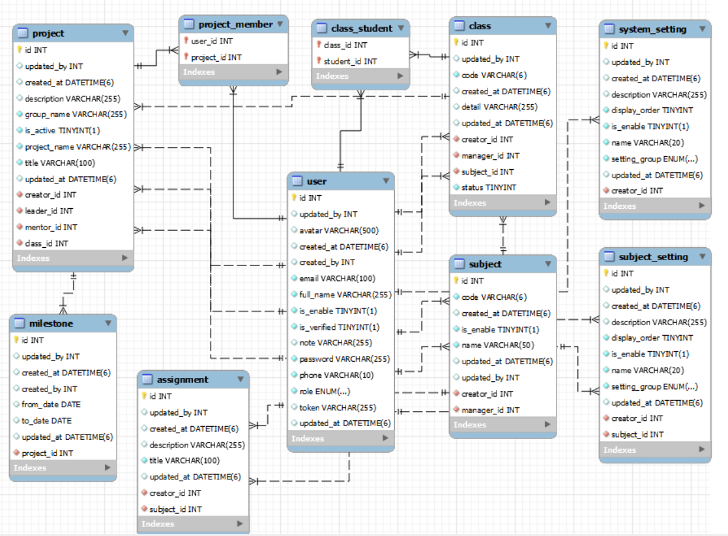

#### 4.1.1. Table Descriptions

|  |  |  |
| --- | --- | --- |
| **No** | **Table** | **Description** |
| 01 | user | To store user's account information.  - Primary keys: id  - Foreign keys: role_id |
| 02 | system_setting | To store settings or configurations of the system.  - Primary keys: id  - Foreign keys: # |
| 03 | subject | To store basic information about the subject.  - Primary keys: id  - Foreign keys: subject_manager_id |
| 04 | assignment | To store information about the assignment of a subject.  - Primary keys: id  - Foreign keys:  subject_id |
| 05 | subject_setting | To store settings of the subject .  - Primary keys: id  - Foreign keys: subject_id, class_id, project_id |
| 07 | class | To store basic information about the class.  - Primary keys: id  - Foreign keys: teacher_id , sememter_id |
| 08 | milestone | To store information about the assignment of a class.  - Primary keys: id  - Foreign keys:  class_id, project_id |
| 09 | class_student | To store information about the assignment of students of a class.  - Primary keys: class_id, project_id, member_id  - Foreign keys: class_idproject_id, member_id |
| 10 | project | To store information about the project.  - Primary keys: id  - Foreign keys: class_id, project_mentor_id, team_leader_id |
| 11 | project_member | To store information about the assignment of members of a project.  - Primary keys: class_id, project_id, member_id  - Foreign keys: class_idproject_id, member_id |

### 4.2 Code Packages

#### 4.2.1. Package Diagram

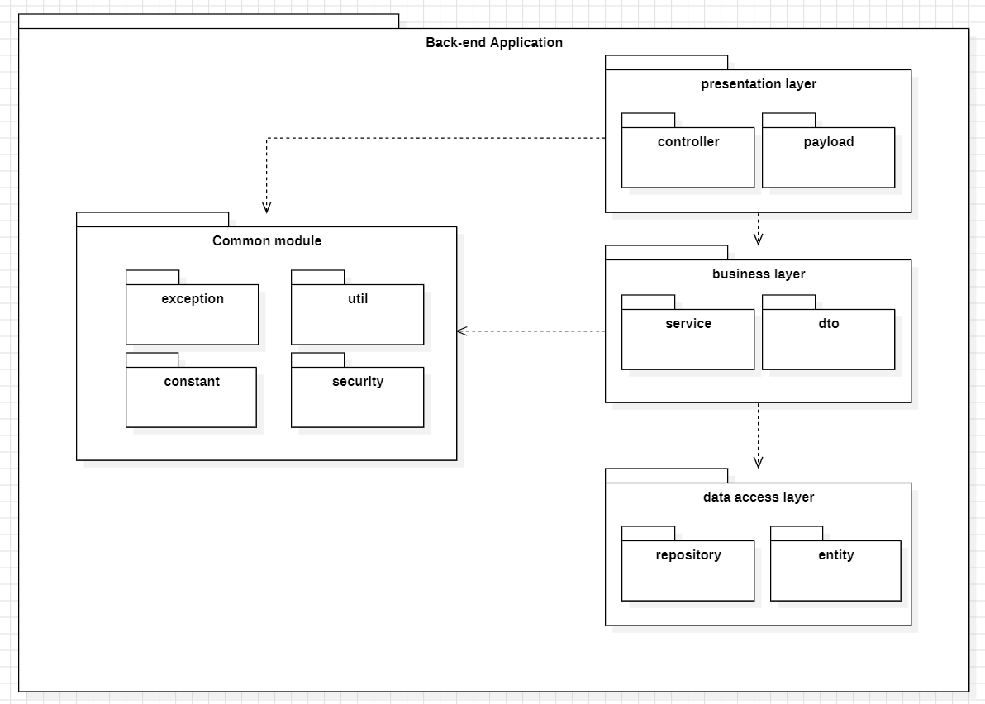

#### 4.2.1. Package descriptions

|  |  |  |
| --- | --- | --- |
| **No** | **Package** | **Description** |
| 01 | controller | Contains classes responsible for handling HTTP requests and managing the application's request-routing logic. |
| 02 | exception | Houses classes and exception types used to handle and manage exceptional situations in the application |
| 03 | payload | Contains classes used for transferring data between controllers, services, or other components in the application |
| 04 | constant | Stores classes or files holding constants and fixed values used throughout the application. |
| 05 | entity | Contains classes representing data objects or database tables. These classes are typically mapped to the database. |
| 06 | service | Holds the business logic of this application. |
| 07 | serviceImpl | Contains the implementations of the service interfaces. These classes implement the methods defined in the service interfaces and contain the specific business logic of the application. |
| 08 | security | Encapsulates security-related components that safeguard the application against a wide range of security threats and vulnerabilities. |
| 09 | util | Contains utility classes and methods that provide common functionality used across different parts of the application. Here is data encoded and encrypted. |
| 10 | repository | Contains classes responsible for database interaction, such as CRUD operations on entities. These classes often use Spring Data JPA or a similar technology for data access. |

# II. Requirement Specifications

## **Common Feature**

### **1.1 UC-1_View Landing Page**

#### **a. Functionalities**

|  |  |  |  |
| --- | --- | --- | --- |
| UC ID and Name: | **UC-1_View landing page** | | |
| Created By: | DatNV | Date Created: | 1/Nov/2023 |
| Primary Actor: | Guest, Registered User | Secondary Actors: | None |
| Trigger: | This screen appear when a user enters the website | | |
| Description: | When the user opens the first link or after login as user, shows the landing page. | | |
| Preconditions: | None | | |
| Postconditions: | None | | |
| Normal Flow: | **1.0 View landing page**  1. The user accesses the system's landing page.  2. The landing page displays basic information and welcomes the user.  3. If the user is not logged in, the system prompts them to log in.  4. If the user is logged in, provide quick links to the dashboard. | | |
| Alternative Flows: |  | | |
| Exceptions: | N/A | | |
| Priority: | Medium | | |
| Frequency of Use: | High | | |
| Business Rules: | None | | |
| Other Information: | N/A | | |
| Assumptions: | N/A | | |

#### **b. Business Rules**

None

### **1.2 UC-2_Register an account**

#### **a. Functionalities**

|  |  |  |  |
| --- | --- | --- | --- |
| UC ID and Name: | **UC-2_Register an account** | | |
| Created By: | DatNV | Date Created: | 1/Nov/2023 |
| Primary Actor: | Guest | Secondary Actors: | None |
| Trigger: | Click a button Register | | |
| Description: | Signup for a new account | | |
| Preconditions: | The user email/phone does not register | | |
| Postconditions: | The user has an account to login into system | | |
| Normal Flow: | **2.0 Register User**   1. The user accesses the registration page. 2. The registration page prompts the user to enter required information. 3. The system validates the entered information 4. If the information is valid, the user submits the registration form. 5. The system creates a new account for the user with the provided information. 6. The system sends a confirmation email to the user's provided email address. 7. The confirmation email includes a link or code for the user to verify their email address. 8. The user clicks the verification link or enters the code to confirm their email address. 9. Once the email address is confirmed, the system activates the user's account. 10. The system displays a confirmation message to the user, informing them that the registration process is complete. 11. The user can now log in using their registered email and password. | | |
| Alternative Flows: | None | | |
| Exceptions: | N/A | | |
| Priority: | High, Must Have | | |
| Frequency of Use: | N/A | | |
| Business Rules: | FR1, FR2 | | |
| Other Information: | N/A | | |
| Assumptions: | N/A | | |

#### **b. Business Rules**

|  |  |  |
| --- | --- | --- |
| **ID** | **Business Rule** | **Business Rule Description** |
| FR1 | Password Encoding | User’s password must be encoded |
| FR2 | Authenticate email or phone number | User account will not active if   * ·    His/her already not authenticate |

### **1.3 UC-3_Login to the system**

#### **a. Functionalities**

|  |  |  |  |
| --- | --- | --- | --- |
| UC ID and Name: | **UC-3_Login System** | | |
| Created By: | DatNV | Date Created: | 1/Nov/2023 |
| Primary Actor: | Register User | Secondary Actors: | None |
| Trigger: | User clicks Login button | | |
| Description: | Users can log in to the system by providing their username and password or via Google login page | | |
| Preconditions: | User account has been created & authorized | | |
| Postconditions: | User logs in the system successfully | | |
| Normal Flow | **3.0 Login to the system**   1. The user navigates to the system's login page. 2. The login page prompts the user to enter their registered email address and password. 3. The user enters their credentials. 4. The system verifies the entered information against the stored user data. 5. If the credentials are valid, the system grants access to the user. 6. The system logs the user into the system and directs to the system. | | |
| Alternative Flows: | ***3.1 Google Login***  1. User chooses to login system using Google account  2. System redirects the user to the Google’s Login screen  3. User types in the Google account details and chooses to login  4. Google validates user’s login information successfully and redirect him/her back to the system | | |
| Exceptions: | ***3.0.E1 System can’t authenticate the user***   1. If the entered email address is not associated with any registered account, the system displays an error message and prompts the user to enter a valid email address. 2. If the entered password is incorrect, the system displays an error message and prompts the user to enter the correct password.   ***3.0.E2 User has been disabled***  1. The system show show the message “ Your account has been disabled” | | |
| Priority: | Must Have | | |
| Frequency of Use: | High | | |
| Business Rules: | FR1 | | |
| Other Information: | N/A | | |
| Assumptions: | N/A | | |

#### **b. Business Rules**

|  |  |  |
| --- | --- | --- |
| **ID** | **Business Rule** | **Business Rule Description** |
| FR1 | Invalid Logging In | User can’t be authenticated to login the system if below cases   * His/her logging-in details are incorrect * His/her account has not been verified * His/her account has been locked or blocked |

### **1.4 UC-4_Reset password**

#### **a. Functionalities**

|  |  |  |  |
| --- | --- | --- | --- |
| UC ID and Name: | **UC-4_Reset password** | | |
| Created By: | DatNV | Date Created: | 1/Nov/2023 |
| Primary Actor: | Registered User | Secondary Actors: | None |
| Trigger: | When users click on the “Forgot Password” button in the Login screen | | |
| Description: | Reset and create a new password in case of forgetting the old one with email. | | |
| Preconditions: | The user account is active | | |
| Postconditions: | The user can log in with the new password | | |
| Normal Flow: | **4.0** **Reset password**   1. The user navigates to the system's password reset page. 2. The password reset page provides a field for the user to enter their registered email address. 3. The user enters their email address and submits the request to reset the password. 4. The system verifies that the entered email address is associated with a registered account. 5. If the email address is valid, the system generates a unique reset link or code. 6. The system sends a password reset email to the user's registered email address. 7. The email contains a link or code for the user to reset their password. 8. The user clicks the reset link or enters the provided code. 9. The system verifies the link or code for validity and prompts the user to enter a new password. 10. The user enters a new password and confirms it. 11. The system updates the user's password with the new one. 12. The system displays a confirmation message indicating that the password has been successfully reset. | | |
| Alternative Flows: | None | | |
| Exceptions: | N/A | | |
| Priority: | High, Must Have | | |
| Frequency of Use: | Low | | |
| Business Rules: | FR1 | | |
| Other Information: | N/A | | |
| Assumptions: | N/A | | |

#### **b. Business Rules**

|  |  |  |
| --- | --- | --- |
| **ID** | **Business Rule** | **Business Rule Description** |
| FR1 | Password Encoding | User’s password must be encoded |

### **1.5 UC-8_Change password**

#### **a. Functionalities**

|  |  |  |  |
| --- | --- | --- | --- |
| UC ID and Name: | **UC-8_Change password** | | |
| Created By: | DatNV | Date Created: | 1/Nov/2023 |
| Primary Actor: | Registered User | Primary Actor: | None |
| Trigger: | When users click on the button “Change Password” | | |
| Description: | This is a function which allows the user to change his/her password by inputting his current password as well as new password. | | |
| Preconditions: | Users login successfully | | |
| Postconditions: | Users can change passwords. | | |
| Normal Flow: | **8.0 Change password**   1. The user navigates to the account settings or changes the password page within the system. 2. The page prompts the user to enter their current password and the new desired password. 3. The user enters their current password and the new password. 4. The system validates the entered current password to ensure it matches the user's existing password. 5. If the current password is valid, and the new password meets the requirements, the system updates the user's password. 6. The system displays a confirmation message indicating that the password has been successfully changed. | | |
| Alternative Flows: | None | | |
| Exceptions: | N/A | | |
| Priority: | High, Must Have | | |
| Frequency of Use: | Medium | | |
| Business Rules: | FR1 | | |
| Other Information: | N/A | | |
| Assumptions: | N/A | | |

#### **b. Business Rules**

|  |  |  |
| --- | --- | --- |
| **ID** | **Business Rule** | **Business Rule Description** |
| FR1 | Password Encoding | User’s password must be encoded |

### **1.6 UC-6_Logout**

#### **a. Functionalities**

|  |  |  |  |
| --- | --- | --- | --- |
| UC ID and Name: | **UC-6_Logout** | | |
| Created By: | DatNV | Date Created: | 1/Nov/2023 |
| Primary Actor: | Registered User | Secondary Actors: | None |
| Trigger: | When users click on the button “Logout” | | |
| Description: | This is a function which allows the user to sign out the system | | |
| Preconditions: | Users login successfully | | |
| Postconditions: | Users logout of the system. | | |
| Normal Flow: | **6.0 Logout**  1. User selects "Logout”  2. User logout of the system successfully | | |
| Alternative Flows: | N/A | | |
| Exceptions: | N/A | | |
| Priority: | Medium | | |
| Frequency of Use: | Medium | | |
| Business Rules: | None | | |
| Other Information: | N/A | | |
| Assumptions: | N/A | | |

#### **b. Business Rules**

None

### **1.7 UC-7_View/Edit profile**

#### **a. Functionalities**

|  |  |  |  |
| --- | --- | --- | --- |
| UC ID and Name: | **UC-7_View/Edit profile** | | |
| Created By: | DatNV | Date Created: | 1/Nov/2023 |
| Primary Actor: | Registered User | Secondary Actors: | None |
| Trigger: | User clicks “My profile” button | | |
| Description: | Users can view/edit his/her profile’s information. | | |
| Preconditions: | User has logged the system | | |
| Postconditions: | User see profile successfully | | |
| Normal Flow: | **7.0 View/Edit profile**  1. User selects "My profile”  2. The system displays the profile of the user.  3. User edits his/her own profile.  4. Click “Save” and the user has updated his/her profile for the system. | | |
| Alternative Flows: | None | | |
| Exceptions: | N/A | | |
| Priority: | High | | |
| Frequency of Use: | Medium | | |
| Business Rules: | None | | |
| Other Information: | N/A | | |
| Assumptions: | N/A | | |

#### **b. Business Rules**

None

## **2. Admin Feature**

### **2.1 UC-9_View user list**

#### **a. Functional Description**

|  |  |  |  |
| --- | --- | --- | --- |
| UC ID and Name: | **UC-9_View user list** | | |
| Created By: | DatNV | Date Created: | 1/Nov/2023 |
| Primary Actor: | Admin | Secondary Actors: | None |
| Trigger: | Clicks “User” button from the sidebar | | |
| Description: | Admin can see a list of all users. | | |
| Preconditions: | User account have admin role | | |
| Postconditions: | Show a list of all users in the system and their information. | | |
| Normal Flow | **9.0 List users**  1. User clicks the “User” in the sidebar  2. System show a list of all users | | |
| Alternative Flows: | None | | |
| Exceptions: |  | | |
| Priority: | Must Have | | |
| Frequency of Use: | Medium | | |
| Business Rules: | None | | |
| Other Information: | N/A | | |
| Assumptions: | N/A | | |

#### **b. Business Rules**

None

### **2.2 UC-10_Add new user**

#### **a. Functional Description**

|  |  |  |  |
| --- | --- | --- | --- |
| UC ID and Name: | **UC-10_Add new user** | | |
| Created By: | DatNV | Date Created: | 1/Nov/2023 |
| Primary Actor: | Admin | Secondary Actors: | None |
| Trigger: | Clicks *Add new user* button in User list screen | | |
| Description: | Admin can be a new user to this system without registering. | | |
| Preconditions: | User account have admin role | | |
| Postconditions: | Add a new user to the system successfully | | |
| Normal Flow | **10.0 Add new user**  1. User clicks the “Add new user” button.  2. The web displays a form for the admin to fill out the user's details.  3. User fills out the form and clicks the “Add” button.  4. A new user has been added to the system. | | |
| Alternative Flows: | None | | |
| Exceptions: | None | | |
| Priority: | Medium | | |
| Frequency of Use: | Medium | | |
| Business Rules: | FR1 | | |
| Other Information: | N/A | | |
| Assumptions: | N/A | | |

#### **b. Business Rules**

|  |  |  |
| --- | --- | --- |
| **ID** | **Business Rule** | **Business Rule Description** |
| FR1 | Password Encoding | User’s password must be encoded |

### **2.3 UC-12_Update user details**

#### **a. Functional Description**

|  |  |  |  |
| --- | --- | --- | --- |
| UC ID and Name: | **UC-12_Update user details** | | |
| Created By: | DatNV | Date Created: | 1/Nov/2023 |
| Primary Actor: | Admin | Secondary Actors: | None |
| Trigger: | Clicks View details button from User list screen | | |
| Description: | Admin can update user information. | | |
| Preconditions: | User account have admin role | | |
| Postconditions: | User details has been updated successfully | | |
| Normal Flow | **12.0 Update user details**  1. User clicks “View Details” of the user list screen.  2. The system displays the user's details.  3. User edits the user's details .  4. Click “Update” and the user has updated the user's details for the system. | | |
| Alternative Flows: | None | | |
| Exceptions: | None | | |
| Priority: | Medium | | |
| Frequency of Use: | Medium | | |
| Business Rules: | None | | |
| Other Information: | N/A | | |
| Assumptions: | N/A | | |

#### **b. Business Rules**

None

### **2.4 UC-11_Activate/Deactivate user**

#### **a. Functional Description**

|  |  |  |  |
| --- | --- | --- | --- |
| UC ID and Name: | **UC-11_Activate/Deactivate user** | | |
| Created By: | DatNV | Date Created: | 1/Nov/2023 |
| Primary Actor: | Admin | Secondary Actors: | None |
| Trigger: | Clicks Status toggle in User List screen | | |
| Description: | Admin can change the status of the user's account. | | |
| Preconditions: | User account have admin role | | |
| Postconditions: | Activate/deactivate a user successfully | | |
| Normal Flow | **11.0 Activate/Deactivate user**  1. User clicks status toggle to activate/deactivate a user.  2. The system displays a confirmation form.  3. Click “Confirm” to activate/deactivate a user.  4. A user has been activated/deactivated successfully | | |
| Alternative Flows: | None | | |
| Exceptions: | None | | |
| Priority: | Must Have | | |
| Frequency of Use: | Medium | | |
| Business Rules: | None | | |
| Other Information: | N/A | | |
| Assumptions: | N/A | | |

#### **b. Business Rules**

None

### **2.5 UC-13_View subject list**

#### **a. Functional Description**

|  |  |  |  |
| --- | --- | --- | --- |
| UC ID and Name: | **UC-13_View subject list** | | |
| Created By: | DatNV | Date Created: | 1/Nov/2023 |
| Primary Actor: | Admin | Secondary Actors: | None |
| Trigger: | Clicks “Subject” button from the sidebar | | |
| Description: | Admin can see a list of all subjects. | | |
| Preconditions: | PRE-1. User account have admin role | | |
| Postconditions: | Show a list of all subjects in the system and their information. | | |
| Normal Flow | **13.0 View subject list**  1. User clicks the “Subject” in the sidebar  2. System show a list of all subjects | | |
| Alternative Flows: | None | | |
| Exceptions: | N/A | | |
| Priority: | Must Have | | |
| Frequency of Use: | Medium | | |
| Business Rules: | None | | |
| Other Information: | N/A | | |
| Assumptions: | N/A | | |

#### **b. Business Rules**

None

### **2.6 UC-15_Add new subject**

#### **a. Functional Description**

|  |  |  |  |
| --- | --- | --- | --- |
| UC ID and Name: | **UC-15_Add subject** | | |
| Created By: | DatNV | Date Created: | 1/Nov/2023 |
| Primary Actor: | Admin | Secondary Actors: | None |
| Trigger: | Admin and subject manager can add new subjects. | | |
| Description: | The admin add new subject to the system | | |
| Preconditions: | User account have admin role | | |
| Postconditions: | Add a new subject to the system successfully | | |
| Normal Flow | **15.0 Add new subject**  1. User clicks the “Add new subject” button.  2. The system displays a form for the admin to fill out the subject's details.  3. User fills out the form and clicks the “Add” button.  4. A new subject has been added to the system. | | |
| Alternative Flows: | None | | |
| Exceptions: | None | | |
| Priority: | Medium | | |
| Frequency of Use: | Medium | | |
| Business Rules: | None | | |
| Other Information: | N/A | | |
| Assumptions: | N/A | | |

#### **b. Business Rules**

None

### **2.7 UC-14_Update subject details**

#### **a. Functional Description**

|  |  |  |  |
| --- | --- | --- | --- |
| UC ID and Name: | **UC-14_View/Update subject details** | | |
| Created By: | DatNV | Date Created: | 1/Nov/2023 |
| Primary Actor: | Admin | Secondary Actors: | None |
| Trigger: | Clicks View details button from Subject list screen | | |
| Description: | Admin and subject manager clicks on each subject in the list to see detail. | | |
| Preconditions: | PRE-1. User account have admin role | | |
| Postconditions: | Subject details has been updated successfully | | |
| Normal Flow | **14.0 Update subject details**  1. User clicks “View Details” of a user.  2. The system displays the subject's details.  3. User edits the subject's details.  4. Click “Update” and the user has updated the subject's details for the system. | | |
| Alternative Flows: | **14.1 Subject has been existed**  1. The system displays the message "This subject has been existed"  2. User re-enters the subject name.  3. Go back to step 4 of normal flow | | |
| Exceptions: | None | | |
| Priority: | Medium | | |
| Frequency of Use: | Medium | | |
| Business Rules: | None | | |
| Other Information: | N/A | | |
| Assumptions: | N/A | | |

#### **b. Business Rules**

None

### **2.8 UC-16_Activate/Deactivate subject**

#### **a. Functional Description**

|  |  |  |  |
| --- | --- | --- | --- |
| UC ID and Name: | **UC-16_Activate/Deactivate subject** | | |
| Created By: | DatNV | Date Created: | 1/Nov/2023 |
| Primary Actor: | Admin | Secondary Actors: | None |
| Trigger: | Clicks Status toggle in Subject List screen | | |
| Description: | The admin deactivate/activate subjects | | |
| Preconditions: | PRE-1. User account have admin role | | |
| Postconditions: | Activate/deactivate a subject successfully | | |
| Normal Flow | **16.0 Activate/Deactivate subject**  1. User clicks status toggle to activate/deactivate a subject.  2. The system displays a confirmation form.  3. Click “Confirm” to activate/deactivate a subject.  4. A subject has been activated/deactivated successfully. | | |
| Alternative Flows: | None | | |
| Exceptions: | N/A | | |
| Priority: | Must Have | | |
| Frequency of Use: | Low | | |
| Business Rules: | None | | |
| Other Information: | N/A | | |
| Assumptions: | N/A | | |

#### **b. Business Rules**

None

### **2.9 UC-19_View setting list**

#### **a. Functional Description**

|  |  |  |  |
| --- | --- | --- | --- |
| UC ID and Name: | **UC-18_View setting list** | | |
| Created By: | DatNV | Date Created: | 1/Nov/2023 |
| Primary Actor: | Admin | Secondary Actors: | None |
| Trigger: | Clicks “Setting” button from the sidebar | | |
| Description: | Admin can see a list of all system settings. | | |
| Preconditions: | User account have admin role | | |
| Postconditions: | Show a list of all settings in the system and their information. | | |
| Normal Flow | **18.0 View setting list**  1. User clicks the “Setting” in the sidebar  2. System show a list of all settings | | |
| Alternative Flows: | None | | |
| Exceptions: | N/A | | |
| Priority: | Must Have | | |
| Frequency of Use: | Medium | | |
| Business Rules: | None | | |
| Other Information: | N/A | | |
| Assumptions: | N/A | | |

#### **b. Business Rules**

None

### **2.10 UC-19_Add new setting**

#### **a. Functional Description**

|  |  |  |  |
| --- | --- | --- | --- |
| UC ID and Name: | **UC-19_Add new system setting** | | |
| Created By: | DatNV | Date Created: | 1/Nov/2023 |
| Primary Actor: | Admin | Secondary Actors: | None |
| Trigger: | Clicks *Add new* button in Setting list screen | | |
| Description: | Admin can add new settings. | | |
| Preconditions: | PRE-1. User account have admin role | | |
| Postconditions: | Add a new setting to the system successfully | | |
| Normal Flow | **19.0 Add new setting**  1. User clicks the “Add new” button.  2. The system displays a form for the admin to fill out setting's details.  3. User fills out the form and clicks the “Add” button.  4. A new setting has been added to the system. | | |
| Alternative Flows: | None | | |
| Exceptions: | None | | |
| Priority: | Medium | | |
| Frequency of Use: | Medium | | |
| Business Rules: | None | | |
| Other Information: | N/A | | |
| Assumptions: | N/A | | |

#### **b. Business Rules**

None

### **2.11 UC-20_Update setting details**

#### **a. Functional Description**

|  |  |  |  |
| --- | --- | --- | --- |
| UC ID and Name: | **UC-20_Update setting details** | | |
| Created By: | DatNV | Date Created: | 1/Nov/2023 |
| Primary Actor: | Admin | Secondary Actors: | None |
| Trigger: | Clicks “Edit icon” from Setting list screen | | |
| Description: | Admin can update settings. | | |
| Preconditions: | User account have admin role | | |
| Postconditions: | Subject details has been updated successfully | | |
| Normal Flow | **20.0 Update setting details**  1. User clicks the “Edit” Icon of a setting.  2. The system displays setting's details.  3. User edits the setting's details.  4. Click “Update” and the user has updated setting's details for the system. | | |
| Alternative Flows: | None | | |
| Exceptions: | None | | |
| Priority: | Medium | | |
| Frequency of Use: | Low | | |
| Business Rules: | None | | |
| Other Information: | N/A | | |
| Assumptions: | N/A | | |

#### **b. Business Rules**

None

### **2.12 UC-21_Activate/Deactivate setting**

#### **a. Functional Description**

|  |  |  |  |
| --- | --- | --- | --- |
| UC ID and Name: | **UC-21_ Activate/Deactivate setting** | | |
| Created By: | DatNV | Date Created: | 1/Nov/2023 |
| Primary Actor: | Admin | Secondary Actors: | None |
| Trigger: | Clicks Status toggle in Setting List screen | | |
| Description: | Admin can activate or deactivate. | | |
| Preconditions: | User account have admin role | | |
| Postconditions: | Activate/deactivate a setting successfully | | |
| Normal Flow | **21.0 Activate/Deactivate setting in Setting List**  1. User clicks status toggle to activate/deactivate a setting or choose “edit” icon to update status in setting details  2. The system displays a confirmation form.  3. Click “Confirm” to activate/deactivate a setting.  4. A setting has been activated/deactivated successfully. | | |
| Alternative Flows: |  | | |
| Exceptions: | None | | |
| Priority: | Must Have | | |
| Frequency of Use: | Low | | |
| Business Rules: | None | | |
| Other Information: | N/A | | |
| Assumptions: | N/A | | |

#### **b. Business Rules**

None

## **3. Subject Manager Feature**

### **3.1 UC-22_View subject assignment list**

#### **a. Functional Description**

|  |  |  |  |  |
| --- | --- | --- | --- | --- |
| UC ID and Name: | **UC-22_View subject assignment list** | | | |
| Created By: | DatNV |  | Date Created: | 1/Nov/2023 |
| Primary Actor: | Subject Manager |  | Secondary Actors: | None |
| Trigger: | Clicks “Subject Assignment” button from the sidebar | | | |
| Description: | The Subject Manager can see a list of subject assignments. | | | |
| Preconditions: | User account have subject manager role | | | |
| Postconditions: | Show a list of all subject assignments and their information. | | | |
| Normal Flow | **22.0 List subject assignments**  1. User clicks the “Assignment” in the sidebar  2. System show a list of all Subject Assignment | | | |
| Alternative Flows: | None | | | |
| Exceptions: | None | | | |
| Priority: | Must have | | | |
| Frequency of Use: | High | | | |
| Business Rules: | None | | | |
| Other Information: | N/A | | | |
| Assumptions: | N/A | | | |

#### **b. Business Rules**

None

### **3.2 UC-23_ Add new subject assignment**

#### **a. Functional Description**

|  |  |  |  |
| --- | --- | --- | --- |
| UC ID and Name: | **UC-23_Add new subject assignment** | | |
| Created By: | DatNV | Date Created: | 1/Nov/2023 |
| Primary Actor: | Subject Manager | Secondary Actors: | None |
| Trigger: | Clicks *Add assignment* button in *subject assignment* list screen | | |
| Description: | The Subject Manager can add new subject assignments. | | |
| Preconditions: | User account have subject manager role | | |
| Postconditions: | Add a subject assignmentof this subject to the system successfully | | |
| Normal Flow | **23.0 Add new subject assignment**  1. Users click the “Add new subject assignment” button.  2. The system displays a form for users  to fill out class's details.  3. User fills out the form and clicks the “Add” button.  4. A new subject assignment has been added to the system. | | |
| Alternative Flows: | None | | |
| Exceptions: | None | | |
| Priority: | Must Have | | |
| Frequency of Use: | Medium | | |
| Business Rules: | None | | |
| Other Information: | N/A | | |
| Assumptions: | N/A | | |

#### **b. Business Rules**

None

### **3.3 UC-24_ Update subject assignment details**

#### **a. Functional Description**

|  |  |  |  |
| --- | --- | --- | --- |
| UC ID and Name: | **UC-24_Update subject assignment details** | | |
| Created By: | DatNV | Date Created: | 1/Nov/2023 |
| Primary Actor: | Subject Manager | Secondary Actors: | None |
| Trigger: | Clicks “Edit” icon from Subject Assignment list screen | | |
| Description: | The Subject Manager can update subject assignments. | | |
| Preconditions: | User account have subject managerrole | | |
| Postconditions: | Subject Assignment details has been updated successfully | | |
| Normal Flow | **24.0 Update  subject assignment details**  1. Userclicks the “Edit” icon of the subject assignment list screen.  2. The system displays subject assignment’s details.  3. User edits subject assignment’s details.  4. Click “Update” and the user has updated the subject assignment’s details for the system. | | |
| Alternative Flows: | None | | |
| Exceptions: | None | | |
| Priority: | Medium | | |
| Frequency of Use: | Medium | | |
| Business Rules: | None | | |
| Other Information: | N/A | | |
| Assumptions: | N/A | | |

#### **b. Business Rules**

None

### **3.4 UC-25_ Delete subject assignments**

#### **a. Functional Description**

|  |  |  |  |
| --- | --- | --- | --- |
| UC ID and Name: | **UC-25_Delete subject assignment** | | |
| Created By: | DatNV | Date Created: | 1/Nov/2023 |
| Primary Actor: | Subject Manager | Secondary Actors: | None |
| Trigger: | Clicks “Delete” button from the sidebar | | |
| Description: | The Subject Manager can delete subject assignments. | | |
| Preconditions: | User account have subject manager role | | |
| Postconditions: | Delete subject assignment with its id. | | |
| Normal Flow | **25.0 Delete subject assignment**  1. User clicks the “Delete” in the list subject assignment  2. System will delete subject assignment | | |
| Alternative Flows: | None | | |
| Exceptions: | None | | |
| Priority: | Must Have | | |
| Frequency of Use: | Low | | |
| Business Rules: | None | | |
| Other Information: | N/A | | |
| Assumptions: | N/A | | |

#### **b. Business Rules**

None

### **3.5 UC-31_View class list**

#### **a. Functional Description**

|  |  |  |  |
| --- | --- | --- | --- |
| UC ID and Name: | **UC-31_View List Classes** | | |
| Created By: | DatNV | Date Created: | 1/Nov/2023 |
| Primary Actor: | Subject Manager | Secondary Actors: | None |
| Trigger: | Clicks “Class” button from the sidebar | | |
| Description: | The Subject Manager can see a list of classes | | |
| Preconditions: | User account have subject manager role | | |
| Postconditions: | Show a list of all classes and their information. | | |
| Normal Flow | **31.0 View class list**  1. User clicks the “Class” in the sidebar  2. System show a list of all classes | | |
| Alternative Flows: | None | | |
| Exceptions: | None | | |
| Priority: | Must Have | | |
| Frequency of Use: | High | | |
| Business Rules: | None | | |
| Other Information: | N/A | | |
| Assumptions: | N/A | | |

#### **b. Business Rules**

None

### **3.6 UC-32_ Add new class**

#### **a. Functional Description**

|  |  |  |  |
| --- | --- | --- | --- |
| UC ID and Name: | **UC-32_Add new class** | | |
| Created By: | DatNV | Date Created: | 1/Nov/2023 |
| Primary Actor: | Subject Manager | Secondary Actors: | None |
| Trigger: | Clicks *Add new class* button in Class list screen | | |
| Description: | The Subject Manager can add a new class. | | |
| Preconditions: | User account have subject manager role | | |
| Postconditions: | Add a class that learn this subject to the system successfully | | |
| Normal Flow | **32.0 Add new class**  1. User clicks the “Add new class” button.  2. The system displays a form for users  to fill out class's details.  3. User fills out the form and clicks the “Add” button.  4. A new class has been added to the system. | | |
| Alternative Flows: | None | | |
| Exceptions: | None | | |
| Priority: | Medium | | |
| Frequency of Use: | High | | |
| Business Rules: | None | | |
| Other Information: | N/A | | |
| Assumptions: | N/A | | |

#### **b. Business Rules**

None

### **3.7 UC-33_ Update class details**

#### **a. Functional Description**

|  |  |  |  |
| --- | --- | --- | --- |
| UC ID and Name: | **UC-33_Update class details** | | |
| Created By: | DatNV | Date Created: | 1/Nov/2023 |
| Primary Actor: | Subject Manager | Secondary Actors: | None |
| Trigger: | Clicks “Edit” icon from Class list screen | | |
| Description: | The Subject Manager can update classes. | | |
| Preconditions: | User account have subject managerrole | | |
| Postconditions: | Class details has been updated successfully | | |
| Normal Flow | **30.0 Update class details**  1. Userclicks the “Edit” icon of the class list screen.  2. The system displays class's details.  3. User edits the class's details.  4. Click “Update” and the user has updated the class's details for the system. | | |
| Alternative Flows: | None | | |
| Exceptions: | None | | |
| Priority: | Medium | | |
| Frequency of Use: | Medium | | |
| Business Rules: | None | | |
| Other Information: | N/A | | |
| Assumptions: | N/A | | |

#### **b. Business Rules**

None

### **3.8 UC-34_ Update class assignment details**

#### **a. Functional Description**

|  |  |  |  |
| --- | --- | --- | --- |
| UC ID and Name: | **UC-34_Update class assignment details** | | |
| Created By: | DatNV | Date Created: | 1/Nov/2023 |
| Primary Actor: | Subject Manager | Secondary Actors: | None |
| Trigger: | Clicks “Details” button from the Class Assignment list | | |
| Description: | The Subject Manager can update class assignments. | | |
| Preconditions: | PRE-1. User account have subject managerrole | | |
| Postconditions: | The website display the updated class *assignment* list | | |
| Normal Flow | **34.0 Update class assignment details**  1. User clicks “View Details” of a user.  2. The system displays class *assignment* details.  3.User  edits class *assignment* details .  4. Click “Update” and the user has updated class *assignment* details for the system.  5. The system displays the user list | | |
| Alternative Flows: | None | | |
| Exceptions: | None | | |
| Priority: | Must Have | | |
| Frequency of Use: | Medium | | |
| Business Rules: | None | | |
| Other Information: | N/A | | |

#### **b. Business Rules**

None

## **4. Class Manager Feature**

### **4.1 UC-36_View assigned class list**

#### **a. Functional Description**

|  |  |  |  |
| --- | --- | --- | --- |
| UC ID and Name: | **UC-36_View assigned class list** | | |
| Created By: | DatNV | Date Created: | 1/Nov/2023 |
| Primary Actor: | Class Manager | Secondary Actors: | None |
| Trigger: | Clicks “Assigned Class” button from the sidebar | | |
| Description: | Class Manager can see assigned classes | | |
| Preconditions: | User account have class managerrole | | |
| Postconditions: | Show a list of all assigned classes and their information. | | |
| Normal Flow | **36.0 View assigned class list**  1. User clicks the “Assigned Class” in the sidebar  2. System shows a list of all assigned classes. | | |
| Alternative Flows: | None | | |
| Exceptions: | None | | |
| Priority: | Must Have | | |
| Frequency of Use: | High | | |
| Business Rules: | None | | |
| Other Information: | N/A | | |
| Assumptions: | N/A | | |

#### **b. Business Rules**

None

### **4.2 UC-37_ Update assigned class details**

#### **a. Functional Description**

|  |  |  |  |
| --- | --- | --- | --- |
| UC ID and Name: | **UC-37_Update assigned class details** | | |
| Created By: | DatNV | Date Created: | 1/Nov/2023 |
| Primary Actor: | Class Manager | Secondary Actors: | None |
| Trigger: | Clicks “Edit” icon from Assigned class list screen | | |
| Description: | Class Manager can update class description. | | |
| Preconditions: | User account have class manager role | | |
| Postconditions: | Assigned class details has been updated successfully | | |
| Normal Flow | **37.0 Update assigned class details**  1. User clicks the “Edit” icon from the Class list screen.  2. The system displays the assigned class's details.  3. User edits assigned class’s details.  4. Click “Update” and the user has updated the assigned class’s details for the system. | | |
| Alternative Flows: | None | | |
| Exceptions: | None | | |
| Priority: | Medium | | |
| Frequency of Use: | Medium | | |
| Business Rules: | None | | |
| Other Information: | N/A | | |
| Assumptions: | N/A | | |

#### **b. Business Rules**

None

### **4.3 UC-38_ List class assignments**

#### **a. Functional Description**

|  |  |  |  |
| --- | --- | --- | --- |
| UC ID and Name: | **UC-38_List class assignments** | | |
| Created By: | DatNV | Date Created: | 1/Nov/2023 |
| Primary Actor: | Class manager | Secondary Actors: | None |
| Trigger: | Clicks “Class” button from the sidebar, choose assignment button | | |
| Description: | Class Manager can change information of class assignments | | |
| Preconditions: | PRE-1. User account have class manager role | | |
| Postconditions: | The website display the class *assignment* list | | |
| Normal Flow | **38.0 List class assignments**  1. User clicks the “Class” in the sidebar  2. System show a list of all class in subject  3. Click view detail  4. Choose Assignment button | | |
| Alternative Flows: | None | | |
| Exceptions: | None | | |
| Priority: | Medium | | |
| Frequency of Use: | High | | |
| Business Rules: | None | | |
| Other Information: | N/A | | |
| Assumptions: | N/A | | |

#### **b. Business Rules**

None

### **4.4 UC-56_ View class student list**

#### **a. Functional Description**

|  |  |  |  |
| --- | --- | --- | --- |
| UC ID and Name: | **UC-56_View class student list** | | |
| Created By: | DatNV | Date Created: | 1/Nov/2023 |
| Primary Actor: | Class Manager | Secondary Actors: | None |
| Trigger: | Clicks “Class Student” button from the sidebar | | |
| Description: | Class Managers can view the list of students assigned to a specific class. | | |
| Preconditions: | User account have class manager role | | |
| Postconditions: | Show a list of all students grouped by class and their information. | | |
| Normal Flow | **56.0 View class student list**  1. User clicks the “Class student” button  in the sidebar  2. System shows a list of all students grouped by class. | | |
| Alternative Flows: | None | | |
| Exceptions: | None | | |
| Priority: | Must Have | | |
| Frequency of Use: | Medium | | |
| Business Rules: | None | | |
| Other Information: | N/A | | |
| Assumptions: | N/A | | |

#### **b. Business Rules**

None

### **4.5 UC-60_ Add student**

#### **a. Functional Description**

|  |  |  |  |
| --- | --- | --- | --- |
| UC ID and Name: | **UC-60_Import Student From Excel** | | |
| Created By: | DatNV | Date Created: | 1/Nov/2023 |
| Primary Actor: | Class Manager | Secondary Actors: | None |
| Trigger: | Clicks “Add new” button  in Student Class List screen | | |
| Description: | Class Managers can import member information from an Excel file. | | |
| Preconditions: | User account have class managerrole | | |
| Postconditions: | Add student to the class successfully | | |
| Normal Flow | **60.0 Add student** 1 User clicks “Add new” button  2  The system displays a text box to fill the email of the student that wants to add.  3. Clicks “Add” button  4. A class has added  a student successfully | | |
| ` | None | | |
| Exceptions: | None | | |
| Priority: | Must Have | | |
| Frequency of Use: | Medium | | |
| Business Rules: | None | | |
| Other Information: | N/A | | |
| Assumptions: | N/A | | |

#### **b. Business Rules**

None

### **4.6 UC-40_ Remove student**

#### **a. Functional Description**

|  |  |  |  |
| --- | --- | --- | --- |
| UC ID and Name: | **UC-40_Remove student** | | |
| Created By: | DatNV | Date Created: | 1/Nov/2023 |
| Primary Actor: | Class Manager | Secondary Actors: | None |
| Trigger: | Clicks “X” button  in Student Class List screen | | |
| Description: | Class Managers can remove members from a class or project. | | |
| Preconditions: | User account have class managerrole | | |
| Postconditions: | Remove a student from the class successfully | | |
| Normal Flow | **40.0 Remove student**  1 User clicks “X” button  2 The web displays a confirmation form.  3 Click “Confirm” to remove the student.  4. A class has removed  a student successfully | | |
| ` | None | | |
| Exceptions: | None | | |
| Priority: | Must Have | | |
| Frequency of Use: | N/A | | |
| Business Rules: | None | | |
| Other Information: | N/A | | |
| Assumptions: | N/A | | |

#### **b. Business Rules**

None

### **4.7 UC-50_ View project list**

#### **a. Functional Description**

|  |  |  |  |
| --- | --- | --- | --- |
| UC ID and Name: | **UC-50_View project list** | | |
| Created By: | DatNV | Date Created: | 1/Nov/2023 |
| Primary Actor: | Class manager | Secondary Actors: | None |
| Trigger: | Clicks “Projects list” button from the sidebar | | |
| Description: | Class Managers can view a list of projects. | | |
| Preconditions: | User account have class manager role | | |
| Postconditions: | Show a list of all projects in all assigned classes. | | |
| Normal Flow | **50.0 View project list**  1. User clicks the “Projects list” in the sidebar  2. System show a list of all projects | | |
| Alternative Flows: | None | | |
| Exceptions: | None | | |
| Priority: | Must Have | | |
| Frequency of Use: | High | | |
| Business Rules: | None | | |
| Other Information: | N/A | | |
| Assumptions: | N/A | | |

#### **b. Business Rules**

None

### **4.8 UC-51_ Add new project**

#### **a. Functional Description**

|  |  |  |  |
| --- | --- | --- | --- |
| UC ID and Name: | **UC-51_Add new project** | | |
| Created By: | DatNV | Date Created: | 1/Nov/2023 |
| Primary Actor: | Class manager | Secondary Actors: | None |
| Trigger: | Clicks “Add Projects” button from the “Projects list” screen | | |
| Description: | Class Managers can add new projects. | | |
| Preconditions: | User account have class manager role | | |
| Postconditions: | Add a new project to selected classes. | | |
| Normal Flow | **51.0 Add new project**  1. User clicks the “Add Projects” in the “Projects list” screen  2. System add a new project to selected class | | |
| Alternative Flows: | None | | |
| Exceptions: | None | | |
| Priority: | Must Have | | |
| Frequency of Use: | Medium | | |
| Business Rules: | None | | |
| Other Information: | N/A | | |
| Assumptions: | N/A | | |

#### **b. Business Rules**

None

### **4.9 UC-55_ Update project details**

#### **a. Functional Description**

|  |  |  |  |
| --- | --- | --- | --- |
| UC ID and Name: | **UC-55_Update project details** | | |
| Created By: | DatNV | Date Created: | 1/Nov/2023 |
| Primary Actor: | Class manager | Secondary Actors: | None |
| Trigger: | Clicks “View details” button from the “Projects list” screen | | |
| Description: | Class Managers can update project details. | | |
| Preconditions: | User account have class manager role | | |
| Postconditions: | View and update project details. | | |
| Normal Flow | **55.0 Update project details**  1. User clicks the “View details” in the “Projects list” screen  2. Input change details  3. Click “Update” button | | |
| Alternative Flows: |  | | |
| Exceptions: | None | | |
| Priority: | Must Have | | |
| Frequency of Use: | Medium | | |
| Business Rules: | None | | |
| Other Information: | N/A | | |
| Assumptions: | N/A | | |

#### **b. Business Rules**

None

### **4.10 UC-54_ Delete inactive project**

#### **a. Functional Description**

|  |  |  |  |
| --- | --- | --- | --- |
| UC ID and Name: | **UC-54_Delete inactive project** | | |
| Created By: | DatNV | Date Created: | 1/Nov/2023 |
| Primary Actor: | Class manager | Secondary Actors: | None |
| Trigger: | Clicks “Delete project” button from the “Projects list” screen | | |
| Description: | Class Managers can delete inactive projects. | | |
| Preconditions: | User account have class manager role | | |
| Postconditions: | Remove inactive projects from the system. | | |
| Normal Flow | **54.0 Delete inactive project**  1. User clicks the “Delete” in the “Projects list” screen  2. Click “Ok” button on pop-up dialog | | |
| Alternative Flows: | None | | |
| Exceptions: | None | | |
| Priority: | Must Have | | |
| Frequency of Use: | Low | | |
| Business Rules: | None | | |
| Other Information: | N/A | | |
| Assumptions: | N/A | | |

#### **b. Business Rules**

None

### **4.11 UC-39_ View project member list**

#### **a. Functional Description**

|  |  |  |  |
| --- | --- | --- | --- |
| UC ID and Name: | **UC-39_View project member list** | | |
| Created By: | DatNV | Date Created: | 1/Nov/2023 |
| Primary Actor: | Class manager | Secondary Actors: | None |
| Trigger: | Clicks any project title in “Projects list” screen | | |
| Description: | Class Managers can view the list of members assigned to a specific project. | | |
| Preconditions: | User account have class manager role | | |
| Postconditions: | Show a list of all members in all projects. | | |
| Normal Flow | **39.0 View project member list**  1. User clicks the any project title in “Projects list” screen  2. System show a list of all projects | | |
| Alternative Flows: | None | | |
| Exceptions: | None | | |
| Priority: | Must Have | | |
| Frequency of Use: | Medium | | |
| Business Rules: | None | | |
| Other Information: | N/A | | |
| Assumptions: | N/A | | |

#### **b. Business Rules**

None

### **4.12 UC-42_ Assign team leader**

#### **a. Functional Description**

|  |  |  |  |
| --- | --- | --- | --- |
| UC ID and Name: | **UC-42_Assign team as leader** | | |
| Created By: | DatNV | Date Created: | 1/Nov/2023 |
| Primary Actor: | Class manager | Secondary Actors: | None |
| Trigger: | Clicks “Select team leader” button on ”List project” screen | | |
| Description: | Class Managers can assign a member as the leader of a project or class. | | |
| Preconditions: | PRE-1. User account have class manager role | | |
| Postconditions: | Grant permission for the leader of the project. | | |
| Normal Flow | **42.0 Assign team leader**  1. User clicks the “Select team leader” button on ”List project” screen | | |
| Alternative Flows: | None | | |
| Exceptions: | None | | |
| Priority: | Must Have | | |
| Frequency of Use: | Medium | | |
| Business Rules: | None | | |
| Other Information: | N/A | | |
| Assumptions: | N/A | | |

#### **b. Business Rules**

None

### **4.13 UC-44_ Update member status with note**

#### **a. Functional Description**

|  |  |  |  |
| --- | --- | --- | --- |
| UC ID and Name: | **UC-44_Update members status with note** | | |
| Created By: | DatNV | Date Created: | 1/Nov/2023 |
| Primary Actor: | Class manager | Secondary Actors: | None |
| Trigger: | Clicks “Note” button on ”List project member” screen | | |
| Description: | Class Managers can update a project's member records with relevant notes. | | |
| Preconditions: | User account have class manager role | | |
| Postconditions: | *Give notes to a member in projects.* | | |
| Normal Flow | **44.0 Update members status with note**  1. Input note description  2. User clicks the “Note” button on ”List project” screen to update | | |
| Alternative Flows: | None | | |
| Exceptions: | None | | |
| Priority: | Must Have | | |
| Frequency of Use: | Low | | |
| Business Rules: | None | | |
| Other Information: | N/A | | |
| Assumptions: | N/A | | |

#### **b. Business Rules**

None

### **4.14 UC-41_ Import/Export/Move member**

#### **a. Functional Description**

|  |  |  |  |
| --- | --- | --- | --- |
| UC ID and Name: | **UC-41_Import/Export/Move member** | | |
| Created By: | DatNV | Date Created: | 1/Nov/2023 |
| Primary Actor: | Class manager | Secondary Actors: | None |
| Trigger: | Clicks “Arrange member” button on ”List project member” screen | | |
| Description: | Class Managers can import member information from an Excel file. | | |
| Preconditions: | User account have class manager role | | |
| Postconditions: | *Move members between projects* | | |
| Normal Flow | **41.0 Import/Export/Move member**  1. User clicks the “Arrange member” button on ”List project” screen  2. Drag and drop member name between project groups | | |
| Alternative Flows: | None | | |
| Exceptions: | None | | |
| Priority: | Must Have | | |
| Frequency of Use: | Medium | | |
| Business Rules: | None | | |
| Other Information: | N/A | | |
| Assumptions: | N/A | | |

#### **b. Business Rules**

None

### **4.15 UC-62_ View assigned project list**

#### **a. Functional Description**

|  |  |  |  |
| --- | --- | --- | --- |
| UC ID and Name: | UC-62_View assigned project list | | |
| Created By: | DatNV | Date Created: | 1/Nov/2023 |
| Primary Actor: | Project Mentor | Secondary Actors: | None |
| Trigger: | Clicks “Assigned Projects” button from the sidebar | | |
| Description: | Project Mentor can access a list of projects assigned to students. | | |
| Preconditions: | User account have project mentorrole | | |
| Postconditions: | Show a list of all assigned projects and their information. | | |
| Normal Flow | **62.0 View assigned project list**  1. User clicks the “Assigned Projects” in the sidebar  2. System shows a list of all assigned projects. | | |
| Alternative Flows: | None | | |
| Exceptions: | None | | |
| Priority: | Must Have | | |
| Frequency of Use: | High | | |
| Business Rules: | None | | |
| Other Information: | N/A | | |
| Assumptions: | N/A | | |

#### **b. Business Rules**

None

### **4.16 UC-63_ Update assigned project details**

#### **a. Functional Description**

|  |  |  |  |
| --- | --- | --- | --- |
| UC ID and Name: | UC-63_Update assigned project details | | |
| Created By: | DatNV | Date Created: | 1/Nov/2023 |
| Primary Actor: | Project Mentor | Secondary Actors: | None |
| Trigger: | Clicks “Edit details” button from the list | | |
| Description: | Project Mentor can access details of specific projects. | | |
| Preconditions: | User account have class managerrole | | |
| Postconditions: | Show a list of all assigned classes and their information. | | |
| Normal Flow | **63.0 Update assigned project**  1. Clicks “Edit details” button on ”Project Submission list” screen  2. Input update details  3. Click Update | | |
| Alternative Flows: | None | | |
| Exceptions: | None | | |
| Priority: | Must Have | | |
| Frequency of Use: | High | | |
| Business Rules: | None | | |
| Other Information: | N/A | | |
| Assumptions: | N/A | | |

#### **b. Business Rules**

None

### **4.17 UC-61_ Export class students with Excel**

#### **a. Functional Description**

|  |  |  |  |
| --- | --- | --- | --- |
| UC ID and Name: | **UC-61_Export class students with Excel** | | |
| Created By: | DatNV | Date Created: | 1/Nov/2023 |
| Primary Actor: | Student | Secondary Actors: | None |
| Trigger: | Clicks “Import” button  from Class list screen | | |
| Description: | Subject Manager can export list class student to excel file | | |
| Preconditions: | User account have class manager role | | |
| Postconditions: | Synchronize class information with Gitlab successfully | | |
| Normal Flow | **61.0 Update assigned class details**  1.User clicks the “*Export*” in the screen  2. Download file excel list student if user export. | | |
| Alternative Flows: | None | | |
| Exceptions: | None | | |
| Priority: | Medium | | |
| Frequency of Use: | Medium | | |
| Business Rules: | None | | |
| Other Information: | N/A | | |
| Assumptions: | N/A | | |

#### **b. Business Rules**

None

# III. Design Specifications

## **1. Common Feature**

### **1.1 Authentication**

#### **a. User Register**

This screen allows users to be authenticated to the system screens/functionalities.

Related use cases:

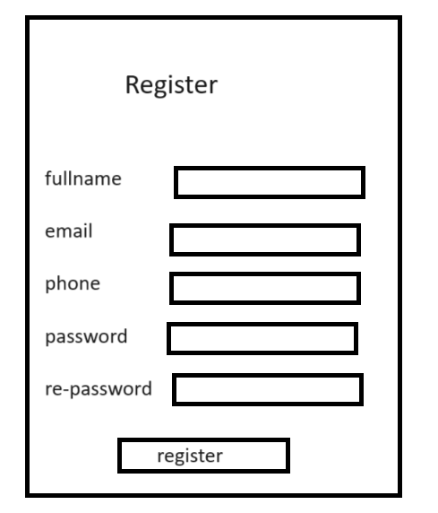

|  |  |  |
| --- | --- | --- |
| **Field Name** | **Field Type** | **Description** |
| Fullname* | Text Box | Enter full name |
| Username* | Text Box | Enter Email or Phone number |
| Password* | Password Box | Enter password |
| Re-Password* | Password Box | Enter password |
| Register | Button | Click to Register account |

#### **b. User Login**

This screen allows users to change their password.

Related use cases:

* [UC-3_Login](https://docs.google.com/document/d/12WUVF9drpY1HSYgpNq1JY2UvNiHSz3SUNO5U4dRYRJM/edit#heading=h.49gfa85)

##### UI Design

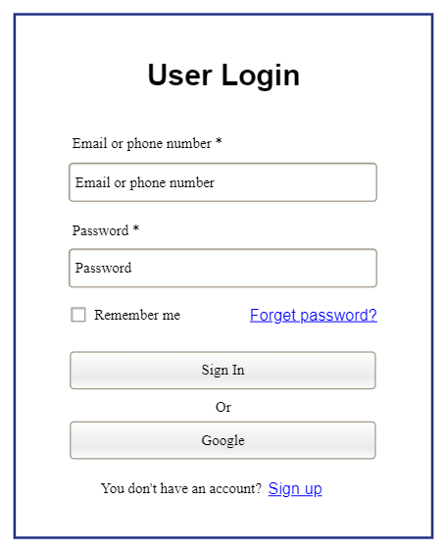

|  |  |  |
| --- | --- | --- |
| **Field Name** | **Field Type** | **Description** |
| Email or phone number* | Text Box | This is for user to input valid email address/ valid phone number for logging in |
| Password* | Password Box | This is for user to input password for logging in |
| Login | Button | User clicks to authenticate him/herself into the system with provided email/phone & password |
| Remember me | Check Box | User ticks to remember login information |
| Forgot Password? | Hyperlink | User clicks to redirect to the Password Reset page for resetting his/her forgot password |
| Login with Google | Hyperlink | Allow user to login with his/her Google account |
| Sign up | Hyperlink | User clicks to redirect to the User Register page for registering new user account to access the system |

#### **c. Password Reset**

This screen allows users reset their password if forgot

Related use cases:

##### UI Design

This screen allows users to verify username and then accept user enter new password.

# 

|  |  |  |
| --- | --- | --- |
| **Field Name** | **Field Type** | **Description** |
| Email | Password Box | This is for user to input email to verify |
| Reset Password | Button | Click to send link/otp to email/phone |
| Sign in | Hyperlink | Click to go Login Page |

#### **d. Password Change**

This screen allows users change their password

Related use cases:

##### UI Design

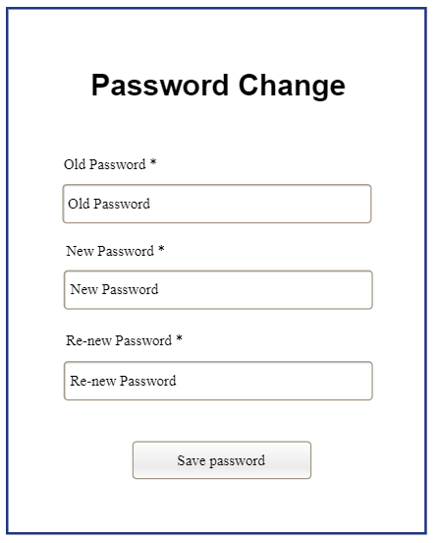

|  |  |  |
| --- | --- | --- |
| **Field Name** | **Field Type** | **Description** |
| Old password * | Password Box | This is for user to input old password |
| New Password* | Password Box | This is for user to input new password |
| ReNew Password* | Password Box | This is for user to input confirm new password |
| Save password | Button | User clicks to update new password |

#### **d. User Profile**

This screen allows users to see their profile

Related use cases:

##### UI Design

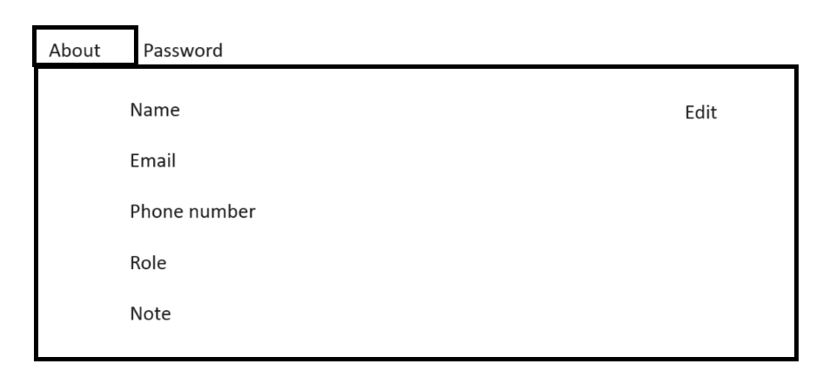

|  |  |  |
| --- | --- | --- |
| **Field Name** | **Field Type** | **Description** |
| Password | Navigation link | Navigate to tab change password |
| Edit | Button | Open edit user information |

## **2. Admin Feature**

### **2.1 Dashboard**

#### **Admin Dashboard**

This screen allows admins to navigate to manage user list, subject list, and setting list.

##### UI Design

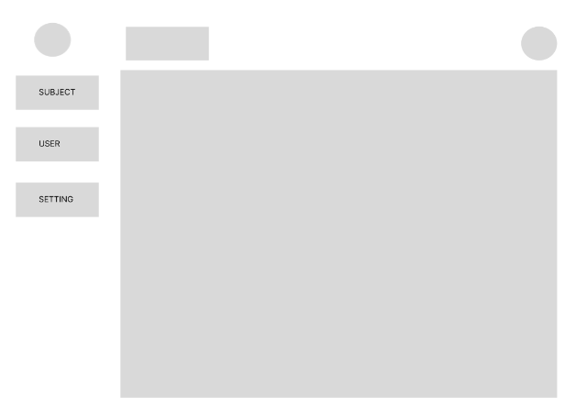

|  |  |  |
| --- | --- | --- |
| **Field Name** | **Field Type** | **Description** |
| Subject | Hyperlink | Click to show subject list and edit |
| User | Hyperlink | Click to show userlist and edit |
| Setting | Hyperlink | Click to show settinglist and edit |

### **2.2 User Manager**

#### **User List**

This screen allows admins to see the list of users and manage them.

##### UI Design

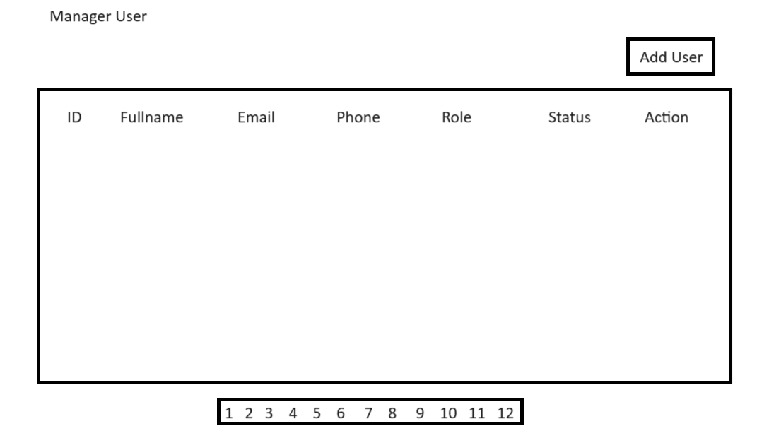

|  |  |  |
| --- | --- | --- |
| **Field Name** | **Field Type** | **Description** |
| Add User | Button | Click to open “Add user” form |
| Pagination | Navigation Link | Click to navigate to next page of list user |
| Header field (ID, fullname, email, phone, role) | Button | Sort list by this column |

#### **New User**

This screen allows admins to add new users.

##### UI Design

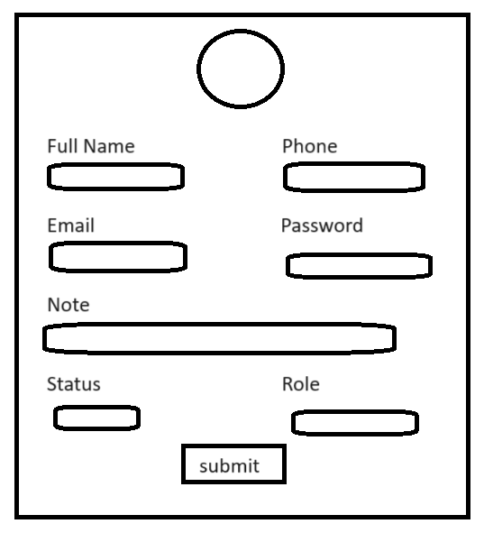

|  |  |  |
| --- | --- | --- |
| **Field Name** | **Field Type** | **Description** |
| Full Name | Text | Input full name for new user |
| Phone | Text | Input phone for new user |
| Email | Text | Input email for new user |
| Password | Password | Input password for new user |
| Note | Text | Input note for new user |
| Status | Combo box | Select status for new user |
| Role | Combo box | Select role for new user |
| Submit | Button | Click to create new user |

#### **Update User**

This screen allows admins to update user’s information.

##### UI Design

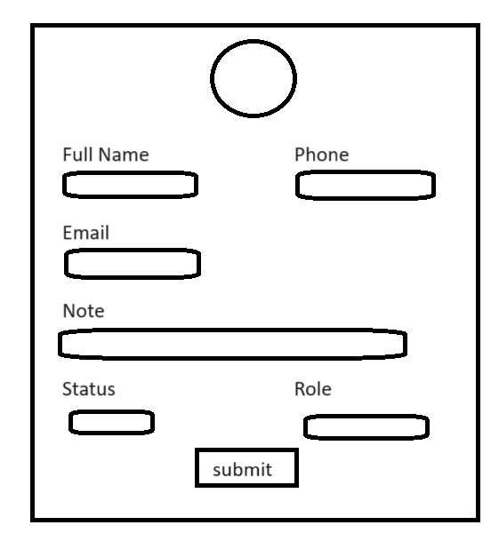

|  |  |  |
| --- | --- | --- |
| **Field Name** | **Field Type** | **Description** |
| Full Name | Text | Input full name for user to update |
| Phone | Text | Input phone for user to update |
| Email | Text | Input email for user to update |
| Note | Text | Input note for user to update |
| Status | Combo box | Select status for user |
| Role | Combo box | Select role for user |
| Submit | Button | Click to update new user |

### **2.3 Subject Manager**

#### **Subject List**

This screen allows admins to see the list of users and manage them.

##### UI Design

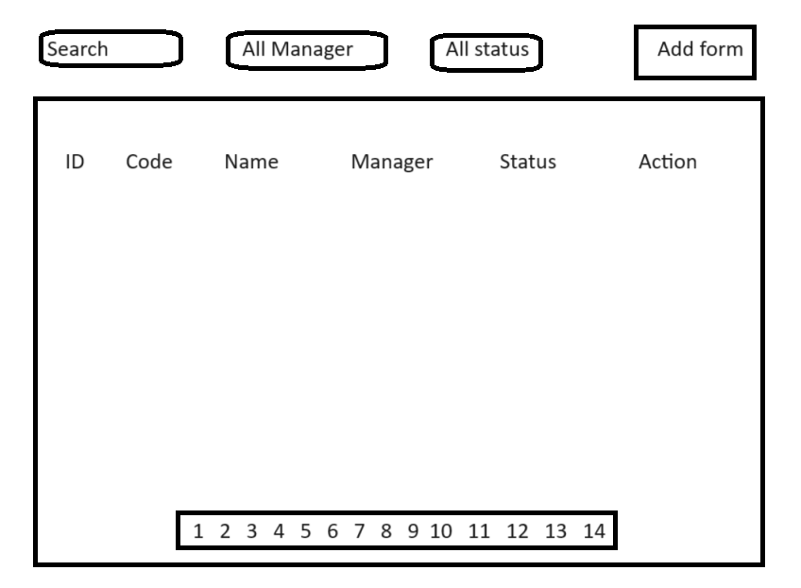

|  |  |  |
| --- | --- | --- |
| **Field Name** | **Field Type** | **Description** |
| Add form | Button | Click to open “Add Subject” form |
| Search | Text | Fill in and show list subject which have name containing |
| Manager | Combo box | Select to show list subject which managed by this person |
| Status | Combo box | Select to show list subject which has selected status |
| Pagination | Navigation Link | Click to navigate to next page of list subject |
| Header field (ID, name, manager) | Button | Sort list by this column |

#### **New Subject/ Subject Details/ Update Subject**

This screen allows admins to add new users.

##### UI Design

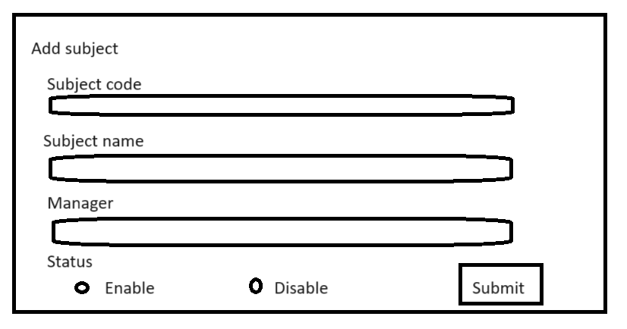

|  |  |  |
| --- | --- | --- |
| **Field Name** | **Field Type** | **Description** |
| Subject code | Text | Input subject code for new subject |
| Subject name | Text | Input subject name for new subject |
| Manager | Combo box | Select manager for new subject |
| Status | Combo box | Select status for new subject |
| Submit | Button | Click to create new subject |

### **2.4 Class Manager**

#### **Class List**

This screen allows admins to see the list of classes and manage them.

##### UI Design

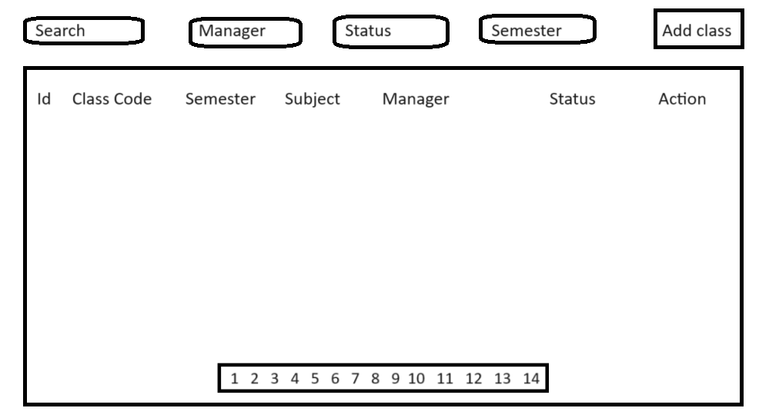

|  |  |  |
| --- | --- | --- |
| **Field Name** | **Field Type** | **Description** |
| Add form | Button | Click to open “Add Class” form |
| Search | Text | Fill in and show list class which have name containing |
| Manager | Combo box | Select to show list class which managed by this person |
| Status | Combo box | Select to show list class which has selected status |
| Semester | Combo box | Select to show list class which has selected semester |
| Pagination | Navigation Link | Click to navigate to next page of list class |
| Header field (ID, class code, semester, subject manager) | Button | Sort list by this column |

#### **New Class**

This screen allows admins to add new classes.

##### UI Design

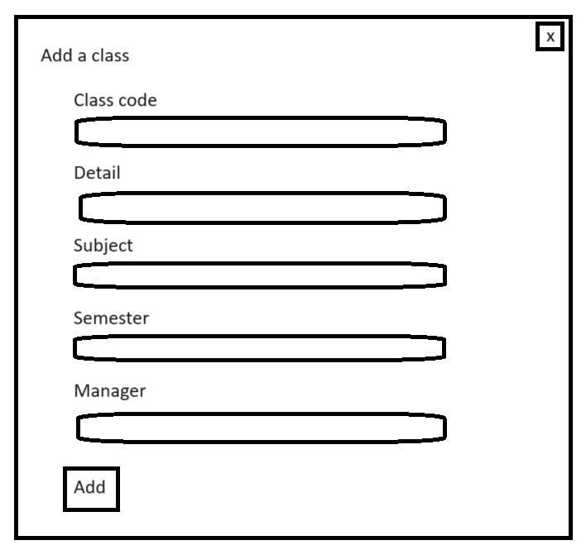

|  |  |  |
| --- | --- | --- |
| **Field Name** | **Field Type** | **Description** |
| Class code | Text | Input class code for new class |
| Detail | Text | Input class detail for new class |
| Subject | Combo box | Select subject for new class |
| Semester | Combo box | Select semester for new class |
| Manager | Combo box | Select manager for new class |
| Add | Button | Click to create new class |

#### **Update Class**

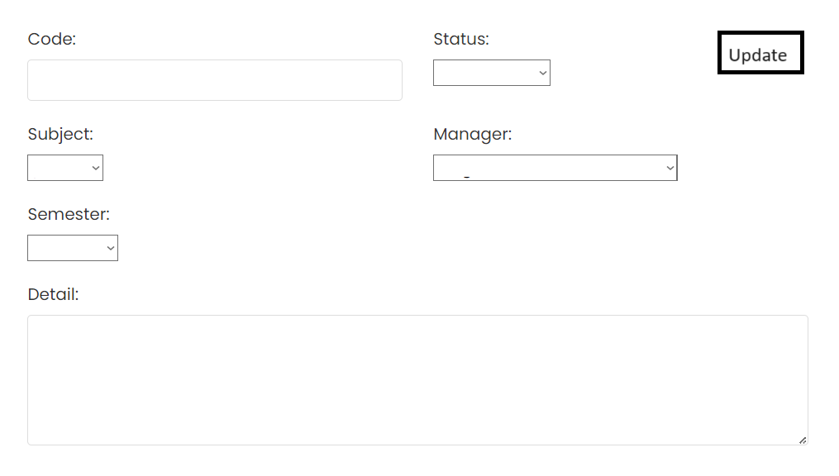

|  |  |  |
| --- | --- | --- |
| **Field Name** | **Field Type** | **Description** |
| Class code | Text | Input class code for updating class |
| Status | Combo box | Select subject for updating status |
| Detail | Text | Input class detail for updating class |
| Subject | Combo box | Select subject for updating class |
| Manager | Combo box | Select manager for updating class |
| Add | Button | Click to update class |

#### **Subject Assignment List**

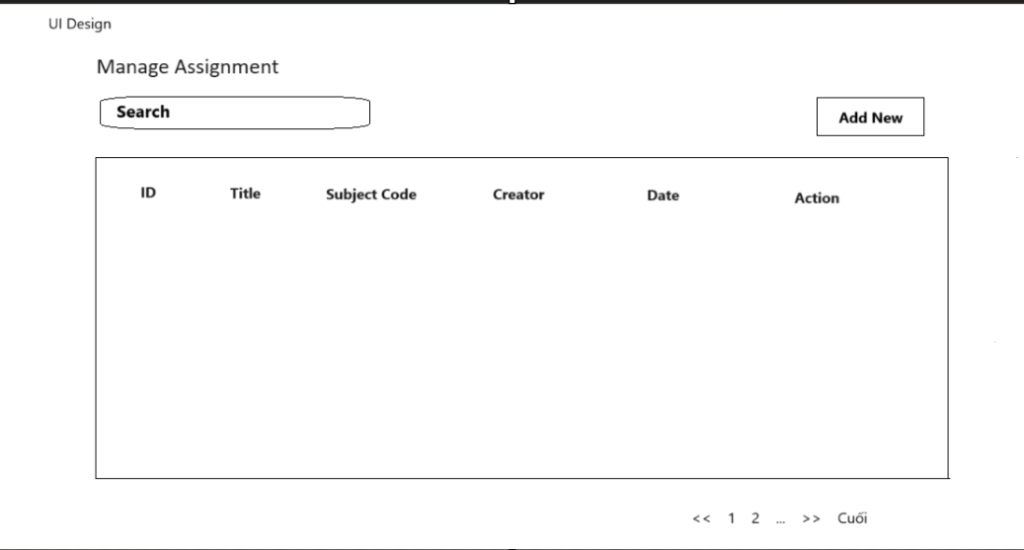

|  |  |  |
| --- | --- | --- |
| **Field Name** | **Field Type** | **Description** |
| Add form | Button | Click to open “Add New” form |
| Search | Text | Fill in and show list assignment which have name containing |
| Manager | Combo box | Select to show list assignment which created by this person |
| Pagination | Navigation Link | Click to navigate to next page of list assignment |
| Header field (ID, Title, Subject Code) | Button | Sort list by this column |

#### **New Subject Assignment**

|  |  |  |
| --- | --- | --- |
| **Field Name** | **Field Type** | **Description** |
| Subject code | Combo box | Select subject for new assignment |
| Title | Text | Input title for new assignment |
| Description | Text | Input description for new assignment |
| Submit | Button | Click to create new subject assignment |

#### **Subject Assignment Details/ Update Subject Assignment**

# 

|  |  |  |
| --- | --- | --- |
| **Field Name** | **Field Type** | **Description** |
| Title | Text | Input title for updating title |
| Description | Text | Input description detail for updating assignment |
| Subject Code | Combo box | Select subject for updating assignment |
| Update | Button | Click to update assignment |

### **2.6 Setting Manager**

#### **System Setting List**

UI design:

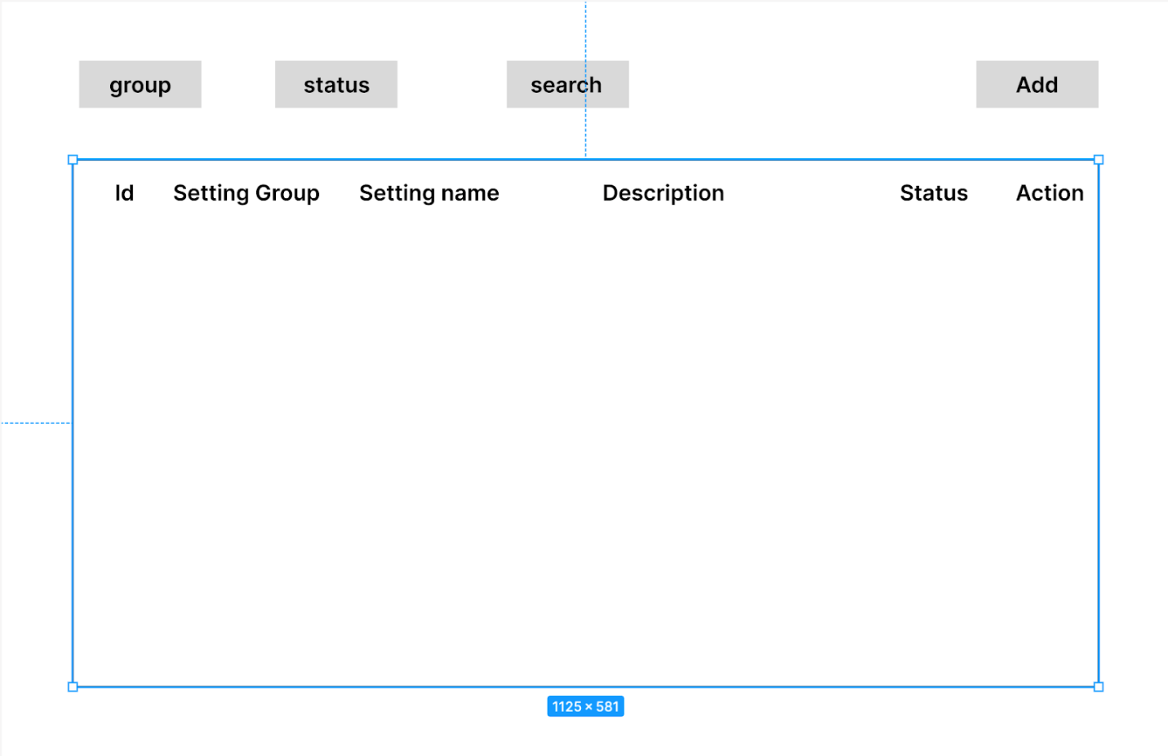

|  |  |  |
| --- | --- | --- |
| **Field Name** | **Field Type** | **Description** |
| group | Combo box | Select to show list setting which has selected group |
| status | Combo box | Select to show list setting which has selected status |
| search | Text | Fill in and show list setting which have name containing |
| add | Button | Click to open “Add System” form |

#### **New System Setting**

UI design:

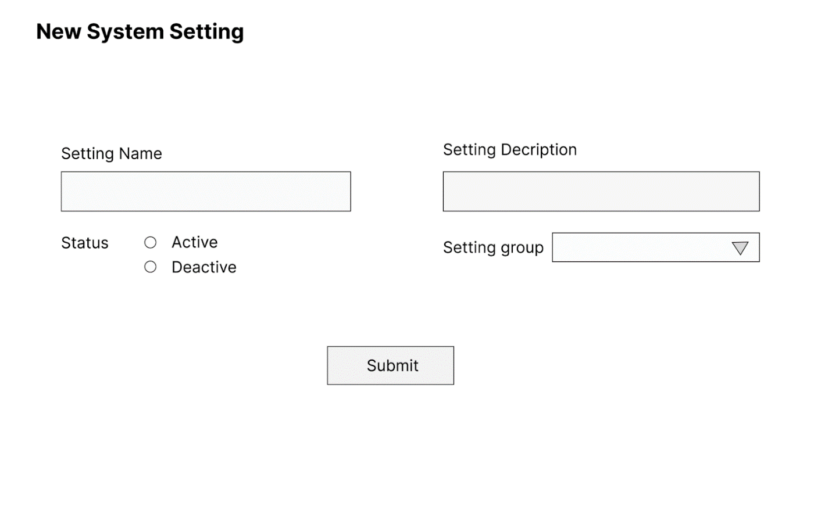

|  |  |  |
| --- | --- | --- |
| **Field Name** | **Field Type** | **Description** |
| Setting Name | Text | Input setting name for new setting |
| Setting Description | Text | Input setting description for new setting |
| Status | Combo box | Select status for new setting |
| Setting group | Combo box | Select group for new setting |
| Submit | Button | Click to create new system setting |

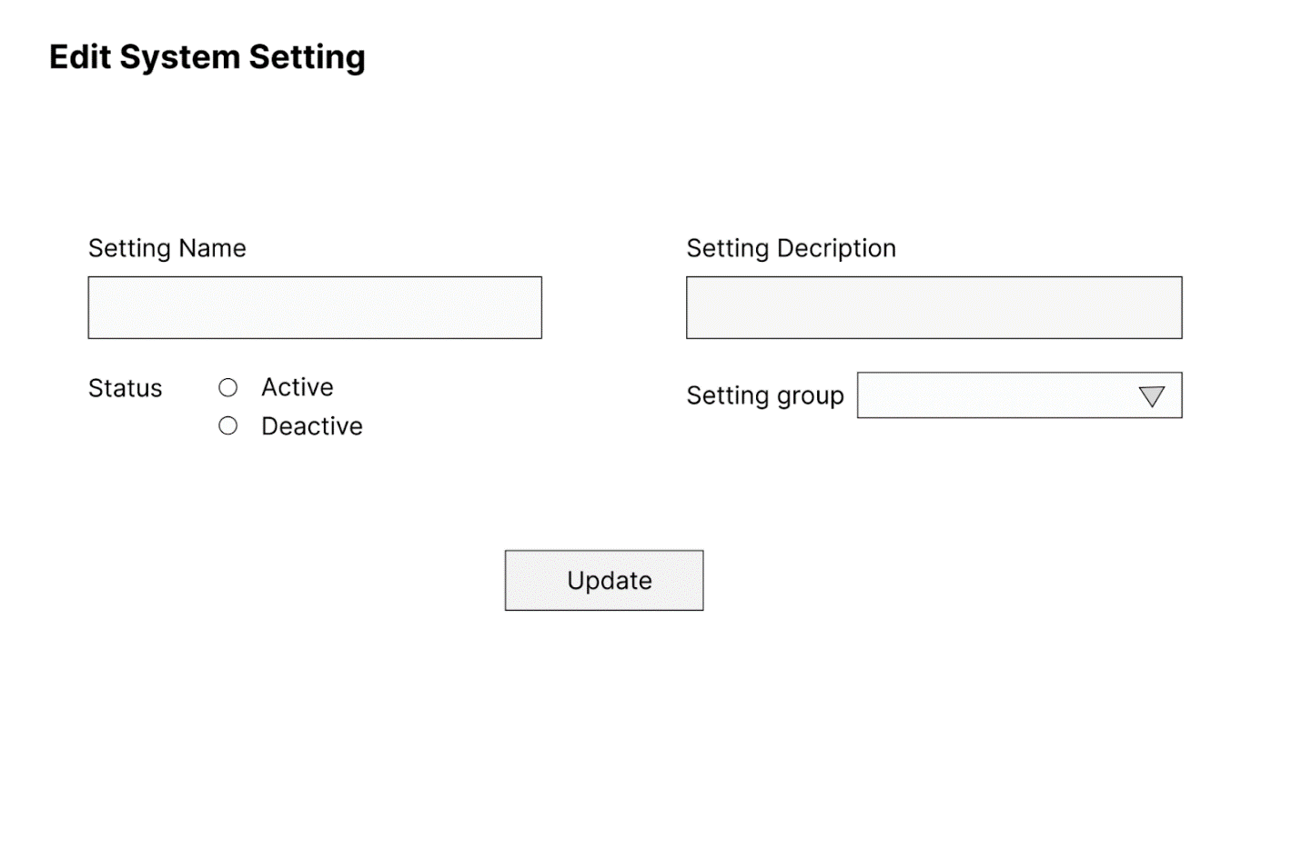

|  |  |  |
| --- | --- | --- |
| **Field Name** | **Field Type** | **Description** |
| Setting Name | Text | Input setting name for new setting |
| Setting Decription | Text | Input setting decription for new setting |
| Status | Combo box | Select status for new setting |
| Setting group | Combo box | Select group for new setting |
| Update | Button | Click to update system setting |

# IV. Appendix

## 1. Assumptions & Dependencies

AS-1: The project team will have the necessary skills and experience to complete the project successfully.

AS-2: The stakeholders will be available to provide timely feedback and approvals.

AS-3: The project will not be significantly impacted by external factors, such as changes in technology.

AS-4: faculty and administrative staff are adequately trained to use the new student management system effectively.

AS-5: This system will comply with all applicable information security laws and regulations.

AS-6:

DE-1: The project is dependent on the successful integration of student data from various sources, such as enrollment systems, course registration, and grading systems.

DE-2: Dependencies exist on upgrading hardware infrastructure to support the new software. This includes server capacity and network improvements.

DE-3: The training of faculty and staff depends on the completion of software development. Delays in development will affect the training schedule.

DE-4: Dependencies exist on timely security audits to ensure the protection of student data. Delays in security audits may impact project timelines.

## 2. Limitations & Exclusions

LI-1: The project has a limited time of 3 months(one semester) to implement the project student management system. There will be no resources to extend this period.

LI-2: The project uses limited resources, includes 5 development members and costs no money.

EX-1: Online Payment Feature: The project does not include an online payment feature for tuition fees or project fees.

EX-2: Integration with University Fee System: The project does not deeply integrate with the university's tuition fee system. Tuition fees will be managed through a different system.

EX-3: Advanced System Features: The project does not encompass advanced features like study note management or student event management. These features may be considered for future projects.

## 3. Messages List

|  |  |  |  |  |
| --- | --- | --- | --- | --- |
| **#** | **Message code** | **Message Type** | **Context** | **Content** |
| 1 | MSG01 | In line | There is not any search result | No search result. |
| 2 | MSG02 | Pop-up, with red text | Input-required fields are empty | The * field is required. |
| 3 | MSG03 | Toast message | Updating asset(s) information successfully | Update asset(s) successfully. |
| 4 | MSG04 | Toast message | Adding new asset successfully | Add assets successfully. |
| 5 | MSG05 | Toast message | Confirming email of asset hand-over is sent successfully | A confirmation email has been sent to {email_address}. |
| 6 | MSG06 | Toast message | Resetting asset information successfully | Return asset(s) successfully. |
| 7 | MSG07 | Toast message | Deleting asset information successfully | Delete asset(s) successfully. |
| 8 | MSG08 | Pop-up, with red text | Input value length > max length | Exceed max length of {max_length}. |
| 9 | MSG09 | In line | Username or password is not correct when clicking sign-in | Incorrect username or password. Please check again. |
| 10 | MSG10 |  |  |  |