# **Chat connect**

**1.Introduction**

### **Overcome:**

### **Chat Connect is a sample project built using the Android Compose UI toolkit. It demonstrates how to create a simple chat app using the Compose libraries. The app allows users to send and receive text messages. The project showcases the use of Composes declarative UI and state management capabilities. It also includes examples of how to handle input and navigation using composable functions and how to use data from a firebase to populate the UI.**

**Purpose:**

**A chat application makes it easy to communicate with people anywhere in the world by sending and receiving messages in real time. With a web or mobile chat app, users are able to receive the same engaging and lively interactions through custom messaging features, just as they would in person.**

**2.Problem definition & design thinking**

1. **Empathy map**

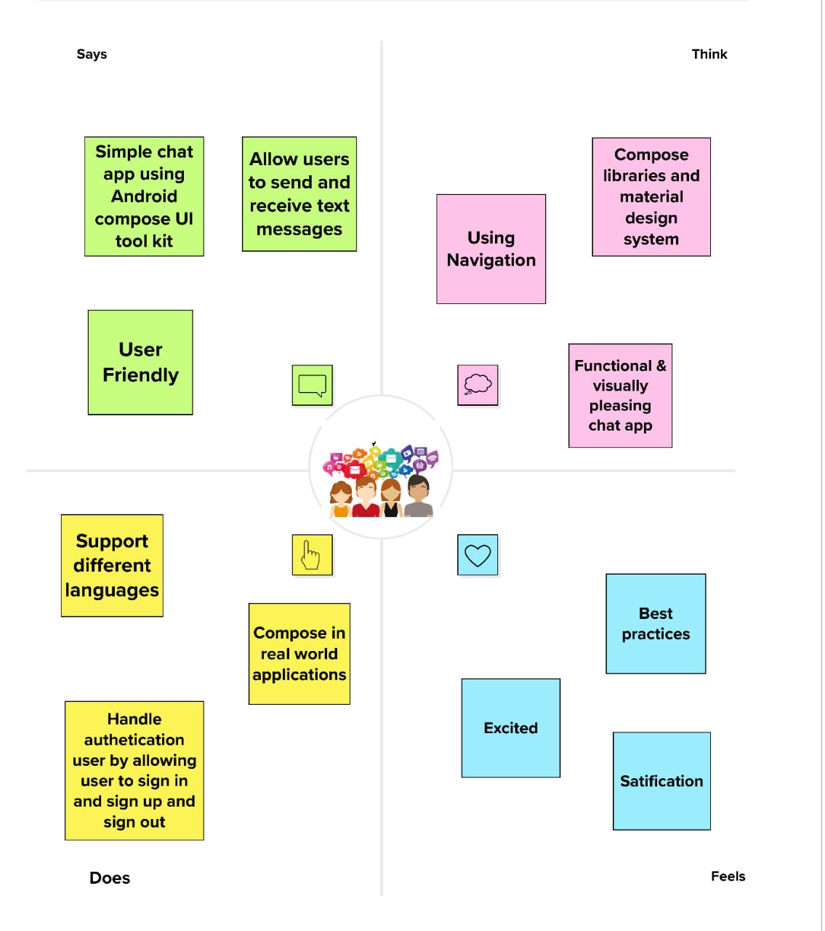

1. **Brainstorm &ideation**

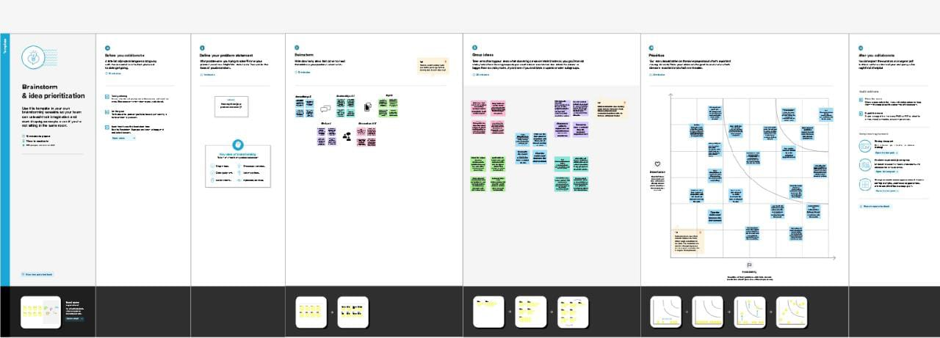**Your**

**3.Result:**

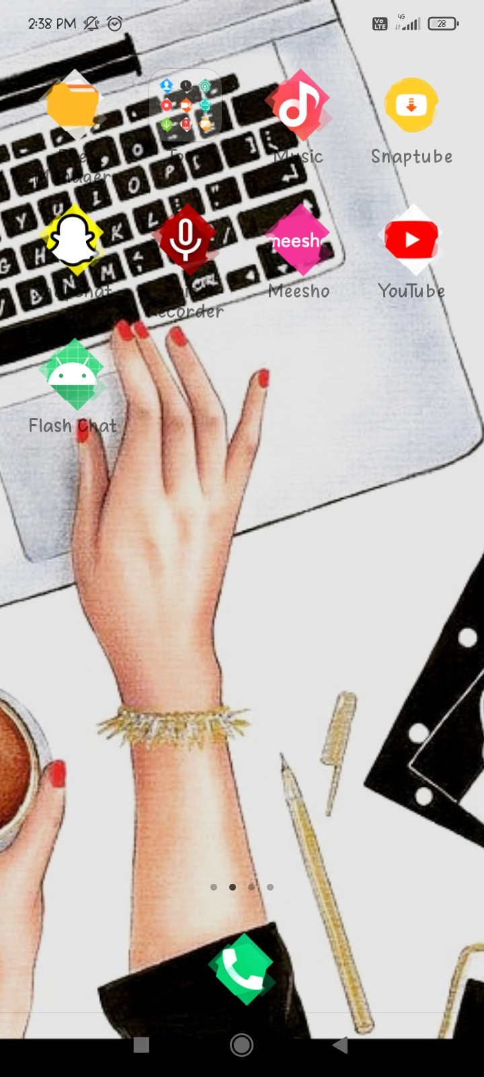

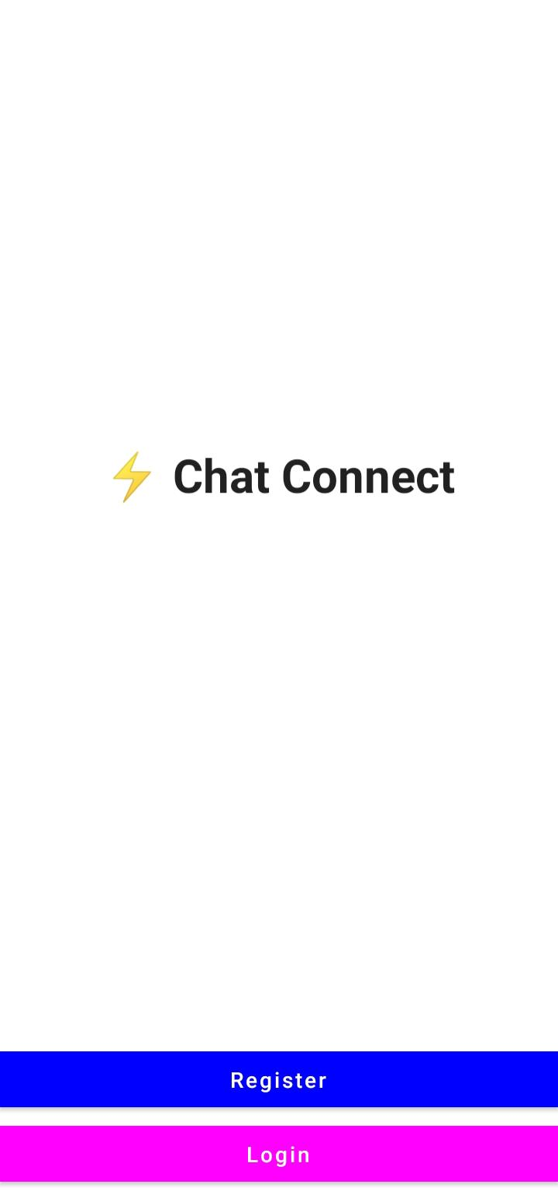

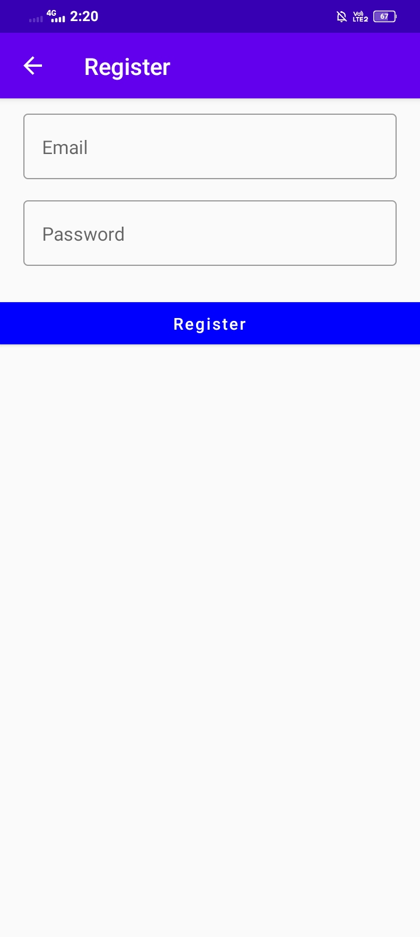

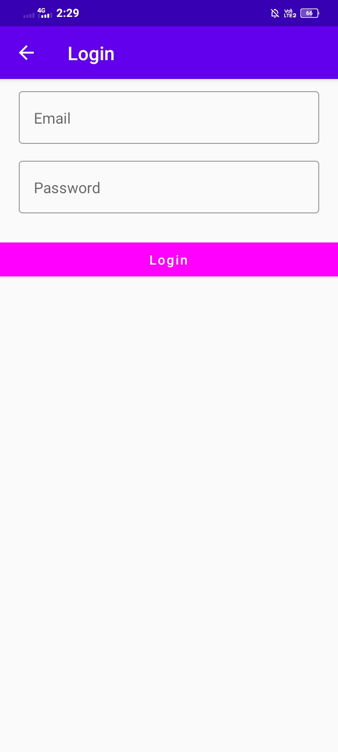

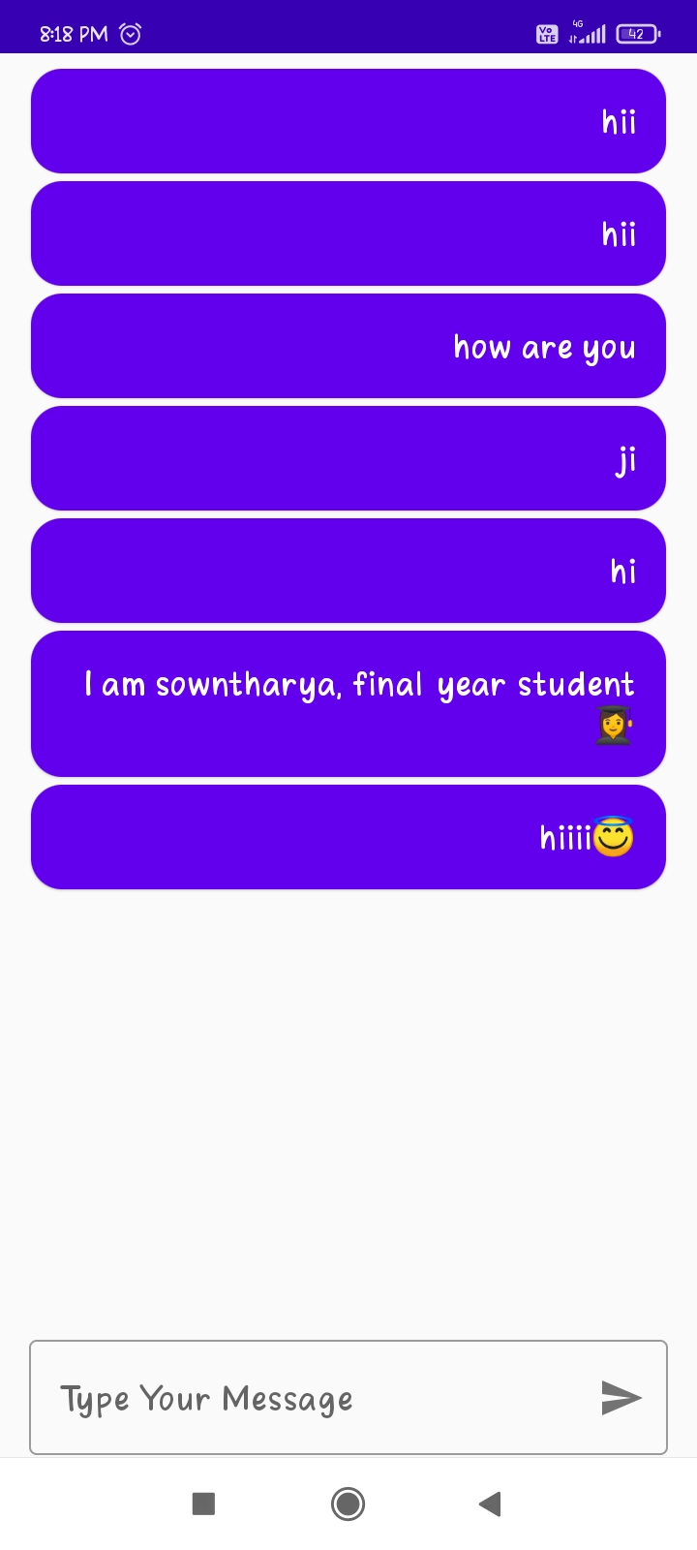

**4.Advantages:**

**Chat application makes it easy to communicate with people anywhere in the world by sending and receiving messages in real time. With a web or mobile chat app, users are able to receive the same engaging and lively interactions through custom messaging features, just as they would in person.**

**The online chat channel is an efficient mode of communication for providing information that is convenient, easy, and comfortable for the customer. Online chat is a dynamic medium used to promote sales and offer information in real time ranging from technical to product to service.**

**Disadvantages:**

* **You can't be sure other people are being honest or that they are who they say they are.**
* **If you are feeling vulnerable, people online might try to take advantage of you.**
* 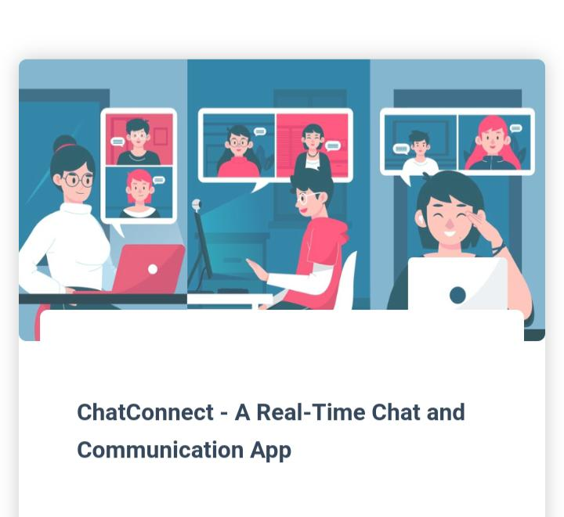**Building relationships online can result in your spending less time with friends and family.**

**5.Applications:**

* Telegram.
* Viber.
* Signal.
* WhatsApp.
* Facebook Messenger.
* Line.
* WeChat.
* Skype.

WhatsApp is recently popular chat app.

Many of the people like whatsApp very much.  **6.conclusion:**

**Chatting app allows you to communicate with your customers in web chat rooms. It enables you to send and receive messages. Chatting apps make it easier, simpler, and faster to connect with everyone and it is also easy to use. There are many types of chatting apps and every one has its own format, design, and functions.**

**7.Future scope:**

**the end of the day, chat applications is still one of the most effective forms of marketing. If you use it correctly, you can target prospective customers with relevant information, at precisely the right time – gaining brand loyalists for life.**