Help file

Hello dear reader,
I`m Madalin Tudose,the designer of the “Site under construction” style page that you`ve just download and in this file I`ll explain you how to set up the page.
Firstly, I must thank you for downloading my design .

Secondly,the package that you bought contains:

- A folder with images used in the design
- A folder with the javascript files
- The main file index.html
- The css file style.css
- The PSD design.

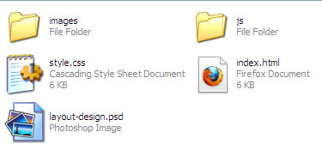

First thing,the functionality of the webpage consist in a “CountDown” and a “Slider” , both powered by JQuery,some social links and an e-mail subscription form.
This is how the webpage looks.It has a nice gradient as background(picture named background_gradient.png ,image assigned to the body layer).The black rectangle is the background of the main content and and is the picture named page_background.png ,assigned to the #main layer.

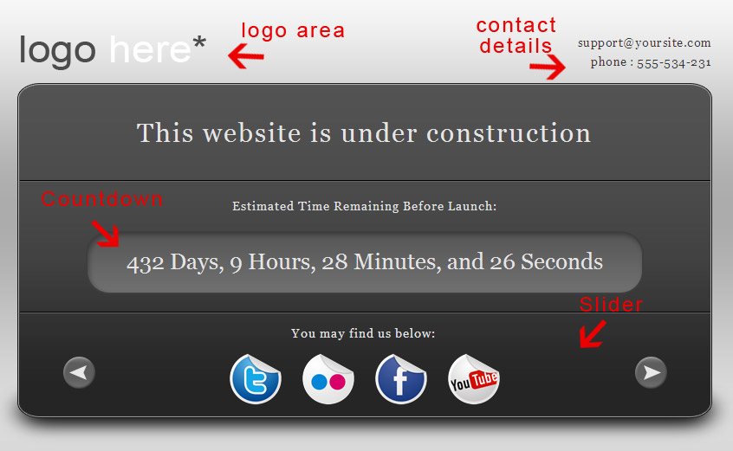

The CountDown

I`ll explain you how to set up the countdown.Next,is a picture with a part of the coded page,where the Countdown code is situated.
Update! Please ignore the picture. The template has been updated with a new function and to set up the date, just add a real date like: December 10, 2011 02:15:00. You can locate the function inside index.html file.
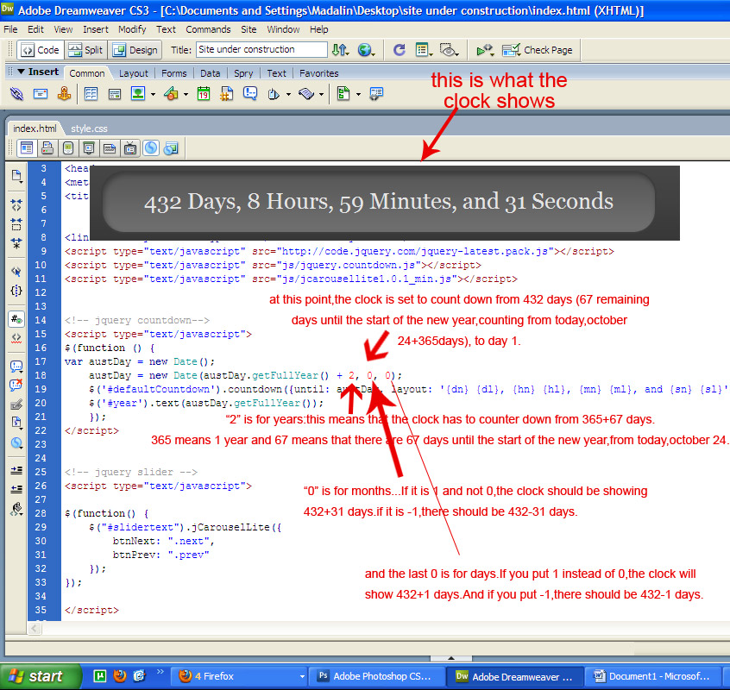

The header

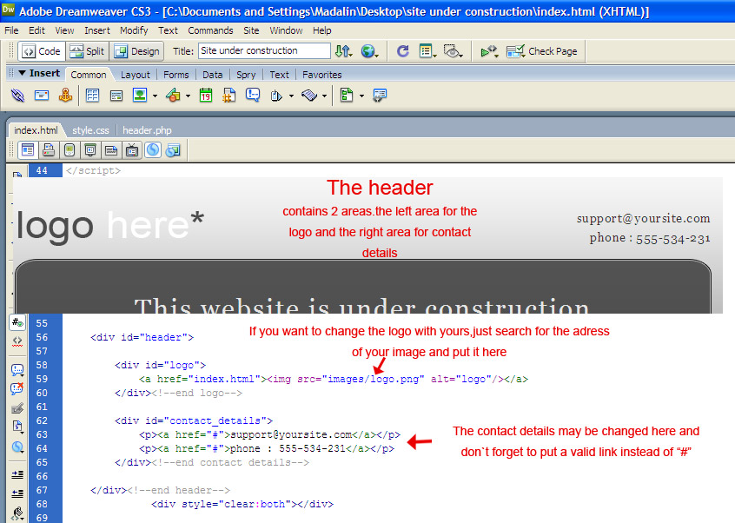

The slider

First slide:

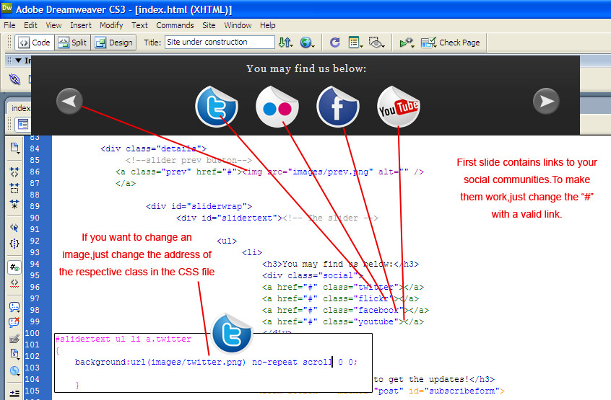

Second slide:

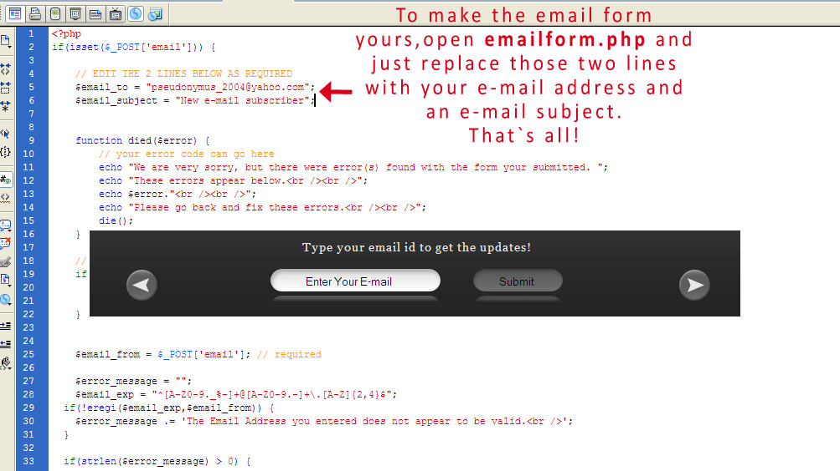

3rd slide:
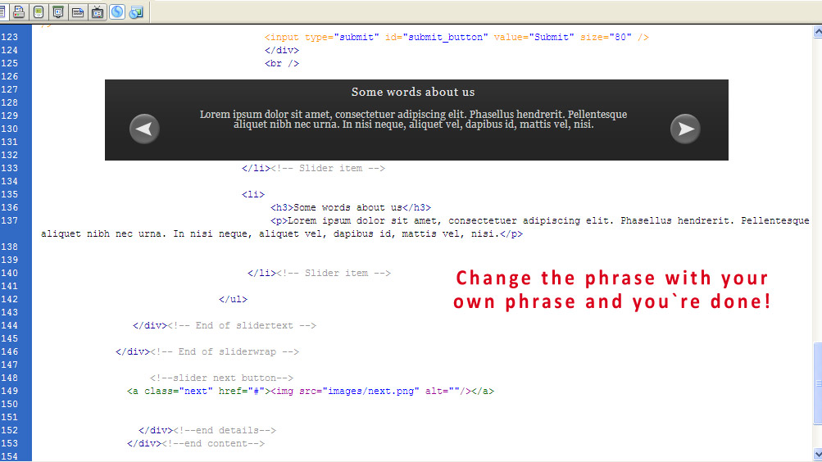

If you have questions or some obscure points regarding the webpage,don`t hesitate to contact me at madalintudose@gmail.com.
I`m available on :
Twitter: http://twitter.com/ourtuts
Website: http://www.ourtuts.com/ just leave a comment or contact me.

