

**American International University- Bangladesh**

**CSC 3215: Web Technologies**

**CO1 and CO3 Evaluation**

**Project Report**

**Fall 2019-2020**

**Project Title: Doctor & Patient Management System**

**Section: M**

|  |  |
| --- | --- |
| Student Name | Student Id |
| Arafat Al Zami | **17-34822-2** |
| Rahaman Minhazur | **18-36175-1** |
| Hasan MD.Nazmul | **18-36144-1** |
|  |  |

**Introduction:**

Doctor and patient Management System is a system for managing the hospital functions and events. It is also web application for the hospital which manages doctors and patients. It is an effective software specifically designed to fulfill various requirements in managing hospitals. Our main focus is to make peoples life easier in the hour of need and save peoples time.

**Background Study:**

Doctor and patient management system is a web base system. It mainly acts as a media of communication between hospitals and patients. Here, the hospital system has been automated but the benefit is not for all. So we want to develop the website with some simple features for checking appointment, asking for appointment, prescription. There are many hospital management system on internet. They are also very well designed and have a rich features too but there are no option to book own appointment for the patients. A patient who faced a lot of trouble for booking appointment of the doctors. So we can provide easier and friendly management system which is benefited for all the patients.

**Requirement Analysis:**

1. **User Category:**

There are 4-types of Users here. They are:

* Admin
* Doctor
* Staff
* Patient

1. **Feature List:**

Common Features for all users:

1. All users can login and logout to the system.

2. All user can recover password to the system.

3. All user can upload own picture.

In this project the “Admin” has the following features:

* Admin can add doctors and manage doctors (Add/Update).
* Admin can add stuff.
* Admin can manipulate all user information.
* Admin can delete any users.
* Can edit any users.
* Admin can fix the schedule of the doctor.
* Admin can view appointment history.

In this project the “Doctor” has the following features:

* Doctor can search own patients.
* Doctor can provide online prescription.
* Can command on the prescription.
* Can view own information.
* Doctor can view own patients information.

In this project the “Staff” has the following features:

* Staff can view own information.
* Can entry new patient.
* Staff can approve the patient.
* Can search the doctor.
* Can search the patients.
* Staff can view the patient’s details.
* Staff can edit the patient’s information.

In this project the “Patient” has the following features:

* Patient can register.
* Patients can search the doctor
* Can view the own information.
* Patient can book his/her appointment.
* Patients can see his/her own appointment history.

**Design:**

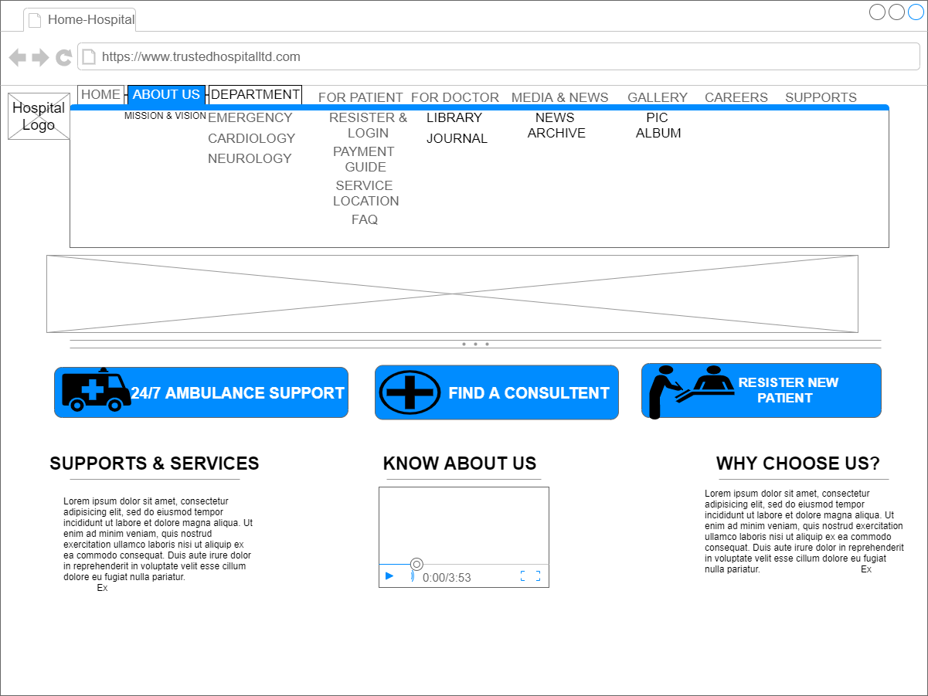

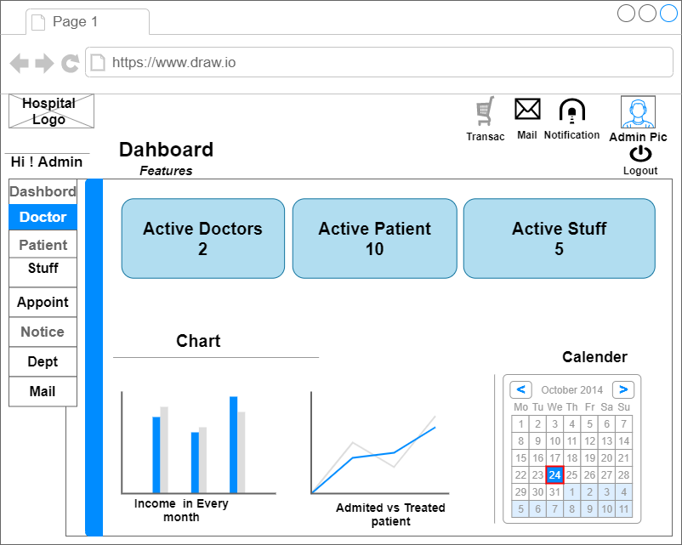

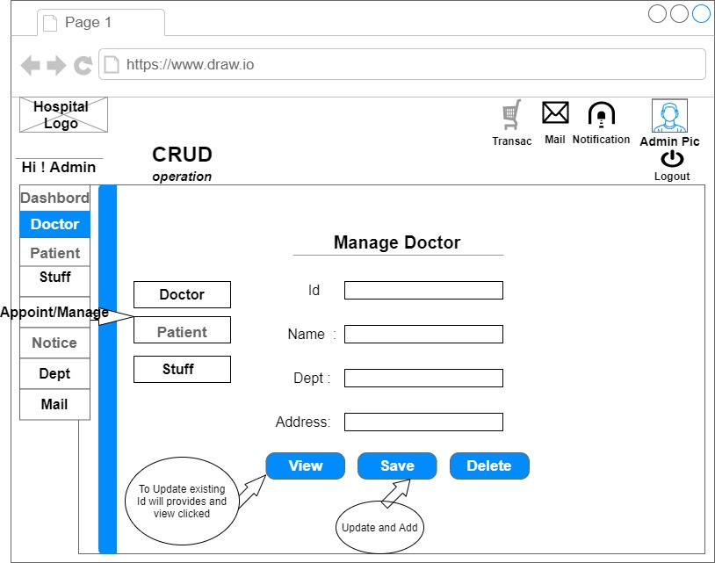

**Tools Used:**

To develop this project, we have used the following:

• Notepad++.

• XAMPP V3.2.4.

• MySQLi for database.

• Google Chrome.

• draw.io

• wireframe.

**System Images against the Specification:**

Give a screen shot of some GUIs (Midterm project) and write a very small description (Maximum 40 words) or caption for each of the GUIs. Include minimum 5 images and maximum 10.

**Impact of this Project:**

Doctor and patient management system works for the benefits of the society and acts as “Virtual Doctor” for the patients. This system offers a numbers of benefits to users and can capture data, store, view, add and delete the records entered the data can also be posted information ti the database. Patients can online booked his/her appointment so reduce his/her time. The doctor patient relationship is build up with some simple step. The distance between the doctor and patient come much shorter. Patients can online booked his/her appointment so reduce his/her time without waiting in queue. They will be able to perform activities from home.

**Limitations and Possible Future Improvements:**

Due to certain limitations all patients can create multiple user accounts. This can be done by taking their phone number while registering. The number will be verified after that so it becomes clear that whether that number belongs to him or not. Failing to verify the number will result in failed registration.

The limitation of the system is all patients can pay the full amount of visiting. In future premium patients will enable the priority service and extra facility like (discount on visiting).

Another limitation is patients can only book his/her appointment service to national doctor. In future, we want to develop the system worldwide. Then the patient can be book his/her appointment for the international doctor who is included in this system. People will find this very beneficial at the end of the day. So we try to develop the system day by day and added here others features.

***[Note: Make sure that your report is maximum 8 pages (including cover page). Print (Colored) the report and submit it with spiral bind.]***

|  |  |  |  |  |  |
| --- | --- | --- | --- | --- | --- |
| **CO1 and CO3 Evaluation: Project Report Evaluation** | | | | | |
| **Project Proposal**  **(5)** | **Background**  **Study**  **(5)** | **Requirement Analysis**  **(5)** | **Entity**  **Diagram**  **(5)** | **System Images**  **against the**  **Specification (5)** | **Total (25)** |
|  |  |  |  |  |  |
|  | | | | | |