ASSIGNMENT1

1. **Install Power BI Desktop and share the final screenshot of the report view page which appears when power desktop starts .**

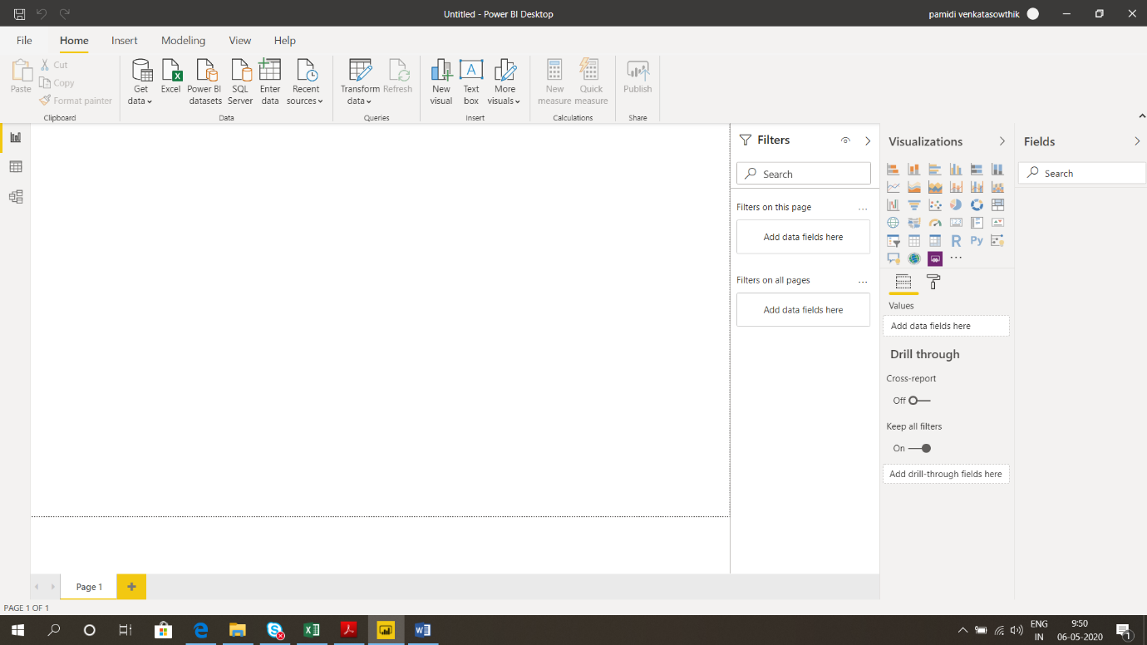

2.

A.  Report View

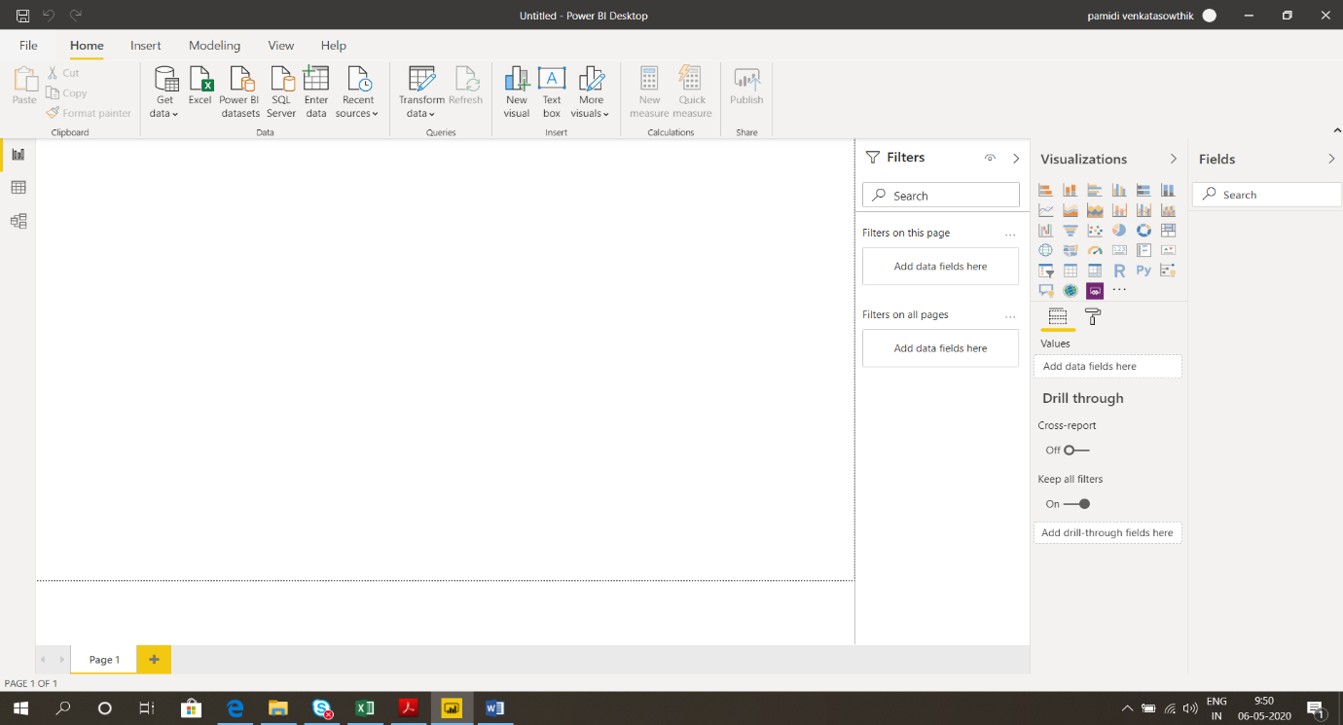

B. Data view

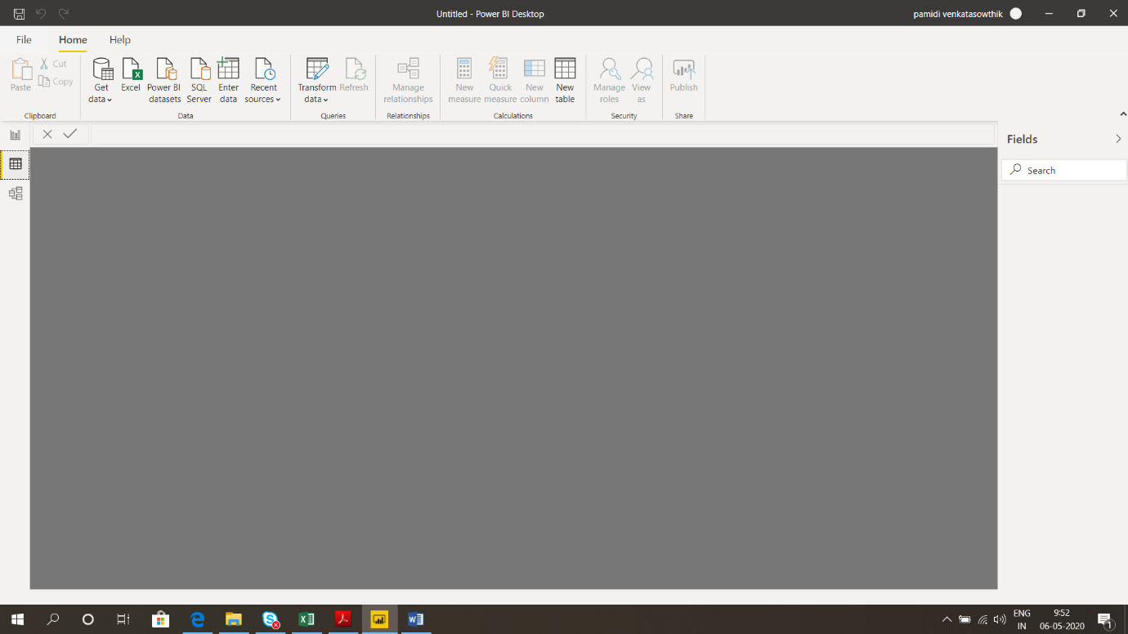

C. Model View

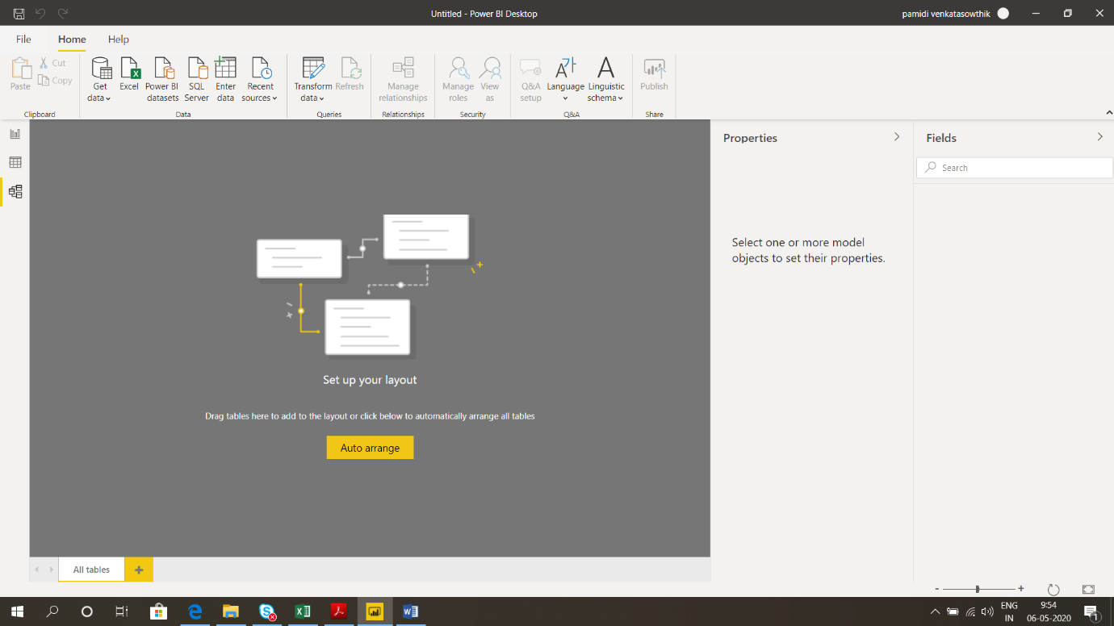

D. Power Query Editor

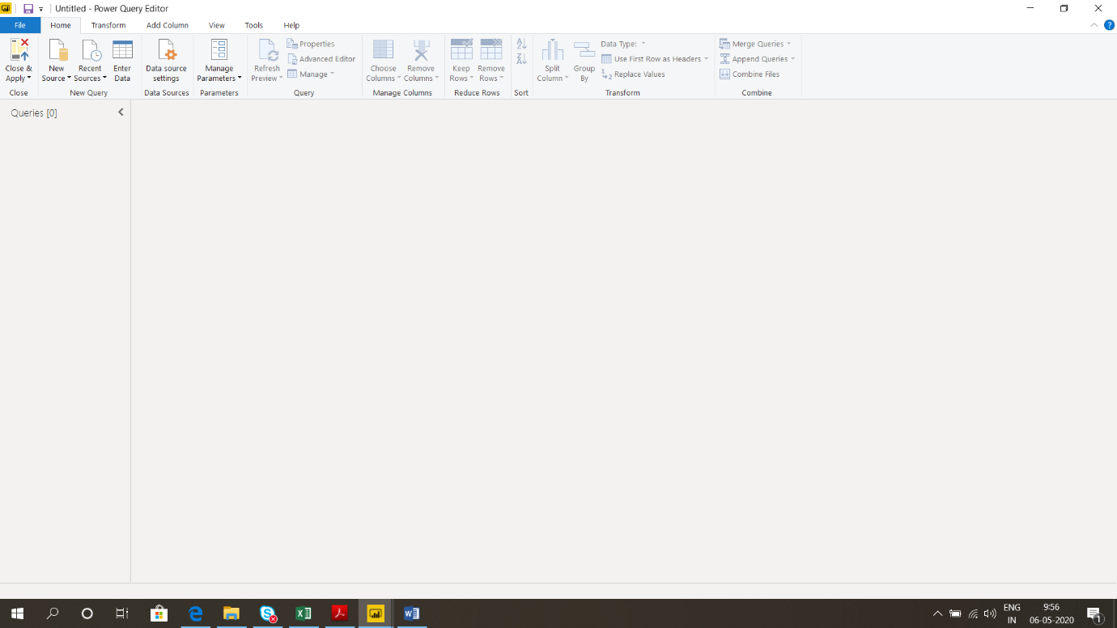

E. Advance Editor

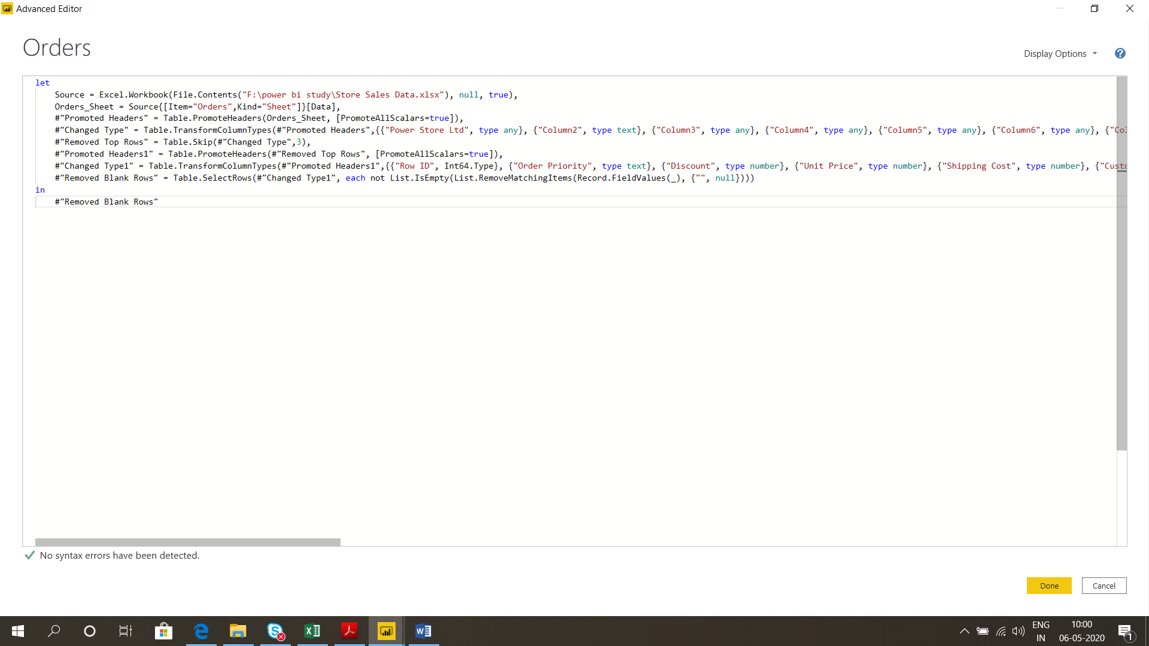

**Prepare a document with details of the following along with their price**

Power BI Desktop -- Free

Power BI Pro -- RS 660 per user per month

Power BI Premium – RS 330,190 a month per dedicated cloud compute and storage resource.