CS427 - Game Development

& 3D Visualization: TANK 2D

# 1. Member

Phan Trung Đức - 21125035

Hứa Trường Khả - 21125045

Nguyễn Đình Ngọc Trí - 21125065

Lê Trường Thọ - 21125158

# 2. Main content of game

## A. Introduction

Tank 2D is a top-down shooter game where you, the player, control various tanks, shoot down enemies and discover the secret behind the scene. Currently, the game has only single player mode with two stages

## B. Gameplay

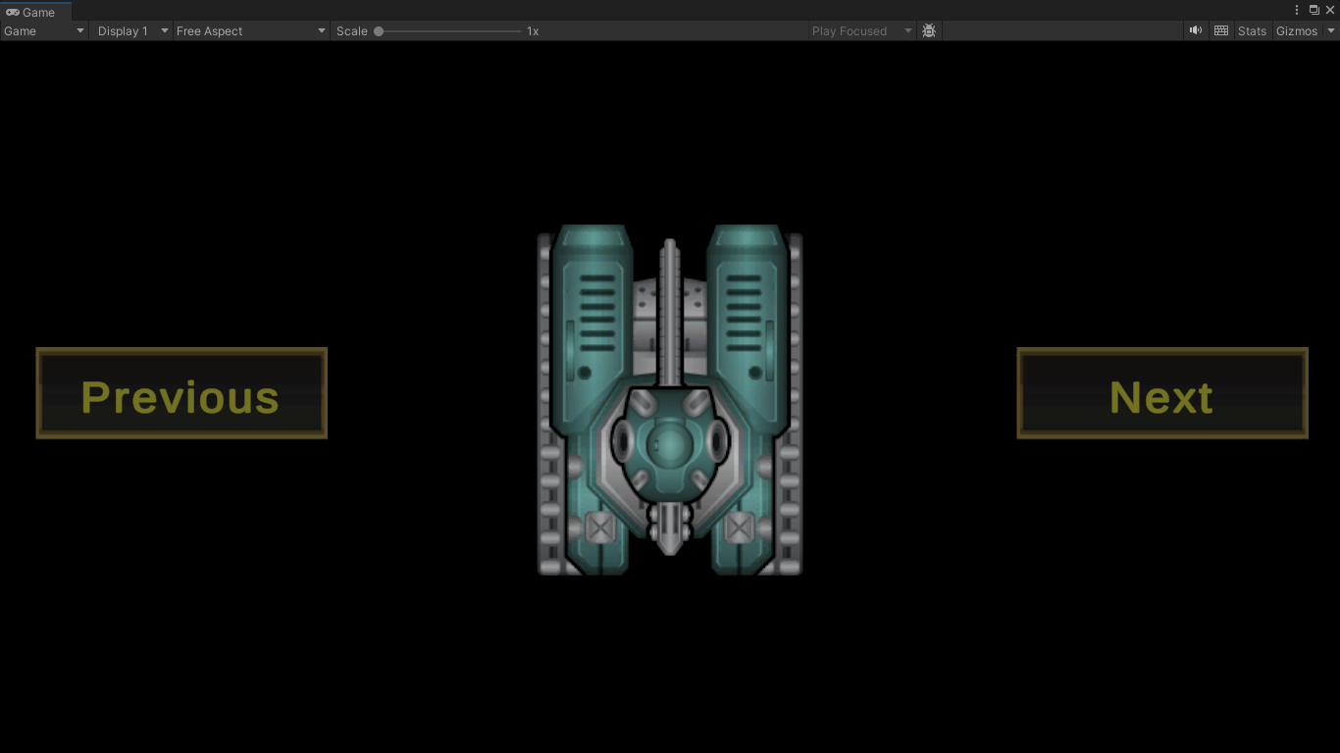

*Tank selection*

Tank 2D is around tank battles. First, the player chooses a tank. The choice is not permanent, so anyone exploring what each tank does with no risk. To the latest patch, Tank 2D consists of two stages, each has a different objective to be accomplished successfully, but mostly around shooting down your enemy's tanks.

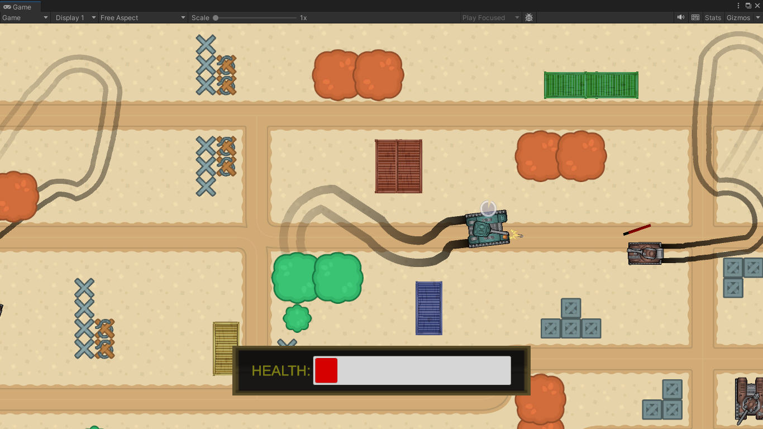

*Gameplay*

## C. Game Features

Tank 2D controls including W, A, S, D, the cursor, and left mouse. The first four are for movement control while you aim with the cursor and shoot with the left mouse. The controls seem simple, yet have been tuned so that it gives the experience of controlling a strong heavy tank that might be a bit challenging at first, but satisfying when mastered.

The HUD system of the game is made with simplicity, yet helpful. All information is represented in a popular method so that players can easily get familiar with and focus on our gameplay. We also provide a game control cheat sheet at the starting screen of each level so that players can go straight to the game without any tutorial.

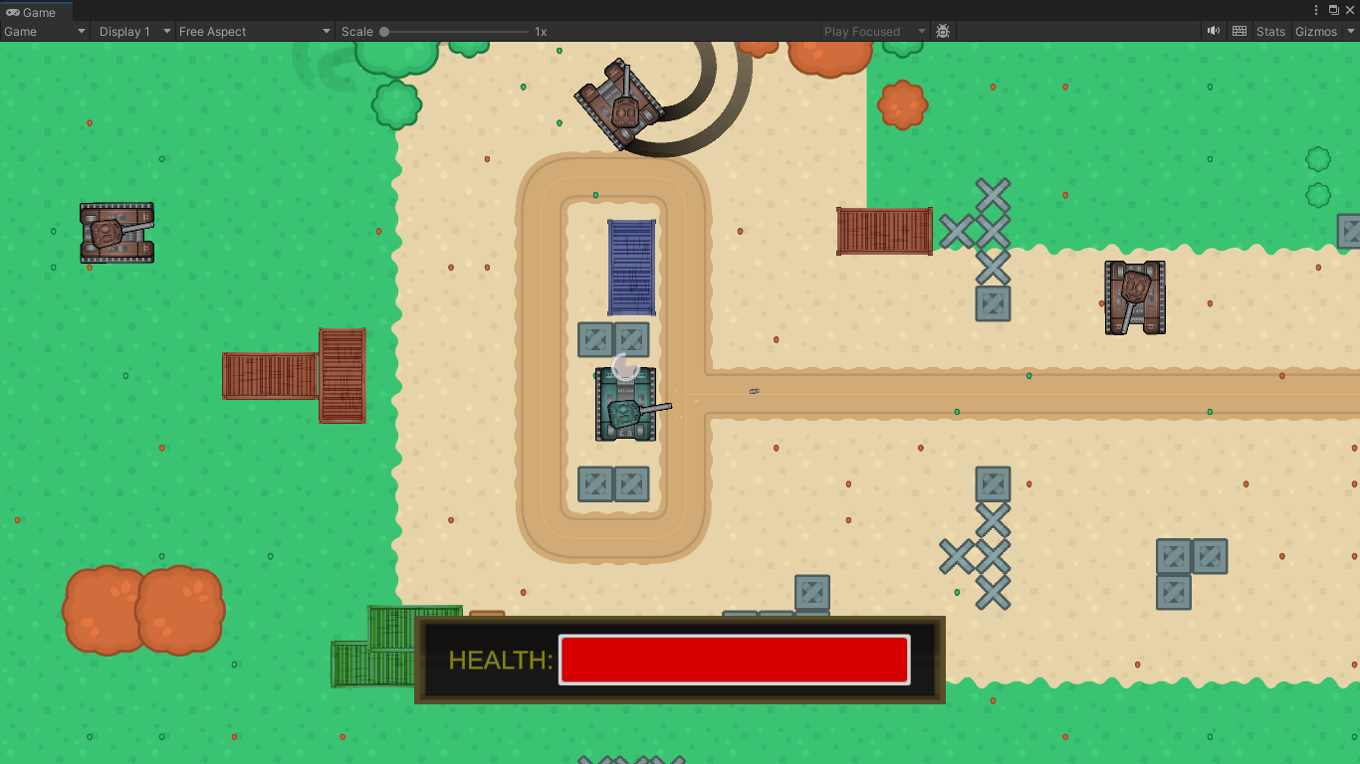

*HUD system*

## D. Graphic Resource

For the tanks related resource, including the tanks sprites, bullets, track trace, etc., we use sprites from [1]. For anything else, which is mostly around the platform objects, the sprites are adapted from [2]. Both sources are totally free even for commercial use, which hopefully means that our project is graphically ready to be uploaded to the store.

## E. Implementation Technique

For graphical technique, our project only uses basic techniques such as 2D Sprite or Animation. On the other hand, our physic system is taking momentum to calculation, making the tank movement feel realistic, but might be weird for beginners. For object manipulation, we apply object pooling to optimize the life cycle of objects in the game.

Our AI system, which controls the enemy’s tanks, is another strong point. Implemented with template parterm allow the system to be easily upgraded and extended. We also provide gizmos for built in AI behavior.

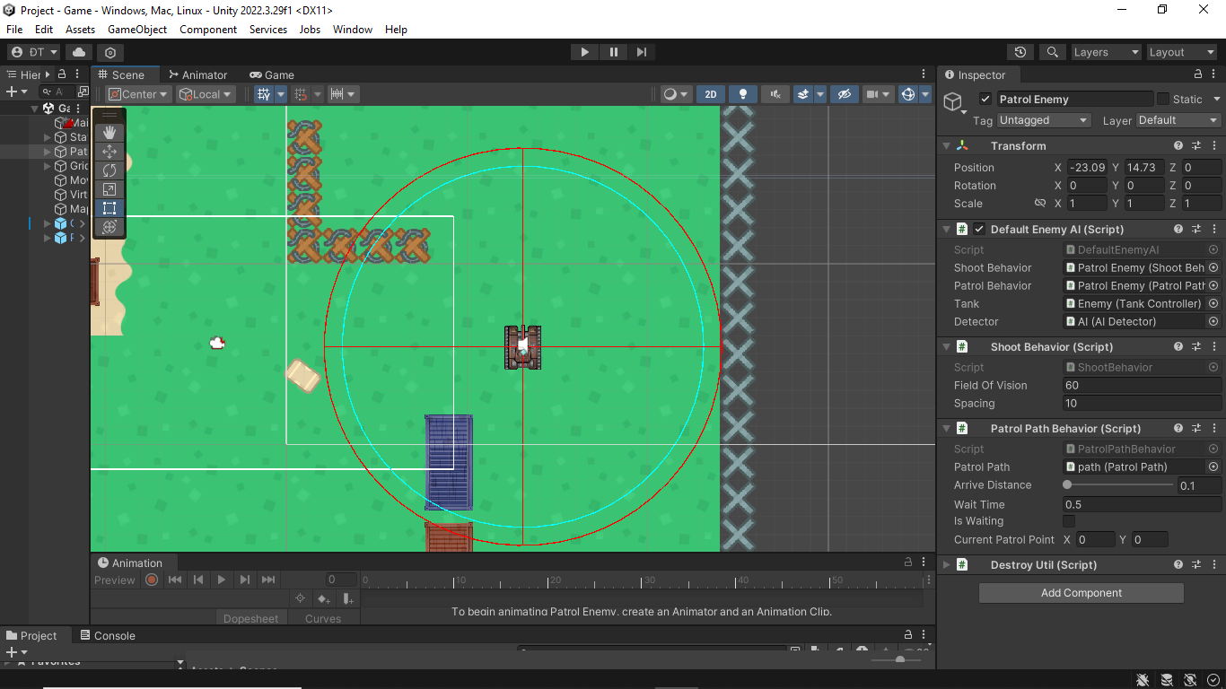

*AI features*

# 3. Project Configuration

The entire game is built on Unity 2022.3.29f1

# Resource reference

[1] [https://craftpix.net/freebies/free-2d-battle-tank-game-assets/](https://craftpix.net/freebies/free-2d-battle-tank-game-assets/?fbclid=IwZXh0bgNhZW0CMTAAAR1gJMXRO_IXRrf0VSPjxJLbm0jfoodVDE_1KfQfM993_UxEZd731Y6GjRg_aem_bXwSzz5BEt_getlB8Tj9mQ)

[2] [https://www.kenney.nl/assets/top-down-tanks-redux](https://www.kenney.nl/assets/top-down-tanks-redux?fbclid=IwZXh0bgNhZW0CMTAAAR2-5rtbesWn8DvAY17eeBExtHQU41tDO5taoskjJGLghRydKdDyJTDxghE_aem_cwgijBj-Iyvi2flIH_ffjA)