Hospital Booking & Feedback Platform
Technical Specification
Architecture · Database · API · Frontend · Admin Dashboard
Prepared August 2026

Table of Contents

1. Product Overview
A web platform that lets patients discover hospitals, book and pay for a doctor's queue slot in advance, and receive an AI-driven symptom triage that recommends the best-fit doctors nearby. After each visit the platform collects structured feedback (text and voice) in exchange for a discount reward, and feeds the aggregated data to an admin dashboard for operational and commercial analytics.

1.1 Core User Journey
- User registers with a phone number and verifies via SMS OTP.
- User browses the hospital leaderboard or asks the AI chatbot to suggest doctors based on symptoms.
- User books a queue slot and pays in advance via Payme, Click, or Uzum Bank.
- 1–2 hours after the appointment window ends, a push notification invites feedback with a discount incentive.
- User submits a rating, tag selections, free text, and/or a voice recording; voice is transcribed and tagged to a medical category.
- Admins manage hospitals, doctors, and discount codes, and export visit statistics by medical category — used commercially to anticipate drug demand and prevent shortages.

1.2 Core Modules
- Authentication & user profile
- Hospital leaderboard & detail pages
- AI symptom-to-doctor chatbot
- Queue booking & advance payment (local payment rails)
- Post-visit feedback (text + voice/STT) & discount rewards
- Push notifications
- Admin dashboard (CRUD, statistics, export)

2. Recommended Technology Stack
Backend in Python, frontend in React + Vite, as specified. The table below lists the concrete framework/library choice per layer and the reasoning.
Layer | Choice | Why
Frontend framework | React 18 + Vite + TypeScript | Fast dev/build; role-based code-splitting for patient vs. admin bundles
Styling / UI kit | Tailwind CSS + shadcn/ui | Rapid, accessible components; easy theming, Cyrillic/Latin font support
Server state | TanStack Query | Caching, retries, background refetch for API data (queue status, notifications)
Client state | Zustand | Lightweight store for auth/session, chat state
Forms & validation | React Hook Form + Zod | Type-safe validation shared with backend Pydantic schemas
Routing | React Router v6 | Role-guarded routes (patient / admin)
i18n | react-i18next | UZ / RU / EN language switching
Backend framework | FastAPI (Python 3.12) | Async I/O suits payment webhooks, AI calls, STT jobs; auto OpenAPI docs
ORM & migrations | SQLAlchemy 2.0 (async) + Alembic | Mature, type-safe, versioned schema changes
Primary database | PostgreSQL 16 + PostGIS | Relational integrity for payments/queue; PostGIS powers distance ranking
Cache / broker | Redis | Session cache, Celery broker, rate limiting, queue counters
Background jobs | Celery + Celery Beat | Feedback reminders, STT transcription, stats rollups, push dispatch
Object storage | AWS S3 or self-hosted MinIO | Voice recordings, hospital/doctor images, exported reports
Auth | JWT (access + refresh) + phone OTP via Eskiz.uz | Standard local flow; phone-first registration
Payments | Payme, Click.uz, Uzum Bank via PayTechUZ SDK | One open-source library unifies all three local rails (FastAPI adapters available)
AI / symptom triage | Claude API (structured output) | Symptom classification + plain-language explanation, no self-hosted LLM needed
Speech-to-text | faster-whisper (self-hosted) or Yandex SpeechKit (cloud) | Self-host for cost control at scale; cloud API for fastest MVP delivery
Push notifications | Web Push (VAPID) | Browser push is sufficient for a web-only MVP; swap/add FCM if a mobile app ships later
Maps / geocoding | Yandex Maps API (primary) or Google Maps Platform | Yandex has stronger UZ address coverage
Containers | Docker + Docker Compose (dev), Kubernetes or Compose on VPS (prod) | Reproducible environments, easy horizontal scaling
CI/CD | GitHub Actions | Lint, test, build, deploy pipeline
Observability | Sentry + Prometheus/Grafana + Loki | Errors, metrics, logs in one open-source stack
Hosting | Regional VPS/cloud (e.g. UZINFOCOM, local cloud) or AWS eu-central-1 | Consider data-residency rules for medical & payment data

3. System Architecture
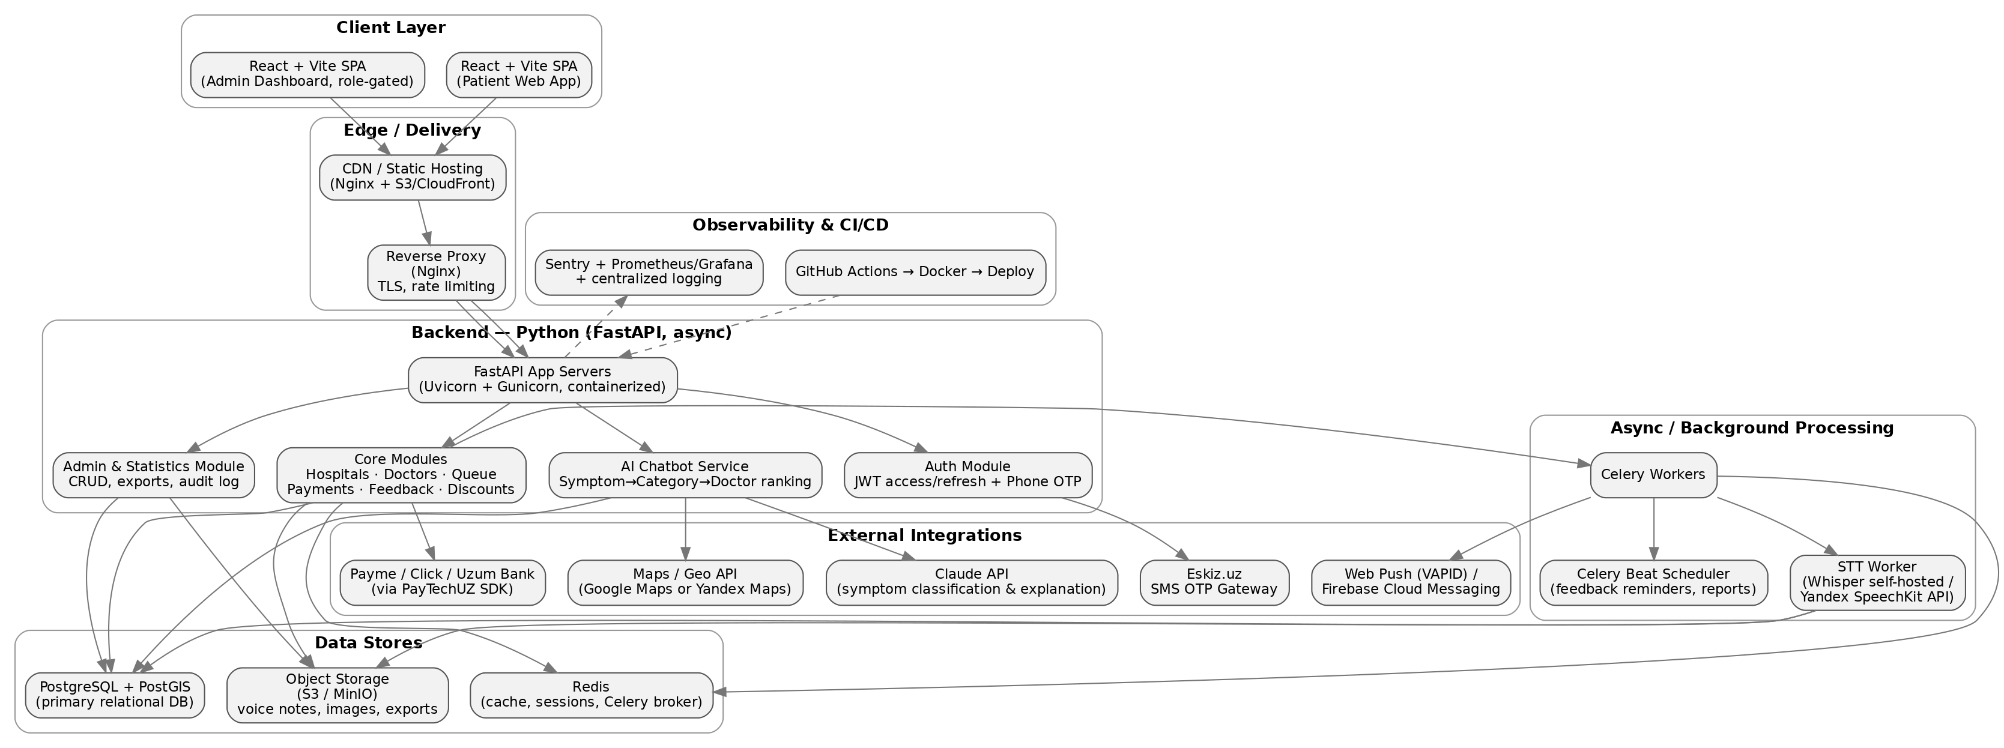
Figure 1 — High-level system architecture
The frontend is a single React + Vite SPA split into a patient-facing bundle and a role-gated admin bundle, served via CDN/Nginx. All traffic goes through FastAPI application servers running behind an Nginx reverse proxy. Long-running or scheduled work (STT transcription, feedback reminders, notification dispatch, statistics rollups) is offloaded to Celery workers backed by Redis, keeping API request latency low. PostgreSQL with the PostGIS extension is the system of record; PostGIS powers the distance calculations used both in the hospital leaderboard and the AI doctor-ranking logic. Voice recordings, images, and generated reports live in S3-compatible object storage rather than the database.

4. Database Schema
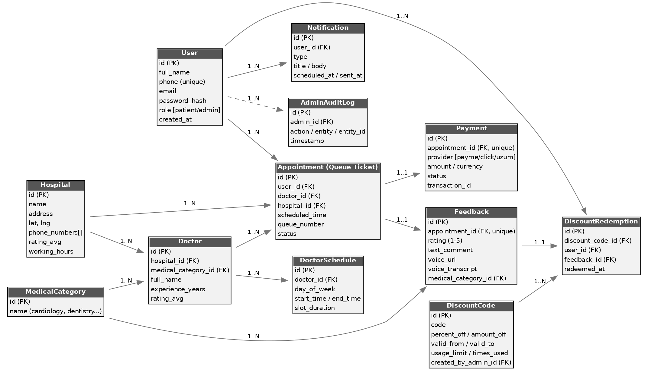
Figure 2 — Entity-relationship diagram

4.1 Entity Summary
Entity | Purpose
User | Patients and admins. Phone-first identity, role field, hashed password.
Hospital | Name, address, lat/lng, phone numbers, working hours, computed rating_avg.
MedicalCategory | Cardiology, Dentistry, Pediatrics, etc. — used across doctors, feedback, and statistics.
Doctor | Linked to a hospital and a category; experience, bio, computed rating_avg.
DoctorSchedule | Recurring weekly availability windows and slot duration per doctor.
Appointment (Queue Ticket) | Links user, doctor, hospital; carries status (pending → paid → confirmed → completed/cancelled) and queue_number.
Payment | One-to-one with Appointment; provider, amount, status, gateway transaction_id.
Feedback | One-to-one with Appointment; rating, tags, text, voice_url, voice_transcript, category tag.
DiscountCode | Admin-created reward codes: percent/amount off, validity window, usage limits.
DiscountRedemption | Join of a code to a user and the feedback that earned it.
Notification | Push/SMS messages queued and sent to a user, with scheduling metadata.
AdminAuditLog | Immutable log of every admin create/update/delete action.
Notes: Appointment↔Payment and Appointment↔Feedback are 1:1. Doctor and Feedback both carry a medical_category_id, which is what powers the admin's per-category visit statistics used for drug-demand forecasting. PostGIS geography columns on Hospital enable efficient ST_Distance queries for both the leaderboard and AI ranking.

5. Core Process Flows

5.1 Queue Booking & Advance Payment
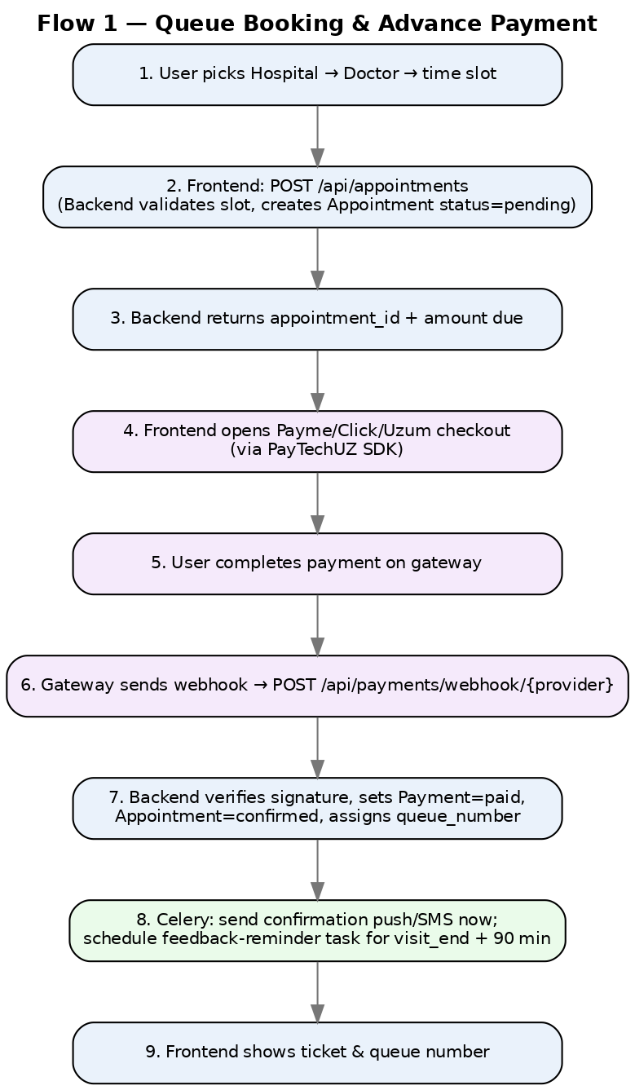
Figure 3 — Booking and payment sequence
Payment integration uses PayTechUZ, an open-source unified SDK covering Payme, Click, and Uzum Bank with ready FastAPI adapters and webhook handlers, so all three gateways share one integration surface instead of three bespoke implementations. Official references: docs.payme.uz, docs.click.uz, developer.uzumbank.uz.

5.2 Post-Visit Feedback, Speech-to-Text & Discount Reward
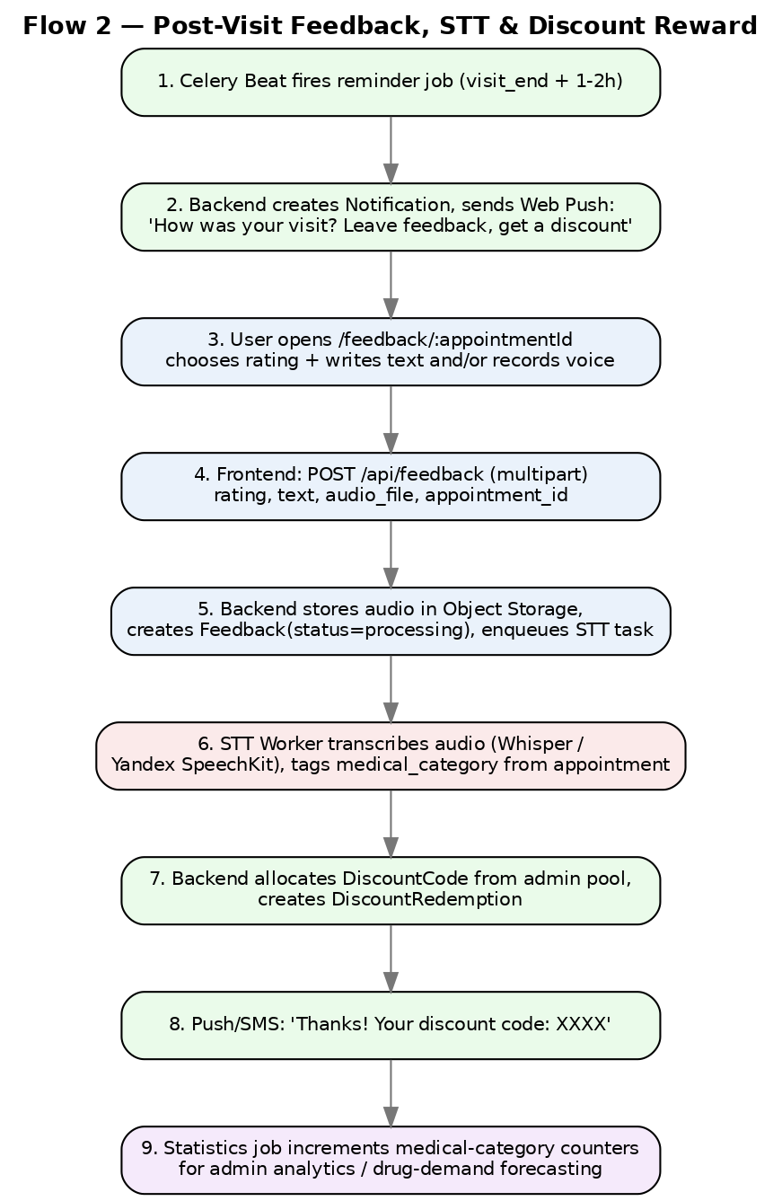
Figure 4 — Feedback and reward sequence
The reminder is scheduled by Celery Beat relative to the appointment's scheduled end time, not a fixed clock time, so it fires 1–2 hours after each individual visit. Discount codes are drawn from a pool the admin pre-creates rather than generated ad hoc, so admins retain full control over promotional budget and rules.

5.3 AI Symptom Chatbot → Doctor Suggestion
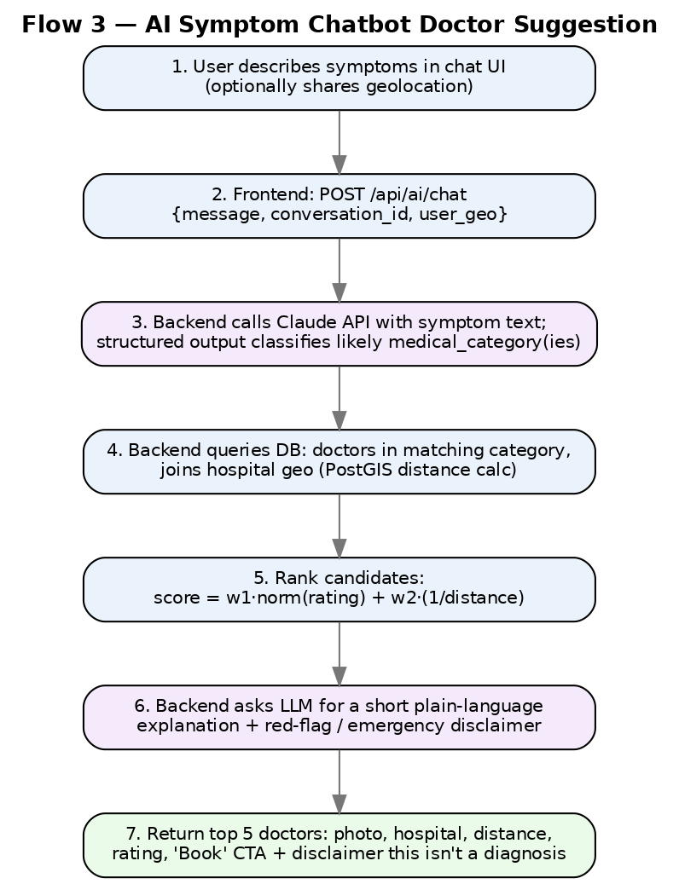
Figure 5 — AI chatbot ranking sequence
Ranking formula: score = w1 × normalized(doctor.rating_avg) + w2 × (1 / (1 + distance_km)), with default weights w1=0.6, w2=0.4, configurable per deployment. Ties break on soonest available slot. The chatbot always appends a disclaimer that suggestions are not a medical diagnosis and to seek emergency care for red-flag symptoms (chest pain, difficulty breathing, severe bleeding, etc.), which should be enforced as a hard-coded safety rule independent of the LLM response.

6. Backend API Reference
All endpoints are prefixed /api and versioned (e.g. /api/v1) once the platform stabilizes. Auth uses a Bearer JWT except where noted; admin endpoints additionally require role=admin.

6.1 Auth
Method | Endpoint | Access | Description
POST | /api/auth/register | Public | Create account with phone, name, password; triggers OTP SMS via Eskiz.uz
POST | /api/auth/verify-otp | Public | Confirms OTP code, activates account, issues JWT access + refresh tokens
POST | /api/auth/login | Public | Phone/email + password login, returns JWT pair
POST | /api/auth/refresh | Public (refresh token) | Issues a new access token
POST | /api/auth/logout | Authenticated | Revokes refresh token
POST | /api/auth/forgot-password | Public | Sends OTP/reset link
POST | /api/auth/reset-password | Public (reset token) | Sets new password

6.2 Users / Profile
Method | Endpoint | Access | Description
GET | /api/users/me | Authenticated | Current user profile
PATCH | /api/users/me | Authenticated | Update profile fields
GET | /api/users/me/appointments | Authenticated | My queue tickets, past and upcoming
GET | /api/users/me/notifications | Authenticated | My notification feed
GET | /api/users/me/discounts | Authenticated | My discount wallet

6.3 Hospitals
Method | Endpoint | Access | Description
GET | /api/hospitals | Public | Paginated list; filters: category, city, sort=rating|distance
GET | /api/hospitals/leaderboard | Public | Ranked leaderboard; optional ?category= filter, weighted score
GET | /api/hospitals/{id} | Public | Full detail: geo, phone numbers, working hours, doctor list, rating
POST | /api/hospitals | Admin | Create hospital
PUT | /api/hospitals/{id} | Admin | Update hospital
DELETE | /api/hospitals/{id} | Admin | Soft-delete hospital

6.4 Doctors & Categories
Method | Endpoint | Access | Description
GET | /api/doctors | Public | Filter by hospital_id, category_id
GET | /api/doctors/{id} | Public | Doctor profile: bio, experience, rating, hospital
GET | /api/doctors/{id}/schedule | Public | Available slots by day
POST | /api/doctors | Admin | Create doctor
PUT | /api/doctors/{id} | Admin | Update doctor
DELETE | /api/doctors/{id} | Admin | Soft-delete doctor
GET/POST/PUT/DELETE | /api/categories | Public read / Admin write | Medical categories (cardiology, dentistry, ...)

6.5 Appointments / Queue
Method | Endpoint | Access | Description
POST | /api/appointments | Authenticated | Create appointment (status=pending); validates slot availability, returns amount due
GET | /api/appointments/{id} | Owner or Admin | Appointment detail + live queue position
GET | /api/appointments | Authenticated / Admin | Mine, or all with filters (admin)
PATCH | /api/appointments/{id}/cancel | Owner or Admin | Cancel and trigger refund flow if paid
GET | /api/appointments/{id}/queue-status | Owner | Real-time queue number / estimated wait

6.6 Payments
Method | Endpoint | Access | Description
POST | /api/payments/checkout | Authenticated | {appointment_id, provider} → returns checkout URL/token (Payme/Click/Uzum)
POST | /api/payments/webhook/payme | Payme server | CheckPerformTransaction / CreateTransaction / PerformTransaction callbacks
POST | /api/payments/webhook/click | Click server | Prepare / Complete callbacks (signature verified via SHA1 digest)
POST | /api/payments/webhook/uzum | Uzum Bank server | Payment status callback
GET | /api/payments/{id} | Owner or Admin | Payment status/detail

6.7 Feedback
Method | Endpoint | Access | Description
POST | /api/feedback | Authenticated | Multipart: appointment_id, rating, tags[], text_comment, audio_file
GET | /api/feedback/{id} | Owner or Admin | Feedback detail including transcript once processed
GET | /api/feedback | Admin | Filter by hospital, category, sentiment, date range
GET | /api/feedback/{id}/transcript | Admin | Raw STT transcript + detected sentiment/keywords

6.8 Discounts
Method | Endpoint | Access | Description
POST | /api/discounts | Admin | Create discount code / batch (percent_off or amount_off, validity window, usage_limit)
GET | /api/discounts | Admin | List + filters
PUT | /api/discounts/{id} | Admin | Update code rules
DELETE | /api/discounts/{id} | Admin | Deactivate code
GET | /api/discounts/mine | Authenticated | My redeemed / available codes
POST | /api/discounts/validate | Authenticated | Validate a code at checkout

6.9 Notifications
Method | Endpoint | Access | Description
GET | /api/notifications | Authenticated | My notifications, paginated
PATCH | /api/notifications/{id}/read | Authenticated | Mark as read
POST | /api/notifications/push-subscribe | Authenticated | Register browser Web Push (VAPID) subscription

6.10 AI Chatbot
Method | Endpoint | Access | Description
POST | /api/ai/chat | Authenticated | {message, conversation_id, user_geo} → top 5 ranked doctor suggestions
GET | /api/ai/conversations/{id} | Owner | Chat history
POST | /api/ai/feedback | Authenticated | Thumbs up/down on a suggestion (improves prompt tuning)

6.11 Admin & Statistics
Method | Endpoint | Access | Description
GET | /api/admin/stats/overview | Admin | KPIs: users, appointments, revenue, feedback volume
GET | /api/admin/stats/by-category | Admin | Visit counts per medical category over a date range — demand/drug-deficiency signal
GET | /api/admin/stats/export | Admin | ?format=csv|pdf&filters= — generates async export job, returns file URL
GET | /api/admin/audit-log | Admin | All admin CRUD/actions with actor, entity, timestamp
* | /api/hospitals, /api/doctors, /api/discounts, /api/categories | Admin | Full CRUD reused from the modules above, gated by role

7. Frontend Structure
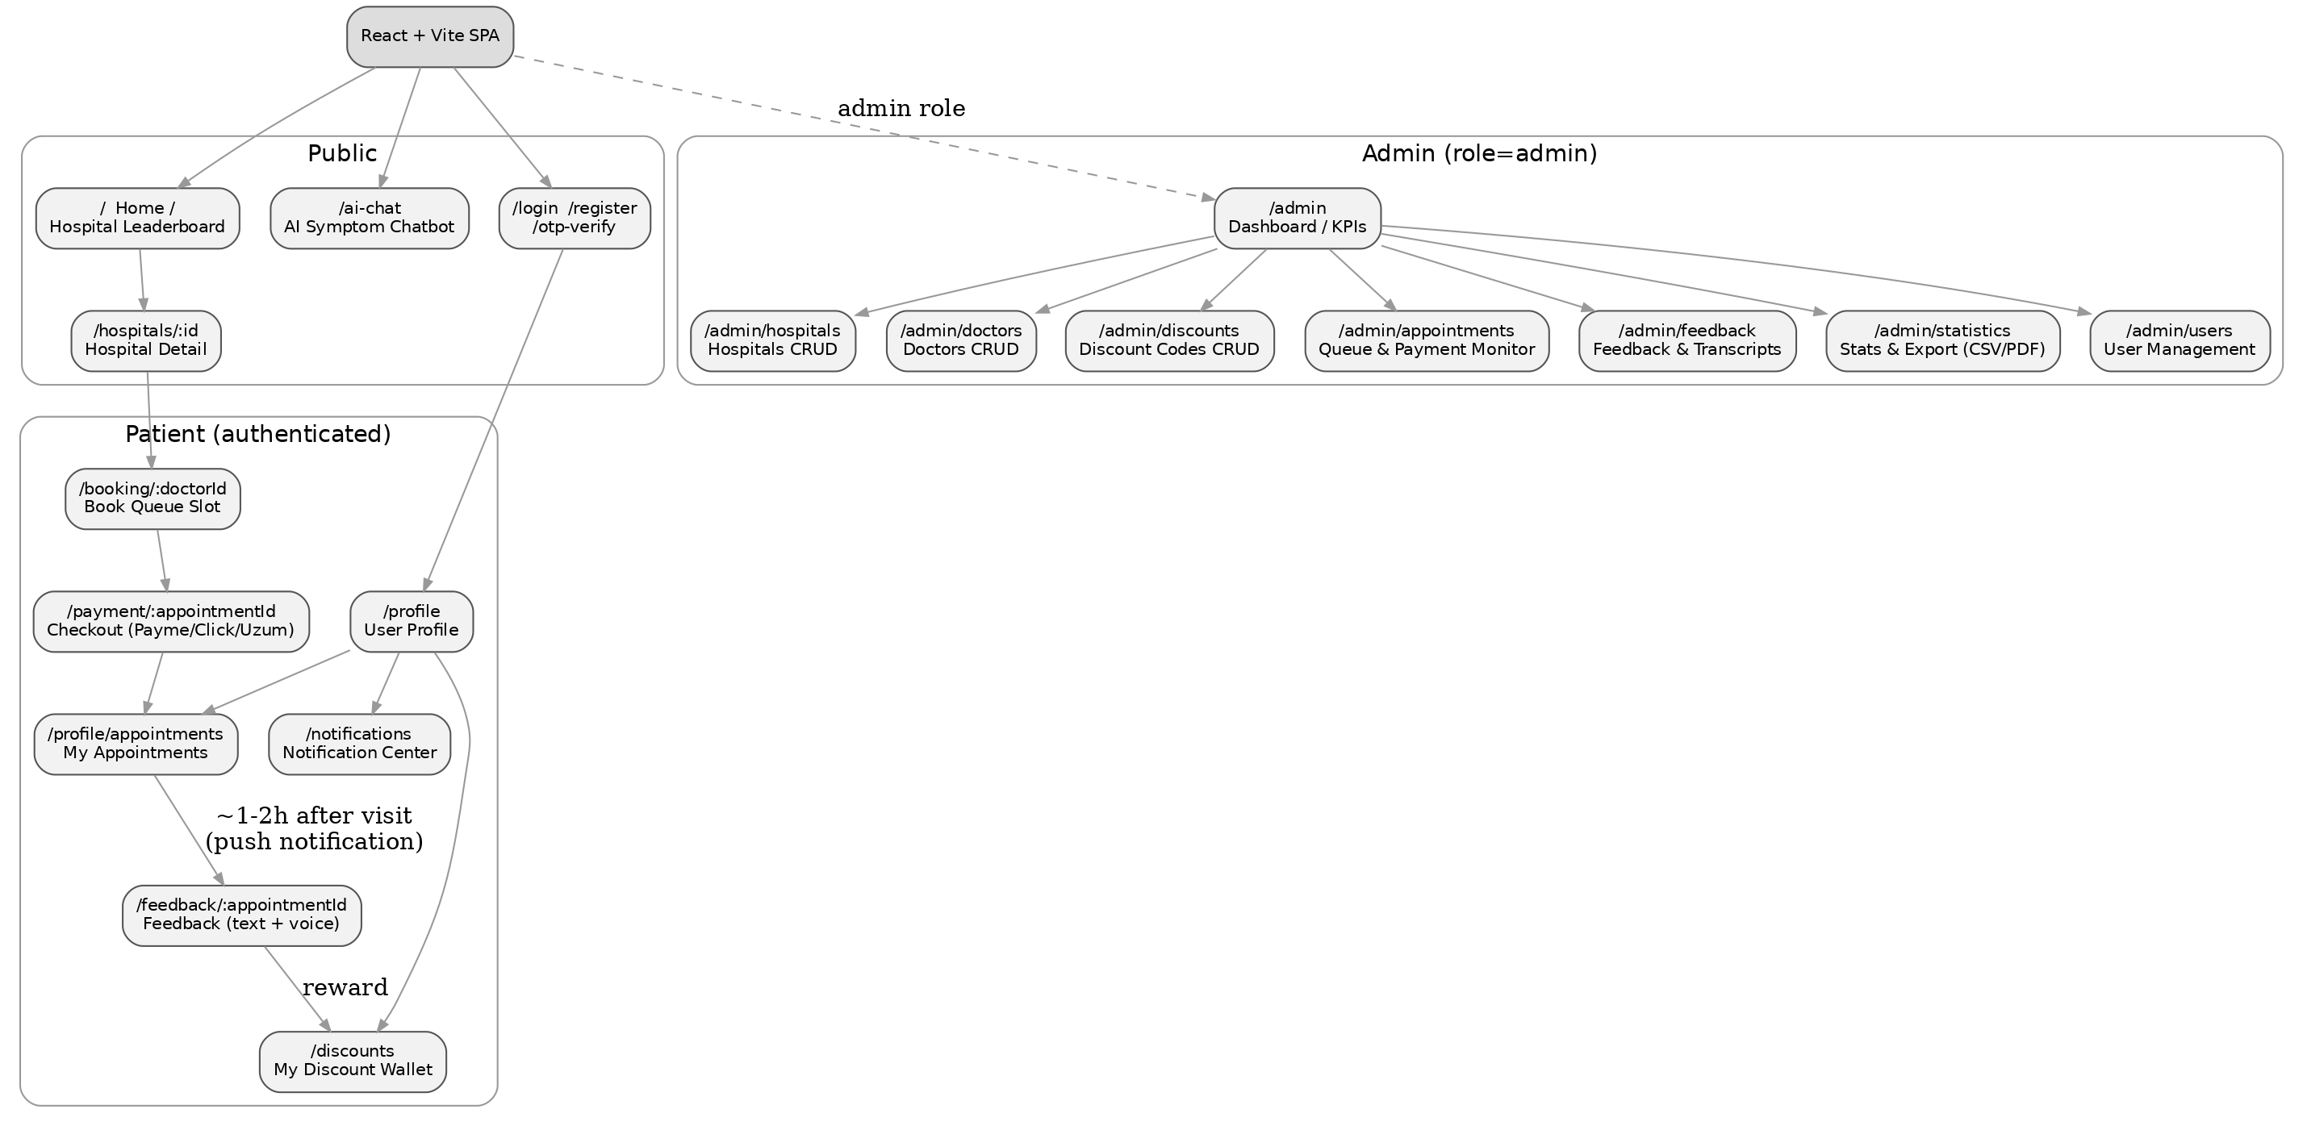
Figure 6 — Site map

7.1 Patient-Facing Pages
Route | Contains
/ (Home) | Search bar (symptom or hospital name), featured hospitals, quick links to Leaderboard and AI Chat.
/leaderboard | Ranked hospital list; filter by medical category and city; sort by score, distance, or rating.
/hospitals/:id | Hero image, geo map + 'Get Directions' button, tap-to-call numbers, working hours, doctor list with specialties, ratings/reviews summary.
/ai-chat | Conversational symptom intake; returns top 5 doctors ranked by category match, distance, and reputation, each with a Book button; medical disclaimer shown.
/login /register /otp-verify | Phone-first signup, OTP confirmation, password login/reset.
/booking/:doctorId | Slot picker from doctor's schedule, price display, Continue to Payment.
/payment/:appointmentId | Provider choice (Payme/Click/Uzum), hosted checkout redirect, status polling.
/profile | Personal info, language switch, saved payment history.
/profile/appointments | Upcoming and past queue tickets, cancel option, queue-position tracker.
/feedback/:appointmentId | Rating + icon tag chips + text box + voice recorder (see dedicated section below); reward reveal on submit.
/notifications | Feed of confirmations, feedback reminders, discount alerts.
/discounts | Wallet of earned/available discount codes with expiry.

7.2 Admin Dashboard Pages
Route | Contains
/admin | KPI dashboard: active users, today's appointments, revenue, top categories, feedback sentiment trend.
/admin/hospitals | CRUD table: name, address, geo picker, phones, hours, photo upload.
/admin/doctors | CRUD table linked to hospital + category, schedule editor.
/admin/discounts | Create/edit codes, set rules and validity, view redemption stats.
/admin/appointments | Live queue/payment monitor, filters by status/hospital/date.
/admin/feedback | Review list with transcripts, sentiment tag, filter by category/hospital.
/admin/statistics | Charts of visits per medical category over time (for drug-demand forecasting), exportable CSV/PDF.
/admin/users | User management, role changes, account status.
/admin/audit-log | Searchable log of all admin actions.

8. Feedback Page — Detailed Spec
Matches the requested reference design: icon-based multi-select reasons, plus rating, text, and voice.
- Step 1 — Rating: 1–5 stars or hearts, required.
- Step 2 — 'What did you like most?' icon chip grid, multi-select, admin-configurable per category:
  - Friendly doctor
  - Clean facility
  - Short wait time
  - Polite staff
  - Easy booking
  - Fair price
  - Clear explanation
  - On-time appointment
- Step 3 — Optional free-text comment box.
- Step 4 — Voice feedback: a record button using the browser MediaRecorder API (webm/opus); shows a live waveform, allows playback and re-record before submit.
- Step 5 — Submit → multipart POST /api/feedback; the audio is uploaded to object storage and transcribed asynchronously (STT worker); rating/tags/text are stored immediately.
- Step 6 — Success state reveals the earned discount code with a copy-to-clipboard action and adds it to /discounts.
Server-side, every feedback entry is tagged with the medical_category of the underlying appointment (not re-derived from the text), so per-category statistics stay accurate even before transcription completes.

9. Security, Scalability & Operations

9.1 Security
- PCI scope is minimized by redirecting to each gateway's hosted checkout (Payme Checkout / Click invoice / Uzum payment form) — card data never touches the backend.
- Role-based access control (patient/admin) enforced via FastAPI dependencies; every admin mutation writes to AdminAuditLog.
- Rate limiting (Redis token bucket) on OTP requests and the AI chat endpoint to prevent abuse and cost overrun.
- TLS everywhere; sensitive PII columns (phone, email) can use pgcrypto at-rest encryption if required by policy.
- Explicit user consent required for voice recording storage and AI processing, per O'zbekiston shaxsiy ma'lumotlar to'g'risidagi qonun (local personal data law).

9.2 Scalability
- FastAPI app servers scale horizontally behind Nginx/a load balancer; stateless by design (JWT, no server-side sessions).
- Celery workers scale independently — add dedicated STT worker pools during peak hours without touching API capacity.
- Redis and PostgreSQL read replicas as traffic grows; PostGIS indexes (GiST) keep distance queries fast at scale.

9.3 Operations
- CI/CD via GitHub Actions: lint → test → build Docker image → deploy.
- Observability: Sentry for errors, Prometheus/Grafana for metrics, Loki for centralized logs.
- Automated PostgreSQL backups (WAL + daily snapshots) and object storage versioning.

10. Local Integration Notes

10.1 Payments
PayTechUZ (open source) provides a unified client for Payme, Click, Uzum, Paynet and Octo with pre-built FastAPI/Django integrations and webhook handlers — recommended over building three separate gateway integrations. Official gateway docs: docs.payme.uz, docs.click.uz, developer.uzumbank.uz.

10.2 SMS OTP
Eskiz.uz is a widely used local SMS gateway with a documented OTP-sending method; requires registering for an API key and complying with Ministry of Digital Technologies rules on transactional SMS.

10.3 Speech-to-Text
For Uzbek/Russian voice feedback, evaluate Yandex SpeechKit (cloud, strong regional language support) for fastest MVP delivery, or self-hosted faster-whisper if voice volume grows and per-minute cloud costs become significant. Both can be swapped behind the same Celery STT task interface.

