**HW1: visualization**

1. **Creation of three different disk images**

The three disk images are as follows.

|  |  |  |
| --- | --- | --- |
| **Disk Image** | **Result** | **Commands for Creation** |
| **QEMU-qcow2** |  | **sudo qemu-system-x86_64**  **-hda ubuntu.img**  **-boot d**  **-cdrom ./ubuntu-20.04.6-live-server-amd64.iso**  **-m 2046**  **-boot strict=on** |
| **QEMU-raw** |  | **sudo qemu-system-x86_64**  **-drive format=raw, file=ubuntu_raw.raw**  **-boot d**  **-cdrom ./ubuntu-20.04.6-live-server-amd64.iso**  **-m 2046**  **-boot strict=on** |
| **Container** |  | **sudo docker pull ubuntu:20.04** |

1. **Present main steps to enable a QEMU VM. In addition, please present the detailed QEMU commands, and VM configurations: 10 points**

* Steps to enable a QEMU VM

Step1: install QEMU on a platform like Linux or window

Step2: download 20.04 ubuntu server operating system.

Step3: build a VM with the command mentioned below.

Step4: start the VM with the command mentioned below.

* Commands required

|  |  |
| --- | --- |
| **QEMU-qcow2** | 1. **sudo qemu-system-x86_64 -hda ubuntu.img -boot d -cdrom ./ubuntu-20.04.6-live-server-amd64.iso -m 2046** 2. **sudo qemu-system-x86_64 -hda ubuntu.img** |
| **QEMU-raw** | 1. **sudo qemu-system-x86_64 -drive format=raw, file=ubuntu_raw.raw -boot d -cdrom ./ubuntu-20.04.6-live-server-amd64.iso -m 2046 -boot strict=on** 2. **sudo qemu-system-x86_64 -driv format=raw,file=ubuntu_raw.raw** |

1. **Present main steps to create the Docker container. This must show your steps in creating your own image and your image history! Do not copy any classmate's image. In addition, please describe the operations you use to manage Docker containers (and some other operations which you think are also important): 10 points**

* Steps to create a container

Step1: install docker on a platform like Linux or window

Step2: pull a ubuntu server image for docker hub.

Step3: run the image

Step4: install the tools such as sysbench, SSH, sshpass.

Step5: exit the image, and then save the container as a new image named ubnutu-server:20.04

Step6: start the new image.

* Commands required

|  |  |
| --- | --- |
| Docker image | 1. Pull an image from hub   **sudo docker image pull ubuntu:20.04**   1. Run the image   **sudo run -it ubuntu:20.04 /bin/bash**   1. Install the tools on the image   **spt-get install sysbench**  **spt-get install ssh**  **spt-get install sshpass**   1. Exit the image 2. Show all active containers   **sudo docker ps -a**   1. Create a new image with the active container created by the original image   **sudo docker commit container_id new_name_image** |

1. **Proof of experiment. Include screen snapshots of your Docker and QEMU running environments for each experiment: 10 points**

* **QEMU**

1. Start QEMU

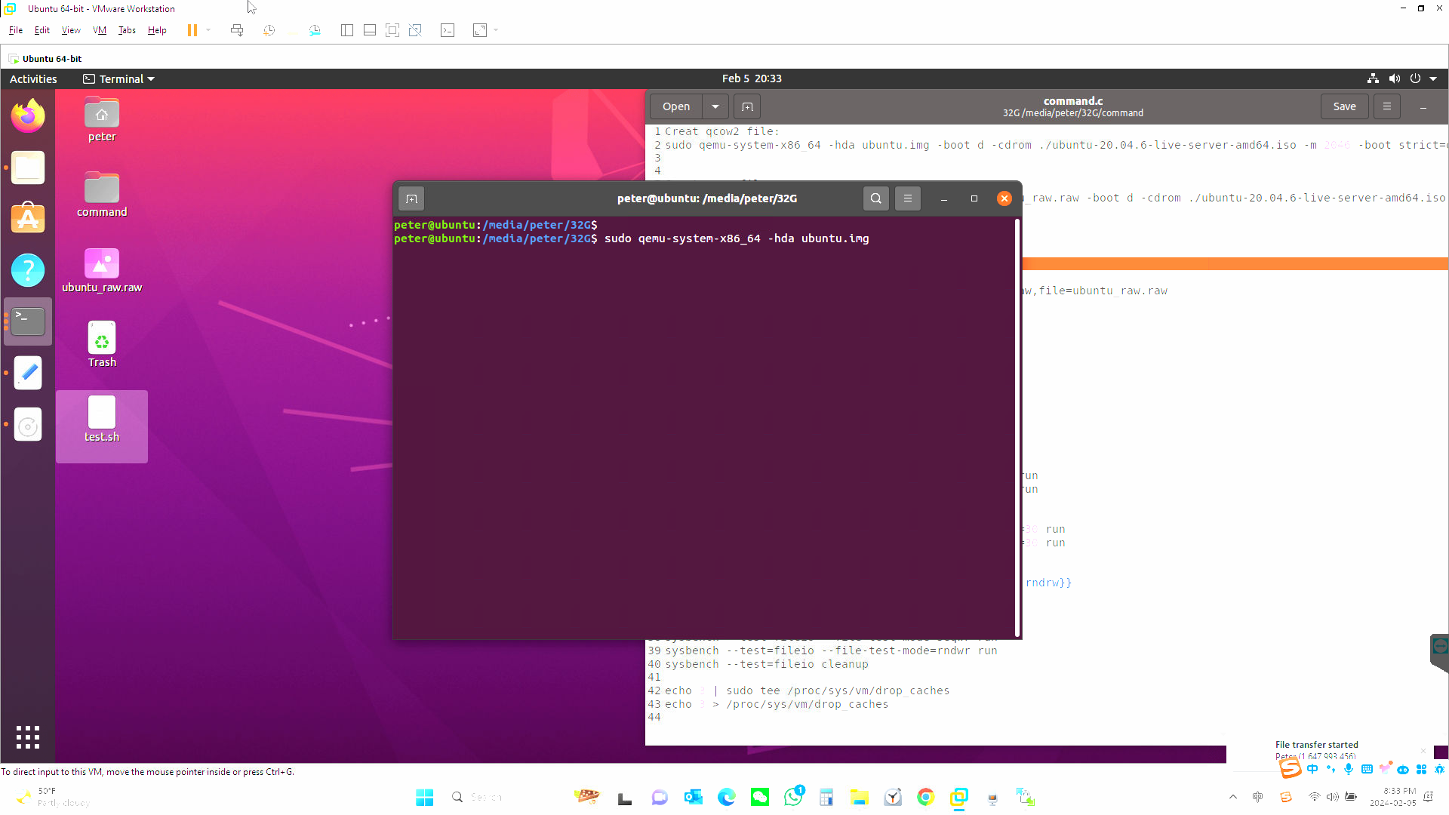

1. **Log in**

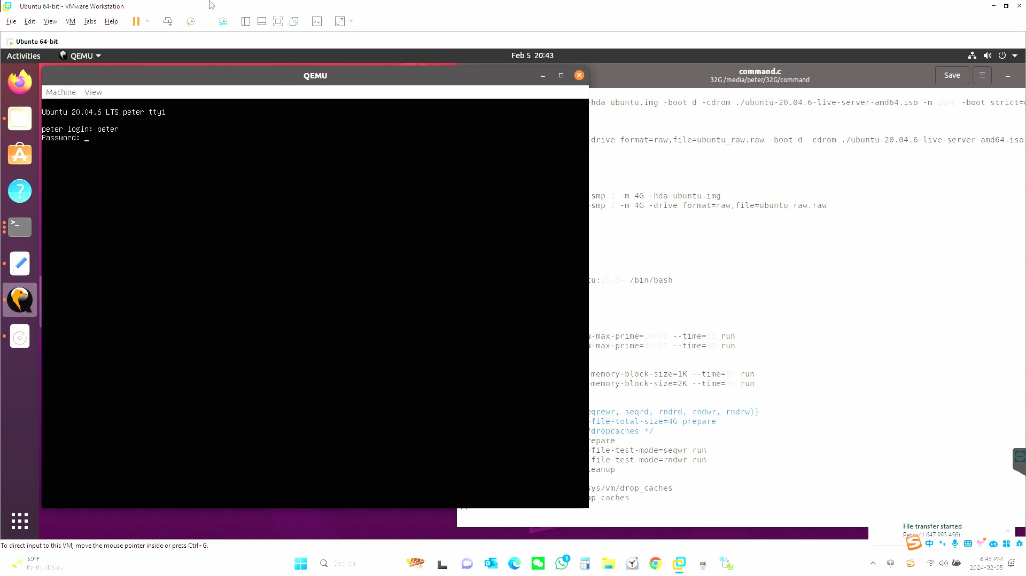

1. **System info**

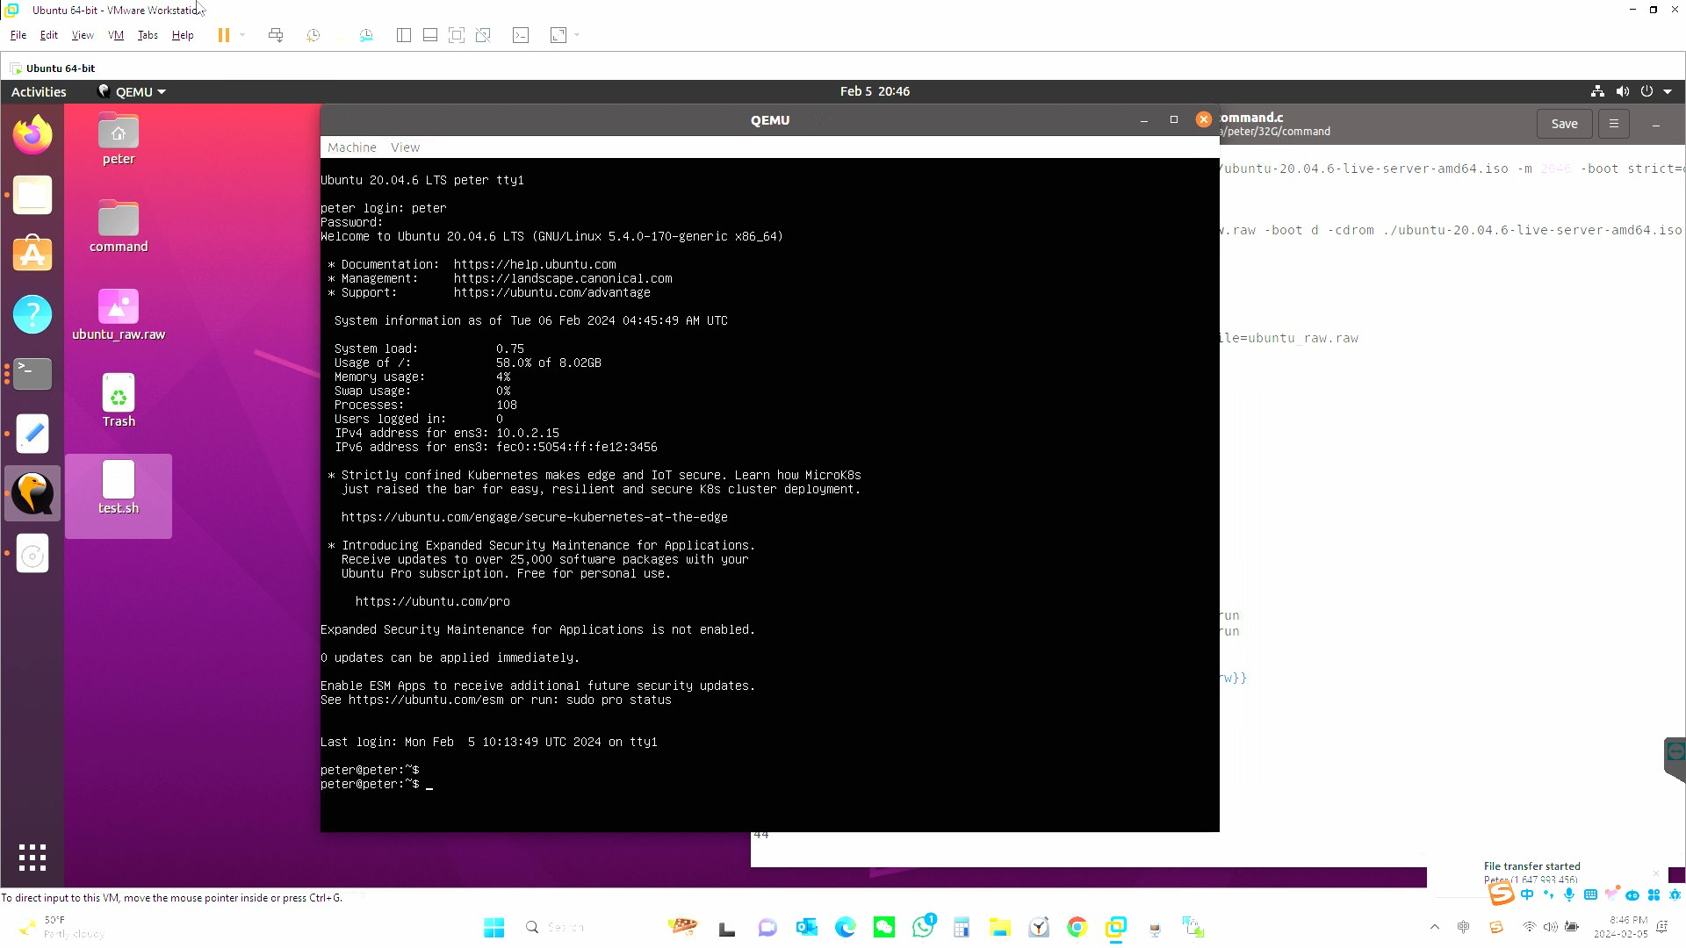

* **Container**

1. **Start container**

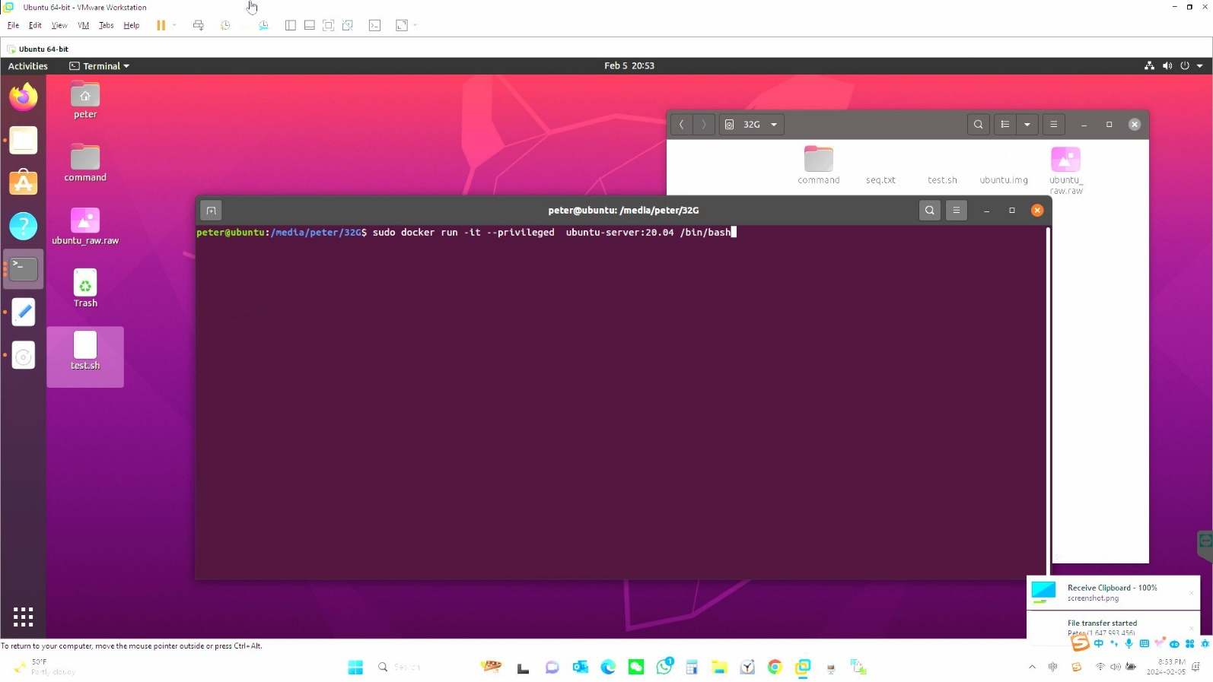

1. **System info**

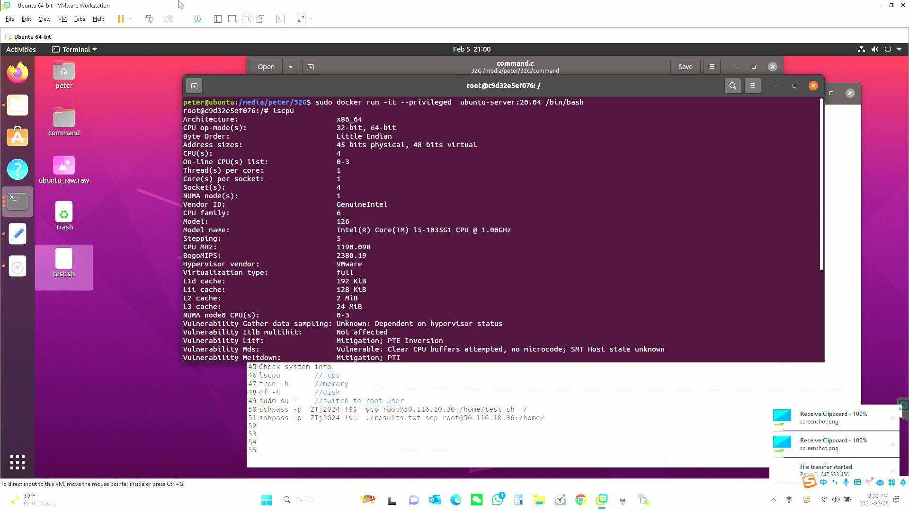

1. **Present your measurements in given different scenarios for each virtualization technology: 20 points**

* **For QEMU (qcow2)**

There are 24 test cases, and perform each test case 5 times. The experiment results are as follows.

**8 test cases for CPU**

|  |  |  |  |
| --- | --- | --- | --- |
| **Command** | **Cpus** | **Memory** | **Prime** |
| sudo qemu-system-x86_64 /  -smp 2 -m 2G -hda ubuntu.img | 2 | 2G | 10000 |
| 2 | 2G | 20000 |

|  |  |  |  |
| --- | --- | --- | --- |
| **Command** | **Cpus** | **Memory** | **Prime** |
| sudo qemu-system-x86_64 /  -smp 2 -m 4G -hda ubuntu.img | 2 | 4G | 10000 |
| 2 | 4G | 20000 |

|  |  |  |  |
| --- | --- | --- | --- |
| **Command** | **Cpus** | **Memory** | **Prime** |
| sudo qemu-system-x86_64 /  -smp 4 -m 2G -hda ubuntu.img | 4 | 2G | 10000 |
| 4 | 2G | 20000 |

|  |  |  |  |
| --- | --- | --- | --- |
| **Command** | **Cpus** | **Memory** | **Prime** |
| sudo qemu-system-x86_64 /  -smp 4 -m 4G -hda ubuntu.img | 4 | 4G | 10000 |
| 4 | 4G | 20000 |

**8 test cases for MEMORY**

|  |  |  |  |
| --- | --- | --- | --- |
| **Command** | **Cpus** | **Memory** | **Block Size** |
| sudo qemu-system-x86_64 /  -smp 2 -m 2G -hda ubuntu.img | 2 | 2G | 1K |
| 2 | 2G | 2K |

|  |  |  |  |
| --- | --- | --- | --- |
| **Command** | **Cpus** | **Memory** | **Block Size** |
| sudo qemu-system-x86_64 /  -smp 2 -m 4G -hda ubuntu.img | 2 | 4G | 1K |
| 2 | 4G | 2K |

|  |  |  |  |
| --- | --- | --- | --- |
| **Command** | **Cpus** | **Memory** | **Block Size** |
| sudo qemu-system-x86_64 /  -smp 4 -m 2G -hda ubuntu.img | 4 | 2G | 1K |
| 4 | 2G | 2K |

|  |  |  |  |
| --- | --- | --- | --- |
| **Command** | **Cpus** | **Memory** | **Block Size** |
| sudo qemu-system-x86_64 /  -smp 4 -m 4G -hda ubuntu.img | 4 | 4G | 1K |
| 4 | 4G | 2K |

**8 test cases for FILEIO**

|  |  |  |  |
| --- | --- | --- | --- |
| **Command** | **Cpus** | **Memory** | **mode** |
| sudo qemu-system-x86_64 /  -smp 2 -m 2G -hda ubuntu.img | 2 | 2G | seqrewr |
| 2 | 2G | rndwr |

|  |  |  |  |
| --- | --- | --- | --- |
| **Command** | **Cpus** | **Memory** | **mode** |
| sudo qemu-system-x86_64 /  -smp 2 -m 4G -hda ubuntu.img | 2 | 4G | seqrewr |
| 2 | 4G | rndwr |

|  |  |  |  |
| --- | --- | --- | --- |
| **Command** | **Cpus** | **Memory** | **mode** |
| sudo qemu-system-x86_64 /  -smp 4 -m 2G -hda ubuntu.img | 4 | 2G | seqrewr |
| 4 | 2G | rndwr |

|  |  |  |  |
| --- | --- | --- | --- |
| **Command** | **Cpus** | **Memory** | **mode** |
| sudo qemu-system-x86_64 /  -smp 4 -m 4G -hda ubuntu.img | 4 | 4G | seqrewr |
| 4 | 4G | rndwr |

* **For QEMU (RAW)**

There are 24 test cases, and perform each test case 5 times. The experiment results are as follows.

**8 test cases for CPU**

|  |  |  |  |
| --- | --- | --- | --- |
| **Command** | **Cpus** | **Memory** | **Prime** |
| sudo qemu-system-x86_64 /  -smp 2 -m 2G /  -drive format=raw,file=ubuntu_raw.raw | 2 | 2G | 10000 |
| 2 | 2G | 20000 |

|  |  |  |  |
| --- | --- | --- | --- |
| **Command** | **Cpus** | **Memory** | **Prime** |
| sudo qemu-system-x86_64 /  -smp 2 -m 4G /  -drive format=raw,file=ubuntu_raw.raw | 2 | 4G | 10000 |
| 2 | 4G | 20000 |

|  |  |  |  |
| --- | --- | --- | --- |
| **Command** | **Cpus** | **Memory** | **Prime** |
| sudo qemu-system-x86_64 /  -smp 4 -m 2G /  -drive format=raw,file=ubuntu_raw.raw | 4 | 2G | 10000 |
| 4 | 2G | 20000 |

|  |  |  |  |
| --- | --- | --- | --- |
| **Command** | **Cpus** | **Memory** | **Prime** |
| sudo qemu-system-x86_64 /  -smp 4 -m 4G /  -drive format=raw,file=ubuntu_raw.raw | 4 | 4G | 10000 |
| 4 | 4G | 20000 |

**8 test cases for MEMORY**

|  |  |  |  |
| --- | --- | --- | --- |
| **Command** | **Cpus** | **Memory** | **Block Size** |
| sudo qemu-system-x86_64 /  -smp 2 -m 2G /  -drive format=raw,file=ubuntu_raw.raw | 2 | 2G | 1K |
| 2 | 2G | 2K |

|  |  |  |  |
| --- | --- | --- | --- |
| **Command** | **Cpus** | **Memory** | **Block Size** |
| sudo qemu-system-x86_64 /  -smp 2 -m 4G /  -drive format=raw,file=ubuntu_raw.raw | 2 | 4G | 1K |
| 2 | 4G | 2K |

|  |  |  |  |
| --- | --- | --- | --- |
| **Command** | **Cpus** | **Memory** | **Block Size** |
| sudo qemu-system-x86_64 /  -smp 4 -m 2G /  -drive format=raw,file=ubuntu_raw.raw | 4 | 2G | 1K |
| 4 | 2G | 2K |

|  |  |  |  |
| --- | --- | --- | --- |
| **Command** | **Cpus** | **Memory** | **Block Size** |
| sudo qemu-system-x86_64 /  -smp 4 -m 4G /  -drive format=raw,file=ubuntu_raw.raw | 4 | 4G | 1K |
| 4 | 4G | 2K |

**8 test cases for FILEIO**

|  |  |  |  |
| --- | --- | --- | --- |
| **Command** | **Cpus** | **Memory** | **mode** |
| sudo qemu-system-x86_64 /  -smp 2 -m 2G /  -drive format=raw,file=ubuntu_raw.raw | 2 | 2G | seqrewr |
| 2 | 2G | rndwr |

|  |  |  |  |
| --- | --- | --- | --- |
| **Command** | **Cpus** | **Memory** | **mode** |
| sudo qemu-system-x86_64 /  -smp 2 -m 4G /  -drive format=raw,file=ubuntu_raw.raw | 2 | 4G | seqrewr |
| 2 | 4G | rndwr |

|  |  |  |  |
| --- | --- | --- | --- |
| **Command** | **Cpus** | **Memory** | **mode** |
| sudo qemu-system-x86_64 /  -smp 4 -m 2G /  -drive format=raw,file=ubuntu_raw.raw | 4 | 2G | seqrewr |
| 4 | 2G | rndwr |

|  |  |  |  |
| --- | --- | --- | --- |
| **Command** | **Cpus** | **Memory** | **mode** |
| sudo qemu-system-x86_64 /  -smp 4 -m 4G /  -drive format=raw,file=ubuntu_raw.raw | 4 | 4G | seqrewr |
| 4 | 4G | rndwr |

* **Container**

There are 24 test cases, and perform each test case 5 times. The experiment results are as follows.

**8 test cases for CPU**

|  |  |  |  |
| --- | --- | --- | --- |
| **Command** | **Cpus** | **Memory** | **Prime** |
| sudo docker run -it --privileged /  --cpus=2 --memory=2G /  ubuntu-server:20.04 /bin/bash | 2 | 2G | 10000 |
| 2 | 2G | 20000 |

|  |  |  |  |
| --- | --- | --- | --- |
| **Command** | **Cpus** | **Memory** | **Prime** |
| sudo docker run -it --privileged /  --cpus=2 --memory=4G /  ubuntu-server:20.04 /bin/bash | 2 | 4G | 10000 |
| 2 | 4G | 20000 |

|  |  |  |  |
| --- | --- | --- | --- |
| **Command** | **Cpus** | **Memory** | **Prime** |
| sudo docker run -it --privileged /  --cpus=4 --memory=2G /  ubuntu-server:20.04 /bin/bash | 4 | 2G | 10000 |
| 4 | 2G | 20000 |

|  |  |  |  |
| --- | --- | --- | --- |
| **Command** | **Cpus** | **Memory** | **Prime** |
| sudo docker run -it --privileged /  --cpus=4 --memory=4G /  ubuntu-server:20.04 /bin/bash | 4 | 4G | 10000 |
| 4 | 4G | 20000 |

**8 test cases for MEMORY**

|  |  |  |  |
| --- | --- | --- | --- |
| **Command** | **Cpus** | **Memory** | **Block Size** |
| sudo docker run -it --privileged /  --cpus=2 --memory=2G /  ubuntu-server:20.04 /bin/bash | 2 | 2G | 1K |
| 2 | 2G | 2K |

|  |  |  |  |
| --- | --- | --- | --- |
| **Command** | **Cpus** | **Memory** | **Block Size** |
| sudo docker run -it --privileged /  --cpus=2 --memory=4G /  ubuntu-server:20.04 /bin/bash | 2 | 4G | 1K |
| 2 | 4G | 2K |

|  |  |  |  |
| --- | --- | --- | --- |
| **Command** | **Cpus** | **Memory** | **Block Size** |
| sudo docker run -it --privileged /  --cpus=4 --memory=2G /  ubuntu-server:20.04 /bin/bash | 4 | 2G | 1K |
| 4 | 2G | 2K |

|  |  |  |  |
| --- | --- | --- | --- |
| **Command** | **Cpus** | **Memory** | **Block Size** |
| sudo docker run -it --privileged /  --cpus=4 --memory=4G /  ubuntu-server:20.04 /bin/bash | 4 | 4G | 1K |
| 4 | 4G | 2K |

**8 test cases for FILEIO**

|  |  |  |  |
| --- | --- | --- | --- |
| **Command** | **Cpus** | **Memory** | **mode** |
| sudo docker run -it --privileged /  --cpus=2 --memory=2G /  ubuntu-server:20.04 /bin/bash | 2 | 2G | seqrewr |
| 2 | 2G | rndwr |

|  |  |  |  |
| --- | --- | --- | --- |
| **Command** | **Cpus** | **Memory** | **mode** |
| sudo docker run -it --privileged /  --cpus=2 --memory=4G /  ubuntu-server:20.04 /bin/bash | 2 | 4G | seqrewr |
| 2 | 4G | rndwr |

|  |  |  |  |
| --- | --- | --- | --- |
| **Command** | **Cpus** | **Memory** | **mode** |
| sudo docker run -it --privileged /  --cpus=4 --memory=2G /  ubuntu-server:20.04 /bin/bash | 4 | 2G | seqrewr |
| 4 | 2G | rndwr |

|  |  |  |  |
| --- | --- | --- | --- |
| **Command** | **Cpus** | **Memory** | **mode** |
| sudo docker run -it --privileged /  --cpus=4 --memory=4G /  ubuntu-server:20.04 /bin/bash | 4 | 4G | seqrewr |
| 4 | 4G | rndwr |

1. **Shell scripts for running the experiment: 10 points**

The shell script is used for performing the experiment automatically.

|  |
| --- |
| #!/bin/bash  #/** */  touch "results.txt"  #/** Init */  K=(1 2 3 4 5)  CPU=("10000" "20000")  MEMORY=("1k" "2k")  FILEIO=("seqrewr" "rndwr")  #/** Execute commands */  echo "################ CPU #################" | tee -a results.txt  for k in "${K[@]}"; do  #/** compute five times */  echo "******* $k ******" | tee -a results.txt  #/** CPU */  for cpu in "${CPU[@]}"; do  echo "@@@ $cpu " | tee -a results.txt  sysbench --test=cpu --cpu-max-prime=$cpu /  --time=30 run | tee -a results.txt  echo "" | tee -a results.txt  done  done  echo "################ MEMO #################"| tee -a results.txt  for k in "${K[@]}"; do  #/** MEMO */  echo "********** $k *************" | tee -a results.txt  for memo in "${MEMORY[@]}"; do  echo "@@@ $memo " | tee -a results.txt  sysbench --test=memory --memory-block-size=$memo /  --time=30 run | tee -a results.txt  echo "" | tee -a results.txt  done  done  echo "################# FILEIO ##############" | tee -a results.txt  for k in "${K[@]}"; do  #/** FILEIO */  echo "*********** $k *************" | tee -a results.txt  for fileio in "${FILEIO[@]}"; do  echo "@@@ $fileio " | tee -a results.txt  /** prepare data */  sysbench --test=fileio prepare  sysbench --test=fileio --file-test-mode=$fileio /  --time=30 run | tee -a results.txt /  sysbench --test=fileio cleanup  echo "" | tee -a results.txt    #/** clean cache */  echo 3 > /proc/sys/vm/drop_caches | tee -a results.txt  done  done  echo "################ UPLOAD ###############" | tee -a results.txt  sshpass -p 'ZTj2024!!$$' scp ./results.txt root@50.116.10.36:/home/  echo "success!" | tee -a results.txt  echo "################ DELETE ################"  rm results.txt |
|  |

**Table1 shell script**

1. **Presentation and analysis of the performance data: 20 points**
2. **Qemu(qcow2)**

**Cpus = 2, Memory = 2G**

|  |  |  |  |  |  |
| --- | --- | --- | --- | --- | --- |
| **CPUs** | **MEMORY** | **Prime** | **min** | **avg** | **max** |
| 2 | 2G | 10000 | 2.272 | 3.71 | 91.78 |
| 2 | 2G | 20000 | 6.36 | 9.23 | 94.9 |

|  |  |  |  |  |  |
| --- | --- | --- | --- | --- | --- |
| CPUs | MEMORY | Block size | min | avg | max |
| 2 | 2G | 1k | 0 | 0 | 23.248 |
| 2 | 2G | 2k | 0 | 0 | 25.504 |

|  |  |  |  |  |  |
| --- | --- | --- | --- | --- | --- |
| CPUs | MEMORY | FiloIO | min | avg | max |
| 2 | 2G | Seq | 0.05 | 0.422 | 76.522 |
| 2 | 2G | Rnd | 0.026 | 0.978 | 99.396 |

**Cpus = 2, Memory = 4G**

|  |  |  |  |  |  |
| --- | --- | --- | --- | --- | --- |
| **CPUs** | **MEMORY** | **Prime** | **min** | **avg** | **max** |
| 2 | 4G | 10000 | 2.84 | 3.99 | 29.19 |
| 2 | 4G | 20000 | 5.81 | 7.89 | 34.33 |

|  |  |  |  |  |  |
| --- | --- | --- | --- | --- | --- |
| CPUs | MEMORY | Block size | min | avg | max |
| 2 | 4G | 1k | 0 | 0 | 18.026 |
| 2 | 4G | 2k | 0 | 0 | 16.054 |

|  |  |  |  |  |  |
| --- | --- | --- | --- | --- | --- |
| CPUs | MEMORY | FiloIO | min | avg | max |
| 2 | 4G | seq | 0.03 | 0.4 | 95.374 |
| 2 | 4G | rnd | 0.024 | 0.928 | 89.854 |

**Cpus =4, Memory = 2G**

|  |  |  |  |  |  |
| --- | --- | --- | --- | --- | --- |
| **CPUs** | **MEMORY** | **Prime** | **min** | **avg** | **max** |
| 4 | 2G | 10000 | 2.17 | 2.816 | 39.946 |
| 4 | 2G | 20000 | 5.766 | 7.136 | 26.282 |

|  |  |  |  |  |  |
| --- | --- | --- | --- | --- | --- |
| CPUs | MEMORY | Block size | min | avg | max |
| 4 | 2G | 1k | 0 | 0 | 14.93 |
| 4 | 2G | 2k | 0 | 0 | 12.69 |

|  |  |  |  |  |  |
| --- | --- | --- | --- | --- | --- |
| CPUs | MEMORY | FiloIO | min | avg | max |
| 4 | 2G | seq | 0.042 | 0.442 | 56.828 |
| 4 | 2G | rnd | 0.024 | 0.824 | 49.362 |

**Cpus = 4, Memory = 4G**

|  |  |  |  |  |  |
| --- | --- | --- | --- | --- | --- |
| **CPUs** | **MEMORY** | **Prime** | **min** | **avg** | **max** |
| 4 | 4G | 10000 | 2.142 | 2.86 | 18.466 |
| 4 | 4G | 20000 | 5.676 | 6.936 | 23.794 |

|  |  |  |  |  |  |
| --- | --- | --- | --- | --- | --- |
| CPUs | MEMORY | Block size | min | avg | max |
| 4 | 4G | 1k | 0 | 0 | 15.214 |
| 4 | 4G | 2k | 0 | 0 | 17.706 |

|  |  |  |  |  |  |
| --- | --- | --- | --- | --- | --- |
| CPUs | MEMORY | FiloIO | min | avg | max |
| 4 | 4G | seq | 0.02 | 0.36 | 45.284 |
| 4 | 4G | rnd | 0.024 | 0.874 | 42.664 |

1. **Qemu(RAW)**

**Cpus = 2, Memory = 2G**

|  |  |  |  |  |  |
| --- | --- | --- | --- | --- | --- |
| **CPUs** | **MEMORY** | **Prime** | **min** | **avg** | **max** |
| 2 | 2G | 10000 | 2.158 | 3.284 | 48.716 |
| 2 | 2G | 20000 | 5.754 | 7.626 | 46.552 |

|  |  |  |  |  |  |
| --- | --- | --- | --- | --- | --- |
| CPUs | MEMORY | Block size | min | avg | max |
| 2 | 2G | 1k | 0 | 0 | 5.73 |
| 2 | 2G | 2k | 0 | 0 | 7.964 |

|  |  |  |  |  |  |
| --- | --- | --- | --- | --- | --- |
| CPUs | MEMORY | FiloIO | min | avg | max |
| 2 | 2G | seq | 0.042 | 0.312 | 19.566 |
| 2 | 2G | rnd | 0.022 | 0.706 | 33.312 |

**Cpus = 2, Memory = 4G**

|  |  |  |  |  |  |
| --- | --- | --- | --- | --- | --- |
| **CPUs** | **MEMORY** | **Prime** | **min** | **avg** | **max** |
| 2 | 4G | 10000 | 2.154 | 3.362 | 31.05 |
| 2 | 4G | 20000 | 5.888 | 8.69 | 44.33 |

|  |  |  |  |  |  |
| --- | --- | --- | --- | --- | --- |
| CPUs | MEMORY | Block size | min | avg | max |
| 2 | 4G | 1k | 0 | 0 | 17.762 |
| 2 | 4G | 2k | 0 | 0 | 18.008 |

|  |  |  |  |  |  |
| --- | --- | --- | --- | --- | --- |
| CPUs | MEMORY | FiloIO | min | avg | max |
| 2 | 4G | seq | 0.024 | 0.394 | 75.674 |
| 2 | 4G | rnd | 0.024 | 1.006 | 85.932 |

**Cpus = 4, Memory = 2G**

|  |  |  |  |  |  |
| --- | --- | --- | --- | --- | --- |
| **CPUs** | **MEMORY** | **Prime** | **min** | **avg** | **max** |
| 4 | 2G | 10000 | 2.288 | 3.79 | 53.662 |
| 4 | 2G | 20000 | 5.982 | 8.732 | 56.116 |

|  |  |  |  |  |  |
| --- | --- | --- | --- | --- | --- |
| CPUs | MEMORY | Block size | min | avg | max |
| 4 | 2G | 1k | 0 | 0 | 57.716 |
| 4 | 2G | 2k | 0 | 0 | 59.154 |

|  |  |  |  |  |  |
| --- | --- | --- | --- | --- | --- |
| CPUs | MEMORY | FiloIO | min | avg | max |
| 4 | 2G | seq | 0.062 | 1.082 | 124.124 |
| 4 | 2G | rnd | 0.032 | 1.93 | 168.43 |

**Cpus = 4, Memory = 4G**

|  |  |  |  |  |  |
| --- | --- | --- | --- | --- | --- |
| **CPUs** | **MEMORY** | **Prime** | **min** | **avg** | **max** |
| 4 | 4G | 10000 | 2.168 | 3.238 | 55.16 |
| 4 | 4G | 20000 | 5.932 | 7.932 | 43.622 |

|  |  |  |  |  |  |
| --- | --- | --- | --- | --- | --- |
| CPUs | MEMORY | Block size | min | avg | max |
| 4 | 4G | 1k | 0 | 0 | 27.928 |
| 4 | 4G | 2k | 0 | 0 | 28.022 |

|  |  |  |  |  |  |
| --- | --- | --- | --- | --- | --- |
| CPUs | MEMORY | FiloIO | min | avg | max |
| 4 | 4G | seq | 0.028 | 0.45 | 106.908 |
| 4 | 4G | rnd | 0.026 | 0.966 | 98.672 |

1. **Docker**

**Cpus = 2, Memory = 2G**

|  |  |  |  |  |  |
| --- | --- | --- | --- | --- | --- |
| **CPUs** | **MEMORY** | **Prime** | **min** | **avg** | **max** |
| 2 | 2G | 10000 | 0.32 | 0.452 | 34.586 |
| 2 | 2G | 20000 | 0.84 | 1.118 | 27.442 |

|  |  |  |  |  |  |
| --- | --- | --- | --- | --- | --- |
| CPUs | MEMORY | Block size | min | avg | max |
| 2 | 2G | 1k | 0 | 0 | 16.112 |
| 2 | 2G | 2k | 0 | 0 | 22.74 |

|  |  |  |  |  |  |
| --- | --- | --- | --- | --- | --- |
| CPUs | MEMORY | FiloIO | min | avg | max |
| 2 | 2G | seq | 0 | 0.076 | 11068.354 |
| 2 | 2G | rnd | 0 | 0.124 | 4616.096 |

**Cpus = 2, Memory = 4G**

|  |  |  |  |  |  |
| --- | --- | --- | --- | --- | --- |
| **CPUs** | **MEMORY** | **Prime** | **min** | **avg** | **max** |
| 2 | 4G | 10000 | 0.406 | 0.49 | 34.546 |
| 2 | 4G | 20000 | 1.078 | 1.25 | 36.058 |

|  |  |  |  |  |  |
| --- | --- | --- | --- | --- | --- |
| CPUs | MEMORY | Block size | min | avg | max |
| 2 | 4G | 1k | 0 | 0 | 27.21 |
| 2 | 4G | 2k | 0 | 0 | 10.142 |

|  |  |  |  |  |  |
| --- | --- | --- | --- | --- | --- |
| CPUs | MEMORY | FiloIO | min | avg | max |
| 2 | 4G | seq | 0 | 0.072 | 5893.68 |
| 2 | 4G | rnd | 0 | 0.13 | 4825.658 |

**Cpus = 4, Memory = 2G**

|  |  |  |  |  |  |
| --- | --- | --- | --- | --- | --- |
| **CPUs** | **MEMORY** | **Prime** | **min** | **avg** | **max** |
| 4 | 2G | 10000 | 0.446 | 0.61 | 36.644 |
| 4 | 2G | 20000 | 1.156 | 1.546 | 41.526 |

|  |  |  |  |  |  |
| --- | --- | --- | --- | --- | --- |
| CPUs | MEMORY | Block size | min | avg | max |
| 4 | 2G | 1k | 0 | 0 | 17.632 |
| 4 | 2G | 2k | 0 | 0 | 10.078 |

|  |  |  |  |  |  |
| --- | --- | --- | --- | --- | --- |
| CPUs | MEMORY | FiloIO | min | avg | max |
| 2 | 2G | seq | 0 | 0.052 | 4129 |
| 2 | 2G | rnd | 0 | 0.13 | 857.616 |

**Cpus = 4, Memory = 4G**

|  |  |  |  |  |  |
| --- | --- | --- | --- | --- | --- |
| **CPUs** | **MEMORY** | **Prime** | **min** | **avg** | **max** |
| 4 | 4G | 10000 | 0.32 | 0.424 | 2.786 |
| 4 | 4G | 20000 | 0.848 | 1.126 | 179.568 |

|  |  |  |  |  |  |
| --- | --- | --- | --- | --- | --- |
| CPUs | MEMORY | Block size | min | avg | max |
| 4 | 4G | 1k | 0 | 0 | 1.992 |
| 4 | 4G | 2k | 0 | 0 | 1.48 |

|  |  |  |  |  |  |
| --- | --- | --- | --- | --- | --- |
| CPUs | MEMORY | FiloIO | min | avg | max |
| 4 | 4G | seq | 0 | 0.022 | 138.08 |
| 4 | 4G | rnd | 0 | 0.164 | 5088.78 |

**As depicted above, the comparison among the three ways is as follow.**

|  |  |  |
| --- | --- | --- |
| **CPUs** | **MEMORY** | **Performance (average latency)** |
| 2 | 2G | Docker < Qemu(raw) < Qemu(qcow2) |
| 2 | 4G | Docker < Qemu(raw) < Qemu(qcow2) |
| 4 | 2G | Docker < Qemu(raw) <= Qemu(qcow2) |
| 4 | 4G | Docker < Qemu(qcow2) <= Qemu(raw) |

**Table 2 comparison results**

It's important to consider, Docker is much faster in terms of latency than both QEMU(qcow2) and QEMU(raw). For both QEMU(qcow2) and QEMU(raw), in the context of limited resources like CPU and memory, QEMU(raw) potentially outperform in terms of latency. However, if the resources become more powerful, QEMU(qcow2) will have lower latency than QEMU(raw).