Name: Rajkumar Kushwaha

Course: CSC725 Homework 2 Report

A three-block convolutional neural network was trained on the full CIFAR-10 training set and evaluated once on the held-out test set after 10 epochs. The final model achieved 70.93% test accuracy. The report records the architecture, training results, and the required manual model-complexity analysis.

Architecture and data
Each convolution uses a 3 × 3 kernel, stride 1, padding 1, and a bias. It is followed by ReLU and 2 × 2 max pooling with stride 2. The last feature map is flattened and sent to a linear layer that produces ten class logits.
Stage | Output shape | Operation
Input | 3 × 32 × 32 | RGB image
Block 1 | 16 × 16 × 16 | Conv 3→16, ReLU, max pool
Block 2 | 32 × 8 × 8 | Conv 16→32, ReLU, max pool
Block 3 | 64 × 4 × 4 | Conv 32→64, ReLU, max pool
Classifier | 10 | Flatten 1,024 features; linear 1,024→10

The data came from torchvision.datasets.CIFAR10: 50,000 training images and 10,000 test images. Inputs were converted to tensors and normalized from [0, 1] to [-1, 1]. DataLoader used batches of 128 and shuffled the training set; no samples were dropped. The test set was reserved for final evaluation.

What each layer contributes
Convolutions learn spatial features with weights shared across image locations. ReLU lets successive layers represent nonlinear patterns. Max pooling reduces spatial resolution from 32 to 16 to 8 to 4 pixels per side, while retaining strong local responses. The linear layer combines the resulting 1,024 features into ten class scores.

Training and evaluation
Cross-entropy loss and Adam with learning rate 0.001 were used for 10 epochs. The run used seed 725 and Apple MPS execution. Each epoch processed all 50,000 training images. Training loss is averaged by sample count, including the short final batch; training accuracy is the fraction correct during that epoch. These online metrics are recorded before each mini-batch parameter update.
Epoch | Training loss | Training accuracy | Images
1 | 1.581941 | 43.08% | 50,000
2 | 1.248324 | 55.85% | 50,000
3 | 1.108871 | 61.27% | 50,000
4 | 1.004164 | 64.94% | 50,000
5 | 0.938810 | 67.48% | 50,000
6 | 0.879292 | 69.56% | 50,000
7 | 0.830892 | 71.32% | 50,000
8 | 0.791003 | 72.68% | 50,000
9 | 0.755155 | 74.14% | 50,000
10 | 0.720605 | 75.27% | 50,000

Training curves
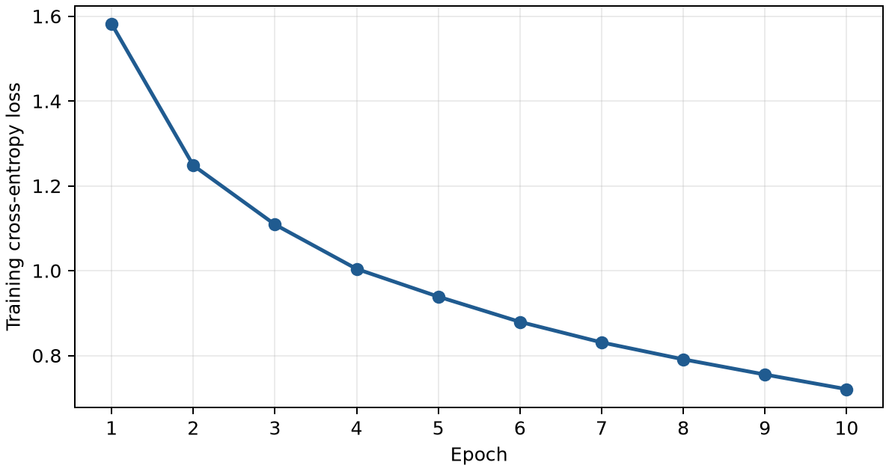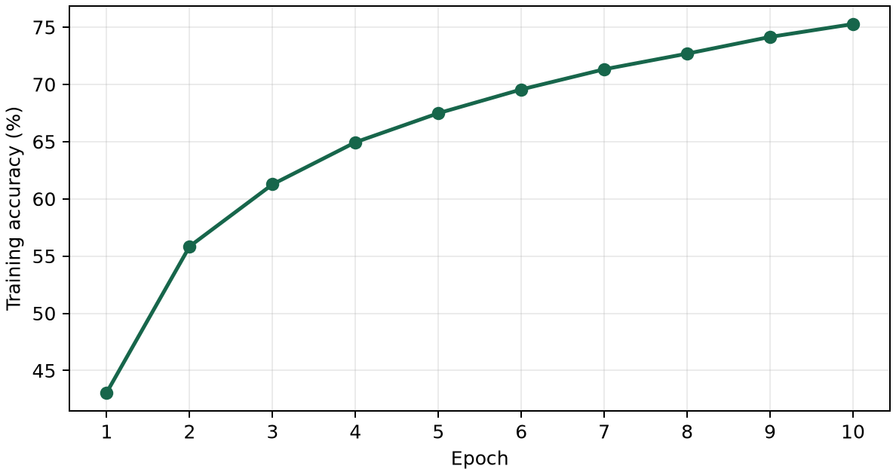
Loss decreased from 1.581941 to 0.720605, while online training accuracy rose from 43.08% to 75.27%. After training, the model was switched to evaluation mode and run on the test set without gradient calculation. It correctly classified 7,093 of 10,000 images: 70.93% test accuracy and 0.847338 test loss. The test set did not select a checkpoint or training configuration. The training and test accuracies differ, but the online training value is not a fixed-model evaluation, so their gap alone does not measure overfitting precisely.

Extra Credit: Model Complexity Analysis

The implemented count_parameters function counts trainable weight and bias elements in each convolutional and linear layer. The calculate_flops function obtains each layer's output dimensions and applies the specified formulas. It uses no external model-profiling package. Per the assignment, one multiplication counts as one FLOP; additions, bias operations, ReLU, and pooling are excluded.
Layer | Weights | Biases | Total parameters | FLOPs per image
Conv1 | 432 | 16 | 448 | 442,368
Conv2 | 4,608 | 32 | 4,640 | 1,179,648
Conv3 | 18,432 | 64 | 18,496 | 1,179,648
Linear | 10,240 | 10 | 10,250 | 10,240
Total | 33,712 | 122 | 33,834 | 2,811,904

Manual check of the first convolution:

H_out = W_out = (32 + 2 × 1 − 3) / 1 + 1 = 32
Parameters = 16 × (3 × 3 × 3 + 1) = 448 = 432 weights + 16 biases
FLOPs = 32 × 32 × 16 × 3 × 3 × 3 = 442,368 multiplications
The manual Conv1 values match the function output. As a second check, the final 64 × 4 × 4 feature map has 1,024 elements, so the linear layer has 1,024 × 10 + 10 = 10,250 parameters and 1,024 × 10 = 10,240 multiplication FLOPs.

Implementation challenges and checks:
Tracking the three pooling stages established the classifier's 1,024 inputs. For the FLOP calculation, convolution dimensions are measured before their following pooling layer. Sample-weighted averaging handles the last, smaller mini-batch correctly.
The saved checkpoint was reloaded to reproduce the final test predictions and metrics. Automated implementation checks passed for the architecture, training outputs, and complexity calculations.

