**CHAPTER 1: INTRODUCTION**

Smart Vital is a portable health monitoring device. It is designed to measure vital signs of an individual. It includes Sp0₂ level, heart rate, ECG, temperature, and blood pressure measurement by utilizing embedded system and IoT. The device provides easy and quick access to essential health parameters in real-time through locally as well as through mobile application. The main purpose for the development of the device is to facilitate users with a reliable and user-friendly product for healthcare management system.

The device is developed so that it can be placed at first aid or medical box at home or it can be used while travelling as it is compact and easy to carry. A single compact device is used unlike having different devices for measuring health vitals. It offering all in one general health measurement, making sure that you have all the necessary health information well within access whether you are on the go or at home. The device Smart Vitals fulfils the increase in the need and demand of the health care system as it is portable and convenient to use. The system uses ESP32 WROVER as microcontroller, which is the main processing segment for collecting the data from sensors like Max30100, AD8232, 10K NTC Thermistor temperature sensor. The readings from the sensor are locally access via OLED display and also transmitted to mobile application made via Flutter. If there is any abnormality in the reading, a alert message is sent, ensuring timely intervention.

……………..

**CHAPTER 2: REVIEW OF LITERATURE**

The continuous advancement in technologies in health care has led to advanced approaches like Smart Vitals. The importance of products like Smart Vitals has emerged as a necessary device in healthcare and management due to the rapid global interest for its portability and remote health monitoring features. The incorporation of IoT and micro-controller enable the device to provide users with essential health vitals giving a proper and prompt insights into a person's health state providing assurance to the user. By gaining knowledge on personal health, it allows users to take an active part in maintaining their health and taking precautions as needed. As the device has features such as being portable and remotely accessibility, it makes devices like Smart Vitals to be effective and beneficial for any individual to keep track of their health, even on the areas with insufficient healthcare facilities.

Smart Vitals: A Portable Health Monitoring System, summarizes the importance of compact device, high-tech health monitoring system via advanced technology. It focuses on device's intelligence, accessibility with user friendly components making it advanced, accurate and efficient health measuring system made to achieve present days' requirements. The device helps to tackle obstacles related to healthcare management by allowing users to view their real time health vitals. One of the major benefits is the ability to minimize the need for medical visits for regular health check-ups, reducing expense and saving time. In todays' modern market, people are more inclined towards smart healthcare system including wearable technologies, Smart Vital distinguishes itself by presenting value for money, live tracking, and mobile application integration.

The "Android Based Health Parameter Monitoring" by (Trivedi & Cheeran , 2017) has embedded system with Android mobile app that tracks and keeps record of vital heath signs which includes body temperature and heart rate via sensors and transmits data via Bluetooth to mobile app. While Smart Vitals offers wide range of health parameters for monitoring including ECG, blood pressure and SpO₂ level. The data transmission is real-time based and quick in the mobile application via Wi-Fi connection. The mobile application developed by (Trivedi & Cheeran , 2017) is very minimal delivering limited user interaction, with basic display of readings. In comparison, Smart Vital offers more user engagement with visual analytics. The system has dashboard which allows users to view detailed data trends, elevating user experience allowing the app to be user-friendly and helpful.

According to (Varghese & Muthukumaraswamy, 2025)’s “An IoT-Based Health Monitoring System for Elderly Patients”, health care has been lacking behind a lot due to growth in elderly population in China, which is the reason for the development of remote health monitoring device. The device includes components for measuring pulse rate, blood pressure, temperature and oxygen saturation and Arduino as the core processing unit. The data collected is then sent to Light-Dependent Resistor (LDR) for remote viewing and to ThingSpeak for analytical view. Although the system by (Varghese & Muthukumaraswamy, 2025) offers most of what Smart Vitals offers, the system does not contain mobile application which is somewhat a necessary part as it allows users to view data anywhere with Wi-Fi connection. Smart Vital offers a feature to sent alert message to the users for any irregularity in the reading, which allows users to take precautions to make sure they are maintaining their health status, which is lacking in the “An IoT-Based Health Monitoring System for Elderly Patients” research paper. The need for alert message is crucial as the system focuses on elderly patients who are more vulnerable to health issues.

“Development of Blood Oxygen Level, Heart Rate And Temperature Monitoring System by Using ESP32” system developed by (Ahmad, et al., 2022) has presented their system using ESP32 integrated with MAX30102 and MLX90614 for SpO₂, Beat Per Minute (BPM) and body temperature respectively, which will then be displayed on the android application. The ESP used in the development of the system is powered by using LIPO rechargeable battery via charger module. ESP 32 WROVER B used in the Smart Vital project has a built-in battery holder which can power the microcontroller without the need for extra components or modules. The results can be monitored on the Serial Monitor of Arduino IDE and via cloud system. One of the biggest drawbacks of the system I think is not using a remote tool for displaying data, additionally not including mobile application. Smart Vital project contains both OLED display and mobile application for user convenience. The accuracy rate of 89%, 98% and 95% for heart rate, blood oxygen level and temperature, can be improved by using sensor such as MAX30100 as per (Sari, et al., 2021), an accuracy of 97.14% and 99% was achieved with right calibration. Similarly,10K NTC thermistor thermometer sensor was used in Smart Vitals which gives more accurate reading when calibration is done right. (Ahmad, et al., 2022) has stated in their research paper on how the system can be further improved, by adding blood pressure measurements, which is implemented in Smart Vitals.

(Sheikh , et al., 2024) has delivered a simple system in “Analysis of Patient Health Using Arduino and Monitoring System” for measuring vital signs such as temperature, heart rate and blood oxygen level, processing data via Arduino. While making any device which includes crucial data it is important for the developers to choose the components wisely specially health monitoring system. The study carried out by (Hosan, et al., 2025) concluded that ESP is reliable as it performs much better in comparison to Arduino while performing sophisticated tasks. “Analysis of Patient Health Using Arduino and Monitoring System” does not focus on development of mobile application, only the use of LCD is seen. Smart Vitals has mobile application which allows users to explore different features. (Sheikh , et al., 2024) has stated in their journal about inaccurate readings and less IoT features. It is essential to have nearly precise reading while developing such system so that users can have assurance and can take precautions accordingly.

**CHAPTER 3: REVIEW OF TECHNOLOGY**

The tools, technology and components used in the project are listed below:

1. **Hardware Components**
2. **ESP 32 WROVER TYPE B** is a micro-controller, it has powerful ability to process data with built-in Wi-Fi which was the reason for its usage.

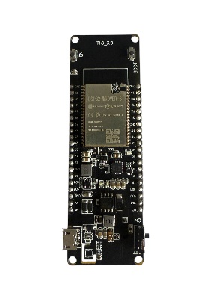

1. **MAX30100** is a sensor for measuring Sp0₂ and heart rate. It was used as it has high accuracy rate.

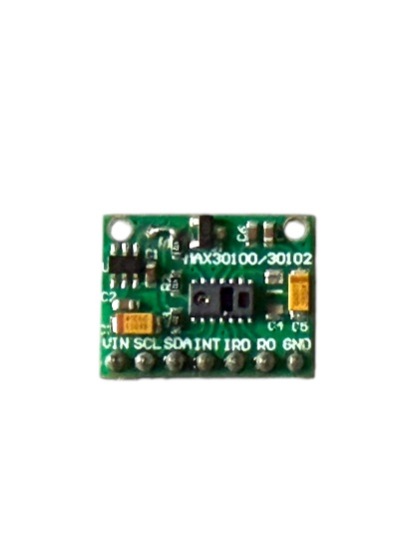

1. **MAX30102** **sensor** uses photoplethysmography (PPG) which was used to measure an estimated blood pressure.

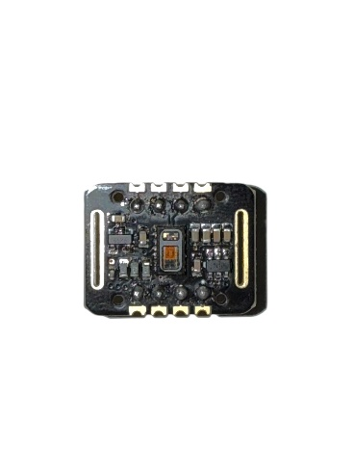

1. **AD8232** is a device to measure ECG signal. It was used as it gives optimal ECG signal measurement.

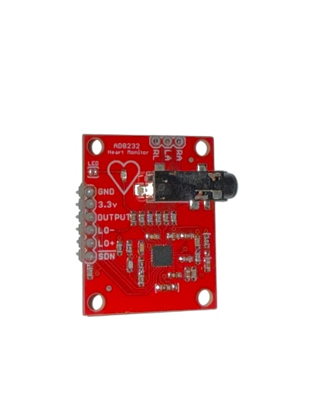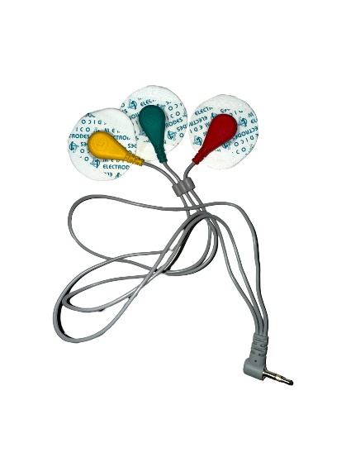

1. **10K NTC Thermistor temperature sensor** is used for measuring body temperature. Its resistance lowers while temperature is increased, making it suitable for accurate temperature measurement.

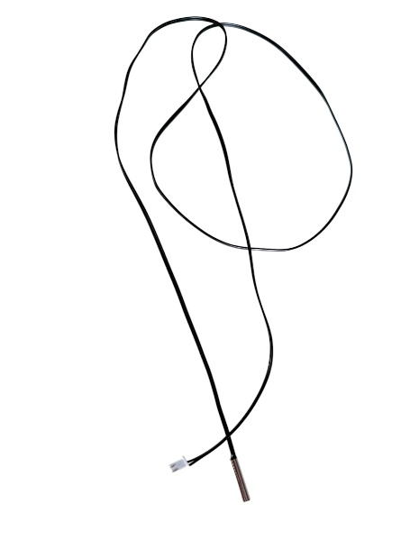

1. **Resistor** is electrical component which controls voltage and limit current. It ensured the components receive proper voltage and current supply.

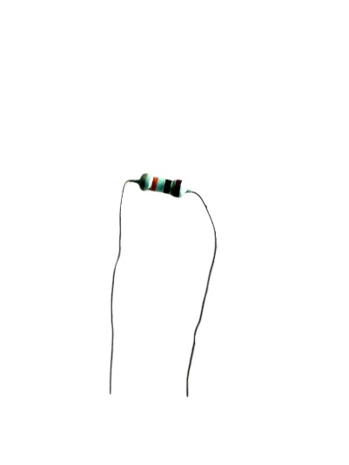

1. **Push Button** is electromechanical switch, allowing manual control of the circuit. It was implemented to switch the sensors measurement as per requirement.

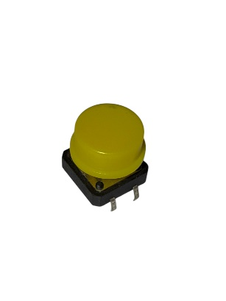

1. **OLED** was used for local display of the real-time measurements.

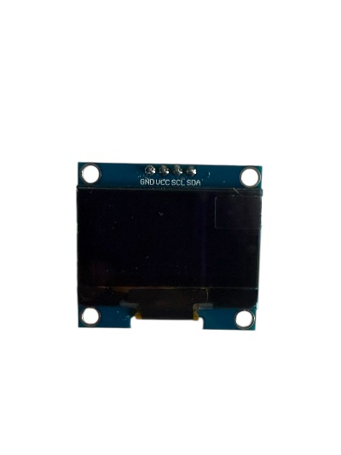

1. **Battery** was used to provide a common power supply to make sure the ESP works properly with sensors.

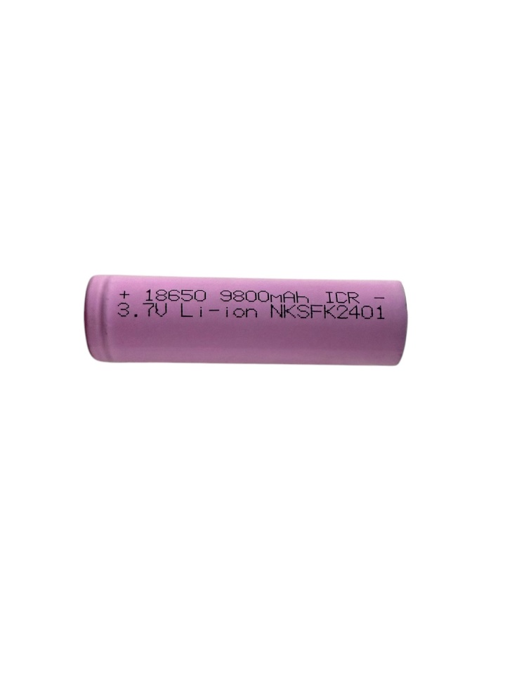

1. Backend
2. Operating System
3. Windows 11 is used as it supports all the software and hardware components for smooth operation.
4. Language, framework and Libraries
5. C/C++ was used as primary programing language as it helps in effective programing and suitable for hardware like ESP32.
6. Dart was adopted for development of mobile application.
7. Flutter was used for creating responsive UI for real-time data visualization.
8. ThingSpeak allowed to visualize, collect and analyze data after integration with microcontroller.
9. ESP32-SDK allowed effective development, handle wireless communication and hardware integration.
10. Wire.h was used for I2C communication for effective data exchange among ESP32 and components used.
11. WiFi.h library was used as it allows Wi-Fi connectivity for IoT devices which helps in data transmission.
12. MAX30102 Library allowed easy communication with MAX sensor and collect accurate data in real-time.
13. U8g2 library is common library for graphics display used with microcontrollers to get display in OLED.
14. Version Control
15. GitHub was utilized as it helped to manage the codes and files efficiently and keep track of the project history.
16. Documentation
17. MS Word was used to prepare a thorough report of the project.
18. MS Project was used to present a well-constructed workflow of the project for ease development of the project.
19. MS PowerPoint was used to deliver presentation which supports the development of the product.
20. Web Browser
21. Google Chrome was utilized as it is easy to use, offers secure surfing experience and is trusted web browser for debugging and running web portals.

**CHAPTER 4: METHODOLOGY**

Agile methodology has been used for Smart Vitals project. Agile method allows scalability and adaptability which enables to handle technical error effortlessly at early stages without interrupting other components. The flexibility, in Agile methodology allows developers to include new features or components in later stages based on the evolving requirements. Constant feedback is provided which ensures the progression of the project to meet the end goal the expectations. Additionally, the agile method offers iterative process enabling to build and improve the project piece by piece rather than following a linear or firm plan.

The Agile process has different stages each stage contributing for the progressive development of the Smart Vitals project. Research and Specification Collection is the first stage where the essential modules like ESP32, MAX30100 SpO₂ sensor, ECG sensor, Temperature sensor, are examined with the help of the datasheets. The next stage is Planning and Circuit Designing where the sensor connections were validated with the help of Wokwi for circuit diagram layout. After the successful circuit design, the main focus was integration of MAX30100, ECG and Temperature sensor with ESP32 for processing sensor data and with OLED for data monitoring. Then, 3D models and PCB design was developed and designed in TinkerCAD during Designing and Prototyping stage. In the Development stage, the microcontroller was programmed to analyze sensor data to communicate wirelessly with the mobile app. After the system being functional, in the Testing phase the product was regularly tested ensuring precision, stability and working of hardware and software components. Lastly, in deployment and maintenance stage, improvement of the product was done where the product was updated based on user feedback.

The waterfall method is a conventional and sequential approach where each stage must conclude before beginning with the next stage following stable workflow used for project that has well-defined end goal. The project Smart Vitals project has different hardware and software integration which needs to be tested continuously for precision and improvement, in waterfall method testing is conducted following the development stage. Any issue in the project might not be identified until the very end which will be very risky making the process time consuming and complex which is the reason for Agile methodology being used as it offers constant testing and evaluation throughout the product development. RAD focuses on prompt development of the prototypes and user reviews. The Smart Vitals project focuses on providing accurate, dependable and secure data which are essential for health care, RAD focuses on quick deployment which could result in patchy testing and disparity between hardware and software. Therefore, Agile methodology is used as it provides iterative feedback which assures the product is tested thoroughly and reliable medically. The Spiral Model mainly focuses on risk management and developing the project in an iterative manner which can help the developers eliminate or avoid the risks completely during the initial phase. It focuses on thorough reports, planning which is suitable for large-scale project with peak risks which is why agile method is used as it is suitable for small to medium scale projects like Smart Vital with risks like data reliability which can be avoided with regular evaluation.

**CHAPTER 5: PRODUCT DESIGN**

**CHAPTER 6: SOFTWARE REQUIREMENT ANALYSIS**

The table below represents the features of the project with its priority as HIGH, MEDUIM OR LOW.

|  |  |
| --- | --- |
| **Features** | **Priority** |
| The device should be easy to use and portable. | HIGH |
| Button for turning the device on and off. | HIGH |
| The device should connect to Wi-Fi for flawless communication. | HIGH |
| Buttons for switching between the sensors for particular health measurement. | HIGH |
| Accurate readings from sensors. | HIGH |
| The reading taken via sensor should be displayed on the OLED. | HIGH |
| The measurements should be shown in the mobile application through Wi-Fi connection. | HIGH |
| Alert message should be sent to the user if there is any abnormality in the reading. | MEDIUM |
| The data from the measurements should be logged. | MEDIUM |
| The battery can be replaced with ease when power runs out. | MEDIUM |
|  |  |

**CHAPTER 7: IMPLEMENTATION AND TESTING**

**CHAPTER 8: PRODUCT EVALUATION**

**CHAPTER 9: PROJECT EVALUATION**

**Task Sheet**

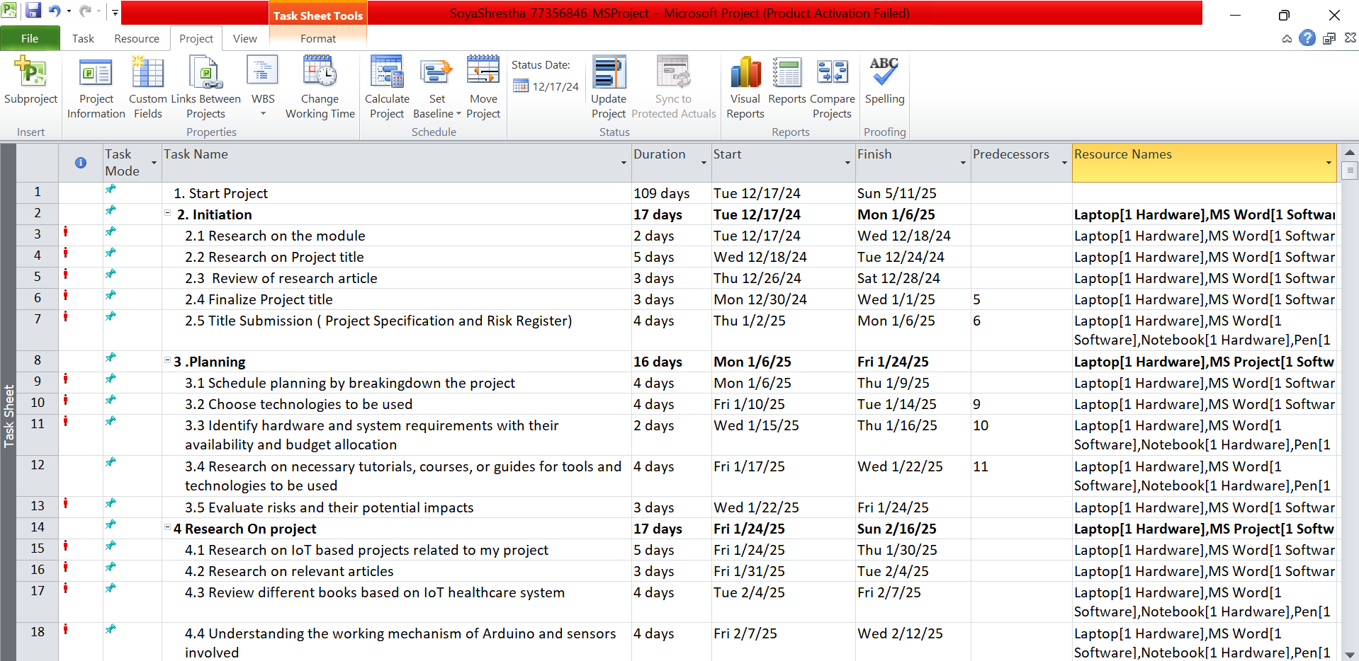

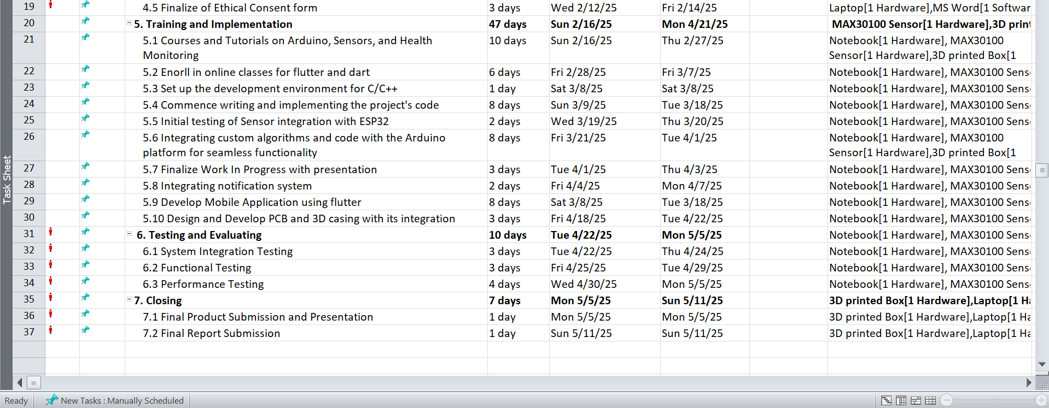

The above figure represents the complete flow of how the project was successfully concluded by following a planned task sheet.

**Gnatt Chart**

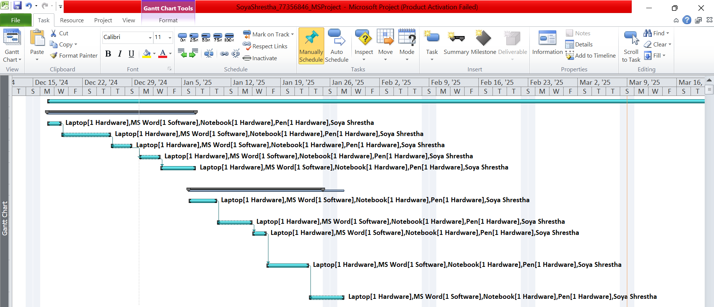

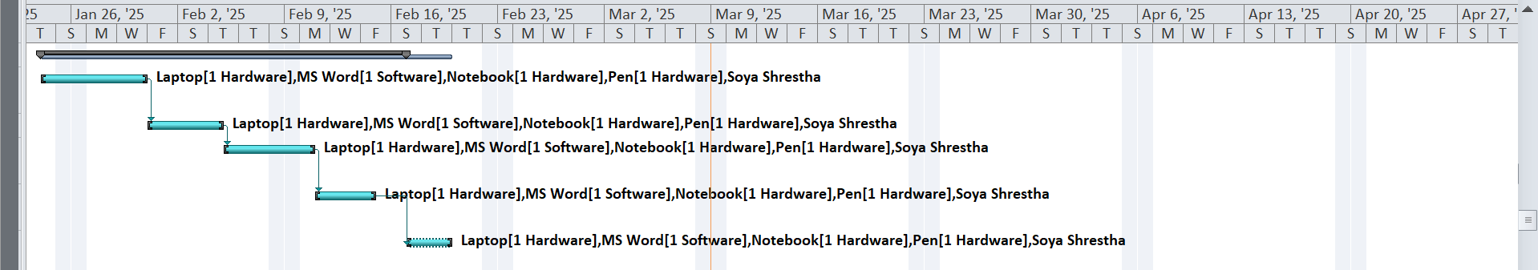

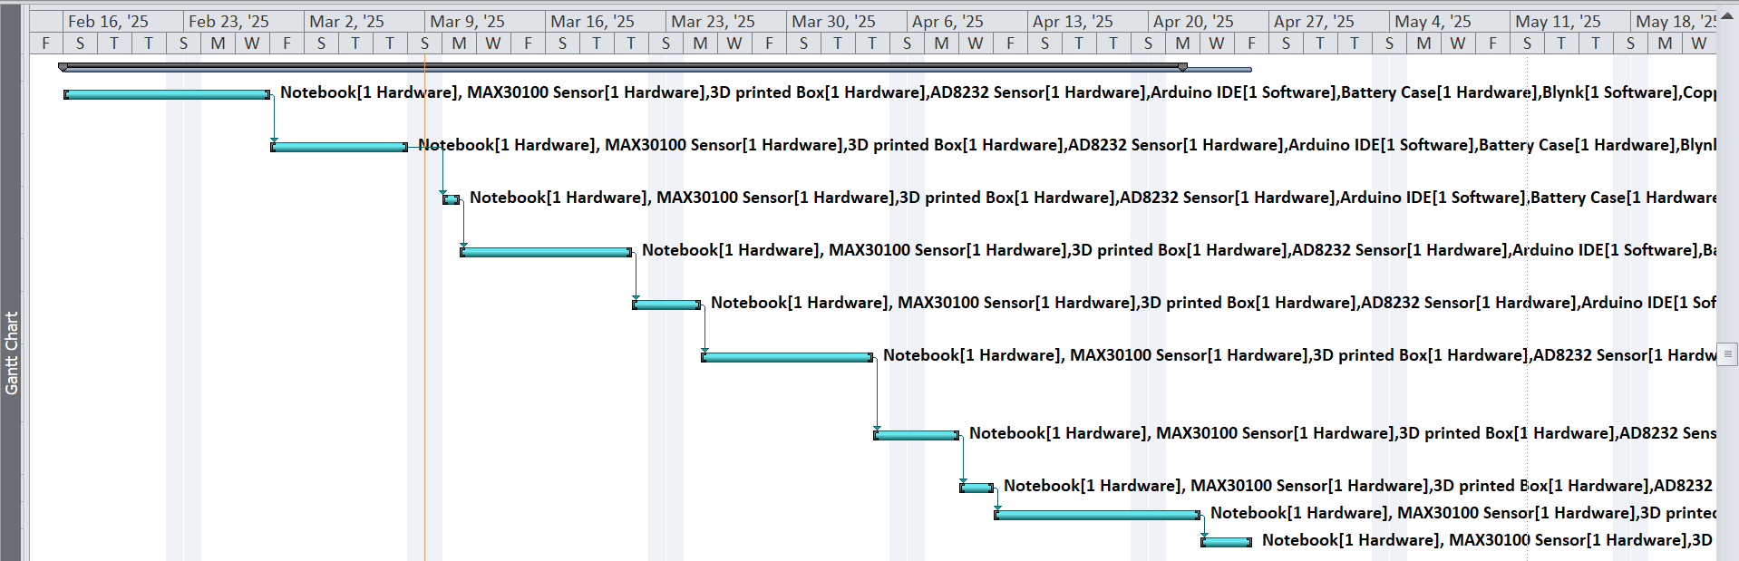

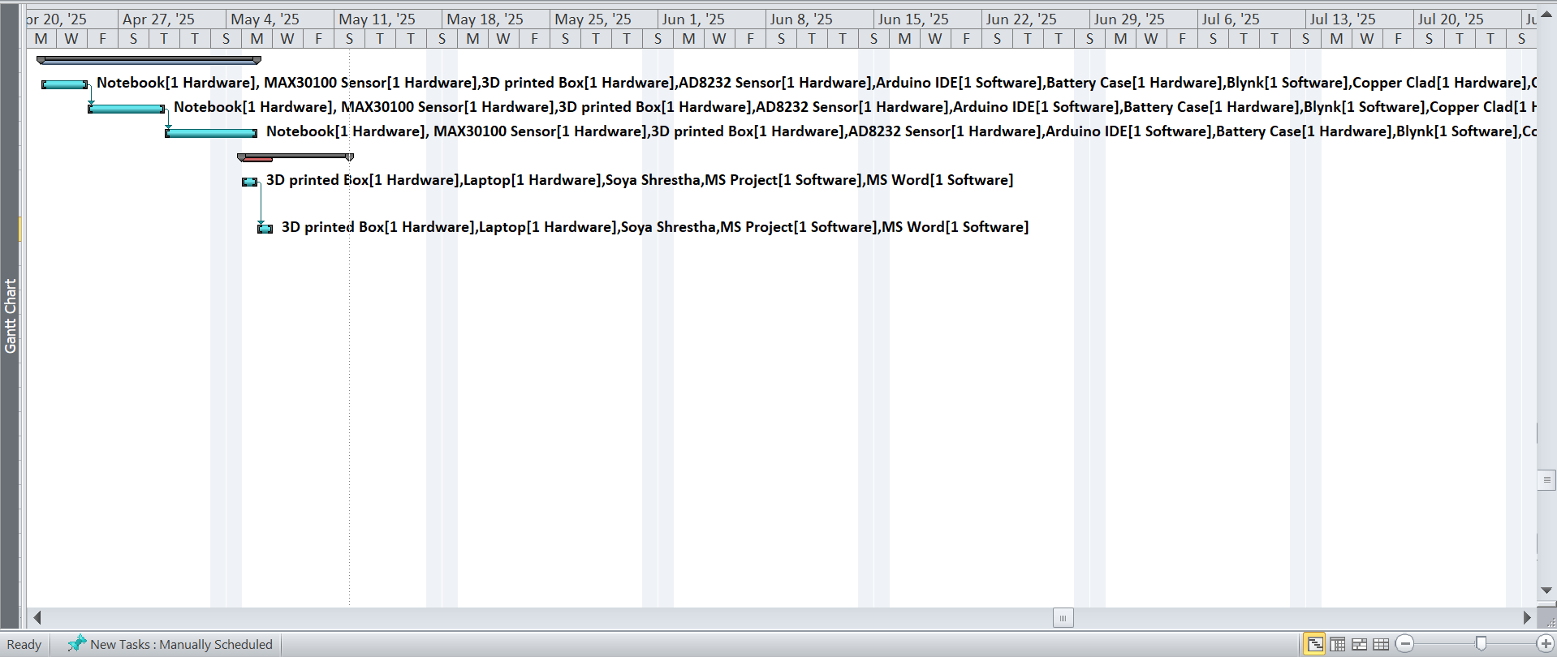

**Timeline**

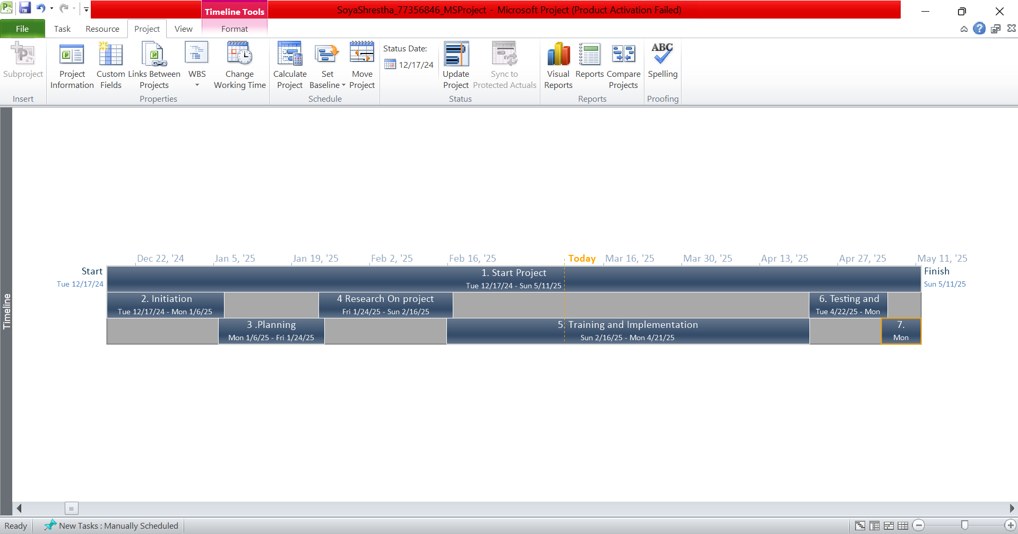

Key stages of the project are shown in the MS Project Timeline, with initiation phase starting at 12/17/2024, followed by Planning phase, Research phase, Training and implementation phase, Testing and Evaluation phase with Closing phase marking the end of the project at 05/11/2025.

**Resource Sheet**

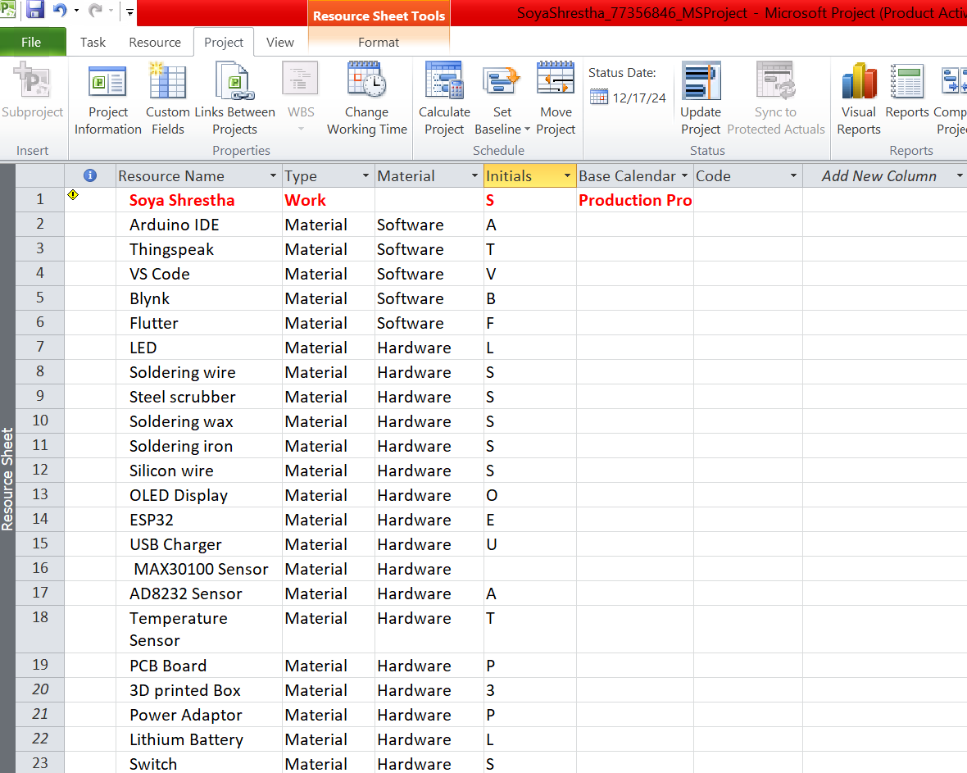

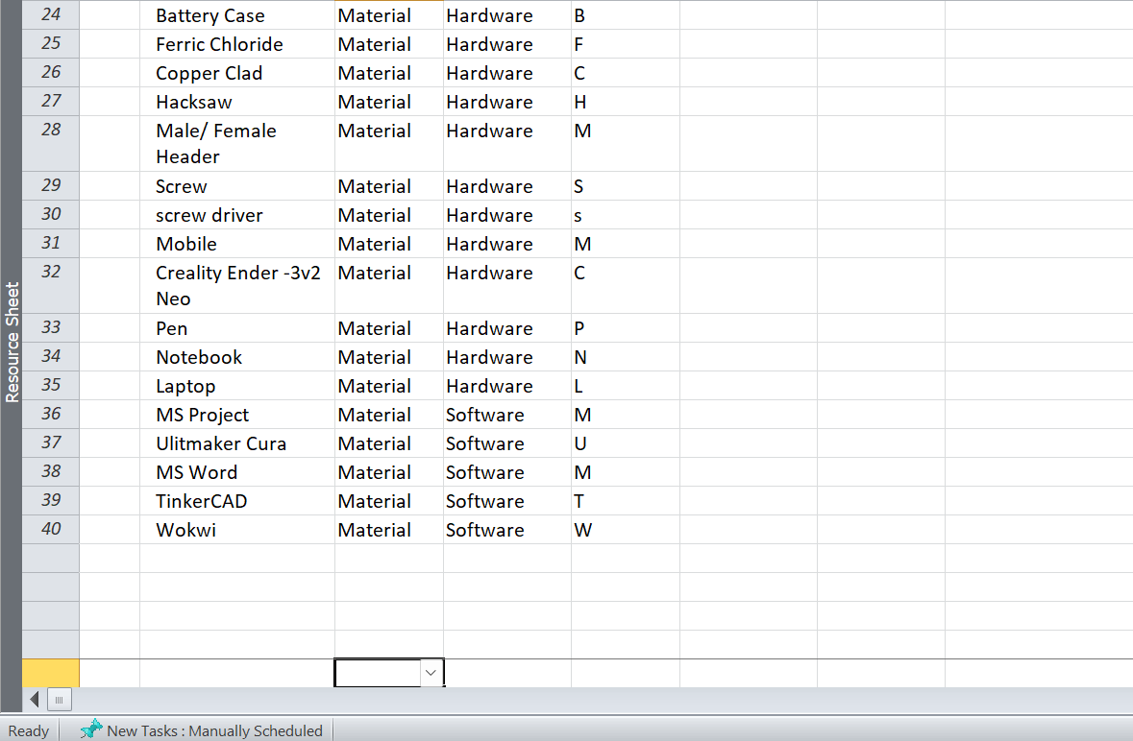

**CHAPTER 10: SUMMARY AND CONCLUSION**