## 4CS015 – Portfolio Part -4

**STUDENT NAME**: **SOYAM BAJGAIN**

**STUDENT NUMBER**: 2358512

You will need to complete the workshop and then submit this Word file, complete with your answers, via Canvas, by the end of Semester (week 12).

For this assignment (workshop) you will show you how to navigate and create file systems from command prompt in both Windows (os) and Linux (os), also how to create a batch file to be executed in the Windows (os).

**NOTE: Please make sure you have written your command as well as the screenshot of the commands. Failure to do so will result in marks deduction.**

**Task 1 (Windows Command Line)**

1. Write a command to Create a directory "**test**"

**Ans: MKDIR test**



1. Write the command to list all the directories/files inside the directory **test**

**Ans: tree /f**

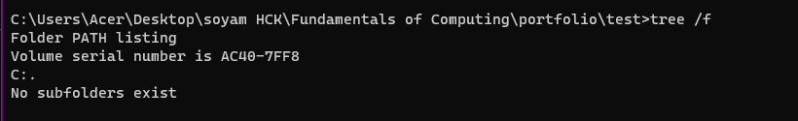

1. Create a file "**hello.txt**" containing the word "Hello", inside the test directory.

Ans:

echo Hello>hello.txt

1. Display the content of **hello.txt** in the command line.

1. Make directory **test1** in the Desktop and copy **hello.txt** from **test** to **test1**

**Ans:**

**MKDIR test1 (inside desktop)**

**COPY hello.txt \Users\Acer\Desktop\test1 (inside test folder)**

1. Now delete the file **hello.txt** in the current directory

Ans: DEL hello.txt



1. Write a command to display your current directory.

Ans: CHDIR

1. Now rename the file to **hello2.txt**

**Ans: RENAME hello.txt hello2.txt**

1. Now navigate outside the directory test.

Ans: CD.. or CD../.. (to navigate two directories back)

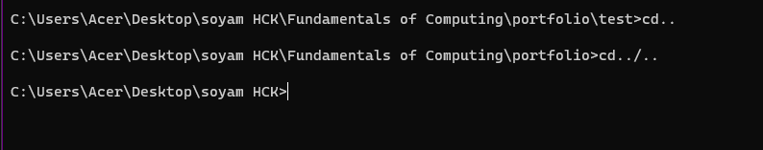

1. Write the command to print the tree structure. It should look something like this:

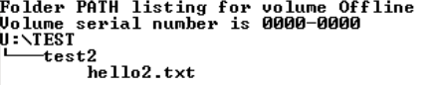

Ans:

MKDIR f

CD f

MKDIR TEST

CD TEST

MKDIR test2

CD test2

ECHO >hello2.txt

CD../..

TREE /F

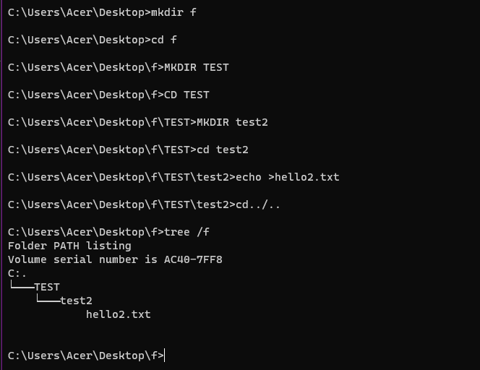

**Task 2**

Create the following directory structure and paste it after this picture. (15 marks):

**Note: MYMODULES must be inside <your_name> directory.**

**Make a directory with your name on the desktop and navigate to the directory before you display the following structure.**

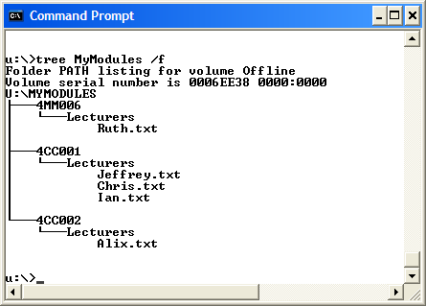

MKDIR SOYAM

CD SOYAM

MKDIR MYMODULES

CD MYMODULES

MKDIR 4MM006, 4CC001, 4CC002

CD 4MM006

MKDIR LECTURES

CD LECTURES

ECHO >RUTH.TXT

CD../..

CD 4CC001

MKDIR LECTURES

CD LECTURES

ECHO> JEFFERY.TXT

ECHO> CHRIS.TXT

ECHO> IAN.TXT

CD../..

CD 4CC002\

MKDIR LECTURES

CD LECTURES

ECHO > ALIX.TXT

CD../..

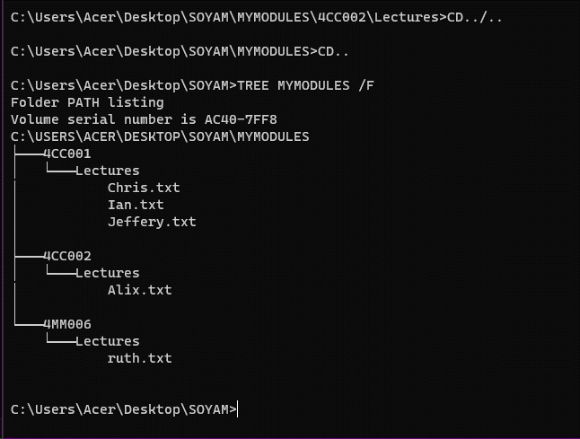]

**Task 3(Linux terminal)** (10 marks)

Now, Boot into Linux operating system in virtualbox or Windows-SubSystem for LInux(On Windows)

1. Write a command to Create a directory "**test**"

Ans:

Mkdir test

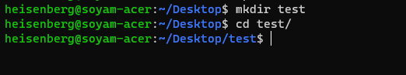

1. Write the command to list all the directories/files inside the directory **test**

**Ans:**

**ls -a**

1. Create a file "**hello.txt**" containing the word "Hello", inside the test directory.

Ans:

**CAT >**hello.txt

Hello

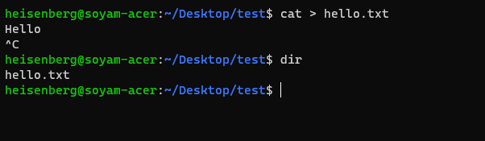

1. Display the content of **hello.txt** in the command line.

Ans: CAT hello.txt

1. Make directory **test1** in the Desktop and copy **hello.txt** from **test** to **test1**

**Ans:**

mkdirtest1(inside desktop)

cd test

cd hello.txt ~/desktop/test1

1. Now delete the file **hello.txt** in the current directory

Ans:

rm hello.txt



1. Write a command to display your current directory.

Ans:

Pwd

1. Now rename the file to **hello2.txt**

**Ans:**

mv hello.txt hello2.txt

1. Now navigate outside the directory test.

Ans:

Cd ..

1. Write the command to print the tree structure.

Ans:

tree

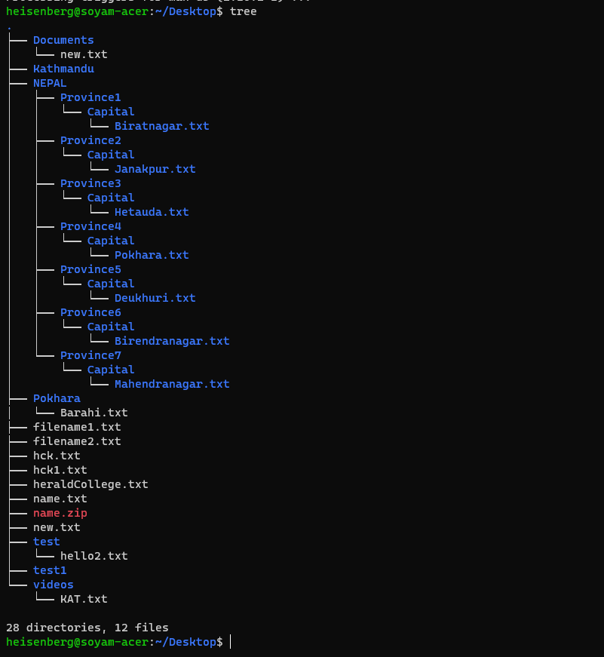

**Task 4**

Create the following directory structure (identical to the one that you created in Windows Command Prompt):

**Note: MYMODULES must be inside <your_name> directory.**

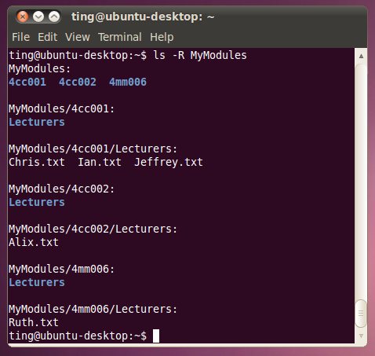

and insert it below (15 marks):

Ans:

inside desktop directory, the following commands were run.

mkdir soyam

cd soyam\

mkdir mymodules

cd mymodules/

mkdir 4cc001 4cc002 4mm006

cd 4cc001

mkdir lectures

cd lectures/

touch chris .txt

touch ian . txt

touch jeffrey .txt

cd ../..

cd 4cc002

mkdir lectures

cd lectures/

touch alix.txt

cd ../..

cd 4mm006/

mkdir lectures

cd lectures/

touch ruth.txt

cd ../..

cd ..

ls -r mymodules

[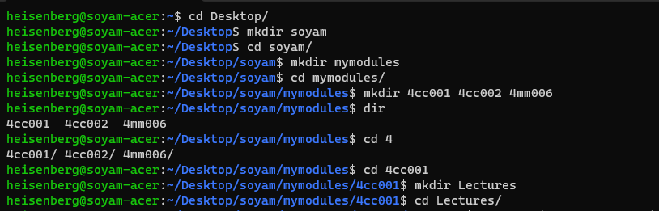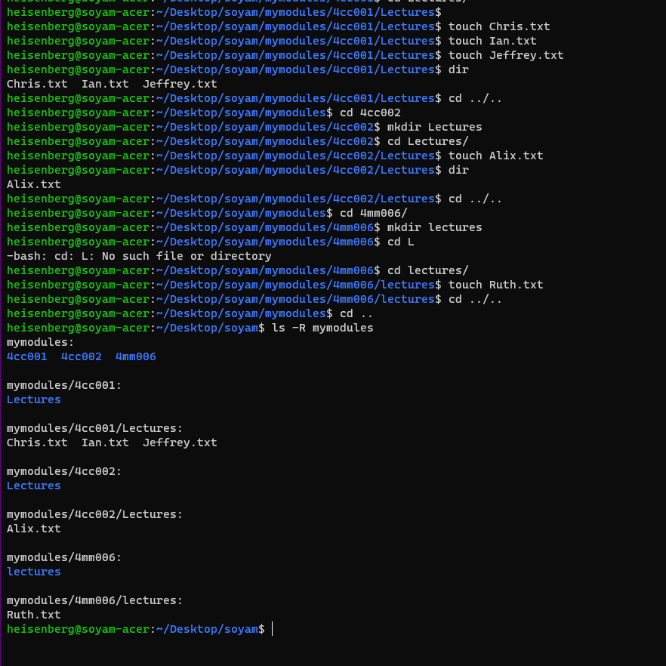]

**Task 5**

**Batch file material (50 marks in total)**

Create a batch file (windows) **YourNumber.bat** from notepad (or your preferred text editor).

The batch file should create a directory structure similar to the one create for the first section of this assignment but the directory entries should be provided from an input request from the batch file itself.

You should be able to create a root directory and directory structure and populate it if required. The batch file program will ask for names (**input directory names and file names**) to be used and have some form of **error checking** (empty – incorrect character, length, etc.) You can add other features such as being able to edit the new structure from within the batch file program (**find and change a directory name**).

Run batch file from windows prompt: YourNumber.bat <enter>

[Insert your picture(s) here] – Directory structure created / menu of batch file (inputs and output when batch file is executed) (10 marks)

Here, the batch file is opened from windows prompt. The inputs are shown in the image below whereas the output is shown in the image below that image.

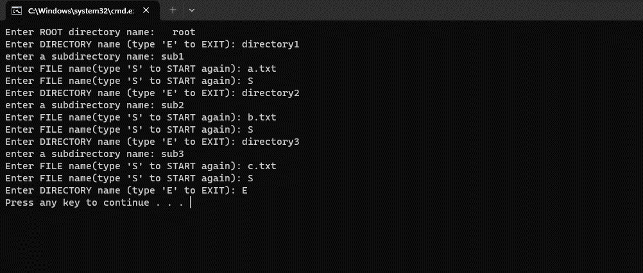

Here, the tree is shown from command prompt. This image consists of the output (tree format of directories) of the batch file according to the inputs given above.

[Insert your text here] – Batch file listing (script)(40 marks)

The batch script is listed in the table below.

|  |
| --- |
| **@echo off**  **set /p rootname="Enter ROOT directory name: "**  **mkdir "%rootname%"**  **:dir**  **set /p dirname="Enter DIRECTORY name (type 'E' to EXIT): "**  **if "%dirname%"=="E" goto :end**  **if "%dirname%"=="" (**  **echo directory name is empty.**  **goto :dir**  **)**  **set /p subdirname="enter a subdirectory name: "**  **md "%rootname%"\%dirname%\%subdirname%"**  **:file**  **set /p filename="Enter FILE name(type 'S' to START again): "**  **if "%filename%"=="S" (**  **goto :dir**  **)**  **if "%filename%"=="" (**  **echo error:empty file name.**  **goto :file**  **)**  **echo. > "%rootname%\%dirname%\%subdirname%\%filename%"**  **goto :file**  **:end**  **pause** |

**The images given above shows (IN GUI) the different directories created when the batch file ran.**

|  |
| --- |
|  |
|  |
|  |
|  |
|  |
|  |
|  |
|  |