Instruction:

Complete all questions in 1 hr.

Let’s get started with nice and easy examples of Batch script:

1. Open your favorite text editor. Save it as filename.bat (All files) right click on the file and

edit> type >

@echo off

echo Hello World!

pause

Run it. You have created your first batch file.

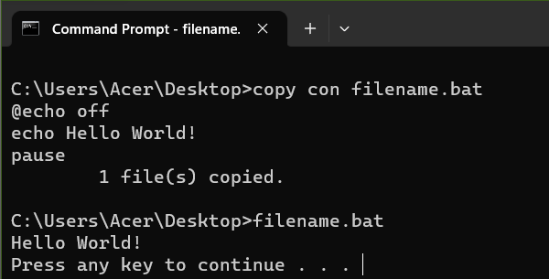

*Write the function of set up commands @Echo off and pause.*

Answer: The function of set up commands @Echo off is to hide all the commands written inside the bat file and the function of pause is to stop execution of the batch file and wait for the user to press any key.

1. Create a batch program which takes two numeric inputs from the user and checks whether they are equal or not.

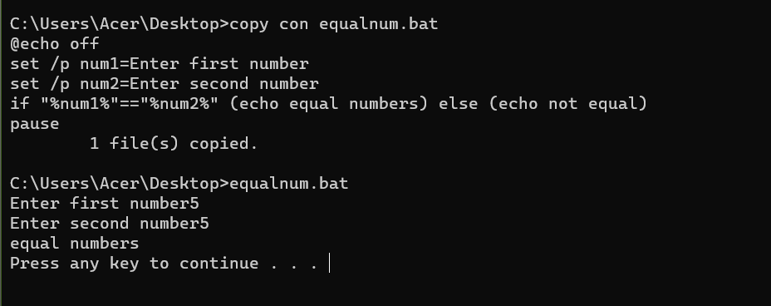

1. Create a batch program which takes a numeric input from the user and checks whether the input is odd or even.

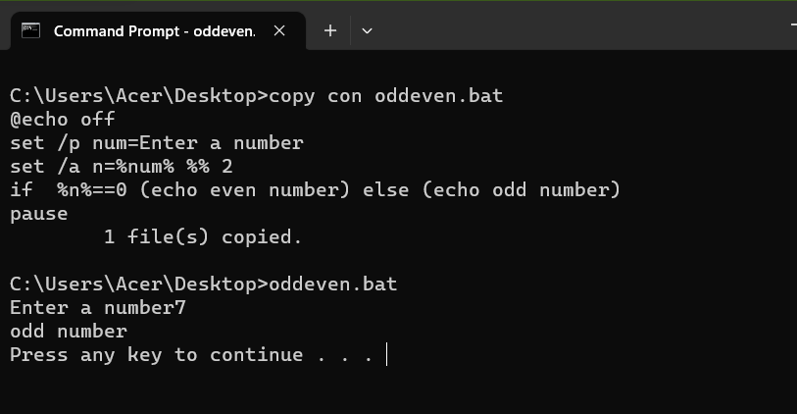

1. Create a batch program which prints natural numbers 1 to 10 using for loop.

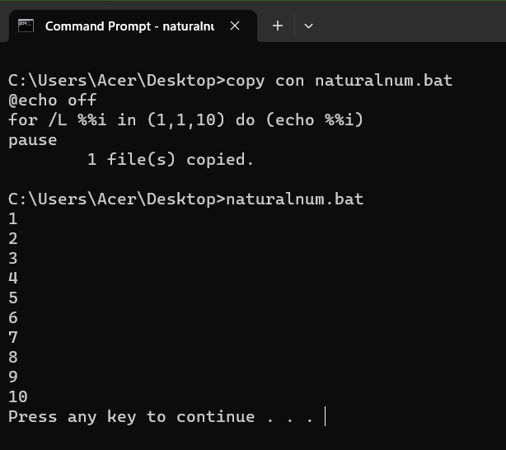

1. Create a simple calculator using a batch script. Which takes two number and third inputs can be “add” ,“sub”, “mul”, “div” and displays the result after calculation and displays error message for any other input in the third. eg: if first input is 2 , second input is 3 and third input is add then it displays the result 5. Note: use function

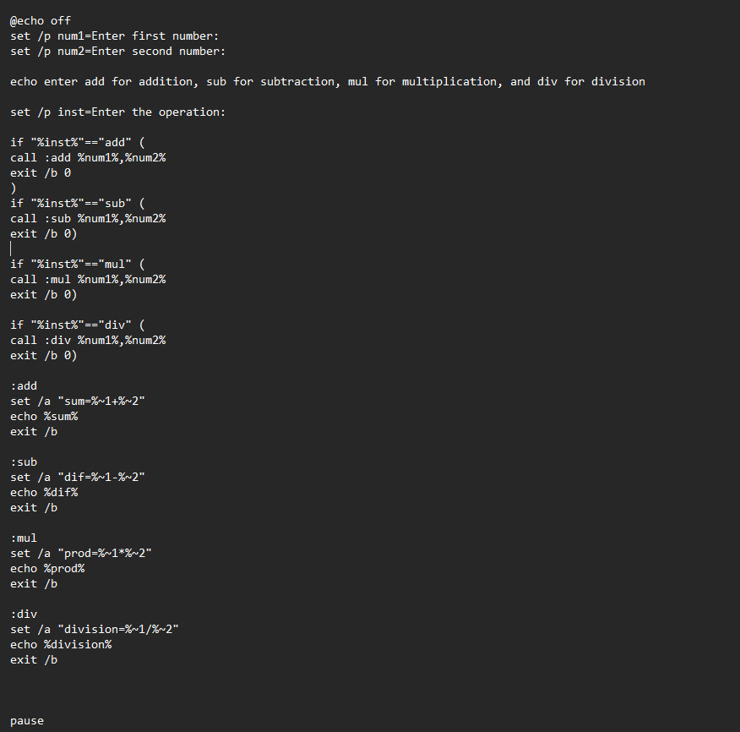

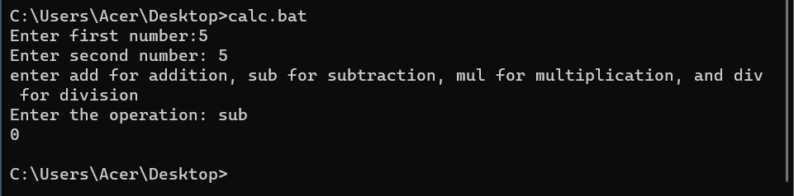

1. Write a batch program to swap mouse keys.

Answer: The batch program to swap mouse keys is

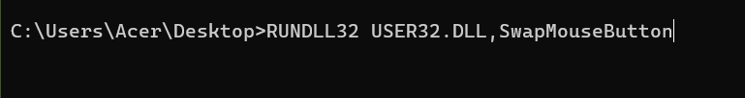

1. The following script is the malicious script responsible for system crash. Explain how it works and explain how you can protect your pc from system crash in Windows OS and Linux.

It is not permanently harmful for computers but annoying.

**Warning: do not run this script.**

**:S**

**Start %0**

**Goto S**

**Answer:** The script above, known as fork bomb, is a type of denial-of-service (DoS) cyber attack that seeks to consume central processing unit (CPU) time. Also known as a rabbit attack, it involves the use of forking processes.

During a fork bomb attack, a hacker will essentially create copies of a program. Fork bomb attacks work by using loops to create a seemingly unlimited number of programs.

It starts by running the Start %0 command, which starts the script itself again, and then it goes to the S label, which is the beginning of the script, and it repeats this process indefinitely. This results in the script consuming a lot of system resources and causing the system to crash or become unresponsive.

We can protect windows OS from system crash by using better anti-malware software and keeping all system and software up to date and we can protect linux from system crash by limiting user processes.