Instruction:

Complete all questions in 1 hour.

1. Differentiate between Data and Information.

**Answer:**

|  |  |
| --- | --- |
| Data | Information |
| Data is a discrete unit made up of basic components without a defined meaning. | Information is a collection of facts with a logical significance when taken as a whole. |
| In making decisions, only the raw data is sufficient. | Information is sufficient to make decisions |

1. Write short notes on:
2. DBMS

**Answer:** The database management system is an application which manages the database. A wide range of commercial databases, such as: MySQL,Oracle etc. are in use by a variety of applications. DBMSs provide an interface to perform a variety of operations, like database creation, store data in databases, update information, create tables and much more. It's meant to protect and secure the database. It also ensures data consistency in case of more than one user.

1. SQL

**Answer:** SQL stands for Structured Query Language, which is a computer language that stores, manipulates and retrieves data stored in the relational database. The SQL specification was developed by IBM computer scientists in the 1970s, becoming a standard of U.S. National Standards InstituteANSIn1986 and International Organization for StandardizationISO n 1987.

1. File System

**Answer:** A file system consists of a software application that organizes and stores files on your storage device. It's responsible for the storage and retrieval of data. Files are more closely related to an operating system and shipped as part of a specific operating system.

1. Download and install MySQL from any browser.



1. Create a database named HCK

1. Create tables named Students, Parents and Tutors.

1. Create the attributes like (id, full_name, email, phone_no, address and gender) in all the above tables with suitable data types.

1. Insert the data using SQL Commands in all the table. (3 data)

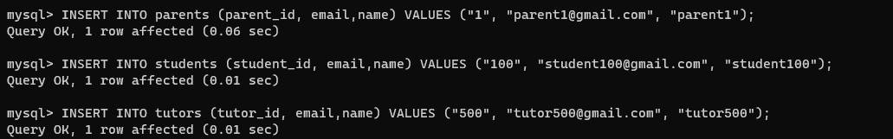

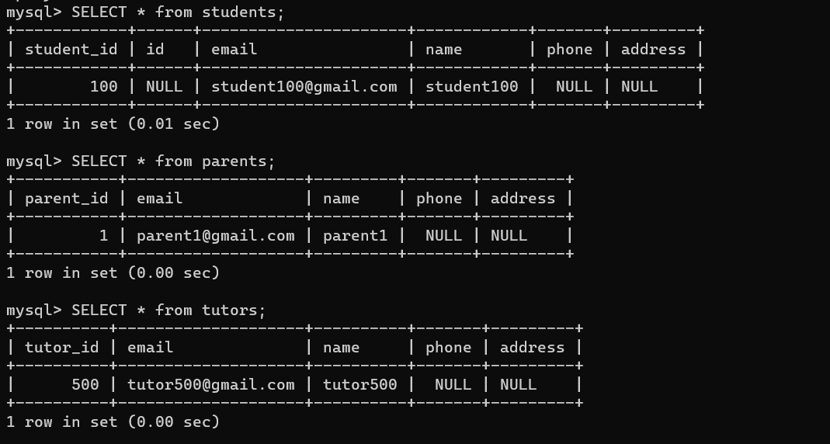

1. Display the all data of the table Tutors.

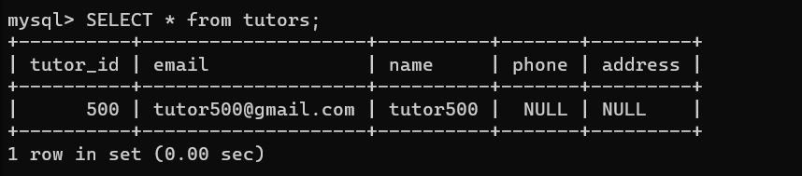

1. Display only male students from table Students.

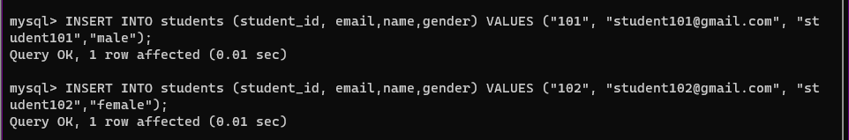



1. Drop column Parents using SQL command.
2. Drop TABLE Parents using SQL command.

There was no column named “parents” so I considered that the question meant TABLE, not column. So, I dropped the table “parents”.

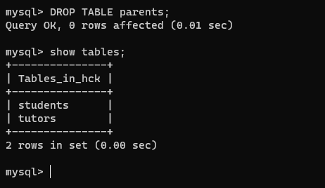

1. Delete a row in student using SQL command.

