Fundamentals of Computing (4CS015) Tutorial: Week 3

**Instruction:**

Complete all questions in **1 hour.**

1. Draw the logic diagram of the following gates using logsim and complete the Truth tables.
   1. AND

|  |  |  |
| --- | --- | --- |
| A | B | A.B |
| 0 | 0 | 0 |
| 0 | 1 | 0 |
| 1 | 0 | 0 |
| 1 | 1 | 1 |

[Insert your gif image here]

* 1. NOR (do the same as in Q No a for all of the following)

|  |  |  |
| --- | --- | --- |
| **A** | **B** | **(A+B)’** |
| **0** | **0** | **1** |
| **0** | **1** | **0** |
| **1** | **0** | **0** |
| **1** | **1** | **0** |

* 1. OR

|  |  |  |
| --- | --- | --- |
| **A** | **B** | **A+B** |
| **0** | **0** | **0** |
| **0** | **1** | **1** |
| **1** | **0** | **1** |
| **1** | **1** | **1** |

* 1. NAND (using NOT and AND)

|  |  |  |
| --- | --- | --- |
| A | B | (A.B)’ |
| 0 | 0 | 1 |
| 0 | 1 | 1 |
| 1 | 0 | 1 |
| 1 | 1 | 0 |

* 1. XOR using AOI

|  |  |  |
| --- | --- | --- |
| A | B | A’.B + A.B’ |
| 0 | 0 | 0 |
| 0 | 1 | 1 |
| 1 | 0 | 1 |
| 1 | 1 | 0 |

1. Use LogSim to build the equivalent circuit for the following Boolean equations. Prove that the expressions are equivalent by computing truth table.

**! (A + B) =! A.! B**

|  |  |  |  |
| --- | --- | --- | --- |
| A | B | !(A+B) | !A.!B |
|  |  |  |  |
| 0 | 0 | 1 | 1 |
|  |  |  |  |
| 0 | 1 | 0 | 0 |
|  |  |  |  |
| 1 | 0 | 0 | 0 |
|  |  |  |  |
| 1 | 1 | 0 | 0 |
|  |  |  |  |

3. Draw the following circuit of half adder using LogSim.

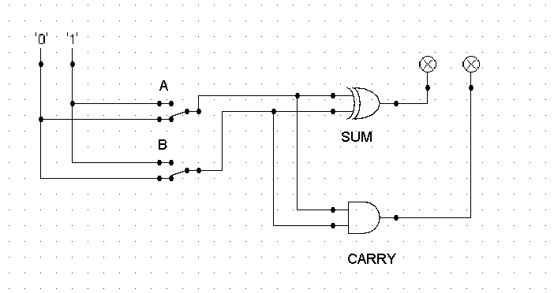

1. Draw full adder using Logsim and construct truth table.



|  |  |  |  |  |
| --- | --- | --- | --- | --- |
| A | B | C(in) | SUM | CARRY |
| 0 | 0 | 0 | 0 | 0 |
| 0 | 0 | 1 | 1 | 0 |
| 0 | 1 | 0 | 1 | 0 |
| 0 | 1 | 1 | 0 | 1 |
| 1 | 0 | 0 | 1 | 0 |
| 1 | 0 | 1 | 0 | 1 |
| 1 | 1 | 0 | 0 | 1 |
| 1 | 1 | 1 | 1 | 1 |

1. Draw the logic circuit for the following Boolean equations using logsim simulator.
   1. AB+C



* 1. A(B+C)



* 1. X’Y’Z’

