**Instruction:**

Complete all questions in **1 hour.**

1. The table below shows the Truth table of Half Subtractor, write SOP expression for difference, and borrow and design the circuit using Logsim.

|  |  |  |  |
| --- | --- | --- | --- |
| **A** | **B** | **Difference** | **Borrow** |
| **0** | **0** | **0** | **0** |
| **0** | **1** | **1** | **1** |
| **1** | **0** | **1** | **0** |
| **1** | **1** | **0** | **0** |

**Answer:** The SOP expression for difference is: A’.B + A.B’

The SOP expression for borrow is: A’.B

*Insert your Gif image here.*



1. Design 2:4 decoder using logsim and Construct Truth table.

|  |  |  |  |  |  |
| --- | --- | --- | --- | --- | --- |
| A1 | A0 | D3 | D2 | D1 | D0 |
| 0 | 0 | 0 | 0 | 0 | 1 |
| 0 | 1 | 0 | 0 | 1 | 0 |
| 1 | 0 | 0 | 1 | 0 | 0 |
| 1 | 1 | 1 | 0 | 0 | 0 |

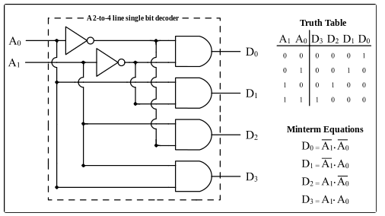



1. Draw the following simple ALU circuit using Logsim and describe the outputs when instructions are 1 and 0.

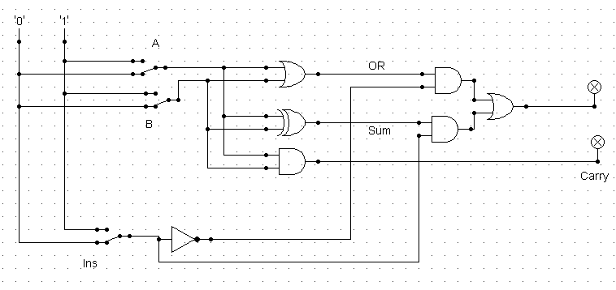



1. Draw the circuit in Logsim to perform the following operation.
   1. 0110 + 0110

* 1. 1010 + 1111

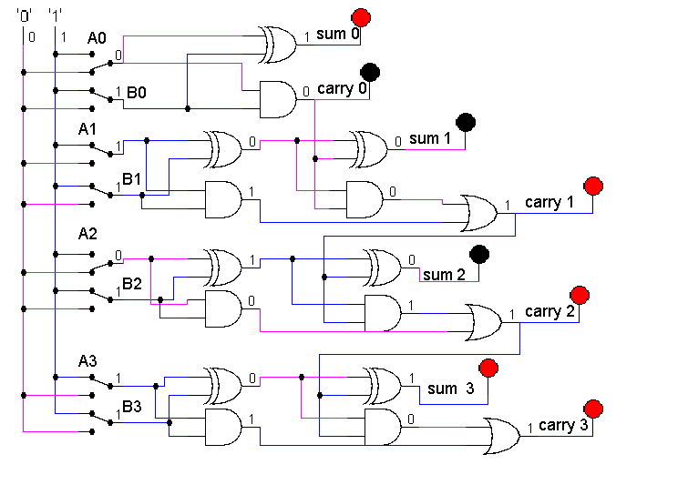

1. Write short notes on the following topic:
2. ALU

An Arithmetic Logic Unit (ALU) is a digital circuit within a computer's central processing unit (CPU) that performs arithmetic and logical operations on binary numbers. It is responsible for performing basic arithmetic operations such as addition, subtraction, multiplication, and division, as well as logical operations such as AND, OR, NOT, and XOR.

1. Decoder

The decoder is combinatorial logic circuit (CLC). The circuit in which, at any time output is only depends upon inputs only is called CLC. It converts binary information from ‘n’ input lines to a maximum of 2^n output lines. A decoder takes a binary input and activates a specific output line based on the binary code. For example, a 2-to-4 decoder will take a two-bit binary input and activate one of its four output lines based on the input code. A 3-to-8 decoder will take a three-bit binary input and activate one of its eight output lines based on the input code.

1. Multiplexer

A multiplexer (MUX) is a digital circuit that selects one of several input signals and forwards the selected input to a single output. It selects the outputs with the help of Decoder. A multiplexer has multiple input lines, one or more select lines, and a single output line. The select lines determine which input line will be connected to the output. For example, a 2-to-1 multiplexer will have two input lines, one select line, and a single output line.