1. What is the command to change directory and how to move one directory back?

**Answer:** The command to change directory is cd and to move one directory back is cd ..

1. What is the command to make a directory named IPHONE and IPAD and remove the directory named IPAD?

**Answer:** The command to make directory named IPHONE and IPAD are mkdir IPHONE and mkdir IPAD and the command to remove the directory named IPAD is rm IPAD.

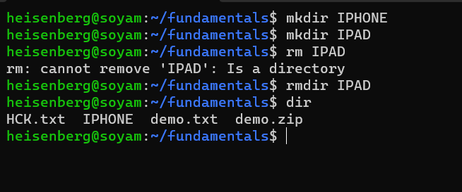

1. Make a directory name TextDocuments in the desktop and make 3 text files: **textfile1.txt, textfile2.txt and textfile3.txt** inside the TextDocument.

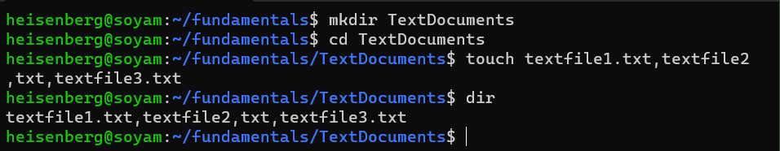

1. Remove the directory TextDocuments and contents within it.

1. What is the command to list all the invisible files and to display the directories in detail?
   1. ls –a
   2. ls –l
   3. ls -al
2. How to remove the commands from the screen without closing the terminal?

**Answer:** The commands from the screen without closing the terminal is by pressing ctrl + l key.

1. Which command is used to find out the path of the current working directory (folder) you’re in?

**Answer:** PWDcommand is used to find out the path of the current working directory (folder) you’re in.

1. What is the command to check which directory are you currently working on?

**Answer:** PWDcommand is used to find out the path of the current working directory (folder) you’re in.

1. What is the difference between?
   1. cd ..
   2. cd
   3. cd –

**Answer:** The difference between cd .., cd , and cd – is that “cd ..” command is used to go one directory back and “cd” command is used to go the directory of choice by user within that directory and “cd –” command is used to go to one directory forward.

1. Create a file name name.txt on Desktop and add text “Hello, my name is John” into the file.

**Answer:** 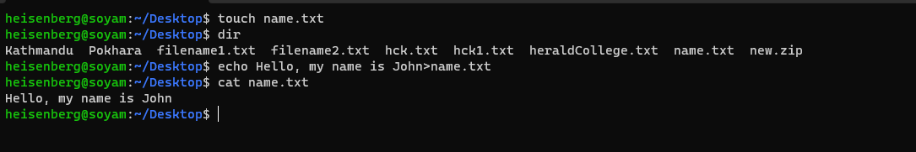

1. Copy new.txt from the current directory to a Document directory.

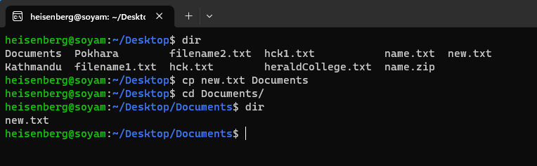

1. Compress the file “name.txt” into a zip archive.

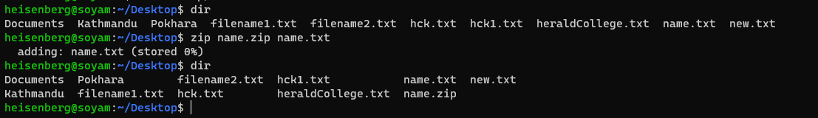

1. **df** is used to get the report of disk space uses on the system. The results shown is KBs. What if I want to see the report in megabytes?

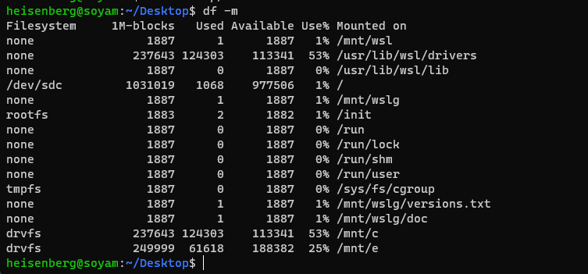

1. What is the command to move file KAT.txt from directory Pictures to directory Videos if the full path of Pictures directory is /home/user/Pictures?

